BMSW4002: Effective Team Working and Communication
Name of the Student
Student ID

Introduction
Communication is a task for relying on the information that involves an exchange of ideas, messages, and also information through the use of language, visuals, indications, working, or behavior amid two or more living creatures. To imply that everyone engaged completely comprehends the topic, communication is defined as the transmission, receiving, or exchange of information, thoughts, or figurative language (Sutiyatno, 2018). The sender, message, route, receiver, reaction, and circumstances all play a role in communication. Further, to express oneself, it is necessary to engage in discussion. Work growth necessitates effective communication. Good communication skills may help you navigate your everyday life and improve your interactions with others by allowing you to understand and be understood by others. Effective communication is the process of conveying ideas, thoughts, opinions, information, or facts in such a way that the message is heard and comprehended with intent (Stacho et al., 2019). When we have the opportunity, both the sender and the recipient are overjoyed. The presentation will highlight the organizational overview of Tesco, the benefits of effective communication for Tesco’s business process, the theory related to the model of communication, the type of barriers preventing effective communication between the organization and its external stakeholders, and also discuss the channels of communication used by Tesco and that can be improved.
Discussion
TASK 1
Organizational Overview
Tesco is the largest British retailer and the third-largest supermarket chain in the world, with stores in Europe, the United States, and Asia. "In 1919, a man named Jack Cohen "established a stand in London's East End" and began selling merchandise on the first day, earning "between £1 and £4". T.E. Stockwell is the company from whom Jack ordered more tea. T.E. Stockwell and Cohen's initials were joined to produce TESCO tea, which Cohen was the first to commercialize. Tesco originally opened its doors in north London in 1929. (Tesco, 2022). Since then, Tesco has continued to grow through a combination of store acquisitions, retail services, and adapting to changing customer expectations. Tesco's main objective is to deliver excellent customer service. Customers must be satisfied since they are more likely to return. This is far less costly for the organization than hiring additional personnel. Tesco, in general, maintains a hierarchical structure. Furthermore, Tesco was founded with a single goal in mind: to be the customer's champion. Our major purpose is to deliver excellent service to British consumers every day. With this in mind, we put our customers first in all we do, from retail employees to support staff.
Benefits of effective communication on the organization’s business process
Employers who invest time and effort in effective communication often notice a boost in productivity and employee morale. Workers that can effectively communicate with clients and co-workers are seen as great assets to a company. The business process Tesco tends to implement in their operation advantage is by using electronic mail because it is useful for sending the messages to staff or management. Consequently, They are also beneficial for Tesco to interact with local or foreign branches because they’re easier to send and can have more information than letters.
The benefits of effective communication for Tesco’s business process are as follows:-
- Employees are encouraged to contribute new ideas while their morale is improved.
- The more satisfied a person is at work, the more likely they are to stay, resulting in improved job production and product quality.
- Effective communication also encourages the exchange of new ideas, which can boost productivity at Tesco (Nisar, Prabhakar, and Strakova, 2019).
- It imparts a sense of belonging among the team members.
- When everyone is working together to achieve the same goals and understands what those goals are, there will be a sense of belonging in the company.
- It also provides everyone the sense that they are contributing equally to the task, which promotes the workplace culture.
- Boosts productivity
- Improved communication strategies can help workers better understand their jobs, making it easier for them to do their allocated responsibilities.
- Employees of Tesco might save time and money by using such approaches to complete more work while lowering stress (Kalogiannidis, 2020).
- It creates a solid foundation for a long-term partnership.
- Allowing for multiple points of view and viewpoints on how to complete tasks, goals, and objectives helps management and employees build a trusting relationship.
- Other employees will develop confidence since they will perceive their opinions are valued.
- There is no longer any room for doubt.
- Disobedience to orders in their given task, regardless of what that duty is, irritates employees at work at Tesco
- It is easy to create an environment of turmoil and perplexity when no one knows what Tesco is supposed to do or what is going on(Kalogiannidis, 2020).
- Employee dedication and commitment to Tesco have increased.
- Employees are more committed to upholding the Tesco principles and goals if their dedication is based on how they are treated.
- Employee’s constant engagement in corporate principles ensures their sustained loyalty to the Tesco
Theories connecting to models of communication
Shannon Weaver’s Model of communication
The Shannon and Weaver Model of Communication states that social communication may be broken down into six main components: sender, encoder, channel, noise, decoding, and recipient. (Deacon et al., 2021).
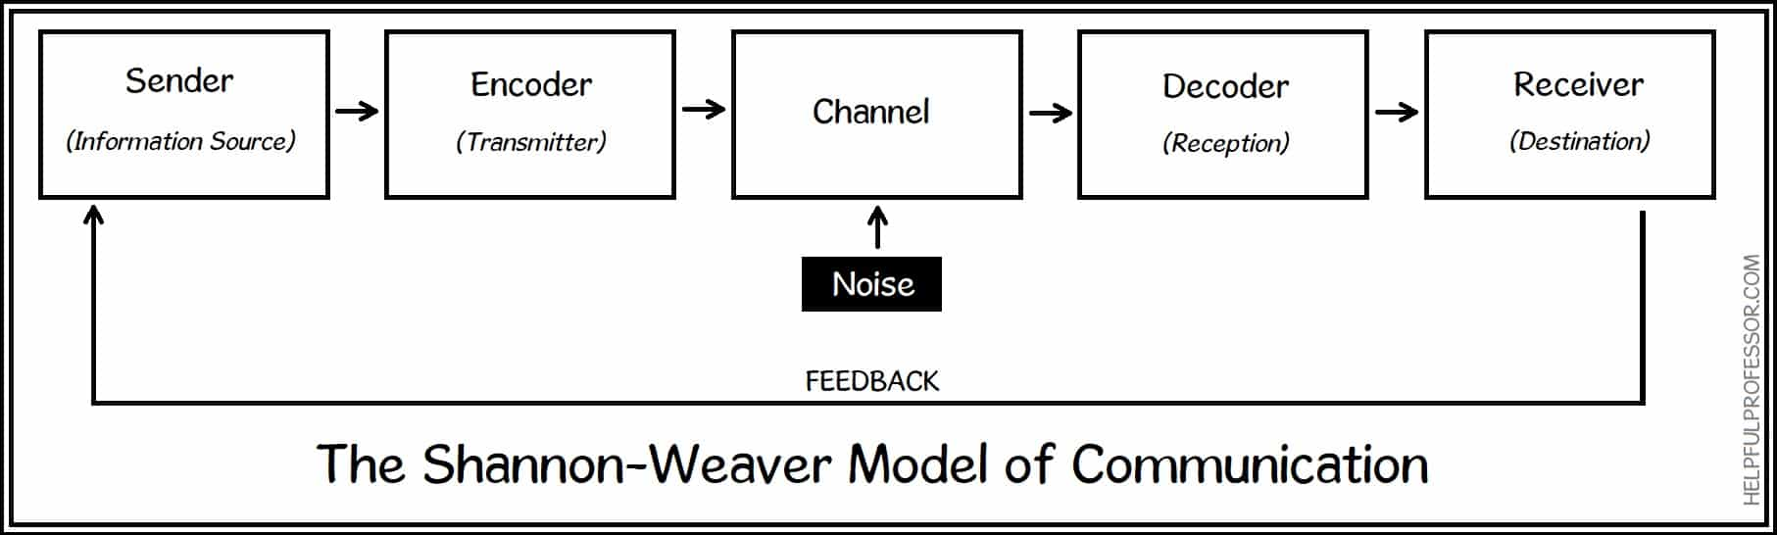
Sender-
- The information begins with the person of the source.
- The information source begins by selecting a signal to send, a message recipient, and dissemination channels.
- A person who, for example, delivers a nightly broadcast
Encoder-
- “The encoder is a device that turns a user’s thoughts into electrical signals that may be sent to a receiver.
- The Shannon model was created to explain why we need numeric values or radio waves to encode our voices on devices like phones and computers (Cer et al., 2018).
  - Example- An telephone and radio station
Channel
- The organization that transmits evidence on or after a source and spreader to an interpreter and receiver is known as the communication channel.
- The medium is a term used to describe this situation.
  - Example- Individual sending “email is using the world wide web as a medium”.
Noise
Noise interrupts a message whole is on the way from the sender to the receiver.
Two types are
- Internal-
- Sender makes mistakes encoding a message
- Example- Someone (Tesco employees )speaking in a heavy accent
- External-
- Something external impedes the message
- Example- Crackling of poorly turned radio (Lundrigan, Patwari and Kasera, 2019).
Decoder
- Decoding is the inverse of encoding. This idea was developed by Shannon and Weaver concerning language via technology like mobiles.
- The device that deciphers a communication into binary digits or a wave into a form that the recipient can understand is usually required in this approach.
  - Example- Cell receivers which turn “turn bits of data into readable messages”.
Receiver
- “In Shannon and Weaver-style of communication, the receiver is the last step”.
- This is where the receiver receives the communication, or what’s left after noise is factored in.
Feedback
- • When a message recipient responds to a sender to complete the feedback loop, they may do so to inform the sender that they have received messages or that the message was received plainly and clearly. (Bassi, Piantanida and Shitz, 2018).
- What amount of understanding do they have of the message?
Lasswell communication model.
In the retail industry like Tesco of they follow this communication model where it claims that
thinks that the term answer is a great way to characterize a communication act.
- Who
- Says what
- To Whom
- What channel and,
- With what effect?
The Communication Model of Lasswell
This paradigm focuses on the communication process and how it is used in daily life. According to Lasswell, communications serves three purposes:
- The term ecosystem monitoring refers to the fact that one’s surroundings are being monitored (Babaei, Ghavidel and RiahiNia, 2021).
- The interplay between social elements
- Culture is passed down via the generations. In a diverse culture with many customers.
The Lasswell model depicts the best flow of communication. There are many different methods to communicate. Furthermore, this communication model resembles that of Aristotle.
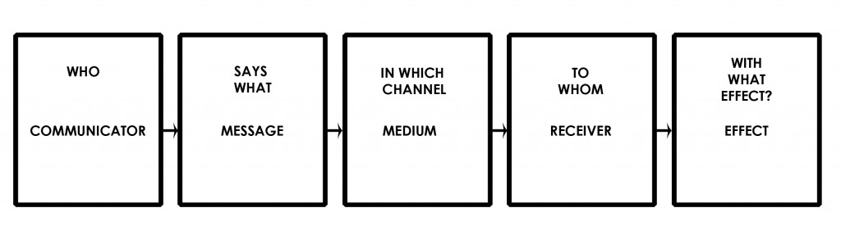
Types of barriers that can prevent effective communication between the organization and its external stakeholders.
There are essentially barriers to effective communication between Tesco and its external stakeholders. External stakeholders of Tesco involve customers, vendors, lenders, competitors, pressure groups, communities, and the government are just a few of the parties involved.
- A lack of excitement for one’s job is referred to as job discontent.
- Unless you are unhappy with your job or have lost interest in it, you are far less likely to communicate successfully - both receiving and transmitting.
- Inability to listen to what others are saying
- Effective communication necessitates active listening.
- If they do not listen to someone, they would not be able to communicate with them since it bases the assumptions about their inclusion on their preconceptions rather than facts (Auschra, 2018).
- Transparency and confidence are lacking among Tesco’s employees.
- When there is a lack of honesty and trust, it is incredibly difficult to express anything.
- Styles of Communication
- Everyone communicates in their unique way. Some people choose to be outspoken, while others prefer to stay quiet.
- Specific data is used by some, whereas generalizations are used by others, and so on.
- When a person’s communication style is strongly ingrained, connecting with those who communicate differently can be extremely challenging.
- Disagreements in the Tesco
  - Conflict arises for several causes, and it obstructs efficient communication when it does.
  - It is not necessary to comprehend the nature of the problem what counts is that you take steps to address it.
  - When an issue is solved, it resurfaces, and people begin to take sides, obstructing good dialogue.
- Language as a barrier in Tesco
- Others unfamiliar with our idioms, buzzwords, and jargon may find it difficult to comprehend us (Brannen, Mughan and Moore, 2020).
- Tesco is excluding workers when we use such jargon in our arguments.
- If Tesco wants to improve employees’ public speaking, they must consider it.
Channels of communication used by the organization and channels that can be used to improve communication
- Tesco communicates through channels of communication. is crucial to think about which channels they utilized for different jobs because selecting the wrong channel for work or contact might have disastrous implications.
- More strong communication channels that stimulate involvement and assure comprehension are required for complex interactions.
- The channel that Tesco mainly use is “E-mails, Phone, fax, memo, club cards, letter, notices, meeting, and report” to provide information to their customer, and workers for effective organization.
Some effective communications channels that Tesco might use are
Personal Communication and Face-to-Face Communication in Tesco
- One of the most important types of communication inside a Tesco is personal interaction.
- The presence of the physical speaker, speech quality, and facial motions all aid workers grasp what he or she is trying to express.
Broadcast Media for Communication at Tesco
- Television, radio, and loudspeakers are examples of broadcast media communication. You should employ a variety of media while speaking to a large group of people.
- A countrywide network might be used by a company to inform clients about a service or promote an employment climate. Further, Tesco’s broadcast channel would be television advertisements (Yujie, 2021).
Mobile Communication Channels
- An effective message should be used to mask or a more complicated campaign is to be sent out to just one individual or a small group.
- A mobile channel provides a variety of possibilities, as well as the extra benefit of allowing the recipient to comprehend the reciter’s tone.
- Some employees may opt to use another channel instead of an expressive channel while preparing for a face-to-face meeting to save time and effort (Yujie, 2021).
Channels of Electronic Communication
- Email, the Internet, business networks, and social media sites are all examples of electronic message channels.
- Individuals, small groups, and large organizations can all benefit from this path. It’s a less personal yet more effective way to communicate.
- If Tesco is going to use this channel, make sure to speak clearly and avoid irony and ambiguity unless the situation calls for it.
Improvement of channel for communication for Tesco
In the retail industry, internal communication is crucial.
- One of the most significant barriers to internal communication is connecting difficult-to-reach individuals.
- As the number of frontline and in-store staff in the retail industry has expanded, the barrier has become more visible.
- Because of the increasing number of gaps between origin and destination, messages in retail top-down and cross-channel communications may be easily misconstrued (Chen and Chiu, 2021).
- Data disappears is replaced, and then wiped out again until consumers receive a message that has no resemblance to the original. This offers excellent conditions for strewn-together phone-like conversation.
Create an effective communications plan for your business.
- Not having an internal communication plan is one of the worst mistakes any retail internal communications manager can make.
- Suppliers rely on area managers to provide corporate information to employees in Tesco stores all around the world.
Make eye contact with someone.
- Another method for avoiding the vacant phone problem is to create a new point of connection. Employees at large companies receive a variety of emails, warnings, and publications.
- Retail personnel, on the other hand, have limited access to smart devices, making it difficult for them to keep updated (Phillips, 2020).
- It is a good idea to choose someone to oversee information flow, which is generally the local director or manager.
Mobile Retail’s Demands
- Seventy percent of employees no longer work at a desk. To reach everyone, effective communication must be mobile, especially in the dispersed retail sector like Tesco.
- Employees at retail Tesco stores must remain in touch, and what better way to do so than through social media?
Conclusion
Hence, to conclude Communication’s importance cannot be emphasized. It is essential to share one’s thoughts and ideas to live a richer and happier life. If we converse more, people will suffer less and feel better about almost everything. It sums up that communication is the act of conveying information from one area to another. In most cases, communication is the most crucial path. It encompasses not just data transfer or notification, but also the receiver’s comprehension of the information or signal. This not only boosts customer satisfaction, retention, and loyalty, but it also provides a slew of other advantages, including increasing brand trust. Removes spammy email communications and cuts report time in half. Employees and management have shown a greater level of respect for one another. Furthermore, communicates with management and employees using email since it is a handy method of communication. Emails are useful for Tesco to engage with local or global branches because they are easier to send than letters and can carry more information. Significantly it sums up a deal with the benefits of effective communication, theories like “Shannon Weaver and Lasswell communication model”. The barrier of communications and its external stakeholder and channel of communication and its improvement are utilized by Tesco for their better outcome.

TASK 2

References
Auschra, C., 2018. Barriers to the integration of care in inter-organisational settings: a literature review. International journal of integrated care, 18(1).
Babaei, P., Ghavidel, S. and RiahiNia, N., 2021. Content Analysis of Infographics with the Theme of Reading Based on the Lasswell's Communication Model. Research on Information Science and Public Libraries, 26(4), pp.629-664.
Bassi, G., Piantanida, P. and Shitz, S.S., 2018. The wiretap channel with generalized feedback: Secure communication and key generation. IEEE Transactions on Information Theory, 65(4), pp.2213-2233.
Brannen, M.Y., Mughan, T. and Moore, F., 2020. THE CREATIVE USE OF INSIDER ETHNOGRAPHY AS A MEANS FOR ORGANIZATIONAL SELF INVESTIGATION. The Routledge Companion to Anthropology and Business, p.27.
Cer, D., Yang, Y., Kong, S.Y., Hua, N., Limtiaco, N., John, R.S., Constant, N., Guajardo-Cespedes, M., Yuan, S., Tar, C. and Sung, Y.H., 2018. Universal sentence encoder. arXiv preprint arXiv:1803.11175.
Chen, C.Y. and Chiu, M.C., 2021. Parameter estimation of impulsive noise for channel coded communication systems. IET Communications, 15(3), pp.445-452.
Deacon, C., Fox, B.R., Morland, L., Samways, M.J., Weaver, S., Massey, R. and Hill, M.J., 2021. Patterns in macroinvertebrate taxonomic richness and community assembly among urban wetlands in Cape Town, South Africa: Implications for wetland management. Urban Ecosystems, 24(5), pp.1061-1072.
Kalogiannidis, S., 2020. Impact of effective business communication on employee performance. European Journal of Business and Management Research, 5(6).
Lundrigan, P., Patwari, N. and Kasera, S.K., 2019, October. On-off noise power communication. In The 25th Annual International Conference on Mobile Computing and Networking (pp. 1-14).
Nisar, T.M., Prabhakar, G. and Strakova, L., 2019. Social media information benefits, knowledge management and smart organizations. Journal of Business Research, 94, pp.264-272.
Phillips, S., 2020. Working through the pandemic: Accelerating the transition to remote working. Business Information Review, 37(3), pp.129-134.
Stacho, Z., Stachová, K., Papula, J., Papulová, Z. and Kohnová, L., 2019. Effective communication in organisations increases their competitiveness. Polish Journal of Management Studies, 19.
Sutiyatno, S., 2018. The effect of teacher's verbal communication and non-verbal communication on students' English achievement. Journal of Language Teaching and Research, 9(2), pp.430-437.
Tesco. 2022. [online] Available at: <https://www.tesco.com/> [Accessed 15 June 2022].
Yujie, Z., 2021. Live stream Shopping from the Perspective of Media Convergence. Journal of Frontiers in Art Research, 1, pp.56-60.

