In this dissertation, I will be exploring the question “What is the impact of society on the notion of the ideal body?” I choose the question as I felt that the idealisation of certain body types has grown and become increasingly relevant in today’s society. The need to fit the ideal body is so ingrained within our society that it affects children as young as nine (Gill and Radowitz, 2017).
Through magazines, advertisements, films and literature, we praise the ideal body type and “we are now so accustomed to being addressed by these images that we scarcely notice their total impact” (Berger, 1972), we see these images daily and begin to normalise the bullying and the manipulation behind the headlines and articles. Our attractiveness has “…become much more important than its ever been in the past,” (The Institute of Art and Ideas, n.d.). Attractive people have always an advantage, more so now than ever thanks to the digital age of social media, photographs and the media. It matters how we look and how we appear as individuals – however, attractiveness is based on the ideal body. The ideal body is created by society and specifically through the male gaze. It is also influenced by stereotypes of gender, which I will explore with Judith Butler’s Gender Trouble (Butler, 1999) in mind.
In chapter one, I will explore what the ideal body is, with references to music videos and plastic surgery, looking at the ‘ideal body’ type that is celebrated and the most popular with the western world at the moment.
In chapter two, I will look at the Laura Mulvey’s male gaze theory as I feel that it is still very relevant in today’s society, and analysing photographs and artists with the theory in mind.
Finally, in chapter three, with reference to Michel Foucalt’s idea of surveillance (Foucault and Sheridan, 2012), I will consider the media, particularly advertising campaigns, and explore how the media influences our society, consciously and unconsciously.

Chapter 1 – Ideal Body
I have chosen to explore the ideal body as I feel that it is an important factor in today’s society and it is something that affects our lives daily, particularly with younger people. ORLAN states that “Beauty is the product of the dominant ideology. (Thus when ideology changes, the ideal body follows.)” (Schnackenberg, 2016) although the ideal body has changed over the years, it has always been influenced by how it would appeal to others, and “not a site of individual self-determination” (Bordo, 2003). In today’s society, ideal body is smaller and slimmer, “our bodily ideals have become firmer and more contained,” (Bordo, 2003) with men’s bodies becoming more muscular and women’s more toned.
According to Adam Smith, “society is an artificial device created to foster a mutual economy” that society is a fake concept, however many other sociologists, including Robert M MacIver, disagree as it isn’t based on facts, historical or otherwise (Sharma and Sharma, 1997:210-211). Whereas Peter L. Berger states that society is “nothing but a human product” (Berger, 2011:3) although it was constructed by humans, it continues to influence us and rule us. Richard Outhwaite believes that the idea of society is still significant as it “still resonates with people’s perception of social reality.” (Thompson, 2017) people are still bound by the rules and the idea of society.
Therefore, my interpretation of the word “society” consists of a group of people, in this case the western world, who follow the same law, the same social standards and the behavioural characteristics.
The concept of something being ‘ideal’ is very abstract “Existing only in the imagination; desirable or perfect but not likely to become reality,” or “A person or thing regarded as perfect” (Oxford Dictionary of English). The definition shows how the ‘ideal’ is impossible to achieve as it doesn’t exist, it is an artificial concept and the standards are different in every individual. Therefore
idea of the ideal body is impermanent and the standard changes in different continents and places.

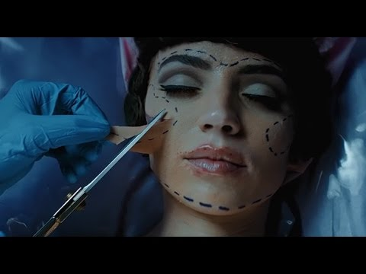
Figure 1 (Martinez, 2016)
Figure 1 is taken from a music video written and directed by Melanie Martinez (2016) seemingly set in the 1950s where body image and misogyny were present. The ideal body is relevant within this music video as it explores plastic surgery and the ramifications of it. The title of the music song and music video is “Mrs Potato Head,” clearly referencing the toy which fits in with the childlike themes of her album and music videos.
The music video starts with close up of a doll with blond hair and blue eyes having her hair brushed. The girl brushing the dolls hair is Martinez, the singer and the director of the video, who is depicted as a younger girl (Martinez, 2016). As she’s brushing the dolls hair, she sits in front of a television that’s playing adverts, advertising weight loss pills and blond wigs; whilst the ad is playing for the diet pills, she eats a cookie and hesitates to have another bite, looking down at herself and back at the model, clearly comparing herself to the model associety “has taught women to be insecure bodies, constantly monitoring themselves for signs of imperfection,”(Bordo, 2003) with music videos and advertisements fuelling these ideals.
What’s depicted so far is very relatable and realistic – it is something that most girls go through at some point. The fact that it’s so relatable is problematic as the issue is affecting young girls and women around the world. It’s clear to see that this is an ominous scene for the lyrics “When little girls grow into their mother's face, But little girls are learning how to cut and paste” (Martinez, n.d.), that from their mothers, and from society, women are taught from a young age that their natural appearance isn’t good enough.
When the music begins to play, the camera pans in on the tv as a film begins on the television. The film begins with a woman knocking on a door with long dark hair, meeting her partner or husband, clearly excited to see him. He leads her up to a bedroom and gives her a gift. As the camera zooms in on the piece of paper he has given her, we realise that is an appointment for a facelift.
The man then begins tugging and moulding her face with his hands, showing the surgeon what he would like done to her face, while she sits there, passive. As the surgeon begins drawing marks on her face, the man still has a grasp on her chin, a controlling gesture. John Berger states that the “ideal nude ought to be constructed by taking the face of one body, the breasts of another, the legs of a third… and so on. The result would glorify Man.” (John Berger, 1972:62) which is something that’s happening on a daily basis, with women changing their appearances and bodies in order to fit the “ideal” body, which is continuously changing. The ideal body is impossible to gain naturally, however with the help of plastic surgery and body modification it’s becoming more achievable. The surgeon is literally catering to the male gaze, in particular her partner’s gaze.
In one of the crucial scenes (Figure 1) a manwearing scrubs and a rabbit mask is her surgeon. The fact that the nurses and surgeons are wearing masks adds a playful feel to the otherwise serious and perhaps hard-hitting video. The woman is lying on the operating table, unconscious and passive. The rabbit hybrid begins injecting her lips and tearing the skin from her face. He cuts the tops of her breasts open and stuffs them with scrunched up paper, reminiscent of one of the first scenes with Martinez. Women who “consider any health risk worth the resulting boon to their self-esteem” (Bordo, 2003: 20) are clearly at risk, not just with their physical health, but also their mental health. The number of surgeries is rising, demonstrating how strong the desire to be “perfect” is becoming, fuelled by the media, but mostly from society’s standards and “of potential lovers and employers” (Bordo, 2003: 20).
In another scene, the husband unwraps the bandages, finally revealing her face as she smiles hopefully at him. She’s clearly agreed to the surgery as she thinks it’s going to please him. As he’s unwinding the bandage we can see his face fall with disappointment, upset that her appearance doesn’t fit the ideal image he had in his head.
The ‘film’ ends with her looking at the mirror and then out of a window at her partner talking to another woman, the implication of the video being that altering your body and looks for another person to suit their beauty standards will only end in unhappiness. The chorus “Don't be dramatic, it's only some plastic, No one will love you if you're unattractive,” ” (Martinez, n.d.), links to the idea of the male gaze and how we judge someone based on their appearance. The camera pans out and we see Martinez again, sitting with her legs crossed and a little shocked and upset as she throws the blond wig down and takes the tissues out of her bra, the little girl realising that changing herself to fit society’s standards or to fit the ideal body does not guarantee happiness or love.
Body modification has definitely become more accepted in the western society, especially plastic surgery and Botox. While body modification is mostly used to enhance or dramatically change features, there are some people who use body modification in the form tattoos and piercings, which don’t always appeal to the modern beauty standard.


Figure 2 (Chasseur Interviews tattoo artist Grace Neutral, n.d.)
Above is a portrait of Grace Neutral (Figure 2), a tattoo artist and model who began gaining popularity through social media. Her appearance is startling for those who aren’t familiar with heavily modified people, especially a woman who is meant to be delicate and pure. The black background contrasts with her pale skin which highlights her black tattoos. The top of her chest and collar bones are exposed, giving a delicate feel to the photo despite the tattoos. Although Neutral is the focus of the photo, her tattoos are what our eyes are drawn to.
On her chest is a large illustration of Snow White holding an apple; the tattoo covers the entirety of her chest and upper torso. Some might say that the fact that the ink completely covers her breasts almost desexualises them as they’re disguised, distracting us from the shape of her body and drawing our eyes to look at the lines of her tattoos instead, rather than the curves of her body. Her legs, arms and stomach are also tattooed, however the most unusual tattoo is the whites of her eyes. The fact that the whites of her eyes have been permanently turned purple isn’t something that our western society sees everyday; it isn’t something that’s necessarily appealing or attractive however it does go against modern beauty standards.
Her hand is under her chin, with her gaze directed towards the right; although she isn’t confronting the camera, she isn’t completely passive. Her pose is strong and thoughtful. The expression on her face is one of determination or defiance, in contrast for Kylie Jenner in figure 5.
From Figure 2, it is immediately clear that Neutral likes body modification; her tattoos are clearly visible, so are the gauges in her nose and her split tongue. Neutral has also explored scarification, which is something that isn’t sought after or believed to be attracted, however the procedure is gaining popularity. Ref grotesque or to orlan quote
In one episode of ‘Pins and Needles’ Neutral travels to Japan to explore the “extreme beauty” (Grace Neutral Explores Korea's Illegal Beauty Scene, 2016) there. While at a shop in Korea, an elderly man looks her up and down with an expression of disgust. He states “She’s got a pretty face and a nice body but because of the tattoos, she’s ruined,” (Grace Neutral Explores Korea's Illegal Beauty Scene, 2016) While the statement is understandable considering how controversial tattoos are in Korea at the moment, it is also an example of the male gaze. It is possible he wasn’t talking about her in a sexual context, the fact that he even mentioned her “pretty face” and a “nice body” demonstrates how normal our views on the ideal body have become and how accepted it is to judge a woman is if she’s an object. The fact that he believes that “she’s ruined” because she doesn’t appeal to the male gaze or Korea’s beauty standards anymore, suggests that an unscarred body is more attractive to our society.
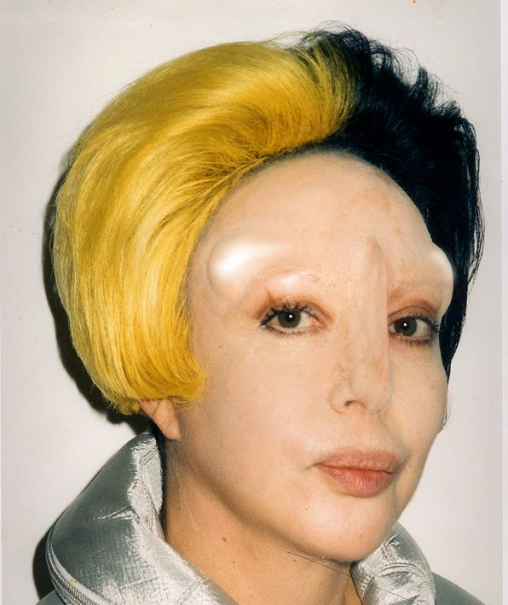
Figure 3 (ORLAN, n.d.)
Another example of women going against the ideal body is ORLAN, a well known artist who has explored surgery and body modification, going against the ideal body and the male gaze. While Neutral explores a similar theme, modifying her body into something that’s more otherworldly rather than human, its unclear whether Neutral has intentionally made herself unattractive to go against the beauty standards. ORLAN is an artist that has purposely made herself ugly, at least according to today’s beauty standards (Ince, 2000).
In figure 3, a woman has had her portrait taken. Its immediately clear that she has had some body modification and surgeries. Some aspects of her look has inspired various artists and celebrities including Lady Gaga, and Martinez (Figure 1), both have been inspired by her hair and copied the shocking contrast of black and blond. The style has also become popular in various subcultures, past and present.
As her body modifications aren’t as noticeable as Neutral’s (figure 2), they are more subtle and more natural looking which gives more of an impact as we begin to dissect the image. OLRLAN has horns implanted underneath her skin, created by cheek implants (Ince, 2000). Some might draw comparisons to the special effects make up used in sci-fi programmes and films such as star trek, especially the shape of her nose and the protrusions on her forehead, which were designed to look like the protruding brow of Leonardo's "Mona Lisa," Frank, 2013).
The second thing we notice is the slope of her nose – she has clearly had a nose job, which again, isn’t that shocking in today’s society, however the way she has chosen to shape her nose is surprising. The fact that it’s so straight and protrudes from her forehead is eyecatching - this is something one would have surgery to get rid of rather than to achieve it. In comparison to the Kardashians (figure 5), who are leading plastic surgery icons in today’s pop culture, ORLAN has had surgery in order “disrupt the standards of beauty.” (Frank, 2013), and has used surgery as a tool to change her looks, not to appear younger or better.
It implies that society is only accepting of body modification is only acceptable when a person is trying to look better, to fit society’s idea of an ideal beauty. Modifications such as Neutral’s (figure 2) and ORLAN’s (figure 3) surgeries are still shocking to us, however they are just as brutal on the body as any other plastic surgery. The ideal body is fuelled by the male gaze, designed to appear attractive to men and women through the male’s point of view and ORLAN has clearly dismissed the notion, instead, choosing to have an unconventional appearance.

Chapter 2 - Male Gaze
Within this chapter, I will explore photographers and artists, drawing heavily on Laura Mulvey’s Visual Pleasure and Narrative Cinema,” with reference to the male gaze. I will compare and contrast the images in order to see if the theory is still relevant today and how it relates to the ideal body.
The male gaze is a theory realised by Laura Mulvey, based on cinema and the visual arts. The theory is based on how society depicts films through the male point of view, and places women in a passive, sexualised role. Women are seen as objects, “in a world ordered by sexual imbalance,” (Mulvey, 1989:836) they are there to be looked at for the male’s viewing pleasure.
The female figure “is styled accordingly” in order to appeal to the presumed, heterosexual male’s “phantasy,”(Mulvey, 1989:836) and I will explore a few examples of this is below.
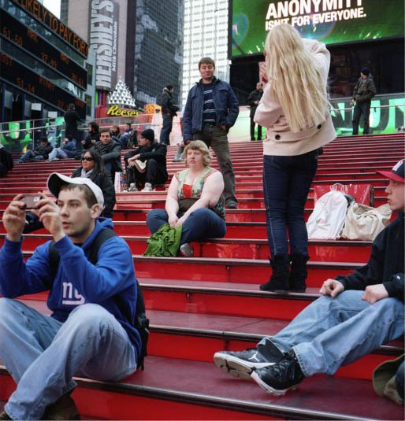
Figure 4 (Morris-Cafiero, Anonymity Isn't for Everyone, 2010)
In the photo above by Morris-Cafiero, an overweight woman is casually sitting on the steps whilst a picture is being taken. In the top right hand corner, on a shop front window is the statement “Anonymity isn’t for everyone” which is where the title has been taken from. Our viewpoint suggests this picture will contain a woman. Behind the seated woman is a man, which is the focus of the photograph being taken. He is pulling a face, apparently in mockery of the overweigh woman. Berger states, “Men survey women before treating them,” (John Berger, 1972:47) and figure 4 is an accurate example of this. What she captured were other tourists, but also quite literally the male gaze.
After seeing the photo, the artist decided to purposely capture people gazing at her in various situations, including going clothes shopping, walking and being a tourist, all of which her camera captured people glancing at her, presumably for her weight. The series illustrates how society judges people and how the media manipulates and contributes to what we think is desirable, or even what we’re told to find desirable, contributes to our views and desires.
The collection of photos is entitled "Wait Watchers" clearly a play on words, referencing the dieting programme called ‘Weight Watchers’ (Weightwatchers.com, 2017) The "wait" implies that it’s something inevitable and is bound to happen, and that being judged and looked at is to be expected. The noun “watchers” links to the idea of the male gaze and how we are constantly surveyed.
According to a Morris-Cafiero, it "wasn't just a quick little glance," (The Cut, 2017) demonstrating the power he felt as a male, criticising an innocent woman on whether or not he was attracted to her based on today’s beauty standards.“Most people now obey the rules because they know they are being watched (and) regulate their own behaviour for fear of becoming the wrong kind of person,” (Thompson, 2017) The fact that he knew he was being photographed shows that he had no embarrassment or shame about how blatantly objectifying he was being.
After looking at the series, one would expect to feel saddened and angered, however it could also be a positive thing as she’s exposing the male gaze and through that empowering herself. She has willingly put herself in that position and captured the male gaze unaware.
Many of the comments were discriminative and harmful, one in particular said "if she would clean up, wear attractive feminine clothing, wash and style her hair, and smile at people, she would find a whole different world opening up to her." (The Cut, 2017), which illustrates the ideal body type and standard that women are subjected to on a daily basis. “Men look at women. Women watch themselves being looked at.” (John Berger, 1972:51) therefore society judges women based on the male gaze, and what is traditionally attractive and according to the commenter above, in order to be accepted, she should smile more to appear more “feminine.” Simone de Beauvoir wrote that “Misogynists have often reproached intellectual women for “letting themselves go”; but they preach to them: if you want to be our equals, stop wearing makeup and polishing your nails (Beauvoir, Borde, Malovany-Chevallier, 2011:815) demonstrating the contradicting messages that women are fed every day.

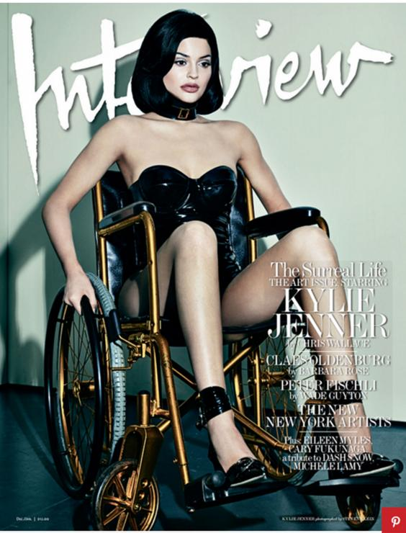
Figure 5 (The Surreal Life, 2015)

The image above is from a photo shoot that Kylie Jenner did for the magazine, Interview. This particular photo (The Surreal Life, 2015) from the collection is particularly controversial. Kylie is sat on a gold wheelchair, stiff and doll like, pale against the contrast of her synthetic hair and PVC outfit. Her clothes are tight and form fitting, and the fact that it seems to be made out of latex implies that she’s fetishising, sexualising herself and the wheelchair. Every blemish and pore is blurred and photo shopped, furthering the idea that she’s mimicking a doll, dehumanising her. The doll-like nature of the shoot reinforces the idea that people with disabilities are powerless clearly exploiting them and their disabilities in the name of fashion.
A doll is lifeless, an object to be manipulated and played with, in this instance by the male that is carrying her paralysed body around, a literal object“ To be on display is to have the surface of one’s own skin, the hairs of one’s own body, turned into a disguise, which in that situation, can never be discarded,” Berger, 1972:54. Being so passive and pliant leaves her vulnerable to the male gaze. She’s pretending to be a doll, something that is plastic, linking with the idea of plastic surgery and trying to achieve the ideal body, something that is completely unachievable and Jenner is definitely one of the contributors to this.
The fact that the wheelchair is gold hints towards her wealth and privilege, and her being an ablesit. The cut of the neckline draws attention to her cleavage and the chocker adds to the suggestion that the outfit is BDSM(Urban Dictionary, 2003) related. Her hands are gripping the wheel, with her arms stiff, suggesting that she doesn’t have any mobility whatsoever, appearing very doll-like. Her expression is vacant, looking away from the camera, with “Her body is arranged in the way that it is, to display it to the man looking at the picture. This picture is made to appeal to his sexuality. It has nothing to do with her sexuality.” (Berger, 1972 :55) which leaves her objectified and vulnerable to the male gaze. Her pose isn’t necessarily provocative, or sexual but her clothing and shoes suggest otherwise.
Jenner is being objectified, not justinthe sexual sense but as an actual doll, perhaps even a sex doll. Betik says "she is literally being objectified made to look like a sex doll, and this wheelchair is an added element of passivity they’re adding on" (The Mighty, 2015) and I completely agree with the statement. While the magazine stated that "placing Kylie in a variety of positions of power and control and exploring her image as an object of vast media scrutiny" however the ideaof her being in "positions of power and control" (The Mighty, 2015) is completely eradicated with this photo shoot as it does the complete opposite.
Her demeanour ispassive, not only in the chair but also her body language and facial expressions, illustrating the fact that she is not in a position of power; her “sexual passion needs to be minimized so that the spectator may feel that he has the monopoly of such passion,” (Berger, 1972:55)the presumed viewer is male, and traditionally men are meant to be strong and capable of having sexual control over a woman and in order to do this, they need to see Jenner helpless. She is there for people to gaze at her.
Another example of the male gaze within photographs is within media. Media is a big part of how we see our bodies, shaping our idea of the ideal body. There are often interviews and magazine articles criticising celebrities for being too fat, too skinny, or not muscular enough. It’s their job to get our attention and to fabricate imperfections, causing body insecurities. The insecurities create a need to fix them, which is where advertisements come in and offer us alternatives.

Chapter 3 – Media and Advertising
Finally, I will begin looking at media and advertising, analysing the images we see daily and how it influences our views on the body. I will make reference to the ideal body and the male gaze with reference to Beauvoir’s The Second Sex. The images below are every day examples of how media and advertising influence our ways of thinking and perceiving, most of the time without us realising it.
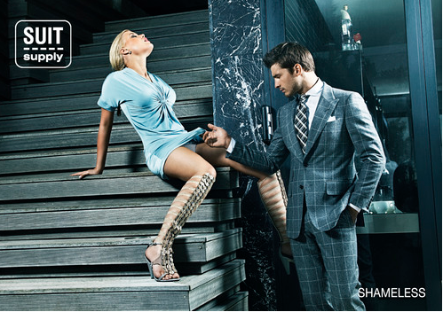
Figure 6 (Suit Supply: Shameless, 2010)

Both the male gaze and the idea of ideal beauty is very palpable in figure 6, so much so that the advert was eventually banned when it was released to the public. This particular advertising campaign was entitled “Shameless” for the company ‘Suit Supply’ (Shameless, 2010). The name of the campaign is ironic, as the advert is shameless in its blatant sexualisation of women.

The ad features a man and a woman in a bathroom with the man clearly in a position of power. His hand in his suit pocket suggests casual and nonchalant, clearly confident and dominant. A woman is sat on the stairs with her legs spread wide with her crotch almost eyelevel with the male model, which is clearly meant to be the centre of attention. In contrast to the male, she is wearing a short dress which is a lot more casual that the formal suit. The dress is a light blue which is a contrast to the darker shades of gray and dominant blue in the rest of the photograph. She is leaning on her hands with her head thrown back, as if she’s presenting herself to him as an object “to-be-looked-at,” Paasonen, Nikunen and Saarenmaa, 2007) completely at his command.

The male model casually lifts up her skirt without any visible emotion or effort which suggests his aloofness. While the woman’s face is turned away, the male’s expression seems very blasé considering that he has a woman offering herself to him. The fact that he’s so blasé demonstrates his arrogance, and could imply that he almost expects her to submit, “woman has always been man’s dependant, if not his slave” (Beauvoir, Borde and Malovany-Chevallier, 2011). The shadows highlight the line of his jaw, hinting towards dominance and power, whereas the main light source is focused on the woman, drawing our gaze. Everything else is in shadow, including the suit. Although the ad is meant to be selling suits, there is nothing about the image that says this. Its obvious that the photo is meant to appeal to the male gaze (Mulvey,1989) and purposely so, the blatant sexualisation of the scene, and of the woman, is clearly meant to please the viewer.
The colours used in the photograph are aesthetically pleasing, and are usually colours that we would associate with men’s products although it doesn’t make sense form a marketing standpoint as the suit blends into the background while the woman’s skin and dress stand out. Suits usually represent someone in power, suggesting that he’s wealthy and of higher class. The dominance that the male displays adds to the stereotype of a “man’s man”, of someone who is traditionally masculine. The subordinate woman fits the traditional idea of a woman, someone who is delicate and submissive. The colour blue is traditionally associated with men from birth and is seen as a masculine colour (Palmer and Schloss, 2010).

The photo above is one in a collection, many of which are targeted towards the male gaze with women placed in various positions. The company is using a woman to draw their viewers and potential customers’ attention. They are objectifying the woman, using her to sell suits. She is the focus of the ad, which shows that the ad is targeted toward men and seen through the male gaze. It tells the consumers that if they were to buy this suit, that there is an opportunity to become the male in the photo, “It offers him an improved alternative to what he is” (John Berger, 1972:142) of someone in control, powerful and shameless with an obedient woman there to control. This advertises something that’s glamorous and so desirable that it creates a sense of loss or jealousy if you don’t have it. It also creates an insecurity by idealising traditional gender roles; with the man being very masculine and in control, while the woman is subordinate (Butler, 1999). Another example of traditional gender roles is Robin Thicke’s music video for Blurred Lines (figure 7).
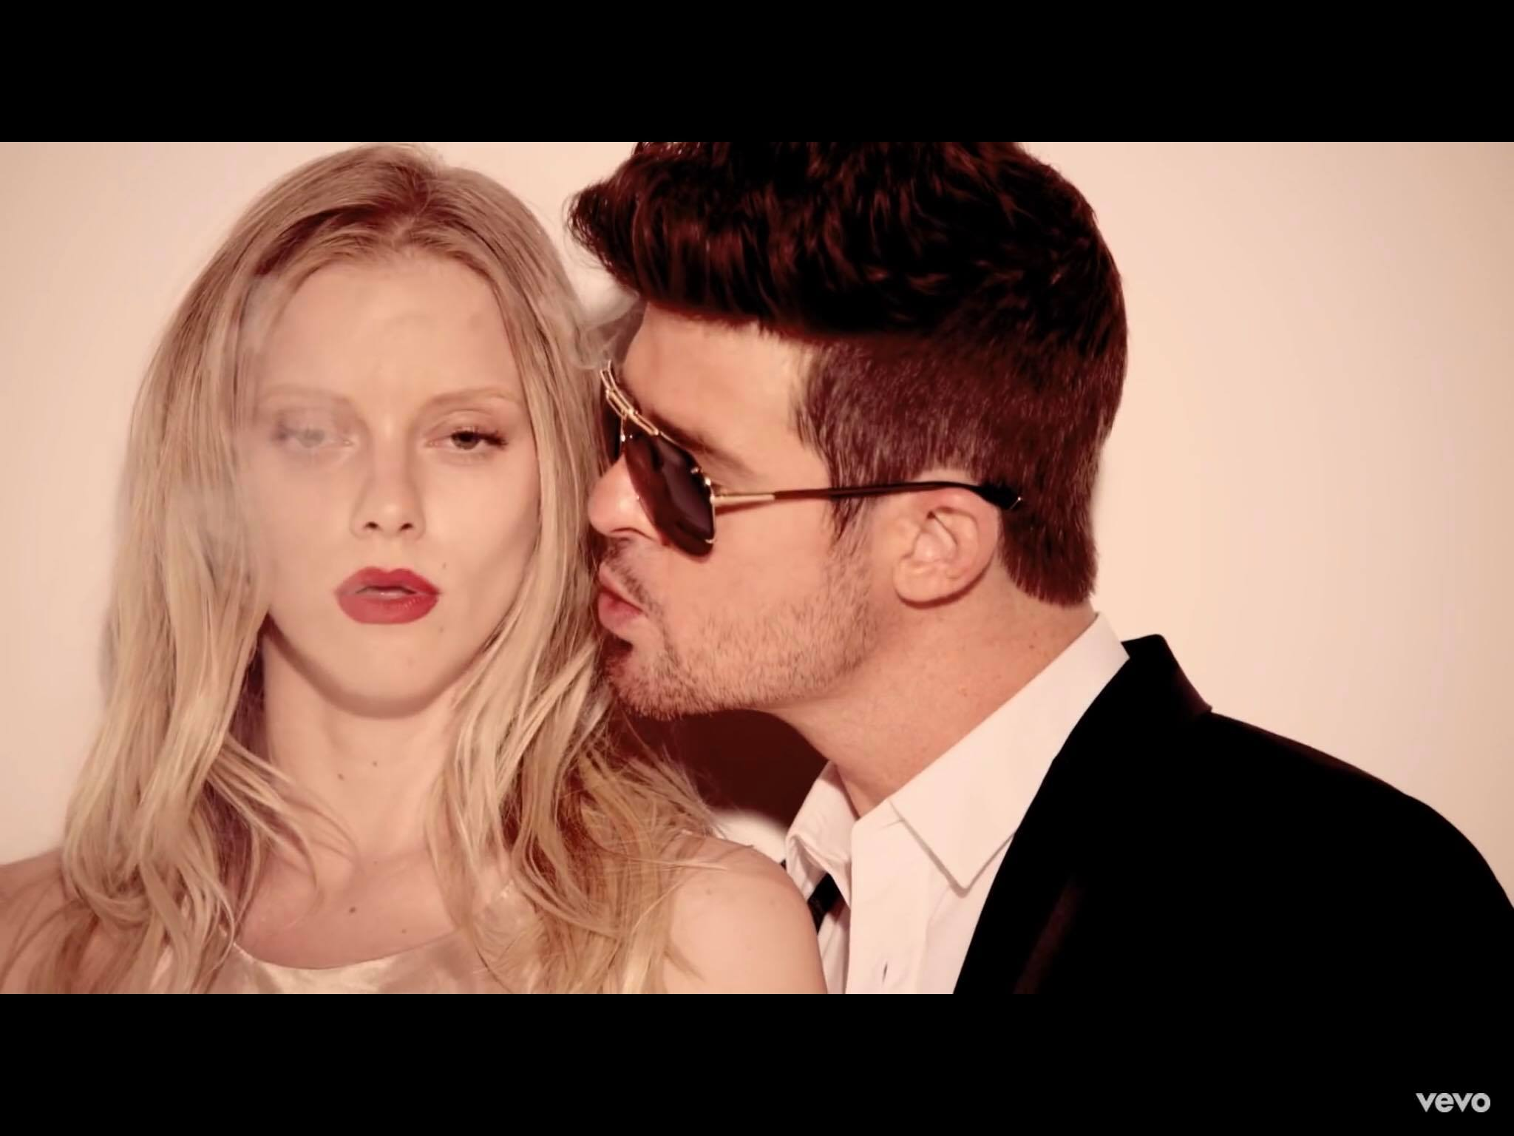
Figure 7 - (Thicke, 2013)

The phrase ‘blurred lines’ (Thicke, 2013) suggests that the boundaries aren’t defined or clear, in this case meaning that Thicke isn’t sure where the boundaries are in relation to a relationship or sex. Although Robin Thicke seems to be taking most of the blame when it comes to the media, Pharell Williams claimed to have written the song and the lyrics (Gigwise.com, 2014), however both share the blame.

On the face of things, this song or music video isn’t the worst song out there in terms of misogynistic or suggestive lyrics and rape undertones that “are constant in other parts of the music industry,” (Project Censored, 2015). There are many songs from different genre including pop-punk and rap music that are demeaning to women.

This particular video is just one example of songs and videos that we see every day, although this one has gained notoriety for its controversial lyrics leading it to be banned at various events and universities (the Guardian, 2017). However banning just one song isn’t going to change the music industry. If the video hadn’t been so objectifying the song itself wouldn’t of caused as much trouble however the video enhances the lyrics. From the start, the male gaze is very obvious even to someone who isn’t necessarily aware of the theory of the male gaze or misogyny. There are two versions of the video, one more explicit than the other, however in both videos the objectification of women is apparent. The video features fully dressed men, most of them in suits, blatantly admiring the naked girls that are traipsing around.

The men are completely dressed, formally in suits whereas the women are dressed in a skin coloured thong. The fact that the thong is skin coloured probably adds to the idea of them being even more naked, sexualising them further. The contrast in clothing shows that the men are in a position of power as the women are naked and therefore vulnerable.

In another scene, one of the models is naked, seemingly lying down on the floor. The camera begins on her face, with her expression being one of confusion, her red lipstick catching the viewers attention. Although the women are practically naked, they are wearing makeup which consists of bright red lipstick, clearly designed to appeal to the male gaze as “red makes men feel more amorous toward women,” (Rochester.edu, 2008). The colour red usually suggests lust and passion, and immediately draws the eye. The camera pans down and we see her bottom, where there is a tiny red stop sign – which immediately suggests that she’s confused about why she should say stop or why there is a stop sign there. This suggests rape or at least something without consent as the stop sign clearly means stop – and yet its been made tiny, something that’s insignificant and placed on her behind with the placement clearly intentional, “Sexual violence and rape are thus normalized as a constant in society,” (Project Censored, 2015).

Although again, it is only a music video and clearly the intention was to make a unique and amusing video. Due to society’s acceptance of everyday misogyny and sexism (Twitter.com, 2012), we don’t immediately see the problems. However you don’t have to look too deep into this particular video in order to see the problems, without having to be aware of the male gaze theory. There are some silly scenes within the video however the obvious sexualisation of the women overwhelms the supposed light hearted video.
Throughout the video naked women dance while the men clearly ogle and then blatantly adjust their crotch. The women are literally there to please the male sexual appetite, which it clearly does. The blatant objectification of the women definitely contributes to the ideal body type as all of the women have the same body type and facial features with wide eyes, red lips and tiny waists. Over the course of the video, the models look directly at the camera which would usually suggest that they are aware of the male gaze, as they aren’t passive and avoiding the gaze – but they don’t really confront the male gaze or in a more modern sense, any gaze. Their expressions aren’t confrontational or empowering, they are one of seduction, appealing to the male gaze and fuelling society’s preconceived ideas of the subordinate female.

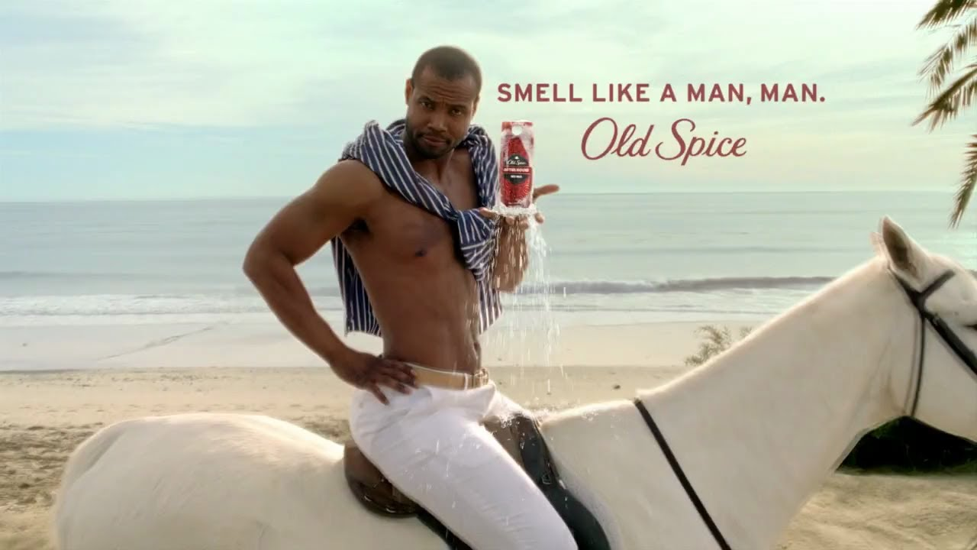
Figure 8 (HD Old Spice Commercial Compilation, 2013)
The ad (HD Old Spice Commercial Compilation, 2013) begins with the model directly addressing the viewer, which, unlike other adverts, is presumed to be both female and male. He addresses the viewer, “Hello ladies,” standing in the shower with a towel that it wrapped around his waist. Similarly to the women in the images above and many adverts we see today, he fits our western society’s ideal male body. While women are certainly under pressure from society to conform to a specific body type, men are too, however it isn’t often discussed or analysed. Perhaps it’s because the affects of men being objectified and judged has a lesser effect than it does on women as “A man's appearance doesn't define him nearly as much as a woman's appearance defines her” when women are looked at, they are seen as an object, and judged on their appearance on where they stand in society (LaFata, 2015).
The man above is our society’s image of the ideal male body; someone with a six pack, confident and masculine. He clearly exudes confidence and some might say dominance. He fits the stereotype (Dictionary.cambridge.org) of an “alpha male” or a “man’s man” as the texts suggests. In the first scene, besides being in the shower, there is nothing else for us to look at, keeping our focus on him. He is holding the product throughout the video, which is bright red, keeping our attention on the object. In contrast to many ads, the product that he’s attempting to sell us is always in our line of sight which keeps our gaze on the product rather than on him and his body, stopping us from completely objectifying him as one would with a female model.
His torso is exposed, sexualising and objectifying himself, however unlike Kylie’s photo shoot in figure 5, he isn’t objectified in the same way. He is facing the camera, engaging with the audience; he is an active participant, quite literally, whereas Kylie very passive. He’s completely aware of how he’s portrayed and in control of what’s happening and of himself.
The sentence, “if he stopped using lady scented body wash” is immediately problematic for a variety of reasons, however he masks it with humour. It implies that a more feminine scent isn’t ideal, that it doesn’t make the male as desirable as Old Spice, a masculine scent would. It uses the social construct of femininity and masculinity playing into the stereotypical gender roles, encouraged by the patriarchy and society. While on the surface it’s a harmless, passing comment on masculinity, perhaps even poking fun at it, however it reinforces it. The phrase suggests that if the man starts using Old Spice, he would improve himself and be closer to becoming the model and having the power to lure women and fitting the ideal body type.
In the last scene of the ad, he is riding a white horse as he moves along the beach, clearly playing on the idea of a knight in shining armour. The subtle hint to fairy tales comes along with connotations of women being a ‘damsel in distress’and that “the male will be the “effective and active” element and that the female must be the one to passively wait for him,” (Bordo, 2003:13) to rescue her from her ‘feminine’ scented man.

The text on figure 8 is easy to read and the bright red font is the only other colour in the ad besides the product, highlighting the product placement. The text “smell like a man, man” creates an insecurity with those who don’t identify as a “man’s man,” and only reinforces the gender norms.
On the other hand, the cheesy scenes and the absurdity of the video could be poking fun at how society sees stereotypes, specifically how we see men and masculinity. Some might say that it highlights the sexualisation that we see in the media on daily basis, turning the common scenario on it’s head. However, it is doing more harm than good as it unconsciously fuels ideal body types. It could also give men a justification on objectifying women and to continue creating adverts, photo shoots and media campaigns with the male gaze being the goal rather than seeing women as equal.
Although ads that objectify men are rare, there has been an increase in brands (Coca-cola, 2013) who have released advertisement campaigns with the men being sexualised and objectified. Predictably, since seeing these campaigns, men have complained that there is a double standard as they are being sexualised and if it were the other way around there would be an uproar. While on the surface of things, the question “how if it's not okay to objectify women, it shouldn't be okay to objectify men either” (LaFata, 2015) is valid. However, men have been objectifying women for centuries, and haven’t seen an issue with it, until they become the surveyed rather than the surveyor, and begin to see the problem.

Bibliography
Armstrong, T. (1991). Colour perception. Diss, Norfolk, Eng.: Tarquin Publications.
Barker, C. (2004). The Sage dictionary of cultural studies. 1st ed. London: Sage Publications, pp.
Beauvoir, S., Borde, C. and Malovany-Chevallier, S. (2011). The second sex. New York: Vintage.
Berger, J. (1972). Ways of Seeing. London: Penguin.
Berger, P. (2011). Sacred Canopy. Open Road Media.
Beyond Beauty. (2016). [video] Available at: https://www.youtube.com/watch?v=S0SNPHqMm0E [Accessed 15 Nov. 2017].
Blair, O. (2017). A wheelchair user re-created that Kylie Jenner photoshoot to make an important point. [online] The Independent. Available at: http://www.independent.co.uk/news/people/wheelchair-user-re-creates-kylie-jenner-interview-photoshoot-amid-ableism-controversy-a6761791.html [Accessed 15 Nov. 2017].
Bordo, S. (2003). Unbearable weight. Berkeley, Calif.: University of California Press.
Buchbinder, D. (2012). Studying Men and Masculinities. Routledge.
Butler, J. (1999). Gender trouble. 2nd ed. New York: Routledge.
Butler, J. (2004). Undoing gender. New York: Routledge.
Butler, J. and Salih, S. (2004). The Judith Butler reader. Malden, MA: Blackwell.
Chasseur Interviews tattoo artist Grace Neutral. (n.d.). [image] Available at: http://chasseurmagazine.com/chasseur-interviews-tattoo-artist-grace-neutral/ [Accessed 22 Nov. 2017].
Coca-cola (2013). Diet Coke's Sexy 'Gardener' Advert. [video] Available at: https://www.youtube.com/watch?v=PwYCvTpYMCA [Accessed 24 Nov. 2017].
Dazed. (2017). Where do fat women fit into the #womanspreading movement?. [online] Available at: http://www.dazeddigital.com/life-culture/article/38191/1/where-do-fat-women-fit-into-the-womanspreading-movement [Accessed 23 Nov. 2017].
Dictionary.cambridge.org. (n.d.). a man's man Meaning in the Cambridge English Dictionary. [online] Available at: https://dictionary.cambridge.org/dictionary/english/a-man-s-man [Accessed 25 Nov. 2017].
Eu.suistudio.com. (n.d.). Home | SUISTUDIO Online Store. [online] Available at: https://eu.suistudio.com/en_GB/home [Accessed 23 Nov. 2017].
Foucault, M. and Sheridan, A. (2012). Discipline and punish. New York: Vintage.
Frank, P. (2013). 'We Have All Eternity To Be Skeletal'. [online] HuffPost UK. Available at: http://www.huffingtonpost.co.uk/entry/performance-artist-orlan-interview-beauty-surgery_n_2526077 [Accessed 5 Dec. 2017].
HD Old Spice Commercial Compilation. (2013). [video] Available at: https://www.youtube.com/watch?v=VrdqqTvyiV8 [Accessed 25 Nov. 2017].
Goffman, E (1979) Gender Advertisments. New York: Harper and Row.
Project Censored. (2015). Male Gaze and its Impact on Gender Portrayals in Media - Censored Notebook. [online] Available at: http://projectcensored.org/male-gaze-and-its-impact-on-gender-portrayals-in-media/ [Accessed 21 Nov. 2017].
The Cut. (2017). The Photographer Who Captures Fat-Shaming on Camera. [online] Available at: https://www.thecut.com/2014/11/photographer-who-captures-fat-shaming-on-film.html [Accessed 24 Oct. 2017].
Gigwise.com. (2014). Robin Thicke blames drugs and Pharrell for 'Blurred Lines'. [online] Available at: https://www.gigwise.com/news/94306/Robin-Thicke-blames-drugs-and-Pharrell-for-%27Blurred-Lines%27 [Accessed 22 Nov. 2017].
Gill, E. and Radowitz, J. (2017). The plastic surgery games telling nine-year-old girls how to stop being 'ugly'. [online] Manchester Evening News. Available at: http://www.manchestereveningnews.co.uk/news/greater-manchester-news/plastic-surgery-apps-for-girls-13227037 [Accessed 7 Dec. 2017].
Goffman, E. (1979) Gender Advertisements. New York: Harper and Row
Grace Neutral Explores Korea's Illegal Beauty Scene. (2016). [video] Available at: https://www.youtube.com/watch?v=JYfJfCeQ8As [Accessed 21 Nov. 2017].
the Guardian. (2017). Robin Thicke's Blurred Lines gets banned at another university. [online] Available at: https://www.theguardian.com/music/2013/nov/12/robin-thicke-blurred-lines-banned-another-university [Accessed 16 Nov. 2017].
Heller, S. (2000). Sex appeal. New York, NY: Allworth Press.
Ince, K. (2000). Orlan: millennial female. Oxford: Berg.
Instagram. (2017). Instagram post by Boyfriends Of Instagram • Apr 6, 2017 at 1:23am UTC. [online] Available at: https://www.instagram.com/p/BShnucKg7n8/?taken-by=boyfriends_of_insta [Accessed 6 Dec. 2017].
The Institute of Art and Ideas (n.d.). Selling Ourselves: The body as a commodity. [video] Available at: https://iai.tv/video/selling-ourselves [Accessed 7 Dec. 2017].
Itten, J. (1967). The art of color. New York: Reinhold.
Kayser, D., Elliot, A. and Feltman, R. (2010). Red and romantic behavior in men viewing women. [ebook] Wiley Online Library. Available at: http://onlinelibrary.wiley.com/doi/10.1002/ejsp.757/epdf [Accessed 3 Dec. 2017].
LaFata, A. (2015). Why It's Completely Okay To Objectify Men. [online] Elitedaily.com. Available at: https://www.elitedaily.com/life/culture/okay-to-objectify-men/1106317/amp [Accessed 21 Nov. 2017].
Mail Online. (2015). Disabled model recreates Kylie Jenner's controversial wheelchair shoot. [online] Available at: http://www.dailymail.co.uk/femail/article-3362220/Disabled-model-poses-PVC-corset-response-Kylie-Jenner-s-hypocritical-wheelchair-shoot.html [Accessed 20 Oct. 2017].
Mail Online. (2017). Women's clothing company leaves males completely NAKED in its ads. [online] Available at: http://www.dailymail.co.uk/femail/article-4974004/Women-s-suit-company-leaves-men-NAKED-ads.html [Accessed 23 Nov. 2017].
Martinez, M. (2016). Melanie Martinez - Mrs. Potato Head [Official Video]. [video] Available at: https://www.youtube.com/watch?v=wkri1NUq9ro [Accessed 21 Nov. 2017].
Martinez, M. (n.d.). Melanie Martinez Lyrics - Mrs. Potato Head. [online] Azlyrics.com. Available at: https://www.azlyrics.com/lyrics/melaniemartinez/mrspotatohead.html [Accessed 24 Nov. 2017].
McCleary, C. (2014). A Not-So-Beautiful Campaign: A Feminist Analysis of the Dove Campaign for Real Beauty. University of Tennessee.
Messaris, P. (1997). Visual persuasion. Thousand Oaks: Sage Publications.
Morris-Cafiero, H. (2010). Anonymity Isn't For Everyone. [image] Available at: http://www.haleymorriscafiero.com/wait-watchers/dpg68mjiebulc8wgt344rpg4s1181d [Accessed 24 Sep. 2017].
The Mighty. (2015). Kylie Jenner’s Wheelchair Photo Shoot Sparks Outrage. [online] Available at: https://themighty.com/2015/12/kylie-jenners-wheelchair-photo-shoot-creates-controversy/ [Accessed 20 Oct. 2017].
Mulvey, L (1989). Visual and Other Pleasures. Hampshire: Palgrave.
Mulvey, L (1999) Film Theory and Criticism: Introductory Readings. Visual Pleasure and Narrative Cinema. New York: Oxford University Press, pp.833-44.
ORLAN (n.d.). [image] Available at: https://i.pinimg.com/736x/9b/63/ff/9b63ff67008e3e96a230545bf56623a6--facials-mac.jpg [Accessed 5 Dec. 2017].
Paasonen, S., Nikunen, K. and Saarenmaa, L. (2007). Pornification. Oxford: Berg.
Palmer, S. and Schloss, K. (2010). An ecological valence theory of human color preference. Proceedings of the National Academy of Sciences, [online] 107(19), pp.8877-8882. Available at: https://www.ncbi.nlm.nih.gov/pmc/articles/PMC2889342/ [Accessed 7 Dec. 2017].
Rochester.edu. (2008). Psychological Study Reveals That Red Enhances Men's Attraction to Women. [online] Available at: http://www.rochester.edu/news/show.php?id=3268 [Accessed 3 Dec. 2017].
Schnackenberg, N. (2016). False Bodies, True Selves: Moving Beyond Appearance-Focused Identity Struggles and Returning to the True Self. Karmac Books.
Sharma, R. and Sharma, R. (1997). Social Psychology. Atlantic publishers & distributors, pp.209-212.
The Surreal Life. (2015). Interview, (December/January), p.1.
Tansley, J. (2015). Mersyside model hits back at Kylie Jenner's wheelchair stunt. [online] Liverppol Echo. Available at: http://www.liverpoolecho.co.uk/news/showbiz-news/merseyside-model-hits-back-kylie-10605022 [Accessed 15 Nov. 2017].
Thicke, R. (2013). Robin Thicke - Blurred Lines (Unrated Verison) ft. T.I., Pharrell. [video] Available at: https://www.youtube.com/watch?v=zwT6DZCQi9k [Accessed 15 Nov. 2017].
Thompson, K. (2017). What is society, and should sociologists study it?. [online] ReviseSociology. Available at: https://revisesociology.com/2017/07/07/what-is-society-sociology/ [Accessed 26 Oct. 2017].
Twitter.com. (2012). EverydaySexism (@EverydaySexism). [online] Available at: https://twitter.com/everydaysexism?lang=en [Accessed 8 Dec. 2017].
Urban Dictionary. (2003). Urban Dictionary: BDSM. [online] Available at: https://www.urbandictionary.com/define.php?term=BDSM [Accessed 5 Dec. 2017].
VICELAND. (n.d.). Grace Neutral - VICELAND. [online] Available at: https://www.viceland.com/en_us/host/grace-neutral [Accessed 27 Nov. 2017].
Warner, C. (2017). Beauty Pageant Contestants In Peru Listed Facts About Women's Rights Instead Of Body Measurements. [online] Bustle. Available at: https://www.bustle.com/p/beauty-pageant-contestants-in-peru-listed-facts-about-womens-rights-instead-of-body-measurements-3147857 [Accessed 5 Dec. 2017].
Weightwatchers.com. (2017). Welcome to Weighwatchers - Where no food is off limits | Weight Watchers UK. [online] Available at: https://www.weightwatchers.com/uk/ [Accessed 3 Nov. 2017].
Williams, J. (1978). Decoding Advertisements. London: Marion Boyars.
Young, S. (2017). Asos has stopped editing out stretchmarks and people love it. [online] The Independent. Available at: http://www.independent.co.uk/life-style/fashion/asos-model-stretchmarks-untouched-photos-praise-beautiful-normal-photoshop-a7816611.html [Accessed 7 Dec. 2017].

