Mohammad Hafizul Hasan
2219262
Assignment report for
Learning in the Digital Era – BMPL4007/BMPS4009

Table of Contents

Written summary Task 2
Mind map task 3
Presentation Task 4
Reflection Task 5
Refrences List 6

Written Summary Task
Preparing for higher Education:

Everyone want to be successful in their life, most people want to go for higher education for better career opportunity or to pursue their dream career. It is everyone dream to be successfully complete their higher education but it can be turn into nightmare quickly without proper planning. It is very important for every student to have proper planning how to complete their higher education successfully


Image: A young happy college female student sitting on sofa at home, using laptop when studying ( Halfpoint, June 17, 2019: online)

The planning should include following
1.Place of study – Students need to find comfortable place for study without any or minimum distraction, it can be very difficult or challenging to study effectively if the chosen place is not suitable & comfortable. Finding a suitable place for study is very critical for academic success (Dr Penny Grub,January 2019, p.7).
2. Time of study – Need to find out best time for study in terms of distraction and personal preference. It is helpful to learn your learning style so that you can adjust your study habits to be most productive and build your own strengths. (Sheryl Burghtahler)
3. Time management - Time management is very important to be successful in higher education. Statistically, graduates who had their time well planned are more successful than who did not. (Rooney, John and Reardon,2009 p 35-36)
4. Prioritising task – Prioritizing task is very important for academic success. Sometimes student do very hard work but do not get desired result because of poor prioritising task skill, which can lead to demotivation and lack of confidence.
5. perfectionist / procrastination – To be successful in higher education student need to overcome perfectionist / procrastination problem. Failure to manage perfectionist/ procrastination problem can lead unnecessary delay, frustration which can lead to much bigger problem.

Mind Map Task

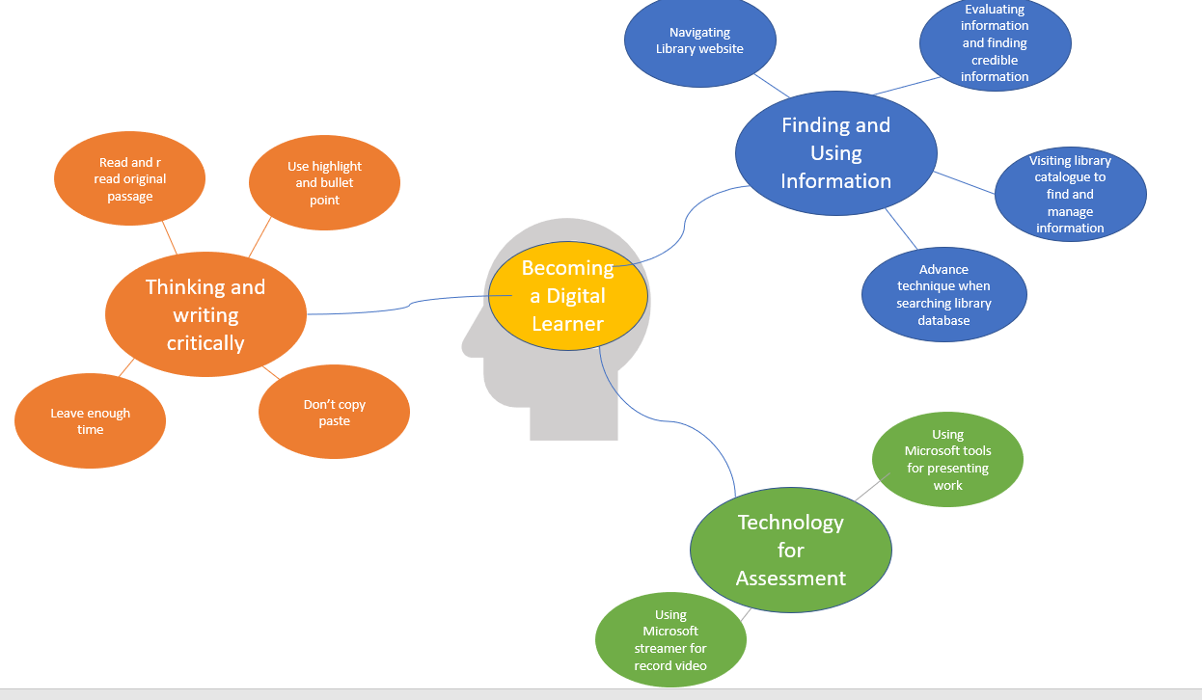

Mind Map of becoming digital learner (Rhiannon Sandy, 2022)

Presentation Task
Please follow this link to view my presentation:
https://youtu.be/RiqMDML2FHo
<iframe width="560" height="315" src="https://www.youtube.com/embed/RiqMDML2FHo" title="YouTube video player" frameborder="0" allow="accelerometer; autoplay; clipboard-write; encrypted-media; gyroscope; picture-in-picture" allowfullscreen></iframe>

Reflection Task
Its been long time since I left education on high school. I was working as a Security officer for past ten years. Then I decided to progress further in my career & became police officer. I decided to start higher education in UWTSD and build foundation for Policing profession.
Studying in University is quiet different than high school study hence I need to adjust to these change of environment. (Thurbar & Walton 2012). However feelings of anxiety prior to starting university may result slow and difficult adjustment of the new environment (Sevnic & Gizir 2014). My School and college education from back home (Bangladesh), which is quite different than studying here. Back then it was mainly text book study.
Study method has changed a lot since I left my high school. It’s mainly now online material and digital resources. Our lectures are online virtual session, where we study from home. I need to do research a lot on google, YouTube, e-books & university online library.
I was struggling in the beginning to get used to online method of learning and slowly I am getting the grasp of it. In the beginning researching online was quite challenging for me as I was surfing every where then slowly I have build the analytical & critical method of researching online to get the required information effectively for my university assignment.

References list:
References:
Buegstahler, Sheryl. (no date). Preparing for college: An Online Tutorial. www.washington.edu [Online] [Accessed 9th November 2022]
Available at: https://www.washington.edu/doit/preparing-college-online-tutorial
Dr Penny Grub.(15 January 2019). Preparing for Higher Education Study. Fantastic Books Publishing
Halfpoint. June 17, 2019. A young happy college female student sitting on sofa at home, using laptop when studying. www.istockphoto.com [Online] . [Accessed 9th November 2022] .Available at : https://www.istockphoto.com/photo/a-young-female-student-sitting-on-sofa-using-laptop-when-studying-gm1156480842-315197884?phrase=preparing%20for%20college
Rhiannon, Sandy.(2022). Learning in the digital Era: Becoming a digital learner. UWTSD [Lecture notes]
Rooney, John J., and John F.Reardon.(15 March 2009). Preparing for college: practical advice for students and their families. New York. Ferguson Publishing.
S.Sevnic, C.A. Gizir. (2014). Factor Negatively Affecting University Adjustment from the views of First-Year University Students: The case of Mersin University. Educational science theory and practice.
Thurber CA, Walton EA. 2012. Homesickness and adjustment in university students. Journal of American College Health. [PubMed] [Google Scholar]

