An effective people practice professional will:
Understand the purpose and value of the people profession.
Q: With reference to the CIPD Profession Map, appraise what it means to be a people professional. (AC 1.1)

Professionals should have specific ways of behaving, which is universal and consistent, even in challenging situations. The CIPD (2024) describe how people professionals in a fast-changing world are instrumental in supporting people, fostering inclusive environments and assist in driving the direction of an organisation. They have set out The Profession Map as a benchmark for how people professionals should behave. The map sets the standard for what it means to be a people professional, starting with the purpose at the heart of the map (Appendix 1). Around the purpose sits three values, principles led, evidence-based and outcomes driven which arose from research and feedback from across the people profession. By applying these values to work, professionals will be able to assist in better decision making. It is important for professionals to follow Codes of Conduct as these can promote ethical values and can set expectations of behaviours, for example, The CIPD (2023) set out expectations of their members through their Code of Conduct, such as supporting organisational needs, applying sound judgements and considering their impact on others. Whilst it is important to understand the principles of being a professional, Taylor and Woodhams (2022) suggest that putting them into practice is the important part, Waite et al (2021) expand further explaining that being a people professional is not just having a certain mindset or beliefs, but about also putting positive values into practice and demonstrating these daily in both their work and how they interact with others. Crosby Management Training (2023) support this further explaining that all people professionals should have one thing in common which is the ability to connect with people effectively whilst remaining impartial to ensure decisions are evidence-based and as such can reduce risks. As a people professional it is also important to continuously develop your skills, knowledge surrounding latest evidence and legislation to ensure that the best possible advice is given, and best practice is being followed. Without this, there are potential risks that can arise in the form of legal issues, damage to reputation and a question of professionalism could be raised (Taylor and Woodhams, 2022).

Know own personal and ethical values and apply these consistently in their (people practice) work.
Q: Discuss your personal and ethical values (one of each), with examples of how these are evident in your work. (If you have yet to work in people practice, explore how you believe your values would inform your work.) (AC 1.2)
The way in which decisions are made can have significant impact on people’s lives and business reputation, ethical values provide us with the standard and ethos by how we can make decisions based on good principles to improve people’s lives and work experiences (CIPD, 2024). There are frameworks that professionals can lean on for support when faced with an ethical dilemma, for example, Deontology. This perspective is based on fundamental rights and wrongs and emphasises doing the ‘right thing’ based on justice and equality (Waite et al, 2021). One ethical value that is dear to me is fairness. I believe this to be an important value to demonstrate in my HR role for stakeholders and employees to feel safe, engaged and to improve employee satisfaction. The Welsh Government (2024) highlight that employers who promote ‘fair work’ and treat their employees with value can assist in organisational performance through retention of staff, lower absenteeism and enable workers to feel more motivated to invest in their development. I believe that as a HR assistant, I evidence fairness in my work by ensuring that all employees have or can access internal policies and ensuring that there are effective ways that employee voice is heard and issues can be raised through trusted channels, such as employee consultation groups. Furthermore, I believe it is important for me to provide a positive contribution to all parts of the employee lifecycle, ensuring fairness through induction programmes, L&D opportunities and ensuring employees have a thorough understanding into our organisational values, goals and how they can assist in achieving these. A personal value that I cherish is honesty. By demonstrating honesty in my work can open communication channels and foster an environment of trust between employees and the employer. Vitasek (2022), supports this by explaining relationships that are based on trust lead to a more productive workforce and encourage employee buy-in to contribute to the organisations shared goals, thus improving organisational performance. I believe to evidence honesty in my work by leading by example in demonstrating our organisational values to the wider workforce, providing honest and accurate information in relation to company policies and communicate regular business updates to ensure transparency.

Know the importance of people professionals contributing to discussions in an informed, clear and confident way to influence others.
Q: Discuss reasons why this is important and the consequences of people practitioners not being willing or able to influence others. (AC 1.3)
As listed in the core behaviours of The CIPD’s Profession Map (2024), people professionals should show professional courage to contribute to discussions and communicate key information in an engaging way to influence others. Ohlrich (2024), explains that demonstrating effective influence is more than just ensuring others see your viewpoint, it is about gaining buy-in and building a consensus for change. It is also important for professionals to demonstrate key skills and techniques to assist in influencing others such as specific written and verbal communication ques, building relationships or through persuasive negotiation, without this there is a risk that unethical decisions could be made. Professionals can pull persuasion techniques from frameworks such as a Robert Cialdini’s six principles of influence which are, reciprocity, scarcity, authority, consistency, liking and consensus and by understanding these principles, professionals are able to use them to their advantage to persuade others (Schenker, 2024). The CIPD (2019) conducted an evidence review of unethical workplace behaviour and explained that this behaviour can range from illegal activity; to counter productive work behaviour such as sabotaging career opportunities for colleagues or not complying with work-based policies and so it is important for professionals to use their professional courage to contribute and influence discussions and ensure that ethical values are being upheld. Unethical behaviour impacts every part of an organisation and can stem from many causes including the culture of an organisation and ultimately if one unethical decision is made, organisations can run the risk of creating an environment that is toxic and unproductive. If professionals are not diligent in their approach to influencing decisions, business relationships and reputation could be damaged which could result in individuals deterring from working with or for an organisation, there is a risk of higher employee turnover as an unethical decision or toxic environments can result in demotivated employees and valuable talent could be lost (HR Zone, 2024).

Know when and how to raise matters that might be unethical or illegal.
Q: Discuss, with examples, when and how you would react to both unethical and illegal matters (one of each). (AC 1.4)

The current academic course I am undertaking requires all individuals to become members of the CIPD and as a result be responsible for upholding the CIPD’s Code of Conduct (2023). One principle listed in the code of conduct is that members of the CIPD must demonstrate high standards of ethical conduct, honesty and professional integrity. One unethical matter that seems to be an issue worldwide with consequences for individuals and institutions is academic cheating and dishonesty. One theoretical approach to academic cheating suggests that certain behaviours and attitudes are developed through observational learning of our peers, and therefore, students would be more likely to academically cheat if they witness their peers doing the same (Gruber, 2022). As a member of the CIPD, I have a personal responsibility to take action against any breach of conduct so, if I was subject to have witnessed a breach of honesty in regard to academic cheating, I would ensure I am upholding my duty to report this as necessary to the CIPD and to potentially mitigate the risk of an unethical culture of dishonesty developing.
By law, employers have a duty of care for anyone who attends their workplace, and they must do all they reasonably can to protect the health and safety of everyone at work (ACAS 2023). There can be severe consequences for organisations who are not H&S compliant, for example, employees risk losing their lives due to lack of H&S compliance and basic breaches can result in fines of up to £20,000 and unlimited fines that could financially destroy an organisation could be made for major incidents. (Work Wallet, 2021). As an inspiring people professional, it is important that I lead by example and whilst there are specific policies and procedures in place that aid in protecting the H&S of everyone in the workplace, it is vital that I lean on professional courage and report any concerns within the workplace, including any sightings of H&S breaches. Through whistleblowing, I am legally protected to raise a concern in the workplace that is or could be seen to have a negative effect on an individual’s H&S. I can report any concerns to a senior member of staff who should listen to my concern in detail and then decide if any further action is required. As I have a duty of supporting the welfare of those in the workplace, if I believe my concern to not be dealt with adequately, I will ensure this is reported further to another senior stakeholder and emphasise the risks to the individual and the organisation (GOV UK, 2024).
Be able to make use of related theory and thinking, to argue the human and business benefits of people feeling included, valued, and fairly treated at work.
Q: Demonstrate your ability to do this with a written argument, which poses different theoretical perspectives, as well as your own. (AC 2.1)

Creating a workplace environment that is inclusive is to value individual differences, empowering everyone to be themselves and thrive in the workplace and fostering a culture where everybody feels they belong and their contribution matters (CIPD 2024). Studies show that by fostering an environment where individuals feel valued and included, employees are more engaged, will be more likely to recommend their employer to work for and a sense of belonging in an organisation can affect an employee’s mindset on whether they decide to stay or not, which could affect organisational performance as a result (Hamill, 2019). The CIPD (2024) explain that inclusion can have positive benefits on employee wellbeing and by creating an environment that promotes a positive state of wellbeing, it can deliver mutual benefits to people, organisations, economies and communities. The CIPD’s Good Work Index (2024), offers insights which are evidence-based for professionals and employers to champion better working lives. The latest report shows only 39% of employee’s surveyed felt that their workplace positively impacts their mental health, as such, leaders and professionals should be setting motivating goals and champion supportive working environments, so they are able to benefit from engaged staff who are less likely to suffer from work-related anxiety or depression. There are some theories of motivation that can be applied to people feeling the need to be included and valued in work and can help employers understand their employees more on a psychological level. Maslow’s Hierarchy of Needs theory suggests that we need to fill our basic needs before we move on to the next level of needs, for example, once our basic needs are met such as the basic essentials of being alive, we will then shift to our addressing our higher-level needs such as belonging and the need to fulfil our true potential (Waite et al, 2021). When applying this theory to the workplace, Herrity (2024) explains that once we reach the final level of the hierarchy, a person just wants to feel they are doing their best which aids in their motivation to continue their career path and succeed. Because of this, leaders and professionals should do what they can to ensure all employees are provided with the same opportunities to succeed.
Know how to design people practice initiatives to be inclusive and how to check inclusivity after an initiative has been implemented.
Q: Discuss, with examples, how you have, or would, achieve both of these (AC 2.2)

One people practice initiative which is common in organisations in recent years is flexible working. There is a statutory right for employees to request flexible working arrangements and organisations should understand the importance of creating a culture of flexible working to maximise the benefits (ACAS, 2024). The CIPD UK Working Lives survey (2019) shows that those in occupations of a higher level had more access to flexible working arrangements to aid their work-life balance, which suggests that there is a lack of equality in those who can access these arrangements. As an inspiring people professional, if a new initiative was being implemented in my organisation surrounding flexible working arrangements, I would assist in ensuring that measures have or will be taken to assist in incorporating inclusivity surrounding this initiative. Firstly, I would ensure I am actively improving my knowledge surrounding flexible working arrangements to understand that employees have different needs, and these arrangements will look different across different areas of the organisation. I could also assist in conversations which could aid in rethinking our organisational culture which highlights key benefits to both employees and the organisation that flexible working could bring, consult with employees and stakeholders to ensure this process can work for both parties and have a policy which is easily accessible to everybody and work with them to explore how arrangements can be applied for each individual to thrive under flexible working. For example, employees whose jobs may prevent them working from home, could benefit from other flexible working arrangements such as compressed hours, or flexitime (CIPD, 2024). After the flexible working initiative has been implemented, it is important to measure the impact this is having on both the workforce and the organisation to help gauge an employee’s views on inclusivity and wellbeing, which The CIPD (2024) suggest can be done through either qualitative or quantitative measures. Employee surveys or regular catch ups and discussions can be held with stakeholders of different ages, ethnicities and genders to measure the extent to which their needs are being met for a chance to reflect and address any changes that require implementation.

Be able to work inclusively with others and build positive working relationships.
Q: Using a combination of your own reflections and feedback from at least one other person, discuss your ability to work inclusively and positively with others. (AC 2.3)

As an inspiring people professional currently working towards associate status within my CIPD membership, there is certain criteria set by the CIPD which a member at an associate level should be demonstrating. For me to thoroughly understand my ability and to gain feedback for areas of development for this behaviour, I presented my line manager with an assessment provided by the CIPD on my ability to work inclusively and asked them to rate me from emerging to exceeding in each criteria set. My line manager and I discussed the fact that I am currently in an entry level HR role and thus I am only starting to build positive working relationships with stakeholders in my organisation, this should develop more as I gain confidence, develop within my role and as a result my ability to work positively and effectively with others should grow. Whilst I already collaborate positively with line managers and stakeholders when undertaking my administrative tasks to help ensure the employee lifecycle is operating as smooth as possible, I have asked my line manager to provide me with certain tasks and goals that could assist in ensuring I develop this ability further. Going forward, my line manager has requested that I shadow some internal meetings and discussions with stakeholders in the business, so I am able to develop my ability to work inclusively, build further relationships and develop my professional courage to contribute to discussions. Furthermore, after reflecting on my ability to seek and listen to diverse opinions I have realised that this could also be an area for development, however, my line manager assured me that one of the most important skills as a HR professional is listening. Whilst I am eager to develop my skills and contribute to discussions, it is also important that I keep asking questions to understand a wider range of diverse opinions, which can ultimately lead to better decision making. As a result, my line manager and I will be discussing case studies within organisations alongside other members of our Human Resources department, and in-depth conversations will take place to understand diverse opinions and different thought processes.

Understand how the people practitioner role is evolving and the implications this has for your ongoing professional development.
Q: Demonstrate your understanding of this with a written response and related entries in your CPD Plan. (AC 3.1)

It is important for people professionals to keep on top of their development as the role of a professional is constantly changing and there is a risk of drawing from outdated ideas, outdated evidence and potentially illegal practices (Taylor and Woodhams, 2022). Meggison and Whittaker (cited in Waite et al, 2021) explain that by engaging in ongoing processes of reflection and action, individuals can take control of their ongoing professional development. With rise of artificial intelligence and advanced technology, professionals have found that HR processes are able to be streamlined from recruitment and onboarding through to employment management which as a result has reduced administrative burdens and enabled professionals to focus more on strategic aspects of the profession (Forbes, 2024). In my role as a HR Assistant, I tend to tackle the day-to-day administrative tasks which support the HR department in delivering a seamless employee experience. However, the development of technology within the wider world of work could mean that the requirements and tasks expected of me could change. The CIPD (2020) collaborated with professionals from around the world to identify key trends that will impact and shape the role and capabilities of people professionals by 2030. Some trends that have been identified are internal changes, digital transformations and clear focuses on EDI. As a result, people professionals should be leaning into their professional courage to take the lead on strategic change and assist in developing an effective EDI strategy, develop skills for a digital world and build credibility within analytics. In terms of my professional development and based off the key trends identified by CIPD, I have identified a need for the following areas of development as shown in my development plan below.

What do I want/need to learn? | What will I do to achieve this? | What resources or support will I need?
How to develop professional courage and influence to achieve positive outcomes. | Complete CIPD online course surrounding professional courage.  Ask my colleagues/line manager for feedback on my communication style, courage, how I come across and what could be better? | - Homepage - Professional Courage and Influence  - Time with colleagues/line manager to reflect on behaviours.
Understand the importance of working inclusively and the benefits this can have on my organisation. | Read factsheets on the benefits of encouraging employee voice.  Read factsheets on diversity and inclusion to understand more. | - Equality, diversity and inclusion in the Workplace | Factsheets | CIPD  - Employee Voice | CIPD

Be able to assess (own) strengths, weaknesses and development areas, based on own considerations and feedback from others.
Using a combination of your own conclusions and feedback from at least one other person, assess yourself against a specification of your choice (such as a role/job description or any two of the core behaviour areas of the CIPD Profession Map (associate level). Briefly explain the outcome of your assessment (strengths, weaknesses and development areas) and the information that informed your conclusions. (AC 3.2)

As I currently work in an entry level role within my organisations HR department and currently working towards an associate level of my CIPD membership, I assessed my own strengths, weaknesses and development areas against my job description (Appendix 2). I believe my overall strengths to be my confidence in my ability to be the first point of contact for the HR department via telephone and email, my organisational skills when comes to administrative tasks such as managing our email inbox efficiently and assigning emails to the correct team member and having a proactive work ethic to develop my knowledge and understanding. I can understand these points as my strengths as I believe this is where I am the most productive, from feedback off those who work closely with me and from also identifying areas in which I believe to be my weaknesses. For example, some areas of development that I believe I can improve on is to take ownership ensuring our Right to Work checks are conducted properly in line with legislation and assist in mitigating any risks that could occur if these are not done correctly. Alongside my own considerations and for me to gain a more balanced view on my conclusions, I decided to ask both my line manager and a colleague within HR for feedback. As mentioned in AC 2.3, feedback from my line manager has enabled me to identify weaknesses and areas of development, for example, expanding my knowledge on how the HR function assists in our organisational goals and working closely with my line manager to deliver our HR strategy. Therefore, my attendance in internal team meetings and discussions surrounding strategic goals is crucial for me to understand the role I play in this. My colleague also suggested that an area for development is my sustainability knowledge and understanding the wider business risks that could occur if we as an organisation are not sustainable. Therefore, I understand that development is needed in this area and as such, I aim to be more pro-active in my approach to sustainability by meeting with our sustainability manager to gain a scope into how I can support the strategy within a HR function.

Be able to formulate a range of appropriate CPD options to support ongoing learning.
Following on from your self-assessment, identify a range of formal or informal development activities and add these to your CPD Plan/document. Provide a brief explanation as to why you have selected these activities. (AC 3.3)

Off the back of a self-assessment tool I had completed on the CIPD learning hub based on the core behaviours of valuing people, ethical practice, professional courage and working inclusively, I have added several recommendations to my learning plan and tailored the activities to which I believe will be the best equipped to help me develop my knowledge and skills. I have decided that I will ask my colleagues and line manager for feedback on my communication style, so I am able to reflect on my behaviours with the insight of those who work with me closely on both a personal and professional level. I also believe a course on developing professional courage through the CIPD will benefit me to thoroughly understand the importance and benefits of leaning into this to influence others. When starting a brand-new role there can be a certain amount of self-doubt and insecurity and I am hopeful these activities will provide me with the skills I need to develop further. When it comes to ethical practice and the role of professionals, I believe that reading factsheets on this topic is important as a quick and effective task to gain insight into ethical behaviour. As an inspiring people professional I believe this to be a priority and as such, will also undertake a course to develop a deeper insight into the importance of acting ethically and the potential human and organisational risks of acting unethically. Another valuable activity for my development would be to gather feedback from my line manager and colleagues on the extent to which I value people in the workplace, which could be argued is also a priority for an individual working in HR. As people are at the heart of organisations, it is important to thoroughly understand why we should value them and as such will undertake a course on valuing people to understand how this can have an effect on employee wellbeing and ultimately the organisation. Finally, I believe it would be beneficial for my learning style to read CIPD factsheets on EDI and employee voice and how this can be achieved in the workplace to assist in our organisation’s success.

What do I want/need to learn? | What will I do to achieve this? | What resources or support will I need? | Target dates for review and completion
How to develop professional courage and influence to achieve positive outcomes. | Complete CIPD online course surrounding professional courage.  Ask my colleagues/line manager for feedback on my communication style, courage, how I come across and what could be better. | - Homepage - Professional Courage and Influence  - Time with colleagues/line manager to reflect on behaviours. | 01 March 2025
To understand ethical practice and the positives outcomes this can achieve. | Complete CIPD online course on ethical practice.  Read CIPD Factsheets on ethical practice and the role of people professionals. | - Ethical practice and the role of people professionals | Factsheets | CIPD  - The Profession Map / Core behaviours / Ethical practice | CIPD  - Homepage - Ethical Practice | 01 March 2025
Understand how I can value people more in the workplace. | Read factsheets and relevant resources on valuing people and employee wellbeing.  Gather feedback from colleagues/line manager on the extent to which I value people in my work. | - Wellbeing at Work | Factsheets | CIPD  - Time and feedback from my colleagues and line manager. | 01 March 2025
Understand the importance of working inclusively and the benefits this can have on my organisation. | Read factsheets on the benefits of encouraging employee voice.  Read factsheets on diversity and inclusion to understand more. | - Equality, diversity and inclusion in the Workplace | Factsheets | CIPD  - Employee Voice | CIPD | 01 March 2025

Be able to reflect on and draw conclusions about the effectiveness of development activities.
Reflect on three development activities, already undertaken, that have had an impact on your work behaviour or performance, explaining how they have impacted you. (Your reflections should be presented within your CPD Record document.) (AC 3.4)

Key dates | What did you do? | Why? | What did you learn from this? | How have/will you use this?  Any further action?
10 December 2024 | ACAS Webinar – Managing Grievances Effectively | - As I have recently started a brand-new entry-level role within HR, I took it upon myself to join an ACAS webinar to understand grievances in greater detail and how these can be managed effectively by leaders and HR to minimise costs, maintain employee satisfaction and mitigate risks. | - There can be several costs to organisations when conflict arises in the form of financial, health and wellbeing and company reputation.  - The process of handling grievances can vary.  - Employers should deal with these concerns promptly and carry out investigations into the concerns that have been raised to identify the facts.  - To consider not only the wellbeing of the employee who has raised the grievance but also the individual who the grievance has been raised about. | - As I am currently in an entry level HR role, I have used this webinar to expand my knowledge on what a grievance is and how this can be handled effectively. I believe I will now be able to tell the difference between a formal grievance and an informal concern and have been given the information on how managers and HR can approach these.
03 January 2025 | Read Ethical practice and the role of people professionals – CIPD Factsheet. | - To understand my role as an inspiring people professional in assessing and reinforcing ethical behaviours.  - Understand why ethical practice is important. | - Organisational reputation is based off valuable relationships with staff, not just products and services.  - Demonstrating ethical practice can give employers a competitive advantage with employee relationships contributing to organisational success.  - The effect on employee engagement when organisational culture and ethical values differ. | - I have used this so far in my role to collaborate with my line manager and colleagues, ensuring that organisational policies and processes are fair.  - I will continue to lead by example through internal communications and assisting in ensuring our expectations and values are made clear from the attraction through to the separation stage of the employee lifecycle. For example, advertising our ethical values through job descriptions, support training programmes and assist my senior team in developing communication strategies which communicate what our organisation can gain from an ethical culture.
09 January 2025 | Listened to Employment Rights Bill Initial Analysis podcast by Daniel Barnett, employment barrister. | To gain a greater understanding on upcoming employment legislation changes in line with the new labour government. | Understood upcoming legislation changes to employment law within the next two years and what these changes mean for employers in light of new unfair dismissal laws, flexible working, ending fire and rehire and new sexual harassment laws. | - Going forward, I will be ensuring that Toolbox Talks will be created surrounding the new employment laws on flexible working. I will circulate this to the wider business ensuring that employees are aware of their rights.  - I have collaborated with my colleagues and line manager to ensure we as an organisation are taking all reasonable steps to prevent sexual harassment within the workplace. This includes a risk assessment, updated policy, toolbox talk, training to line managers on how to manage reports of sexual harassment and ensure employees understand where to report a case of sexual harassment.

Appendix 1

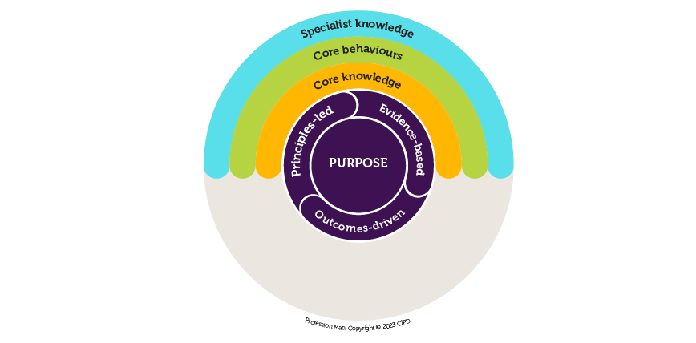

Appendix 2
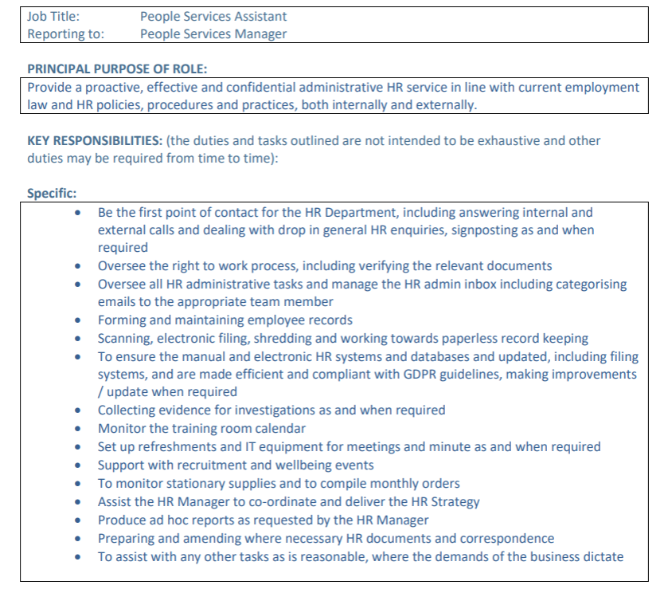
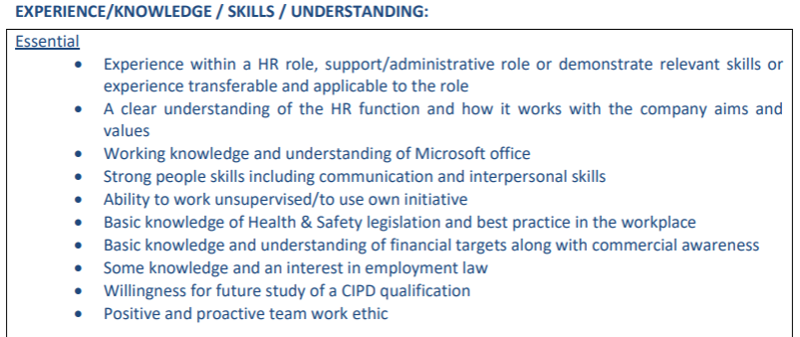

Reference List.
ACAS (2023) Keeping everyone safe at work. Available at: Keeping everyone safe at work - Acas (Accessed: 23 December 2024).
ACAS (2024) Changing your culture - implementing flexible working. Available at: Changing your culture - Implementing flexible working - ACAS (Accessed: 01 January 2025).
CIPD (2019) Flexible working: A step to creating more inclusive workplaces. Available at: Flexible working: a step to creating more inclusive workplaces | CIPD (Accessed: 01 January 2025).
CIPD (2019) An evidence review of unethical workplace behaviour. Available at: https://www.cipd.org/globalassets/media/knowledge/knowledge-hub/reports/unethical-behaviour-in-the-workplace_report-2_tcm18-57022.pdf (Accessed: 21 December 2024).
CIPD (2020) People Profession 2030: A collective view of future trends. Available at: People Profession 2030 future trends | CIPD (Accessed: 01 January 2025).
CIPD (2023) Code of Conduct and Ethics. Available at: https://www.cipd.org/globalassets/media/comms/code-of-conduct/2023-cipd-code-of-conduct-and-ethics.pdf (Accessed: 16 December 2024).
CIPD (2024) Equality, diversity and inclusion in the workplace. Available at: Equality, diversity and inclusion in the Workplace | Factsheets | CIPD (Accessed: 28 December 2024).
CIPD (2024) Ethics at work: An employer’s guide. Available at: Ethics at work: An employer’s guide | CIPD (Accessed: 21 December 2024).
CIPD (2024) Explore the Profession Map. Available at: https://www.cipd.org/uk/the-people-profession/the-profession-map/explore-the-profession-map/ (Accessed: 16 December 2024).
CIPD (2024) Flexible working: Guidance for people professionals on planning and managing. Available at: Flexible working: Guidance for people professionals on planning and managing | CIPD (Accessed: 01 January 2025).
CIPD (2024) Good Work Index. Available at: CIPD Good Work Index 2024: Summary report (Accessed: 28 December 2024).
CIPD (2024) Why work in the people profession? Available at: Why work in the people profession? | CIPD | CIPD (Accessed: 18 December 2024).
Forbes (2024) How Will AI Impact HR. Available at: How Will AI Impact HR? (Accessed: 01 January 2025).
GOV UK (2024) Whistleblowing for employees. Available at: Whistleblowing for employees: What is a whistleblower - GOV.UK (Accessed: 23 December 2024).
GOV Wales (2024) A guide to fair work. Available at: A guide to fair work | GOV.WALES (Accessed: 21 December 2024).
Gruber, H. (2022) Academic dishonesty and its relations to peer cheating and culture. Available at: Academic dishonesty and its relations to peer cheating and culture: A meta-analysis of the perceived peer cheating effect - ScienceDirect (Accessed: 23 December 2024).
Hamill, L. (2019) What an inclusive workplace actually looks like and seven ways to achieve it. Available at: What An Inclusive Workplace Actually Looks Like, And Seven Ways To Achieve It (Accessed: 28 December 2024).
Herrity, J (2024) Maslow's Hierarchy of Needs: Applying it in the workplace. Available at: Maslow’s Hierarchy of Needs: Applying It in the Workplace | Indeed.com (Accessed: 28 December 2024).
HR Zone (2024) 5 Ways Unethical Behaviour Can Damage Reputation. Available at: https://hrzone.com/blog/5-ways-unethical-behaviour-can-damage-hr-functions/ (Accessed: 21 December 2024).
Ohlrich, K. (2024) The Most Important Skill for HR Managers is Influence. Available at: https://peoplemanagingpeople.com/strategy-operations/hr-systems/hr-influence/ (Accessed: 21 December 2024).
Schenker, M. (2024) How to Use Cialdini's 6 Principles to Boost conversions. Available at: https://cxl.com/blog/cialdinis-principles-persuasion/ (Accessed: 21 December 2024).
Taylor, S. and Woodhams, C. (2022) Studying Human Resource Management. Third edition. Kogan Page.
Vitasek, K. (2022) The Role of Honesty in Success. Available at: https://www.forbes.com/sites/katevitasek/2022/11/29/the-role-of-honesty-in-success-and-why-cutting-corners-is-a-bad-idea/ (Accessed: 21 December 2024).
Waite, K et al. (2021) People Practice: A complete guide. Kogan Page.
Work Wallet (2021) The consequences of health and safety non-compliance. Available at: The consequences of health and safety non-compliance - Work Wallet (Accessed: 23 December 2024).

