The University of Wales Trinity St David
Module BMPF7008
Student Number: 2117164
Work based Learning Project
Vocal Identity: Perception of the singing voice
By Lyanna Austin

Module BMPF7008 Work-Based Learning Project
CONTENTS

Project Proposal Form 4
Project Report 7
CHAPTER 1: INTRODUCTION 7
1.1 Rationale
1.2 Research Aims and Questions
CHAPTER 2: LITERATURE REVIEW 8
2.1 Introduction 8
2.2 Vocal Production 8
2.3 Vocal Self Perceptions 9
2.4 Vocal Perceptual Profile 12
2.4 Auditory Perceptions 12
2.5 Neuroplasticity and Learning 12
2.6 Identity 12
2.7 Vocal Identity 13
CHAPTER 3: METHODOLOGY 14
3.1 Research Design and Methods 14
3.1.1 Phase 1 - Questionnaire 14
3.1.2 Phase 2 – Interviews 15
3.2 Ethical Considerations 16
CHAPTER 4: PRESENTATION OF FINDINGS 18
4.1 Summary of Quantitative Analysis 18
4.1.1 Results of the Voice Perceptual Profile 18
4.2. Summary of Qualitative Analysis 22
4.2.1 Singing ability 22
4.2.2 Learning 23
4.2.3 Perceptions of the singing self 23
4.2.4 Comparison 26
4.2. 5 Emotions 27
4.2.6 Influences 27
4.2.7 Vocal identity 27
CHAPTER 5: DISCUSSIONS 29
5.1 Emergent Themes 29
5. 2 Summary of research questions 30
5.3 Limitations 32
5.4 Recommendations 33
5.5 Future research 33
5.6 Conclusions 34

REFERENCES 35
APPENDICES 43
Appendix A: Project Information Sheet for Participants 43
Appendix B: Participant Consent Form 44
Appendix C: Questionnaire 45
Appendix D: Transcription of Interviews 49
Appendix E: Ethics Form 112
Appendix F: Questionnaire Responses 136
Appendix G: Coding 145
Appendix H: Cumulative Emergent Themes 174
Appendix I: List of Tables 175
Appendix J: Vocal Identity Reflective Model 176
Appendix K: Vocal Identity and the Development Pathway 177
PROJECT PROPOSAL FORM
TITLE: VOCAL IDENTITY: THE PERCEPTION OF THE SINGING VOICE
- The context
Singing and speaking are integral components of our identities (Welch, 2017). Voices have inherent physical characteristics that result in distinctive acoustic qualities that reflect an individual's vocal identity (Kim, 2003). There is a common use of the term vocal identity in the discourse on singing pedagogy (Monks, 2003). Despite this, research has been limited on vocal identity, whether it exists, and how to measure it (Monks, 2003). Therefore, this research investigates the perceptions of the singer’s self, the nature of a singer’s relationship with their voice, and the relationship to vocal identity. The purpose of this research is to investigate and determine whether the perception of their singing voice can influence vocal identity. In addition, it identifies critical factors and connections relating to vocal perception and vocal Identity. The essay will attempt to define vocal identity and briefly determine the emergent themes surrounding key components and their impacts on pedagogy.
- The justification
Individual voices are unique (Miller, 2003). An acoustic voice profile identifies and even verifies an individual. An individual's voice reveals their personality, feelings, actions, and listening preferences (Shewell, 2013). However, how the singing voice develops and connects to a person's identity is largely under research (Lemon-McMahon, 2019). Moreover, little is understood about how vocal identity is connected to the singing self or to a singer's identity. Therefore, this research investigates the perceptions of a singer and the development and relationship of vocal sound in Contemporary Commercial Music (CCM). A key objective of the research is to investigate voice perception and develop a comprehensive evaluation and analysis of the attributes of vocal identity. As part of a research project, findings will be examined for pedagogical considerations. Teachers may be able to assess their teaching methods by the development of a theoretical framework or reflective model of vocal identity. This might provide them with tools and methods to assist their students in taking a more holistic approach to vocal development.
3. Outlined impact
I will evaluate the literature on vocal perception and identity. The research will primarily use mixed methods (MMR) (Creswell et. al, 2011).
- This research is grounded in a relativist ontology, a subjective experience (Denzin & Lincoln, 2011).
- In terms of epistemology, pragmatic epistemology emphasises ‘practical understandings of concrete, real-world issues’ (Patton, 2005, p. 153). A focus is placed on the examination of the practical consequences of research data in order to determine the value and meaning of this data (Morgan, 2014).
- In sociology, symbolic interactionism is one of the main theoretical frameworks. This perspective relies on the symbolic meaning that people develop and build upon in the process of social interaction (Morgan, 1980).
As part of this research, data will be collected and converted in two phases (Teddie and Tashakkori, 2009). The first phase involves a three-part questionnaire, and the second involves semi-structured interviews. MMR provides the researcher with the opportunity to examine a phenomenon from a variety of perspectives using various methods. For increased rigour, combining quantitative and qualitative data increases the validity of the research and the ability to draw valid inferences (Mason, 1996; Denscombe, 2017). The research will focus on five to six participants ranging from amateur to professional CCM singers. An information sheet describing the project and a consent form will be provided to each participant. There will be three components to the Phase 1 questionnaires: vocal identity, vocal perceptual profile (VPP), and the singing voice.
A semi-structured online interview will be conducted in phase 2 to build upon the questionnaire's findings and explore them in further detail. A presentation should accompany the report by the end of January 2023.
4. Ethics and insider research
Social research is based on ethical principles (Merton, 1972). Insider research aims to 'improve key practices and processes' (Stacey, 2000). From conception to completion, the researcher's point of inspection is evident throughout insider research (Druzenko et al., 2014). It is important to note that insider research has both advantages and disadvantages; insiders have a greater understanding of the context and can assess the consequences of avenues of inquiry (Griffiths, 1985).
Throughout the research process, participants will be informed of the purpose of the study. The writing up of the data will eliminate any references that could be used to identify individuals. To ensure the validity of the study, some questionnaires were administered to singers known to the researcher. All singers will be coded to protect this study's validity. All singers were given the opportunity to participate in the study without being under any pressure. An explanation of the study was provided to each student. Participants may opt-out of the research process and turn off the recording equipment at any time if they do not wish to participate. Alternatively, they may refuse permission to use transcriptions if they disagree with anything said.
Personal learning outcomes
- The purpose of this project is to conduct my first work-based research.
- Ability to analyse texts, synthesise ideas and reflect upon research at an advanced level through critical thinking.
- Interpret texts and ask questions with a theoretical frame of reference.
- This study will provide insight into how to formulate focused questions for my MA module 6 work based learning project on the findings of this study.

TITLE: VOCAL IDENTITY: THE PERCEPTION OF THE SINGING VOICE
CHAPTER 1: INTRODUCTION
1.1 Rationale
This study aims to investigate the relationship between a singer's perception of their voice and the impact on their vocal identity. The term vocal identity is complex and multidimensional (Kreiman et al., 2003). Our voices express and communicate who we are, according to Becker and Goffi-Fyn (2016), who asserts that our voices are intimately related to our ‘conscious and unconscious sense of self’ (p.10). Only a few articles directly address vocal identity (Becker and Goffi-Fyn, 2016; Monks, 2003; Yarnall, 2017; Zangger and Borch, 2013). Presently, discourse on vocal identity focuses primarily on vocality (Dunn and Jones, 1994; Meizel, 2011). Consequently, this study investigates singers' perceptions, specifically how they feel and reflect on their voice and singing ability and what is vocal identity. To assess the potential contributing factors for analysis, two phases of data collection will be used for individuals aged 18 and over who are both professional and amateur singers (including untrained).
1.2 Research aims and research questions
This research aims to understand the factors contributing to an individual's distinctive voice. As far as examining singer perceptions, ‘a systematic perceptual analysis is helpful in the learning of singing’ (Shewell, p. 82, 2013). Using a pragmatic perceptual voice scheme can identify parameters of vocal attributes and formulate themes to answer the questions below.
Central research questions
- What impact does the relationship between the singer and the voice have on vocal identity?
- What factors influence a singer's identity?
- Is the identity of the singer relevant to singing?
- What is the process by which vocal sound is developed?
- Does ‘vocal identity’ exist? If so, what is it?
- In what ways can the perceptual approach to voice skills (Shewell, 2013) assist the singer in understanding the sound of their voice?
Learning outcomes
- To gain a better understanding of vocal identity and the key components.
- Analysing the voice perception profile in order to understand the perception of the singing voice.
- Studying perceptions and vocal identity as it pertains to current singing pedagogy.
- To develop a theoretical framework for pedagogical considerations based on the findings.
CHAPTER 2: LITERATURE REVIEW
This literature review explores the research concerning vocal production and vocal self-perception and then considers the research into vocal identity. This review examines seven main areas: (1) Vocal production, (2) Vocal self-perception, (3) Vocal perceptual profile, (4) Auditory perception, (5) Neuroplasticity and learning, (6) Identity and (7) Vocal identity.
2.1 Vocal production
Singing and the body are inextricably linked (Sundberg, 1987), and singers cannot separate voice from the body: voice exists as both a part of the body and a part of the mind (Monks, 2007). The voice conveys various information, including physical characteristics like body size and gender, as well as clues to the individual's identity and emotional state (Kreiman & Sidtis, 2011). The vocal production system's physiological elements are dynamically modified for vocalisations to be produced (Kamiloğlu, and Sauter, 2022). Vocal sound is produced by the ‘voice organ’ (Sundberg, 1987, p.1) and requires coordination of five main actions: respiration (Leigh-Post, 2014; McCoy, 2012), resonance (McCoy, 2012), oscillation/vibration, (Callaghan, 2014), articulation (McCoy, 2012, p.158), and the brain (Callaghan, 2000; Thurman & Welch, 2000). By vibrating the vocal folds, air flowing from the lungs is intensified and resonated by the pharynx and articulatory muscles.
There are several factors that affect the adjustment of these complex manoeuvres, including psychological, physical, kinaesthetic, environmental, and acoustic factors (Callaghan, 2000). The brain generates ‘neurological signal’ (Callaghan, 2000, p.25) that activate the motor skills required to produce sound (Parkinson et al., 2012; Selleck & Sataloff, 2014; Silbert et. al, 2014). To contextualise the development of vocal sound, it is necessary to understand voice physiology. When understanding the singing voice, it is necessary to recognise that it is produced by the entire body-mind of the singer (Thurman and Welch, 2000). There are many factors to consider for a singer to develop a positive singing self, including their exposure to music, and formal or informal training, of which can influence their perceptions (Lemon- McMahon, 2019).
2.2 Voice perception
Vocal perception research is not as advanced as research on speech perception (Sundberg, 2013). However, is rooted in the production of voice (Sundberg, 2013). Based on Ghazanfar and Rendall (2008), vocal sounds are produced by the interaction between a source (the laryngeal folds) and a filter (the vocal tract above the larynx). Singing, perceptions occur at the neurological, psychological, physical, and emotional levels, consciously and unconsciously (Monks, 2007). The process of vocal communication requires an understanding of both production and perception, and the producer's voice expresses internal processes through specific acoustic patterns (Latinus and Belin, 2011). Research conducted by Monks (2003) with adolescents concluded that singing perceptions are often very complex and psychologically based. Singers who have difficulty mastering their singing technique and fully expressing their distinct sounds may benefit from supplemental intervention. The provision of reflective assessment diaries or a curriculum may be beneficial to younger singers.
Singing perceptions are formed by various factors, including home environment, music learning environment, social comparisons, ethnicity, age, gender, and singing experience (Stephens, 2012). To identify the direct impact of influence on singing perception, predictors must be assessed.
Figure 1: Stephens (2012) shows predictors and conceptualisation of singing perceptions.
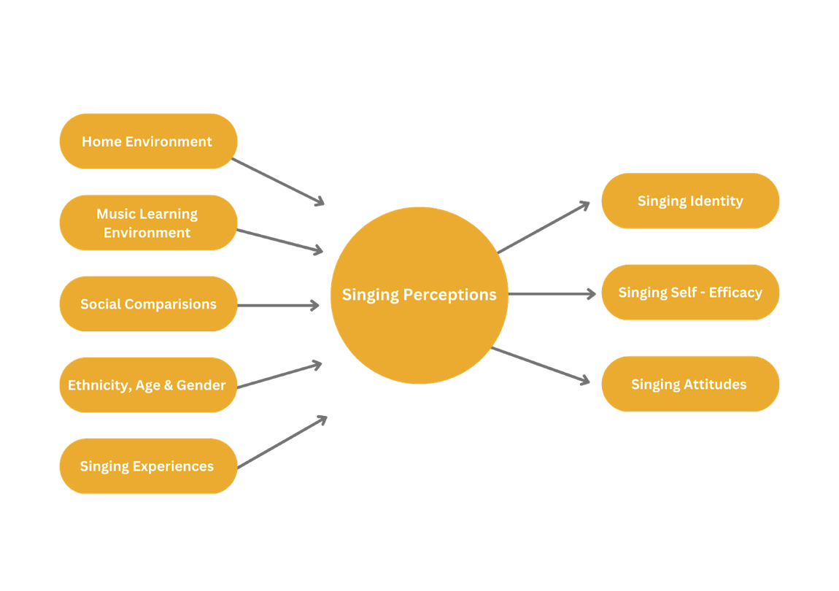
Vocal self-perception
In 1984, Haskell (1984), a speech therapist, described singing perceptions as ‘the physical and psychological experience of one's own voice’ (p. 172). He identified two primary levels of voice self-perception, sensory monitoring, and vocal self-identification, as illustrated in
Figure 2: Haskell (1984) showing his concept of vocal self-perception
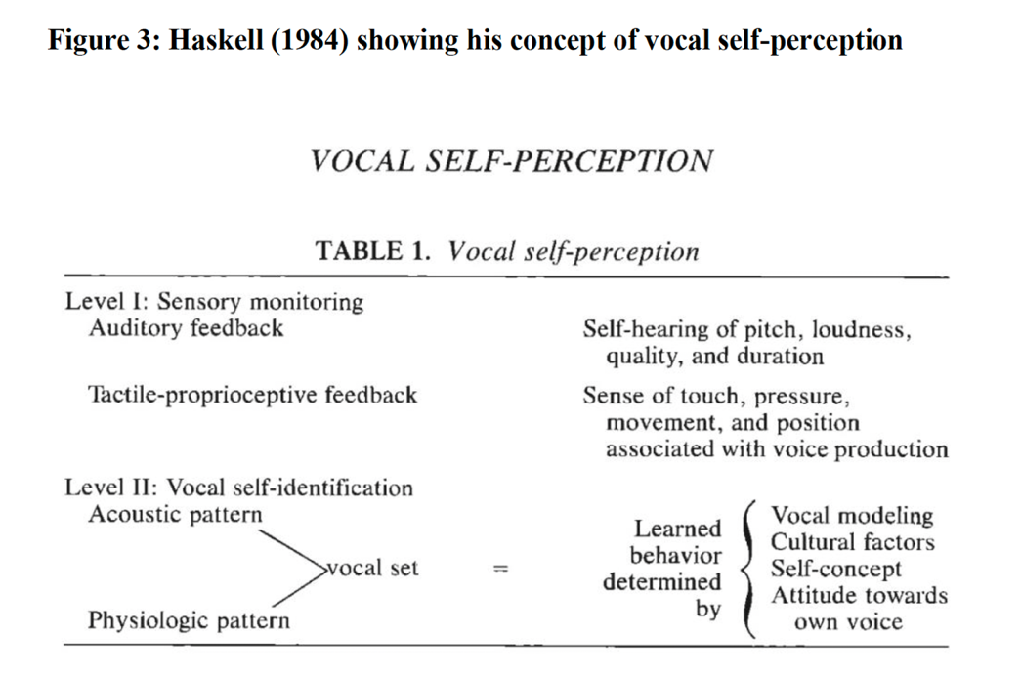
It is essential to assess predictors and make them a part of the research design to identify the direct impact of influence on singing perception.
Voice surveillance
Maladaptive behaviour that involves excessive concern about how one’s is perceived by others may manifest itself as a form of voice surveillance (Monks. 2003). This demonstrates excessive self-awareness of technical flaws that impede performance (Emmons & Thomas, 1998). Additionally, it may manifest as a fear of singing in public.
Sympathetic resonation reaches throughout the body, the inner ear through the singer’s resonating chamber. This sympathetic resonance is not perceived by outside listeners, resulting in a different perception of the sound. Therefore, it is not surprising that many people are surprised by the sound of their voice when they listen to a recording of themselves; usually, the reaction is adverse (Haskell, 1987; Schumann, 2014).
2.3 Auditory perception
Studies in acoustics and auditory perception focus on how the ear and brain recognise sound patterns over time (Monk 2003). Since singers sing with physical apparatus and experience sound through sensations, the sounds they hear from their voices are not the same as those experienced by others. Monks (2003) study on vocal perception revealed several emerging themes, including lack of sensory feedback, mismatch of internal and external auditory feedback, and influences of general health on the mismatch of auditory and vocal perception.
The singer may prefer the sound in their head or the sound they hear outside, but the mismatch will be felt either positively or negatively. When others perceive the external sound as perfectly satisfactory, a singer may compensate for the dissatisfaction with the sound they hear inside by altering it (Monks, 2007).
It may be beneficial to provide real-time visual feedback (Batty et al., 2002) to teachers and singers to discuss auditory differences in their practice. In the research literature, it is established that fundamental auditory and acoustic differences exist between a singer's internal sound and the sound perceived by a teacher or audience, yet this needs to be addressed in vocal pedagogical books (Fourcin, 2006).

2.4 Voice Perceptual Profiles
The VPP allows the teacher and singer to ‘follow a systematic step-by-step approach through the eight core parameters’ (Shewell, 2013, p. 83). A framework may organise the information heard and seen in a voice into numerical and written forms. This framework may be used as a model for habitual assessment in this study and in vocal practice. The profile is ideal for research and practical guidance in planning appropriate therapeutic actions for singing based on the student’s perception and teachers assessment. This tool aims to assess voices in a pedagogical context, evaluate singing techniques, and assess for vocal disorders.
2.5 The brain, neuroplasticity, and learning
There are certain ‘hardwired’ aspects to the brain (Arden, 2010, p.1), and there are also some ‘fixed’ features (Doidge, 2007, p.17). Several studies have demonstrated that when activities are performed, the brain's structure changes and its circuits are perfected (Doidge, 2007; Ho, Lee, and Martin, 2011; Merzenich, 2000,). The term ‘neuroplasticity’ refers to this phenomenon (Doidge, 2007, p. 19). Our understanding of how learning changes our brains has implications for many aspects of our lives, including singing (Merzenich, 1998).
Individuals' brain maps differ due to the plasticity of these connections. An individual who becomes more skilled at a particular task (such as singing) can allocate more brain space to that task, resulting in a larger brain map. The most effective formal learning occurs when it is aligned with ‘learners’ innate interests’ (Schmidt-Jones, 2017, p.622). Therefore, given the connections between physical actions, thoughts, perceptions, and emotions associated with learning, it is imperative to consider the influence of the brain in vocal pedagogy. For example, using repetitive exercises and systematic teaching methods, especially while teaching students in their formative years (Monks, 2009).
2.6 Identity
Western philosophy has long used the phrase ‘identity’ (Brubaker and Cooper, 2000). It also placed a great deal of emphasis on the individual and gender place within society (Erikson, 1968). Based on Erikson's theory, ‘identity is a function of individual mental processes’ (Faircloth, 2012, p.186). However, culture and social interactions are now widely acknowledged as shaping identity (Kaplan and Flum, 2012; Faircloth, 2012; Sarup, 1996; McCarthey and Moje, 2002; Schachter, 2005; McCallister, 2004). Identity is a ‘consequence of the interaction between people, institutions and practices’ (Sarup, 1996, p.11). Kaplan and Flum (2012) suggest that the processes of identity formation in educational settings are influenced by teachers, the context, motivation, and the interaction between ‘teachers, students, and academic content’ (p.175). The context in which identities are shaped will be established by teachers, learning institutions, and pedagogical methods (Kaplan and Flum, 2012). Since identity is central to this research question, it is crucial to understand vocal pedagogies' positive and negative effects on students' identity.
2.7 Vocal Identity
Becker and Goffi-Fyn (2016) state that our ‘voices are a tool for embodied self-expression’ (p.10). According to their research, adolescents in choral settings are empowered with the knowledge of and ability to take responsibility for their voices (Becker and Goffi-Fyn, 2016). There is, however, no specific exploration of vocal identity nor a definition provided. A study by Yarnall (2017) examined the relationship between vocal timbre and identity. Yarnall compares vocal timbre to a ‘fingerprint’ (p.568) which can become a ‘fundamental part of one’s inner sound world’ (p.568). Zangger Borch (2013) suggests the success of singers depends on finding and developing their unique vocal identity and thus avoiding imitation of well-known artists, although imitation can be useful for technique. According to Zangger Borch (2013) vocal identity is determined by one's physiology, morphology, background, and ideals. Additionally, he states that a strong vocal identity is a ‘characteristic of great singers’ (Zangger Borch, 2013). Further details are not provided, and the statements appear to be based more on personal experience than scientific research. The spoken voice provides significant exposure to aspects of a person's identity (Karpf, 2006; Nott, 2018). In addition to revealing information about our ‘biological, psychological, and social status’ (Karpf, 2006, p.10), it can also reveal ‘social class, race, and level of education’, (Karpf, 2006, p.10). This highlights the contribution spoken voice can have on developing an individual's identity. In summary, although the literature on vocal identity is limited, the discourse, both formal and informal text, is growing and is an essential and primary component of the research.

CHAPTER 3: METHODOLOGY
3.1 Research design and methodology
Due to the wide range of analytic approaches and techniques available, selecting the most appropriate approach is imperative (Cohen et al., 2007). The research study falls under the pragmatic paradigm. By applying pragmatism, we can explore and understand the relationships between knowledge and action in context (Kelly and Cardeiro, 2020). The concept of knowing, in this sense, has the potential to transform practice (Biesta, 2010). The research will be conducted using a mixed methods approach combining qualitative and quantitative methods. By obtaining ‘practice-led research' (Candy, 2016, p. 1) allows me to focus on my methods and develop my practice out of the acquired findings. The use of convergent design is appropriate for mixed method approaches and is beneficial for ‘triangulation to enhance the reliability’ of results (Gray, 2009, p. 193).
Pragmatist theory uses symbolic interactionism (Dennis & Smith, 2015). For this study, it is essential to capture what people feel or how they act based on the meaning they place on things; these meanings result from an interpretive process involving social interactions (Dennis & Smith, 2015; Hewitt, 2003). In Dennis and Smith (2015), meaning is not explained as an individual phenomenon, but rather arises from social interaction. Interactionism is centred on the development of the self-concerning social influences (Dennis & Smith, 2015). The theory states that “identity is constructed through a synthesis of individual and socially or culturally agreed-upon meanings” (Randles, 2011, p.2). Therefore, it provides a foundation for an investigation into vocal identity.
The research project aims to recruit five to six participants, from amateur to professional (CCM) singers. This qualitative and quantitative study encompasses multiple methods of inquiry (Silverman, 2011), and data collection process will be divided into two phases.
3.1.1 Phase One
To develop a comprehensive vocal profile, it is necessary to analyse a wide range of vocal characteristics and expressions (Bänziger et al., 2014; Bose, 2001; Henrich et al., 2008; Laver, 1980; Mathieson, 2001; Wapnick and Ekholm, 1997). For this analysis, the VPP (Shewell, 2013), includes several parameters: channel, breath, body, pitch, loudness, articulation, resonances, and phonation. Phase one involves a three-part questionnaire that includes VPP as one of the sections to gather numeric ratings on the singer’s voice.
Using VPP, qualitative descriptions and quantitative numerical evaluations can be generated to assist the student and teacher in determining the most appropriate voice training strategy. A reflective approach to the voice perceptual profile enables participants to connect with the core skills of singing. The results of this exercise may provide insight into what they hear, understand, and feel about their voice. It also determines what aspects have a higher impact on the singer's perception. My goal is to conduct research with amateurs and professional singers willing to explore their perceptions and experiences concerning vocal sound and development. Several open-ended and closed-ended questions were included in the questionnaire, which was conducted using Google Forms. Although the VPP collects quantitative data, additional qualitative questions were added to assist participants in discussing their results in greater detail. In addition, a listening question was built into the research design to assess their perceptions of their voice quality.
3.1.2 Phase Two
The qualitative 'Semi-structured Interview' (Denzin & Lincoln, 2000, p.645) examines the answers to the questionnaire and assesses the singer's understanding of vocal identity. The interview will consist of open-ended questions that will be analysed for emerging themes. Both questionnaire and interview responses will be analysed and coded using Quirkos coding software. The codes act as a ‘building block’ (Given, 2008, p. 249) for the following emerging themes. Interviews will be conducted with a sample of participants to ensure the most accurate data analysis. All interviews were recorded via online Zoom software and transcribed verbatim (Merriam, 1998; Morris, 2015).
Figure 3: Depicts the research design.

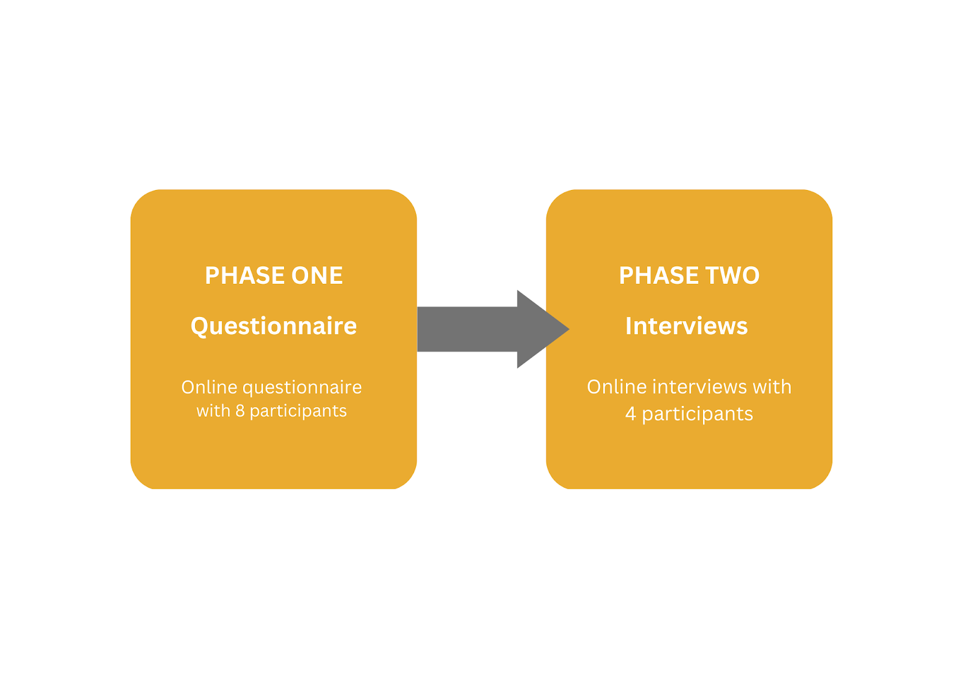
3.2 Ethical considerations
Participants in the research will be anonymous. Any information provided by the participants, such as their names or locations, will be removed during the data analysis stage. Some interviews were conducted with people known to the researcher personally as colleagues in the field. The perspective of an insider researcher is influenced by their socio-demographic characteristics and may also reveal a variety of assumptions, biases, beliefs, and expectations (Druzenko et al., 2014). It is common for insider researchers to possess intrinsic and tacit knowledge of a particular group (Bonner, et.al 2002). As a vocal coach, involvement in this research question can positively and negatively impact the project.
Table 1: Shows the advantages and disadvantages of insider research.
Insider research
Advantages | Disadvantages
Not seen as ‘strangers’ but members of the group. | Not seen as researchers but as advocates by some.
Incorporate traditionally ignored or  unrecognised perspectives into theory. | May be biased towards interpretation/findings.
More economical – know the culture and  language (jargon), familiar with local conditions. | May initially have difficulty re-establishing  ties with local ‘culture’.
Less inclined to construct stereotypes. | Unknown researcher qualities
Easier to gain acceptance, trust and  cooperation. | Reliance on participants with whom the  researcher feels comfortable.
Involve yourself fully with the participants  and their activities | Focusing on the dramatic events rather than the routine.
 | Experiencing role conflicts.
(Adapted from: Gerrish, 1997; Kite, 1999; Lipson, 1994; Miles & Huberman, 1994;
Schatzman & Strauss, 1973; Tom-Orme, 1991).

CHAPTER 4: PRESENTATION OF FINDINGS
The purpose of this study was to examine the singers’ responses taken from the questionnaires and interviews, especially using (Shewell, 2018) VPP questionnaire for quantitative analysis.
4.1 Phase 1 - Quantitative analysis
The sound of a voice has been described in a variety of ways over the years, including breathy, rough, strained, harsh, metallic, constricted, strident, strained, nasal, and husky (De Bodt, et. al, 1997). Even though other frameworks, such as GRBAS and CAPE-V, are available (Nemr et al., 2012), the VPP framework was included in the questionnaire to assess the core vocal skills used in vocal studios and to improve singers' understanding of voice function.
Procedure
The first phase of this study used VPP in the three-part questionnaire. An evaluation scale was utilised to determine the rating of eight vocal parameters. Each participant was asked to relate the questions to their own vocal experiences.
4.1.1 Results: Voice Perceptual Profile
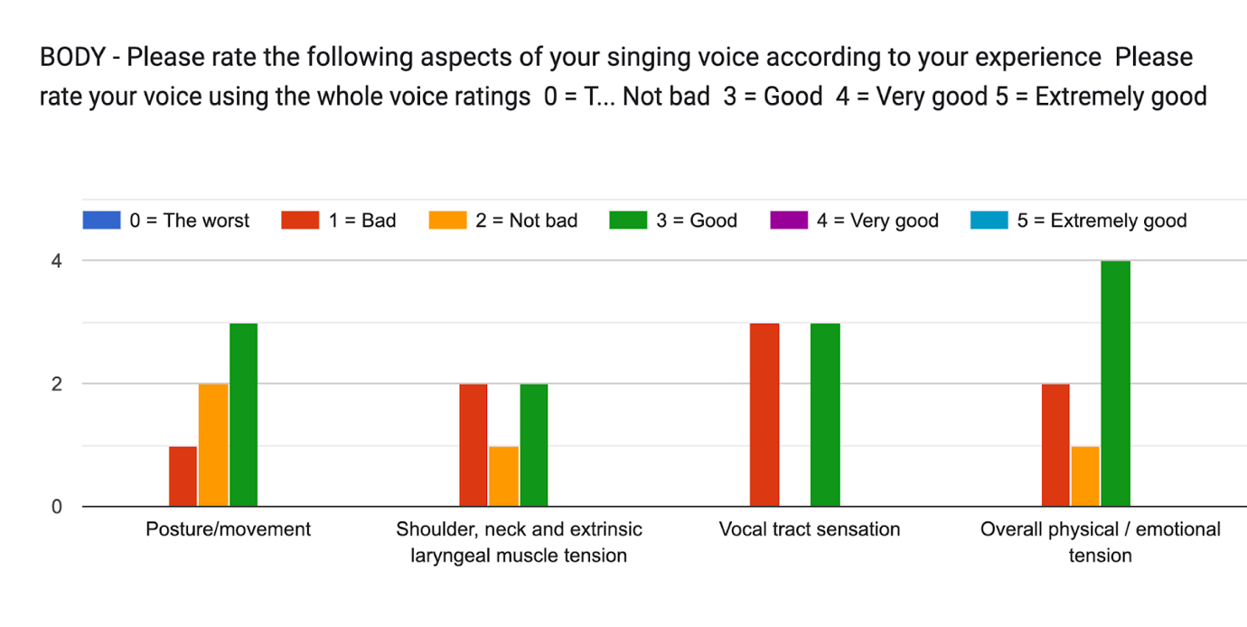

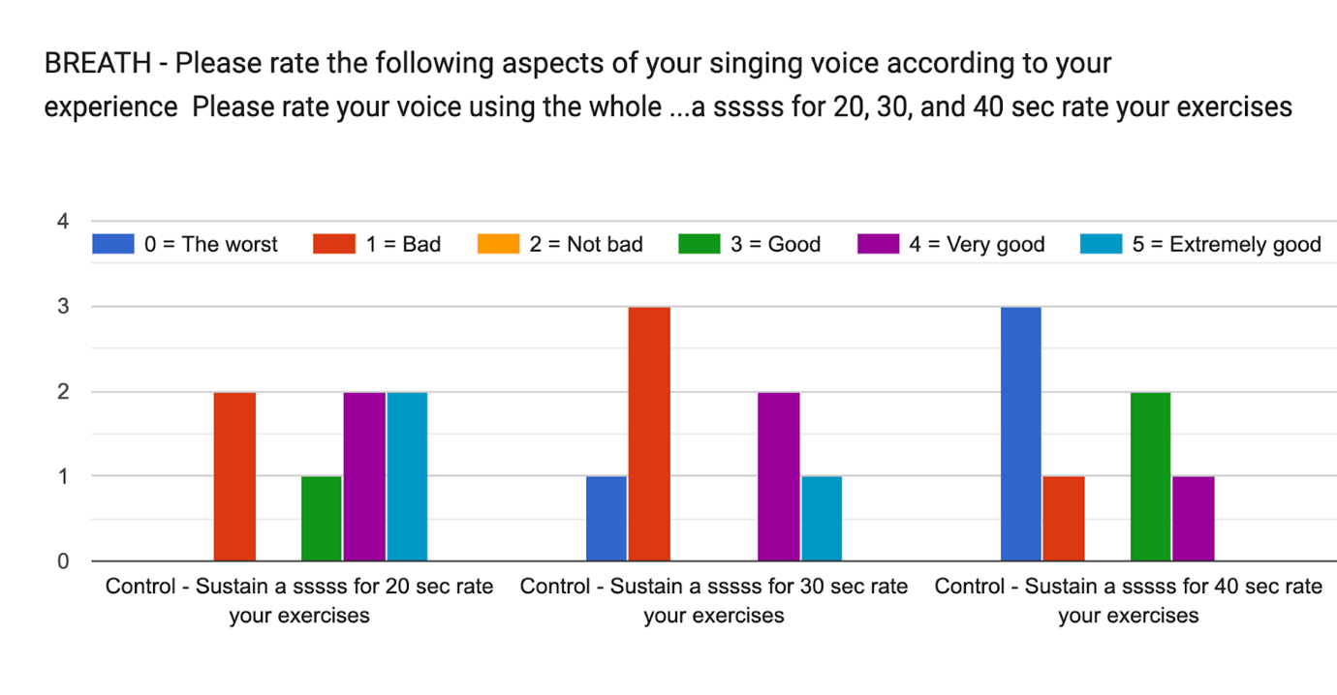
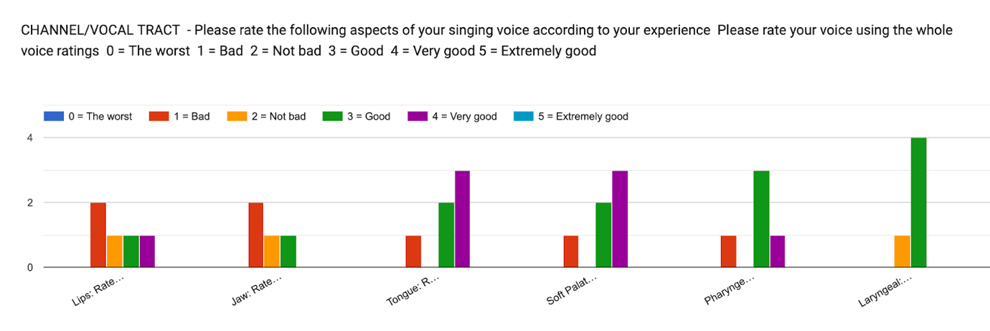

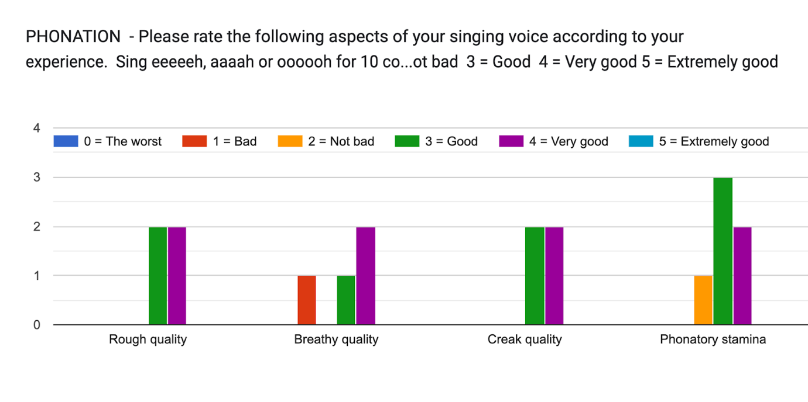

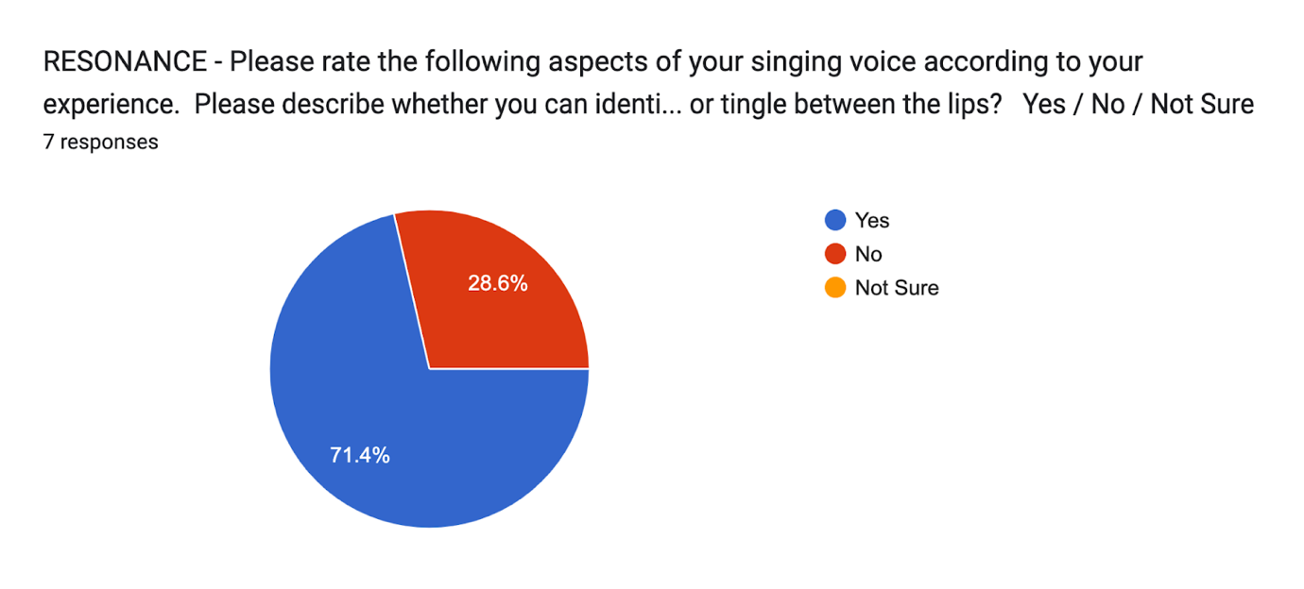
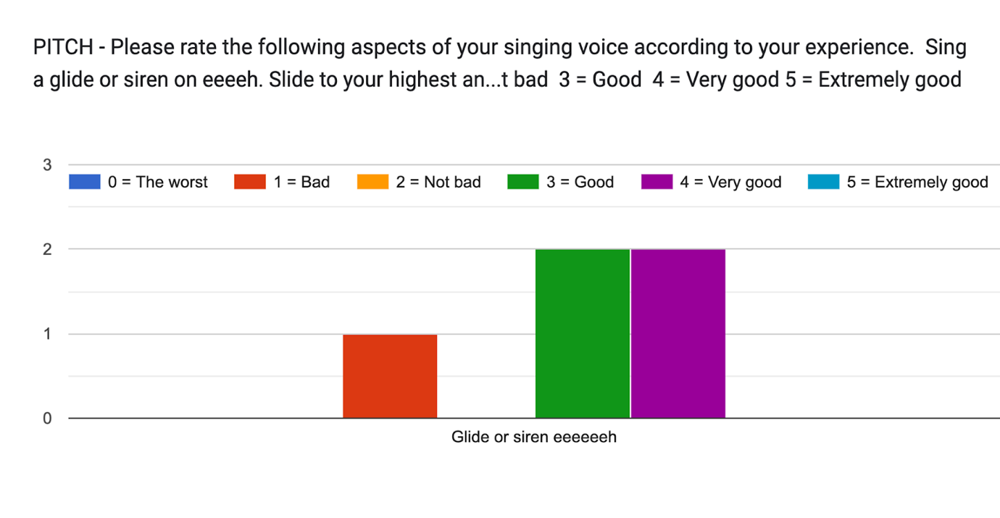
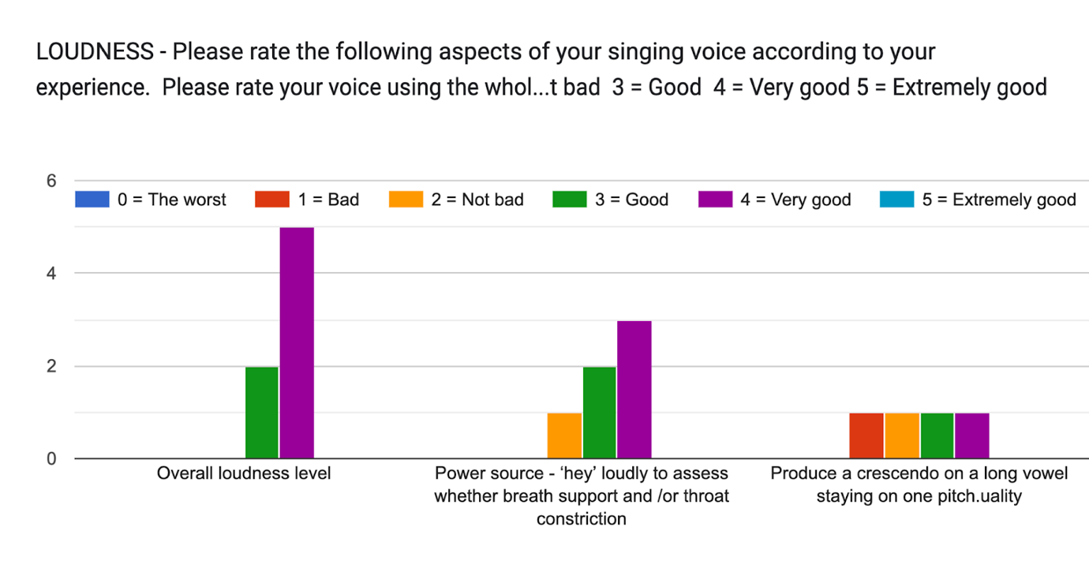
Figure 5: VPP parameters ratings.
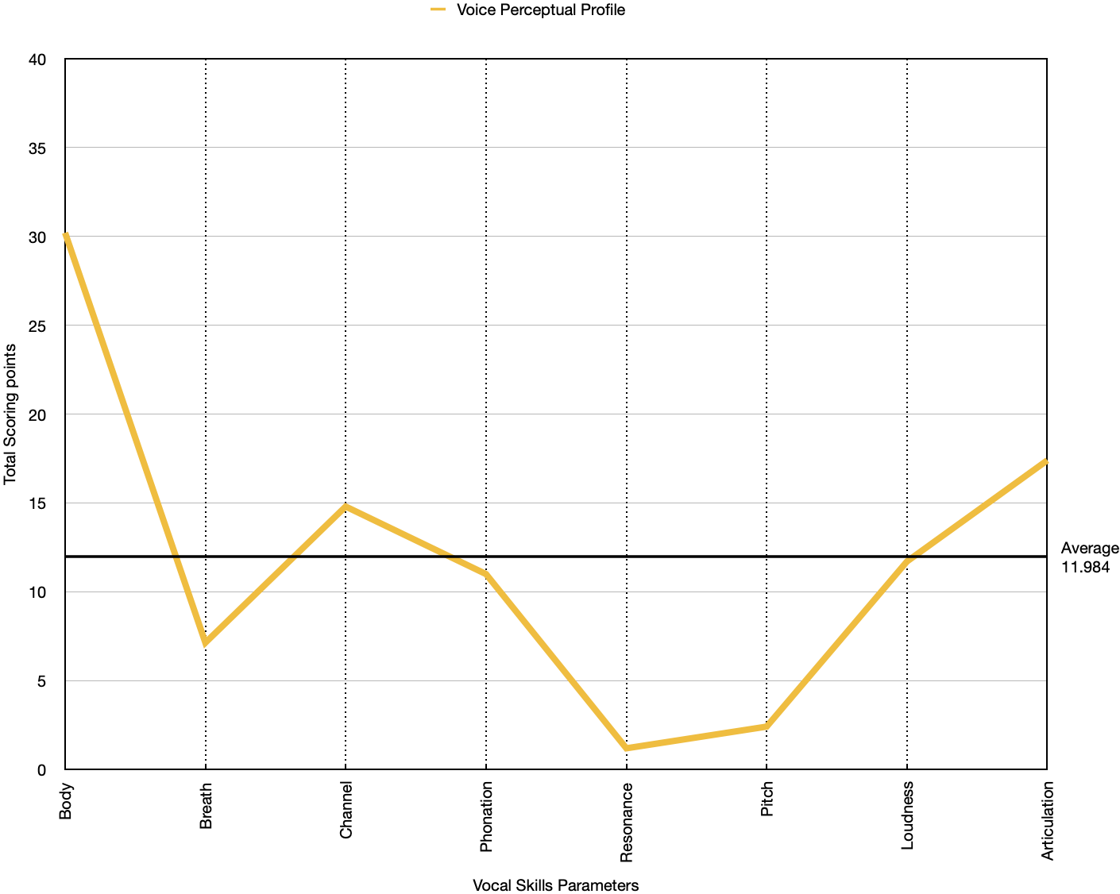 The VPP line chart summarises the impact of the parameters on the participants. The sample of the seven participants, with a median of 40 and an average mean is 11.984.
Overall, the body parameter received the highest rating; consequently, resonance received the lowest. However, resonances do not have multiple questions, contributing to the low score. Further analysis of resonance is needed.
Summary: Most participants could control and understand their voice in relation to voice skills parameters, which were helpful indicators for them to examine their own singing ability. In this study, the results varied across the data, so we are not able to provide a reliable correlation. However, this pattern of variation indicates that each person's vocal ability is unique. The VPP revealed that some participants needed help answering some of the questions related to channel/vocal. Notably, terminology, descriptive language and definitions are informative for singers' perception and education. Taking into consideration these parameters in our practice can help our student develop a positive send of self-perception and a positive attitude toward singing, which in turn will help them articulate and expression their vocal identity.

4.2 Phases 2 - Qualitative data
Braun and Clarke's (2006) six-step process of thematic analysis. After transcribing and reading the data several times, the data was initially coded using Quirkos software with two cycles of Invivo and process coding. After identifying patterns, potential themes were established, which were then compared within the data set. In addition, the data was revised, defined, and categorised into themes, and extracts based on those themes and the literature relevant to the research question were selected.
The cumulative themes that emerged from phase 2 data.
- Singing ability
- Learning
- Perceptions of the singing self
- Comparison
- Emotions
- Influences
- Vocal identity
4.2.1 Singing ability
“When you're singing, you're in control” - P4
The participants believed their voices expressed their feelings. The need for additional training was acknowledged by a few for full expression. Some participants indicated that their lack of formal vocal training affected their ability and level of confidence. Most participants had some experience with music education, choirs and vocal training. In this study, participants varied between untrained to professional. The study clearly demonstrated that untrained or amateur participants had a need to acquire an understanding of some basic vocal terminology. Even so, they made good use of the questionnaire by undertaking research on terms they were unfamiliar with. As part of their discussion in the interviews, participants used descriptive language.
Table 2: Language used by participants to describe their voices.
Participants | Descriptive language
P1 | Soulful, strong, yet calm, generally lots of tone and depending on what I am singing and what for it can be perceived as very expressive.
P 2 | Very calming, melancholic and soothing. I think it comes from my breathy tone.
P 3 | Loud and that I have presence and authority when I sing.
P 4 | I can sing. I can show emotion if it s the right song and I am feeling strong to sing it well, but I think it lacks omph!! I think both singers and non-musicians would generally like my timbre and tone it is easy to listen too.
Upon reflection, the vocal perceptual profile proved challenging for all participants who lacked technical ability.
“I found the second set of questions were hard because I didn't know the terminology like the larynx”. - P2
“Some of the stuff, I didn't understand the technical stuff”. - P3
When participants reflected on vocal perception, they seem to have a lower confidence level. Despite this, their motivation to sing encouraged participants to continue engaging in vocal groups and choirs to enhance their learning abilities.
“It makes me happy when I sing. Whether it is good or bad. My singing, I think it makes me happy. Whenever I do a choir or a session or wherever I am, I feel I've got to go there. And then when I get there, I really feel sort of confident and you know, happy and content with myself afterwards, almost like you know, better within myself and having achieved something. I think it's the success thing having achieved something”. - P2
All participants agreed that their vocal skills needed to be developed and that they would benefit from learning new techniques.
Table 3: Participants' response with suggested vocal improvements.
Participants | Improvements
P1 | Consistency
P2 | High pitch
P3 | Tone, breathing, delivery, style.
P4 | Stronger. More modern, and sexy! I feel all prim and proper and want to sound cool. Also, to improvise and ad-lib more confidently.
In phase 2 of the interviews, voice perceptual feedback was utilised to develop these responses.
4.2.2 Learning
It is evident that many participants are reflecting on their formative years of vocal and musical development. Participants found that primary and secondary school music education shape their identity and gave them a sense of purpose.
Table 4: Description of the process by which participants learned how to sing.
Participants | Learning
P1 | College at uni, but mostly self-taught
P2 | Short courses and youtube
P3 | Church worship band
P4 | Choirs

4.2.3 Perceptions of the singing self
Analysis of participants' perceptions identified that the singing voice is an intrinsic part who the whole being (Sundberg, 1977).
“Singing is you” - P4
“Singing it's about the sound. And how that comes out and how that affects. Yeah, so I suppose singing for me is a kind of a spiritual thing” - P3
“My voice and singing is a part of me and part of my identity. If and when my voice actually feels and sounds good I feel better in myself. More defined as a person, more fully me, less inhibited and less unsure” - P4
“I think that the voice is an intrinsic part of my, my being really” - P3
Table 5: Participants' descriptive perception responses
Descriptor | Response
Register | Head, chest and falsetto
Pitch | High and lower
Genre | Classical, R&B, Gospel
Voice quality | Warm, intense, lighter, airy, comfortable, breathy, ringy, soulful, loud and piercing
Classification | Alto, soprano, falsetto, mezzo soprano
The participants reflected upon how others perceive their voices.
“Very calming, melancholic and soothing”. - P2
Participants working on their perceived weaknesses considered vocality and development to be important factors.
“I think other singers will say I do have good moments and that I ‘can sing’. - P4
“Other non-musical people would say I can sing well. I think both singers and non-musicians would generally like my timbre and tone. It is easy to listen too.” - P4
Several participants agreed that rather than being an innate skill, singing can also be acquired through learning and developed over time with continued instruction.
“I think everybody can sing. Yeah, everybody, everybody who can speak, they can sing. I agree because, because singing is, you know, like building your muscle memories to recognise tones to recognise notes, melodies”. - P1
However, several participants referred to the formative years as crucial for vocal development.
“It is in your formative years, you know, when you're younger, like you know, I think that makes a big difference to your attitude to singing”. - P2
A significant portion of the participants believed that music education during their formative years negatively or positively affected them.
“It gave me a place and it gave me a position. But, and it was quite good, and I felt like important”. - P2
Positive effects were generally attributed to the individual, while negative effects were generally attributed to social interactions and influences.
There is a high level of self-criticism among participants, during the recordings of the phase one question.
“I felt really cringey. I felt embarrassed. I played it back twice or maybe three times to check. I watched it through and thought, I could have improved this bit, I could have improved that bit. So there I was very critical. I suppose the only positive really was, wow! I did it.” - P2
Music and vocal training are developed in a variety of settings, including choirs, church worship teams, bands, schools, and singing groups.
“From church worship band, then eventually self-taught using the Singing Success CD program” - P4
In addition to community singing, acting, and public speaking classes, well-being covering physical health and mental health also plays an influential role in vocal development.
“Allergies/rhinosinusitis/postnasal drip/ear problems. Fibroids / reduced movement of diaphragm / Menorrhagia/anaemia” - P4
4.2.4 Comparison
The theme of comparison emerged from all participants. When asked the question do you compare yourself to other singers? It was stated by all participants that they negatively compare themselves to others.
“I make comparisons with other singers? Yes, and sometimes that is fine and useful perhaps, but other times it makes me feel pretty lousy when I am not at my best (most of the time)” - P4
In contrast, some respondents emphasised the importance of comparison as a tool for improving performance.
“For sure! I compare it to other R&B and gospel singers with effortless trills or Broadway singers with clear singing, and I feel like I have to train myself more.” - P3
Analysing the effects of comparison in pedagogical texts, especially during formative years of vocal training, could assist the singer in understanding their own vocal identity.
4.2.5 Emotions
Participants also discussed an inherent emotional connection to the act of singing, in addition to their perceptions of singing ability.
“Singing...it’s an emotional thing” - P 3
“It makes me happy when I sing. Yeah, whether it's good or bad. My singing, I think it makes me happy” - P4
For this participant, singing represented more than just a simple activity. As an integral part of oneself, singing serves as a means of self-expression, creativity, and well-being.
“It comes from you, it comes from your soul”. - P4
4.2.6 Influences of Social Systems
As a result of the social context of singing, it has been found that social systems shape vocal sound (Lemon-McMahon, 2019). Among the key factors identified in literature include education, community, family, and cultural perspectives (Hughes, 2013, 2014; Pascale 2005; Rutkowski, 1990; Welch 2005).
Participants highlighted music exposure and experience, health, education, performances, and community.
“Learning to sing as a young person, all orchestra members had to be part of a choir, which were quite classical based musically. Being part of Newham Girl Singers made my singing kind of girly and sweet" - P2
It was found that positive peer support, encouragement, and validation were essential to ongoing vocal engagement, which is linked to vocal confidence or performance anxiety (Lemon-McMahon, p. 235, 2019). The impact of a single positive or negative incident can be significant for a singer's identity and confidence. Among the participants, one recalls both positive and negative experiences at secondary school that has influenced her confidence.
I found myself thinking about like, you know, good and bad times. You know, sort of what you know, the question about what influences, like... I could have written an essay. I think a lot of it is in your formative years, you know, when you're younger, like you know, I think that makes a big difference to your attitude to singing. - P2
There is evidence that positive and negative interactions during teaching can boost confidence and/or create performance anxiety (Osborne, 2016; Osorio et.al, 2017; Zakaria, Musib, and Shariff, 2013). Teachers are responsible for assessing their use of language, validating students in their lessons, and ensuring that their students are in a safe environment for vocal development.
Other influencing factors such as physical health and mental health, were identified as having a significant impact on the singer.

“Medically: Allergies/rhinosinusitis/post nasal drip/ear problems. Fibroids/reduced movement of diaphragm/Menorrhagia/anaemia” P4

“I’m struggling slightly mentally in life anyway, at the moment, and I'm unemployed at the moment due to sickness, and there's a lot going on in my life. - P2
4.2.7 Vocal identity
Despite not consciously considering vocal identity before, some participants recognised the importance of thinking about what it is during the interviews.
“I never really gave any thought to what it is. I mean, yeah. I suppose like, it's about you as a singer.” - P4
“how I see my voice, but more kind of like how, how clear I am about what I feel about my voice” - P3
Vocal identity was considered by all participant as impactful on their singing experience and some participants used terms like, "Signature voice or distinct voice". - P1 and P4.
For pedagogical considerations, it is essential to create frameworks that explore identity, how they produce sound, attributes that make sound unique. In addition, developing new techniques and adapt assessment to encourage singers to become aware and help them develop language to articulate their perceptions of their voice.
“It’s such a complex instrument, and there's so many things that play a part in affecting it”. - P4
CHAPTER 5: DISCUSSIONS
5.1 Emergent Themes
Table 6 - Emergent themes from phases 1 and 2
Themes | Factors/components
Theme 1: Development of singing ability | Lack of formal vocal training  Limited exposure to music  Confidence  Expression  Articulation  Self-worth  Inherent ability
Theme 2: Perceptions of the singing self | Formative years  Cultural background  Feminism  Economic background  Identity  Vocal monitoring  Sense of self  Auditory feedback
Theme 3: Learning | Training  Musicality  Opportunity for musical engagement  Perpetual learning
Theme 4: Comparison | Self-worth  Self-esteem  Validation  Motivation
Theme 5: Emotions | Confidence  Expression  Spirituality  Stylistic choices
Theme 6: Influences of social systems | Education  Family  Culture  Community
Theme 7: Vocal identity | Self-perception  Physical health  Mental health  Identity  Self-worth  Emotional connection
5. 2 Summary of research questions
Primary research questions: how does a singers' perception impact vocal identity?
During the study, using the centralised research questions helped navigate the broad scope of the topic.
“It’s such a complex instrument, and there's so many things that play a part in affecting it”. - P4
- What impact does the relationship between the singer and the voice have on vocal identity?
Using two phases in this study allows for descriptive feedback for singer's internal process and additional personal reflective practices that may benefit the singer and the teacher. Thus, singers and vocal teachers will have the ability to create and engage in a learning pathway that extends beyond just technique. The learning pathway has the potential to address more contributing factors, such as physical health, mental health, and mindfulness. Further frameworks could be included for validation, positive teaching styles, motivation, comparison, motor skills, reflective self-perception tests, and vocal acceptance.
- What factors influence a singer's identity?
Based on the literature review and findings, education, family, culture, and social influences (Monks, 2012; Lemon-McMahon, 2019).
- Is the identity of the singer relevant to singing?
Identity plays a significant role in the development of a singer (Kaplan and Flum, 2012). However, there are multifaceted components to identity, and more research is needed to understand the correlation between identity and vocal identity.
- What is the process by which vocal sound is developed?
Understanding the mechanism of the voice is crucial for the growth and development of the student. Using the VPP in this study created a systematic profile to navigate the core skills for vocal production. The research revealed that several participants struggled to explain their weaknesses or internal processes due to a lack of knowledge. Providing students with more knowledge can increase their confidence and singing ability to articulate their answers. Furthermore, lack of understanding may lead to misuse of the voice, resulting in voice disorders.
- Does ‘vocal identity’ exist? If so, what is it?
It is assumed that vocal identity does exist, but there are a wide variety of variables that affect it. Vocal identity is multifaceted and shaped by culture, identity, musicality, vocal education and training, vocal health, and musical experience. However, it has links to components that comprise the singer's self-concept (Lemon-McMahon, 2019). A correlation has not yet been established between these factors, and further research is required. Based on the findings, vocal identity does exist and is difficult to explain. Some participants used the language of “Signature voice” - P1 implying distinct characteristics that are recognisable, referred to by Yarnall (2017) who connects vocal timbre with vocal identity, comparing it to a ‘fingerprint’ (p.568). (See appendix J) for a reflective model on vocal identity.
- In what ways can the perceptual approach to voice skills (Shewell, 2018) assist the singer in understanding the sound of their voice?
Using the VPP, provided with constructive and informative parameters to measure their development. It offers students the opportunity to become aware of their internal as well as auditory vocal experiences, giving them a greater sense of autonomy and motivation. Teachers can use adapted measurement tools to track progress and adapt vocal plans based on their scores over a period.
5.3 Limitations
It should be noted that the study had several limitations beyond the scope of this project.
- The study comprises several centralising questions involving many variables, making it difficult to make meaningful correlations.
- Untrained participants were unable to answer some of the questions.
- Both phases could have more closed questions to narrow the focus of the answers.
- More research into the questionnaires detailed prompting to be considered.
- There were no direct questions about participants' cultural backgrounds.
- Although varying in age and vocal skill, only the female gender was identified.
- This research focused only on adult voices to enable some consistency in personal and vocal maturity across participants. However, the impact of childhood experiences was a significant finding. Therefore, a suggestion for future research would be to investigate adolescent voices.
- Due to the absence of audio samples, it is possible that the recording test was fabricated.
- Potentially, live assessments would be more beneficial so the participant may ask questions if necessary.
5.4 Recommendations
The ability to understand one's vocal sound will allow the singer to develop a greater sense of identity, expression, and vocal agency. In terms of pedagogical texts, there's a lack of guidance as to how to approach the singing self and vocal identity holistically.
The cumulative findings Singing ability
- Learning
- Perceptions of the singing self
- Comparison
- Emotions
- Influences
- Vocal identity
In addition, self-confidence, validation, and vocal experiences can have a long-term impact on a person's association with singing or singing attitude towards their vocal sound.
These findings raise some potential subset research questions.
- What are the effects of micro criticism teachers on students' performance and self-esteem?
- Analyse the effects of comparison on the singer.
- Perceptual assessments: how do they affect vocal development?
- Evaluate the effects of positive or negative validation on adolescent singers
- Critically analyse key components of vocal identity in adolescent
5.5 Future research
To facilitate comprehensive singing development and engagement, pedagogical practices that encompass vocal identity components are essential, especially in the formative years. The variances and correlations within these key components of vocal identity can be analysed in future research. As well as the impact of spectral analysis of vocal identity on the singer.
5.6 Conclusion
In this study, the initial hypothesis was to determine how the perception of the singer's voice impacts vocal identity. The scope of vocal identity is vast and has generated more question for further research. The study also attempts to contextualise and define vocal identity; however, more research is needed to determine what it is and a standardised way of measuring it.
An individual's vocal identity is shaped by a variety of factors (Hughes, 2014) and is strongly influenced by their social and learning experiences. ‘Voices serve as perceptual markers for deeply intertwined ideas about identity and music’ (Meikel p. 267-274, 2011).
In short, the voice provides others with an aural representation of who we are (Lemon-McMahon, 2019).) A reflective model which highlights the components of vocal identity and (see appendix K) vocal identity development pathway. A singer's vocal identity refers to their perception of the voice as a musical instrument, as well as how they develop their vocal sound. My research has inspired me to think about future pedagogical practices, including
- Vocal profiling assessment tools
- Use of language for critique methods
- Self-awareness models
- reflective practices
- Stylisation
- Mindfulness
- Articulation for singers

References

Arden, J. (2010) Rewire Your Brain: Think Your Way to a Better Life. Hoboken, NJ: John Wiley & Sons.
Batty, S. V., Howard, D.M., Garner, P.E., Turner, P. & White, A.D. (2002) ‘Clinical pilot study assessment of a portable real-time voice analyser’, Logopedics, Phoniatrics, Vocology, 27(2), pp. 59-62.
Becker, N. and Goffi-Fynn, J. (2016). ‘Discovering Voices: Expanding Students' musical and Vocal Ideals In An Urban Community Children's Choir’, The Choral Journal, 56(7), p.8.

Biesta, G.J. (2010). ‘Why ‘what works’ still won’t work: From evidence-based education to value-based education’, Studies in philosophy and education, 29(5), pp.491-503.

Bonner, Ann & Tolhurst, Gerda. (2002). ‘Insider-outsider perspectives of participant observation’, Nurse researcher. 9, pp. 7-19.

Braun, V. and Clarke, V., (2006). ‘Using thematic analysis in psychology’, Qualitative research in psychology, 3(2), pp.77-101.

Brubaker, R. and Cooper, F., (2000). ‘Beyond" identity"’, Theory and society, 29(1), pp.1-47.

Callaghan, J. (2000) Singing and Voice Science. San Diego, CA: Singular Publishing Group.

Callaghan, J. (2014) Singing and Science: Body, Brain & Voice. Oxford, UK: Compton.

Candy, L. (2016) ‘Practice-based research: A guide’, CCS Report: 2006-V1.0 November, available from https://www.creativityandcognition.com/resources/PBR%20Guide-1.1-2006.pdf last accessed 31/12/22.

Cohen, L., Manion, L. and Morrison, K. (2007) Research methods in education, 6th Ed. Abingdon: Routledge.
Creswell, J.W., Klassen, A.C., Plano Clark, V.L. and Smith, K.C., (2011). Best practices for mixed methods research in the health sciences. Bethesda, (Maryland): National Institutes of Health, (2013), pp.541-545.

De Bodt, M.S., Wuyts, F.L., Van de Heyning, P.H. and Croux, C., (1997). ‘Test-retest study of the GRBAS scale: influence of experience and professional background on perceptual rating of voice quality’. Journal of voice, 11(1), pp.74-80.

Dennis, A.J. and Smith, G.W.H.,(2015). Interactionism, symbolic, pp. 352-356.

Denscombe, M., (2017). EBOOK: The good research guide: For small-scale social research projects. McGraw-Hill Education (UK).

Denzin, N. K. and Lincoln, Y. S., (2000). Handbook of qualitative research, 2nd Ed. Thousand Oaks, CA: Sage.

Denzin, N.K. and Lincoln, Y.S. eds., (2011). The Sage handbook of qualitative research. Sage.
Doidge, N., (2007). The Brain That Changes Itself. London, UK: Penguin Books.
Druzenko, L. and Mansouri, F., (2014). ‘Social engagement among migrant youth: attitudes and meanings’.

Dunn, L., and Jones, N. A., (1994). Embodied Voices: Representing Female Vocality in Western Culture. New York, NY: Cambridge University Press.

Emmons, S. and Thomas, A., (1998). Power performance for singers: Transcending the barriers. Oxford University Press.

Erikson, E.H., (1968). Identity, Youth and Crisis. New York, NY: Norton.

Faircloth, B., (2012). ‘“Wearing a mask” vs. connecting identity with learning. Contemporary Educational Psychology’, 37(3), 186-194.

Fourcin, A., (2006). ‘Hearing and Singing’ in J. Chapman (Ed.), Singing and Teaching Singing: A Holistic Approach to Classical Voice, (pp. 227-240). San Diego: Plural Publishing.
Gerrish, K., (1997). ‘Being a ‘marginal native’: dilemmas of the participant observer’. Nurse Researcher, 5, (1), 25-34.
Ghazanfar, A.A. and Rendall, D., (2008). ‘Evolution of human vocal production’. Current biology, 18(11), pp. R457-R460.

Given, L.M. ed., (2008). The Sage encyclopaedia of qualitative research methods. Sage publications.

Gray, D. E., (2009). Doing Research in the Real World. 2nd Ed. Thousand Oaks: Sage Publications.

Griffiths, G.. (1985). ‘“Doubts, dilemmas and diary keeping: some reflections on teacher based research”’. Issues in educational research: qualitative methods, Edited by: Burgess, R. London: The Falmer Press

Haskell, J.A., (1987). ‘Vocal self-perception: The other side of the equation’. Journal of Voice, 1(2), pp.172-179.

Hewitt, J.P., (2003). ‘Symbols, objects, and meanings’. Handbook of symbolic interactionism, pp.307-325.
Hughes, D., (2013). ‘An encultured identity: Individuality, expressivity and the singing- self’. Australian Voice, 15, 13-19.
Hughes, D., (2014). Contemporary vocal artistry in popular culture music: Perceptions, observations and lived experiences. S. Harrison & J. O’Bryan (Eds.), Teaching Singing in the 21st Century, (pp.287-302). London, UK: Springer.
Kamiloğlu, R.G. and Sauter, D.A., (2021). ‘Voice production and perception’. In Oxford Research Encyclopedia of Psychology.

Kaplan, A., & Flum, H., (2012). ‘Identity formation in educational settings: A critical focus for education in the 21st century’. Contemporary Educational Psychology, 37(3), 171-175.
Karpf, A., (2006). The Human Voice: The Story of a Remarkable Talent. London, UK: Bloomsbury Publishing.
Kelly, L.M. and Cordeiro, M., (2020). ‘Three principles of pragmatism for research on organizational processes’. Methodological innovations, 13(2), p.2059799120937242.

Kim, Y.E., (2003). ‘Singing voice analysis/synthesis’ (Doctoral dissertation, Massachusetts institute of Technology.
Kite, K., (1999). ‘Participant observation, peripheral observation or a participant observation?’ Nurse Researcher, 7(1), 44-55.
Kreiman, J. and Sidtis, D., (2011). Foundations of voice studies: An interdisciplinary approach to voice production and perception. John Wiley & Sons.

Kreiman, J., Vanlancker-Sidtis, D. and Gerratt, B.R., (2003). ‘Defining and measuring voice quality’. ISCA Tutorial and Research Workshop on Voice Quality: Functions, Analysis and Synthesis.

Latinus, M. and Belin, P., (2011). ‘Human voice perception’. Current Biology, 21(4), pp. R143-R145.

Leigh-Post, K., (2014). Mind-Body Awareness for Singers: Unleashing Optimal Performance. San Diego, CA: Plural Publishing.

Lemon-McMahon, B., (2019). ‘The singing voice and vocal identity: Investigating the perceptions and beliefs of singers and teachers’.
Lipson, J. G., (1984). ‘Combining researcher, clinical and personal roles: enrichment or confusion?’, Human Organization, 43, (4), 348-352.
Mason, J., (1996). Qualitative Researching. London: Sage.

McCallister, C., (2004). ‘Schooling the possible self’. Curriculum Inquiry, 34(4), 425-461.

McCarthey, S.J. and Moje, E.B.,(2002). ‘Identity matters’. Reading research quarterly, 37(2), pp.228-238.

McCoy, S., (2012). Your Voice: An Inside View (2nd ed.). Delaware, OH: Inside View Press.
Meizel, K., (2011). ‘A powerful voice: Investigating vocality and identity’. Voice and Speech Review, 7(1), 267-274.
Meizel, K., (2011). ‘A powerful voice: Investigating vocality and identity’. Voice and Speech Review, 7(1), 267-274.

Merriam, S., (1998). Qualitative Research and Case Study Applications in Education. San Farncisco: Jossey-Bass Publishers.

Merton, R., (1972). ‘Insiders and outsiders; a chapter in the sociology of knowledge’. American Journal of Sociology, 78(July): 9–47.

Merzenich, M., (1998). ‘Seeing in the sound’. Nature, 404, 820-821.
Miles, M. B., and Huberman, A. M., (1994). Qualitative data analysis: an expanded sourcebook. London: Sage.
Miller, R., (1986). The Structure of Singing. New York, Ed.

Monks, S., (2009). ‘The role of vocal identity in developing a unique vocal timbre’. Poster session presented at International Congress of Voice Teachers, Paris.

Monks, S., (2003). ‘Adolescent singers and perceptions of vocal identity’. British Journal of Music Education, 20(3), pp.243-256.

Monks, S.J., (2007). ‘Perceptions of the singing voice’ (Doctoral dissertation, University of Sheffield).

Morgan, D.L., (2014). ‘Pragmatism as a paradigm for social research;. Qualitative inquiry, 20(8), pp.1045-1053.

Morgan, G., (1980). ‘Paradigms, metaphors, and puzzle solving in organization theory’. Administrative science quarterly, pp.605-622.

Nemr, K., Simoes-Zenari, M., Cordeiro, G.F., Tsuji, D., Ogawa, A.I., Ubrig, M.T. and Menezes, M.H.M., (2012). ‘GRBAS and Cape-V scales: high reliability and consensus when applied at different times’. Journal of voice, 26(6), pp.812-e17.
Nott, G., (2018). ATO now holds voiceprint (Online article). Computerworld. Available from https://www.computerworld. com.au/article/633461/ato-now-holds-voiceprint-one-seven- australians/. Accessed 10/12/22
Osborne, M., (2016). Building performance confidence. In G.E. McPherson (Ed.), The Child as Musician: A Handbook of Musical Development, (2nd Ed. Digital edition) (pp.609-634). Oxford, UK: Oxford University Press.
Osório, F.L., Burin, A.B., Nirenberg, I.S., and Barbar, A.E.M., (2017). ‘Music performance anxiety: Perceived causes and coping strategies’. European Psychiatry, 41(SS), S110.
Parkinson, A.L., Flagmeier, S.G., Manes, J.L., Larson, C.R., Rogers, B., and Robin, D.A., (2012). ‘Understanding the neural mechanisms involved in sensory control of voice’.
Pascale, L., (2005). ‘Dispelling the myth of the non-singer: Embracing two aesthetics for singing’. Philosophy of Music Education Review, 13(2), 165-175.
Patton, M.Q., (2005). ‘Qualitative research’. Encyclopaedia of statistics in behavioural science. Production, Neuroimage, 61(1), 314-322. Publishing.

Randles, C., (2011). “What is a good musician?” ‘An analysis of student beliefs. Arts Education’. Policy Review, 112, 1-8. Journal of Voice, 28(6), 688-693.
Rutkowski, J., (1990). ‘The measurement and evaluation of children’s singing voice development’. The Quarterly, 1(1-2), 81-95.
Sarup, M., (1996). Identity, Culture and the Postmodern World. Edinburgh, UK: Edinburgh University Press.

Schachter, E. P., (2005). ‘Context and identity formation: A theoretical analysis and a case study’. Journal of Adolescent Research, 20(3), 375-395.
Schatzman, L., and Strauss, A. L., (1973). Field Research: Strategies for a natural sociology. Englewood Cliffs: Prentice Hall.
Schmidt-Jones, C. A, (2017). ‘Open ends and means: Inquiry as a link between formal music concepts and informal music learning’. International Journal of Music Education, 35(4), 621-630.
Schumann, T., (2014). ‘Singer identity in adolescence’ (Dissertation). The University of Wisconsin, Milwaukee.
Selleck, M.A. and Sataloff, R.T., (2014). The impact of the auditory system on phonation: a review. Journal of Voice, 28(6), pp.688-693.

Shewell, C., (2013). Voice work: art and science in changing voices. John Wiley & Sons.

Silbert, L.J., Honey, C.J., Simony, E., Poeppel, D., & Hasson, U., (2014). ‘Coupled neural systems underlie the production and comprehension of naturalistic narrative speech’. Proceedings of the National Academy of Sciences, 111(43), E4687-96.

Silverman, D., (2011). A guide to the principles of qualitative research.

Stacey, R., (2000). Strategic management and organizational dynamics: The challenge of complexity. 5th Ed. London: Prentice Hall.

Stephens, E.G., (2012). Formation and prediction of the singing perceptions of self-labelled singers and non-singers. The University of Miami.

Sundberg, J., (1987). The Science of the Singing Voice. DeKalb, Illinois: Northern Illinois

Sundberg, J., (2013). ‘Perception of singing’. In D. Deutsch (Ed.), The psychology of music (pp. 69–105). Elsevier Academic Press. Available from https://doi.org/10.1016/B978-0-12-381460-9.00003-1 last accessed 22/09/22.

Sundberg, J., (1977). ‘The acoustics of the singing voice’. Scientific American, 236(3), pp.82-91.

Teddlie, C. and Tashakkori, A., (2009). ‘Foundations of mixed methods research: Integrating quantitative and qualitative approaches in the social and behavioural sciences’. Sage.

Thurman, L. and Welch, G.F., (2000). ‘Fore-words: Sunsets, Elephants, Vocal Self-Expression, and Lifelong Learning’. Bodymind & voice: Foundations of voice education.
Tom-Orme, L., (1991). ‘The search for insider-outsider partnerships in research’. In H. Hibbard, P. A. Nutting, and M. L. Grady (Eds.). Primary care research: theory and methods, Conference Proceedings, (pp. 229-233). US Department of Health and Human Services. University Press.
Welch, G., (2005). ‘We “are” musical’. International Journal of Music Education, 23(2), 117-120.

Welch, GF; (2017). Singer identities and educational environments. In: MacDonald, R and Miell, D and Hargreaves, D, (eds). Oxford Handbook of Musical Identities. Oxford University Press: New York, NY, USA.

Yarnall, S., (2017). ‘The ‘Real’Me: Practical Application of Research into the Perception of Vocal Timbre’. Contemporary Music Review, 36(6), pp.562-579.
Zakaria, J.B., Musib, H.B., & Shariff, S.M., (2013). Overcoming performance anxiety among music undergraduates. Procedia - Social and Behavioral Sciences, 90 (C), 226-234.
Zangger Borch, D., (2013). ‘Discover you vocal ID’ (Online article). Voice Council Magazine. Available from http://www.voicecouncil.com/discover-your-vocal-id last accessed 10/12/22.
Appendix A: Project information sheet for participants

Below are the details for the research project.
I am currently researching how vocal identity is impacted by the singer's perception of their voice, and I would like to invite you to participate in a three-part questionnaire and online focus group with 5-6 other participants. All data collected will remain anonymous.
If you would like to participate in this research, please read and sign the documents attached.
I have attached an Information and Consent form for your information.
If you would like any further information. Please contact me at 07810 897449 or singwithfreedom7@gmail.com.
I look forward to hearing from you.
Thank you in advance for your support of this research.
Yours sincerely,
Lyanna Austin
—--------------------------------

Appendix B: Participant consent form

Information and Consent Form
This document provides information about a research project I am currently working on. The
project is part of an MA in vocal pedagogy I am undertaking with the University of Wales Trinity
Saint David through the Voice Study Centre. I am keen to examine how vocal identity is
impacted by the singer&#39;s perception of their voice. The purpose of the proposed research
project is to investigate how vocal identity can be influenced by the perception of a singer by
utilising interdisciplinary approaches. This research will analyse the data collected from CCM
singers and explore implications for singing pedagogy.
This will involve:
● Providing consent to participate by completing a consent form (October 2022).
● Phase one - completing a three-part online anonymous questionnaire about your
experiences as a singer that will involve open questions for your response (End of
October).
● Phase two is participation in an online focus group (maximum of 6 participants) to further
examine emerging themes from the questionnaire responses (End of October), and
an optional debriefing session will be provided prior to submitting the report ( Jan 2023).
● The final report/presentation will be available to you (in late March).
If you have any questions about participating in this project, please get in touch by email at
singwithfreedom7@gmail.com or on 07810897449. If you are happy to participate, please
complete the attached consent form with a digital signature (your name is typed in the box) and
email it to me as soon as possible.
Many thanks in advance for your time and responses.

Lyanna Austin
Vocal Coach

Appendix C: Questionnaire

Vocal Identity: The perception of the singing voice
PART A - CONTEXTUAL

You will be asked a number of questions related to your personal vocal experience.
You will be asked to complete three questionnaires;
Part A - Contextual
Part B - Your perceptual profile
Part C - Your singing voice
The questionnaires are broken down into ten questions per questionnaire.
Please give a complete and detailed response as soon as you can, as this provides 'richer' data for analysis.
Email*
Valid email
Gender ( Please click on the relevant bar below)
Male
Female
Age range (Please click on the relevant bar below)
Date of assessment
Please describe your singing experience. E.g, choirs, vocal lessons, performances, artistry
Which description best describes your singing ability
Please describe your singing voice
Do you think your vocal sound is different when you sing live verses a recording?
If yes, please detail the differences and how you feel about them.
Are there any other experiences that have influenced your development as a singer
The Voice Skills Perceptual Profile

PART - B
You will be asked a number of closed questions related to your personal vocal experience.
Please give a complete and detailed response, as this provides 'richer' data for analysis. You will also be asked two multiple-choice questions. By answering these questions, you confirm that you have completed a participant consent form and are happy to complete all phases of the research. Adapted from the Voice Skills Framework (Shewell, 2018).
Email*
Valid email

BODY - Please rate the following aspects of your singing voice according to your experience

Please rate your voice using the whole voice ratings

0 = The worst 1 = Bad 2 = Not bad 3 = Good 4 = Very good 5 = Extremely good
Posture/movement
Shoulder, neck and extrinsic laryngeal muscle tension
Vocal tract sensation
Overall physical/emotional tension

BREATH - Please rate the following aspects of your singing voice according to your experience

Please rate your voice using the whole voice ratings

0 = The worst 1 = Bad 2 = Not bad 3 = Good 4 = Very good 5 = Extremely good

Control - Sustain a sssss for 20, 30, and 40-sec rate your exercises

Control - Sustain a sssss for 20-sec rate your exercises
Control - Sustain a sssss for 30-sec rate your exercises
Control - Sustain a sssss for 40-sec rate your exercises

CHANNEL/VOCAL TRACT - Please rate the following aspects of your singing voice according to your experience

Please rate your voice using the whole voice ratings

0 = The worst 1 = Bad 2 = Not bad 3 = Good 4 = Very good 5 = Extremely good
Lips: Rate on range of movement and apparent tensions and describe how that feels
Jaw: Rate on the degree of open or close settings, and on apparent or described excess tension
Tongue: Range of movement and apparent tension and describe front/back and close/open settings
Soft Palate: Rate on adequacy of audible open/closure settings
Pharyngeal constriction: Rate on whether audible constriction
Laryngeal: rate in larynx position and laryngeal muscle tension/laxness. Listen for frequent audible inhalation

PHONATION - Please rate the following aspects of your singing voice according to your experience.
Sing eeeeeh, aaaah or oooooh for 10 counts each on a note of your choice.

Please rate your voice using the whole voice ratings

0 = The worst 1 = Bad 2 = Not bad 3 = Good 4 = Very good 5 = Extremely good
Rough quality
Breathy quality
Creak quality
Phonatory stamina

Please describe your vocal stamina after a vocally demanding performance.

RESONANCE - Please rate the following aspects of your singing voice according to your experience.

Please describe whether you can identify the balance of head/oral/chest resonant quality. Hum on long mid-pitch Mmmmm, can you feel any tickle or tingle between the lips?

Yes / No / Not Sure
Question

PITCH - Please rate the following aspects of your singing voice according to your experience.

Sing a glide or siren on eeeeh. Slide to your highest and lowest notes.

Please rate your voice using the whole voice ratings

0 = The worst 1 = Bad 2 = Not bad 3 = Good 4 = Very good 5 = Extremely good
Glide or siren eeeeeeh
LOUDNESS - Please rate the following aspects of your singing voice according to your experience.

Please rate your voice using the whole voice ratings

0 = The worst 1 = Bad 2 = Not bad 3 = Good 4 = Very good 5 = Extremely good
Overall loudness level
Power source - ‘hey’ loudly to assess whether breath support and /or throat constriction
Produce a crescendo on a long vowel staying on one pitch.uality
ARTICULATION - Please rate the following aspects of your singing voice according to your experience.

Please rate your voice using the whole voice ratings

0 = The worst 1 = Bad 2 = Not bad 3 = Good 4 = Very good 5 = Extremely good
Consonants
Vowels
Pace
Pause
Fluency
Rhythm
Any other observation

Please describe any other observations in relation to the voice skills profile you would like to mention.

Your Singing Voice
PART - C
You will be asked a number of questions related to your personal vocal experience.
You will be asked to complete three questionnaires;
Part A - Contextual
Part B - Your perceptual profile
Part C - Your singing voice
The questionnaires are broken down into 10 questions per questionnaire.
Please give as complete and detailed a response as you can as this provides 'richer' data for analysis.
Email*
Valid email

How did you learn to sing?

Required

Have you had private (one-to-one) singing lesson?
If yes, please detail how your lessons helped your vocal development.
Long answer text

What other influences could have impacted your vocal development?
Long answer text

Please sing an entire song of your choice and record your performance. Please listen/watch your performance and detail your reaction to hearing your voice on that recording.
Long answer text

How does your perception of your voice impact your sense of self?
Long answer text

Tell me how others perceive your voice. e.g description of tonal, timbre and emotion expression
Long answer text

Do you compare your voice to anyone else? Detail how that makes you feel.
Long answer text
What are some of the areas for your voice you feel you need to develop to feel more confident?

Appendix D: Transcription of Interviews
Interview Participant 1

Fri, Oct 21, 2022
7:54PM
47:05
SUMMARY KEYWORDS: sing, singing, vocal, question, songs, voice, people, singer, identity, tone, sound, hear, listen, thinking, bit, thoughts, speak, worship, friend, describe

Participant 1 00:50
I think it's quite interesting. Is just like, I still wonder, I mean, like the detail of the purpose of your questions. And as a vocal coach. I'm a bit, it not confused, but it's, you know, like to find, to decide, which should I choose, you know, like, from one to five or four, it's worse or bad or good?
Moderator 01:23
Yeah, yeah. Yeah, I understand. Yeah. And did you find the line of questioning clear? Or did it need more specifications? Because I had some a few people wanting to know how I wanted them to answer. So it was really interesting. Sorry.
Participant 1 2 01:45
Well, actually, some questions, I find this a little bit confusing but since at that time, I think that we are we were going to have the group discussion. So I was at that time, I thought that I don't have to I just answer it, and then later, probably, we could discuss about it.
Moderator 02:09
Yes, that's wonderful. It's really helpful to get your feedback on any questions that you didn't really understand. So I could make changes for my next project.
Participant 1 2 02:21
You study, vocal, or?
Moderator 02:23
Yes, so I'm a vocal coach. And I'm on of voice pedagogy masters. And so yeah, so part of my course.
Participant 1 02:32
I'm really interested in, you know, like, vocal because here in Indonesia, . I also, you know, like, I help people and I do vocal coaching too.
Moderator 02:44
Yeah, that's amazing. I think Fina has told me about you before. You do some workshops. Is that correct? So that's wonderful. It's really good to have people from different backgrounds as well. So just so lovely having, knowing that you're a coach, so you can, you know, speak into some of the things that you've experienced. Before we move forward on, the questions I had for you. I would love to know what questions did you need more elaboration on? If you could let me know.
Participant 1 03:21
Let's see part A vocal identity the perception of singing voice. All right, please describe your singing experience; choirs, vocal lessons, performances, artistry. Well, I forgot what I answered. I think it's performances. Right. Well, that one it's a little bit confusing. Yeah. Because, describe your singing experience?, I thought it's, you know, like probably like state your considered. about you know, like, about vocal. I think it's, it's better if you give, you know, like choices. So like, yeah.
Moderator 04:46
Maybe more prompting, do you think ? Yeah, prompting the reason why I didn't do choices because everybody's experience is so vast. So I didn't want to, you know, reduce that to what I know, you know, some other people could be doing something completely different that would I would love to know about. So maybe that's why that's why the question is for you to just answer like, Oh, I've done gigs, I've done in musical theater, I've done this, I've done that, you know. I sang at church or you know, whatever your experiences as a singer, or, I've not done any of those. So just kind of finding out what it is that build your singing experience. Yes, do fantastic. Anything, any other question?
Participant 1 2 05:36
Also, this one, you know, like, if you're a singer, amateur professional or untrained. It's really like, am I an amateur? Professional, even though you know, like, your career as a singer. But people tend to be so humble and think that they're still amateurs.
Moderator 06:02
Yeah, it's hard, it’s your perception of yourself, isn't it?. It's you're like, Oh, well, who am I? You know? So that's really interesting that that has come up, you know, as a Oh, interesting question. So thank you for that. That's really, really helpful.
Participant 1 06:24
And please describe your singing voice. Yes. I don't think I answer that.
Moderator 06:31
Okay. Yeah, can you tell me why?
Participant 1 06:34
Because, in what way do you want me to describe my singing voice from the pitch? From my experience from my, my, you know, weaknesses, or from which way?
Moderator 06:50
Yeah, so it needed a bit more prompting on that question. Yeah. So for example, It’s actually is quite interesting, because I think I didn't want to prompt. But how do you hear your sound? You know, there's more layers there that needs to be investigated with regarding this question. So…maybe it's the timbre? Or maybe it's the the range? So maybe I could do some tick boxes? And then you can describe based on those, do you think that would be better?
Participant 1 2 07:35
What exactly do you want from this question though?
Moderator 07:38
It's more about how you perceive your sound. So more about what you think are your honest thoughts about your own voice and how you would describe it. If someone imagined talking to someone who's never heard your voice before? How would you describe it to them?
Participant 1 07:54
Okay, like I sound a bit breathy. And my, I think I explained that under some part of your questions, like my sound in my lower pitch, I sound a bit better than my higher pitch. No. Like, it's a bit bright that I don't like it. Yeah, but at a lower tone. I really like it. I like my singing voice. I don't like my speaking voice.
Moderator 08:33
Interesting.
Participant 1 08:34
Yeah. Because people tend to do when, whenever they hear me singing, you know, like, they hear my recording. and then they said, Is this really you? I said, yeah, because I have I’m s good impersonator. Whenever I sing I just, you know, like, in whatever perceptions, I can do, you know, like, like this, or this sound, you know,
Moderator 08:59
Yeah,
Participant 1 09:00
I speak, I speak like this. So it's that's how I described my singing voice.
Moderator 09:08
No, that's wonderful. Thank you so much. And again, that's really helpful to know, how that question felt for you, and a better way to describe it. But that's why I wanted to have a discussion afterward, so that I could pull on anything you didn't understand, and anything you wanted to comment on as well. So, this is really, really helpful for me. Okay, unless you have another question that you just like want to know.
Participant 1 09:40
No, it's okay.
Moderator 09:43
So I want to discuss your reaction to your own recording, because one of the questions was to sing a song. What you know, recorded video or voice memo, and then listen back to it and write how you felt about it. So I just want to hear from you about your response to your own voice being played back to you. How did you feel?
Participant 1 10:12
Well, for singing that's the thing, I think it's this very vast and it's very hard, when you ask a singer to listen to her own voice, or their own voices. Because, again, for some songs, are the songs that I like to listen to me singing it again. I think it's, you know, for some songs, I really like, the way I sound.
Moderator 10:51
Right?
Participant 1 10:52
Yes, but for other songs, especially for songs again, go back to why I don't like my higher pitch songs. So if I sing powerhouse songs, like Beyonce song or Celine Dion, well, I kinda, you know, it’s a bit uncomfortable to listen to my own voice.
Moderator 11:18
Yeah. So, it's uncomfortable depending on what song? Okay. Um, can I ask you what song did you choose to sing?
Participant 1 2 11:32
I sang Coldplay
Moderator 11:33
You sang Coldplay. Okay. Yeah. So when you were listening back to a song that you know very well, and you like, yeah. How did that feel? Just describing words of the feeling of it.
Participant 2 2 11:47
Okay. You know, like, What do you mean? What would you feel?
Moderator 11:57
So like, if I was listening to my voice, which I do all the time, cause I do demos for songwriters and things. So I did one the other day. And I was listening back and I was like, Oh, I like it. I like what I've heard back. Like in as, especially as a vocal coach, I can hear all the moments that were insecure, that weren't steady in tone. I could hear some pitch things. So I'm thinking from that point of view, I can hear the elements that are wrong. Okay. However, I like my tone. I like the tone of my voice. Sometimes I wish it could be higher. So that's why I would write all these things down. So sometimes I wish it could be higher. If I compare, if I bring comparison into it. You know, I compare I would like it to sound a little brighter. But that's because of outside influences, right? But, when I'm listening to my own tone, I recognize me I know, that's a nice tone. I know. It's nice and rich quality. My voice has a really soulful, deep quality to it's very rich, I enjoy that about the sound because it reflects me. However, the negatives would be, oh, I can hear that there are some insecurities when I'm singing specifically, anything airy. Sometimes my onset isn't great. So I have to or over sing on the onset, so I have to work those things out. So I've got this positive and negative thing going on in my brain about my sound. But what the question is, is not necessarily to be guided by my perception of how I analyse myself, but I'm looking for like, okay, when you heard it, what was your natural reaction? Like, I liked it or I didn't like it. It was good. And this is why, you know, just a few thoughts on how you how your brain thinks about listening to your own voice.
Participant 1 2 14:09
Well, most of the times I feel comfortable listening to my own voice singing, then speaking. Yeah, and you know what, even because I am so comfortable listening me singing. When I get nervous, you know, like, just automatically I was sing.
Moderator 14:34
Wow, okay, that's really interesting. Yeah. So when you feeling nervous within yourself, you'd like to sing to help you. Right. Can I ask a few questions about just to prompt a little bit more with your reaction so when you listen to your voice. You like it? And do you like your tone?
Participant 1 15:09
Yes, well, I like my tone. I like how I you know, like do the rendition. What do you call that? Rendition of your of the song.
Moderator 15:24
Your interpretation?
Participant 1 15:26
Yeah. Yeah. My own interpretation, because I think that as a singer, that's one of my strengths in singing by changing people’s song. You know, I like it becomes like my own song.
Moderator 15:45
Yeah, that's amazing.
Participant 1 15:47
I like, I like the tone. I like how I do it. I think I have my own, you know, like signature kind of thing to interpret any kind of songs that I sing.
Moderator 16:00
And do you feel like you're an expressive singer? So, you feel your emotions when you sing as well? Yeah, yeah. and what were some of the negative things you like? And things I didn't like.
Participant 1 16:15
Well, I consider my voice like a melancholy voice, you know, I get put character into my tone. So every time you know, like changing upbeat on upbeat songs.
Moderator 16:33
Yep!
Participant 1 16:34
Um, if I don't change it into my, you know, like, my own interpretation, the way I sing it. It's really hard for me to sing an upbeat song. You know, it's like, it's, most of the time I feel like, oh, I don't like,
Moderator 16:51
Right, right. Interesting. Okay, so I'm going to ask another question, one second. Do you feel that you're voice or how you hear your voice gives you a sense of self? Like self worth? Do you feel that there's a connection between the two? Like, when I'm confident or when I'm feeling like, you know, happy or something like that is your voice? Is, there's a connection between how you sing? Um, is there any thoughts there? If that makes sense?
Participant 1 17:48
No, I did get a question. No. Okay.
Moderator 17:52
So, the idea is that your voice?
Participant 1 17:56
Okay.
Moderator 17:58
Your singing voice. Is there a connection between how you sing and does it help your confidence? Does it help your self-worth? Or is there no connection at all?
Participant 1 18:14
I think it contributes a lot to my confidence, you know.
Moderator 18:23
Can you explain how? Again, the way I interpret any songs that I sing. And also the feedbacks coming from people.
Participant 1 18:41
So it brings me energy to to sing, you know, like to sing and kind of sounds to do the singing. You know, like for for like, helping people like motivating people encouraging people sometimes even if I don't have any gift to give on my friend's birthday. I just have my voice. It's not because I'm, too you know, like, I'm narcissistic, it's just like for certain people a lot for my best friends. They I think it's more useful for them because that's always their feedback every time they listen to my voice. So I send them or when they get sick, I just send them you know, like a song that can motivate them by helping them like singing, even a simple song like… 'God is so good'. Four lines and they will feel like being like, lullabied by it by my voice.
Moderator 20:07
Yeah, that's amazing. That's such a gift. I have another question about this is very, a very obscure question that just needs a bit of help. Because I'm still struggling with this question myself. That's why I want to do the research. But when you hear the word vocal identity, could you just tell me what you think? That could mean?
Participant 1 20:36
Okay, that phrase, I think, represents timbre, And because it's not only singing, I think, you know, this is what I just learned in YouTube, because I also do public speaking, workshop training. So, there are two things that can be found to, you know, like to build you as a person. The first is your visual image and the second is your vocal image. So, when you say vocal identity, I think it's more or less the same, like, your vocal image, you know, your sound, the tone, how will you use the tempo, the intonation, the way you speak, or you sing? I think that is part of the things that you know, like, considered as your vocal identity.
Moderator 21:48
Fantastic. That's such a such a good way of describing vocal identity. And so, if you were... Do you think that understanding vocal identity is important to a singer?
Participant 1 22:07
Yes
Moderator 22:08
Can you tell me why?
Participant 1 22:10
It's really important. Because you want to be recognised, you know, by the tone when people don't see you. But when they hear you singing, those say, up, this must be Billy Eilish. This must be Celine Dion. So I think vocal identity can help singer to do you know like to, for people to help them to recognize you as a singer.
Moderator 22:43
Wow.
Participant 1 22:45
Yeah.
Moderator 22:46
And do you feel that with vocal identity even though because I'm, I'm thinking about the perception to how you see yourself and how you hear yourself can affect your vocal identity? Do you think there's space to say how other people what they think of you can affect your vocal identity?
Participant 1 23:09
That's interesting questions. Yeah, okay. I think it contributes a lot to your vocal identity, whatever people said about your voice. Because well, besides me singing as a singer, I also sing as a worship leader in a church. So when you lead worship, sometimes you just can't be you, you know, like doing your something else.
Moderator 23:49
Interesting. Very interesting. Yes.
Participant 1 23:53
So, when I lead vocal and when I lead worship I will sound very bold with my voice. You know, like singing, “We worship you. Hallelujah, hallelujah”. You know, I can but I don't want that voice to be recognised as my vocal identity.
Moderator 24:22
Can you say why?
Participant 1 24:28
This is really interesting. I never thought again, I think if we go back to the first questions, because how do you perceive yourself ? How do you see yourself as singer? because I feel comfortable listening to my own voice singing Rather than if you hear your voice singing. “Hallelujah, Hallelujah”, yeah, you know for people and for congregations in, in the surface, I think it's okay, but not like the whole day I can listen to myself.
Moderator 25:34
So, do you think it's to do with where you are as a singer and the environment that you're you're in. Does that shifts and changes how you sing? So, for me, I'm worship leader too. So I'm thinking, Oh, I wouldn't do what I would do, like if I was singing my own songs. Because, I first of all, I know that people get distracted. You know, there'll be like, what's she doing? Why is she you're showing off? But I think growing up, I was like, Oh, I don't want to show off. So I'll sing good enough. And then I will show off when I'm singing like jazz or like R&B or, if it's my own song, because I have full control of it. But in another setting, it's like, I've had people say, you know, you don't have to sing that much. You know, you can turn it down. It's just, it's just church, you know. But then what I realised is, is that social settings and social influences have a part to play in your development as a singer. So in the back of my head, I've got like, I sing a certain way at church, and then on my songs, I sing a certain way. And why is that? Why can't I be accepted? I'm just thinking, why can't I do that? And maybe there is some rules that we must follow, because, you know, it is distracting, obviously the songs are for congregation. Therefore congregation, so it's got to be a certain way that people can sing it.
Participant 1 27:28
And sing along songs.
Moderator 27:30
Yes, sing along songs, you know, so if people aren't vocally, able to sing, because I've got more of a more training, singing for the untrained basically. And so, I've got to consider those people. But does that affect me as a singer? So, it's just these thoughts, I'm just throwing out to you because I just think just your answer just really just started to make me think about, oh yeah, I do that too. If you've got any more thoughts on that. Do you identify with that ? with what I was just saying, Do you feel more there's more?
Participant 1 28:16
Well, to wear the word worship leader on my sleeve sometimes it, you know, like, because when you said worship leader. With the loud voice and stuff. That's what I don't want to be my signature or voice vocal., I think singing in church comes with characters, but you have to be loud, they have to be very powerful. Because, you know, whenever you lead worship, you will have to be able to sing almost all kinds of songs, great pop songs, if you sing Hillsongs, or a bit gospel. If you think Israel Hougton, you know, like Kirk Franklin, and you shouldn't be able to sing. Also, like for example, or I forgot her name. You know, those songs Taya probably from your songs.
Moderator 29:55
Yeah. Yeah. Softer, sweeter.
Participant 1 29:58
You have to, you have to have a versatile kind of sounds? That's what I don't want people to identify me, you know, as, as a worship leader.
Moderator 30:13
Right. But that's something you like to do, though, isn't it?
Participant 1 30:17
Yeah, I really love leading worship. I really love. You know, like, it empowers people. Yes. I love singing something that can empowers people, it can you know, like motivate people. Yeah, I can draw people to God.
Moderator 30:40
And do you think that? So, you said, you don't want to be identified as that, even though that's something you do? So, do you think that vocal identity is more specific? If you're singing in a specific thing, say for example, you're doing worship. But that's not how you ‘Sing Sing’, you know, I sing better in this genre. So, how can we get specific about what that means for you? So, if it's not, if your vocal identity is not formed from that, what what is what kind of genre or what kind of aspects help you to understand that vocal identity? I don't know if I made any sense there. You know, I mean, like, so for example, I identify with you the same like, my worship, leading voice is not something I feel like, is me fully. Yeah, it's just one part of who I am.
Participant 1 31:54
Yeah, that's only one part.
Moderator 31:56
So then, that leads the question. Oh, so there's multiple things that helped to develop me as a vocalist and my vocal identity through my timbre through my, you know, the quality of my voice quality, you know,
Participant 1 32:16
Dept of the tone, right?
Moderator 32:19
Yeah. And my dynamics, like how I add my expression of emotion, in my singing, so, this is really good. Like, we don't have the answer, but just the fact that we're asking these questions is like, Oh, wow, it's not just one. That's just not, that's one part of who I am. And I've got another part. And so all of these combined, maybe make up this vocal identity? Yeah. What do you think?
Participant 1 32:57
Well, I think I think it's, um, as you know, like, if we talk about go back to a vocal identity, well, yeah, there should be more than then a worship leading kind of voice, I think worship leading kind of voice cannot be identified cannot be, you know, like, be put as, as the point for your vocal identity. It's just, you know, like, it's, it's the, I think it's just got to be some art to your vocal identity. Yeah. This is me speaking as a professional singer. But if you ask people who minister as a worship leader, but doesn't work as a singer, you know, professionally, I think they want that to be contributed, as, you know, like they vocal identity.
Moderator 34:13
Why, wow, that's very interesting. Because what you're saying is, because you're a professional, you have more understanding and knowledge of the vastness of music, and this and what it means to sing in different genres. But if you only really like, listen to worship music, yeah. That means that that would be your world. So then your vocal identity would be formed around that. That's interesting. Wow, you're so wise. So wise, I love it. Okay, so any other thoughts? This is the last question. Thank you so much for giving me your time. I know it's very late.
Participant 1 34:59
Well, I like, you know, like, I'm always challenged to find, or to, to simplify everything. Even though from my experience, coaching people to sing, this is what I found, it's really interesting that I think everybody can sing. Yeah, everybody, everybody who can speak they can sing. I agree, because, because singing is, you know, like building your muscle memories to recognise tones to recognise notes, melodies. That's where I, I found that when, when a friend of mine, want to give her a gift for their parents. And then they said, I want to sing, you know, this specific songs. Can you? You know, like, train us how to sing. I said, Yes. And then when my friend introduced to fiancé. He said, you know, Maida. I’ve never sing before never, ever, ever, ever sing before. And that time, I thought, Oh, my God, it's going to be hard. Yeah. And the song that he asked for them to sing is 'You raised me up'. You know, like, it's really hard, soft. But again, he said, You do anything you want, because I'm really, really not so into it. I really want to learn how to sing for a month for Okay, 10 sessions. I just give him you know, like, at first, I listen to his voice. Yeah. And it's awful. Based on tone based on pitch, it was like, oh, no. And then they're three more months to get married. So, I said I need 10 sessions. If I fail, you find another coach. So I do 10 sessions, just to fix on his ear first. Yeah. So, and then when I fix his ear to listen to himself, you know, like I give them certain onset, or me like to sing and then getting used to their voices. I know, like, at first, he doesn't understand and then when he can listen that he's not his off or on pitch. It's, it's really good because he can train, you know, he can exercise. And from that experience, until, you know what long story short, he managed and I considered he succeeded singing that song. Yeah, because I learned the repetition. I don't give them any other songs for them to practice. I just keep on repeating the song, you know. So, get their vocal cords, and all the signals in their body recognise the song that song. Yeah, so it's okay. You don't understand any kind of songs, just this song. Just like repeat from that experience. I learned, you know, like this muscle memory, just like when they learn how to drive how to ride a bike. So, I put that theory into this, you know, like this practice. And I’ve tried to change, people mindset about singing. Yeah. Because sometimes when you said, I can't sing, I'm sorry. Because you have this perception when you say I can't sing. And then in your head, there's Beyonce. And then when you say you can't say you can't sing like, who's in your mind?
Moderator 42:01
Yeah. Comparison. Yeah.
Participant 1 2 42:02
Yeah, the comparison. So I said, everybody can sing. So that's my, from the whole experience of me singing and vocal do a vocal coaching. I think. Because most people when I said, everybody can sing this, some of them still laugh at me. You know, like, no, or sometimes they make jokes like, oh, you sound bad. You should be better, you know, like that. Because she's said that everybody can sing.
Moderator 42:37
Wow, understand? Yeah, yeah.
Participant 1 2 42:41
I think, yeah. I love, you know, to help people to sing, because I think singing is one of a great things to, you know, to escape from. Any troubles of life? Yeah. Yeah, we just sometimes you just don't want to listen, right? You want to sing it out?
Moderator 43:11
Yeah. There's something about us as humans, that there's, there's a purpose why we sing, there's there's something that's connected to the act of singing that. I mean, there are scientific, you know, research that kind of says it releases, specific endorphins. And, you know, it's calming or, you know, dopamine, you know, it makes you happy. So, it's, there's evidence behind that as well. And especially for like mental health. Yeah, more research coming out about mental health and the effects on singing has on that. So it's really, it's really interesting. But thank you. So, so much, it's time for you to sleep
Participant 1 2 43:58
Thank you very much for involving me having me.
Interview Participant 2
Fri, Oct 21, 2022
6:36PM
21:14
SUMMARY KEYWORDS: singing, good, secondary school, sing, choir, song, singer, coming, play, thought, vocal, question, identity, sound, recording, music, feel, thoughts, belting, solos
Participant 2 00:04
I found the second set of questions were hard because I didn't know the terminology like the larynx and all of that, I know it did say your own perception of it, but I did google a couple of things. So that they were quite hard. I think probably someone that's like more professionally trained would know that them but yeah. The ones that the ones that where it said, Say ee, like, you know that that was easier? Because it was explained? Yeah. When I got to the question that said, like, record yourself. Oh, my God. Whaaat!! Should I just answer it, because I know the answer. And I was like, no, no, do it properly. Yeah. So had me phone. But yeah. That was good. But yeah, the questions, the questions were good. It kind of like, took me back, like, to my childhood quite a lot. Yeah, I found myself thinking about, like, you know, good and bad times. You know, sort of what, you know, the question about what influences, like... I could have written an essay. I think a lot of it is in your formative years, you know, when you're younger, like you know, I think that makes a big difference to your attitude to singing.
Moderator 01:48
Yeah, 100%. That's good, that, I'm just loving what people are saying. So I'm just really taking in what you're saying. Because you can see when people are really thinking about it, the kind of emotions it evokes. And like you said, it took you back to your formative years. And, that's really key because it's like, okay, but then what happens in the formative years that can actually shift and change with sound. So that's a really, key thing for me that you just said that. Thank you.
Participant 2 02:19
Yeah, I think it was very odd for me, because I was kind of like, I didn't have a great time at Secondary School. I did wonderful time at primary school. You know, singing that age, you know, in choirs and stuff. But like, at secondary school, it was very much a double edged sword with me. I was, I was bullied a bit for like, my image, and my parents were hippie parents. I was a bit individual. I didn't fit in. And, yeah, so school was hard for me anyway in secondary school, and then kind of like, I had a lot of musical skills by them, because I played instruments, and I went to the Newham Academy of Music regularly. And I think that I had a skill and it was quite nice, because I was like King of the music department. You know, I was like, “mm mm mmm” I'm good! I'm clever, nobody else can do it kid of thing. And it gave me a place and it gave me a position. But, and it was quite good, and I felt like important. But also, along with that, like I said, in the thing there was mild bullying, because like, they didn't like that some of the kids didn't like that I was top dog. And kind of wanting to muscle in or, or like, yeah, sort of like, it was a real mixture of feelings. And it also got to the point, I think this might be key to people's feelings. Teachers often pick out the good singer. And I've done that because I'm a teacher myself in primary school. And I've seen like, you know, school performances, when the best best singer comes on and sings a song and then she sings another song and another song. And everyone's like aww she says when she's only six, and she sings beautifully, and I couldn't imagine a lot of pressure on that one kid. And it's also a lot of pressure on the other children, because, instantly, they've been given a message that they're not good enough. No, and I think that, that happened quite a lot in secondary school, that I got everything you know, I got all the solos I got all the instrumentals. You know, I was asked to do this, I was asked to do that. And it was almost like, you know, the other kids were like, for God sake, what about us, you know, as good as you or as musical as you but we can still do it. You know, there's that sort of thing. And I think that's quite a hard thing you want your best singer performing but don't want to put too much pressure on them and make them the star of the show. Yeah, especially young age, because I also believe that other children can shine as well just got sweet voice and look cute. You know, they can still sing welll, they can still do it with a help.
Moderator 05:18
Yeah, development, isn't it?

Participant 2 05:20

Yeah. So for me that was case in point. You're gonna be about oh, no, she talks too much. Years ago, in secondary school, like, we did a Christmas show. And I remember, I was singing, like, set various solos lead in various songs. And like we sang deck the halls and this has always stayed with me. I must have been about like 14 and it's always stayed with me. We will sing your deck the halls. And I was singing the whole song, deck the halls with boughs of holly. And I went deck the halls with boughs of holly, and then everybody else joined in and when fa la la la la la la. And it was like, everybody had decided that this weren't going to be my song, that they were going to join in, and it was really weird. And like, the teachers or whatever, like that as well. And then I think all the kids were making a stand and saying, like, you know why she got another solo song? We're gonna join in. Yeah, it was a bizarrest thing. And nobody told him to do it. They decided amongst themselves, even the teacher didn't know. Yeah. And that has always stayed with me. Like, they were so enraged or annoyed that I have yet another song that they felt. Let's join in. Yeah, yeah.

Moderator 06: 50

Wow. It's interesting the core memories that you pick up, isn't it? So interesting. Okay, so I have a couple questions here. I'm just kind of leading on. Can you discuss that recording experience?
Participant 2 07:02
The recording experience? Yeah. That was, that was hard. I think, I ...this is like a little tiny room that's on adjacent to the living room. So my partner was watching TV in the living room. So I did feel self-conscious.
Moderator 07:38
So okay, so that was already influencing you?
Participant 2 07:43
Yeah. So yeah. So that outside, so I didn't feel that I could let rip. As much as I could have. I shouldn't feel self-conscious in front of my partner. Yeah, but yeah, so that was the first barrier. I think the next barrier was what am I going to sing ? What am i going to sing ? Putting that pressure on yourself. It's bizarre, isn't it? And, and so I I chose Three Little Birds Bob Marley. And then, you know, (Sandra), that was one of our songs that we first did in (Sandra), you know, I remember a second name. Yeah, yeah, that was...we, I used to belong to that choirs with her and singing groups. And that was one of the first songs we did. And funny enough, talking about solos, at school the "rise up this morning", that was my little solo. And it was our first performance as the choir. And it was also my first time singing after a long, long time, singing as an adult and not a kid, and so that song was quite poignant for me. And I remember being really nervous, but I also remember a great sense of achievement. Yeah. Yeah. So I thought, yeah, so I chose that song cause i thought It's was familiar to me. But it did bring up a lot of sort of thoughts and feelings and, and comparisons. Like when I when I sang it, I was okay. I sung it very weakly, but and then watching it back. It was like, Oh, no.
Moderator 09:39
So talk to me about when you listened and watched it back. What were your actual feelings in that moment?
Participant 2 1 09:46
Quiet cringy, I felt quite sort of, like, Oh, what have I done? And flying through my head should I re-record it? Which is interesting. But Yeah, I felt I felt a little bit embarrassed.
Moderator 10:02
Because?
Participant 2 10:02
I feel like I think my perception, I have low, low perception of my singing skill. I also want it to be higher. So it was really weak compared to how I imagined it would be
Moderator 10:18
Interesting.
Participant 2 10:19
Yeah. So it's like, you know, I wanted it to be all beautiful and amazing. And in my mind's eye as I was singing, it was beautiful and amazing. But when I heard it, I was like, No, you're singing for you, too. Yeah, and yeah, so.
Moderator 10:37
So when you were when you were listening to the recording, you went straight to a negative? Is there any positive?
Participant 2 1 10:50
Self critical!
Moderator 10:52
Aha, I think we all are. Especially when it comes to recordings it's like ahh.
Participant 2 10:57
Yeah, absolutely. I think the field I mean, which is like, I've done two major jobs in my life, one is teaching and one is in mental health sector. And I think like, you're a certain type of person if you're into that field. And you're also a certain type of person if you're a musician. So yeah. I think I felt really cringey, feel embarrassed, I played it back twice, or maybe three times to check. I watched it through and thought I could have improved that bit I could have improved that bit. So, there was a very critical... I suppose the only positive really was... wow, I did it.
Moderator 11:46
Good. Yeah. Can I ask you another question? When you hear your voice? Do you like the tone of your voice?
Participant 2 11:57
You know, what I? I like the tone of my voice. Because, yeah, I do like the tone of my voice. But I absolutely hate it too. When I compare it to other people,
Moderator 12:07
Right? Interesting.
Participant 2 12:09
Yeah, I like...cause I was in sort of classical choirs and, you know, Music Academy, and a lot of the choirs I went to, were affiliated to the orchestras, like if he was in an orchestra, you had to then do a choir. And I was also a Newham girls singers and, and so, so my voice is kind of like, quite sort of sweet and professional. I think it lacks that omph, that sexy sound, but I don't know. I prefer rock music. But I think most pop singers have got that same sexy... fuck on.
Moderator 12:37
Yeah. I know, you mean that. The quality of the sound?
Participant 2 12:54
Yeah, so I like that. I think it's quite a sweet sound. And I quite like it. But I also think, you know, I'm a big woman and this sweet, sweet sound is coming out. And yeah, that's...
Moderator 13:13
Interesting. I have another question here which is moving forward, from this questionnaire and just this discussion, how can you start to make differences in how you hear your, how you feel about yourself and your sound?
Participant 2 13:39
Yeah. I mean, I think, I think there's a couple of things there. First of all, like, I'm struggling slightly mentally in life anyway, at the moment, and I'm unemployed at the moment due to sickness, and there's a lot going on in my life. And I think you have to actually be in a really good place to sing. It's like to sing well, you have to be in a good place, but also singing puts you in a good place. Yeah, so so it's a hard one. I think for me...go on...
Moderator 14:18
When you say puts you in a good place. Can you just elaborate on what good place is?
Participant 2 14:22
Yeah. It makes me happy when I sing. Yeah, whether it's good or bad. My singing, I think it makes me happy. Whenever I do a choir or a session or wherever I feel I've got to go there. And then when I get there, I really feel sort of confident and you know, happy and content with myself afterwards almost like you know, better within myself and having achieved something. I think it's the success thing having achieved something.
Moderator 14:59
Interesting this So interesting. Okay, what was he going to say you were going to say something else?
Participant 2 15:04
Oh, yeah, I forgot what I was gonna say, I need a purpose for singing. I think for me, I don't... when I go to like rock gigs, and I'm at the front, and I'm belting out the songs along with the singer. Yeah, that's fun. That's good. But that really is belting it out rather than proper singing. But like, yeah, that makes me happy. And sometimes I sing along to the, you know, the stereo, you know, and belt it out. But I think I don't sing for pleasure enough. I don't think I sing for the sheer fun of playing music as well, I don't play my violin, I don't play my recorder. I don't do it as much as I should. I tend to need a purpose in order to play. So if I've got somebody coming up, or a choir or something, then so I think that's quite an important thing to actually do some singing. And not worry about it you know, you don't need a reason.
Moderator 16:07
I love that. I love that. Do you think? Oh, oh...,share your thoughts on? Does singing help you with your sense of self?
Participant 2 1 16:25
I think it does. I think it definitely does. I think I think because it's something I can do. It's like an instant success story. You know. So when you're singing, you're in control. To a certain extent, you know, obviously, you've got the rest of the group to sing with, but you're in control. And, and you're doing it, and it's coming from you. So it gives you a big sense of self worth. Yeah, I think it's really important.
Lyanna Austin 17:00
Moderator 17:00
I love that. And last question I have is if I say the words vocal identity, what do you how? What do you think about that? What do you think that is, by definition? And just any thoughts that you have on the words vocal identity?
Participant 2 17:18
I just kind of took it as oh, yes. The name of your study, your thing that you're looking into. I never really gave it any thought as to what it is. I mean, yeah. I suppose like, it's about you as a singer. Yeah. I'm coming from a place where Mandy has been doing courses online about singing and self, singing for wellbeing. Yeah. So I think that's, that's quite the front of my mind, really, because I'm thinking like, you know, see him for wellbeing singing for goodness. So I think the vocal identity, it is about how you sing and how you perceive your singing. But I don't know whether them words are coming out of my mouth, because I've done the survey.
Moderator 18:14
Yeah, no... that's good. That's really good. Thank you for stating that, because it's really important for research to know where thoughts are coming from and what's influenced them. Yeah, no, that's good. I just was looking at my hold on...
Participant 2 18:41
Sing, when you when you play music, or you sing or do poetry or art, I think more than any other genre, the arts, it comes from you it comes from your soul. Maybe that's because artist is rather than a footballer. It comes from you, and it's your soul coming out of your mouth or coming out of your fingers. And I think that that's identity as well because just me playing the rules of the game, although I am playing the rules because there's certain notes and things that you have to follow certain rules. It's coming from inside it's coming from me. So my singing is me.
Moderator 19:23
Wow, that's so powerful. That is so powerful. My ‘singing is me’. Last question. So, we talked about vocal identity, we talked about your perception of your own, you know, recording. Do you think that a singers identity is connected to the vocal sound?
Participant 2 20:25
As a person? Yeah. 100% Yeah, definitely.
Moderator 20:30
Yeah. Okay. Yeah. Any thoughts? Any last thoughts? or thoughts on the whole thing?
Participant 2 20:35
No, I think it's a really interesting area because I think singing is so music is so personal. It's so yeah, you don't, you can't go through the motions with singing or music. You have to put your heart and soul into it and, and I think each person's individual experience is very poignant in where they are now. musically.
Interview - Participant 3

Sat, Oct, 22, 2022
6.57pm

SUMMARY OF CODE WORDS : Singing, sing, voice, people, hear, choir, sound, questions, bit, mic, suppose, identity, thoughts, perception, soprano, vocal, tone, feel, outside influences, church
Participant 3 00:10
Well, as you can see, I'm not a youngster anymore. I mean,singing was my passion when I was younger, and I was a high soprano, very high soprano. Everybody wanted me to train up, and then I just didn't, I think, yeah. So at school, I sang in the plays, and then when I got older, I joined the choir and got all my middles, you know… can’t even remember what it's called. It's such a long time now. And I think the one choir, which was really good, was East London Chorus. So, I had learned to sight read, which is, which is good, then I forgotten. I know everyone loves a sight reader, except, It’s just, you have to keep doing it to remember it. So I haven't sung properly for a long time. So that was wonderful. We did lots of really challenging stuff in German and the Rio Grande and lots of German songs and the Messiah. So, so really, my singing, kind of my singing days have come to an end now, but I'm in another choir now and singing group, because it's with the church. That's where I'm linked up with. Yeah. And I really hate singing at the front, because I really can't stand singing into the mic.
Moderator 01:39
Interesting. Can you tell me why?
Participant 3 1 01:41
I feel a disconnection with the mic. And my voice, you know. And I think for me, singing is about a kind of connection. And the mic, it brings a kind of an autonomy, it's almost like you're on your own with the mic. And the mixer does the mixing. Yeah, you know, not you…so. And I hate, I hate the fact that we can't, we can't physically join our voices together. I think yeah. So, for me singing is not about me. Singing it's about the sound. And how that comes out and how that affects. Yeah, so I suppose singing for me is a kind of a spiritual thing. When I'm singing with others.
Moderator 02:40
Yeah, yeah. What about singing by yourself?
Participant 3 02:44
Well, singing by myself, I don't feel I can make this, my mouth. It's a mouth thing. I mean, this is really, this is quite deep. Because, you know, when you sent that to me, the reason I wanted to do this was because, hey, this is quite deep for me. You know, this is deep, deep. And I think it's my mouth. And you know, using it and opening my mouth and teeth and I got wonky teeth, and, I mean, people love my voice. They say it's lovely, but I don't. Somehow I can't connect with that. Yeah. And also, I think I feel technically, my throat. My throat I can't I have tried to train. I think I had one or two lessons, and it's hard. It's hard. And I just like, you know, I I quite like to sing, because it's easy for me. But to really develop that and to be able to sustain, I'd have to train you know, right.
Moderator 04:05
Fantastic. So I have a few questions. First of all, were there any questions that you you're like I needed a bit more prompting on that one. Especially the voice perception profile. How did you find that one?
Participant 3 04:23
All you have to remind me I ended I only did it a little while ago. Have you got there got questions down there? I don't even know what they are.
Moderator 04:30
So the voice perception ones were all about, you know, how. How you feel about was it good? Was it bad? Was it worse that one? Let me just pull them up hold o.
Participant 3 04:47
Some of the, some of it. I didn't understand the technical stuff.
Moderator 04:51
Okay. Yeah, that's one of the questions I thought that, because that is a an actual model of by a professor and so I wanted to see how people responded to it.
Participant 3 05:10
Yeah, yeah, that's it. For example, you know, you had the question. Yeah. I mean, I can stand up all right, you know, chest up, you know, the stomach, the diaphragm. I understand how you know that there's power in the diaphragm. And my uncle sings, and been trained all his life. And he's kind of like giving me tips, yeah. And I understand that, you know, it's best that the power comes from the stomach, not the, not the throat.
Moderator 05:35
100% using your abdominal muscles. Yeah.
Participant 3 05:38
Yeah. Yeah.
Moderator 05:39
So the, the perceptual profile was a bit tricky because of some of the language. You would say?
Participant 3 05:49
Yeah, I didn't know it was talking about really.
Moderator 05:50
Okay. Now, that's really, really good to know.
Participant 3 05:54
Unless you, unless your kind of, I don't know what your target group is, you know, who, whether it's people that are singing, you know, so.
Moderator 06:02
Yeah, it's all it's about having a balance of people that are doing it professionally. Some are teachers. And so they just understood straightaway. But then they did mention someone who might not, they might not understand. Yeah. So, it's just good to find out what people understood, what people don't understand. Yeah. Did you happen to do the exercise where you had to sing?
Participant 3 06:31
Well, no, because I need just got this questionnaire today.
Moderator 06:34
Okay. so, okay, one of the questions is to sing something into like a phone. Like your phone voice memo? listen to it back. Okay. Now from your own experience, maybe when you're talking about the microphone, when you hear your voice back, can you tell me on some of your reactions to that?
Participant 3 07:00
Yeah. Because I sing at church and it's recorded, and I listened to it the other week, and I tend to do these ethereal descants. And It kind of like, it makes me laugh, I think. I don't know. It's a kind of a disconnect, really, because it’s between the sound and me. Yeah.
Moderator 07:22
So you feel there's a disconnection when you hear it back from when it's recorded. But yeah, that's really interesting. And how do you feel about that? You know there's a disconnection, do you feel like that’s something you really want to work on.

Participant 3 07:40
Yes. I think, I think it's I want it to sound good.
Moderator 07:46
Okay, but it sounds bad.
Participant 3 07:51
Yeah, I think always, I think whenever I sing. I mean, yeah, whenever I sing. I feel it's not good.
Moderator 08:03
Okay. And, by good the definition to you, what does that can you break that down for? Is it, is it pitch is it steadiness of tone?
Participant 3 08:19
Think I've got those things that I don't know. It's more of an emotional thing. And it's more of a kind of, it's not, I don't because my voice is good. But then, I listen to some sort of black soul singer. And I can hear all those huge tones and rich low tones. And you know the flexibility of the vocal cords, I think, oh my God, I can't even sing. But it's because I think, I think probably it's because I have a stylised voice. You know, I grew up in the church. So my, my, my tone is like, it's clear, and high. I'm very, I'm sort of soprano. I think I lack the fullness. Yeah. I suppose I'm a soprano. And I've always wanted to be able to sing lower as well.
Moderator 09:21
Right. That's so interesting. So, it's interesting that you said about comparing your voice to someone else’s sound Yeah. Do you think that comparison makes us feel or gives us a complex about our own perception of our voice?
Participant 3 09:46
Yeah, yeah. I think that, I think that is a norm for voices, especially in, especially now. You think of The Voice and the X Factor and you've got to sing out, you know. When I hear a good voice, and with clear tone, you know, powerful, I think, ooooh, I couldn't ever be there. And yeah, yeah.
Moderator 10:19
And you said you couldn't ever be there because?
Participant 3 10:24
Because well, I suppose with the stuff I've got now, you know, I mean I can see that I'm older now. I feel that I've passed it, but in a way I'm not past it, but I mean, but you know, what is singing for? That's the point.
Moderator 10:50
This is good. That's really really good.
Participant 3 10:53
And you know that one thing because you know Mandy, I know Mandy she was an inspiration. And, and when she came well, she was an inspiration for lots of reasons. I mean, one, I think, because she was just pressing, I thought that she was pressing through her own barriers, you know? And, and so bold and courageous. You know, so I think there's that there's that link. So what is singing for what is singing for singing is communication is that singing is kind of in us. And I want to get a choir going at my church now. And I love this sort of going around to all people's homes and getting them to sing too. So yeah, yeah.
Moderator 11:57
That's great. Thanks so much. I know that when you're thinking about it on the spot, it can be can feel like oh, but it's really helpful to get multiple views to help strengthen the research. And so, I have another question. When you have when you heard the word vocal identity, by your own thoughts, what do you think that means?
Participant 3 12:43
How singing makes me feel as a person. And how I sing as a person as a vocalist. So my singing identity is not professional for fun. Bit churchy? Not really hip. Not, not really envogue. Because the answer is, I think there's a different way. I mean, the churches, they don't even hit the note. You know, they slide up and they slide up in their noses. And they're probably half a tone off the actual note, but it doesn't matter. Half the time. They don't even know what the, you know, is that important? You know, is that important? It is to me? Because I hear it.
Moderator 13:45
And it's and the thing is, it's totally, it's totally different, isn't it? It's like, it's like, trust, like and honoring your own voice and honoring your own sound mean and just being like, Okay, you lot are doing that. But this is this is what I'm about. That's really good. I like your definition of that. I think how you broke it down was really, really insightful. So do you think that having an understanding of vocal identity gives you a sense of self?
Participant 3 14:25
These are deep questions.
Moderator 14:29
I don't even know what the answer are, I'm just throwing it out there.
Participant 3 14:35
Yes, it does. Because, I mean, the thing is, I was excited to do this to talk about it because I realised the other day what I did, I got my phone out. And I did karaoke, and I did Les Miserables, karaoke, and I sang with it. Yeah. And as I sang, I thought, this sounds really good. And but then my voice I just got so tired. After about half an hour, three quarters of an hour, I realised that I couldn't sustain it. And then I felt frustrated. So that yes, I think I think that the voice is an intrinsic part of my, my being really. And I don't think it is for everybody, but it's like, in my life, I've pushed it back. It's, and I've, I've had to cut it off. But I, I do, I do sing all the time I sing with kids, I work, I go to schools, and I just burst into song.
Moderator 16:06
That's really, really good. Do do you think, you know, when you said cut it off? Like? What? How has that impacted you?
Participant 3 16:18
I think it's diminished me as a person.
Moderator 16:21
Really?
Participant 3 16:23
I really do. In East London chorus. I mean, everybody was a bit pretentious. You know, I was a soprano. And the sopranos are always, you know, the best girls. And I could sight read as well. But it was just so exhilarating and so challenging. But I don't think it was so much about music as status and you know, the conductor sort of making yourself known using the choir. I think a lot of because that was kind of semi professional, really, I suppose. And we had to learn a lot of new material. And it was exposed, it was too expensive to be in there because you had to pay for the music and all that stuff. So although it was great on a technical level, was it was it really singing it? Or was I just part of a machine? Part of you know, someone else's dream, but you there's kind of different layers isn't there?
Moderator 17:34
But did you did you in? Is it something you enjoyed?
Participant 3 17:36
I enjoyed it. I really did enjoy it. Yeah, I
Moderator 17:39
Did a sense of like a boost of of, you know, positivity. Yeah. Do you think it inspired well being?
Participant 3 17:49
Yeah, yeah. Yeah. Because it Yes. It was it because it was hard. It was beautiful. It was fun being with other people in the choir. Yeah.
Moderator 18:02
That's amazing. So it definitely impacted you when you separate when it was. You've separated yourself from it. It seems like to me that you're you're still you've still got singing as a part of your world today. Yeah. Is that something that you would like to increase?
Participant 3 18:25
Yeah, I mean, I'm going to I am going to, but it takes boldness and all these things, but identity was spoken about. And the opening of the mouth. I mean, this is, you know, you have a field day as psychologists could have a field day on that very on that very thing. So yeah, yeah. But I think I think you have to battle through in order to get launch myself out. I've got to get over myself and sort of like follow Mandy. Really? Yeah.
Moderator 19:05
She's amazing. I love Sandra. I'm so proud of everything that she does. She's amazing.
Participant 3 19:10
But I think I think all performers have that seems to me that that it's a very strange characteristic, you know, people with real talent. Have these negative toxic voices about Yeah, that's something else that's
Moderator 19:29
Do you have any thoughts about when you hear your own voice I'm going back to perception you were talking about microphone versus you singing live when you sing, when you what kind of feelings or thoughts do you have on the differences? So I know you said with the mic is nearly full disconnect. Did you feel like this narrow what was the diff? What's the difference without it?
Participant 3 20:04
Was it I think it's closer I think I think there's a sense in which people have to come closer to each other I don't I don't know if you've ever heard the on the YouTube that the sea shanty ran or did that. I mean that I mean, it just goes into your chest, it hits you in the chest. There are several others that do singing on YouTube, and they've themselves but they do all the parts. But there's not quite the same. But the sea shanty one is there's something that connects people to people. When the voice is just the voice, right? There's so
Moderator 20:48
Yeah, and what about the feeling within yourself? So you're talking from the perspective of others hearing your voice? What about you as a as a singer? How do you feel about? Okay, I haven't got a mic. What's the feeling of the differences with the mic? And without the mic?
Participant 3 21:12
I think it's a feeling of personal it's hard to say really?
Moderator 21:21
Yeah, that's fine.
Participant 3 21:22
It's hard to say. The voice is powerful. And there's something that something about it being projected electronically. That seems to bypass the whole of it.
Moderator 21:41
Wow, wow, I never thought of it like that.
Participant 3 21:45
I mean, it's just so I mean, the mic is, you know, this is a kind of a door that's come between and in this, the electrics and then there's the or the sound men and this and that. And, and music is something primeval, you know, it's something about linking together so who is manipulating this electronic stuff, you know, this jungle of electrics that kind of disempowers the singer and manipulates the sound?
Moderator 22:26
Wow.
Participant 3 22:27
You know, you can even get technology that stops it going off key.
Moderator 22:32
Yeah, auto tune.
Participant 3 22:35
So it's, it's kind of like the electronics is about capitalism and think about the Beatles and the early groups, how they, how they started out. And the whole progression of the apple record and how, yeah, I think that I think there's a political thing there, too. I really think that there's something Yeah, so things I haven't thought about,
Moderator 23:10
So do you think that outside influences have an impact on how you feel about your voice?
Participant 3 23:20
Oh, definitely. Because other people are the mirror of it. And I went in, I went, where was it was it was Shakespeare was born. And we went into my friend and I went into a church. And there was a rotunda it was a huge building, about the size of half the size of a football pitch. And it was stone, and the ceiling was round. And the sound of it and I just sang. I just and the thing is the whole it was like there were it was like the harmonics made it sound as if it wasn't just me singing. And I can't remember I said that now. But I must have said it for a reason. When you look at it back you'll find out why. But yeah, but that and then she but the thing is my perception of the bit. Yeah. What influences Yeah. I mean, my friend she'll she said that was lovely. And another woman. Woman said to me, Oh, that was fantastic. And it was it was fantastic for me, but not because I wanted to be heard singing but because I just it was just an expression of myself. But I didn't, I suppose I don't really want to know what other people think. In a way because that if they listen, they listen. But I can't I kind of I kind of can't take the compliments. I can't take them.
Moderator 25:00
I think a lot of people struggle with that. Yeah, yeah. So yeah, how to process it?
Participant 3 25:07
Yeah, that's right. That's right. Because where does it put you? You know, you're either fantastic, and you know that fantastic is such a tiny fish and a huge, you know, there's the there's Fantasticks, and there's Fantasticks isn't there. Yeah. And so, yeah. So but I mean, there's such a such a huge spectrum of voice and I suppose there is the norm, you know, you've got the Pavarotti is and you know, the fantastic tenors. Nobody wants that wants to sing like them. And you've got the, the Phantom of the Opera type singers, you know, Lloyd Webber stuff? Yeah.
Moderator 26:04
That's great. So I'm just gonna quickly ask one more question. Is there anything else you would like to discuss about the questionnaire? Or any thoughts on your voice?
Participant 1 26:31
Not really, I mean, this, you've made me think quite a lot. And, you know, I just hope what I've said is useful for you. And I must, you must let me know when your thesis is out, when you've finished your MA. I'd love to read, you know, what conclusion.

Transcript – Participants 4
Wed, Nov 02, 2022
10:37PM
57:35
SUMMARY KEYWORDS: feel, singing, people, bit, voice, singer, sound, vocal, sense, question, performance, guess, find, hear, identity, person, good, perform, affect, bad
Moderator 00:03
Okay, so I, because I've done three now already, I've done three little minute interviews, I realized now that I'm just gonna ask the question and then let you talk. Because I'm like, yeah, like trying to get involved in. And there's just more to transcribe and more to code. So I'm just like to be silent. Although I do like chatting, which is great. So how did you find the questionnaires? How did you find it overall?
Participant 4 00:46
Yeah, I had questions about the questions. So I like really didn't think that could mean like so many different things. So I wasn't sure if I answered them. Not necessarily right. But in the way that would be expected or given what you will kind of try and find out. I wasn't sure. So I just went for what I kind of assumed seemed the most logical area to talk about, but I don't know it was right.
Moderator 01:17
Okay, so more clarity on some of the questions would have been helpful. Would have prompt been helpful as well.
Participant 4 01:24
Yeah, I guess. So. What was what was it about? Like, from your experience? And what was that? What's that mean? Like? So? I don't know. So maybe even more kind of on like,what you meant by experience.
Moderator 01:38
So so like vocal experience being more specific? Yeah. Even that, even that. So if I had said vocal experience with that, like,
Participant 4 01:47
Say, for example, can't remember which question it was, but it's quite early on. Sorry. Like, like, based on your experience, and then I'm kind of like thinking, Well, do you mean like, forever? Or do you mean recently? And I'm also kind of like thinking like that. So the word experience just mean so many different things. Yeah. Yeah. And other points? It's like, does that mean like health stuff? Or learning stuff? Or? I wasn't sure. Yeah. So I think for me, it was a combination of everything. Yeah, from the very beginning, like what kind of things do you think from your own experience of singing? But that is also like societal influences as well, you know, so it's just more about how you how you even see that word, you know, for yourself. Because everyone was different. Some people went straight to oh, when I did this thing at school. So they focused in it? Oh, yeah. Primary School. That's when I first started. And that's how it developed. So we have something happening. Yeah. Yeah.
Moderator 02:56
So, but that doesn't mean that was the right answer. It's just, it's everyone's own, you know, thought pattern on on what that means regarding vocals for you. That makes sense. Okay, and then how did you find the perceptual test? The
Participant 4 03:17
Test as in the listening back?
Moderator 03:19
So yes, the one where there was like, worse, bad. I was trying to find like the right words, because all these other words, were just might not. It didn't make sense. But then I felt like installed and make sense anyway.
Participant 4 03:32
The thing is, I want to use, I guess it would have would have helped to have had like a, for each section. Say for example, stamina, and then to just kind of say, like, I know, that's kind of a more obvious one, but some didn't seem as obvious. So like, actually, to kind of say, bad being like, you can't hold a note as long or you can't.
Moderator 04:00
Oh, so more description. Yeah,
Participant 4 04:04
Something to define what the good and the bad was. Some are a bit sort of like, I'm assuming, because like, outcome wise, it would kind of make sense. But yeah, always straightforward.
Moderator 04:19
Yeah, so I lifted that straight from Christina, Shewell's book... yeah.
Participant 4 04:29
The thing is that I see it though, isn't it? So somebody who doesn't know what those things are and will be like, I don't know what's supposed to be good or bad. Ya know, already, then it's like so say, say how desperate somebody is. Somebody might not know. Like breathy as in it's very breathy is bad. They might think that oooh, yes. It's very breathy. That means good. Yeah, the breath so they're not going to know.
Moderator 04:58
Well, what's really interesting Here's that it's, it's, this is why I like this so much, because I'm learning that there's no right or wrong answer. Hmm. So for example, it's about that person's perception to them. So like to us as singing teachers, we know, our that's not good. But to them as the singer, they're like, oh, no, that's great.
Participant 4 05:22
Yeah, no, I Agree with that.
Moderator 05:23
And so and so it's interesting going, Oh, what, what, how do you hear yourself? How do you feel about your own voice? What is good and bad to you? Because the whole thing is about how does your own understanding of your voice affect your vocal identity? So your anyway? Oh, I'm gonna ask you that question later. But you know, I mean, so. So it's interesting, though, because I've lifted it from a specific book, that, actually, it's meant to be with someone there. So I kind of adapted it a little bit so that it's more of just you going, how do I feel about that specific thing when I do that? Because I had to have quantitative research as well. So I've got qualitative and quantitative together mixed methods. And so I needed to have a rating type system. So I definitely will reconstruct, like in the future, because I've got three more modules to develop this idea. So I definitely will reconstruct some of the questions so that they are more understandable to the general non trained person.
Participant 4 06:49
I guess what I'd be really interested in as well, if you could do like a live assessment with somebody. And like you, you put down how you see it, do you see what i mean?and they see it, and then that's probably the really intriguing side of it, isn't it?
Moderator 07:03
Yeah, I think so. That's a really, really good idea. Because then it's like, oh, just because there's elements of okay, yeah, you like your own sound. Some people I noticed in the questionnaire, they didn't have, you know, formal training. So that's, that's another side of things, you know, like, oh, so because they didn't have formal training, everything that that constitutes their vocal vocal identity is coming from a different space from where we're coming from. And, so it's bringing the language down to match. Yeah, you know, different people from different backgrounds. So it was really interesting, because one, one of your students were saying, Oh, I didn't know what that word meant. So I had to google it. And so I was like, Oh, cool. That's the fact that you didn't just go I don't know what that means. I'm not gonna answer it. The fact that you like did the research. You know, it's great. Um, yeah, soit's just interesting. Sorry, my brains gone off on my nose. Yes, it's so so so interesting. Okay, so let me get down to some of these questionsso I've had a mad morning. So good. I work I do graphics for a church and they were like we need you to get any pictures I know okay. Okay, all right. So how did...when you were doing the exercises on your singing voice, and the exercise where you had to sing and listen to yourself back? I did read your your answers, but I just want to hear some of your thoughts on your reaction to that. And how did that affect, as you know, just let me just hear your reaction to that. When you did that.
Participant 4 09:48
It was pretty similar to what I expected it to sound like anyway, because it kind of felt sticky and like, not free. It's kind of like a bit gunky and sticky, so it sounded a bit gunky and sticky. I think it just sounded slightly slightly more muffled sounding than I would have thought. But it actually kind of does sound like that. Anyway. In my head, I'm kind of thinking it's, hopefully just have it read it or the inside because it's all gunky. But it's like no, actually, it did to sounded really muffled. So, yeah, annoying. I think like, as in, you don't want it to sound as bad as you think it's gonna sound, but it does. Or sideways. And then you're like, Oh, that's really that's, sucks. I hear that. I really hear that. And when you so you're talking now from a very analytical point of view, you know, you're, you're using these words I was this it was this was just on the sound itself. How did you feel? Frustrated? Yeah, there's no one want you? There's not? Not what what I listened back to? I don't know, it's coming. It's like you're making me listen.
Moderator 11:11
Do you feel like it didn't represent you? It represented how it sounded at the time. Yeah. So you know, as I say, I was expecting it. I don't like listening back to myself. Full stop. So, why is that?
Participant 4 11:30
Because I just don't like it. I mean, occasionally I like it. But it always lines up with how I feel when I when I'm doing it. So if it feels really good coming out, and it's like, yeah, then I know, I'm probably going to be quite happy hearing it back. It's probably gonna be okay. But that's like, such a small percentage of the time. Maybe most of the time, it's just like, Oh, I know. It's gonna sound rubbish. Please don't play it. You know, so it's like torture.
Moderator 11:59
Do you think? Just random question, do you think that people feel that in general, about their voices?
Participant 4 12:07
Yeah, I think most people do most of the time. Because I, you know, there's all like, it is that thing, isn't it? Like you have really good days where everything's great. It feels great. It sounds great. And it's like, yeah, and if you listen, but you're generally going to be like, Oh, that's pretty. You're right. I can deal with that. And then other days, as I say, most of the time, it's like, oh, no, please don't play back. Yeah, I think that a lot of people I don't, I think that's, you know, it's partly because it's such a complex instrument, and there's so many things that play a part in affecting it. And it's, you know, always say that when it comes down to do recordings for GCSEs and stuff, it always seems like they do it at the worst possible times when everyone's got a cold. I was recording them a couple of weeks ago, so they've all got colds. No one's well, everyone's snotty, it's just like what? They always seems to be like that it never seems to be well timed. You know, and then you end up having to do them again, because it's like, no, they clearly.
Moderator 13:08
And do you find that in your students that when you have to do things that are recorded, and they listen back to their voice? What was what some of the reactions they get? Um,
Participant 4 13:21
Some sometimes they really like it, most of them most of the time. Will you know, they're picky. So they'll allow like it even less than I do. Like, I'll listen and be like, you actually done really well like actually sounds really good. And at your age, i'm like hello. And there'll be like, Oh, no, but that little bit there. And it's like, seriously, like, it's not a biggie. So I think they're, I think we will fussier than other people are because they're like, is it the word object? objective? And we're, we're not we're, you know, we're fussier about ourselves, I guess, isn't it?
Moderator 13:58
Yeah. And do you have ideas on like, why that is? You know what I mean? Like,
Participant 4 14:07
Like, physical basis or other basis?
Moderator 14:13
Physical do you say?
Participant 4 14:14
Yeah, physical other?
Moderator 14:16
I think Yeah. Any, any combination of the two?
Participant 4 14:20
I mean, obviously, from a physical basis, they know what they're capable of. They know what they're fed themselves do. They weave themselves all the time? And the same for us? You don't really like so there'll be times when it's like, yeah, and we know that those happen. And it's like, we're not always at that place. So I think just from the the experience of having been there, also, just obviously how we hear ourselves. So my years have been like popping and all sorts of bad stuff recently. Anyway, so it's like, hey, i've got to get on with it, I don't know what they're doing. But we're, you know, we're comparing obviously what we're hearing on the inside and it doesn't always , you know, match up exactly with what's coming out. So we know that we know from experience what to kind of expect, but it's never going to be exactly the same as what we physically here. So it's always going to be different. I don't know, I also have a kind of a random theory that we're kind of, in that sense, we're supposed to not think we're like there. And we're, you know, it's a bit of a way of making us go should be humble. Because actually, you know, I think I always kind of say, like, probably about 80% of the best thing is, are the most nervous and the ones that think they're not good. And that's generally the case, isn't it? Yeah. That's amazing. You know, they know what they're capable of, but they know how hard it is to be at that place. So it's like, so I think it's also for our sanity, but in a kind of roundabout annoying way.
Moderator 15:59
Yeah. Do you think that like, the emotional aspect of things, and self and our sense of self? Self conception? You know, do you think that plays a part in how we present and how we feel?
Participant 4 16:19
Yeah. 100%? Yeah. Yeah,
Lyanna Austin 16:26
Can you? Can you give me thoughts on why that is?
Participant 4 16:32
Why it is part of us, isn't it? So your voice, how you sound how that connects with you how you physically feel when you're making the sound? All of those things kind of rolled into one. So it's a really, it's a really tricky one, isn't it? So say, say for example, on one of those like way, you know, wonderful days, very rare ones. When everything's working well. I'm probably also in the right frame of mind as well. So it's like, everything seems to kind of work together. So physically, I feel cool. My mind and just kind of how I'm in myself feels like I'm one whole person. Not always kind of disjointed mess, you know, but then a lot of the time, I feel like it's a whole big, just, like, disjointed. And it's like, and you want me to speak in front of an audience today? Really? Oh, my goodness, no, and everything? And, yeah, yeah. And I don't think generally, if I'm kind of, you know, not 100% Internally, it also feels like the voice just stays inside somewhere, rather than like, even if it's loud, or whatever, it still doesn't feel like it's coming out if it was like, it's kind of like messy and just not where it should be. And it's completely different ballgame. Like, everything just feels different. Like I always kind of say it, but I'm generally so much happier teaching that as soon as I have to before. It's like, Oh, mate, like, the whole thing is just like, messy. It's just everything screws up. If I'm just teaching something, I could be demoing something to a student. I'm like, I feel like me and my brain are like one thing. And my voice kind of connects with that. And it's like, yeah, and it's a performance like, no.
Moderator 18:20
Do you think it's outside influences? That shape that? That feeling? Or is it? Is it just because it feels messy, feels disconnected? Or is it because you have to present this? Who you are?
Participant 4 18:33
Yeah, probably more that isn't it? To me anyway. I feel like teaching isn't about me presenting. It's about guiding and helping and it's not has a straightforward thing to it. Right? I can understand it. My brain kind of goes, Yeah, I'm helping this person to get to what they want to get to. But then if I'm performing, yeah, I didn't know. It's like, is it a bit of a British thing as well?, like, we're not we're not expected to, like, be out there. It's sort of supposed to be
Moderator 19:06
Reserved, having that reserved culture.
Participant 4 19:07
Is it that and then I had that kind of battle? In that sense, like, because I'm a quiet person. So you know. And there's this kind of weird stuff where I always kind of say this, but a strange. It's almost like my expectation of the fact that if I'm, if I know something am I supposed to do? Well, that's a whole different ballgame to if, say, I'm just improving something. And it's just, it's a nothing to begin with. So there's no expectation.
Moderator 19:35
That's true. Yeah.
Participant 4 19:36
Completely different. Yeah. So if it's like, I don't know, I have to sing something from memory. My memory just goes for a star. Can't remember stuff.
Moderator 19:47
So I'm getting that too. I tell you im like what?
Participant 4 19:51
Doesn't work. And then to be able to do it, well, it's like a whole other thing and then still be me, but it's like it's not really me, because it's something I need to do, rather than something I would just choose to do, if you see what I mean. So there's been lots of little conflict. So I don't know, a lot of it, I think is the interaction between how I see myself and how everything around me feels and how everything seems I, I, you know, I hate the whole being recorded being filmed, whatever, you know, unless, unless, and this is, again, a bit of a teaching thing, if there's like a purpose to which I kind of understand more, you know, then it's like, oh, okay, like if I was being filmed doing a workshop, and it's like, well, is to help people did it, then it makes more sense to me. But if it's like, I don't know, you just talk to me with cameras around where it's really live recorded. It's just like, ah, almost falls apart. And everything inside me just has this big battle with this. Like, I don't understand why there's so many lights, why these are noisy. Why am I here? Like, why do I do this? Why did I put myself through this?
Moderator 21:03
Why do i do this?
Participant 4 21:07
Why do I do it? Like, this is so against everything in me, and I know, it's gonna take me like, at least a week to recover, because I'm just gonna feel
Moderator 21:14
like, this is so interesting. So interesting. So do you on the other side of this? Do you feel that? Okay, so we've gone into a space of I'm presenting who I am. But what if sometimes singing can pull, pull you together? Rather than? I'm presenting a mess, but actually, it can, it could do something that could do the opposite, and actually organize the mess. Is that a potential thought?
Participant 4 21:46
Yeah. Um,
Moderator 21:49
so you know, how people say, for example, oh, I was feeling this way and this way, and then I went to choir and then afterwards, I felt, I felt like myself again, I felt like I was clear in thought I felt happier I felt. So it's affecting their well being, you know, their emotions and their, their sense of mental health as well. What do you think about that, when it comes to you, as a performer? Now discussing, like, oh, I have to, everything's a mess. Not necessarily, because I'm a mess. But I've gone into a space and everything's kind of like, ah, and then I have to present who I am as a human being in this space. What do you what are your thoughts on some of that?
Participant 4 2 22:30
Yeah, there have been times like that. And I definitely remember, like, some choir rehearsals and stuff. Some difficult ones as well. Like, we done stuff, like the funeral for our choir director. And that was probably one of the hardest ones, but there was a real sort of sense of everyone sharing the same sentiment, you know, and it just, you could feel that the unity and that was that was really lovely. So oh, I speak. So there's definitely been times so especially like rehearsing sometimes, you know, actually doing stuff that would be performances, but I think just rarer. So definitely, like community choiry type things focuses, at the time. I mean, obviously, we've all done, you know, we've done stuff like worship wise Kingdom movement stuff, where you just kind of lost in the moment, there's no, there's no sense of like we are performing. And I think those kinds of times have been really good. And I guess that's the problem, isn't it? It's the trying to decipher? Yeah, when is it? As you as you're putting it, like, me show myself to the world, which is like, has crazy scary, right? Or when is it like we're just all together sharing an experience? And it's like, it's cool.
Moderator 24:10
So you have an overall kind of a way of seeing, performance. So for example, you could perform in a rehearsal space. And, but then when you perform in front of others, is there is a difference, would you say?
Participant 4 2 24:32
Yeah, and I don't I don't know how to quite define that. And it's been a long time. But that, you know, there's been times when you're kind of more having a bit of a jam, rather than, like, this is a performance and it's like, you know, and you're kind of having more fun with something. Whereas when something's like, I don't know, the worst and worst ones is when you're expected to know exactly what to do and how to do it and sounds great, but actually, you still don't actually really know so it's like yours Somewhere in the middle, wow. Like, this is just the worst because it's like, oh, so it needs to sound great. But I actually don't know what's happening. Yeah. So like, say if you can't hear stuff properly, and it's like, my ears aren't even working. I have no clue what's going on. I can't hear in the singers. I can't hear the keyboard. This is a complete, like my brain just in its like, this is a nightmare. Like that. And as I say, I think that's like a hierarchy. So if something's been recorded in some shape, or form, and especially if it's like cameras and all that, then that's definitely like scary, horrible performance, as opposed to like, a chilled out thing. Do you know? I mean, yeah, this is worse.
Moderator 25:41
It's good. It's just great. I'm just pulling more. So I'm just pulling out things that you're saying is like, too, so we can see what's behind what you're saying? That makes sense. Yeah. Yeah, basically, like, attaching fear, to performance. But fear at different levels, depending on what's happening. And also, so for example, in is not working affects it affects, you know, the performance experience. So it's very interesting, because it's like, oh, okay, now I can see how we see ourselves. And we, we can we know, oh, my perception of myself is one I've got all these things in a ducks in a row. I feel comfortable. Do you know what i mean ? and I feel comfortable.
Participant 4 26:38
I mean, it sounds any better. Yeah, it's true. It's interesting.
Moderator 26:43
Yeah. So when, when this is when it's set up this way, then I feel my I can perform my best because I feel comfortable. Because I know that my, my brain is going to, and everyone has different I believe, because I have moments like that as well. Like, I hate performing songs. I don't, I don't really like. I'm, like, you know, like, so I realized this the other day when I was doing I was doing Quaglino's or something like that. And I was singing and I was like, my memory, like, I'm pretty good with my memory. Until it's a song I don't even I've learned very quickly, or song. I'm like, I've never liked this song. And the lyrics just won't stick. It just won't stick and I get nervous. And I fumble and like why can't I remember these lyrics? I've sung this song 1000 times and my friends are like, Lyanna man, you know, the song, why are you mumbling over lyrics, like, they don't understand. And it's like a combination of things that make me feel like I don't know what I'm doing. And then I can lose my sense of Oh, hold on. I'm, I'm really good at this. Do you know what i mean? Yeah. So I think you're right in saying that, like, you know, everyone's brains works, and need specific things to be able to feel safe in their sound and safe in their environment. So ultimately, that could be an effect of how you perform. Interesting, isn't it? Yeah. How you record in the studio? Because some people that's their fear.
Participant 4 28:24
Scary.
Moderator 28:25
Yeah. To me, I'm like, That's me. I'm like, oh, that's gonna be the clearest. I see it as like, I get to show you exactly who I am. Because I don't have one chance to do it. I have multiple chances
Participant 4 28:37
True see maybe I need to reframe that one, because I just find it scary. Like, it's just scary. Even like what you're saying there about, so for me, it's lyrics wise, like, I might not like songs because of like, the vibe, I might, it might not be into it. But if the lyrics are cool, then I'm cool. But if there's lyrics that are like I'm not happy. I'm not happy. I'm not singing that.
Moderator 29:06
Yeah. Because it makes you feel is I really believe that's probably why this research is the idea is developing because I really feel like there's something here that needs kind of investigating because more so because there are some material out there that's kind of talks about, you know, sense of self. How, you know, how it helps mental health and all these things. But I think it could, you could go deeper to say like, even your how you sound as of oh, that's another question I wanted to ask you is when I when I say the word vocal identity, what does that mean to you?
Participant 4 29:46
It's a good question. Um,see if it was out of the context of this. I'd be like, if someone said What's your vocal identity? I guess I would kind of think of it a little bit like, how I see my voice, but more kind of like how, how clear I am about what I feel about my voice, if that makes sense. Yeah, that's nice like that. Maybe that's how I'd kind of see it. So, you know, like, I can never think of names. But obviously, there's like famous people that just have a really clear vocal identity, like they come across how they come across, like, all the time, they're very, you know, that that is their sound. That's, it is kind of like them personified. Right, yeah. You know, I mean,
Moderator 30:44
Is everyone like that? Do you think?
Participant 4 30:46
No, okay. And like, even even like accents and stuff, like, my accent changes a bit all the time. You know, and I think that's also just part of being human. Like, if I'm at home, I talk a lot more cockney, if I'm at school offices a lot clearer. I speak a bit nicer, you know. So there is going to be a bit of a difference in accent. Because It partly depends on who you're around them, in what context? So even just speaking, it's going to be different. But yeah, it's an odd one, isn't it very vocal identity? And I don't really know where I sit within that, if you see what I mean. Because
Moderator 31:26
Yeah, because I'm so there's not a lot of research on vocal identity. And I guess my hypothesis is, I've seen students really, like despise their own voice. But there's something that's an I feel like I fit in that camp sometimes, where I've had to learn to love my voice. And to understand what, when I go to, you know, performances. And I hear people go, Oh, my gosh, you've got an amazing voice. And I'm like, I think amazing is a strong word do me like, how I perceive and how I can be better, where know what my voice to be. That makes sense. So I know. And maybe that's just because of my upbringing, I'm very hard on myself. So I've never positioned my myself to accept where I'm at, at any stage. Now. So whenever I've written music, so I've got loads of albums and songs, but I've taken them down. Because I'm like, that doesn't represent who I am today. That That singer then is not who I want the world to hear. So I write songs, and then take them down. And it's silly, because it's like, no, you should have just that 18 year old version of you need to accept how you sounded then?
Participant 4 32:46
Well, that's the other thing, isn't it? Aren't we also a journey? We're not just in one time we were a whole person. That's the whole lifespan. So you are as much the 18 year old as you will be the, you know, 68 year old or yeah, they're no different. Yeah, just.
Moderator 33:04
But I think it's the acceptance, isn't it? Yeah. And so that's the journey from where I'm like, oh, a lot of my students, like, I'm like, oh, but you're great. And I'm, I can, I'm putting myself in? I'm looking at myself going. Yeah, but you don't think that about yourself? So then how can you count? What's the disconnect between what you're saying to this person? And how you feel about you? And is there a framework that can be created, that helps the artist or the performer or the singer, amateur or not? To develop? Understanding their voice, not just from an auditory, you know, sensory way. But having attributes of oh, that's, that's great. This is who you are. And actually going this is part of like, what you said the journey, potentially, and, and creating a method that kind of helps. Helps the vocal journey. I don't even know what I'm trying to say here. But it gives more language, I guess, to the vocal journey, because I feel like in pop culture, it's like, you have to sound like this. And you have to sound great all the time. And if you listen to this person stuff, it's just constant consistently great. You know, there's not, there's not much. I mean, there are a few artists where you're like, oh my gosh, look how that artists is developed, and you can journey with them. And that's great, but mostly in the commercial sense. It's like you have to be on the money all the time. And so I'm like, is there language here that will will? Is there is there some science here or some sort of something that can help? You know, as teachers we can go into a session be like, okay, when we're, when we're seeing our self. As much as we're doing all the technical things, like I can teach you all the technical, you know, things of these core skills that you need to be able to do this thing called singing. But you as a human being, you need to accept who you are. You know what I mean, like more holistic language that can help to aid the singer along the way, because I feel like that's something I missed out on. And now I'm having to fight the fight and reframe a lot of the areas of my singing a lot of even how I listened back to recordings, like I did a recording two months ago. And now I'm like, I can hear all the things that are like, let me do that again. Oh, you know, let me do that again. But they're my friends. Like, there's nothing wrong with it stop. You know, and I'm having to figure that out within my body. As much as it is technical, it's actually a physical of having a physical reaction to a moment in time that I was present for, I wasn't not present for it. You know, I was there. And I did what I thought was good. And so I need to, to be to break it down. And understand what's going on in my mind. And yeah, anyways, there I go again, talking through.
Participant 4 36:39
This is all very good.
Moderator 36:40
Yeah. So I hope that makes sense as to what, you know, this is all about for this particular module. I guess it's the beginning part of the wider idea. And yeah, yeah. Any extra thoughts?
Participant 4 37:02
Yeah, kind of, like, following on from what you're saying, really, I guess, like, often I sort of say to students, like, you know, depending on kind of their headspace, what they're kind of thinking, but often, you know, there'll be there'll be mostly thinking, you know, the other people won't think they're good, they'd be laughing or whatever, you know, I mean, and some of them are brilliant thing is, this is where it's so frustrating. It's like, Oh, my God, like, they're really good. And they're still, like, worried about what other people are thinking. And often I kind of say, okay, so if you imagine is even just one person in that room, that you're gonna bring something to them, that's, you know, maybe gonna make them be a bit braver, or going to help them going through a situation that they they know that you understand it or, you know, they get something from what you perform, that helps them in their life. And then they're kind of like, oh, yeah, good point. Okay. That's, that's really useful, because that's important. And they they tend to find that helps. And my own advice do I remember? No, no,
Moderator 38:12
It's a war. It's a war. War against itself.
Participant 4 38:16
Yeah. What is that? We need to get the bottom of it Lyanna.
Moderator 38:21
Come on.
Participant 4 38:23
Yes, we need to do it. I need to do it.
Moderator 38:25
So... Oh, man, there's so many, so many. I'm so glad I picked this subject. Because I'm like, I'm invested. Like, and it's making my this making my academic journey less painful.
Participant 4 38:44
Do you think there's something in the idea that, like, everyone's an expert, everyone's got an opinion, it's a bit like being a football player, you know, everyone's like, Oh, they're rubbish. And it's like, they're not out there playing it. But now moan, everyone else said they did it wrong, you know, and everyone's a critic, isn't it? If you see, yeah. And then I think we've talked for generations, you know, people have learned to become critical. So very useful to hearing other people are being critical, and then they think everyone else has been critical of them. Do you see what I mean?
Moderator 39:17
Yeah, and especially if you're, if you know, you're a critical person.
Participant 4 39:20
This is it.
Moderator 39:21
I'm like, I know, when it comes to singers, I'm like, especially the environment I grew up in was very harsh. So you know, you didn't get places you didn't you weren't allowed to solo you want these things was things in place that ensure that critical analysis is gonna be there, you know? And so I think that's probably why I'm really hard on myself, because I think I'm afraid of someone saying, Oh, that was awful. You know, so if I can do that to my So first,
Participant 4 40:02
That's it. And I think that's partly British culture too.
Lyanna Austin 40:05
Yeah. 100 %
Participant 4 40:06
It's a socially ingrained system, isn't it? Yeah. This kind of perpetuate in the negative, you know, but then that's the very thing that holds people back rather than releases them. So the fact that they're so critical means they won't actually step out.
Moderator 40:27
And I and I really admire people that. Like, I always think of Macy Gray. Because I think like, she just, she just is. And everyone loves her for it, because it's not necessarily about her her accuracy. Or like, it's sounding like the framework that we were taught. She, she demolishes all of those rules. And yet, people still love like, she's like Marmite, people love or hate, Do you know what i mean? but I admire people like that, because they're, they don't care. And they're there. They've understood how their voice works for them. And they're just presenting to the world. And that, to me is something I really want to really feel 100% Like, I'm doing that. Because now there's a because I've been I've been also talking about, I was talking to someone who does. He's a theologian, but he was studying psychology a little bit. And he was saying that there's, you know, we inherit certain things. So for example, three generations ago, you know, it was all about an inheritance of how you're supposed to be as a human being as a man as a woman, then we've gone into the age of authenticity, which is like, No, this is who I am. And now we've gone into an age of profilicity, which is like, who am I, through the lens of the internet and through social media and through, you know, and how I present through that. So, so interested in talking about that, because I was like, wow, I really feel like I still in that inheritance stage. I inherited a way of this is the singer, this is the way you're supposed to sound sing. And I'm watching people have often, in the authentic age, do this thing and just break all the rules. And it's like, I'm stuck. I'm stuck in this, like, Ah, I want to do that. But I don't know. Because I'm still in inheritance, you know? And now we're watching singers. You know, break the rules again, you know? And that's great. Because that's the whole point of singing. Isn't it supposed to be supposed to break bridge? Culture? Sound, you know, sound supposed to be creative tool? Yeah, so I'm just, I'm like, oh, there's a lot. There's a lot to learn. Here, I think in and what does vocalize, we can see how, how we see ourselves in that, in those different stages of psychology, we can see that like, oh, vocal identity shifting, it's constantly. It's constantly shifting.
Participant 4 43:30
Yeah. Do you reckon this scope for, like singing therapy, but not, in terms like to say like art therapy, can be used to kind of, you know, deal with the psychological stuff in your life? Do you know what I mean? Like, yeah. Do you think this scope is like singing? I think the tricky thing is a bit like, I guess if say. If, if someone's been trained as an artist, they probably find it really hard to just do art therapy, because in their head, like, it has to be so perfect. Yeah. And I think for a lot of like, a, say non singers, like to them like singing is, you know, they just get out of their heads and just sing a lot of the time, right. But as soon as somebody kind of frames it as like, I'm performing I'm singing, I need to take this seriously. We then you know, we're stuck in that. Headspace again, where we're being self critical. So I don't know the kind of therapy scenario where people kind of use singing more as a way of exploring the self. Does that make sense? Rather than singing for singing, do you not mean Yeah. Who am I and what am I about and that whole as you say, kind of bridging the gaps back into authenticity and beyond again, yeah.
Moderator 44:55
I love that. So now my brain means like reframing everything. Yeah, that's really good. That is really, really good information. That's why I am, I am certain that I'm enjoying this. Because even like the non trained singer, like, or someone who's just like, oh, just like choir as loud and quiet, like they don't see themselves as like, there's so much information and data you can extract from their experience. Yeah, exactly. And Grace, because she'd been in like community choir back years ago with me, and she's done a couple of things. And she's, she's so she's so loyal. She's so on the ball. But she's so honest. So she's exactly what she's thinking and what she's going through. And you're just like, Oh, my God. There's just so much to everything, just saying. So yeah, she's brilliant. Like, I think that's the thing, isn't it? We don't, we don't see it from a non singing perspective. Yeah. And that's, that's mostly the problem. So, yeah, especially when a majority of the people that will actually listen to it won't have the level of ability to do it. Yeah, I mean, as in the way that you've crafted it and worked at it. And also, because we're all individual, like, no one, you know, Voiceprint, all that kind of stuff. Like, no one's really has the same frequency. So we can imitate, but overall, yeah, that's so interesting to me. Okay. Last question, and then I'll let you go. Sorry. That was comparison. So there was a question about comparison. Can you talk me through some of your thoughts on why comparison can affect how we feel about ourselves as singers and maybe also reflect back to your own recording?
Participant 4 47:19
Yeah, I guess, all sorts of ways isn't it? Like, make you feel crap? To be honest? Cuz, you know, if you're kind of like, maybe it's just not the thing you're good at, and it's the thing someone else is good at, but you'd still be like, I'm so rubbish. You know, I mean, like, and to be fair, if it's like the other way round, you know, then you'll also feel like a bit, a little bit smug. Because it's like, well, I can do that. And someone else can't do you know, meet up too, isn't it? It's always a two way thing. So I guess lots lots of stuff. Like sometimes I've just physically not got that kind of level of energy memory. I lack memory. I can't remember lyrics. The whole nerves thing. I always feel like, you know, I'm the one that's completely falling apart on the inside, and everyone else is fine. Probably not.
Moderator 48:14
But they all look like they're on their fine.
Participant 4 48:17
And in my head, I know that I look like I'm falling apart. Maybe no one else knows. Oh, that was an interesting one the other day, I put high heeled shoes on with your pool. So all souls, and as soon as I put them on, I'm like, Oh, I have regrets. This is just and it's like a hole in heels. And I can feel like my muscles are tension tension. I'm like mad. I feel like my legs are just gonna give away a it's just so painful. I know. And a lady afterwards was like, Were you okay? You were drinking a lot of water I really wouldn't afford about the fact I might have been seen to be drinking a lot. I was only taking it occasionally my head. But she obviously knew something was up Actually, mostly because I feel like I'm gonna collapse my shoes are like, ah, and as soon as I could take them off. Oh, man, but I probably was you know, a bit dry because of actually like it's all being filmed to doesn't help but yeah, so how people perceive you, they're probably not thinking you know, anything else is wrong, you know, but they might notice something. So in my head, though, I feel like I'm falling apart on the inside. Surely everyone else knows. It probably normally wouldn't. But yeah, guess what, sorry. Back to the question. I've got off pest now.
Moderator 49:44
Um, yeah, just about how comparison can impact how you see yourself
Participant 4 49:51
And everyone else has got it together. Everyone else? Yeah. And they're not confused or lost or anything else, they know that how many parts and everything's fine. And that's probably also not necessarily 100% the case to everyone else who's probably a little bit lost. I always feel like I'm the main one that's lost. And I guess the kind of idea of like, I'm, like, you know, the weakest link or whatever. So you know, for someone that's going to fall apart it's me. Otherwise, it's going to invert too early. And...guilty. I just like, so used to putting my hand up to everything. It's me, and it might not even remember me as well as me. So that whole thing, I just always feel like, I'm just the worst one. So just
Moderator 50:13
It does affects you. When you compare yourself to people, what it does is it sets a bar. Yeah. That you feel like, Ah, I'm not actually achieving that. And then how does that make you feel about your own voice? Just in context. So for example, when it comes to being in a group setting, and you having to sing apart, you don't feel like oh, my voice is terrible. It's just in that context of doing that thing.
Participant 4 50:57
No, then just generally makes me feel like it's terrible. So it has a knock on effect of like, then the heart then there's like a whole backstory that kind of like, oh, you're just rubbish, and you can't do it. And your voice is awful. And just everything is just so everything just becomes an amplified nag. Does that make sense?
Moderator 51:43
Do you feel like it's like evidence? Like, sorry, Like evidence, like you're collecting evidence about yourself? So for example, I do this with like, when it comes to academic work, or maths or spotting, like spelling mistakes, where I'm like, I know I'm not good at it. I know, I'm no good at it. And I've had to own that. But I know what the bar I know where the bar is, and I know where I am. And even if I have a good day where it's like you did it. But because I'm not consistent in that thing. I always see myself underneath it. That makes sense.
Participant 4 52:27
Yeah. So I think there's, as I say, there's days when very occasionally, it's like, yay. But then most of the time, it's time it's like nooo. And so most of those days are like, yeah, there'll be like little replays of stuff. You know, I mean.
Moderator 52:46
I think it's slightly different in a way that like, you aren't good at what you do. But how the bar is set can affect.
Participant 4 53:07
Even be above and there's like an imaginary bar. And I'm trying to even figure out where the bar is, is like a mission in itself. So it's like, you know, in some scenarios, it might feel like, I don't even know what the expectation really is. Because, you know, certain things just don't necessarily add up like, yeah. You know, so then it's like, the bar must be ridiculously high. That's why I can't find it. You see what I mean? out there somewhere, I don't even know how to begin like, so. I'm just now a mess.

Appendix E: Ethics form
APPLICATION FOR ETHICAL APPROVAL

In order for research to result in benefit and minimise risk of harm, it must be conducted ethically. A researcher may not be covered by the University’s insurance if ethical approval has not been obtained prior to commencement.

The University follows the OECD Frascati manual definition of research activity: “creative work undertaken on a systematic basis in order to increase the stock of knowledge, including knowledge of man, culture and society, and the use of this stock of knowledge to devise new applications”. As such this covers activities undertaken by members of staff, postgraduate research students, and both taught postgraduate and undergraduate students working on dissertations/projects.

The individual undertaking the research activity is known as the “principal researcher”.

Ethical approval is not required for routine audits, performance reviews, quality assurance studies, testing within normal educational requirements, and literary or artistic criticism.

Please read the notes for guidance before completing ALL sections of the form.

This form must be completed and approved prior to undertaking any research activity. Please see Checklist for details of process for different categories of application.

Delete the Guidance Notes at the end of the form BEFORE submitting your application

SECTION A: About You (Principal Researcher)
1 | Full Name: |  | Lyanna Austin
2 | Tick all boxes which apply: |  | Member of staff: | ☐ | Honorary research fellow: | ☐
3 | Undergraduate Student | ☐ | Taught Postgraduate Student | ☒ | Postgraduate Research Student | ☐

4 | Institute/Academic Discipline/Centre: | WAPPAR
5 | Campus: | Carmarthen
6 | E-mail address: | lyannaaustin@gmail.com
7 | Contact Telephone Number: | 07810897449
 | For students:
8 | Student Number: | 2117164
9 | Programme of Study: | MA in Professional Practice (Voice Pedagogy)
10 | Director of Studies/Supervisor: | Debbie Winter/Louise Emanuel

SECTION B: Approval for Research Activity
1 | Has the research activity received approval in principle?  (please check the Guidance Notes as to the appropriate approval process for different levels of research by different categories of individual) |  | YES | ☒ | NO | ☐
 |  |  |  |  | Date
2 | If Yes, please indicate source of approval (and date where known): Approval in principle must be obtained from the relevant source prior to seeking ethical approval | Research Degrees Committee |  | ☐
3 |  | Institute Research Committee |  | ☐
4 |  | Other (write in)  WAPPAR Ethics Board Representative |  | ☒

SECTION C: Internal and External Ethical Guidance Materials
 | Please list the core ethical guidance documents that have been referred to during the completion of this form (including any discipline-specific codes of research ethics, and also any specific ethical guidance relating to the proposed methodology). Please tick to confirm that your research proposal adheres to these codes and guidelines.
1 | UWTSD Research Ethics & Integrity Code of Practice | ☒
2 | UWTSD Research Data Management Policy | ☒
3 |  | ☐

SECTION D: External Collaborative Research Activity
1 | Does the research activity involve collaborators outside of the University? |  | YES | ☐ | NO | ☒
2 | If Yes, please provide the name of the external organisation and name and contact details for the main contact person and confirmation this person has consented to their personal data being shared.as part of this collaboration.
3 | Institution
4 | Contact person name
5 | Contact person e-mail address
6 | Has this individual consented to sharing their details on this form? |  | YES | ☐ | NO |  |  | ☐
7 | Are you in receipt of a KESS scholarship? |  | YES | ☐ | NO |  |  | ☐
8 | Is your research externally funded |  | YES | ☐ | NO |  |  | ☐
9 | Are you specifically employed to undertake this research in either a paid or voluntary capacity? | Voluntary | YES | ☐ | NO |  | ☐
10 |  | Employed | YES | ☐ | NO |  | ☐
11 | Is the research being undertaken within an existing UWTSD Athrofa Professional Learning Partnership (APLP) | If YES then the permission question below does not need to be answered. | YES | ☐ | NO |  |  | ☐
12 | Permission to undertake the research has been provided by the partner organisation | (If YES attach copy)  If NO the application cannot continue | YES | ☐ | NO |  |  | ☐

Where research activity is carried out in collaboration with an external organisation
13 | Does this organisation have its own ethics approval system? | YES | ☐ | NO | ☐
14 | If Yes, please attach a copy of any final approval (or interim approval) from the organisation

SECTION E: Details of Research Activity
1 | Indicative title: | Vocal Identity: The perception of the singing voice
2 | Proposed start date: | 19th September 2022 | Proposed end date: | 5th January 2023
3 | Introduction to the Research (maximum 300 words)  Ensure that you write for a Non-Specialist Audience when outlining your response to the three points below:  · Purpose of Research Activity  · Proposed Research Question  · Aims of Research Activity  · Objectives of Research Activity  Demonstrate, briefly, how Existing Research has informed the proposed activity and explain  · What the research activity will add to the body of knowledge  · How it addresses an area of importance.
4 | Purpose of Research Activity  The purpose of the proposed research project is to investigate how vocal identity can be influenced by the perception of a singer by utilising interdisciplinary approaches. This research will analyse the data collected from CCM singers and explore implications for singing pedagogy.
5 | Research Question  As a first step in understanding the perception of the singing voice, it is important to consider the following questions.  1. How can using Shewell’s 2018 voice skills perceptual approach help the singer to understand the sound of their voice?  2. What are some of the interactions between body and mind that singers experience? (Posture, movement, channel, psychology, and breath). And how can that affect the singer’s perception of their voice quality.  3. How does the relationship between the singer and the voice impact vocal identity?
6 | Aims of Research Activity  This research aims to use Shewell's, 2018, perceptual voice skills framework as a basis to explore, the relationship between the singer and their voice. This research aims examine how perceptions may influence vocal identity and what psychological processes are involved in the manifestation of these perceptions.  One of the aims it examine aspects of vocal identity through listening questionnaires, discussion and reflective diaries and gain descriptive data from focus groups.
7 | Objectives of Research Activity  · To make use of Shewell’s perceptual voice skills framework as rationale to understand what takes place within the body and mind of the singer.  · To explore Singers’ perception of self and singing voice and the relationship between personality and vocal quality.  · To gather numerical and descriptive data from participants  · To discuss how a singer’s perceptions can influence vocal identity in the singer expression  · To evidence the narratives of the singer’s experience.
8 | Proposed methods (maximum 600 words)  Provide a brief summary of all the methods that may be used in the research activity, making it clear what specific techniques may be used. If methods other than those listed in this section are deemed appropriate later, additional ethical approval for those methods will be needed.
9 | In this research study I will take a pragmatic mixed method approach. I will be using a combination of quantitative and qualitative data to address the research objectives. This is beneficial as there will be some degree of triangulation. I aim to recruit 5-6 participants for the research project. I am looking for CCM solo singers ranging from amateur to professional.  This research will consist of:  1. Questionnaires (drawing rationale from the Shewell’s 2018 VPSF to gather numerical rating on the singer’s speech and singing voice). I will develop two sets of questionnaires to gather information on CCM singers understanding and relationship to their vocal apparatus. In addition, a listening questionnaire built to assess their perceptions of their voice quality.  2. Reflective diaries (based on perceptual listening assessment). I will develop several research questions that are descriptive in nature to help the singers describe the phenomenon of unique vocal quality.  3. Focus group discussion (on vocal identity). To create a series of guided questions a develop and document a discuss centred on the Singers’ perception of self and singing voice and the relationship between personality and vocal identity.

10 | Location of research activity  Identify all locations where research activity will take place.
11 | This research activity will takes place online with participants from the London and greater London area.
12 | Research activity outside of the UK  If research activity will take place overseas, you are responsible for ensuring that local ethical considerations are complied with and that the relevant permissions are sought. Specify any local guidelines (e.g. from local professional associations/learned societies/universities) that exist and whether these involve any ethical stipulations beyond those usual in the UK (provide details of any licenses or permissions required). Also specify whether there are any specific ethical issues raised by the local context in which the research activity is taking place, for example, particular cultural and/or legal sensitivities or vulnerabilities of participants.
13 | N/A

14 | Use of documentation not in the public domain: Are any documents NOT publicly available? | NO | ☒
14 |  | YES | ☐
15 | If Yes, please provide details here of how you will gain access to specific documentation that is not in the public domain and that this is in accordance with prevailing data protection law of the country in question and England and Wales.

SECTION F: Scope of Research Activity
1 | Will the research activity include: | YES | NO
2 | Use of a questionnaire or similar research instrument? | ☒ | ☐
3 | Use of interviews? | ☐ | ☒
4 | Use of diaries? | ☒ | ☐
5 | Participant observation with their knowledge? | ☐ | ☒
6 | Participant observation without their knowledge? | ☒ | ☐
7 | Use of video or audio recording? | ☐ | ☒
8 | Access to personal or confidential information without the participants’ specific consent? | ☐ | ☒
9 | Administration of any questions, test stimuli, presentation that may be experienced as physically, mentally or emotionally harmful / offensive? | ☐ | ☒
10 | Performance of any acts which may cause embarrassment or affect self-esteem? | ☐ | ☒
11 | Investigation of participants involved in illegal activities? | ☐ | ☒
12 | Use of procedures that involve deception? | ☐ | ☒
13 | Administration of any substance, agent or placebo? | ☐ | ☒
14 | Working with live vertebrate animals? | ☐ | ☒
15 | Other primary data collection methods, please explain in this box  For example, ‘focus groups’. Please indicate the type of data collection method(s) in this box and tick the accompany box. | ☒ | ☐
16 | Details of any other primary data collection method:  Online Focus Group – The purpose is to gathering opinions, beliefs, and attitudes about their perceptions on voice quality and to testing my theoretical assumptions. | ☒ | ☐
If NO to every question, then the research activity is (ethically) low risk and may be exempt from some of the following sections (please refer to Guidance Notes).

If YES to any question, then no research activity should be undertaken until full ethical approval has been obtained.

SECTION G: Intended Participants
1 | Who are the intended participants: | YES | NO
2 | Students or staff at the University? | ☐ | ☒
3 | Adults (over the age of 18 and competent to give consent)? | ☒ | ☐
4 | Vulnerable adults? | ☐ | ☒
5 | Children and Young People under the age of 18? (Consent from Parent, Carer or Guardian will be required) | ☐ | ☒
6 | Prisoners? | ☐ | ☒
7 | Young offenders? | ☐ | ☒
8 | Those who could be considered to have a particularly dependent relationship with the investigator or a gatekeeper? | ☐ | ☒
9 | People engaged in illegal activities? | ☐ | ☒
10 | Others (please identify specifically any group who may be unable to give consent) please indicate here and tick the appropriate box. | ☐ | ☒
11 | Other – please indicate here: | ☐ | ☒

12 | Participant numbers and source  Provide an estimate of the expected number of participants. How will you identify participants and how will they be recruited?
13 | How many participants are expected? | 5 - 6 participants
14 | Who will the participants be? | A combination of amateur and professional singers CMM singers.
15 | How will you identify the participants? | Word of mouth, previous clients, current students and through church and potential choirs members

16 | Information for participants: | YES | NO | N/A
17 | Will you describe the main research procedures to participants in advance, so that they are informed about what to expect? | ☒ | ☐ | ☐
18 | Will you tell participants that their participation is voluntary? | ☒ | ☐ | ☐
19 | Will you obtain written consent for participation? | ☒ | ☐ | ☐
20 | Will you explain to participants that refusal to participate in the research will not affect their treatment or education (if relevant)? | ☒ | ☐ | ☐
21 | If the research is observational, will you ask participants for their consent to being observed? | ☒ | ☐ | ☐
22 | Will you tell participants that they may withdraw from the research at any time and for any reason? | ☒ | ☐ | ☐
23 | With questionnaires, will you give participants the option of omitting questions they do not want to answer? | ☒ | ☐ | ☐
24 | Will you tell participants that their data will be treated with full confidentiality and that, if published, it will not be identifiable as theirs? | ☒ | ☐ | ☐
25 | Will you debrief participants at the end of their participation, in a way appropriate to the type of research undertaken? | ☒ | ☐ | ☐
26 | If NO to any of above questions, please give an explanation
27

28 | Information for participants: | YES | NO | N/A
29 | Will participants be paid? | ☐ | ☒ | ☐
30 | Is specialist electrical or other equipment to be used with participants? | ☐ | ☒ | ☐
31 | Are there any financial or other interests to the investigator or University arising from this study? | ☐ | ☒ | ☐
32 | Will the research activity involve deliberately misleading participants in any way, or the partial or full concealment of the specific study aims? | ☐ | ☒ | ☐
33 | If YES to any question, please provide full details
34

SECTION H: Anticipated Risks
1 | Outline any anticipated risks that may adversely affect any of the participants, the researchers and/or the University, and the steps that will be taken to address them.  If you have completed a full risk assessment (for example as required by a laboratory, or external research collaborator) you may append that to this form.
2 | Full risk assessment completed and appended? |  | Yes | ☐
2 |  |  | No | ☒
3 | Risks to participants  For example: emotional distress, financial disclosure, physical harm, transfer of personal data, sensitive organisational information
4 | Risk to Participant:  Participants accessing each other's contact information without consent  Topics discussed on self in the focus group has potential to cause emotional distress to participant  Participants capturing Images of other participants captured without consent during online focus groups.  People who have not been invited to the meeting gaining accessing  Inappropriate content/ language being posted to the group  Participants information being released in the public domain without consent.  Internet failures causing researchers to leave meetings | How will you mitigate the Risk to Participant  Zoom meetings to be set up by researcher and to remain as ‘Host’ throughout.  Offer to cease interview  Signpost participant to external/internal support services  Establish a group contract and code of conduct  Researcher to disable the recording function for participants.  Meetings will include a password protection which is only sent to participants.  Research to use the waiting room function so participants have to be let in by meeting host.  Host to ‘lock’ the meeting once all participants are present so no-one else can join the meeting.  Group contract and code of conduct  Disable private chat between individuals  Host to remove any inappropriate content and block participants if necessary  Researchers to disabled share screen  Data will be protected according to the UWTSD data protection guideline and GDPR.  Research will check the internet signal and battery life of devices before sessions.  If there is a disconnection at the beginning of the session or during. The research will give 3 attempts to reconnect on the same or a different device. Otherwise, will contact participants to rebook the session.
5 | If research activity may include sensitive, embarrassing or upsetting topics (e.g. sexual activity, drug use) or issues likely to disclose information requiring further action (e.g. criminal activity), give details of the procedures to deal with these issues, including any support/advice (e.g. helpline numbers) to be offered to participants. Note that where applicable, consent procedures should make it clear that if something potentially or actually illegal is discovered in the course of a project, it may need to be disclosed to the proper authorities
6 | Risks to investigator  For example: personal safety, physical harm, emotional distress, risk of accusation of harm/impropriety, conflict of interest
 | Risk to Investigator:  Participants accessing researchers’ personal information  Researchers being exposed to inappropriate material / content in the background of a video  And verbal abuse or bullying  Conversations becoming unmanageable by Researcher | How will you mitigate the Risk to Investigator:  Researchers to use work mobile numbers and email addresses for meetings  Researchers to be aware of the area of their home which young people will be viewing during video calls  Group contract  Participants and researcher to be aware of what is in their background and make sure their home setting appropriate to be shared with the rest of the group.  Focus groups will have a limited in size for monitoring discussions  Group agreement on how participant conduct themselves during discussions
7 | University/institutional risks  For example: adverse publicity, financial loss, data protection
 | Risk to University:  Legal risks: activities that might lead to a participant disclosing criminal activity to a researcher which would necessitate reporting to enforcement authorities  Reputational risk: damage to public perception of University or the University/researchers’ reputation in the eyes of research community and / or the general public.  Not adhering to the data protection guidelines | How will you mitigate the Risk to University:  This would necessitate reporting to enforcement authorities.  Researchers have an obligation to ensure that research is conducted with integrity. High standard must be observed and conducted throughout academic research.  Ensuring that all data protection guidelines are being followed throughout the research project. Keeping data confidential and secure.

8 | Disclosure and Barring Service
9 | If the research activity involves children or vulnerable adults, a Disclosure and Barring Service (DBS) certificate must be obtained before any contact with such participants. | YES | NO | N/A
10 | Does your research require you to hold a current DBS Certificate? | ☐ | ☒ | ☐

SECTION I: Feedback, Consent and Confidentiality
1 | Feedback  What de-briefing and feedback will be provided to participants, how will this be done and when?
 | I would like to feedback my finding to all participants involved in the research project, and I will provide a work email address for participants to contact me.
2 | Informed consent  Describe the arrangements to inform potential participants, before providing consent, of what is involved in participating. Describe the arrangements for participants to provide full consent before data collection begins. If gaining consent in this way is inappropriate, explain how consent will be obtained and recorded in accordance with prevailing data protection legislation.
 | I will provide a comprehensive instruction guide and consent form on google docs or a word document for participation in my research project. I will send this via email to potential participants, which will outline what will be required for participation as well as a code of conduct and group contract for the focus group discussion.
3 | Confidentiality / Anonymity  Set out how anonymity of participants and confidentiality will be ensured in any outputs. If anonymity is not being offered, explain why this is the case.
 | Confidentially will be ensured as participants personal will not be mentioned in any of my research.

SECTION J: Data Protection and Storage
In completing this section refer to the University’s Research Data Management Policy and the extensive resources on the University’s Research Data Management web pages (http://uwtsd.ac.uk/library/research-data-management/).
1 | Does the research activity involve personal data (as defined by the General Data Protection Regulation 2016 “GDPR” and the Data Protection Act 2018 “DPA”)? | YES | NO
 | “Personal data” means any information relating to an identified or identifiable natural person (‘data subject’). An identifiable natural person is one who can be identified, directly or indirectly, in particular by reference to an identifier such as a name, an identification number, location data, an online identifier or to one or more factors specific to the physical, physiological, genetic, mental, economic, cultural or social identity of that natural person. | ☒ | ☐
2 | If YES, provide a description of the data and explain why this data needs to be collected:
This research activity will require online questionnaires using a work account on either survey monkey, mail chimp or flodesk survey software to secure date collection in according with GDPR. This data is being collected to help answer the phase one of the research question surrounding voice perceptual profile and well as a listening assessment.

I will be collecting reflective diaries to gather data on narratives of the singer experience of the phenomenon of unique vocal quality.

I will host focus group discussion on zoom to have a guided discussion on the singing voice the singers’ perception of and the relationship between personality and vocal identity. This focus group will be audio recorded.
3 | Does it involve special category data (as defined by the GDPR)? | YES | NO
 | “Special category data” means sensitive personal data consisting of information as to the data subjects’ –  (a) racial or ethnic origin,  (b) political opinions,  (c ) religious beliefs or other beliefs of a similar nature,  (d) membership of a trade union (within the meaning of the Trade Union and Labour Relations (Consolidation) Act 1992),  (e) physical or mental health or condition,  (f) sexual life,  (g) genetics,  (h) biometric data (as used for ID purposes), | ☐ | ☒
4 | If YES, provide a description of the special category data and explain why this data needs to be collected:

5 | Will the research activity involve storing personal data and/or special category data on one of the following: | YES | NO
6 | Manual files (i.e. in paper form)? | ☐ | ☒
7 | University computers? | ☐ | ☒
8 | Private company computers? | ☐ | ☒
9 | Home or other personal computers? | ☐ | ☒
10 | Laptop computers/ CDs/ Portable disk-drives/ memory sticks? | ☐ | ☒
11 | “Cloud” storage or websites? | ☒ | ☐
12 | Other – specify: | ☐ | ☒
13 | For all stored data, explain the measures in place to ensure the security of the data collected, data confidentiality, including details of password protection, encryption, anonymisation and pseudonymisation:
All data will be kept in password protected cloud storage on the company’s Office 365 system which will not be shared. Audio/visual data will be transcribed and would be shown to participants to
check accuracy of reporting. Any USB sticks used to store or transfer data will be password protected. All participants will be given a unique identifier to ensure confidentiality and this list will be kept securely in the password protected folder.

14 | All Data Storage
15 | Will the research activity involve any of the following activities: | YES | NO
16 | Electronic transfer of data in any form? | ☒ | ☐
17 | Sharing of data with others at the University? | ☐ | ☒
18 | Sharing of data with other organisations? | ☐ | ☒
19 | Export of data outside the European Union or importing of data from outside the UK? | ☐ | ☒
20 | Use of personal addresses, postcodes, faxes, emails or telephone numbers? | ☐ | ☒
21 | Publication of data that might allow identification of individuals? | ☐ | ☒
22 | Use of data management system? | ☐ | ☒
23 | Data archiving? | ☐ | ☒
24 | If YES to any question, please provide full details, explaining how this will be conducted in accordance with the GDPR and DPA (and/or any international equivalent):
 | All data will be encrypted and kept in password protected cloud storage on the Company’s Office 365 system which will not be shared. Any USB sticks used to store or transfer data will be password protected. All data transfers will be encrypted and password protected. All participants will be given a unique identifier to ensure confidentiality and this list will be kept securely in the password protected folder. The data will be stored until the completion of the project and then deleted. In accordance with the DPA2018, participants will have the right to ask to see what data is held relating to them, and this data will be deleted immediately if the participant requests this, in which case the data will not be used in the project.
25 | List all who will have access to the data generated by the research activity:
 | Lyanna Austin
26 | List who will have control of, and act as custodian(s) for, data generated by the research activity:
 | Lyanna Austin
27 | Give details of data storage arrangements, including security measures in place to protect the data, where data will be stored, how long for, and in what form. Will data be archived – if so how and if not why not.
All data will be encrypted and kept in password protected cloud storage on the Company’s Office 365 system which will not be shared. Any USB sticks used to store or transfer data will be password protected, and will be reformatted at the end of the project in order to destroy the data. The data will be stored until the completion of the project and then deleted.

(this box should expand as you type)
28 | Please indicate if your data will be stored in the UWTSD Research Data Repository (see https://researchdata.uwtsd.ac.uk/ ). If so please explain. (Most relevant to academic staff)
 | N/A
29 | Confirm that you have read the UWTSD guidance on data management (see https://www.uwtsd.ac.uk/library/research-data-management/) | YES | ☒
29 |  | NO | ☐
30 | Confirm that you are aware that you need to keep all data until after your research has completed or the end of your funding | YES | ☒
30 |  | NO | ☐

SECTION K: Declaration
31 | The information which I have provided is correct and complete to the best of my knowledge. I have attempted to identify any risks and issues related to the research activity and acknowledge my obligations and the rights of the participants.  In submitting this application I hereby confirm that I undertake to ensure that the above named research activity will meet the University’s Research Ethics and Integrity Code of Practice which is published on the website: https://www.uwtsd.ac.uk/research/research-ethics/
 | Signature of applicant: | Lyanna Austin | Date: 4th August 2022

For STUDENT Submissions:
32 | Director of Studies/Supervisor: | Louise Emanuel | Date:  13-9-22
33 | Signature: | Louise Emanuel | Date:  13-9-22

For STAFF Submissions:
34 | Academic Director/ Assistant Dean: |  | Date:
35 | Signature: |  | Date:

Checklist: Please complete the checklist below to ensure that you have completed the form according to the guidelines and attached any required documentation:
☒ | I have read the guidance notes supplied before completing the form.
☒ | I have completed ALL RELEVANT sections of the form in full.
☒ | I confirm that the research activity has received approval in principle
☐ | I have attached a copy of final/interim approval from external organisation (where appropriate)
☐ | I have attached a full risk assessment (and have NOT completed Section H of this form) (where appropriate) ONLY TICK IF YOU HAVE ATTACHED A FULL RISK ASSESSMENT
☒ | I understand that it is my responsibility to ensure that the above named research activity will meet the University’s Research Ethics and Integrity Code of Practice.
☒ | I understand that before commencing data collection all documents aimed at respondents (including information sheets, consent forms, questionnaires, interview schedules etc.) must be confirmed by the DoS/Supervisor, module tutor or Academic Director.
☒ | I have deleted the guidance notes before submitting the PG2 for consideration

RESEARCH STUDENTS AND STAFF ONLY
All communications relating to this application during its processing must be in writing and emailed to pgresearch@uwtsd.ac.uk , with the title ‘Ethical Approval’ followed by your name.
You will be informed of the outcome of your claim by email; therefore it is important that you check your University and personal email accounts regularly.
STUDENTS ON UNDERGRADUATE OR TAUGHT MASTERS PROGRAMMES should submit this form (and receive the outcome) via systems explained to you by the supervisor/module leader.

This form is available electronically from the Academic Office web pages: https://www.uwtsd.ac.uk/academic-office/appendices-and-forms/

Application Process

All staff research projects and all research students must submit the Ethical Approval Form to the University Research Ethics Committee via the Academic Office (pgresearch@uwtsd.ac.uk). Staff research directly in relation to personal study for taught undergraduate or Masters programmes should be submitted via the Institute procedures explained below.

Taught masters and taught undergraduate research Ethical Approval Forms are considered within Institutes. Institutes will provide details of the specific processes for this. Where the Ethical issues within any single ethical application are of particular concern the Institute will refer these to the University Research Ethics Committee. Any student activity that involves the collection of primary data needs to undergo Ethical approval, this includes assignment work as well as dissertations.

Notes for guidance in completion of this form

Section A: About You
Please complete all relevant sections

Section B: Approval for research activity
Research proposals must be approved in principle before applying for Ethical Approval. The proposal approval only becomes final when the ethical approval is received.

The process for proposal approval varies according the individual and programme of study:
· Research students, by application on form PG1 to the Research Degrees Committee
· Taught students by review of research proposal within Institutes (Institutes provide specific details of these processes)
· Staff, by agreement by the Academic Director/Assistant Dean

Section C: External Ethical Guidance materials
Many discipline areas are required to operate with the discipline specific codes of research ethics (for example health, psychology, education etc.), any such codes must be listed and you must tick to confirm that you have consulted with these.

Section D: External Collaborative Research Activity
Provide details of the external collaborative partners, where appropriate you might want to submit a copy of the external collaboration agreement with the Ethical Approval Form. If the partner requires the research to be subject to its own internal Ethical approval process then please provide details of that process and a copy of any final (or interim) approvals received from the organisation.

Section E: Details of Research Activity
Remember that the individuals reviewing this Ethical Approval Form may not have seen your research proposal, and also may not be experts in the specific area of your research. The information provided should therefore be jargon free and clearly stated.

Indicative Title: please use the same title as used on the research proposal.

Purpose: the Ethical approval process will want to ensure that the methods you propose are adequate and appropriate to address the research aims and objectives. Excessive additional data collection can be seen as unethical.

Proposed Methods: the Ethical approval process seeks to ensure that you understand the methods that are intended, and that the implementation of those methods will be appropriate and without unnecessary impact on respondents. This section must explain how the methods described will lead to the collection of necessary and sufficient data, but not excessive data. Please be specific.

Location: this needs to mention geographical location and also local situation (for example, within Local Authority Offices in Cardiff, using a private room but close to other individuals). If you are collecting data within an organisational setting then you need to explain the permissions that you have obtained to do this.

Research Activity outside of the UK: please complete this section in detail, and note any guidance you have received. Also describe your own familiarity (or not) with the location that you will be utilising.

Section F: Scope of Research Activity
Please tick ALL of the research activities that might be undertaken. If any additional types of activity are intended then please add an extra box and describe these.

If you have answered no to all questions in F then sections G and I do not need to be completed. . Signatures are still required in section K.

Section G: Intended Participants
Please tick all categories that might apply.

Numbers & Source: if you are using a series of different methods or research activities please list numbers for each stage/phase. Be clear about how you will find respondents. Will you use intermediaries, and if so how? How will you ensure compliance with your sampling strategy?

Information for participants: all participants should be appropriately informed about the research, what is expected of them and what will happen to the information that they provide. The Ethical review process does not ask to see this documentation, but requires this to be reviewed and approved by the Director of Studies in the case of research students, the supervisor/module tutor in relation to students on taught programmes and the Academic Director/Assistant Dean in relation to staff research.

Section H: Anticipate Risks
All research carries some level of risk. The answers you provide to questions in this section will be reviewed to ensure that you have an appropriate understanding of the type of risks involved and how you can mitigate against these risks. If you have completed a full risk assessment, as required for example for laboratory work, field work, clinical tests, diving operations, or by a collaborative partner, you may append that to this form. In that case, please tick the box indicating this has been provided. You will not then be required to complete Section H.

Risk to participants Think very carefully about how your actions/questions/discussions might affect the people you are involving as participants. You might identify the risk as small but it would still be a risk. Many types of question have the potential to make respondents less content with their life / job; you need to recognise and try to ameliorate any such effects
If these are business owners, time with you may reduce profit.
In some locations physical risk is very real to both participants and yourself, please consider this.

Risk to you, the researcher Think about where you will meet people, if there are any dangers involved in the location. If you are meeting people as individuals think about using a public place. In general do not visit people in their own homes or remote locations. If you are talking to individuals about certain issues think about how their responses might affect you emotionally. What about the risk of collecting insufficient data?

Risk to the University When undertaking your research, you are acting as a member of the University (student or staff). Professionalism is important, so it is important to be well organised and well prepared. Punctuality, clarity etc. are all part of this. What will you do to ensure this? You must ensure you do not harm the good name of the University in any way and do nothing to undermine the reputation of the research it conducts and sponsors. Upholding high standards of conduct and integrity are vital in this regard. You must also conduct the research in such a way to minimise the potential for claims of negligence made against the University, its researchers and any collaborating individual or organisation. In this respect you should always comply with ethical, legal and professional frameworks, obligations and standards as required by statutory and regulatory authorities, as well as the university’s Research Integrity and Ethics Code of Practice. Research misconduct in this respect can take many forms, including:
· fabrication: making up results or other outputs (eg, artefacts) and presenting them as if they were real
· falsification: manipulating research processes or changing or omitting data without good cause
· plagiarism: using other people’s material without giving proper credit
· failure to meet ethical, legal and professional obligations: for example failure to declare competing interests; misrepresentation of involvement or authorship; misrepresentation of interests; breach of confidentiality; lack of informed consent; misuse of personal data; and abuse of research subjects or material
· improper dealing with allegations of misconduct: failing to address possible infringements such as attempts to cover up misconduct and reprisals against whistle-blowers

Adverse Outcomes. Think carefully about the possibilities, and cover here

Section I: Feedback, Consent and Confidentiality

Feedback to participants: outline your approach. Will interview transcripts be shared with respondents to check accuracy? Will summaries of questionnaire analysis be made available to respondents in some way? Will an overview report be provided? How and when?

Informed consent: Draft letter / e-mail / or heading (or footer) section of questionnaire must be approved by DoS/supervisor (if research student), supervisor/module tutor if taught student, or Academic Director / Assistant Dean if a member of staff.
Confidentiality/Anonymity. Explain clearly how you will ensure confidentiality and anonymity.

Section J: Data Protection and Storage
Before completing this section it is necessary to read the University’s Research Data Management information. The questions that follow are designed to ensure compliance with the Data Protection Act as well as established research protocols.

Many research activities will involve electronic transfer of data and use of data management systems in the summarisation and analysis of data. You will need to explain these in relation to compliance with the Data Protection Act.

Think carefully about who will have access to your data, this will include supervisors and examiners. Also that a thesis will be made available via the University library and the British Library system. If you are seeking an access bar for a period of time after completion then mention it here. If you will provide a copy of your findings, or intend to give a presentation, to a facilitating/ supporting/accessing organisation then explain that in this section. But also think about the general principle of data sharing, as explained in the Research Data Management information.

In terms of storage of data please ensure security, and also mitigate against loss of data.

Section K: Declaration
Ensure the appropriate countersignatures have been provided
Look carefully at the checklist and ensure that you comply with and tick all that are relevant to your research.

Appendix F: Questionnaire responses

Questionnaire - The Voice Skills

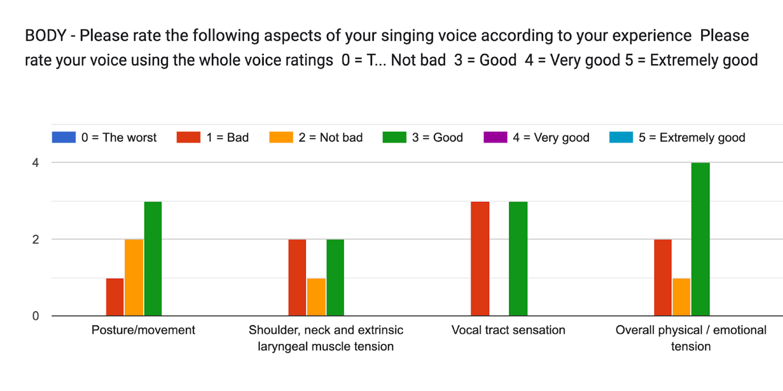

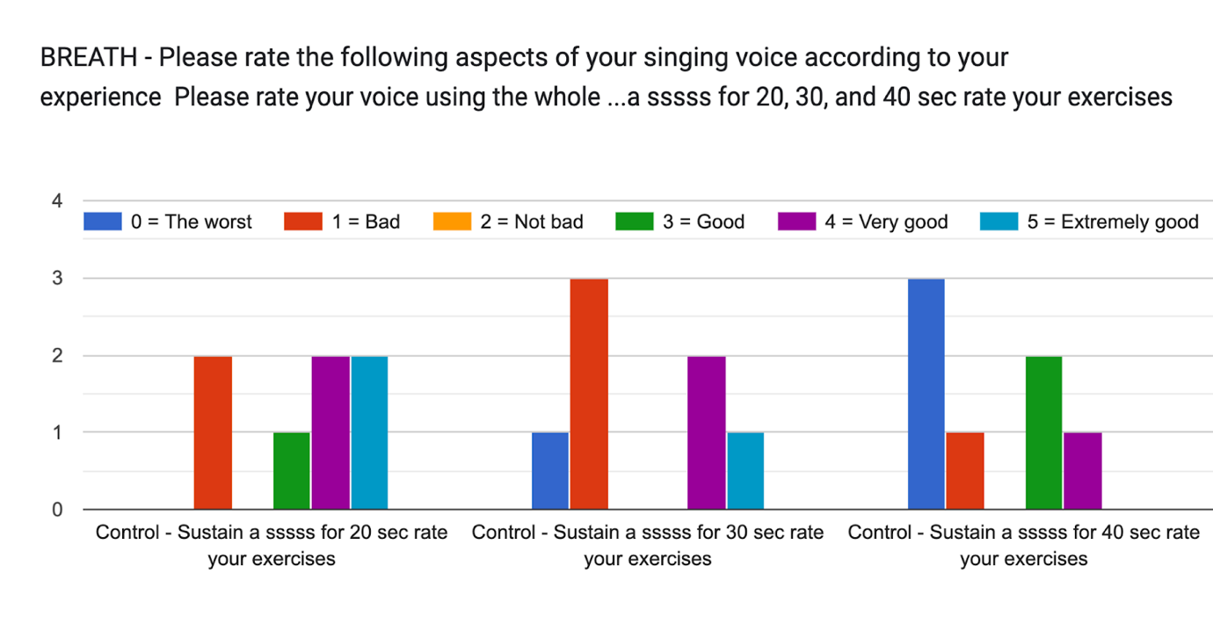
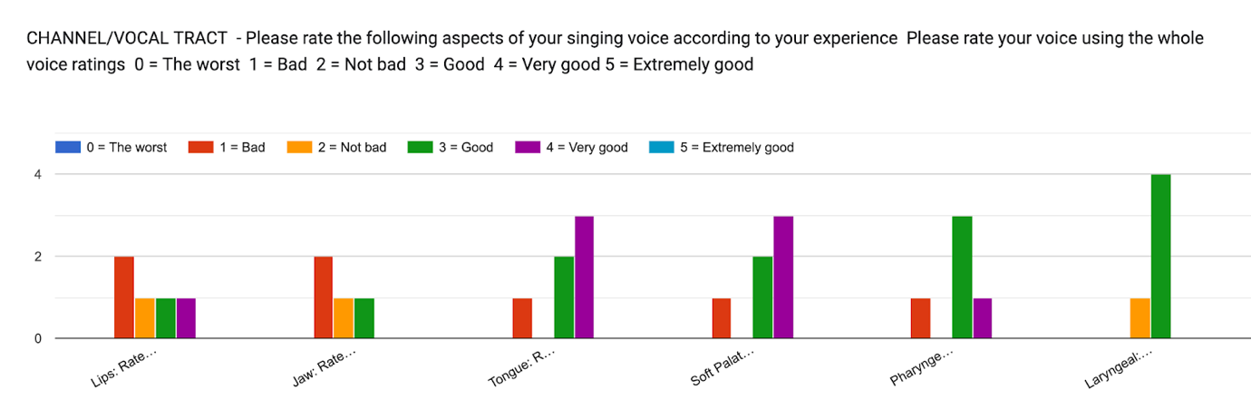
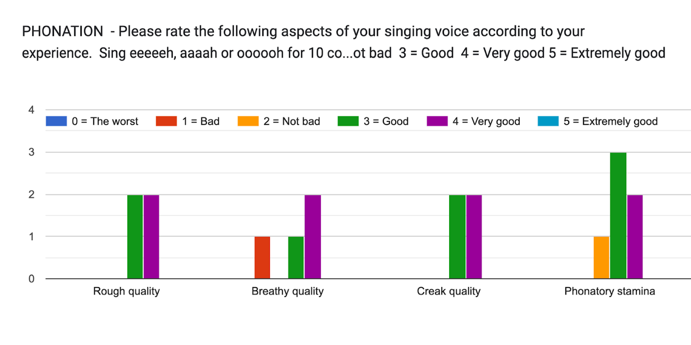

- Depends on how snotty I've been. If my nose has been and remained clear then my voice usually feels and sounds fine and clear. But, if I have been or have become snotty then it can sound very clogged up and sometimes become intermittent. I think this is in part directly because of the snot and also because of what I end up doing due to the sensation of the snot
- Tired and out of breath.
- If I don't warm up, I lose my voice after a vocally demanding performance.
- Lately I tend to get a bit tired after singing 5 consecutive song, my voice become raspy
- Sometimes I have a little vocal fatigue if I have been singing a lot of songs that require belting.
- Medium Vocal Stamina I think. I would get tired after a performance probably because of trying too hard. Often in groups I feel I have to sing louder or stronger to support others so work harder than I need to.
- My voice gets very tired after 1 hour. Especially in soprano sections sustaining high notes as in the Messiah

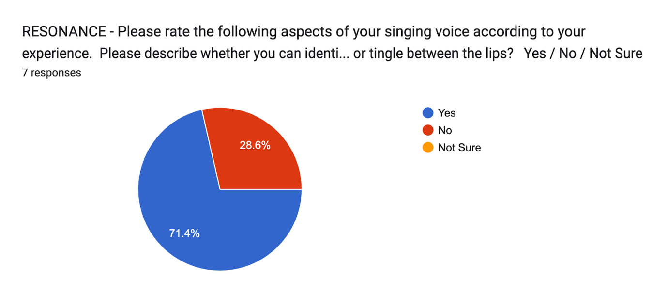

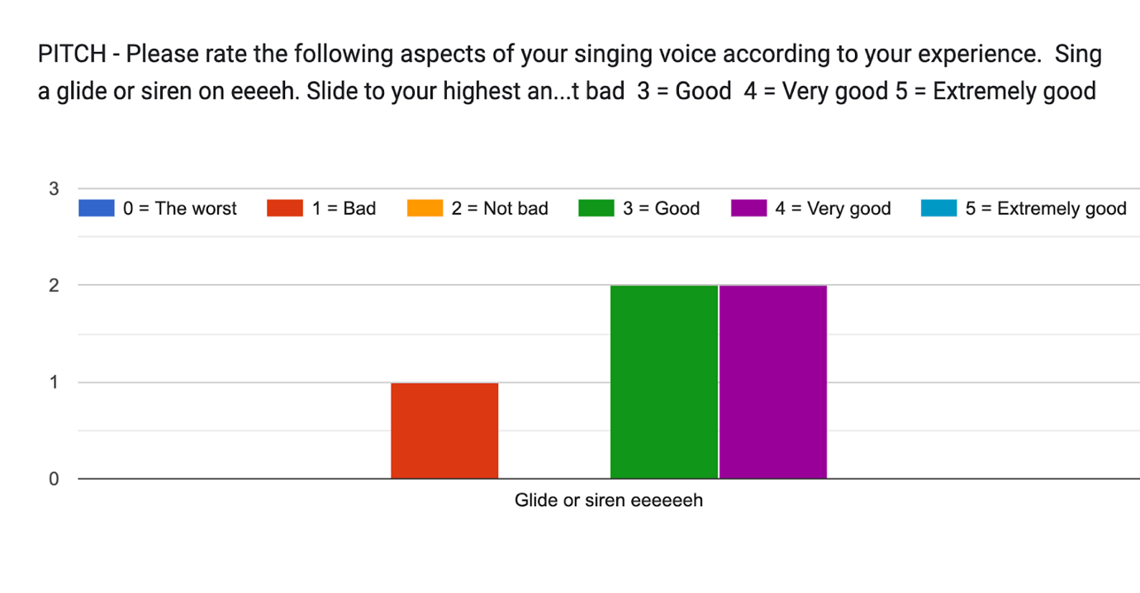

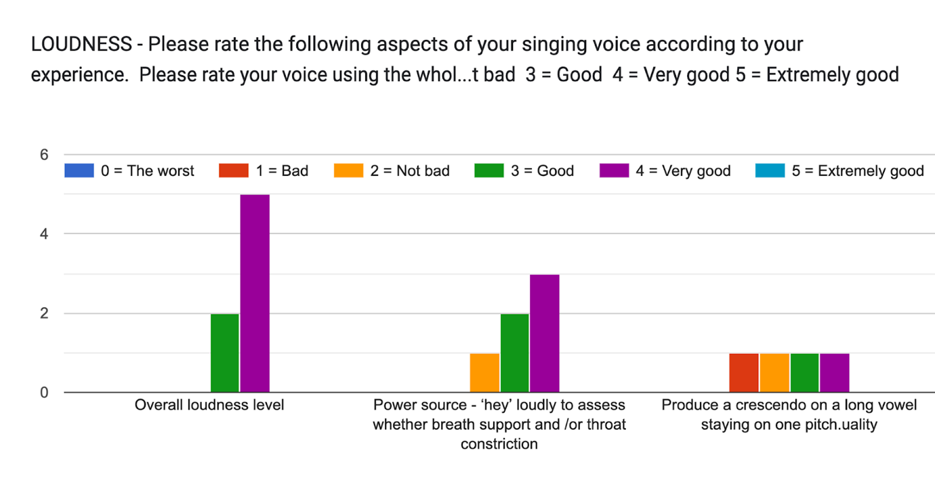

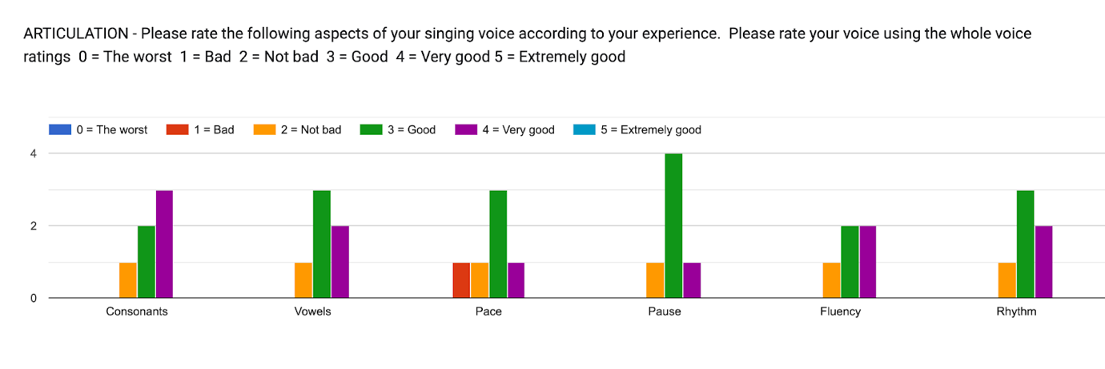

- I do much better at sustain when I'm not thinking about it, but here I was definitely thinking about it, so worse that might be. LOL
- I need help with breath control it was hard for me to keep longer counts but that could be because of posture.
- I am experiencing hormonal changes and this has drastically affected my voice, especially on the higher register
- Never had formal singing training only what I learnt though singing in choirs. Also I am rubbish at vibrato!
- People really like my high notes. They seem to induce emotions in people.

Questionnaire - Vocal Identity

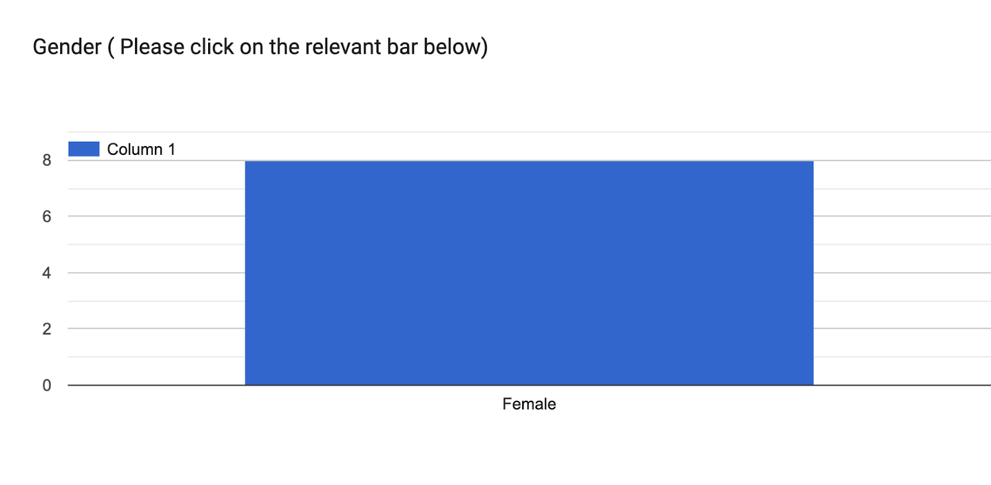
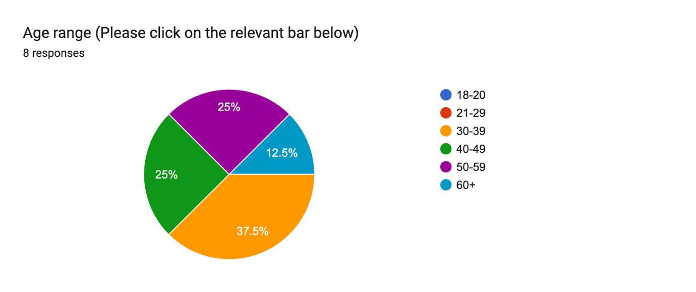

- Soloist & BGV performances, Vocal arranger, Vocal producer, Choir director
- Performing for college, uni. Singing at church, group, choir and solo. Singing professionally choir, group and solo. Mostly soul, neo soul, jazz, RnB, gospel
- Mostly choir and some worship teams
- I sing in bands of multiple genres, record and write material for studio, work with choir/singing workshops
- performer, Worship Leader, learn speech level singing
- Vocal performances, BGVs, worship leading, vocal production and arrangement.
- Music School Choirs, Singing groups, solo and group performances, Cabaret, play performances
- Singing in Church choir as a young person and East London Chorus

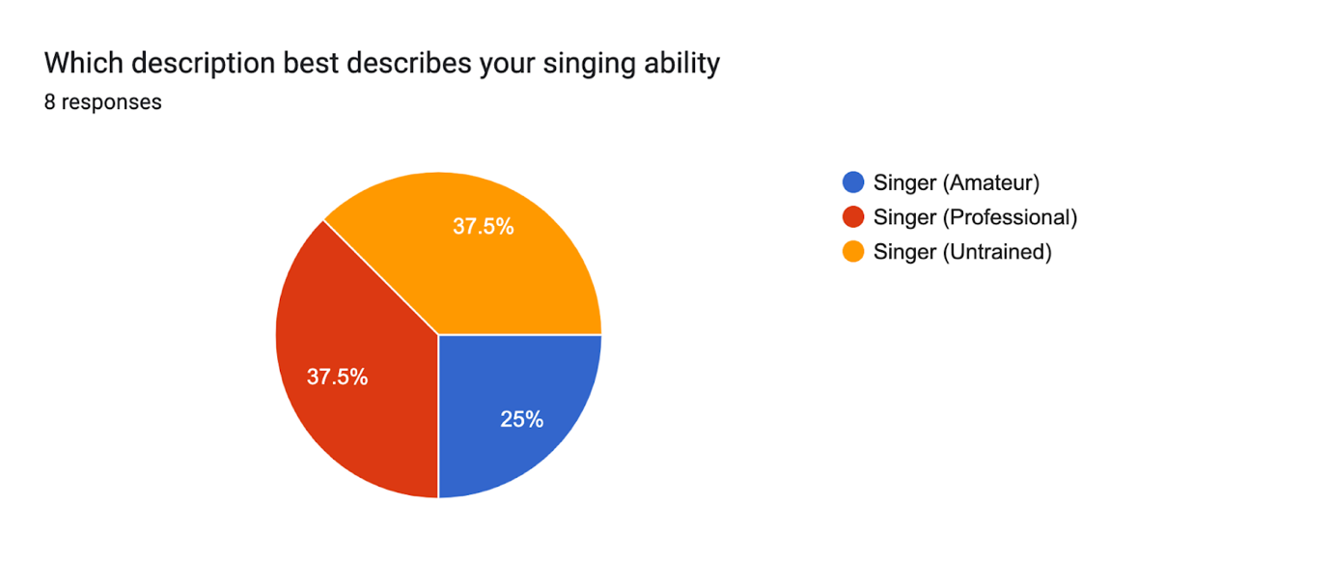

Please describe your singing voice?

8 responses

- Mezzo-Soprano
- High, soulful, loud (when high). Somewhat unpredictable
- Singing voice ok
- I sing alto register, I would say my voice is warmer on chest register but more as I resonate in head voice my tonal quality and be more intense and piercing. I using falsetto for lighter more airy sounds on the higher end of may range.
- Breathy, quite wide vocal range
- Mezzo-soprano, R&B/gospel bent.
- Soprano. Comfortable singing higher pitches. Classically/traditional trained as a child.
- Soprano - it's high and ringy, good in a church where the harmonics are great

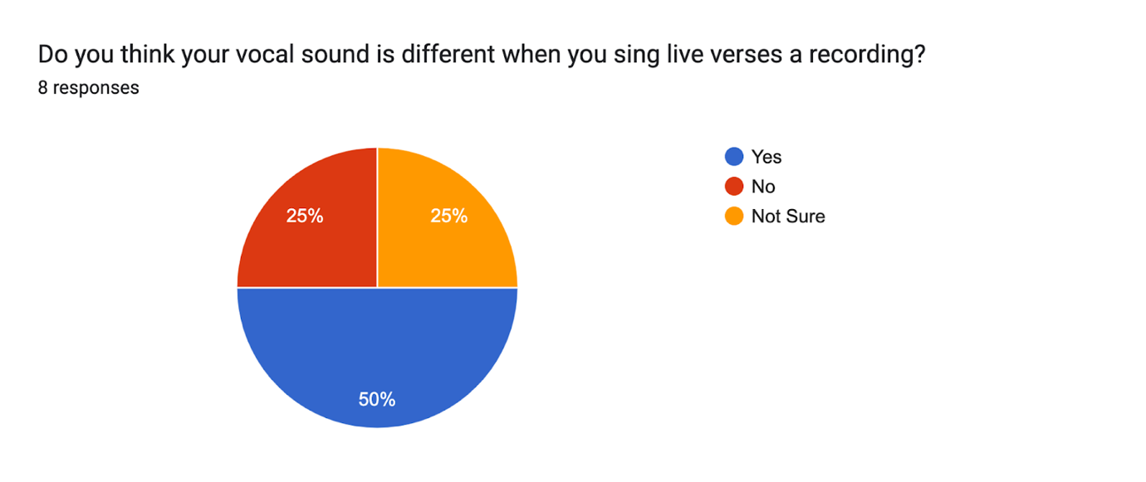

If yes, please detail the differences and how you feel about them.
6 responses

- Assuming that you mean how I hear it when I sing compared to when I listen back to a recording.
- I feel I sound better when recording because I can easily blend with whoever is next to me. I think my voice changes when I’m live and I have more fear singing alone than singing with someone in a choir.
- Whilst recording the microphone picks up every inflection and often unheard (when singing live) frequency of my voice). It can vary according to the recording so sometimes I use a lot less effort in the studio according to the style especially on songs that require a lot of power (belting)
- In recording, sometimes it sounds too compressed
- In recordings, I can rely on pitch correction and reverb which is helpful, however I think I sound as similar as I in recordings and live.
- I sound much more nasal on recordings

Are there any other experiences that have influenced your development as a singer?
8 responses

- Other singers' vibrato like Beyonce, style like Whitney Houston, Mariah Carey, and Michael Jackson.
- Medically: Allergies/rhinosinusitis/post nasal drip/ear problems. Fibroids/reduced movement of diaphragm/Menorrhagia/anaemia.
- No.
- Constantly singing live in front of audiences has certainly influence of my singing voice. I find you have to adapt accordingly, whether it be a big audience or a small intimate one, it’s challenging to consider your audience and present your voice/song/story in the in apt way, no matter how long you have been singing.
- Acting lesson, public speaking lesson.
- R&B/Gospel artists that influence the way I lead vocally, the attitude and emotion behind a song, and the taste when it comes to presenting it as art.
- Learning to sing as a young person, all orchestra members had to be part of a choir, which were quite classical based musically. Being part of Newham Girl Singers made my singing kind of girly and "sweet". At school I was a strong singer and a better musician and singer than most but this put pressure on me more.

Questionnaire - Your Singing Voice

How did you learn to sing? 4 responses

- Mostly on my own. Little bits at college at uni etc, but mostly self taught
- I took some short courses and youtube
- From church worship band, then eventually self-taught using Singing Success CD program.
- Through choirs in Newham Music Academy

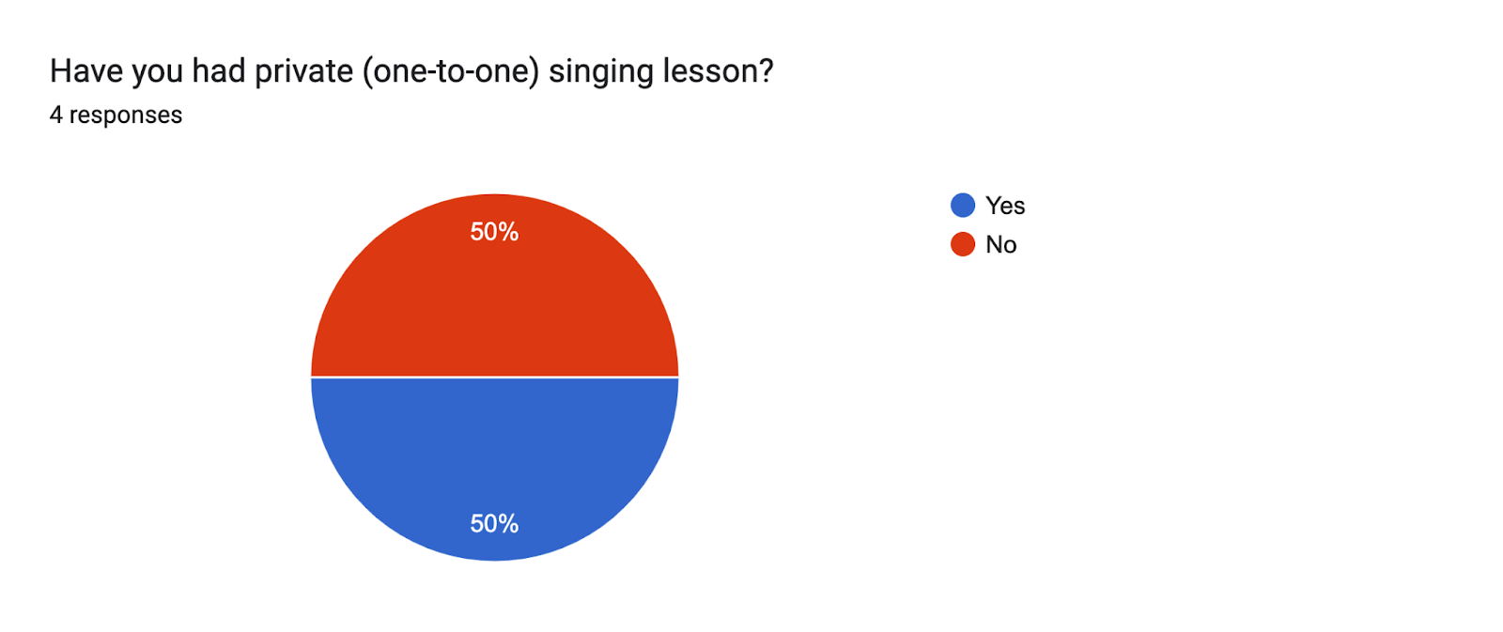

If yes, please detail how your lessons helped your vocal development.
2 responses

- I learn classic like vocal warmup with etude in high school and this lessons really help my passagio
- It helped me understand more regarding head voice and chest voice.

What other influences could have impacted your vocal development?
3 responses

- Growing up with lots of music playing (records etc)
- Gospel choir, different styles of worship leaders, watching musicals
- Singing at school and in choir as a young adult. Being part of the Singing for Well-being courses (run by Mandy - Amaris Arts) had a huge influence on my singing. Using voice either spoken or singing in community run plays. Being a teacher (so using voice constantly and striving to do so correctly) Having a Mental Health 'nervous' breakdown lost me my confidence and voice.

Please sing an entire song of your choice and record your performance. Please listen/watch your performance and detail your reaction to hearing your voice on that recording.
3 responses

- Its as I expect and I don't like it. I have a cold and feel groggy and tense. Can feel and hear the snot and reduced sound compared to normal
- I kept noticing parts where I should have put more emotion to convey the message or tell the story. Other times I'm happy listening to myself attempting to sing difficult songs.
- Awww! kind of embarrassing!! So quiet and weak! I noticed I was singing through my teeth a bit. A teeny bit nasal but ok. I can hold a tune but there was no substance, like I was going through the motions! I looked (and felt) self-conscious.

How does your perception of your voice impact your sense of self?
3 responses

- My voice and singing is a part of me and part of my identity. If and when my voice actually feels and sounds good I feel better in myself. More defined as a person, more fully me, less inhibited and less unsure
- Because I know the depth and capacity of my voice, I am more confident to sing out and try new things.
- It has a huge impact. I see my voice as too pretty, sweet and weak. I can sing strong and loud, but my normal singing tends to be sort of subdued and nice, not jazzy or 'sexy' It makes me feel like I am no good, a tiny bit of a failure, especially when I compare it to other singers. I wish for the confidence I used to have, I even question did I have that confidence or did I just imagine it. Do I have a right to even call myself a singer!
Tell me how others perceive your voice. e.g description of tonal, timbre and emotion expression
4 responses
- From what I can tell soulful, strong yet calm, generally lots of tone and depending on what I am singing and what for it can be perceived as very expressive
- People said i got a voice that is very calming, melancholic and soothing. I think it comes from my breathy tone
- Others have said that my singing voice is loud and that I have presence and authority when I sing.
- I think other singers will say I do have good moments and that I "can sing". I can show emotion if it s the right song and I am feeling strong to sing it well but I think it lacks omph!! and I think singers would see that.Other non musical people would say I can sing well. I think both singers and non musicians would generally like my timbre and tone it is easy to listen too.

Do you compare your voice to anyone else? Detail how that makes you feel.
4 responses

- If you mean do I make comparisons with other singers. Yes, and sometimes that is fine and useful perhaps, but other times it makes me feel pretty lousy, when I am not at my best (most of the time)
- Yes. Sometimes i want my high pitch can be as thick as someone else's voice. That's why i am not confident enough with my high pitch
- For sure! I compare it to other R&B and gospel singers with effortless trills, or broadway singers with clear singing, and I feel like I have to train myself more.
- All the time. It makes me feel bad, and unwilling to sing. As an adult I always feel inferior to other singers. As a kid I was much stronger and felt like I had talent. But not now!

What are some of the areas for your voice you feel you need to develop to feel more confident?
4 responses

- Consistency
- my high pitch
- Tone, breathing, delivery, style.
- To make my singing stronger. More modern and sexy! I feel all prim and proper and want to sound cool!! Also to improvise and ad-lib more confidently.

.

.

Appendix G: Coding
Participant 3
Number | CodeID | Code | Participant 1 | Quote
1 | 1 | Age | Interview Participant 1 | I'm not a youngster anymore
2 | 6 | Singing | Interview Participant 1 | Singing was my passion
3 | 10 | Passion | Interview Participant 1 | Singing was my passion
4 | 18 | Vocal Attributeds | Interview Participant 1 | High soprano
5 | 18 | Vocal Attributeds | Interview Participant 1 | Very high soprano
6 | 31 | Education | Interview Participant 1 | Train
7 | 2 | Vocal Training | Interview Participant 1 | Train
8 | 31 | Education | Interview Participant 1 | School
9 | 13 | Plays | Interview Participant 1 | Play
10 | 3 | Choirs | Interview Participant 1 | Choir
11 | 3 | Choirs | Interview Participant 1 | Choir
12 | 2 | Vocal Training | Interview Participant 1 | Learned to sight reading
13 | 2 | Vocal Training | Interview Participant 1 | Sight reading
14 | 5 | Difficulty or challenges | Interview Participant 1 | Really challenging stuff
15 | 6 | Singing | Interview Participant 1 | Singing I kind of my singing days
16 | 3 | Choirs | Interview Participant 1 | choir now and singing group
17 | 6 | Singing | Interview Participant 1 | And I really hate singing at the front
18 | 8 | Church | Interview Participant 1 | Church
19 | 6 | Singing | Interview Participant 1 | I really can't stand singing into the mic
20 | 9 | Microphone and electronics | Interview Participant 1 | I really can't stand singing into the mic
21 | 9 | Microphone and electronics | Interview Participant 1 | Feel a disconnection with the mic
22 | 32 | Voice | Interview Participant 1 | Voice
23 | 9 | Microphone and electronics | Interview Participant 1 | And the mic it brings a kind of a, an autonomy a kind of, it's almost like you're on your own with the mic
24 | 6 | Singing | Interview Participant 1 | I hate the fact that we can’t, actually physically join our voices together
25 | 5 | Difficulty or challenges | Interview Participant 1 | I hate the fact that we can’t, actually physically join our voices together
26 | 33 | Sound | Interview Participant 1 | Singing it's about the sound
27 | 12 | Spiritual | Interview Participant 1 | Singing for me is a kind of a spiritual thing
28 | 6 | Singing | Interview Participant 1 | Singing by myself
29 | 14 | Feelings | Interview Participant 1 | This is quite deep for me
30 | 16 | Emotions | Interview Participant 1 | This is quite deep for me
31 | 32 | Voice | Interview Participant 1 | Opening my mouth and teeth
32 | 2 | Vocal Training | Interview Participant 1 | Opening my mouth and teeth
33 | 29 | Compliments | Interview Participant 1 | People love my voice
34 | 2 | Vocal Training | Interview Participant 1 | Tried to train
35 | 5 | Difficulty or challenges | Interview Participant 1 | And it's hard. It's hard
36 | 2 | Vocal Training | Interview Participant 1 | Develop that and to be able to sustain I'd have to train
37 | 15 | Don't understand | Interview Participant 1 | Some of the some of the I didn't really understand the technical stuff.
38 | 2 | Vocal Training | Interview Participant 1 | Chest up, you know, the stomach, the diaphragm
39 | 2 | Vocal Training | Interview Participant 1 | Power in the diaphragm
40 | 2 | Vocal Training | Interview Participant 1 | Giving me tip
41 | 2 | Vocal Training | Interview Participant 1 | Best that the power comes from the stomach, not the throat
42 | 15 | Don't understand | Interview Participant 1 | I didn't know it was talking about real
43 | 14 | Feelings | Interview Participant 1 | Yeah, I think always I think whenever I sing. I mean, yeah, whenever I sing. I feel it's not good.
44 | 16 | Emotions | Interview Participant 1 | Emotional thing
45 | 11 | voices | Interview Participant 1 | It's not, I don't because my voice is good
46 | 17 | Comparisons | Interview Participant 1 | I listen to some sort of black soul singers
47 | 2 | Vocal Training | Interview Participant 1 | The flexibility of the vocal cord
48 | 11 | voices | Interview Participant 1 | Stylized voice
49 | 32 | Voice | Interview Participant 1 | My tone is like, it's clear, and high

50 | 2 | Vocal Training | Interview Participant 1 | Soprano
51 | 18 | Vocal Attributeds | Interview Participant 1 | Soprano.
52 | 19 | Communication | Interview Participant 1 | I'm a soprano.
53 | 18 | Vocal Attributeds | Interview Participant 1 | I'm a soprano.
54 | 11 | voices | Interview Participant 1 | You think of The Voice and the X Factor and you've got to sing out, you know, these when I hear a good voices
55 | 1 | Age | Interview Participant 1 | I’m older now. I feel that I've passed it
56 | 1 | Age | Interview Participant 1 | But in a way I'm not past it, but I mean, but you know, what he's singing for that's the point
57 | 5 | Difficulty or challenges | Interview Participant 1 | Pressing through her own barrier
58 | 14 | Feelings | Interview Participant 1 | Bold and courageous
59 | 19 | Communication | Interview Participant 1 | So what is singing for what is singing for singing is communication is that singing is kind of in us.
60 | 21 | Identity | Interview Participant 1 | Singing identity is not professional for
61 | 18 | Vocal Attributeds | Interview Participant 1 | Bit churchy? Not really hip. Not, not really evogue
62 | 20 | Karaoke | Interview Participant 1 | And I did karaoke, and I did Les Miserables, karaoke, and I sang with it
63 | 6 | Singing | Interview Participant 1 | And I did karaoke, and I did Les Miserables, karaoke, and I sang with it
64 | 11 | voices | Interview Participant 1 | And as I sang, I thought, This sounds really good
65 | 6 | Singing | Interview Participant 1 | And as I sang, I thought, This sounds really good
66 | 2 | Vocal Training | Interview Participant 1 | But then my voice, I just got so tired. After about half an hou
67 | 14 | Feelings | Interview Participant 1 | I couldn't sustain it. And then I felt frustrate
68 | 5 | Difficulty or challenges | Interview Participant 1 | In my life, I've pushed it back
69 | 6 | Singing | Interview Participant 1 | Sing all the time, I sing with kids, I work, I go to schools, and I just burst into song.
70 | 21 | Identity | Interview Participant 1 | I think it's diminished me as a person.
71 | 14 | Feelings | Interview Participant 1 | I think it's diminished me as a person.
72 | 14 | Feelings | Interview Participant 1 | Everybody was a bit pretentious
73 | 18 | Vocal Attributeds | Interview Participant 1 | Soprano
74 | 23 | Learning | Interview Participant 1 | Learn a lot of new material
75 | 34 | Semi Professional | Interview Participant 1 | Semi-professional
76 | 6 | Singing | Interview Participant 1 | So although it was great on a technical level, was it was it really singing it? Or was I just part of a machine
77 | 2 | Vocal Training | Interview Participant 1 | So although it was great on a technical level, was it was it really singing it? Or was I just part of a machine
78 | 5 | Difficulty or challenges | Interview Participant 1 | Because it was hard
79 | 3 | Choirs | Interview Participant 1 | It was fun being with other people in the choir.
80 | 21 | Identity | Interview Participant 1 | Identity was spoke about
81 | 21 | Identity | Interview Participant 1 | Psychologists could have a field day on that very on that very thing
82 | 5 | Difficulty or challenges | Interview Participant 1 | Battle through in order to get launch myself out
83 | 35 | Confidence | Interview Participant 1 | I've got to get over myself
84 | 38 | Performers | Interview Participant 1 | Performers
85 | 26 | Toxic | Interview Participant 1 | Very strange characteristic, you know, people with real talent. Have these negative toxic voices
86 | 7 | Songs | Interview Participant 1 | Sea shanty one is there's something that connects people to people. When the voice is just the voice, right
87 | 2 | Vocal Training | Interview Participant 1 | Sea shanty one is there's something that connects people to people. When the voice is just the voice, right
88 | 11 | voices | Interview Participant 1 | The voice is powerful
89 | 9 | Microphone and electronics | Interview Participant 1 | Something about it being projected electronically. That seems to bypass the whole of it.
90 | 39 | Captilism | Interview Participant 1 | Electronics is about capitalism
91 | 40 | Reflection | Interview Participant 1 | Because other people are the mirror of it
92 | 33 | Sound | Interview Participant 1 | Sound
93 | 33 | Sound | Interview Participant 1 | Harmonics made it sound
94 | 41 | Express | Interview Participant 1 | Fantastic for me, but not because I wanted to be heard singing but because I just it was just an expression of myself
95 | 22 | Self doubt | Interview Participant 1 | I suppose I don't really want to know what other people thin
97 | 29 | Compliments | Interview Participant 1 | But I can't I kind of I kind of can't take the compliment
98 | 11 | voices | Interview Participant 1 | Such a huge spectrum of voice

Participant 1

Number | CodeID | Code | Participant 2 | Quote
1 | 1 | Confusion | Participant 2 | Vocal coach
2 | 1 | Confusion | Participant 2 | Little bit confusing
3 | 22 | Music Training | Participant 2 | Group discussion
4 | 35 | Vocals | Participant 2 | Vocal
5 | 2 | Vocal Coaching | Participant 2 | Vocal coaching
6 | 3 | Perceptions | Participant 2 | Perception of singing voice
7 | 4 | Performances | Participant 2 | Performances, artist
8 | 20 | Vocal Identity | Participant 2 | Vocal identity
9 | 5 | Singing Experience | Participant 2 | Singing experience
10 | 36 | Choirs | Participant 2 | Choir
11 | 4 | Performances | Participant 2 | Performance
12 | 5 | Singing Experience | Participant 2 | Describe your singing experience
13 | 1 | Confusion | Participant 2 | Confusing
14 | 6 | Singer | Participant 2 | Single
15 | 7 | Amateur | Participant 2 | Amateur
16 | 8 | Professional | Participant 2 | Professional
17 | 37 | Untrained | Participant 2 | Untrained
18 | 8 | Professional | Participant 2 | Professional
19 | 38 | Career | Participant 2 | Career
20 | 7 | Amateur | Participant 2 | Amateur
21 | 10 | Vocal attributes | Participant 2 | Describe your singing voice
22 | 9 | Singing voice | Participant 2 | Singing voice
23 | 10 | Vocal attributes | Participant 2 | Pitch
24 | 5 | Singing Experience | Participant 2 | Experience
25 | 10 | Vocal attributes | Participant 2 | Breath
26 | 10 | Vocal attributes | Participant 2 | Lower pitch
27 | 10 | Vocal attributes | Participant 2 | Higher pitch
28 | 10 | Vocal attributes | Participant 2 | Bit bright
29 | 10 | Vocal attributes | Participant 2 | A lower tone
30 | 9 | Singing voice | Participant 2 | Singing voice
31 | 11 | Speaking voice | Participant 2 | Speaking voice
32 | 9 | Singing voice | Participant 2 | Singing
33 | 10 | Vocal attributes | Participant 2 | Good impersonator
34 | 3 | Perceptions | Participant 2 | Perception
35 | 12 | Sound | Participant 2 | Sound
36 | 9 | Singing voice | Participant 2 | Singing voice
37 | 15 | Reactions to own voice | Participant 2 | Reaction
38 | 5 | Singing Experience | Participant 2 | Singing
39 | 9 | Singing voice | Participant 2 | Singing
40 | 6 | Singer | Participant 2 | Singing
41 | 16 | Listening | Participant 2 | Listen to her own voic
42 | 9 | Singing voice | Participant 2 | Own voice
43 | 14 | Songs | Participant 2 | Song
44 | 14 | Songs | Participant 2 | Song
45 | 16 | Listening | Participant 2 | Listen
46 | 9 | Singing voice | Participant 2 | Singing
47 | 14 | Songs | Participant 2 | Song
48 | 12 | Sound | Participant 2 | Sound
49 | 14 | Songs | Participant 2 | Song
50 | 14 | Songs | Participant 2 | Songs
51 | 10 | Vocal attributes | Participant 2 | Higher pitch song
52 | 14 | Songs | Participant 2 | Songs
53 | 14 | Songs | Participant 2 | Song
54 | 30 | Finding things difficult | Participant 2 | Bit uncomfortable to listen to my own voices
55 | 16 | Listening | Participant 2 | Well, most of the times I feel comfortable listening to my own voice singing
56 | 9 | Singing voice | Participant 2 | Just automatically I was sing
57 | 9 | Singing voice | Participant 2 | Comfortable listening me singing
58 | 10 | Vocal attributes | Participant 2 | Well, I like my ton
59 | 14 | Songs | Participant 2 | Song
60 | 20 | Vocal Identity | Participant 2 | My own interpretation
61 | 10 | Vocal attributes | Participant 2 | Singer, that's one of my strength in singing
62 | 27 | Signature voice | Participant 2 | Singer, that's one of my strength in singing
63 | 14 | Songs | Participant 2 | Becomes like my own song.
64 | 15 | Reactions to own voice | Participant 2 | Singer, that's one of my strength in singing
65 | 10 | Vocal attributes | Participant 2 | I like the tone
66 | 27 | Signature voice | Participant 2 | Like signature kind of thing to interpret any kind of songs that I sing
67 | 10 | Vocal attributes | Participant 2 | melancholy voic
68 | 14 | Songs | Participant 2 | upbeat song
69 | 15 | Reactions to own voice | Participant 2 | like, my own interpretation, that the way I sing i
70 | 9 | Singing voice | Participant 2 | that the way I sing i
71 | 17 | Confidence | Participant 2 | contributes a lot to my confidence
72 | 9 | Singing voice | Participant 2 | energy to to sin
73 | 9 | Singing voice | Participant 2 | singin
74 | 18 | Helping people | Participant 2 | helping people like motivating peopl
75 | 19 | Motivation | Participant 2 | helping people like motivating peopl
76 | 9 | Singing voice | Participant 2 | I just have my voice.
77 | 16 | Listening | Participant 2 | listen to my voice
78 | 19 | Motivation | Participant 2 | motivate them by helping the
79 | 14 | Songs | Participant 2 | simple song like 'God is so goo
80 | 21 | Timbre | Participant 2 | I think, represents timbre,
81 | 20 | Vocal Identity | Participant 2 | I think, represents timbre,
82 | 11 | Speaking voice | Participant 2 | public speakin
83 | 22 | Music Training | Participant 2 | workshop trainin
84 | 17 | Confidence | Participant 2 | build you as a perso
85 | 39 | Identity | Participant 2 | visual image
86 | 23 | Vocal Image | Participant 2 | vocal image. So, when you say vocal identit
87 | 20 | Vocal Identity | Participant 2 | vocal image. So, when you say vocal identit
88 | 23 | Vocal Image | Participant 2 | vocal, your vocal image, you know, your sound, the tone,
89 | 12 | Sound | Participant 2 | vocal, your vocal image, you know, your sound, the tone,
90 | 10 | Vocal attributes | Participant 2 | your sound, the tone, how will you use the tempo, the, the intonation
91 | 11 | Speaking voice | Participant 2 | the way you speak, or you sing
92 | 9 | Singing voice | Participant 2 | the way you speak, or you sing
93 | 39 | Identity | Participant 2 | vocal identit
94 | 20 | Vocal Identity | Participant 2 | vocal identit
95 | 24 | Vocal Recognition | Participant 2 | recognized, you know, by the tone when people don't see yo
96 | 9 | Singing voice | Participant 2 | singing
97 | 20 | Vocal Identity | Participant 2 | So I think vocal identity can help singer to do you know like to, for people to help them to recognize you as a singer.
98 | 20 | Vocal Identity | Participant 2 | contributes a lot to your vocal identit
99 | 11 | Speaking voice | Participant 2 | voic
100 | 9 | Singing voice | Participant 2 | voic
101 | 35 | Vocals | Participant 2 | voic
102 | 26 | Worship | Participant 2 | sing as a worship leader in a churc
103 | 26 | Worship | Participant 2 | lead worship
104 | 35 | Vocals | Participant 2 | I lead voc
105 | 26 | Worship | Participant 2 | lead worshi
106 | 12 | Sound | Participant 2 | soun
107 | 15 | Reactions to own voice | Participant 2 | very bold with my voic
108 | 9 | Singing voice | Participant 2 | very bold with my voic
109 | 9 | Singing voice | Participant 2 | singing
110 | 26 | Worship | Participant 2 | worship
111 | 9 | Singing voice | Participant 2 | Yeah, but I don't want that voice to be recognized as my vocal identity.
112 | 20 | Vocal Identity | Participant 2 | vocal identit
113 | 6 | Singer | Participant 2 | yourself as singe
114 | 16 | Listening | Participant 2 | listening
115 | 35 | Vocals | Participant 2 | voic
116 | 9 | Singing voice | Participant 2 | singing
117 | 15 | Reactions to own voice | Participant 2 | hear your voice singin
118 | 9 | Singing voice | Participant 2 | hear your voice singin
119 | 16 | Listening | Participant 2 | whole day I can listen to myself
120 | 14 | Songs | Participant 2 | sing along songs
121 | 26 | Worship | Participant 2 | worship leade
122 | 26 | Worship | Participant 2 | worship leade
123 | 10 | Vocal attributes | Participant 2 | loud voice
124 | 27 | Signature voice | Participant 2 | signature or voic
125 | 26 | Worship | Participant 2 | k singing in church
126 | 26 | Worship | Participant 2 | lead worship,
127 | 14 | Songs | Participant 2 | sing almost all kinds of song
128 | 28 | Genre songs | Participant 2 | great pop song
129 | 28 | Genre songs | Participant 2 | gospel. If you think Israel Hougton you know like, Kirk Fran
130 | 12 | Sound | Participant 2 | you have to have a versatile kind of sound
131 | 20 | Vocal Identity | Participant 2 | I don't want people to identify me, you know, as, as a worship leader
132 | 26 | Worship | Participant 2 | love leading worshi
133 | 29 | Empowerment | Participant 2 | it gives people empowers
134 | 29 | Empowerment | Participant 2 | singing something that can empower
135 | 9 | Singing voice | Participant 2 | singing something that can empower
136 | 10 | Vocal attributes | Participant 2 | Dept of the ton
137 | 20 | Vocal Identity | Participant 2 | vocal identit
138 | 26 | Worship | Participant 2 | worship leading
139 | 26 | Worship | Participant 2 | worship leading
140 | 39 | Identity | Participant 2 | identified
141 | 20 | Vocal Identity | Participant 2 | vocal identity
142 | 20 | Vocal Identity | Participant 2 | vocal identity
143 | 26 | Worship | Participant 2 | who minister as a worship leade
144 | 20 | Vocal Identity | Participant 2 | vocal identit
145 | 25 | Influence | Participant 2 | lead worship
146 | 26 | Worship | Participant 2 | lead worship
147 | 30 | Finding things difficult | Participant 2 | challenged
148 | 5 | Singing Experience | Participant 2 | my experience, coaching people to sing
149 | 2 | Vocal Coaching | Participant 2 | my experience, coaching people to sing
150 | 2 | Vocal Coaching | Participant 2 | everybody can sing
151 | 2 | Vocal Coaching | Participant 2 | everybody who can speak they can sin
152 | 2 | Vocal Coaching | Participant 2 | building your muscle memories
153 | 10 | Vocal attributes | Participant 2 | recognize tone
154 | 2 | Vocal Coaching | Participant 2 | recognize tone
155 | 10 | Vocal attributes | Participant 2 | recognize notes, melodies
156 | 14 | Songs | Participant 2 | specific song
157 | 22 | Music Training | Participant 2 | trai
158 | 9 | Singing voice | Participant 2 | I want to sin
159 | 30 | Finding things difficult | Participant 2 | it's gonna be hard.
160 | 30 | Finding things difficult | Participant 2 | it's really har
161 | 2 | Vocal Coaching | Participant 2 | learn how to sing
162 | 9 | Singing voice | Participant 2 | learn how to sing
163 | 2 | Vocal Coaching | Participant 2 | Okay, 10 sessions. I just give him you know, like, at first I listen to his voic
164 | 16 | Listening | Participant 2 | I listen to his voi
165 | 15 | Reactions to own voice | Participant 2 | Yeah. And it's awful. Based on Tone based on pitch
166 | 2 | Vocal Coaching | Participant 2 | coac
167 | 2 | Vocal Coaching | Participant 2 | So I do 10 sessions, just to fix on his ear firs
168 | 10 | Vocal attributes | Participant 2 | onset, or me like to seeing and then getting used to their voice
169 | 2 | Vocal Coaching | Participant 2 | onset, or me like to seeing and then getting used to their voices
170 | 2 | Vocal Coaching | Participant 2 | It's, it's really good because he can train, you know, he can exercis
171 | 14 | Songs | Participant 2 | Yeah, because I learned the repetition. I don't give them any other songs for them to practice
172 | 10 | Vocal attributes | Participant 2 | Yeah, because I learned the repetition. I don't give them any other songs for them to practice
173 | 10 | Vocal attributes | Participant 2 | I just keep on repeating the song, you know. So get their vocal cords, and all the signals in their body recognize the song that song
174 | 14 | Songs | Participant 2 | I just keep on repeating the song, you know. So get their vocal cords, and all the signals in their body recognize the song that song
175 | 14 | Songs | Participant 2 | songs
176 | 5 | Singing Experience | Participant 2 | experienc
177 | 2 | Vocal Coaching | Participant 2 | muscle memory, just like when they learn how to drive how to ride a bi
178 | 31 | Theory | Participant 2 | theor
179 | 2 | Vocal Coaching | Participant 2 | practice
180 | 32 | Mindsets | Participant 2 | people mindset about singin
181 | 3 | Perceptions | Participant 2 | can't sing, I'm sorry. Because you have this perception when you say I can't sin
182 | 33 | Can't sing | Participant 2 | when you say you can't say you can't sing like, who's in your mind?
183 | 40 | Comparision | Participant 2 | compariso
184 | 2 | Vocal Coaching | Participant 2 | everybody can sing.
185 | 5 | Singing Experience | Participant 2 | experience of me singin
186 | 2 | Vocal Coaching | Participant 2 | vocal do a vocal coachin
187 | 9 | Singing voice | Participant 2 | s that everybody can sing.
188 | 2 | Vocal Coaching | Participant 2 | s that everybody can sing.
189 | 18 | Helping people | Participant 2 | help people to sin
190 | 2 | Vocal Coaching | Participant 2 | help people to sin
191 | 9 | Singing voice | Participant 2 | help people to sin
192 | 29 | Empowerment | Participant 2 | seeing is one of a great thing to, you know, to escape from. Any troubles of life

Participant 3

Number | Code ID | Code | Participant 3 | Quote
1 | 1 | Confusion | Participant 3 | vocal coach
2 | 1 | Confusion | Participant 3 | a little bit confusin
3 | 22 | Music Training | Participant 3 | group discussio
4 | 35 | Vocals | Participant 3 | voca
5 | 2 | Vocal Coaching | Participant 3 | o vocal coachin
6 | 3 | Perceptions | Participant 3 | perception of singing voic
7 | 4 | Performances | Participant 3 | performances, artistr
8 | 20 | Vocal Identity | Participant 3 | vocal identit
9 | 5 | Singing Experience | Participant 3 | singing experienc
10 | 36 | Choirs | Participant 3 | choir
11 | 4 | Performances | Participant 3 | performance
12 | 5 | Singing Experience | Participant 3 | describe your singing experienc
13 | 1 | Confusion | Participant 3 | confusin
14 | 6 | Singer | Participant 3 | singe
15 | 7 | Amateur | Participant 3 | amateur
16 | 8 | Professional | Participant 3 | professional
17 | 37 | Untrained | Participant 3 | r untraine
18 | 8 | Professional | Participant 3 | Professiona
19 | 38 | Career | Participant 3 | career
20 | 7 | Amateur | Participant 3 | l amateur
21 | 10 | Vocal attributes | Participant 3 | describe your singing voic
22 | 9 | Singing voice | Participant 3 | singing voic
23 | 10 | Vocal attributes | Participant 3 | pitch
24 | 5 | Singing Experience | Participant 3 | experience
25 | 10 | Vocal attributes | Participant 3 | breath
26 | 10 | Vocal attributes | Participant 3 | lower pitc
27 | 10 | Vocal attributes | Participant 3 | higher pitc
28 | 10 | Vocal attributes | Participant 3 | bit brigh
29 | 10 | Vocal attributes | Participant 3 | a lower ton
30 | 9 | Singing voice | Participant 3 | singing voic
31 | 11 | Speaking voice | Participant 3 | speaking voice
32 | 9 | Singing voice | Participant 3 | singin
33 | 10 | Vocal attributes | Participant 3 | good impersonato
34 | 3 | Perceptions | Participant 3 | perception
35 | 12 | Sound | Participant 3 | sound
36 | 9 | Singing voice | Participant 3 | singing voic
37 | 15 | Reactions to own voice | Participant 3 | reactio
38 | 5 | Singing Experience | Participant 3 | singing
39 | 9 | Singing voice | Participant 3 | singing
40 | 6 | Singer | Participant 3 | singe
41 | 16 | Listening | Participant 3 | listen to her own voic
42 | 9 | Singing voice | Participant 3 | own voice
43 | 14 | Songs | Participant 3 | song
44 | 14 | Songs | Participant 3 | song
45 | 16 | Listening | Participant 3 | listen
46 | 9 | Singing voice | Participant 3 | singin
47 | 14 | Songs | Participant 3 | song
48 | 12 | Sound | Participant 3 | sound
49 | 14 | Songs | Participant 3 | r song
50 | 14 | Songs | Participant 3 | songs
51 | 10 | Vocal attributes | Participant 3 | higher pitch song
52 | 14 | Songs | Participant 3 | songs
53 | 14 | Songs | Participant 3 | e song
54 | 30 | Finding things difficult | Participant 3 | bit uncomfortable to listen to my own voices
55 | 16 | Listening | Participant 3 | Well, most of the times I feel comfortable listening to my own voice singin
56 | 9 | Singing voice | Participant 3 | just automatically I was sing
57 | 9 | Singing voice | Participant 3 | comfortable listening me singing
58 | 10 | Vocal attributes | Participant 3 | Well, I like my ton
59 | 14 | Songs | Participant 3 | son
60 | 20 | Vocal Identity | Participant 3 | My own interpretation
61 | 10 | Vocal attributes | Participant 3 | singer, that's one of my strength in singi
62 | 27 | Signature voice | Participant 3 | singer, that's one of my strength in singi
63 | 14 | Songs | Participant 3 | becomes like my own song.
64 | 15 | Reactions to own voice | Participant 3 | singer, that's one of my strength in singi
65 | 10 | Vocal attributes | Participant 3 | I like the ton
66 | 27 | Signature voice | Participant 3 | like signature kind of thing to interpret any kind of songs that I sing
67 | 10 | Vocal attributes | Participant 3 | melancholy voic
68 | 14 | Songs | Participant 3 | upbeat song
69 | 15 | Reactions to own voice | Participant 3 | like, my own interpretation, that the way I sing i
70 | 9 | Singing voice | Participant 3 | that the way I sing i
71 | 17 | Confidence | Participant 3 | contributes a lot to my confidence
72 | 9 | Singing voice | Participant 3 | energy to to sin
73 | 9 | Singing voice | Participant 3 | singin
74 | 18 | Helping people | Participant 3 | helping people like motivating peopl
75 | 19 | Motivation | Participant 3 | helping people like motivating peopl
76 | 9 | Singing voice | Participant 3 | I just have my voice.
77 | 16 | Listening | Participant 3 | listen to my voice
78 | 19 | Motivation | Participant 3 | motivate them by helping the
79 | 14 | Songs | Participant 3 | simple song like 'God is so goo
80 | 21 | Timbre | Participant 3 | I think, represents timbre,
81 | 20 | Vocal Identity | Participant 3 | I think, represents timbre,
82 | 11 | Speaking voice | Participant 3 | public speakin
83 | 22 | Music Training | Participant 3 | workshop trainin
84 | 17 | Confidence | Participant 3 | build you as a perso
85 | 39 | Identity | Participant 3 | visual image
86 | 23 | Vocal Image | Participant 3 | vocal image. So, when you say vocal identit
87 | 20 | Vocal Identity | Participant 3 | vocal image. So, when you say vocal identit
88 | 23 | Vocal Image | Participant 3 | vocal, your vocal image, you know, your sound, the tone,
89 | 12 | Sound | Participant 3 | vocal, your vocal image, you know, your sound, the tone,
90 | 10 | Vocal attributes | Participant 3 | your sound, the tone, how will you use the tempo, the, the intonation
91 | 11 | Speaking voice | Participant 3 | the way you speak, or you sing
92 | 9 | Singing voice | Participant 3 | the way you speak, or you sing
93 | 39 | Identity | Participant 3 | vocal identit
94 | 20 | Vocal Identity | Participant 3 | vocal identit
95 | 24 | Vocal Recognition | Participant 3 | recognized, you know, by the tone when people don't see yo
96 | 9 | Singing voice | Participant 3 | singing
97 | 20 | Vocal Identity | Participant 3 | So I think vocal identity can help singer to do you know like to, for people to help them to recognize you as a singer.
98 | 20 | Vocal Identity | Participant 3 | contributes a lot to your vocal identit
99 | 11 | Speaking voice | Participant 3 | voic
100 | 9 | Singing voice | Participant 3 | voic
101 | 35 | Vocals | Participant 3 | voic
102 | 26 | Worship | Participant 3 | sing as a worship leader in a churc
103 | 26 | Worship | Participant 3 | lead worship
104 | 35 | Vocals | Participant 3 | I lead voc
105 | 26 | Worship | Participant 3 | lead worshi
106 | 12 | Sound | Participant 3 | soun
107 | 15 | Reactions to own voice | Participant 3 | very bold with my voic
108 | 9 | Singing voice | Participant 3 | very bold with my voic
109 | 9 | Singing voice | Participant 3 | singing
110 | 26 | Worship | Participant 3 | worship
111 | 9 | Singing voice | Participant 3 | Yeah, but I don't want that voice to be recognized as my vocal identity.
112 | 20 | Vocal Identity | Participant 3 | vocal identit
113 | 6 | Singer | Participant 3 | yourself as singe
114 | 16 | Listening | Participant 3 | listening
115 | 35 | Vocals | Participant 3 | voic
116 | 9 | Singing voice | Participant 3 | singing
117 | 15 | Reactions to own voice | Participant 3 | hear your voice singin
118 | 9 | Singing voice | Participant 3 | hear your voice singin
119 | 16 | Listening | Participant 3 | whole day I can listen to myself
120 | 14 | Songs | Participant 3 | sing along songs
121 | 26 | Worship | Participant 3 | worship leade
122 | 26 | Worship | Participant 3 | worship leade
123 | 10 | Vocal attributes | Participant 3 | loud voice
124 | 27 | Signature voice | Participant 3 | signature or voic
125 | 26 | Worship | Participant 3 | k singing in church
126 | 26 | Worship | Participant 3 | lead worship,
127 | 14 | Songs | Participant 3 | sing almost all kinds of song
128 | 28 | Genre songs | Participant 3 | great pop song
129 | 28 | Genre songs | Participant 3 | gospel. If you think Israel Hougton you know like, Kirk Fran
130 | 12 | Sound | Participant 3 | you have to have a versatile kind of sound
131 | 20 | Vocal Identity | Participant 3 | I don't want people to identify me, you know, as, as a worship leader
132 | 26 | Worship | Participant 3 | love leading worshi
133 | 29 | Empowerment | Participant 3 | it gives people empowers
134 | 29 | Empowerment | Participant 3 | singing something that can empower
135 | 9 | Singing voice | Participant 3 | singing something that can empower
136 | 10 | Vocal attributes | Participant 3 | Dept of the ton
137 | 20 | Vocal Identity | Participant 3 | vocal identit
138 | 26 | Worship | Participant 3 | worship leading
139 | 26 | Worship | Participant 3 | worship leading
140 | 39 | Identity | Participant 3 | identified
141 | 20 | Vocal Identity | Participant 3 | vocal identity
142 | 20 | Vocal Identity | Participant 3 | vocal identity
143 | 26 | Worship | Participant 3 | who minister as a worship leade
144 | 20 | Vocal Identity | Participant 3 | vocal identit
145 | 25 | Influence | Participant 3 | lead worship
146 | 26 | Worship | Participant 3 | lead worship
147 | 30 | Finding things difficult | Participant 3 | challenged
148 | 5 | Singing Experience | Participant 3 | my experience, coaching people to sing
149 | 2 | Vocal Coaching | Participant 3 | my experience, coaching people to sing
150 | 2 | Vocal Coaching | Participant 3 | everybody can sing
151 | 2 | Vocal Coaching | Participant 3 | everybody who can speak they can sin
152 | 2 | Vocal Coaching | Participant 3 | building your muscle memories
153 | 10 | Vocal attributes | Participant 3 | recognize tone
154 | 2 | Vocal Coaching | Participant 3 | recognize tone
155 | 10 | Vocal attributes | Participant 3 | recognize notes, melodies
156 | 14 | Songs | Participant 3 | specific song
157 | 22 | Music Training | Participant 3 | trai
158 | 9 | Singing voice | Participant 3 | I want to sin
159 | 30 | Finding things difficult | Participant 3 | it's gonna be hard.
160 | 30 | Finding things difficult | Participant 3 | it's really har
161 | 2 | Vocal Coaching | Participant 3 | learn how to sing
162 | 9 | Singing voice | Participant 3 | learn how to sing
163 | 2 | Vocal Coaching | Participant 3 | Okay, 10 sessions. I just give him you know, like, at first I listen to his voic
164 | 16 | Listening | Participant 3 | I listen to his voi
165 | 15 | Reactions to own voice | Participant 3 | Yeah. And it's awful. Based on Tone based on pitch
166 | 2 | Vocal Coaching | Participant 3 | coac
167 | 2 | Vocal Coaching | Participant 3 | So I do 10 sessions, just to fix on his ear firs
168 | 10 | Vocal attributes | Participant 3 | onset, or me like to seeing and then getting used to their voice
169 | 2 | Vocal Coaching | Participant 3 | onset, or me like to seeing and then getting used to their voices
170 | 2 | Vocal Coaching | Participant 3 | It's, it's really good because he can train, you know, he can exercis
171 | 14 | Songs | Participant 3 | Yeah, because I learned the repetition. I don't give them any other songs for them to practice
172 | 10 | Vocal attributes | Participant 3 | Yeah, because I learned the repetition. I don't give them any other songs for them to practice
173 | 10 | Vocal attributes | Participant 3 | I just keep on repeating the song, you know. So get their vocal cords, and all the signals in their body recognize the song that song
174 | 14 | Songs | Participant 3 | I just keep on repeating the song, you know. So get their vocal cords, and all the signals in their body recognize the song that song
175 | 14 | Songs | Participant 3 | songs
176 | 5 | Singing Experience | Participant 3 | experienc
177 | 2 | Vocal Coaching | Participant 3 | muscle memory, just like when they learn how to drive how to ride a bi
178 | 31 | Theory | Participant 3 | theor
179 | 2 | Vocal Coaching | Participant 3 | practice
180 | 32 | Mindsets | Participant 3 | people mindset about singin
181 | 3 | Perceptions | Participant 3 | can't sing, I'm sorry. Because you have this perception when you say I can't sin
182 | 33 | Can't sing | Participant 3 | when you say you can't say you can't sing like, who's in your mind?
183 | 40 | Comparision | Participant 3 | compariso
184 | 2 | Vocal Coaching | Participant 3 | everybody can sing.
185 | 5 | Singing Experience | Participant 3 | experience of me singin
186 | 2 | Vocal Coaching | Participant 3 | vocal do a vocal coachin
187 | 9 | Singing voice | Participant 3 | s that everybody can sing.
188 | 2 | Vocal Coaching | Participant 3 | s that everybody can sing.
189 | 18 | Helping people | Participant 3 | help people to sin
190 | 2 | Vocal Coaching | Participant 3 | help people to sin
191 | 9 | Singing voice | Participant 3 | help people to sin
192 | 29 | Empowerment | Participant 3 | seeing is one of a great thing to, you know, to escape from. Any troubles of life

Participant 4

Number | Code ID | Code | Participant | Quote
1 | 1 | Questions | Participant 4 | questions about the question
2 | 2 | Differences | Participant 4 | different thing
3 | 3 | Expectations | Participant 4 | expecte
4 | 4 | Experience | Participant 4 | experienc
5 | 4 | Experience | Participant 4 | experienc
6 | 1 | Questions | Participant 4 | h question
7 | 4 | Experience | Participant 4 | experienc
8 | 5 | Experience | Participant 4 | experience
9 | 6 | Recent Activity | Participant 4 | forever? Or do you mean recently
10 | 4 | Experience | Participant 4 | experienc
11 | 7 | Health | Participant 4 | health stuff
12 | 8 | Learning | Participant 4 | learnin
13 | 9 | Societal Influencers | Participant 4 | societal influences
14 | 4 | Experience | Participant 4 | experience of singing
15 | 10 | Singing | Participant 4 | experience of singing
16 | 2 | Differences | Participant 4 | Because everyone was differen
17 | 11 | Education | Participant 4 | Primary Schoo
18 | 12 | Listening test | Participant 4 | listening bac
19 | 13 | Vocal Training | Participant 4 | stamin
20 | 13 | Vocal Training | Participant 4 | you can't hold a note as long or you can't.
21 | 14 | Definintions | Participant 4 | defin
22 | 15 | Past and Presnt | Participant 4 | good and the ba
23 | 5 | Experience | Participant 4 | outcom
24 | 16 | Not sure | Participant 4 | doesn't kno
25 | 16 | Not sure | Participant 4 | good or ba
26 | 16 | Not sure | Participant 4 | Somebody might not kno
27 | 10 | Singing | Participant 4 | breathy
28 | 10 | Singing | Participant 4 | breat
29 | 13 | Vocal Training | Participant 4 | live assessmen
33 | 19 | Similar | Participant 4 | simila
34 | 3 | Expectations | Participant 4 | what I expected it to sound like
35 | 20 | Sound | Participant 4 | what I expected it to sound like
36 | 21 | Descriptions | Participant 4 | felt stick
37 | 21 | Descriptions | Participant 4 | gunk
38 | 21 | Descriptions | Participant 4 | really muffle
39 | 20 | Sound | Participant 4 | sound as ba
40 | 20 | Sound | Participant 4 | sound
41 | 22 | Listening | Participant 4 | I listened back t
42 | 24 | Analytical or point of view | Participant 4 | very analytical poin
43 | 23 | Feelings | Participant 4 | I just don't like it
44 | 23 | Feelings | Participant 4 | I'm probably going to be quite happy hearing it back
45 | 22 | Listening | Participant 4 | probably going to be quite happy hearing it back
46 | 21 | Descriptions | Participant 4 | It's gonna sound rubbish
47 | 23 | Feelings | Participant 4 | really good days
48 | 23 | Feelings | Participant 4 | everything's grea
49 | 23 | Feelings | Participant 4 | It feels great. It sounds grea
50 | 20 | Sound | Participant 4 | It feels great. It sounds great
51 | 22 | Listening | Participant 4 | please don't play ba
52 | 10 | Singing | Participant 4 | complex instrument
53 | 24 | Analytical or point of view | Participant 4 | play a part in affecting it
54 | 25 | Recordings | Participant 4 | recordings
55 | 11 | Education | Participant 4 | GCSE
56 | 25 | Recordings | Participant 4 | recording the
57 | 7 | Health | Participant 4 | when everyone's got a col
58 | 7 | Health | Participant 4 | everyone's snott
59 | 23 | Feelings | Participant 4 | they really like i
60 | 21 | Descriptions | Participant 4 | they really like i
61 | 23 | Feelings | Participant 4 | they're pick
62 | 22 | Listening | Participant 4 | listen
63 | 4 | Experience | Participant 4 | done really wel
64 | 23 | Feelings | Participant 4 | I think we will fussier than other peopl
65 | 26 | Objective | Participant 4 | objective
66 | 27 | Capability | Participant 4 | physical basis, they know what they're capable o
67 | 4 | Experience | Participant 4 | experience
68 | 4 | Experience | Participant 4 | experience
69 | 22 | Listening | Participant 4 | how we hear ourselv
70 | 28 | Comparision | Participant 4 | comparing
71 | 12 | Listening test | Participant 4 | what we're hearing on the inside and it doesn't always , you know, match up exactly with what's coming out
72 | 3 | Expectations | Participant 4 | what to kind of expe
73 | 3 | Expectations | Participant 4 | but it's never going to be exactly the same as what we physically here
74 | 29 | Theory | Participant 4 | theory
75 | 2 | Differences | Participant 4 | differen
76 | 30 | Attributes | Participant 4 | humble
77 | 23 | Feelings | Participant 4 | most nervou
78 | 27 | Capability | Participant 4 | You know, they know what they're capable of
79 | 31 | Difficulty | Participant 4 | how hard it is to be at that pl
80 | 32 | Mental Health | Participant 4 | for our sanit
81 | 33 | Voice | Participant 4 | So your voic
82 | 23 | Feelings | Participant 4 | really trick
83 | 4 | Experience | Participant 4 | wonderful day
84 | 4 | Experience | Participant 4 | When everything's working wel
85 | 32 | Mental Health | Participant 4 | right frame of mind as wel
86 | 32 | Mental Health | Participant 4 | My mind and just kind of how I'm in myself feels like I'm one whole perso
87 | 23 | Feelings | Participant 4 | Not always kind of disjointed me
88 | 34 | Speaking | Participant 4 | speak in front of an audience tod
89 | 7 | Health | Participant 4 | not 100% Internally
90 | 33 | Voice | Participant 4 | voice just stays inside somewher
91 | 33 | Voice | Participant 4 | rather than like, even if it's lou
92 | 32 | Mental Health | Participant 4 | f like mess
93 | 33 | Voice | Participant 4 | it still doesn't feel like it's coming ou
94 | 2 | Differences | Participant 4 | feels differen
95 | 13 | Vocal Training | Participant 4 | so much happier teachin
96 | 23 | Feelings | Participant 4 | so much happier teaching
97 | 21 | Descriptions | Participant 4 | the whole thing is just like, messy. It's just everything screws up
98 | 13 | Vocal Training | Participant 4 | teachin
99 | 13 | Vocal Training | Participant 4 | I could be demoin
100 | 35 | The brain | Participant 4 | I feel like me and my brain are like one thin
101 | 36 | Performance | Participant 4 | performance
102 | 13 | Vocal Training | Participant 4 | teachin
103 | 13 | Vocal Training | Participant 4 | presentin
104 | 36 | Performance | Participant 4 | presenting
105 | 35 | The brain | Participant 4 | My brain kind of goes,
106 | 37 | Helping people | Participant 4 | helping this person to get to what they want to get t
107 | 37 | Helping people | Participant 4 | guiding and helpin
108 | 36 | Performance | Participant 4 | performing
109 | 3 | Expectations | Participant 4 | we're not expected to
110 | 38 | British Culture | Participant 4 | Britis
111 | 31 | Difficulty | Participant 4 | battle
112 | 39 | Identity | Participant 4 | quiet perso
113 | 23 | Feelings | Participant 4 | strang
114 | 3 | Expectations | Participant 4 | expectation
115 | 2 | Differences | Participant 4 | different
116 | 11 | Education | Participant 4 | improving somethin
117 | 3 | Expectations | Participant 4 | no expectation
118 | 2 | Differences | Participant 4 | Completely differen
119 | 35 | The brain | Participant 4 | My memory just goes for a sta
120 | 35 | The brain | Participant 4 | sing something from memor
121 | 10 | Singing | Participant 4 | sing something from memor
122 | 39 | Identity | Participant 4 | not really me, because it's something I need to do, rather than something I would just choose to d
123 | 31 | Difficulty | Participant 4 | little conflic
124 | 40 | Interactions | Participant 4 | interaction between how I see myself and how everything around me feels and how everything see
125 | 25 | Recordings | Participant 4 | I hate the whole being recorded being filmed
126 | 13 | Vocal Training | Participant 4 | unless, and this is, again, a bit of a teaching thing, if there's like a purpose to which I kind of understand mor
127 | 37 | Helping people | Participant 4 | to help peopl
128 | 25 | Recordings | Participant 4 | live recorded.
129 | 31 | Difficulty | Participant 4 | And everything inside me just has this big battl
130 | 16 | Not sure | Participant 4 | I don't understan
131 | 16 | Not sure | Participant 4 | I don't understand why there's so many lights, why these are nois
132 | 41 | Why? | Participant 4 | Why am I here
133 | 41 | Why? | Participant 4 | Why did I put myself through this
134 | 41 | Why? | Participant 4 | Why do I do it?
135 | 31 | Difficulty | Participant 4 | so against everything in m
136 | 39 | Identity | Participant 4 | so against everything in me
137 | 42 | Recovery | Participant 4 | recover
138 | 31 | Difficulty | Participant 4 | difficult one
139 | 43 | Choir | Participant 4 | choir rehearsal
140 | 23 | Feelings | Participant 4 | you could feel that the unit
141 | 43 | Choir | Participant 4 | rehearsing
143 | 36 | Performance | Participant 4 | performances,
144 | 43 | Choir | Participant 4 | community choiry typ
145 | 44 | Worship | Participant 4 | worship
146 | 44 | Worship | Participant 4 | Kingdom movemen
147 | 16 | Not sure | Participant 4 | lost in the momen
148 | 36 | Performance | Participant 4 | there's no, there's no sense of like we are performing.
149 | 23 | Feelings | Participant 4 | has crazy scar
150 | 4 | Experience | Participant 4 | experience
151 | 14 | Definintions | Participant 4 | define
152 | 36 | Performance | Participant 4 | having a bit of a jam, rather than, like, this is a performance
153 | 45 | Fun | Participant 4 | more fun with somethin
154 | 31 | Difficulty | Participant 4 | worst and wors
155 | 3 | Expectations | Participant 4 | worst and worst ones is when you're expected to know exactly what to do and how to do it and sounds great
156 | 16 | Not sure | Participant 4 | still don't actually really kno
157 | 16 | Not sure | Participant 4 | ut I actually don't know what's happenin
158 | 22 | Listening | Participant 4 | if you can't hea
159 | 22 | Listening | Participant 4 | my ears aren't even workin
160 | 16 | Not sure | Participant 4 | I have no clue what's going o
161 | 22 | Listening | Participant 4 | I can't hear the keyboard
162 | 35 | The brain | Participant 4 | my brain just in its like, this is a nightmar
163 | 25 | Recordings | Participant 4 | recorded
164 | 23 | Feelings | Participant 4 | definitely like scar
165 | 36 | Performance | Participant 4 | horrible performanc
166 | 32 | Mental Health | Participant 4 | reframe
167 | 23 | Feelings | Participant 4 | scar
168 | 46 | Lyrics | Participant 4 | lyric
169 | 46 | Lyrics | Participant 4 | lyric
170 | 46 | Lyrics | Participant 4 | lyric
171 | 47 | Context | Participant 4 | context
172 | 48 | Vocal Identity | Participant 4 | What's your vocal identity?
173 | 48 | Vocal Identity | Participant 4 | how I see my voice
174 | 48 | Vocal Identity | Participant 4 | how clear I am about what I feel about my voice
175 | 48 | Vocal Identity | Participant 4 | they come across how they come acros
176 | 48 | Vocal Identity | Participant 4 | you know, that that is their soun
177 | 20 | Sound | Participant 4 | you know, that that is their soun
178 | 39 | Identity | Participant 4 | like them personifie
179 | 48 | Vocal Identity | Participant 4 | like them personifie
180 | 49 | Accents | Participant 4 | accents and stuff, like, my accent change
181 | 50 | Humanity | Participant 4 | just part of being huma
182 | 49 | Accents | Participant 4 | cockne
183 | 49 | Accents | Participant 4 | if I'm at school offices a lot cleare
184 | 49 | Accents | Participant 4 | I speak a bit nice
185 | 34 | Speaking | Participant 4 | So even just speaking
186 | 47 | Context | Participant 4 | contex
187 | 48 | Vocal Identity | Participant 4 | vocal identity
188 | 51 | Journey | Participant 4 | journe
189 | 39 | Identity | Participant 4 | We're not just in one time we were a whole perso
190 | 50 | Humanity | Participant 4 | We're not just in one time we were a whole perso
191 | 50 | Humanity | Participant 4 | That's the whole lifespa
192 | 2 | Differences | Participant 4 | no different
193 | 13 | Vocal Training | Participant 4 | student
194 | 23 | Feelings | Participant 4 | brillian
195 | 28 | Comparision | Participant 4 | worried about what other people are thinki
196 | 52 | Opinions | Participant 4 | worried about what other people are thinking
197 | 53 | Confidence | Participant 4 | bit brave
198 | 37 | Helping people | Participant 4 | going to help them going through a situatio
199 | 36 | Performance | Participant 4 | perform
200 | 37 | Helping people | Participant 4 | helps them in their life.
201 | 54 | Everyones an Expert | Participant 4 | the idea that, like, everyone's an expert
202 | 52 | Opinions | Participant 4 | everyone's got an opinio
203 | 55 | Critic | Participant 4 | being critical
204 | 55 | Critic | Participant 4 | people have learned to become critica
205 | 55 | Critic | Participant 4 | everyone's a critic
206 | 55 | Critic | Participant 4 | has been critical of the
207 | 38 | British Culture | Participant 4 | British cultur
208 | 9 | Societal Influencers | Participant 4 | socially ingrained syste
209 | 55 | Critic | Participant 4 | so critical means they won't actually step out
210 | 10 | Singing | Participant 4 | singing therapy
211 | 56 | Therapy | Participant 4 | art therap
212 | 56 | Therapy | Participant 4 | deal with the psychological stuf
213 | 10 | Singing | Participant 4 | singing?
214 | 31 | Difficulty | Participant 4 | really har
215 | 56 | Therapy | Participant 4 | art therap
216 | 57 | Non Singers | Participant 4 | non singer
217 | 10 | Singing | Participant 4 | e singin
218 | 36 | Performance | Participant 4 | frames it as like, I'm performin
219 | 10 | Singing | Participant 4 | singin
220 | 55 | Critic | Participant 4 | we're being self critica
221 | 10 | Singing | Participant 4 | singing
222 | 10 | Singing | Participant 4 | n singing for singin
223 | 58 | Self | Participant 4 | exploring the sel
224 | 58 | Self | Participant 4 | bridging the gaps back into authenticity and beyon
225 | 39 | Identity | Participant 4 | bridging the gaps back into authenticity and beyon
226 | 28 | Comparision | Participant 4 | it's the thing someone else is good at, but you'd still be like, I'm so rubbish
227 | 53 | Confidence | Participant 4 | you'll also feel like a bit, a little bit smug
228 | 35 | The brain | Participant 4 | level of energy memor
229 | 23 | Feelings | Participant 4 | The whole nerves thin
230 | 46 | Lyrics | Participant 4 | I can't remember lyrics
231 | 23 | Feelings | Participant 4 | falling apar
232 | 7 | Health | Participant 4 | I can feel like my muscles are tension tensio
233 | 13 | Vocal Training | Participant 4 | can feel like my muscles are tension tensio
234 | 25 | Recordings | Participant 4 | being filmed
235 | 59 | Perception | Participant 4 | so how people perceive yo
236 | 7 | Health | Participant 4 | falling apart on the insid
237 | 32 | Mental Health | Participant 4 | falling apart on the inside.
238 | 23 | Feelings | Participant 4 | And they're not confuse
239 | 23 | Feelings | Participant 4 | I always feel like I'm the main one that's los
240 | 23 | Feelings | Participant 4 | weakest lin
241 | 23 | Feelings | Participant 4 | o fall apart
242 | 23 | Feelings | Participant 4 | feel like it's terrible
243 | 6 | Recent Activity | Participant 4 | whole backstory
244 | 23 | Feelings | Participant 4 | you're just rubbis
245 | 33 | Voice | Participant 4 | do it. And your voice i
246 | 33 | Voice | Participant 4 | amplifie
247 | 3 | Expectations | Participant 4 | to gauge where the bar is set
248 | 3 | Expectations | Participant 4 | imaginary ba
249 | 3 | Expectations | Participant 4 | where the bar i
250 | 3 | Expectations | Participant 4 | even know what the expectatio
251 | 3 | Expectations | Participant 4 | bar must be ridiculously hig
252 | 16 | Not sure | Participant 4 | I don't even know how to begin
253 | 13 | Vocal Training | Participant 4 | approach singing formerl

Appendix H: Cumulative Emergent themes
Theme | Factors/components
Theme 1: Development of singing ability | Lack of formal vocal training  Limited exposure to music  Confidence  Expression  Articulation  Self-worth  Inherent ability
Theme 2: Perceptions of the singing self | Formative years  Cultural background  Feminism  Economic background  Identity  Vocal monitoring  Sense of self  Auditory feedback
Theme 3: Learning | Training  Musicality  Opportunity for musical engagement  Perpetual learning
Theme 4: Comparison | Self-worth  Self-esteem  Validation  Motivation
Theme 5: Emotions | Confidence  Expression  Spirituality  Stylistic choices
Theme 6: Influences of social systems | Education  Family  Culture  Community
Theme 7: Vocal identity | Self-perception  Physical health  Mental health  Identity  Self-worth  Emotional connection

Appendix I: List of tables
Table 1: Advantages and disadvantages of insider research 16
Table 2: Language used by participants to describe their voices 22
Table 3: Participants' response with suggested vocal improvements 23
Table 4: Description of the process by which participants learned how to sing 24
Table 5: Participants' descriptive perception responses 25
Table 6 - Emergent themes from phases 1 and 2 29

Appendix J: Vocal Identity Reflective Model

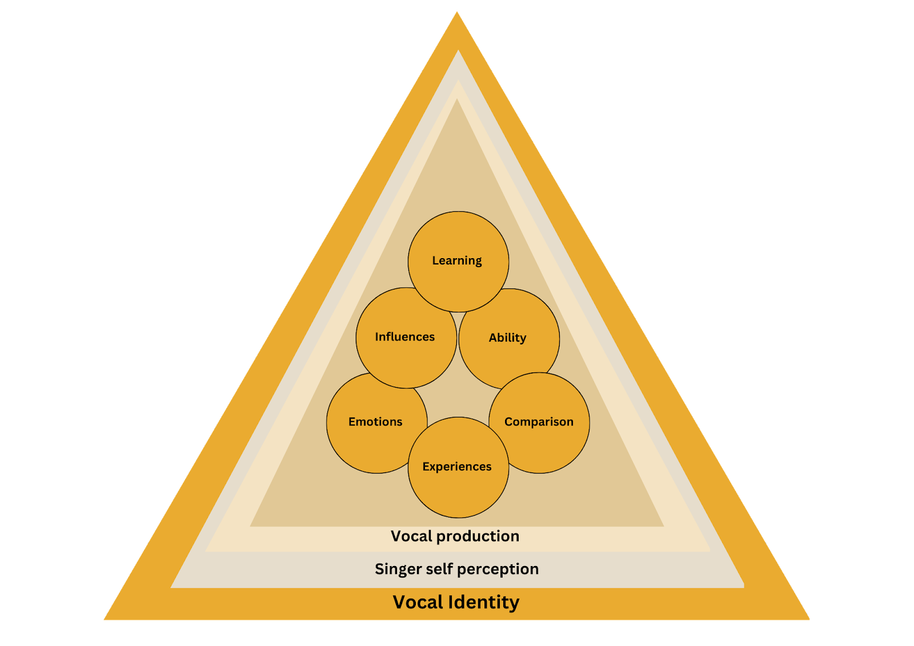
Adapted from (Lemon-McMahon, 2019)

Appendix K: Vocal Identity and the Development Pathway

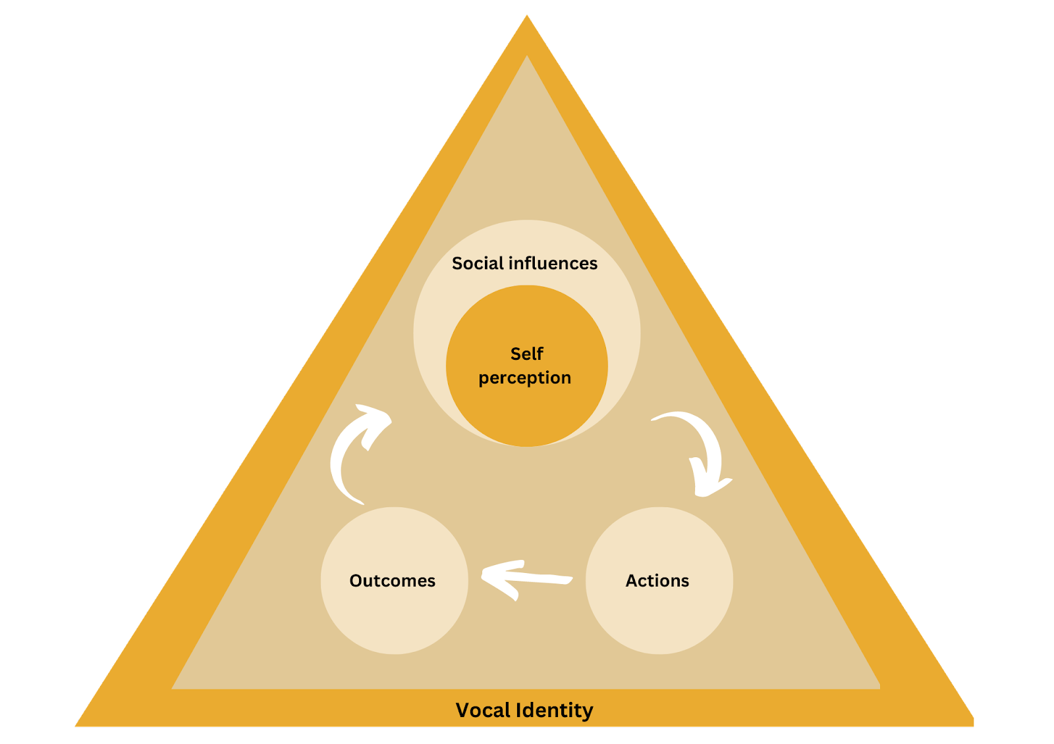
Adapted from (Lemon-McMahon, 2019)

