

Programme Name: - Master of Business Administration
Module Name: - Strategic Management
Module Code: - LCMB7003
Assignment Title: - Assessment component - Individual report
Lecturer’s Name: - Amare Desta
Zulf Khan
Student Name: - Abhi Shitalbhai Shah
Student Id: - 2511298
Submission Date: - Wednesday 01/04/2026 by 2pm
Word count: - 4802

Table of Contents
Section 1: Strategic Management Analysis of Louis Vuitton
- Organisational Context and Overview…………………………………………3
- External Environment Analysis……………………………………….…………6
2.1 PESTEL Analysis 2.2 Critical Success Factors in the Luxury Fashion Industry
- Internal Environment Analysis ……….…………………………………………8
3.1 Organisational Resources and Capabilities 3.2 Core Competencies
3.3 VIRO Framework Analysis of Louis Vuitton
3.4 Strategic Implication of Internal Analysis
- Industry Analysis……………………………...…………………………….……13
4.1 Poter’s Five Forces Models
- Corporate Social Responsibility and Sustainability……………………….16
5.1 Environmental Sustainability Initiatives
5.2 Ethical Sourcing and Responsible Supply Chain
5.3 Social Responsibility and Community Engagement
- Strategic Performance Analysis using the Balanced Scorecard………...17
- Strategic Recommendations……………...……………………………………18
Section 2: Reflective Account………………………………………………………….19
- Description
- Feelings
- Evaluation
- Analysis
- Conclusion
- Action Plan
- References…………………………………………………………………….…20

1.Organisational Context and Overview
Louis Vuitton is one of the leading brands in the luxury fashion industry, operating as a part of the global conglomerate LVMH. Established in 1854 by Louis Vuitton in Paris, the brand began with the production of luxury trunks for the elite class. The trunks were unique with flat tops and were very light, making them easy to stack while traveling.

Louis Vuitton has evolved from being a luggage manufacturer to a global luxury fashion brand. Currently, the brand operates in the following product categories: handbags and leather goods, shoes, ready-to-wear, watches, jewelry, and fragrances. The brand is renowned for combining high-quality craftsmanship with innovative designs. Research studies on the luxury industry indicate that brands such as Louis Vuitton rely on their prestige, heritage, and exclusivity to stay ahead of the competition. The iconic LV logo and patterns have become a global symbol of luxury.

The firm has operations in more than 60 countries, with flagship stores located in fashion capitals such as Paris, New York, London, Tokyo, and Shanghai. Unlike other fashion houses, it maintains a firm control over most of its retail outlets and does not rely on third-party retailers. The objective is quite simple: maintain the highest level of customer service and retain the elite status of the brand. The luxury market has expanded globally due to an increase in disposable incomes, more international travelers, and the emergence of new markets. China and India have emerged as new players due to an increase in the number of high-income earners.

However, Louis Vuitton is confronted with stiff competition from other luxury brands such as Gucci, Chanel, Hermès, and Prada. Despite this, Louis Vuitton is one of the most valuable brands in the industry due to its strong brand equity, high pricing, and innovation. The company’s mission is to provide luxury products that reflect exceptional craftsmanship, creativity, and timeless elegance. Looking into the future, Louis Vuitton plans to reinforce its position in the luxury market and enter new markets while maintaining exclusivity, enhancing the customer experience, and adopting digital technology.

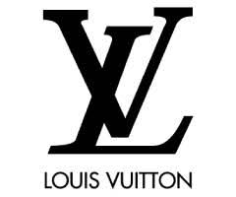
From the perspective of strategic management, Louis Vuitton is an exemplary case of how a firm can maintain its competitive advantage by capitalizing on its intangible resources, such as brand status, heritage, and design acumen. According to research, luxury brands function on the principles of differentiation, emotional branding, and strong customer ties, and Louis Vuitton exemplifies these principles to create a unique value proposition for luxury consumers across the globe.

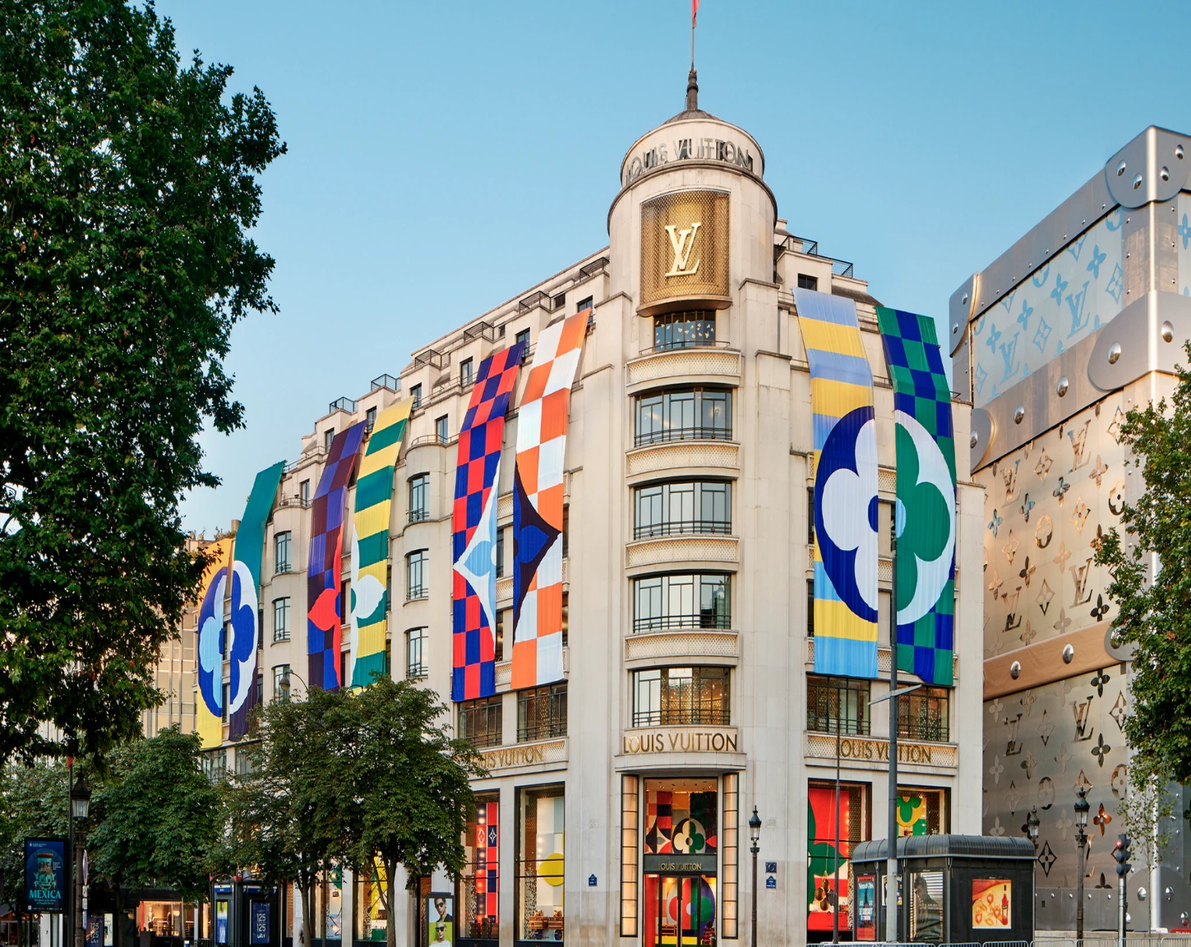
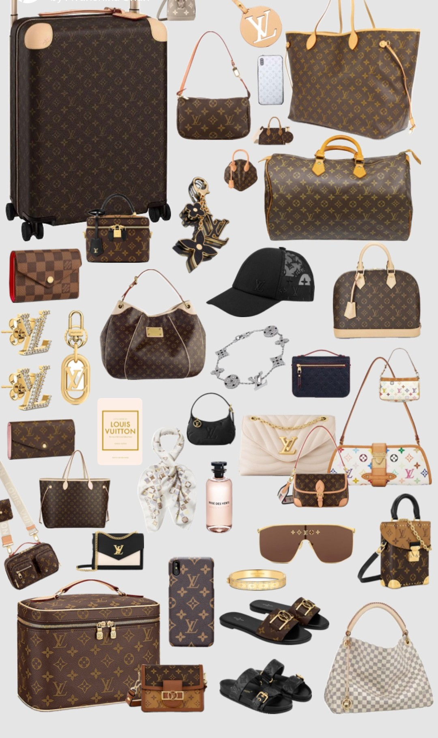

Figure 1: Louis Vuitton Brand Logo, Paris Store, and its core products
Source: Louis Vuitton Brand Archives and Pinterest

2. External Environment Analysis
Analysis of the external environment is an important part of strategic management because it helps organisations understand the macro-environmental factors that affect their business environment and strategic choices. According to the literature on strategic management, which is often cited in Harvard Business School publications, organisations need to constantly assess the external environment to detect opportunities and threats in their competitive environment. These external factors are often outside the control of the organisation but can have a major impact on its performance and sustainability.

In the case of luxury fashion brands like Louis Vuitton, the external environmental factors are of great importance because the luxury industry is very sensitive to economic, social, and technological changes. Globalisation has opened up new markets for luxury brands to operate in different international markets. However, this also exposes them to different political, economic, and cultural environments.

Among the most popular approaches to analysing the external environment, PESTEL analysis is one of the most prominent. This tool focuses on six important aspects of the macro environment: political, economic, social, technological, environmental, and legal, and all of these factors influence the strategies and performances of luxury fashion brands.

2.1 PESTEL Analysis
PESTEL analysis is a strategic management technique that helps to identify the macro-environmental factors that influence the strategy and performance of an organization. It is a tool that helps organizations to systematically analyse the external environment and be ready for any threats and opportunities that may arise.

This factor includes government policies, trade policies, taxation policies, and regulations that affect organizations. Political stability and trade policies in different regions are important for a global luxury brand such as Louis Vuitton. Customs policies and import taxes can affect the pricing of luxury goods in different countries. Luxury brands have global supply chains for raw materials and production. Political instability and trade barriers can affect these supply chains and increase costs. Intellectual property rights are an important part of this factor. They are essential for luxury brands. Luxury brands are vulnerable to counterfeiting. Strong legal systems are required to protect trademarks and brand identity.

Economic conditions influence the way and means of spending and purchasing in the luxury segment. Economic growth, inflation, exchange rate fluctuations, and unemployment are all interlinked with consumer confidence and spending behaviour. Luxury products, in general, are marketed to the rich, who appear less affected during economic downturns, but global economic recessions do affect luxury demand. During times of economic uncertainty, discretionary spending, including luxury products, normally pulls back. However, the luxury market is undergoing new dynamics, with China and India, as emerging economies, driving the growth. The rising middle class and increased disposable incomes in these countries present new opportunities for luxury brands. Simultaneously, exchange rate movements may impact the profitability of luxury companies operating globally.

Social elements influence the behaviour of consumers when they are shopping for luxury fashion. The lifestyles, age, and values of people influence the demand for luxury fashion. Modern consumers are more concerned about authenticity, sustainability, and ethics when it comes to the selection of luxury brands. The influence of social media has particularly affected the younger generation, including millennials and Gen Z. Brands such as Louis Vuitton have therefore initiated art and designer collaborations to keep their brand fresh and attractive to the younger generation. The influence of globalization has also erased boundaries in the fashion industry, and the world of luxury fashion is more interconnected than ever before.

The tech revolution has transformed the world of retail and fashion. Technology such as online shopping platforms, digital tools, and data analytics has impacted the way luxury brands connect with consumers and operate their businesses.

Luxury brands are adopting digital marketing and online shopping platforms to reach their consumers worldwide. Online shopping platforms and virtual reality shopping enable customers to purchase luxury products without visiting the store.
Artificial intelligence and data analytics enable luxury brands to analyse customer shopping behaviour and design their marketing strategies accordingly. When luxury brands know what their customers want and how they shop, they can design better experiences for them and build lifelong loyalty.

2.2 Critical Success Factors in the Luxury Fashion Industry
In the world of high fashion, there are certain factors that will always contribute to the success of a luxury brand. These factors are based on what makes a luxury brand unique and what consumers expect from a luxury brand.

The factors are:
- Rich brand history and reputation
- High-quality products and craftsmanship
- Innovation in design and marketing
- Limited and exclusive distribution channels
- Effective customer relationship management

Louis Vuitton has leveraged these factors through investments in brand management, innovative design, and retail expansion. Its ability to remain exclusive while expanding its reach across the globe has been an integral part of its success formula.

3. Internal Environment Analysis
The internal environment analysis is concerned with the assessment of the resources, capabilities, and competencies within an organisation that build the basis for competitive advantage. As per the findings of strategic management studies widely quoted in literature related to Harvard Business School, organisations succeed in gaining sustainable competitive advantage by leveraging valuable resources and building unique capabilities that are difficult for competitors to imitate.
In the case of luxury fashion brands, internal resources such as brand reputation, craftsmanship, design capabilities, and distribution networks are extremely important in determining strategic success. Internal resources enable organisations to differentiate their offerings and add value to customers.

In the case of Louis Vuitton, internal resources are mainly based on its strong brand heritage, high-quality craftsmanship, innovative design methodologies, and retail infrastructure around the globe. This has helped the company to establish itself as one of the most successful luxury brands in the world. The internal environment analysis usually involves the assessment of organisational resources and capabilities and the identification of core competencies that build strategic advantages. The most popular tool used for this purpose is the VRIO framework developed by Jay Barney.

3.1 Organisational Resources and Capabilities

On the other hand, resources are considered to be the assets that the organisation possesses and makes use of in order to achieve organisational strategies. Resources can be broadly classified into two types: tangible resources and intangible resources.

Tangible resources can be considered as the physical assets that an organisation makes use of in order to carry out its business operations. For Louis Vuitton, tangible resources can be considered as manufacturing facilities, retail outlets, financial resources, and supply chain management facilities, among others. The company has a wide network of retail outlets located in different parts of the world, especially in metropolitan cities. The retail outlets are designed in such a manner that customers get a luxurious shopping experience, as the brand is considered to be a luxury brand. Financial resources also play a significant role in supporting the organisational strategies of the company. The company, being a part of the LVMH group, enjoys significant financial support from the group, which enables the company to access global resources.

Intangible resources are non-physical in nature, yet they play an important role in the success of the organisation. In the case of the luxury industry, intangible resources are more significant than physical ones, as they affect brand names as well as customer loyalty.

Key intangible resources of Louis Vuitton:
• Brand reputation and prestige
• Creativity in terms of design and art
• Intellectual property and trademarks
• Customer loyalty and brand recognition

The LV monogram as well as the brand’s product design are considered to be among the most recognizable in the global luxury industry, thus helping the company to maintain brand exclusivity.

3.2 Core Competencies
The basic idea behind core competencies is that these are the unique qualities and strengths of an organisation, which ultimately help in the creation of value for consumers and thereby achieve a sustained competitive advantage in the market. As per strategic management literature and research done by Harvard Business School, core competencies emerge out of the integration of skills and knowledge present within an organisation.

One of the main core competencies of Louis Vuitton is its craftsmanship and product quality. Over the past 159 years, since its founding in 1854, Louis Vuitton has established a very strong reputation in the market in terms of its ability to deliver high-quality products to its consumers.

Another significant competency for the brand is its rich heritage and global prestige. Over the years, Louis Vuitton has created a unique brand identity, as represented by their iconic monogram pattern and traditional designs. In the luxury industry, brand heritage is a critical competency because, in the case of luxury products, customers may be motivated to purchase such products because of their symbolic significance and their ability to convey status to customers. The brand has managed to strike a balance between preserving its heritage and keeping up with fashion trends, thus ensuring its relevance in the current market.

Another significant competency for the brand is innovation, as represented by their creative designs. The brand regularly partners with designers to create new collections, as well as to recreate their traditional designs, thus keeping up with current fashion trends while ensuring their relevance to their current customer base as well as to a new generation of customers.

Moreover, Louis Vuitton enjoys a powerful retail and distribution infrastructure across the globe. Louis Vuitton stores can be found in the most important luxury shopping hubs worldwide, and the company prides itself on providing a luxurious shopping experience to its consumers. Thus, the brand maintains a high level of exclusivity for its products. In conclusion, the craftsmanship, brand heritage, innovation, and retail presence of the company constitute the core competencies of the company, which would ensure the continued leadership position of Louis Vuitton in the fashion industry.

3.3 VRIO Framework Analysis of Louis Vuitton
The VRIO model, proposed by Jay B. Barney, is used for strategic management and helps in analysing an organisation’s resources and whether it has created any sustainable competitive advantage. This model measures resources on four parameters: value, rarity, imitability, and organisation.

The first parameter, ‘value,’ helps in analysing whether the company is able to take advantage of opportunities or overcome threats with the help of its resources. In the case of Louis Vuitton, their reputation and brand history are extremely valuable resources because they are able to charge premium prices and maintain customer loyalty due to their brand image. People associate their brand with status and luxury goods.

The rarity dimension assesses whether a resource is scarce and not readily available with other competitors. Louis Vuitton has rare resources such as its brand legacy and LV brand logo. Although many companies are in the same business, few have managed to gain such recognition and legacy as Louis Vuitton has attained in the market.

The imitability dimension assesses whether a competitor can easily imitate a specific resource. The resources associated with Louis Vuitton are not easy to imitate because this company has managed to acquire this legacy after many years of operation. Although other companies may attempt to copy what Louis Vuitton is doing, it is extremely hard to copy its legacy.

The organisation dimension focuses on whether a company is well-organised to fully exploit its resources. In this case, Louis Vuitton enjoys support from its parent company, LVMH, which offers financial support, distribution channels, and management skills.
In conclusion, from the analysis of the VRIO framework, it is evident that Louis Vuitton’s key resources, such as its brand, craftsmanship, and heritage, are all well-positioned to offer a competitive advantage in the industry in which it operates.

Table 1 – VRIO Summary for Louis Vuitton
Resource / Capability | Valuable | Rare | Difficult to Imitate | Organised | Competitive Outcome
Brand reputation | Yes | Yes | Yes | Yes | Sustained competitive advantage
Craftsmanship | Yes | Yes | Yes | Yes | Sustained competitive advantage
Global retail network | Yes | Moderate | Moderate | Yes | Temporary advantage
Financial support (LVMH) | Yes | No | No | Yes | Competitive parity
Design innovation | Yes | Yes | Moderate | Yes | Competitive advantage
Table 1 adapted from Jay B. Barney (1991) Firm Resources and Sustained Competitive Advantage, Journal of Management; and Jay B. Barney & Hesterly (2015) Strategic Management and Competitive Advantage.

3.4 Strategic Implications of Internal Analysis
Internal analysis reveals that the company has several strengths that have helped the firm achieve long-term competitiveness in the market. The most prominent advantage that Louis Vuitton possesses is its brand reputation and craftsmanship, which are hard to duplicate for its competitors.

It is obvious that luxury brands are highly dependent on intangible resources such as brand heritage and perception. Louis Vuitton has successfully established its brand image in the international market, representing prestige and exclusivity for its customers. The brand image of the company allows it to enjoy premium pricing and maintain its margins.

Additionally, access to financial support, distribution channels, and strategic partnerships through its affiliation with LVMH would be advantageous for its position in the industry.

Nevertheless, there are also challenges that may be identified from an internal analysis perspective. Exclusiveness and new markets pose strategic challenges for the company, and over-expansion may harm the prestige of the brand.
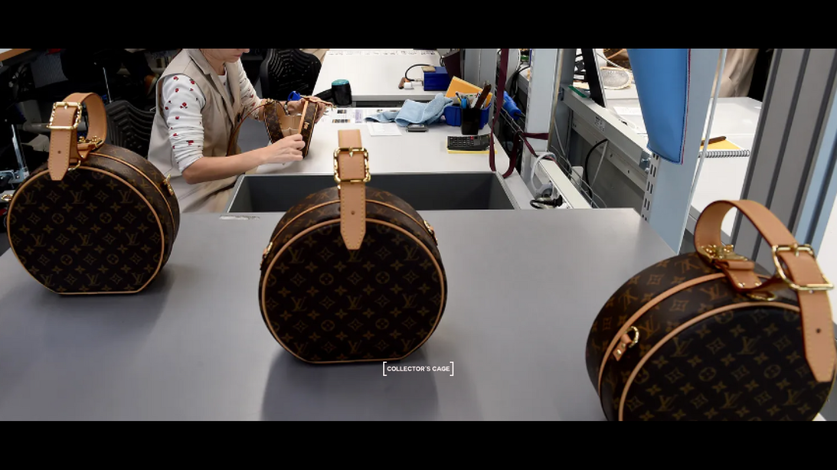

Figure 2: Artisan crafting luxury leather products in a Louis Vuitton manufacturing workshop.
Source: Louis Vuitton

4. Industry Analysis
Industry analysis is an important part of strategic management. The industry analysis helps an organisation understand the competitive forces that impact its profitability. It is always important for an organisation to conduct industry analysis and develop strategies accordingly. The luxury fashion industry is known for its brand identity, product differentiation, quality, and exclusive nature. Luxury goods are not only associated with quality; they also symbolise prestige and social status.

Considering the competitive and dynamic nature of this industry, it is important for companies to be innovative in terms of products, marketing, and customer service. The dynamic nature of fashion trends is also posing challenges for companies to strike a balance between tradition and modernity. The emergence of technology and online shopping is also changing the industry's nature. The Five Forces Model proposed by Michael E. Porter is commonly used to understand these forces.

4.1 Porter’s Five Forces Model
The Five Forces Model includes competitive rivalry, threat of new entrants, bargaining power of buyers, bargaining power of suppliers, and threat of substitutes. These forces help companies understand industry challenges and opportunities.

Competitive rivalry in the luxury fashion industry is high due to the presence of global brands such as Louis Vuitton, Gucci, Chanel, Hermès, and Prada. These brands compete through innovation, marketing, and maintaining a strong brand image.

The threat of new entrants is low due to high entry barriers such as brand reputation, high capital investment, and limited access to prime retail spaces. Established brands like Louis Vuitton already have strong customer loyalty, making it difficult for new entrants.

The bargaining power of buyers is moderate. Although buyers value exclusivity and brand reputation, increased access to information through digital platforms has made them aware of alternatives.

The bargaining power of suppliers is also moderate, as luxury brands depend on specialised materials and craftsmanship. However, large companies like LVMH maintain strong supplier relationships.

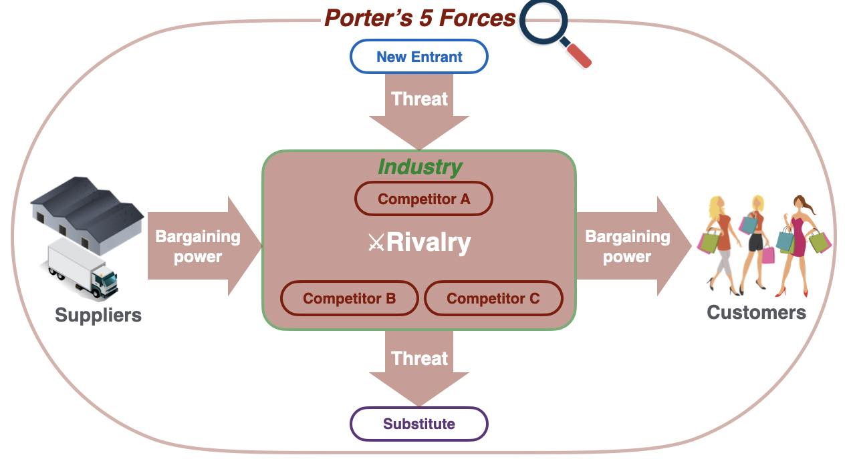
The threat of substitutes is moderate, as consumers may shift to premium or contemporary brands offering similar designs at lower prices. To address this, luxury brands focus on innovation, quality, and maintaining a strong brand image.
Figure 3: Porter’s Five Forces Model used for analysing industry competition.
Source: Porter (2008)

Table 2 – Summary of Porter’s Five Forces for Louis Vuitton
Competitive Force | Industry Impact | Strategic Implication
Competitive Rivalry | High | Luxury brands compete through innovation and brand identity
Threat of New Entrants | Low | High investment and brand reputation create entry barriers
Buyer Power | Moderate | Customers seek prestige but have access to alternatives
Supplier Power | Moderate | Dependence on specialised materials and craftsmanship
Threat of Substitutes | Moderate | Premium brands and designer goods act as alternatives

Table 2 adapted from Michael E. Porter (1979) How Competitive Forces Shape Strategy, Harvard Business Review; and Michael E. Porter (2008) The Five Competitive Forces That Shape Strategy.

5. Corporate Social Responsibility and Sustainability
Corporate Social Responsibility (CSR) is defined as “the obligation of an organization to make a positive contribution to society in the course of business operations.” Today’s business environment is not only concerned with making profits but also with the social, environmental, and economic impacts that organizations make. A study that is widely cited in business journals associated with Harvard University indicates that CSR is part of strategic management due to its impact on reputation.

CSR in the luxury fashion industry is significant today since consumers demand that brands be socially responsible. Sustainability is something that consumers value. Therefore, brands include it in their strategies. Louis Vuitton, being part of LVMH, includes CSR in its strategies.

5.1 Environmental Sustainability Initiatives
Environmental sustainability is an essential aspect of the fashion industry, considering the high resource requirements of the industry. Luxury fashion companies are embracing various initiatives to promote environmental sustainability. Louis Vuitton is committed to reducing greenhouse gas emissions, waste, and energy consumption, as well as increasing production efficiency. The company invests in new technologies to reduce its environmental footprint.

5.2 Ethical Sourcing and Responsible Supply Chain
Responsible sourcing is an essential aspect of the luxury industry, considering that the product requires various materials such as leather, fabric, and metal. Louis Vuitton works with suppliers to promote high ethical and environmental standards. The company supports responsible sourcing, including sustainable supply chains, as part of LVMH’s strategy.

5.3 Social Responsibility and Community Engagement
The other way through which Louis Vuitton can contribute to social development is through community involvement. Louis Vuitton participates in cultural, educational, and artistic activities to promote creativity, heritage, etc. It works with artists, cultural, and educational institutions, as well as training activities to promote the continuation of craftsmanship in the luxury industry.

6. Strategic Performance Analysis Using the Balanced Scorecard
Balanced Scorecard is a method for strategic performance management that assesses an organisation’s performance through various dimensions rather than focusing solely on financial performance. Balanced Scorecard was first introduced by Robert S. Kaplan and David P. Norton in terms of financial, customer, internal business processes, and learning and growth. This method is significant for luxury brands like Louis Vuitton, as its success is dependent on brand image, innovation, and customer experience.

The financial perspective is about value creation through revenue, profits, and market share. Louis Vuitton has good financial performance due to its premium pricing, luxury brand image, and demand for luxury products.

The customer perspective is based on customer value and customer relationship. In the case of Louis Vuitton, brand image and customer loyalty are of prime importance. Louis Vuitton focuses on enhancing customer experience through personalized services, products, and marketing.

The internal process perspective is based on efficient business processes and product quality. Louis Vuitton focuses on craftsmanship, skilled labor, and technology. In addition, it also focuses on efficient supply chain management and innovation in products.

The learning and growth perspective is based on innovation, employee management, and knowledge. Louis Vuitton focuses on training programs, traditional craftsmanship, and innovation through partnerships with designers and artists.

7. Strategic Recommendations
Strategic recommendations are critical in strategic management since they assist in converting the analysis into strategies that boost success and sustain competitiveness. In the global luxury fashion industry, the organization needs to address consumer behaviour changes, technological advancements, and sustainability issues. However, the organization needs to balance these with the need to remain exclusive. Based on the analysis above, the following recommendations will boost the competitiveness of the organization.

One of the recommendations is that the organization needs to invest more in digital innovation. Although the organization has digital channels such as the internet, it needs to expand the e-commerce platform to incorporate personalized experiences and the use of technologies such as AI to better understand consumer behaviour.
The other recommendation would be to expand in emerging markets such as India, China, and Brazil, where there is an increasing demand for luxury goods. The company can increase its presence in the market by maintaining exclusivity, which would be beneficial for improving market share.

The other recommendation would be to strengthen sustainability initiatives, which would be essential for the company. For instance, the company can focus on sustainable materials, improving resource efficiency, reducing carbon emissions, and improving sustainability reporting.

The other recommendation would be to maintain innovation and creative partnerships, which would be essential for maintaining competitiveness in the market. For instance, Louis Vuitton can focus on innovation in product design, functionality, sustainability, and technology, which would make the company unique in the market.

Section 2 – Reflective Account
1. Description
The aim and objective of this reflective piece is to reflect on my learning experience while working on a strategic management assignment on one of the most recognized and renowned luxury fashion brands in the world, Louis Vuitton.

The assignment asked me to apply strategic management concepts to analyse the company’s external environment, internal capabilities, and strategies.

While working on the report, I used various sources like academic journals, textbooks, and industry reports to conduct my research on the topic. In my report, I analysed the company’s external environmental factors using the PESTEL tool, internal company capabilities using the VRIO tool, and the company’s overall industry rivalry using Michael E. Porter’s Five Forces tool. In addition to these, I also conducted research on the company’s sustainability practices, its performance measurement using the Balanced Scorecard approach, and strategic recommendations.

The learning experience while working on this assignment was quite interesting because while doing my research on Louis Vuitton, I learned how these multinational companies sustain their competitive edge in the market while responding to changing market needs.

2. Feelings
At the start of the assignment, I was interested in the assignment, yet somewhat overwhelmed by the sheer breadth of the assignment. Strategic management involves a wide range of frameworks and analytical models, which can be overwhelming to apply to a global luxury brand. However, as I progressed with researching the assignment on Louis Vuitton, my confidence in completing the assignment increased. The more I learned about the company’s rich heritage, brand reputation, and innovative marketing practices, the more interested I became in completing the assignment. The more I learned, the more interested I became in the assignment, especially with regards to how luxury brands can be exclusive in a global market.

Applying the VRIO framework, for instance, gave me a sense of accomplishment as I could relate concepts to actual business practices. Even though the assignment was time-consuming, it was worth it as it furthered my knowledge of strategic management.

3. Evaluation
In conclusion, the assignment was both challenging and rewarding. First, the assignment was rewarding in the sense that it allowed me to apply my knowledge of the theoretical frameworks to a real-life organisation like Louis Vuitton, which helped me to understand the practical application of strategic management concepts in real-life business decisions. Secondly, the assignment was also rewarding in the sense that it helped me to improve my research skills, especially since I used academic sources to find credible information and to compare different viewpoints. Thirdly, the assignment also helped me to improve my academic writing skills in the sense that it allowed me to structure my ideas in a clear and coherent way.

However, the assignment was also associated with some challenges, especially in the sense that it was difficult to manage the amount of information available on the luxury fashion industry and to identify the most relevant information. Secondly, it was also difficult to apply strategic management concepts like Michael E. Porter’s Five Forces and the VRIO concept, which also required more research.

4. Analysis
Further reflection on this topic suggests that strategic management models offer valuable instruments for analysis of complex business environments. PESTEL analysis helped to identify how external factors, such as economic conditions, technology, and environmental problems, affect global companies.

The VRIO model also helped to understand how internal resources are vital for gaining competitive advantage in business. Through this analysis, I learned that it is vital for an organisation to have valuable and unique resources that cannot be easily imitated by competitors. Michael E. Porter’s Five Forces model also helped to identify the competitive environment in the luxury fashion industry. Through this analysis, I learned that the level of competition between established luxury brands is high, while the threat of new entrants is relatively low due to high brand development costs and customer loyalty.

Overall, I gained an understanding of how strategic decisions are made in global business organisations.

5. Conclusion
In conclusion, this assignment was very beneficial to me in the sense that it allowed me to practically apply the theories learned in strategic management to the case study of Louis Vuitton. It also helped me improve my understanding of how organizations use these theories to analyse their inner strength and outer environment in order to design strategies. In addition, this assignment helped me improve my research, analytical, and academic writing skills. The assignment was also difficult in its own way, and overcoming these challenges helped me improve my ability to practically apply my knowledge to real-life situations. Overall, this assignment helped me improve my understanding of strategic management and my confidence in business analysis.

6. Action Plan
From this reflection, I have been able to identify several areas where I need to improve. First, I need to improve my research skills by looking at more academic journals and literature on strategic management. This will help me to get more in-depth knowledge about business strategies and trends in the industry. Second, I need to improve my knowledge about more advanced strategic management concepts by looking at more case studies on strategic management in global businesses. Analysing more businesses in different sectors will improve my understanding and my ability to apply strategic management concepts more effectively. Third, I need to improve my time management skills while doing large assignments. Improving my time management skills will allow me to develop each section of my reports more effectively in the future.

Finally, I need to improve my critical thinking skills by getting more in-depth knowledge about strategic management concepts in academic and real-life scenarios. These skills will be very helpful in my future career in business management, consulting, and leadership.
8. References
Archie B. Carroll (1991). The pyramid of corporate social responsibility: Toward the moral management of organisational stakeholders. Business Horizons, 34(4), pp. 39–48.
Boston Consulting Group (2023). True Luxury Global Consumer Insight Report. Boston: Boston Consulting Group.
Deloitte (2023). Global Powers of Luxury Goods. London: Deloitte Insights.
European Commission (2022). Sustainable fashion and environmental impact of the textile industry. Brussels: European Commission.
Gerry Johnson, Kevan Scholes and Richard Whittington (2017). Exploring Strategy. 11th ed. Harlow: Pearson Education.
Gerry Johnson, Kevan Scholes and Richard Whittington (2020). Exploring Strategy: Text and Cases. 12th ed. Harlow: Pearson Education.
Gilles Lipovetsky and Elyette Roux (2003). Luxury: The New Rules of Marketing. London: Kogan Page.
Jay B. Barney (1991). Firm resources and sustained competitive advantage. Journal of Management, 17(1), pp. 99–120.
Jay B. Barney and Delwyn N. Clark (2007). Resource-Based Theory: Creating and Sustaining Competitive Advantage. Oxford: Oxford University Press.
Jean-Noël Kapferer (2015). Kapferer on Luxury: How Luxury Brands Can Grow Yet Remain Rare. London: Kogan Page.
Jean-Noël Kapferer and Vincent Bastien (2012). The Luxury Strategy: Break the Rules of Marketing to Build Luxury Brands. London: Kogan Page.
Louis Vuitton (2024) Louis Vuitton Maison Champs-Élysées. Available at: https://au.louisvuitton.com/eng-au/point-of-sale/france/louis-vuitton-paris-champs-elysees.
Louis Vuitton (2024). Brand history and sustainability initiatives. Paris: Louis Vuitton Official Publications.
LVMH (2023). Annual Report. Paris: LVMH.
McKinsey & Company (2023). The State of Fashion and Luxury Industry Report. New York: McKinsey.
Michael E. Porter (1985). Competitive Advantage: Creating and Sustaining Superior Performance. New York: Free Press.
Michael E. Porter (1996). What is strategy? Harvard Business Review, 74(6), pp. 61–78.
Michael E. Porter (2008). The five competitive forces that shape strategy. Harvard Business Review, 86(1), pp. 78–93.
Michael E. Porter and Mark R. Kramer (2011). Creating shared value. Harvard Business Review, 89(1–2), pp. 62–77.
Philip Kotler and Kevin Lane Keller (2016). Marketing Management. 15th ed. Harlow: Pearson.
Pierre-Yves Donzé and Veronica Pouillard (2019). The luxury value chain: A review and research agenda. Journal of Business Research, 102, pp. 1–13.
Robert S. Kaplan and David P. Norton (1992). The Balanced Scorecard: Measures that drive performance. Harvard Business Review, 70(1), pp. 71–79.
Robert S. Kaplan and David P. Norton (1996). The Balanced Scorecard: Translating Strategy into Action. Boston: Harvard Business School Press.
Statista (2024). Global luxury goods market statistics and consumer trends.
United Nations Environment Programme (2021). Sustainability in the global fashion industry.

