EVIDENCE OF LEARNING E-PORTFOLIO REPORT

LEARNING IN THE DIGITAL ERA BMP54009/BMPL4007

KYLIE HEEKS (2223360)

Table of contents
- Written summary preparing for higher education……………………………………………………………2
- Mind Map………………………………………………………………………………………………………………………..3
- Presentation…………………………………………………………………………………………………………………….4
- Reflection…………………………………………………………………………………………………………………………5
- Reference list……………………………………………………………………………………………………………………6

Task one – Written Summary

With many options of higher education qualifications available and hundreds of different subjects to choose from (nationalcareersservice), once choices of study have been nominated the preparation prior is a key element that will contribute almost entirely to succeeding.

The most significant way to do this is to plan and will be extremely helpful to try to plan ahead “failing to plan is planning to fail” (Lakein,Alan.). Starting with what may seem the basics, where to study? To be able to strive to success being in a appropriate environment is vital, a thinking place, a quiet place, a place to be seated comfortably a desk.

Taken from (Rutkowski.David.) internationally with a rough estimated average of 7% of students without a desk reaching the greatest success levels in comparison to the 26% that are at the lowest, finding that those without desks academically are three times more likely to be at the bottom rather than the top.

A quiet place, according to (Hendrix.Ella.) research has observed that some low-level environment noise can support imagination as well as focusing on learning, too much noise can also cause diversions leading to a lack of ability to concentrate within studying. If noise is causing negative impacts within learning, then a quiet place is the best way to ensure most effective learning.

Time planning is the essence of almost everyday be it for study, work, family and social. Ensure time is set for the most important issues as well as the ones that are less but most specifically self, overthinking, last minute delays can all disturb positive studies.

It is also vitally important that clear boundaries are set; according to (NHS: 7 simple tips to tackle working from home) “Setting boundaries with other members of your household is key to mental wellbeing while working at home.”
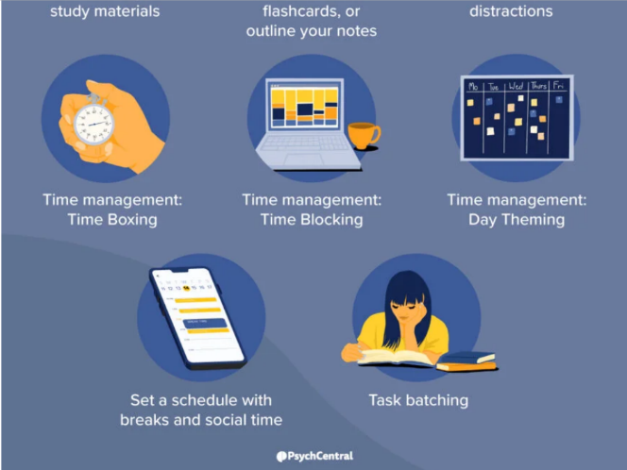
Image sourced from Psychcentral.

Task two – Mind Map

Task 3 – Presentation
Please follow this link to view my presentation:
https://uowtsd-my.sharepoint.com/:f:/g/personal/2223360_student_uwtsd_ac_uk/EpnXLKwXjhVBv7ruVQWsm-YBSmnVSBQivxyC6ivTAqH5wA

Task 4 – Reflection
Applying for university seems to have been the easiest process, preparing and planning have been the hardest. Where did I go wrong, I figured it would be easy and simple taking care of three children as well as studying I was wrong. The only part of university set routine that was driven inside of my mind was lecture day Thursday, a time balance that was set out and worked for me most likely because I hadn’t had to sit down and plan it myself. The only plan in my head was to succeed and be able to know and show my children that I’ve done it, is this a bad thing well no it isn’t because a plan of success is a goal and having aims to achieve it are what will make it work and become a reality. However the realisation of how to succeed is now a importance and adapting and changing the way I approach my studying at university is vital. Its time to plan although I may sit at a table and have the lights to the brightness I need them I am majority of the time interrupted each time I start to understand and educate leaving me lost within my own learning. I will no longer allow myself to have this happen because after just a few weeks ive realised the true effects it can cause even emotionally, did meeting deadlines ever mean to frustrate and upset one especially when they feel they cant do it, no they are not they are a guided timeline allowing you to set your own time management and meet expectations. “Don’t procrastinate” (Keiling.H/4FEB2023). “Having days dedicated to just studying can help you focus your efforts, though this might not always be possible” (Ucas.).

References

Coronavirus(COVID-19)and mental wellbeing. Available at: https://www.nhs.uk/every-mind-matters/coronavirus/simple-tips-to-tackle-working-from-home/ (Accessed:10th March 2023).

Hendrix.Ella/. How your surroundings affect the way you study. Available at: https://www.UCAS.com//connect/blogs/how-your-surroundings-affect-way-you-study (Accessed:10th March 2023).

Keiling.Hanne/Indeed/9 key time management skills and how to improve them. Available at: https://www.indeed.com/career-advice/career-development/time-managment-skills (Accessed:10th March 2023).

Lakein,Alan/Allauthor.com. Available at: https://allauthor.com/qoute/90095/ (Accessed:10th March 2023).

National,careers,service/Highereducation. Available at: https://nationalcareers.service.gov.uk/explore-your-education-and-training-choices/higher-education (Accessed:10th March 2023).

Psychcentral/8 highly effective study habits. Available at: https://psychcentral.com/health/highly-effective-study-habits (Accessed 10th March 2023).

