Learning in digital era – ACCA4025 Assignment 1: E – Portfolio Mr Aqeel Akhtar Student ID: 2526191 Course: CertHE Computing skill for workplace

Contents
E-Portfolio 3
Task 1- Study and employment skills 4
1a) 4
References: 5
1b 5

E-Portfolio
Welcome to my e-portfolio for the L4 learning in digital era unit. This portfolio presents the skills and knowledge developed throughout the unit and explains how they can support academic study and future employment. The portfolio is organised into four tasks. Task 1 explores study and employment skills in computering and IT, including the use of artificial intelligence. Task 2 focuses on teamwork and the creation of an academic poster. Task 3 explores virtual collaboration and referencing tools. Task 4 explains the creation and review of this e-portfolio. The purpose of portfolio is to demonstrate learning, research, digital skills and reflection. It also provides evidence of activities completed during the unit.

Task 1- Study and employment skills

1a) Important skills for studying and working in computing and IT:
Essential Skills for Study and Employment in Computing and IT
Students studying computing and IT need skills such as problem-solving, communication, teamwork, technical knowledge and research. These skills support university study and can help prepare students for work in the technology industry. Computing curriculum guidelines identify technical knowledge and problem-solving as important parts of computer science education [1].
Technical skills and problem-solving. Technical skills help people understand computers, software and other technologies. Problem-solving is useful when systems or programs do not work as expected. Computing education guidelines describe the knowledge and abilities students need to develop, including finding solutions to problems [1]. A computing textbook can also support students as they learn core concepts and practise applying them [2]. Students can build these skills by practising programming, learning how software works and completing practical tasks.
Communication and teamwork. People working in IT often need to explain ideas, listen to others and share information. They may also need to work with colleagues to complete a project. Research on student software engineering teams examines how soft skills and collaboration relate to group performance [3]. Developing these skills can help students work effectively with classmates and future colleagues.
Research and academic skills. Research skills help students find information and judge whether it is reliable. They are useful when completing assignments that require evidence to support claims. Referencing shows where information came from and gives credit to its original author. Using IEEE referencing helps students present and organise sources consistently.
Digital literacy and responsible use of AI. Digital literacy involves using technology safely and effectively. ChatGPT can be used for tasks such as brainstorming, studying and coding [4]. However, students should check AI-generated information before relying on it and follow their college’s rules for AI use.
Conclusion. Students studying computing and IT need technical knowledge, problem-solving, communication, teamwork and research skills. Developing these skills can support their studies and help prepare them for work in the technology industry [1], [3].

References:
[1] A. N. Kumar et al., Computer Science Curricula 2023. New York, NY, USA: Association for Computing Machinery, IEEE Computer Society, and AAAI Press, 2024, doi: 10.1145/3664191.
[2] J. G. Brookshear and D. Brylow, Computer Science: An Overview, 13th ed. Harlow, U.K.: Pearson Education, 2019.
[3] K. Schekkerman and A. Capiluppi, “Soft Skills and Group Performance in Higher Education: A Quantitative Study of Student Teams in Software Engineering,” Computer Applications in Engineering Education, vol. 34, no. 3, Art. no. e70204, 2026, doi: 10.1002/cae.70204.
[4] OpenAI, “What is ChatGPT: FAQ,” OpenAI Help Center. [Online]. Available: https://help.openai.com/en/articles/12677804-what-is-chatgpt-faq. Accessed: Oct. 16, 2026.
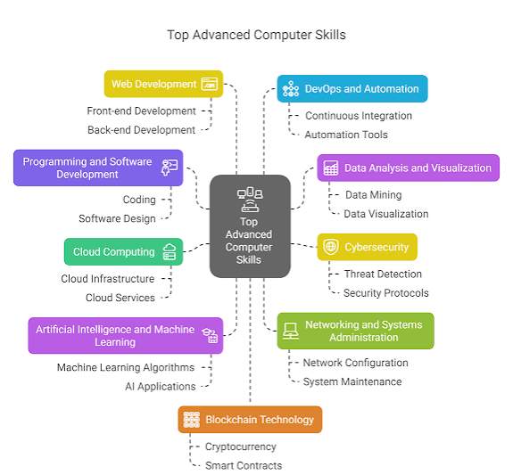
Figure 1- Top Advanced skills
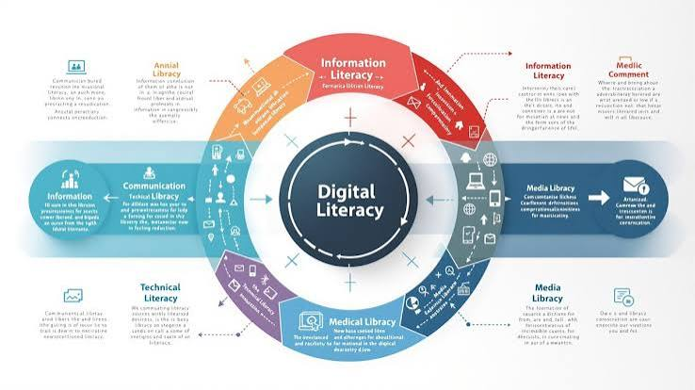
Figure 2- Digital Literacy In AI

1b) Popular AI Assistants and Their Uses
AI Tools for Students
Artificial intelligence (AI) tools can support students in different ways. They can help explain difficult topics, support research and writing, and assist with programming. However, AI can produce incorrect information, so students should check important answers against reliable sources [3], [6].
ChatGPT. ChatGPT can explain computing and IT topics, help students work through programming problems step by step, and support revision and understanding [1].
Microsoft Copilot. Copilot in Microsoft 365 can help students summarise and analyse documents, find details in their work, and draft or revise text in applications such as Word [2].
Google Gemini. Gemini can help students brainstorm ideas, plan tasks, create outlines and get simpler summaries of complex topics [3].
Claude. Claude can help students analyse documents, including PDFs and other course materials, to understand their contents [4].
Perplexity. Perplexity can answer questions using web sources and provide links to those sources. Students can use those links to check the original information and investigate further [5].
Conclusion. AI assistants can help students explore topics, understand difficult information and practise new skills. They should be used responsibly: students should fact-check AI responses, avoid entering personal information unless their college has approved it, and follow their college’s rules. AI should support learning rather than replace independent thinking [1], [6].

References:
[1] OpenAI, “Using study mode in ChatGPT,” OpenAI Help Center. [Online]. Available: https://help.openai.com/en/articles/11780217. Accessed: Oct. 11, 2026.
[2] Microsoft, “How Copilot Chat works in Microsoft 365 apps,” Microsoft Support. [Online]. Available: https://support.microsoft.com/en-us/microsoft-365-copilot/how-copilot-chat-works-in-microsoft-365-apps. Accessed: Oct. 19, 2026.
[3] Google, “Use Gemini Apps,” Gemini Apps Help. [Online]. Available: https://support.google.com/gemini/answer/13275745. Accessed: Oct. 17, 2026.
[4] Anthropic, “What kinds of documents can I upload to Claude.ai?,” Anthropic Help Center. [Online]. Available: https://support.anthropic.com/en/articles/8241126-what-kinds-of-documents-can-i-upload-to-claude-ai. Accessed: Oct. 23, 2026.
[5] Perplexity, “What is Pro Search?,” Perplexity Help Center. [Online]. Available: https://www.perplexity.ai/help-center/en/articles/10352903-what-is-pro-search. Accessed: Oct. 1, 2026.
[6] Department for Education, “Generative artificial intelligence (AI) in education,” GOV.UK. [Online]. Available: https://www.gov.uk/government/publications/generative-artificial-intelligence-in-education. Accessed: Oct. 9, 2026.
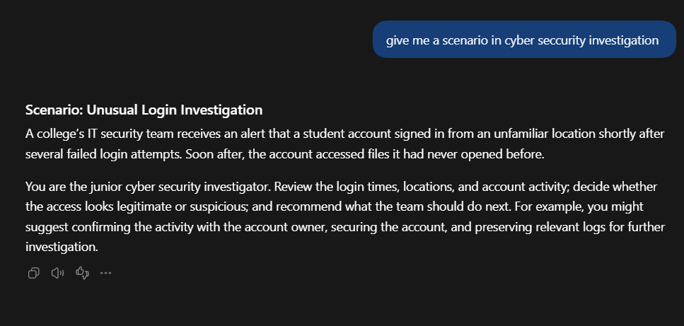
Figure 3- Using ChatGPT to do cyber security investigation
A college detects a student account signing in from an unfamiliar location after repeated failed attempts. A cyber security investigator checks the login and file activity to decide whether the account was compromised and recommends steps to secure it and preserve evidence.
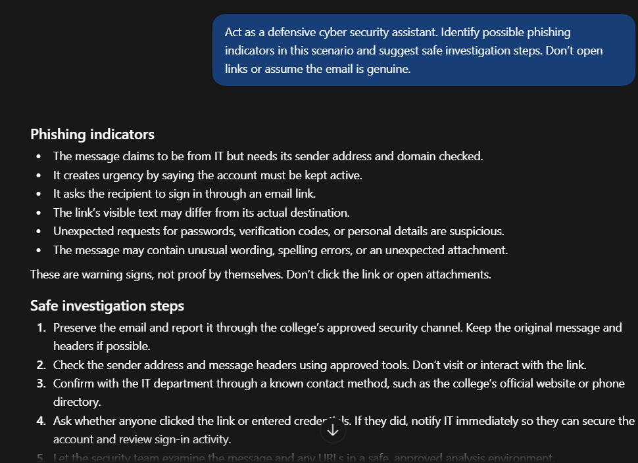
Figure 4- cyber security defense
A college staff member receives a suspicious email pretending to be from IT and urging them to sign in. The security team checks the message safely, confirms its legitimacy through trusted channels, and helps protect any accounts that may have been affected.

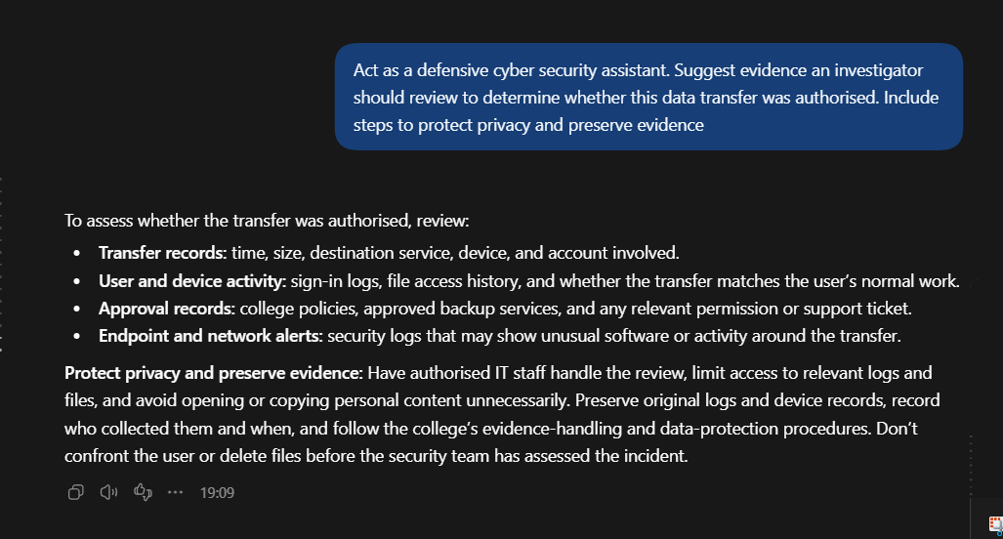
Figure 5- Cyber security defence
A laptop sends an unusually large amount of data to an unfamiliar storage service. Investigators check activity and approval records to determine whether the transfer was legitimate, while protecting private information and preserving evidence.

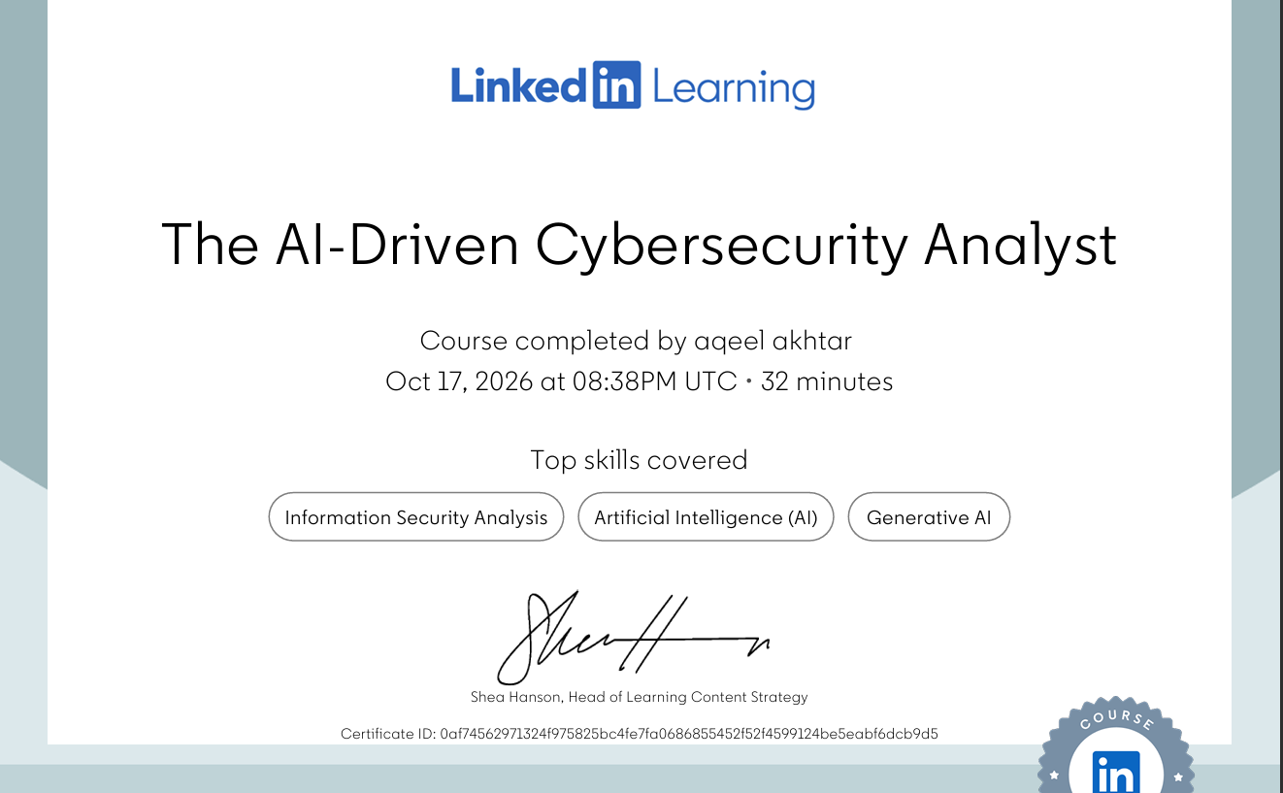
Figure 6- Certificate of AI course on LinkedIn learning
I learned how AI can support cybersecurity analysis, including threat detection, security reporting, and configuration tasks. The course also covered prompt engineering, ethical and privacy considerations, and ways attackers might misuse AI.

