

A license plate recognition platform
based on the deep learning framework

by
Xi Wang

Supervisor: Dr. Gordon Dickers

Project submitted as part of the requirements for the award of M.Sc. Software Engineering (Web Development)

September 2023

DECLARATION

I, Xi Wang declare that I am the sole author of this Project; that all references cited have been consulted; that I have conducted all work of which this is a record, and that the finished work lies within the prescribed word limits.

This work has not previously been accepted as part of any other degree submission.

Signed: Xi Wang

Date: 13/9/2023

FORM OF CONSENT

I, Xi Wang hereby consent that my Project, submitted in candidature for the M.Sc. Software Engineering (Web Development) degree, if successful, may be made available for inter-library loan or photocopying (subject to the law of copyright), and that the title and abstract may be made available to outside organisations.

Signed: Xi Wang

Date: 13/9/2023

ABSTRACT
Artificial intelligence is being applied in various societal domains. License plate identification is an essential application of artificial intelligence in transportation that can enhance traffic management and safety supervision efficiency (Sarfraz et al., 2003). License plate recognition technology has begun to play an essential role in parking management, traffic management, safety monitoring, and other industries as automobile usage has increased and people's desire for convenience has increased. A typical license plate recognition system's processing stages comprise picture capture, image preprocessing, license plate placement, character segmentation, character recognition, and result output. Each processing step must provide high efficiency and strong anti-interference capabilities to ensure that the recognition function achieves appropriate quality. As a result, algorithms and technologies for license plate recognition in complex environments face major challenges.

This article will look at implementation strategies for deep learning-based license plate recognition. In this post, we first go over the background and importance of license plate recognition systems. Second, this presentation will describe the core ideas and current state of deep learning research. The computational principles and implementation approaches for the deep learning-based license plate identification technology will then be thoroughly discussed. The foundation of license plate recognition technology is the position of license plates. This article will describe how to use Faster RCNN to recognize license plates and extract photo attributes. The CRNN and CTC are then used to ascertain the license plate's content. To aid the application, a recommendation for developing a web application that can read license plates is made. For this effort, experimental verification as well as result analysis will be done concurrently. A summary of the work is provided along with some directions for further research.

Table of Contents
ABSTRACT I
CHAPTER 1: INTRODUCTION 1
CHAPTER 2: LITERATURE REVIEW 5
2.1 History of license plate 5
2.2 Development of recognition of license plates 8
2.3 License plate positioning 12
2.4 Character recognition 14
CHAPTER 3: RESEARCH AND DEVELOPMENT METHODOLOGY 18
3.1 Dataset 18
3.2 Data processing 19
3.3 Objection detection 21
3.4 Character recognition 27
3.5 Web Application 34
CHAPTER 4: DESIGN AND IMPLEMENTATION 39
CHAPTER 5: RESULTS AND EVALUATION 44
CHAPTER 6: CONCLUSIONS AND RECOMMENDATIONS 50
CHAPTER 7: REFLECTION 52
REFERENCES 53

List of Figures
Figure 1.1 Current British number plates 2
Figure 2.1 Structure of UK license plates 7
Figure 2.2 license plate 12
Figure 3.1 Faster RCNN 26
Figure 3.2 Web Application 35
Figure 4.1 Loss of train 40

List of Tables
Table of Contents II
Table 3.1 Annotations example 18
Table 3.2 Architecture 32
Table 5.1 Result of different learning rate 47

CHAPTER 1: INTRODUCTION
Technology advancements based on artificial intelligence in numerous sectors have successfully encouraged advances in respective disciplines, thanks to the field's ongoing growth. A key use of artificial intelligence in computer vision is license plate identification, which can increase the effectiveness of traffic management and safety monitoring (Sarfraz et al., 2003). Using multi-layer neural network models, deep learning technology can efficiently mine information to recognize license plate pictures. In the parking, traffic, security monitoring, and other industries, license plate recognition technology has started to play a significant role (Abedin et al., 2017). Of course, this is just the tip of the technology's iceberg; there is still a lot of uncharted ground to be covered.

As technology for scanning license plates develops, license plates—the sole way to confirm a car's identity—become more and more crucial in a variety of application scenarios. Without a question, vehicles are among the most practical modes of transportation. Parking lots have become one of the most significant situations in people's life as a result of the development in automobiles. Parking facilities have kept up with the changes in recent years to give automobile owners a better parking experience. The majority of parking lots have actively implemented OCR license plate recognition systems and gradually upgraded their intelligence as a result of the artificial intelligence wave.

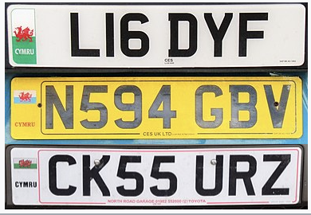
Figure 1.1 Current British number plates

A card parking system is used in conventional parking lots. When entering and leaving the parking lot, drivers must swipe their cards to record their parking time and pay any applicable costs. In order to collect payments, the parking lot has to set up a management room at the entrance and exit and hire specialist employees. A lot of time is wasted when there are too many linkages on-site, and peak hours will surely see traffic jams at the entry and exit. Additionally, goods like cards are simple to misplace. Car owners and managers must invest time and effort to make up for lost vehicles.

Following the launch of the license plate recognition system, several issues raised by the swipe card parking model were resolved, and humanized advancements in administration and operation were made. The license plate recognition system is based on OCR and image processing technology, which can automatically recognize and record the license plate information of arriving and departing cars, enabling quick movement and practical management. Smart parking is made possible by license plate recognition technology. Typically, the entrance and exit of the station are where the terminal equipment for the license plate recognition system is situated. When a car enters or departs, the camera will automatically take a picture of the license plate and use OCR technology to read the information. The system has a high recognition rate and fast recognition speed, supports single shooting or screen viewing, and can realize intelligent batch recognition.

Technically speaking, license plate recognition entails finding a particular license plate number through image recognition and fully automating the detection of license plate number data. However, license plate recognition has its own unique technological aspects due to complex environments, natural light, the ability to overcome distortions produced on by factors like license plate freedom from coercion, and perspective. The standard processing steps for a license plate recognition system include image acquisition, image preprocessing, positioning the plate, character segmentation, character recognition, and result output. Each processing step must provide excellent efficiency and outstanding resistance to interference in order to ensure that the recognition function reaches the appropriate quality.

In order to improve the precision of license plate recognition, the data is regularly improved utilizing a number of auxiliary technologies, such as picture improvement and light correction. The two most crucial components of the license plate recognition system are character recognition and plate positioning. License plate localization, which is the act of processing visuals to accurately determine the location of the license plate in the picture, is one of the most crucial steps in the complete license plate recognition process (Yan et al., 2001). As opposed to this, character recognition can extract license plate numbers from segmented characters.The algorithms of these two modules are regularly updated in order to improve the recognition rate and accuracy, and academics from all over the world have been studying this topic for a very long period.

Static image recognition and dynamic video stream recognition, which may be separated by the recognition environment, are the two basic divisions of license plate recognition. Dynamic video stream recognition may be thought of as ongoing static picture recognition. Additionally, dynamic video stream identification demands a higher recognition speed to accomplish real-time license plate recognition, necessitating a bigger performance boost. As a result, algorithms and technology for reading license plates encounter several difficulties.

We will look at implementation strategies for deep learning-based license plate recognition in this study. In this post, we first go over the background and importance of license plate recognition systems. Second, this presentation will describe the core ideas and current state of deep learning research. The computational principles and implementation approaches for the deep learning-based license plate identification technology will then be thoroughly discussed. The foundation of license plate recognition technology is the position of license plates. This post will explain how to identify license plates and extract picture characteristics using FasterRCNN. The content of the license plate is then determined using the CRNN and CTC. An suggestion for creating a web app that recognizes license plates is also put up to help the application. For this effort, experimental verification as well as result analysis will be done concurrently. A summary of the work is provided along with some directions for further research.

CHAPTER 2: LITERATURE REVIEW

2.1 History of license plate
The laws governing vehicle registration dictate the precise type of license plate that is used, and the design of a license plate and its recognition are closely related. The current UK automotive registration law has undergone a number of revisions since it came into effect in 2001. The major goal of the policy is to make sure that all vehicles operating on public roads have current registrations and insurance. In order to facilitate law enforcement and car monitoring, it also intends to develop a uniform system for identifying vehicles and their owners. In the UK, the first vehicle registration system was put into place in 1903 with the enactment of the Motor Vehicle Act. Each vehicle had to register with the neighborhood government and get a unique license plate under this arrangement. This process was unpredictable, resulting in inconsistent shapes and designs for registered car number plates. As a result, it was challenging for law enforcement and other authorities to locate the car and its driver, especially if they were traveling through another location.

In 1935, the British government altered the registration process for automobiles by standardizing the appearance of license plates. The format of the system, which is still in use today, consists of three letters and three numerals. The license plate had the car's registration number written on it, and each location was designated by a special letter code. This approach helped law enforcement identify cars and their owners more easily, but it still had significant flaws because it ignored the brand, model, or year of the car's manufacture.
In 1962, the British government unveiled a new system that offered more thorough information about automobiles. A two-letter area code, a two-digit age identifier, and a three-letter, seven-character registration number were all part of the system. A single age identity was given to vehicles registered between January and June, whilst a separate age identification was given to vehicles registered between July and December. Updates to the age IDs were made every six months. This system was in use up until 2001, when a completely new system took its place.

The age identification number and the arbitrary letters make up the two components of the current UK vehicle registration system, which was implemented in September 2001 (Shi et al., 2005). The age identifier is made up of two numerals that indicate the registration year and a letter that represents the six-month registration term. For instance, the age tag "21E" would be present on a car registered between March and August 2021. The three randomly chosen letters that make up the random letters are utilized to differentiate amongst automobiles with the same age identification.

The elimination of regional codes was one key modification to the current system. Each region had a distinctive two-letter designation under the former system, which was visible on the license plate. However, because it offered no meaningful information about the car or its owner, this technology was judged unneeded. Additionally, it made it challenging for drivers to relocate without having to buy new license plates. Automobiles can be registered and used anywhere in the UK because the present system does not contain regional codes.

The inclusion of reflective number plates was another modification made to the existing system. The reflective coating on these license plates increases their visibility in low light, enhancing traffic safety. Additionally, compared to the old number plates, which were composed of metal or plastic, they are intended to be more robust and long-lasting.

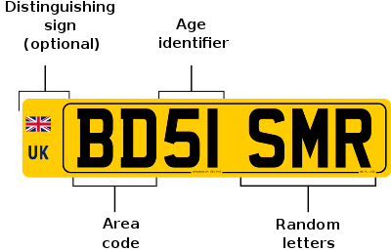
Figure 2.1 Structure of UK license plates

The car's year has been clearly apparent in the license plate image since 2001. Check to see if the car is new or used. The two numbers follow a pattern. The first half of the year (March through September) and the second half (September through March) are both written directly on the license plate. For example, the first half of 2011 is written as 11, whereas the second half of 2012 is written as 2012. For instance, the first half of 2005 is referred to as "05". Three letters are randomly arranged in the final part.

Since it has been in existence for more than 20 years, the UK's current car registration system has shown to be successful in accomplishing its goals. All vehicles operated on UK public roads must be registered, licensed, and insured in order to avoid fines and other consequences. Additionally, because number plates are uniform in design and look, it is simpler for law enforcement to recognize automobiles and their owners, which aids vehicle monitoring.

2.2 Development of recognition of license plates
Numerous companies and academic institutions have concentrated on researching automatic license plate recognition since the early 1990s. The project seeks to identify vehicle license plate numbers by analyzing images of license plates and mechanically extracting license plate information (Yu & Kim, 2000). However, it has proven difficult to recognize license plates due to factors including fluctuations in ambient light, dust in the light's path, seasonal variations, and the rather hazy license plate itself. Researchers have created a variety of techniques for identifying license plates to get over these difficulties, including conventional graphical techniques and shallow machine learning models (Hsu et al., 2012). The field of automatic license plate recognition has progressed as a result of these research.

Because it can correctly truncate the license plate region from the image and provide data support for subsequent license plate identification, license plate localization is an essential part of license plate recognition. Machine learning-based localization methods and graphic image-based localization techniques are the two main categories of license plate localization techniques.

The placement of edge detection and the placement of color are the two key elements of the graphic image-based positioning technique. Color placement is becoming more and more common, but it also puts additional strain on the system and opens up a lot more possible areas without a license plate. On the other hand, methods for finding license plates based on machine learning deliver accurate results by creating models of neural networks (Chang et al., 2004). The secret to this approach is coming up with workable instructional methodologies and components. To build a neural network model and train the data to locate license plates, it is frequently necessary to have a collection of training data with precise output. The trained model has a respectable localization accuracy for recognizing license plates, according to Anagnostopoulos et al. (2008).

To avoid image quality degradation, active infrared illumination cameras and specialized sensors are frequently employed in license plate identification. Deep learning-based automatic number plate identification is a growing area of scientific interest. For feature extraction and regression on location parameters, deep neural networks are utilized. The algorithms YOLO and RCNN, which are frequently used to locate license plates, are aware of the restrictions of the plate and either signal them out or directly intercept them. All of these target identification algorithms have won accolades for their efficiency and affordability.

Since deep learning approaches use a lot of power per machine, they are costly and need a lot of processing. Additionally, the necessary graphics cards are rather pricey. Deep learning-based license plate identification is now feasible because to distributed training techniques and the advancement of cloud computing technology. As a result, the effectiveness of training may be increased by using bigger data sets and dispersed training techniques. To increase detection accuracy, deeper learning techniques with more layers, such as huge models based on recurrent neural networks (RNN) and convolutional neural networks (CNN), can be used.

Numerous deep learning models have also emerged as a result of the ongoing development of deep learning techniques. The capacity to read text in various font sizes, viewing angles, and lighting conditions is necessary for reading license plates (Weihong & Jiaoyang, 2020). Because they can be trained to identify visual cues like character shape and spacing, which are crucial for reading license plates, CNNs are an excellent candidate for this task.

LeNet, AlexNet, VGG, and ResNet are some of the CNN models that have been created for computer vision. LeNet was one of the first CNN models to identify numbers written in cursive. The first CNN model to demonstrate cutting-edge performance in tests of large-scale photo identification was AlexNet, which took first place in the 2012 ImageNet Large-Scale Visual Recognition Challenge (Polishetty et al., 2016). The Visual Geometry Group at the University of Oxford created a CNN model called as VGG, and it has proved effective in a variety of picture recognition applications.VGG16 uses a series of sequential 3x3 convolutional kernels as opposed to AlexNet, which uses bigger convolutional kernels. The topology of VGGNet is pretty simple, using a maximum pooling size of 2x2 and a convolutional kernel that is the same size (3x3) throughout the network. VGG may be used to continuously deepen the network architecture, improving performance at the same time.

CNN imaging history saw a sea change with the introduction of ResNet, which has since excelled in a variety of image identification tasks, including the detection of license plates (Yao et al., 2019). The depth of the network frequently affects how well the model performs. Since more layers provide the network the ability to extract feature patterns in more intricate ways, deeper networks should potentially produce better outcomes. The accuracy of the network, however, degrades or reaches a saturation point as the depth of the network grows, a condition called as deterioration. Deep networks have a degradation issue, indicating that they are at the very least difficult to train.

To get around the degradation problem, ResNet provides residual learning and augments residual units.ResNet has several qualities that make it a good candidate for recognizing license plates. To make sure that the network can respond to changes in the input data, it employs batch normalization to normalize the input data. The dimensionality of the feature map is further reduced using a global average pooling layer, which enhances generalization performance and lessens overfitting (Wu et al., 2005).

There are alternatives to deep learning methods for recognizing license plates, including more traditional machine learning methods like Decision Trees and Support Vector Machines. These algorithms are capable of accurately identifying objects even in dim circumstances or when the license plate is hidden (Caner et al., 2008). The accuracy of recognition rates can be improved by combining deep learning techniques with traditional machine learning methods. Deep learning algorithms will grow more proficient and accurate at detecting license plates as computer science and data resources advance. This method has a wide range of applications in the field of license plate recognition.

2.3 License plate positioning
Finding the license plate in a picture or video frame is the initial step in license plate identification. The majority of traditional techniques for reading license plates rely on hand-made elements. These detection methods frequently use methodology based on edges, colors, textures, and features. In order to locate the plate, edge-based approaches primarily rely on the location, angle, and shape of the license plate edge. Due to its vulnerability to noise and light variations, this method has the drawback of producing imprecise localization (Wen et al., 2011). The Hough transform-based edge identification of license plates and edge detection are only two of the numerous superior techniques that researchers have suggested to address this issue.

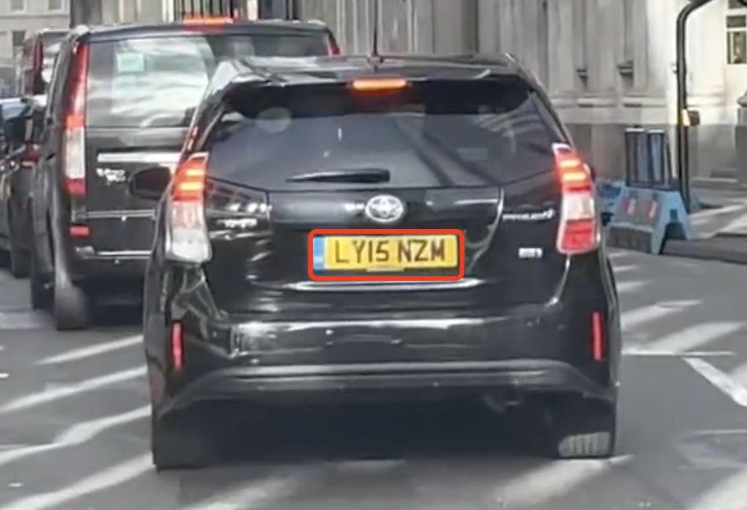
Figure 2.2 license plate

By removing pixels of a specific color from the license plate, the color-based technique locates the plate. This method has the benefit of lessening the impact of noise and lighting variations, but it has the drawbacks of being unable to handle color variations, the license plate color being close to the background color, and the license plate being buried. Using the unique texture characteristics of the license plate, the texture-based technique locates the plate (Jiao et al., 2009). Although this approach finds license plates more precisely, it also has the drawback of being vulnerable to factors like texture changes and plate occlusion. By identifying the characters on license plates, character-based approaches locate plates. This method has the advantage of being able to find the license plate more precisely and addressing problems like license plate occlusion, but it also has the drawback of taking longer and requiring more computations. Recently, deep learning-based algorithms for reading license plates have drawn the attention of more researchers.

Deep learning has become a potent technique for object localization and recognition in recent years. The objective of the object identification problem known as license plate localization is to locate a license plate inside an image. In most cases, these techniques use neural networks to classify and extract traits from photos of license plates. Deep learning-based approaches have the following advantages over more conventional ones: first, they can automatically learn the features of license plate images, which reduces the workload involved in manually creating features; second, they can handle more complex scenarios, such as changes in illumination, occlusions, license plate color, etc.; and third, they can achieve end-to-end recognition, minimize the number of intermediate processing steps, and speed up the process.

For instance, in a variety of object identification tasks, such as license plate placement, Faster R-CNN and YOLO have demonstrated promising results. A region proposal network (RPN) is used in the two-stage faster R-CNN object identification approach to create region proposals, and an R-CNN is used to categorize and enhance region suggestions. However, using the one-stage object identification approach YOLO, it is possible to predict with precision the bounding boxes and class probabilities of objects in photos. A sizable dataset of license plate photo annotations must be provided in order to train a deep learning-based license plate finding system (Kim et al., 2017). After the model has been trained, obtain a license and broaden the dataset to incorporate a variety of license plate styles, dimensions, and orientations to make sure the model is adaptable to different conditions.

Once trained, the model may be used to find license plates in an input image. The model will extract the license plate's bounding box coordinates from the image. To eliminate superfluous bounding boxes and improve localization accuracy, post-processing techniques like non-maximum suppression can be applied.

2.4 Character recognition
German scientist Tausheck originally presented the idea of OCR (Optical Character Recognition) in 1929, and later American scientist Handel also suggested the notion of employing technology to recognize text. OCR research has been going on all around the world since the 1960s and 1970s. Early on, the majority of research was devoted to character recognition techniques, and the only recognized characters were the numerals 0 through 9.

Traditional text recognition technology employs template matching to categorize. However, for the text line, recognizing each character is the only way to know what the final content will be. As a result, the text line can be character segmented to produce a single text. Thus, the most used segmentation technique is over-segmentation-dynamic programming. It is required to over-segment the candidate characters to make them adequately fragmented, and then combine the segmented pieces using dynamic programming to acquire the ideal combination, because a single character may provide numerous recognition results due to the segmentation location. This procedure has to be designed manually. the loss function. A different approach is to run every character through the sliding window. The size of the sliding window determines how accurate this procedure is. Information loss will occur if the sliding window size is too large, while computing power needs will significantly rise if it is too small. The classic approach mentioned above does full-text recognition by identifying each individual character. The context information is lost throughout this operation. It is impossible to guarantee the input recognition accuracy rate, but it has a high recognition accuracy rate for a single character.

Traditional OCR techniques often employ statistical machine learning techniques such as binarization, noise filtering, correlation domain analysis, AdaBoost, etc. to extract text information from photos using the opencv algorithm library. According to the processing approach, traditional OCR technology may be separated into three stages: picture preparation, text recognition, and post-processing. Traditional OCR has produced decent recognition results for images in straightforward scenarios. The conventional technique is, however, dependent on the picture modeling of a particular scene, and once it leaps out of the present scene, the model will become invalid, as can be seen from the operation procedure. With the rapid development of deep learning technology in recent years, OCR technology based on deep learning has gradually matured and can flexibly respond to different scenarios.

Deep learning-based scene text recognition mostly uses two techniques. Text detection and text recognition are separated into two stages in the first; an end-to-end model is used in the second to accomplish text detection and recognition all at once. text recognition As the name implies, text detection seeks to find the text in a photograph and, at its heart, to separate the text from the backdrop. The following are some examples of text detection techniques in use today: CTPN is a text detection technique that was introduced at ECCV 2016 and enhanced by Faster RCNN. It combines CNN and LSTM deep network, and it can find text lines directly in the convolutional layers while supporting picture input of any size.

The CTPN consists of three components: text line edge refinement, text box circularly linking, and small-scale text box detection. The precise application procedure is: to acquire the feature map of conv5_3, use the VGG16 network to extract features, then apply 3*3 sliding to the resulting feature map. The window is moved to reveal the associated feature vector, which is then entered into the BLSTM to learn sequence features before being coupled to a fully connected FC layer, which eventually outputs the outcome.

The NMS algorithm filters out redundant candidate boxes, and the entire convolution network recognizes text line candidate boxes, making up the EAST method's two simple phases for efficient and accurate text identification. Its three-part network topology incorporates the concepts of HyperNet and U-shape. feature extraction: extract four tiers of feature maps using PVANet/VGG16; feature merging: to create merged feature maps, employ procedures like upsampling, concatenation, and convolution; Single-channel score feature map and multi-channel geometric feature map are the output layers.

Although character recognition in certain basic situations, like electronic papers, is quite accurate, no one today dares to claim that they can perform well in any complicated environments. Now, because everyone is concentrating on more difficult problems, nobody really pays attention to how to further increase the accuracy of text recognition in electronic documents. Text recognition in complicated visual and text scenarios cannot be handled by the classic OCR approach. License plate recognition is one of the study topics on which more and more people are concentrating: how to effectively read text in difficult scenarios.

CHAPTER 3: RESEARCH AND DEVELOPMENT METHODOLOGY

3.1 Dataset
There are 500 photos of UK license plates in our dataset. To guarantee data dependability and correctness, these photos were carefully reviewed and processed after being obtained from public sources. The automobile brands and models shown in these license plate pictures include BMW, Mercedes-Benz, Audi, and more. Each image clearly displays the typeface, color, and license plate number, as well as other pertinent car data. For research and applications in the disciplines of vehicle identification, traffic flow statistics, and other relevant areas, these data are extremely important.

Each image is painstakingly labeled and classified using the latest cutting-edge technologies in preparation for machine learning and training. Make a note of the frame's top left and lower right coordinates. As an illustration, the two vertices of the frame are the top left (154, 383) and bottom right (386, 473) of an image. We randomly chose 20 images to serve as the test set for the algorithm, while the remaining 480 images took part in the training and were divided into 82 parts. For training data, 80% were chosen at random, and for verification data, 20%. The data set is annotated using the voc data set format, and there are examples of xml annotations in the Annotations folder.

Table 3.1 Annotations example
<annotation>
<folder></folder>
<filename>car1.jpg</filename>
<path>/content/ Annotations/images/car1.jpg</path>
<source>
<database>Unknown</database>
</source>
<size>
<width>1920</width>
<height>1080</height>
<depth>3</depth>
</size>
<segmented>0</segmented>
<object>
<name>number_plate</name>
<pose>Unspecified</pose>
<truncated>0</truncated>
<difficult>0</difficult>
<bndbox>
<xmin>1093</xmin>
<ymin>645</ymin>
<xmax>1396</xmax>
<ymax>727</ymax>
</bndbox>
</object>
</annotation>

3.2 Data processing
This crucial step is taking each image, using OpenCV to transform it to an array, and resizing it to 224 by 224, which is a common suitable size for pretrained transfer learning models. We will next divide the picture by the maximum number to normalize it as we are aware that the maximum number for an 8-bit image is 28 -1 = 255. We multiply the picture by 255.0 as a result. The process of normalizing (Min-Max Scaler) an array involves dividing it by its maximum value. Additionally, we must standardize our labeling. Considering that the output range for deep learning models should be between 0 and 1. To normalize the labels, we need to divide the diagonal points by the width and height of the image. And finally the values in the python list.

In addition, the images and labels of the license plate area—the results of target detection—must be transformed into lmdb format and stored. Lightning Memory-Mapped Database (also known as a lightning-fast memory-mapped database) is its full name. A data file and a lock file are both included in its straightforward file structure. Multiple processes may open the same LMDB file at once. They are simple to access and offer incredibly fast data access rates. Running a separate database maintenance process is not necessary. The only requirements are to specify the file location and reference the LMDB library in the code that retrieves the data. Although LMDB employs memory mapping to access files, addressing inside the file is very short and may be accomplished using pointer arithmetic, which makes it exceedingly costly for the system to access a large number of small files. Database single files help lessen the processing costs associated with copying and transferring data sets.

To store a data sample with two key-value pairs, or to save the picture and its label separately, we must first get the binary format data of the image file. the lmdb database, followed by the writing of the picture and label, respectively. Similar to the example given earlier, you must convert the key value to bytes format. The label format is str, which needs to be encoded and transformed to bytes before sending to the database, whereas the picture format retrieved here is bytes, necessitating no conversion. In this case, the key provides access to both the image and its label. The picture must first be decoded since it is encoded before being written to the database. The tag is decoded using .decode() to regain the string format. The read image data is in binary format, so first use np.frombuffer() to convert it to a decimal format file, which is a one-dimensional array. This can then be converted to a grayscale image (a two-dimensional array) or a color image (a three-dimensional array) using cv2.imdecode().

3.3 Objection detection
One of the most fundamental challenges in the area of computer vision is target detection. Deep learning techniques are currently in front of other technological options in this area. Object detection is required for the target detection operation. The position of the frame and the category of the frame are the two outputs. There might be several categories and aims. Here, the frame is perpendicular to the image's width and height. frame with a rectangle. In a way, the deep learning-based target detection framework may be seen as a multi-task learning framework that focuses on regression and classification.

The first framework to use an end-to-end deep learning model to accomplish the object detection problem for photos is FasterRCNN. Faster RCNN generally involves feeding an image into the convolutional network to produce an image feature map. Utilize the feature map and the region proposal network to return object suggestions and accompanying scores. Apply the Rol pooling layer to equalize the sizes of all proposals. The fully connected layer receives the proposals to create the target object's bounding box. Since normalization may be handled by the Faster R-CNN model by itself. There is no need to conduct mean/std normalization or picture scaling procedures because ImageNet's mean and standard deviation are used by default for normalization and scale modifications.

The two-stage implementation of FasterRCNN. The stage here alludes to a boundary estimate procedure. The boundary and its matching category, which are tasks for regression and classification, are the two items that each stage outputs. But these two phases are different from one another. The RPN network is utilized in the first stage to do preliminary categorization and screening of the boxes of rules that have been violated by violence. Therefore, this is a binary classification task for each box, marking each box with No object, and for the frame that is thought to have an object, giving the deviation between these anchors and the true value. The first stage obtains some frames that may contain objects, and the task of the second stage is to classify and predict these frames. And output the same deviation as the first stage's format, then continue to rectify the first stage's findings.

We mostly employed FasterRCNN's bounding box regression job. Finding the location of the item is the target detection's most crucial duty. To demonstrate that if we enter a picture, there is only one object in the image, we utilize a case study. However, the following two circumstances could occur as a result of incorrect positioning: First In one instance, the object is small and the frame is in certain places where there is no object, meaning that a particular edge is not at the object's edge. We then anticipate that the network will produce some regression values, allowing us to move the frame away from this edge and shrink the entire box. In the second case, some areas of the object are outside the picture, that is, a certain edge divides the object into two parts: inside the picture and outside the picture. We hope that the network can predict some values for this picture to express this How much the edge should expand outward to include the entire object in the picture.

The rough frame generation issue must be resolved via the Region Proposal Network. An anchor in target detection represents a certain fundamental frame. For instance, a photograph may be downscaled 16 times to create a feature map. By mapping back to the original image, each pixel may be thought of as a 1616 square of the original image. This frame, a 1616 frame, serves as an anchor. The square base frame may be resized and distorted in order to identify other sizes and forms of frames. The number of anchors corresponding to each pixel has been extended from one to nine, and FasterRCNN has chosen 9 alternative sizes and shapes. Please refer to the test section for further information on the specific operating principles. Take the feature vector that an anchor represents from the original feature map, send it to RPN, process it through the hidden layer, send the feature to two branches, and output two tensors that each contain 2 and 4 integers, The anchor's placement in the foreground or background is indicated by the first two numbers in the classification results, and the anchor's offset—which shows how to relocate it to the truth box after a displacement—is shown by the next four numbers. Thus, the majority of erroneous frames devoid of objects may be filtered out by RPN filtering, relieving the burden on later detection tasks.

The border regressor's expression comes next. The boxes produced by the ROI Head and RPN networks are not actual boxes, but rather the difference between the predicted box and the box representing the true value. In other words, the residual is being learned by the network. This deviation is the outcome of a planned border deviation conversion rather than a straightforward subtraction of the real value and the four projected border coordinates. Four integers are used to express the deviation, which may be divided into the size deviation and the deviation of the center point. The first is the center point's deviation expression. x_a is the abscissa of the center point of the anchor, x_a is the width coordinate of the center point of the prediction frame, and x-x_a is really the abscissa of the center point of the prediction frame and the base frame anchor. After normalization, the frame deviation of the center point is calculated, and the absolute difference is scaled by the width of the fundamental frame anchor. The four formulae above can be used to represent the difference between the genuine value and the anchor as well as the difference between the anticipated value and the anchor. The formula may also be used to transform the deviation amount and the prediction or actual value box into one another. The discrepancy between the anchor and the anchor appears to be predicted by the network. In actuality, there is a prediction box with the deviation. The representations are shared by the ROI Head output regressor and the RPN network output regressor.

An essential function that addresses the issue of overlapping output boundaries is non-maximum suppression. When two boxes overlap and their IOUs are more than a certain threshold, the one with the lower score is eliminated. Finally, certain clear frames without overlap are acquired as long as the frame does not have the highest score. The Faster RCNN test procedure uses non-maximum suppression in both phases, which enables rapid realization of frame screening and filtering.

Data that have been pooled from regions of any size are subject to bounding box regression in Faster RCNN, and all region sizes share the same regression weights. On the feature map, all of the features used for regression in our formulation have the same spatial size (n n). The accounting of diverse sizes is made possible by the learning of k bounding box regressors. Each of the k regressors is in charge of one scale and one aspect ratio, and they do not share weights. Therefore, even if the size/scale of features is consistent, boxes of different sizes may still be anticipated. There is a lot of overlap in certain RPN plans. To reduce duplication, we apply non-maximum suppression (NMS) to proposed regions based on their cls ratings. With the NMS IoU threshold set at 0.7, each image has about 2k proposed regions. It show that NMS substantially reduces the number of recommendations without degrading the final detection accuracy. For detection after NMS, we use the top N proposed sites. The Fast R-CNN is trained using 2k RPN proposals in the next section, and it is then tested using a new batch of proposals.

The RPN can be trained end-to-end using backpropagation and stochastic gradient descent (SGD) because it is obviously a two-branch fully convolutional network. In order to train the Fast R-CNN network on the training samples, the "image-centric" sampling technique must be used. Positive and negative samples from a single picture make up each mini-batch. Although the loss function may be optimized in this way, there will be a bias in favor of negative samples since there are more negative samples overall. In order to calculate the loss function, the authors randomly select 256 anchor boxes from each picture, with a ratio of up to 1:1 between sampled positive and negative anchors. Only when there are less than 128 positive samples in the picture is negative padding employed. All new layers are randomly initialized from a Gaussian distribution with a standard deviation of 0.01 and a mean of 0 before training, according to the authors. The pre-training of the ImageNet classification model initializes the other layers, i.e., the shared convolutional layers.

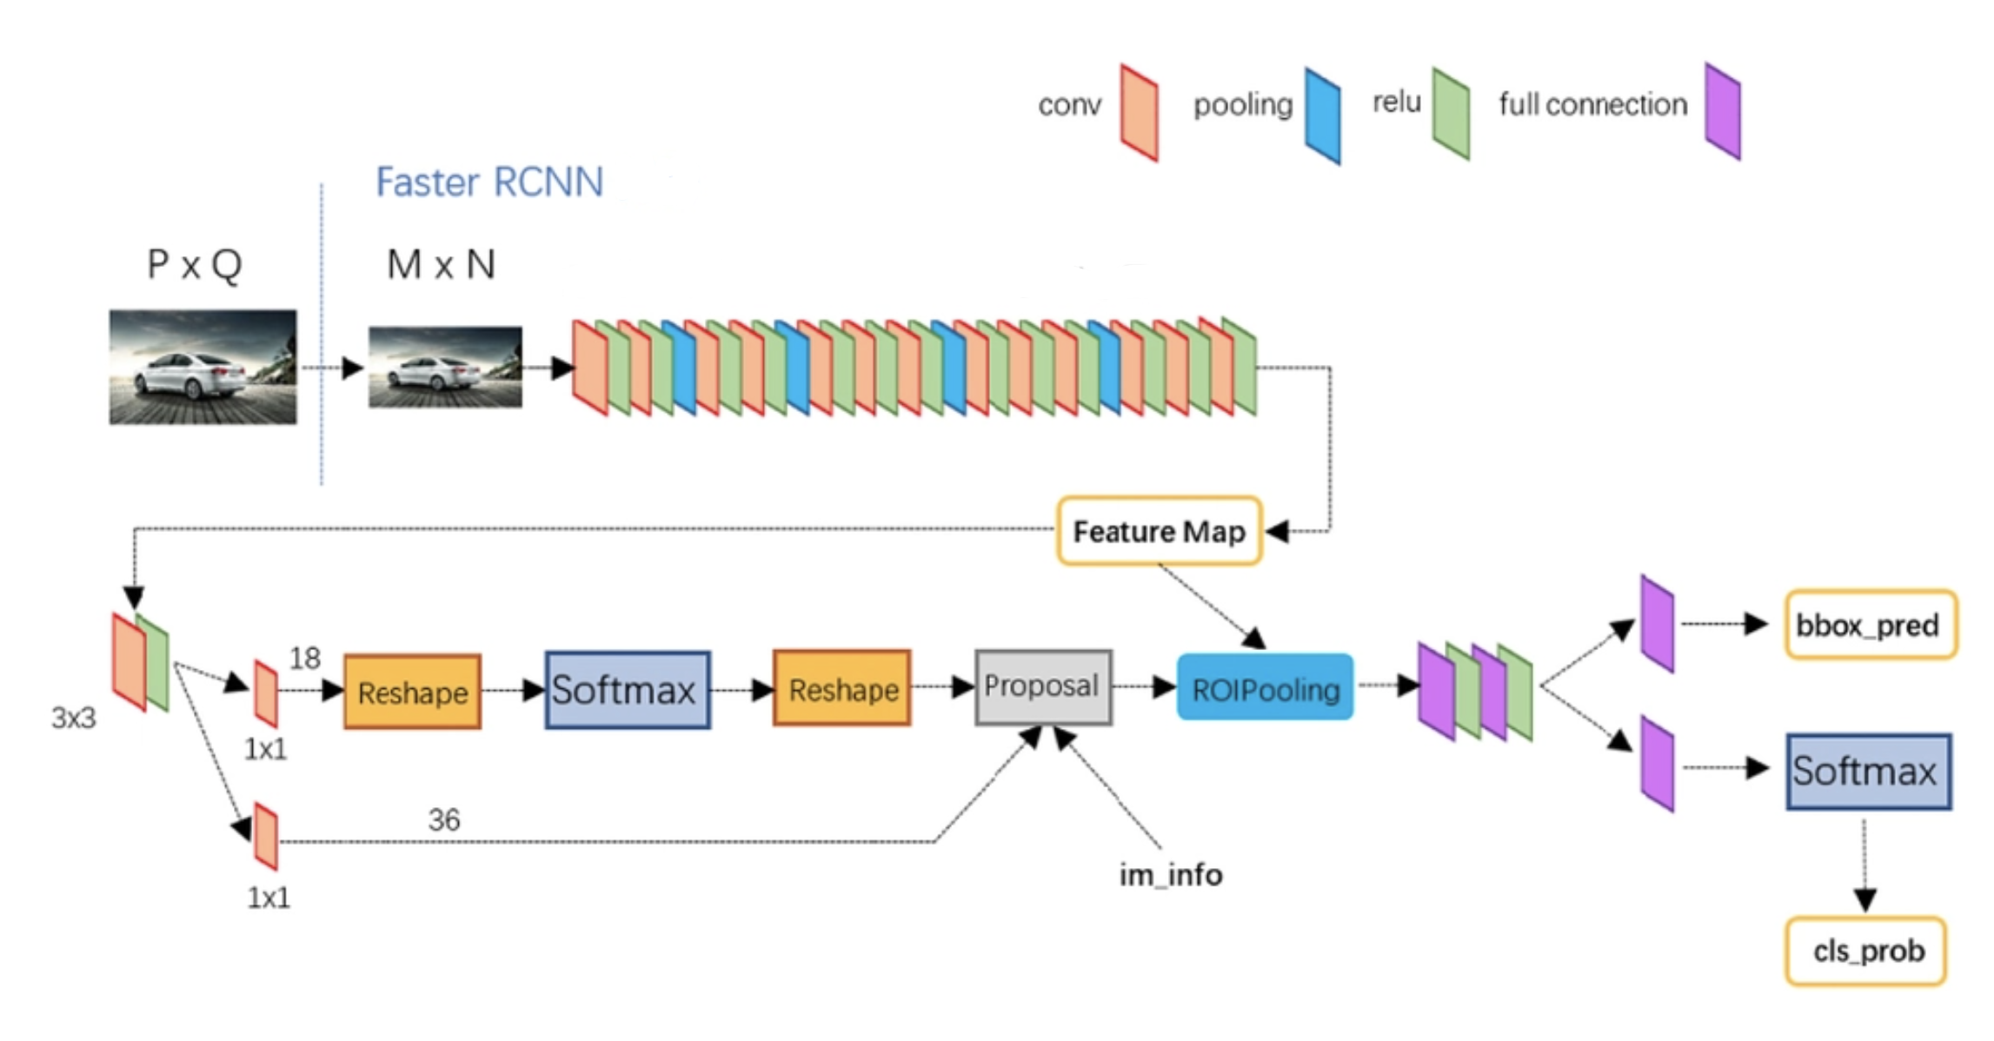
Figure 3.1 Faster RCNN

Independently trained RPN and fast R-CNN both modify their convolutional layers in different ways. We must thus develop a mechanism that permits sharing convolutional layers across two networks rather than learning two separate networks. Creating a single network that incorporates RPN and Fast R-CNN and optimizing it via backpropagation is not as simple as it may seem. It is not apparent if changing the proposal procedure will result in convergence when Fast R CNN is learnt because Fast R-CNN training depends on fixed object proposals. Despite the fact that this combined optimization is an attractive topic for additional investigation, the authors developed an effective 4-step training strategy to find common traits through alternating optimization.

Initialize the pre-trained classification model for ImageNet's parameters first. Before starting to independently train the RPN network parameters, the pre-trained classification model for ImageNet will first set the parameters for the pre-convolution network layer. After modifying the parameters for the special convolutional layer and fully connected layer of the RPN network, initialize the pre-convolutional network parameters using the classification model that has already been trained on ImageNet, and train the Fast R-CNN Network parameters using the target suggestion frame generated by the RPN proposals network. The pre-convolutional network layer parameters that were discovered using Faster RCNN are then used to fine-tune the special convolution layer and fully connected layer parameters of the RPN network. Additionally, modify the parameters of the fully connected layer of the Fast R-CNN network while maintaining the settings for the pre-convolutional network layer. The RPN network and the Fast R-CNN network combine the properties of the pre-convolutional network layer to form a single network.

3.4 Character recognition
The characters on the license plate are just standard text; they haven't been bent or rotated in any way. Utilizing the CRNN and CTC recognition approach is preferable. However, certain corrective adjustments must be applied during reasoning because to the perspective issue brought on by the shooting angle. Recognizing texts of varying lengths from end to end Implementation of the CRNN code In the realm of OCR, CRNN is a fairly established and popular recognition method. Please see my prior paper for details on its theoretical foundation. The installation of the CRNN code and its recognition impact will be explained in detail in this article.

The data set that we obtain is the most unique. In order to assist subsequent network training, we often transform the original data set for picture deep learning training into lmdb format. As a result, the data set also has to be converted to lmdb format. The lmdb format conversion code is as follows. The concept is rather straightforward: after reading in the picture and the text label that corresponds to it, use the dictionary to store the combination as a cache, and then use the put function of the lmdb package to save the dictionary as a cache.

The digitization of text labels, in which we utilize numbers to represent each text, is another activity that has to be highlighted in the data preparation section. For instance, the ID for the letter "A" is 11, the ID for the letter "B" is 12, the ID for the word "?" is 90, and so on. A dictionary data structure may be used to hold the results of this encoding and decoding effort. When making a prediction, encoding converts the network output to text.

End-to-end OCR is difficult due to the alignment problem with sequences of different lengths. CRNN OCR really stole the idea of solving indefinite-length audio sequences from speech recognition. Similar to the speech recognition challenge, OCR may be viewed as a timing-dependent word or phrase recognition issue. The approach for training RNN based on Connectionist Temporal Classification (CTC) outperforms conventional voice recognition algorithms in the field of speech recognition by a significant margin. Using CRNN as an example, researchers have used the CTC loss function to OCR recognition. The CRNN technique receives a 100*32 normalized height entry image and uses it to extract features using a 7-layer CNN (typically VGG16), which is then divided into columns (Map-to-Sequence).

The 512-dimensional properties of each column, The input is sent into two layers of bidirectional LSTM with 256 units each for classification. The training method approximates the soft alignment of character positions and class labels under the control of the CTC loss function. The difference is that the CNN network's image feature vectors are utilized as the features input into the LSTM instead of the speech's acoustic properties. The CRNN method's most important addition is its capacity to combine the serialized recognition capabilities of LSTM with the visual feature engineering potential of CNN. In addition to extracting powerful traits, sequence recognition is utilized to get beyond the extremely difficult single-character segmentation and single-character recognition in conventional methods. Additionally, serialized recognition (using a corpus) inherently incorporates timing restrictions. In order to address the problem that character stretching lowers the recognition rate, CRNN uniformly scales the training image to 10032 (w h) in the training phase. In the testing phase, CRNN maintains the input image size ratio, but the image height must still be unified to 32 Pixel.

Because the length of the picture text is changeable, there will be a difficulty with alignment decoding, hence RNN needs a second partner to address this issue. The well-known CTC decoding is this companion. We are aware that the CRNN's RNN layer generates a sequence with variable length. For instance, if the source picture has a width of W and outputs S sequences after going through CNN and RNN. Now, we must convert the sequence into the final recognition outcome. RNN will undoubtedly produce a significant amount of duplicate data while doing time series classification. A letter, for instance, is identified twice in a row. Redundancy may be removed in a variety of ways, but one straightforward one is to observe two consecutive letters. Words like chef and geek pose complications, hence CTC features a blank method to address this issue. At the same time, CTC suggests the procedure of introducing a blank to clear up this uncertainty. As a result, there may be several ways to receive a label. According to common sense, we should increase the likelihood that a text picture we transmit to the network will be labeled L. A labeled sequence's conditional probability is the total of all path probabilities projected to it since the pathways are mutually exclusive. The original input sequence no longer has to be precisely segmented by CTC using this way of mapping B and the total of all candidate routes, allowing the sequence length of the RNN layer output to be translated to the label length. Any RNN model may be used with CTC, but the bidirectional RNN/LSTM model is more suited since the labeling probability is connected to the complete input string rather than just the fragments in the prior narrow window range. To identify the character matching to the most likely pixel area, ctc will calculate the loss. For the strategy of employing the greatest probability path, CTC decoding is typically not appropriate; instead, a prefix search algorithm or a constraint decoding algorithm should be employed. The prior neural network may be backpropagated and updated by computing the probability. The loss function O of CTC is specified as the negative maximum likelihood, much like in conventional classification. It is decided to use the likelihood's logarithm for simplicity in the computation. The reduction of the optimization of the loss function O is the aim of our training.

Since CTC believes that the output of each time slice is independent of one another, it pays greater attention to maximizing the sum of the probabilities of the pathways included in the mapped (deduplicated, deemptied) labels. When the output looks for the path with the highest probability based on the provided input, it is more likely to search for the path that can be mapped to the right outcome. The test probability is the accumulation of the probability of each time slice. Additionally, the "many-to-one" scenario is taken into account throughout the search, increasing the likelihood of decoding the right outcome. Alignment is only a method to discover the outcome, and CTC is only interested in the outcome. Without alignment, the CTC technique may decode and provide the right result. However, when CTC is decoding, particularly when looking for decoding, some of the lawful pathways involved in decoding may be "a relatively neat and well-defined many-to-one alignment."

The three main components of CRNN are CNN, RNN, and CTC, which stand for the convolution layer, circulation layer, and transcription layer, respectively, in the CRNN paper's description. First, the underlying feature extraction is done using the CNN component. To learn linked sequence information and forecast label distribution, RNN uses BiLSTM. Sequence alignment and prediction findings are produced using CTC. The following is a general description of the end-to-end OCR process used by CRNN: A text-containing original picture is imported. The text position on the original image is detected; the detection result may be a horizontal or an inclined rectangular frame. The text from the original image is then converted. Character recognition is carried out on each horizontal text block slice image in turn, and the recognition results of each slice image are added up to produce the text recognition result of the original image. The picture corresponding to the frame is cut out and rotated to obtain a horizontal text block slice image.

Table 3.2 Architecture
Type | Architecture
Input | Wx32
Convolution | maps: 64, k: 3x3, s: 1, p: 1
MaxPooling | Windows: 2x2, s: 2
Convolution | maps: 128, k: 3x3, s: 1, p: 1
MaxPooling | Windows: 2x2, s: 2
Convolution | maps: 256, k: 3x3, s: 1, p: 1
Convolution | maps: 256, k: 3x3, s: 1, p: 1
MaxPooling | Windows: 1x2, s: 2
Convolution | maps: 512, k: 3x3, s: 1, p: 1
BatchNormalization
Convolution | maps: 512, k: 3x3, s: 1, p: 1
BatchNormalization
MaxPooling | Windows: 1x2, s: 2
Convolution | maps: 512, k: 2x2, s: 1, p: 0
Map-to-Sequence
Bidirectional-LSTM | hidden units: 256
Bidirectional-LSTM | hidden units: 256
Transcription

The picture will initially be resized to 32W3 size in order to input features into Recurrent Layers. After passing through CNN, the value changes to 1(W/4)512. The features may then be entered into the LSTM after setting T=(W/4) and D=512. Although the network input stated in the CRNN study is a normalized grayscale picture of size 10032, meaning that the height is unified to 32 pixels, the method described above is the optimal training procedure. The deep neural network structural diagram for CRNN is shown below. CNN uses the traditional VGG16. It's important to note that CRNN substitutes a 12 rectangle pooling window (wh) for the traditional 22 square pooling window in the third and fourth max pooling layers of VGG16. The reason for this alteration is that most text pictures have feature maps that are rectangular in shape and have tiny height, width, and length. If you employ For English letter recognition (such as differentiating between i and l), the 12 pooling window is more appropriate. The Batch Normalization module, which is intended to hasten model convergence, is also introduced in the VGG16 component. Additionally, it is important to note that the input of the CRNN is a grayscale picture with a depth of 1. A 512x1x16 (chw) feature vector is the output of the CNN component. Analyze the RNN layer next. The RNN component employs a bidirectional LSTM and has 256 hidden layer units. CRNN uses two layers of BiLSTM to form this RNN layer. The output dimension of the RNN layer will be (s, b, class_num), where class_num is the total number of text categories.

It's important to note that a 3-dimensional tensor (Tensors) is the only input type that Pytorch's LSTM unit will take. Each dimension's significance cannot be misunderstood. The sequence structure is embodied in the first dimension, the mini-batch structure is embodied in the second, and the input elements are embodied in the third. This dimension can be set to 1 in the input tensor if the tiny block structure is not appropriate for the application, but this dimension must be reflected.

We must modify the CNN layer's output in accordance with the input specifications of the LSTM; specifically, we must change the CNN layer's output to take the form of [seq_len, batch, input_size]. The precise procedure is as follows: Squeeze the h dimension out first, then use permute to replace it. The function modifies the order of each dimension, changing [w, b, c] to [seq_len, batch, input_size], where [16, batch, 512] is the precise size. The matrix may be passed to the RNN layer after modification. The output format for the RNN layer is as follows. Bidirectional BiLSTM is being used, hence the output dimension will be hidden_unit * 2.

The output dimension is then changed back to 512 and transmitted to the second LSTM layer using the linear transformation function self.embedding1 = torch.nn.Linear(hidden_unit * 2, 512). Continue wiring torch.nn.Linear(hidden_unit * 2, class_num) after the second LSTM layer such that the output of the complete RNN layer equals the total number of text categories.

The transcription layer, which converts the output result of the RNN layer into the final recognition text result and enables variable-length text recognition, is presently being designed after the CNN layer and the RNN layer have been finished. [probs, labels, probs_sizes, label_sizes]—that is, the prediction results, labels, number of prediction results, and number of labels—are the inputs of CTCLoss. Character misalignment during training is addressed via the transcription layer's ctc loss function. To address the issue of having no characters in some locations, ctc provides the blank character; recursion enables efficient calculation of the gradient.

3.5 Web Application
We will construct web applications to build a comprehensive website that provides license plate recognition services to the general public. Numerous http requests, such as get, post, and other popular ones, are frequently included in our services. Web development requires a basic understanding of concepts like switching between various sites, data transport and communication, storing web pages, caching, and other related ones. According to estimates, writing in native Python is still difficult and time-consuming. Flask will be the main development framework as a result. The Flask web application framework is made in Python. It was developed by Armin Ronacher, the leader of Pocco, a world-wide organization of Python enthusiasts. Flask is built on the Werkzeug WSGI toolkit and Jinja2 template engine. Both of them are Pocco initiatives. You may reference a ton of online publications with the application background and use knowledge of the Flask framework. We stress practical experience in order to create a really straightforward web site utilizing flask.

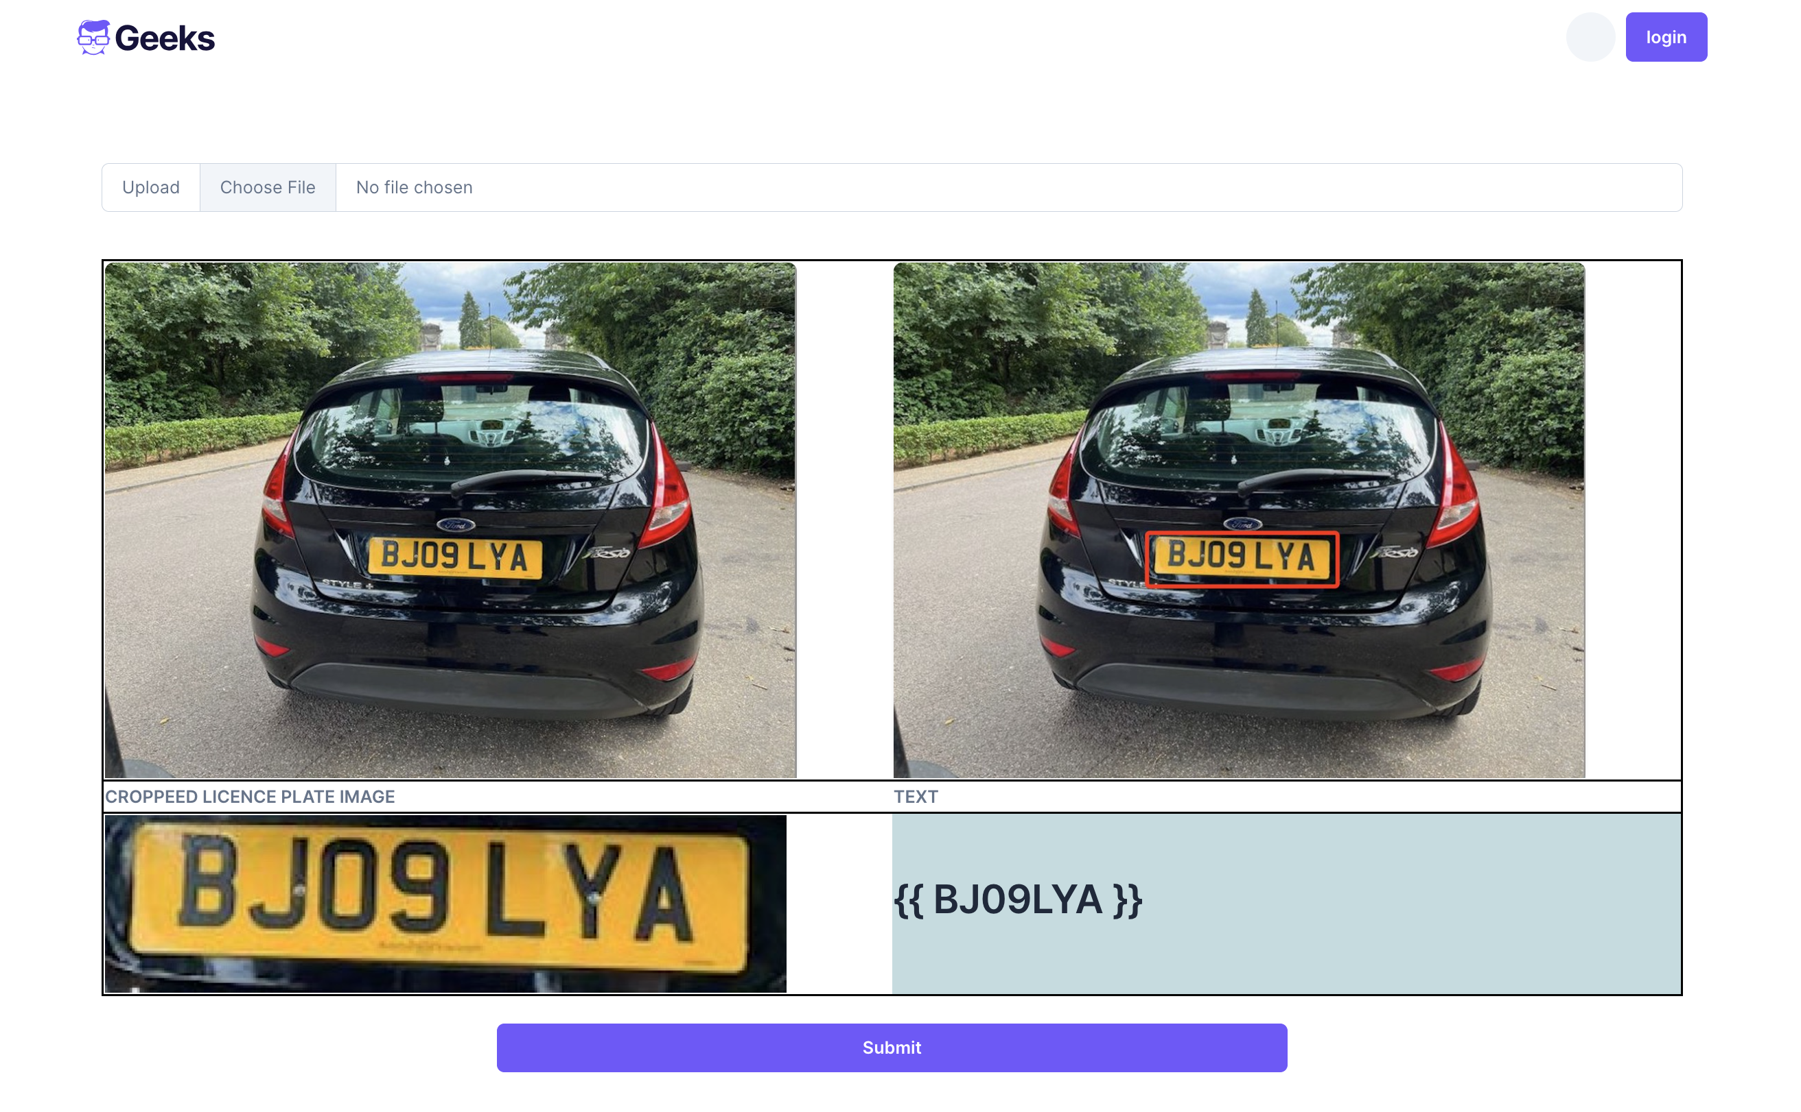
Figure 3.2 Web Application

The lack of unnecessary libraries and toolkits makes Flask a highly lightweight framework, allowing you to build your own libraries as necessary. The Flask API is incredibly straightforward and simple to learn. Plugins may be added to Flask to expand its capabilities, and it is simple to interact with other libraries and frameworks. Additionally, Flask gives developers the option to select necessary elements like template engines, databases, and form validation. Other Python libraries and frameworks, like SQLAlchemy, WTForms, and Jinja2, are also supported by Flask for integration. Using a RESTful API, Flask makes it simple to build RESTful web services.

We will now apply a deep learning model to forecast using this uploaded image. In order to include our pipeline and essentially all the required libraries and functions with the right model path, we first create a new file with the name deeplearning.py. Additionally, make two files in the static folder called "roi" and "predict," and your code will then look like this. On Flask, "add text" is also an option; you can find it here. We're almost done now. Now, when we input a photo of a vehicle with its license plate number, our model predicts the bounding box while cropping the photo, saving the result in the roi and prediction folders. We will edit index.html and add future text to hold the text in order to display it on the web.

The front-end website, back-end service, and database are the three primary parts that make up this web application's architecture. Mainly used as an interface for apps to communicate with users, the front-end page. This service is a web application created online that is in charge of showing application results and taking user input. The user interface is provided via HTML, CSS, and JavaScript, while the HTTP protocol is used to connect with users. The backend service, which is the major part of the program, manages user requests, provides data and communicates with the database while carrying out functions like text and picture recognition. The database is the program's data storage system, and it is in charge of storing and managing the data that the application needs. The database in this program houses user-uploaded photos, results of recognition, and other relevant data.

This application's primary features are image uploading, trimming out the license plate area, text recognition, displaying the results, downloading, and exporting. Through the program, users may post pictures that include license plate numbers. The software also offers upload choices and advice for user convenience, such as selecting the ideal shooting angle, eliminating shadows and reflections, etc. The program automatically edits and enhances submitted photographs, among other operations. The accuracy and effectiveness of future processing can be enhanced by these procedures. The model developed in the preceding article will be used by the license plate area cutting function to recognize and cut the image's license plate area. These techniques enable the app to remove the license plate region from the image before text recognition.

The character recognition model will be used by the text recognition function to identify the text in the image of the clipped license plate. The information is simultaneously made available to users for usage. Additionally, user data will be kept in the database for later processing and administration. The user will receive the recognition results via the result display method, and they may view them in the web application. The whole text of the license plate number, the annotation of the image's license plate region, and the cutting of the license plate portion of the image are all displayed in the result. Last but not least, customers have the option to download a text file containing the license plate number for use in managing and utilizing the recognition results. The program also offers a few more data export features to make it easier for users to export and manipulate data as necessary.

CHAPTER 4: DESIGN AND IMPLEMENTATION
A neural network must be trained by closely scrutinizing the data before it can access any neural network code. This action is required. The duty to evaluate the material is one that should be taken seriously. This is because there may be many outliers in the data, which would make it possible to build stronger models by understanding how they are distributed. In order to guarantee that the outcomes are same when the code is executed again, pick a random seed that consistently utilizes a predefined number. Then, a variety of optimization algorithms, such as stochastic gradient descent (SGD), Adam, and RMSprop, are used to train LPRNet. To prevent overfitting as a result of training, the model may need to be altered (Yang et al., 2018).

The goal of model validation is to guarantee the accuracy of the data analysis, the consistency of the model's logic, and the dependability and consistency of the results. To assess the model and take care of the important issues described above, utilize the following methods. In order to ensure the correctness of the data collection, analysis, and processing procedures as well as to certify that the sample data chosen is representative and capable of satisfying the modeling requirements, modelled data must first be validated. In order to limit the factors affecting the data, it is first required to confirm that its meaning is precise and clear.

Then, it's crucial to confirm that the time period of the sample data matches the specifications of the sample size and performance period in order to lessen the elements that affect the model's stability. The logic of the model design is often verified using model methodology validation, sample exclusion rules, and key definition validation. The chosen modeling strategy has been demonstrated to satisfy the requirements, the modeling concept is clear, and the modeling scheme is complete based on the actual business case. By eliminating the improper samples, the model's actual training impact is enhanced, demonstrating that the sample exclusion criteria are acceptable for the business environment to which the model is applied.

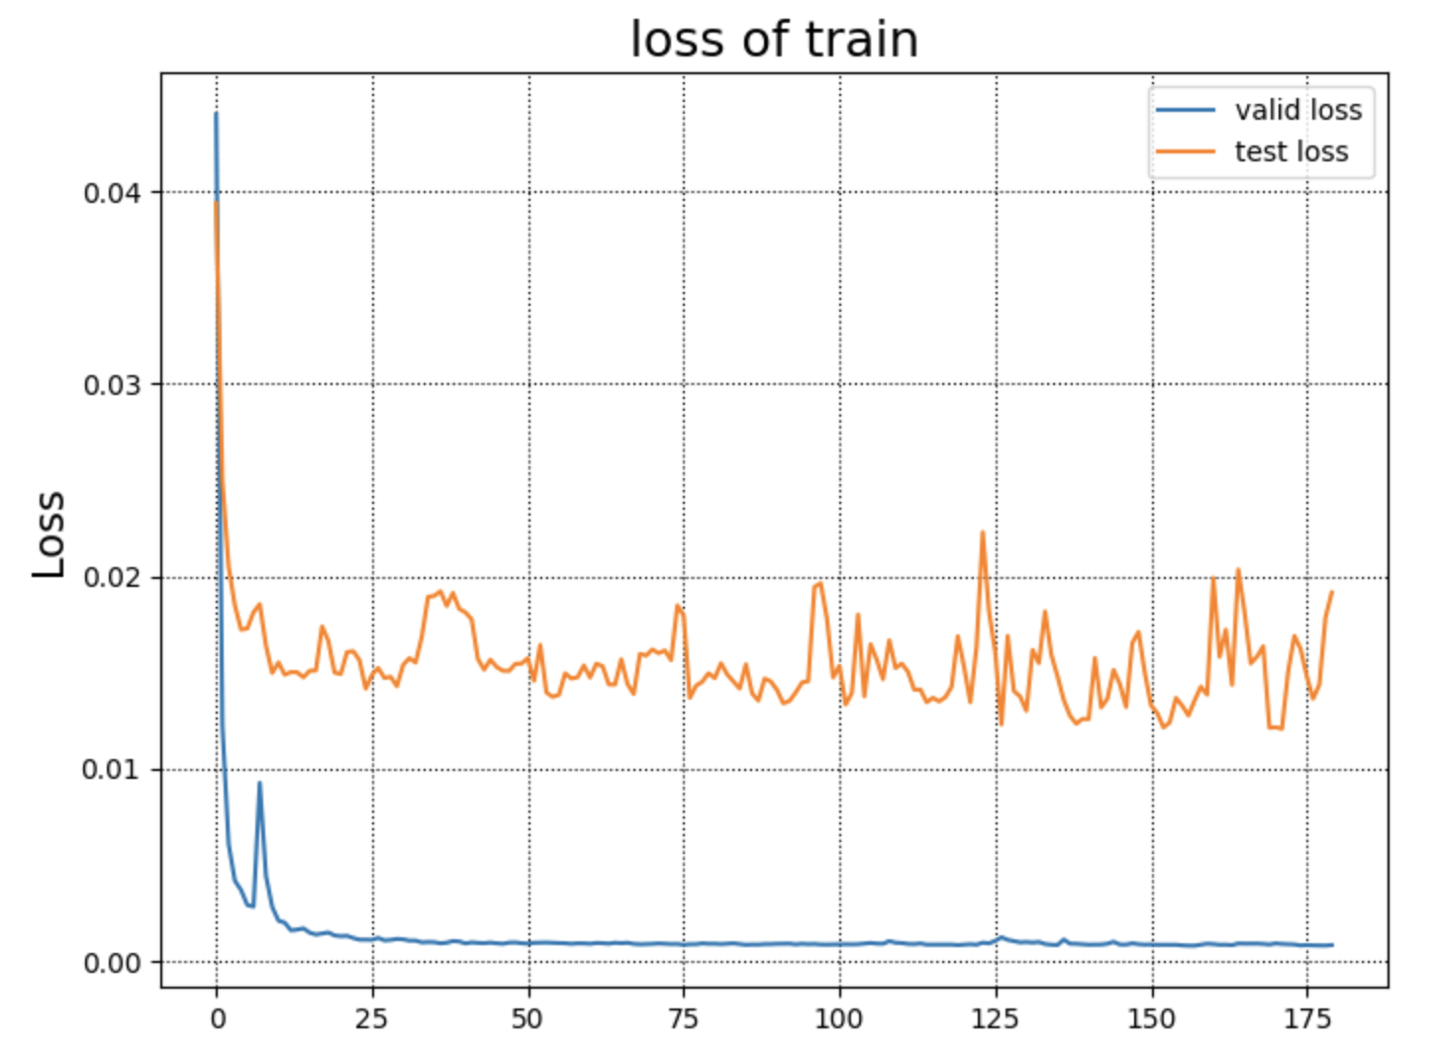
Figure 4.1 Loss of train

Along with model design validation, there is model development validation, which primarily consists of model development process validation and model results validation to guarantee that the model parameters are chosen appropriately, the variable analysis and model training process is true and accurate, and the model results are valid. The validation of the model development process includes examining the model variables chosen, the precision and validity of the analysis, the weights given to each variable, the consistency of the variable grouping with the business logic and the application requirements, the dimensionality of the final model variables, and the reproducibility of the entire modeling process. In order to ensure that the model can accurately anticipate threats over a longer period of time, the outputs of the model are often verified by comparing the training set, validation set, and test set. This contrasts the model's capacity for accuracy and discrimination. The fraction of accurate positive predictions among all positive forecasts is known as precision. Recall is a metric used to determine the proportion of true positives among actual positives. According to Wang et al. (2019), the F1-score is described as the average of the accuracy and recall rates. The validation dataset may also improve the model's accuracy and dependability. The process of fine-tuning involves altering the model's hyperparameters, such as the learning rate, batch size, and number of iterations.

After extensive parameter changing and training, our model was ultimately produced. We went through a number of rounds to enhance the model's performance throughout the training phase. To get better outcomes, we experimented with a variety of optimization approaches, including stochastic gradient descent and Adam optimizer. In order to increase the model's accuracy and generalizability, we additionally incorporated more training data. While the model was being trained, we adjusted its parameters and carried out a great deal of analysis and study. To find the best setup, we looked at several model topologies and hyperparameters. To avoid overfitting and increase the generalizability of the model, we also applied a number of additional approaches, including batch normalization and dropout.

Finding the right hyperparameters for the model is one of the most challenging steps in the machine learning workflow. The hyperparameters have a direct impact on how well a machine learning model performs. The model improves when more hyperparameters are adjusted. The essentially controlling elements of the neural networks that we train are parameters. The neural network's W and b weights, which will be learnt during training, are its most important weights. There are also hyperparameters, which are the crucial tuning parameters we employ to regulate the development, usage, effectiveness, etc. of our model. Since there are several hyperparameters and numerous interpretations for each hyperparameter, it is a combinatorial issue. If two hyperparameters need to be changed, for example, the "lattice method" might be employed; however, this method has limitations. The "lattice method" can be employed, for example, if two hyperparameters need to be changed; nevertheless, this strategy has a significant disadvantage, mostly because the numerous hyperparameters vary in importance and effectiveness.

Due to the widespread usage of stochastic gradient descent in contemporary neural network optimization methods, it is easy to determine the likelihood that a given set of hyperparameters would provide successful results by examining the set's learning curve. If the learning curves of a collection of hyperparameters fail to converge or perform badly, you can terminate the training process early by employing the early-stopping approach. Finding the right hyperparameters for the model is one of the most challenging steps in the machine learning workflow. The hyperparameters have a direct impact on how well a machine learning model performs. The model improves when more hyperparameters are adjusted.

The essentially controlling elements of the neural networks that we train are parameters. The neural network's W and b weights, which will be learnt during training, are its most important weights. There are also hyperparameters, which are the crucial tuning variables we employ to regulate the development, usage, and effectiveness of our model. Since there are several hyperparameters and numerous interpretations for each hyperparameter, it is a combinatorial issue. The "lattice method" can be employed, for example, if two hyperparameters need to be changed; nevertheless, this strategy has a significant disadvantage, mostly because the numerous hyperparameters vary in importance and effectiveness. Due to the widespread usage of stochastic gradient descent in contemporary neural network optimization methods, it is easy to determine the likelihood that a given set of hyperparameters would provide successful results by examining the set's learning curve. If the learning curves of a collection of hyperparameters fail to converge or perform badly, you can terminate the training process early by employing the early-stopping approach.

CHAPTER 5: RESULTS AND EVALUATION
Read and preprocess a test image before sending it to the VGG16 backbone network to acquire the Feature Map. Utilizing the RPN network, create the anchor. The classification and placement prediction value is used to locate the anchor of the positive sample. The remaining anchors are then sorted by confidence once the anchor outside the picture border has been removed. To obtain the remaining amount of RP before the IOU threshold of 0.7 is achieved, the NMS is performed once. Supply data to the ROI Pooling module. The RP is delivered to the convolution and fully linked detection module, which is structurally similar to Faster RCNN, after it has been pooled to a predetermined size. Obtain the output of the Faster RCNN detection module, decode the position coordinates, and then determine the final object's categorization and placing.

Each anchor must be given the class label "target, non-target" in order to train RPN. The anchor with the greatest IoU of the GT bounding box or the anchor with an IoU of any GT bounding box more than 0.7 must be met for the positive label (positive label). A GT bounding box can have several positive labels since it can relate to many anchors. The first rule can be used to create positive samples in some extreme instances, such as when the IoU of the anchor box corresponding to all Anchors and the ground truth is less than 0.7. In reality, employing the rule of an anchor with an IoU more than 0.7 can essentially locate enough positive samples. It is an anchor that bears the negative label if its IoU over all GT bounding boxes is less than 0.3. We ignore anchors that cross the picture boundary, have neither positive nor negative labels, and do not affect the training objective in any way.

The CCPD dataset and the AOLP dataset will be used as two open source datasets to evaluate and validate the experiment's findings. Several distinct parameter sets are routinely used in investigations, and each parameter set is measured by averaging multiple measurements. The test results will be compared to the real value by looking at the joint intersection of the predicted and actual value boxes (IoU), which will also be utilized as a performance indicator. A 0.5 threshold is typically employed to determine the underload. The forecast frame is accurate if the IoU is under 0.01. Detection and identification will also be done using end-to-end performance measurements. We use the standard end-to-end review methodology to get our results. Predictions are considered accurate when the data and the outcomes of the license plate recognition are consistent.

We will also contrast the outcomes of various datasets and learning environments. As a single dataset does not correctly reflect a real-world scenario, it might not be enough to evaluate the system's performance. In a manner similar to this, various sets of learning parameters exhibit learning at various rates, and changes to these factors may have an effect on the learning outcomes. The final accuracy and gradient will be calculated taking into consideration these influences. We'll contrast our findings with those of renowned models like VGG and ResNet. These techniques will be employed to evaluate the accuracy of our model.

A low learning rate helps the model discover the local optimum but may prevent it from leaving the local optimum and obtaining the global optimum; Finding the local/global optimum is not made easier by a fast learning rate, although it can speed up iterative updates; commonly, early use A higher learning rate is used to find the global approximation ideal and a lower learning rate is used to find the local optimal in order to obtain the model's global optimal solution.

The training effect is directly impacted by the dataset's size. As long as you have been training, the problem of non-convergence is often not caused by too small a data collection. On the other hand, non-convergence typically results from too much information in the sample, which prevents the network from being large enough to fit the full sample space. A tiny sample size may simply result in the overfitting issue. Overfitting occurs if the validation set does not converge. At this point, different anti-overfit techniques including dropout, SGD, increasing the number of minibatch, lowering the number of nodes in the fc layer, momentun, and finetune should be taken into consideration. A too-high learning rate will cause an abrupt rise in loss. The most likely explanation is that you use softmax or a function with exp as the classification layer's loss function and relu as its activation function. The weight will remain unaltered moving forward if a specific training is transferred to the final layer and a certain node is overactivated (for instance, by 100), exp(100)=Inf, overflow occurs, and all weights after bp become NAN. So that the loss will fly, keep NAN.

Our model was successfully built and optimized after intensive training, careful parameter change, and multiple iterations. In addition to changing the model's parameters, we have done a significant amount of study and analysis. Our test findings demonstrate that the suggested methodology outperforms competing state-of-the-art methods on both datasets. Our method outperforms the previous top strategy on the 500-UK-plate dataset, especially in terms of average accuracy rate Our solution outperforms the previous best method on the 500-UK-plate dataset by 94.7%, with an average accuracy of 92.33%. Our approach is also straightforward to adapt for usage with different license plate identification problems and computationally effective.

Table 5.1 Result of different learning rate
Learning rate | Valid Accuracy | Test Accuracy
0.01 | 97.2 | 91.8
0.01 | 99.5 | 91.8
0.01 | 94.1 | 91.8
0.02 | 99.6 | 94.7
0.02 | 98.9 | 94.7
0.02 | 99.2 | 94.7
0.05 | 95.0 | 90.5
0.05 | 92.4 | 90.5
0.05 | 96.9 | 90.5

A two-order network and RPN are used by faster RCNN to achieve high-precision object identification capabilities. The second-order network is more accurate when compared to other first-order networks. Its benefits are particularly pronounced for high-precision, multi-scale, and tiny object situations. Faster RCNN can produce superior results after Fine-tune and performs admirably on various data sets and object tasks. The overall algorithmic architecture of Faster RCNN has several places that may be tuned, offering a large area for algorithm optimization. There are other flaws in the original Faster RCNN as well, and these flaws have also become the focus of optimization and improvement by later researchers. Whether it is VGGNet or ResNet, the feature map only has one layer and a low resolution, making it difficult to recognize small items and objects with multiple scales. As a result, the multi-layer fusion feature map improves feature map resolution. All of these directions may be made more efficient. When RPN creates proposals, NMS is employed, and the classification score is used as the screening criterion in order to prevent overlapping boxes. NMS's filtering, however, is not very accommodating to obscured objects. Due to NMS, proposals that belong to two objects may be combined into one, preventing detection from happening. As a result, NMS may be enhanced and optimized to increase detection efficiency.

The following Mask RCNN enhanced this Pooling to increase the positioning accuracy because the twofold rounding of the Faster RCNN's initial RoI Pooling caused a loss of precision. A completely linked network is used towards the conclusion of the original Faster RCNN. After RoI Pooling, each RoI must pass through the fully linked network on its own without using shared computing, taking up the majority of the network's parameters. A current advancement is the fully convolutional network. The direction that has to be researched is how to replace this portion of the fully linked network and get a lighter network. To achieve a balance of positive and negative samples in the RPN and RCNN portions, hyperparameters are employed to restrict the quantity of positive and negative samples. Research is also being done to see whether this positive and negative sample balancing strategy is best for certain jobs and data. Although there is a clear separation of effort between the RPN and RCNN stages of Faster RCNN, the pace is still somewhat slow, and real-time implementation has not yet been achieved. As a result, it is also important to consider the network's order, including if a single order may make the network quicker and whether a network with more orders can further increase its accuracy.
The addition of CRNN enables the model to learn directly from sequence labels without detailed annotations, to learn information representation directly from image data without manual production features, and to learn information representation without the need for preprocessing steps like binarization, segmentation, and component positioning. It has the same properties as RNN and can generate a series of predictions. The issue of picture and text character alignment may be successfully handled at the same time as the context dependency of the input sequence can be properly recorded. However, in handwriting settings with a lot of latitude, CTC will still result in recognition failures. The network is susceptible to error when a text line has a series of repeated characters. Another drawback of CRNN is that it might make identification mistakes and is sometimes sensitive to the tilt angle of the input image. The length of the CTC output sequence is completely arbitrary, and CTC does not care how consecutive tags are related to one another during recognition, which makes it prone to mistakes.

CHAPTER 6: CONCLUSIONS AND RECOMMENDATIONS
According to Sarfraz et al. (2003), license plate recognition is a crucial application of artificial intelligence in computer vision that might enhance traffic management and safety monitoring. At every stage of processing, great efficiency and solid immunity to interference must be ensured in order to guarantee that the recognition function is of an acceptable caliber. There are various issues with the algorithms and methods utilized for license plate recognition. After that, the work will be summarized and potential lines of inquiry will be proposed. The use of deep learning-based LPR and its application, as well as its underlying ideas, the state of the art in the field, fundamental principles of algorithms, and implementation methods, are all examined in this study.

We first discuss the history and significance of license plate recognition technologies in this piece. Second, the main concepts and state of deep learning research will be discussed in this session. The deep learning-based license plate identification technique will then be comprehensively explored, along with its computational foundations and implementation strategies. The location of license plates serves as the basis for license plate recognition technology. In this article, we'll go through how to extract visual characteristics and recognize license plates using FasterRCNN. The content of the license plate is then determined using the CRNN and CTC. A suggestion is offered for creating a web application that can read license plates to help the application. For this endeavor, experimental verification and result analysis will be done simultaneously. The work is summarized, and recommendations for additional study are also given.

CHAPTER 7: REFLECTION
There are still numerous areas that may be concentrated on and improved, even if license plate recognition has made some success as a deep learning application in complicated circumstances. The acquired data set is initially rather straightforward. 500 British license plates are the only ones in the data set utilized for this article. Despite being sampled, the automobile model's color and perspective are still highly restricted when compared to the actual situation. Numerous cars and various weather conditions are not taken into consideration, and the chosen background is not sufficiently rich. The data set is very tiny, making it challenging to build a highly robust model. Finally, while the two-step model is more accurate than the one-step model, it is slower in recognizing patterns. I'll do further research on these topics in the future.

REFERENCES
[1] S. Du, M. Ibrahim, M. Shehata, and W. Badawy, “Automatic License Plate Recognition (ALPR): A State-of-the-Art Review,” IEEE Transactions on Circuits and Systems for Video Technology, vol. 23, no. 2, pp. 311–325, Feb. 2013, doi: https://doi.org/10.1109/tcsvt.2012.2203741.

[2] S.-L. Chang, L.-S. Chen, Y.-C. Chung, and S.-W. Chen, “Automatic License Plate Recognition,” IEEE Transactions on Intelligent Transportation Systems, vol. 5, no. 1, pp. 42–53, Mar. 2004, doi: https://doi.org/10.1109/tits.2004.825086.

[3] K. K. Kim, K. I. Kim, J. B. Kim, and H. J. Kim, “Learning-based approach for license plate recognition,” IEEE Xplore, Dec. 01, 2000. https://ieeexplore.ieee.org/document/890140 (accessed Feb. 23, 2020).

[4] C. N. E. Anagnostopoulos, I. E. Anagnostopoulos, V. Loumos, and E. Kayafas, “A License Plate-Recognition Algorithm for Intelligent Transportation System Applications,” IEEE Transactions on Intelligent Transportation Systems, vol. 7, no. 3, pp. 377–392, Sep. 2006, doi: https://doi.org/10.1109/tits.2006.880641.

[5] M. H. ter Brugge, J. H. Stevens, J. A. G. Nijhuis, and L. Spaanenburg, “License plate recognition using DTCNNs,” IEEE Xplore, Apr. 01, 1998. https://ieeexplore.ieee.org/abstract/document/685366 (accessed Sep. 12, 2023).

[6] M. Sarfraz, M. H. Ahmed, and S. A. Ghazi, “Saudi Arabian license plate recognition system,” Jul. 2003, doi: https://doi.org/10.1109/gmag.2003.1219663.

[7] C.-N. .E. Anagnostopoulos, I. E. Anagnostopoulos, I. D. Psoroulas, V. Loumos, and E. Kayafas, “License Plate Recognition From Still Images and Video Sequences: A Survey,” IEEE Transactions on Intelligent Transportation Systems, vol. 9, no. 3, pp. 377–391, Sep. 2008, doi: https://doi.org/10.1109/tits.2008.922938.

[8] M. A. H. Bakhtan, M. Abdullah, and A. A. Rahman, “A review on License Plate Recognition system algorithms,” 2016 International Conference on Information and Communication Technology (ICICTM), 2016, doi: https://doi.org/10.1109/icictm.2016.7890782.

[9] Y. LeCun, Y. Bengio, and G. Hinton, “Deep Learning,” Nature, vol. 521, no. 7553, pp. 436–444, May 2015, doi: https://doi.org/10.1038/nature14539.

[10] I. Goodfellow, Y. Bengio, and A. Courville, Deep Learning. Cambridge, Massachusetts: The Mit Press, 2016.

[11] A. Kamilaris and F. X. Prenafeta-Boldú, “Deep learning in agriculture: A survey,” Computers and Electronics in Agriculture, vol. 147, pp. 70–90, Apr. 2018, doi: https://doi.org/10.1016/j.compag.2018.02.016.

[12] L. Deng, “Deep Learning: Methods and Applications,” Foundations and Trends® in Signal Processing, vol. 7, no. 3–4, pp. 197–387, 2014, doi: https://doi.org/10.1561/2000000039.

[13] A. Mathew, P. Amudha, and S. Sivakumari, “Deep Learning Techniques: An Overview,” Advances in Intelligent Systems and Computing, pp. 599–608, May 2020, doi: https://doi.org/10.1007/978-981-15-3383-9_54.

[14] R. Girshick, “Fast R-CNN,” openaccess.thecvf.com, 2015. https://openaccess.thecvf.com/content_iccv_2015/html/Girshick_Fast_R-CNN_ICCV_2015_paper.html

[15] X. Chen and A. Gupta, “An Implementation of Faster RCNN with Study for Region Sampling,” arXiv:1702.02138 [cs], Feb. 2017, Available: https://arxiv.org/abs/1702.02138

[16] Sciencedirect.com, 2022. https://www.sciencedirect.com/science/article/pii/S0925231218303229/pdf?isDTMRedir=true&download=true

[17] Z. He and L. Zhang, “Multi-Adversarial Faster-RCNN for Unrestricted Object Detection,” openaccess.thecvf.com, 2019. https://openaccess.thecvf.com/content_ICCV_2019/html/He_Multi-Adversarial_Faster-RCNN_for_Unrestricted_Object_Detection_ICCV_2019_paper.html (accessed Sep. 12, 2023).

[18] X. Wang, A. Shrivastava, and A. Gupta, “A-Fast-RCNN: Hard Positive Generation via Adversary for Object Detection,” openaccess.thecvf.com, 2017. https://openaccess.thecvf.com/content_cvpr_2017/html/Wang_A-Fast-RCNN_Hard_Positive_CVPR_2017_paper.html (accessed Sep. 12, 2023).

[19] S. Mori, C. Y. Suen, and K. Yamamoto, “Historical review of OCR research and development,” Proceedings of the IEEE, vol. 80, no. 7, pp. 1029–1058, Jul. 1992, doi: https://doi.org/10.1109/5.156468.

[20] T. T. H. Nguyen, A. Jatowt, M. Coustaty, and A. Doucet, “Survey of Post-OCR Processing Approaches,” ACM Computing Surveys, vol. 54, no. 6, pp. 1–37, Jul. 2021, doi: https://doi.org/10.1145/3453476.

[21] R. Smith, “An Overview of the Tesseract OCR Engine,” Ninth International Conference on Document Analysis and Recognition (ICDAR 2007) Vol 2, Sep. 2007, doi: https://doi.org/10.1109/icdar.2007.4376991.

[22] T. Sato, Takeo Kanade, E. K. Hughes, and M. A. Smith, “Video OCR for digital news archive,” Nov. 2002, doi: https://doi.org/10.1109/caivd.1998.646033.

[23] N. Subramani, A. Matton, M. Greaves, and A. Lam, “A Survey of Deep Learning Approaches for OCR and Document Understanding,” arXiv:2011.13534 [cs], Feb. 2021, Available: https://arxiv.org/abs/2011.13534

[24] X. Fu, E. Ch’ng, Uwe Aickelin, and S. See, “CRNN: A Joint Neural Network for Redundancy Detection,” Repository@Nottingham (University of Nottingham), May 2017, doi: https://doi.org/10.1109/smartcomp.2017.7946996.

[25] L. Perotin, R. Serizel, E. Vincent, and A. Guerin, “CRNN-Based Multiple DoA Estimation Using Acoustic Intensity Features for Ambisonics Recordings,” IEEE Journal of Selected Topics in Signal Processing, vol. 13, no. 1, pp. 22–33, Mar. 2019, doi: https://doi.org/10.1109/jstsp.2019.2900164.

[26] H. Yan, Q. He, and W. Xie, “Crnn-Ctc Based Mandarin Keywords Spotting,” May 2020, doi: https://doi.org/10.1109/icassp40776.2020.9054618.

[27] J. Calvo-Zaragoza, A. H. Toselli, and E. Vidal, “Handwritten Music Recognition for Mensural notation with convolutional recurrent neural networks,” Pattern Recognition Letters, vol. 128, pp. 115–121, Dec. 2019, doi: https://doi.org/10.1016/j.patrec.2019.08.021.

[28] Y. Liu, J. Yan, and Y. Xiang, “Research on License Plate Recognition Algorithm Based on ABCNet,” IEEE Xplore, Sep. 01, 2020. https://ieeexplore.ieee.org/abstract/document/9236855 (accessed Sep. 12, 2023).

[29] M. D. Zeiler, “ADADELTA: An Adaptive Learning Rate Method,” arXiv:1212.5701 [cs], Dec. 2012, Available: https://arxiv.org/abs/1212.5701

[30] R. A. Jacobs, “Increased rates of convergence through learning rate adaptation,” Neural Networks, vol. 1, no. 4, pp. 295–307, Jan. 1988, doi: https://doi.org/10.1016/0893-6080(88)90003-2.

