Michael Williams

Investigate the current success of the market leaders within the Pizza Industry

BA (Hons) Business Management
UWTSD SWANSEA
2019



Declaration

I, Michael Williams, declare that this work has not previously been accepted in substance for any degree and is not being concurrently submitted in candidature for any degree

Signed…………………………………………… Date………………………………………………

STATEMENT 1

This dissertation is being submitted in partial fulfilment of the requirements for the degree of BA.
Signed……………………………………………. Date………………………………………………

STATEMENT 2

This dissertation is the result of my own independent work/investigation, except where otherwise stated. Other sources are acknowledged by footnotes giving explicit references. A bibliography is appended.
Signed…………………………………………… Date………………………………………………

STATEMENT 3

I hereby give consent for my dissertation, if accepted, to be available for photocopying and for interlibrary loan, and for the title and summary to be made available to outside organisations.
Signed……………………………………………… Date…………………………………………………

STATEMENT 4
I hereby give consent for my dissertation, if accepted, to be available on the university’s IT system to those who have consent to use the system.
Signed……………………………………………… Date…………………………………………………

Acknowledgements

This thesis is dedicated to anyone who has ever been told they can’t do something due to dyslexia, if you make it interesting, you’ll find a way.
I would like to thank my dissertation supervisor Maria Heffernan for assisting me during this time.
I would also like to all my lectures over the last three years.
Finally, I would like to thank Catrin Macaulay for her help finding spelling and grammar errors with my work over the last year (especially thank you for this dissertation) as without the help provided, I fear I may have failed.

Abstract
The following dissertation will seek to Investigate the current success of the market leaders within the Pizza Industry
The aim of this study was to investigate the current success of the market leaders within the pizza industry. The main objectives were to research the current literature on the effective and innovative development within the pizza industry growth and popularity. Secondly to determine through conducting primary research whether people are choosing pizza chains based upon Price, quality or added value to the product and how these have an impact on the company’s brand recognition, And finally to analyse and evaluate the possible impact this has had on the pizza industry, and market leading pizza organisations. Both quantitative and qualitative research methods have been utilised in order to gain a greater understanding of the expansive subject matter. subsequent data will be analysed using a variety of statistical and descriptive methods. Both positive and negative responses have been analysed and attention drawn to the relevant resulting statistics. The main findings show that Pizza Hut’s late adoption and integration has hindered their growth as a company and allowed their main competitor Domino’s to surpass them in yearly profits. The pizza industry is moving fast due to the advent and integration of new technologies these and others are further explored in this dissertation.


Investigate the current success of the market leaders within the Pizza Industry
Michael Williams | P149184 | Business Management

Contents
Acknowledgements 2
Abstract 3
1. Introduction 8
1.1 Aim 8
1.2 Rationale-Competitive Drivers 8
1.3 History of the Pizza Industry 8
1.4 Conclusion 9
2. Literature review 10
2.1 International Growth 10
2.2 The growth of the pizza industry 10
2.3 The Growth of Competition 10
2.4 Pricing Strategies 11
2.5 Domino’s Dominance of the Market 12
2.6 Other factors 13
2.7 Fast Food Technology 14
2.8 Performing a Value Chain Analysis 15
2.9 Pizza Hut 16
2.9.1 Primary activities 16
2.9.2 Support activities 17
2.10 Domino’s 17
2.10.1 Primary Activities 17
2.10.2 Support Activities 18
2.11 conclusions 18
3. Research Methodology 20
3.1 Research Approach 20
3.2 The Research Onion 20
3.2.1 Positivism 21
3.2.2 Phenomenological 21
3.3 Research Approach 21
3.3 Research Strategy and Method 22
3.4 Interview 22
3.5 Questionnaires 23
3.6 Data Triangulation 23
3.7 Sample 24
3.8 Data Collection Methods and Analysis 25
3.9 Reliability and Validity 25
3.10 Ethical Considerations 26
4. Data Analysis and Findings 27
4.1 Introduction 27
4.2 Background of findings 27
4.3 Main findings 28
4.3.1 Participants 28
4.4.1 Initial findings 28
4.4.2 Pizza Eating Frequency 29
4.4.3 Pizza Purchasing Habits 29
4.4.4. Pizza Hut vs Domino’s Pizza Consumption 30
4.4.5 Consumers Pizza Preferences 31
4.4.6 Vale for Money 32
4.4.7 New Methods of Ordering 33
4.4.8 Aversions to Takeaway Pizza 34
4.4.9 Potency of Advertisements 35
4.4.10 Drone Delivery 36
4.4.11 Gender Rates 37
4.4.12 Open Ended Questions 38
4.5. Interview 38
4.6 Limitations of the study 38
4.7 Discussion 39
4.7.1 Literature 39
4.7.2 Research questions 39
5.Conclusions 41
5.1 Conclusion 41
5.2 Areas of further research 43
5.3 Recommendations 44
6.0 References 46
7.0 Appendices 51
7.1 Appendix A - Table of Figures 51
7.2 Appendix B – Interview Minutes 51
7.3 Appendix C – Survey Questions 52
7.4- Appendices D-Gantt Chart 56

Introduction

1.1 Aim
The aim of this dissertation is to critically analyse the leading forces in the pizza industry using the two current market leaders in the pizza industry as a case study, namely Domino’s and Pizza Hut.
The primary objectives of this dissertation are:
Objective One - To research the current literature on the effective and innovative development within the pizza industry growth and popularity.
Objective Two – To determine through conducting primary research whether people are choosing pizza chains based upon Price, quality or added value to the product and how these have an impact on the company’s brand recognition.
Objective Three – to analyse and evaluate the possible impact this has had on the pizza industry, and market leading pizza organisations.

1.2 Rationale-Competitive Drivers
In recent years the pizza giant Pizza Hut has lost its number one spot in the pizza market to Domino’s. How could such a well-established company such as Pizza Hut be overtaken by such a fast-growing competitor? The answer to this question is that the rise of Domino’s is intrinsically linked to the implementation of methods and modernisation of the technology and infrastructure of the business (Guan, L. ,2019),the methods and customer experience no doubt also play a large part in the popularity in the growing fast food chain.
The pizza industry often appears in the news in relation to poor diet and junk food but also on account of its technological innovation and advancements in the field of food production technology. The fast food industry is the modern equivalent to the Ford motor company just as Ford revolutionised the car industry by popularising the production line (Markillie, Paul, 1992); the modern fast food industry has made leaps and bounds in producing hot food for relatively cheap prices that can be delivered to your house through the touch of a button. The emerging technologies and methods of food production storage and delivery are crucial if a company wishes to become an industry leader as it can make the difference of making large profits or losses per item sold.

1.3 History of the Pizza Industry
The pizza industry is growing faster than ever before, the first Pizza hut opened in 1958 (Pizza Hut Online Ordering, 2019) and the first Domino’s Pizza opened in 1960 (Corporate.dominos.co.uk, 2019) since then the companies have been growing rapidly taking the market leader spots (1st and 2nd respectively), first each of the companies spread throughout their home country (America) and then began to expand overseas, now as the two most powerful forces in the global pizza industry have to compete with each other in order to attempt to gain the most sales and become the number one pizza franchise across the globe (Williams 2019). More recently with the invent of new technologies takeaway pizza can reach an even larger demographic than ever before.
Pizza is easier than ever to order due to companies utilising technologies such as mobile applications and online ordering. Allen (2018 ,p.1) states that “Digital and online ordering is growing 300 percent faster than dine-in ordering” this has led to an increase in competition between Pizza Hut and Domino’s as both companies are innovating technologically to create new ways to order online and to make these new technologies as efficient and addictive as possible to gather as much customer loyalty as possible (Farrell, 2019).
In recent years dominos overtook pizza hut as the number one global pizza distributor (Matyszczyk, 2018) the increasing amount of innovation in companies like Dominos and Pizza Hut may very cause one company to become superior.

1.4 Conclusion
In an ever-changing and developing industry, research should be insightful as regards what companies’ strengths and weaknesses are and areas they could be looking to improve. This will also provide a useful basis for any other companies to use as a basis to start their companies as they should be able to see what works and what is less effective at generating a healthy business in the long run.
The researcher is required to be unbiased when it comes to conducting research into both companies (Domino’s and Pizza Hut) as a true assessment of the state of the pizza industry and what the general public thinks and feels about each of the brands.
The following chapter provides insight into key literature that will allow this dissertation to be free from any predispositions on the researcher’s part and will incorporate numerous opinions of each of the companies from various sources.

Literature review

2.1 International Growth
Some of the largest pizza chains are continuously spreading from their home country of America and expanding into countries with high or rising disposable income. According to Liz Barrett a writer for PMQ Pizza Magazine:
many nations view Western foods such as pizza and fried chicken as status symbols, furthering the growth of fast-food brands in places such as Ghana, Africa. Euromonitor International showed sales at the Middle East and Africa pizzerias (chain and independent) growing from $4.29 billion in 2015 to $4.66 billion in 2016 (Barrett, 2018, p.1).
Pizza Hut should Have a head start when it comes to global growth as its parent company has many other existing brands in other countries (PepsiCo, 2019) giving the parent company (Pepsi Co) information into existing spending and eating habits.

2.2 The growth of the pizza industry
In America, pizza is a way of life. Many areas across America have different styles of pizza and will fiercely defend their own style of pizza when questioned about its validity as pizza. But despite their differences, everyone agrees that pizza is a cultural icon. The price of pizza can vary wildly from obscenely expensive gourmet pizza to cheap frozen supermarket pizza. Americans eat a lot of pizza, as pointed out by Chalabi (2019,p.1) who stated that:
21% of white Americans aged two to 19 will eat pizza on any given day; for black and Hispanic Americans, that figure is almost identical, at 20%. Men eat more pizza than women, but not by much: 15% of men, compared with 11% of women,
This presents an ample opportunity for entrepreneurs and particularly for franchises.
There are plenty of American pizza restaurants creeping into the UK (Butler, 2019). The first to emerge in the UK were the big brands such as Pizza Hut and Domino’s closely followed by Papa John’s and many more recent pizza chains. The Independent reported that during 2017, Domino’s sold one pizza every 3 seconds or 97 million pizzas over the year which suggests that Americans are not the only ones who are hungry for pizza (Cox, 2018).

2.3 The Growth of Competition

Michael Porter (1985 p.1) believed that “Competition is at the core of the success or failure of firms. Competition determines the appropriateness of a firm's activities that can contribute to its performance, such as innovations, a cohesive culture, or good implementation”. Competition in the pizza industry is growing between Domino’s and Pizza Hut, innovations, cohesive culture and good implementation of strategy all play a role in the competitive strategies implemented by both Domino’s and Pizza Hut.
Competition, according to the theory of perfect competition, forces businesses to strive to develop new products, services and technologies, which in turn gives consumers better products and services. The greater competition normally creates an average lower market price for the products, compared to what the price would be if there was no competition as in a monopoly, or little competition in an oligopoly. However, perfect competition can also lead to ‘duplication of effort’ wasting valuable research and product development time. Further, it can lead to increased costs and consequently increased prices. Having research expenses can be a costly or a small business whereas a bigger business that occupies oligopolies and monopiles will spend less of its total income on research while still seeing large leaps in innovation (Holt and Charles, 1982).
Critics of perfect competition have also argued that competition can be destabilising, predominantly competition between certain financial markets (Simkovic, 2011)
Authorities have also questioned the constructiveness of perfect competition in profitability in favour of a more oligopolous system. Experts such as Armstrong and Kesten (2007) have argued that competition-based objectives are counterproductive to raising capital because they limit the options and strategies for businesses as well as their ability to offer innovative responses to changes in the market. Additionally, attempting to defeat rivals with competitive prices has a strong possibility of causing price wars (Craige School of Business, 2005)
This being said, business and economic competition in most countries are often limited or legally restricted. Competition is subject to legal restrictions such as breaking anti-competitive agreements or abuse of a dominant market position (Bell, 2018). The consequences of breaking these regulations could result in a company being fined 10% of their global turnover as well as action being taken by any consumers who may have been inconvenienced or harmed by the company's actions. Moreover, the individuals within the company may also be disqualified from being a company director and the severity of the breach may lead to further legal consequences. However, regulations in other countries will vary from the UK’s law (Luigs, et al. 2004).

2.4 Pricing Strategies
Competition has become fierce over the last few decades resulting in companies trying to get customers in any way possible. Lowering the price of products in areas with large amounts of competition has been a strategy used by both Domino’s and Pizza Hut (Mehanna, 2016). It is common for fast food restaurants to use a number of pricing strategies in order to attempt to attract customers (Bojanic, 2007)

An interesting article exists from The Metro (Diebelius, 2017) detailing the expanse of the price difference in areas with high versus low levels of competition, Within the UK, a large Margherita costs £14.99; in New Zealand the same pizza costs just £2.87. It is a similar situation in Australia, with Margherita pizzas selling at £3.04.

Domino’s also tends to use a strategy called psychological pricing where in the UK people associate high priced pizza with ‘prestige’ (Smith, 2016). This can help to explain why people are willing to pay so much for pizza in the UK, while in Australia and New Zealand people tend to switch out to cheaper brands of pizza because the ‘prestige’ does not matter to them as much as the cost of the pizza.

Meanwhile, Pizza Hut’s strategy varies from Domino’s since their prices remain fairly consistent globally meaning that in developing areas their target demographic is slightly older than in more developed countries (Garcia, 2018). This is due to the fact that younger people in developed countries have more disposable income, while most young people in developing countries do not have the same disposable income as their first world counterparts. However older people in these areas do have disposable income, hence Domino’s shift in target age groups around the world. This can also help to explain the price difference in the pizza Domino’s sells globally as they do not change their target demographic, as a result they have had to adapt their prices. (cong huynh, 2013)

The struggle to be the best pizza distributor has led both companies selling pizza at their bottom line. Most customer choices are now based upon pizza with added value through other aspects of the business such as technological interfaces and delivery methods (Jamieson, 2015).

2.5 Domino’s Dominance of the Market
Over recent years Domino’s has proved itself to be a hard-hitting company. Recent innovations in technology are making pizza easier, quicker and cheaper to produce. The Los Angeles Times (2017) reported in May that Domino’s stock had risen 5,000 per cent since 2008, with same-store sales in the United States climbing for 24 straight quarters. Around July 2017 ‘nation’s restaurant news’ made note that Domino’s was on track to overtaking Pizza Hut as the number one pizza distributor globally (Prasso, Sheridan, 2007).
‘Fast Company’ named Domino’s one of its ‘Most Innovative Companies of 2017’, in part because of its zero-click ordering app that, when opened, automatically sends in the customer’s preloaded preferred order after a 10-second countdown, not to mention its cloud-based AnyWare app that lets users order from their Samsung Smart TV, PlayStation 4, Amazon Echo and even their car (using Ford’s Sync service). All in all, Domino’s offers at least 10 ways to order pizza online, including tweeting a pizza emoji via Twitter or opening a chat through Facebook Messenger (Dominos.co.nz, 2018).
Domino's now gets more than 60% of its orders through these various digital platforms. In an interview on October 12, 2018 with Jim Cramer on CNBC's Mad Money, Doyle said "natural voice" is the next big development in the pizza order. "We've been talking about natural voice as how we think people are going to interact with technology for a while," he said in the interview. "We started investing in it three or four years ago. We're seeing that play out now" (Gurdus, 2019).
But Domino’s is not just leading the way in ordering innovations. The company has also partnered with Ford to test autonomous delivery vehicles. A specially designed Ford Fusion sedan (Gianatasio, 2015), which Domino's has tried out with randomly selected customers in Ann Arbor, Michigan, boasts self-driving technology as well as an actual oven. To get their pizzas, customers must meet the car outside their homes and enter a number on the car's automated keypad—it is delivered without any human interaction. And that is the real test; company president Russell Weiner has said. "How will customers react to coming outside to get their food? We need to make sure the interface is clear and simple" (CNNMoney, 2017).
Even though some of their business improvements may take a few years to begin to show their profitability, Domino’s will carry on asserting its dominance in the pizza market through innovative technology and online sales.
That being said, Pizza Hut is not losing its spot at number one without a fight. Pizza Hut has shown signs that it is ramping up its digital ordering systems to keep competitive with Domino’s. Chris Dargis (Chen, 2017), chief e-commerce officer for Pizza Hut U.S, was quoted as saying “We are always a pizza company, but we view tech as a way to help customers get better pizza,” and that “Pizza Hut understands that digital, especially mobile, is where consumers are, and we want to step up the game around that.”

2.6 Other factors
There are a number of other factors that have affected the sale of pizza and, as a result, have had a knock-on effect on how Pizza Hut and Domino’s run their businesses and what services they offer.
The average consumer has become more and more aware of eating healthily in recent years. People are exercising more, eating more natural foods, and regularly going to restaurants that offer healthier choices. Pizza restaurants offer a range of different dishes with most offering some form of salads or alternative pasta dishes so that a health-conscious consumer has more choice than just pizza (WSAU, 2019). According to Fry (2019), the environmentally conscious consumers (particularly younger consumers) are looking at frequenting pizza parlours that source their ingredients from Fairtrade or local sources.
Recent changes in technology, advertising and social media have led to pizza restaurants making huge strides in their online presence, by streamlining the production, ordering and paying process. Due to recent health crazes, the fast food industry had begun to stagnate but the convenience and temptation of having a pizza ready to eat delivered to your door in 30 minutes or less, has proved a tempting offer and with the whole process easily being completed without having to leave your chair and without making any human contact, this is a further bonus for people with severe anxiety (O'Rourke, 2019).

2.7 Fast Food Technology
Technology is effectively allowing customers to receive fast food faster than ever before. Technological developments have also benefited the consumer's engagement and experience. Drones can now be used to deliver products to you at home (Dominos.com.au, 2019).
Mobile ordering enables many businesses to allow their customers to place food orders via a mobile app. Both Starbucks and McDonalds have apps that allow customer ordering in large cities. These systems are growing quickly in popularity and offer customers the convenience of reading the menu at their leisure. In some cases, the app even allows tracking of the food or reservations of specific tables.
Facebook has also announced that users can order food for takeout or delivery using both the Facebook mobile app and their website (Chowdhry, 2017). Other novel payment options include contactless payment methods; indeed, many people have adopted contactless payment cards as a lot of cities appear to now be moving towards contactless payment society utilising smartphones such as Android Pay and Apple Pay (Thestar.com.my, 2019).
These technologies have been gaining popularity recently because none of these is a technology push. These technologies are being implemented because businesses are trying to make their product more accessible to customers and to increase consumer experience, to remain competitive in today's market (Dominos.com.au, 2019).
In recent years a new type of restaurant has begun to emerge known as the ‘fast casual’ restaurant. Fast-casual restaurants are one of the fastest growing segments in the restaurant market, and they are beginning to see success in the pizza market (Anon, 2018) Fast-casual restaurants focus on pleasing the lunchtime crowd whereas traditional pizza parlours generally focus their attention on takeaway or evening meals. These new restaurants are beginning to compete with other restaurants such as Nando's and Chipotle leaving pizza parlours mostly untouched (Maynard, 2019).

Pizza chains that focus on improving the customer experience will be more likely to see an increase in sales in the coming years as consumers become more in need of good customer experience. Assimilating new payment and/or ordering technologies will not only improve the customer’s experience but will also positively impact the company in many ways. Businesses that also integrate other technologies that also increase the quality of the customer experience such as faster food prep automatic table ordering, drone delivery will also see improvements in their business.

2.8 Performing a Value Chain Analysis
A business should try to strive for either competitive differentiation or cost differentiation (Riley, 2019).
There are a few ways for companies to try to get a differentiation advantage which include trying to identify value-creating activities and focus on developing them further for the customer (see Figure 1 below).

Figure 1: Value Chain Analysis
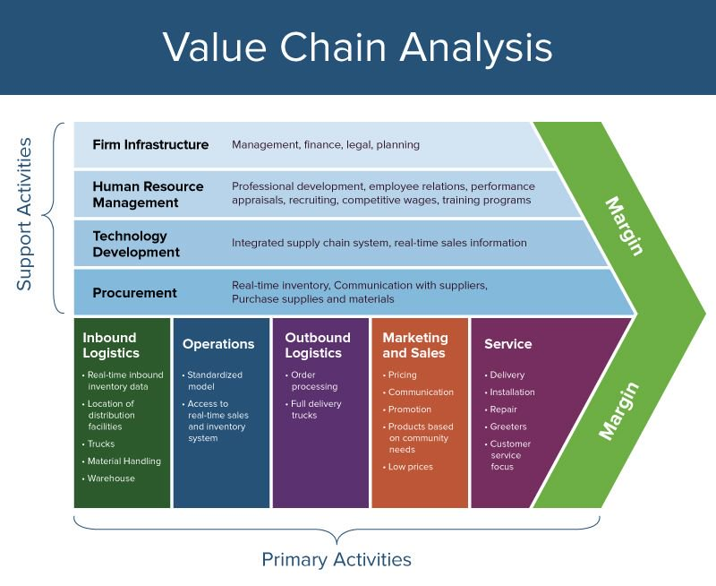Source:(Riley, 2019)

Another way is to assess what differentiation strategies a business uses and see which add value to the consumer and then increase them. For example, a company could add more product features if that is what customers already like about a device. Businesses can also offer a complimentary product range to support the sales of their original product.
Looking towards the best differentiation method for a business, that is sustainable for the business in the long-term, is yet another way for companies to get a differentiation advantage. For most companies, a mix of a few different activities helps deliver higher customer value. (‘Adding value, not taking away’,1996)

For a business to gain a cost advantage in the market, it should:
Start to determine the primary activity of their company; from this, they can cut production on secondary activities and reduce costs on their primary activity. This, however, can be difficult for some companies as a strong knowledge of an organisations value chain is required.
Break down the primary activity into stages and analyse how the work is done in each stage and identify how it adds customer value to the product. Then rank each stage by relative importance to the total cost of the product through value added.
Look for any major sources of cost, or areas where the business is lacking and either increase or decrease the amount of cash going into that stage of production.
Identify each of the cost drivers and break them down, so that a further reduction in cost can be made.
Search for areas where costs can be reduced; once these are found, they can be worked on one by one until they have all been completed.

The more value that is created within a product or service, the more your customers will be willing to pay a higher price (‘Adding value, not taking away’,1996).

2.9 Pizza Hut

2.9.1 Primary activities
Inbound logistics: Pizza Hut’s main inbound logistics is its pizza ingredients. Because it is such a large company, it can rely upon economies of scale during purchasing their ingredients; also purchasing a large amount from the same supplier helps with keeping pizzas consistent across their various outlets (Partridge, 2011).
Operations: Pizza Hut operates over a vast global territory; by targeting areas that have proven to enjoy pizza they can open a multitude of franchises.
Outbound logistics: Pizza Hut focuses on two different methods of service, eating in the store and the more recent home delivery service.
Marketing and Sales: Pizza Hut has invested a large amount of money into marketing in an attempt to drive further sales and to steal customers from its rival companies such as Domino’s.
Service: Pizza Hut tries to offer value to its customers by providing a reasonably priced pizza in convenient locations, in a family-friendly atmosphere.

2.9.2 Support activities

2.9.2.1 Infrastructure:
Pizza Hut uses the same method of infrastructure as its parent company Yum! Brands, utilising Point of Sale (POS), the result of which is a saving of over 20% (Procure4.com, 2019).

2.9.2.2 Human Resources:
Pizza Hut generally hires unskilled junior workers as this helps keep costs down.

2.9.2.3 Technological development:
Pizza Hut has created a pizza assembly line that is probably their greatest asset, though many fast-food companies utilise similar methods such as Domino's pizza and McDonald's. Having a highly automated production line also helps keep costs down and maintains consistency within their brand (Europe.businesschief.com, 2016).

2.9.2.4 Procurement:
All Pizza Hut’s raw materials (that can be produced in the UK) are sourced in the UK and from locations as local as possible to reduce transport costs (Pizzahut.co.uk, 2019).
By looking at these activities it can be seen that Pizza Hut is producing good quality pizza consistently, quickly and efficiently. These qualities make it competitive for other pizza chains such as Domino’s pizza. Pizza Hut is also very good at marketing swaying potential customers to part with their cash for something that due to the efficiency of the business was created at a fraction of the final price. They are a strong force in the industry.

2.10 Domino’s

2.10.1 Primary Activities

2.10.1.1 Inbound Logistics
Over a number of years, Domino's has created highly efficient links with regular suppliers, saving money on the cost of raw ingredients. According to Partridge (2011), Domino's also sources most of its ingredients from local sources which has a number of benefits including fresher pizza, cheaper transportation costs and the additional advantage of being able to use it in its promotional material (Corporate.dominos.co.uk, 2019)

2.10.1.2 Operations
Large parts of production are industrialised; removing humans from large parts of the production process saves a huge amount of money on wages.
Domino’s gives each member of staff on the job training; this helps the cohesion and the efficiency of the business (Corporate.dominos.co.uk, 2019).

2.10.1.3 Outbound Logistics
Domino’s purposefully finds low-cost transportation for its raw ingredients and keeps a delivery schedule, timing each order so that new stock comes in just as they are running out of material; this keeps storage costs down (Anon, 2009)

2.10.1.4 Marketing and Sales
Large amounts of sales are driven by their advertising campaign in order to try to compete with their biggest rival, Pizza Hut. Their products are priced at reasonable prices to generate a high volume of sales. Their advertising campaign also includes a number of special offers and discounts continuously (Anon, 2009).

2.10.1.5 Service
Frequent evaluation of suppliers is used in order to keep costs down by switching to the cheapest source of raw materials. Value creating activities are commonplace within the business to add value on to the cheaper pizza (Corporate.dominos.co.uk, 2019)

2.10.2 Support Activities

2.10.2.1 Technological Development
Numerous technological developments have been utilised within Domino’s and manufacturing technologies are utilised by staff in every branch and require minimal training to use. New emerging ways to order over apps or Facebook and new novel ways to pay have been established as well as new technological advancements in delivery technology such as drones and heated electric delivery vans (Dominos.com.au, 2019).

2.10.2.2 Human Resource Management
Domino’s has consistent worker policies over all of its franchises. It utilises Effective Training Programmes to Improve Worker Efficiency and Effectiveness. Wages are kept minimal but Value-Creating Activities are supplied to workers such as health insurance plans to help supplement low wages (Dominos.com.au, 2019).

2.10.2.3 Firm Infrastructure
Mis (Management information systems) systems are used because they are very cost effective. Domino's franchises also have relatively free management layers to reduce overhead costs. The business structure is very minimal helping to keep planning cost down. Value creating activities are encouraged all the way down the management ladder as it helps to save cash at every stage (Corporate.dominos.co.uk, 2019)

2.11 conclusions
Chapter two has provided an in-depth review of the current literature associated with both Domino’s and Pizza Hut. The research discusses areas of strength within each company but also areas of weakness. Some information was lacking in particulate areas as the companies are most likely keep some secrets concerning the inner working of the companies.
Chapter 3 will summarise the proposed research strategy that was used during research and thee data collection techniques that were employed within this dissertation study that in due course attempts to satisfy the previously stated research objectives.

Research Methodology

3.1 Research Approach
Research has many definitions; in this case the working definition by Collis and Hussey (2009) shall be employed: “A process of enquiry and investigation, systematic and methodical and which increases knowledge” (Collis & Hussey, 2009, p. 55)
A commonly used strategic tool to the creation of an effective research strategy was developed by Saunders, et al., (2007), simply known as ‘The Research Onion’ depicted in Figure 2 below.

3.2 The Research Onion
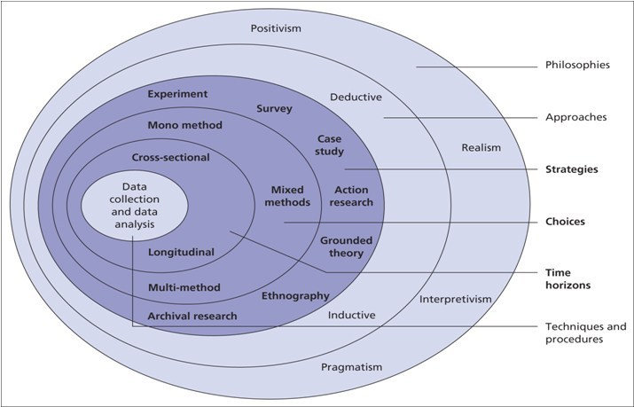
Source: Saunders (2007) Figure 2: The research Onion
As seen above, the Research Onion contains layers relating to each particular stage of research. By working through these layers to the centre section of the research onion Saunders (2007) claim that a pathway for creating an effective research strategy can be accomplished. Essentially the Research Onion strategy provides a system of best practice for a research design that eventually provides the researcher with the best data and analysis method, in order to accomplish the research question.
For the present dissertation, an organised pathway was chosen using the layers depicted in Figure 2 above to help with the development of the research design and methodology best suited for accomplishing the objectives set out in the main research question, the aim of which was to carry out a critical analysis of the pizza industry’s innovations and their effect on sales.
The ontological framework will also be used during data analysis, the ontological framework consists of the two distinct philosophies: positivism and phenomenological (Saunders, 2007).

3.2.1 Positivism
Positivistic research assumes that reality as we perceive it exists, independent of any social or moral considerations.

3.2.2 Phenomenological
Phenomenology research is used to describe how people experience certain aspects of day to day life. A phenomenological study should attempt to discard preconceived notions about human responses and feelings to particular situations.
The philosophy undertaken for the purpose of this research was largely a positivistic approach, as in order to best meet the objectives set out in the research question a subjective approach was applied through the utilisation of quantitative data to analyse and interpret people’s opinions of various pizza brands. The benefits of positivistic research are such that a great amount of quantitative data can be generated and interpreted. However, there were also elements of the phenomenological approach incorporated in areas when looking at people’s responses to particular pizza companies and brands.

3.3 Research Approach
Conferring to Ritchie, (2013) the ‘deductive approach’ is a research theory constructed on the logical process for creating suggestions or ‘deductions’. This style contrasts with the ‘inductive approach’ which consists of the researcher looking for patterns and associations derived from observations or data.
The research conducted was for the purpose of proving the legitimacy of both the research gathered from news sources and research gathered from the pizza companies. The research followed an inductive approach where the pre-existing information and knowledge gathered within the pizza industry was tested based on these findings. The inductive approach is one where research is as represented in Figure 3 below.


Figure 3 - The Process of Deduction Source: (Trochim, 2006).

Using the deductive approach, while conducting the research, enabled the researcher to get unbiased results. By operating with the deductive approach, the researcher then looked to either to confirm or discard other pieces of literature from the company that agree with the research findings. Any outlying findings were looked at closely to see if the data extraction method was incorrect in any way or if the findings had been misinterpreted.

3.3 Research Strategy and Method
Saunders, (2007) discusses the strategy for research and refers to how the researcher intends to carry out the research by means of the tools and techniques that are utilised to facilitate the research process.
This study utilised both surveys in the form of a questionnaire and an individual interview in addition to the research material published by both Pizza Hut and Domino’s with the successive findings incorporated into the analysis.
Bryman and Bell (2015), state that surveys are usually utilised when collecting quantitative data and are used especially to collect large quantities of soft data for use in the production of knowledge from the procured data. The survey method was used in order to gain large amounts of statistical data (in agreement with the positivistic approach) on the effectiveness of the pizza industry’s marketing, technological development and pricing strategies.
The one to one interview utilised a qualitative data collection style. This was used in conjunction with the survey data collection to analyse the online data that was collected from the pizza companies’ websites. The data collected through this method should substantially reinforce other areas of data that were collected. A perspective from within one of the organisations was considered to be an incredibly useful perspective to have during this research.
The research was conducted with an individual interview of an employee working within one of the established pizza restaurants. The confirmation or denial of claims produced by the pizza companies were then further explored and analysed. Through the knowledge gained from questionnaires aimed at the general public, it became evident whether the companies’ strategies are valid and are working.
Both the qualitative and quantitative data techniques used in conjunction with the pizza companies own data accessible through their own websites, allowed for a mixed methods approach to the research methodology.

3.4 Interview
As stated by O'Gorman and MacIntosh (2015), there are strengths associated with interviews that centre on the ability to provide a strong source of data and that can dive deeper into previously unrecognised themes.
The one to one interview that was conducted during the research period took on a semi-structured design, in a way that benefited the researcher as the questions were prepared in advance to ensure the critical areas were covered. Interviews are favoured in some circumstances as the structure allows ideas to be discussed whilst still allowing the participants to retain the freedom to express their own thoughts and feelings (O'Gorman & MacIntosh, 2015). Through the semi-structured interview, a higher level of reliability and the scope for the organisations in question can be attained.
As this was a one to one interview involving one participant, the researcher aimed to further benefit from obtaining rich data associated with the participant’s retail experiences building on the finding from earlier claims made by each of the company’s websites and by various newspapers (O'Gorman & MacIntosh, 2015).

3.5 Questionnaires
The questionnaire provided an easy to interpret set of data; it also delivered an effective way of collecting a large number of responses from a sample of the public. The same set of questions was used throughout the questionnaire. Full survey responses from 196 members of the general public were collected. The data collected through the survey were used in conjunction with the data collected through the interview.
The survey method of data collection had certain advantages to this field of study; firstly the relatively low cost of each survey, secondly the amount of data that could be collected from a large number of people in a considerable short period of time, thirdly the wide range of people that were available to be targeted by the survey. The repeatability of the analysis is also a benefit of using this method of research (O'Gorman & MacIntosh, 2015).

3.6 Data Triangulation
By utilising and combining both research methods the data collection created more valuable findings and the research benefited from the operation of this mixed method approach. This particular design strategy added value to the data collected by gaining a deeper understanding of the topic of research in comparing both qualitative and quantitative data (Castro, et al., 2010) (see Figure 4 below).
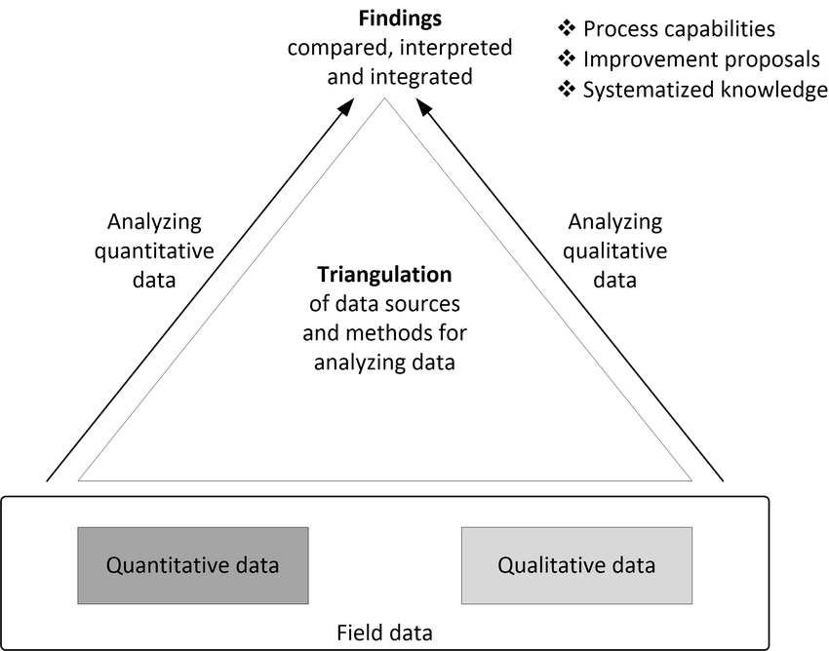
Figure 4 ‘Triangulation of data sources and methods for analysing data in inductive SPA’(Stojanov, 2007)

3.7 Sample
Due to constraints, those related to the research were primarily time and costs-based restrictions. Another limitation faced within this study was the fact that most populations are impractically sized; thus to overcome this issue, the research was conducted on a large enough sample of the population to get a good cross section of the general public while simultaneously not gathering too large of a sample making it hard to process and analyse the findings. (Saunders, et al., 2007). Researchers should attempt to construct a sample that will best represent the wider population and consequently act as a ‘microcosm’ to increase both the validity and reliability of the collected data (Bryman & Bell, 2015) This was achieved due to the large number of respondents within the survey but there was a slight gender imbalance in the final data.
There are several variations in the sample types that may be obtained; however, for this research a convenient sample was employed. A convenient best representative sample is a non-random population sample, for the purpose of greater convenience the size and other limiting factors are reduced and as such the costs and time constraints that are associated with the data collection are reduced (Fink, 2003).
Due to the cost and time limitations associated with this study and due to the specific requirements, a convenient sample was implemented in order to best satisfy the research objectives whilst furthermore considering the limitations associated with the lack of resources at the researcher’s disposal ,The researcher set out to gather 125 full respondents but to ensure the data was accurate and reliable 196 were gathered , a 50/50 gender ratio was also targeted at the beginning of the study but by the end many more female participants had filled out the survey the researcher tried to correct the imbalance but male participants seemed to be less willing to comply.

3.8 Data Collection Methods and Analysis
This study looked at the effectiveness of both Domino’s and Pizza Hut’s strategic implementation of value-adding services to their pizza, including pricing strategies technological innovation and promotional material.
Implementing a mixed-methods approach where interviews and questionnaire were utilised, provided varied data and analysis of both the internal workings of the business and the external public interpretation of the pizza industry. By utilising a double research approach the pre-existing theories associated with marketing and the public interpretation of both companies were able to be tested and compared with the data collected using from the companies’ websites (and newspapers), in the hope that the results would either complement or contrast from one another and provoke a more insightful discussion and meaningful analysis.
The data analysis technique proposed for this study shared similarities with that of the ‘confirmatory data analysis’ as the data obtained from the resulting research was compared (and contrasted) with that of the pre-existing reports and claims related to the pizza industry and more closely the companies Domino’s and Pizza Hut (Hoaglin, 2003).

3.9 Reliability and Validity
The reliability and validity of this study are substantially important to the process and any outcomes of the research.
Kirk and Miller (1986) refer to the ability of research at meeting the predetermined objectives, as well as the integrity of the findings. Reliability is concerned with the ability to repeat the research and get the same findings each time whereas validity is concerned with the accuracy of the research and if any knowledge produced by the data is true.
It is important that the researcher considered any threats to the reliability and validity of this study by attempting to limit errors and any resulting bias in the final results. Furthermore, the researcher attempted to employ the correct research design and methodology that was been deemed to best satisfy the research objectives and initial questions.
To attempt to restrict any potential reliability issues associated with the repeatability of the research obtained, all research questions and their ensuing findings were made available for other academics should they wish to repeat the study or conduct a similar study. An example survey during this research as well as a transcript of the individual interview can be found in Appendix.

3.10 Ethical Considerations
Rodgers (1987) states that scrutiny of ethical considerations while collecting research has increased since the 1940s due to a number of cases of high-profile malpractice.
Ethical considerations have become progressively important to conducting efficient and effective research and one must consider the protection of the human participants in areas such as consent, mental competence communication and a full understanding of what their data will be used for (Sage Publications, 2007).
All research conducted during this project followed strict ethical regulations which are supported by ethics documents available in Appendix.
Before conducting research, all people taking part in the research were made aware of the research’s purpose, its underlying aims and objectives and any questions they would be asked. Every participant within the study was older than 18 years of age due to the legality of collecting data from under 18 years old. All information and data were kept confidential and complied with the data collection laws. This l is all outlined with the accompanying ethics forms shown in Appendices.
The participants within this study had their anonymity respected; this is important not just for the legality but also the ethics of the study None of the data collected required a detailed collection of personal information, and information collected was nevertheless fairly general.

With the purpose of answering the research question, data from the Dominos and Pizza Hut websites were collected which stated the areas they were trying to become differentiated from the competition in. This information was sourced directly from published material online from their websites and other credible news sources to prevent claims of any favouritism, slander or liable and any findings are a true reflection of the data collected as opposed to the researcher’s thoughts or feelings.
The survey data was also collected anonymously to protect the identity of the participants from any implications that may have ensued from collecting data from them.

Data Analysis and Findings
The aim of this chapter is to gain insights into the analysis of the data gathered through the primary research methods, in this case, surveys and a one to one interview as outlined in Chapter 3.

4.1 Introduction
This chapter’s purpose is to analyse the data collected from both the primary research collected (survey and online interview) and the secondary research collected (online) in order to gather data to help solve the original objectives.
The method first created by Braun and Clarke (2006) shall be utilised during the information processing phase during this study on the data gathered through the online interview, the data gathered from the online survey and the secondary data gathered from other online sources such as newspapers and the fast food companies websites themselves. The data was processed by Google automatically after completing the online surveys through google docs and the findings offered invaluable insights into the mind of the general public.
The transcript of the interview is available for further analysis by any other parties wishing to see the raw data.

4.2 Background of findings
The researcher assessed the interview data for any complementary and overlapping areas of data collection in order to see if there were any established theories that corresponded with theories from Chapter 2. The evaluation is presented in a narrative format; any points that are subsequently linked the use of graphical data and knowledge have been taken from the analysis of the findings, as presented by google docs. Using pie charts allowed for an easier understanding of population size and what the population of the general public thought and felt in relation to the size of the whole data set. Likert scales were also used in order to see general trends in the data as statistical waves will form around the most popular areas of a question. Open-ended questions were also utilised as they allow more data to be collected especially data that might not have been immediately apparent to the researcher, helping to improve the depth and quality of data gathered. The interview was conducted with a manager at Domino’s to gather inside thoughts and feelings of the inside of the pizza industry itself. The interview contained 7 questions directed at a variety of the outstanding questions that the general public could not answer. The interview was conducted online due to the busy lifestyle of the Domino’s manager; this was beneficial to both parties as otherwise, there would have been some trouble involved in conducting the research. A similar online method was utilised to collect a large amount of data from the surveys. The questionnaire was analysed easily thanks to google docs doing all the conversions automatically and putting all the statistics into easy to understand charts and graphs. The survey contained 20 questions relating to how the general public thought and felt about pizza, the pizza industry and different brands within the pizza industry.

4.3 Main findings
The main findings have shown subsequent links between the growth of Domino’s pizza and its popularity as a brand, also where both companies could improve if they wish to increase their market share of the industry. The analysis shall consist of discussing the data at a surface level and them making deeper higher-level evaluations of the companies in question and how they can and suggested areas of development for both companies.

4.3.1 Participants
The researcher set out to gather data from at least 125 members of the general public. 196 members of the general public took the survey with the results showing an interesting variation amongst demographics with a slight lean towards female participants, 60% of the data collected was from female participants. All participants were over 18, as a restriction was placed at the beginning of the survey before the participants could take part in the survey, they had to verify their age.
An interview was conducted with a franchise manager at Domino’s pizza. Information was gathered that could only be from inside the pizza industry and which was supplementary to the data given by the public.

4.4.1 Initial findings
The first question “Do you eat pizza?” was used to help the researcher gauge the responses and see what type of margin of error he could expect from the general public. It was also an easy question to allow participants to ease into the survey.
98.5% of participants agreed that they ate pizza; the 1.5% of participants who said no consisted of a mixture of people but it was evident to the researcher that some people had not been truthful on this question as the individual data of the respondents showed that after they initially ticked that they did not eat pizza, for on the second question they then clicked that they ate pizza multiple times per week. This in itself was a contradiction as the second question was not required to pass to the subsequent questions. The researcher deduced from this that he had a margin of error of about 1.5% because of multiple factors.
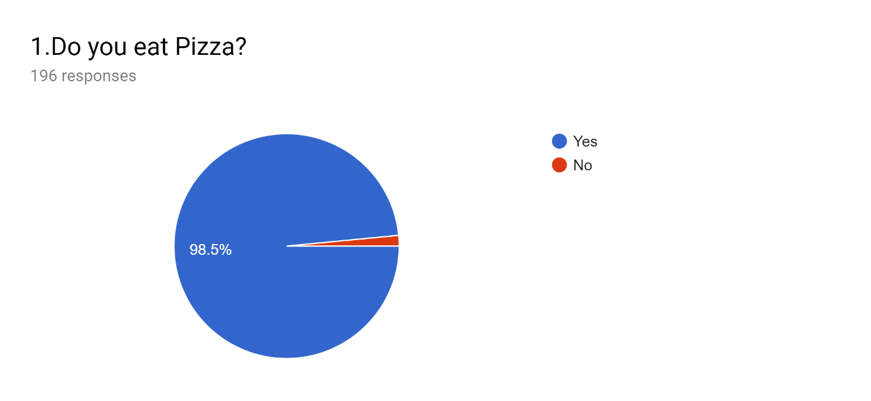 Figure 5 - Questionnaire question 1

4.4.2 Pizza Eating Frequency
The people surveyed stated that they mostly ate pizza once a week or a few times a month, Domino’s and Pizza Hut could capitalise on this by focusing adverts about buying one’s weekly or monthly pizza from them or perhaps having a reorder scheme or loyalty card. This data showed that there were a lot of people who also did not eat pizza that often; this is bad news for pizza companies like Domino’s and Pizza Hut.
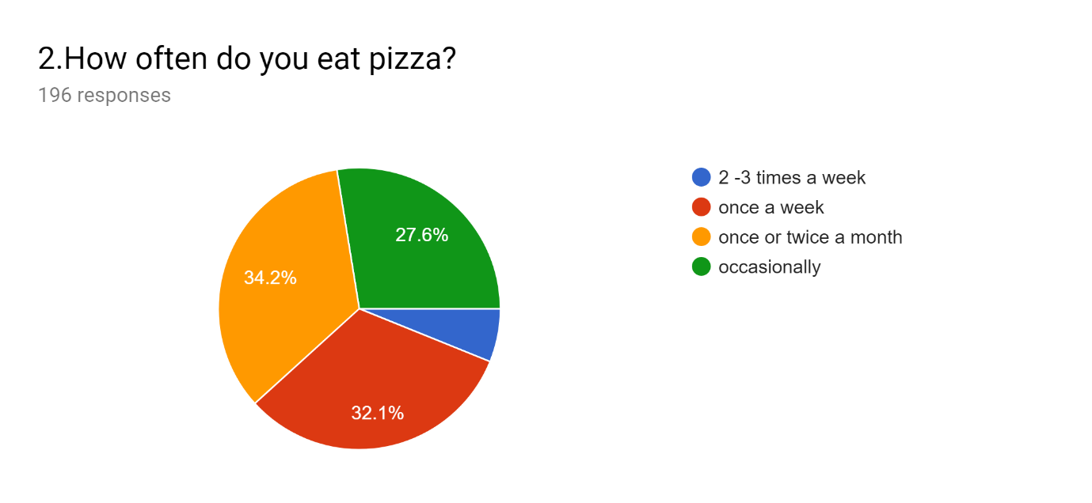
Figure 6 - Questionnaire question 2

4.4.3 Pizza Purchasing Habits
51% of participants stated that they purchased their pizza from the supermarket instead of buying it from pizza chains like Domino’s and Pizza Hut. This finding put the scale of the pizza market in to perspective for the researcher; it also has full ramifications for the pizza industry as they appear to be losing over 50 per cent of potential sales to supermarkets.
39.3% of participants stated that they purchase their pizza from delivery companies whereas 9.7% of participants preferred to get their pizza from eat in restaurants. This data can also be seen shadowing the later data collection on whether people preferred Domino’s or Pizza Hut as Pizza Hut has established itself as a eat in style of restaurant whereas Domino’s focuses more on the delivery side of business.
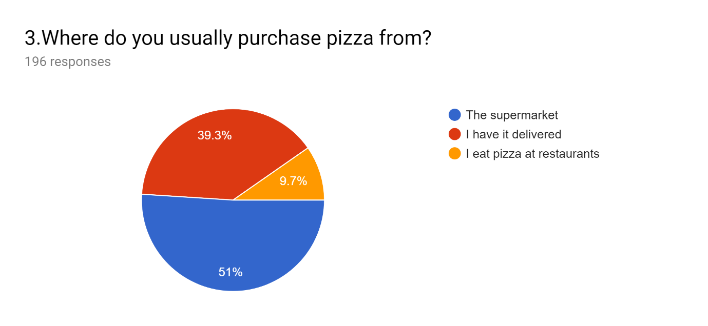
Figure 7 - Questionnaire question 3

4.4.4. Pizza Hut vs Domino’s Pizza Consumption
Have you ever eaten at Pizza Hut? And have you ever eaten Domino’s pizza? These are interlinked questions and as can be seen from the data, Domino's pizza is supposedly more popular with the general public as 13.3 per cent of participants had never eaten at Pizza Hut but only 4.6 per cent of participants had never eaten Domino’s pizza.
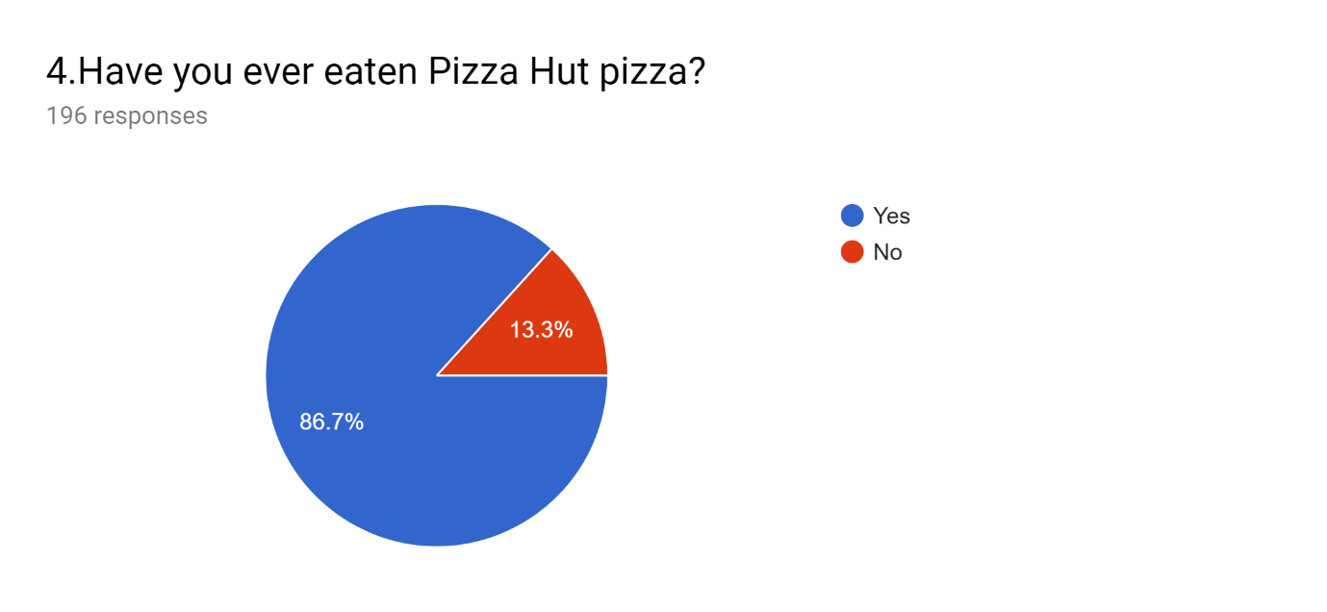
Figure 8 - Questionnaire question 4

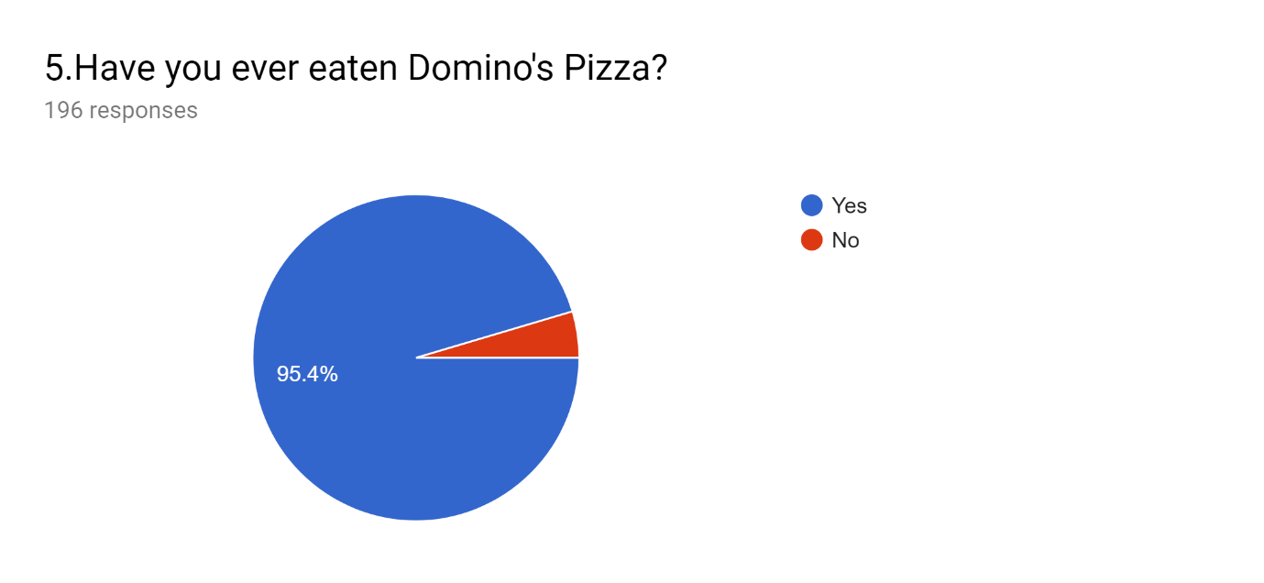
Figure 9 - Questionnaire question 5

4.4.5 Consumers Pizza Preferences
People largely preferred Domino’s pizza with a staggering 54.1%, followed by Pizza Hut, supermarket pizza and other pizzas, this suggests the average consumer greatly prefers Domino’s Pizza over any other brand.
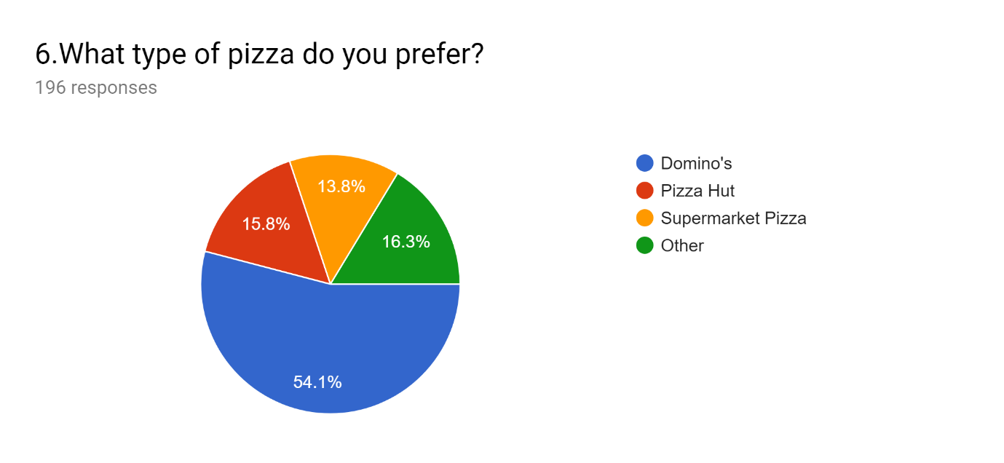
Figure 10 - Questionnaire question 6

4.4.6 Vale for Money
Do you think that Domino's pizza is good value for money? And, do you think Pizza Hut is good value for money? This is another set of interlinked questions and as the data showed people thought that Domino’s pizza is very expensive whereas Pizza Hut is relatively good value for money. This is interesting as combined with the data from the last question that the majority of people prefer Domino’s pizza it means that despite the price, more people are willing to pay the high price it costs to get Domino's pizza because of the quality and taste of the pizza itself.
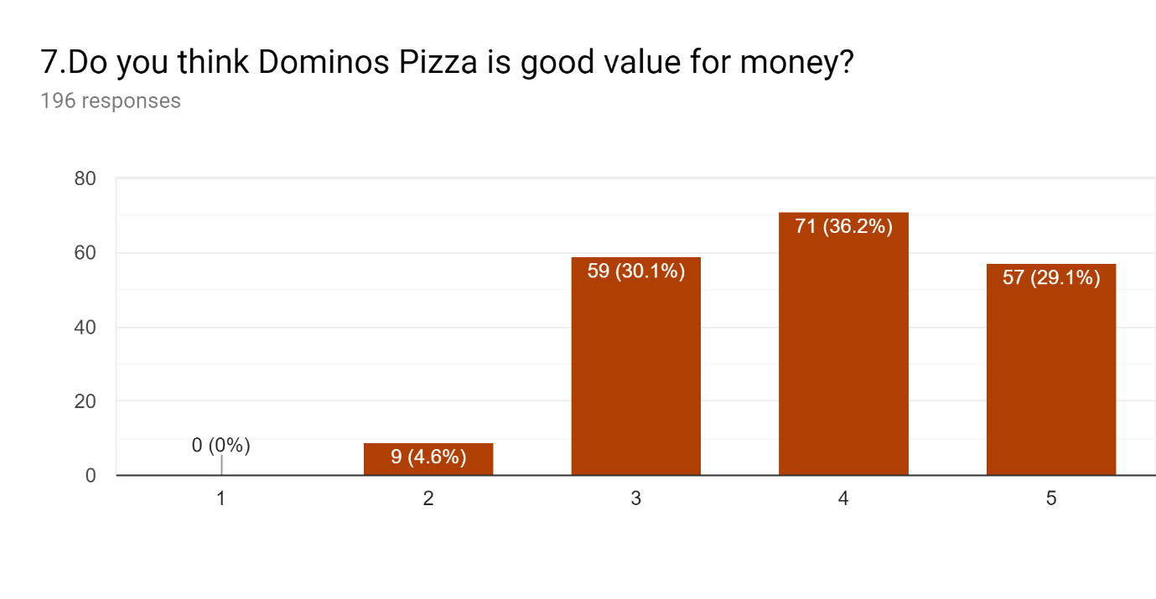
Figure 11 - Questionnaire question 7
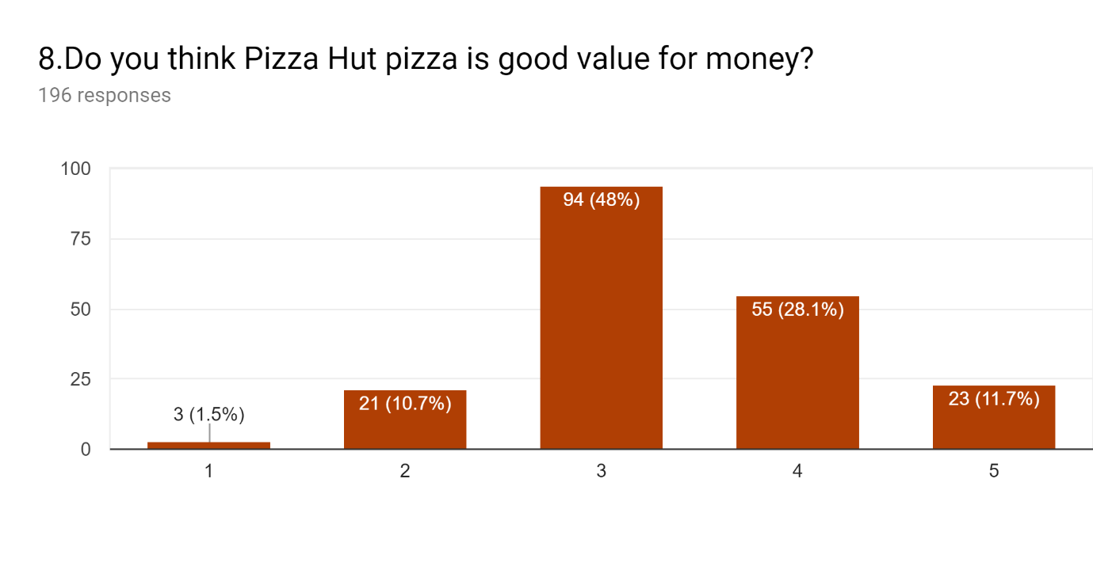 Figure 12 - Questionnaire question 8

4.4.7 New Methods of Ordering
58% of participants had previously used the Domino’s app for ordering their pizza most of whom found the app very easy or easy to use. In contrast to this only about a quarter of people knew that you could order a pizza through Pizza Hut online and online research also supports the fact they seem to be lacking in order processing technology as they have no phone application to compete with Domino’s.
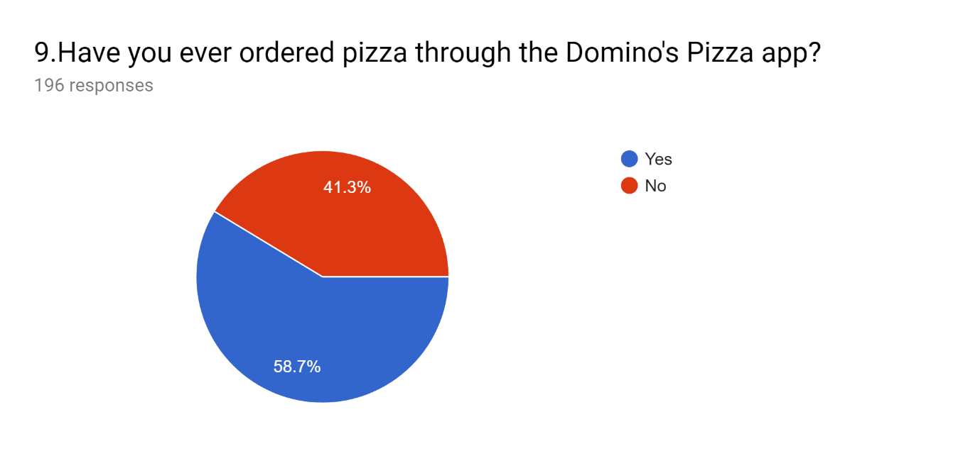
Figure 13 - Questionnaire question 9
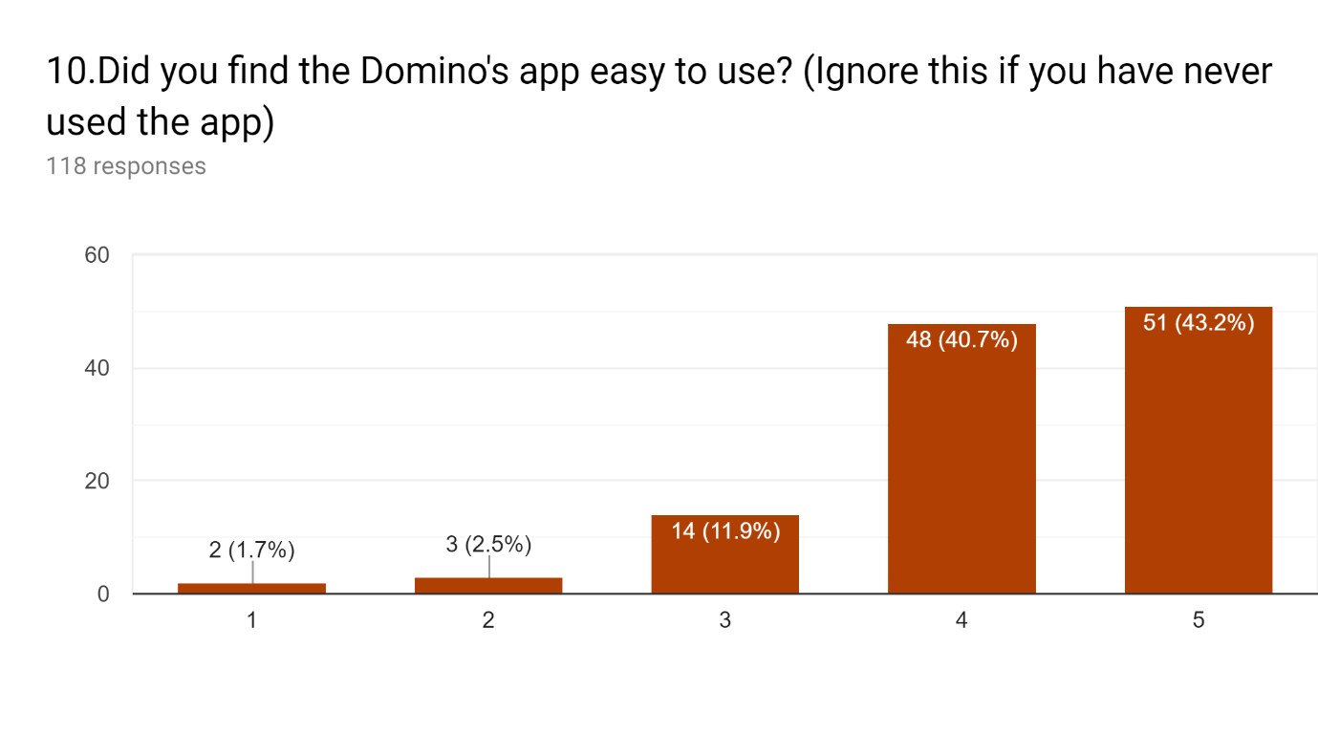
Figure 14 - Questionnaire question 10

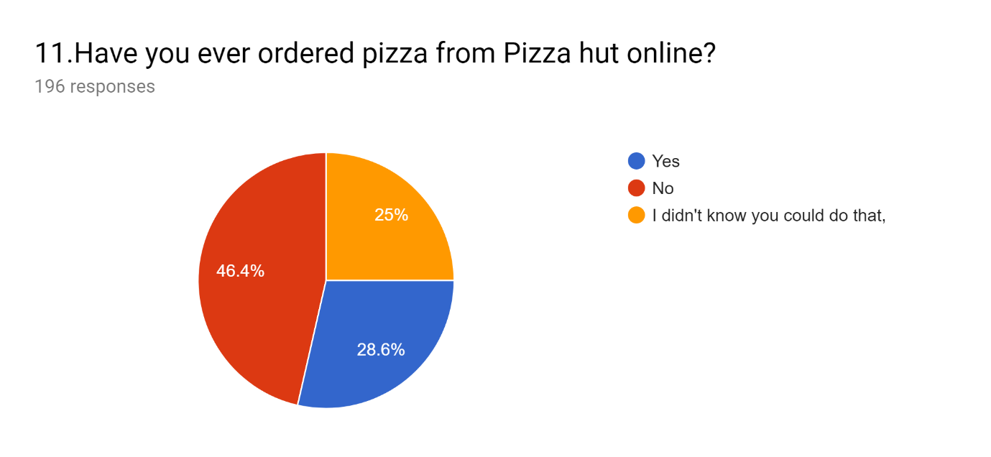 Figure 15 - Questionnaire question 11

4.4.8 Aversions to Takeaway Pizza
Both pizza chains may care to think about the reasons the general public do not like to buy take away pizza as the majority of people buy their pizza from supermarkets regularly. This may be due to a number of factors such as cost, convenience or the health aspects of ordering pizza. To combat this Pizza Hut has their famous ‘salad bar’ to choose from when dining in their restaurants and you can order salads off their menu, but Domino’s seems to be lacking anything remotely healthy from their menu. This could increase their growth even further if they started supplying healthier options.
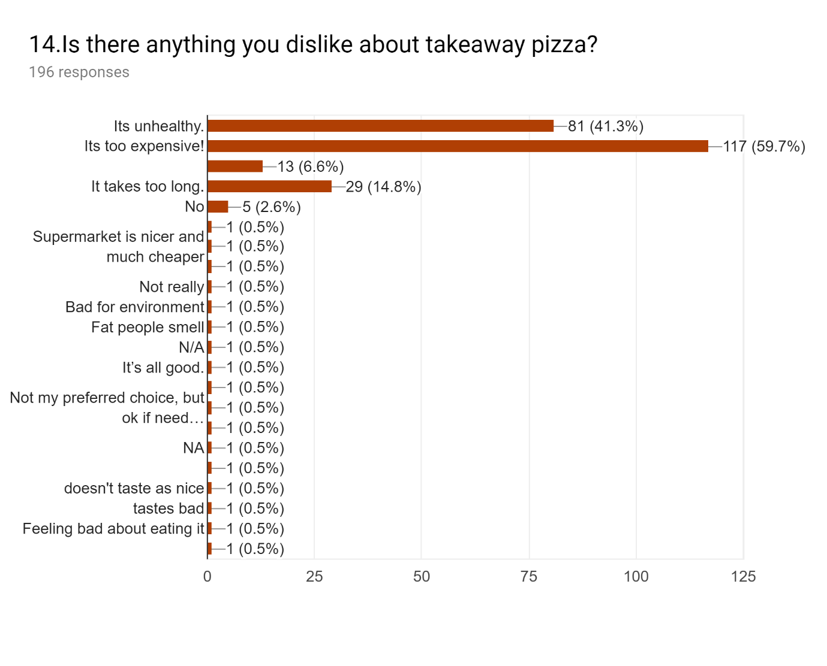
Figure 16 - Questionnaire question 14

4.4.9 Potency of Advertisements
Domino’s advertisement campaign may be responsible for the large growth in market share they are currently experiencing as 88% of the public had seen an advertisement for Domino’s pizza whereas 56% stated they had seen an advertisement for Pizza Hut with a large number of people also not sure if they had seen an advertisement for Pizza Hut. This could be down to two factors: (1) Pizza Hut is not making its brand memorable enough for consumers to remember that it is specifically their advert or (2) they need to increase the frequency and potency of their advertising campaign to try to have a higher result of brand recognition like Domino’s.
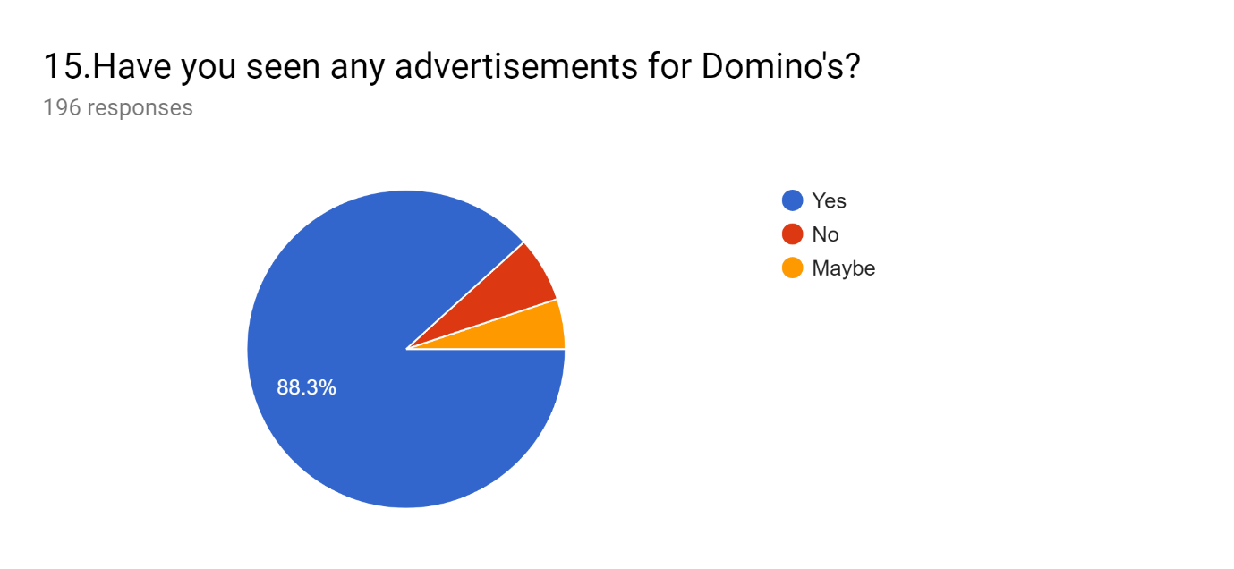
Figure 17 - Questionnaire question 15
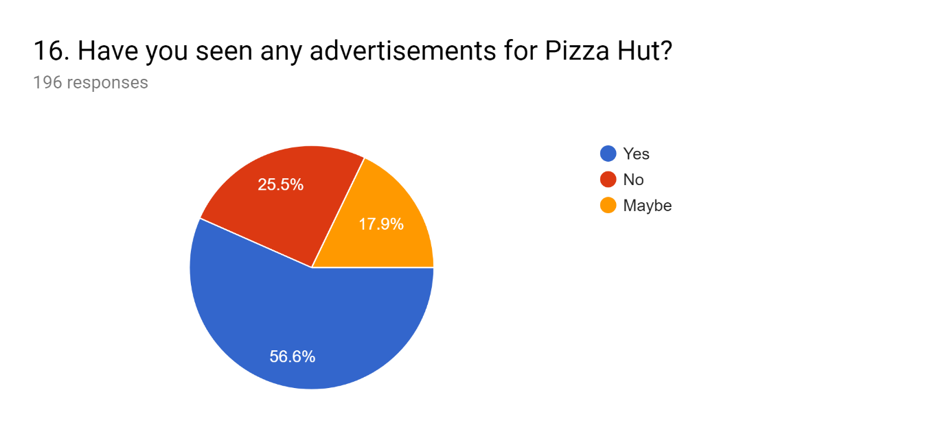
Figure 18 - Questionnaire question 16

4.4.10 Drone Delivery
Many pizza companies get excited about including new technology in the workplace when the pizza industry started posing videos online that they were trying pizza delivery by drone as this would drastically reduce the cost of delivering the product and also potentially get it to consumers faster. The statistics show that 99% of consumers have not had pizza delivered by drone (the 1% who said they have may very well fall under our margin of error), but over 30% of people said they would like drone delivery in the future and another 30% also stated they did not mind as long as the pizza gets to them faster and cheaper. Delivery by drone would provide many benefits to the company and the consumer as the eradication of the human involvement in the delivery process would help to keep company costs down; drones are cheaper to run than cars or motorbikes. Taking the human element out of the delivery process would also help keep human error to a minimum with the added benefit of also delivering products faster.
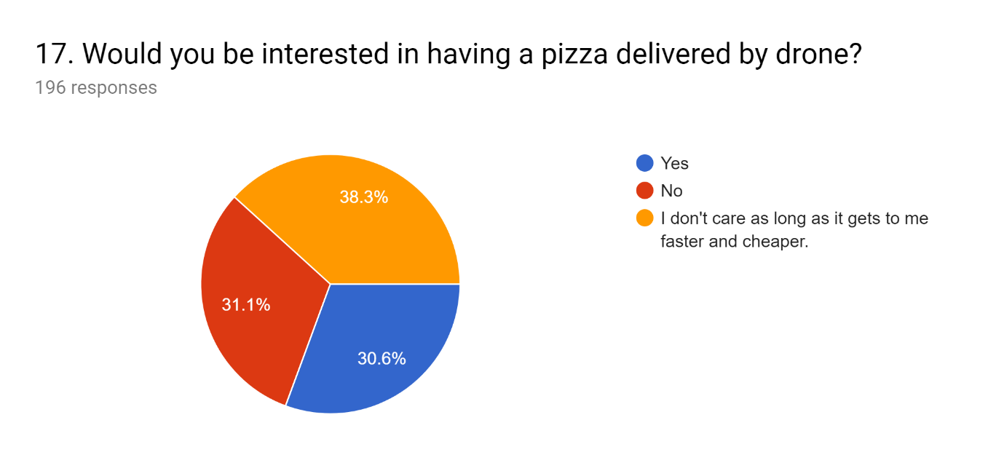
Figure 19 - Questionnaire question 17

4.4.11 Gender Rates
A large number of the respondents were female (60%); the researcher tried to counter this by sharing the survey with more groups of male participants, but the end result was a slight gender imbalance between the results.
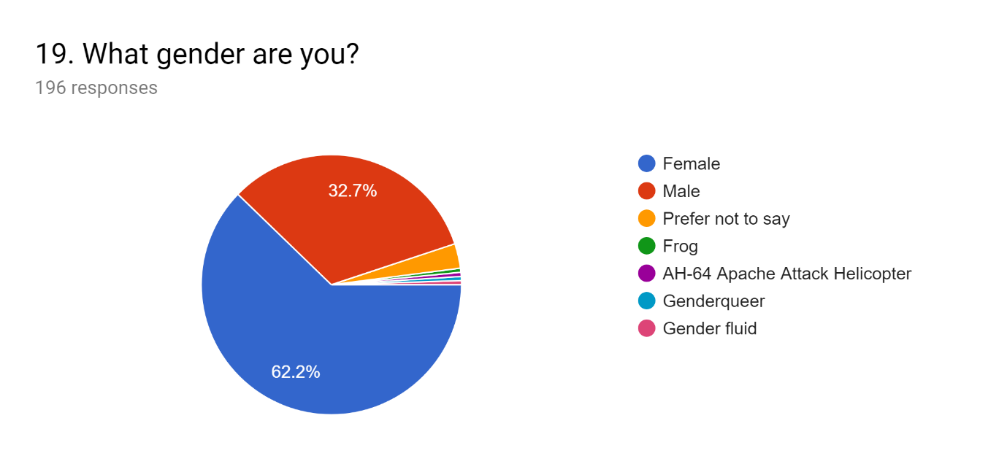
Figure 20 - Questionnaire question 19

4.4.12 Open Ended Questions
Throughout analysing the open questions a few trends were noticed, one of which was that people seemed to have a preferred brand of choice and they supported it like a football team, resulting in comments such as "The cheese balls are amazing!! The pizza is nice but very expensive!” and “Not as good as Papa John's". In hindsight the researcher could have included some options for the smaller pizza chains."

4.5. Interview
To summarise the interview the researcher asked the interviewee a total of seven questions ,concerning issues that had been found difficult to answer during the survey, The first few questions concerned the implementation of technology within dominos (as the manager was from Domino’s) The manager stated that he thought technology was beneficial to the efficiency and profitability of domino’s, not of the new technologies that he was aware of from his perspective were technologies related to the workforce such atomised staff rota and delivery trackers.
The dominos mobile phone application was also said to have made his job easier as he could spend more time on other duties instead of answering the phones.
The interviewee also stated he thought that dominos relative success was related to the businesses ability to cover large areas from such a compact store location, as the business he believed, was efficient enough (no doubt because of the technologies and innovations put in place) to serve a considerably large amount of orders without any serious drawbacks.
Some of the technologies as publicised in the media he seemed to think that they were possible to innovate with in the future, but he also stated that he did not think they would be implemented anytime soon.
As the interviewee was with a business professional , as is the life of businesses professional tends to be, he was short on time and it was hard to find an interview slot that was good for the both of us , so the researcher deemed it beneficial to conduct an online interview where the questions were decided upon in advance and the questions were messaged across the internet and recorded digitally including timestamps on the messages.

4.6 Limitations of the study
Due to a large amount of data collected it was evident that there would be some anomalies popping up in various questions; these have however been taken into account by considering a margin of error.
Due to a number of factors a manager from Pizza Hut could not be found who was willing to answer the interview questions in time for the completion of this dissertation. This may have produced an unbalanced argument but considering the questions largely were not about the organisation in question but instead about the future of the pizza industry, the one interview has not had a significant impact on the data or on the conclusions reached as a result of the data.
There was also a slight gender imbalance within the data collected (about 10%) this should not have a large impact on the data as there is no apparent gender divide with people’s pizza preferences. A larger male opinion would have been captured if the researcher had more resources at his disposal.
The open-ended questions collected produced mixed results; some of the information collected is incredibly insightful and useful for the research whereas quite a lot of other data collected this way is completely unusable as it is either filled with sarcastic remarks and jokes or the participant has just typed anything in the question box so that they could go to the next question.

4.7 Discussion

4.7.1 Literature
The Pizza industry has been growing continuously now for over 50 years it has shown to be an industry ingrained in many countries across the globe. The primary data suggested that the takeaway industry is growing in popularity based on two premises these two premises are that consumers seemed to prefer the taste of Domino’s Pizza (this can be linked with the quality of the pizza) and it helps explain Domino’s (and Pizza Huts) recent success and growth as well as their popularity among the consumers represented within our survey data this was evident from the literature provided by Barrett (2018). Our research conducted supports this trend and shows little signs of the popularity of pizza waning any time soon.
The interview conducted in 2018 with Jim Cramer on CNBC's Mad Money (Gurdus, 2019) was correct in stating that there are many technological innovations that dominos are marking innovations within the industry ,but our research suggests that ,the innovations that consumers are aware of are considerably different from the ones that managers are aware of from within the business , the interview data suggests that managers are kept on a need to know basis with technological innovation and are only aware of developments in software that will be utilised within their workplace. Alternatively, Newspapers prefer to report on larger, more exciting innovations that are more likely to increase the sales of their newspapers.

4.7.2 Research questions
The price of the pizza also turned out to be a factor that some consumers were concerned about. When cheaper pizza was available people would buy cheaper lower quality pizza over the higher quality higher priced takeaway option. Supermarkets seem to provide the best cheap pizza that consumers buy and consumer on a regular basis. Diebelius’ (2017) research in to different prices of Domino’s Pizza across the globe would suggest that Dominos (and Pizza Hut) are aware of these factors and the reason they do not lower their prices in the UK must be problematic in some way ,perhaps as they have large supermarkets to compete with selling low priced pizza’s already. The existing market structure within the pizza industry would suggest that the companies prices are largely basing their prices around this market structure as they hold large shares of the market ,they can price fix their products ,as the price of their products are shown to be considerably higher that otherwise needed to be The companies have shown some signs that they have started to add more value to their products once again in a bid to gain more market share through technological innovations such as drone delivery and amusing phone applications and ordering processes to make the expense of the pizza more justifiable to the consumer.
The final chapter seeks to summarise and conclude all of the research conducted within the dissertation. The researcher seeks to summarise the primary research ground it to the secondary research or the online findings that support the conclusions, with specific references to the initial objectives in Chapter one.

5.Conclusions

5.1 Conclusion
This concluding chapter will summarise the collective research and seek to fulfil the original questions and hypothesis as set out by the objectives.
Domino’s and Pizza Hut have been ever growing in the past few decades trying to compete with each other for the top place in the pizza chain hierarchy. Pizza Hut has normally been the dominant force in the market as it is attached to its larger parent company Pepsi co which has mastered the aim of selling fast food to the masses. However, in recent years a shift has occurred where Domino’s has now become the top pizza distributor worldwide. The present research sought to determine what caused this shift? Could it be attributed to Domino’s’ technological innovations or is it just a passing market trend?
Objective One - To research the current literature on the effective and innovative development within the pizza industry growth and popularity.
There is an extremely large amount of research and publications available online, as companies like Domino’s and Pizza Hut utilise a lot of media publications in order to compete with each other. It has become apparent during this research that some of the claims made online may be exaggerations of the truth or targeted campaigns in order to try for each of the business giants to scare each other.
Pizza Hut and Dominoes are both industry giants; Domino’s, however, has been creeping up and more recently overtaking Pizza Hut’s number one spot in the market, during the research of what the public think and feel about Domino’s pizza a few things can be ascertained as regards what has caused its recent growth,
People prefer Domino’s pizza over Pizza Hut pizza
People like the Domino's pizza delivery app
People don’t know you can order from Pizza Hut online
Domino’s has a stronger marketing presence
Even still consumers consider Domino’s pizza more expensive than Pizza Hut pizza (the literature has also shown that Domino’s pizza can be sold at lower prices as it is in many other countries around the world). These profits have undoubtedly been helping the company grow faster than its main rival Pizza Hut. As we have also seen people are buying pizza from supermarkets quite regularly as well as eating pizza fairly regularly; Domino’s and Pizza Hut would do well to try and target those individuals and convert them to eating take away pizza more regularly than buying it from the supermarket.
The health factor also had a large role to play in what people thought of taking away pizza the research would suggest that sales would increase if healthier choices were available for consumers.

Objective Two – To determine through conducting primary research whether people are choosing pizza chains based upon Price, quality or added value to the product and how these have an impact on the company’s brand recognition.

From the data it can be seen that people are choosing pizza on two factors price and taste, supermarkets currently take up a large section of the pizza purchased demographic as supermarket pizzas are cheap. Domino’s was second as their pizza is seen as the best tasting by the general public, the general public do also think that Domino’s pizzas are rather expensive despite their discounts and deals.
Companies like Pizza Hut and Dominos have been adding value to their pizza for years through the method of delivering it right to your home, but in more recent years with the advent of new technologies Domino’s and Pizza Hut have been attempting to add value to their pizza through the usage of the mobile applications where consumers can watch as their pizza goes through the ordering stage to the out for delivery stage. Consumers love the Domino’s app and find it simple and enjoyable to use.

Objective Three – to analyse and evaluate the possible impact this has had on the pizza industry, and market leading pizza organisations.

Technology has a large part to play in the growth of a lot of businesses. During the present research, two different perspectives emerged; the perspective of the public and media, and the perspective of internal employees. The external view of the pizza industry suggested that there was a lot of innovation going into new pizza delivery methods such as drones and ways to make our pizza better, more consistent and arrive at the correct temperature. This is all very exciting but through a combination of research and surveying and interviewing , it became obvious to the researcher that the hype that had been generated by the media was basically just that; it was all just hype spread by the media (as the media does) to increase the reputation of both the pizza companies involved and get readers reading the newspaper. The internal perspective of the company also offered invaluable insights to the workings of the company. The staff were mostly aware of recent technological innovations concerning their work life, such as computer systems and software or electronic kitchen equipment that may make their job easier in the long run.

Technological innovations such as the aforementioned delivery drones seem to be a while off before they become common practice. Other technology especially technology such as redesigned vans to keep pizzas hotter in the back, do not seem to have made it past the development phase as managers have heard very little about it from within the company.
It is evident that from the primary research that people seem to prefer Domino’s over Pizza Hut which could be one of the factors that is driving the company’s growth as from the secondary research it can be seen that Domino’s has overtaken Pizza Hut in recent years. This may also have a connection to their advertising campaign as Pizza Hut seems to spend less on its marketing. As the interview ascertained, new technology is prevalent on both sides of fast food companies and people within the workforce use technologies such as driver trackers and management systems.
Domino’s pizza was seen as more expensive than Pizza Hut’s; despite the many deals they offer they seem to confuse the majority of the public, whereas Pizza Hut has an edge in the pricing factor and the majority of people surveyed preferred Pizza Hut as they are cheaper. They still offered deals but less and as a consequence were less confusing for consumers. The Domino’s pizza App seems to be quite a big pulling factor also as a significant number of consumers had used the app and found it very easy to use. Pizza Hut does offer delivery online and through a phone application, but the majority of the public still prefer using the Domino’s app. More research would be needed to ascertain why the Domino’s app is superior to Pizza Hut’s ordering systems.

5.2 Areas of further research
Over the cross-sectional data gathering method utilised, due to certain factors such as time limitations, certain areas are not as developed as would be preferred.
Area of further research needed | Reason for the decision
A larger number of survey respondents. | The data did begin to smooth out in the end but there were some erratic swings in the data gathered towards the end. Having a larger pool say 300-500 would have stopped the data from changing towards the end of the collection. The data would have to have been handled by a researcher with experience in collecting and handling large amounts of data, as the researcher within this study was approaching his limited knowledge and capabilities with collecting data.
A larger number of interviews were needed with more organisational professionals. | The biggest struggle that faced the researcher during this dissertation was finding an organisational professional who was willing to participate in his online interview. Having another interviewee from Pizza Hut would have produced some valuable data to complement that of Domino’s.
Conducting interviews with people within the organisations | Conducting interviews with more staff from within the organisations such as company executives and advertisement developers, or people from within the research and development department would have been hugely valuable for the researcher.
Depth of the study | Owing to the moderately limited amount of time and lack of financial recourses available the depth of the research conducted was hindered to a small degree. As a consequence of the lack of resources available, there was a risk of the sample not being a true and fair reflection of the population at large and as of such it was possible ,as previously mentioned, to gather as many respondents as possible within the time limitations of the study.
Figure 21 – Table of Further Research

5.3 Recommendations
The pizza industry is growing globally; previous data would have suggested that Pizza Hut would be on top of this global pizza monopoly, but the research suggests that due to Domino’s recent advances, it will be the global pizza chain of the future. This can be attributed to a number of factors, the most prominent factors being (1) that people prefer the taste of Domino’s pizza; (2) Domino’s can justify having a high priced pizza because of the taste of its pizza which produces higher profits for the company; (3) Domino’s’ advertisements are more prominent and are noticed by the public more and (4) the functionality of their app has increased ease of communication with customers and increased sales.
Pizza Hut could implement ways of tackling each of these issues, Pizza hut could conduct more research and development to try to become, as the general public would see it, the best tasting pizza available, overtaking Dominos in this aspect. Pizza huts pizza prices are already extremely competitive, offering a reward scheme may make more brand loyal customers for the company, Pizza hut may also want to consider an aggressive ad campaign to tackle its public awareness issues. Pizza hut should also consider conducting more development into the mobile app it has or the online ordering method to make it easer to use or more consumer friendly, they could also in turn make their mobile application more fun for consumers to use this should be a good way to add value to their service.
Domino’s should look at future developments within its organisation, it seems to be conducting a significant amount of research and development into new technologies but very few of the aforementioned technologies actually surface within the company. In order to remain the market leader Dominos should focus on adding value to its product (and by extension the service it provides) innovations are a great way to continue doing this , but to keep its brand loyal customers satiated new developments that excite customer’s should be delivered.
Both large Pizza retailers needs to try and tackle the large amount of sales that the pizza industry are currently losing to supermarkets, there are 2 recommendations for the pizza industry going forward , improve the quality of their pizza so supermarket quality doesn’t seem like a attractive offer to consumers (this is similar to Dominos current strategy) or lower prices (or supply lower cost alternatives) so that making or buying pizza at home becomes an unattractive concept to consumers ,for example why make burgers at home when you can go to McDonalds and buy one for cheaper than it would cost you to make at home?

6.0 References
‘Adding value, not taking away’ (1996) Director, 50(2), p. 17. Available at: https://ezproxy.uwtsd.ac.uk/login?url=https://search.ebscohost.com/login.aspx?direct=true&db=bth&AN=9610162614&site=ehost-live (Accessed: 1 February 2019).
Agarwal, V. (2013). Managerial Economics. 4th ed. Pearson India, pp.68-90,-123-167.
ALLEN, A., 2018. A 'NEW NORMAL' FOR THE PIZZA INDUSTRY. Pizza Today, 36(2), pp. 54-55.
Anon, 2009. Company Spotlight: Domino's Pizza. MarketWatch: Global Round-up, 8(4), pp.94–102.
Anon, 2018. Digital Marketing Strategies for Quick Service and Fast Casual Restaurants. QSR Web. News Features, pp.QSR Web. News Features, Nov 6, 2018.
Armstrong, J. and Kesten, C. (2007). Competitor-oriented Objectives: The Myth of Market Share. [online] Wayback Machine. Available at: http://marketing.wharton.upenn.edu:80/documents/research/CompOrientPDF 11-27 (2).pdf [Accessed 22 Jan. 2019].
Barrett, L. (2017). Pizza Power Report 2018 | PMQ Pizza Magazine. [online] Pmq.com. Available at: http://www.pmq.com/December-2017/The-2018-Pizza-Power-Report-A-State-of-the-Industry-Analysis/ [Accessed 3 May 2019].
Bell, G. (2018). Competition law - the basics. [online] Out-law.com. Available at: https://www.out-law.com/en/topics/eu--competition/competition/competition-law---the-basics/ [Accessed 22 Jan. 2019].
Bojanic, D. (2007). Global Pricing Strategy for a Quick-Service Restaurant Chain. [online] Digitalcommons.fiu.edu. Available at: https://digitalcommons.fiu.edu/cgi/viewcontent.cgi?referer=https://www.google.com/&httpsredir=1&article=1431&context=hospitalityreview [Accessed 17 Feb. 2019].
Braun, V., & Clarke, V. (2006). Using thematic analysis in psychology. Qualitative research in psychology, 3(2), 77-101. Retrieved April 15, 2018
Butler, S. (2019). UK restaurant numbers drop for first time in eight years. [online] the Guardian. Available at: https://www.theguardian.com/business/2018/jun/28/uk-restaurant-numbers-drop-for-first-time-in-eight-years [Accessed 28 Jan. 2019].
Chalabi, M. (2019). A National Pizza Day investigation: how many slices a day do Americans eat?. [online] the Guardian. Available at: https://www.theguardian.com/lifeandstyle/datablog/2017/feb/09/national-pizza-day-how-many-slices-do-americans-eat [Accessed 22 Jan. 2019].
Chen, Y. (2017). To turn around sales declines, Pizza Hut is stepping up its digital ordering and delivery - Digiday. [online] Digiday. Available at: https://digiday.com/marketing/turn-around-sales-declines-pizza-hut-stepping-digital-ordering-delivery/ [Accessed 24 Jan. 2019].
Chowdhry, A. (2017). Facebook Adds Options For Ordering Food. [online] Forbes.com. Available at: https://www.forbes.com/sites/amitchowdhry/2017/10/15/facebook-food-order/#73fa5ef17b6b [Accessed 28 Jan. 2019].
CNNMoney. (2017). Domino's testing self-driving pizza delivery. [online] Available at: https://money.cnn.com/2017/08/29/technology/ford-dominos-self-driving-car/index.html [Accessed 28 Jan. 2019].
Collis, J., & Hussey, R. (2009). Business Research (3rd ed.). New York: Palgrave Macmillian. Retrieved March 10, 2018
cong huynh, r. (2013). Market study & Analysis of pizza industry. [online] Slideshare.net. Available at: https://www.slideshare.net/richhuynh87/market-study-analysis-of-pizza-industry [Accessed 16 Feb. 2019].
Corporate.dominos.co.uk. (2019). Domino's - Our journey. [online] Available at: https://corporate.dominos.co.uk/our-journey [Accessed 2 May 2019].
Corporate.dominos.co.uk. (2019). Domino's - Store operations. [online] Available at: https://corporate.dominos.co.uk/Store-operations [Accessed 28 Jan. 2019].
Corporate.dominos.co.uk. (2019). Domino's. [online] Available at: https://corporate.dominos.co.uk/working-for-us [Accessed 28 Jan. 2019].
Cox, J. (2018). Domino’s profits jump after selling record 97 million pizzas in 2017. [online] The Independent. Available at: https://www.independent.co.uk/news/business/news/dominos-pizza-latest-profit-record-sales-uk-consumers-eating-out-restaurant-a8245271.html [Accessed 22 Jan. 2019].
CRAIG SCHOOL OF BUSINESS (CALIFORNIA STATE UNIVERSITY, FRESNO). (2005). International journal of business. Fresno, CA, Premier Pub. http://accesbib.uqam.ca/cgi-bin/bduqam/transit.pl?&noMan=24711318a.
Diebelius, G. (2017). Why is Domino's so expensive in the UK and cheap in Australia and New Zealand? | Metro News. [online] Metro.co.uk. Available at: https://metro.co.uk/2017/02/09/why-is-dominos-so-expensive-in-the-uk-6432174/ [Accessed 11 Feb. 2019].
Dominos.co.nz. (2018). Domino's Pizza - Privacy And Policy. [online] Available at: https://www.dominos.co.nz/inside-dominos/contact-us/privacy-policy [Accessed 28 Jan. 2019].
Dominos.com.au. (2019). Technology & Innovation - Domino's Pizza. [online] Available at: https://www.dominos.com.au/about-us/technology [Accessed 28 Jan. 2019].
Europe.businesschief.com. (2016). How Pizza Hut Restaurants UK has transformed its IT operations. [online] Available at: https://europe.businesschief.com/Pizza-Hut-Restaurants-UK/profiles/223/How-Pizza-Hut-Restaurants-UK-has-transformed-its-IT-operations [Accessed 28 Jan. 2019].
Farrell, S. (2019). The rise and rise of Domino's Pizza. [online] the Guardian. Available at: https://www.theguardian.com/business/2014/jan/08/dominos-pizza-sales-up [Accessed 2 May 2019].
Fry, C. (2019). The growth in organic and Fairtrade textiles. [online] the Guardian. Available at: https://www.theguardian.com/environment/2007/apr/13/fairtrade.organics [Accessed 28 Jan. 2019].
Garcia, T. (2018). Yum Brands’ Pizza Hut is losing out on one key demographic. [online] MarketWatch. Available at: https://www.marketwatch.com/story/yum-brands-pizza-hut-is-losing-out-one-key-demographic-2018-10-31 [Accessed 16 Feb. 2019].
Gianatasio, D. (2015). Domino's Just Unveiled a Radical Pizza Delivery Car That Took 4 Years to Build. [online] Adweek.com. Available at: https://www.adweek.com/creativity/dominos-just-unveiled-radical-pizza-delivery-car-took-4-years-build-167707/ [Accessed 22 Jan. 2019].
Guan, L. (2019) ‘Dominos serves up a slice of tech innovation’, CIO (13284045), p. N.PAG. Available at: https://search-ebscohost-com.ezproxy.uwtsd.ac.uk/login.aspx?direct=true&db=bth&AN=135850411&site=ehost-live (Accessed: 28 April 2019).
Gurdus, E. (2019). Domino's Pizza CEO says voice ordering and self-driving cars could be the future of delivery. [online] CNBC. Available at: https://www.cnbc.com/2017/10/12/dominos-ceo-alexa-and-autonomous-cars-may-be-future-of-delivery.html [Accessed 28 Jan. 2019].
Holt Jr., Charles A., 1982. On the Use of Profit Data to Estimate the Social Cost of Monopoly Power in an Oligopoly. Journal of Economics & Business, 34(4), pp.283–291.
Hospitality & Catering News. (2018). Taking advantage of the ever-increasing UK Pizza Restaurant Market - Hospitality & Catering News. [online] Available at: https://www.hospitalityandcateringnews.com/2018/10/taking-advantage-ever-increasing-uk-pizza-restaurant-market/ [Accessed 10 Feb. 2019].
Jamieson, S. (2015). Domino's sales climb as customers order pizza by app. [online] Telegraph.co.uk. Available at: https://www.telegraph.co.uk/finance/newsbysector/epic/dom/11767078/Dominos-sales-climb-as-customers-order-pizza-by-app.html [Accessed 25 Feb. 2019].
Lufkin, B. (2018). How can a fast food chain ever make money from a $1 burger?. [online] Bbc.com. Available at: http://www.bbc.com/capital/story/20180222-how-can-a-fast-food-chain-ever-make-money-from-a-1-burger [Accessed 10 Feb. 2019].
Luigs, S. et al. (2004) ‘New EU states proactive on competition’, International Financial Law Review, 23(12), pp. 40–42. Available at: https://ezproxy.uwtsd.ac.uk/login?url=https://search.ebscohost.com/login.aspx?direct=true&db=bth&AN=15507898&site=ehost-live (Accessed: 1 February 2019).
Markillie, Paul, 1992. The secrets of the production line. Economist, 325, p.survey.pp.02.
Matyszczyk, C. (2018). Domino's Just Overtook Pizza Hut as the World's Biggest. Here's the 1 Reason Pizza Hut Lost. [online] Inc.com. Available at: https://www.inc.com/chris-matyszczyk/dominos-just-overtook-pizza-hut-as-worlds-biggest-heres-1-reason-pizza-hut-lost.html [Accessed 2 May 2019].
Maynard, M. (2019). Ready When I Get There: Mobile Takeout Is A Rising Restaurant Trend. [online] Forbes.com. Available at: https://www.forbes.com/sites/michelinemaynard/2019/01/27/ready-when-i-get-there-mobile-takeout-is-a-rising-restaurant-trend/#68e3f7112f59 [Accessed 28 Jan. 2019].
Mehanna, T. (2016). The Price war that redefined the pizza industry. [online] Linkedin.com. Available at: https://www.linkedin.com/pulse/price-war-redefined-pizza-industry-toni-mehanna [Accessed 11 Feb. 2019].
Merriam-webster.com. (2019). Definition of COMPETITION. [online] Available at: https://www.merriam-webster.com/dictionary/competition [Accessed 22 Jan. 2019].
O'ROURKE, A. (2019). Fear calling? Nine ways to tackle your Sunday night anxiety | Her.ie. [online] Her.ie. Available at: https://www.her.ie/health/nine-ways-to-tackle-your-sunday-night-anxiety-446417 [Accessed 1 Feb. 2019].
Partridge, A. (2011). Foodservice Logistics Brings Value to the Table - Inbound Logistics. [online] Inboundlogistics.com. Available at: https://www.inboundlogistics.com/cms/article/foodservice-logistics-brings-value-to-the-table/ [Accessed 28 Jan. 2019].
PepsiCo, Inc. Official Website. (2019). Product Information. [online] Available at: https://www.pepsico.com/brands/product-information [Accessed 28 Apr. 2019].
Pizza Hut Online Ordering. (2019). Pizza Delivery, Deals, Restaurants and Takeaway | Order Online with Pizza Hut. [online] Available at: https://www.pizzahut.co.uk/aboutus/ [Accessed 2 May 2019].
Pizzahut.co.uk. (2019). Pizza Hut. [online] Available at: https://www.pizzahut.co.uk/faqs/ [Accessed 28 Jan. 2019].
Porter, M. (1985). Competitive Advantage. 1st ed. Newyork: The Free Press, p.1.
Porter, M.E., 1947. Competitive advantage: creating and sustaining superior performance New., New York: Free. pp.1-5
Prasso, Sheridan, 2007. India's Pizza Wars. Fortune International (Europe), 156(6), pp.31–34.
Procure4.com. (2019). Yum! Brands | Procurement Consultants | Procure4 |. [online] Available at: http://www.procure4.com/case-studies/yum-brands [Accessed 28 Jan. 2019].
Riley, J. (2019). Value Chain Analysis | tutor2u Business. [online] tutor2u. Available at: https://www.tutor2u.net/business/reference/value-chain-analysis [Accessed 28 Jan. 2019].
Simkovic, M. (2011). Competition and Crisis in Mortgage Securitization. SSRN Electronic Journal, 2(2), pp.1,16-28,41,55-59.
Smith, A. (1776). The wealth of nations. 92nd ed. William Strahan, Thomas Cadell, pp.1-4,38-42,67-96.
Smith, M. (2016). Pizza Price Wars: Will the competition keep falling like Domino’s?. [online] T2 2016 MPK732 MARKETING MANAGEMENT (CLUSTER A). Available at: https://mpk732t22016clustera.wordpress.com/2016/09/04/pizza-price-wars-will-the-competition-keep-falling-like-dominos/ [Accessed 11 Feb. 2019].
Stojanov, Z. (2007). Triangulation of data sources and methods for analyzing data in inductive SPA. [online] Research Gate. Available at: https://www.researchgate.net/figure/Triangulation-of-data-sources-and-methods-for-analyzing-data-in-inductive-SPA_fig5_304918878 [Accessed 24 Apr. 2019].
Trochim, W. (2006). Social Research Methods - Knowledge Base - Deduction & Induction. [online] Socialresearchmethods.net. Available at: https://socialresearchmethods.net/kb/dedind.php [Accessed 2 May 2019].
Williams, A. (2019). Store Wars: Domino's and Pizza Hut. [online] the Guardian. Available at: https://www.theguardian.com/money/2012/aug/24/store-wars-dominos-pizza-hut [Accessed 2 May 2019].
WSAU. (2019). U.S. fast food chains offering more healthy options for kids. [online] Available at: https://wsau.com/news/articles/2019/jan/09/us-fast-food-chains-offering-more-healthy-options-for-kids/ [Accessed 28 Jan. 2019].

7.0 Appendices

7.1 Appendix A - Table of Figures
Figure Number | Page Number
Figure 1 – Value Chain Analysis | Page 15
Figure 2 – The research onion | Page 20
Figure 3 – The Process of Deduction | Page 21
Figure 4 - Triangulation of data sources and methods for analysing data in inductive SPA’ | Page 24
Figure 5 - Questionnaire question 1 | Page 29
Figure 6 - Questionnaire question 2 | Page 29
Figure 7 - Questionnaire question 3 | Page 30
Figure 8 - Questionnaire question 4 | Page 30
Figure 9 - Questionnaire question 5 | Page 31
Figure 10 - Questionnaire question 6 | Page 31
Figure 11 - Questionnaire question 7 | Page 32
Figure 12 - Questionnaire question 8 | Page 32
Figure 13 - Questionnaire question 9 | Page 33
Figure 14 - Questionnaire question 10 | Page 33
Figure 15 - Questionnaire question 11 | Page 34
Figure 16 - Questionnaire question 14 | Page 35
Figure 17 - Questionnaire question 15 | Page 36
Figure 18 - Questionnaire question 16 | Page 36
Figure 19 - Questionnaire question 17 | Page 37
Figure 20 - Questionnaire question 19 | Page 37
Figure 21 - Table of Further Research | Page 43
Figure 22 – Gant Chart | Page 56

7.2 Appendix B – Interview Minutes
Interviewer – “This Interview is in Connection with the UWTSD all answer are confidential, all data collected will be separated from the identity of the participant.”
Interviewee – “Uwtsd?”
Researcher – “The university of wales and trinity St David”
Interviewee – “Go ahead”
Researcher – "The first question do you think technology in the workplace (Domino's) makes it more efficient and profitable?"
Interviewee - “Definitely. It helps keep track of the items and stats easier”
Researcher - “Second question could you give me some examples of technologies that are utilised while in work this can be anything from technology used by delivery drivers, processing the food, or during the ordering process”
Interviewee - “Keeping track of labour costs depending on how busy it is. So you can have a minimal amount of workers for how busy the shift is. Tracking on drivers’ cars so we can tell customers that the delivery is nearby if they ask where it is etc”
Researcher – “Do you think there are any new technologies coming into the pizza industry?"
Interviewee - “Not that I know of. Other than possibly a better system in place for an order making and managing as it is a little out of date"
Researcher - “Question 4, do you think the Domino's app makes your job easier?"
Interviewee - “A little bit yeah. Let’s customers know where the food is roughly so they're less likely to be calling up taking time to make the food"
Researcher - “Question 5, do you think that because of the growing amount of technology in the workplace humans will be phased out of the business?”
Interviewee - “It may be possible in the future. But with current tech that won't be happening for a while. As it would cost a ton of money for the company as there are many many stores. As well, tech is prone to glitching and messing up so there's likely going to be someone there just in case.”
Researcher - “Do you think that any technologies such as drones will be phased at any time soon?"
Interviewee - “Only the higher-grade drones have the programming and strength to deliver the food. So, it may happen soon but only in select stores.”
Researcher - “What would you say is the most prominent factor in Domino's recent popularity and growth?”
Interviewee - “Our ability to handle such a large amount of orders and large area coverage well with such a small store. Popularity has been growing recently so more and more orders keep coming through, but we handle it pretty well but at the same time if it keeps getting busier, we're going to need to get a larger store”

7.3 Appendix C – Survey Questions
This a 20 question survey, conducted through the University of Wales Trinity St David. The purpose of this research is to identify peoples preferences within the pizza industry. This survey should take approximately 5 minutes to complete. This research is part of a final year of undergraduates study. If any participants wish to contact me regarding the survey and the results please email me at mwilliams.149184@student.uwtsd.ac.uk
By continuing past this point I hereby acknowledge that the data is confidential and all data submitted will be used by the University of Wales Trinity St David for academic and educational purpose.
* Required
1.Do you eat Pizza? * Mark only one oval.
Yes
No
2.How often do you eat pizza? *
Mark only one oval.
2 -3 times a week
once a week
once or twice a month
occasionally
3.Where do you usually purchase pizza from? *
Mark only one oval.
The supermarket
I have it delivered
I eat pizza at restaurants
4.Have you ever eaten Pizza Hut pizza? *
Mark only one oval.
Yes
No
5.Have you ever eaten Domino's Pizza? *
Mark only one oval.
Yes
No
6.What type of pizza do you prefer? *
Mark only one oval.
Domino's
Pizza Hut
Supermarket Pizza
Other
7.Do you think Domino’s Pizza is good value for money? *
Mark only one oval.
It's very cheap 1 2 3 4 5 It's very expensive
8.Do you think Pizza Hut pizza is good value for money? *
Mark only one oval.
It's very cheap 1 2 3 4 5 it's very expensive
9.Have you ever ordered pizza through the Domino's Pizza app? *
Mark only one oval.
Yes
No
10.Did you find the Domino's app easy to use? (Ignore this if you have never used the app)
Mark only one oval.
Confusing 1 2 3 4 5 Very easy to use
11.Have you ever ordered pizza from Pizza hut online? *
Mark only one oval.
Yes
No
I didn't know you could do that,
12.Do you have any thoughts or feelings about Domino's?

13.Do you have any thoughts or feelings about Pizza Hut?
14.Is there anything you dislike about takeaway pizza? *
Check all that apply.
Its unhealthy.
Its too expensive!
The pricing and ordering is confusing.
It takes too long.
Other:
15.Have you seen any advertisements for Domino's? *
Mark only one oval.
Yes
No
_{Maybe}
16. Have you seen any advertisements for Pizza Hut? *
Mark only one oval.
Yes
No
_{Maybe}
17. Would you be interested in having a pizza delivered by drone? *
Mark only one oval.
Yes
No
I don't care as long as it gets to me faster and cheaper.
18. Have you ever had a pizza delivered by drone? *
Mark only one oval.
Yes
No

19. What gender are you? *
Mark only one oval.
Female
Male
Prefer Not to say
Other (please enter)
:
20.Thank you for your time, Do you have any thoughts about this survey?

7.4- Appendices D-Gantt Chart
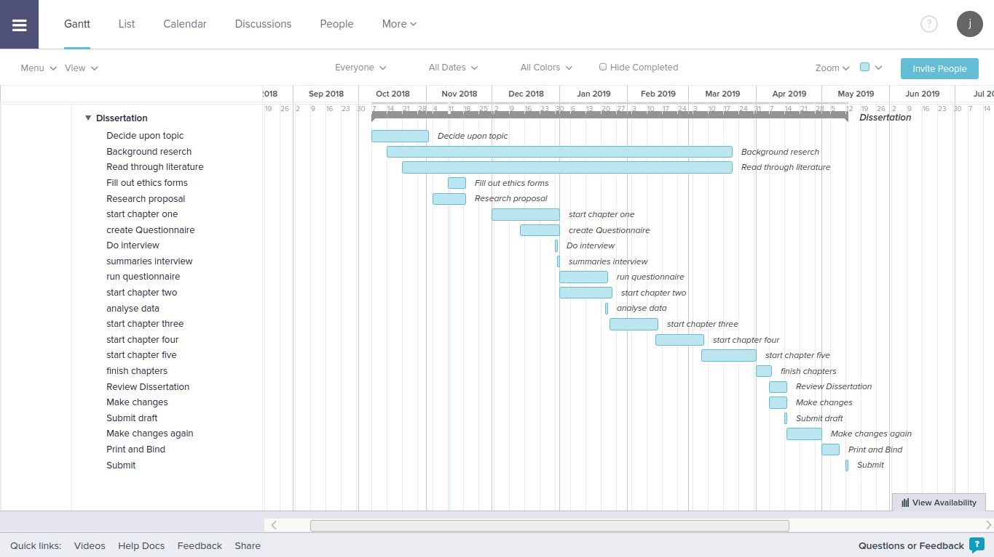
Figure 22 – Gant Chart

