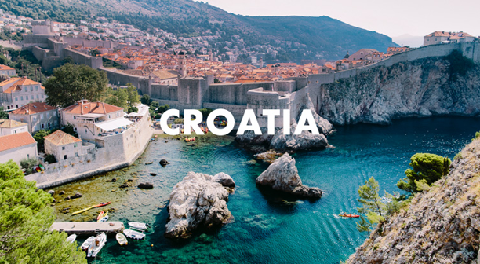
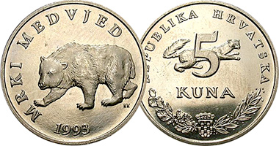
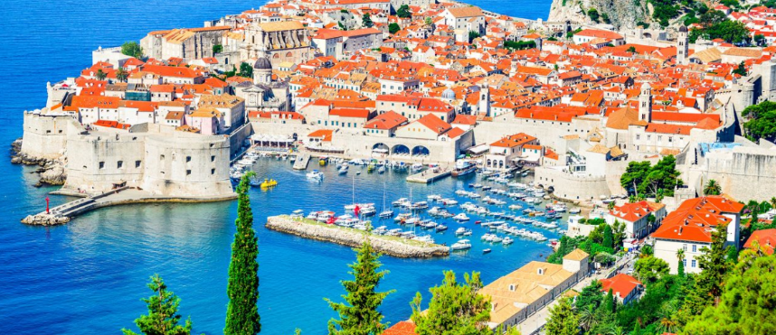
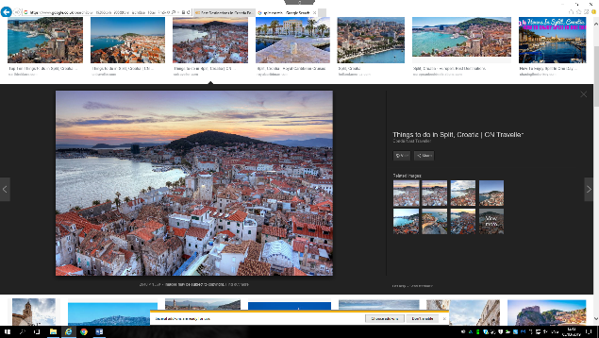
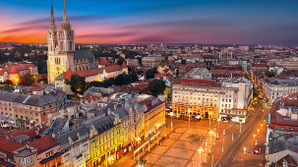
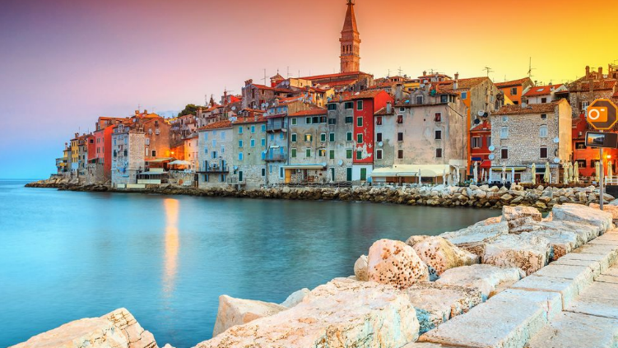
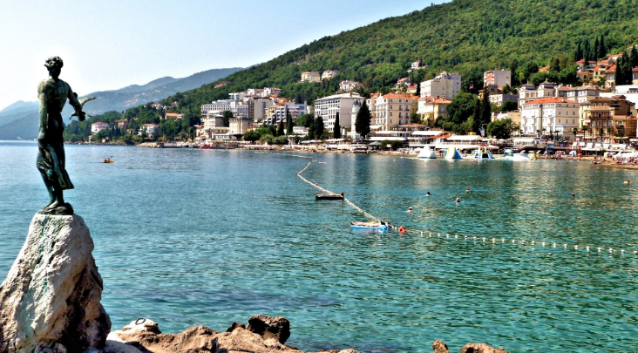
Croatia. Perfect for two.
Introduction to Croatia.
Croatia is based in Europe between Slovenia, Hungary, Serbia, Bosnia and Herzegovina, and Montenegro.
In 2018 Croatia has set a record of tourists visiting which was 20 million. This is 6.5% more than in 2017 which is the most in Croatia’s history of tourist’s visitations. The most popular areas where Istria, Split, Kvarner, Zadar and Dubrovnik.
The language spoken in Croatia is Croatian but there are other languages that are quite often spoken there and those are Serbian, Czech, Italian, Hungarian, Slovakian and Romanian. Also due to the large tourism demand most Croats are able to speak basic English as it’s helpful to attract more tourists.
Croatia has its own currency which is the Croatian Kuna. 1 Croatian Kuna is
equal to 0.12 Pound Sterling.
https://www.trafalgar.com/enau/destinations/europe/croatia
When travelling to and around Croatia tourists will need to carry their passports with them whenever going out further to have some form of identity.
Overall crime rates in Croatia are low and like in any busy town/area the tourists would have to be careful of pickpockets and just not carry extremely large amount of money with them. Always keep their belongings on or near them and just generally be aware of their surroundings. Any crimes committed are also encouraged to be reported straight away to the local police.
In most cases when travelling to Croatia all that the tourists would need is a passport unless they are coming from a non-European country then there would have to be extra research done to check if anything else is required prior entering the country or booking flights/holiday.
Top 5 destinations in Croatia for couples to visit.
No.1 Dubrovnik. (Best to travel in May and October).
Known as the Old Town Dubrovnik is a perfect destination for a romantic walk through the historical town which is also on the coast. It’s one of the most popular towns in Croatia and it’s also perfect for the Game of Thrones fanatic couples as they get to take a walk through the ‘Kings Landing’. But that’s not it they can also enjoy the breath taking sun sets at the Buza bar or a romantic dinner at one of the many restaurants that are in Dubrovnik. There is even an opportunity for wine tasting.
https://www.homeaway.ca/d/39571/dubrovnik
No.2 Split. (Best to travel in June and September).
In Croatia Split is the largest coastal town with a beautiful and interesting history. When taking a romantic walk with a partner the couple are basically walking through the historical artefacts which is the town itself. Plenty of good restaurants with cheap prices, bars, cafes and even a sandy beach to relax on. When in Split it’s great to also explore the beautiful Krka waterfalls or even take a swim in them to cool down. Another plus is that the town has great plane connections with major European airports which allows tourists from more areas to come and visit the beautiful town.
https://www.cntraveller.com/gallery/things-to-do-in-split-croatia
No.3 Rovinj. (Best to travel in the summer).
Rovinj is known for being a romantic location with a beautiful quarter, loads of art galleries, Plenty of restaurants and bars to choose from. The couples can explore the romantic streets, alleyways and passages or sit down and enjoy a glass of wine at Piassa Grande. There’s also the gardens of St. Catherine Island and the Mulini Beach to enjoy.
https://www.vrbo.com/vacation-rentals/europe/croatia/rovinj
No.4 Opatija. (Best to travel in spring and autumn).
The perfect place for couples of all ages, Opatija has a Vienna like architecture making it have a romantic vibe and the oldest along with the longest seafront promenade. There’s also lovely parks to choose from, interesting cafes and restaurants to enjoy a meal at.
https://www.croatiaweek.com/1-2-million-overnight-stays-for-first-time-in-opatija/
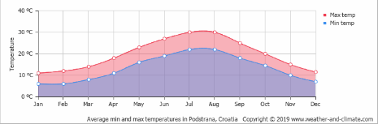
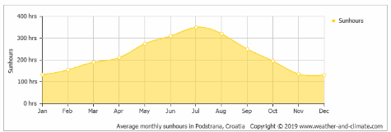
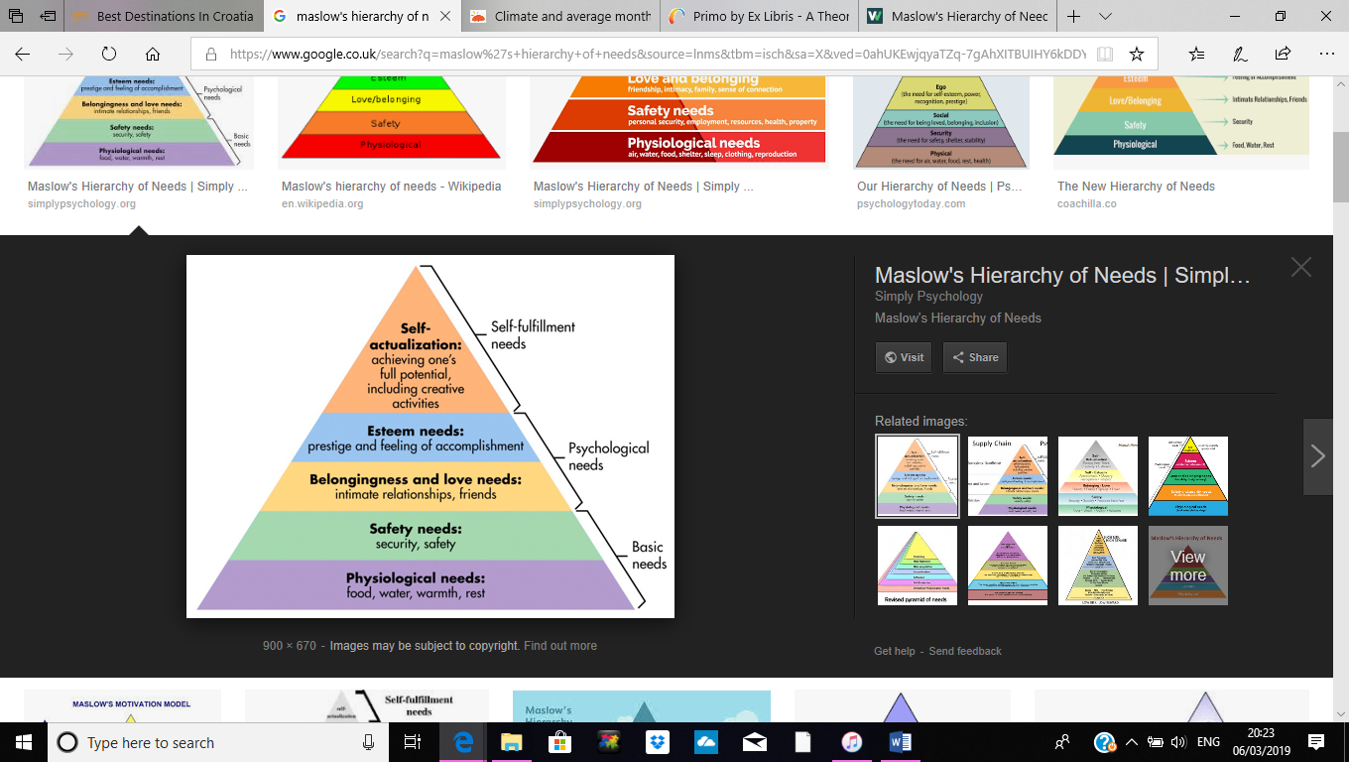
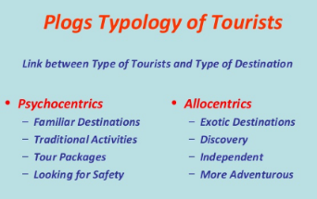
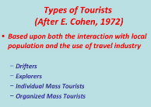
No.5 Zagreb. (Best to travel in spring).
Zagreb is the capital of Croatia with a good vibe, plenty of historical towns to explore, museums, parks and a good nightlife that couples can enjoy on their stay. The Upper town is the most romantic area, the by hand gas powered street lamps add to the romantic mood every evening, along with the street festivals and restaurants.
https://www.intrepidtravel.com/adventures/zagreb-guide-croatia-travel/
Looking at the statistics of the weather in Croatia it looks that the best times to visit would be from middle of April to start of October as the temperatures are either over 20 degrees or just under 10 the lowest.
https://weather-and-climate.com/average-monthly-Rainfall-Temperature-Sunshine-inches,hvar,Croatia
Also the most sun hour occur between May and September which are similar months to the temperature months meaning that for those who are seeking the warmth and sunny days those months are the best to go at.
https://weather-and-climate.com/average-monthly-Rainfall-Temperature-Sunshine-inches,hvar,Croatia
Looking at Maslow’s Hierarchy of Needs it suggests that people follow a set of needs and wants. The more basic needs are at the bottom of the list or as some may want to look at it a pyramid. Those needs include food, water, sleep and warmth. When those needs are met the person is then able to move on to the next stage. The next stage would be safety and security, going higher up the pyramid the needs become less physical and more psychological or social. Then the rest of the pyramid is formed of feeling love and belonging, esteem and self-actualization. Once all of the needs are met people are more open and self-aware.
Whilst being in Croatia the tourists are still able to achieve all their needs such as food, water, sleep and warmth due to the restaurants, hotels or wherever they would be staying so that they are able to move on to the next stage.
Before going on a holiday the tourist may need to consider if they have the financial security and health and wellness to go. After looking into the security and safety of Croatia where crime rates are low it’s believed that the safety and security needs are mostly met.
As the holiday is couple targeted the social needs in most stages are met. Also the esteem needs are able to be achieved by participating in the holiday and achieving things throughout. Social media plays a big role in self-esteem now such as posting photos of achievements on the internet.
After such a holiday self-actualization becomes reached as the person realizes that they don’t have to be concerned about others opinion and are more self-aware.
https://www.simplypsychology.org/maslow.html
Croatia overall is a perfect destination for tourists that can be called an allocentric which is a person that according to Plog’s theory is an adventurer that would like to experience new activities. This kind of tourist is confident, ready to try new things and explore the culture and people from the specific destination.
Croatia is a good destination for an allocentric because it offers multiple of exciting activities and places to explore such as a variety of water sports, hiking, festivals and learning the culture. Some of these activities include zip lining at the Crikvenica coastal, paragliding at Istria’s Ucla or Mount Cicarija, basic and extreme canyoning and white water rafting at Cetina River, cliff jumping and many more.
Also Croatia is a suitable for a psychocentric which from Plog’s theory is a person that is not as adventurous as an allocentric. This kind of tourists prefer to go back to the places that they have already explored so they can just simply relax and know exactly what to expect. For example just stay in a hotel or a family type accommodation where they feel safe and secure.
Croatia has plenty of calm and family friendly resorts where tourists that are psychocentric can relax in. English is a very common language in Croatia due to the demand therefore most tourists are able to communicate freely without the stress.
https://www.slideshare.net/magielsr/t1-tourism-system-presentation-948850
From looking at Cohens theory there are four different types of tourists, an organized mass, individual mass, explorer and drifter.
Croatia is catering for many needs right now as its developing more each year therefore it has hotels where tourists don’t have to leave the site or package trips with ready-made itinerary’s for the organised mass tourists so that they can relax and not make any decisions.
The individual mass tourists are very similar but they like to make some decisions and have control over their itinerary. They may base their ideas on the hotels plans but then execute them themselves.
The explorer then will arrange their trips and their goal is not to be a sitting down all day sunbathing. They enjoy learning about the country and Croatia has a strong history and culture. They may even learn some phrases in that country.
Then the drifter will prefer to live in the local community, get to know it and the people there.

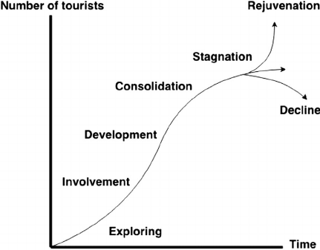
https://www.slideshare.net/magielsr/t1-tourism-system-presentation-948850
Within Butler’s life cycle theory.
When a country is going through the Butler’s life cycle theory they each start of at the discovery stage where the country is still fairly ‘new’ to tourists. It’s only been discovered by a small amount of people which then gets passed on so more people come to visit. The country or destination created profit therefore they are able to develop and provide for the new tourists.
At the second stage more tourist tend to arrive to the destination meaning that there is a stronger demand for more and better accommodation, attractions, restaurants and shops.
In the third stage as the destination is visited by even more tourists all of the facilities are becoming overflown. General public may become unhappy as they may have lost or not gained anything from the industry. Also the destinations culture seems to be disappearing with more tourists coming in.
Towards the fourth stage a problem appears – stagnation. Tourists are now getting bored of the destination at this stage as it has been visited too many times. Some negative comment may appear about how the destination used to be. This then leads to an economic decline. This forces some businesses to close down therefore people losing jobs and unemployment rising in the area.
The fifth stage is either the decline or the rejuvenation of the destination. The destination may go into decline meaning that tourists stop visiting, there’s been damage done to the destination and people are losing jobs due to business closure. Or the destination could go into rejuvenation. This is where it would develop strategies that are more sustainable to match the numbers of visitors coming to the destination.
https://www.researchgate.net/figure/Tourism-destination-life-cycle-Source-Butler-1980_fig1_268818059
From looking at the information given by European Economy (2018) Croatia has been on the rise since the 90’s after managing to recover from the slight lack of tourists before and has been generating a major income. Considering that there has been improvement already made there is still more needed to be done to reach the country’s full potential. Croatia’s main weakness is the low average spending money and limited amount of services which will have to be worked on to keep up the interest.
Overall Croatia is on the right track to keep developing and on Butler’s life cycle it’s around the second stage where facilities are still being developed for tourist’s expectations and needs and hopefully will attract more international travellers and generate more profit. For example as mentioned earlier in 2018 it has beaten its record in history by having 6.5% more tourists visiting than in 2017 which would have generated an important amount of income to carry on with the major developments that the destination will need to work on for further tourist interest.
The destination has load of natural beauty and natural attractions therefore more tourists will be interested either way but by adding those extra developments it will increase the tourist amount coming in and money spend in the country also that way creating more jobs for the local people and reducing poverty.

References.
Chepkemoi, J. (2017). ‘What Languages are Spoken in Croatia?’, [Online], Available: https://www.worldatlas.com/articles/what-languages-are-spoken-in-croatia.html , [Accessed Date – 2019, February, 25].
Cherry. K, (2018). ‘The Five Levels of Maslow's Hierarchy of Needs’, [Online], Available: https://www.verywellmind.com/what-is-maslows-hierarchy-of-needs-4136760 , [Accessed Date – 2019, March, 6].
Dimitrova, N. (2019), ‘20 million tourists visited Croatia in 2018 setting a record’, [Online], Available: https://www.themayor.eu/en/20-million-tourists-visited-croatia-in-2018-setting-a-record, [Accessed – 2019, February, 25].
Frank, G, (2017),’ 5 awesome destinations in Croatia for couples’, [Online], Available: https://www.frankaboutcroatia.com/destinations-in-croatia-for-couples/,[Accessed Date – 2019, March, 4].
GOV.UK, (2019), ‘Croatia ‘, [Online], Available: https://www.gov.uk/foreign-travel-advice/croatia, [Accessed Date – 2019, March, 5].
GOV.UK, (2019), ‘Croatia’, [Online], Available: https://www.gov.uk/foreign-travel-advice/croatia/safety-and-security , [Accessed Date – 2019, March, 5].
Maslow, A.H; Stephens, C.D and Heil, G, (1998). ‘Maslow on management’, New York: Wiley.
McLeod. S, (2018), ‘Maslow's Hierarchy of Needs’ [Online], Available: https://www.simplypsychology.org/maslow.html , [Accessed – 2019, March 6].
SmarterTravel, (2019), ‘Is Croatia Safe? Warnings and Dangers Travelers Need to Know’, [Online], Available: https://www.smartertravel.com/tips-croatia-warnings-dangers-stay-safe/, [Accessed Date- 2019, February, 25].
Tutorialspoint, (2019), ‘Plog’s Model of Tourists Behavior’, [Online], Available: https://www.tutorialspoint.com/tourism_management/tourism_management_plogs_model_behavior.htm,[Accessed Date – 2019, March, 6].
TravelTriangle, (2019), ‘10 Best Adventure Sports In Croatia For Both Adventure Junkies & Rookies’, [Online], Available: https://traveltriangle.com/blog/adventure-sports-in-croatia/, [Accessed Date – 2019, March, 6].
Slideshare, (2017), ‘An Introduction To Tourism’, [Online], Available: https://www.slideshare.net/magielsr/t1-tourism-system-presentation-948850, [Accessed Date – 2019, March, 6].
Grzywacz. R and Żegleń. P, (2016),’ TYPOLOGY OF TOURISTS AND THEIR SATISFACTION LEVEL’, [Online], Available: https://www.researchgate.net/publication/300109727_TYPOLOGY_OF_TOURISTS_AND_THEIR_SATISFACTION_LEVEL, [Accessed Date – 2019, March, 6].
Barcelona Field Studies Centre, (2018), ‘The Butler Model of tourist resort development’, [Online], Available: https://geographyfieldwork.com/ButlerModel.htm, [Accessed Date – 2019, March, 6].
European Commission, (2018), ‘Croatia’s Tourism Industry: Beyond the Sun and Sea’, [Online], Available: https://ec.europa.eu/info/sites/info/files/economy-finance/eb036_en.pdf,[Access Date – 2019, March, 6].
World Weather & Climate Information, (2019),’CLIMATE AND AVERAGE MONTHLY WEATHER IN Hvar (Hvar Island), Croatia’, [Online], Available: https://weather-and-climate.com/average-monthly-Rainfall-Temperature-Sunshine-inches,hvar,Croatia, [Accessed Date – 2019, March, 6].

