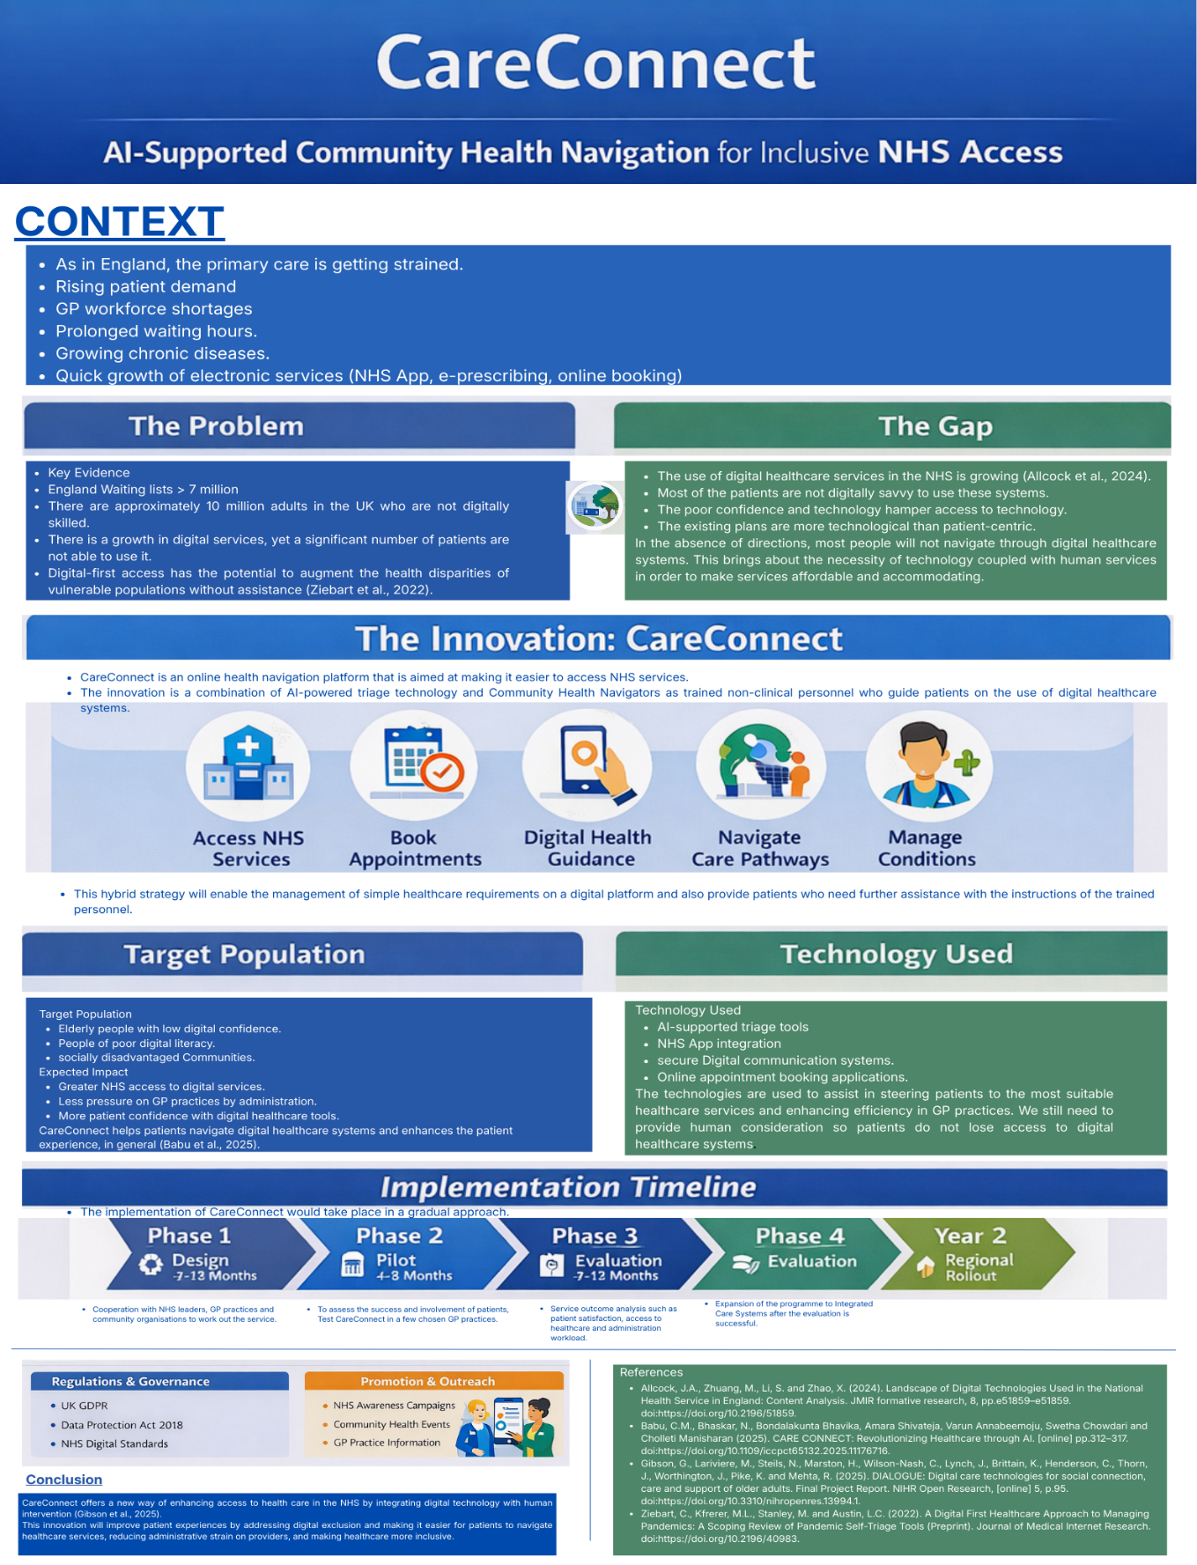
Name: Tazeem Akhter
STUDENT ID:2333384
Directed to: NHS Integrated Care Board Leader
Dear Integrated Care Board Leader,
My proposal is for an innovation project called CareConnect that will solve the mounting pressure that the primary care services are facing in England. Increased patient demand, long queues, workforce shortage, and increased patients with long-term health conditions are some of the challenges that GP practices are encountering (Willson et al., 2022). Simultaneously, the NHS is going more and more digital with the help of the NHS App, electronic prescriptions, and online booking (Salina et al., 2022). Although these innovations create conditions to enhance access to healthcare, they can also contribute to the increase of health disparities if vulnerable groups cannot access digital services. Many sick people are not likely to be able to find their way through digital healthcare systems and get the required care without proper assistance.
To solve this problem, I would suggest CareConnect, which is a community-based digital health navigational programme that will enhance access to NHS services and decrease administrative burden on GP practices. The program is a digital health initiative that is integrated with organized human services to enable patients to have a better experience navigating the NHS digital. Patients would also be helped by trained Community Health Navigators to make use of the services, including the NHS App, making appointments online, using electronic prescriptions and digital health information, so that even those with low digital confidence can get access to the necessary healthcare services.
I came up with CareConnect as a reaction to the pressure mounting on the NHS primary care. The number of contacts with millions of patients every year by GP practices is constantly growing, and such digital healthcare services as the NHS App and online triage systems are constantly being expanded. Nevertheless, several patients are not digitally savvy enough to use such platforms (Kitsios et al., 2023). CareConnect focuses on making sure that digital innovation does not create barriers in accessing healthcare for vulnerable populations.
CareConnect would present trained Community Health Navigators to aid in the use of digital healthcare services through GP practices and community health hubs through CareConnect. These are non-clinical personnel who would help patients navigate through the NHS App, make their appointments online, request e-prescriptions, and interpret digital health information. Giving patients individualised advice, Community Health Navigators can aid them to eliminate digital barriers, gain confidence using digital tools, and make sure that not digitally confident individuals do not miss out on receiving healthcare services.
I have modeled CareConnect on the concept of blended care that integrates digital healthcare services with personalized human assistance. Digital systems can be used to handle routine and administrative healthcare requirements, including appointment booking or accessing health information. Nonetheless, Community Health Navigators would provide direct support to patients who need extra support or feel uncomfortable with using digital technologies. This will be a way of making sure that digital healthcare enhances efficiency and is accessible to every patient. With assistance provided to people who might otherwise not be able to deal with digital systems, CareConnect assists in making sure that digital healthcare transformation consolidates and enhances primary care services instead of augmenting health disparities (Hertwig et al., 2026).
Expected Impact and Benefits
CareConnect should deliver some positive results to patients, health care professionals, and the overall NHS. The campaign has the potential to enhance access to NHS digital services, especially for those people who are affected by impediments to using digital technologies. It also has the potential of minimizing the administration burden and congestion of phones in GP practices and allows healthcare professionals to attend to complicated clinical demands. Moreover, CareConnect will be able to enhance patient trust toward the use of digital healthcare tools as well as contribute to lessening digital health disparities and enhancing patient experiences in the primary care community.
Implementation Plan
I suggest that CareConnect should be introduced in a gradual manner within a span of about 12-24 months.
Phase 1: Design and Stakeholder Engagement (Months 1–3)
At this stage, work would be done with GP practices, Integrated Care Boards, community organisations, and charities involved in digital inclusion to streamline the CareConnect model and build training programmes to train Community Health Navigators.
Phase 2: Pilot Program (Months 4–6)
The project would be tested in some of the chosen GP practices, especially in the areas where digital exclusion is high.
Phase 3: Evaluation and Improvement (Months 7–12)
The measures that would have been used to assess the pilot program include patient satisfaction, use of the digital services, and administrative load.
Phase 4: Expansion and Integration (Year 2)
CareConnect may be replicated in Integrated Care Systems to promote broader NHS digital strategies in healthcare following a successful assessment.
Stakeholders and Resources
In a bid to implement CareConnect successfully, I would work with several key stakeholders, namely GP practice managers, Integrated Care Boards, NHS England digital transformation teams, local authorities, community organizations, and digital inclusion charities. I would also collaborate with IT service providers in facilitating the adoption of digital healthcare systems. Moreover, I would also hire and train Community Health Navigators, offer adequate working space in the GP practices and community hubs, and maintain continuous monitoring and assessment of the program. CareConnect can be successfully implemented in NHS primary care services through the organized and efficient allocation of resources, in my opinion (Checkland et al., 2023).
Regulatory and Governance Issues
CareConnect would be run in compliance with the major regulations and governance standards of the UK healthcare system. The program would be in line with UK GDPR and the Data Protection Act 2018 to provide safety and secure management of patient information (Solano-Kamaiko et al., 2025). CHN would be trained on data protection, confidentiality, and safeguarding as a measure to ensure digital healthcare systems are handled responsibly. The boundary of professional relationships would also be clear, such that the navigators offer guidance and support to the patients without making clinical decisions.
Value and Feasibility
In my opinion, CareConnect is consistent with the major NHS priorities such as enhancing access to healthcare, decreasing health disparities, and enhancing the sustainability of primary care services. I have modeled this project as an extension of the current NHS digital systems, including the NHS App and online appointment systems, and not a complete replacement of new technologies. Integrating digital tools with well-organized human assistance, I will contribute to the increased efficiency of the provided services without increasing the cost or making the given approach too difficult to implement in the NHS primary care context.
Call to Action
I give a strong recommendation to the Integrated Care Board to grant the pilot implementation of CareConnect to apply to selected GP practices. Through investment in the community-based digital health navigation, we will be able to alleviate the administrative burden on the primary care services and enhance the patients' access to digital healthcare systems. CareConnect is a solution that is practical and inclusive to ensure that digital transformation empowers healthcare services instead of increasing inequalities. I think this initiative can help create a more accessible, efficient, and patient-centred NHS with strategic help and cooperation.

References
AlLcock, J.A., Zhuang, M., Li, S., and Zhao, X. (2024). Landscape of Digital Technologies Used in the National Health Service in England: Content Analysis. JMIR formative research, 8, pp.e51859–e51859. doi:https://doi.org/10.2196/51859.
Babu, C.M., Bhaskar, N., Bondalakunta Bhavika, Amara Shivateja, Varun Annabeemoju, Swetha Chowdari, and Cholleti Manisharan (2025). CARE CONNECT: Revolutionizing Healthcare through AI. [online] pp.312–317. doi:https://doi.org/10.1109/iccpct65132.2025.11176716.
Checkland, K., Bramwell, D., Warwick-Giles, L., Bailey, S. and Hammond, J. (2023). Primary care networks as a means of supporting primary care: findings from qualitative case study-based evaluation in the English NHS. BMJ Open, [online] 13(11), p.e075111. doi:https://doi.org/10.1136/bmjopen-2023-075111.
Gibson, G., Lariviere, M., Steils, N., Marston, H., Wilson-Nash, C., Lynch, J., Brittain, K., Henderson, C., Thorn, J., Worthington, J., Pike, K., and Mehta, R. (2025). DIALOGUE: Digital care technologies for social connection, care, and support of older adults. Final Project Report. NIHR Open Research, [online] 5, p.95. doi:https://doi.org/10.3310/nihropenres.13994.1.
Hertwig, M., Göttgens, F., Rademacher, S., Vieweg, M., Nyhsen, T., Dorn, J., Dohmen, S., Simon, T.-P., Jansen, P., Braun, A., Müller-Funogea, J., Kluwig, D., Yazdi, A. and Brokmann, J.C. (2026). CareConnect: An Implementation Pilot Study of a Participatory Telecare Model in Long-Term Care Facilities. Healthcare, 14(3), p.335. doi:https://doi.org/10.3390/healthcare14030335.
Kitsios, F., Stefanakakis, S., Kamariotou, M. and Dermentzoglou, L. (2023). Digital Service Platform and Innovation in Healthcare: Measuring Users’ Satisfaction and Implications. Electronics, 12(3), p.662. doi:https://doi.org/10.3390/electronics12030662.
Salina, T., Costelloe, C., Powell, J., Papoutsi, C., Reidy, C., Gudgin, B., Shenton, C., and Greaves, F. (2022). An observational study of uptake and adoption of the NHS App in England. doi:https://doi.org/10.1101/2022.03.16.22272200.
Solano-Kamaiko, I.R., Tan, M., Ming, J., Avgar, A.C., Aditya Vashistha, Sterling, M., and Dell, N. (2025). ‘Who is running it?’ Towards Equitable AI Deployment in Home Care Work. pp.1–19. doi:https://doi.org/10.1145/3706598.3713850.
Willson, K.A., Lim, D., Toloo, G., FitzGerald, G., Kinnear, F.B., and Morel, D.G. (2022). Potential role of general practice in reducing emergency department demand: A qualitative study. Emergency Medicine Australasia, 34(5). doi:https://doi.org/10.1111/1742-6723.13964.
Ziebart, C., Kfrerer, M.L., Stanley, M., and Austin, L.C. (2022). A Digital First Healthcare Approach to Managing Pandemics: A Scoping Review of Pandemic Self-Triage Tools (Preprint). Journal of Medical Internet Research. doi:https://doi.org/10.2196/40983.

