Shereen Garrahan – 2242394
Marketing Essentials-Group E/BMIH4005 - Lecturer Scott James
Marketing essay-1500words
Comparing marketing methods and strategies of two multinational brands
Holiday Inn and six senses

Introduction
There are many diverse types of hotels within the hotel industry around the world, from being very luxury and high end to basic, cheaper priced hotels. A study was conducted to check comparison of the marketing methods of two multinational hotel brands, comparing Six senses to Holiday inn, to see the differences between the marketing strategies of two different hotels. Looking at the SWOT analysis (appendix1) and looking at PESTILE the businesses marketing mix, segmentation and targeting and positioning of each business brand.
When analysing the two different chains of hotels and looking at the SWOT (Appendix 1) the strengths of the Holiday inn are they are one of the leading brands in the tourism and hospitality sector, have over 1200 hotels worldwide and over a million-guest staying in the hotels recorded annually. They have high brand visibility due to excellent advertising and their parent brand and are entering new markets across continents. (www.mbskool.com/brandguide.tourismandhospitality)Holiday Inn SWOT Analysis, Competitors & USP | MBA Skool Holiday inn is a modern hotel providing businesses and leisure travellers with comfort and has 224,885 approx rooms globally, Holiday inn belongs to one of the biggest hotel chains. It is a budget hotel service provider, yet it benefits from the same efficient management as all the other brands of the group. Holiday inn's logo is widely recognisable. (www.howandwhatnet.swot-analysis-holidayinn) SWOT analysis of Holiday Inn (Holiday Inn SWOT) - www.howandwhat.net
When in compare SWOT (appendix1) for Six Senses, they are said to be one of the world's most luxurious hotels brands are renowned for its focus on wellness and sustainability, hotels and resorts set in locations of incredible beauty, they have properties in 12 countries, awards for top hotel brand for two years in a row it has been publicized as the best award hotel. Six senses have some of the world's most, breathtaking island resorts, spas, beachside and mountain retreats.Six Senses Joins IHG | IHG Six senses expect to expand to 60 properties within the next 10 years, soon guests will be able to book their stay through IHG’s booking platforms, they have 21 properties in 17 countries.
Holiday inn seem to dominate the with online presence between the two companies they have the most online traffic and presence is much larger than Six senses. Holiday inn does more marketing and advertising, they have more social media traffic. Facebook social traffic for Holiday inn is 91.29% compared to Six senses with 36.08% in the period of February-April 2023 (Website Performance (similarweb.com)
Comparing to Six senses their weaknesses are a lack of advertising, lack of marketing and online traffic, they only target a smaller number of customers, also a lack of brand awareness. (Website Performance (similarweb.com) Weaknesses of Holiday inn differ and suggest that feedback from holiday inn has not been good, customers have rated their experience with the hotel as bad, poor, average. (trust pilot 2021) Holiday inn has competitors offering the same services and a competitive market, are not as luxury as others, seen as a cheaper, basic option.
Holiday inn, opportunities, their position is strong financially they are widely expanding all over the world. The holiday inn corporation has a strong affiliation with REIT (real estate investment trust) or similar organisation that provides back up for hotels, it has a strong skilled work force all over. Holiday Inn Strategic Management (ukessays.com) Six Senses has many opportunities also and differentiates itself from other chains through its engagement in sustainability across all its hotels, looking to be completely plastic free by 2022, also ensure that its produce is locally grown and farmed (Hamdi). The group is known for opening in remote areas, and contributes to local producers, the group can bargain with its suppliers, as it is potentially the only company that aids the suppliers in remote areas.
From information Holiday inn can grow and its profitability has prompted IGH group to finance expansion, plans to increase the portfolio of 60 hotels with approx 7500 rooms within the next few years. They have extended their agreement with IGH in 2018, for another 15 years. SWOT analysis of Holiday Inn (Holiday Inn SWOT) - www.howandwhat.net
Six Senses increases costs, but clients are willing to pay to get the luxury and high-quality products. The strategy has a long-term advantage considering the rising level of global Warming Awareness. More people take decisions in Favor of sustainable omitting classical hotel industries. Another advantage is being one of the first in the industry to take steps towards sustainability, other hotels are at the first steps only. Competitive Analysis of Six Senses – blogmarketing9113BC_10.3 (wordpress.com)
Threats for any business can be factors which can negatively impact its business, factors of threats for Holiday inn would be competitor activity, changing of government policies and increasing costs for operations, affecting hotel rates. Decline in tourism industry due to natural disasters and terror activities. Competition from premier inn and Travelodge is a threat, also the rate of expansion of other hotels is faster than holiday inn.SWOT analysis of Holiday Inn (Holiday Inn SWOT) - www.howandwhat.net Some similar threats for both brands, like travel ban or natural disasters, cannot be avoided by any, both brands have competitors in the industry, both have threat of new entrant's, different hotels are emerging daily. The barriers set by Six Senses such as economies of scale, product differentiation, capital requirements of entry, cost disadvantages independent of size, government policies, access to supply or distribution channels, experience, and expected retaliation– practically draw out any access and promising future to those who attempt to enter, leading to low levels of threat. Competitive Analysis of Six Senses – blogmarketing9113BC_10.3 (wordpress.com) Six Senses faces low threat, as the hotel group remains one of its kind, being trend-setters. Six Senses face no threat of substitute products or services, as it deems to be the group that sets such threats which other chains follow up on.
PESTEL analysis, (see appendix 2,2b) the government has a stronghold over the hotel industry, for instance, travel ban, would affect the tourism and hotel industry immediately. In a case of political unrest or emergency the government can ban travel, and this would harm the hotel industry.
All businesses are affected by economic changes the hotel industry is one of the most susceptible to its influence. Success depends on a few primary factors, including unemployment rates, job growth, and travel spent. Economic conditions like inflation, unemployment, recession, and economic instability directly affect the hotel industry.
The hotel industry is reliant on technology, which play a role in marketing or advertising or running of the hotel business. Social media gave way for hotel reviews and feedback and modern technology is constantly updating systems and technologies, whist also to maintain sustainability.
Six senses company’s brands are divided into 4 groups: Luxury & Lifestyle, Premium, Essentials, and Suites, and in total it has 16 brands under these collections. As of 2021, it has 6,031 open hotels, 1,791 pipeline hotels, 889,164 open rooms, and 270,274 pipeline rooms globally.Website Performance (similarweb.com) While Holiday inn also plans to increase the portfolio of 60 hotels with approx 7500 rooms. Holiday inn seem to dominate the with online presence between the two companies they have the most online traffic and presence. Holiday inn does a lot more marketing and advertising for their brand, they have more social media traffic. Facebook social traffic for Holiday inn is 91.29% compared to Six senses with 36.08% in the period of February-April 2023 (Website Performance (similarweb.com)
Competitive strategy of the company is an essential part of its development and capacity building, where it is important to take into consideration various aspects of the market segment and the industry itself. Primarily, Six Senses resort chose the Blue Ocean Strategy, meaning creating a new demand and outstanding classical barriers. “Not only do they anticipate client demand, but they also often go to the next level and actually create demand through innovations”, reports Weldest Case Study (Tuominen & Binder, 2014).
Holiday inn operations are influenced by the policies set by the government, the Holiday Inn group focus on concerns such as health and safety employment, laws, worker protection and environment. A business environment they must abide by the employment procedures and tax obligations where they operate. As the company is widely expanded and well developed, they must co-operate with the practices set by political body.Holiday Inn Strategic Management (ukessays.com)
A marketing mix is the set of actions that a business uses to promote its brand in the market and influence customers. An effective marketing mix focuses its efforts in areas to build a robust marketing plan. The marketing mix of Holiday inn (Appendix 3 &5) and Six senses (Appendix 4&5) The main marketing strategy of Six senses is societal-oriented. They ensure to satisfy and improve the consumer’s and the society’s well-being. Focusing on sustainable marketing, socially and environmentally responsible, that meets the needs of consumers and business while also the future generations ones.
Also looking at Bowman’s Strategy Clock is a Tool that helps to understand How Products are Positioned in the Market. (Appendix 7) Positioning of the two brands are different, interesting how IHG breaks down its brands in three segments of mainstream. (Appendix 8) This shows how thin IHG is in the luxury segment that helps it during this environment where many luxury hotels are still closed or facing low occupancy rates compared to select service (mainstream in IHG speak)IHG's Q2 Results RevPAR Down 75% & 5% Global Hotels Closed - LoyaltyLobby
Conclusion
Six senses hotel targets wealthier customers with a more costly price tag for stays and focus on the hotels being luxury and different from others, in comparison to Holiday inn hotels who are cheaper, basic, offering affordable stays to suit many budgets, targeting a wider range of customers. Holiday inn plans to increase the portfolio of 60 hotels with approx 7500 rooms within the next few years. Holiday inns profitability has prompted IGH group to finance expansion, just like Six senses are expanding and adding to the portfolio of properties. A lot of similarities with the brands, they also face similar problems with government and climate recession issues, also major differences in the two, they target different customers and have different approaches to their marketing and advertising strategies.

Appendix
SWOT analysis information to look at the strengths, weaknesses, opportunities, and threats (Appendix 1)
PESTEL or PESTLE analysis, also known as PEST analysis, is a tool for business analysis of political, economic, social, and technological factors (Appendix 2)
Marketing mix of Holiday in (Appendix 3)
Holiday Inn SWOT Analysis, Competitors & USP | MBA Skool
(www.howandwhatnet.swot-analysis-holidayinn) SWOT analysis of Holiday Inn (Holiday Inn SWOT) - www.howandwhat.net
.Six Senses Joins IHG | IHG
(Website Performance (similarweb.com)
Holiday Inn Strategic Management (ukessays.com)
SWOT analysis of Holiday Inn (Holiday Inn SWOT) - www.howandwhat.net
Competitive Analysis of Six Senses – blogmarketing9113BC_10.3 (wordpress.com)
.SWOT analysis of Holiday Inn (Holiday Inn SWOT) - www.howandwhat.net
Competitive Analysis of Six Senses – blogmarketing9113BC_10.3 (wordpress.com)
Website Performance (similarweb.com)
Website Performance (similarweb.com)
.Holiday Inn Strategic Management (ukessays.com)
swot analysis chart for holiday inn - Bing images
Detailed PESTEL Analysis of Hotel Industry | EdrawMax Online
marketing mix of holiday inn - Bing images
IHG's Q2 Results RevPAR Down 75% & 5% Global Hotels Closed - LoyaltyLobby

Appendix 1
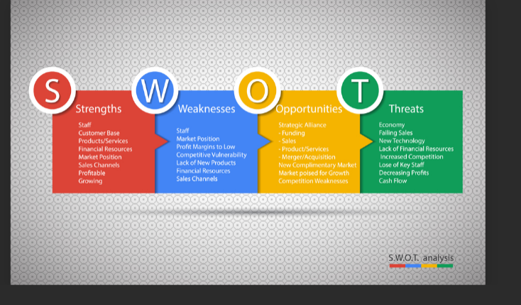
swot analysis chart for holiday inn - Bing images

Appendix 2
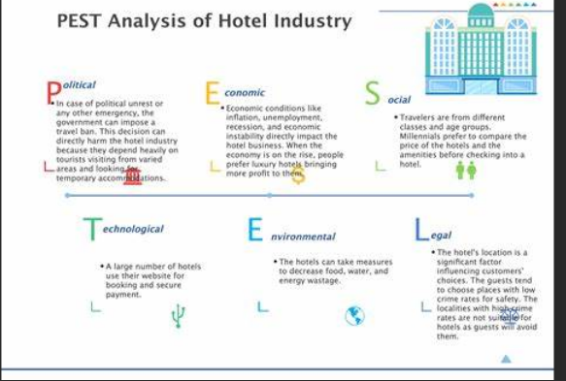
Detailed PESTEL Analysis of Hotel Industry | EdrawMax Online
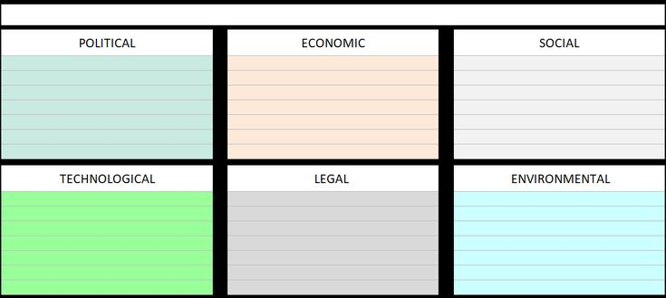PESTLE of Holiday Inn and Six Senses
*government has a stronghold over the hotel industry *political unrest or emergency
*unemployment rates, job growth, and travel spent
* inflation, unemployment, recession, and economic instability
* Facebook social traffic for Holiday inn is 91.29% compared to Six senses with 36.08% in the period of Febuary-April 2023
*marketing or advertising *reviews an feedback
*computers and technology and social media sites
*marketing or advertising
*UpToDate systems and technologies
*substainability *employment procedures and tax obligations* practices set by political body
Six senses company’s brands are divided into 4 groups: has 16 brands. As of 2021, it has 6,031 open hotels, 1,791 pipeline hotels, 889,164 open rooms.* Holiday inn plans to increase the portfolio and go over the 60 hotels with approx 7500
Appendix 3
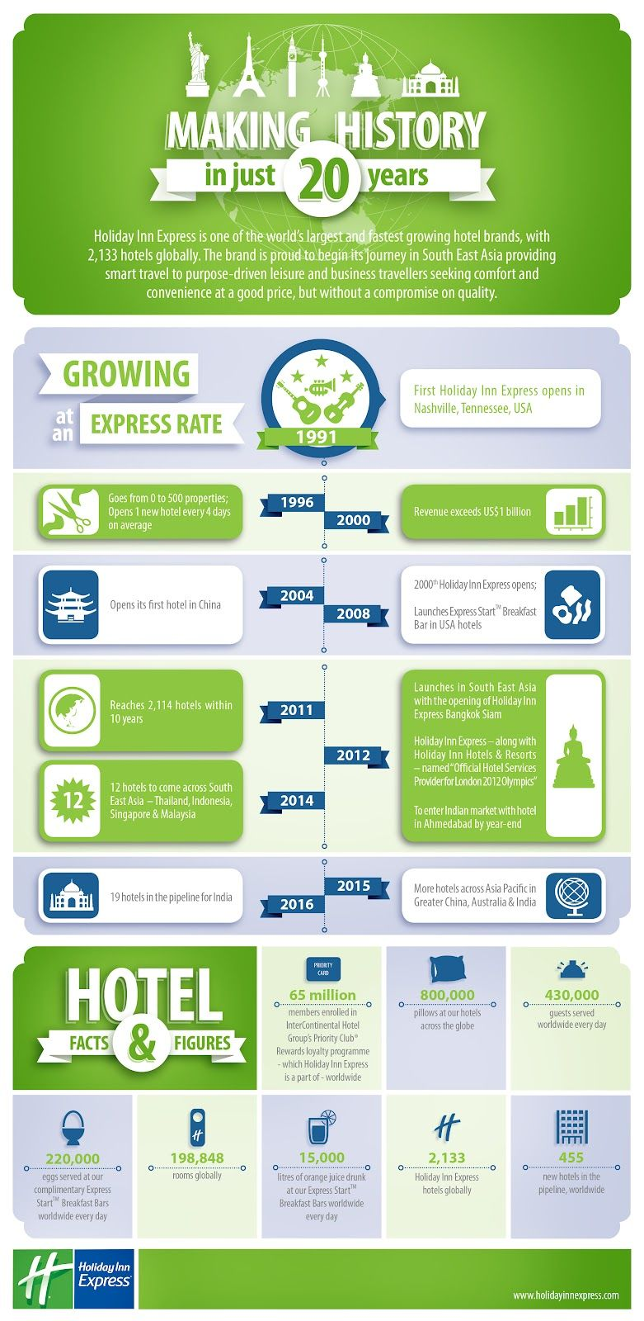
marketing mix of holiday inn - Bing images
Appendix 4
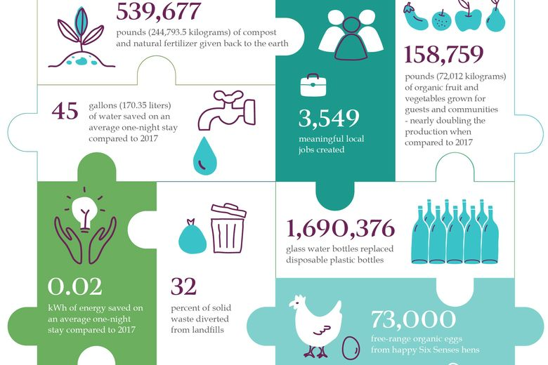
marketing mix for six senses hotels - Bing images

Appendix 5

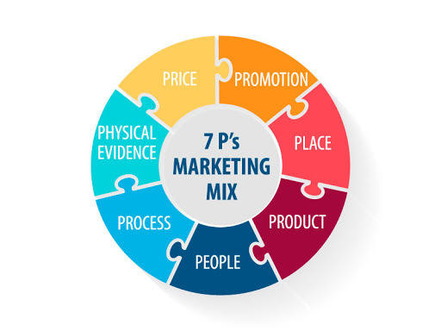

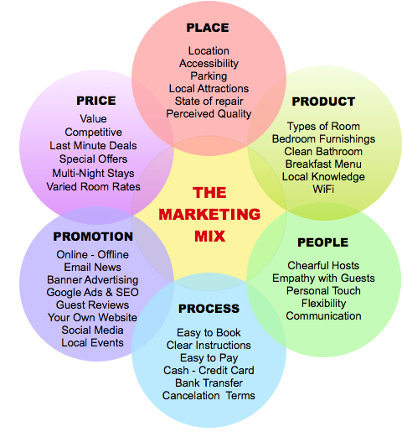
six senses hotel marketing mix info chart - Bing images

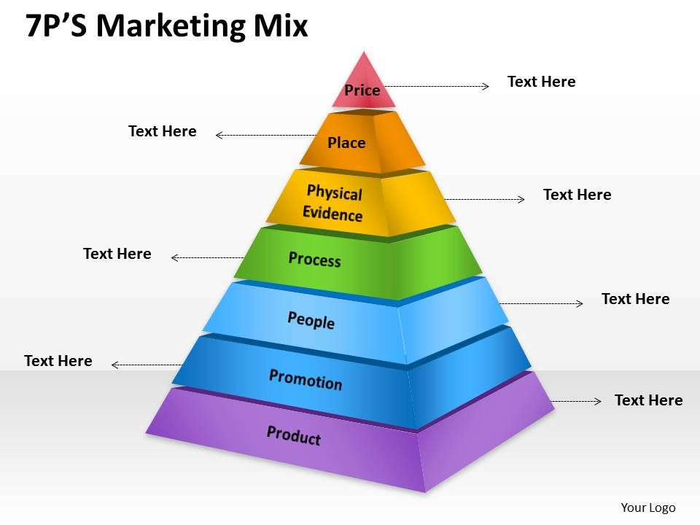
Value
competitive ,deals
Accesability, location, parking
local actractions
reviews online feedback and guest compalaints online reports happy customers, rebooking customers
easy to book, clear instructions, easy to pay, cancellations, terms
Good staff, cheerful hosts, persenal touch, empathy with guests, good communication
types of room,furnishings,wifi,food services,local knowledge, hotel extras
feedback guest reviews,website, social media, advertising banners, special offers, loyalty offers
marketing mix 7 ps for hotels chart Holiday inn - Bing images

Appendix 6
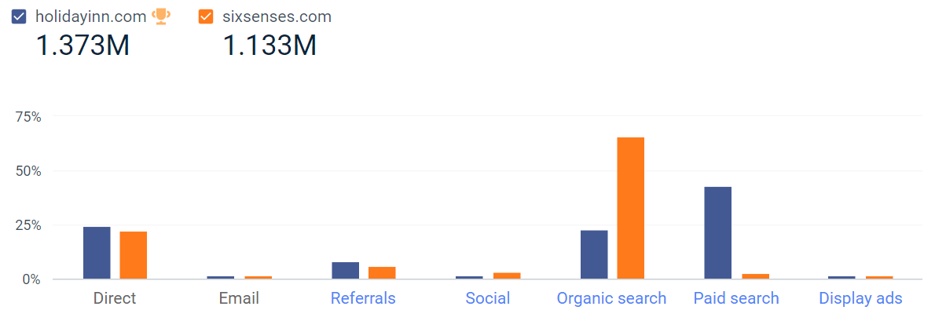
Website Performance (similarweb.com)

Appendix 7
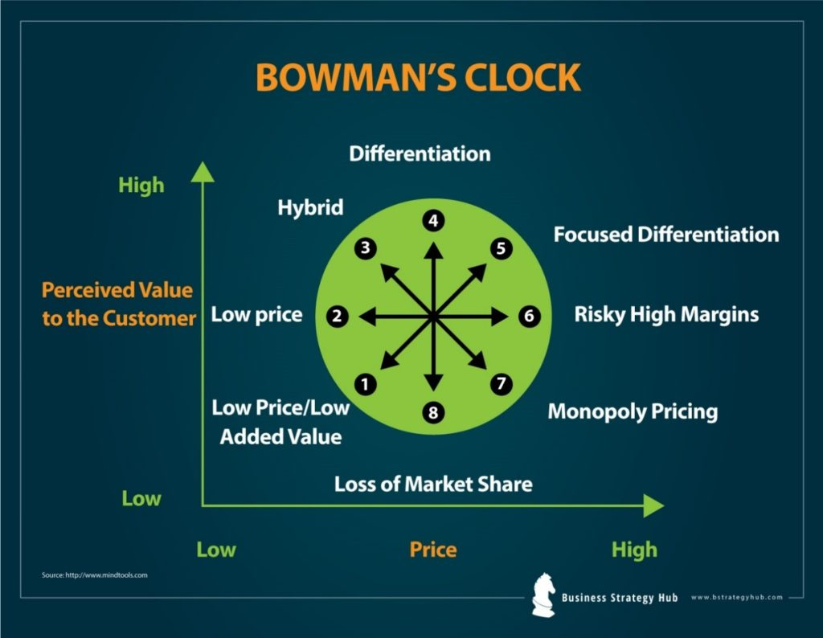
Strategic Clock - Bing images
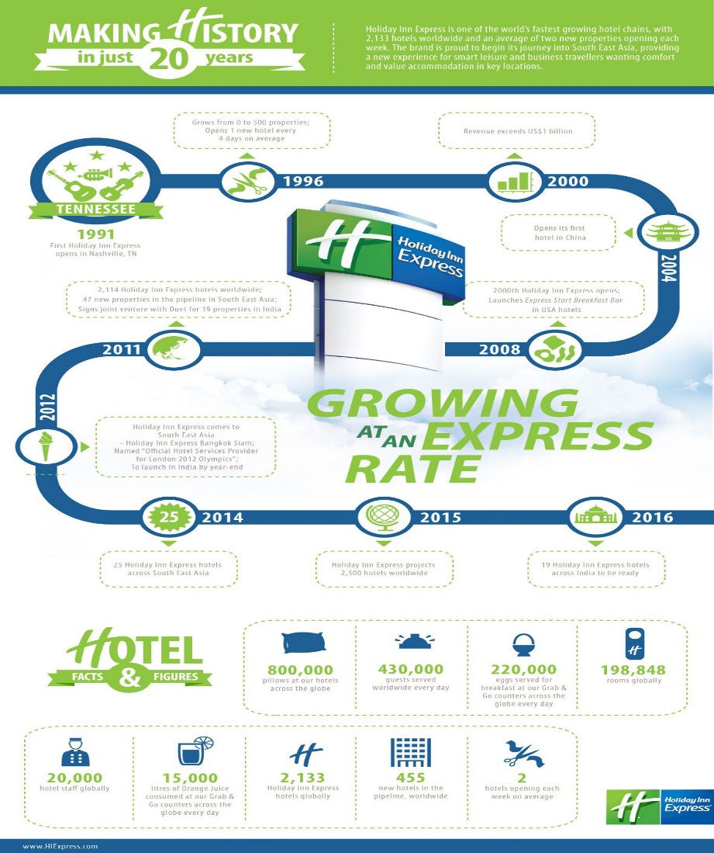
Appendix 8
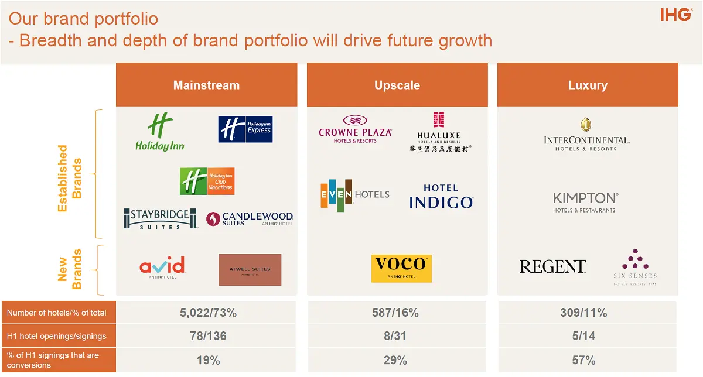
Brand Positioning holiday inn - Bing images

Wrote by Shereen Garraghan

