
BMDP7010 Review of Professional learning
20117773
Victoria Wall | 4439 words (Review of Learning) – Portfolio total word count = 7,628

Table of Contents
Introduction 2
Review of learning 5
Annotated CV …………………………………………………………………………………………………………..22
Job Description 31
Training Needs Analysis 34
Personal Development Plan 36
Reference list …………………………………………………………………………………………………………..38

Introduction
Reflective practice is essential for professional development and is key to employability in today’s professions (Wharton, 2017). Schon (1983) also supported this view and stated that being a reflective practitioner was a critical element of professional practice (Christopher, 2015). Reflective practice can assist professionals to learn from experience about themselves, their studies, the way they relate to work and home and other factors such as culture and the wider society. (Bolton & Delderfield, 2018).
Reflection stems from the Latin verb, ‘reflectere’, meaning to’ bend’ or ‘turn back on the self’ (Van Seggelen- Damen et al, 2017). In every-day language, reflection, reflecting, and reflective practice is a commonly used term but can be interpreted in a variety of ways (Reynolds, 2011).
The American philosopher John Dewey argued that “ We do not learn from experience. We learn from reflecting on experience” (Dewey, 1933 cited by Third, 2022). Dewey (1933) expressed that experiences shape us and adopting reflection into learning initiates growth and change (Third, 2022).
Donald Schon shared Dewey’s view and described reflective practice as the “…… ability to reflect on one’s actions and to be able to engage in a process of continued learning” (University of Cambridge, 2024).
This review of learning will explore the progression of my learning throughout my career to date. I will be reflecting chronologically to demonstrate my learning over the past 20 years, focusing predominantly on my policing career. This is where the major landmarks of my professional learning have occurred. My experience equates to level 7 as an advanced practitioner in policing as evidenced in my Master’s Degree in Policing. My review of learning will demonstrate the relevance to my future development as a Senior Lecturer in Policing Practice as well as progressing to level 8 in the Doctorate in Professional Practice (DProf) programme.
As a Senior lecturer, my area of specialism is Police education. Since the introduction of the Police Education and Qualifications Framework in 2016 to professionalise police training through three entry routes, there have been developments. From April 2024, a fourth entry route, the Police Constable Entry Programme (PCEP) will be implemented and delivered in police organisations. Unlike the other three entry routes, this will not provide an individual with a qualification (College of Policing, 2023). There are concerns that this fourth entry route will cause issues in the future over pay, remuneration, career opportunities and training standards not being supportive of professionalising practice (Police federation, 2024). As a professional involved in policing education, I plan to focus part 2 of my doctorate programme on police education and hope to have the opportunity to undertake research to evaluate the effectiveness of the fourth entry route.
Reflective practice is a key element to policing practice and a practice I have undertaken throughout my policing career. Christopher (2015) recognises that contemporary policing is a complex and multi-faceted profession and adopts a naturally critically reflective practice. Most officers critically reflect post- incident and used in transactional policing methods, such as de-briefs following major incidents. The concern with de-briefs are they tend to be problem-focused which may manifest from presumptions of what good practice looks like and not then challenged systematically (Lorenz et al, 2021 as cited in Staller & Koerner, 2022).
There has previously been limited literature examining reflection within policing, however the College of Policing incorporate reflective practice as part of the curriculum for the policing programme entry routes and is incorporated into continuing professional development (CPD) activity (College of Policing, 2020).
The College of Policing (2024) highlights that undertaking reflective practice on a regular basis can improve emotional intelligence and enhance self-awareness. This in turn will improve decision-making abilities, enhances personal and professional effectiveness and is seen as a benefit to officers, their force and the public they serve.
Review of learning
This section has been structured to highlight chronologically significant milestones in my career which have impacted upon my work, it’s direction, and provided me with critical experiential learning opportunities. The timeline has been structured to assist focus and reflection on pertinent points for discussion.
Learning is described as a change in behaviour that is due to experience (Lachman 1997 cited by Houwer & Moors, 2013). A definition proposed by Gregory Kimble in 1961 describes learning as “relatively permanent change in a behaviour potentiality that occurs as a result of reinforced practice” (Kimble, 2023). The way individual’s learn are varied and I have reflected on relevant theories identified associated to my learning style.
A key point to commence my learning review was from when I graduated from Swansea University in 2004 with a BSc (Hons) Health Science. Being a graduate, I knew I wanted to work in the health sector but was unclear which career path to take. It was clear to me, even in these early years I had a thirst for academia and research. I recognised the need to secure employment if I was going to be undertaking further post-graduate study. In 2004, I was successful in securing a post as a Maxillofacial researcher for the National Health Service. I thoroughly enjoyed this position as it enabled me to undertake primary research from patient data which was being recognised and evaluated at the International Craniofacial Society. This was my first full-time job and I enjoyed the sense of independence and ability to investigate, explore and test hypothesis. In September 2004, I started my post-graduate Master’s Degree in Health Care Management to support my career progression in the National Health Service. Unfortunately, my research post was a fixed term contract, and I was on maternity leave at the point of renewal. I secured further employment upon return from my short 5-month maternity leave in September 2005 with Dyfed-Powys Police as a Criminal Investigation Department (CID) administrator. I recognised the continuous informal learning undertaken in this role, which highlighted my skills and interest in criminal investigation and the role of policing. I often carried out additional duties to support the unit such as transcribing the undercover unit surveillance logs, transcribing suspect interviews, submitting intelligence and reviewing Public Protection Policies. I saw the benefit of the additional experience and insight into policing this gave me and enhanced my curiosity to work in the area of crime and public protection. I did not consider this as ‘learning’ at the time as I did not attend courses or receive formal training.
Eraut (2004) conducted a study which concluded that ‘informal learning’ was seen as mostly invisible due to it either being taken for granted or not recognised as learning. It Is only from reflecting on the administrative role within the police that the experiential learning experience heightened my motivation and confidence to progress my career and join the police.
Research has shown that Informal work-based learning is driven by the individual and strongly contextualised by work environments (Decius & Hein, 2023). My manager and colleagues encouraged me to apply to be a police officer. My manager provided me with work related tasks which enabled some exposure to the world of policing to gain greater insight and experience.
A key influential figure in my organisation was a Detective Chief Inspector (DCI) working in public protection. This senior manager was extremely supportive of my aspirations of becoming a police officer and gave me insights into policing. I consider the DCI adopted a Humanism approach to learning, which is believed to be part of the self-actualisation process. Humanism focuses the centre of learning around the individual. (Sanders & Wong, 2020).
I consider there is evidence to demonstrate my Growth Mindset even from this early on in my career as I strongly believe that success comes from hard work and effort, not natural ability. Psychologist, Dweck (2015) developed the growth-mindset model based on her research on motivation and achievement in children and she indicated that a growth mindset can have a significant impact on how a person approaches learning. Dweck (2016) summarises the impact of the growth mindset quite well stating those individuals who believe their talents can be developed through hard work, good strategies and input from others, tend to achieve more than those who have a fixed mindset. A key element to my learning is reflected well in achievement goal theory (Elliot & Church, 1997).
Achievement goal Theory (AGT) is a popular theoretical framework relating to motivation. According to AGT, achievement goals are future-orientated and represented cognitively as desired outcomes (Devon et al, 2021). I have aligned with this theory throughout my policing career which has helped with sustaining engagement, commitment and being sufficiently challenged. There are some notable disadvantages to this approach, being that goals being set may be above the employees’ skill and competency level. This could be detrimental to motivation and performance to complete the goal (Indeed, 2023). Dunning et al, (2003, pg 83) also recognised this same concern stating individuals sometimes are not able to spot the limitations of their knowledge and can overestimate the extent of their skills and talent, resulting in poor metacognitive judgements.
A more recent study conducted by Decius & Hein (2023) highlighted that previous studies on lecturer’s professional learning and motivation appeared to neglect three key areas of learning including informal workplace learning (IWL), reporting that 90% of professional learning derives from informal training in the workplace. The majority of my learning has been from informal learning, and it must not be overlooked the benefit of experiential experiences in the workplace.
On December 17th 2007, I joined Dyfed-Powys Police as a Police Constable. I was confident I had made the right decision to deviate from my childhood dream of working in the health sector.
I found very early on in my career, I was confident in making decisions at incidents, during investigations and found job satisfaction in mentoring and supporting students and colleagues. I found myself demonstrating leadership qualities as a Police Constable and not operating in a supervisory capacity. This could have been an early sign of my love of training and supporting of colleagues, canvassing my growth model mindset onto others.
Leadership can be defined as a relationship between power and persuasion and the leader can influence the actions and behaviour of others (Mullins, 2016). There are many definitions of leadership but this review will discuss ones relevant to me.
Due to recognising myself as a ‘leader’, I sat my Sergeants promotion exam in 2013 and passed. I was given the opportunity to ‘act up’ as a supervisor for 10 months in uniform. This experience of managing a team was invaluable. This highlights the experiential experiences as a supervisor are what made me ‘grow’ as a leader, not the practicalities of sitting a legal exam to promote me to a sergeant. I had now been a police officer for 6 years and promotion interviews were coming up. I took this opportunity to undertake reflection of my career to date, which assisted and guided me to decide my next career step. When looking at David Kolb’s experiential learning cycle, I used this to allow myself to reflect on my experience as a supervisor.
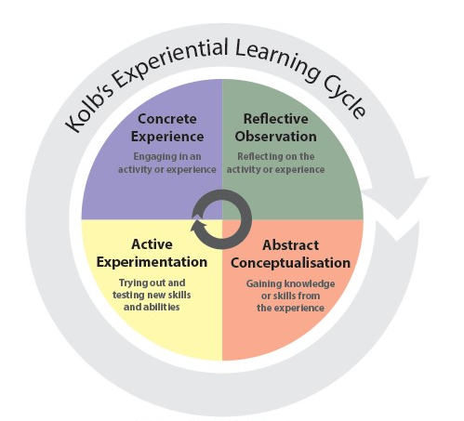
Figure 2: Kolb’s experiential learning cycle (SkillsYouNeed.com)

David Kolb (1984) argued learning is an integrated process of varying learning styles, referring to it as a continual cycle of experience, which can be entered at any stage but for successful learning to be achieved, all four must be complete (Mcleod.S, (2024). Cherry (2022) highlighted educator, Mark Smith’s criticism of Kolb’s model, stating the theory is only supported by weak empirical evidence and the learning process is far more complex than suggested in the learning cycle. It also does not fully acknowledge the different experiences and cultures which may impact the learning process. This is particularly pertinent in the experiences of a police officer as not one incident is the same and there are many factors which can impact experiences such as environment, culture, values and alignment with the code of ethics.
From utilising Kolb’s cycle, it did assist with my reflection of experience to date and the next step I wanted to take in my career. In February 2015, I decided to not apply for the Sergeant’s promotion boards and applied for a public protection position as a child abuse and adult abuse investigator and was successful. I found this area of work very rewarding and had no plans to leave the area of public protection. This area of work meant I carried very high case load and worked long hours which impacted my time outside of work with my young family. The sense of duty I felt to safeguard the public from harm outweighed the stressful demands that came with the role.
Dyfed-Powys Police decided to merge the public protection unit and CID departments and rebrand the department as the ‘Joint Investigation Unit’ in 2017. The significant organisational change in my department resulted in a lot of staff sickness, which meant I often was working alone, dealing with multiple investigations. I found that I spent more hours in work than at home and it was starting to impact my relationship with my husband. I have a strong work ethic, but I knew something had to change as the quality of working life balance had deteriorated significantly and I was started to resent working in CID.
Using Rolfe et al’s (2001) model of reflection I have been able to critically reflect and understand how I was feeling and the action I needed to take.

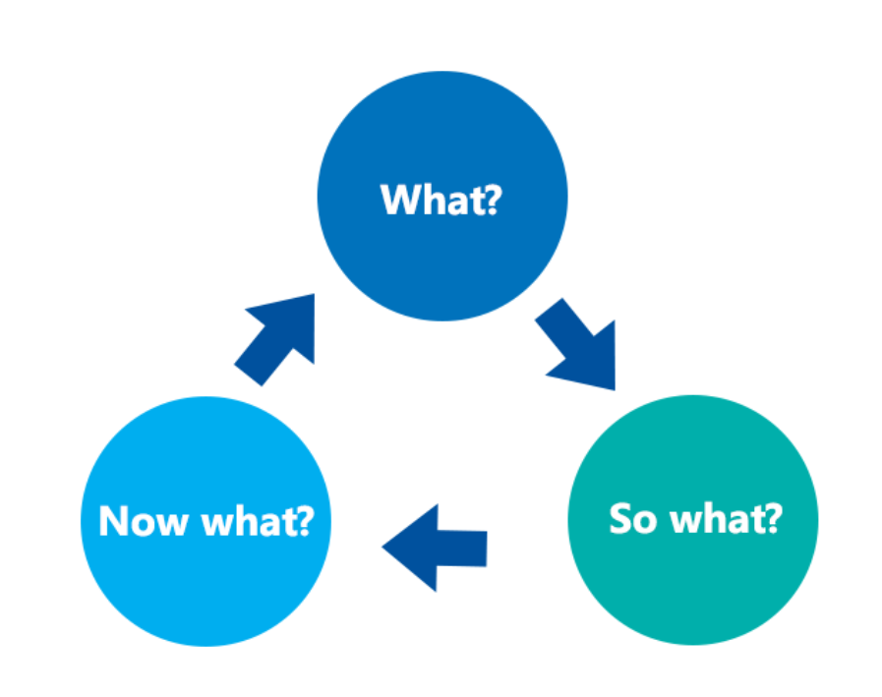
Figure 3: Rolf’s Model of reflection (NursingAnswers.Net, 2020)
What? –I was experiencing high levels of demand in work with very little support and this was having an impact on my home life. I have a very strong work ethic, but my values and commitment lie with my family and I did not want my dedication to the public and work affect my marriage or home life.
So What? - I was starting to feel resentful towards the organisation and felt I was slowly burning out. At this stage, I considered I had reverted to a fixed mindset and did not review what options were available to me.
Now what? –I approached my supervisor and requested to go back to response as I knew this would achieve a much greater work-life balance with fixed rest days. I had balanced the consequences of losing my Detective/ CID accreditation but did not feel I could stay within CID in the current environment.
The unit Detective Inspector encouraged me consider a move to Offender Management. This was a specialist department in the police managing the sex and violent offenders residing in the local communities. I learnt from this experience that speaking to a supervisor when struggling was the right thing to do but I should have spoken to him a lot earlier when I was starting to burn out and not cope with the demands of the role.
The outcome of this situation was a positive one and the two years I spent in Offender Management, were the happiest of my career. I thoroughly enjoyed being an Offender Manager and working with multi-agencies. I enjoyed exploring the psychology of offenders and safeguarding our communities.
In 2020, I was asked to act up as a Detective Sergeant in CID on a temporary basis. I should have been overjoyed by being offered this opportunity, but I was reluctant to leave Offender management as I was so happy there. I took the opportunity to supervise the Investigative unit. This opportunity really strengthened my leadership abilities despite working in a transactional environment of processing prisoners, I demonstrated transformational leadership qualities.
Bernard Bass developed the transformational leadership theory. Bass was interested in the influence leaders had on their subordinates and believed a leader transforms their followers by displaying their own leadership qualities. Bass believed the four elements of effective leadership were Idealised influence, Inspirational drive, Individual consideration and Intellectual stimulation (HRF, 2024). Transformational leaders are described as energetic, enthusiastic and passionate and focused on ensuring everyone is successful (Cherry, 2023).
I worked in a very fast-paced and challenging environment and it was critical my staff were supported. I demonstrated transformational leadership with a colleague who had joined the team on an action plan for poor performance. The officer was de-motivated, low in confidence and aggrieved by being placed on an action plan. I met with this member and ensured I supported him to achieve the aims of the plan and saw this as a collective effort of working together to achieve a desired goal. I assigned him a buddy for support and we had regular reviews to see how he was doing. Over the space of three months, this officer’s performance dramatically improved and we could finalise his action plan. My goal was to inspire growth and instil confidence in team members. I evidenced transformational leadership traits of possessing active listening skills, being emotionally intelligent, supportive and having the ability to pro-actively address performance issues (Cherry, 2023). Recognition was given by senior officers of the team’s performance when dealing with complex jobs, evidencing the positive impact transformational leadership has on performance.
The detrimental impact of being a transformational leader should be considered as Cherry (2023) states it contributes to burnout when members feel constantly pressured to give up a lot of time to support others. However, Kloutsiniotis et al, (2022) argues that Transformational leadership actually reduces symptoms of burnout such as stress, anxiety and workplace loneliness. I acknowledge the viewpoint of Cherry but consider transformational leadership is what is needed in policing.
In March 2020, I moved to the Central force Offender Management Team as a Detective Sergeant. This role saw me develop strategic and leadership skills and afforded me to undertake work on a national scale, influencing national policing portfolio subject areas. I consider this role made me grow significantly as an individual and exposed me to higher levels of strategic management and leadership.
To assist me in reflecting this transition from working in an operational policing environment to a Strategic management role, I will utilise the Gibb’s reflective cycle.
Gibbs (1998) focused on the ability to self-reflect whilst also having scope of the continuous engagement in learning and development needed (Wilding, 2008, cited by Physionewbies, 2021).
I will use the key headings in the Gibb’s cycle to assist me to reflect on my transition in the early stages of my role in the Central Offender Management Team.

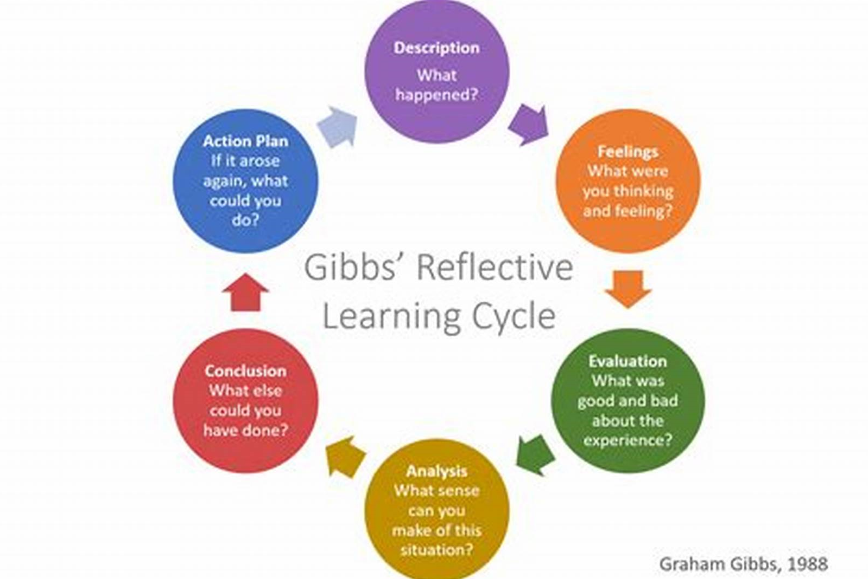
Figure 4: Gibb’s Reflective Cycle (Physionewbies, 2021)

What happened? I started in Central Offender Management in March 2020. I had responsibility for the force -wide offender management teams. I had minimal handover from my predecessor and felt very vulnerable about not having full insight and understanding of the department’s operations. I undertook a scoping exercise of each function of the central offender management unit and quickly realised there was minimal investment and support in place to enable the offender management teams to robustly manage sexual and violent offenders. I approached the senior management team and asked if I could contribute to the Force Management Statement (FMS) as I was aware these reports identified Risk gradings and supported business case submissions.
I raised the following concerns that needed addressing:
- The number of sex offenders in our community was increasing and the confidential database (VISOR) that managed all sexual and violent offenders were managed by only two part time officers. A VISOR uplift was urgently required as there was insufficient resilience within the VISOR unit to meet the demand. This carried a business risk and directly impacted the risk to the community.
- There was insufficient digital technology and innovation to support our investigation and monitoring of offenders.
- Demand ratio in two divisional areas were over their case load by 9% according to the National Police Chief Council (NPCC) guidelines.
- Non-existent training provision for Offender Management.
As a result of these concerns raised, I pro-actively addressed and resolved the issues:
- I submitted a business case using quantitative data to support my findings and future predictions of demand. My business case was approved and secured an uplift to the department.
- I undertook a scoping exercise with the force to see what was currently in use and what was needed to address demand. We were not adhering to the Policing Vision 2025 and not taking measures to ensure our communities were safe. I conducted research for eligible funding and submitted a bid to the Home Office for £184,000 to support the purchase of technology. I was awarded the full amount and able to purchase all the tools and equipment needed and upskill our offender managers with specialist training. I was supported by the procurement and finance department to ensure I met all requirements for the procurement and funding process.
- As a result of my force management statement (FMS) submission and highlighting in the MoRiLe (Management of risk in law enforcement) assessment, I was able to secure an uplift of staff for two divisional teams. I understood the risks of staff burn out and inability to manage risk if we didn’t improve resilience.
- From undertaking a scoping exercise, it was clear there had been insufficient investment into Offender Management training, this impacting reputational risk but also staff development. We did not have VISOR (sex offender database) and Risk management trainers in force and as a short-term measure outsourced to a neighbouring force for support.
I attended the College of Policing, train the trainer courses for offender management and VISOR training. I was accredited to deliver all offender management programmes in force and nationally. I created a bespoke Offender Management training programme for continuing professional development days (CPD), which I solely delivered.

I demonstrated ‘action learning’ by embracing the change process and allowed little room for error as I was in regular consultation with colleagues and agencies to support seamless facilitation of change required. Mullins (2016) describes action learning as individuals who work collaboratively to find solutions to problems and having the ability to reflect on experience and lessons from others. Action learning encourages teamwork, critical thinking, leadership and problem-solving (Indeed, 2023).

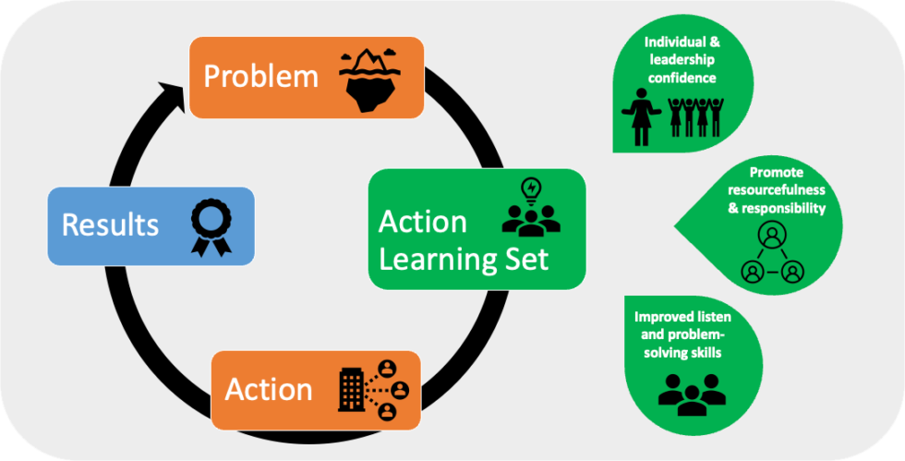
Figure 5: Action learning set (Berrison, 2024)

What were you thinking? I was cognisant that I was new to strategic management in policing albeit I was not in a senior management position. I was aware my proposals would have a significant impact to the organisation. I ensured I provided evidenced-based information to support my rationale for change. I initially felt intimidated taking my proposals to senior management for fear of rejection but preparing my business case with supporting evidence helped increase my confidence.
I am a strong believer that you can be a leader at any level in the organisation. Walsh & Vito (2019) argue that leadership can be found not only at executive level but at any level of the organisation with first line supervisors who are the closest to department employees being the ones who lead by example.
As a result of leading on this change management project, I was making decisions that were above my supervisory level. I demonstrated high levels of resilience despite solely delivering on this project with very little experience. I identified opportunities for not only organisational growth but also personal.
I felt completely unsupported at times with ‘light touch’ support from senior management, but I channelled this frustration into determination to make improvements to Offender Management, demonstrating further my levels of resilience and commitment. I worked closely with colleagues, procurement, finance, the Home Office, legal services and the NPCC lead to ensure this project was delivered successfully.

Evaluation & Analysis
Using the SWOT analysis, I highlighted the strengths, weaknesses, opportunities and threats if actions were not taken to demonstrate this. I do consider my positive outlook and commitment to change encouraged others. Betari’s box theory demonstrates the impact that our own attitudes and behaviours can have on individuals around us and this is a theory taught in personal safety training as part of conflict management.
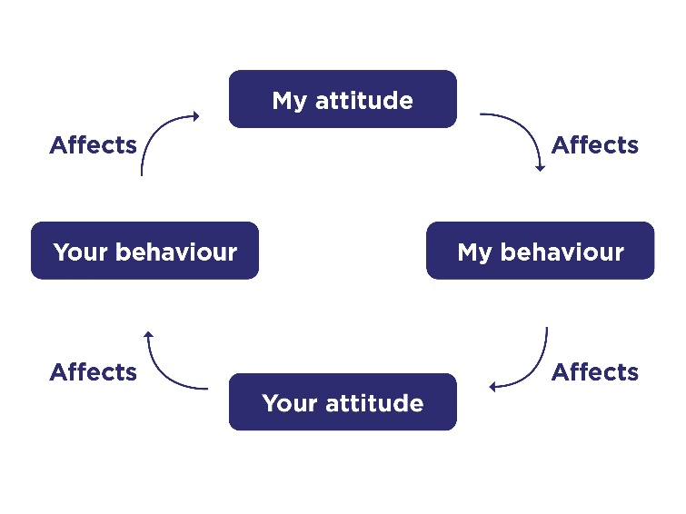
Figure 6: Betari’s box (College of Policing, 2020)

I hoped that my positive attitude to change positively influenced others. I had excellent support from my colleagues who volunteered to attend procurement briefings and supported the scope of new products. I was aware if I presented as demotivated or sceptical about change, this may have had a detrimental impact on others.
My approach to leadership can be reflected in the Kolb’s experiential learning theory. According to Kolb (1984), “Learning is a process, in which knowledge is created through transformation of experience” (Sharlanova, 2004, p.36)
Conclusion
I have had the opportunity to reflect on this transition and whether I would do anything different in future. I have since project management national initiatives and my approach has changed because of my initial experience. I should have approached senior leaders at the earliest opportunity to seek support as it was a lot to manage on top of the everyday policing duties. To promote efficiency, I should have requested administrative support. Since this experience, I have requested administrative support for projects I have led on since.

Action plan
At the commencement of any project, I create an action plan which is taken to senior management for approval. In this plan, I will ensure project deliverables and actions are clearly listed and assigned to the correct person so there is organisational accountability. I need to not be afraid to ask for support and not see this as a sign of failure. Action focused meetings should be in place with relevant departments at the commencement of the project, ensuring a senior management representative are present in the meetings to prevent delays in any strategic/ funding matters to be authorised.
I was fortunate to complete a Masters degree in Policing during my time as a strategic Offender management supervisor and graduated with an MSc Policing (Operational and Strategic leadership) in 2023. This degree equipped me with the skills and knowledge required for strategic management and the opportunity to undertake research of Integrated Offender management within Dyfed-Powys. This enhanced my specialism further and my study is now in the policing library and force library with recommendations taking forward for action. I am very proud of this achievement and this made me reflect on the next steps of my career. In December 2023, I applied to be a Senior Lecturer in Policing Practice. I have been in this position since March 2024. My development plan and training needs analysis will be focused on my new role and support me in my development to the next level.


Curriculum Vitae (CV)
of
Victoria Wall

Personal statement:
I am a Senior Lecturer in Operational Policing, working for the University of South Wales. This has afforded me the opportunity to utilise my extensive policing knowledge and experience after serving 17 years as a police officer. I worked in various departments such as Criminal Investigation, Public Protection and Offender Management. I am an accredited College of Policing trainer in Offender Management and developed a bespoke Offender Management programme for Dyfed-Powys Police. I have completed a Master’s degree in Policing (Operational and Strategic Management) and have previously undertaking research into Integrated Offender Management (IOM) and the ability to manage risk and support desistance from crime.
My specialist knowledge is in Policing curriculum and Offender Management have enabled me to professionalise my practice further by undertaking studies on the Doctorate in Professional Practice (DProf) programme. This will further my expertise and specialism in this area of policing and afford me the opportunity to undertake research into police training, evaluating police entry routes and the contribution to professionalising policing practice.

WORK HISTORY
Senior Lecturer in Policing Practice – March 2024 – to present
- Contribute to the planning, design and development of Operational Policing courses to it’s full potential.
- Promote positive collaboration with assigned force and key stakeholders.
- Enhance student experience & contribute to the wider student experience. I completed a coach and mentoring course in 2014 and I strongly believe my skills and leadership style will support students to maximise their potential and remain motivated to learn.
- Key contact for collaborative learning and contractual partnership enquiries
- Co-ordinate and manage the policing programme for assigned partner. I have good organisation skills and able to use this skill to good effect by co-ordinating the policing degree entry route programmes with 115 students on the first intake.
- Develop and deliver high-quality material and activity that meets the learning needs of the student.
- Subject delivery of course material – Due to my experience in various areas of policing, I can ensure the accuracy of delivery and keep up to date with legislative changes or curriculum changes. I used the College of Policing, Approved professional practice and the knowledge hub to support me in this delivery.
- Identify and progress appropriate funding opportunities.
- Ensure contemporary and current research is relevant to subject All Senior lecturers must have an area to lead on. I have requested if I can be research lead for the Operational Policing curriculum as I aim to undertake research as part of my doctorate studies to evaluate the effectiveness of the police entry routes in the recruitment and sustainability of professional police officers.
- Reflect critically on own teaching, learning and practice.
- Incorporate subject and pedagogic research as part of integrated approach to academic practice
- Academic leadership, supporting Ops Policing team to fulfil responsibilities.
- Contribute to the strategic direction of the subject/ learning and teaching strategies.
- Responsible for monitoring and co-ordinating reporting requirements for the policing programmes

March 2020 – March 2024
Detective Sergeant, Central Offender Management Unit, Public Protection. In this role I was nominated for an award in 2023 in the Dyfed-Powys Police Force Annual Awards. The category I was nominated for was “Unsung Hero”. This was for the innovation work I undertook with securing a substantial amount of funding to purchase offender management technology and leading on the new Integrated offender management strategy which was successfully implemented in force in 2022. Although I became runner up in this award, I was honoured to have been nominated.
- VISOR supervision
- Staff supervision – This I consider a strength and my transformational approach to leadership really supports my values around staff support and investment.
- Risk Management Plans for all prison releases
- VISOR actions process/ allocation of cases
- Transfer process administration
- Transfer process review meetings I received a nomination at an awards ceremony in April 2022 for the creation of the transfer process. This was a process I created due to concerns of probation led registered violent and sex offenders transferring into the area with no formal transfer assessment taking place. I was nominated for the Mid and West Wales Safeguarding Board (MAWWSB) under the category of “Innovation and Creativity leading to Improved Safeguarding Practice for Children and Adult at Risk” and was awarded runner up.
- Chair MAPPA L1 MH meetings – community cases (monthly)
- Chair MAPPA L1 MH meetings – Ward cases (monthly)
- Marketing/ press relations
- Intelligence management of travelling offenders
- Review of case files –Sexual offences and Internet related offences
- Sexual Harm Prevention Order (SHPO) creation and submission of conditions to legal services
- Regional NPCC MOSOVO lead duties.
- Regional NPCC ARMS lead duties.
- Regional NPCC Electronic monitoring lead duties
- Regional IOM lead duties
- Screening for MAPPA and integrated offender management referrals
- Force Offender Management training portfolio – arrangement of training/ professional inputs etc I developed a bespoke Offender Management training programme which was recognised by IOM Cymru and shared with other forces to replicate as good practice. The work undertaken to design this programme involved skills such as research, exploration, careful planning and organisation.
- Stalking prevention order management – strategic oversight
- Electronic monitoring
- Author of FMS & various strategic reports
- Home office reports – re: digital funding
- Attendance at National meetings
- Funding applications/ bids
- Procurement
- Policy guidance re: various aspects of offender management
- Management of SCPO process
- Management of PDP process
- Management of DV safeguarding devices

December 2019 – March 2020

Detective Sergeant – CID – Investigation team This role was very demanding but demonstrated my strength in Transformational leadership. As described in my review of learning, I was able to motivate the team to work hard, produce high standards of work but feel supported and in a trustworthy environment where they could speak to me at any time if they had any concerns/ worries or faced barriers in the workplace.
- Incident management
- Investigation plan authoriser
- Supervision of staff within CID/ Investigation
- Staff welfare and development
- Crime scene adviser
- Investigation decision maker
- Manage processing of prisoners
- Attend serious incidents
- Manage crime scenes and undertake examinations
- Child protection and safeguarding decisions
- Produce investigative reports as required

March 2018 – Dec 2019
Detective Constable – Offender Management Unit This was the most rewarding job for me and becoming a specialist in an area of policing, really focused my mind on what I wanted to do for the future. I found I demonstrated leadership skills in this role even as a detective constable. I would be organising the diary of offender visits and supporting colleagues to complete file work. I was mentoring my colleagues and loved helping and supporting the team. This role solidified that I was ready for promotion.
- Investigative interviewing for suspects, victims and witnesses
- Sexual Offences trained officer
- Conduct serious and complex investigations
- Domestic Violence safeguarding officer
- Disclosure officer – Claire’s law and Sarah’s law
- Management and Monitoring of sexual and violent offenders
- Contingency planning
- Victim safeguarding plans
- Review complex and forensic data
- Prepare files for Magistrates and Crown courts
- Attend multi-agency meetings
- Risk management assessments of offenders
- Arrest of suspects

May 2015 – March 2018
Detective Constable – Investigation officer – Serious and Complex Crime This was the most stressful role of my career. Team moral was low with very little resilience to deal with demand. This was the role that had a detrimental effect on my home life and was a turning point in my career. I am a very private and resilient individual but on reflection it taught me to recognise the signs of burnout going forward in work and ask for support/ help when needed.
- Arrest of suspects
- Investigative interviewing
- Accredited Child Protection Officer
- Disclosure officer
- Action child protection, vulnerable adult and professional abuse referrals
- Joint visits of children and vulnerable adults
- Achieving best evidence interview trained officer
- Produce investigation reports for court

Dec 2007 – March 2015
Response officer and Response Supervisor This role really developed my resilience and decision-making skills as I was often the senior officer at scene of an incident and the team would look to me for direction and support.
- Investigative interviewing for suspects, victims and witnesses
- Conduct criminal investigations
- Attend incidents
- Crime scene examinations
- Missing person enquiries
- Missing person database champion
- Supervision of incidents
- Supervision of staff, welfare and development management
- Crime audits

September 2005 – Dec 2007
Senior Administrator – Crime Management and Reduction Dept This was the role that instigated my entry into policing as a police officer. I worked with a great team and the management were very supportive of development. A female Detective Chief Inspector demonstrated to me what a good role model she was and what I aimed to be like as I progressed through my career.
Administrative duties including:
- Typing of reports
- Preparing Power Point presentations for senior officers
- Transcribing interviews and surveillance logs These were additional duties to help give me an insight into policing
- Data collection and analysis
- Arrangement of meetings and conferences
Mar 2003 – September 2005
Maxillofacial Research assistant – NHS This was my first experience of research and I enjoyed the ability to utilise my investigative mindset (which I didn’t know I had at this early stage of my career)
- Collation and analysis of patient data
- Analysis of Quantitative and Qualitative data
- Preparation of presentations
- International Craniofacial Society Website Management
- Arrangement for conferences and meetings
- Society membership management
- International Research projects/ studies
- Report writing
- Arrangement and facilitation of International Craniofacial Society Conference in 2005
- Liaison and partnership working with other University hospitals

Education
- September 2023 (UWTSD) - MSc Policing (Operational and Strategic Management) This was a memorable achievement for me as I was able to progress my studies whilst working in a very demanding job. I was fortunate to be able to focus my dissertation on Integrated management and the ability to manage risk and encourage desistance. The findings of my study have informed future practice in Dyfed-Powys and a copy of my dissertation is now in the College of Policing library and Dyfed-Powys Police Library. UWTSD have also asked for a copy to be kept in the academic library repository. This had a positive impact on my career as I was given credibility for not only my specialism in offender management but my research capabilities.
- August 2008 (Swansea University) – Postgraduate Diploma in Healthcare Management My intention here was to go into Management in the Health Service)
- July 2004 (Swansea University) – BSc (Hons) Health Science
- July 2000 – (Carmarthenshire College of Technology and Art) – BTEC National Diploma in Science (Health Studies
- July 1998 (Glan-Y- Mor Comprehensive School) – 10 GCSE’s obtained grade A-C including Maths, English language, English Literature, Science, History, Welsh, French and Health & Social Care.
Vocational Qualifications
- Transformational Leadership Programme (2021) This provided me with the skills to use coaching as a style of leadership, work positively through change and being able to use leadership coaching to improve mental health, wellbeing and resilience within the organisation.
- VISOR & MOSOVO College of Policing trainer accreditation (2020) This provided me with the skills and ability to teach and solidified this was the path I wanted to take and progress into police education.
- IOSH Health & Safety at Work (2018)
- PIP Level 2 Suspect and Witness Interview trained officer (2016)
- PIP Level 2 Significant Witness/ ABE trained interviewer (2016)
- National Investigator’s Accreditation (2015)
- Sexual Offences Trained Officer (2015)
- Child Protection and Safeguarding course (SCAIDIP) (2015)
- Coaching and Mentoring Development Programme (2014)
- Sergeants OSPRE Part 1 & 2 Police Promotion examination (2013)
- National Vocational Qualification (NVQ) Level 3 & Level 4 in Policing (2010)
- Effective Account Management (2007)
- Job retention Case management training (2006)

Hobbies & Interests

- Running This is a key activity that maintains my wellbeing. It allows me to de-stress and relax and escape from reality. I often run by the sea and use this as a form of mindfulness.
- Keeping fit
- Walking the dogs
- Spending time with my husband and two children. I have very strong family values and they will always be my priority. I am grateful for the quality time I get to spend with them and my ability to be present as a mother and still maintain a career.
- Travelling and learning about different cultures

ROLE PROFILE

Detective Sergeant – Public Protection Unit – CMRD

Rank: Detective Sergeant
Location: Crime management and Reduction Dept, HQ
Role purpose: To provide support to the strategic and operational management of public protection within the force.

Major Tasks:
- To undertake audit and review of public protection related matters within the force as directed.

- Complete all Freedom of Information (FOI) requests for force wide Offender Management. Data protection training should be completed here to fully understand the processing of requests.

- To liaise and analyse relevant information to critically review through self-inspection and qualitative measures to evaluate nature of the service afforded by the Public Protection Unit.

- Represent Welsh forces in NPCC national meetings in Offender Management, Electronic Monitoring & Integrated Offender Management.

- To represent Dyfed Powys Police at relevant Multi Agency Conferencing in Child Protection, Adult Protection, Domestic Abuse, Multi-Agency Public Protection Arrangements (MAPPA) and Investigation of Rape and Sexual Offences).
- Chair MAPPA and MARAC meetings.

- To advise on force-wide single/multi-agency training in Child Protection, Adult Protection, Domestic Abuse, MAPPA and Investigation of Rape and Sexual Offences in liaison with Development Services.

- To provide specialist training support, both internally and externally, concerning Public Protection. To be a qualified College of Policing trainer for VISOR (Sex Offender Database) and Risk management.

- To be responsible for the creation of the Offender Management training portfolio for the force and lead on it’s delivery.

- Dissemination of national guidance and best practice and to advise BCU personnel on issues Public Protection.

- Ensure that Force Policy and good practice procedures are communicated to officers and staff at all levels implementing a reliable two-way flow of information, demonstrating through own example.

- Reviewer and updater of all information sharing arrangements in place

- Author and reviewer of all Offender Management policies.

- To provide central support in the four identified areas of Public Protection. This is very generic description and my responsibility was a central support function for Domestic Violence and Offender Management.

- To work together with partner agencies to assist in conducting and leading on Serious Case and Management Reviews within the Public Protection remit.

- To assist in the monitoring of operational commitment and identify demand by consultation with Divisions, Specialist Departments and other agencies.

- Responsible for all funding applications for Offender Management

- Co-ordination of all Domestic Violence and Offender Management technology provisions in force.

- To comply with Dyfed-Powys Police Policies on Staff Development, Personal Development Review (P.D.R), Equal Opportunities, Health & Safety, Management of Police Information, Data Protection and Information Security and act in accordance with Force Guidance documents and protocols.
Attainments
1. Must evidence being abreast of Force Policy, Home Office guidance, legislation and issues affecting operational policing procedures and current good practice concerning, Child Protection, Adult Protection, Domestic Abuse, MAPPA, Investigation of Rape and Sexual Offences and Family Liaison.(E)
2. Must have previous criminal investigative experience, preferably involving Child Protection, Adult Protection, Domestic Abuse, MAPPA and Investigation of Rape and Sexual Offences. (E)
3. Must have the ability to review, monitor and evaluate performance and the effective deployment of resources.(E) No formal training is provided for this but is expected as part of the strategic offender management duties.
4. Must have analytical skills and possess ability to effectively implement management information. (E)
5. Should have attended an Initial CID course or completed the ICIDP programme . (D)
Key: (E) = Essential (D) = Desirable
Role Profile : |  | D/Sergeant - Public Protection Unit - CMRD
Date created : |  | 09/03/2007
Last updated : |  | 17/08/2010

Training (learning needs analysis)

As indicated in my learning review, my training needs analysis will be relating to my current role as a Senior Lecturer in Policing Practice. I have recently left policing and moved to the University of South Wales to commence a career in academia. My experience in policing has supported me to achieve this role but I am cognisant that I am new to lecturing. The training (learning) Needs Analysis has come at a pertinent time to support this transition and ensure I support the Organisation’s strategic plans and support my development of future aspirations to be Head of Subject in Policing.
 | Expectations of the role – Organisation service delivery | Training needs to support Organisational objectives & Role specification | How will this be achieved | Date
1. | Contribute to achieving the university’s vision by offering exceptional learning experiences using scholarly applied research and innovative delivery and assessment models. | Pedagogic teaching methods & learning resources experience needed to support academic teaching practice and research | 1. Undertake a recognised teaching qualification – registration on PGCLTHE course commencing October 2024  2. Join the University research network to ensure up to date with research opportunities and adhere to ethical processes when undertaking research for part 2 of the Doctorate. | October 2024
2 | Make substantial contribution to and co-ordinate tasks related to student recruitment, student experience, student support and academic leadership in practice based learning and contractual partnerships. | Understanding recruitment initiative with current stakeholders and how to promote the university | Engage with media team and programme leads to understand how to effectively contribute to recruitment of police entry route academic programmes | September 2024
3. | Contribution to the quality assurance processes including course revalidation and implementation of new regulatory requirements in accordance with the 2030 Curriculum Design. | Understand course revalidation – Optimised curriculum | Member of the course revalidation working group | June 2024
4. | Assume responsibility for link officer duties ensuring that key stakeholders work together to deliver programmes that align to the requirements of police forces, the College of Policing and USW and maintaining positive working relationships on a local level. | CELT digital training | 1.Work closely with forces to develop working relationships and close collaboration by working out of Police Headquarters twice a week.  2. Collaborative teams channel to be set up to support ongoing communication  3. set up fortnightly meetings with aligned force  4.Attend digital course to maximise the use of Blackboard for collaboration | In place & ongoing

Personal Development Plan – Victoria Wall
Period: 17th May 2024 – 17th May 2025

Need priority | Identified Need | Recommended Action | Implementation |  | Action taken and outcomes
 |  |  | Resources needed | Timescale
1. | Required to have recognised HE teaching qualification | Enrol on PGCLTHE/HEA scheme | Enrolment on course and cover for Senior Lecturer when on the course (every Thursday PM 1pm-4pm) | October 2024 | Complete – Enrolled on PgCert HE -start date October 2024
2. | Leadership course in Academia | Request as part of personal development plan to register on a leadership course | Identify dates when university course is run and cost. Authorisation required from Head of Ops Policing to attend. | March 2025
3. | Digital literacy | Training to enhance quality of presentation for student delivery to ensure inclusive an accessible to all | Liaise with inclusion lead for support  Inclusion and neurodiversity training to be completed | Sept 2025
 | Contribute to strategic direction of the subject | Nominate to be part of the revalidation working group. This will support my | Attendance at working group with colleagues | Sept 2025
6. | Undertake research in Police education | Join the University research network | CPD time to undertake scholarly activity and enhance skillset in readiness to undertake Part 2 of the Doctorate programme. | ongoing

Reference list

Berrison (2024), Action learning sets: Available at: Create Powerful Solutions with Action Learning Sets - Berrison (Accessed 17th May 2024)

Bolton.G & Delderfield,R, (2018), Reflective Practice. Writing and Professional Development. Fifth Edition. Sage Publications limited. Available at: https://uk.sagepub.com/sites/default/files/upm-assets/90765_book_item_90765.pdf (Accessed: 11th May 2024).

Cherry.K, (2022), Kolb’s cycle of learning. Available at: Kolb's Cycle of Learning (verywellmind.com). (Accessed on 16th May 2024)

Cherry. K, (2023). How Transformational leadership can inspire others. Available at: Transformational Leadership: How to Inspire and Motivate (verywellmind.com) (Accessed on 17th May 2024)

Christopher.S, (2015), The Police Service can be a critically reflective practice… if it wants. Policing: A Journal of Policy and Practice, Volume 9, Issue 4, December 2015, Pages 326- 339. Available at: https://doi.org/10.1093/police/pav007 (Accessed on 14th May 2024).

College of Policing (2020a). Continuing Professional Development (CPD). Available at : Continuing professional development (CPD) | College of Policing. (Accessed 14th May 2024)

College of Policing (2020b), Conflict management skills. Available at: Conflict management skills | College of Policing (Accessed 17th May 2024)

College of Policing (2023), Police Constable entry routes. Available at: Police constable entry routes | College of Policing. ( Accessed 17th May 2024)

College of Policing (2024), Resources for reflective practice. Available at: Resources for reflective practice (college.police.uk) (Accessed on 15th May 2024).

Decius.J & Hein.J, (2023), Motivated to learn? Investigating the link of achievement goals and informal workplace learning of lecturers in higher education. Available at: (PDF) Motivated to learn? Investigating the link of achievement goals and informal workplace learning of lecturers in higher education (researchgate.net) (Accessed on 15th May 2024)
Devon.C, Pelletier.G & Daniels.L, (2021), Achievement Goal Theory Review: An application to School Psychology. Canadian Journal of School Psychology, 37(1), 40-56. Available at: Achievement Goal Theory Review: An Application to School Psychology - Devon J. Chazan, Gabrielle N. Pelletier, Lia M. Daniels, 2022 (sagepub.com). ( Accessed on 16th May 2024)

Dunning. D, Johnson.K, Ehrlinger.J & Kruger.J, (2003). Why people fail to recognize their own Incompetence. Current Directions in Psychological Science. 12(3), 83-87. Available at: Why People Fail to Recognize Their Own Incompetence - David Dunning, Kerri Johnson, Joyce Ehrlinger, Justin Kruger, 2003 (sagepub.com) (Accessed 16/5/2024)
Dweck.C, (2016), What Having a “Growth Mindset” actually means”. Available at: What Having a “Growth Mindset” Actually Means (hbr.org) (Accessed 16th May 2024)

Dweck.C, (2015), Carol Dweck Revisits the ‘Growth Mindset’. Available at : Carol Dweck Revisits the 'Growth Mindset' (Opinion) (edweek.org). (Accessed 16th May 2024).

Eraut.M, (2004), Informal learning in the workplace. Available at: (PDF) Informal Learning in the Workplace (researchgate.net) (Accessed 16th May 2024)

Houwer.J & Moors A, (2013), What is learning? On the nature and merits of a functional definition of learning. Available at: https://www.researchgate.net/publication/235380853_What_is_learning_On_the_nature_and_merits_of_a_functional_definition_of_learning?enrichId=rgreq-0d6ab77b7278efedceca8425ca7514bb-XXX&enrichSource=Y292ZXJQYWdlOzIzNTM4MDg1MztBUzoxMDI0MDA1NzY3MjA5MTFAMTQwMTQyNTYwODg1OQ%3D%3D&el=1_x_2&_esc=publicationCoverPdf (Accessed on 15th May 2024)

HRF, (2024), Bass Transformational leadership theory explained. Available at: Bass Transformational Leadership Theory Explained - HRF (healthresearchfunding.org). (Accessed 14th May 2024)

Indeed (2023), What is goal-setting theory? Principles, Pros and Cons. Available at: What Is Goal-Setting Theory? Principles, Pros and Cons | Indeed.com. (Accessed 16th May 2024)

Kimble.G, (2023), “Learning Theory”, Encyclopedia Brittanica. Available at: Learning theory | Definition, Examples, Approaches, & Facts | Britannica (Accessed 16th May 2024)

Mcleod.S (2024), Kolb’s learning styles and Experiential Learning cycle. Available at: Kolb's Learning Styles & Experiential Learning Cycle (simplypsychology.org). (Accessed 15th May 2024).

Mullins.L, (2016), Management and Organisational behaviour, eleventh edition. Harlow. Pearson.
NursingAnswers.net, (2020), Example Reflective Essay using Rolfe Reflective model. Available at : Example Reflective Essay using Rolfe Reflective Model (nursinganswers.net) (Accessed 16th May 2024)

Physionewbies, (2021), Reflective Practice. Available at: Reflective Practice – Physio Newbies (wordpress.com) (Accessed 17th May 2024)

Police Federation, (2024), Why the proposed fourth entry route into policing won’t work. Available at: Why the proposed fourth entry route into policing won't work (polfed.org) (Accessed 17th May 2024)

Sanders & Wong, (2020), Learning Thoeries: Understanding how people learn. Available at: Learning Theories: Understanding How People Learn – Instruction in Libraries and Information Centers (illinois.edu) (Accessed 15th May 2024)

Sharlanova.V (2004), Experiential learning. Trakia Journal of Sciences, Vol 2. No.4 pp 36-39. Available at: http://www.uni-sz.bg/tsj/volume2_4/experiential%20learning.pdf ( Accessed17th May 2024)

Staller. M & Koerner.S, (2022), A case example of teaching reflective policing to police students. Teaching Public Administration, 41 (3), 351-366. Available at: https://doi.org/10.1177/01447394211067109 (Accessed: 15th May 2024)

Reynolds.M, (2011), Reflective practice: Origins and Interpretations. Action Learning Research and Practice. Available at: (PDF) Reflective practice: Origins and interpretations (researchgate.net) (Accessed 15th May 2024)

Third (2022), The beginning of Theories and models of reflective practice – John Dewey. Reflective Practice in Early Years Education. Available at: 3.2 The Beginning of Theories & Models of Reflective Practice – John Dewey – Reflective Practice in Early Years Education (pressbooks.pub) (Accessed: 15th May 2024)

University of Cambridge (2024), Study Skills: Reflective Practice toolkit. Available at: What is reflective practice? - Reflective Practice Toolkit - LibGuides at University of Cambridge Subject Libraries (Accessed: 12th May 2024)

Van Seggelen-Damen.I, Van Hezewijk.R, Helsdingen.A and Woperels.I, (2017), Reflection: A Socratic approach. Theory & Psychology, 27(6), 793-814. Available at: https://doi.org/10.1177/0959354317736388 (Accessed 15th May 2024)

Walsh.W & Vito.G, (2019), Police leadership and administration: A 21st Century approach. New York & Oxon. Routledge.

Wharton, Sue. (2017) Reflection in university and the employability agenda : a discourse analysis case study. Reflective Practice, 18 (4). 567-579. Available at: WRAP-reflection-university-employability-agenda-Wharton-2017.pdf (warwick.ac.uk) (Accessed: 12th May 2024)

