University of Wales Trinity Saint David

BA(Hons) Business Management

Module Name :Management Economics
Code Module:LCBB5003
Student Name:Daniela Gabriela Lisenche
Student Number:2029607
Lecturer Name:Taye Osadiya

MANAGEMENT ECONOMICS

Table of Contents
Task 1 3
Task 2 4
Substitute 4
Complements 6
Level of income of the individuals 6
Consumer tastes & preferences 7
Consumer expectations of price 7
Demographics - Number of Consumers 7
Task 3 8
Substitution Effects 8
Income effects 9
Pricing Strategy 10
Reference 12

Task 1
“Microprocessors” is the most important component within computer architecture. Without microprocessors, computers cannot be imagined. In addition to this, any of the tasks cannot be completed on a computer without the microprocessors. The microprocessor is a device which is programmable and takes in input to perform “arithmetic” and “logical” operations to produce the desired output. “Microprocessors” play a significant role in every sector and industry and “AMD” is one of the largest manufacturers of microprocessors around the globe.
AMD or “Advanced Micro Devices, Inc.”, a US-based multinational company, is one of the largest manufacturers in the world. It is based in Santa Clara, California. The main products of AMD are “microprocessors”, “embedded processors”, “motherboard chipsets”, and “graphics processors” along with this, “workstations”, “FPGAs for servers”, “personal computers”, and “embedded system applications”. Though “Advanced Micro Devices, Inc.” was the main competitor of the most renowned microprocessor manufacturing company, “Intel”, AMD was lacking behind its competitors from 2007. The sudden launch of AMD’s Ryzen processors in 2017 has changed the course of future events for AMD. The Ryzen processor series has received a warm welcome from buyers as they were better in performance than the competitors’ offerings, with a still lower price tag. This lower level of the price of the product of the AMD has affected positively the result in terms of sales from AMD.
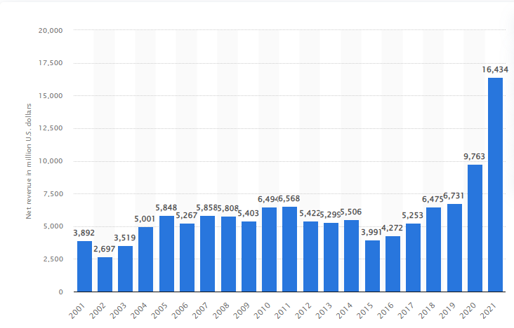
Figure 1: Revenue of AMD
(Source: Statista.com, 2022)
The above figure shows that there is a significant increase in the revenue of AMD in 2017 in contrast with the revenue in 2016. It will increase gradually in 2018 and 2019. In addition to this, the lower level of price and better value-for-money providing has helped the company to generate revenue, almost four times higher than the revenue of 2016 in 2021, $16434 million.

Task 2

Substitute
“Substitute goods” play an important role in the economy of any nation or in any marketplace. Substitute goods can be referred to the good or service that has a similar utility value if not the same. In simple terms, the “substitute” is the good or the service that can be taken into consideration in place of another good or service, where the essential utility value is almost similar to the “utility value” of the main product or service. The key substitute for the microprocessors of AMD is the semiconductors that have been offered by “Intel”.
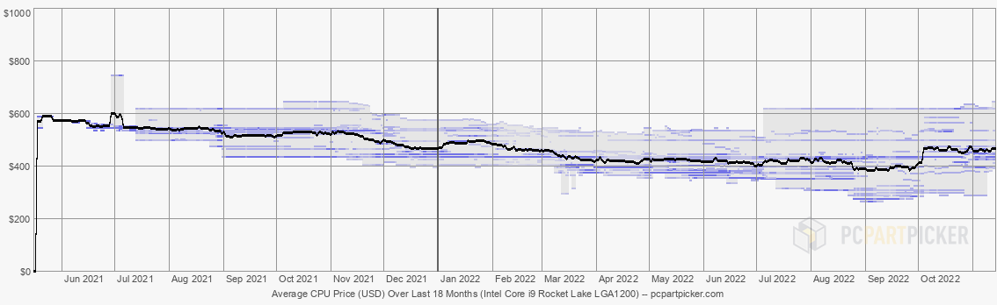
Figure 2: Price trend of “Intel Core i9 Rocket Lake (LGA1200)”
(Source: Pcpartpicker.com, 2022)
This can be observed from the above graph, the price of the particular processor has not differed much. Hence, the substitute goods’ price is not prone to decrease in the near future ((Pcpartpicker.com, 2022). Due to this stiffness in the price of the offering by Intel has given an upper hand to the products of AMD.
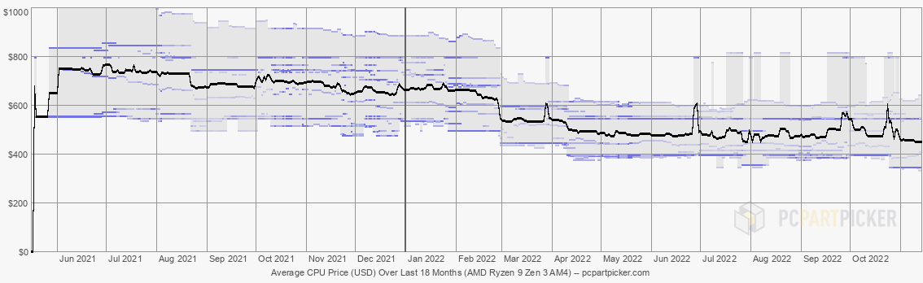
Figure 3: Price trend of “AMD Ryzen 9 Zen 3 (AM4)”
(Source: Pcpartpicker.com, 2022)
On the other hand, figure 3 show the price of AMD’s product is decreasing hence the consumers are getting better value in contrast to the offers produced by Intel (Pcpartpicker.com, 2022). This decrease in the price has helped AMD to generate a massive amount of revenue in 2021 as shown in figure 1.

Complements
The main “complement goods” of the microprocessors are the boards for sorting to the motherboards. As per the viewpoint of Estache and Foucart, (2021, p. 103789), the complements are the products that are needed with the product in this scenario. Hence the price of the “complement goods” has a significant impact on the chosen product. The demand for “microprocessors” offered by AMD can increase the price of complementary goods, which are lower than its competitors. On the other hand, if the price of the complementary goods is high then the demand for the chosen company's products would decrease significantly. Hence, this can be observed that the price of AMD's complement, the AMD-supported motherboards have a huge impact on the demand for the product in the market. In addition to this, there are several other factors that may have an impact on the demand for AMD microprocessors. These factors are the life cycle of the complement goods. If AMD chooses to change its socket on the motherboard then the consumers would be less prone to buy the products of AMD as they would be required to invest more if they choose to increase the processing power of the computer. As per the assumptions of Gómez‐Sánchez, et al, (2022, p. 819) the consumers would have to buy the additional component that is compatible with the latest processor offered by AMD. This would influence the demand for the product of AMD.

Level of income of the individuals
The income of the consumer has a significant impact on the demand for the microprocessors offered by AMD as individuals with lower income will not be able to buy the flagship product offered by AMD. Therefore, AMD has to offer a wide range of products so that it can target and cater for every segment of the market within the US and around the world. As per the viewpoint of Boshra, et al, (2020, p. 27), if they choose to target only one portion of the market, such as only the higher level of income group or only the lower level of the income group then they would lose a huge consumer base. This would result in a reduction in the target market, hence lowering the chances of generating revenue and incurring a better level of profits.

Consumer tastes & preferences
According to the viewpoint of Meagher, Wong, and Zauner, (2020, p. 590), tests and preferences of consumers have a massive impact on the demand for goods and services in any economy or marketplace. In addition to this, if the consumer's first priority is to get the best possible performance and the price of the product is not significant or has any relevance to the choice of the consumer then, the consumer would obviously opt for the best possible product and that has the highest level of utility. On the other hand, if the preference of the consumer is to get the best value for money product the consumer would evaluate every single factor before buying the product. In such cases, the demand for any particular product becomes challenging to evaluate as the behaviour of the consumer may vary. In addition to this, the demand for AMD microprocessors can increase or decrease depending on different scenarios, such as the community of the consumer, the level of income and so on.

Consumer expectations of price
The price is one of the most important factors when deciding whether to purchase a product or not. Usually, the consumer's price anticipates the price of an upcoming product or the price trend of an existing product. As per the viewpoint of Nguyen, and Shi, (2018, p. 32), this can vary from individual to individual as this has a significant impact on the choice of the consumer. If the anticipated price is lower than the actual price of the product then the demand would decrease for the product. On the other hand, if the actual price of the product becomes less in contrast with the anticipated price by the consumers, the demand for the product will be higher than the expected demand by the company. The pricing of the product can affect the performance of the company.

Demographics - Number of Consumers
According to the viewpoint of Oliveira, and Dias, (2019, p. 318), the number of consumers is very important for any of the companies. If the company created a large market then they have a larger number of buyers in contrast with its competitors. AMD and Intel are one of the largest semiconductor or microprocessor manufacturers around the world and both companies operate in different segments of the market and in different economies around the world. AMD not only produces processes for computers but several other kinds of semiconductors and microprocessors. These include processors for workstations, graphics cards or video cards, and so on. In addition to this, the introductory price of the product offered by AMD is significantly lower than the offering of Intel. The performance is significantly better in the entry-level market. This factor presents a greater consumer base for AMD. A higher level of the consumer base allows the company to opt for better marketing strategy implementation and spending on research and development for the development of new products.

Task 3
Demand for a good or service is influenced by a number of factors, including price, income, and preferences. Every time they change, these factors have an impact on how much of a good or service is in demand. The price elasticity of demand is a gauge of how economically sensitive demand is to a change in price. The measurement of the change in the quantity requested as a result of a change in a good's or service's price is known as price elasticity of demand. A product is considered "elastic" if its "price" varies and this causes a "crucial" shift in either the demand for the product or the demand for the product. This shows that there are other "substitutes" for the particular product that is readily available. Luxury automobiles, bikes, coffee, cake, and other items are examples of "elastic" products. A product can be categorized as "inelastic" if its "price" increases without causing a "crucial" change in either the demand for the product or the demand for the product. The products are hence necessities. Contrarily, inelastic products can include high-end goods or addictive substances, such as gasoline, milk, classic vehicles, life-saving medications, and so forth.
The “Price elasticity of demand” can be calculated by the following formula,
“Price Elasticity of Demand = Percentage change in quantity / Percentage change in price”

Substitution Effects
There is a huge difference between necessity and luxury. Here in terms of the microprocessors, the demand for the product may increase or decrease depending on the different factors that has been mentioned earlier. Classification of the product whether the product is "luxury" or "necessity" cannot be determined. This hurdle takes place because of the different behavior of the consumers. Some individuals prefer the flagship product offered by any company. On the other hand, there is a group of consumers whose preference is to get the best value-for-money product. Because of this difference in choices of the consumers the determination of the category of the product cannot be determined along with the elasticity of the chosen product.
If this factor is excluded from the consideration of the evaluation of the elasticity of the product, then this can be observed that the price of every single new product is increasing though the demand for the new product is not decreasing. Hence this can be considered as the "luxury" good in this scenario. One consumer would always choose to purchase the product or service which enables the consumers to maximise their utility. If the luxury good is providing more utility than its necessity counterpart then the customer would always choose to opt for the luxury good over necessity (Nor, et al, 2021, p.223). If the product offered by AMD were a necessity, an increase in price would have resulted in the quantity that has been sold by AMD. This phenomenon cannot be observed in the case of AMD products.

Income effects
The price of the product and the level of income of the consumers are closely related to each other along with the market demand for the product. With a lower level of income, an individual consumer would not be able to buy the best possible offering made by AMD, this phenomenon takes place as the consumer cannot go out of their budget line. Hence they are not able to change their budget constraints often. This affects the demand for the product as they are not able to buy the goods that they desire (Peng, Yang, and Chen, 2020, p.13). If the consumer with a lower level of income is opting for a very expensive product, this indicates that the individual is putting an alarming amount of his or her income into this product.An individual chooses to purchase any of the microprocessors offered by AMD, then that would not result in a major effect on a budget line. Therefore the consumer will obviously opt for the product that gives the highest utility to the consumer. As utility maximum is one of the most important factors at the time of making a decision (Giupponi, 2019, p.45).
After the analysis of every single factor that can have an impact on the demand level of AMD's microprocessor the demand level has only increased. The microprocessor is necessary to lead daily life, this can be said that the product is inelastic in nature (Filippini, and Kumar, 2021, p.359). The product is considered inelastic because the quantity demanded of the product is increasing along with its price. Therefore this can be considered a “luxury good” as it is “inelastic” in nature.
Pricing policy is one of the main components of a business. The pricing of the products is not correctly done and changed then the company can face a decrease in demand for the product. The pricing affects the demand for the product if the price increases the demand for the product would decrease as most of the consumer's level of income would remain unchanged. This will cause a reduction in the quantity demanded of the microprocessors of the AMD (Geunes, 2018, p.238). On the other hand, if the company chooses to reduce the price of the products, the demand for the product would increase even more.

Pricing Strategy
The pricing strategy that must be taken into consideration by the company is that the company should offer an introductory price for the product in a limited quantity. This would help the company to perform an act of organic marketing (Ma, et al, 2020, p.5). This can help the company to draw the attention of the consumers towards the company. In addition to this, the company can maintain the cash flow in a better way. There is another strategy that should be taken into consideration by the company should enjoy a lighter level of profit at the beginning of the product's life, hence just after the launch of the product (Chen, et al, 2019, p.2755). This will help the company generate a higher level of revenue. Hence higher amount of revenue means the highest level of profit. Then the following step by the company is that AMD should decrease the price of the product so that consumers with a lower level of income can opt for AMD’s products. This will not only help the company to aid in terms of clearing the inventory stocks of the company but also help the company to lure in new consumers to the products of the company. In this way, they would be able to retain new and existing customers in the ecosystem of AMD. Assuming that one consumer has bought a processor of AMD and had a good experience with the product hence at the time of buying a graphics card the consumer would consider buying another product of AMD.

Reference
Boshra, A.A., Al-Dabbagh, Z.S., Al Eid, N.A., Al Eid, M.A., Al-Musaibeh, S.S., Al-Miqtiq, M.N., Alamri, A.S. and Al-Zeyad, G.M., 2020. The effects of corona virus (COVID-19) outbreak on the individuals’ mental health and on the decision makers: A comparative epidemiological study. International Journal of Medical Research & Health Sciences, 9(3), pp.26-47.
Chen, X., Wu, S., Wang, X. and Li, D., 2019. Optimal pricing strategy for the perishable food supply chain. International Journal of Production Research, 57(9), pp.2755-2768.
Estache, A. and Foucart, R., 2021. On the political economy of industrial, labor and social reforms as complements. European Economic Review, 137, p.103789.
Filippini, M. and Kumar, N., 2021. Gas demand in the Swiss household sector. Applied Economics Letters, 28(5), pp.359-364.
Geunes, J., 2018. Revisiting the two-stage EOQ/EPQ model with inelastic demand: decentralisation and coordination. International Journal of Production Research, 56(1-2), pp.238-250.
Giupponi, G., 2019. When income effects are large: Labor supply responses and the value of welfare transfers, p.45.
Gómez‐Sánchez, A.M., Mañez, J.A. and Sanchis‐Llopis, J.A., 2022. Are importing and exporting complements or substitutes in an emerging economy? The case of Colombia. Review of International Economics, 30(3), pp.819-835.
Ma, J., Xu, M., Meng, Q. and Cheng, L., 2020. Ridesharing user equilibrium problem under OD-based surge pricing strategy. Transportation Research Part B: Methodological, 134, pp.1-24.
Meagher, K.J., Wong, A. and Zauner, K.G., 2020. A competitive analysis of fail fast: Shakeout and uncertainty about consumer tastes. Journal of Economic Behavior & Organization, 177, pp.589-600.
Nguyen, A. and Shi, G., 2018. Consumer Expectations of Preferential Pricing in The US versus China. Journal of Marketing Development & Competitiveness, 12(1) p. 32
Nor, N.M., Thinng, W.B.K., Veerman, J.L., Ibrahim, N.S., Mohamad, F.Z. and Ibrahim, S., 2021. Price elasticity of demand and the impact of taxing sugar-sweetened beverages in Malaysia. Malaysian Journal of Public Health Medicine, 21(1), pp.223-229.
Oliveira, G.D. and Dias, L.C., 2019. Influence of demographics on consumer preferences for alternative fuel vehicles: a review of choice modelling studies and a study in Portugal. Energies, 12(2), p.318.
Pcpartpicker.com, 2022, Price trend of AMD Ryzen 9 Zen 3 (AM4), Available at: https://pcpartpicker.com/trends/price/cpu/ [Accessed on: 14.11.12]
Pcpartpicker.com, 2022, Price trend of Intel Core i9 Rocket Lake (LGA1200), Available at: https://pcpartpicker.com/trends/price/cpu/ [Accessed on: 14.11.12]
Peng, K., Yang, C. and Chen, Y., 2020. Land transfer in rural China: incentives, influencing factors and income effects. Applied Economics, 52(50), pp.5477-5490.
Statista.com, 2022, Revenue of AMD, Available at: https://www.statista.com/statistics/267872/amds-net-revenue-since-2001/ [Accessed on: 14.11.12]

