Developing Relationships

And

Workplace Achievement

BMSW5102 Developing Relationships and Workplace Achievement

Yen Yen Lai (1710668) 9th December 2019
Table of Contents

01 Critically evaluative development vehicles available to an organisation appropriate to the development needs of the individual 2
Introduction 2
Development Needs of the Individual – Training and Development 2
Development Needs of the Individual - Motivation 3

02 Critically assess the potential benefits to the organisation and the individual of personally developing individuals in the workplace. 5
Benefits and Drawback of Training and Development 5
For the Organisation 5
For the Individual 5

Benefits and Drawback of Motivation 6
For the Organisation 6
For the Individual 6

03 Develop a plan to meet the identified development needs and expectations of an individual. 8
Conclusion 9

Appendices 10
Table A Personal-level Needs Assessment 10
Table C Personal Development Plan 11
Table D Personal Development Plan 12

References and bibliography 13

Critically evaluative development vehicles available to an organisation appropriate to the development needs of the individual.

Introduction
All organisations aim to progress and grow in the business world, but to achieve this the organisation should recognize that its employees are integral to its success.

There are many development vehicles an organisation could deploy to develop its employees. Strong evidence shows there are immediate links between highly motivated employees who continuously learn and develop tied with business’s growth. Organisations can benefit through greater profits and growth if they maximize support for individual employee’s development needs, and multi-layered motivation activities.

Development Needs of the Individual - Training and Development

Surbhi (2018) defined training as job-related activities organized by the organisation. Employees attend internal or external classes to master essential knowledge or skills in order to perform well and to improve standards. On the other hand, development can be considered as long-term progression activities, which focuses more on specific employee’s personal characteristic growth and future prospective within an organisation (Surbhi, 2018).

A Personal-level Needs Assessment (Table A) to identify the right level of support for training and development will affect employee retention from their first day, and the organisation should align this plan with their values and strategy (Allen Comm, 2019). A personal-level needs assessment (Table A) process can provide insight into who needs to train, and what kind of job-related training is required. It can also highlight suitable internal or external resources, time scales for completion and other extra interests the employee may have.

Training activities that are conducted internally (on-the-job) such as videos, demonstrations, computer-based e-Learning, handouts, discussions, case-studies, coaching, mentoring, and even group training can provide a good learning platform for new employees. It allows the new employees to practice new skills instantly and meet other employees from different departments creating greater workplace engagement and collaboration. There are also cost-efficiency benefits to internal training. For example, Swansea University’s human resources operate a self-enrolling internal e-learning system for employees. It covers topics such as “Introduction to Share Point”, “First Aid at Work”, and “Manual Handling Risk Assessment”, all of which help to build up proficiency skills and risk awareness in the workplace.

Off-the-job training can be referred to as external training, where the organisation outsources the training courses to professional trainers, career consultants, or training agencies. These can take the form of lectures, conferences, team building events, and even networking events. These are more related to specific skills, targeted for management level or top executives (Surbhi, 2018). For instance, Family Housing Association insisted on senior managers attending a “Safeguarding Vulnerable Adults” full day course conducted by Home Instead Senior Care, an external specialist, because this specialist knowledge and experience will enable senior management to be more aware of any potential abuse or negligence which could happen in the workplace and raise the alarm.

Specialist skills provide senior managers and executives with the chance to develop, strengthen their conceptual and theoretical knowledge, and deepen their understanding of the goals of the organisation in order to support lower grade employees to adapt to any new changes in the workplace (Surbhi, 2018).

However, organisations need to avoid the general assumption of “Train more do better”, as improved job performance resulting from implementation after new skills training can be as low as 10 per cent (Griffin, 2014, p251). Allen Comm (2019) also stated that high-impact training and development programmes need to be tailored to organisation’s business objectives and focus on measurable impact. All this is time consuming and can be costly in terms of an organisation’s resources.

Training will not as effective as intended, or may be regarded as time and investment wasted, if the individual employee failed to transfer the new knowledge to the workplace. Without post-training support and coaching from managers or colleagues to implement the new skills or share the new ideas, much of the new knowledge will be lost.

Development Needs of the Individual – Motivation

Robbins and Judge defined motivation as:
“the processes that accounts for an individual’s intensity, direction and persistence of effort toward attaining a goal” (Robbins and Judge, 2009, p. 209)

First, we examine what drives human needs and desires leading to motivated individuals. Maslow’s (1954) theory stated individual’s needs of development is motivated based on satisfying five series of sequential needs. The five sequential needs are: Physiological, Safety, Social, Esteem, Self-actualization (Wood and West, 2010).

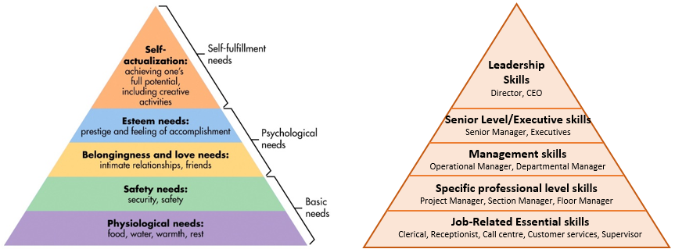
Source from: Mainul Haque (2018)
Table B: Employee Job-Related & Role Development Plan

Physiological needs form the basic needs in the hierarchy, and once these needs are satisfied, an individual will progress up the hierarchy to the next level. Once the safety needs are satisfied, an individual moves up again. Therefore, we can say that needs serve as a motivational force that generates momentum. Once an individual gets started, she will keep moving upwards to the next level of the hierarchy. An organisation can utilize induction periods or appraisals to find individuals showing desire to build their long-term career to progress to higher level within the organisation. The job-related skills and role development plan (Table B) is designed to give a clear picture to motivate individuals to continuously progress, fulfilling individual’s development needs.

The organisation needs to realise employee achievement should be rewarded according to their productivity. This means financial compensation such as performance-pay or bonuses to help an individual meet physiological needs, and act as motivating factor to continue and improve upon the good performance. For example, NDA use performance related pay to reward its employees who achieve their agreed targets. Additional payments can be set as a motivator for personal and organisational targets, employees will rise to the challenge to satisfy financial security needs.

Maslow’s theory, however, is unable to predict ‘when’ particular needs would become important. Assuming that needs are the starting point for motivation, different people want different things at different times, leading sometimes to long delays between moving up the hierarchy, or even needs being left unsatisfied (Arnold et al. 2010).

Rewards in financial form may not appeal to all employees. By using Herzberg’s Motivation-Hygiene Theory (1959) for this intrinsic motivation effect on rewards behaviour, it can be shown that some individual’s want to be noticed, and valued. They care about what they have achieved, because they are driven by internal personal values, or feelings of happiness rather than being motivated by financial reward. For this reason, individual may prefer a job promotion, addition job responsibilities, or even in a formal recognition certificate such as a Best Employee of the Month (Honore, p68-69).

Critically assess the potential benefits to the organisation and the individual of personally developing individuals in the workplace.

Benefits and Drawback of Training and Development

For the Organisation
The Personal-level Needs Assessment (Table A) is a powerful tool for organisations to communicate and engage with individuals. It helps to decide the level of training and development is required by individuals who are alignment with the organisation’s objectives, who share the organisation’s vision and the individuals who will strengthen trust and boost morale in the workplace.

A well trained and experienced individual knows how to handle customer enquiries in the right manner either face-to-face or on the phone. This is a proven trait which training and development can enhance individual confidence when handling difficult customers, and keeping a situation under control when problems get tough. Such qualities are highly valued by call centres and customer facing organisations, because it safeguards the organisation’s business image, leading to increased customer satisfaction, and helps growth and increased profitability.

Training and development of individuals helps in the development of an organization by increasing the net individual knowledge and proficiency skills of all staff in total, leading to more effective decision making and problem solving. Such knowledge is considered as a source of sustainability and competitive advantage for the organization within the business world.

Specific training for senior management tends to be expensive non-transferable skills, which can cause stakeholders to question whether the training is necessary. Whether the individual will stay with the organisation after all the money spent, and whether the specific skills are aligned with the organisation’s objectives, are key concerns and applicable to how widely the organisation benefits from it.

Changes of government or legislation relating to industries means organisations need to appoint the right individuals to attend training to keep knowledge up to date, to ensure compliance with legal regulations. As time needed to select the right individual, given sufficient training time to learn and implement new changes for the workplace and ensure compliance within time limits, all these causes extra spending for the organisation.

For the Individual
Internal training can improve an individual’s skills proficiency, and production speed (quantitatively and qualitatively). Higher work performance can make an individual stand out from others, leading to a better chance of getting promoted.

External training will provide greater awareness of external business techniques and innovation methods in processing that are used in other workplaces. Individuals can suggest new creative process procedures, improving personal work performance, which could lead to respect or receiving rewards (Woods and West, 2010).

The learning experience from a training course can make individuals feel positive, motivated to perform better, and help develop better beliefs, attitudes and job satisfaction. Improved engagement and collaboration with other department while training together with others, allows individuals to develop a sense of team spirit and inclusivity.

According to survey data (O’Connell et. Al., 2004) collected by O’Connel and Byrne research highlighted that there are huge differences of individual that working for large organisation have 63 percentage chance in receiving training, compared with just 29 percentage chance of individual that working for smaller organisation (2012). For this reason, individual aims to develop themselves in shorter period more likely choose to work for large organisation instead of small family business, due to it will help fulfilling development needs faster.

Benefits and Drawback of Motivation

For the Organisation
“Motivating employees requires employers to study the employee’s monetary, physical and psychological needs, because individuals are motivated by a number of items namely intrinsic and extrinsic rewards.” (Certo, 2004) For example, Admiral Group provide a lot of employee benefits such as free daily fruit, gym membership, and free eye tests to motivate individuals to stay healthy and that indirectly reduces sick leave, resulting in improved overall performance (Admiral, 2018).

Besides maintaining a healthy individual, the organisation should focus on creating a healthy working environment too, saying that we spent a great deal amount of time at work, the working environment could have considerable knockout effect on individual’s health, safety and wellbeing. This can lead to improved employee’s productivity, and has sustainable long-term benefits.

A positive and fun environment energize the workplace, motivates individuals to join in socialise with others department, creates a strong morale, bringing positive impact and high productivity, which helps the organisation’s growth (Admiral, 2018).

Motivating individuals to pay attention to safety checks and be aware of safety procedures in the workplace can reduce accident rates. The organisation should regularly promote and motivate individuals to participate in basic safety tests. The less accidents or mistakes that happen mean lower insurance costs.

If an individual felt that did not received same level of motivation and support comparing with another employee, this can caused tension and resentful feeling in the workplace. Therefore, organisation have to consider treating all employees fairly including provide same level of motivation to everyone.

For the Individual
Herzberg Motivation-Hygiene theory (1959) is widely used to link motivation, job satisfaction, and positive behaviour for an individual in workplace. The motivator factors listed as achievement, recognition, work itself, responsibility and advancement. The job content itself and a job that interests the individual can motivate someone to work hard, take up more responsibilities, and be willing to learn. These responses will make individuals feel good by achieving targets and lead to job satisfaction (Honore, 2009).

The intrinsic motivation from Herzberg’s (1959) theory played an important role in how an individual behaves in the workplace. As they enjoy the work they do, they would pay more attention to details, leading to the production of higher quality work, and better work performance.

Motivation empowers individuals to take responsibilities, make their own judgement, assess risk, and make decisions after researching facts, therefore it motivates an individual to be more successful in workplace.

Individual enjoyment at work should balance the amount of time spent in work and allow sufficient time away from work. If the passion for work becomes excessive, then the extra effort input in work could lead to mental health issues. There is a danger this could escalate into an obsessive passion causing negative consequences, such as burnout or stress related conditions (Taylor, 2015 p40-41).

Develop a plan to meet the identified development needs and expectations of an individual.

The Edge Café has suffered a decline in business caused by employees’ job dissatisfaction, staff rest room not being used for its main purpose, and a lack of business management skills from the owner. A Personal Development Plan (Table C and Table D) had been designed to motivate them engaged with each other and customers, to help improve the café business.

Although Karen and Simon have been portraying themselves as young Welsh entrepreneurs, they both graduated after studying Drama; which indicates they do not have any business management experience. There are numerous personal issues and conflicts between employees, namely Penny and Sharon both felt they are stuck in a job with little prospects and feel unmotivated. Sangita who management experience from previous job feels overlooked, Wolfram the cook feels insecure in his job, Jayne feels that she is being taken advantage of and can’t prioritize her study over work, and lastly by treating both cleaners Margaret and Joan to free coffee and breakfast, the owners have blurred role boundaries and expectations. The author found that the owners have not been fully utilizing the staff rest room to its full potential, because it has been used as overflow storeroom.

The author has proposed several changes to employees’ responsibilities, including essential skills training, personal development plans for each employee, creative activities for greater workplace engagement and to reverse the café’s declining business.

The author has prioritized re-inventing the café façade with an “Around the World” theme as a new talking point/attraction for customers. Simon is to assign Penny and Sharon to work together on creating this new talking point, discussing which city, and which airlines to put on display. As well as they will agree which fascinating information will be provided for customers to read. This will create engagement between the two of them, reducing Penny’s frustration about not being able to travel, and Sharon feelings of failure, motivating both to research different places as if they are travelling around the world.

Karen and Simon are to instruct Margaret and Joan to clear out all the overflow stock from staff rest room, making sure it’s clean and tidy, and put in additional cushions on the sofa, and a reed diffuser to refresh the room. All employees will be encouraged to take turns to recharge in this room, have conversations, discuss or give suggestions, which will create a better engagement space.

Sangita is to be offered the Café Manager job role. Karen and Simon are to formally interview her, discussing their business expansion plan, strategy, and expectations of her. As Sangita already has previous management experience, a few specific training courses to increase her knowledge on legislations and policy, will help her transition to the manager role more quickly and smoothly.

To alleviate Wolfram’s lack of self-esteem and insecurity, he could be enrolled on a professional cookery course. He can gain confidence and knowledge on professional level prevent him from resigning. Karen and Simon could offer to pay the course fee in return for him signing a new commitment contract. To give Wolfram a chance to practice his new skills and knowledge from the cookery class, he could be instructed to create a new menu to replace the old one, as customers’ tastes could change, and it also has the benefit of encouraging him to be creative.

A six months Apprenticeship contract could be offered to Jayne. Moving her back to work on weekend shifts, she can prioritize her university study. As her ability of handling customers is a big bonus for the café, Sangita could allocate her the task of replying to customer letters or emails. Jayne can also pick up administration skills as part of her apprenticeship while reducing paperwork for Sangita. This can boost her confidence and build up administrative experience for her curriculum vitae.

Karen could speak to Sharon in private, encourage her to study a Customer Service Level 3 certificate course with a local college or e-learning centre. This could build up her confidence, gain her formal qualifications, and may even help her get the job she dreams of in the future.

Karen and Simon should realize that offering training and development opportunities helps motivate their employees and benefits both parties. They can create a whole new atmosphere at the café with employees who have new attitudes and belief in themselves. Therefore, it is vital to spend some time drawing up personal development plan with S.M.A.R.T. objectives for each employee, and evaluated the impact after the training on employees and on the café business.

Conclusion

An organisation can work together with its employees to design a personal development plan which both parties agree to. This plan should meet the training and development that the employee needs. In addition, by utilising different motivators in a workplace to lift morale, interest in work through motivation can increase output and reduce cost. By empowering employees to decide their own career paths within the organisation, it can help with the retention of employees.

Appendices
Appendix: Table A Personal-level Needs Assessment
Section 1. General Information
Date: Department:

Manager’s Name: Contact Information:

Department Description and Hours of Operations:

Best Training Days and Times:

Section 2. Target Audience Assessment
Number of Employees: Language & Special Needs:

Types of Learning Activities Employees Prefer (check all that apply)
 Video  Demonstrations  Computer-based  Handouts

 Discussion  Mock Scenarios  Lecture  Other:

Section 3. Training Information
Job Position Job Required Frequency Current Resources
Topics Needed Training Methods Available
Section 4. Budget Considerations and Recordkeeping Comments
Copyright: 2004 by Phyllis A. Simmons, MA, CSP
Appendix : Table C Personal Development Plan

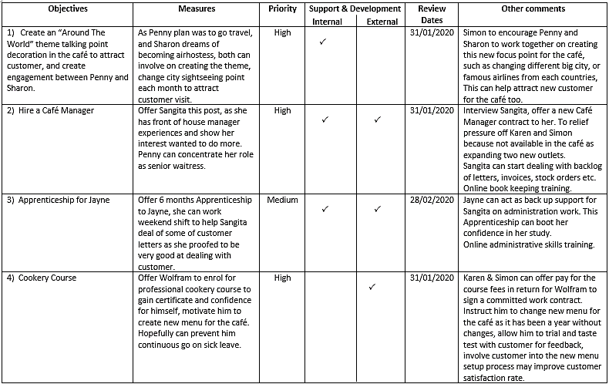
Appendix: Table D Personal Development Plan

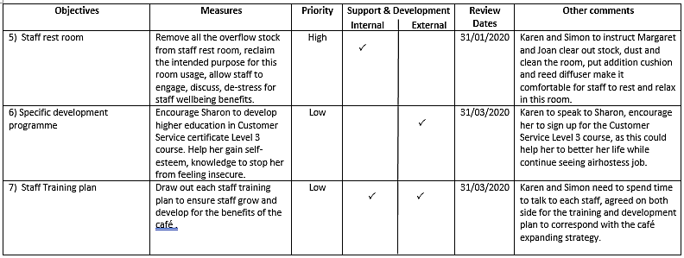

REFERENCES and bibliography

Admiral Group plc. (2018) Annual Report 2018. Available at: https://admiralgroup.co.uk/sites/default/files_public/annual-report/2019/03/2018-full-year-results-annual-report.pdf (Accessed: 3 December 2019).

Allen Communication Learning Services (2019) ‘What is employee training and development?’ [online] Available at: https://www.allencomm.com/what-is-employee-training-development/ (Accessed 30 November 2019)

Arnold, J., Randall, R. et al. (2016) Work psychology: understanding human behavior in the workplace. 6th edn. New York : Pearson Education.

Bogardus, A.M. (2004) Human resources jumpstart Anne M. Bogardus. San Francisco ; London: SYBE.

Fletcher, L., Alfes, K., and Robinson, D. (2018) ‘The Relationship between perceived training and development and employee retention: the mediating role of work attitudes’, The International Journal of Human Resource Management, Vol. 29, 2018 – Issue 18 p2701-2728 [online] Available at: https://www.tandfonline.com/doi/full/10.1080/09585192.2016.1262888 (Accessed 1st November 2019)

Greenan, P. (2016) ‘Personal development plans: insight from a case based approach’. Journal of Workplace Learning vol.28(5) pp. 322-334.

Griffin, R. (2014) Complete Training Evaluation: The Comprehensive Guide to Measuring Return on Investment. London, England: Kogan Page.

Haque, M. (2018) Professionalism Perspectives Among Medical Students Of A Novel Medical Graduate School In Malaysia. Available at: https://www.researchgate.net/publication/324279637_Professionalism_Perspectives_Among_Medical_Students_Of_A_Novel_Medical_Graduate_School_In_Malaysia (Accessed 30 November 2019)

Herzberg, F. (1964) The motivation to work / by Frederick Herzberg, Bernard Mausner, Barbara Bloch Snyderman. 2nd edn. New York: Wiley.

Honore, J. (2009) Employee Motivation. Consortium Journal of Hospitality & Tourism, vol.14(1) pp. 63-75.

Latham, G. P. and Pinder, C. C. (2005) ‘Work Motivation Theory and Research at the Dawn of the Twenty-First Century’, Annual Review of Psychology, vol. 56(1), pp. 485–516.[online] Available at: https://www.bing.com/search?q=fundamental+synonym&form=EDGEAR&qs=
HS&cvid=8cc718a2fa684598b6e467aadafad7fc&cc=GB&setlang=en-US. (Accessed 30 November 2019)

Maslow, A.H. (1987) Motivation and personality / Abraham H.Maslow. 3rd edn. New York: Harper & Row.

McLeod, S. A. (2018) Maslow's hierarchy of needs. Available at : https://www.simplypsychology.org/maslow.html (Accessed 30 November 2019)

O’Connell, P.J. and Byrne, D. (2012) ‘The Determinants and Effects of Training at Work: Bringing the Workplace Back in’, European Socialogical Review, vol. 28(3) 2012 pp. 283-300

Pajaron, T., (11 November 2015) How to Identify Training Needs at Your Organisation. [online] Available at: https://trainingindustry.com/articles/professional-development/how-to-identify-training-needs-at-your-organisation/ (Accessed 20 October 2019)

Roberts, C. (2009) Reflections. Fleet Equipment, vol.35(9), 12. [online] Available at: https://search.proquest.com/docview/216172367?accountid=14680 (Accessed 23 October 2019)

Surbhi, S., (26 July 2018) Difference Between Training and Development. [online] Available at: https://keydifferences.com/difference-between-training-and-development.html (Accessed 23 October 2019)

Stum, D. (2001), ‘Maslow revisited: building the employee commitment pyramid’. Strategy & Leadership, vol. 29(4). pp. 4-9. Available at: https://doi.org/10.1108/10878570110400053 (Accessed 30 November 2019)

Taylor, B.M. (2015) ‘The Hierarchical Model of Motivation: A Lens For Viewing The Complexities Of Motivation’. Performance Improvement vol. 54(4) pp. 36-42

Woods, S.A., and West, M.A. (2010) The Psychology of Work and Organisations Andover: South-Western Cengage Learning.

