

Module - Fundamentals of Construction Technology
ACBA4001
Assignment 1 – Site Investigation Case Study

Contents Page
Introduction – Page 3
Site Details – Page 4 – 5
Historical Appraisal - Page 6 – 7
Geological Appraisal – Page 7 - 11
Environmental Appraisal – Page 11 - 12
Archaeological Appraisal – Page 12 - 13
Foundation Recommendation – Page 13 - 14
Refeferences – Page 15

Introduction
The city and county of Swansea have decided to enter a joint agreement with the Marriott Hotels. They have proposed plans to build a new restaurant/ice cream parlour. I will highlight on below images where they proposed building is to be located. The new building is a fairly large building with a gross internal area (GIA) of 300m2 at the ground floor level.
As a junior construction professional I have been tasked with initiating a preliminary study for a full site investigation as part of the feasibility stage.
The site is located in the busy city if Swansea on the Maritime Quarter. This site comes with a lot of challenges which we must be careful about, this is due to the rich history of Swansea during the Second World War, and the industrial history of the Maritime Quarter which I will touch on later.
The site is very close to Swansea Beach meaning we mmust be very careful in the ground investigation as the water table might be high, and the soil type might be sandy. Meaning the firm clay might be very deep, making it quite difficult to build on.

Site Details
The proposed site is located in the Maritime Quarter, Swansea right next to Marriott Hotel and the and the Civic Centre East Car Park. 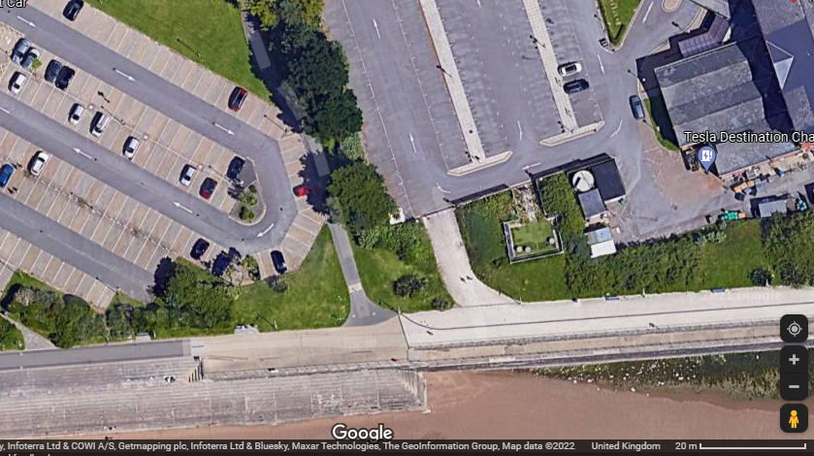
Photo 1
As seen in the above arial photo of the proposed site it shares boundaries with two existing carparks, and is less than 30 meters from Swansea Beach.
The site is currently used a carpark in some sections, within the site boundaries there is a viewing platform that is for the people staying in the Marriott Hotel. There is also a footpath that can be seen in the above photo, but through my research on the Swansea Council website this is not a public right of way.
During the warmer months of the year this particular location can get quite busy due to it’s close proximity to the beach, and the Civic Carpark can get very full as it is one of the closest carparks to the beach.
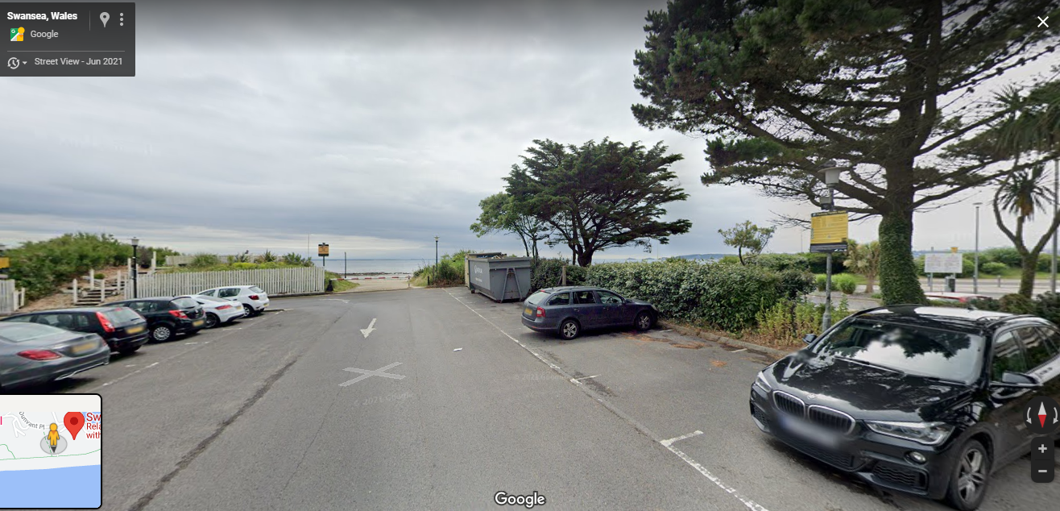
Photo 2
As seen in photo 2 the proposed site currently has a lot of greenery and vegetation, and also has two large trees within the boundary.
The proposed use for this site will be a new restaurant/ ice cream parlour on the first floor. The first floor will have a gross internal area of 300m2. The second floor will have a self-contained managers apartment and will have all the staff welfare facilities.
From a brief desk top study that I conducted there are some lighting

Site access could prove difficult as the main road (Oystermouth Road) is extremely busy, and traffic can be very bad during busy hours of the day. Due to the site sharing boundaries with two car parks there are two possible access points, both are highlighted in the below photo and coloured in green and red
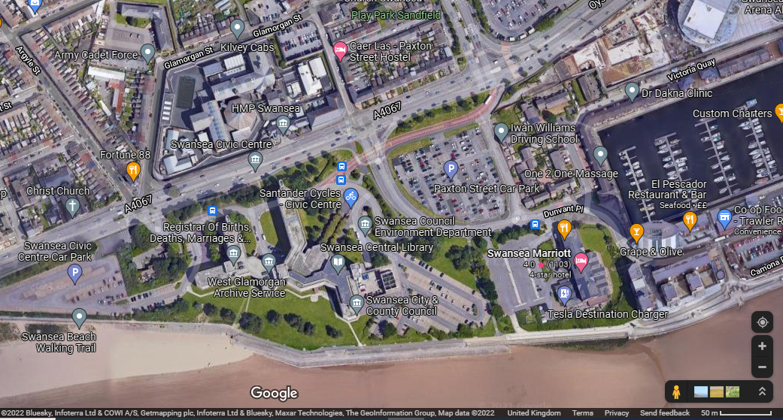
Photo 3
The access point highlighted in red takes you past the Swansea Library in to the Civic Centre East car park, this is a relatively quiet road but will not be suitable forlarge, tall vehicles as there is a height restriction on a section of the road where you must drive under the building.
The access point highlighted in green will bring you straight to the Marriott hotel car park and is the shortest route making it the most sustainable. On this route there is no height restrictions, but it is a very busy junction.

Historical Appraisal
Throughout my research of the past uses of the area of the proposed site I discovered that there used to be a railway track that passed through very near to the site. The Swansea and Mumbles railroad was built in 1804 and was originally built to transport limestone from quarries in Mumbles to Swansea. The rail road was in service until it was closed in October 1959 and Oystermouth Road was later built in its place
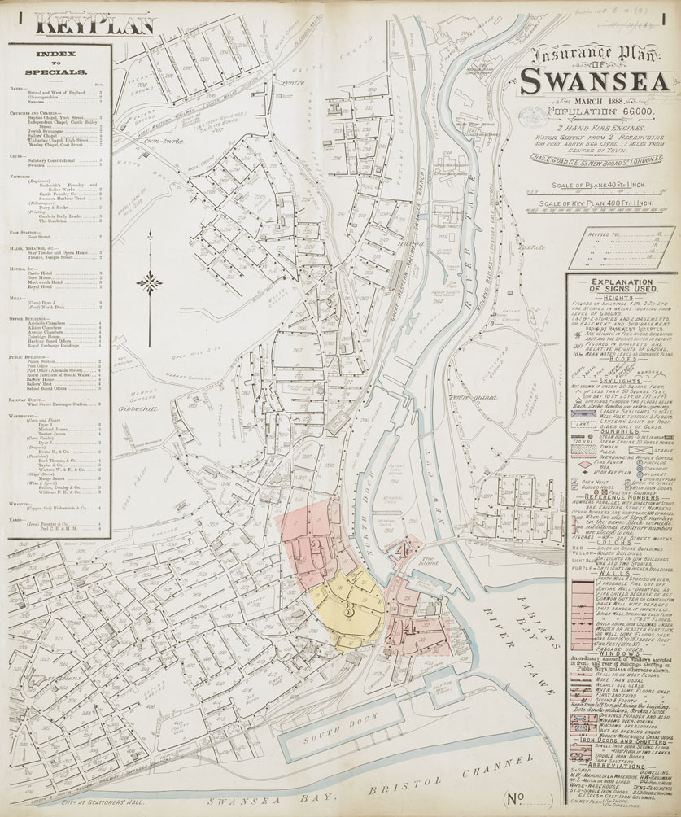

Photo 4
The above map is from 1888 and was created to assist insurance companies to assess fire risks and to better understand the building footprints and their uses.
I also researched to find some even earlier uses of the area and discovered that there were many buildings in the Maritime Quarter. I discovered the map that is shown below that shows there was a hospital close to where the Swansea library is located today. Closer to where the docks are looked to be a sort of industrial area back in 1876-1877.
There was a timber sawmill close to the site, slightly further east down the train track there was a stores, and also a copper ore and goods shed.

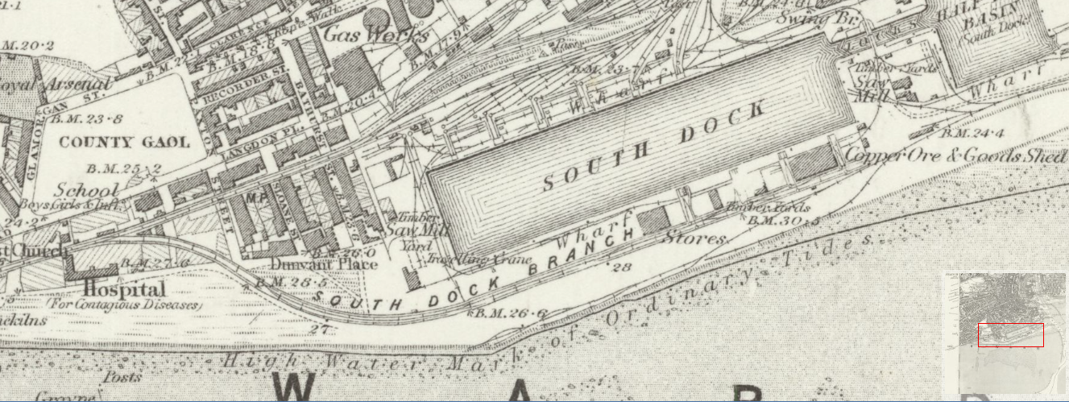
Photo 5
Since these maps were produced practically all the buildings shown in the surrounding area of the maps have been demolished and re-built over with newer buildings.

Geological Appraisal
I researched borehole logs to see if I could discover any in the surrounding area of the proposed site, much to my surprised I discovered that there were many that have been conducted in the area and one had been done within the site boundary.
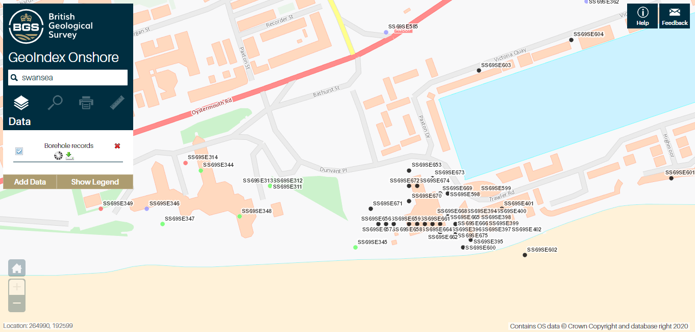
Photo 5
The above photo shows all the boreholes that have been recorded in the surrounding area of the site, many of which are confidential so I could not access the information except for the green coloured one which is on the proposed site.
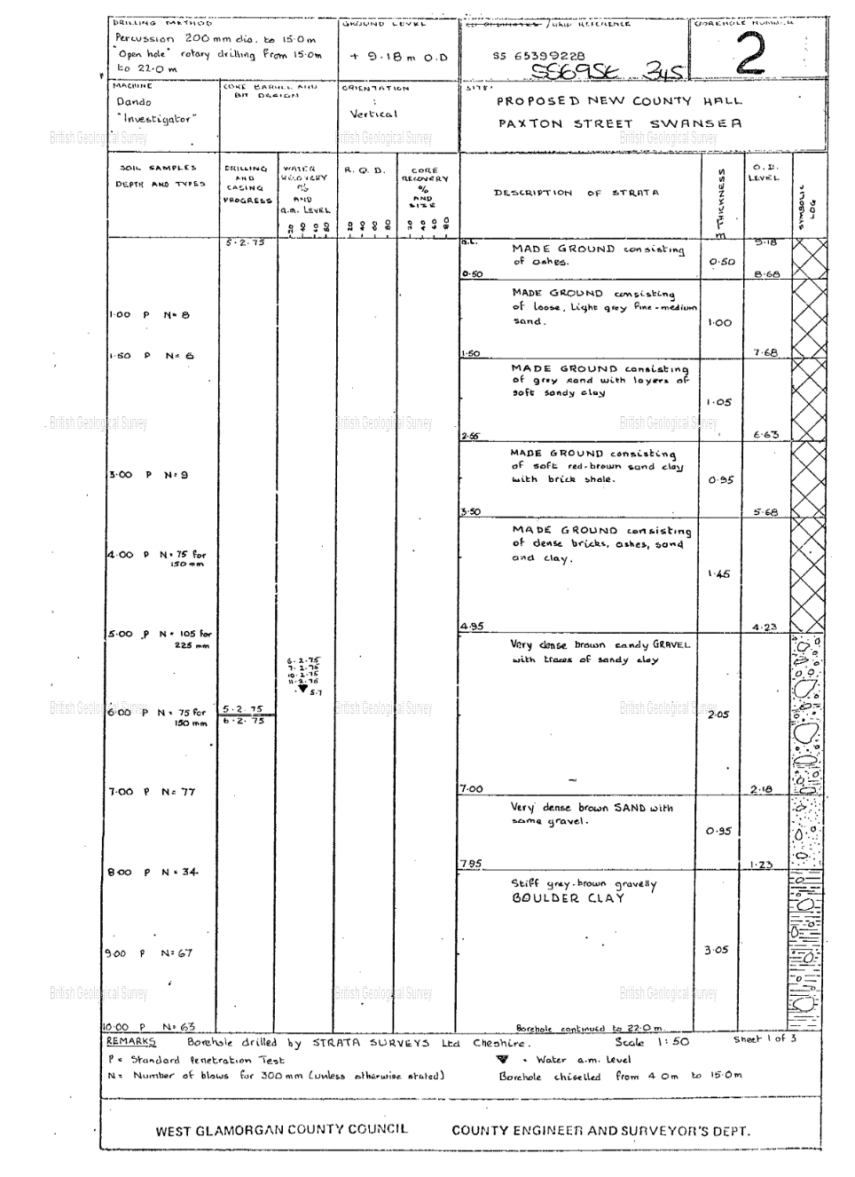

Photo 6 – Page 1 of 3 of the Borehole Log

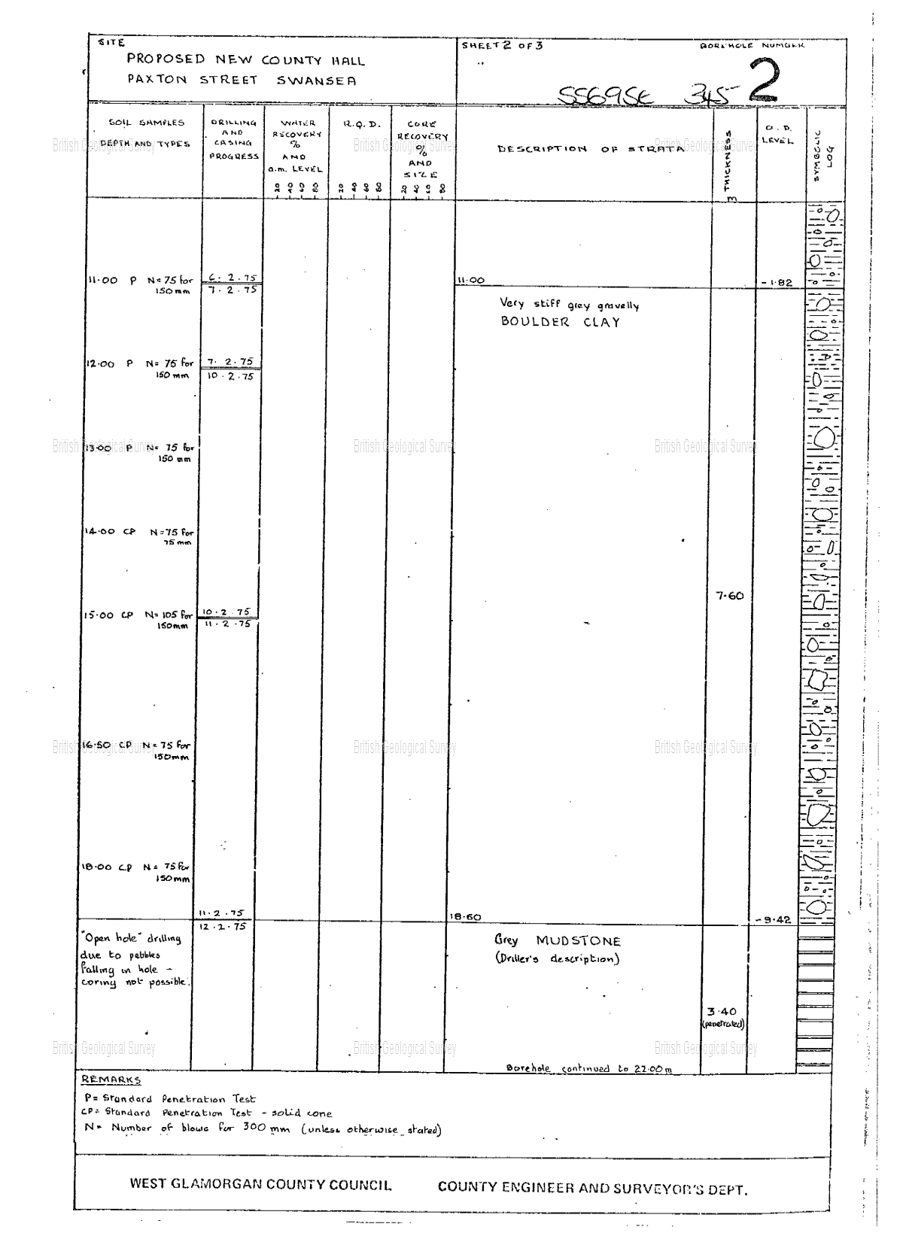
Photo 7 – Page 2 of 3 of the borehole log

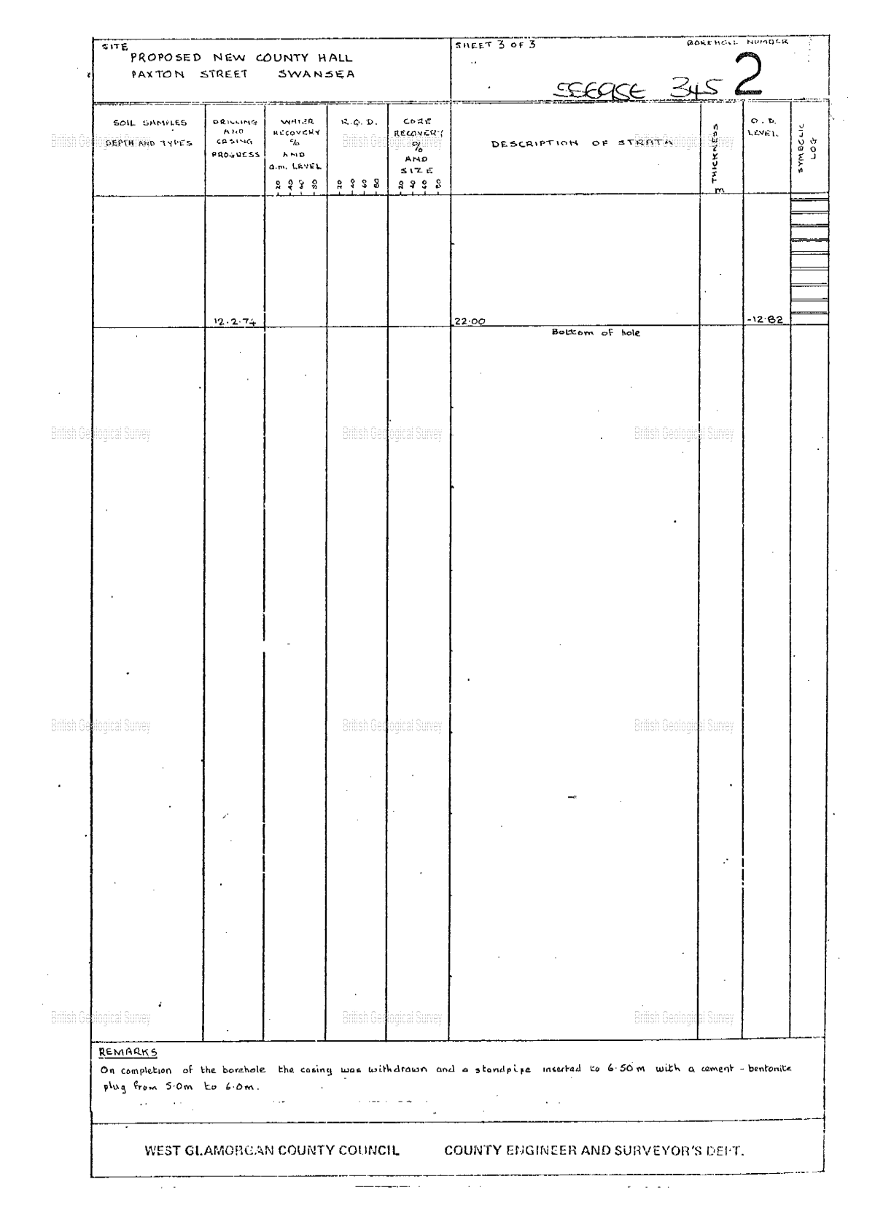
Photo 8 – Page 3 of 3 of the borehole log

As can be seen in the above three pages of the borehole log that was done on the site, this borehole took samples of multiple soil types and went to a total depth of 22 meters. The log shows that the first 4.95 meters is made ground with the first 3.5 meters being ashy, soft, sandy/clay which is unsuitable to build on. To reach the stiff clay which more suitable to build on the drill went to a depth of 7.95 meters. The drill reached very stiff clay at 11 meters deep and then hit “grey mudstone at 18.6 meters, which continued until the end of the bore hole.
Looking at the borehole log I believe that there is a possible risk of ground subsidence, not only due to the results shown above but because of the location of the site. Being right next to the ocean if there is stormy weather the tide can get very high and get close to the site, this could cause the water table to rise and could even wash away the soil particles over time, causing the ground to shift and become less stable.
There is also a lot of clay shown in the borehole log, clay is good to build on as it is firm, but in very hot weather clay could shrink, causing subsidence.
I went on the Coal Authority website and drew out the approximate site boundary, and to my surprise the property is located on the coalfield and is not located within the “Cheshire Brine Compensation District”. This must be considered when conducting the full site investigation as drilling into a mine or building over could cause it to collapse causing big problems. Mining was a massive industry in South Wales in the 19th century so it is very common to be near a mine when working in this area, to get more detailed information on the location of the mines you can purchase maps and mining reports that will go into detail on the Coal Authority website, these vary in cost but the Enviro All-in-One package costs £243.53 +VAT.
Environmental Appraisal
Due to the rich industrial history of this area it’s very likely that there are potential contamination sources. There used to be a railway travelling near the site, fuel and oils could have leaked from the rail carts and collected in the soil contaminating the ground. There was also a timber sawmill nearby, the fuel used to power the saw mil and the vehicles used to transport the timber could have contaminated ground.
The site is close to the beach, when the tide is out the water is far away from the sea wall (roughly 250 meters) but when the tide is in the water is much closer. In stormy weather the water can come right up to the sea wall, which is only about 15 meters from the site, this could have an impact on the ground water and cause a higher groundwater level.
I went on the BGS website to research the hydrogeology in the area and discovered the below map.
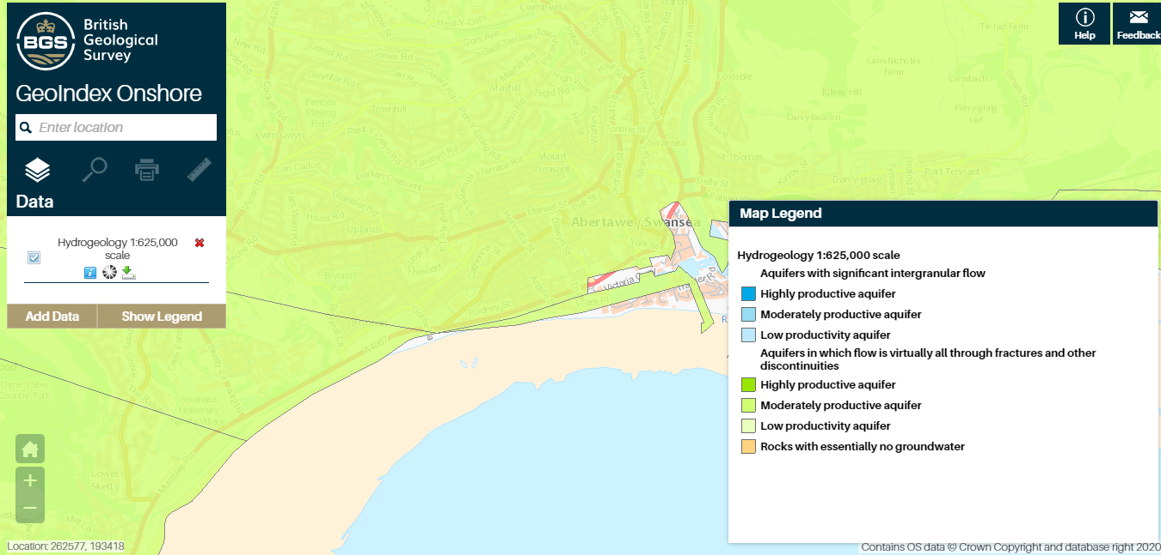
Photo 9
This image shows us the that the body of permeable rock which can contain/transmit groundwater is moderately productive in the area, meaning that the borehole yield is should be 1-10 l/s.
Archaeological Appraisal
With the location of the site we are at risk of uncovering archaeology when we are exciting and even when we are drilling, due to the number of historical buildings discovered when researching the historical appraisal of the site its very likely that there will be some remnants of these building still in the ground that have simply been built over or filled in. There’s the possibility of uncovering some tools/machines from one of the many industrial buildings that used to exist in the area.
Swansea has been occupied for many years with some of the oldest remains dating back to 22,000BC, so is a long history that could be buried under the site. It is known that Vikings arrived in Swansea sometime between the 9th and 11th century, so there is the possibility of uncover old buildings from that era, and even weapons and human remains.
There is also a risk of uncovering UXBs (unexploded bombs), because during the Second World War the Germans set up a campaign called “The Blitz” which was a bombing campaign and Swansea was heavily targeted to try and target the docks to try and stop the allies exporting coal and other goods. With the site being next to the docks UXBs are a major risk.
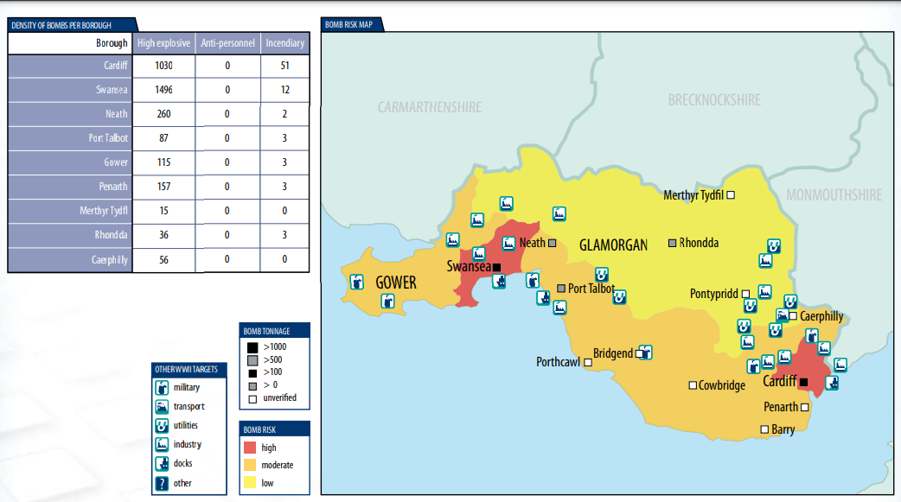
Photo 10
I found the above photo on the Government website which shows the amount of bombs dropped, with the sheer amount that was dropped on Swansea and the destruction it caused to the city it is expected that there are many UXB’s in the ground to this day.

Foundation Recommendation
From my research into the borehole log that was conducted in the area of the site I have gathered information on the ground conditions. Many more bore holes must by done within the 300m2 area that the building is planned to be built in to know the ground conditions in each area as it can vary in places. But based on the information that I have gathered I believe that a piled raft foundation will be the most suitable foundation for the proposed restaurant/ice cream parlour. The reason I have chosen the piled raft foundation is because the first 3.5m being made up of soft ashy, gravely/sandy material, which is not suitable to build on, especially for a building with an GIA of 300m2, as the weigh will be too much for this ground. With the piles extending down approximately 8 meters from the bottom of the raft the piles will be reaching the very dense clay which is more suitable for building on.
The addition of piles to the raft foundation will also increase the performance of the foundation and reduce the risk of settlement, if the soil particles are washed away the structure should stay strong as most of the weigh is supported by the dense clay.
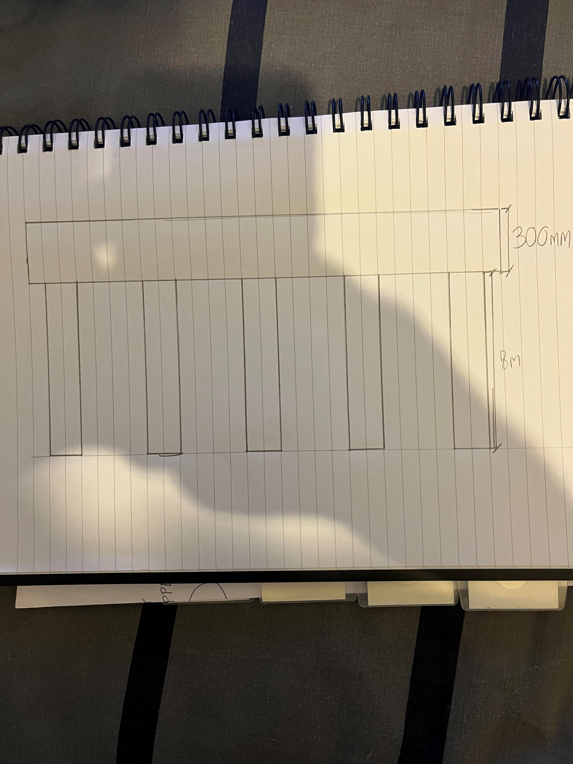

References
Photo 1: Google.com (2022) available at: https://www.google.com/maps/place/Swansea+Marriott+Hotel/@51.6134653,-3.9460101,122m/data=!3m1!1e3!4m5!3m4!1s0x486e8ab49338a0b1:0x927675fd7a0f0c1b!8m2!3d51.613715!4d-3.944272
Photo 2: Google.com (June 2021) available at: https://www.google.com/maps/@51.61359,-3.945403,3a,75y,181.23h,89.66t/data=!3m6!1e1!3m4!1sDQ8S4sF378C5Qxuxgc07MA!2e0!7i16384!8i8192
Photo 3: Google.com (2022) available at: https://www.google.com/maps/@51.6146233,-3.9486492,487m/data=!3m1!1e3
Photo 4: The British Library (no date) available at: http://www.bl.uk/onlinegallery/onlineex/firemaps/wales/largeimage148625.html
Photo 5: National Library of Scotland (no date) available at: https://maps.nls.uk/view/102342508
“Originally built under an Act of Parliament of 1804 to move limestone from the quarries of Mumbles to Swansea and to the markets beyond” – En.Wikipedia.org (19/07/21) available at: https://en.wikipedia.org/wiki/Swansea_and_Mumbles_Railway
Photo 5: bgs.ac.uk (no date) available at: http://mapapps2.bgs.ac.uk/geoindex/home.html?layer=BGSBoreholes&_ga=2.81416471.1831303932.1641308732-501387283.1641308732
Photo 6: bgs.ac.uk (no date) available at: http://scans.bgs.ac.uk/sobi_scans/boreholes/370246/images/10677923.html
Photo 7: bgs.ac.uk (no date) available at: http://scans.bgs.ac.uk/sobi_scans/boreholes/370246/images/10677924.html
Photo 8: bgs.ac.uk (no date) available at: http://scans.bgs.ac.uk/sobi_scans/boreholes/370246/images/10677925.html
Photo 9: bgs.ac.uk (no date) available at: http://mapapps2.bgs.ac.uk/geoindex/home.html?layer=BGSHydroMap&_ga=2.14415031.1831303932.1641308732-501387283.164130873
“The oldest known remains on the Gower Peninsula are the Red Lady of Paviland: human bones dating from 22,000 BC” – en.wikipedia.org (21/10/21) available at: https://en.wikipedia.org/wiki/History_of_Swansea#Early_history
“The Vikings arrived sometime between the 9th and 11th centuries, leaving behind their name for a settlement in the area. The precise nature and location of this settlement are still disputed” – en.wikipedia.org (21/10/21) available at: https://en.wikipedia.org/wiki/History_of_Swansea#Early_history
Photo 10 – www.cardiff.gov.uk (no date) available at: https://www.cardiff.gov.uk/ENG/resident/Schools-and-learning/Schools/21st-Century-Schools/Keep-up-to-date-and-contact-us/Publications/st-mary-the-virgin/Documents/App%20E%20-%20UXO%20Map.pdf

