

MODULE CODE: ECPT6003

ASSESSMENT COMPONENT: A2 Professional Observation

STUDENT NAME: Matthew Drummond

STUDENT NUMBER:2014426

Use of Generative AI in Assessment

(Lecturer to indicate Yes or No against each element)

RESEARCH | For this assessment, you can use Generative AI to support you in research, including searching for bibliography, using tools to summarise, compare and interrogate materials. | Yes ☒  No ☐
STRUCTURE | For this assessment, you can use Generative AI to support you in structuring your submission, including creating a draft argument structure, identifying parts and headings, etc. | Yes ☒  No ☐
PROOFREADING | For this assessment, you can use Generative AI to check your own text/creation for grammatical and syntactical mistakes, including rephrasing of your own work within specific standards. | Yes ☒  No ☐
WRITING | For this assessment, you can use Generative AI to create text for submission. | Yes ☐  No ☒
CREATIVE | For this assessment, you can use Generative AI to create creative materials, such as images. | Yes ☐  No ☒
PROGRAMING | For this assessment, you can use Generative AI to create and check code. | Yes ☐  No ☒
NONE | For this assessment, you are not allowed to use any type of Generative AI support. This includes research support, structure support, writing/proofreading support and creative support. | Yes ☐  No ☒

AI Acknowledgement
I confirm that I have not used any AI tools in the research and creation of this assignment.
I confirm that I have not presented any AI generated materials as my own work.
I confirm that I have copies of my drafts, notes, and other resources I used, which I may be asked to provide in evidence.
Table of Contents
Introduction 5
Lesson Observations 6
Observation One 6
Observation Two 8
Observation Three 9
Action Plan 11
References 13
Appendices 14
Teacher Observation Form – Lecturer One 14
Teacher Observation Form – Lecturer Two 15
Teacher Observation Form – Lecturer Three 16

Introduction
Professional development in the post-compulsory education and training is in part, a constant process of critical reflection and the continuous appraisal of one’s own teaching practice. Educational practitioners in the post-16 sector are typically required to have dual competencies, they are expected to have expertise in both their particular specialism, and in the pedagogy of teaching that specialist subject area (Welsh Government, 2023). Certain specialist subjects or learner groups can be challenging to teach for a number of reasons, particularly for inexperienced professionals. Gaining experience from more experienced practitioners is an invaluable part of this development process (Race, 2020).
Observation and evaluation of other teaching practitioners is a critical part of a teaching professionals’ development, particularly in the early stages (Race, 2020). Brookfields (2017) four critical lenses includes the peer lens. The peer lens not only involves being observed by other professionals but also observing experienced colleagues and making comparisons with ones own teaching styles and strategies. Reviewing another professionals’ teaching practices in comparison with their own can help a developing practitioner to recognise where good practice has been employed, and critically where it can be improved (Avis, Fisher and Thompson, 2019).
Observation in this context is not a passive act of watching but is a structured and engaged activity analysing another practitioner's delivery, identifying their teaching strategies and evaluating their effectiveness by gauging learners’ responses all in real time. It is the identification of best practice, when it has been employed, and understanding the rationale behind as well as the recognition of adherence to professional standards (Avis, Fisher and Thompson, 2019).
This essay details the learnings from 6 hours of observing teaching professionals delivering higher education in the areas of architecture, construction & the environment. These observations were carried out through a lens of identifying best practice and alignment with professional standards where it has occurred with the purpose of improving my own teaching practice and professional development. Specific points for improvement were identified from both the observations and feedback from the microteach. An action plan was formulated from the identified improvement points which will be used within my own wider professional development plan.

Lesson Observations
For this report I observed three lecturers that teach within the University of Wales Trinity St Davids Welsh Institute of Science and Art School of Architecture, Construction and Environment. The first observation in which I observed Lecturer One was a 2-hour session for the module Building Services and Energy Performance in Buildings delivered as part of the MSc in Sustainable Construction and Properties and Facilities Management. The second observation was a 2-hour session for the module Technology and Environment 1 which is delivered by Lecturer Two as part of the level 4 BA Architecture programme. The third session was a 2-hour session for the module Environmental Monitoring and Assessment delivered as part of the level 6 Environment, Sustainability & Climate-change BSc.

Observation One
The beginning of the observation was a little less streamlined than Lecturer One would have liked (something they openly stated to me after the observation), this was due to 2 factors; several of the learners were late, some considerably due to weather related travel issues but also (by Lecturer One’s own admission) because the lecturer had to delay the start of delivery so they could print out some material that was to be used during the class. This is an example of the realities of teaching, an acute planning gap on the day combined with uncontrollable external circumstances (adverse weather) resulting in the sub optimal start to the lesson. Practitioners must always plan in flexibility to account for unforeseen issues and adapt and compensate where required (Avis, Fisher and Thompson, 2019).
The level of study was at Masters level (level 7) and all of the students were mature students who were completing their studies alongside working jobs within the construction industry. The atmosphere was comfortable and friendly as the group is a small and intimate one, with all the learners being familiar with each other and having established relationships with each other and Lecturer One. This setup is one that Lecturer One takes account for when aligning their teaching delivery to best practice. A smaller learner group means they can more easily 1) take account of each learners starting point and tailor content delivery at a more appropriate level that accounts for each learner’s background knowledge/experience. Smaller groups mean that a practitioner can better ‘promote engagement in learning and equity of opportunity” (Advance HE, 2023) as they can each engage with each student more meaningfully.
Some homework had been set the week prior with the intention of reviewing that material during this session, not all learners had completed the homework, but they were paired with others who had. This is a good example by Lecturer One of a differentiation of process and peer tutoring, strategies which Avis, Fisher and Thompson (2019) have deemed to be effective to improving learner outcomes. This approach aligns well with Standard 9 of the Welsh professional standards (Welsh Government, 2023) which encourages practitioners to ‘enable learners to share responsibility for their own learning and assessment’.
The focus of the session was an in-depth review of Passive House Planning Package (PHPP) calculations for commercial buildings and their relation to building regulation documents. The material was worked through methodically with an emphasis on worked examples, both by Lecturer One demonstrating the calculations, and by setting learners examples to work through in class and reviewing them. The use of worked examples by Lecturer One moves the learning from passive observation to active participation - integrating formative feedback that can improve not just student knowledge, but their motivation and engagement (Race, 2019). This strategy of working through PHPP calculations collectively in class compliments the composition of the class, Knowles et al. (2005) determines that mature students are more engaged in learning about topics that immediate relevance to their lives or employment context. PHPP is a very technical subject and was very thoroughly explained throughout the session by Lecturer One who displayed their extensive knowledge of the subject throughout the session – evidencing their adherence to the professional standard to maintain and update knowledge of subject area and how best to teach them (Welsh Government, 2023).
Learners appeared relaxed and comfortable when answering questions posed by Lecturer One and asking questions to Lecturer One. A relaxed and open environment had been cultivated which helps to make learners feel secure and ask questions uninhibited. This atmosphere helped in the formative assessment strategy which itself encouraged a shift from passive reception of content to active learning (Avis, Fisher and Thompson, 2019). Lecturer One handled questions in a respectful manner, by breaking the question down into parts, reflecting those questions back to the group and gently teasing the answers from them whilst politely and respectfully correcting any wrong answers. This approach aligns well with the principles of demonstrating dignity, courtesy and respect and listening to others’ views and ensuring all have an equal opportunity to be heard.
After this observation there was much to reflect on in relation to my own professional development and teaching strategies, particularly with regards to class engagement. I observed Lecturer One skilfully navigate a difficult topic, maintain an engaging and inclusive atmosphere and give learners the confidence to attempt difficult tasks and answer challenging questions in front of the peers without reservation.

Observation Two
Lecturer Two started the session by recapping on the previous session, learners within this group were initially quite shy and quiet so Lecturer Two used a mix of open questioning and targeted questioning to engage with the group which helped them ‘open up’ and engage more as the session progressed. As the learners in this group are level 4 students, they are only at the start of their second semester at the university. Lecturer Two is still in the process of drawing them out of their shells and building their confidences, Lecturer Two does this gently and sensitively – demonstrating their commitments to the professional standards to build positive collaborative relationships and demonstrate commitment to learners, their learning, safety and well-being.
The subject matter was a technical and consequential one which reviewed and dissected various insulation material used within buildings and their respective fire resistance properties. Lecturer Two used a wide range of sample materials and props that were passed around to learners and helped to demonstrate the key differences in the physicality and workability of the materials and their use within different building elements. Lecturer Two also used several videos of each insulation material undergoing tests to quantify their resistance to ignition. These videos were in my view, very impactful – demonstrating the importance of selecting appropriate insulation material during design of a building to minimize fire risk. Learners appeared particularly engaged during these videos and followed them up with a range of pertinent questions. These two approaches; the use of physical sample materials and demonstration videos were very effective for enhancing the delivery of the subject matter – a great example of the professional standard to plan and deliver effective learning, teaching and assessment.
I observed Lecturer Twos classroom presence to be strong; they employed a lot of physical movement - talking with their hands and roaming the classroom engaging each learner. The atmosphere was relaxed and although learners were in general quiet, they appeared comfortable asking questions and responding to direct questions posed by Lecturer Two – reinforcing Lecturer Twos commitment to demonstrate commitment to learners, their learning, safety and well-being.
An in-class activity was set for learners to research and obtain the thermal conductivity values for a list of insulation materials. This activity engaged the learners well as they worked in pairs to find the answers. This in class task was a great example of the use of the professional standard to enable learners to share responsibility for their own learning and assessment.
There were many valuable learning experiences gained from my observation of Lecturer Two. Their commitment to building the confidence of shy and quiet learners in an encouraging and considered manner was inspirational. Lecturer Twos use of both physical props and visual media really helped explain the key concepts they were trying to deliver during the session. These two things are something I will strive to embed within my own teaching strategies as I develop my own teaching practice.

Observation Three
Lecturer three began the lecture with a recap on the material covered in the previous session, that previous session was an important precursor to this session so lecturer three made sure that the learners had remembered and grasped the important concepts needed for this session. This approach demonstrated a commitment to learners and took account of their starting points in a safe and inclusive environment.
The content and delivery of lecturer threes lecture was well considered and well structured, the presentation of their slides was clean, professional and supported with high quality images and graphics that added value to the session content. This aligned strongly with the standard to plan and deliver effective learning, teaching and assessment. I particularly appreciated the style and format of Lecturer Threes PowerPoint presentation and will incorporate elements of their style choices into my own presentation material.
Lecture Threes delivery of challenging lesson material that is heavy with corporate jargon and technical definitions was very good. They broke the subject matter down into manageable chunks and explained the concepts in clear and plain language which helped learners comprehend the topic better. This ability to simplify difficult subject matter and teach it to the uninitiated demonstrated Lecturer Threes strong grasp on the topic, exhibiting strong alignment to the professional standard to maintain and update knowledge of my subject and how best to teach and assess them.
Lecturer Three employed formative assessments continuously throughout the session to check each learner was keeping up with the lesson. This was done through a combination of open questions to the class and targeted questioning to individual learners. Learners were very responsive to these questions and appeared comfortable answering them, critically even when they were unsure of the answers, this displayed to me that learners were comfortable with putting themselves out there to answer a question if when they thought their response may be incorrect. This demonstrated to me that learners were confident and comfortable within Lecturer Threes learning environment and felt safe voicing their thoughts, demonstrating that lecturer Three had created a safe learning environment – aligning with the standards to build positive collaborative relationships and demonstrate commitment to learners, their learning, safety and well-being.
Overall, I found the observation of Lecturer Three enlightening. I admired the rapport they had with learners and the friendly, inclusive and productive inter-class dynamics they had fostered with this group. I will strive to emulate much of this as I develop my own teaching practice.

Action Plan
From the 6 hours of observations the key elements of best practice and teaching in line with professional standards informed the formulation of an action plan using SMART objective. Feedback from my microteach has influenced the specific actions listed in the action plan below.
Target | Specific  Steps | Measurable  What | Achievable  How | Realistic  Why | Time-bound  When | Professional Standard
Assess Entry Knowledge | Use a 'Tuning In' strategy to identify prior knowledge rather than assuming zero knowledge and take the time at the start of a session to evaluate learners current knowledge of the topic prior to proceeding with the session content. | Document in the reflection section of the lesson plan template as to whether an assessment of entry knowledge was carried out after each session. | Incorporate a specific slide at start of each session PowerPoint that emphasis’s the assessment of entry knowledge and recap on previous session | Ensures that all learners are ‘on the same page’ at the beginning of each session. | Incorporate into all future delivery sessions where possible and relevant. | Demonstrate commitment to learners, their learning, safety and well-being
Enhance Accessibility | Ensure all presentation media meets visual accessibility standards.  Use high-contrast colours for fonts and backgrounds. Avoid light text on dark backgrounds. | Apply to all existing and future presentation. | Achieved by careful formatting of presentation material. | Important to ensure accessibility for all learners | Re-format existing resources prior to next delivery. Implement on creation of future material. | Value and promote diversity, equality of opportunity and inclusion
Increase Engagement | Transition learners from passive recipients to active participants using engaging formative strategies during sessions, and tasking learners with in-class research/tasks. | Specifically list these tasks in every lesson plan where it is relevant and possible to do so. | Yes, is mostly achievable for most sessions with considered planning of session activities. | Vital for increased engagement of learners which will lead to better outcomes for them. | Apply to all future sessions where it is feasible. | Enable learners to share responsibility for learning.
Manage Content Volume to Allow for Session Recap | Reduce lesson content to allow for a 5-minute recap at the end of every session. | Carve out specific time in lesson plan for recap to conclude a session. | Yes, a simple action to implement for all sessions. | It is important to conclude each session by clearly summarising key learning points. | Apply to all future session deliveries. | Plan and deliver effective learning.

References
Advance HE (2023) Professional standards framework for teaching and supporting learning in higher education 2023. Available at: https://www.advance-he.ac.uk (Accessed: 21st January 2026).
Avis, J., Fisher, R. and Thompson, R. (eds) (2019) Teaching in lifelong learning: a guide to theory and practice. 3rd edn. London: Open University Press. Available at: http://www.openup.co.uk (Accessed: 21st January 2026).
Brookfield, S. (2017) Becoming a critically reflective teacher. 2nd edn. Hoboken: Jossey-Bass. Available at: https://www.wiley.com (Accessed: 21st January 2026).
Knowles, M., Holton, E. F. III and Swanson, R. A. (2005) The adult learner: The definitive classic in adult education and human resource development. 6th edn. Burlington, MA: Elsevier. Available at: http://taylorandfrancis.com (Accessed: 21st January 2026).
Race, P. (2020) The lecturer’s toolkit: a practical guide to assessment, learning and teaching. 5th edn. Abingdon: Routledge. Available at: http://taylorandfrancis.com (Accessed: 21st January 2026).
Welsh Government (2023) Professional standards for further education teachers, work-based learning practitioners and adult learning practitioners in Wales. Available at: https://www.gov.wales (Accessed: 21st January 2026).

Appendices

Teacher Observation Form – Lecturer One
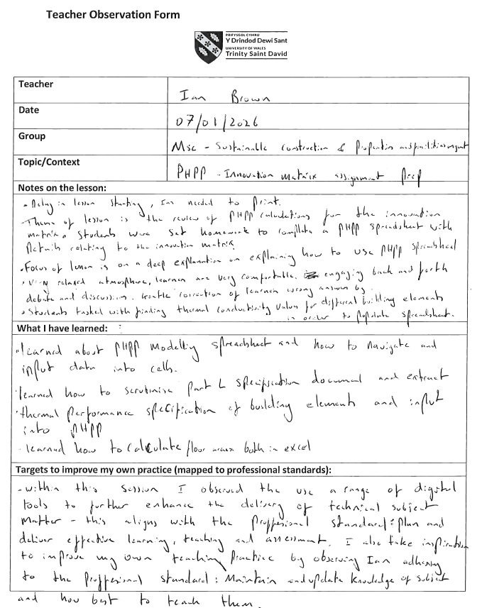

Teacher Observation Form – Lecturer Two
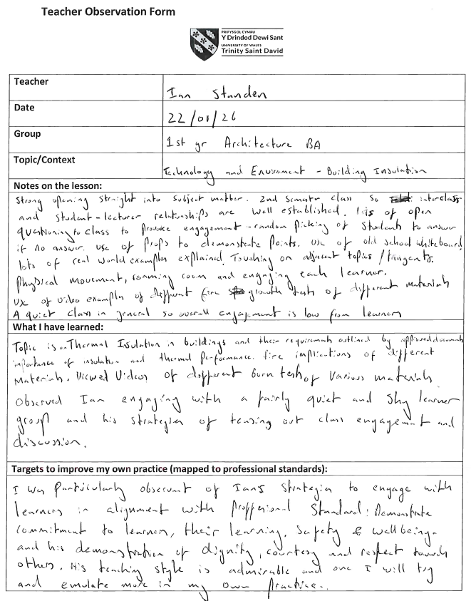

Teacher Observation Form – Lecturer Three


