The Fundamentals of Construction Technology

Assignment 2 – Construction Detailing
Lecturer: Juan A Ferriz-Papi
Student: Cai Gibbons
Student Number: 1907914
Course: Civil Engineering

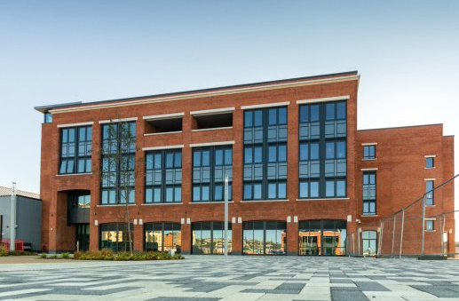

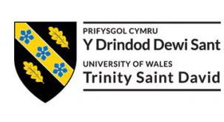

Contents

- - Introduction (Page 3)

- - Ground Floor (Page 3)

- - Level Floor (Page 3-4)

- - Openings (Page 4)

  - - Openings (Page 4)

- - Eaves (Page 5)

  - - Roof Covering (Page 5)

- - Roof Structure (Page 5-6)

  - - Roof Structure (Page 6)

- - Conclusion (Page 6)

- - Compliance with Building Regulations (Page 7-10)

  - - Compliance with Building Regulations (Page 11)

- - Reference List (Page 12)

- - Bibliography (Page 13-15)

- – Appendices (Page 15-20)

- Introduction
This report details how various parts of a new build would be constructed, with the aid of annotated sketches, concise construction methods and an explanation of how the constructors can comply with relevant building regulations. The focus of this report is the detailing of the ground floor, first floor, openings, eaves and roofs. Multiple annotated drawings are used for some aspects, easing the conveyance of these methods. The importance of understanding the methods outlined in this piece is significant as most developments in the construction sector will follow these, or similar methods in their builds. This shows a greater level of understanding of how buildings are constructed. Moreover, the understanding of building regulations in the construction sector is detrimental to the success and longevity of a build.
- Ground floor
Construction Method
The load bearing walls of a project are commonly referred to as sleeper walls. Sleeper walls are constructed on small foundations, known as strip foundations. These foundations allow the load of the floor to be transferred effectively to the ground. The sleeper walls will be used to secure joists at regular intervals throughout the floor. The distance between each joist is referred to as the span. The width of the span is determined by the size of timber used in the project. Recommend span sizes are found in ‘Span tables for solid timber members in floors, ceilings and roofs’ by TRADA. The joists must be placed at regular intervals to the required size of the room in order to avoid failure. Galvanised steel joist hangers can be used to secure the joist to the sleeper walls, rather than embedding the joists. Between the joist and the sleeper walls, a wall plate is placed. A damp proof course between the sleeper walls and the wall plate should be used. This prevents rising moisture from decaying the timber joists. In cases where it is not possible to use sleeper walls, joists should be suspended from the exterior walls of a room. To prevent the build-up of condensation, the sleeper walls should be constructed with gaps between the brickwork, underneath the joists. Possible solutions for this are the use of airbricks or a honeycomb brickwork bond. Ventilation is required to ensure that the timber stays dry, preventing decay. Vents should be installed in the exterior wall to allow this. To insulate the floor, blanket (often referred to as quilted) insulation can be implemented, using netting that is stapled to the joists. An alternative solution for this is using battens between the joists that can support rigid insulation. Adequate insulation is important as Pelsmaker (2017) estimates “between 10% and 25% of heat loss in homes is from the ground floor”. Above this, tongue and groove softwood flooring is to be laid. This method is supported by fig 1 and fig 3.
- Level Floor
Construction Method
Timber joists are to be imbedded in the wall, in an even placement throughout the floor. These joists must be accurately cut to length to support the full width of the blockwork. An even mortar joint of between 10mm and 15mm all the way around the sides and tops of the joist is required. A bead of silicon mastic between the blockwork and the joist must be used. Steel joist hangers should be used to secure the joist and blockwork, to add stability. Metal herringbone struts inserted between joists will prevent deflecting and wobbling. Netting can then be implemented between the joists, allowing insulation such as mineral wool to be laid. The Energy Saving Trust states that “this will save homes around £40 a year”. Above this, the tongue and groove floorboards can be laid. This method is supported by fig 2 and 3.
- Openings - Windows
Construction Method
In the case of a window being constructed in a wall that has already been built, a temporary wall will need to be built to support the load of the wall being modified. In the case of a new construction, the window can be constructed as the wall is being built, by leaving sufficient space in the brickwork. The exact starting point of where the windows are going to be constructed should be measured and determined. The placement of windows should be an informed decision, as Misiopecki (2018) explains “the window position has a crucial impact on the amount of energy lost through the thermal bridges”. The lintel should then be constructed, a steel stepped lintel to the outer leaf of the wall would be suitable. A cavity tray should be fixed to the lintel to avoid dampness permeating through the skin of the inner wall. The window frame should then be formed using two side jambs, a head jamb and a sill across the bottom. A jamb liner can be used to improve air tightness. Flashing is required for veneer in cavity walls. Flashing should be accompanied by weep holes to allow moisture to be released from the wall. Weep holes are to be placed directly above the flashing and extend to the drainage plane. Vents at the top of the drainage cavity should be installed to decrease dry times. Prefabricated UPVC windows can then be installed. Vapour resistant foil should be used around the windows as to ensure that all moisture is kept out of the building. See fig 3 and fig 4 for evidence.
  - Openings - Doors
Construction Method
Doors are to be constructed in the same format, but the brickwork above the door will need to be supported. This can achieved by using a larger, prefabricated lintel with strong structural strength. Alternatively, arched brickwork can be laid which will evenly disperse the load of the wall to the structure. The jamb on one side of the door will bear the weight of the doors, which is referred to as the hinge jamb. The other side, where the door latches, is referred to as the lock jamb. These jambs must be ensured to be accurately vertical as otherwise the door will not close tightly. The door jamb and the surrounding wall will need to be concealed by casing, referred to as architrave. This is conveyed in fig 10.

- Roof - Eaves
Construction Method
Eaves are the horizontal part of the roof that protrudes beyond the structure. Their functions include; providing shade, weather protection and aesthetic functions. The width of the eave is relative to the pitch of the roof. Closed, soffited eaves are to be constructed. A soffit is the panel that forms the underside of the eave, connecting it at a 90 ° angle with the exterior wall. The construction of the roof structure will allow an overhang, permitting closed eaves to then be constructed. Once the relevant amount of material has been determined and the soffit boards have been cut, channels can be formed in the fascia board and the exterior wall. The soffit board can be placed in these channels, ensuring it is perpendicular and not canted. The panels are to be held in place using small-headed nails driven into the fascia board. Once nailed, the soffit will expand over time into the receiving channels. The eaves must incorporate guttering, to promote surface run off and decrease moisture induced problems. Soffits must be ventilated, which can be through the roof structure. Unventilated soffits can lead to the formation of ice dams at eaves. Fig 5 supports this.
  - Roof - Roof Covering
Construction Method
Slate is to be laid to the double lap principle, with every slate course fixed to the battens by head or centre nailing. The double lap principle allows an overlap, which prevents water penetration and leakage. Battens are fixed to the roof structure, in straight consistent rows. This provides an anchorage for nails to secure the slate. Beneath the battens, rigid insulation can be implemented between them and the roof joists. Beneath this, blanket insulation is to be implemented, followed by a service void, then plasterboard and skim. The installation of roof covering should be completed by a competent fitter, as Pierpoint (2014) states “when failures occur they usually originate in flashings, attachment nails and faults in original installation”. Fig 6 conveys this method.
- Roof Structure – Main Roof
Construction Method
To allow for the desired storage space in the roof structure, a queen post truss is the best fitted solution. A queen post truss is a type of pitched roof support that uses two vertical tie posts connected between the tie beam and the rafters. The queen post truss has two vertical members, known as the queen posts. Once the tie beam and queen posts have been constructed, a straining sill is fitted on the tie beam and on the feet of the queen post. This reduces the thrust from the struts. The common rafters are then fitted to the queen post heads. Purlins are then laid on the principal rafters to support the common rafters and are fixed with cleats. The principal rafters, straining sill, straining beams and struts are in compression whereas the tie beam and queen posts are under tension. This allows for successful structural strength. A queen post truss can be constructed using timber or steel. Branco (2010) clarifies that “the misunderstanding of the overall behaviour of traditional timber trusses can result in incorrect strengthening interventions or, frequently, on their replacement”. This highlights that to avoid frequent repairs or replacement, timber strengths should be researched and understood thoroughly before construction. Fig 7 depicts this construction.
  - Roof Structure – Smaller Roof Structure
Construction Method
As indicated in the roof plan, there are two other roofs which will need to be constructed. As these roofs do not require storage space, it would be appropriate to use a king post truss. A king post truss is a triangular shaped roof truss, with a central vertical post that distributes tension to a support beam below. Once the tie beam is constructed, the king post is fixed in the centre. The head of the king post is fixed to the principal rafter, with a ridge board then embedded at the top of the king post, supporting the common rafters. Purlins are fixed to the principal rafter using cleats, which then support the common rafter. The struts are connected to the king post and principal rafters in an inclined direction. This is to prevent the sagging of the principal rafters. The tie beam secures the principal rafter and stops it from spreading as it is under thrust. The roof plan is displayed in fig 9. Fig 8 portrays the construction of a king post truss.
- Conclusion
The included construction methods, sketches and instruction on how to comply with relevant building standards contained in this document should allow the successful construction of a single, two storey detached domestic building with a loft room. The construction details that were to be solved, such as the detailing of the ground floor, first floor, openings, eaves and roofs have been addressed.

Regulation Document | Requirements | British Standard Regulations is Derived from | Compliance with Regulation | Cross-reference between Building Method and Drawings
Structure: Approved Document A. Under Section 2B: Sizes of certain timber members in floors and roofs for dwellings. | Guidance on the sizing of certain members in floors and roofs is given in ‘Span tables for solid timber members in floors, ceilings and roofs’. This is published by TRADA. | BS EN 1995-1-1:2004 Design of timber structures. | Members used in timber floors and roofs structures are constructed with the recommended span size from TRADA. | See Fig 1,2,6,7,9.  See Section 2.0, 3.0, 5.1, 6.0, 6.1.
Structure: Approved Document A. Under Section 2C: The Thickness of Walls in Certain Small Buildings. | Floors and Roofs should;  Be secured to the supporting walls by the connections specified in paragraph 2C35 and 2C36. | BS EN 845-1:2003+A1:2008  Specification for ancillary components for masonry. Ties, tension straps, hangers and brackets. | Floors and Roof are secured using galvanised steel joist hangers. | See Fig 3.  See Section 2.0, 3.0.
Structure: Approved Document A. Section 4: Roof Covering. | All Materials used to cover a roof should be capable of safely withstanding the concentrated imposed loads upon roofs. | Specified in BS EN 1991-1-1:2002. Eurocode 1. Actions on structures. General actions. Densities, self-weight, imposed loads for buildings. | All materials used in the covering of the roof (natural slate) can withstand the imposed loads of the roof. | See Fig 5,6.  See Section 5.1.
Structure: Approved Document A. Section 4: Roof Covering. | Roofing can be designed to protect a building from precipitation by holding the precipitation at the face or by stopping it from penetrating beyond the back of the roofing system. | BS 8000-6:2013  Workmanship on building sites. Code of practice for slating and tiling of roofs and claddings. (partially replaced but current). | The natural slate covering prevents precipitation from penetrating beyond the back of the roof system. | See Fig 5,6.  See Section 5.0.
- Compliance with Building Regulations
https://www.gov.uk/
https://www.bsigroup.com/en-GB/

Regulation Document | Requirements | British Standard Regulation is Derived from | Compliance with Regulations | Cross-reference between Building Method and Drawings
Site preparation and resistance to contaminates and moisture: Approved Document C:  Joint between doors and windows. Section 5.29. | The joint between walls and door/window frames should;  a) Resist the penetration of precipitation to the inside of a building; and  b) Not be damaged by precipitation and not permit precipitation to reach any part of the building which would be damaged by it. | BRE IP 1/06 Assessing the effects of thermal bridging at junctions and around openings. | The use of weatherstripping, weep holes and flashing with the professional construction of openings satisfies this criterion. | See Fig 3,4.  See Section 4.0, 4.1.
Site preparation and resistance to contaminates and moisture: Approved Document C:  Joint between doors and windows. Section 5.30 | Damp-proof course should be provided to direct moisture towards the outside of the building:  a) Where the downward flow of moisture would be interrupted at an obstruction (e.g. a lintel);  b) Where sill elements do not form a complete barrier to transfer precipitation;  c) Where reveal elements do not form a complete barrier to the transfer of rain and snow. | BRE IP 1/06 Assessing the effects of thermal bridging at junctions and around openings. | Damp-proof course is provided at openings. | See Fig 3,4  See Section 4.0, 4.1.
https://www.gov.uk/
https://www.bsigroup.com/en-GB/

Regulation Document | Requirements | British Standard Regulation is Derived from | Compliance with Regulations | Cross-reference between Building Method and Drawings
Site preparation and resistance to contaminates and moisture: Approved Document C:  Suspended Timber Ground Floors (Moisture from the ground) Section 4.13 | Any suspended timber floor next to the ground will meet the requirement if:  a) the ground is covered so as to resist moisture and prevent plant growth; and  b) there is a ventilated air space between the ground covering and the timber; and  c) there are damp-proof course between the timber and any material which can carry moisture from the ground. | BS 8215:1991  Code of practice for design and installation of damp-proof courses in masonry construction. | The ground is covered in hardcore to resist moisture and plant growth, there is a ventilated space between ground covering and timber, as well as damp-proof course where timber is in contact with moisture absorbent materials. | See Fig 1.  See Section 2.0.
Material and workmanship: Approved Document 7. | a) Materials are of a suitable nature and quality in relation to the purposes and condition of their use.  b) Workmanship is such that, where relevant, materials are adequately mixed or prepared and applied, used or fixed so as to perform adequately the functions for which they are intended. | BS EN ISO 9001 Quality Management Systems (2008). | All materials used are suitable for their purpose and condition of use. The materials used can adequately perform their intended functions. | See Fig 1-10.  See Section 2.0-6.1.
https://www.gov.uk/
https://www.bsigroup.com/en-GB/

Regulation Document | Requirements | British Standard Regulation is Derived from | Compliance with Regulations | Cross-reference between Building Method and Drawings
Structure: Approved Document A. Section 4: Roof Covering. | Timber battens and counter battens should be of the following species:  a) British-grown  • larch  • British pine  • British spruce  b) imported:  • redwood  • whitewood  • spruce-pine-fir (USA, Canada)  • southern pine (USA). Timber batten size chart provided should also be followed. | BS 5534:2014+A2:2018  Slating and tiling for pitched roofs and vertical cladding. Code of practice. | The timber battens used are produced from British pine. They were sized in accordance with the timber batten size chart given in section 4. | See Fig 6  See Section 5.1.
Building Regulations Approved Document Part M Section 2B. | The masonry above the lintel should be built in accordance with BS EN 1996-2:2006. | BS EN 1996-2:2006  Eurocode 6. Design of masonry structures. Design considerations, selection of materials and execution of masonry. | The masonry above all lintels was built in accordance to the relevant standard. | See Section 4.0, 4.1.
Structure: Approved Document A. Section 2C36 | Vertical strapping at least 1m in length should be provided at eaves at intervals not exceeding 2m if the roof has a) a pitch of 15 ° or more, and  b) Is tiled or slated | BS EN 845-1:2001  Specification for ancillary components for masonry. Ties, tension straps, hangers and brackets. | As natural slating is used to cover the roof, vertical strapping over 1m in length was fitted at eaves, at intervals of 1.5m. | See Fig 5.
https://www.gov.uk/
https://www.bsigroup.com/en-GB/

  - Compliance with Building Regulations - Fire Safety
Regulation Document | Requirements | British Standard Regulation is Derived from | Compliance with Regulations | Cross-reference between Building Method and Drawings
Fire safety: Approved Document B (fire safety) Volume 1: Dwellings, 2019 Edition.  Section 1: Fire detection and alarm systems. | All dwellings should have a fire detection and alarm system, minimum Grade D2 Category LD3 standard, in accordance with the relevant recommendations of BS 5839-6. | BS 5839-6. Recommendations on planning, design, installation, commissioning and maintenance of fire detection and fire alarm systems in domestic premises. | The build will be fitted with a fire detection system with a minimum grade of D2. | N/A
Fire safety: Approved Document B  Approved Document B (fire safety) Volume 1: Dwellings, 2019 Edition  Section 1: Fire detection and alarm systems. | Smoke alarms should be mains operated and conform to BS EN 14604. | BS EN 14604. The requirements, test methods, performance criteria, and manufacturer's instructions for smoke alarms for household or similar residential application. | All smoke alarms fitted will be mains operated and conform to the relevant standard. | N/A
Fire safety: Approved Document B  Approved Document B (fire safety) Volume 1: Dwellings, 2019 Edition. Requirement B4 – part b. | The materials used to construct external walls, and attachments to them, and how they are assembled do not contribute to the rate of fire spread up the outside of the building. | BS EN 15102:2019  Wall coverings. | The chosen materials for external walls and wall coverings does not contribute to the rate of fire spread. | N/A
https://www.gov.uk/
https://www.bsigroup.com/en-GB/

9.0- Reference List
British Standards
Author – British Standards Institute
Website - https://www.bsigroup.com/en-GB/

Building Regulations Approved Documents (2020)
Author – Gov.uk
Website - https://www.gov.uk/government/collections/approved-documents

Construction and Building Materials. Structural analysis of two King-post timber trusses: Non-destructive evaluation and load-carrying tests. (2010)
Author – Jorge M Branco
Academic Journal

Energy and Buildings Volume 158 (2018) “Thermal modelling and investigation of the most energy-efficient window position”.
Author – Cezary Misiopecki
Academic Journal

Span Tables for Timber
Author – TRADA
Website - https://www.trada.co.uk/ad-hoc/span-tables/

The Energy Saving Trust
Author – Anon
Website - https://energysavingtrust.org.uk/home-insulation/floor

The Journal of Preservation Technology (2014)
Author – Pierpoint and Robert N
Academic Journal
10.0- Bibliography
Span Tables for Timber
Website - https://www.trada.co.uk/ad-hoc/span-tables/ - Accessed 28th of March 2020.

The Energy Saving Trust
Website - https://energysavingtrust.org.uk/home-insulation/floor - Accessed 7th of April 2020.

Energy and Buildings Volume 158 (2018) “Thermal modelling and investigation of the most energy-efficient window position”.
Author – Cezary Misiopecki
Academic Journal

The Journal of Preservation Technology (2014)
Author – Pierpoint and Robert N
Academic Journal

Construction and Building Materials. Structural analysis of two King-post timber trusses: Non-destructive evaluation and load-carrying tests. (2010)
Author – Jorge M Branco
Academic Journal

Building Regulations Approved Documents
Website - https://www.gov.uk/government/collections/approved-documents - Accessed 10th of April 2020

British Standards
Website - https://www.bsigroup.com/en-GB/ - Accessed 10th of April 2020

Queen Post Truss Construction
Website - http://www.builderbill-diy-help.com/queen-post-truss.html - Accessed 5th of April 2020.

Window Installation
Website - https://www.windows24.com/windows/instructions/install/new-construction.php - Accessed 3rd of April 2020

Flashing and Lintel
Website - https://www.masonrymagazine.com/blog/2018/02/01/the-ins-and-outs-of-masonry-flashing/ - Accessed 12th of April 2020.

Closed Eave Construction
Website - https://extremehowto.com/soffits-up-close/ - Accessed 14th of April 2020.

Kings Post Truss Construction
https://www.hunker.com/12588800/how-to-design-a-king-post-truss - Accessed 12th of April 2020.

Suspended Timber Floor Construction
https://www.diydoctor.org.uk/projects/hollowfloor.htm - Accessed 8th of April 2020

Timber Floor Construction
https://www.homebuilding.co.uk/floor-structure-guide/ - Accessed 9th of April 2020.

Joist Hangers
https://www.doityourself.com/stry/how-to-install-masonry-joist-hangers Accessed 9th of April 2020.

Exterior Doors
https://www.jeld-wen.co.uk/advice/fitting-and-installation/how-to-fit-an-exterior-door - Accessed 19th of April 2020.

11.0- Appendices

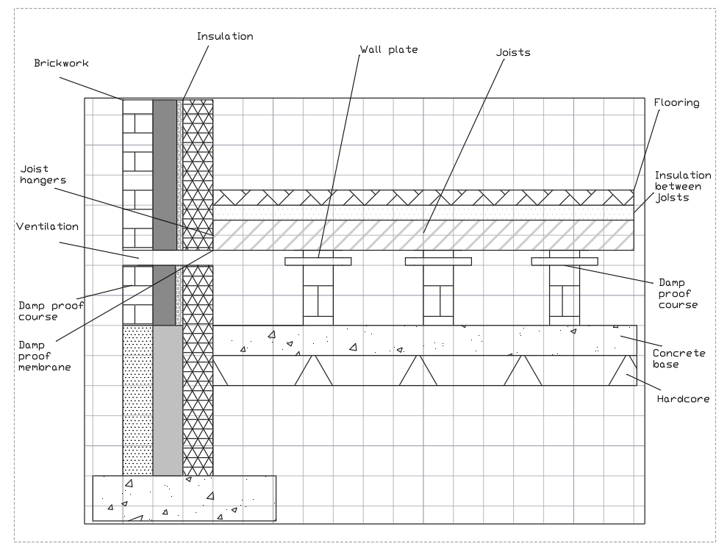

Fig 1 – Suspended Timber Floor

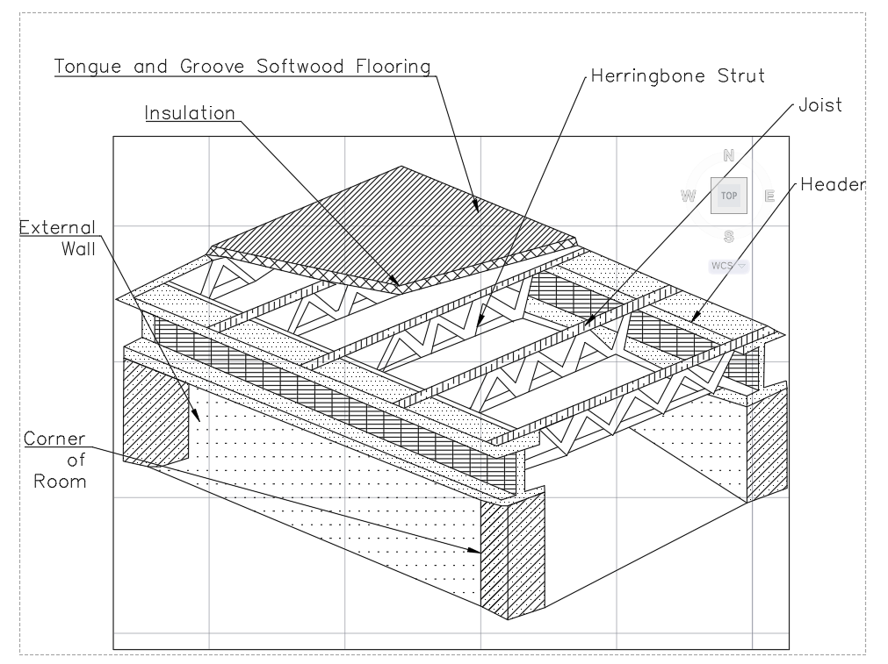
Fig 2 – Timber Level Floor
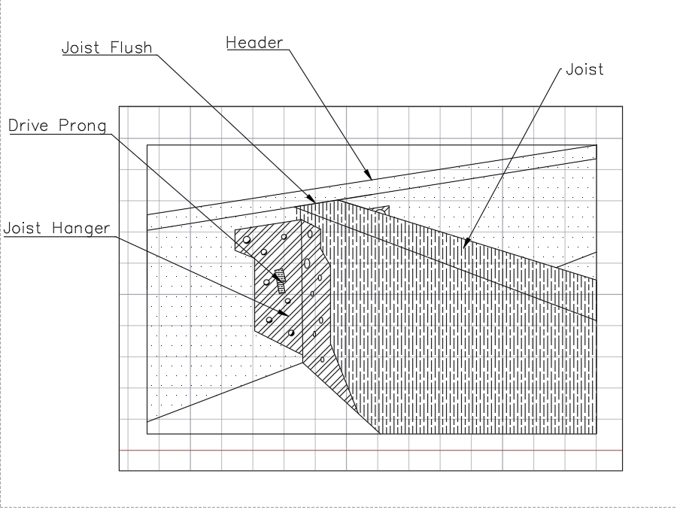

Fig 3 – Joist Hanger
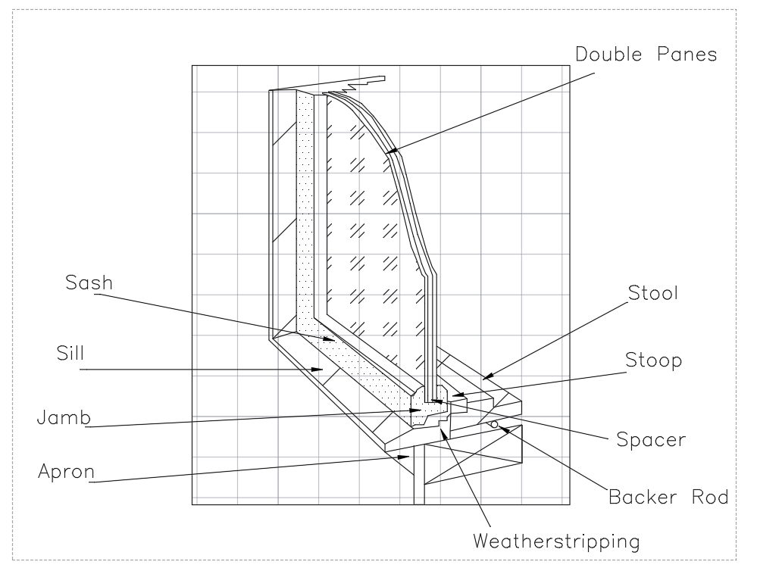
Fig 3 – Window Design
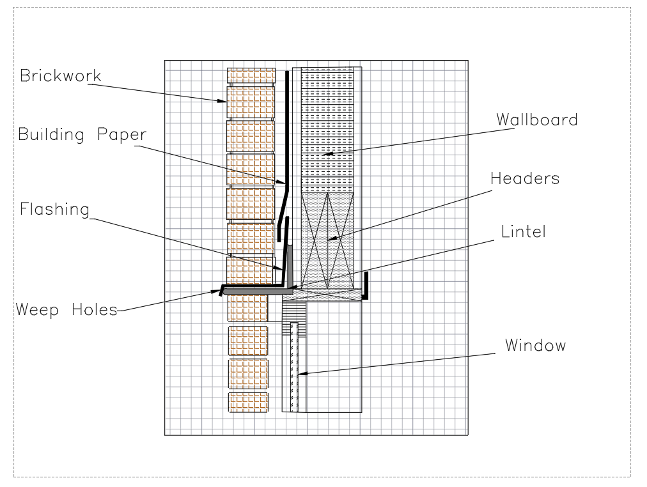
Fig 4 – Window to Wall Design

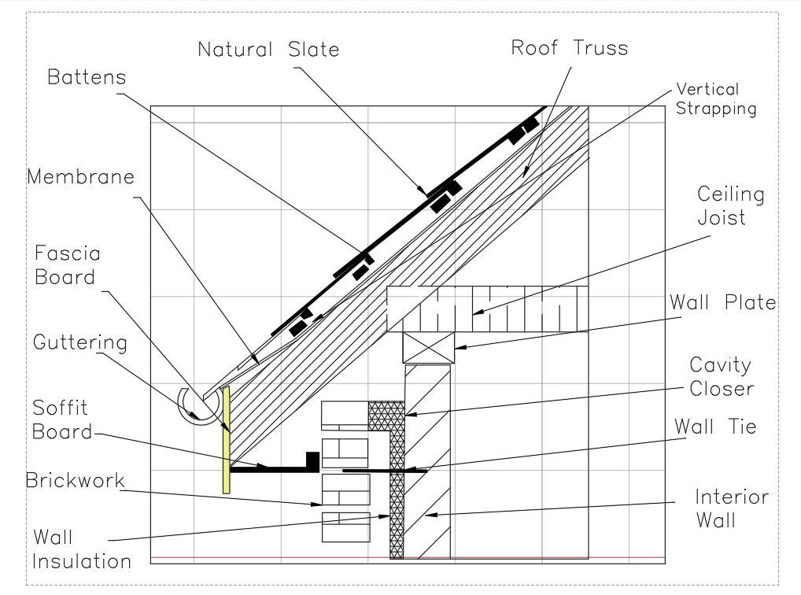
Fig 5 – Closed Eave
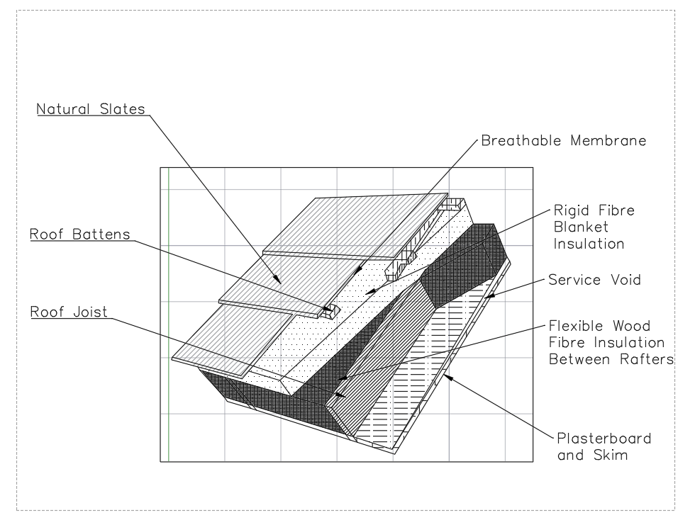
Fig 6 – Roof Covering

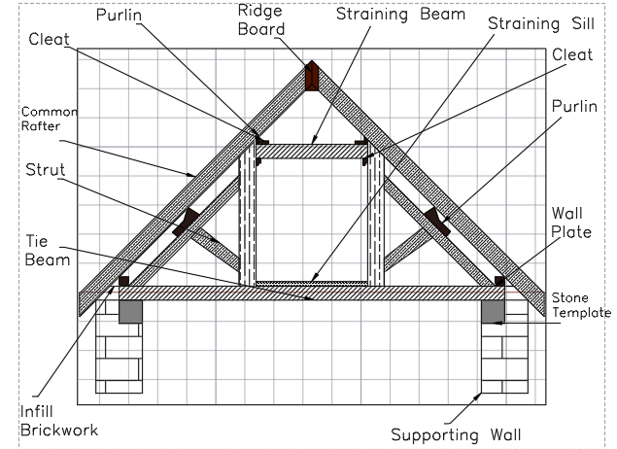
Fig 7 – Queen Post Truss
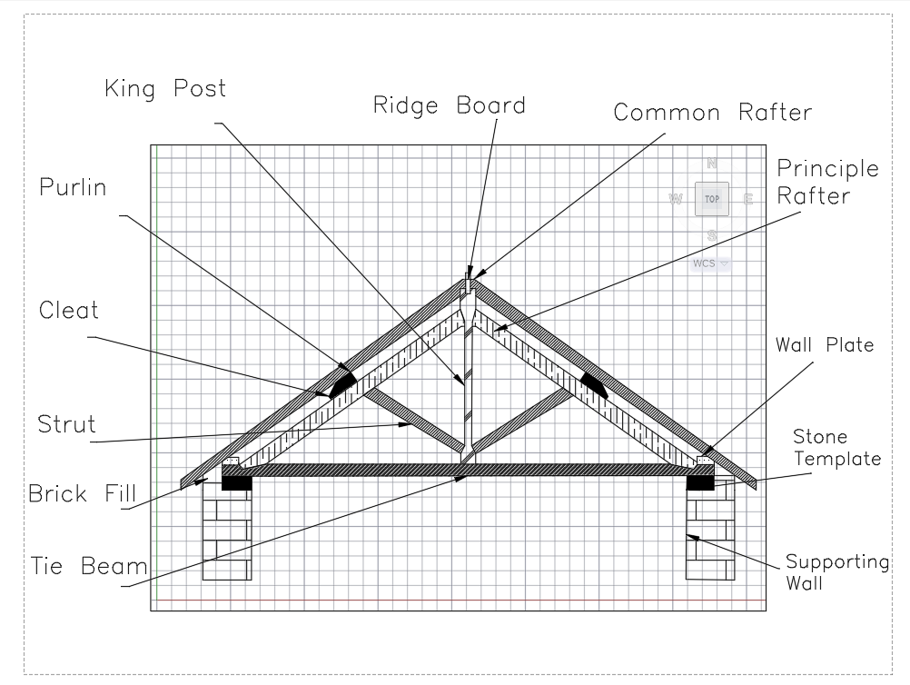
Fig 8 – King Post Truss

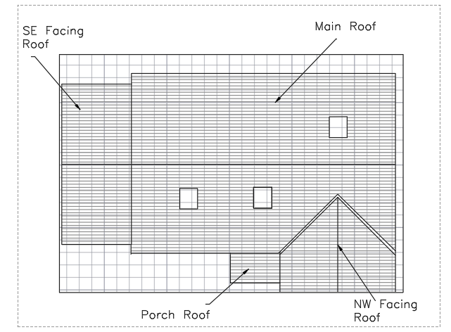
Fig 9 -Roof Plan
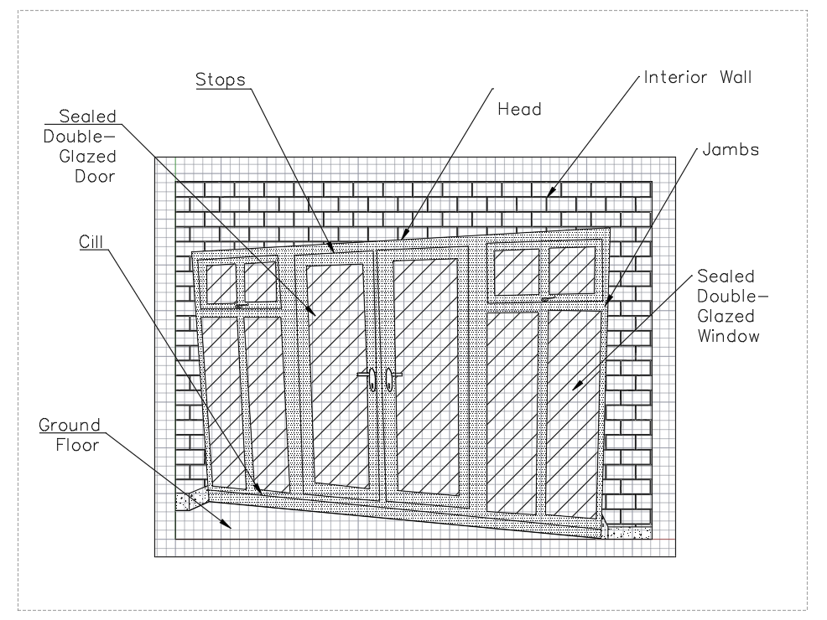
Fig 10 – Exterior Doors

