DS 1 Template

My Screenshots/Photos – Osei Yaw Bonsu

Screenshot/Photo 1
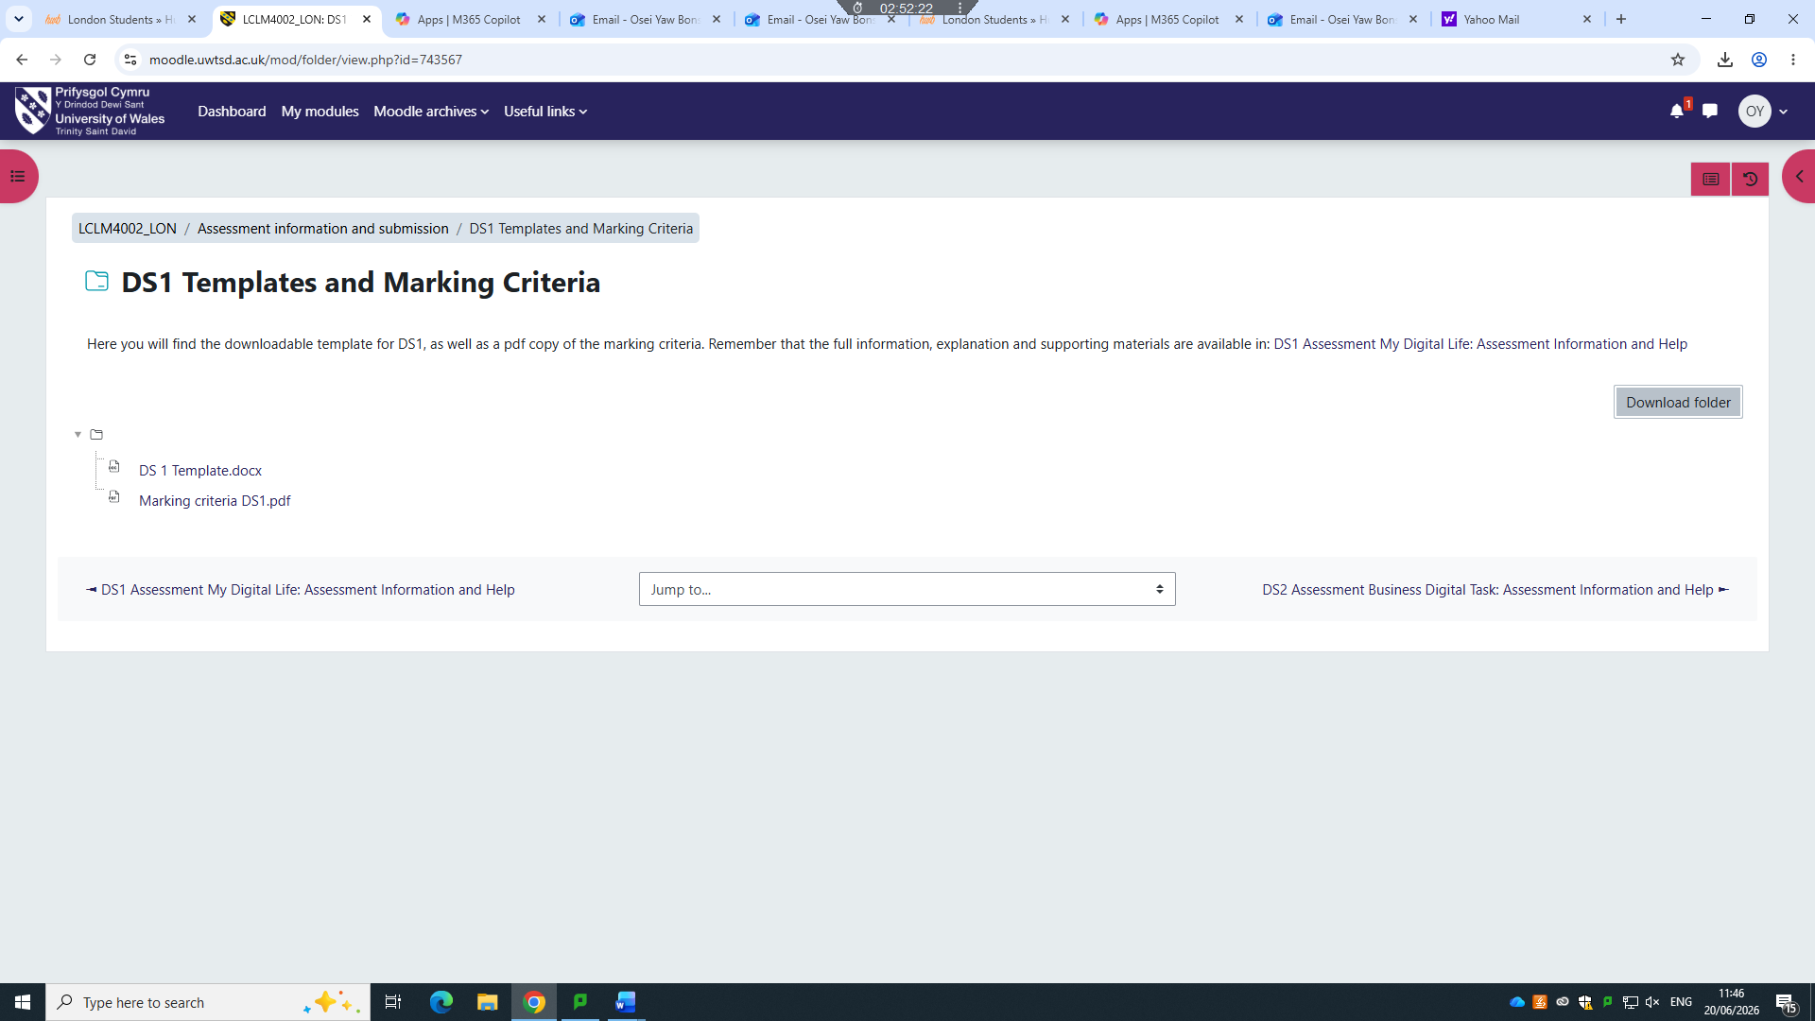
I log in to this page to download it to complete my work for my fist digital skills assessment

Screenshot/Photo 2
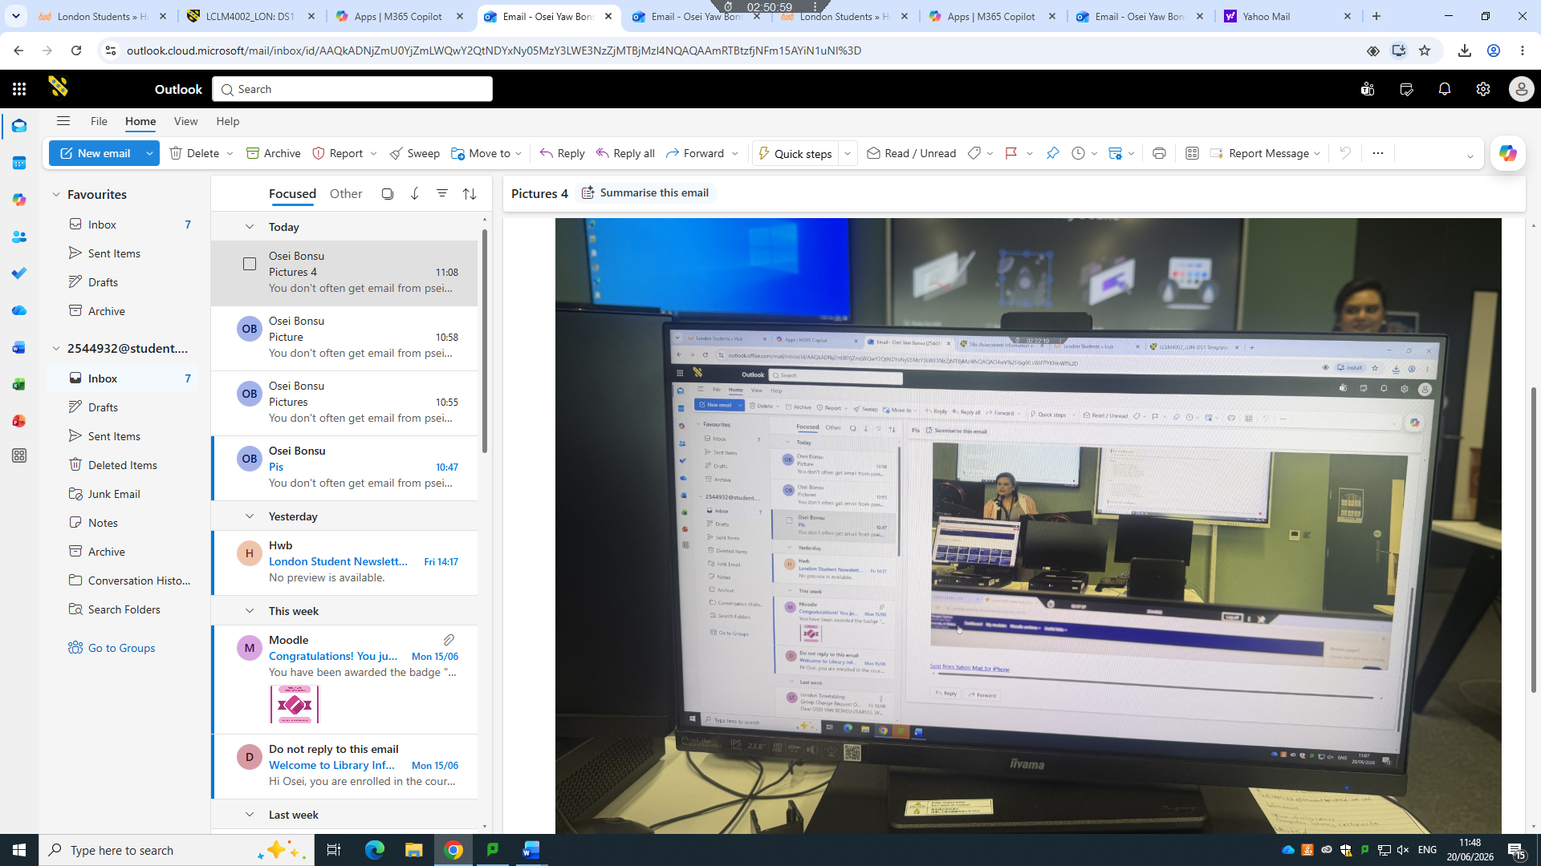
In classroom to study at university I use digital technology and the teacher shares the digital screen with us

Screenshot/Photo 3
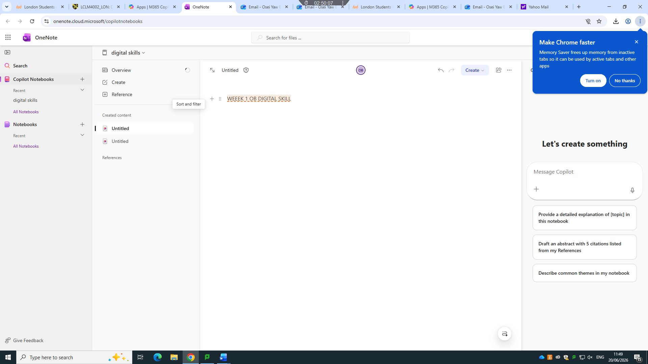
Today in class I learn one note and I use one note to write my notes, this avoids me to carry pen and paper

Screenshot/Photo 4
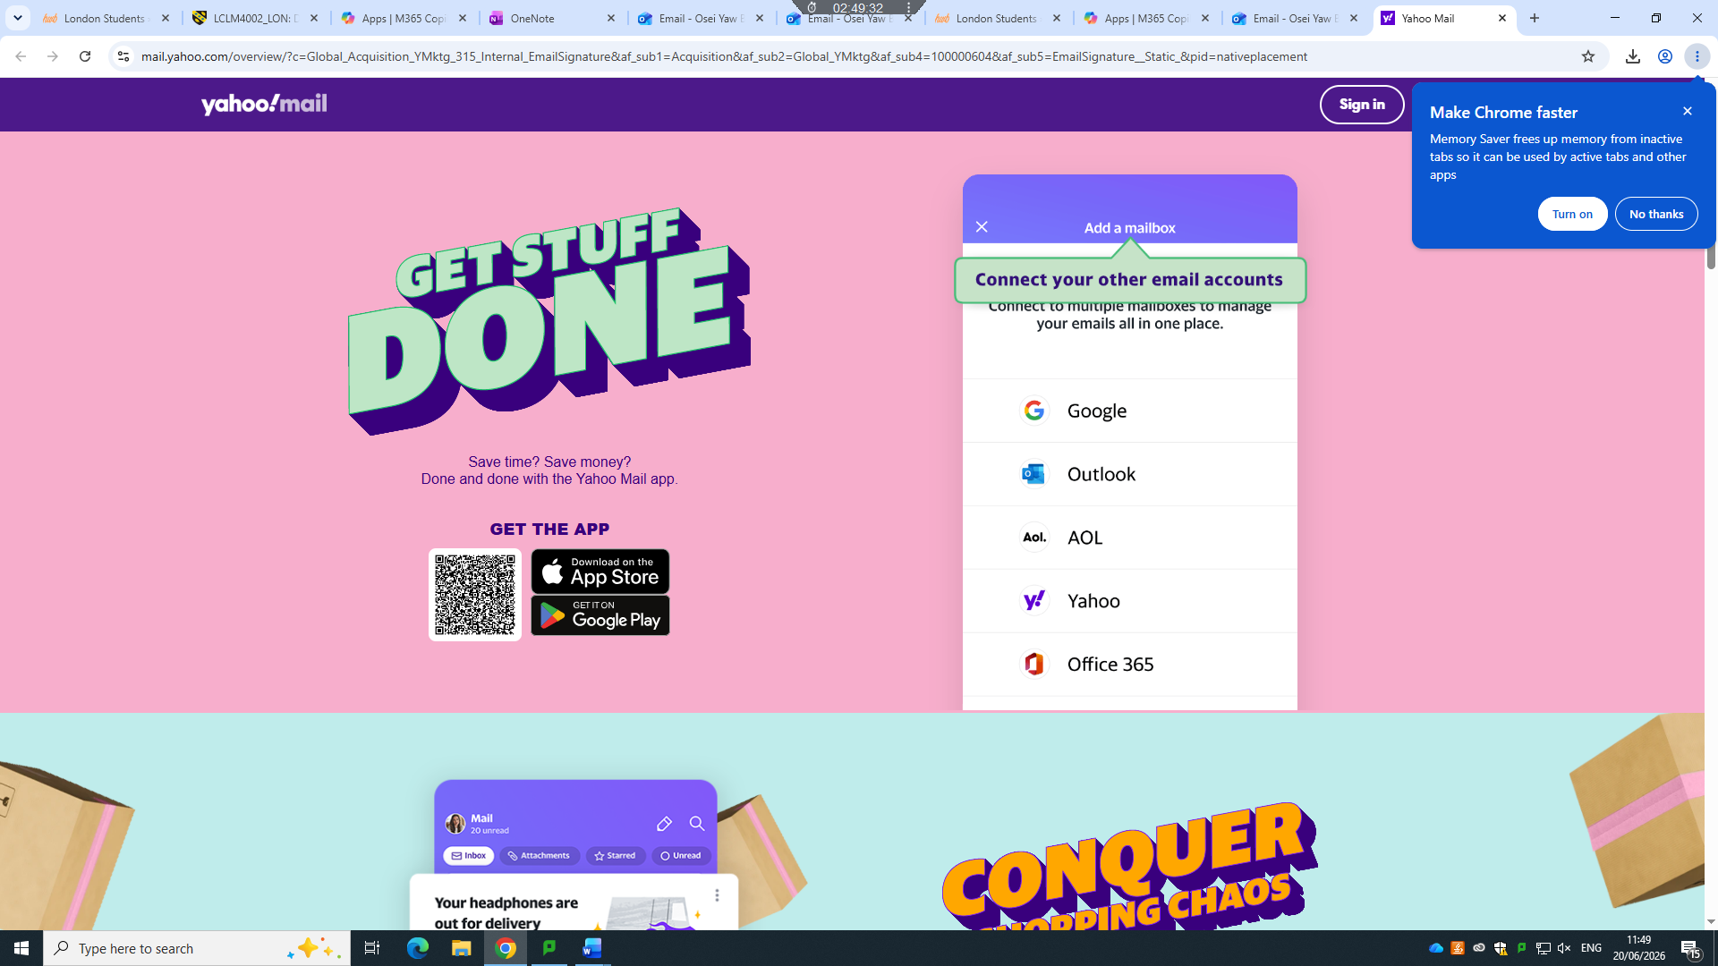
I use Yahoo for personal emails to send to and friends

