

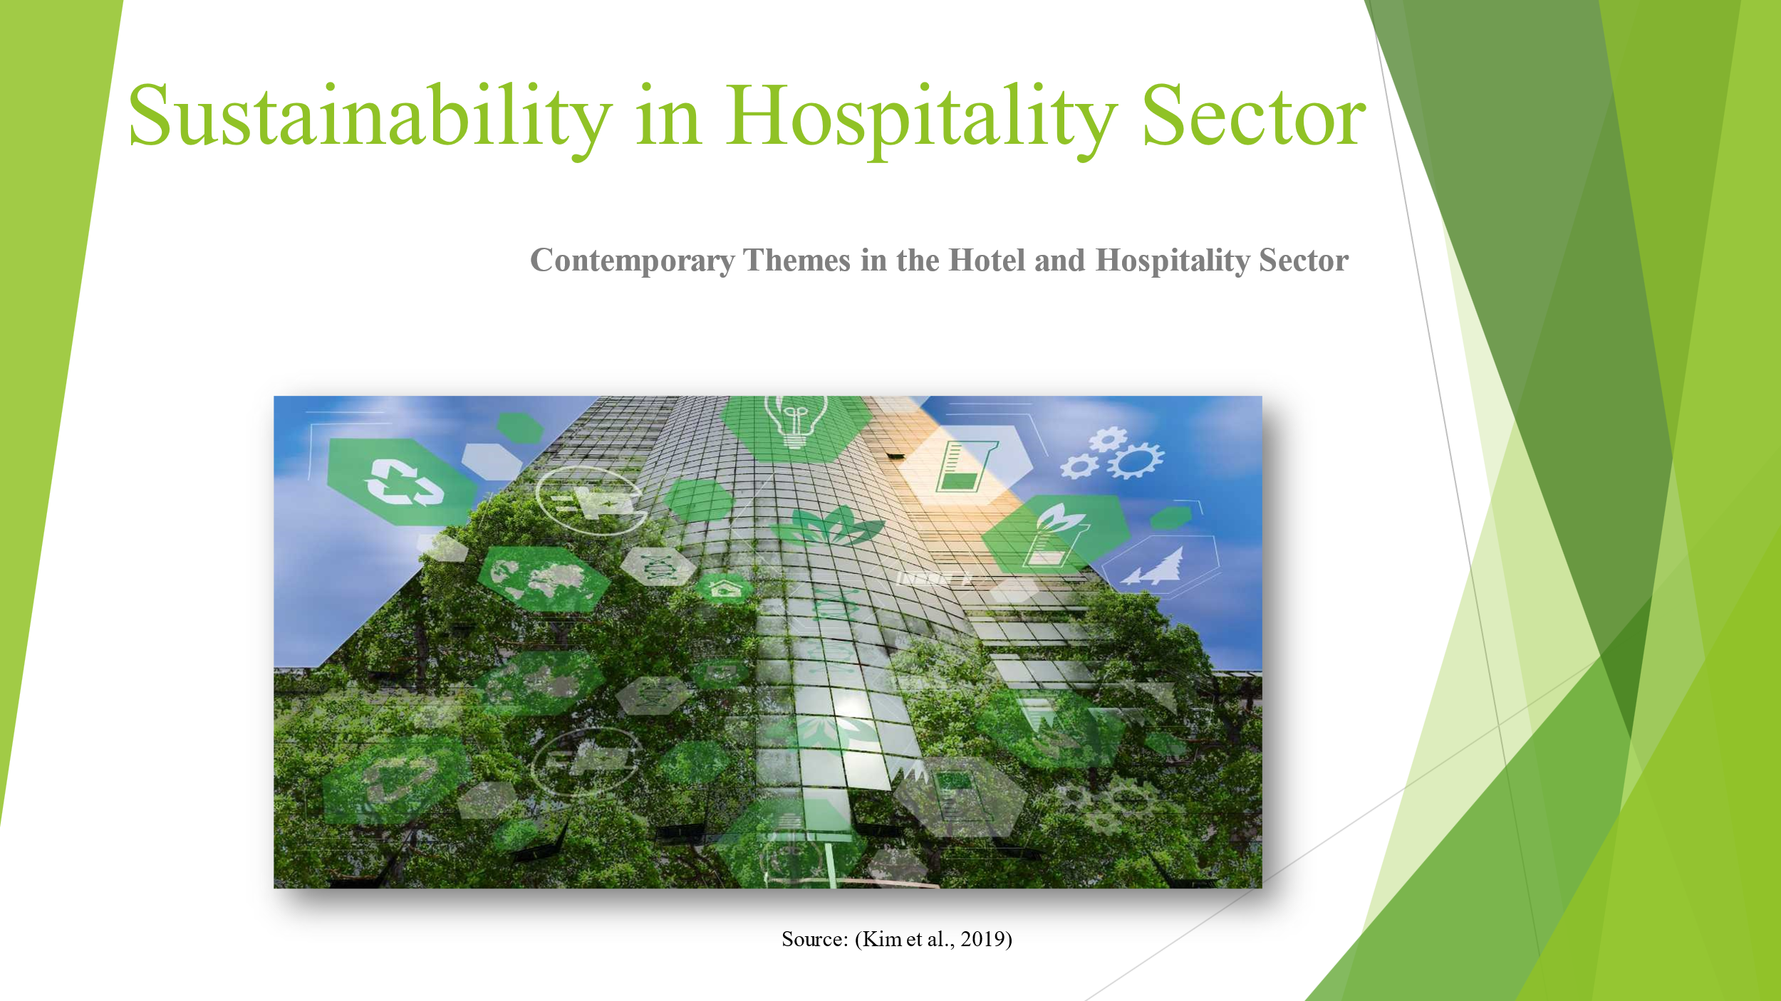
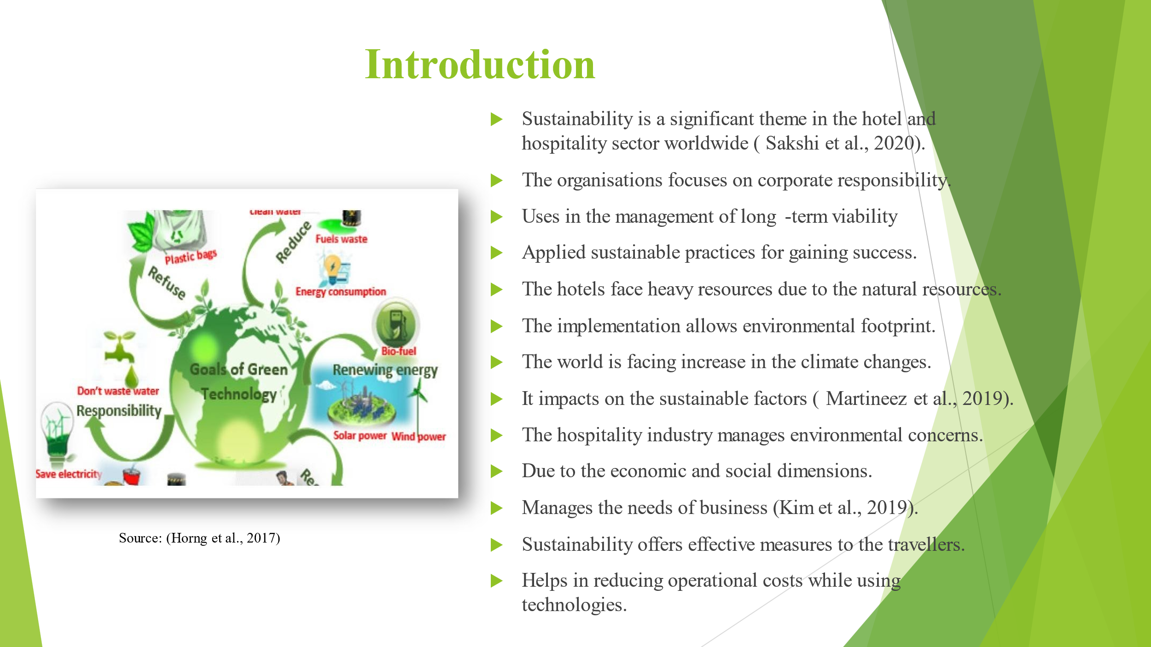

Sustainability is a significant theme in the hotel and hospitality sector worldwide. The organisations focus on corporate responsibility and management of long-term viability for the sustainable practices. The hotels face heavy resources due to the natural resources and the implementing environmental footprint. The world is facing increase in the climate changes that impact on the sustainable factors. Therefore, the hospitality industry manages environmental concerns based on the economic and social dimensions to fulfil the needs of business. Sustainability offers effective measures to the travellers and reducing operational costs while using technologies.
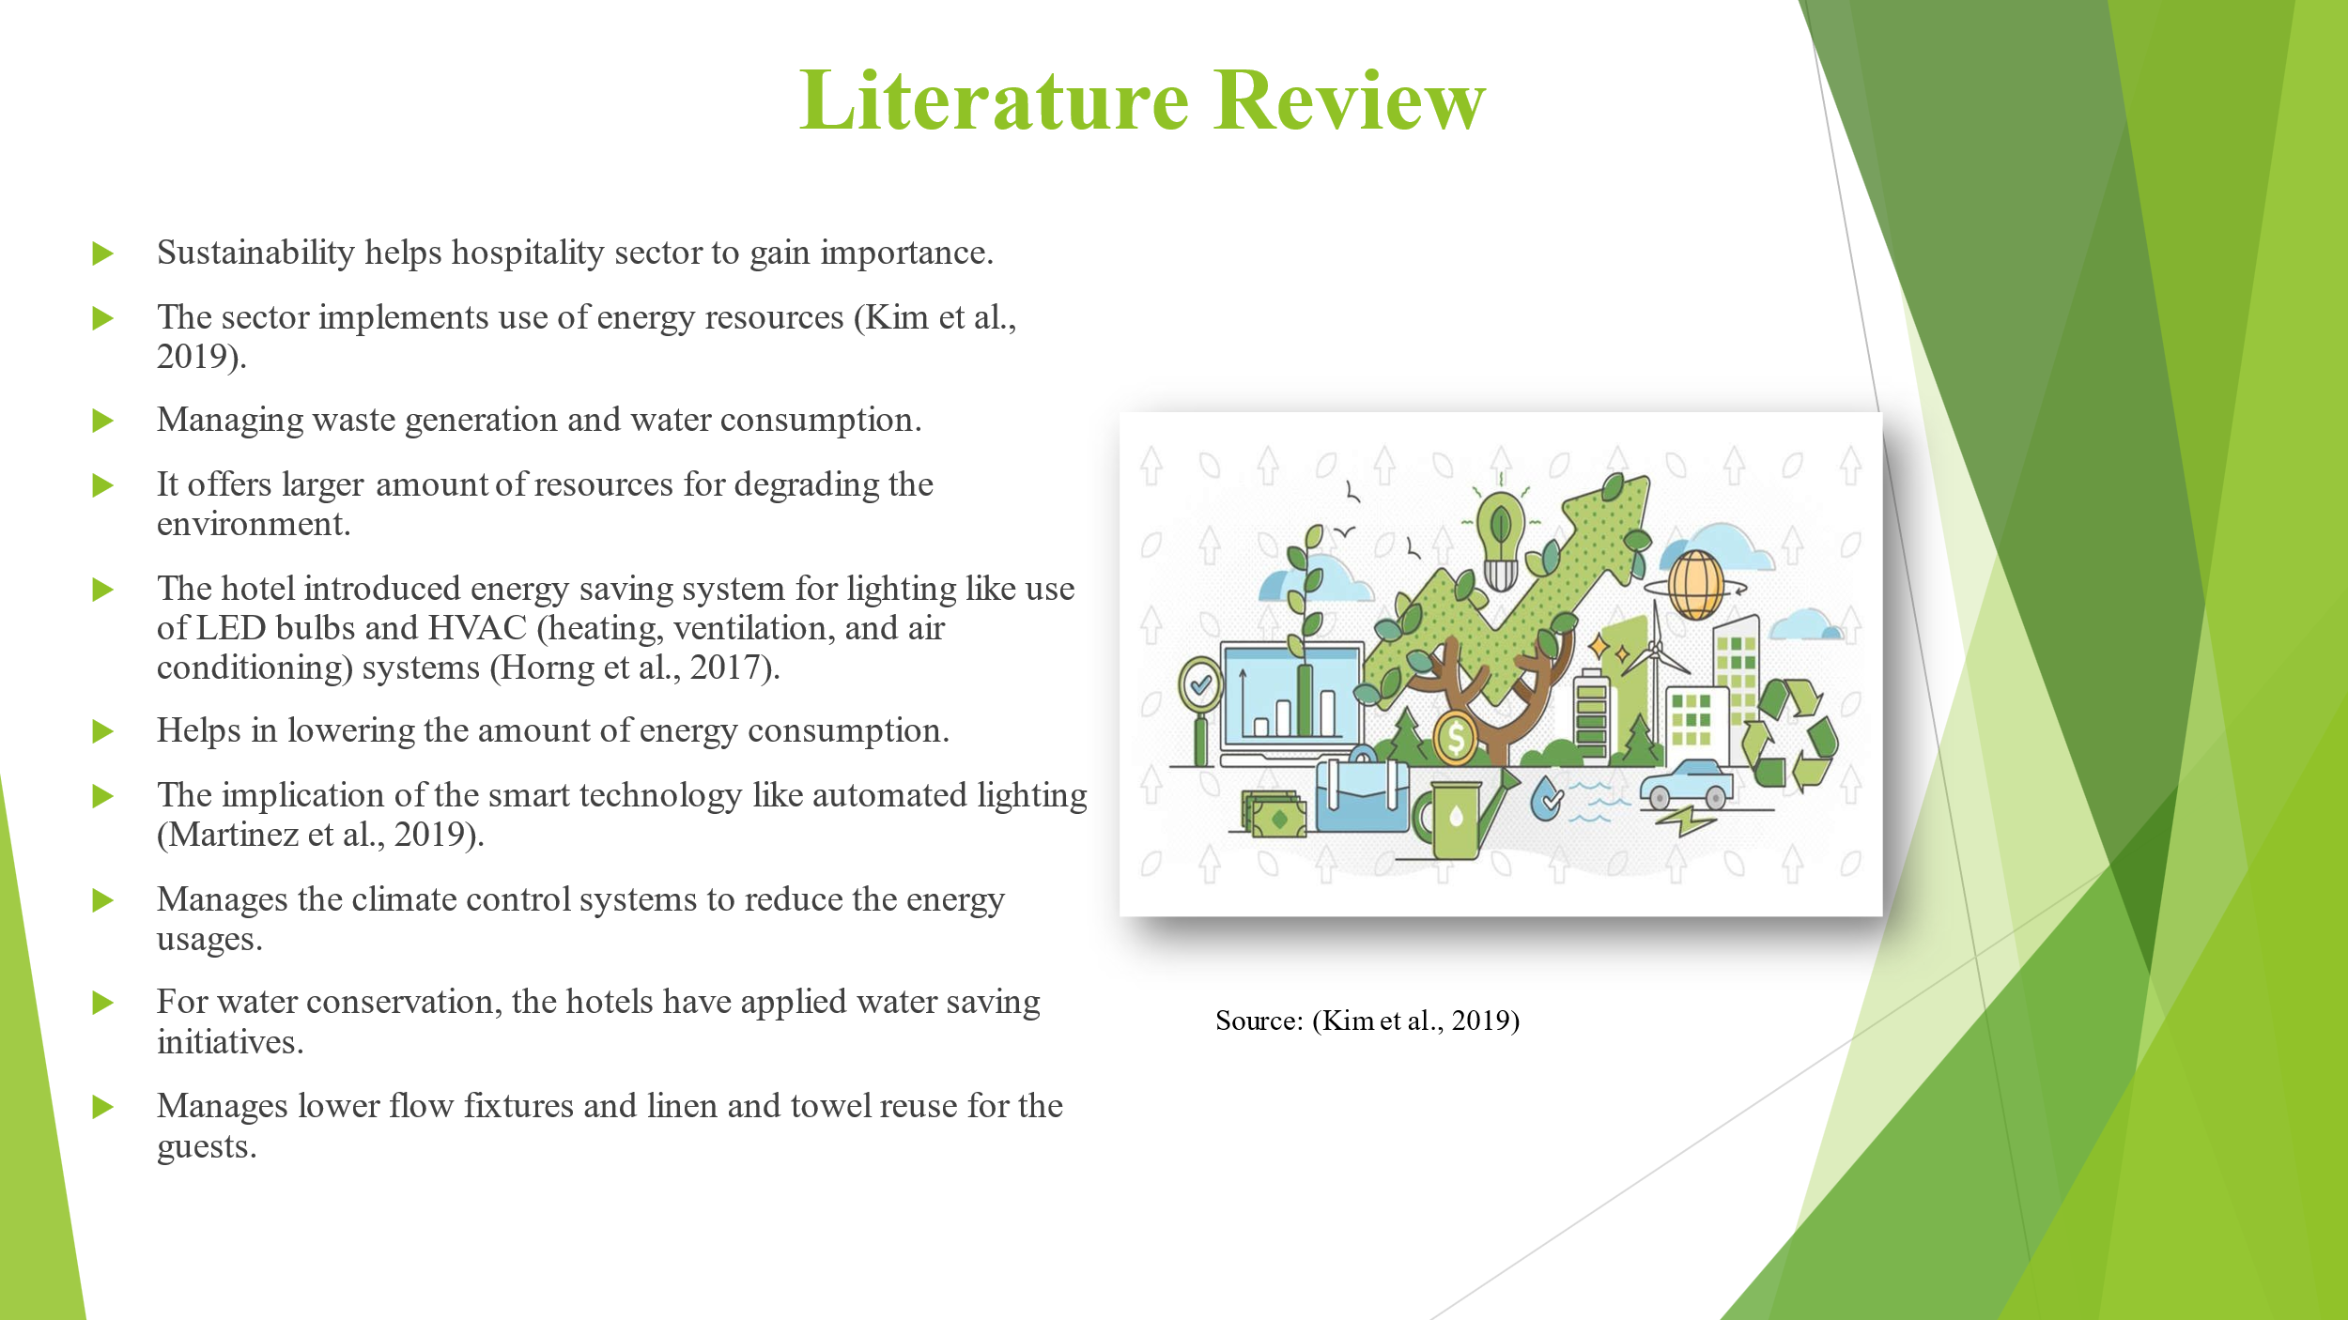
Sustainability is one of the factors for hotel and hospitality sector to gain importance and success in the international industry. The sector implements use of energy resources, managing waste generation, and water consumption to gain efficiency. It offers larger amount of resources that are degrading the environment. The hotel introduced energy saving system for lighting like use of LED bulbs and HVAC (heating, ventilation, and air conditioning) systems for lowering the amount of energy consumption. The implication of the smart technology like automated lighting and climate control systems helps in reducing the energy usages in rooms and hotels. For water conservation, the hotels have applied water saving initiatives that identifies efficient irrigation, lower flow fixtures, and linen and towel reuse for the guests.
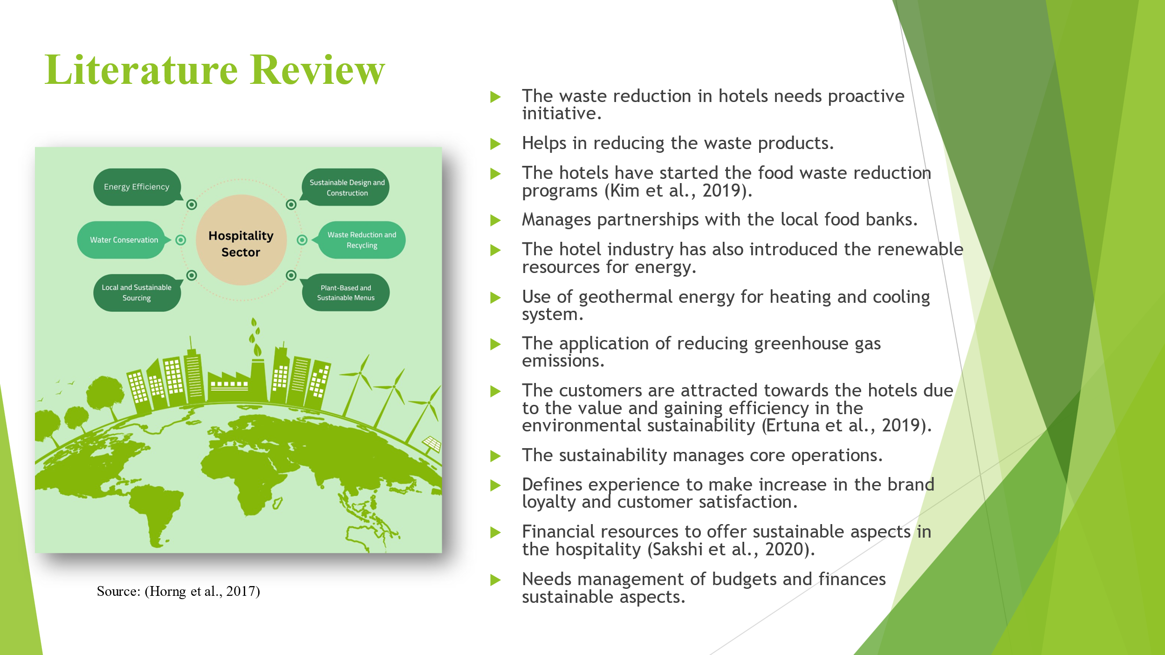

For managing waste reduction in hotels, the management has applied proactive initiative to eliminate the waste products. The hotels have started the food waste reduction programs with partnerships with the local food banks for the management of the surplus food. The hotel industry has also introduced the renewable resources for energy, the initiative of geothermal energy is applied for providing heating and cooling system. The application of reducing greenhouse gas emissions, the renewable energy sources helps in managing energy supply in the stable and predictable manner. It helps hotels while consuming higher costs of energy costs. CSR and sustainability are also inter-related to each other. The customers are attracted towards the hotels due to the value and gaining efficiency in the environmental sustainability. The sustainability manages core operations and manage experience to make increase in the brand loyalty and customer satisfaction. Financial resources to offer sustainable aspects in the hospitality is one of the greater challenges for the management. The hospitality industry needs efficiency in managing budgets and finances for implementing sustainable aspects for successful outcomes.
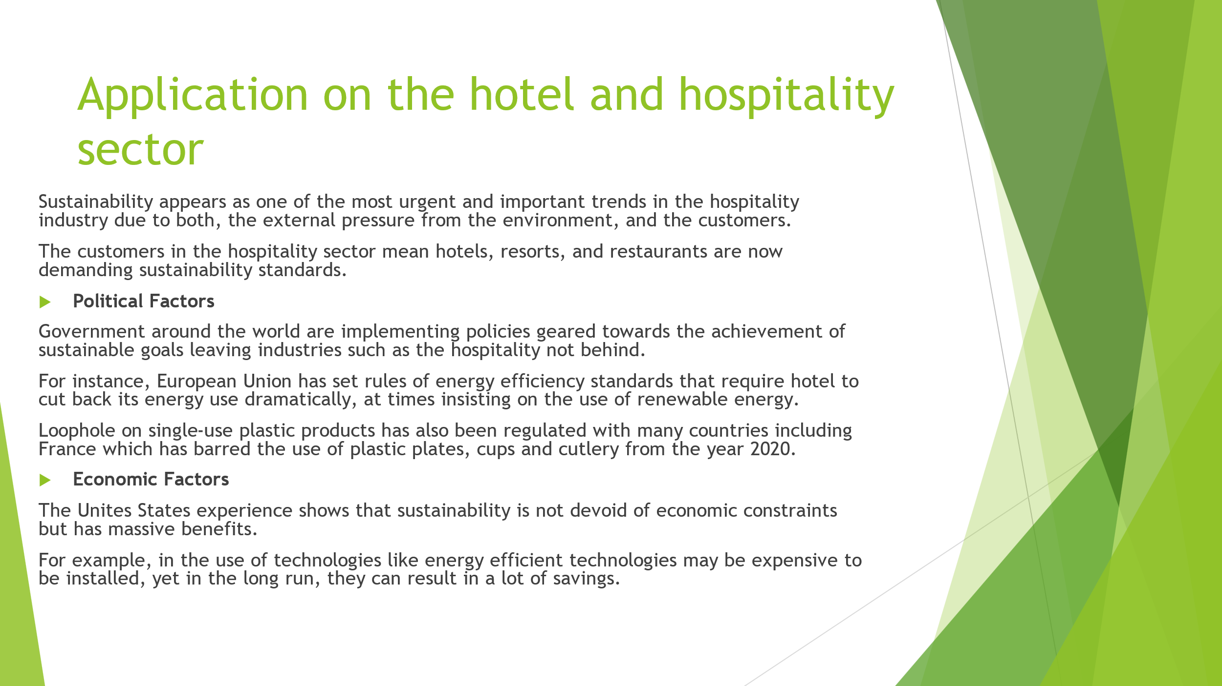
This includes, resource utilization, minimizing wastage, and the impact they have on the environment. In turn, many hotels and restaurants have gone for biodegradable products or have developed elaborate recycling policies. That UK plans to reach the non- emission of greenhouse gases by 2050 is another driving force as it challenges the hospitality industry to advance radically insofar as energy and waste management is concerned . Both operational approaches to business and investments, as well as marketing strategies within the industry, are impacted by these political directives. This shift affects the costing strategies because sustainable hotels achieve high pricing because of the choice customers make. The survey conducted by the Sustainable Travel International shows that 60% of people who travel to the USA are willing to spend more money for green hotels. These economic globes steps show that it is not always wrong to spend more upfront when it comes to sustainable practices in the hospitality industry since there will always be long – term cost savings. According to a report by the International Energy Agency, hotel could reduce energy costs by up to 20% using updated technologies in heating and cooling. also the reflective and burgeoning discipline of eco-tourism has also been observed to have high-growth demands with the global eco-tourism revenues ballooning by 20% every year.
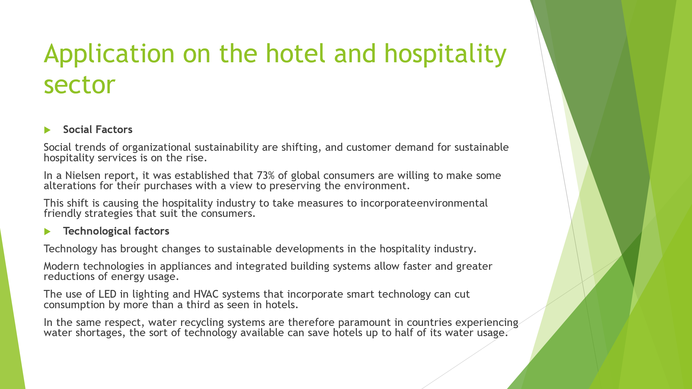

The first aim is to identify the effects that sustainability has on the overall business success in the hospitality industry focusing on, brand loyalty and hotel/restaurant reputation. For instance, a survey that Booking.com conducted showed that as much as 70% of global travellers said that they’d be predisposed to book an accommodation that had an eco-friendly policy regardless of whether or not they began the search for the accommodation with the intent of finding one that offered a sustainable stay. They have done so by incorporating sustainable features into the branding and the business approaches use in the industry, which has impacted greatly on consumer preference as well as the success of the competitive advantage. These integrations not only make it easier to achieve sustainable solutions but also are often considerably cheaper than traditional ones over the long-term. These technologies have been proved time and again to be cost effective in use endowed with potentiality of generating return on investment within few years at best and in the process creating economy in usage of resources thus making these technologies economic and ecological best bets for investment.
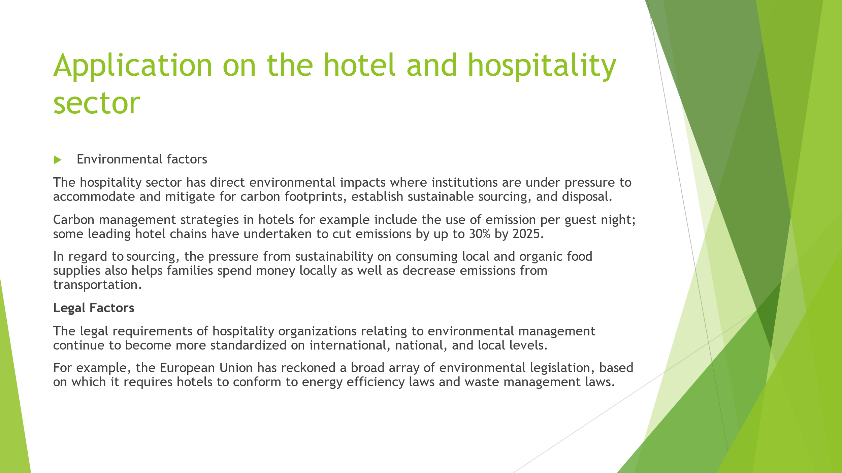
From waste management aspect, increasing role of recycling and composting schemes are noticeable as new trends in the industry. For instance, the Hilton Worldwide introduced the waste management strategy to manage to minimize waste by half in the organization’s hotels by 2030. Such measures not only serve to reduce the effect of their operations on the environment but also turn a good image to the guests. When implemented in real-world studies, results have provided evidence of environmental performance. For example, Marriott International has revealed that water intensity of their properties reduced by 10%, while the carbon intensity has been reduced by 13 %, from 2016 to 2019 which proves that the committed environmental management has a positive impact on hospitality industry. Failure to adhere to these laws can warrant hefty fines and the loss of credibility as evidenced by when an Italian hotel firm was penalized €200, 000 for disposing off their waste improperly in violation of the laws governing the area. For instance, in the U.S., the Environmental Protection Agency or EPA sets regulation standards that organize and dispose of hazardous substances and regulate the use of energy within hotel facilities. The social cost of non-recognition of the laws is high, specifically, customers are likely to shun facilities that neglect the laws on environmental conservation. On the other hand, compliance not only helps avert legal suit but also contributes to the corporate image of a hotel as a socially responsible business which most hotels include on their advertisement to appeal to the environmental conscious travellers.




