
BA (Hons) Leadership and Management Skills for the Workplace
Module: Developing Emotional Intelligence Skills
Module Code: LCLM5006

Assignment Title:
Emotional Intelligence, Mindfulness and Generational Diversity in the Workplace
Component 2 – Individual Written Report
Student Name: Daneil Stoican
Student ID Number:
Lecturer: Nishi Ramsurrun / Abdallah Naser
Submission Deadline:

Table of Contents
1. Introduction 3
2. Emotional Intelligence Components and Models at Work 3
2.1 Defining Emotional Intelligence 3
2.2 Goleman Mixed Model of Emotional Intelligence 4
2.3 Ability Model of Mayer, Salovey, and Caruso 5
2.4 Bar-On Socio-Emotional Model 6
2.5 Application of EI in Organisational Practices 7
3. Generational Characteristics and Effective Work Environment 8
3.1 The Importance of Generational Diversity 8
3.2 Generation X: The Independent Realists 9
3.3 Generation Y (Millennials): The Collaborative Idealists 10
3.4 Generation Z: The Digital Natives 11
3.5 Managing Generational Gaps: Inclusive Leadership 11
4. Conclusion and Recommendations 12
Reference List 14

1. Introduction
Emotional intelligence (EI) is an important leadership and management skill in modern organisations that can be characterized by the ability to identify, comprehend, regulate, and utilize emotions proficiently. Emotional Intelligence (EI), which was conceptualized by Salovey and Mayer (1990) and popularized by Goleman (1995), is a widely studied concept of individual and organisational performance predictor. As Goleman (1995) appropriately notes, when you are switched off to your own emotions, then you will be bad at sensing others; thus, inter- and intra-emotional competence are interrelated.
This report is the result of the request by the senior management and attempts to critically assess the manner in which the employees can apply the elements of EI in the workplace by using the established theoretical models. In addition, the report explores distinctive traits that are relevant to generational cohorts, i.e., Generations X, Y (Millennials), and Z, that managers should take into consideration in order to design inclusive and effective workplace environments. The report will end with major recommendations of how EI and generational awareness can be integrated into the organisational practice. The entire time, the reference is to peer-reviewed academic literature to support the arguments made.

2. Emotional Intelligence Components and Models at Work

2.1 Defining Emotional Intelligence
Emotional Intelligence is widely described as the ability to recognize, evaluate, and communicate emotions correctly; to obtain and produce emotions when they aid cognition; to comprehend emotion and emotional learning; and to control emotions in order to induce emotional and intellectual development (Mayer and Salovey, 1997). This conceptualization, which is multi-dimensional, makes EI distinctly separate from decisions about cognitive intelligence (IQ) and has seen the emergence of a variety of competing but complementary theoretical frameworks, all of which provide their own understanding of how emotions are applied in professional contexts.
The applicability of EI in the work environment is high. Research has always shown that highly EI employees have better interpersonal communication, are more resilient in challenging situations, have a better ability to resolve conflicts, and have a better ability to work in a team.

2.2 Goleman Mixed Model of Emotional Intelligence
The Mixed Model by Daniel Goleman is the most used model in organisational and managerial contexts and warrants five main elements, namely, self-awareness, self-regulation, motivation, empathy, and social skills (Goleman, 1998). These elements can be described as interrelated skills that employees can develop in order to enhance their professional performance.
Self-awareness is the power to identify and know the emotional conditions, strengths, weaknesses, and values of individuals. A self-aware employee is in a better position to control their behavioral responses in the workplace; thus, they are not prone to reactive decision-making (Goleman, 1998). As an illustration, a team leader who is aware of the fact that he or she tends to go on the defensive when criticized will be able to consciously restrain such a reaction and thus maintain the morale as well as psychological safety in the team.
Self-regulation involves control of disruptive impulses and feelings. Employees who manage their emotions well are seen as trustworthy employees, and they are less likely to bring in counterproductive behaviors at work. Self-regulation is especially crucial in high-stakes jobs like healthcare, law enforcement, and financial services, where emotional reactions can be costly.
Motivation, as defined by Goleman, is an inner impulse to achieve something energetically and persistently without any external motivation. Employees who are highly motivated help in organisational performance as they are able to stay engaged, creative, and committed, particularly when faced with uncertainty or change in an organisation. According to Goleman (1998), high EI motivation is associated with an optimistic mindset that is not easily discouraged, which is of immeasurable importance in the unstable work environments?
Empathy - capacity to comprehend and experience the emotions of other people—is another trait of emotionally intelligent professionals. Empathy helps managers to manage a culturally diverse workforce, identify staff issues that are not communicated in the workplace, and implement welfare initiatives that satisfy actual needs. In customer-facing careers as well, empathy is a key factor since it directly determines client satisfaction and loyalty.
The last competency of Goleman is social skills, which involve skills in the management of relationships and networking. Employees who possess high social abilities are good at influencing, inspiring, and guiding others. These are the potential skills that contribute to good leadership, conflict resolution, and coordination within a team.
Figure 1: Goleman’s Five Components of Emotional Intelligence
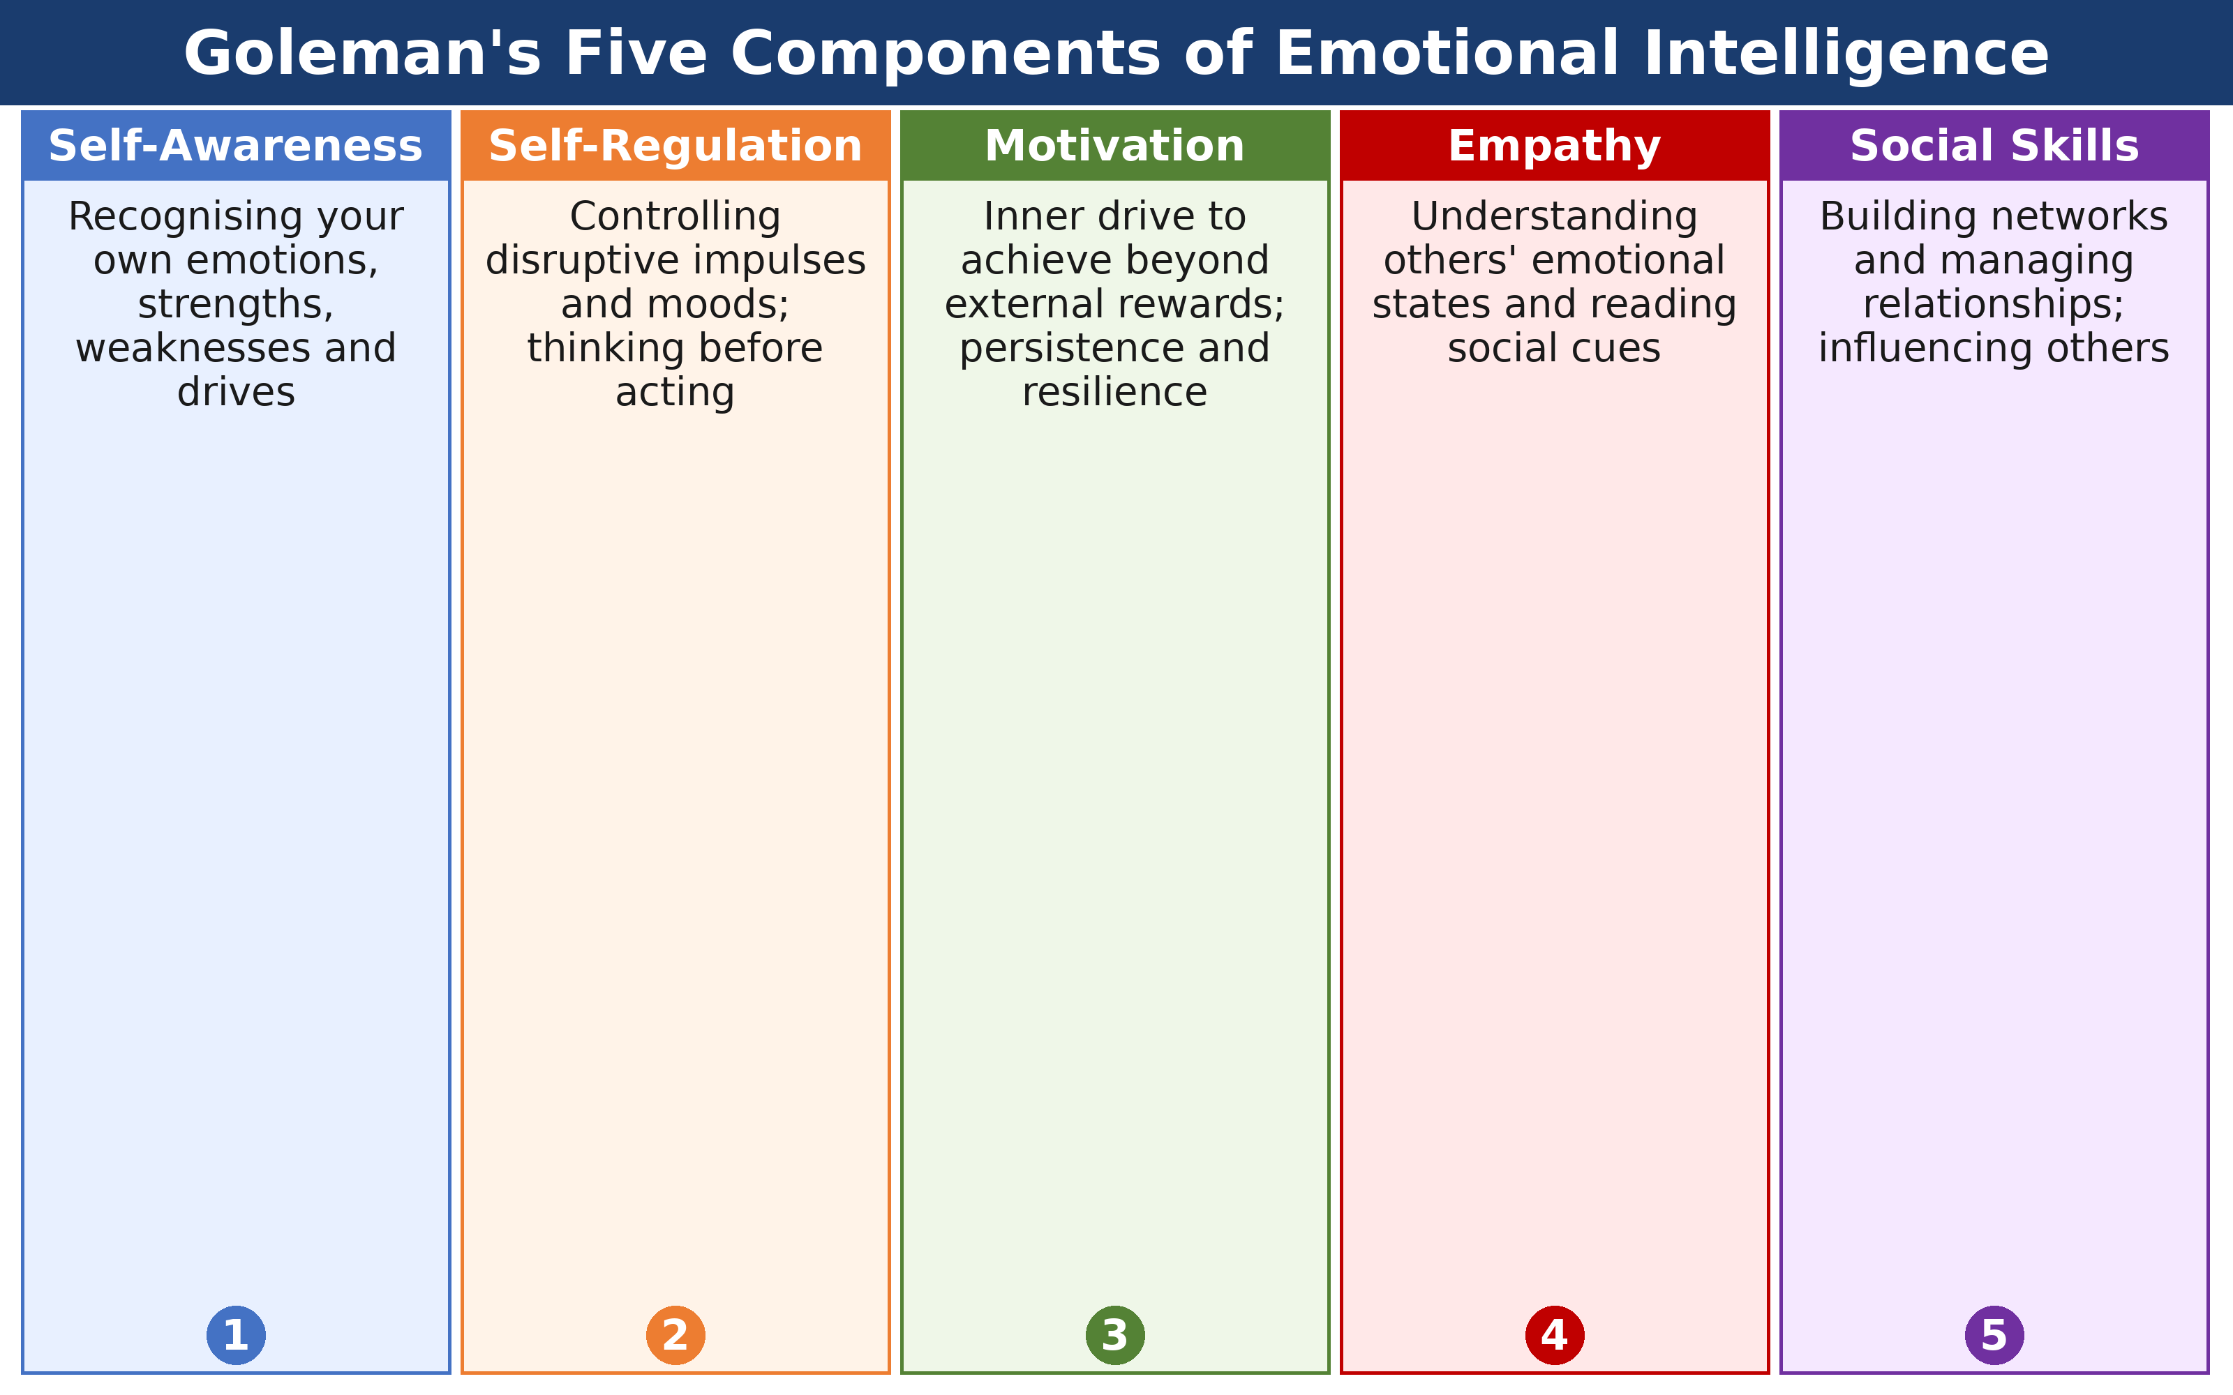
Source: Goleman, D. (1998) Working with Emotional Intelligence. New York: Bantam Books.

2.3 Ability Model of Mayer, Salovey, and Caruso
Another and strictly empirical model is the Ability Model by Mayer, Salovey, and Caruso (2004) that describes EI as a true intelligence in which there are four hierarchically organised branches of emotional perception, emotional facilitation of thought, emotional understanding, and emotional management. As opposed to the model of Goleman, the method measures EI using maximum performance tests and not self-report, which yields higher criterion validity (Mayer et al., 2008).
Applied in the workplace, accuracy in perception facilitates the ability of employees to decipher the facial expressions, tone of voice, and body language, which are also known as non-verbal cues, with more accuracy. Such perceptual accuracy is particularly significant in negotiation, performance appraisals, and cross-cultural communication. The second branch, which is an emotional expedience to thought, suggests that emotional conditions can be strategically utilized to aid thoughts. A manager who has to have a tough conversation may also be consciously controlling his/her emotional arousal levels in order to remain clear and calm (Mayer et al., 2004).
Learning to manage emotions is not only about being able to notice a feeling in the here and now but also a complex process of understanding how emotions develop, grows, and combines throughout our lives. This mental map enables one to follow the path of a feeling to its zenith. As an example, when the employee determines that unrecognized but undeniable frustration, which is present as the antecedent of overt conflict in the workplace, he/she possesses the strategic wisdom of intervening at an early point. They assist in creating a culture of psychological safety as opposed to that of reactive tension by managing the cause of the condition in advance. The highest branch of emotional intelligence is managing emotions. It is a twofold act of observing the internal condition and at the same time manipulating the emotional atmosphere of the other. HR professionals, counselors, and managers cannot do without this competency. The skill of keeping emotions inside and empathic responsiveness is paramount in performance management so that feedback can be constructive and potentially volatile interactions can be turned into opportunities for professional development and mutual respect.

2.4 Bar-On Socio-Emotional Model
The Emotional Quotient Inventory (EQ-i) by Reuven Bar-On offers an extensive system of measuring emotional intelligence (EI) in five major domains, namely intrapersonal skills, interpersonal skills, stress management, adaptability, and general mood (Bar-On, 2006). This model does not emphasize all cognitive capabilities as much as the social and emotional capabilities, which determine how individuals deal with environmental pressures.
Among them, the adaptability domain has a massive organisational importance in the modern VUCA (Volatile, Uncertain, Complex, and Ambiguous) environment. Success in these environments is pegged on the ability of an employee to be flexible and adjust their psychological and behavioral reactions to the changing external forces in VUCA environments. These emotional and social factors are not just soft skills, as demonstrated by widespread empirical studies of a wide range of people in the world by Bar-On. They instead contribute a significant percentage of the variance in overall life satisfaction, as well as in professional job performance, which is frequently more effective than traditional IQ in predicting long-term career success (Bar-On, 2006).

2.5 Application of EI in Organisational Practices
The coherent and convergent theme has appeared in many theoretical paradigms: individuals who openly work on the development of their Emotional Intelligence (EI) have much better professional relationships, greater psychological strength, and better job performance. Located within the context of the dynamic rather than a fixed aspect, current studies indicate that EI is an implementation of dynamic competencies that can be honed by intentional practice and organiational encouragement.
Organisations that value and make investments in systematic EI training programs cite significant institutional advantages. Such investments result in significant changes in team cooperation, a substantial reduction in absenteeism, and a decrease in staff turnover rates. With the establishment of the emotionally intelligent culture, organisations provide a cushion against the stressors of the contemporary corporate culture so that employees would feel accepted and comprehended.
Boyatzis et al. (2013) conducted one of the most interesting longitudinal studies to prove this impact. Their study was based on a sample of medical workers who attended coaching courses with the purpose of enhancing EI. The findings revealed the long-term positive changes in such critical soft skills as empathy and self-regulation. More to the point, these internal psychological changes found their reflection in the form of tangible external factors, like a better score of patient satisfaction and an increase in the overall quality of clinical care. This implies that the results of EI are far-reaching for the person and are directly affecting the end-user or client experience.
Along with the training of EI, mindfulness practice should be included. As described by Kabat-Zinn (1990) as the non-judgmental and conscious realization of the current moment, mindfulness has become a trend among the highly developed psychological processes that boost EI in the business environment. Formal meditation practices, reflective journaling, etc., are not just wellness trends but rather the instruments to be deployed to enhance the neurological pathways related to self-awareness. These interventions make the employees keep track of their changing emotional conditions without entering the trap of reactive, judgmental reactions (Hueselgeger et al., 2013).
Moreover, a research study conducted by Good et al. (2016) deployed randomized controlled trials to determine that mindfulness interventions in the workplace have significant effects on emotional regulation and interpersonal empathy. These results highlight the fact that organisations can develop a more resilient and understanding workforce in a more systematic manner. Turning EI and mindfulness into the key components of professional growth, companies not only improve their productivity, but also improve the personal well-being of individual employees and increase the overall performance of the whole organisation to new levels.

3. Generational Characteristics and Effective Work Environment

3.1 The Importance of Generational Diversity
Multi-generational workforces whereby employees belonging to different generations interact on a daily basis are gradually becoming the norm in contemporary workplaces. Managers need to know the individual values, expectations, and work orientations of every generation to hire successfully, create the right type of incentive structure, and create an inclusive work environment. Generation X (born around 1965–1980), Generation Y or Millennials (born around 1981–1996), and Generation Z (born around 1997–2012) are the three most prominent generations that are represented in the modern labor market (Dimock, 2019). The socioeconomic, technological, and cultural conditions surrounding each of the cohorts have produced their own distinctive impressions on the workplace behavior and emotional orientations.
Figure 2: Generational Diversity in the Workplace – Key Characteristics
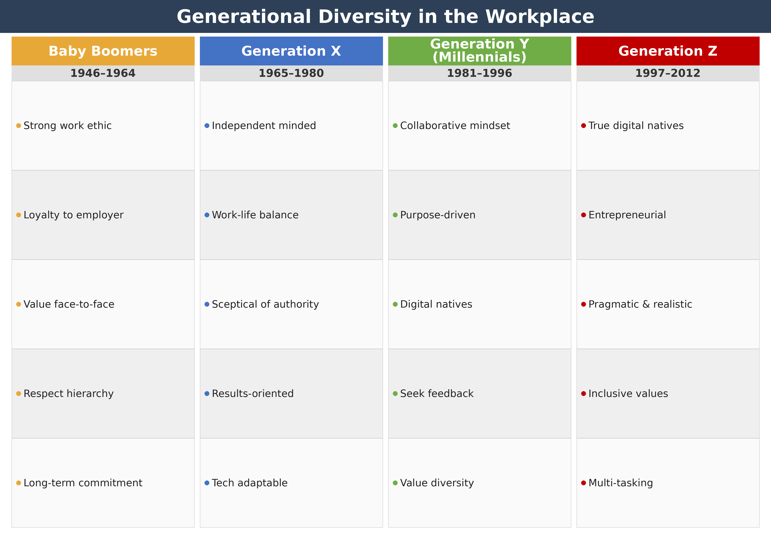
Source: Adapted from Twenge, J.M. (2017) iGen. New York: Atria Books; Deal, J.J. (2007) Retiring the Generation Gap. San Francisco: Jossey-Bass.

3.2 Generation X: The Independent Realists
Gen X began their work life in a time of economic instability, company layoffs, and technological change. These early years of professional experience created a generation of individuals who are self-reliant pragmatists and highly influenced by work-life balance - a phenomenon driven by their early professional experiences. The employees of Generation X are generally distrustful towards authority and would like to have freedom in their job and do not like being micromanaged. They are positive toward performance evaluation based on results and appreciate managerial transparency.
Generation X candidates do not always consider company prestige or financial interests as the sole determinants of job satisfaction; rather, they put more emphasis on job security, career development opportunities, and flexibility. They are very self-reliant and therefore can work in job positions where they are expected to make independent decisions. Nevertheless, the comparatively low level of organisational loyalty they display might pose a challenge in retention, where managers must offer regular recognition and investment in development (Lyons and Kuron, 2014). Generation X is likely to have the highly developed self-regulation skills in terms of EI, the ability developed through professional experiences of dealing with uncertainty, which qualifies them to be effective in conflict resolution and crisis management positions.

3.3 Generation Y (Millennials): The Collaborative Idealists
Millennials are the most numerous generation in the modern labor force, characterized by their digital savviness, collaborative outlook, and a high need for meaningful work. Millennials are influenced by globalization, the spread of the internet, and the financial crisis of 2008, which shaped their preference for organisational cultures that resonate with their values of social responsibility, diversity, and transparency. They require regular and positive feedback and are strongly driven by mentoring connections and learning chances.
Managers who hire a member of Generation Y should realize that remuneration cannot be viewed as the only element that will motivate this group. Millennials are deeply influenced by organisational culture, ethics, and growth opportunities. They do not tolerate a sense of injustice, and they can quickly check out on perceived unequal treatment by the managers. In EI terms, the Millennials tend to be very empathetic individuals with high social skills, although some Millennials can be highly emotional, which, according to a study by Twenge (2017), can be managed in a problematic way, causing avoidance instead of resolution. Managers developing emotionally intelligent leadership skills, especially empathy and motivational awareness, have a better chance to tap the collaborative energy of this generation.

3.4 Generation Z: The Digital Natives
The youngest generation getting into the workforce is called Generation Z and has been raised in a digital world full of constant digital connectivity, social media, and environmental crises all over the world. Consequently, they are defined by technology savvy, entrepreneurial desire, a focus on authenticity, and an increased sensitivity to mental health and well-being (Francis and Hoefel, 2018). In contrast to Millennials, who have some ideals of change within institutions, Gen Z are more pragmatic and prefer concrete rather than abstract corporate mission statements.
To managers, the engagement of Generation Z in employment necessitates the establishment of psychologically safe and diversity-affirming work environments that are technology adaptive. Identity, inclusion, and mental health support are especially important to this generation, which is less tolerant of workplaces that fail to act proactively on these dimensions. According to research, Generation Z workers are expected to stick longer in organisations that invest publicly in employee well-being programs and provide clear career paths. In terms of EI, Generation Z might need more assistance in building self-regulation and interpersonal emotional skills since extensive communication via digital devices has lowered the possibilities of having a subtle emotional face-to-face interaction (Twenge, 2017). Managers who exemplify emotionally intelligent behavior, that is, showing empathy, patience, and open communication, tend to engage Generation Z employees most of all.

3.5 Managing Generational Gaps: Inclusive Leadership
Learning to manage generational differences in the contemporary work environment is not a task of imposing strict stereotypes; instead, it is a subtle endeavor of deconstructing all the macro, attitudinal transformations that guide professional relations. With this undergoing change in trends, leaders are able to go beyond the old, one-size-fits-all methods to develop culturally appealing management strategies that account for the historical and social specifics that provide each group with its own vision of the world. Modern-day leadership demands a careful balancing response: a leader should respect the shared values present in a generational group, but at the same time should respect the specific personality of particular staff and their ambitions. This is the synthesis of modern management. It uses differentiated incentive systems and diversified communication models to meet a broad range of expectations in the area of work-life balance, career advancements, and recognition. In order to develop the culture of real-life collaboration, the leaders should provide a climate of psychological safety in which the exchange of knowledge between younger and older generations should be actively encouraged (Lyons and Kuron, 2014). One of the most practical uses of this philosophy is in the form of reverse mentoring. This program does not only close the digital divide as younger employees are given an opportunity to share technology skills with the top executives. It breaks down the old hierarchies to create mutual respect and turns generational diversity into a strategic tool rather than a source of tension. When each generation believes that their voice is a vital component of the puzzle, the organisation will gain an element of agility and shared intelligence that cannot exist in a separated workplace.

4. Conclusion and Recommendations
In this report, some of the key findings critical to the role of Emotional Intelligence in the workplace have been evaluated based on a mixed model of Emotional Intelligence, which is proposed by Goleman, the Mayer-Salovey-Caruso Ability Model, and the socio-emotional framework, by Bar-On. The evidence over and over again confirms that the EI competencies, such as self-awareness, empathy, self-regulation, motivation, and social skill, can be developed and can make a significant contribution to the individual performance and team performance. Mindfulness practices are a proven way of enhancing these competencies at all levels of the workforce.
The study of the generational diversity shows that Generations X, Y, and Z introduce different value orientations, motivational patterns, and communication styles in the workplace. By being conscious of such variations, managers are in a better position to recruit well, create inclusive cultures, and maintain engagement levels across the generational divide.
The recommendations that are put forward to be considered by the senior management are as follows:
To start with, invest in organised EI development programs, including mindfulness-based training and a 360-degree feedback system to develop self-awareness and empathy at all levels of staff. Secondly, adopt a generationally sensitive approach in management, which provides flexible working schedules and incentive schemes differentiated by the demands of the Generation X, Y, and Z workers. Thirdly, implement intergenerational networks of mentoring that may establish two-way learning that will diminish intergenerational friction and develop shared organisational knowledge. Fourthly, integrate EI evaluation in recruitment and talent management procedures in order to make sure that leadership pipelines are aligned with the emotional intelligence needed to secure long-term organisational performance. Lastly, create a workplace well-being model that effectively meets the mental health concerns of Generation Z without compromising the autonomy and recognition requirements of Generation X practitioners.

Reference List
Bar-On, R. (2006) 'The Bar-On model of emotional-social intelligence (ESI)', Psicothema, 18(Suppl), pp. 13–25.
Boyatzis, R.E., Rochford, K. and Jack, A.I. (2013) 'Antagonistic neural networks underlying differentiated leadership roles', Frontiers in Human Neuroscience, 7, p. 114. https://doi.org/10.3389/fnhum.2013.00114
Deal, J.J. (2007) Retiring the Generation Gap: How Employees Young and Old Can Find Common Ground. San Francisco: Jossey-Bass.
Dimock, M. (2019) 'Defining generations: Where Millennials end and Generation Z begins', Pew Research Center, 17(1), pp. 1–7.
Francis, T. and Hoefel, F. (2018) 'True Gen': Generation Z and its implications for companies', McKinsey & Company, 12(2), pp. 1–10.
Goleman, D. (1995) Emotional intelligence: Why it can matter more than IQ. New York: Bantam Books.
Goleman, D. (1998) Working with emotional intelligence. New York: Bantam Books.
Good, D.J., Lyddy, C.J., Glomb, T.M., Bono, J.E., Brown, K.W., Duffy, M.K., Baer, R.A., Brewer, J.A. and Lazar, S.W. (2016) 'Contemplating mindfulness at work: An integrative review', Journal of Management, 42(1), pp. 114–142. https://doi.org/10.1177/0149206315617003
Hülsheger, U.R., Alberts, H.J., Feinholdt, A. and Lang, J.W. (2013) 'Benefits of mindfulness at work: The role of mindfulness in emotion regulation, emotional exhaustion, and job satisfaction', Journal of Applied Psychology, 98(2), pp. 310–325. https://doi.org/10.1037/a0031313
Kabat-Zinn, J. (1990) Full catastrophe living: Using the wisdom of your body and mind to face stress, pain, and illness. New York: Delacorte.
Lyons, S. and Kuron, L. (2014) 'Generational differences in the workplace: A review of the evidence and directions for future research', Journal of Organizational Behavior, 35(S1), pp. S139–S157. https://doi.org/10.1002/job.1913
Mayer, J.D. and Salovey, P. (1997) 'What is emotional intelligence?’ in Salovey, P. and Sluyter, D.J. (eds.) Emotional development and emotional intelligence. New York: Basic Books, pp. 3–31.
Mayer, J.D., Roberts, R.D. and Barsade, S.G. (2008) 'Human abilities: Emotional intelligence', Annual Review of Psychology, 59, pp. 507–536. https://doi.org/10.1146/annurev.psych.59.103006.093646
Mayer, J.D., Salovey, P. and Caruso, D.R. (2004) 'Emotional intelligence: Theory, findings, and implications', Psychological Inquiry, 15(3), pp. 197–215. https://doi.org/10.1207/s15327965pli1503_02
Salovey, P. and Mayer, J.D. (1990) 'Emotional intelligence', Imagination, Cognition and Personality, 9(3), pp. 185–211. https://doi.org/10.2190/DUGG-P24E-52WK-6CDG
Twenge, J.M. (2017) iGen: Why today's super-connected kids are growing up less rebellious, more tolerant, less happy—and completely unprepared for adulthood. New York: Atria Books.

