
APPENDIX GA36d

Assessment Level 7
Student name: | MD LENIN ASHRAR NIXON | Student ID number: | 2505304
Programme: | MSc Mechanical Engineering
Module: | Research Method
Assignment Title: | Virtual Wind Tunnel Analysis of Micro-Scale Turbines
Lecturer: | Jordan Jenkins | Internal Verifier: | Kerry Tudor
Submission deadline: | 18/05/2026 | Submission date: | 17/05/2026

Executive Summary
This project examines the aerodynamic performance of micro-scale Horizontal-Axis Wind Turbines (HAWTs) and Vertical-Axis Wind Turbines (VAWTs) using SolidWorks Flow Simulation in a controlled virtual wind tunnel. As demand for decentralised renewable energy rises, especially in urban rooftop settings with turbulent wind, this study seeks to provide a detailed aerodynamic comparison of these turbine types at the microscale, a gap in existing research. Both turbine designs are modeled under identical conditions to ensure fairness, simulating rooftop boundary-layer flow at 5 m/s. Outputs include torque generation, pressure distribution, velocity fields, and wake behaviour, which aid in assessing each turbine's response to turbulent inflow and energy extraction efficiency. While the project employs a solid methodology and addresses urban energy challenges, limitations such as unsteady aerodynamic effects and an idealised simulation environment are acknowledged. The study aims to deliver a reproducible CFD framework and insights into the more suitable turbine type for urban wind applications.

Table of Contents
1. Introduction 1
1.1 Background to the Study 1
1.2 Research Aim 2
2. Industrial Relevance 2
2.1 Industry Trends & Applications 2
2.2 Environmental & Ethical Considerations 3
3. Literature Review 3
3.1 Historical Development of Small Wind Turbines 3
3.2 Aerodynamic Principles of HAWT and VAWT 5
3.3 Gaps in Existing Research 6
4. Proposed Methodology 7
4.1 CAD Modelling 7
4.2 Virtual Wind Tunnel Setup 8
4.3 Alternative Methods Considered 8
4.4 Limitations of the Method 9
5. Results Collection & Analysis 10
6. Project Planning & Timescale 10
7. Evaluation 10
7.1 Strengths 10
7.2 Limitations 11
7.3 Expected Contribution 11

List of Figures
Figure 1. GWT-20 VAWT at the testing site in Colorado, USA(Zakis et al., 2025). 4
Figure 2. Interface of the SolidWorks 2025 Software. 7

1. Introduction

1.1 Background to the Study
The global shift to low-carbon energy systems has generated interest in decentralised, small-scale renewable technologies, particularly in urban areas. While large horizontal-axis wind turbines dominate utility-scale generation, there is significant untapped wind energy potential in urban environments, especially rooftops. With 80% of the EU population living in cities, this aligns with national goals such as the UK's aim for a fully decarbonised electricity system by 2030 and net-zero emissions by 2050. Micro-scale wind turbines present a viable solution for building-integrated generation, promoting affordable and clean energy as per UN Sustainable Development Goal 7(Tsionas et al., 2024).
Small-scale wind turbines are increasingly used alongside solar panels to reduce reliance on grid electricity, contributing to sustainable energy generation and distributed generation. Traditional horizontal-axis wind turbines (HAWTs) face challenges in urban settings due to turbulent wind caused by buildings, resulting in decreased performance and higher fatigue loads. In contrast, vertical-axis wind turbines (VAWTs) offer advantages in urban environments with their omnidirectional design and greater resilience to turbulence, achieving 36–84% higher power coefficients on rooftops compared to open fields. However, there is a significant lack of detailed aerodynamic comparisons between micro-scale HAWTs and VAWTs for rooftop applications(Zamre & Lutz, 2022a).
Computational Fluid Dynamics (CFD) enables the study of aerodynamic behaviours in controlled conditions. At the MSc level, SolidWorks Flow Simulation is utilized for virtual wind tunnel studies of micro-turbines. This research models and compares airflow patterns, pressure distributions, and torque generation across various turbine designs within a virtual rooftop wind environment, linking urban renewable energy, aerodynamic design, and engineering simulation workflows(Cekus et al., 2019).

1.2 Research Aim
The goal of this research is to conduct a comparative aerodynamic analysis of micro-scale horizontal-axis (HAWT) and vertical-axis (VAWT) wind turbine designs using a controlled virtual wind tunnel environment in SolidWorks Flow Simulation. The study seeks to evaluate how each turbine architecture influences airflow behaviour, pressure distribution, and torque generation when subjected to identical wind conditions representative of urban rooftop environments. By modelling both turbine types with consistent geometric and operational parameters, the research aims to generate reliable, simulation-based evidence that identifies which design demonstrates superior performance and stability in turbulent, low-speed urban wind flows.
The project aims to generate actionable insights for future microturbine design, rooftop renewable energy integration, and subsequent physical prototypes using a systematic CFD workflow that includes CAD modelling, wind tunnel setup, meshing, simulation, and quantitative analysis.

2. Industrial Relevance

2.1 Industry Trends & Applications
Micro-scale wind technologies are gaining traction in engineering due to the global push for decarbonisation and smart-city development. Key trends include the rise of localised renewable energy generation to support electric vehicle infrastructure, where micro-turbines can provide additional power, especially in areas with limited solar options. Advances in aerodynamic optimisation and Computational Fluid Dynamics (CFD) are enhancing the design of these compact wind systems, leveraging simulation expertise from the automotive sector. Additionally, urban planning increasingly incorporates building-integrated renewables, with microturbines being suited for high-rise rooftops and other structures. They contribute to energy security and resilience by offering a reliable power source under variable conditions. Overall, the research and development of micro-scale wind turbines align with both academic interests and industrial requirements, supporting diverse applications and strategies for urban energy systems(Bereziartua-Gonzalez et al., 2025).

2.2 Environmental & Ethical Considerations
The development of micro-scale wind turbines for urban environments offers significant environmental and ethical benefits. Environmentally, these turbines generate clean electricity on-site, reducing reliance on fossil fuels and lowering carbon footprints, especially in densely populated areas where large turbines are impractical. They enable decentralised renewable generation, enhancing energy resilience and supporting climate mitigation strategies. Ethically, their integration aligns with responsible engineering and sustainable development principles, providing equitable access to clean energy, particularly for communities with limited solar options. However, ethical considerations necessitate minimising potential negative impacts, such as noise and visual intrusion, and evaluating lifecycle impacts to maintain public trust and safety.
Overall, the environmental and ethical considerations of micro-scale wind turbines highlight the necessity of thorough aerodynamic analysis and design optimization. This research enhances turbine performance for urban settings, aligning with the ethical goal of promoting sustainable, low-impact energy technologies that benefit society.

3. Literature Review

3.1 Historical Development of Small Wind Turbines
The evolution of small-scale wind turbines has diverged from that of large-scale systems, primarily driven by the demand for decentralised power generation and adaptability to various environments. Initially, horizontal-axis wind turbines (HAWTs) dominated the landscape, inspired by traditional windmills and optimised for uniform wind flows in rural settings. Their prominence established them as the standard for wind energy development. The 1970s energy crises catalysed interest in small wind systems, leading to the design of compact HAWTs for residential use. However, as urbanisation progressed, the limitations of HAWTs in turbulent conditions prompted a shift towards vertical-axis wind turbines, such as Darrieus and Savonius, which had previously seen limited commercial appeal(Kumar et al., 2019). Figure 1 shows a life size VAWT wind turbine model tested in the USA.

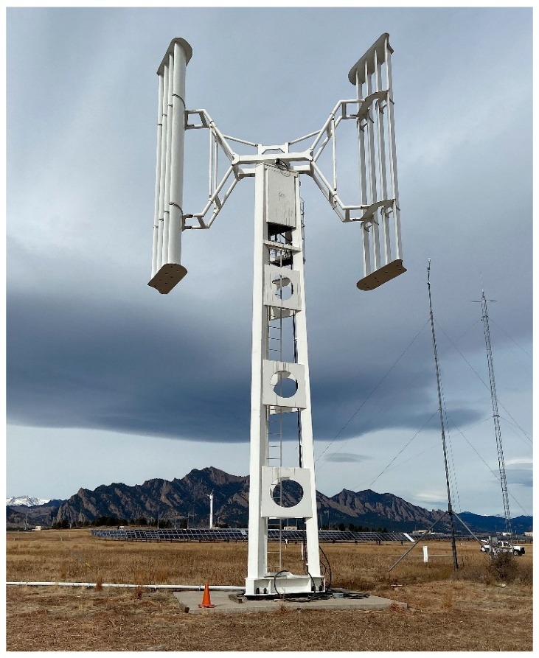
Figure 1. GWT-20 VAWT at the testing site in Colorado, USA(Zakis et al., 2025).
VAWTs offered several advantages that aligned with the challenges of urban wind: omnidirectional operation, lower sensitivity to turbulence, and simpler mechanical layouts. By the early 2000s, advancements in materials, computational modelling, and manufacturing enabled more efficient VAWT designs, sparking a resurgence of interest in micro-scale rooftop systems. The integration of lightweight composites, improved bearings, and refined aerofoil profiles contributed to better performance and durability, making VAWTs increasingly viable for distributed energy generation(Lee et al., 2024).
The rise of computational fluid dynamics (CFD) further accelerated the development of small wind turbines. Tools such as SolidWorks Flow Simulation, ANSYS Fluent, and OpenFOAM allowed engineers to analyse complex flow behaviour around turbine blades without relying solely on physical prototypes. This shift enabled more precise optimisation of blade geometry, tip-speed ratios, and structural configurations, particularly for microturbines intended for turbulent rooftop environments(Warnakula et al., 2023).
Recent global efforts for net-zero emissions and smart-city developments have spurred interest in building-integrated wind systems. Small turbines are being investigated for residential applications and for powering sensors, communication devices, and hybrid renewable systems. This evolution mirrors a broader engineering trend from centralized energy systems to more flexible, distributed technologies suited for various environments.

3.2 Aerodynamic Principles of HAWT and VAWT
The aerodynamic behaviour of micro-scale wind turbines is shaped by airflow interactions, energy conversion to rotational motion, and the management of flow separation and turbulence. Horizontal-axis and vertical-axis turbines both extract wind energy but do so through different geometries, blade orientations, and rotation principles.
Horizontal-axis wind turbines (HAWTs) utilize lift-based aerodynamics akin to aircraft wings, using profiles like the NACA 4412 to create lift that drives rotation. They perform optimally at specific tip-speed ratios but face reduced efficiency in turbulent urban environments due to fluctuating wind conditions, leading to stalls. In contrast, vertical-axis wind turbines (e.g., H-Darrieus model) operate with lift-driven mechanisms and can function omnidirectionally, making them more robust against chaotic rooftop wind patterns. However, varying angles of attack during rotation can cause cyclic loading and dynamic stall, requiring computational fluid dynamics (CFD) analysis for assessment(Brahimi & Paraschivoiu, 2022).
A key aerodynamic difference between Horizontal Axis Wind Turbines (HAWTs) and Vertical Axis Wind Turbines (VAWTs) involves flow interaction. HAWTs benefit from clean inflow when positioned above obstacles, while VAWTs operate within disturbed boundary layers, where increased turbulence can enhance their performance by delaying stall. Additionally, VAWTs generally exhibit higher starting torque due to their design, allowing them to function effectively at lower wind speeds, unlike HAWTs, which require a minimum wind speed to operate, making VAWTs more suitable for urban environments with variable wind conditions(Zamre & Lutz, 2022b).
Comparative CFD studies on HAWT and VAWT focus on aerodynamic principles, such as lift generation, pressure distribution, flow separation, and torque characteristics, to identify the more suitable turbine type for turbulent rooftop environments.

3.3 Gaps in Existing Research
A review of the literature on micro-scale wind turbines identifies key gaps in research, especially regarding comparative aerodynamic studies of horizontal-axis and vertical-axis turbines in urban rooftop environments. While significant studies exist for medium and large scales in open-field conditions, there is a lack of understanding of turbine behaviour in the turbulent, low-speed, and directionally variable winds characteristic of urban settings(Hu et al., 2024).
A second gap exists in the lack of controlled, like-for-like CFD comparisons between HAWT and VAWT designs. Many studies focus on one turbine type with varying simulation setups, boundary conditions, or turbulence models, complicating reliable performance comparisons. Research is needed to evaluate both turbine types under identical conditions to ensure fair assessments of torque generation, flow patterns, and pressure distribution(Kamal & Ali, 2025).
Another gap exists in the limited application of CFD tools like SolidWorks Flow Simulation for analysing micro-turbines at the MSc level. While advanced solvers such as ANSYS Fluent and OpenFOAM are prevalent in academic research, there is a lack of effective studies using SolidWorks for rooftop wind turbine assessment, posing challenges for students and early-career engineers. Additionally, although Vertical Axis Wind Turbines (VAWTs) are considered suitable for turbulent urban conditions, quantitative evidence for this claim at the microscale is lacking, with many findings rooted in theoretical assumptions rather than detailed CFD analysis. Furthermore, the impact of rooftop boundary-layer effects on micro-turbine performance remains underexplored, despite its relevance for practical applications(Kii et al., 2024).
Existing studies on micro-scale rooftop turbines lack replicable CFD workflows, omitting vital details like mesh refinement and turbulence model justification. This project addresses these gaps by offering a controlled simulation comparison of HAWT and VAWT performance, providing practical insights and a reproducible methodology for future research.

4. Proposed Methodology

4.1 CAD Modelling
The CAD modelling stage is crucial for the simulation workflow, as the accuracy of turbine geometries influences CFD results. The project features both horizontal-axis wind turbine (HAWT) and vertical-axis wind turbine (VAWT) models created in SolidWorks, ensuring control over dimensions and designs for fair comparisons. The HAWT is a three-blade rotor using the NACA 4412 aerofoil, optimised for low Reynolds numbers, and includes a geometry that simplifies computational efficiency. The VAWT employs an H-Darrieus configuration, featuring symmetric blades for reduced complexity and effective aerodynamic behaviour. Both models maintain matching rotor diameters and overall dimensions to eliminate geometric bias, and each is checked for solid body integrity to ensure effective meshing in simulations. SolidWorks 2025 Will be used for all the CAD modelling for the project. Figure 2 shows the interface of SolidWorks software.
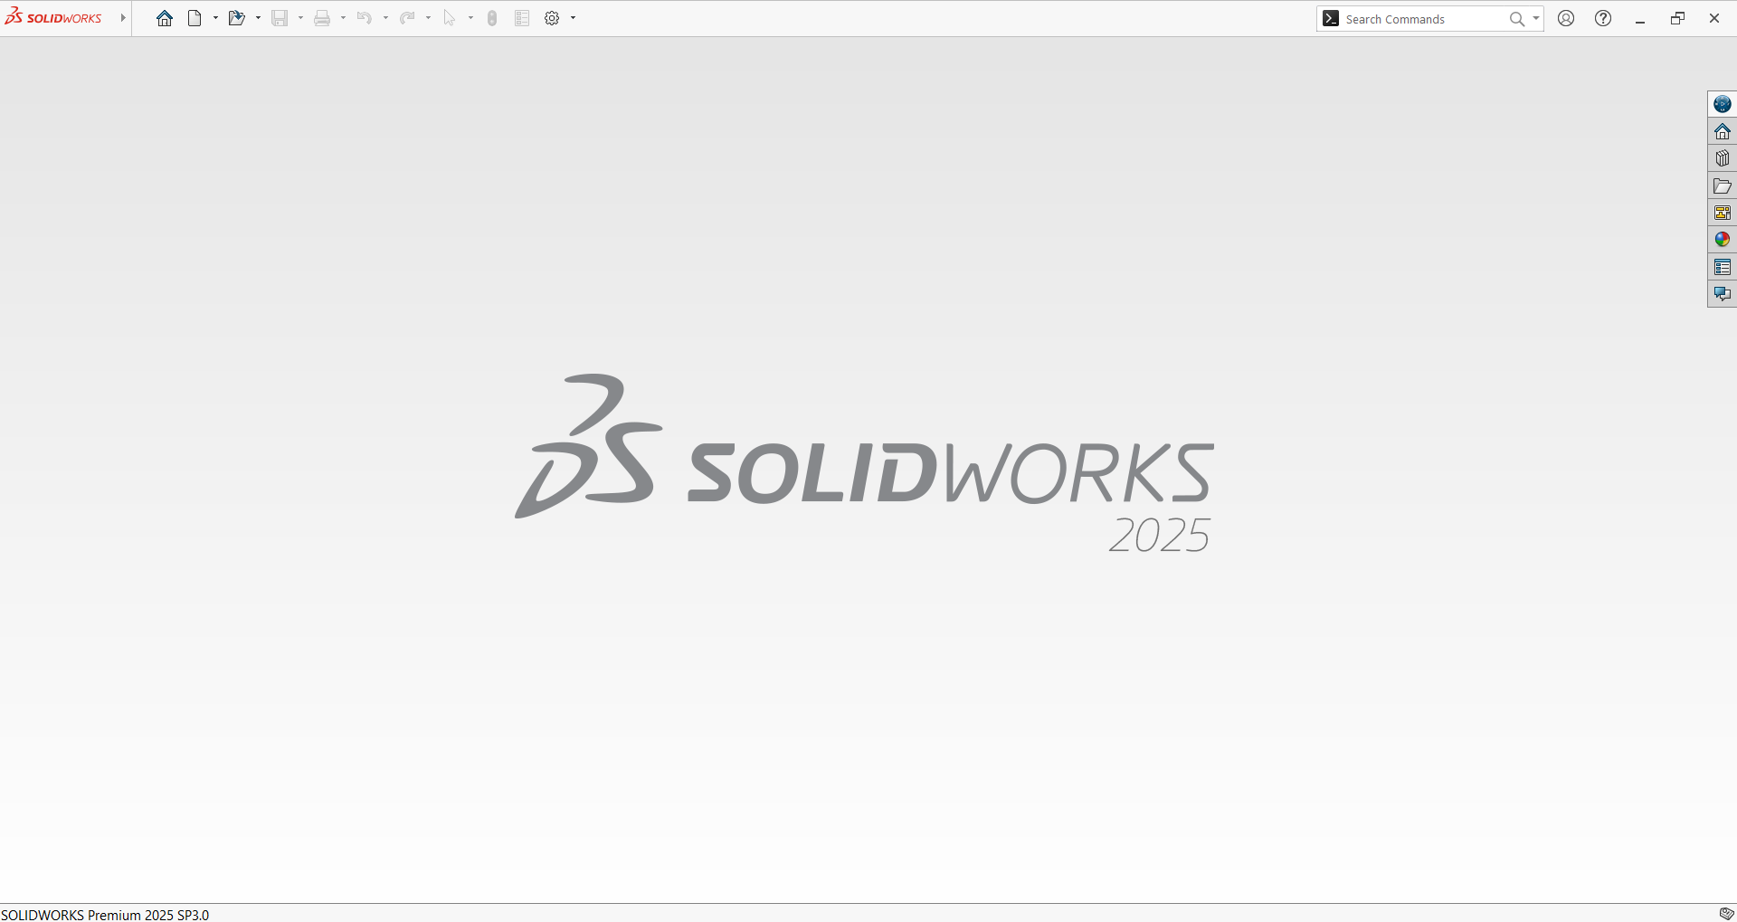
Figure 2. Interface of the SolidWorks 2025 Software.

4.2 Virtual Wind Tunnel Setup
The virtual wind tunnel setup is essential for evaluating turbine designs, ensuring a fair comparison. Created in SolidWorks Flow Simulation, it consists of a rectangular enclosure around the turbine model, designed to minimise blockage and recirculation effects. Boundary conditions are established to simulate urban rooftop flow while keeping a manageable computational domain.
A uniform inlet velocity of 5 m/s simulates a typical urban wind speed at the tunnel's upstream face. The outlet boundary is set to static pressure (0 Pa gauge) for unrestricted flow exit. Other enclosure faces are solid walls or symmetry planes to manage flow behaviour and minimise computational costs. The turbine is placed above a flat surface, incorporating local boundary layers and shear effects.
To accurately model turbulence in SolidWorks Flow Simulation, the k–ε turbulence model is chosen for its balance of accuracy and computational efficiency in external aerodynamic flows. It is particularly suited for urban environments, where higher turbulence levels are expected. A rotating region is established around the turbine rotor, with blades given rotational motion, facilitating the resolution of interactions between the blades and the surrounding flow field.
The same wind tunnel setup is used for both HAWT and VAWT models to allow direct comparison, with only changes to turbine geometry and rotation. This consistent approach facilitates analysis of differences in torque, pressure distribution, and flow patterns attributable to turbine design, excluding environmental variations.

4.3 Alternative Methods Considered
SolidWorks Flow Simulation was chosen for the project due to its accessibility, integrated CAD-CFD workflow, and appropriateness for MSc-level research. However, alternative methods were also evaluated to ensure the selection aligns with best practices in aerodynamic analysis.
ANSYS Fluent is a high-fidelity CFD solver preferred for complex aerodynamic studies, offering advanced turbulence models and transient rotor simulations. Its strengths include capturing unsteady phenomena relevant to wind turbine research, such as dynamic stall and vortex shedding. However, its steep learning curve, high computational costs, and limited student project availability limit its practicality for this study.
OpenFOAM is an open-source CFD platform that offers customisable simulations and advanced rotor modelling techniques, including sliding mesh interfaces and actuator line methods. However, it demands extensive coding knowledge, complex case setup, and significant computational resources, making it less suitable for time-constrained MSc projects that require ease of use and workflow efficiency.
Physical wind tunnel testing presents advantages like real-world validation and direct measurement of torque, pressure, and flow behaviour. However, challenges such as high costs, time demands, logistical issues, and difficulties in maintaining identical testing conditions for different turbine types might hinder reliable comparisons.
SolidWorks Flow Simulation is a practical solution for aerodynamic analysis, integrating well with CAD models and enabling controlled comparisons. Although it may lack the fidelity of advanced solvers in unsteady effects, its reliability and accessibility make it ideal for this research.

4.4 Limitations of the Method
While SolidWorks Flow Simulation offers a user-friendly platform for analysing micro-scale wind turbine aerodynamics, it has several methodological limitations. Key limitations include reliance on a steady-state rotating reference frame, which cannot capture important unsteady phenomena like dynamic stall and vortex shedding, potentially affecting torque predictions under real operating conditions. Additionally, the k–ε turbulence model may lack accuracy in predicting flows around VAWTs, where advanced models like k–ω SST or LES could offer better fidelity, albeit at a higher computational cost. Mesh resolution constraints due to the automatic Cartesian mesh limit boundary-layer refinement, affecting accuracy in torque predictions. Moreover, geometric simplifications in turbine modelling may overlook micro-scale flow influences, particularly at low Reynolds numbers. Lastly, the idealised simulation environment fails to consider real-world variables like gusts and surroundings, making results less applicable as precise performance predictions(Bernal-Orozco et al., 2026).

5. Results Collection & Analysis
The simulation results for both turbine models are collected directly from SolidWorks Flow Simulation once convergence is achieved. Key performance data, including rotor torque, pressure distribution, velocity fields, and wake behaviour. These parameters are extracted to evaluate aerodynamic performance under identical wind conditions. Torque values are exported numerically to enable direct comparison between the HAWT and VAWT, while flow visualisations such as streamlines and pressure contours are used to interpret aerodynamic behaviour qualitatively. These visual outputs help identify flow separation, stall regions, vortex formation, and wake symmetry, providing insight into why one turbine may outperform the other. By combining quantitative torque data with qualitative flow analysis, the results reveal the relative suitability of each turbine design for turbulent urban rooftop environments.

6. Project Planning & Timescale

Weeks 1–2 | Literature review and problem definition
Weeks 3–4 | CAD modelling of HAWT and VAWT
Weeks 5–6 | Virtual wind tunnel setup and simulation preparation
Weeks 7–8 | Running simulations and refining parameters
Weeks 9–10 | Results collection, analysis, and interpretation
Weeks 11–12 | Writing, editing, and final submission preparation

7. Evaluation

7.1 Strengths
This project’s primary strength lies in its controlled, like-for-like comparison of two turbine types under identical CFD conditions. By standardising rotor diameter, wind speed, and simulation setup, the study isolates aerodynamic behaviour rather than external variables, giving the results strong internal validity. Another strength is the use of SolidWorks’ integrated CAD–CFD workflow, which ensures geometric accuracy and reduces errors that often occur when transferring models between platforms. The project also benefits from a clear methodological structure, progressing logically from modelling to simulation to analysis, making the workflow transparent and reproducible. Finally, the focus on micro-scale rooftop wind addresses a growing need for decentralised renewable energy solutions, giving the study practical relevance beyond academic interest.

7.2 Limitations
Despite its strengths, the project is constrained by several methodological limitations. The use of a steady state rotating reference frame means unsteady aerodynamic effects—such as dynamic stall, vortex shedding, and cyclic loading—cannot be fully captured, particularly affecting VAWT accuracy. The k–ε turbulence model provides computational efficiency but is less precise in predicting separated flows and strong curvature effects, which are common in small wind turbines. Mesh control in SolidWorks is also limited compared to advanced CFD solvers, potentially reducing boundary-layer resolution. Additionally, the simulation environment represents an idealised rooftop scenario, lacking real-world variability such as gusts, directional shifts, and interactions with surrounding buildings. These limitations mean the results should be interpreted as comparative indicators rather than exact performance predictions.

7.3 Expected Contribution
This project is expected to contribute meaningfully to micro-scale wind turbine research by providing a replicable CFD workflow tailored to MSc-level tools and constraints. It offers a direct aerodynamic comparison between HAWT and VAWT designs in a rooftop-relevant environment, helping clarify which configuration is better suited for turbulent, low-speed urban wind. The study also highlights the practical capabilities and boundaries of SolidWorks Flow Simulation for renewable energy applications, offering guidance for students and early-career engineers who rely on accessible software. Ultimately, the project aims to support informed decision-making in small-scale wind deployment and encourage further research using higher-fidelity methods or experimental validation.

Reference

Bereziartua-Gonzalez, L., Retegi, A., & Ukar, O. (2025). Human-centered integration of small wind turbines in urban environments: a semi-systematic review from an industrial design perspective. Frontiers in Sustainable Cities, 7. https://doi.org/10.3389/frsc.2025.1561894
Bernal-Orozco, R. A., Huerta-Chavez, O. M., Constantino-Recillas, D. E., & Diaz-Salgado, J. (2026). Airfoil Performance of Small-Scale Vertical Axis Wind Turbines Under Urban Low Wind Speeds Using DMST and LLFVW Models. Energies, 19(4), 945. https://doi.org/10.3390/en19040945
Brahimi, T., & Paraschivoiu, I. (2022). Aerodynamic Analysis and Performance Prediction of VAWT and HAWT Using CARDAAV and Qblade Computer Codes. In Entropy and Exergy in Renewable Energy. IntechOpen. https://doi.org/10.5772/intechopen.96343
Cekus, D., Gnatowska, R., Kwiatoń, P., & Šofer, M. (2019). Simulation research of a wind turbine using SolidWorks software. Journal of Physics: Conference Series, 1398(1), 012001. https://doi.org/10.1088/1742-6596/1398/1/012001
Hu, J., Wang, X., Yang, H., & Huang, B. (2024). Experimental study on rooftop flow field of building based on the operation of vertical-axis wind turbines. Journal of Renewable and Sustainable Energy, 16(3). https://doi.org/10.1063/5.0205549
Kamal, M. A., & Ali, H. H. M. (2025). A Review of the Effects of Key Parameters on the Performance of Horizontal and Vertical Axis Wind Turbines. Journal Européen Des Systèmes Automatisés​, 58(7), 1453–1461. https://doi.org/10.18280/jesa.580713
Kii, T., Yaji, K., Fujita, K., Sha, Z., & Conner Seepersad, C. (2024). Latent Crossover for Data-Driven Multifidelity Topology Design. Journal of Mechanical Design, 146(5). https://doi.org/10.1115/1.4064979
Kumar, P. M., Sivalingam, K., Narasimalu, S., Lim, T.-C., Ramakrishna, S., & Wei, H. (2019). A Review on the Evolution of Darrieus Vertical Axis Wind Turbine: Small Wind Turbines. Journal of Power and Energy Engineering, 07(04), 27–44. https://doi.org/10.4236/jpee.2019.74002
Lee, K.-Y., Cruden, A., Ng, J.-H., & Wong, K.-H. (2024). Variable designs of vertical axis wind turbines—a review. Frontiers in Energy Research, 12. https://doi.org/10.3389/fenrg.2024.1437800
Tsionas, I., Llaguno-Munitxa, M., Stephan, A., Gambale, A., Kumar Raghunathan Srikumar, S., & Mosca, G. (2024). Review of the environmental effects of deploying small wind turbines in cities. IOP Conference Series: Earth and Environmental Science, 1363(1), 012104. https://doi.org/10.1088/1755-1315/1363/1/012104
Warnakula, W. P. J. M., Vidanapathirana, A. C., Ekanayake, R. M. T. C. B., & Senanayake, S. S. D. D. B. (2023). Design of micro scale wind turbine blade for low wind speed applications. 2023 22nd International Symposium INFOTEH-JAHORINA (INFOTEH), 1–6. https://doi.org/10.1109/INFOTEH57020.2023.10094182
Zakis, J., Efanov, O., Scerbina, A., & Fedotov, G. (2025). Highly Efficient Vertical-Axis Wind Turbine: Concept, Structural Design, Theoretical Basis, and Practical Tests Results. Applied Sciences, 16(1), 222. https://doi.org/10.3390/app16010222
Zamre, P., & Lutz, T. (2022a). Computational-fluid-dynamics analysis of a Darrieus vertical-axis wind turbine installation on the rooftop of buildings under turbulent-inflow conditions. Wind Energy Science, 7(4), 1661–1677. https://doi.org/10.5194/wes-7-1661-2022
Zamre, P., & Lutz, T. (2022b). Computational-fluid-dynamics analysis of a Darrieus vertical-axis wind turbine installation on the rooftop of buildings under turbulent-inflow conditions. Wind Energy Science, 7(4), 1661–1677. https://doi.org/10.5194/wes-7-1661-2022

