Study Skills (OME) | April 18  2019
The aim of this report is to look at different methods and techniques, that form part of study skills, that can assist in the learning of higher education. It also looks at self-evaluation and how the improvement of certain attributes can help to be more successful in both higher education learning and employment. By conducting a self-evaluation and completing a number of online character surveys I have been able to identify my strengths, and the skills in which I require development. The study skills module has identified a couple of subjects that I was lacking in skill and the action plan I have put in place is helping me to rectify this. |  | Self-Evaluation

Table of Contents

1. Introduction 2
2. Skills Evaluation 2
2.1. Skills required for successful higher education learning 2
2.2. Self-Evaluation of Academic and Personal Skills 3
2.3. Self-Evaluation of Skills using online surveys 4
2.4. Strengths & Weaknesses 4
2.5. Action Plan 4
3. Application 5
4. Conclusion & Evaluation 6
5. Bibliography 7
APPENDIX A……………………………………………………………………………………………………………………………………….8
APPENDIX B 12
APPENDIX C 13
APPENDIX D 14

Introduction
The aim of this report is to look at different methods and techniques, that form part of study skills, that can assist in the learning of higher education. It also looks at self-evaluation and how the improvement of certain attributes can help in order to be more successful in both higher education learning and employment. The study skills lectures delivered during the course of the first year at UWTSD have been very helpful to show the most common and the most likely methods to help a person to succeed in higher education learning, some of which were already familiar to me, but most of which were new to me.
This report will demonstrate how skills that have been acquired through past employment can be a benefit in a learning environment, and also vice versa, how skills acquired through study can benefit working in employment. A lot of the skills required to be successful in higher education learning, are also the same skills required to be successful in wider employment (for example report writing and presentation techniques).

Skills Evaluation

Skills required for successful higher education learning

There are many skills and attributes that are required in order to be successful in the learning of higher education. Just being a genius or having above average intelligence does not guarantee success. Very few people will excel at every skill and it is impossible for a person to be perfect in every way. However, understanding where your strengths and weaknesses lie will enable a person to work on specific areas and therefore have a much wider range of skills. By developing skills in many different areas, there is far more chance that they will succeed. Some example can be found below.
Networking is a very important skill, but one in which not many people excel or even enjoy. It usually involves stepping out of your comfort zone, approaching strangers and being more social than is normal for the average person. It can be awkward and sometimes daunting, and yet this can be one of the more useful skills to have. As a student, networking can help to put you in touch with the right people, helping you to understand something you are working on, or finding somebody to collaborate your work with. Networking is a skill whereby the results and hard word come to fruition towards the end of higher education, when looking for employment [1].
Time management is all about being about to manage the workload you have. For many people, studying is only a small part of their life and there may be other demands on their time, for example, personal commitments or part time jobs. The time a person has available for study has to be organised, and priorities have to be made in order to successfully complete tasks within a dead-line. This requires self-discipline to stick to a plan [1]. A method that can be used to assist with time management is following the Priority Matrix [2] where you look at how important the task is, versus how urgent the task is. By determining this, it can be easier to prioritise the order in which to do tasks.
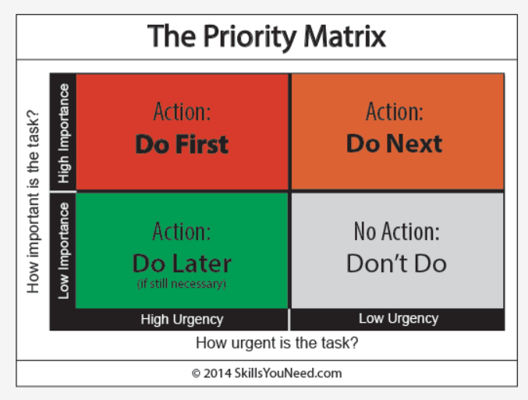
Figure 1 - The Priority Matrix [2]

There are also a number of essential skills needed in order to be successful at university. A few examples of these are;
- A good understanding of the English language is essential as the ability to articulate well in a report or essay is required.
- The ability to read large amounts of text and a suitable method of writing notes. There are many different methods of note taking, which suit different types of people, but it is important to find a method that enables you to revise.
- The ability to study independently of others and be able to research effectively.
- Oral presentation skills. [3]

Self-Evaluation of Academic and Personal Skills

In order to conduct a self-evaluation I completed a number of forms which covered the many skills and attributes related to academic and Personal success. These forms then highlighted the areas in which I believed my strengths lied, and also the areas in which I felt I could improve. This can be found in Appendix A.

Self-Evaluation of Skills using online surveys

In addition to the self-evaluation skills forms, I completed two online surveys that ask a multitude of questions, to establish what type of character I am, and what type of team player I am. The first survey (results of which can be found in Appendix B) was from a website called VIA Character, which determines strengths and weakness based on a number of questions [4]. The second survey (results of which can be found in Appendix C) was from a website called 123test which looked primarily at team working skills, and it selected which type of role within a team you best fit in to. Team working skills are essential when working on certain tasks in higher education, but also in life in general [5].

Strengths & Weaknesses

From both the self-evaluation forms and the online surveys it can be seen that the following skills and attributes are considered my strengths:
Decision making, presentation skills, diligence and organisation, Information Technology skills.
I concur that I believe these closely match my skills as I have to use these skills regularly in my current employment. I have to plan projects from start to finish, making important decisions throughout and present my ideas and progress to my customer.
My weaknesses, or areas in which I need improvement, are as follows:
Creativity, stress management, sensitivity to others and note taking.
I have never considered myself a creative person. I also suffer from stress when I feel that the workload from my employment and my personal commitments conflict. I also fail to think long term with regards to note taking during study and revision, and therefore my notes are poorly organised and difficult to decipher. I almost feel that I don’t need to take good notes, as my short-term memory is very good, without considering that my long-term memory is not particularly good.

Action Plan

After assessing my strengths and weaknesses I have written an action plan (Appendix A).
The areas in which I require improvement are as follows:
Creativity – I do not know if it is possible to change or improve this attribute in a person, however, I have recently started painting and drawing in my spare time. I hope this may unlock the creative part of my brain but it may also help me to look at things differently.
Sensitivity to others – I do feel that I treat everybody with the respect they deserve, but sometimes I can also fail to appreciate that other people react differently to me in certain situations. This can cause me to become impatient with others if they aren’t performing to the level that I expect from them. In future, I am going to try to put myself in their shoes and accept that they may not behave in the same fashion that I might. I will attempt to communicate with the people around me (friends, family, colleagues etc.) to get a better understanding of how people might react to certain situations and this should help.
Note taking – As I explained above, this is something that I am aware of that I need to improve. A bit more self-discipline and reminding myself of the future benefits of effective note taking should help me to become more organised. I plan to make more of an effort to bullet point and summarise points during lessons which should help with revision for future examinations.
Stress Management – In order to prevent stress from building up to an unacceptable level I need to accept my limitations when it comes to productivity and work load. In the past I have found it difficult to say no when given extra work. I intend to be more honest with myself about what is achievable, and give myself a break every now and then.

Application

Prior to enrolling to study at UWTSD I had very little experience in higher education. Unlike other modules on the course, where I have foundation knowledge from previous education, the study skills module has provided me with skills I have not come across before.
The biggest skill/technique/method that I have learnt in the study skills module that I have made use of in the other modules on the course is report writing. That includes how to layout the structure of a report, what sources are suitable and how to properly reference using the i.e.e.e format. In both the Electronics and Physics module I have had to submit a written report. Although the majority of the marks are related to the content, a good number of the available marks are related to report writing skills so I believe that these writing skills have contributed to me passing these written assignments. As part of the study skills module I also presented a presentation as part of a group (details below). I focused my research on report writing, versus essay writing, and the research I did for this presentation helped me when it came to writing reports in the other modules.
Highlighted by my self-evaluation an area in need of improvement is effective note taking. Specifically, the managing of my notes in order to make revision easier prior to examinations. The study skills lecture on methods of note taking has helped me to focus my efforts in this area. I now summarise key points during lessons using bullet points and this has led to me successfully passing both Mathematics examinations with a good result.
Prior to beginning the study skills module, I did very little in the way of backing up data. Quite possibly, I have too much trust in technology and equipment, and I wrongly believed there wouldn’t be an issue by just saving it to my laptop, and only my laptop. The study skills module has shown me the error in doing this, and I have now put into place a number of additional ways to back up my data. Firstly, I sourced an external hard drive to store the data. Secondly, I email any data that I am working on to my various work and personal email addresses. The external hard drive acts as a back-up in case my laptop becomes faulty. The second back up of emailing the data serves as a back-up in case both my laptop becomes faulty and I damage or lose the external hard drive. The data can then be accessed by logging into my email accounts anywhere in the world.
Due to family commitments I was unable to attend the lesson in which the group presentation was conducted. Therefore, this was rearranged and my group presentation consisted of myself and one other. The other person involved was a colleague within my organisation who I had not worked with previously. I presented on the difference between report writing and essays and Chris presented on referencing. I believe we delivered the content within the presentation effectively and assertively. It was clear that both of us had prior experience presenting to large groups of people. The PowerPoint presentation was fairly simple and basic but it allowed us to show our knowledge as opposed to reading from the screen. In hindsight we could have made improvements to the presentation. The introduction of animations or giving the presentation slides a more attention-grabbing appearance may have helped to keep the audience more attentive. Due to other commitments we were unable to do much rehearsal together, and although the presentation did run smoothly, if we had managed to rehearse a few more times I have no doubt it would be better. Slides from the presentation can be found in Appendix D.

Conclusion & Evaluation

I have discovered that my education and employment history have given me a good grasp of the basic skills required to succeed in higher education learning. I have experience in oral presenting, working in a team, learning technical subjects and these have enabled me to focus on the areas in which I require developing. The study skills module has identified a couple of subjects that I was lacking in skill and the action plan I have put in place is helping me to rectify this.
The self-evaluation I conducted is a true reflection of my character, as I am honest and I understand many of my limitations.
I was surprised by the results of the VIA character survey. Although some of my stronger skills were placed near to the top, a number of them were not. For example, Leadership and Team work are placed in the bottom half suggesting that these are skills I need to develop. This contradicts my self- evaluation, which suggests I either have a higher opinion of myself with regards to these skills or I misunderstood the questions asked during the survey. It also showed that love was my strongest characteristic, and although I do have room for love in my heart, I feel the result is more a reflection of the type of questions asked.
The results of the 123test survey, which deemed which role within a team best suited my skills and personality, suggested that I would be an ‘executive’. The attributes of this role are similar to those required in the position I currently work in employment so I believe this to be an accurate result.

Bibliography

1. University of Manchester. [Online] [Cited: 12 April 2019.] www.academiccareer.manchester.ac.uk/about/do/skills/.
2. Time Management Skills. Skills you Need. [Online] [Cited: 18 April 2019.] https://www.skillsyouneed.com/ps/time-management.html.
3. Essential Skills for Undergraduate Life: the 13 Things You Should Know How to Do Before You Go to University. Oxford Royale Academy. [Online] [Cited: 14 April 2019.] https://www.oxford-royale.co.uk/articles/13-skills-university.html.
4. Character Strengths Survey. VIA Character. [Online] [Cited: 27 February 2019.] http://www.viacharacter.org/www/Character-Strengths-Survey.
5. 123test. Team Roles Test. [Online] [Cited: 17 April 2019.] https://www.123test.com/team-roles-test.

APPENDIX A

APPENDIX B

Team Roles Survey
Your answers have been used to identify which team role(s) suits you best. This suitability is expressed as a percentage.
The nine team roles are the Executive, Explorer, Innovator, Analyst, Driver, Chairperson, Completer, Team player and Expert.

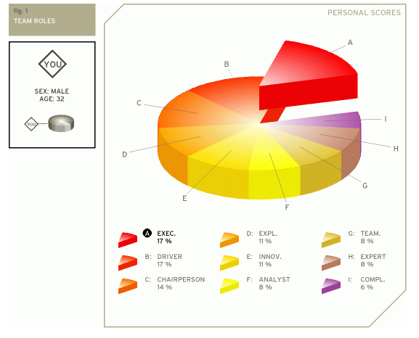

Executive
The executive is sometimes also referred to as the organizer. The executive is generally disciplined and eager to get the job done. He or she is efficient, practical, and systematic. Executives are well organized and diligent, and quickly turn the ideas of a team into concrete actions and practical plans.

APPENDIX C
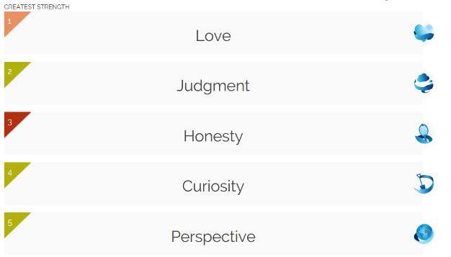
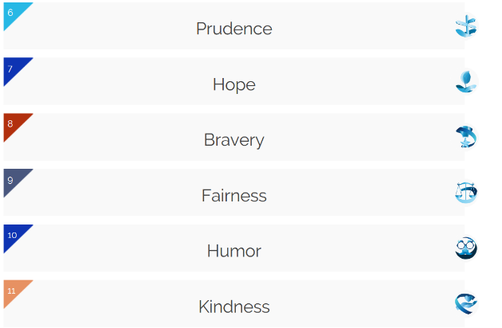
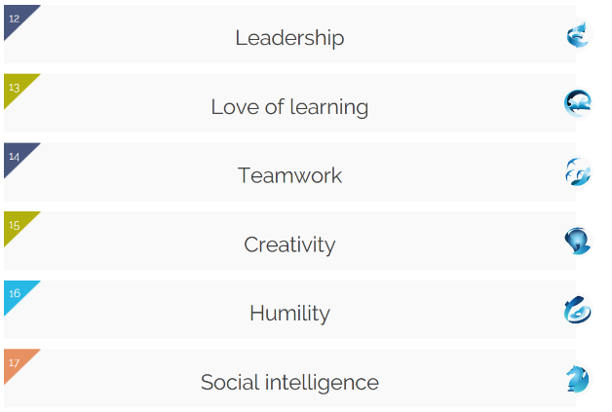
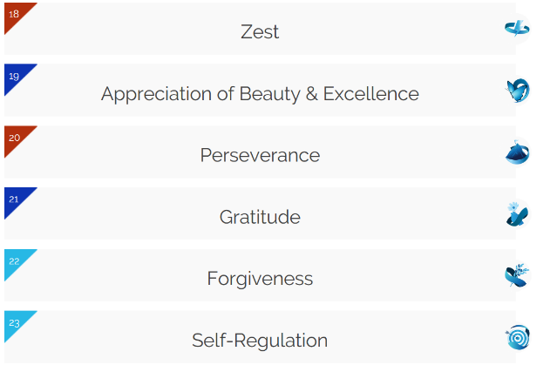

APPENDIX D


