ECIE4003

Additional Needs in Context

Portfolio

Susan Bowers-Roblin

Student Number: 2313941

Element 1 - Poster – Outlining good practice in terms of supporting learners with a specific learning need

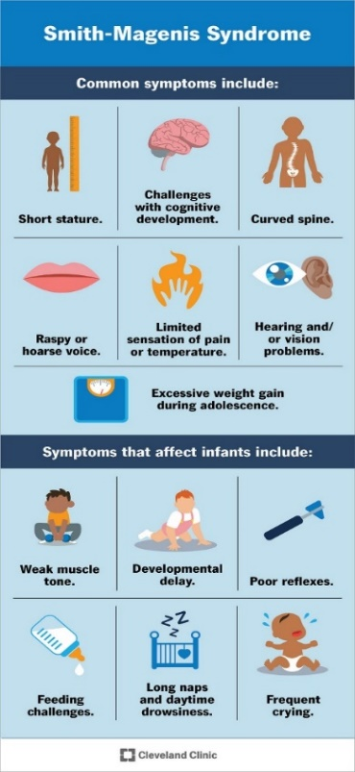
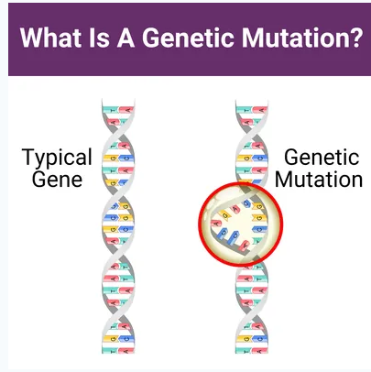
Smith-Magenis Syndrome - (SMS)
Causes, Features, and Symptoms.
SMS is a genetic disability due to a microdeletion or mutation on chromosome 17.
The major features of SMS include: -
- Mild to moderate intellectual disability.
- Delayed speech and language skills.
- Distinctive facial features.
- Sleep disturbances.
- Behavioural problems linked to ADHD.
- Global Delay
https://smith-magenis.org/what-is-sms/
Smith-Magenis syndrome (SMS) is a genetically determined condition, associated with intellectual disability, developmental delay and a pattern of distinctive behaviours.
https://smith-magenis.org/wp-content/uploads/SMS-booklet-2017.pdf
Smith-Magenis Syndrome: Symptoms, Causes & Outlook (clevelandclinic.org)
SMS is caused by genetic mutations in the following known gene(s):
RAI1 means that it consistently has a daily impact. Smith-Magenis syndrome | About the Disease | GARD (nih.gov)
Barriers for those with SMS.
People living with Smith-Magenis Syndrome, are all individuals and will have different barriers to deal with on a day-to-day basis. Some of these barriers could be:
- Eating and Drinking
- Getting Dressed
- Speaking / Asking for help
- Planning their day
- Mobility issues
- Social cues
- Behaviour/reactions
Advice on SMS Behaviour - SMS Foundation UK (smith-magenis.org)
The best way to support those who battle every day with this condition is to remember that everyone has the right to live their best life.
The support that would be needed is an environment that is adequately adapted to mobility issues, access to education, a calming space for timeouts, trained staff, and the use of appropriate social cues and consistent language skills. This can be achieved by making reasonable adjustments, whether that be talking, using flashcards or even sign language. Also, access to different forms of alternative therapies that could consist of hydrotherapy, chiropractic, massage, music therapy and art therapy.
Working together with multi-agency and accepting expertise from organisations such as Snap, Smith-Magenis Syndrome (SMS) Foundation UK and Scope.

Maslow’s Hierarchy of Needs (1954) theory states that one’s basic “physiological needs should be satisfied before one can achieve the need for security and safety” which is the next level in the theory. This can be achieved by having lots of physical and emotional support for day-to-day activities. 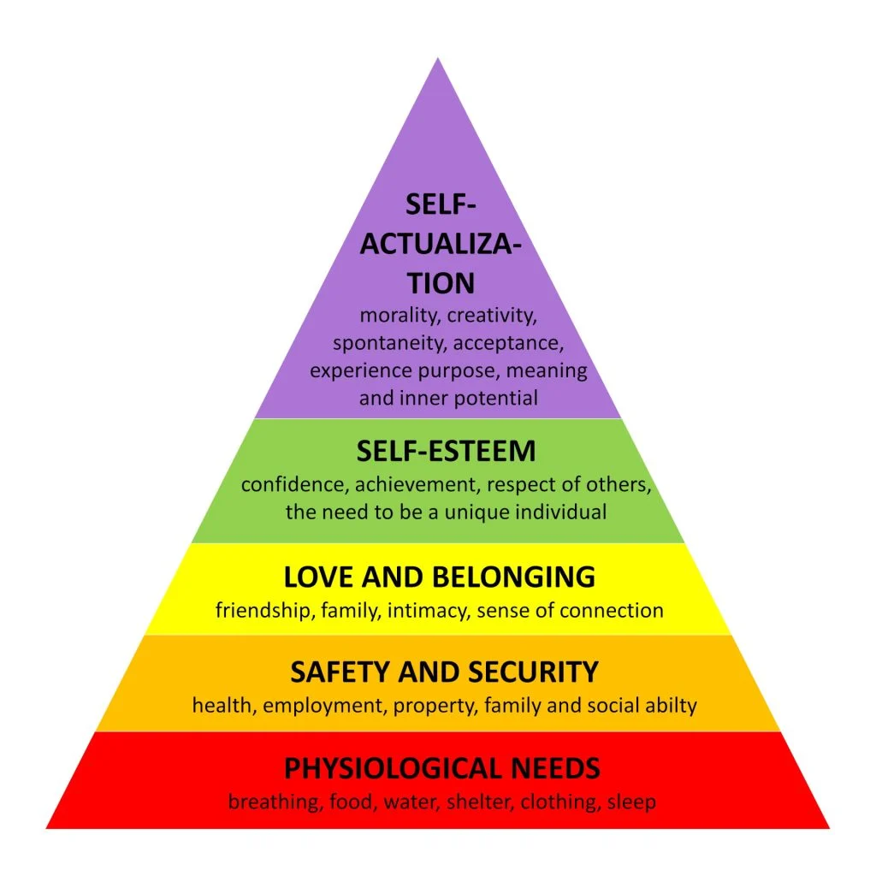

Certain policies need to be followed in line with the duty of care some of these are as follows: -
- The Additional Needs Code of Practice Wales (2021)
- UNCRC (1989)
- Equality Act (2010)
- Salamanca Statement (1994)
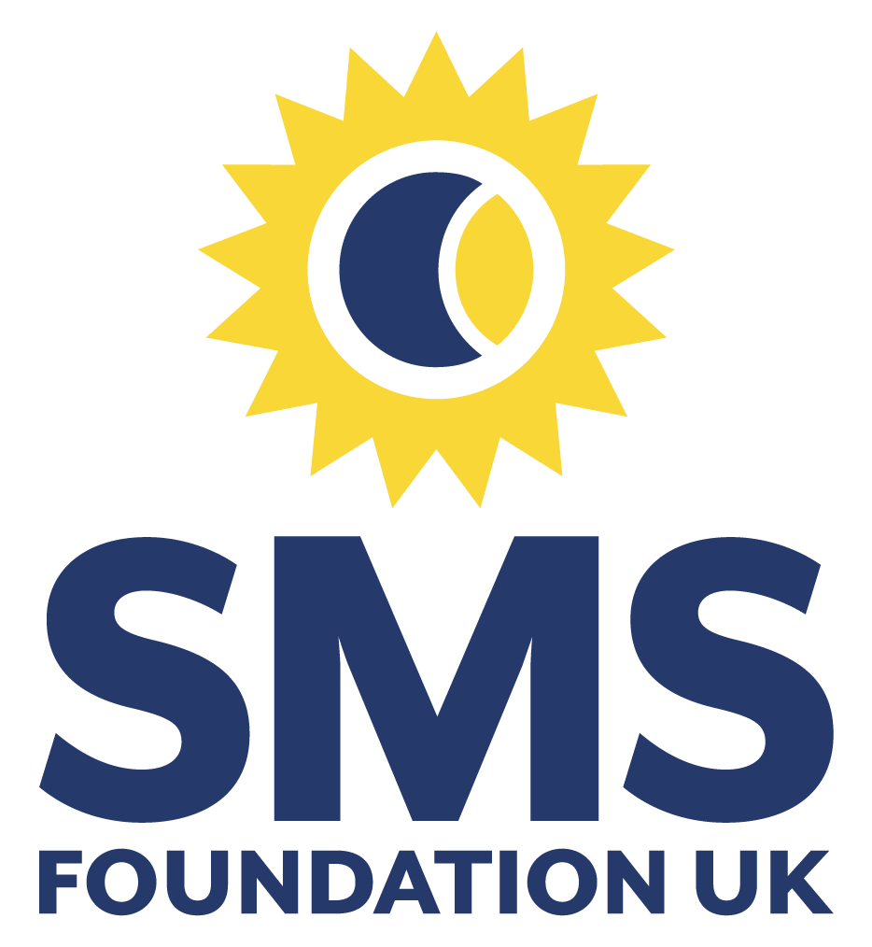

References

Additional Needs Code of Practice Wales (2021). Available at The Additional Learning Needs Code for Wales 2021 (gov.wales) accessed 28th September 2024.

Barriers (2021). Available at Advice on SMS Behaviour - SMS Foundation UK (smith-magenis.org) accessed 21st September 2024.

Causes, Features, and Symptoms Available at https://smith-magenis.org/what-is-sms/ accessed 11th September 2024.

Definition of Smith-Magenis syndrome (2017) Available at https://smith-magenis.org/wp-content/uploads/SMS-booklet-2017.pdf accessed 12th September 2024.

Equality Act (2010). Available at Equality_Act_Advice_Final.pdf (publishing.service.gov.uk) accessed 28th September 2024.

Image, genetic mutations RAI1 (August 2024). Available at Smith-Magenis syndrome | About the Disease | GARD (nih.gov) accessed 14th September 2024.

Image, Common Symptoms (November 2022). Available at Smith-Magenis Syndrome: Symptoms, Causes & Outlook (clevelandclinic.org) accessed 14th September 2024.

Maslow (1954). Available at https://www.simplyplypsychology.org/maslow.html accessed 29th September 2024.

Salamanca Statement (1994). Available at THE SALAMANCA STATEMENT AND (european-agency.org) accessed 28th September 2024.

UNCRC (1989). Available at Layout 1 (unicef.org.uk) accessed 28th September 2024.

Element 2 - Essay - Explore the wide and complex spectrum of additional needs
This essay is going to explore the wide and complex spectrum of additional needs, which includes additional learning needs (ALN) and special educational needs (SEN). “ALN, or Additional Learning Needs, is the term used in Wales for pupils who need extra support in school. The new ALN system replaced the previous Special Educational Needs (SEN) system in September 2022.” (Mentally Healthy Schools 2024). In many senses the term SEN and ALN are interchangeable, however, the difference is that the SEN system only recognised “that learners with most severe/complex needs have legally enforceable ‘statements’ setting out the support needed” (Michael Dauncey 2022). The major change is that in the ALN system includes learners from 0-25 years of age. A Learner has ALN if they have a learning difficulty or disability (whether the learning difficulty or disability arises from a medical condition or otherwise) which calls for additional learning provision (Snap Cymru 2024). The ALN system tries to operate from a social model rather than the medical model of the SEN system where the focus was on those with the most complex needs and perhaps meant that learners in other circumstances were not given the access and support needed.

The medical and social models of disabilities will be discussed in this section. The way additional learning needs have been looked at through the years has eventually changed for the better within the educational and medical professions. Traditionally, the medical model was used to define disabled people, who
Were seen as being disabled by their impairments (e.g. blindness or autism). If you cure their impairments, the issue of how Disabled people fit into society goes away. Society doesn’t have to change to accommodate them (ALLFIE 2024b).
This model consists of the person with the disability being viewed as the barrier to social engagement and would be excluded from all activities instead of included. Disability was seen as a medical condition that needed to be fixed with a cure.
The medical model was used in everyday life before the introduction of the social model in the 1980’s (ALLFIE 2024a). The model was created by disabled people for disabled people. The social model sees society as the barrier and not the impairment/disability as the barrier. It was not until 2014 that the UK government adopted the model within their departments for how they interact with people with disabilities (Scope 2022). If society removes the barriers that stop people from achieving a fulfilling life, this will then include disabled people instead of excluding them. In simple terms, the social model ensures that all buildings have a wheelchair ramp for accessibility meaning that everyone can access the building either for work or leisure purposes.

The social model is used within schools daily as well as other organisations such as the NHS. Schools aim to remove the barriers within their environment to include children and young people who have an impairment or a disability. This means that schools need to have the right equipment in place, and have extra support in the classroom, be it an LSA or software to help a child read or write depending on individual need. The benefits of using the social model are that the children will feel included and be able to attend and achieve in education. It also “recognises the barriers that make life harder for them, by removing the barriers it creates equality and offers them more independence, choice and control” (Scope 2024).
In relation to good practice within the social model reasonable adjustments must be seen to be working in the child’s best interests. This could include making a physical change to the environment such as a ramp for wheelchairs, accessible toilets / changing area, lifts to high level floors. Other changes that could be made include communication by ensuring that there are interpreters or alternative formats available for deaf or blind people (Welsh Government 2021). Another way of ensuring good practice is improving the attitudes and perceptions around those who have disabilities, therefore achieving positive experiences for the people who have a disability (Russell, S 2021). Working together in a multi-agency way and accepting advice and support from organisations such as Snap, Mencap, Scope, and the National Autistic Society.

Looking at Maslow’s Hierarchy of needs in relation to additional needs within education, Maslow argues that a child cannot thrive if their needs are not met. Within Maslow’s pyramid (Capes, 2024), safety and security and love and belonging, are an essential part of someone needs, therefore children need to feel safe and that they belong there while in school. In effect if a child is excluded for their disability or learning needs then the school are not fulfilling the child’s needs.

Policies that relate to good practice would be the United Nations Convention of Right of the Child (UNCRC), 1989 that states that all children and young people under the general principles have the right not to be discriminated against, have their best interests are meet, the right to life survival and development and the right to be heard (UNICEF UK 2024). Other policies that must be considered are the Additional Learning Needs Code for Wales 2021 and the Equality Act 2010, where in it states that children cannot be discriminated against for their disabilities, races, sex, sexual orientation or gender reassignment, religion or belief. All children have a right to an education that if needed is tailored to suit them.

This essay explored the wide and complex spectrum of additional needs, discussing several topics round the medical and social models of disability and the benefits of the social model of disability. Also, the best practice in relation to children and young peoples needs to be able to thieve and achieve within their education. As stated, schools are using the social model daily where they aim to remove the barriers within their environment to include children and young people who have an impairment or a disability. The benefits of using the social model are that the children will feel included and be able to attend and achieve in education, together with the good practice within the social model, reasonable adjustments must be seen to be working in the child’s best interests. In effect if a child is excluded because of a disability or learning need then the school are not fulfilling the child’s needs. All children have a right to an education that if needed is tailored to suit them.

References
ALLFIE, 2024a. The Medical Model of Disability. Available at https://www.allfie.org.uk/definitions/models-of-disability/medical-model-disability/ [Accessed Oct 21, 2024].
ALLFIE, 2024b. Models of Disability. Available at https://www.allfie.org.uk/definitions/models-of-disability/ [Accessed Oct 23, 2024].
CAPES, K., 2024. Maslow's Hierarchy of Needs in Education | Brooks and Kirk. Available at brooksandkirk.co.uk. [Accessed November 1, 2024].
DAUNCEY, MICHAEL, 2022. Identifying Additional Learning Needs: Has the bar been raised or was it previously too low? Available at research.senedd.wales. [Accessed October 29, 2024].
DEPARTMENT OF EDUCATION, 2014. The Equality Act 2010 and Schools. pp. 5–11. Available at assets.publishing.service.gov.uk. [Accessed October 31, 2024].
GOVERNMENT EQUALITIES OFFICE, 2011. The Equality Act, making equality real. Available at assets.publishing.service.gov.uk. [Accessed October 31, 2024].
MENTALLY HEALTHY SCHOOLS, 2024-last update, ALN (Wales): Mentally Healthy Schools. Available at https://www.mentallyhealthyschools.org.uk/factors-that-impact-mental-health/vulnerable-children/children-with-additional-needs/aln-wales/ [Accessed Oct 21, 2024].
RUSSELL, S, 2021. Creating an inclusive environment with and for Disabled workers. Available at www.ucu.org.uk. [Accessed October 29, 2024].
SCOPE, 2024-last update, social model of disability | Disability charity Scope UK. Available at https://www.scope.org.uk/social-model-of-disability [Accessed Oct 21, 2024].
SCOPE, 2022-last update, social model of disability | Disability charity Scope UK. Available at https://www.scope.org.uk/social-model-of-disability [Accessed Oct 23, 2024].
SNAP CYMRU, 2024. What is ALN? Available at www.snapcymru.org. [Accessed October 31, 2024].
UNICEF UK, 2024-last update, What is the UN Convention on Child Rights? Available at https://www.unicef.org.uk/what-we-do/un-convention-child-rights/ [Accessed Oct 31, 2024].
WELSH GOVERNMENT, 2021a. The Additional Learning Needs Code for Wales 2021, pp. 227–231. Available at www.gov.wales. [Accessed October 31, 2024].
WELSH GOVERNMENT, -11-08, 2021b-last update, EU Structural Funds 2014 to 2020: social model of disability | GOV.WALES. Available at https://www.gov.wales/eu-structural-funds-2014-2020-social-model-disability [Accessed Oct 29, 2024].

Element 3
Explore and summarise the additional learning needs of a pupil using a person-centred planning approach.
(Based upon Section 1C IDP: Profile (About me)
and
2A IDP: Description of the child or young person’s additional learning needs (ALN))

Section 1C: Profile (About me)
• What is important to the learner
My family, going out with my support worker. I like to learn about interesting topics, and I love science. I love aeroplanes and know a lot about them. I would like to get my GCSE Maths, but I don’t know if I want to do the work for it. But I need the qualifications to get a job. I want to be an Aeronautical Engineer.

• What is important for the learner
Being listened to and talking to me about what is happening.
I need to know about changes to routines beforehand.
Having clear and exact instructions.

• What is working and should be built on
My natural knowledge of things (my memory is excellent).
Joining my class for 2 hours a day for lessons.
Working with my 1 to 1 in my room on the work that my teacher has given me to complete.

• What is not working and needs to change.
Not having enough time with my teacher to work on my GSCEs.
More time in school, I want to be in for the full day. I don’t want to be on a PSP (Pastoral Support Plan), as I am better behaved now and I want to see my friends more.

Section 2A: Description of the child or young person’s additional learning needs (ALN)
The pupil has a diagnosis of ADHD and childhood autism. His ADHD is medicated.

Cognition and Learning

Unwillingness to engage with activities that are not of his choosing.
Poor concentration and attention, needs prompts to stay on task.
Difficulties accessing the curriculum due to not always being in class with peer group.

Communication and Interaction

Social communication and interaction difficulties related to his autism.
Does not always understand social cues and can reply inappropriately.
He can be easily distracted by his own actions or those of his peers.

Sensory and/or Physical

Poor fine motor skills, writing can be unreadable at times.
Wears glasses for vision, cannot see much without them.
Suffers from asthma.

Behaviour, Emotional and social development

Challenging behaviour can have physical and/or verbal outbursts that have required physical restraint in the past.
Emotional difficulties, has issues recognising other's emotions.
Unable to express own emotions appropriately.
Has past childhood traumas.

Element 4
Discuss the potential support provided to your chosen pupil (utilising the key principles, approaches and policies that guide inclusive practice).
Based upon Section 2B IDP: Description and delivery of the child or young person’s additional learning provision (ALP)

I have provided 4 section boxes in this template 2B1, 2B2, 2B3, 2B4.
This will provide space for 4 ALPs

If you require more, copy and paste the section box as needed – each ALP should be contained in its’ own individual section box.

n.b. Each section box contains 858 title words – these do not count towards your word count for this element

Section 2B1: Description and delivery of the child or young person’s additional learning provision (ALP)
2B1.1) Intended outcome:  These outcomes should be SMART (Specific, Measurable, Achievable, Realistic,  Timebound). | Pupil to be able to extend his time in school from 2 hours a day to 4 and engage with his GCSE work so that he can work towards gaining qualifications.
2B1.2) ALP to be provided:  This should include how often (daily, weekly); the type of support; who provides the support. The description of the Additional Learning Provision (ALP) should be very clear and precise, the above could then be split into smaller goals and targets. |  | 2B1.3) Should the ALP be provided in Welsh? | 2B1.4) Organisation/  Service to provide the ALP, (e.g. NHS, Inclusion Service, Specialist Teacher, etc.): | 2B1.5) Start date: | 2B1.6) End / Review date:
- Increase hours in school to enable pupil to access GCSE lessons and engage with specific staff members for Maths and English together with his 1:1 support to enable him to keep focused and on task. To be managed by Teacher in Charge, subject teachers and parents. To be reviewed weekly and then overall strategy discussed at end of November review meeting.  - Later to include joining a small group of his peers to work with them as a mini class on chosen GCSE subjects. This will include working on past exams papers. To be managed by Teacher in Charge, and subject teachers. Depending on progress with school hours this will be introduced at the end of September and then reviewed weekly. |  | No | School | 09/09/2024 | 25/11/2024
2B1.7) Rationale for the ALP listed above:
If there is a difference of opinion it should be recorded here e.g. a difference of opinion between the child, child’s parent or young
person and professionals. The section could explain how different opinions have been taken into consideration before a particular decision was reached.

Section 2B2: Description and delivery of the child or young person’s additional learning provision (ALP)
2B2.1) Intended outcome:  These outcomes should be SMART (Specific, Measurable, Achievable, Realistic,  Timebound). | Pupil to modify his behaviours in school e.g. reduce impulsive behaviours, inappropriate remarks and reduce his anxiety. This will be evaluated by the pupil being able to display the ability to self-regulate when working/socialising with a small group of his peers for the period of 30 minutes.
2B2.2) ALP to be provided:  This should include how often (daily, weekly); the type of support; who provides the support. The description of the Additional Learning Provision (ALP) should be very clear and precise, the above could then be split into smaller goals and targets. |  | 2B2.3) Should the ALP be provided in Welsh? | 2B2.4) Organisation/  Service to provide the ALP, (e.g. NHS, Inclusion Service, Specialist Teacher, etc.): | 2B2.5) Start date: | 2B2.6) End / Review date:
- Twice weekly specific social interaction sessions with 1:1 LSA to discuss previous peer to peer interactions and any potential misunderstandings that can be learnt from.  - Engage in social circles and mix with peers by encouraging him to mix with friends by inviting the friends into the learning support classroom with a view to moving to more general school areas. To be managed by class teachers and LSA, starting on a twice weekly basis with aim to increase as confidence develops.  - Weekly time with school counsellor for pupil to develop strategies to manage anxiety levels. Sessions to be timetabled for the same weekly slot to support routine and reduce anxiety around change. |  | No | School | 09/09/2024 | 25/11/2024
2B2.7) Rationale for the ALP listed above:
If there is a difference of opinion it should be recorded here e.g. a difference of opinion between the child, child’s parent or young
person and professionals. The section could explain how different opinions have been taken into consideration before a particular decision was reached.
Section 2B3: Description and delivery of the child or young person’s additional learning provision (ALP)
2B3.1) Intended outcome:  These outcomes should be SMART (Specific, Measurable, Achievable, Realistic,  Timebound). | Pupil to improve his ability to express his emotions and to recognise other's emotions this will be measured within the Motional programme software give advice and a final report. Also, through ELSA sessions with age appropriate resources for the pupil around understanding your emotions.
2B3.2) ALP to be provided:  This should include how often (daily, weekly); the type of support; who provides the support. The description of the Additional Learning Provision (ALP) should be very clear and precise, the above could then be split into smaller goals and targets. |  | 2B3.3) Should the ALP be provided in Welsh? | 2B3.4) Organisation/  Service to provide the ALP, (e.g. NHS, Inclusion Service, Specialist Teacher, etc.): | 2B3.5) Start date: | 2B3.6) End / Review date:
- Individual Motional Programme sessions with LSA trained on the programme on a weekly basis.  - ELSA Sessions on a weekly basis, with LSA team and peers, around what is appropriate behaviour and strategies to reduce impulsive behaviour, for example, using social stories. |  | No | School | 09/09/2024 | 25/11/2024
2B3.7) Rationale for the ALP listed above:
If there is a difference of opinion it should be recorded here e.g. a difference of opinion between the child, child’s parent or young
person and professionals. The section could explain how different opinions have been taken into consideration before a particular decision was reached.
Section 2B4: Description and delivery of the child or young person’s additional learning provision (ALP)
2B4.1) Intended outcome:

These outcomes should be SMART (Specific, Measurable, Achievable, Realistic,
Timebound).
2B4.2) ALP to be provided:  This should include how often (daily, weekly); the type of support; who provides the support. The description of the Additional Learning Provision (ALP) should be very clear and precise, the above could then be split into smaller goals and targets. |  | 2B4.3) Should the ALP be provided in Welsh? | 2B4.4) Organisation/  Service to provide the ALP, (e.g. NHS, Inclusion Service, Specialist Teacher, etc.): | 2B4.5) Start date: | 2B4.6) End / Review date:
 |  | Yes / No
2B4.7) Rationale for the ALP listed above:
If there is a difference of opinion it should be recorded here e.g. a difference of opinion between the child, child’s parent or young
person and professionals. The section could explain how different opinions have been taken into consideration before a particular decision was reached.

ALLFIE, 2024a-last update, The Medical Model of Disability. Available: https://www.allfie.org.uk/definitions/models-of-disability/medical-model-disability/ [Oct 21, 2024].
ALLFIE, 2024b-last update, Models of Disability -. Available: https://www.allfie.org.uk/definitions/models-of-disability/ [Oct 23, 2024].
CAPES, K., 2024. Maslow's Hierarchy of Needs in Education | Brooks and Kirk. Brooks & Kirk.
MENTALLY HEALTHY SCHOOLS, 2024-last update, ALN (Wales) : Mentally Healthy Schools. Available: https://www.mentallyhealthyschools.org.uk/factors-that-impact-mental-health/vulnerable-children/children-with-additional-needs/aln-wales/ [Oct 21, 2024].
MICHAEL DAUNCEY, 2022. Identifying Additional Learning Needs: Has the bar been raised or was it previously too low? Senedd Research, .
RUSSELL and S, 2021. Creating an inclusive environment with and for Disabled workers.
SCOPE, 2024-last update, Social model of disability | Disability charity Scope UK. Available: https://www.scope.org.uk/social-model-of-disability [Oct 21, 2024].
SCOPE, 2022-last update, Social model of disability | Disability charity Scope UK. Available: https://www.scope.org.uk/social-model-of-disability [Oct 23, 2024].
SNAP CYMRU, 2024. What is ALN? .
UNICEF UK, 2024-last update, What is the UN Convention on Child Rights?. Available: https://www.unicef.org.uk/what-we-do/un-convention-child-rights/ [Oct 31, 2024].
WELSH GOVERNMENT, -11-08, 2021-last update, EU Structural Funds 2014 to 2020: social model of disability | GOV.WALES. Available: https://www.gov.wales/eu-structural-funds-2014-2020-social-model-disability [Oct 29, 2024].

