Community Engagement

Assignment 1

  - 

  - Student Name: Nicoleta-Raluca Oiaga
  - Student ID:1913093
  - Lecturer name:Tanja Nathan

Table of Contents

Table of Contents 2
Introduction: 3
Mission Statement: 3
Vision Statement: 3
Customers and what they require: 4
SWOT analysis of Starbucks: 5
Strength: 5
Weakness: 6
Opportunity: 6
Threats: 7
Role of an employee in achieving organizational goals and their Training Development: 7
Role of Baristas and its Importance 8
Skills and training required to be Barista: 9
Grinding skills: 9
Steam milk adding: 9
Sale skills: 9
Customer Service skills: 10
Conclusion: 10
References 11
Appendix: 12
Action Plan for Starbucks 12

Introduction:
Starbucks is an American coffee company that was established in 1971 in Seattle. It started by 3 individuals who shared the adoration for a great cup of coffee and extraordinary teas. Jerry Baldwin, Zev Seigel, and Gordon Bowker together began with the principal store that we today know by the name of Starbucks. After becoming an immediate hit in the market, the company went on to new stores in a different part of the country.
All over the world, Starbucks today is a seller and advertiser of coffee. It is one of the most reputed and recognizable brands around the world and has roughly 300,000 employees across 27,339 official stores in 75 countries, and a complete income of $22.387 billion out of 2017. Their items incorporate top-notch premium evaluated coffee, an assortment of new food, distinguished drinks, and desserts. The company has managed to acquire a key position in the market through its business approach and marketing strategies and continue to grow swiftly. The company was a huge success with sales crossing the expectations and in the US, a new franchise was being in different locations. Business visionary Howard Shultz became part of Starbucks as a promoting official in the 1980's, and by 1992 the organization opened up to the world. Now Starbucks was doing very well by transforming an ordinary drink into an excellent item.

Mission Statement:
According to the stated mission stated at their website that is “to inspire and nurture the human spirit – one person, one cup, and one neighborhood at a time.”, they are not only focusing on their coffees that is their product but they also focus towards their customers. They want to empower and reinforce their customers with the help of their products.

Vision Statement:
“To establish Starbucks as the premier purveyor of the finest coffee in the world while maintaining our uncompromising principles while we grow”. Looking to be the best and in line and providing the best coffee, Starbucks need to strive for the best in development in resources and administration. The company achieves this part of its vision proclamation by going on with it around the world extension as one of the top cafe and coffee organizations on the planet (Cole, 2008). Starbucks Coffee's vision proclamation is clear and moving, particularly as far as accomplishing and keeping up the chief status in the cafe and coffee industry. Also, the corporate vision is steady as far as future business up-coming are concerned

Customers and what they require:
Starbucks has its market segmented into 4 divisions that are shopaholics, students, adults, and Starbucks loyalist. Adults are the ones with high incomes and care a lot about status and brand conscious, students are the ones who belong to rich families and are more into spending for lifestyles (Michelli, 2009). The major part of their target market belonged to the middle and higher class but soon they realized the opportunities present in other markets and moved to cater to them strategically.
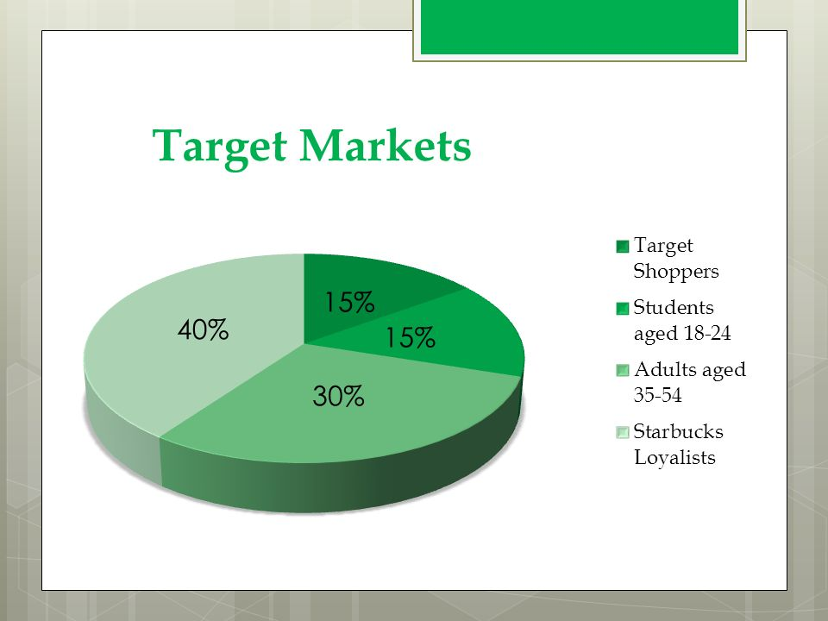
Starbucks has also segmented its target market by demographically and geographically location based on education and their love for coffee. They want to provide a place for their customers where they can relax, have peace of mind, and interact with each other. Starbucks has always focused on its customer to provide them with a place with an environment they can go for. It is proven that their customers pay for the quality of products to receive and the company doesn’t compromise on it (Shiwnarain, 2018). For a fact, customers tend to ignore the high price for the quality and premium quality coffee they receive (Donner and Loh, 2019). With coffee Starbucks became innovative, furthermore, they have been trying to bring new flavors and variations to the table and that’s what people love about their menu, you can find something unique.

SWOT analysis of Starbucks:

Strength:
- Financial Statistics: Starbucks has one of the strongest financial positions in the market with total revenue of 26.5$ billion and of with company had a total profit of 3.6$ billion in the year 2019.
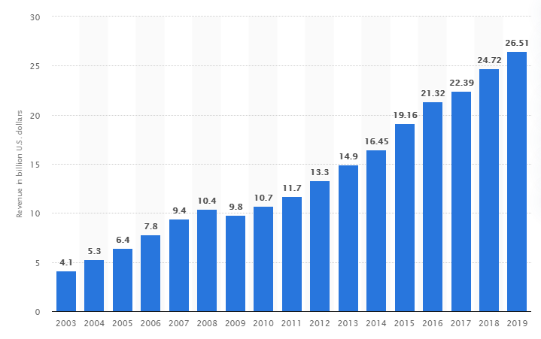
- The largest coffee chain in the world: Starbucks has 27,339 stores around the world in 75 countries making it the largest coffee chain in the world (IIC - International Review of Intellectual Property and Competition Law, 2016)
- Quality maintenance: one this Starbucks doesn’t compromise about is its quality control and that’s what their keeps their customer loyalty to them despite having high prices
- Strategic planning: Starbucks invest the most in its business expansion and marketing so it can produce more advantages for the company

Weakness:
- High price: as offering premium quality products, Starbucks is quite expensive for the most that can get the same from other competitor’s brands for less.
- Major dependency on the US: Despite its chain in the majority of countries around the world, Starbucks generates the majority of the revenue from the US market. Other markets it makes a profit from fall quite far behind it

- Imitability: As Starbucks doesn’t own most of the products on this menu, so they are also being offered by its competitors

Opportunity:
- Product offering: Starbucks has more products being offered online as compared to the ones on the store menu (Taylor, 2008). To attract more customers, they need to increase the number of products on the store menu as well.
- Online order: Starbucks has an online product booking option with its application which is limited to the US market only. They need to expand it further in other regions as well for their loyal customers.

Threats:
- Increasing Competition: Starbucks and its competitors are offering almost all the same products which are a great threat for Starbucks as they need to work more on innovating products on the menu and own them

Role of an employee in achieving organizational goals and their Training Development:
To give out a positive experience to the customer Starbucks is training their employees as word of mouth advertisement is one of their main marketing tactics. They train their employee for becoming a communicator for the brand and this way work harder for the organization. They don’t only believe happy customers but also that happy customers will bring in more customers. They invest more in their employee and allow them to grow within the organization more.
The whole Starbucks faculty including front-end representatives to which they allude to as their accomplices, cooperate in groups, and are centered on quality client care and customer fulfillment (Butler, 2018). Their front-end staff like baristas provides exceptional services to their customers and is trained to be dependable and active of the working team. Starbucks has a high accentuation on an approach that regardless of where you are in the progressive system the organization will perceive singular commitment.
The organization firmly believes that the deep connection with their employees and a sense of ownership have played a key factor to create the environment they have at Starbucks. As we referenced their workers are their accomplices, to show that they have a value for their employees they give provide them with different benefits that are medical coverage even to low maintenance employees. In 2014, Starbucks won the awards for the Disability Employer of the Year and went on to attain the greatest score of 100 of every 2015 on Disability Equality Index by the Human Rights Campaign.

Role of Baristas and its Importance
The most important role that can consider a coffee chain like Starbuck is of a Baristas. Though, they refer them by that instead they like to call them a partner. This brings more sense of ownership towards the company and you try striving for more and better. Being a Barista or a partner as Starbucks prefers you play a very key role in this organization you are the face of it. Batista is the first point of contact with the company with the customer. They make the first impression of the organization on the customer. One can forget how the coffee tasted but cannot forget the attitude and behavior of the barista and how he was treated. A good barista attracts loyal customers and it’s a great step for café owners to get their barista well trained.
With regard to quality coffee, the significance of a decent barista can't be downplayed. A gifted barista has a significant effect on the outcome in the cup and positions with new espresso and great gear as one of the basic components of coffee making. A Barista should be and is always be able to meet the customer down to his level and help him make the right choice for himself with honest guidance. Having a highly trained and genuinely inspired is the blessing of its own because barista just not only makes a coffee to its customer but also make loyal customers to the organization. Sometimes loyalty of customers remains with a coffee shop as long as their barista stays with them because each barista has a slight touch of his contributed toward a customer coffee much that they make up a taste for it.

Skills and training required to be Barista:
A talented barista has a significant effect on the outcome in the cup and positions with new coffee and great gear are one of the basic components of coffee making.

Grinding skills:
Realizing how to change the processor to accelerate or hinder the progression of coffee is urgent expertise. The speed at which the coffee streams from the gathering leader of the machine decides the resultant flavors starting from the earliest stage. Individuals are regularly amazed at the distinction in taste by a slight change of the processor makes. Each time a modification is made to crush better or coarser, the barista must taste a shot of coffee delivered at the new granulate setting to decide the quality? This must be done consistently since coffee changes in character as it ages. The ideal processor setting, for now, may not be immaculate tomorrow.

Steam milk adding:
Coffee is frequently presented with steamed milk as bistro latte, cappuccino, and macchiato. Once the barista has arranged a shot of coffee, their consideration goes to steaming milk to the right temperature and consistency. The ideal outcome is smooth, velvety, and sweet with no obvious air pockets. This is known as microfoam. Steaming and aesthetically pouring the microfoam takes a ton of expertise and practice. The barista plays out these abilities reliably and frequently under tension in the active occasions. Machine support and tidiness become endless undertakings during moderate occasions (Lusiah, 2019).

Sale skills:
Selling coffee using suggestive selling skills can determine the profitability organization and abilities of the barista. A barista should be able to sell something additional of what the customer wants at his will. They should be aware of the right combination of different products.

Customer Service skills:
A Barista should be rightfully trained with customer service and engagement skills. They will be more confident to share coffee knowledge with their customers and provide them with the best experience and boost the trust of a customer with the organization.

Conclusion:
The report development started by looking into the historical backdrop of Starbucks that how they established everything since the beginning. In the 1970s, the coffee business needed rivalry, and the development of new pattern started. Starbucks experienced great achievement and as another top coffee company, they were more goal-oriented. Their forceful development plan has seen achievement since the time the start till now Starbucks established around 27,339 stores worldwide in 75 nations. Starbucks is monetarily solid, and it likewise has major upper hands in this steady developing domain. To develop this, they thought to consider extending their business to the following extends. Starbucks has numerous chances, there is space to propel their innovation, extend their items, and administrations. The best of their qualities is that they have streamed line money related resources, Starbucks is entrenched and the company is universally famous.
The Barista working is Starbucks coffee shop is as important as any of their marketing strategy or their coffee ingredient because they are the ones that make the best out of those ingredients for the customer for the best experience. A barista is also considered to be the face of Starbucks as they are the point of contact for the company and customers and are directly in contact with them. They should be able to study their customer and makeup to their expectations. A well trained Barista is an asset on its own for a coffee company.

References

Butler, L., 2018. Coffee's Dark Secrets: Linguistic Variation in Starbucks and Dunkin Donuts. Lingua Frankly: The student journal of Linguistics at Boston College, 4. [online] Available at: <https://ejournals.bc.edu/index.php/lingua/article/view/10391> [Accessed 16 May 2020].
Cole, G., 2008. Grande Expectations: A Year in the Life of Starbucks’ Stock. Management Decision, 46(4). [online] Available at: <https://www.emerald.com/insight/content/doi/10.1108/00251740810865120/full/html> [Accessed 16 May 2020].
Donner, H., and Loh, T.H., 2019. Does the Starbucks effect exist? Searching for a relationship between Starbucks and adjacent rents. Property Management, 37(4), pp.562-578 [online]. Available at: <https://www.emerald.com/insight/content/doi/10.1108/PM-01-2019-0004/full/html> [Accessed 16 May 2020].
IIC - International Review of Intellectual Property and Competition Law, 2016. “Starbucks v. Sky”, IIC - International Review of Intellectual Property and Competition Law, 47(1), pp.119-119 [online]. Available at: <https://www.researchgate.net/publication/315495237_Starbucks_v_Sky> [Accessed 16 May 2020].
Lusiah, 2019. The Analysis of Determinants Affecting Consumers’ Decision to Choose Starbucks. Jurnal Manajemen, 23(3), p.393 [online]. Available at: <http://www.ecojoin.org/index.php/EJM/article/view/571> [Accessed 16 May 2020].
Michelli, J.A., 2009. The Starbucks Experience - by Joseph a Michelli. NHRD Network Journal, 2(7), pp.100-101 [online]. Available at: <https://journals.sagepub.com/doi/10.1177/0974173920090718?icid=int.sj-abstract.similar-articles.1> [Accessed 16 May 2020].
Shiwnarain, M., 2018. By 2020 Starbucks Hopes To Eliminate Plastic Straws From Their Stores | Science Trends, [online] Available at: < https://sciencetrends.com/by-2020-starbucks-hopes-to-eliminate-plastic-straws-from-their-stores/ > [Accessed 16 May 2020].
Taylor, 2008. Starbucks Spreads the Spirit of Giving with CARE. Advertising & Society Review, 9(1) [online]. Available at: <https://muse.jhu.edu/article/234170> [Accessed 16 May 2020].

Appendix:

Action Plan for Starbucks

Practices needed to be done | Time Frame | Conducted By | Contents or Details
- Maintenance of the employee’s performance | 1 year | Human Resource Department | · strategies development regarding the employee’s training  · employees will help to contribute to social responsibility and sustainability
2. Training sessions for employees | 3 month | HR Department | · Training the workforce to increase their professional and interpersonal skills.  · Ensuring that all of the employees train under effective supervision.
3. Development and implementation of policies for the workers to develop a healthier workplace | 2 months | HR Department | · provide a comfortable environment to employees so to increase their creative ideas · this will probably help to increase creativity
4. Insurance of the mental health of workers | All the time | HR Department | · utilize effective strategies for training and development of employees.

