Exploring The Difference In Levels Of Social Media Use Between Extroverts And Introverts

Abstract

Social media has developed into an integrated part of the lives of most people, specifically younger generations who use these platforms to express and communicate with one another. Past research has begun looking into the relationships between personality traits and how they relate to online media engagement, however results have often varied between individual studies, and there is a clear lack of representation for undergraduate student focus within these studies. The study below aims to determine the link between extraversion and social media usage between undergraduate students. Participants were asked to complete a personality questionnaire (The Big Five Inventory (BFI; John & Srivastava, 1999) to determine the levels of extraversion in participants, and then asked a series of questions to measure their average social media use. An independent t-test was conducted and the study found that there was no significant difference between extraversion and levels of social media usage. This aligns with broader results found within this subject, however there is a significant amongst studies that conclude extroverts display higher levels of social media interaction than introverts, and the inconsistencies between studies shows that there may be influencing factors that are not accounted for.

Introduction

Social media has become an integrated part of everyday life, specifically within younger generations, and this widespread use has influenced psychologists to research its potential impact on wellbeing and behaviour (Kuss & Griffiths 2017). Increasing amounts of literature suggests that consuming daily social media interaction and consumption can negatively influence cognitive functions. Xanidis & Brignell conducted a study that linked extreme social media usage with negative connotations, including decrease in attention span, and therefore led to overall poorer academic performance (Xanidis & Brignell, 2016).

A key factor in human behaviour is understanding personality and its role in predicting individual differences including engagement in social media. Experts often use The Big Five model of personality, a broad trait theory that attempts to help predict and understand behaviours across different contexts (Costa & McCrea, 1992). Extraversion is categorised as one of these core traits, associated with sociability, ability to thrive in social situations and assertiveness. Online media platforms provide constant access to different ways of communication, and according to the Big Five model, those in high extraversion are more likely to seek interaction and social stimulation (John & Srivastava, 1999). Recent studies have begun providing support that those high in extraversion are predicted to have increased levels of social media usage (Correa, Hinsley and de Zuniga, 2010).

Literature within this area shows mixed findings, with some studies claiming specific traits can be linked to higher social media interaction, whilst others claim that there was no significant difference between the two trait groups. Although a significant amount of research has been conducted on the differences in usage of social media linked to personality types, there is a distinct lack of studies using undergraduate samples, and therefore participant demographic may differ to those in other studies.
The Aim of this study was to identify and explore the influence levels of extraversion has on social media usage in undergraduate students. Based on existing literature and research, the hypothesis for this study is that participants categorised as extroverts will display higher levels of social media usage than individuals categorised as introverts due to their need for social stimulation (Bowden‑Green, Hinds, & Joinson, 2020).

Method

Participants
Thirty Four undergraduate psychology students were recruited via convenience sampling to take part in the study (13 male, 19 female and 2 non-binary). All participants were between the ages of 18 and 69 (M=29.26, SD=11.34).
Design
This study used a between subjects design to identify if levels of extraversion directly influenced levels of social media usage, and used the extraversion sub-scale of the Big Five Inventory (John et al., 1991). Participants were categorised into groups of high extraversion and low extraversion (IV) based on the sample mean and then measured on their social media usage (DV). The data was then analysed by an independent sample t test.
Materials
The Big Five Inventory (BFI; John & Srivastava, 1999) was used to assess levels of extraversion in participants (see appendix A). The full BFI includes 44 items, however only items related to the trait of extraversion were used in this study. A total of eight items, therefore, were used to measure extraversion levels. Participants were instructed to respond to each of the eight statements based on how they generally see themselves, and the anchor ‘I see myself as someone who…’ was provided at the beginning of the questionnaire. Responses to each statement, including “... generates a lot of enthusiasm”, were given on a 5-point Likert scales anchored from 1 = strongly disagree to 5 = strongly agree, with total scores on the scale subsequently ranging from eight to 40. Three items were negatively worded and required reverse scoring prior to analysis. Higher scores for this personality trait indicate a more outgoing and sociable person. Internal reliability for the extraversion scale in this study was initiated to be .56 which is lower than that reported by John, Donahue and Kentle (1991) (Cronbach’s alpha = .83).

To measure the level of social media use, the Social Media Use Questionnaire (SMUQ; Xanidis & Brignell., 2016) was used. This questionnaire contained nine items that aimed to assess levels of dependence to social networking sites (SNS). Participants were asked to provide a response to statements, such as “I spend a large proportion of my day using social network sites”, on a five-point scale anchored between zero (never) to five (always). Final scores ranged between zero and 36, with higher scores indicative of higher levels of dependence on SNS. Internal reliability for this scale was .90, which corresponds with previous research using this scale (e.g., Xanidis & Brignell, 2016)

Procedure

Participants were recruited via the Experiment Management System (EMS) to take part in the online study and were sent an access link to take part. Once the link was opened they were shown an informational sheet and consent form (appendix 1&2). Once consent is provided participants were asked for basic demographic information such as age and gender, followed by the Extraversion questionnaire (appendix 4). The individuals are then categorised into two groups influenced by the previous answers, low extraversion or high extraversion, and given the social media usage questionnaire (appendix 5) to measure the level of usage between the two groups. This concluded with a debrief (appendix 3) and a thanks for participation.

RESULTS

In independent samples t-test was conducted to explore the relationship of social media use levels between two independent groups, extroverts and introverts.

Table 1.
Descriptive Statistics Relating to Level of Social Media Use.

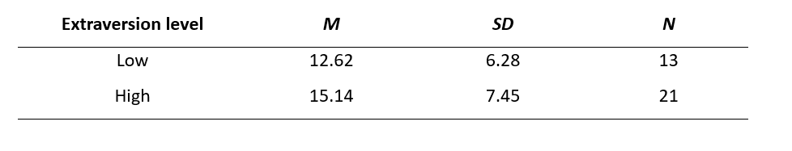

The t-test conducted displayed that there was no significant difference in the levels of social media usage between participants categorised as extroverts and introverts; t (32) = 1.02, p = .16. Although the high extraversion groups mean was higher the defect size (r = .18) was small and therefore not significant. The hypothesis previously stated that participants categorised as extraverts have higher levels in usage of social media than introverts and is not supported with these results, and is therefore rejected.

Discussion

As noted above, the study conducted found that there was no significant difference in the levels of social media usage between extroverts and introverts among undergraduate students, and that the previous hypothesis had no support from the results. Previous research has varied, from Correa et al.(2010), who found extraversion was directly linked to higher social media engagement, and similar results from Ross et al.(2009) claiming extraverts used social networking websites such as facebook for online socialising at a higher rate than introverts. Bowden-Green et al.s’ conclusion determined that the relationship between extraversion and social media use is inconsistent and is easily influenced by other factors such as type of online interactions and behaviours measured. Recent studies have shown that the younger generations' engagement with social media has become habitual within daily routines. The impact this has on linking social media use to personality traits such as extraversion means all individuals report high levels, and it becomes more difficult to link to personality differences and behaviour (Kuss & Griffiths,2017).

Although social media allows individuals to socialise and communicate easier, there are other reasons for using social media that may influence this study when focusing on personality traits and extraversion. The younger generations often use social media for entertainment purposes or procrastination during studying, and there are dozens of different social media apps (TikTok, Snapchat and Facebook) that have different types of communication styles between individuals
(Pew Research Center.2023) . These factors alongside the knowledge that most young people habitually use social media shows how complex social media engagement is, and that personality is not the only significant influence(Xanidis & Brignell, 2016).

There are relevant limitations to this study that need to be acknowledged and improved during future research. The self report measures used in the big five questionnaire can lead to self bias and individuals can be categorised in the wrong simple group depending on personal belief of themselves, therefore questioning the accuracy of this study. Another limitation is the small sample group size (N=34) in this study, and limits its overall reliability of the findings, and using larger and diverse sample sizes will prevent sampling bias and create more reliable research.

To prevent the limitations from influencing future studies, future research should differentiate between passive and active engagement on social media as some traits are more aligned with interactive social media usage than others. Including other personality traits from theories such as Eysenck's PEN framework will allow for a more in depth and comprehensive understanding about online behaviour and social media usage as a whole (Eysenck, 1992). By acknowledging and amending limitations of the study, more in depth research can be conducted about the links between personality traits (extraversion) and social media usage.

In conclusion, the results of this study showed that there was no significant difference in usage of social media of undergraduate students between individuals categorised as extroverts and introverts, and therefore rejected my previous hypothesis. Many factors influenced the results achieved in this study including heavy relevance on self report measures and small sample groups. In future studies more diverse sample groups and less reliance on potentially bias measures,

Whilst reading through literature, it has been acknowledged that this study had its limitations when exploring the relationship between extraversion and social media usage. Including other personality traits such as psychoticism and neuroticism from Eysenck's PEN model and specifying types of social media engagement are two simple ways that can help create more accurate and reliable data when exploring how trait and behavioural differences influence individuals' interaction levels with social media.

REFERENCES

Bowden‑Green, T., Hinds, J., & Joinson, A. (2020). How is extraversion related to social media use? A literature review. Personality and Individual Differences, 164, 110040. https://doi.org/10.1016/j.paid.2020.110040
Correa, T., Hinsley, A. W., & de Zúñiga, H. G. (2010). Who interacts on the Web? The intersection of users’ personality and social media use. Computers in Human Behavior, 26(2), 247–253. https://doi.org/10.1016/j.chb.2009.09.003

Costa, P. T., Jr., & McCrae, R. R. (1992). Revised NEO Personality Inventory (NEO‑PI‑R) and NEO Five‑Factor Inventory (NEO‑FFI) professional manual. Psychological Assessment Resources.

Eysenck, H. J. (1992). The definition and measurement of psychoticism. Personality and Individual Differences, 13(7), 757–785. https://doi.org/10.1016/0191-8869(92)90050-Y

John, O. P., Donahue, E. M., & Kentle, R. L. (1991). The Big Five Inventory--Versions 4a and 54. Berkeley, CA: University of California, Berkeley, Institute of Personality and Social Research.

John, O. P., & Srivastava, S. (1999). The Big Five trait taxonomy: History, measurement, and theoretical perspectives. In L. A. Pervin & O. P. John (Eds.), Handbook of personality: Theory and research (2nd ed., pp. 102–138). Guilford Press.

Kuss, D. J., & Griffiths, M. D. (2017). Social networking sites and addiction: Ten lessons learned. International Journal of Environmental Research and Public Health, 14(3), 311.
Pew Research Center. (2023). Teens, social media and technology 2023. https://www.pewresearch.org/internet/2023/12/15/teens-social-media-and-technology-2023/
Ross, C., Orr, E. S., Sisic, M., Arseneault, J. M., Simmering, M. G., & Orr, R. R. (2009). Personality and motivations associated with Facebook use. Computers in Human Behavior, 25(2), 578–586. https://doi.org/10.1016/j.chb.2008.12.024.
Xanidis, N., & Brignell, C. M. (2016). The association between the use of social network sites, sleep quality and cognitive function during the day. Computers in Human Behaviour, 55(Part A), 121-126. https://doi.org/10.1016/j.chb.2015.09.004

APPENDIX

1. information sheet 25 26

2. consent form 25 26

3. Debrief 25-26.docx

4. The Big Five Inventory - Extraversion.docx

5. Social Media Use Questionnaire (SMU-Q).docx

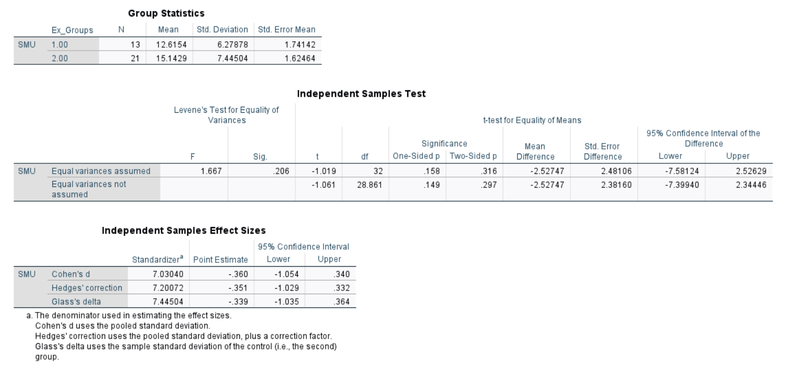

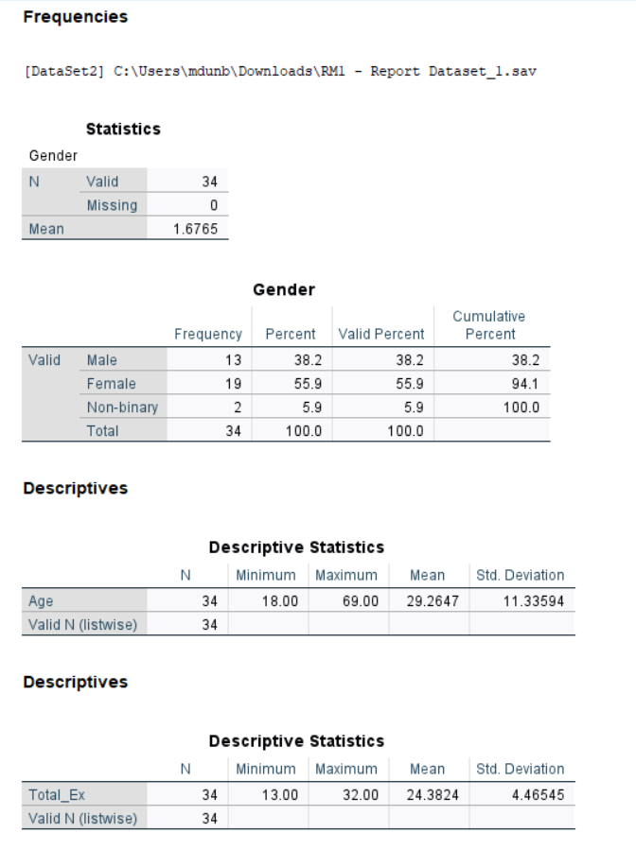

I know that I used CoPilot AI to help create the structure of my assignment and find reliable sources for my research.

