Component 1 Exam Screenshots

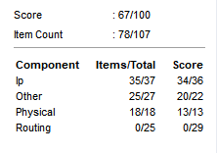
This is the overall score and how many of the item count have been checked off.

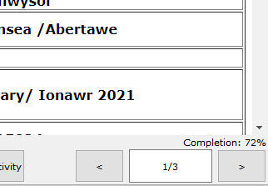
This is a screenshot of the overall completion percentage.

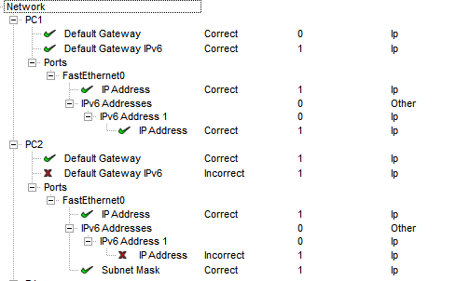

This is both PCs and what has been checked off and what has not been checked off.

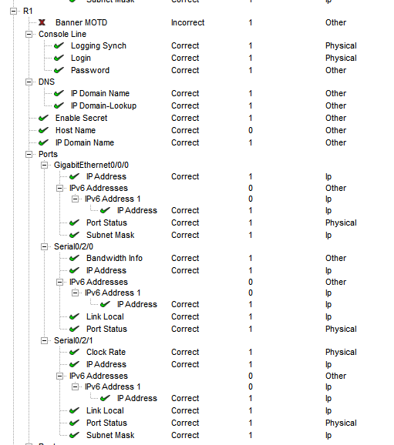
these screenshots are of R1 and what has been checked off and what has not.

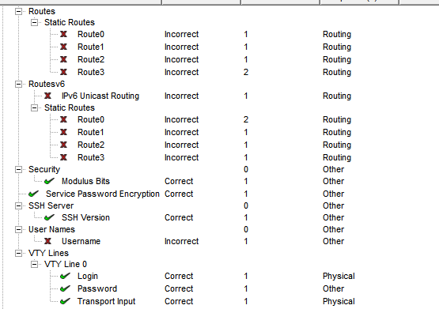

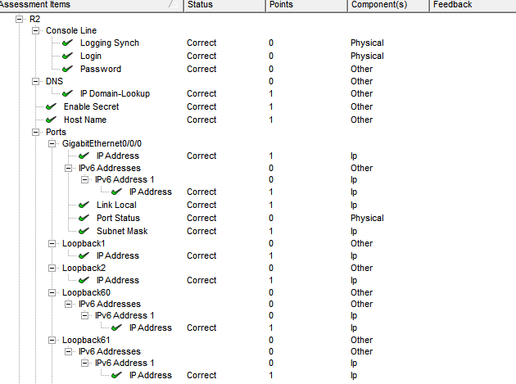
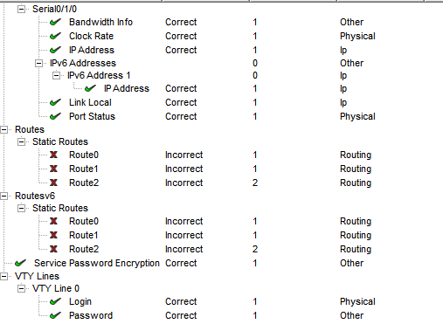
These screenshots are of R2 and what has been checked off and what has not.

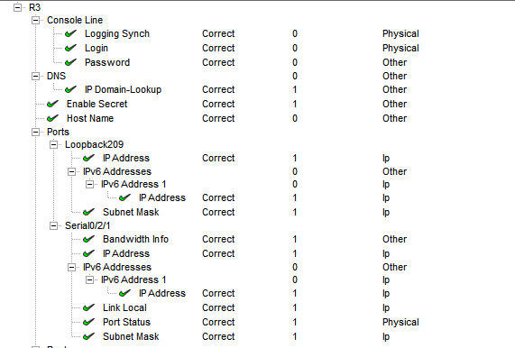
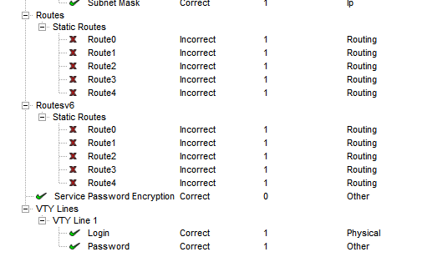
These screenshots of R3 and what has been checked off and what has not.

