Student Name: | Kashif Khan
Student Number: | 1815907
Module Name: | Digital Skills and Research Methods
Module Number: | BMSK4003_LON
Lecturer Name: | Paul Wallin

Table of Contents
Abstract 3
Introduction, Aim, Objectives 4
Literature Review 4
Primary Research 5
Methodology 5
Ethical Considerations 7
Limitations of the Study 7
Results 8
Conclusion 13
References 14

Abstract

To match the latest technology in each and every aspect of the life, a lot more importance is sliding into the use of education of arithmetical and finding techniques for improved comfort and appropriately , fresh business start-up. This might be not difficult to such particular thing and to provide highly dynamic fluency. They should be choose for this. The increased use of technology and revolution in digitalisation makings, and their vastly range of usage also tends to prepare all this necessary. On fresh build work to implement more and more dedication to show the important reserves and plans to make workers better In their works (Kawasaki,2015). Any how , the project at the spot allow to estimate different doubts associated with this vast subject. The final result wants to throw light on the reason of binary skills and research techniques are such necessary as their demand is increased worldwide and there are many known skills are here for binary arts in workplace for example, implementation of latest technologies for example cloud technologies and uses management facilities will meet to obey the new business start- ups (Deursen, 2014). Adding more to it the essay wants to recognise if revolutionized search techniques will keep any role in building the new projects works. As it is already known, there mostly two technologies are being implemented to conduct researches. Among all of these finding, only one from them will be used there due to the nature of the data. The report will go through arranging surveys questionnaires approach amongst to target the community to follow what the eases are regarding indicated statements. And for once the selected methodology was acted upon, the conclusion did no went against statements. The main outputs gain and again raise the fact that there is nothing better than the replacement for modern techniques to excel the era of advancement without teaching the workers how to use digital literacy and how to understand it in their work place. Adding some words in it, the searches shows that it might be good for company and its staffs to learn the skills bundle for assisting in the upcoming waves of latest business world (knobel,2008).the organisation, for one time recruit on the way, ought to manage the important coaching opportunities, if needed some courses will be held in such a way that they can avail the several opportunities of easiness keeping in view of the modern day world.

Introduction, Aim, Objectives

The result present here hopes to test about vitality of arithmetic and how much staff should be literate for the works. Somehow if fresh work start binary arts and findings change overs consults to arts which is came from several automatic and mechanical methodologies. Finding works have turned quick and very easy as exaggeration of advanced days needs to help the job turn more feasible with more freely useable intelligence sources. The result here will show that in how many different ways this binary arts and intelligence can be used in advanced business methods. So firstly the need of this research work can be gathered as given down to this statement:
- First of all we need to inspect whether this binary arts and finding techniques lies as basic need of freshly established business this is one the necessary thing for this cause.
- Secondly it will be done to recognise whether this newly build methodologies are helping the specific staffs in which they are learning these for progress of the company and also if they are availing new and modern skills.
- And also to conduct a survey which will find out whether these skills are helping the workers in daily works and how much they have improved their skills. And to make some adjustments in this business start-ups which will help the business to be successful in future.

Literature Review

People in earth now a days are going ahead very fast by the blessing of latest computing and robotic easiness grants. The workplace have not stayed unchanged by this event. (Martin,2006). Companies in these days support all their workers adding all higher-rank management and regardless of any art of age gaps. To avail more and more arithmetic skills and finding techniques. This motive is came from difference in thinking of modern days business with respect to modernized work . Mainly, when a newly established business is making marks in market and also when it is advancing in presence of older and successful business streams. Yes it is known that through what the world was been through. Fresh business are previously in demanding circumstances on the first step. But there quickness and dynamics of availing to their latest arts needs firstly to prove that how . Arithmetic arts includes any advanced days courtesies that aid the workers to get their good use and implement the return in rising up their institutional advancement and advisability. computerized finding techniques reserves are too verifying to be infinitely in executing and implementing results and inspection based doings. The workers in spite of what age of they are, one of the best resource of an organisation could ever acquire. So, then being capable in modern days industry. Requirements could directly add up numbers for their organisation’s favour. Arts like handling mails to give numbers or altering and interaction, by the help of modern research it help In doing different types of analysis which consists both the data of initial and final research work and these reserves can really give us opportunity to do good with modern research work( hafpenny, 2015). The world is widely moving ahead cost and time efficient organisational methods. The main aim is to do such things in a way that we can avail all required need without any external or additional effort , things like robotics are adding up in building modernized finding work. The need and its capability are indeed boundless.

Primary Research

Methodology
Methodology is main point of any research work because it leads you through a path way to do research. Like other things we do and we find some unwanted errors same like that we also face some difficulties while doing this. This this consists of many things:
Survey Method
As given earlier, in this work we will get data from work that we have done previously. The cause which is considered as central fact behind is that .did we have considerable research which will lead us to wanted result. Primary result means the data which we have collected from basics and past research work. To do this a survey was held to ensure all this and several questionnaires were made.

Population Sample Selection
In first sample all the questions and their answers were written in a compiled way that we can easily compare them. We know that survey was arranged on the importance of binary skills and it also consists of effectiveness of literacy to secure success. hit and trial method was used in this selection. The main reason behind doing all this to confirm it as favouritism free.
Developing Questionnaire
The questionnaires would contain very discrete and relatable questions.
S.I. No. | Questions | Responses
S.I. No. | Questions | Yes | No | No comments
1 | First question was about consideration of research work and its implication to what extent helps the fresh business.
2 | Will it proved helpful to introduce modern finding work is it enhance the workers ability to do the work more energetically?
3 | Will you think that workers of newly build business will avail the technology properly?
4 | What point of view you have about the workers of new establish business will have more strong relationship with consumer ?
5 | Do think that it’s true about advanced finding techniques will help the workers to engage finding works more consistently?
Data Collection and Analysis
The researcher will do research in a sense to produce a competitive and reliable data. Due to hearty and veracity taken into reflection at this point will directly recognise the correctness of finding method. If you have done research properly so that we consider the outputs as best to be and totally reliable.

Ethical Considerations

The finding given above was took into consideration in each desirable size to assure the solution and certainty purpose of the 35 of the present workers. Overall in this procedure, the data security rules has been complied by to assure them accurate and best, the researchers takes authority to keep all the names of the partners mysterious from public point of view.

Limitations of the Study

As par required applications has been used, this finding is implemented by this finding itself. It is to be commented that no important issue happened during the implementation of the research venture. Bur truly, the venture firstly began with a vision to interview at least 50 workers. But as the time went near to festive season, considerable number of workers on consent. So, the venture contains the actions of 35 accessible employees. the researcher conduct no supremacy on how the workers were sensing on the of survey. As the mental conditions of the workers was not in the consideration of the research. You can not say it or consider it fully that each and every worker gave his answer according to situation of his mind, favouritism or any immediate psychological situations( O’leary, 2016).

Results
At the end of the survey respective results were availed . Firstly, the answers and reaction of every single participant given at the end. The participant can reply their view in three different ways which is yes , no, or nothing you can say no comments.
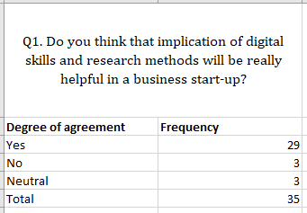
The question which was asked at first in the survey was about will binary arts and finding arts will help the staff of a newly establish business. 29 replied yes, 3 were with no, and remaining employees went for no comments.
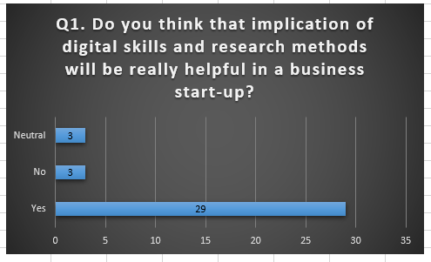
The result of the first answer shows that application of all the binary arts and modern methods of research will have good effect..

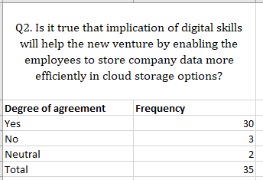
Secondly which question was asked from employees was will they consider this thing true that implementing binary comfort will aid the fresh organization to save several organizational results very effectively through modern memory network techniques. 30 of them answered in favour, 3 of them answered in negative, two have balanced about it.

It is observed with the help of finding that inference of execution of binary robotics will assemble the effectiveness and liability of the work related to business.

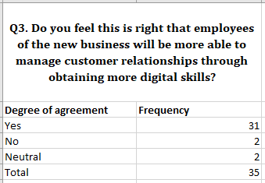
The next questionnaire was to inquire about if the present staff research it right with the help of using binary arts workers will be clever enough to govern efficiently the consumer affairs on binary touch point policy. 31 of them replied yes, 2 with opposite side and other two remained balanced.

It is observed that execution of binary robotics will increase the consumer communication management of the fresh business.

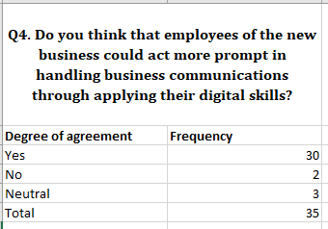
Number four investigation was to inquire those 35 employees will those employees confess with reason that obtaining binary arts the workers can contact more energetically with their consumers pool alongside E-mails and many binary contacting gadgets. 30 replied yes, 3 answered no and 3 selected for being neutral.

So, the appliance of binary automation will enhance the effectiveness of the business affairs.

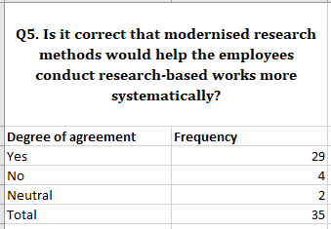
The investigation asked at the last was to inquire from employees to state if they are proclaiming the binary finding methodoligies will make it happen for them to do the research based work in a more regular way. 29 were strongly in its favour, four nodded in no and others stayed to be in neutral zone.

It is observed that revolutionized finding technique will gather some worth to pursue on structured finding of freshly developed business‘s workers.
If the whole reactions of 5 questions were noticed and inspected properly, we can make a single handed statement. That gaining and acquiring more binary arts and finding method for the business which is to be start can help and create regular work of the workers really more easy. If communicated through percentages, round about every single question was 80% in favour or you can say was right in views of workers. This helps us to make a clear awareness on the theorem whether they are same or not.

Conclusion

The result of report here give knowledge on each and every necessary topic keeping in view of use of binary arts and analysis implementation in workplace and their important beneficence to triumphant the start of a new business, the venture pointed to gauge the main cause on the universal hypothesis made on the things which affair. However, collecting of results and their proper research in fact have force us inside of them. The whole analysis work till now has aided the researchers to collect more awareness on the lag advancement which have raised it very high. Adding more to it, engaging the whole analysis has been absolutely a helpful gaining participation.

References

- Kawasaki, G., Filby, L. (2015). The Art of the Start. Portfolio.
- Deursen, A., Dijk, J. (2014). Digital Skills: Unlocking the Information Society. Palgrave Macmillan.
- Knobel, M., Lankshear, C. (2008). Digital Literacies. Peter Lang.
- Martin, A., Madigan, D. (2006). Information and IT Literacy. Facet Pub.
- Halfpenny P. (2015). Innovations in Digital Research Methods. Sage Publications Ltd.
- Daugenti, T. (2018). Digital Disruption: The Future of Work, Skills, Leadership, Education and Careers in a Digital World. Peter Lang Inc., International Academic Publishers.
- O’leary, Z. (2016). Workplace Research. Sage Publications Ltd.

