Assignment
on
Effective Team Work and Communication

Mohammed Shahadat Hussain
1712830

Contents
Introduction 3
Importance of communication in the workplace 3
Conflicts in workplace related to communication 4
Theories of communication to workplace 4
Inter-personal Communication 5
Communication Models￼ 6
Written communication formats 7
Conclusion 10
Reference 10

Introduction
For the operation of the organization, it is very important to ensure that there is proper team work and also generate the effective communication activities between the employees. It will support the organization to develop their efficiency level and increase the motivation level of the employees. With the proper communication, it will easy for the employees to adopt into the corporate environment. The supportive environment reduces the wastage level in the operation.
This assignment will discuss about the different aspects of team work and communication in an organization which enables the employees to enhance the productivity level.

Importance of communication in the workplace
Clear communication is vital in the operation of the organization, because it ensures the proper instructions are provided. With any miscommunication, the value of the operation will go in vein. Clear message is the first sign to build up trust, because rapid clear messages develops the trust level. With clear messages the investors are eager to invest their resources into the business. When the communication level is at a low level, it will create a huge impact on the motivation level of the employees. With low motivation, it is very difficult for the organization to gain the proper output from the work of the employees. The company will want to maintain a proper training and development program for the employees to ensure effective communication (Wilson, 2001).
With good communication, the company knows the different scenarios of the economic condition. The communication is also important for team work; the success of the team depends on the proper conveying of information between the team members. With proper communication, the company can set and achieve the required goals and objectives. (Charlene, 2007).
In real world experience, the communication helps people to develop effective relationships. This helps to generate the cooperation level. Without cooperation, it will be difficult to perform the operation in a proper way. The trust level also increases because the clear communication removes confusion. With the proper communication, it will be easier to develop bonding between team members. As a manager, it is necessary to have the effective communication skills to meet the control over the employee’s operation. Communication encourages the representation and innovation of ideas, further helping to improve the rate of innovation. In addition, the right communication helps to inform the different parties with internal and external issues.

Conflicts in workplace related to communication
Conflicts are a common phenomenon in an organization, because the people have their own judgement power. That’s why it is very difficult to agree with every situation, and so it is likely conflict will arise at some point. However, this is a very unhealthy activity in the organization, because it creates a barrier to executing the operation effectively. As a result, the organization lose their productivity level and there is a decrease in the motivation level of the employees
(Anstey, 2006).
To counter this, the manager is required to generate an effective step to control the problem and increase the efficiency of the operation. That’s why the manager has to think about the conflict and find out how the conflict arose during the operation. With the proper judgement, it will easy for the employees to control the conflict. But conflict is a complex issue in the organization, and it is very difficult to find out the reason why the conflict arises (Wilson, 2001).
Conflict is an inseparable part of the human behavior as everyone will have varying perspectives on the same event. The organization can face conflicts in several areas such as value, power, economic, interpersonal, organizational, environmental etc. These factors influence people in their personal interactions, which creates conflict among the people (Anstey, 2006).
In reality, conflict is common in the job area, because the company provides inefficient resources to perform the operation. In the operation, delay of the supply also creates conflict, because it reduces the efficiency level of the operation. To reduce the conflict, it is necessary to evaluate the different levels of resources and their impact on the operation. A diagram supports the company to develop the optimal decision for its operation. To achieve a goal to a good standard, the company is required to maintain a better relationship with its employees. According to the situation, the company can be required to change its relationship level.

Theories of communication to workplace
According to the work place, the communication style can be different, because the objective of the different communication strategies is different. It is very difficult to select one communication style, because there are lots of options in developing the communication process in the workplace. To select the communication style, it is essential for the organization to think about different factors that have an impact on the operation. It is better for the organization to use a trial and error method to select a communication style. Below, the topic will discuss about the different theories on communication, which are:
Critical Theory: In this theory, it seems that the organization is frequently faced with conflicts in its operation, as there is some communication gap between the upper and lower management. The theory works to solve conflicts in the organization through the development of relationships between different groups, and encourages people to perform more effectively
(Wilson, 2001).
Informative Theory: To ensure less mistakes in the operation is the goal of the informative theory. The theory works to develop effective information through analysis and correcting the information (Wilson, 2001).
Post-Positive Theory: An order does not perform according to the goal, and so it required to maintain work to gain the proper outcome. When the company is assigned a goal, the company is required to focus on the message and also the acceptance of the order by the employees. For example: the weekly operation guideline to perform the next week operation (Charlene, 2007).
Groupware Theory: Now a days, the employees are using digital technology, which allows them to communicate with each other easily and effectively. It helps the employees to perform group operations from a long distance. For example, communication used to spread the group decision among the employees to gain the goal (Wilson, 2001).

Inter-personal Communication
Communication between different people helps to develop interpersonal communication. It involves people sharing emotion, feelings etc. With interpersonal communication, the bonding becomes stronger. Through interpersonal communication, people not only used verbal communication, but also use non-verbal communication to express their opinion (Charlene, 2007). The interpersonal communication helps each other understand the information and improves the flow of the information. People also develop contact between the employees, which helps to create the necessary team work to perform a specific operation. For example, the interpersonal communication helps to develop friends, and people can gain the help from the friend circle. It also develops an emotional attachment with other people, allowing them to provide emotional support. With the interpersonal skill, it will help to reduce conflict among the people, because they know each other and have a mutual relationship (Anstey, 2006).
In real context, the interpersonal communication knowledge allows for smarter operation, because it helps to invest resources into the vital task. Through this, we can get a better result from the operation. It helps people to remove the work stress, because people have time for things like, breakfast, lunch, tea, snacks etc. People have time to spend with others that they like. It creates a happy hour, and people will want to spend time in their work. Interpersonal communication skills evaluate the investment of the personal to perform the operation. With investment level, it will ensure the proper outcome from the work. Without interpersonal skill, it is impossible to develop a good first impression with people you meet.

Communication Models
In everyday life, people are required to communicate with each other to share information. However, there are steps to an effective communication between two or more people. The communication steps are divided into five parts, which are described below:
- In the very early stage, people are required to develop a message which they are to send to the other party. Before this happens, the sender should think about the message length, because language and length of the message impacts the effectiveness of the message.
- Encoding is required to send the message, because the digital technology cannot read the message, so people are required to convert the language and coded for the receiver. It also secures the communication process, because the specific note can only be understood by the sender and receiver (Charlene, 2007).
- Medium is a vital issue, because the sender should select the appropriate medium to send the message. The should sender select the medium that allows the carrying of the message to be secure and delivers the message in a convenient way.
- Decoding of the message will be required to understand the message by the receiver. Without decoding, it is very difficult for the person to understand the actual meaning of the message.
- When the receiver understands the message, the receiver sends the feedback to the sender.
In the real world, the sender and receiver face a huge problem due to noise, so the message loses its actual meaning. To reduce the noise, the sender should use the proper encoding and medium in which they send the message. On the other side, the receiver should use the proper decoding system and provide feedback. This ensures the sender that the receiver has the proper information. With this process, the correct information is passed from one side to the other (Charlene, 2007).

Written communication formats
In the organization, there are generally two types of communications which include oral communication and written communication. Written communication is the most important communication process, because vital operations perform through written communication. Written communication is used in the internal and external communication process. The part below shows the different types of communication processes (Charlene, 2007).

Memo
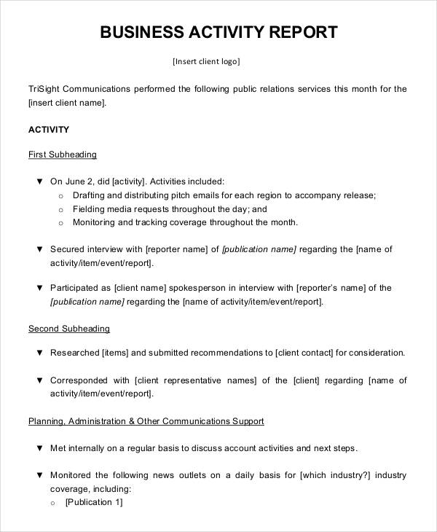
Report
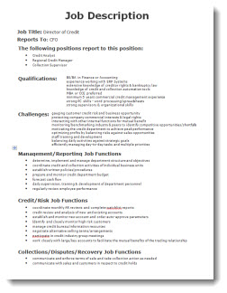
Job Description
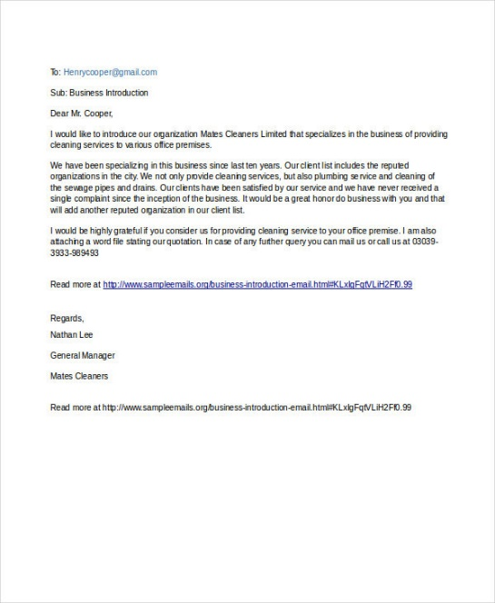
Email
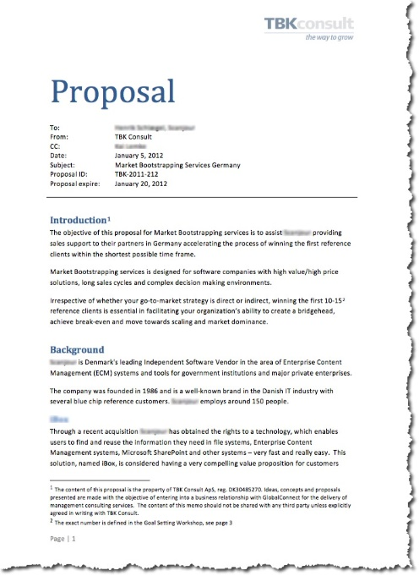
Proposal
Memos are used in the internal communication process, because it helps to deliver the information of the organization’s operation to the people. Nowadays, people use less memos, because people have converted to using emails. In a report, the condition of a specific situation is described. This helps to develop a decision about the specific task. Proposals are used in the business operation to generate a new plan or strategy. A proposal will be sent to the upper management for approval. With digital technology, people use email, instant SMS, social media etc.
With the written communication, people save money e.g. an email requires a low cost to send quickly, further saving time for the user. But, the written format requires time to develop initially, so it creates delay in the communication. Email costs are low, but a huge amount is required to be invested for an email facility.

Conclusion
Team work is not a simple task, because it is a combined operation. For effective team work, it is necessary to develop a good relationship among the team members. Without good relationships, the team work is less productive and the outcome may not be satisfactory. But communication requires the proper environment within an organization. With the proper communication skills, the productivity reaches the next level. Inter personal skill is also important, as it develops emotional attachment among the people. Without this, there are absents, leaves etc. Therefore, the success of the organization is dependent on strong team work and communication.

Reference
Anstey, M. (2006) Managing Change: Negotiating Conflict, (3rd edition) Cape Town: JUTA.
Harvey, Michal, Novicevic, Milorad M, Buckley, M Ronald & Halbersleben, Jonathan RB (2004), ‘The Abilene Paradox after 30 years: a global perspective’, Organizational Dynamics, vol. 33, no. 2, pp. 215–26.
Hede, Andrew (2007), ‘The shadow group: towards an explanation of interpersonal conflict in work groups’, Journal of Managerial Psychology, vol. 22, no. 1, pp. 25–39.
Overbeck, Jennifer R, Correll, Joshua & Park, Bernadette (2005), ‘Internal status sorting in groups: the problem of too many stars’, Research on Managing Groups and Teams, vol. 7, pp. 169–99
Yauch, Charlene A (2007), ‘Team-based work and work system balance in the context of agile manufacturing’, Applied Ergonomics, vol. 38, pp. 19–27
Wilson, Gerald L (2001), Groups in context: leadership and participation in small groups, 6th edn, McGraw-Hill, New York.

