Different types of databases
[1]There are five types of databases which are:
- Hierarchical databases
This kind of database follows the progression of data being categorized into different ranks or levels. Where the data is categorized based on a common point of linkage.
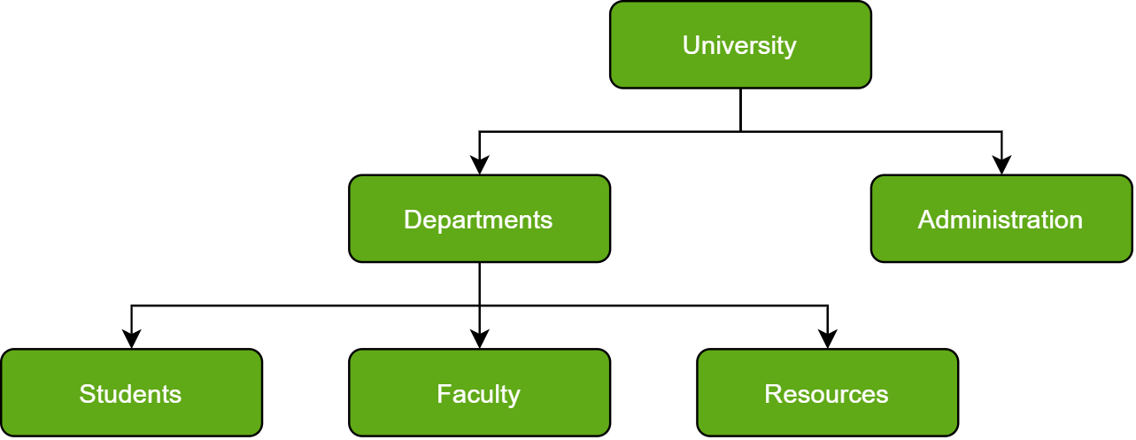

- Network databases
In layman’s terms, a network database is a hierarchical database, but with a major tweak.
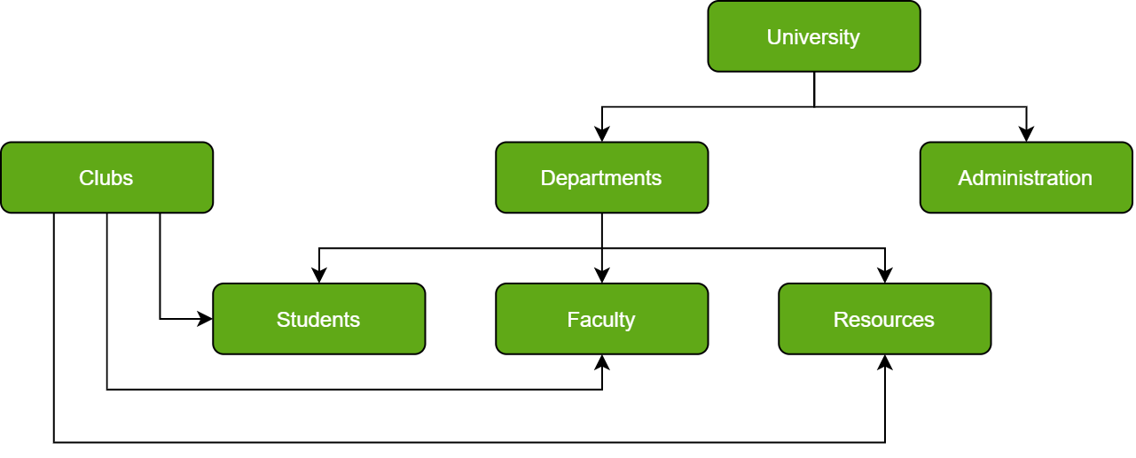

- Object-oriented databases
Those who are familiar with the Object-Oriented Programming Paradigm would be able to relate to this kind of database very easily.
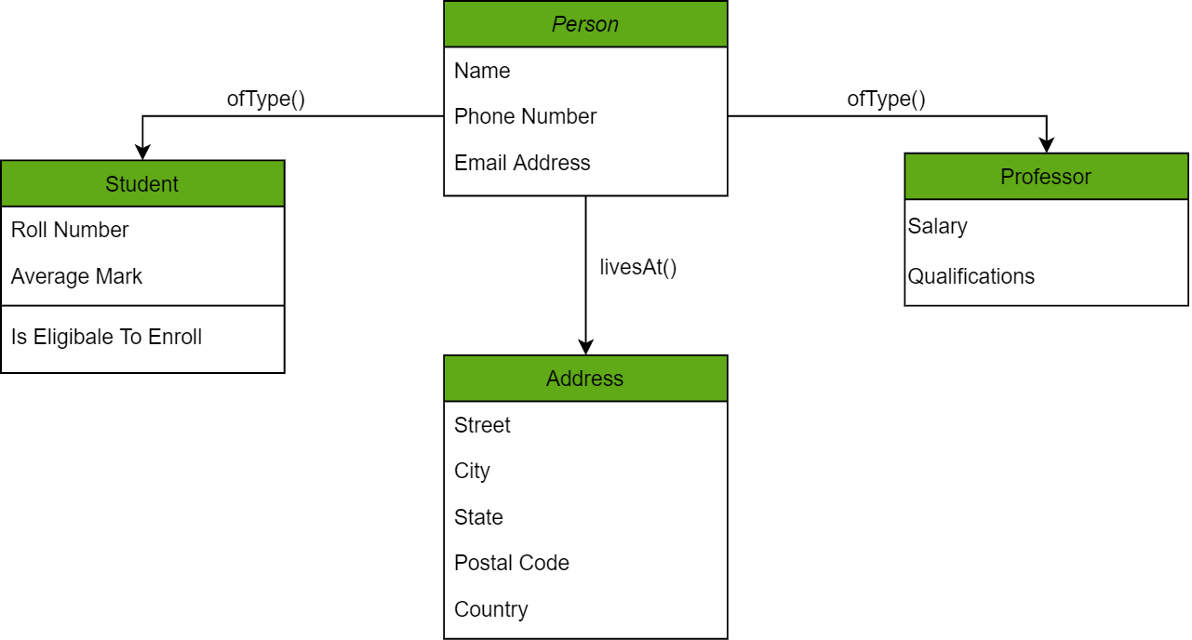
- Relational databases
This is considered the most mature of all the databases out there. These kinds of databases lead in the production line along their management systems.
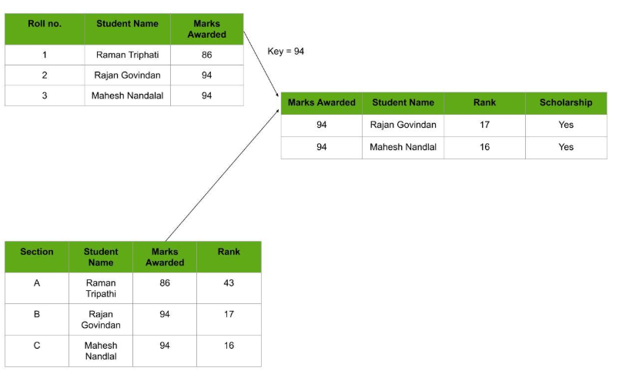

- NoSQL databases
NoSQL is originally referring to non-SQL or non-relational is a database that provides a mechanism for storage and retrieval of data. NoSQL databases include simplicity of design, simpler horizontal scaling to clusters of machines and finer control over availability.
The advantages of NoSQL which are high scalability and high availability. The disadvantages of NoSQL are that it is an open-source database, GUI is not available, backup is a weak point for some NoSQL databases like MongoDB and the large document size.

Types of NoSQL Databases
[2]There are 4 types of NoSQL Databases, they are:
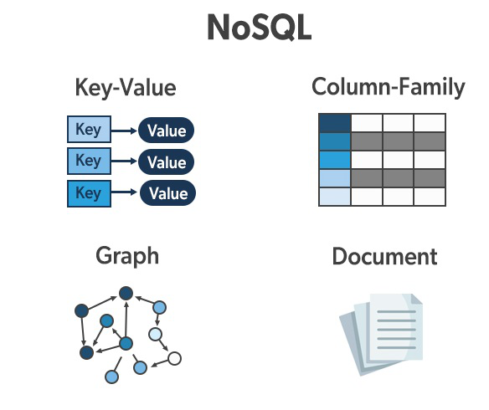
- Document-bases databases
The key features of documents databases are that they are flexible schema, faster creation and maintenance, no foreign keys and they have open formats.
- Key-value stores
The key features of key-value store are that they have simplicity, scalability and speed.
- Column-oriented databases
The key features of columnar oriented databases are that they have scalability, compression and are very responsive.
- Graph-bases databases
The key features of graph database are that they are easy to identify the relationship between the data by using the links which are given to you.

References

[1] | “Types of Databases,” 13 September 2021. [Online]. Available: https://www.geeksforgeeks.org/types-of-databases/. [Accessed 03 February 2023].
[2] | “Types of NoSQL Databases,” 07 July 2022. [Online]. Available: https://www.geeksforgeeks.org/types-of-nosql-databases/?ref=rp. [Accessed 04 February 2023].

