

ACADEMIC REPORT
Analysing Our Own Academic and Employability Skills

Module: ACADEMIC AND EMPLOYABILITY SKILLS
Module Code: BMSW4001
Course: Certificate in Higher Education: Skills for the Workplace

Course Tutor: Lloyd Beharry

Student Name: Jefferson Jurado Daza
Student ID: 1906166

Table of Contents
1.0 INTRODUCTION 3
2.0 SKILLS 3
2.1 WHAT ARE EMPLOYABILITY SKILLS? 3
2.2 HARD SKILLS 3
2.3 SOFT SKILLS 4
2.3.1 TIME MANAGEMENT 4
2.3.2 COMMUNICATION 5
2.3.3 TEAM WORKING 5
3.0 SWOT ANALYSIS 6
4.0 Personal Development Plan 6
APPENDIX 8
REFERENCES 10

1.0 INTRODUCTION
The purpose of this report is to show how Academic and Employability affects productivity in lifestyles and in the workplace. Everyone has a special skill, no one is left out and each one of those skills has a special use in the company whether they know it or not. Some people find it easy to see these skills from others whereas some skills come from within a person; to find them is good but to develop them is hugely profitable. Most people even end up not ever knowing about a skill that they have had until it becomes too late.

2.0 SKILLS
Skills vary from time to time depending on what is being attempted to be done. For example: there are skills where you already know and is something done with the best of your ability; whereas there are other skills that are not there, but they can even be taught to do specific jobs. Here you will read more about this in full detail:

2.1 WHAT ARE EMPLOYABILITY SKILLS?
All sort of jobs not only require experience, but they now require employees to have a skill of some sort to back up what they can do in the workplace. These Employability Skills are skills that could be transferable to any sort of job out there. For example: there are general skills that could transferable from when you are working as an events co-ordinator, hotel cleaner and a kitchen porter. This is what makes you thorough employee because managers expect most people to have employability skills flow in their lifestyle. But they do have an eye for that, so if an employee stated that he has a skill but lies, managers can see right through that due to their own experience. This splits into two different sections: soft skills and hard skills.

2.2 HARD SKILLS
Hard skills are included when talking about employability skills due to the fact that these skills are teachable in the workplace. But what separates it from soft skills is mainly because they are only job focused. Most recently, employers are going to consider prospect for employees with whom have the enough experience with the specific skills that are required to do the job. For example: you go to a job interview to work as an engineer, but you have only worked all your life as a waiter. No correlation in the skills of either counterparts which would not help either parties in the situation and employers do not vouch for this to happen. This will help the employers out greatly both economically and with the workflow due to no training having to be done to teach new employees what is needed to be done. So these hard skills do have a requirement which is that the more experience, the more skills could be developed for certain job roles to boost productivity and raise customer satisfaction.

2.3 SOFT SKILLS
Soft skills on the other hand is on the other spectrum showing that no matter the experiences that you have from work and/or school, these are transferable skills that help to get opportunities because they can be used in any situation. These skills are useful; yes in the workplace; but it is used in our everyday personal life as well. Most of it integrates within a term called Interpersonal Skills which in face is another way of saying people skills. There is a great difference between soft skills and hard skills. One of the main differences is that the other majority of employers want to hire people with aspirations as part of their staff. To decide this, managers are looking for people who they can see improving in the work environment and those who have potential in developing their skillset. All prospects need to do to gain their experience is start at home by growing in Time Management, Team Working and Communication.

2.3.1 TIME MANAGEMENT
Time Management is an important soft skill that is needed to be learnt in your day-to-day life. It is something that us humans do unintentionally because we were taught to manage our time from school and our parents. When to do our homework, separate time for hobbies, when we can go out to play, etc. Even our desire to be punctual to places counts towards our time management because we are using our time efficiently to be well coordinated. Things like that shows that is was always inside of us to do it, but this does not help us in our adult life; time management needs more improving because there is so much to do as an adult but so little time to do so. Which is why Morgan, 2017 states that good time management is when you can conduct our time to the point that it is done without feeling under pressure. Here is a method in which can help to manage your time (Refer to Appendix 1). This is the Eisenhower Decision Matrix. The way in which this works is that you write yourself a list of all the tasks that are needed to be completed and this is then separated into four different sections depending on how urgent and important they are. You can use this in a home situation and the other key area you can use it is at a workplace environment where you can delegate some work to people under your leadership.

2.3.2 COMMUNICATION
This soft skill is very different to the previous because it opens to various sections. Communication is each act of transmitting information to a person. It is another thing that we unintentionally because communication is a part of our lifestyle unless of undesired circumstances. We all have conversations be it verbally or even through instant messaging. Verbal communication is the most obvious form of communication out there and it revolves around four areas; writing, speaking, listening and reading. In a life perspective, everyone needs to have the ability to understand what is going on and be able to give out instructions when the time comes. And most of us do express ourselves through the interpretation of movements. This is part of the non-verbal communications; this is the exchange of information through non-linguistic means. By it saying non-linguistic, it means without the use of words albeit other methods that could be used such as through aesthetic, physical, signs and even symbols. Sometimes a little bit of both works in some circumstances. Most people even prefer to talk face-to-face to another person instead of writing to them due to being able to hear their tone of voice and see their body language.

2.3.3 TEAM WORKING
Now this is the hardest soft skill that there is because most people do end up struggling with performing with other people. Teamwork is when activities and tasks are executed by a group of people to reach an objective to which everyone is committed (Courses.lumenlearning.com, n.d.). People do prefer to work individually because of others incapability to do work for themselves. But companies and businesses now are looking for people who can function well as part of a team because they are understanding that the best work is done in a group because you can obtain all the essential skills and knowledge from every single one of the participants of the group. Work is done at a quicker time when more people are doing their part. The only problem with teamwork is the loose ends; the people who do not participate, because if one fails to collaborate, it will ruin the process.

3.0 SWOT ANALYSIS
SWOT analysis is a framework where you can find out the internal and external components that could potentially impact a person, a place and many more things. SWOT stands for Strengths, Weaknesses, Opportunities and Threats. According to (Rouse et al., 2019), SWOT is the main analysis that companies use because it helps them prepare for future outcomes and accelerates initiatives that could better company results. There are few times that you can even use this to evaluate yourself so that you can see what you can do to improve it. If you look at Appendix 2, you will be able to see that there is an example of a SWOT analysis of my own personal components. It is noticeable that there are a few threats and weaknesses that needs to be worked on. Once every section has been filled out, you can use them to try and bring improvements upon your life and what needs to be changed according to this.

4.0 Personal Development Plan
Personal Development Plans are used so that people can organise their goals and objectives in a very well organised manner. Setting goals and objectives are always done by people but the information to how you are going to get there is always being left out. There are steps in which are needed to be followed to be able to achieve what you are hoping to achieve. This can be used in our every day lives and can be followed by companies in a more extensive method. My own Personal Development Plan can be found as Appendix 3 at the back of this report. This shows a few of my objectives that I want to achieve in the future and showing what I will be doing to achieve each one of them. It is very useful because it is a great way to measure everything out and then you would have them written down so that you do not forget.

5.0 Research and Note-Taking
When attempting to follow on at university, it becomes very difficult to comprehend what lecturers do say and leaves the student struggling for most of the term. This could be highly preventable if the student decides to take some notes during the lectures even if he does not understand them. This will allow the student to have one source with him and then use them to find other sources by researching the topics that they could not understand. They could find this through the use of accurate websites on the internet related to the topic which is the most common method; however there are methods in which can be found in a Library of some sorts.

6.0 Referencing and the Avoidance of Plagiarism
This is a very key area when it comes to doing assignments. Everyone had opinions and some knowledge, but examiners do not only want to see that. Everything always needs to be backed up otherwise it would not be authentic and agreeable. Without references, it would just be an opinion about the matter. Refencing all the places that you have used for your assignments is important to cite because you must be using your own words about the matter. To be able to use referencing effectively, you would have to make sure that you are not stealing the ideas of others but using them to support your ideas. Harvard referencing is the main method to use which follows a very specific way.

7.0 Paraphrasing and Summarising
Whether you are using information from online sources or books as referencing or not, it is important to make sure that it is completely different to what it states in those sources. This is mainly to encourage the use of your own words to write instead of just sending work done by others. If you are thinking about not summarising or paraphrasing, do not do that because many schools and universities now have a system that recognises many sources out there which would catch you out.

8.0 Conclusion
From what is shown throughout this whole assignment is the fact that there is an important demand for skills in everyday life. Both areas of Academic and Employability include so many to which that it is a necessity to have. Some of the skills are compatible with each other and correlate meaning that what you learn in school, ends up being useful in our everyday life. So keep all this into consideration.

APPENDIX

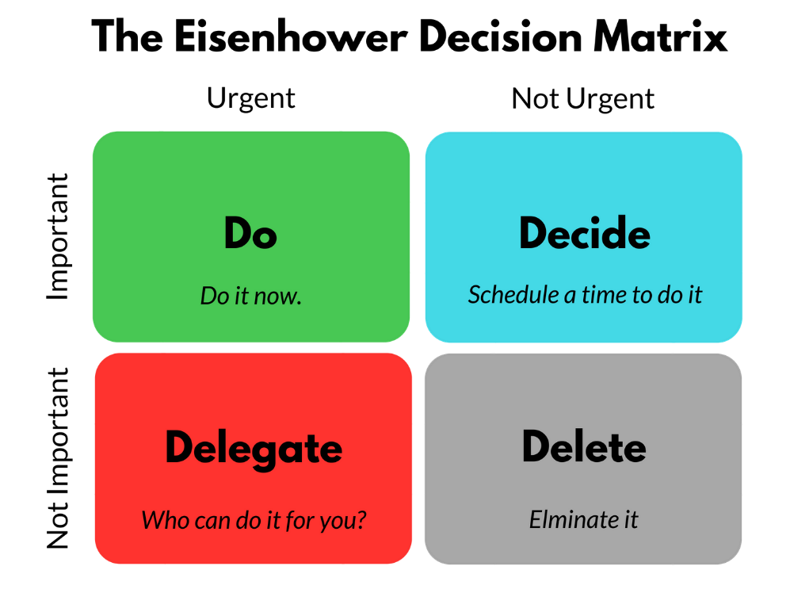
Appendix 1: The Eisenhower Decision Matrix
(Luxafor, 2018)

STRENGTHS | WEAKNESSES
- Photography & Editing Skills  - Lots of Work Experience  - Charitable  - Motivated  - GCSEs and AS-Levels  - IT Knowledge/Content Creation  - Time Management  - Digital Marketing  - Speak Spanish & English | - Slightly impatient  - Low Qualifications
OPPORTUNITIES | THREATS
- Work offer, but need qualification  - Offered to go live in Spain  - Studying Certificate HE Skills in the Workplace  - Technology is taking over, making IT and Social Media an increasing market  - Young enough to still go to University | - The market is ever so increasing that competition for job roles is increasing too  - Time is a key threat because by the time I will be looking for work, it will become very hard to get a job
Appendix 2: SWOT Analysis
(Created by Author)

What are my Objectives? | Where am I now? | Where do I want to be? | How will I get there?  What actions will I take?
What are my Objectives? | Where am I now? | Where do I want to be? | What? | When? | Who?
Finish University | Doing Foundation Course | Graduating | Continue studying to best ability | By 2024 | Me
Get a stable job | Studying | Working | Study and graduate | After finishing studying | Me
Get a family | Single | Married | Wait for the right person | Sometime soon | Me and future wife
Get a home | Living with parents | Paying rent | Work hard | In 6 years | Me
Appendix 3: Personal Development Plan
(Created by Author)

Appendix 4: In-Class Exercise 1
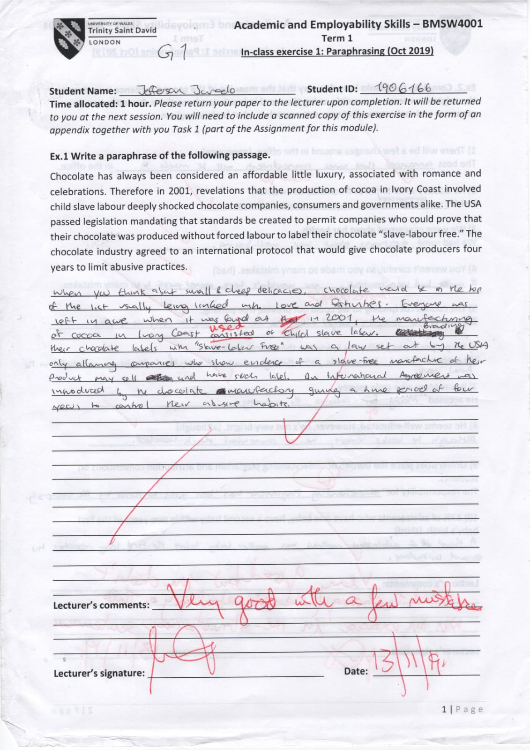
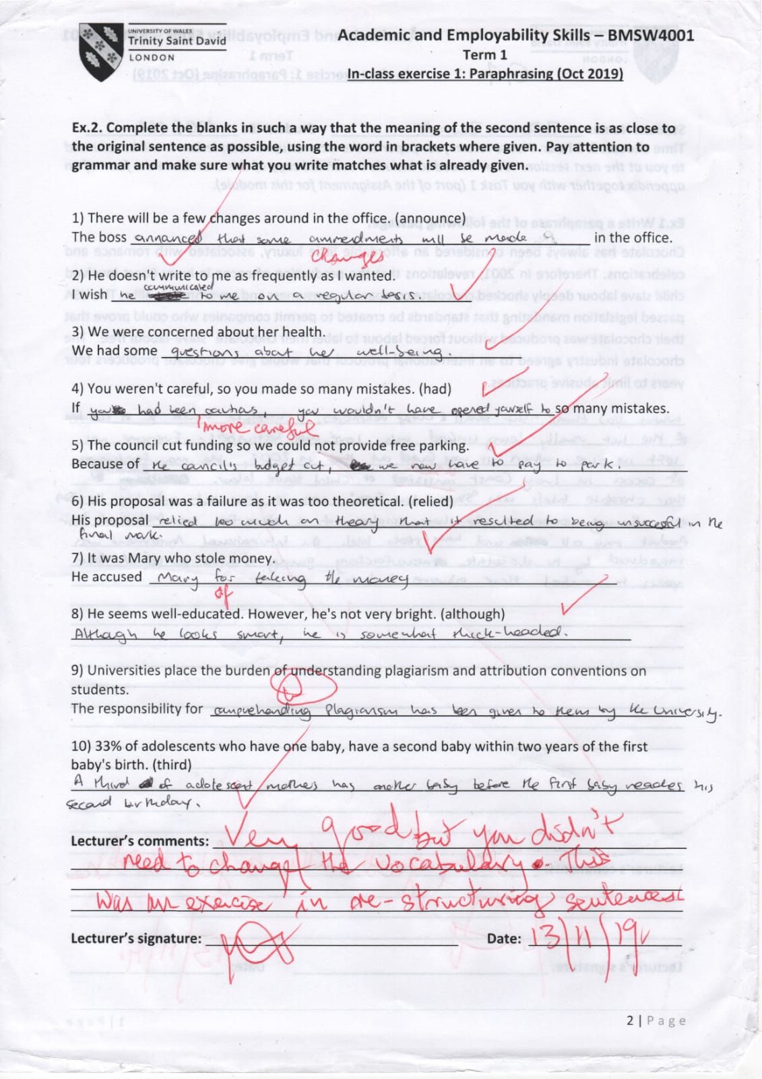

Appendix 5: In-Class Exercise 2
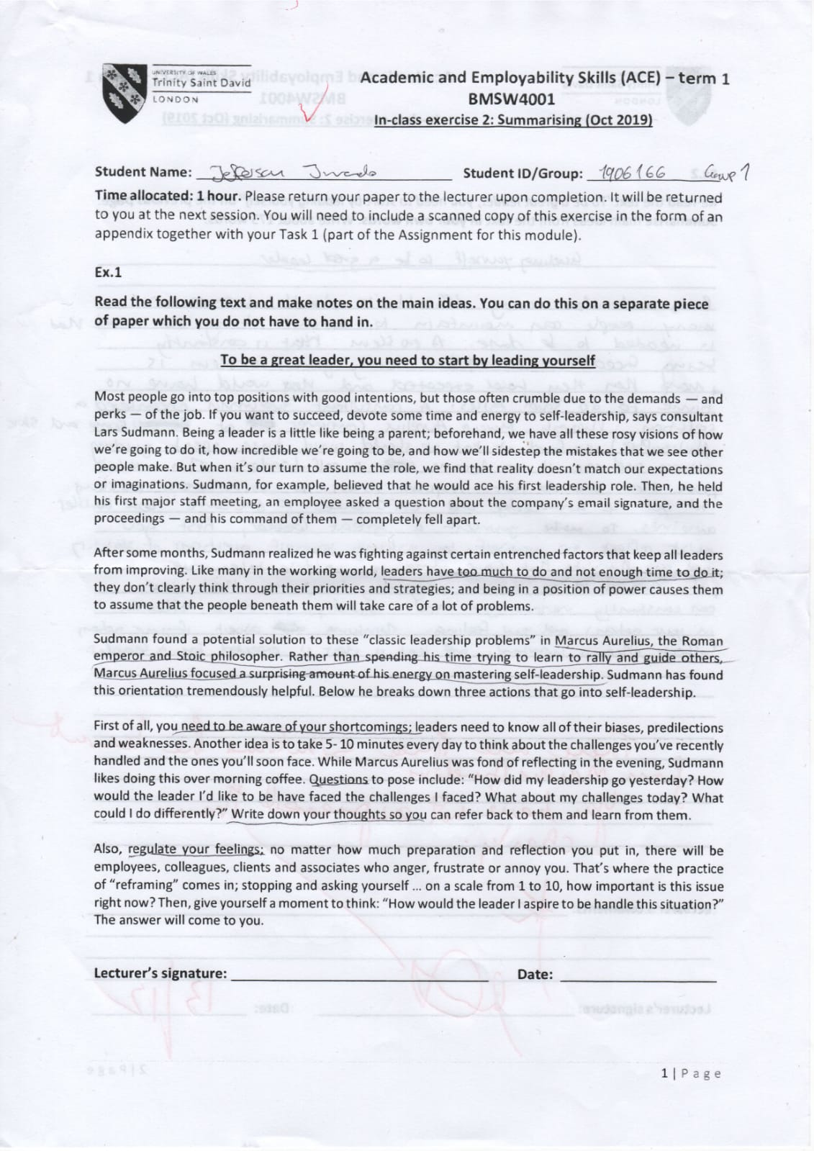

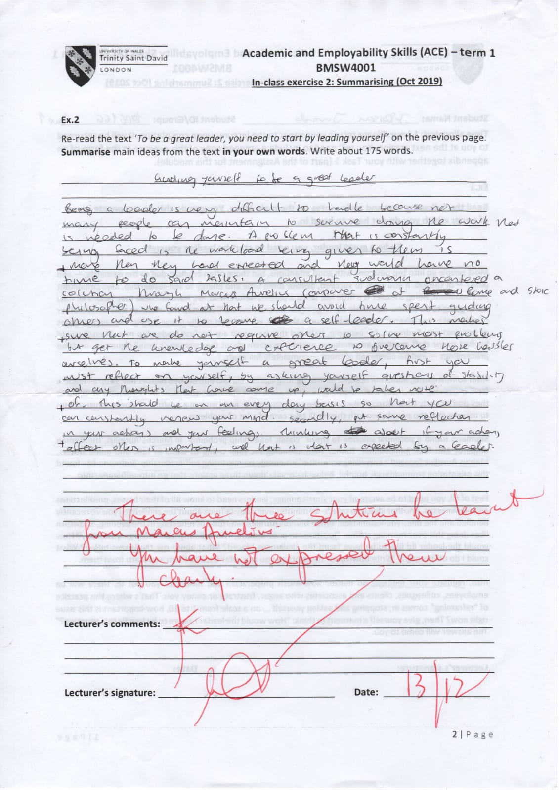

Appendix 6: Paraphrasing and Summarising
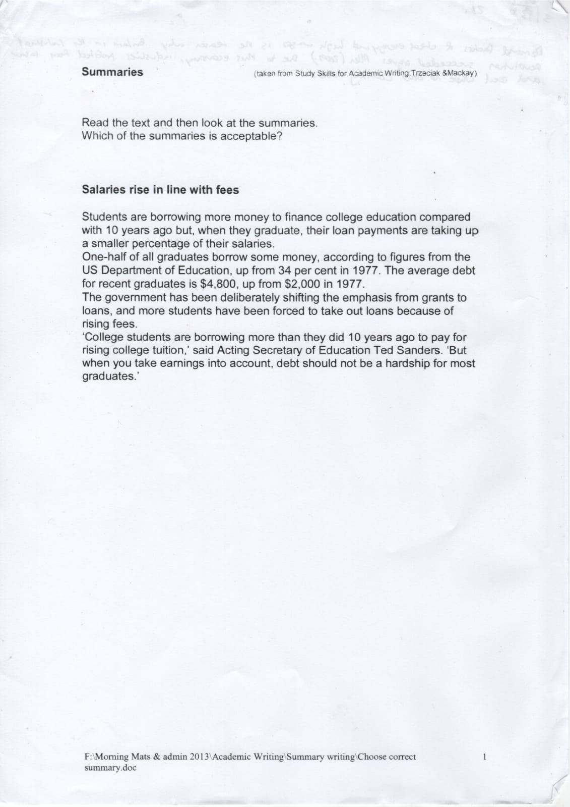

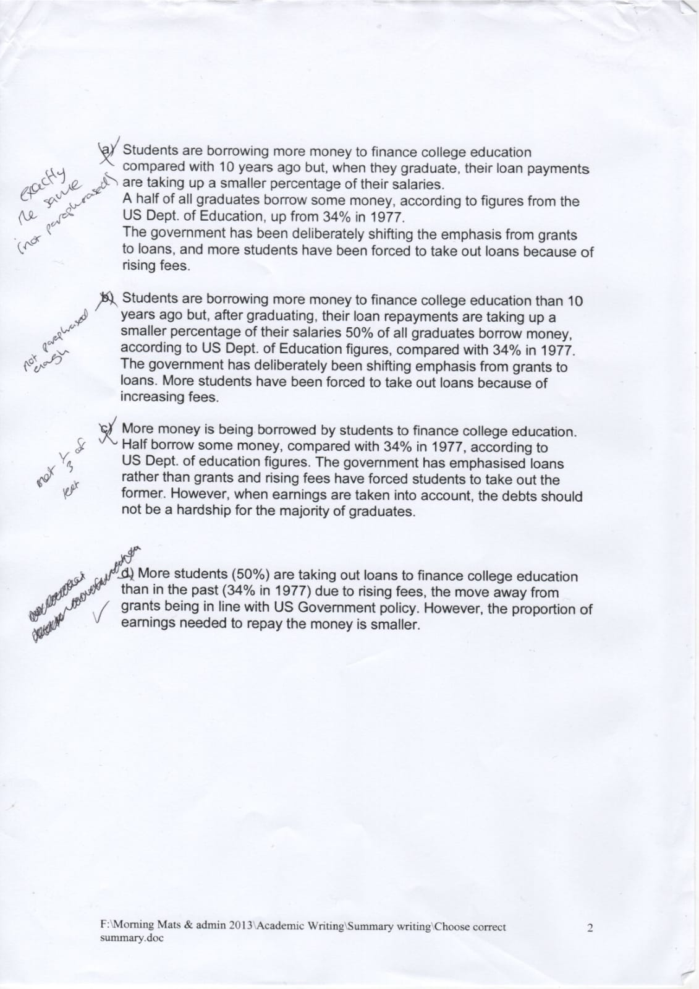

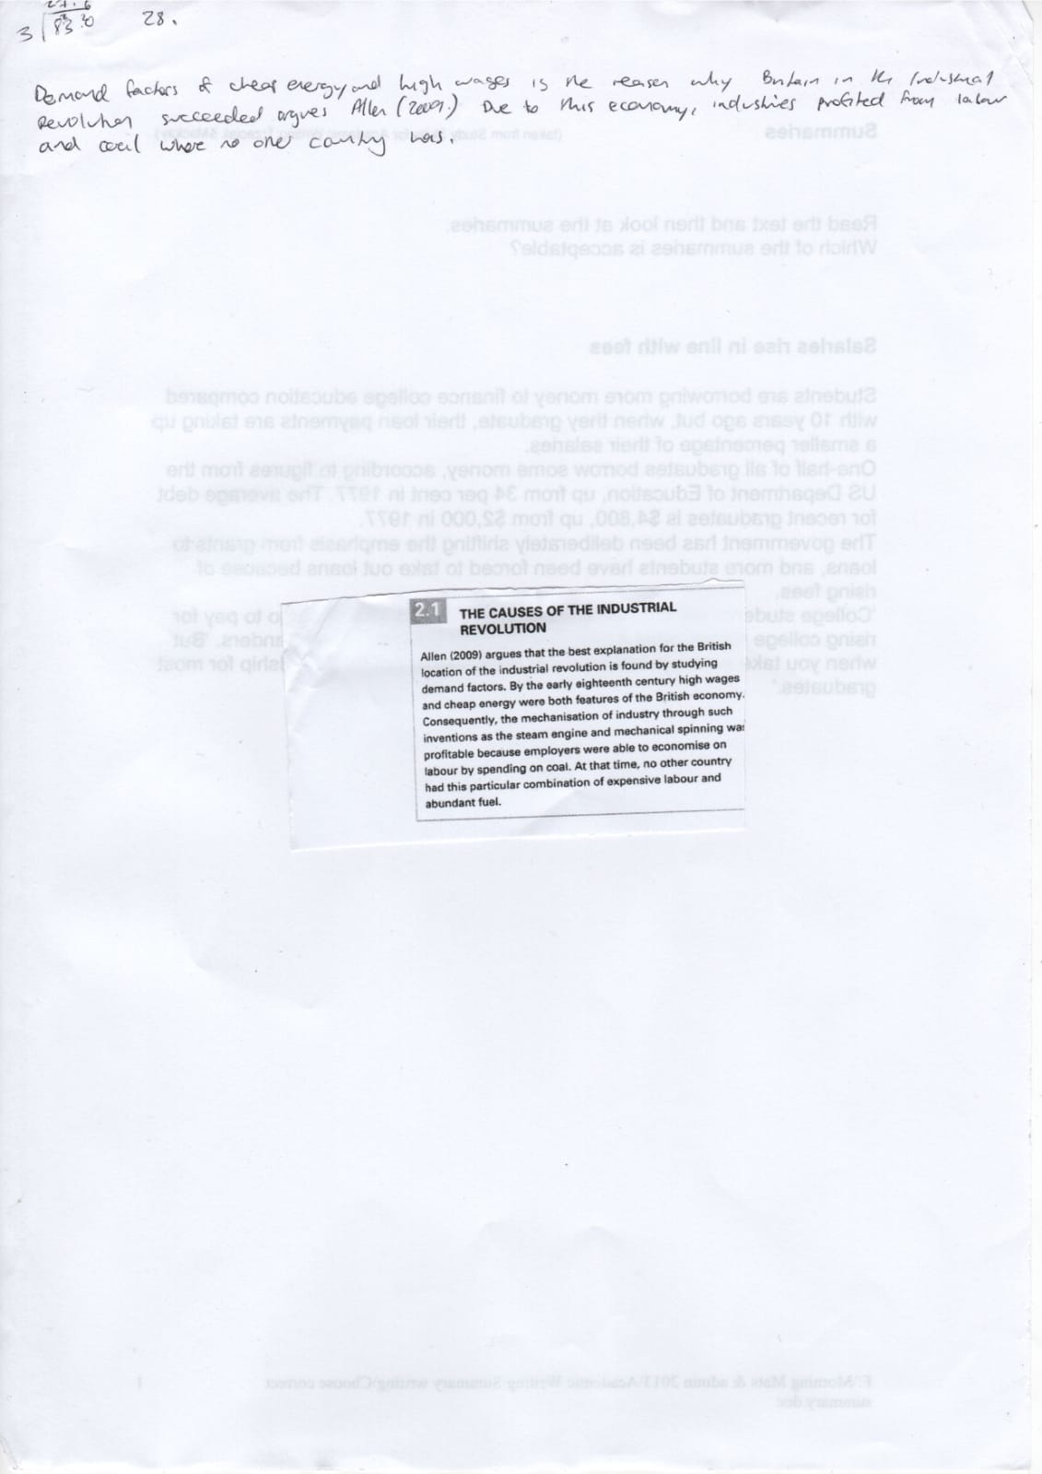

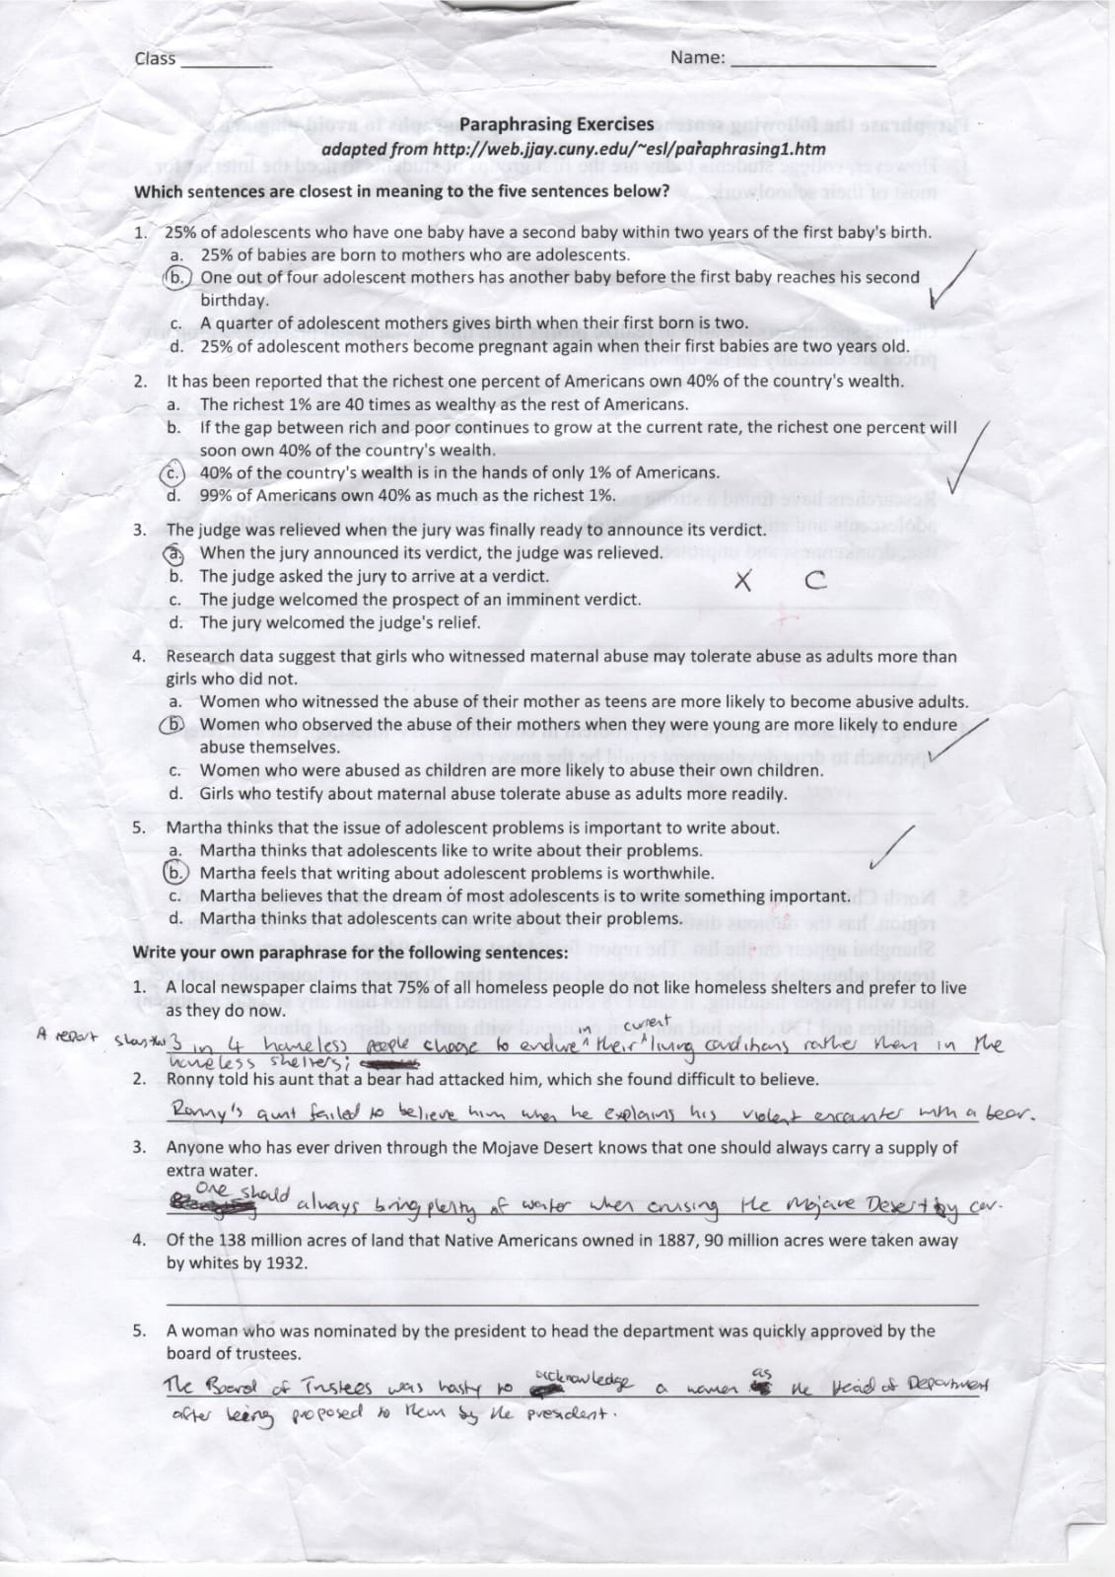

REFERENCES
Courses.lumenlearning.com. (n.d.). Defining Teams and Teamwork | Boundless Management. [online] Available at: https://courses.lumenlearning.com/boundless-management/chapter/defining-teams-and-teamwork/ [Accessed 2 Jan. 2020].
Luxafor (2018). The Eisenhower Matrix: Time and Task Managent Made Simple. [image] Available at: https://luxafor.com/wp-content/uploads/2018/10/The-Eisenhower-Decision-Matrix-png.png [Accessed 2 Jan. 2020].
Morgan, P. (2017). Business student's guide to study and employability. Los Angeles: SAGE, p.52.
Rouse, M., Haughn, M., K. Pratt, M. and Tucci, L. (2019). What is a SWOT Analysis?. [online] SearchCIO. Available at: https://searchcio.techtarget.com/definition/SWOT-analysis-strengths-weaknesses-opportunities-and-threats-analysis [Accessed 2 Jan. 2020].

