ASSESSMENT 1
PROJECT MANAGEMENT

Stefan Gheorghe-2024473

Project Management – LCBB 5005
Lecturer Dr.Molly Jack
University of Wales Trinity Saint David
12.09.2022

Table of Contents
1.Introduction 3
2.Crossrail Budget 3
3.Project Duration 5
4.Project Quality 6
5.Stakeholders 6
6.Risk Management 8
7.Causes for Budget Overruns and Delays 9
8.Conclusion 14
9.References 15

1.Introduction
The Crossrail project, Elizabeth Line railway, is one of the biggest projects in the last decades in the United Kingdom and Europe. Due to the size, time, cost and complexity of this project we can classify it as a public transport mega project. The scope of the Crossrail was to add extra rail capacity to the London network and decrease the commuting times to key business districts. It should also relieve some of the overcrowded existing underground and train services. The Elizabeth line comprises of 10 new stations and 26 miles of new tunnels that will bring 1.5 million people within a 45-minute commuting distance to London’s city centre (Crossrail LTD., 2022).
In October 2007 the Department for Transport (DfT) and Transport for London (TfL) agreed a Heads of Terms for a funding package of £15.9 billion and designated Crossrail Limited as the delivery vehicle for the project. Construction work started at Canary Wharf in May 2009. As a result of extensive value engineering and risk mitigation Crossrail was able to retire £1.1 billion of the funding package in 2010, leaving a revised budget of £14.8 billion (Crossrail LTD, 2017). The design and construction of such a mega project, like the Elisabeth line, represents an example of how complex the managing programs can be, and the numerous contractual agreements that were required to deliver the infrastructure and systems.

2.Crossrail Budget
In figure 1 below, we have an initial source of funding for the £14.8 billion initially allocated for the project.
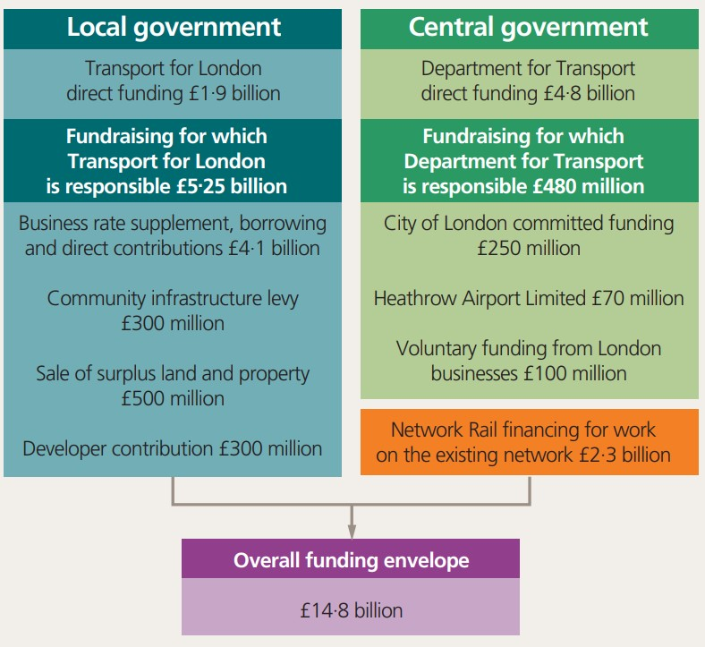
Fig.1 Source: (Buck, 2017)
As we can see, funds were obtained from the central and local government but also from the beneficiaries of the project. The mayor of London adopted a business rate supplement which generated £225 million yearly revenue and allowed the support necessary to borrow £3.5 billion. Property developers also contributed with a significant sum because they understood the benefits of the project and how this will help them as well. Retail spaces and renting facilities closer to the new line would mean greater revenue for them and will improve productivity of companies as the travel time and delays would have less impact on the commuting workforce (Buck, 2017).
From 2017 onward, the allocated budget has been overspent due to increasing costs in key sections of the eastbound tunnels and from increasing costs in constructing parts of the westbound tunnels, as well as problems in the integration of signalling. In 2018, the funding was increased to £17.8 billion with further additions in the next years, driving the total budget of the project to a staggering £18.8 billion, as shown in fig.2.
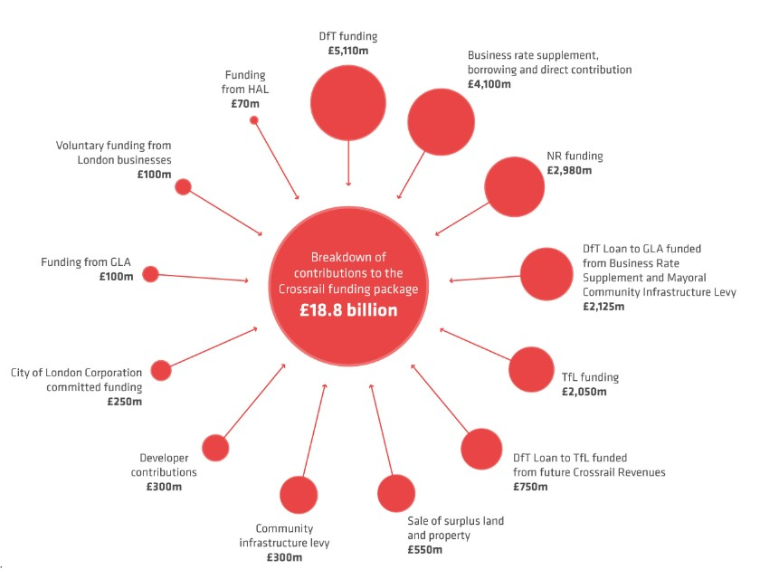
Fig.2 Source: (Crossrail Ltd., 2022)
In terms of cost control, the priority for Crossrail Ltd. was to organise a coherent Work Breakdown Structure (WBS) that would bring the deliverables of the project into smaller components. Below is a list of the hierarchical structure of the WBS adopted by Crossrail Ltd. according to their level.
- Crossrail Programme
- Geographical area (Switched to sector discipline at 66% complete)
- Industry/Delivery Partner
- Asset type
- Location
- Function/Phase
- Contract
- Activity Group
- Activity
(Palczynski, 2016)
Considering that the project was planned to cost a large amount of funds, there was a paramount need to ensure that the costs made offered value for money. The creation of an initial project initiation document was critical in satisfying sponsors and achieving the desired project acceptance.

3.Project Duration
In 2009 a project initial construction programme, represented by a Gantt Chart, was developed (Fig.3) but considering the delays the project has suffered it should be noted that these estimates are no longer accurate.
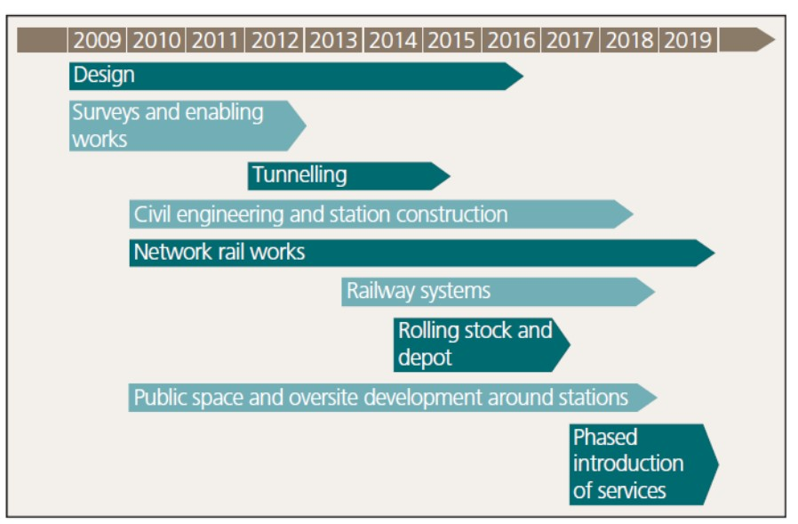
Fig.3 Source: (Haylen, 2019)
In February 2016, it was reported that the project was over 70% complete, with tunnelling completed the year before, and was being delivered on time and on budget. Also, in July 2018 the government announces that the Crossrail Project is 93% complete and entering a critical testing and commissioning phase (Haylen, 2019). Despite the optimism of the project being delivered on time, Crossrail Ltd. announced later that year it encountered construction delays and challenges with the complex signalling systems. The 2020 pandemic led to further delays as almost all work was stopped, further increasing the time and budget costs. These delays have extended the timeline and significantly increased the budget allocated initially.

4.Project Quality
Crossrail Ltd. has been charged to deliver satisfactory quality of the project following the expectations of its sponsors, including Transport for London and Department for Transport. The quality policy set out the approach to quality, which is implemented through Crossrail Management System that commits to:
- Ensure compliance with legislation and regulatory requirements, and relevant codes of practice and standards
- Apply the principles of “right first time”
- Place accountability for quality with those best placed to act
- Set realistic, measurable objectives and targets for all activities, to assist delivery of performance and progress
- Implement review, surveillance and audit programmes to monitor compliance with requirements and assess the effectiveness of the arrangements.
(Crossrail Ltd., 2022)
Because Crossrail Ltd. worked with various contractors there was a need to ensure that these follow the quality requirements expected. The supply chain quality management requires all contractors to:
- Have a quality management system and provide a quality plan that is in accordance with the quality arrangements in the contract
- Appoint a quality manager, which will serve as point of contact for quality management issues
- Develop and implement inspection and test plans that will provide evidence that the requirements have been met
(Crossrail Ltd., 2022)

5.Stakeholders
The scale and complexity, as well as the geographical location of the project, implied from the defining stage a large and diverse community of stakeholders. Considering the project duration, it was clear that the interest and priorities of many stakeholders would change over time and that the project structure would have to adjust as well.
Before the construction began, stakeholders needed to be identified, informed and consulted about the scope of the project, and most importantly categorised by their level of power and influence, using a stakeholder matrix (Fig.4).
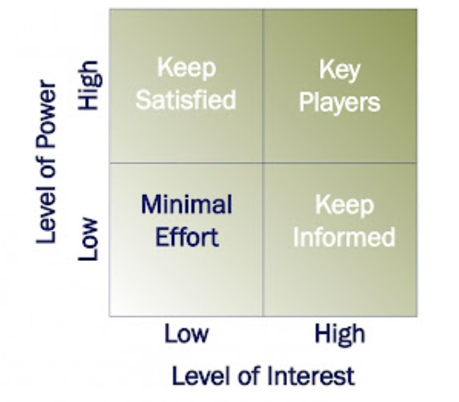
Fig.4 Source: (Department of Finance, 2022)
According to Bailey (2017), stakeholders were identified through standard mapping procedures and were reviewed periodically through the project, as shown in the figure 5 below.
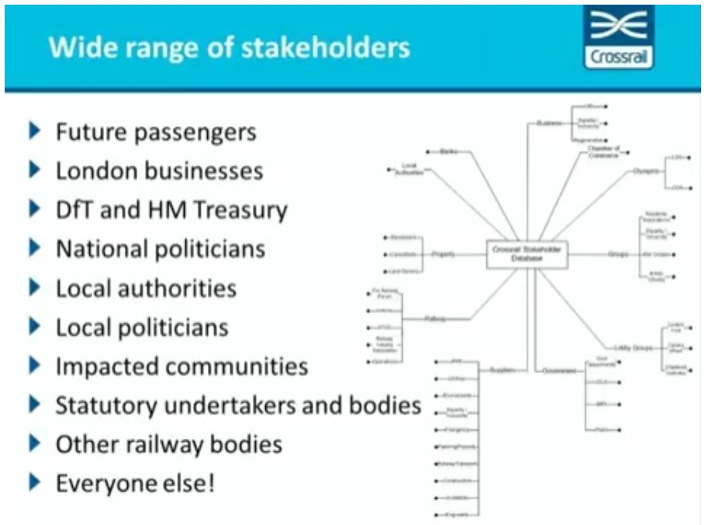
Fig.5 Source: (Bailey, 2017)

6.Risk Management
Crossrail Ltd implemented a risk management plan across the organisation with three core objectives:
- Support the delivery by reducing the likelihood and potential consequences of events that would negatively influence the scope of the project
- Provide assurance to all stakeholders that the project managers understand the significant risks and are actively managing them
- Improve decision making, planning and prioritisation by better understanding the uncertainty and risks.
(Crossrail Ltd, 2016)
The scope of the risk management plan includes all categories of risks, from design and construction until commissioning and operation. This includes business risks, engineering and design risks, environmental and quality risks, security risks, logistics risks, and fraud risks.
The standard risk management process for Crossrail is shown in fig.6 below and is providing a systematic approach on how to identify and manage risks.
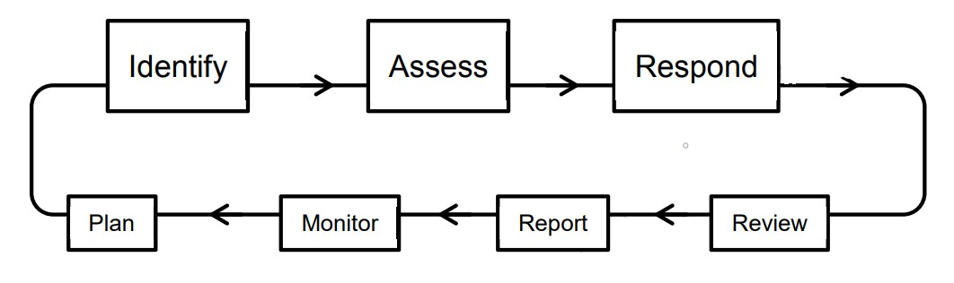
Fig.6 Source: (Crossrail Ltd, 2016)
Risks should be identified methodically to ensure that all sources of potential hazards have been identified and recorded. Next, an assessment of the identified risks is undertaken. The assessment scheme consists of qualitative probability and impact scales and a Probability Impact Diagram that is used to assess the severity of that risk. The main impact categories considered by Crossrail Ltd. are shown the fig.7.
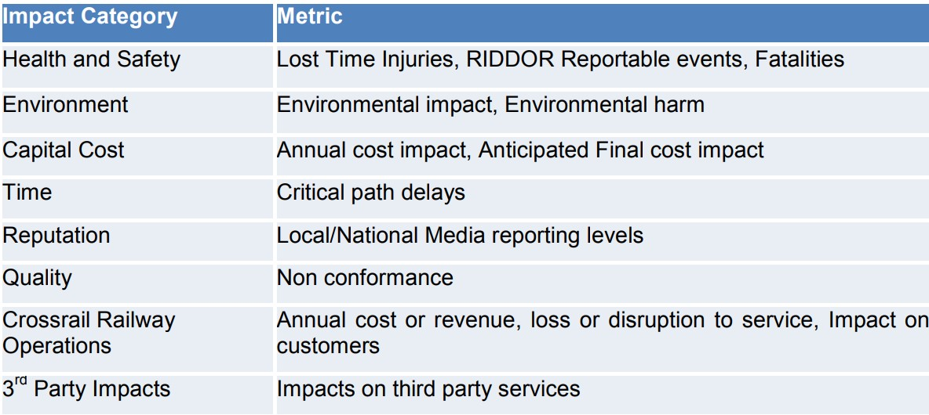
Fig.7 Source: (Crossrail Ltd, 2016)
For each risk identified and assessed, the risk owner must respond and establish a level of mitigation, which might include measures like tolerate, avoid, transfer or reduce. Responses should be allocated to an individual that is responsible for implementing the response. Constant reviews, reports and monitoring is undertaken to avoid deviation from the projects scope. Due to the length of the project life cycle risks should be considered for the long run as well. One risk that could not have been forecasted was the global pandemic of 2020, which added a severe impact on time and budget.

7.Causes for Budget Overruns and Delays
Scheduled initially to cost £14.8 billion and be delivered in December 2018, the Crossrail mega project had reached a total budget of £18.8 billion and officially opened on 24 of May 2022. The project appeared to be progressing reasonably well over the early stages of its construction, with planned milestones achieved and sometimes ahead of schedule as seen in fig.8., which covers September 2011-2013.
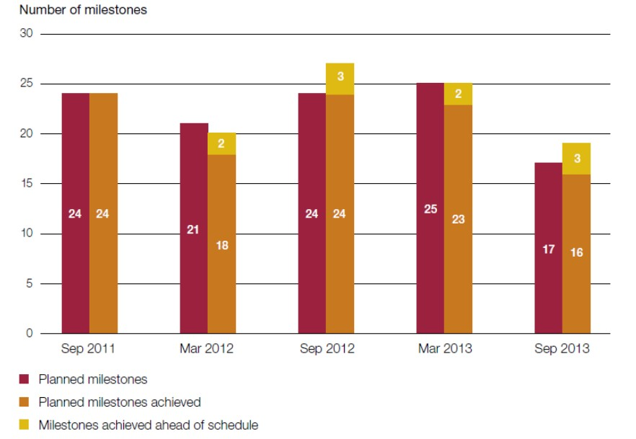
Fig.8 Source: (Haylen, 2019)
A project as complex as Crossrail, in which we encounter numerous components and deliverables, is always subject to uncertainty and risks, especially in the final stages. The complexity and lifespan offer favourable circumstances for overruns in terms of budget and time. In November 2017, an electrical failure at Pudding Mill Lane substation caused a delay in power to the central tunnels and to the extensive testing that needed to be done. A setback here that costs Crossrail Ltd. time and extra money to cover repairs (Haylen, 2019).
In august 2018, the delays to the project became public as the management team announced that the project will be delayed several months, from December 2018 to autumn of 2019. In the same year that delivery date had also been put into question as Crossrail Ltd. announced further reviews of the project. The delay is mostly caused by severe signalling integration problems, as Crossrail passes through three different rail signalling systems and integrating the new high-tech trains with those systems and make a successful transition from one to another has proven a complex problem that was underestimated (Pollalis & Lappas, 2019). In fig.9, we can see the different sections of the Crossrail and the different signalling systems used. All three systems need to successfully work together ensuring a smooth transition.
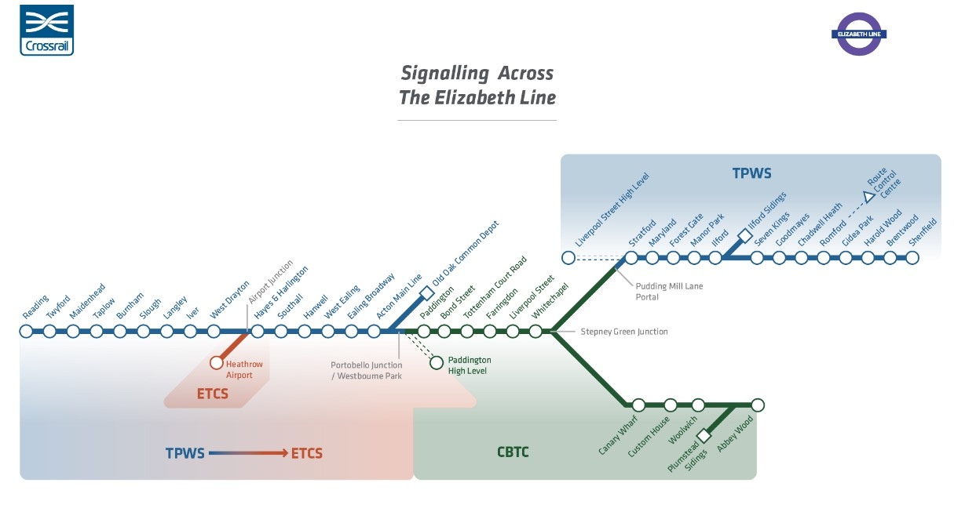
Fig.9 Source: (Crossrail Ltd., 2022)
The delays suffered from this complex problem, both in terms of budget and time, has several causes. One might be the lack of expertise on system integration combined with the responsibility gap between Crossrail, responsible for the construction management of the project, and Transport for London, responsible for the acquisition of the trains (Pollalis & Lappas, 2019).
The National Audit Office presented a report in May 2019 which reveals multiple and serious problems in the project delivery that have been present long before Crossrail Ltd. admitted the delays and budget overruns in 2018. Cost increases have occurred across the project mainly due to contracts for tunnelling, civil engineering, station construction and fittings, and implementation of systems required to operate the station and railway. The biggest increases have been on contracts to install track and key systems in the tunnels, as seen in fig.10 below (National Audit Office, 2019).
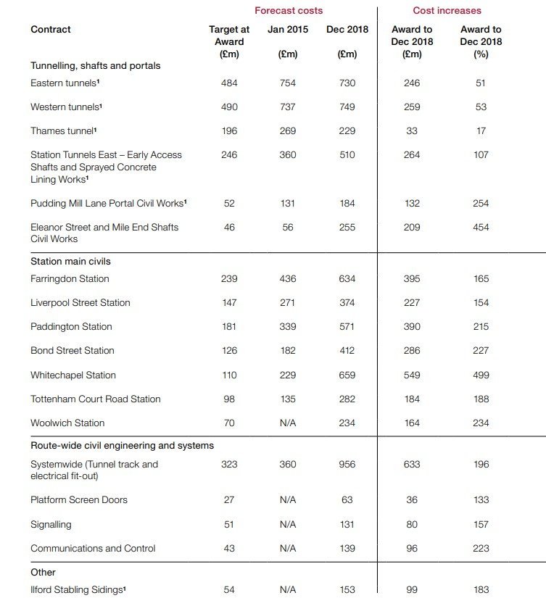
Fig.10 Source: (National Audit Office, 2019)
In fig.11, we can see the causes of cost changes as reported by Crossrail Ltd. The reasons for increases in costs have been divided into four main categories: design change, contractual compensation events, acceleration or changing the sequencing of works to improve confidence in delivering on schedule, and additional scope (National Audit Office, 2019). A key finding is that changes required to designs and schedules on most of the 36 main contracts increased costs up by more than £2.5 billion between 2013 and 2018. Unforeseen clashes between contractors, working for example on stations and system-wide installations, forced design changes, delays and compensation awards to contractors (GCR Staff, 2019).
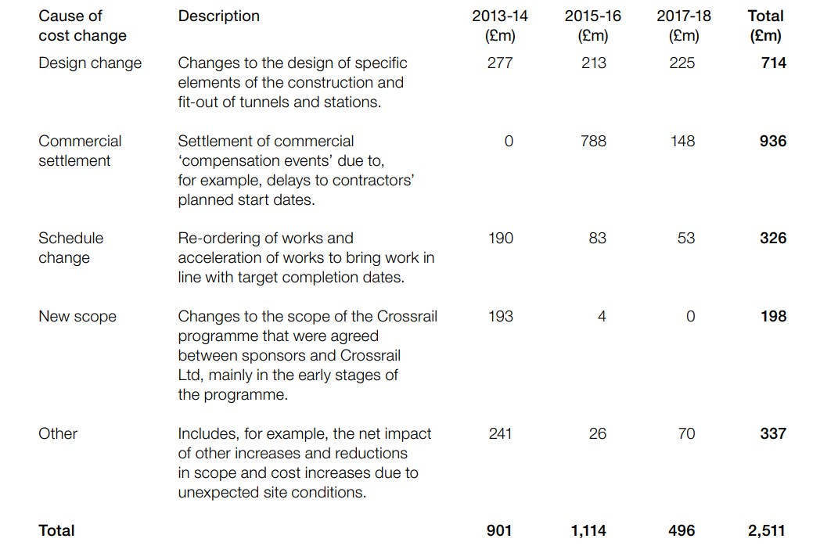
Fig.11 Source: (National Audit Office, 2019)
As shown in the figure above, the settlement of commercial compensation events with contractors resulted in nearly £1 billion of cost increases between 2013 and 2018. These increases occurred due to events outside of contractor’s control. An example of such an event might include access to a work site being delayed, or a design change being instructed by Crossrail Ltd (National Audit Office, 2019).
In March 2020, another delay affected the project by something that nobody could have foreseen, when assessing the risks involved. The global pandemic stopped almost all work on the project and added a further £230 million on an already overrun budget. Covid-19 affected also the transport in London and subsequently the Transport for London (TfL) fare revenue, as much of the revenue TfL registers comes from fares. Because of the psychological long-term effects of the pandemic, TfL also forecasts a drop of 18% in demand for rail fares by 2031 compared to pre-pandemic levels (Loughran, 2021).

8.Conclusion
From the above points we can observe how far the Crossrail project has overrun in terms of budget and time, stretching from £14.8 billion to £18.8 billion and extending from December 2018 to May 2022. Many factors have caused these huge excesses, but as it is with a complex mega project as the Crossrail that stretches over a long lifespan, the main reason for the huge overruns could also be considered the unrealistic forecasts made in the initial planning stage of the project. The management team could have set communication procedures that were not efficient, or the members of the decision teams didn’t have the necessary experience to handle the responsibilities of their positions.
The new Elizabeth Line will bring significant environmental and economical benefits to the city of London and the surrounding areas. If we assess the benefits and costs at a city level then the report indicates a strong business case for the project, in its ability to reduce congestion and generate revenue and jobs. Instead of comparing the original cost and time estimate of this megaproject against the result, it may be more important to think about the value and benefits delivered by this infrastructure across their lifetime and the sustainability of the project. The fully benefits of this project are assumed to be at a net present value of £42 billion over a 60-year period (Taylor, 2017).

9.References
Bailey, R., 2017. Community First: Crossrail Stakeholder Management Case Study. [Online]
Available at: https://pracademy.co.uk/insights/community-first-crossrail-stakeholder-management-case-study/
[Accessed 09 09 2022].
Buck, M., 2017. Crossrail Project: Finance, Funding and Value Capture for London’s Elizabeth Line. [Online]
Available at: https://learninglegacy.crossrail.co.uk/wp-content/uploads/2017/09/1C-002-Finance-Funding-and-Value-Capture.pdf
[Accessed 08 09 2022].
Crossrail LTD., 2022. Building the Elizabeth Line. [Online]
Available at: https://www.crossrail.co.uk/project/
[Accessed 08 09 2022].
Crossrail Ltd., 2022. Funding. [Online]
Available at: https://www.crossrail.co.uk/about-us/funding
[Accessed 09 09 2022].
Crossrail Ltd., 2022. Quality. [Online]
Available at: https://learninglegacy.crossrail.co.uk/learning-legacy-themes/project-and-programme-management/quality-2/
[Accessed 09 09 2022].
Crossrail Ltd., 2022. Signalling on the Elizabeth Line. [Online]
Available at: https://www.crossrail.co.uk/project/our-plan-to-complete-the-elizabeth-line/signalling
[Accessed 10 09 2022].
Crossrail Ltd, 2016. Risk Management Plan. [Online]
Available at: https://learninglegacy.crossrail.co.uk/documents/risk-management-plan/
[Accessed 10 09 2022].
Crossrail LTD, 2017. PROJECT INITIATION AND DEVELOPMENT. [Online]
Available at: https://learninglegacy.crossrail.co.uk/learning-legacy-themes/project-and-programme-management/business-case/
[Accessed 08 09 2022].
Department of Finance, 2022. Stakeholder Engagement within a Programme or Project. [Online]
Available at: https://www.finance-ni.gov.uk/articles/programme-and-project-stakeholders#skip-link
[Accessed 09 09 2022].
GCR Staff, 2019. Bad decisions and poor planning: Why Crossrail went wrong. [Online]
Available at: https://www.globalconstructionreview.com/bad-decisions-and-poor-planning-why-crossrail-went/
[Accessed 11 09 2022].
Haylen, A., 2019. Crossrail (Elizabeth Line). [Online]
Available at: https://researchbriefings.files.parliament.uk/documents/SN00876/SN00876.pdf#:~:text=Crossrail%20is%20the%20plan%20to%20join%20the%20mainline,Crossrail%20route%3B%20and%20a%20new%20fleet%20of%20trains.
[Accessed 09 09 2022].
Loughran, J., 2021. Crossrail faces £150m funding shortfall amid pandemic uncertainty. [Online]
Available at: https://eandt.theiet.org/content/articles/2021/10/crossrail-faces-150m-funding-shortfall-amid-pandemic-uncertainty/
[Accessed 11 09 2022].
National Audit Office, 2019. Completting Crossrail Report - Value for Money. [Online]
Available at: https://www.nao.org.uk/reports/crossrail/
[Accessed 11 09 2022].
Palczynski, R., 2016. Work Breakdown Structure. [Online]
Available at: https://learninglegacy.crossrail.co.uk/documents/work-breakdown-structure/
[Accessed 09 09 2022].
Pollalis, S. & Lappas, D., 2019. Crossrail Elizabeth Line, Harvard: s.n.
Taylor, M., 2017. CROSSRAIL: BUILDING A VIRTUAL VERSION OF LONDON’S ELIZABETH LINE – THE DEVELOPMENT OF THE BIM ENVIRONMENT. [Online]
Available at: https://learninglegacy.crossrail.co.uk/documents/crossrail-development-bim-environment/
[Accessed 08 09 2022].

