

Design and Implementation of a Relational Database System

MediLink Pharmacy - Microsoft Access Solution

Student ID: 2511424
Student Name: Joanna Grabowska
Lecturer’s Name: Dr. Anum Paracha

Table of Contents
1. Introduction 4
2. Requirements and Scenario Overview. 5
3. Entity Identification of System Analysis. 6
3.1 Supplier 6
3.2 Medicine 6
3.3 Customer 6
3.4 Prescription 6
3.5 PrescriptionDetails 6
3.6 Sales 6
3.7 SaleDetails 6
Entity Relationships 6
4. Database Implementation and Design. 8
4.1 Primary Keys 8
4.2 Foreign Keys 8
4.3 Data Types and Constraints 8
5. Normalisation 10
5.1 First Normal Form (1NF) 10
5.2 Second Normal Form (2NF) 10
5.3 Third Normal Form (3NF) 10
6. Query Development 11
6.1 Medicines classified according to the amount in stock. 11
6.2 The maximum unit cost of drugs. 12
6.3 Total Revenue Per Sale 12
6.4 The Average number of quantities sold per medicine 13
6.5 Average purchase of customers. 14
6.6 Customer Purchase History 15
6.7 Items Prescribed by a Doctor. 16
6.8 Drugs Supplied by individual Supplier. 16
6.9 Total Inventory Value 17
6.10 The number of units in which each medicine is prescribed 18
7. Validation and Testing 20
7.1 Primary Key Validation 20
7.2 Referential Integrity Testing 20
7.3 Data integrity can also be known as data validation. 22
7.4 Query Accuracy Testing 23
7.5 Functional Requirement Evaluation 23
7.6 Error Prevention Testing 23
7.7 Limitations 24
Reflection 26
Conclusion 27
Reference 28

List of Figures
Figure 1: ERD for Medlink_Pharmacy 7
Figure 2: Relationships View in MS Access 7
Figure 3: Table Design View 9
Figure 4: Medicines classified according to amount Query 11
Figure 5: Query 1 result 11
Figure 6: maximum unit cost of drugs query 12
Figure 7: Query 2 Result 12
Figure 8: Total Revenue Per Sale query 13
Figure 9: Query 3 Result 13
Figure 10: Average quantity of sold medicines 13
Figure 11: Query 4 Result 14
Figure 12: Average purchase of customers query 14
Figure 13: Query 5 Result 14
Figure 14: Customer Purchase History query 15
Figure 15: Query 6 Result 15
Figure 16: Items Prescribed by a Doctor query 16
Figure 17: Query 7 Result 16
Figure 18: Drugs Supplied by individual Supplier query 16
Figure 19: Query 8 Result 17
Figure 20: Total Inventory Value query 17
Figure 21: Query 9 result 17
Figure 22: Number of units in which each medicine is prescribed, query 18
Figure 23: Query 10 Result 18
Figure 24: Primary Key Validation Testing 20
Figure 25: Referential Integrity Testing 21
Figure 26: Testing Result 22
Figure 27: Data Integrity Testing 22

1. Introduction
The current chain of pharmacies in MediLink Pharmacy is already updating its inventory, prescription form and customer files manually. The inconsiderate system has led to duplication of information, alteration of inventory, delay in reporting and more space to make mistakes by human beings. As the organisation is expanding, the need in automated and properly organised system is becoming topical.
The easiest task of the project will be to analyse and create a relational database on a platform of Microsoft Access software to assist the efficiency, accuracy and precision of the data and reporting potentialities [1]. The proposed system will manage the medicines, suppliers, customers and the exchanges of prescriptions and sales, and it will help the management decide one grounded on the established queries and reports.
The entire database designing process will be presented in this report, and this will entail the identification of the entities, the relational modelling, normalisation to the third normal form (3NF) and query generator, verification and system evaluation testing. The answer would be to fulfil the functional specifications of the assessment brief and display the comprehension of the concepts of the database design.

2. Requirements and Scenario Overview.
Medilink Pharmacy system does not have to answer several operational needs:
- Stock in each store is carried out by the operational manager or with the assistant store managers.
- Supplier information tracking.
- Customer record management
- Prescription recording
- Processing of sales transactions.
- Reporting on the stock and revenue study.
- Ensuring regulatory compliance.
The existing manual process lacks the use of any data storage structure, and this brings about threats as:
- Duplicate medicine records
- Inconsistent stock levels
- Issue with compliance with prescriptions.
- Poor reporting potential.
- The calculation of revenue is slow.

3. Entity Identification of System Analysis.
The following significant parties were identified in the analysis of the scenario:

3.1 Supplier
Stores Store SupplierID, SupplierName, ContactNumber, Email and Address. Suppliers supply medicines to the pharmacy.

3.2 Medicine
is the table that contains the information concerning each medicine, MedicineID, MedicineName, Category, UnitPrice, StockQty, ExpiryDate, SupplierID. Each drug is linked to a supplier.

3.3 Customer
Stores personal information about the patient, like CustomerID, CustomerName, Date of Birth, Phone and Address.

3.4 Prescription
Records of the prescriptions for the clients. Has PrescriptionID, CustomerID, DoctorName and DateIssued.

3.5 PrescriptionDetails
Mediator of Prescription and Medicine. This is a remedy to many-to-many relationship between drugs and prescriptions.

3.6 Sales
Records individual sales, such as SaleID, CustomerID and SaleDate.

3.7 SaleDetails
Links Sales and Medicine. Value and Unitprice per transaction of the stores.

Entity Relationships
It is possible to identify the following relationships:
- The number of Suppliers is one with a high number of Medicines.
- Customers can have many Prescriptions.
- One Prescription, many Medicines, numerous Prescriptions, one Medicine.
- A single Customer can generate high Sales.
- A single Sale can be made up of a variety of Medicines.
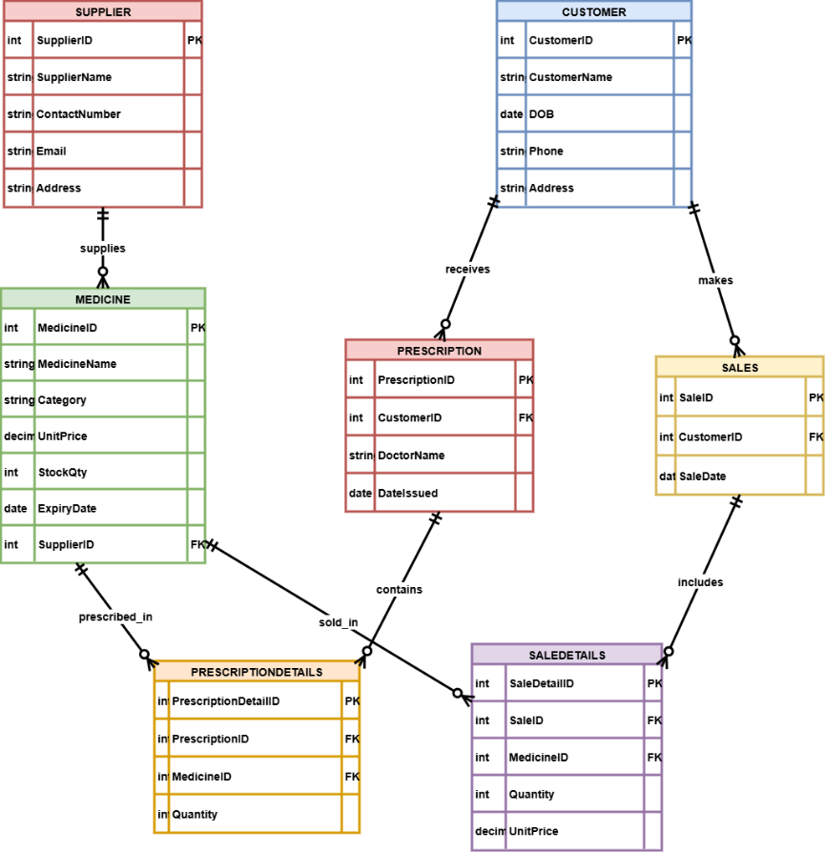
Figure 1: ERD for Medlink_Pharmacy
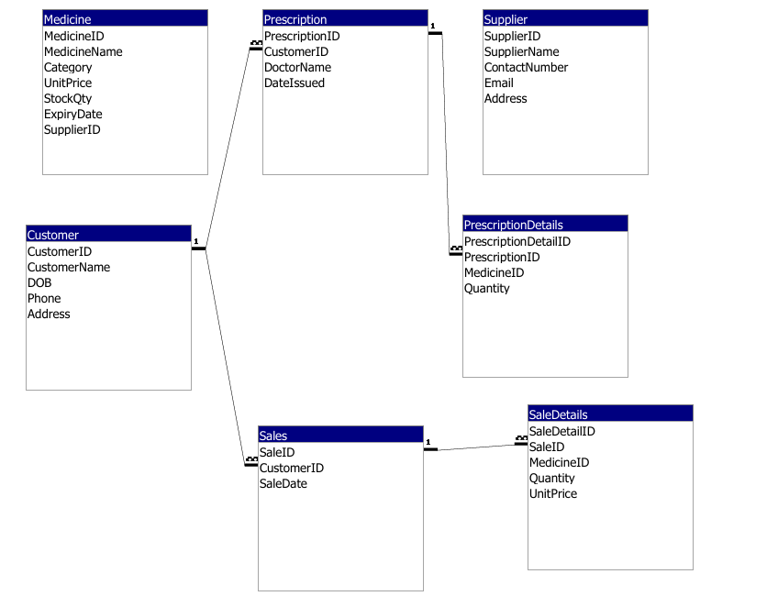
Figure 2: Relationships View in MS Access

4. Database Implementation and Design.
The database was installed in the Microsoft Access database with structured tables and definite data types and restrictions.

4.1 Primary Keys
Each table contains a unique primary key of AutoNumber to ensure that there are no similar records [2].
Examples:
- SupplierID
- MedicineID
- CustomerID
Primary keys do away with duplication and the relation that is to be enforced.

4.2 Foreign Keys
There were relationships between tables that were defined by foreign keys:
- Medicine.SupplierID.SupplierID.SupplierID
- Prescription.CustomerID Customer.CustomerID
- SaleDetails.SaleID Sales.SaleID
The Relationships View was subject to referential integrity.

4.3 Data Types and Constraints
There were sufficient types of data:
- Currency for UnitPrice
- ExpiryDate and SaleDate Date/Time.
- Short Text for names
- Number for quantities
The unnecessary fields were set to the value of NOTNULL to eliminate any incomplete records [3].
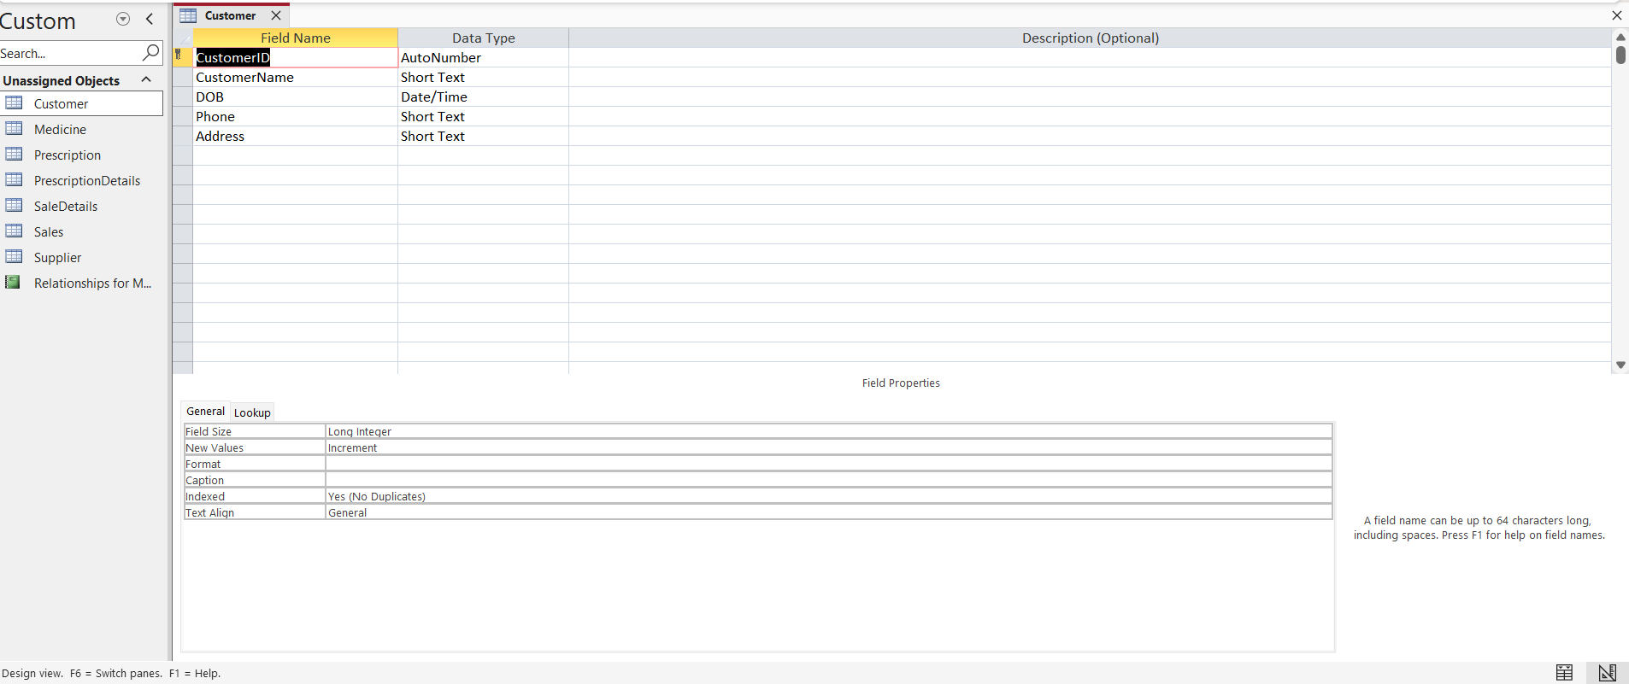
Figure 3: Table Design View

5. Normalisation
Normalisation minimised the dependency and redundancy problems.

5.1 First Normal Form (1NF)
1NF requires:
- No repeating groups
- Atomic values only
The tables are all single values. As an example, storing of medicines in the prescriptions is made in a new table (PrescriptionDetails) rather than in numerous medicine columns in the Prescription table.
Thus, 1NF is met in the database.

5.2 Second Normal Form (2NF)
2NF requires:
- Table must be in 1NF
- No partial dependency of key on composite key.
Bridge tables, such as PrescriptionDetails and SaleDetails, ensure that the attributes are dependent upon the complete primary key. There is no such thing as partial dependencies.
Thus, the database is in 2NF.

5.3 Third Normal Form (3NF)
3NF requires:
- No transitive dependencies
For example:
- The Supplier contact information is not stored in the Medicine table, but it is only stored in the Supplier table.
- Sales Customer information is separate.
- This kills indirect dependencies and gives efficiency of structure.
- This database is therefore complying with the Third Normal Form.

6. Query Development
The query development is a significant component of the MediLink Pharmacy database system, which enables the conversion of the information stored into meaningful information that can be utilised in making decisions. The questions formulated for this system were in managing stock, financial control, supplier, prescription analysis and customer activity.
The queries were constructed on the Microsoft Access SQL and tested to be accurate and relevant to the operations.

6.1 Medicines classified according to the amount in stock.
This query shows all the ordered medicines in descending order of stock.
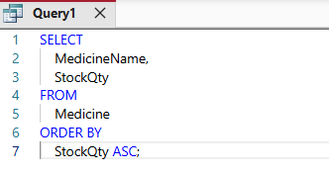
Figure 4: Medicines classified according to amount Query
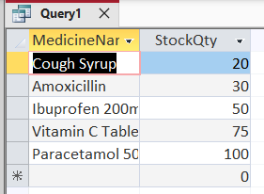
Figure 5: Query 1 result
Purpose:
To allow the pharmacy employees to locate drugs with the least amount of inventory and to prioritise the action of refilling them.
Business Value:
Even though no definite threshold was employed, the sorting of items by the stock quantity can provide immediate access to the manner of distribution of the inventory and prevent shortages.

6.2 The maximum unit cost of drugs.
This query presents the list of medicines in descending order of unit price.
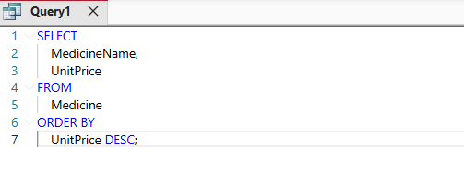
Figure 6: maximum unit cost of drugs query
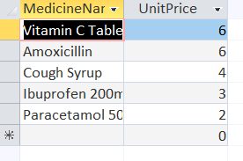
Figure 7: Query 2 Result
Purpose:
To identify high-value medicines and support the price investigation.
Business Value:
The management can know the profit margins, pricing strategy and trace some of the expensive medicines that may require any special storage or tracking.

6.3 Total Revenue Per Sale
This query will add up all the financial figures of the sales in each of the sales through the unit price and arrange the results based on the SaleID.
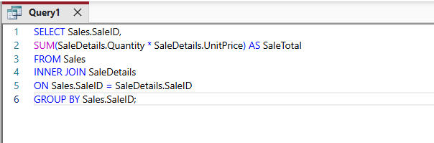
Figure 8: Total Revenue Per Sale query
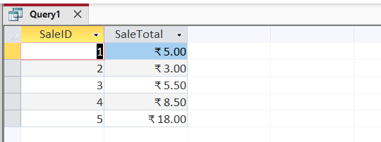
Figure 9: Query 3 Result
Purpose:
To be able to calculate the sum of transactions automatically.
Business Value:
This is to eliminate the manual method of calculating revenue and reduce human error. It also helps to create reports on daily and monthly financial summaries.
The query displays the aggregation functions and calculated fields used in SQL.

6.4 The Average number of quantities sold per medicine
This query is a summary of the units sold of every medicine.
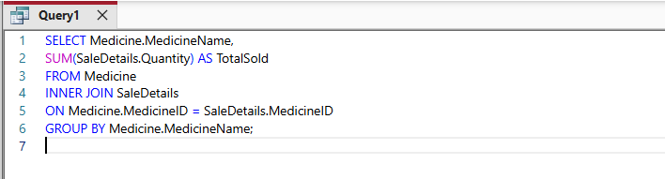
Figure 10: Average quantity of sold medicines
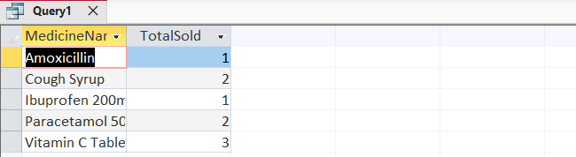
Figure 11: Query 4 Result
Purpose:
To analyse product demand.
Business Value:
Helps find out what medicines to sell, and directs in buying. The drugs with a high demand regularly may require a larger number of stocks.
The functions of grouping and summarisation can also be observed in this query [4].

6.5 Average purchase of customers.
This query enumerates the sales transactions carried out on a customer-by-customer basis.
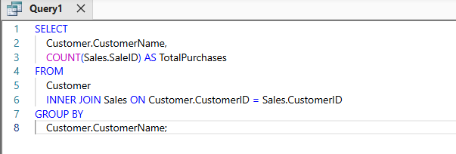
Figure 12: Average purchase of customers' query
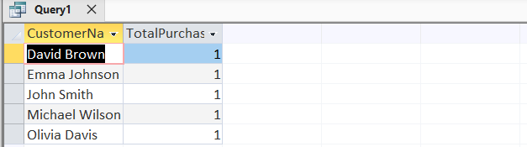
Figure 13: Query 5 Result
Purpose:
To look at customer activity patterns.
Business Value:
Allows the management to be aware of the typical customers and evaluate customer interest. The future can use such data to support the loyalty programs.

6.6 Customer Purchase History
This query is a complex query that will include Customer, Sales, SaleDetails and Medicine tables to provide a total history of a transaction.
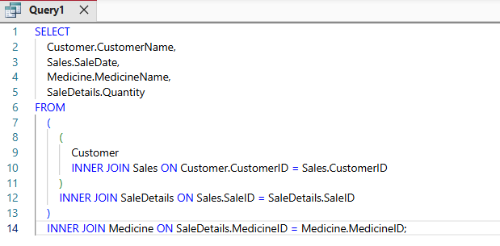
Figure 14: Customer Purchase History query
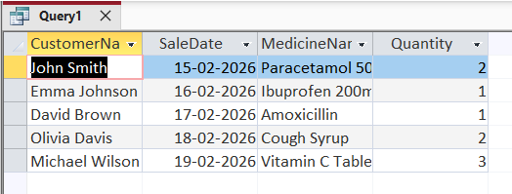
Figure 15: Query 6 Result
Purpose:
To have a great history of the medicines that the individual customer has purchased, and the date when they purchased them.
Business Value:
Increases the level of transparency and ensures that the prior purchase history is accessed by the employees faster than serving a customer.

6.7 Items Prescribed by a Doctor.
The query takes an input of the DoctorName, which is then used to select the prescriptions and count the number of prescriptions that have been issued.
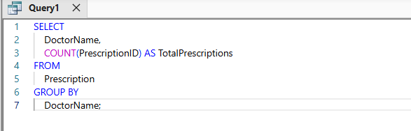
Figure 16: Items Prescribed by a Doctor query
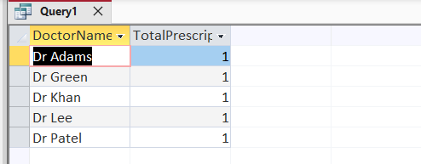
Figure 17: Query 7 Result
Purpose:
To monitor prescribing practice.
Business Value:
Makes it easier to report what is needed and allows one to evaluate the trend of prescribing.

6.8 Drugs Supplied by individual Supplier.
This query is a joining query of the Supplier and Medicine tables.
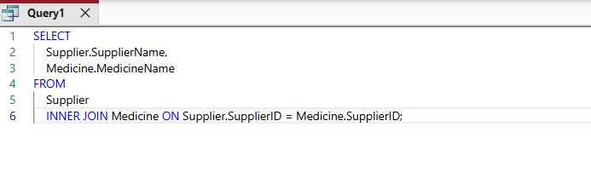
Figure 18: Drugs Supplied by individual Supplier query
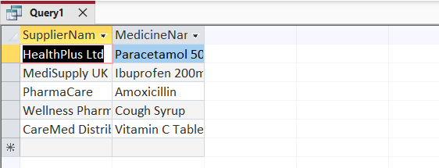
Figure 19: Query 8 Result
Purpose:
To establish the drugs that each supplier provides.
Business Value:
Improves the control of suppliers and visibility of the supply chain.

6.9 Total Inventory Value
This query calculates the stock financial value now in terms of multiplying StockQty and UnitPrice and summing the value.
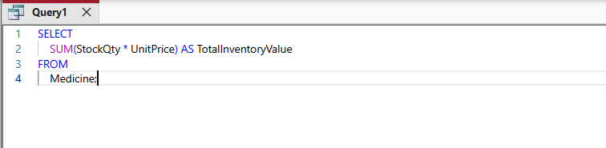
Figure 20: Total Inventory Value query
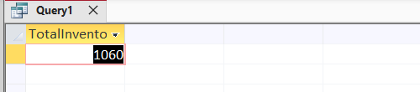
Figure 21: Query 9 result
Purpose:
To determine investment in inventory.
Business Value:
Such a query depicts how, during the calculation of aggregate functions and expressions [5].

6.10 The number of units in which each medicine is prescribed
This query adds together all the quantities of prescriptions of all the medicines with the assistance of the PrescriptionDetails table.
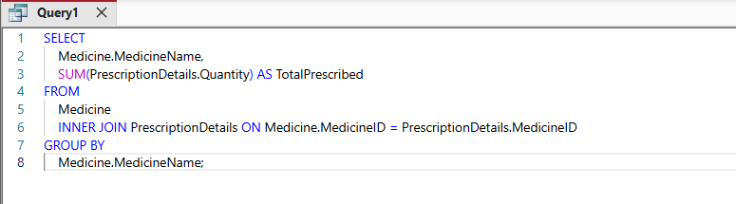
Figure 22: number of units in which each medicine is prescribed query
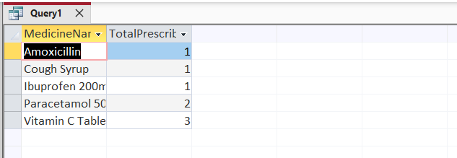
Figure 23: Query 10 Result
Purpose:
To investigate the frequency of prescription.
Business Value:
Helps draws a distinction between medicines that are to be prescribed and those sold over the counter, which makes the inventory planning easier.
Query Design Justification
The selection of queries was made based on the operating priorities in the situation:
- Stock control Stock sorting, and stock valuation queries.
- Financial reporting: Revenue and sales aggregation query.
- Prescription management: Prescription and physician analysis queries.
- Compared to purchase history queries, customer tracking is the first step of the whole process.
- Supplier management Supplier medicine relationship questions.
The queries are not run as a demonstration program but add value to a specific business purpose. Aggregation functions (SUM, COUNT), grouping, join and calculated field were utilised in the process of demonstrating familiarity with the relational database querying methods [6].
All the queries were verified for correctness and cross-analysed with the information input by the samples.

7. Validation and Testing
The validation and testing were done in a way that would ensure that the MediLink pharmacy database system would be able to satisfy its requirements and be functioning under normal working conditions. Throughout the calculations, the test areas were the data integrity, relationship enforcement, and system accuracy, as well as system general reliability [7].

7.1 Primary Key Validation
Primary keys were enforced with all the tables being put through to make sure they were unique.
Test Conducted:
One of the primary key values was attempted to be duplicated.
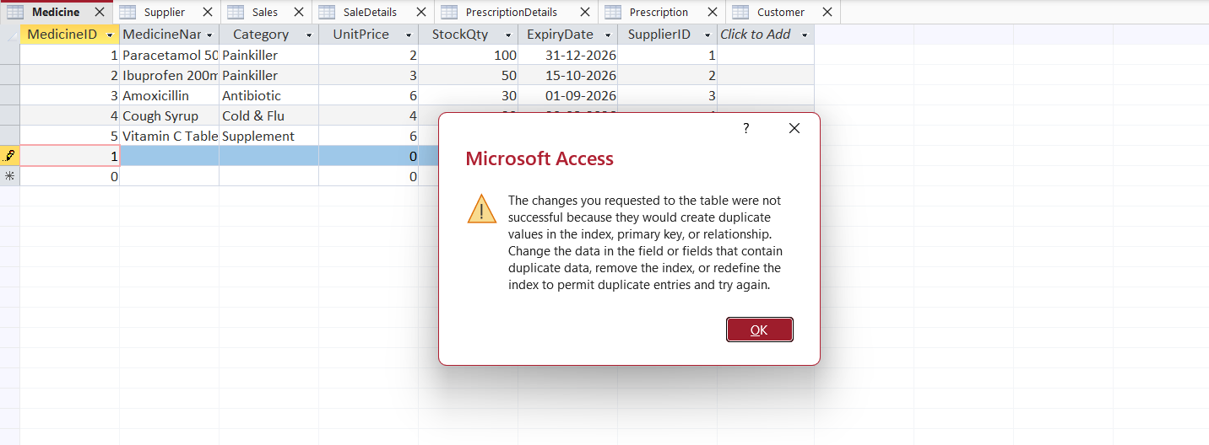
Figure 24: Primary Key Validation Testing
Result:
This system prevented duplication, and this is a sign that primary key constraints were functional.
This renders every record in the database distinct.

7.2 Referential Integrity Testing
The referential integrity between related tables was imposed by means of foreign key relationships.
Tested Relationships were:
- Supplier Medicine
- Customer Sales
- Customer Prescription
- Sales SaleDetails
- Prescription PrescriptionDetails
Test Conducted:
An attempt was made to do away with a customer whose medicines were linked to.
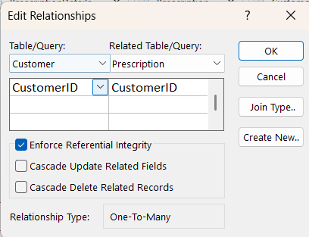
Figure 25: Referential Integrity Testing
Result:
Enforced referential integrity was enforced to provide a system that was characterised by deletion.
This demonstrates that the potential of having orphan records and the integrity of data across tables does not exist.
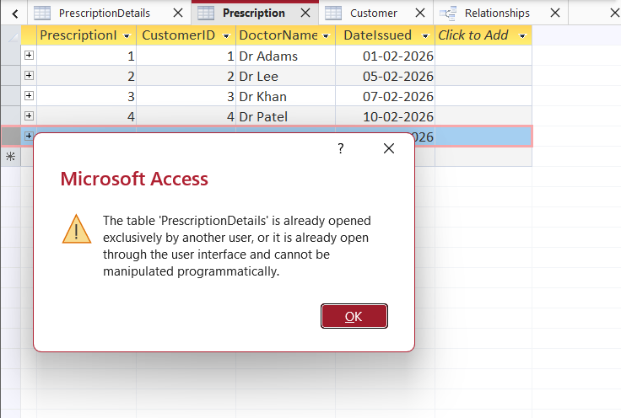
Figure 26: Testing Result

7.3 Data integrity can also be known as data validation.
The field-level was also tested to ensure that it limits the entry of wrong data of the right data types.
Test Conducted:
- Attempted to key in some entry into a numerical field (StockQty).
- Attempted to take out of fields that were not meant to be blank.
- Attempted to log in on the wrong date.
Result:
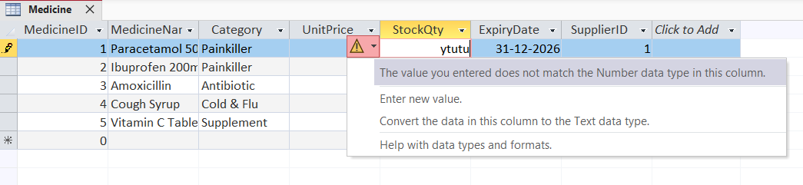
Figure 27: Data Integrity Testing
The system also had validation errors and could not tolerate invalid data entry.
This removes the possibility of errors and increases the reliability of their system.

7.4 Query Accuracy Testing
All queries created were executed, and the findings were compared to the typed sample data in them.
Example:
- For SaleID 1:
- Quantity = 2
- UnitPrice = 2.50
- Expected total = 5.00
The prescription queries were also checked manually.
This shows that aggregation is functioning and that calculated formulas are functioning.

7.5 Functional Requirement Evaluation
The preliminary requirements spelt in the scenario were tested by the database.
Functional Requirement | System Support | Status
Manage medicine inventory | Medicine table with stock tracking | Achieved
Record supplier details | Supplier table | Achieved
Store customer records | Customer table | Achieved
Track prescriptions | Prescription & PrescriptionDetails tables | Achieved
Record sales transactions | Sales & SaleDetails tables | Achieved
Generate reports | Queries and reports | Achieved
The implemented system addresses the requirements of the operations given in the assignment brief.

7.6 Error Prevention Testing
To test, other validation questions were applied:
- Duplicate records
- Negative stock values
- Missing foreign keys
- Orphaned prescriptions or sales.
No inconsistencies were detected, which implies that the relational constraints are functional.

7.7 Limitations
The system does not have any critical weaknesses. The following weaknesses were identified:
- After the sale There is no reduction of the stock after a sale (no update query or macro is required).
- Absence of a new alarm system to express the nearing expiry of medicines.
- None of the barcode scanning integrations.
- No role-based access control.
The restrictions are not detrimental to the basic functionality, but can be enhanced in the development of the system.
Design Justification
The relational database model has been selected due to the reason that the model provides a rational organisation of data, similarity and size. The relational databases minimise redundancy and create relationships among data entities in comparison to the flat-file database system [8].
Each entity was stored in different tables to ensure that the concepts of normalisation were achieved and no similar information was repeated. For example:
- The data on suppliers is stored in a single location and linked with foreign keys.
- Sales and SaleDetails are detached to transact on quite a few medicines.
- prescriptionDetails resolves the many-to-many relationship between prescriptions and medicines.
The need of bridge table was informed by the fact that there is more than one medicine in one prescription, and one prescription may have more than one medicine. The design would violate norms of normalisation due to the lack of a junction table.
The queries have been developed based on the practical business needs, having in mind the theoretical samples. Any query supports a specified business process, such as the income-tracking or inventory appraisal.
Overall, the design is concerned with:
- Data integrity
- Scalability
- Reduced redundancy
- Efficient querying
- Ease of maintenance

Reflection
The implementation and design of the MediLink Pharmacy database gave me a working knowledge of relational database design and implementation. The greatest issue that was observed was that the modelling of many to many relationship and bridge tables would operate with complexities.
The relationships between the attributes would be considered to ensure that we had obtained compliance with the Third Normal Form. The segregation in terms of structure and duct augmented further the segregation to form additional crystals.
The second matter was to write profound questions, not to search for information, but the reflection of what is going on in the real world that is operating. Their advancement of the capability to perform analysis was credible because they introduced the functions of aggregation and calculated fields.
The competencies that were identified in this project are the following:
- Database modelling
- SQL query construction
- Data validation
- Logical problem-solving
- Structured report writing
To be better in future, it could be enhanced by:
- Automated updates on stocks.
- Expiry alert system
- There is also the use of role-based security permissions.
- External integration with the system.
The practical knowledge of the relational database system and its application in the business environment is exhibited in this project.

Conclusion
The MediLink Pharmacy database system has performed adequately in correcting the negativities of the manual system, also inherent to the system, such that it presents more systematised and relational data management. The ER modelling was accomplished by an entity identification, which was normalised to the Third Normal Form. The application of Microsoft Access was employed to create a solution that is strong and capable of scaling.
The system allows the data to be precise using primary keys and foreign keys, and referential integrity to be formed. Through the creation of a query, a query allows one can manipulate the stock, accordingly, monitor the sales and tracking of the prescriptions, which cannot be achieved otherwise. The system is also tested, and the validation of the system is carried out to ensure that the system is within its functional requirements and that it is at least reliable for operational use. The designed solution that was applied is a highly satisfactory interpretation of the ideas of database design and its implementation in the real life scenario..

Reference
- M. S. Hosen, R. Islam, Z. Naeem, E. O. Folorunso, T. S. Chu, M. A. Al Mamun, and N. O. Orunbon, “Data-driven decision making: Advanced database systems for business intelligence,” Nanotechnology Perceptions, vol. 20, no. 3, pp. 687–704, 2024. [Online]. Available: https://www.researchgate.net/profile/Esther-Folorunso-3/publication/382695215_Data-Driven_Decision_Making_Advanced_Database_Systems_for_Business_Intelligence/links/66a9e30775fcd863e5eae75d/Data-Driven-Decision-Making-Advanced-Database-Systems-for-Business-Intelligence.pdf
- J. Lavergne, Database Software 2: Database Objects and Querying a Database, Computer Applications, 2022. [Online]. Available: https://louis.pressbooks.pub/computerapplications/chapter/chapter-a2-database-objects-and-querying-a-database/
- L. Yang, X. Chen, Y. Luo, X. Lan, and W. Wang, “IDEA: A utility-enhanced approach to incomplete data stream anonymisation,” Tsinghua Science and Technology, vol. 27, no. 1, pp. 127–140, 2021. [Online]. Available: https://ieeexplore.ieee.org/iel7/5971803/9515693/09515706.pdf
- S. Verberne, E. Krahmer, S. Wubben, and A. van den Bosch, “Query-based summarisation of discussion threads,” Natural Language Engineering, vol. 26, no. 1, pp. 3–29, 2020. [Online]. Available: https://www.cambridge.org/core/services/aop-cambridge-core/content/view/5CAC0B9D6F20FBA183990FC3DE0CEAF2/S1351324919000123a.pdf
- H. Ding, Z. Wang, Y. Yang, D. Zhang, Z. Xu, H. Chen, R. Piskac, and J. Li, “Proving query equivalence using linear integer arithmetic,” Proceedings of the ACM on Management of Data, vol. 1, no. 4, pp. 1–26, 2023. [Online]. Available: https://dl.acm.org/doi/pdf/10.1145/3626768
- F. Ravat, J. Song, O. Teste, and C. Trojahn, “Efficient querying of multidimensional RDF data with aggregates: Comparing NoSQL, RDF and relational data stores,” International Journal of Information Management, vol. 54, p. 102089, 2020. [Online]. Available: https://www.sciencedirect.com/science/article/am/pii/S0268401219306097
- S. Duggineni, “Impact of controls on data integrity and information systems,” Science and Technology, vol. 13, no. 2, pp. 29–35, 2023. [Online]. Available: https://www.researchgate.net/profile/Sasidhar-Duggineni/publication/372193665_Impact_of_Controls_on_Data_Integrity_and_Information_Systems/links/64a8d256b9ed6874a5046bc3/Impact-of-Controls-on-Data-Integrity-and-Information-Systems.pdf
- K. Thomer and K. M. Wickett, “Relational data paradigms: What do we learn by taking the materiality of databases seriously?” Big Data & Society, vol. 7, no. 1, 2020. [Online]. Available: https://journals.sagepub.com/doi/pdf/10.1177/2053951720934838

