
Applied Leadership and Management in the Workplace
Module Assignment Submission
Student Name: | Robert Peter Morgan
Student Number: | 0551699
Module No: | BMSK4013
Module Title: | Management Communication

Statement of Confirmation of Authenticity
By the act of making this submission, the student declares that this is the work of the student named above. The work has not, in whole or in part, been knowingly presented elsewhere for assessment, or where assessment has been built on a previous assessment, this has been identified. Where materials have been used from other sources it has been properly acknowledged. If this statement is untrue, the student acknowledges that an assessment offence has been committed.
Attention is drawn to the plagiarism and unfair practice policies of both the University and of ILM.

Table of Contents
Section 1: Introduction 3
Section 2: Communication Models 4
Section 3: Verbal, Non – Verbal and Formality 8
Section 4: Overcoming Barriers to Communication 9
Section 5: Assessing Communication in an Organisation 10
Section 6: Motivation in Theory and Practice 11
Section 7: Managing Conflict in the Workplace 12
Section 8: Evaluating My Own Communication Skills 13
Section 9: Personal Development Plan (PDP) 14
Section 10: Conclusion 15
Section 11: References 16
Appendix A: 18
Appendix B: Personal Development Plan (PDP) 19

Section 1: Introduction

Good communication is one of the most important skills a manager can have. It allows leaders to share information, motivate staff and build trust within a team. I have seen many times in the medical library where I work that a message is not explained properly and is drawn out with jargon it can cause delays and frustrations for staff and service users. When information is clear and concise our service users understand us more and appreciate what we are communicating to them. Management communication can be defined as “the process by which managers share information, ideas, and instructions to coordinate work, build relationships, and motivate employees to achieve organisational goals” (Clampitt, 2016; Robbins & Judge, 2022).

This report will critically examine communication in the workplace, drawing on a range of models and theories to assess their relevance to modern management. It will look at Argyles’ Communication Cycle Model (1972) and the three communication frameworks developed by Shannon and Weaver (1949), Schramm (1954), and Berlo (1960). The look at importance of verbal and non-verbal communication and the appropriate use of formality. Barriers to effective communication will be identified and suggest the appropriate strategies to overcome them (Adler et al., 2021). I will also evaluate the communication methods we use in the Medical Library to see which model work best in my workplace.

Finally, the report will analyse two motivation theories (Maslow, 1943; Herzberg et al., 1959) and their impact on performance. Then a self-evaluation of my personal communication skills and a Personal Development Plan (PDP) for future leadership growth

Section 2: Communication Models

Argyle’s Communication Cycle (1972) is an interactive model. It describes communication as a continuous process where ideas are encoded, sent, received, decoded, and then responded to through feedback. This model's key advantage is its emphasis on feedback, showing communication as a dynamic two-way loop. In the medical library this is evident when a clinician requests a literature search. I encode the request into a search strategy, communicate the process back, and their feedback confirms whether the results meet their needs. Research in library communication emphasises that feedback is central to successful service encounters (Radford, 2001). However, the model can oversimplify the complexities of real conversations and does not fully account for power dynamics.

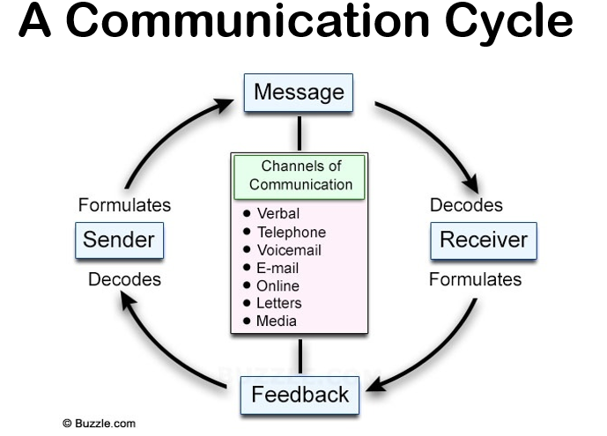

Shannon and Weaver’s Model (1949), is a linear model. It views communication as a process where a sender encodes a message, sends it through a channel and the receiver decodes it. Its main advantages are its simplicity and its introduction of noise, which disrupts clarity. For example, when I email colleagues about a system outage, poor wording (semantic noise) or inbox overload physical noise may mean the message is missed. Its primary limitation is that it is a one-way model that overlooks feedback and context. Despite this, Umeozor, Ukwoma, and Onwuasoanya (2018) note its relevance in libraries, where information retrieval often breaks down due to noise like unclear queries or technical barriers.

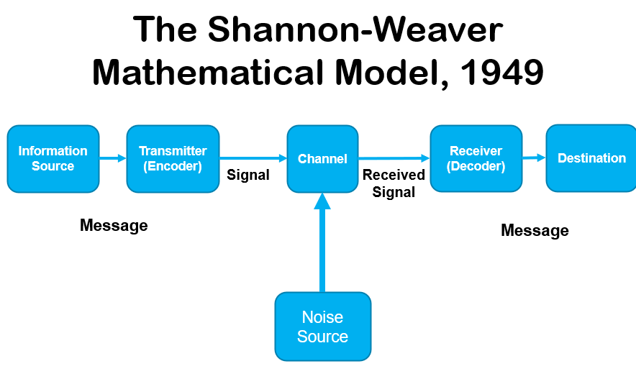

Schramm’s Model (1954), another interactive model. It develops the idea further by emphasising shared fields of experience between sender and receiver. Its strength is its focus on shared understanding, suggesting communication is more effective when both parties have common ground. In the library, this occurs when discussing search results with a clinical researcher; our shared knowledge of medical terminology ensures the conversation flows effectively. While it effectively highlights the need for shared context and feedback, it can assume a level of cooperation that is not always present and gives little guidance on overcoming significant knowledge gaps.
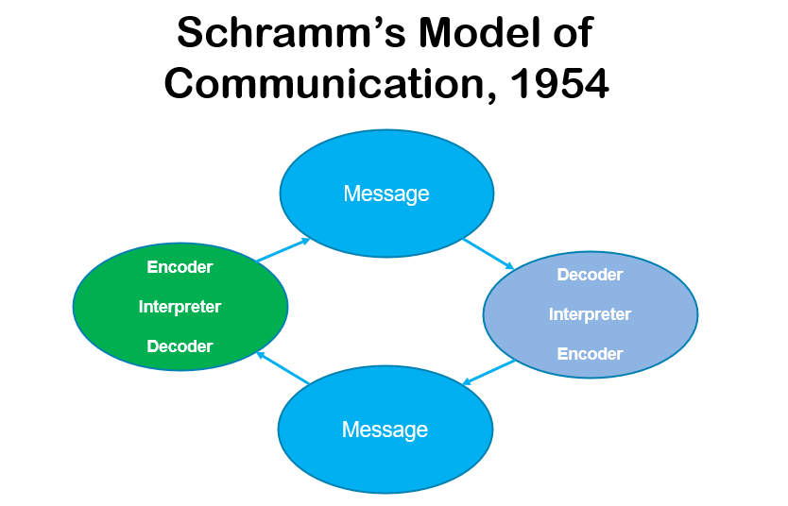

Berlo’s SMCR Model (Source, Message, Channel, Receiver) (1960), is a linear model. It focuses on the attributes of the participants, highlighting how the skills, attitudes, and knowledge of both sender and receiver affect the outcome. The model’s main advantage is that it focuses on human factors. For instance, when training new staff to use databases, my ability to explain clearly (source skills) and their willingness to learn (receiver attitude) will both affect success. Its main limitation is that it does not explicitly account for feedback or noise, placing a heavy emphasis on individual factors.

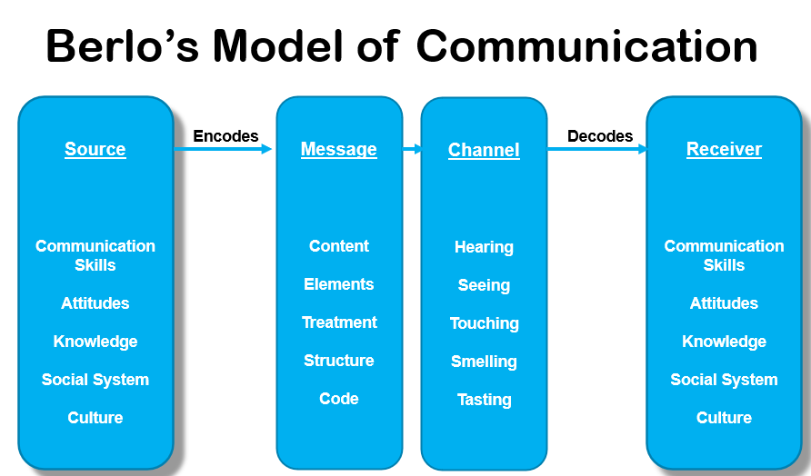

Section 3: Verbal, Non – Verbal and Formality

Workplace communication relies on more than just the exchanging of spoken words. Verbal exchanges that are quick, clear and direct are always essential at the library enquiry desk. A well phrased explanation can resolve an issue in minutes (Adler et al., 2021).

When words alone are not enough. Non-verbal cues like tone, posture and facial expressions will add meanings that cannot be captured in speech alone (Knapp et al., 2014). When a member of staff or a student is clearly struggling with work, recognising these signs of stress me to adjust my response with empathy and care.

Formality also plays a key role. A Literature Search on a topic will demand precision and professionalism. On the other hand, a casual chat with a colleague will build good rapport and help solve problems quickly (Clampitt, 2016). A good and skilled communicator know how to balance these all these elements choosing the right style for the situation, the audience and the message needed at those times.

Section 4: Overcoming Barriers to Communication

Effective communication isn’t just about delivering a message it is about recognising and removing the obstacles that can stand in its way. In the medical library, many of these barriers are practical and immediate. One recent example involved a new nurse who couldn’t speak English very well. They were struggling to verbally request a specific textbook due to the strong accent. This created a language barrier and increased the risk of misunderstanding. To address the issue, we asked the nurse to complete a written inter library loan form. This simple solution ensured accuracy and gave us the necessary information we needed to find the book. The nurse felt supported and understood and fed this information back to our manager

Another common challenge is hierarchy. Junior members staff may hesitate to question unclear instructions from managers, fearing they’ll be seen as incompetent. This reluctance can lead to confusion and missed opportunities for understanding what is needed from them. A proactive remedy to this will involve a manager encouraging open and encouraging them to ask more questions, give welcoming feedback. By doing these simple things it can create a psychologically safe environment where staff will feel confident to speak up (Clampitt, 2016).

Technology can and will always also get in the way. Overloaded inboxes, system glitches, or poorly structured messages can cause important updates to be missed. To reduce this risk, we use a multi-channel approach: clear and purposeful email subject lines, paired with short verbal reminders, help reinforce key messages and ensure they’re received and understood (Robbins & Judge, 2022).

Section 5: Assessing Communication in an Organisation

In our library, both verbal and written communication channels are used for distinct but complementary purposes. Verbal communication excels in situations requiring immediacy and rapport-building, such as helping a junior doctor find a resource at the enquiry desk. This aligns with research showing that internal dialogue is crucial for effective teamwork (Wakimoto, 2017). Written communication, including Standard Operating Procedures (SOPs), emails, and online guides, provides a permanent record that ensures accuracy and consistency (Clampitt, 2016).

However, each has limitations. Verbal instructions can be forgotten, and written messages can be lost in a digital deluge. The most effective communication strategy often involves a combination of both. For example, a planned system outage is first announced via a formal email (written) to provide a detailed record, then reinforced with signs at the desk and verbal reminders (verbal and non-verbal) to ensure the message has been received and understood. This blended approach leverages the strengths of each channel, creating a resilient communication system.

Section 6: Motivation in Theory and Practice

Understanding what motivates employees is fundamental to effective management. Theories from Maslow (1943) and Herzberg (1959) offer valuable frameworks. Maslow’s hierarchy of needs proposes that individuals are motivated to fulfil a sequence of needs, from basic security to self-actualisation. In the library, a salary and job security meet physiological needs. Having good teamwork always will fulfil belongingness needs, and recognition from clinicians for providing them with good literature searches does build esteem.

Herzberg’s two-factor theory separates factors that cause dissatisfaction (hygiene factors) from those that actively drive satisfaction (motivators). Hygiene factors are prerequisites for a neutral state; their absence causes dissatisfaction, but their presence does not motivate. In the NHS library, these include a safe working environment, fair workload distribution, and reliable IT systems. If the catalogue system constantly crashes when searching for books and articles. The staff become dissatisfied and when it but when it works, they simply expect it. This does not in itself motivate them.

Motivators, on the other hand, are intrinsic to the work itself and include recognition, responsibility, achievement, and opportunities for growth. These are the factors that boost engagement and performance. For example, when I was given the responsibility to lead a training session for new junior doctors, the sense of achievement and the positive feedback I received were powerful motivators that increased my job satisfaction far more than a smoothly functioning printer. This demonstrates Herzberg’s core insight that to truly motivate staff, managers must focus not only on eliminating dissatisfaction but on actively creating opportunities for recognition, growth, and meaningful work.

Section 7: Managing Conflict in the Workplace

Conflict is an inevitable part of any workplace. Thomas and Kilmann (1974) identified five distinct approaches to handling it: competing, collaborating, compromising, avoiding, and accommodating. While a competing (win-lose) approach may be fast, it damages relationships. Collaborating to find a win-win solution is ideal but time consuming.

In a recent example, conflict arose when a new staff member felt they were being assigned less favourable tasks. They voiced their intention to raise a grievance, creating tension within the team, who felt unfairly accused. If ignored (an avoiding approach), this conflict could have escalated, damaging morale and productivity.

Applying Thomas and Kilmann’s model, a collaborating approach was used to resolve the issue. The manager facilitated an open discussion where all parties could voice their perspectives. They clarified how duties were allocated and worked with the team to review the rota system, ensuring transparency and fairness. This professional conflict resolution strategy, based on clear communication and mediation, successfully de-escalated the tension. By acknowledging the grievance and collaboratively finding a fair solution, the manager rebuilt trust and strengthened the team.

Section 8: Evaluating My Own Communication Skills

To evaluate my personal communication skills. I designed an anonymous short questionnaire (see Appendix A) and gave it to five of my colleagues. They rated me on a scale of 1 to 5 across five categories of clarity, timeliness, tone, accuracy, and effectiveness. I also asked for suggestions.

The results were the following.

Clarity (4), Timeliness (4), Tone (4), Accuracy (4), Effectiveness (4).

Suggestions.

“Emails are clear and well-structured.”

“Good at explaining complex information simply.”

“Sometimes messages are longer than necessary.”

The feedback indicates my strengths in accuracy and clarity. But they do highlight areas for development in timeliness and, crucially, conciseness. The comment about message length relates directly to Shannon and Weaver’s concept of "noise". Unnecessary words can obscure the core message and make it less effective. While Berlo’s model would point to my strong skills in encoding accurate messages. Argyle’s cycle reminds me that feedback is essential for improvement. This survey provided that vital feedback, showing that while I am approachable and reliable, I need to deliver shorter, timelier updates to become a more effective communicator and future leader

Section 9: Personal Development Plan (PDP)

Based on the survey feedback and my self-reflection, I have developed a Personal Development Plan (PDP) to strengthen my communication skills. The plan focuses on improving conciseness, timeliness, and the effective use of feedback while maintaining accuracy and clarity. Each objective has been structured around the SMART framework, ensuring that the goals are specific, measurable, achievable, relevant and time bound. By following this plan, I aim to build more efficient communication habits that will enhance my performance and support my development as a future leader.
What do I want to learn? | What do I have to do? | What support and resources will I need? | How will I measure success? | Target Date for Review
To write more concise and focused emails | Edit messages before sending, use bullet points and plain language | Time set aside for editing as for guidance from a colleague | Emails are shorter and colleagues report greater clarity | Ongoing
To respond to messages more quickly | Schedule four daily times to check and reply to emails | Set Outlook reminders; agreement with manager to protected time | Answer emails with an hour of being received | Weekly
To maintain accuracy while being concise | Re-read and check messages before sending. | Proofreading messages before sending and use Grammarly | No mistakes flagged in feedback or follow-up | Review after six months
To use feedback more actively | Request regular feedback on communication | Attach an anonymous user satisfaction survey to emails and use paper copies | Hand out paper copies to colleagues and email to service users | Every two months

Section 10: Conclusion

On conclusions of this report. I have attempted to demonstrate the critical link between effective management communication, motivation, and organisational performance within the context of a medical library. An analysis of communication models revealed that while each offers unique insights, those emphasising feedback and shared understanding, such as Argyle’s and Schramm’s, are particularly vital in a service-oriented environment. Effective management requires not just transmitting information but overcoming barriers and strategically selecting the right blend of verbal, non-verbal, and written channels.

Furthermore, an exploration of motivation and conflict theories has shown their practical application in the workplace. Herzberg’s two-factor theory provides a clear roadmap for managers to move beyond merely preventing dissatisfaction to actively fostering an engaged and motivated team. A structured approach to conflict resolution, grounded in collaborative principles, is essential for maintaining team cohesion. My personal reflection, informed by peer feedback, has culminated in a targeted PDP to enhance my own communication effectiveness.

Management communication is not about mastering one single theory. It is about having the awareness when the situation arises to apply the right communication and motivational strategies to build a strong supportive, efficient and a high performing team.

Section 11: References

Adler, R. B., Rosenfeld, L. B., & Proctor, R. F. (2021). Interplay: The process of interpersonal communication (15th ed.). Oxford University Press.

Argyle, M. (1972). The psychology of interpersonal behaviour (3rd ed.). Penguin.

Berlo, D. K. (1960). The process of communication. Holt, Rinehart & Winston.

Clampitt, P. G. (2016). Communicating for managerial effectiveness (6th ed.). Sage.

Herzberg, F., Mausner, B., & Snyderman, B. B. (1959). The motivation to work. John Wiley & Sons.

Knapp, M. L., Hall, J. A., & Horgan, T. G. (2014). Nonverbal communication in human interaction (8th ed.). Cengage.

Maslow, A. H. (1943). A theory of human motivation. Psychological Review, 50 (4), 370–396. https://doi.org/10.1037/h0054346

Radford, M. L. (2001). Encountering users, encountering images: Communication theory and the library context. Journal of Education for Library and Information Science, 42 (1), 27–41. https://doi.org/10.2307/40324035

Robbins, S. P., & Judge, T. A. (2022). Organizational Behaviour (19th ed.). Pearson.

Schramm, W. (1954). How communication works. In W. Schramm (Ed.), The process and effects of mass communication (pp. 3–26). University of Illinois Press.

Shannon, C. E., & Weaver, W. (1949). The mathematical theory of communication. University of Illinois Press.

Thomas, K. W., & Kilmann, R. H. (1974). Thomas–Kilmann conflict mode instrument. Xicom.

Umeozor, S. N., Ukwoma, S. C., & Onwuasoanya, P. N. (2018). Information retrieval: A communication process in the 21st century library. International Journal of Knowledge Content Development & Technology, 8 (2), 57–67. https://doi.org/10.5865/IJKCT.2018.8.2.057

Wakimoto, D. K. (2021). Exploring internal communication in public libraries: Challenges and opportunities for library leaders. Library Leadership & Management, 35(2). https://doi.org/10.5860/llm.v35i2.7466‌. https://doi.org/10.5860/llm.v35i2.7466

Appendix A:

Colleague Feedback Questionnaire: Communication Skills
Instructions: Please answer honestly. Your responses are anonymous and will be used only for personal development purposes.
Section 1: Ratings
Please rate my communication in the following areas on a scale of 1 to 5, where:
1 = Very Poor | 2 = Poor | 3 = Satisfactory | 4 = Good | 5 = Excellent
1. Clarity of communication (how clear and easy to understand I am)
☐ 1 ☐ 2 ☐ 3 ☐ 4 ☐ 5
2. Timeliness of responses (how quickly I reply or provide information)
☐ 1 ☐ 2 ☐ 3 ☐ 4 ☐ 5
3. Tone of communication (whether I am approachable, respectful, and professional)
☐ 1 ☐ 2 ☐ 3 ☐ 4 ☐ 5
4. Accuracy of information provided (whether my communication is correct and reliable)
☐ 1 ☐ 2 ☐ 3 ☐ 4 ☐ 5
5. Overall effectiveness of communication (how well I get the message across)
☐ 1 ☐ 2 ☐ 3 ☐ 4 ☐ 5
Section 2: Open Comments
6. What do I do well in my communication?
__________________________________________________________
7. What could I improve in my communication?
__________________________________________________________
8. Any additional comments or suggestions?
__________________________________________________________

Appendix B: Personal Development Plan (PDP)

What do I want to learn? | What do I have to do? | What support and resources will I need? | How will I measure success? | Target Date for Review
To write more concise and focused emails | Edit messages before sending, use bullet points and plain language | Time set aside for editing as for guidance from a colleague | Emails are shorter and colleagues report greater clarity | Ongoing
To respond to messages more quickly | Schedule four daily times to check and reply to emails | Set Outlook reminders; agreement with manager to protected time | Answer emails with an hour of being received | Weekly
To maintain accuracy while being concise | Re-read and check messages before sending. | Proofreading messages before sending and use Grammarly | No mistakes flagged in feedback or follow-up | Review after six months
To use feedback more actively | Request regular feedback on communication | Attach an anonymous user satisfaction survey to emails and use paper copies | Hand out paper copies to colleagues and email to service users | Every two months

