MSc Digital Transformation
for the Health and Care Professions
BMDS7005

An Evaluation of the Electronic Patient Clinical Record (ePCR) falls pathway referral function in the Welsh Ambulance Services University
NHS Trust (WAST)

Dissertation submitted in partial fulfilment of the award of
Master of Science in Digital Transformation for the Health and Care Professions

Richard Teulon
2212121
5th May 2026

Acknowledgements

To all academic staff especially Dr Ed Conley for the support to complete the course,
My wife Rachel, and our children, Sam, John, Joel and Hannah,
Fellow students and WAST colleagues for encouragement,
Special mention for Cohort 2 Study Buddies,
All of my family and friends,
Shambeko! Say Wah!
Millicano coffee,
Ray Francis,
Mum & Dad
Jesus

Thank you!

Ro.15.13

Declaration


This work has not previously been accepted in substance for any degree and is not being concurrently submitted in candidature for any degree.
Signed……Richard Teulon……………………

Date…………5th May 2026…………………….

Use of Generative AI

RESEARCH | For this assessment, you can use Generative AI to support you in research, including searching for bibliography, using tools to summarise, compare and interrogate materials. | Yes ☒  No ☐
STRUCTURE | For this assessment, you can use Generative AI to support you in structuring your submission, including creating a draft argument structure, identifying parts and headings, etc. | Yes ☐  No ☒
PROOFREADING | For this assessment, you can use Generative AI to check your own text/creation for grammatical and syntactical mistakes, including rephrasing of your own work within specific standards. | Yes ☐  No ☒
WRITING | For this assessment, you can use Generative AI to create text for submission. | Yes ☐  No ☒
CREATIVE | For this assessment, you can use Generative AI to create creative materials, such as images. | Yes ☒  No ☐
PROGRAMMING | For this assessment, you can use Generative AI to create and check code. | Yes ☐  No ☒

Contents
Chapter | Section |  | Page
1. Introduction | 1.1 | Background and context | 5
1. Introduction | 1.2 | Description of the ePCR falls referral function | 8
1. Introduction | 1.3 | Problem statement - rationale for the study | 9
1. Introduction | 1.4 | Anticipated benefits of ePCR | 10
1. Introduction | 1.5 | Project aims and objectives | 11
1. Introduction | 1.6 | Project scope | 12
2. Literature review | 2.1 | Search strategy | 13
2. Literature review | 2.2 | Selection process | 14
2. Literature review | 2.3 | PRISMA diagram | 15
2. Literature review | 2.4 | Literature findings | 16
2. Literature review | 2.5 | The benefits of referrals to falls prevention services | 16
2. Literature review | 2.6 | Modes of referral including digital processes | 19
2. Literature review | 2.7 | Literature summary and key themes | 20
3. Research methodology | 3.1 | Data collection methods | 21
3. Research methodology | 3.2 | Quantitative data | 22
3. Research methodology | 3.3 | Qualitative data | 23
3. Research methodology | 3.4 | Limitations | 24
3. Research methodology | 3.5 | Ethical and information governance considerations | 25
4. Results | 4.1 | Data sources and presentation of results | 25
4. Results | 4.2 | Referral numbers | 25
4. Results | 4.3 | ePCR referral auto-rejects | 29
4. Results | 4.4 | Referral rate | 34
4. Results | 4.5 | Appropriateness of referrals | 35
4. Results | 4.6 | Qualitative data - user survey results | 37
5. Discussion | 5.1 | ePCR referral numbers and the auto-reject issue | 46
5. Discussion | 5.2 | Referral appropriateness | 47
5. Discussion | 5.3 | Data entry | 48
5. Discussion | 5.4 | Digital environment | 49
5. Discussion | 5.5 | Application of the FITT framework | 51
5. Discussion | 5.6 | Application of the Donabedian Model | 53
6. Conclusions |  | Conclusions | 55
Appendices |  | 1. ePCR Falls Pathway User Survey & Poster | 57
Appendices |  | 2. Project Brief | 57
Appendices |  | 3. Ethics Form | 57
References |  |  | 58

Word count: 15,204

- Introduction
- Background and context
This dissertation evaluates the introduction of the electronic falls referral function within the Welsh Ambulance Services University NHS Trust (WAST) electronic patient clinical record (ePCR) system. It focuses on adults aged 65 and over who fall, are attended by WAST clinicians and are not conveyed to hospital. The study examines whether the June 2024 introduction of the digital referral function changed referral volume, referral appropriateness and user experience, and whether the data generated by the system are sufficiently reliable to support service evaluation and improvements.
Falls make up a significant proportion of calls to ambulance services. A recent systematic review quotes a figure of approximately 10% of emergency ambulance calls being for adults aged 65 years and older, who have fallen (Gunson et al., 2025). 13% of the 999 calls received by WAST in 2025 were falls-related, representing the largest call type (Welsh Ambulance Services University NHS Trust, 2026c). A ‘fall’ is defined as an unexpected event which causes a person to rest on the ground, floor or lower level (National Institute for Health and Care Excellence, 2025).
Some patients who have suffered injury or have a medical cause for the fall will require transport to hospital for treatment or further investigation. However, where there is no significant injury, the patient may be left at home with advice, “discharged at scene”, and may benefit from a referral to a falls prevention service who will contact the patient to carry out a multi-factorial risk assessment with the aim of preventing future falls, and therefore reducing future hospital attendance which in turn contributes to reducing pressure on the wider health system (JRCALC / AACE, 2020; Association of Ambulance Chief Executives, 2025). UK ambulance services clinical guidelines, since September 2017, state that all older people who have fallen resulting in an ambulance call or attendance, but are then managed at home, should be offered referral pathways as per local guidelines. The purpose of referral or re-referral is to prevent further falls and injury (JRCALC / AACE, 2020).
In this project a ‘falls referral’ means a referral made by a WAST on-scene ambulance clinician to one of 20 community falls service in Wales. The terms ‘falls team’ or ‘community falls service’ or similar are used interchangeably. The term ‘falls pathway’ can also be used to indicate a referral to a community falls service. While attending to patients in their own homes, ambulance staff are uniquely positioned to identify fall risk factors and facilitate referrals to specialist prevention services (Bonner, Capsey and Batey, 2021).
The WAST ePCR was introduced across Wales in April 2022, following four months of pilot use. It replaced a paper PCR that used digital pen technology to capture clinical data. One of the business objectives of the ePCR was to improve the use of patient pathways (Welsh Ambulance Services University NHS Trust, 2021).
In June 2024 a pathways referral function was added to the ePCR for resolved hypoglycaemia, resolved epilepsy, and non-injury fallers (Welsh Ambulance Services University NHS Trust, 2024a). The hypoglycaemia and epilepsy referrals both generate an automated email to the patient’s GP. The falls referral function, instead, generates an automated email with a system-generated PDF attachment containing relevant information which is sent to the applicable community falls service, selected by the on-scene clinician on the WAST iPad. The referral function identifies the appropriate team based on the patient’s postcode entered in ePCR. There are 20 services available across Wales, each covering a discrete geographical area. The available ePCR Pathways are shown in Figure 1.1.
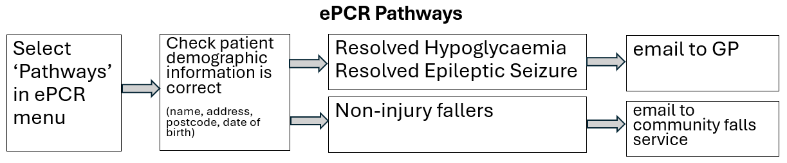
Figure1.1: WAST ePCR Pathways
The new function replaced the previous process of the paramedic phoning a dedicated number to pass information verbally to a WAST team responsible for submitting the referral via email to the falls service. The aim of the new pathways system is for on-scene clinicians to be able to submit referrals directly. The intended benefit was to make the referral process more efficient and increase the number of appropriate referrals, defined as those referrals meeting referral criteria and directed to the correct team (WAST ePCR Provider, 2023).
The wider context of the project is the aging population of Wales, with an associated higher risk of falls (NHS Wales Executive, 2024). There is a national health care focus on falls prevention, as a history of a previous fall is a significant predictor of falling in the elderly. The Welsh Government have published a national framework for community-based falls response (NHS Wales Executive, 2024) as part of the Six Goals for Urgent and Emergency Care (Welsh Government, 2022). Figure 1.2 shows a summary of the goals (NHS Wales, 2024).
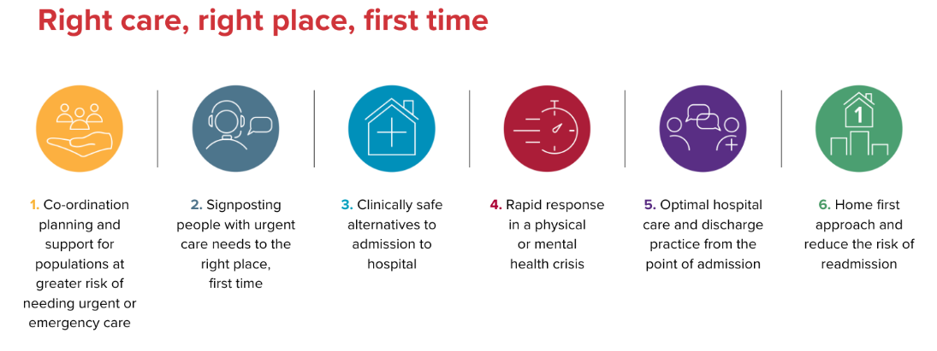
Figure 1.2: Six Goals for Urgent and Emergency Care (NHS Wales, 2024)
Goal 3 relates to the reduction of avoidable conveyance to hospital, a priority reflected in the NHS Wales National Community-Based Falls Response Framework for Wales (NHS Wales Executive, 2024) which aims to develop the provision of community-based falls response services, to provide care at home where possible, reducing the need for hospital attendance and admission. A key aim is to increase the number of referrals to community falls prevention teams. Preventing future falls reduces pressure on the ambulance service to respond, reduces hospital attendance, and therefore reduces pressure on the wider health system. Across emergency services, it is currently a key aim to reduce unnecessary conveyances to hospital, to increase efficiency and make best use of limited resources (Paulin et al., 2025).
The national framework recognises the need to overhaul the types of response to older fallers, that is patients aged 65 and over who have experienced a fall either at home or in the community (NHS Wales Executive, 2024). An emergency ambulance may not always be required and by sending a different type of response, it means that more emergency ambulances will be available for life-threatening emergencies.
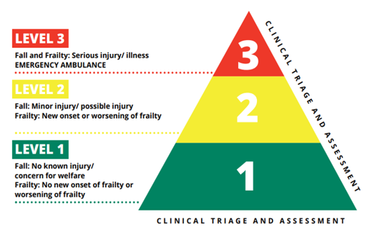
Conditional prioritisation - A paradox of the current type of response is that an older person who has suffered a fall may initially be a low priority for an emergency ambulance, for example if they have no obvious injuries. However, their condition may deteriorate to the extent that they become an emergency if they are lying on the floor for a long period of time. A ‘long lie’ is defined as when a person falls and spends over 1 to 2 hours on the floor because they are unable to get up (Public Services Ombudsman for Wales, 2025). Therefore, there is a need to increase alternative responses instead of an emergency ambulance. This may be a volunteer responder (‘Level 1 falls response’), or a specialist falls car crewed by a paramedic and occupational therapist or physiotherapist (‘Level 2 falls response). Level 1 and 2 responders may be able to treat the patient at scene without the need for an emergency ambulance, which is a ‘Level 3’ response (Welsh Ambulance Services University NHS Trust, 2025a). The three levels of falls responses are shown in Figure 1.3. The ePCR is currently only available to Level 2 and Level 3 responders.
Figure 1.3: Falls and Frailty Response Model (Welsh Ambulance Services University NHS Trust, 2025a)
One of the principles underlying the project is the ‘Making Every Contact Count’ (MECC) approach that encourages heath and care staff to use all interactions with patients to talk about their health or wellbeing (NHS England, 2020).
This principle aligns with a central strategic aim of WAST to provide patients with the ‘right care and advice, in the right place, every time by delivering quality driven, clinically led and value focussed services’ (Welsh Ambulance Services University NHS Trust, 2024b).
  - Description of the ePCR falls pathway referral function
The WAST ePCR is an application used on the WAST-issue iPad, issued to all members of the emergency medical services (EMS) workforce, including paramedics, emergency medical technicians (EMTs) and emergency ambulance practitioners (EAPs). A pathways referral system was added to the ePCR application on 10th June 2024 (Welsh Ambulance Services University NHS Trust, 2024a).
The previous process for making a falls referral, once the patient was deemed suitable for referral by following the pathway criteria and given their consent, was (Welsh Ambulance Services NHS Trust, 2016):
- Ambulance clinician phoned a dedicated 0300 telephone number to the WAST Alternative Care Pathways Co-ordination Point.
- Co-ordination Agent takes patient basic address details and confirms provision of pathway in area.
- Co-ordination Agent opens the Alternative Care Pathway (ACP) database and asked clinician over the phone for details to complete data fields e.g. clinical observations, answers to falls questionnaire.
- Co-ordination Agent completed documentation and sent patient details on system-generated PDF attached to manually created email to the relevant falls team. Agent followed up the referral on the telephone to confirm receipt.
- Co-ordination Agent closed episode of care on ACP database.

The ePCR pathways system is an application programming interface (API). The basic steps in the ePCR referral process are as follows (WAST ePCR Provider, 2023):

- Ambulance clinician selects appropriate Pathway for the patient’s condition from the options, including EMS Falls Pathway, EMS Resolved Epileptic Seizure Pathway, and EMS Resolved Hypoglycaemia Pathway.
- Clinician selects the appropriate Pathway Referral Centre (e.g. falls service) and completes the necessary form with patient details, using information gathered from the ePCR and any other relevant details from the patient. The form will be auto populated from the ePCR where possible.
- Referral sent directly to falls service from ePCR by an automated email with a system-generated PDF attached containing referral details.
- Falls service Accept or Reject the referral using voting buttons in the email.
As well as the ePCR iPad application, the ePCR system comprises a portal which can be accessed on desktop computers. The portal stores completed ePCRs, together with an audit trail of users and timestamps. The portal also includes a Pathways section which includes the functionality to create, view, modify and complete referrals. This functionality is limited to licence-holders.
  - Problem statement - rationale for the study
A falls referral pathway already existed, following previous stakeholder engagement with falls services, last updated in November 2022 (Welsh Ambulance Services University NHS Trust, 2022a). However, there is limited empirical evidence on its utilisation, effectiveness, and data quality within WAST. The introduction in June 2024 of the ePCR falls referral system presents an opportunity to generate measurable data on referral activity. However, the extent to which this digital function has influenced referral numbers, user experience, and the rate of acceptance by falls services, remains unexplored. This study seeks to address this knowledge gap by systematically evaluating referral patterns and user perspectives since the implementation of the ePCR pathway. The study will identify referral activity both before and after the implementation of the ePCR falls pathway as a comparison.
This study addresses the lack of evidence on how the digital falls referral process (the intervention) influences referral frequency and appropriateness (the outcome), and its potential role in preventing future falls, thereby potentially easing demand on healthcare services.
While the implementation of a digital system is sometimes seen as being ‘the solution’ to a problem, there is a need to evaluate its use in practice, to evaluate whether it is being used as anticipated, and to evaluate whether anticipated benefits have been realised.
Anecdotally, there has been a perceived problem of ‘massive’ under-utilisation of the falls referral pathway for older people who have been seen by WAST (Welsh Ambulance Services University NHS Trust, 2023). This perception was not previously easy to measure, due to a lack of reportable information. However, since the introduction of the WAST ePCR across Wales in April 2022, and especially since the introduction of the pathways referral system within ePCR in June 2024, there is an increased potential to report on falls referrals. Therefore, there is now scope to evaluate whether falls referrals are at an ‘acceptable’ level and to evaluate the impact of the ePCR referral function. Figure 1.4 shows a rich picture of the previous process and potential benefits of a fully digital solution.

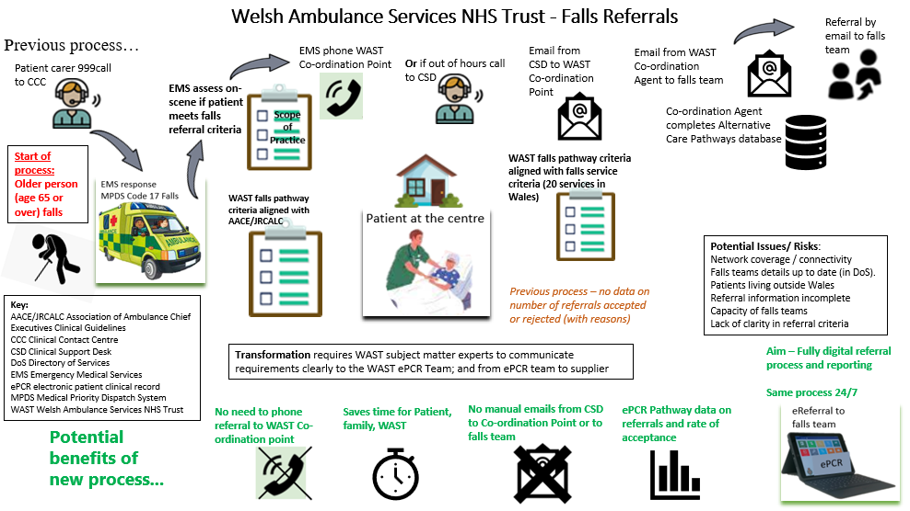
Figure 1.4: WAST falls referrals rich picture – ‘As Is’ and potential benefits of new process

  - Anticipated benefits of ePCR
One of the broader drivers of the project is to evaluate the impact of ePCR, especially in relation to the increased use of referrals for patients to improve their overall care and reduce hospital admission. The ePCR project initiation document set out the ePCR investment objectives and end benefits (Welsh Ambulance Services University NHS Trust, 2021), which still inform WAST’s strategy and aim to better use technology to improve and transform patient ambulance care to ease pressure on the wider health system, as shown in Table 1.1.
Table 1.1: WAST ePCR objectives and anticipated end benefits
ePCR investment objective | Anticipated end benefits
To use better data and access to information to improve the quality of patient care | - Access to patient information prior to their arrival at scene.  - Ability for crews to attend with an understanding of a patient’s medical history to make better informed clinical decisions.  - Capability to improve clinical skills through tracking of care episodes
To increase data sharing in a collaborative whole system approach to health and care provision | - Improved continuity of individual’s care between providers  - Linked data supporting National Digital Strategy (NDR) in a once for Wales approach  - Improved capability to support pandemic response  - Improved collaboration between health & care providers
To improve efficiency using high quality data to reduce waste | - Reduced conveyance to emergency departments  - Increased referrals to appropriate local services (Care closer to home).  - Certain clinical referrals can be made through the system, reducing reliance on phone calls [NB: function added in June 2024].
To increase the value of our clinical data through quality and timeliness | - Improved Ambulance Service Indicator (ASI) reporting  - Improved timeliness of clinical data  - Improved quality of clinical data

An aspect of the ePCR that has had a positive impact on referrals, even prior to the ePCR referral function being added, is the facility to view previous ePCRs relating to the same patient once patient identity has been verified via a link to the Welsh Demographic Service (WDS). This confirmation of patient demographics is attempted for every ePCR and is a prerequisite for using the ePCR Pathways function. This enables the ePCR to be populated with the patient’s NHS number and allows the record to be shared with the Welsh Care Records Service (WCRS), a national clinical document repository which can be accessed by users of the Welsh Clinical Portal (WCP). An example of the benefit of viewing previous ePCRs is the ability to see earlier Clinical Frailty Scale (CFS) scores. This can help the current crew to know what is normal for the patient, and if a falls pathway referral is applicable.
  - Project aims and objectives
The overall aim of this study is to evaluate the impact of the ePCR falls referral function on referral practice within WAST. The specific objectives are to measure referral volume and referral rate before and after implementation, examine referral outcomes including acceptance and rejection, explore clinician experience of using the function, and identify related factors that may influence referral activity.
The research question is:
What impact has the implementation of the ePCR falls pathway referral function had on the number and appropriateness of referrals made to community falls services in Wales?
The research objectives of the project can be separated into operational and experiential objectives:
- Operational:
  - Quantify the falls referrals made by WAST clinicians following attendance to older adults who have experienced a fall (numeric and rate of referrals as a percentage of older fallers discharged at scene).
  - Analyse the outcomes of these referrals, including acceptance, rejection, and time-out rates, and identify the reasons for rejection.
- Experiential:
  - Explore clinicians’ experiences and perceptions of using the electronic Patient Care Record (ePCR) falls referral function.
  - Examine the clinical decision-making processes that inform paramedics’ decisions to initiate a referral, and alignment with pathway guidance.
Numbers of referrals by on-scene ambulance clinicians are the main measure in this study of the impact of the digital intervention. The referral rate will also be measured. A challenge in seeking to measure the referral rate is to clearly define the denominator to be used. In this study this is defined as the number of falls referrals made divided by the number of patients aged 65 years and over attended by WAST following a fall and discharged at scene within the same period.
In this study, referral appropriateness is defined primarily by whether the referral was accepted by the receiving falls service. Factors contributing to appropriateness may relate to process, whether the referral met stated pathway criteria and was sent to the correct team; and information, meaning whether the referral contained sufficient information for the receiving service to act on.
The project considers other factors, or confounding variables, which may affect the numbers of referrals, apart from the digital intervention itself. For example, seasonal variations in the number of falls attended, operational pressures, connectivity issues, and any changes in falls referral criteria, by WAST or the receiving services.
The project will support WAST with meeting its obligations to report performance defined measurement and metrics set out in the National Community Based Falls Response Framework for Wales. The framework specifically involves the monitoring of the number of referrals to community falls services from WAST, and rate of acceptance (NHS Wales, 2024).
  - Project scope
The project focuses on a cohort of patients who have had a fall and are attended by a WAST ambulance but do not require conveyance to hospital. These are patients aged 65 years or older, sometimes known as ‘non-injury fallers’.
The project includes WAST data from September 2022 to March 2026. These are from two data sources, the previously existing system, still in use, the Alternative Care Pathways (ACP) database and the ePCR Pathways referral data, available from June 2024, with the aim of showing the impact of the implementation of the ePCR Pathways function.
The before and after comparison will distinguish clearly between the legacy referral process recorded in ACP and the digital ePCR pathway process. For comparative analysis, the pre implementation period will be defined as September 2022 to May 2024, and the post implementation period as July 2024 to March 2026. June 2024 is the transition month. Where data field names differ between systems, this will be identified and only comparable variables will be used for direct comparison. Any measures available only in the post implementation period will be identified.
The scope of this study does not include the development and testing of the ePCR Pathways function. Certain aspects related to falls are outside the project scope. Older fallers attended solely by St John’s Cymru, who are contracted by WAST to provide a ‘Level 1’ falls response are not included as St John’s Cymru staff do not currently have access to the WAST ePCR. Survey questionnaires were not sent to patients or carers due to ethical issues and to community falls services due to operational and time constraints. The project does not seek to measure the clinical effectiveness of the interventions by community falls services. For example, the project does not record patient outcomes following referral (e.g. re-contact with 111 or 999, further recorded falls, hospital conveyance or admission, or death). It was not possible to explore patient experience and feedback in relation to the WAST falls referral process due to lack of access to data. Patient-reported outcomes following referral to falls services, and how patients feel about ambulance responders using tools and pathways to support the provision of care has been recognised by Gunson et al as a gap in the wider evidence in a recent systematic review (Gunson et al., 2025).

- Literature review
- Search strategy
Underpinning the project research question, (What impact has the implementation of the ePCR falls pathway referral function had on the number and appropriateness of referrals made to community falls services in Wales?), is the assumption that referrals are desirable and beneficial in terms of falls prevention. The literature search strategy aims to seek evidence for this underlying assumption, and evidence relating to the criteria and decision to make a referral. Literature was also sought to provide evidence of the benefits or otherwise of different modes of referral including digital referral processes. Referral processes in the literature could be in relation to falls or other conditions. General searches were carried out in Google Scholar which due to high numbers of results were focussed by search terms in other databases. The databases used were PubMed and the UWTSD Library. The search function was also used in the Mendeley referencing tool. Table 2.1 shows the focussed search results.

Table 2.1: Literature review search results
Date and Database | Search terms | Number of papers identified
14/1/2026 PubMed | “Ambulance” OR “paramedic” AND  “EPR” OR “EHR” OR “digital” OR “electronic” AND  “referral” OR “pathway” OR “fall” OR “falls”  [Title/Abstract, Date range from 2010] | 80
14/1/2026 UWTSD | “Ambulance” OR “paramedic” AND  “fall” OR “falls” AND  “referral” OR “pathway” OR “pathways” OR “community”  [Any field, Date range from 2010] | 16
11/3/26  PubMed | “Ambulance” OR “EMS” OR “paramedic”  AND  “referral” OR “pathway”  AND  “electronic” OR “digital”  [Title/Abstract, from 2015] | 55
Total |  | 151

  - Selection process
The literature search results were screened, with some articles excluded as obviously not relevant from the title. Others were excluded as duplicates of previous search results or following scrutiny of the abstract for relevance to the research question. Articles over 10 years old were excluded as being outdated. Some additional articles were found from citations in the relevant articles. This is known as snowballing (Wohlin et al., 2022).
Following the process described above, 12 articles were included. These can be categorised as in Table 2.2. The article dates ranged from 2017 to 2025.

Table 2.2: Categories of included literature
Literature category | Country | Number
Systematic review | UK, USA, Australia | 3
Cluster randomised trial | UK | 1
Randomised controlled trial | Australia | 1
Retrospective cohort study | UK (Northern Ireland) | 1
Cluster randomised trial and systematic review | UK | 1
Survey | UK, Canada | 2
Delphi study | Australia | 1
Programme review | France | 1
Retrospective single centre study | Germany | 1
Total |  | 12

  - PRISMA diagram
The PRISMA diagram shown in Figure 2.1 summarises the staged identification, screening, eligibility assessment, and inclusion of literature sources. The final set of included studies was small but relevant to the research question, with the strongest representation in studies examining falls referral pathways, digital communication, and paramedic decision making.
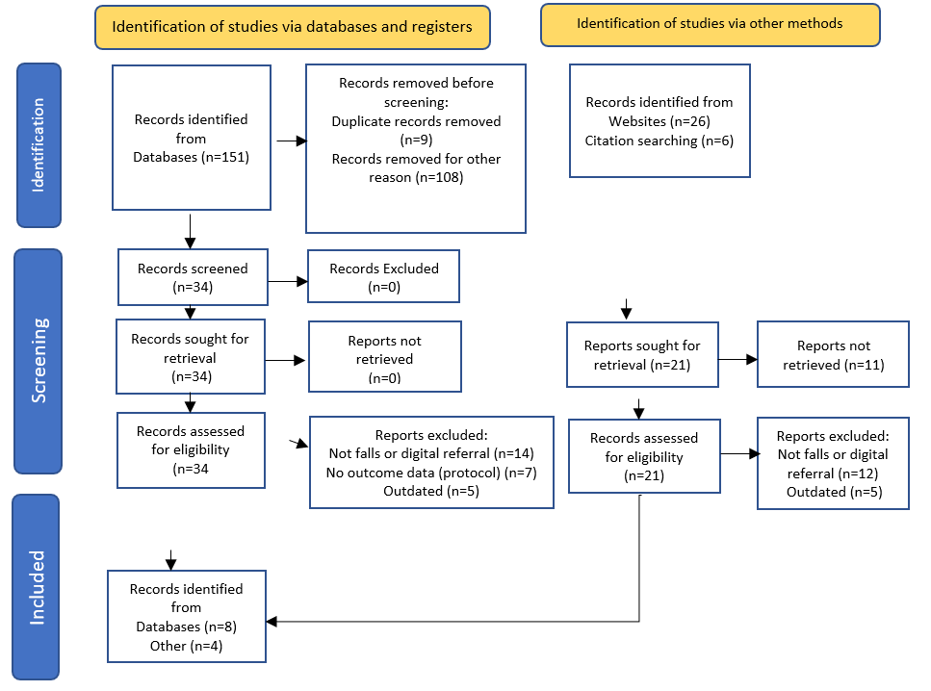
Figure 2.1: PRISMA diagram

  - Literature findings
The selected literature was critically reviewed to identify relevant findings and evidence relating to the research question.
  - The benefit of referrals to falls prevention services
Mikolaizak et al (2016) conducted a randomised controlled trial in one ambulance service in Australia with older fallers not transported to ED. The intervention group received input where appropriate from existing services including physiotherapy, OT, eye care, and medicines management. Patients in the control group received fall prevention advice. Strengths of the study were the direct involvement of paramedics in identifying and referring eligible patients, and the timeliness of interventions. Limitations were patients declining the interventions due to feeling either too fit or too frail, suggesting a possible bias towards patients who are interested in the intervention. Also, self-reporting of the main outcome measure, falls, could result in possible bias due to subsequent falls being under-reported. The study found that the multidisciplinary intervention did not prevent future falls, however future falls and related health service use may be reduced with higher adherence with recommended interventions e.g. home exercise therapy (Mikolaizak et al., 2016). The study provides support for the potential benefit of referral by ambulance services to a falls prevention service, subject to patient engagement.
A cluster randomised trial, Support and Assessment for Fall Emergency Referrals (SAFER 2) was published by Snooks et al (2017). The trial was carried out in three UK ambulance services, including patients aged 65 and over after an emergency call for a fall, attended by paramedics. It compared outcomes between patients who paramedics could refer to a community-based falls service instead of transporting to ED (the intervention group), and patients receiving care as usual (the control group). The paramedics in the control group received a clinical protocol with referral pathway, training and support to change practice. The results compared the outcome in terms of subsequent emergency contacts or death within 1 and 6 months. 8% of patients in the intervention group were referred without ED transport, which gives a potential comparison with current WAST referral rates. The primary outcome (death or repeated emergency care at 1 or 6 months) was not different between the two groups. However, the intervention patients had greater satisfaction with care, and in the first month were less likely to call an ambulance. The trial found that the referral pathway was safe for patients, with some benefit in reducing emergency ambulance usage. A relevant observation by the authors is that it was not possible to state what an appropriate referral rate would be. A limitation of the study is that approximately half of eligible paramedics were recruited, which may indicate a bias towards those more enthusiastic about changing practice than others, possibly limiting the general application of findings (Snooks et al., 2017; Snooks et al., 2017).
Scott (2020) carried out a retrospective cohort study from July to September 2017 in the Northern Ireland Ambulance Service (NIAS), to investigate re-contact rates of older fallers (aged 65 and above) who were referred to a falls prevention service by paramedics following new pathways. This is a clearly written study with well-defined findings and limitations. The referral rate was 7% of older fallers attended by a paramedic for a fall, which provides a possible comparison for WAST rates. There is however no information on the rate of acceptance of referrals by the receiving falls services. NIAS paramedics used a referral protocol to determine if patients met the referral criteria. Paramedics made referrals by telephone to an Emergency Medical Dispatcher (EMD), who would complete an online form and email to the relevant falls team. This process is similar to the previous WAST mode of referral prior to the launch of the ePCR pathways system. The study notes that the planned implementation of electronic patient report form (PRF) and remote access to patient records could potentially improve decision-making, documentation and care (Scott, 2020). This resonates with WAST’s anticipated benefits of implementing ePCR. The conclusions that can be drawn from this study are limited by low participant numbers and as there was no control group. However, alongside existing literature it provides an indication of the potential effectiveness of a falls referral pathway.
A systematic review by Bonner, Capsey and Batey (2021) concluded that referral to community falls services is beneficial in terms of falls prevention (Bonner, Capsey and Batey, 2021). The review is limited in that it only identified three primary research studies, one from 2010, two from 2017. The search methods did not include the PubMed database. The study results were mixed and not all statistically significant in terms of the decrease in subsequent falls, and in calls to the emergency services. There was however a positive effect shown consistently on patients’ sense of well-being and independence in carrying out daily activities (i.e. eating, washing, toileting, moving around safely). It was concluded that the studies demonstrated that referrals were beneficial in reducing unwarranted conveyance to hospital. The studies did not consider the mode of referral, and were carried out (2010, 2017) prior to the widespread use of electronic patient clinical records (ePCR) by UK ambulance services. By 2018 there were 7/13 services using ePCR (Porter et al., 2018) [see also Figure 5.2].
A systematic review by Friend et al (2024) analysed 35 studies reporting on the outcomes of EMS fall prevention interventions. These interventions reduced attendance at ED, and subsequent falls (Friend et al., 2024). There were also improvements in patients’ health-related quality of life and independence in activities of daily living. Friend et al identified four types of intervention strategy: interventions in group settings (e.g. residential care homes); interventions delivered at scene by EMS or EMS with other trained professionals e.g. occupational therapist (OT) or physiotherapist (this is equivalent to WAST’s Level 2 falls response service); intervention by EMS following discharge home from hospital (this is not an intervention currently delivered by WAST); finally, referral or intervention/ education only. This last intervention is deemed by Friend et al to be least effective. However, the relevant references include studies which did find benefits of referrals, e.g. Logan, et al 2010, Snooks et al 2017, Scott, 2020. This highlights the need, when attempting to measure the benefits and outcomes of referrals, to be very clear on the type and purpose of referral, and whether indeed the referral is followed through into a meaningful intervention, which could be indicated by referral acceptance by the falls service. The randomised controlled trial by Logan et al concluded that community falls prevention referral did reduce the rate of subsequent falls in four primary care trusts in England. The study included adults aged 60 and over who had fallen and were attended by an emergency ambulance but not taken to hospital, a group at high risk of falling again. The study was significant as at that time older fallers not taken to hospital by ambulance were unlikely to be routinely referred for falls prevention interventions (Logan et al., 2010). The Falls in Older Adults guideline including guidance on referrals was introduced into UK ambulance clinical guidelines in September 2017 (JRCALC Senior Editor, 2026).
Aïdoud et al (2025) collected data and reviewed the ‘Raise’Age’ programme in France, a home-based fall-prevention initiative. The programme recognises the shift underway in the EMS system towards preventative care, and the important role that EMS clinicians can play in proactively identifying older adults who require ‘lift-assistance’ but do not need to go to hospital, and who would benefit from proactive prevention measures. Where appropriate, such patients were referred to a mobile geriatric team or primary care physician. The review highlights the role of education and training for ambulance staff on fall risks and potential complications such as long lies. Paramedics contributed to the screening protocols completed prior to referral. The success of the programme relies on effective strategic partnership and collaboration between all the healthcare providers involved. Data-driven decision making was seen as vital, to make the most efficient use of available resources (Aïdoud et al., 2025).
A recent systematic review of ambulance responses to older adults who have fallen has been carried out by Gunson, et al, 2025. This related to all fallers, not just non-injury fallers, or those not taken to hospital. The review found that where fall response or referral schemes exist, they have improved outcomes for patients. The review identified a need for further research to increase understanding and to improve prehospital care for this increasing population. The review found that patient care would be improved by a reduction in inappropriate hospital conveyance and increased specialist fall service referrals, supported by pathway availability, training and decision-support (Gunson et al., 2025). These findings support the rationale for the current study.
  - Modes of referral including digital processes
A survey conducted by Barret et al (2021) explored ambulance clinicians’ perceptions of recording and communicating patient information electronically in one UK ambulance service. The service uses ePCR to record the face-to-face patient clinical care and a separate Intelligence Based Information System (IBIS), a database of patient care plans which allows clinicians to electronically refer patients to one of 12 community falls teams, and to diabetic teams. IBIS is also used to send a record of the episode of care to GPs for information. The survey focussed on the use of IBIS by ambulance clinicians of all grades. There was an unsuccessful attempt to collect comparative data from the teams’ receiving referrals. The referral function was installed on iPads in November 2017, prior to that date the clinician would telephone the emergency operations centre and pass a referral to the relevant team. Most staff agreed that that due to the electronic referral function being available, more patients would be referred. Most users felt that using the function was time-efficient, that it enabled collaborative working with falls teams, and that it provided better protection for patient confidential information than making a referral over the telephone. Being able to make electronic referrals without having to telephone a number and wait for an answer may reduce the time on scene with those patients and have an indirect effect on response times to subsequent incidents and mean more efficient use of ambulance resources (Barrett et al., 2021).
Liu et al (2021) surveyed paramedics and interviewed patients on their experiences of using a direct electronic referral programme following a hypoglycaemic episode which required paramedic attendance in Canada. The study was undertaken to explore reasons for low referral rates by paramedics and acceptance by patients, even though paramedics and patients thought the referral programme was beneficial. In April 2016 a direct electronic referral programme was integrated into the electronic ambulance call record system. This was designed with input from multiple stakeholders. A referral email was sent in real-time to a diabetes education centre, who would then telephone patients to arrange an education session. Two paramedics noted that technical or process issues with the direct electronic referral programme may have impeded them from referring patients. One paramedic stated,
"Sometimes difficult to get patients enrolled because it was an afterthought. An automatic pop-up section would have been a good reminder. Frequently paperwork is finished after transfer of patient care, therefore tedious to go back."
(Liu et al., 2021).
The value of study findings may be limited by the low numbers of participants (34 paramedics and 14 patients). Despite the possible limitations, the study highlights certain features relevant to the WAST ePCR falls pathway, such as the importance of involving stakeholders in pathway design, and of the education provided to paramedics on offering a referral. Education should be clear and easy to understand, so it is more likely to be applied in practice in the pre-hospital environment. Also, it demonstrates where the ePCR user interface may affect the ease or otherwise of making a referral which is very relevant to WAST.
Delardes et al (2022) published a delphi study relating to the development of an electronic referral proforma from paramedics to GPs for patients who were seen but not taken to hospital. The study may be limited as it had only 21 participants, however the authors felt this was sufficient for a study of this type. The study supports the use of e-referral by paramedics as it did not unreasonably affect their workflow or workload. The study includes discussion of how e-referral would be perceived by GPs before being implemented. This insight is relevant to consider in terms of what prior communication was carried out with community falls services prior to implementation of the WAST ePCR falls referral system. As paramedics move into more of a community healthcare role, the study provides evidence for the need for and importance of digital communication between the ambulance service and other healthcare providers in the community to be well designed to be efficient and effective for all stakeholders. This will support informational continuity of care which is essential to providing safe and effective healthcare (Delardes et al., 2022).
A study by Faul et al (2025), related to pre-hospital trauma assessment in Germany, contains the transferable observation of the potential gap between digital referral systems and the reality and complexity of patient care. It highlights the need for ongoing alignment between clinical guidelines and the digital referral system (Faul et al., 2025). This learning can be applied to falls referral criteria aligning with the ePCR pathways system.
  - Literature summary and key themes
This dissertation does not test the clinical effectiveness of falls prevention services themselves. Rather, it evaluates whether a digital referral mechanism improves the process of identifying, recording, and transmitting referrals to those services. The wider literature on falls prevention is therefore used to justify why referral matters, while the study itself focuses on referral process, data quality, and system use.
There are key themes emerging from the selected literature which are relevant in relation to WAST. The studies provide evidence for the benefits of a falls referral. Two studies provide the potential for comparison of referral rates for older fallers seen by paramedics but not conveyed to hospital (Snooks, et al 2017 and Scott, 2020), with the caveat of different settings and denominators. Barret et al (2021) identified that paramedics perceived that the availability of an electronic referral process would lead to more referrals being made.
Studies have identified the importance of effective collaboration and communication with health care partners, for example to ensure the suitability of patients to meet the criteria for referrals to falls services. Two studies (Liu et al, 2021, and Delardes et al, 2022) identified the involvement of stakeholders in the design of the electronic referral system, and implied that such involvement would contribute to the effective operation of the referral process. The need for specific training and education for ambulance clinicians on the referral pathway criteria, and the referral system has also been highlighted (Aïdoud et al, 2025, Gunson et al, 2025).
The ePCR user interface and usability by ambulance clinicians may also influence the efficient and effective use of the referral function in practice. A pop-up reminder suggested by one respondent quoted in Liu et al (2021), is resonant of the WAST ePCR ‘nudge’ facility which could potentially be used to identify in real-time if a patient is potentially suitable for a referral based on data entered in the ePCR. Such a facility would be dependent on on-going alignment between clinical guidelines and the digital referral system, an issue identified by Faul et al (2025).
The included literature was all published within the last ten years, so is relatively recent in terms of its relevance to the digital environment of health care settings including ambulance services, although it is recognised that health care is a complex and dynamic environment, and change including digital change, is constant. The literature was from several different countries, so represents evidence from different health care systems, not only the UK.
The key themes identified, and gaps, in the evidence reviewed will be explored in relation to the results of this project. Taken together, the literature suggests that referral pathways for older fallers can be safe, acceptable, and potentially beneficial, particularly where they reduce avoidable conveyance and support access to community interventions. However, the evidence base is mixed regarding the magnitude of effect on future falls and service use. There is also limited evidence on digital referral workflow, informational quality of referrals, and receiving service acceptance of ambulance generated referrals. These gaps are directly relevant to the present study, which evaluates a real-world digital referral function within one ambulance service and considers both system performance and user experience.

- Research methodology
  - Data collection methods
The project is an evaluation of a falls referral function in the WAST ePCR. Evaluation is a vital aspect of any quality improvement initiative (The Health Foundation, 2015). This includes digital transformation, which is seeking to improve an existing process and ultimately contribute to better outcomes for patients.
It has been clearly argued in health informatics literature that the socio-technical nature of health information systems underpins the value of mixed methods research to provide a full, holistic investigation and evaluation (Scott P.J., 2016). Therefore, the successful completion of this research project depends on the appropriate collection and analysis of both quantitative and qualitative health care data.
This study adopts a convergent mixed methods design. Quantitative service data are used to examine referral activity, acceptance outcomes, and changes over time before and after implementation of the digital referral function. Qualitative survey data are used in parallel to explore clinicians’ experiences of using the system and to help interpret observed patterns in referral behaviour. The integration of both strands allows technical performance and human use of the intervention to be considered together.
All data collected was analysed and interpreted to ascertain what can be inferred or deduced in relation to the research question and objectives, with appropriate caveats (limitations) stated, to provide a thorough understanding of the impact of the ePCR falls referral function on referral practices within WAST.
  - Quantitative data
Quantitative data was collected from the WAST data warehouse, comprising Alternative Care Pathways (ACP) data, ePCR Pathways data and ambulance incident data from the WAST Computer Aided Dispatch (CAD) system. These data include the numbers of older adult fallers attended by paramedics; the number of referrals made to community falls services and corresponding rates of acceptance, rejection or time-out. Organisational data was not sampled, as all relevant available data is included in results.
The quantitative data collected includes:
- Numbers of older fallers (aged 65 and over) attended by WAST and discharged at scene over a defined time period (before and after implementation of the ePCR referral function), to enable calculation of referral rates
- Numbers and rate of referrals made to community falls teams by on-scene clinicians before and after implementation of the ePCR referral function
- Numbers of ePCR referrals accepted / rejected / timed out (if not accepted or rejected 96 hours after referral made)
- Analysis of reasons for referral rejection
Quantitative data was sense-checked to ensure that all data fields are meaningful. Data cleansing was undertaken as necessary prior to analysis to address duplicate, missing or inconsistent entries, to ensure data quality and completeness. Data was analysed in an Excel spreadsheet using pivot charts to identify any trends or patterns in the number, rate, and appropriateness (e.g. acceptance-rate) of referrals.
It has only been possible to measure the appropriateness of ePCR referrals. The rate of acceptance is not recorded in the pre-intervention, ACP process.
Quantitative results are used to support the evaluation of the ePCR falls pathway referral function using descriptive statistics only. Comparisons between pre and post implementation periods will be made using appropriate measures. The purpose is not to infer causality with certainty, but to identify meaningful change associated with implementation of the digital referral function.
  - Qualitative data
New qualitative data has been collected through a Microsoft (MS) Forms survey of WAST ambulance clinicians, exploring their perceptions and experiences of using the ePCR automated falls referral system. The survey incorporated both closed and open-ended questions. 59 responses were received and analysed. The participant information, survey questions and a poster used to advertise the survey are included at Appendix 1.
The MS Forms survey was designed to gain as much information and views as possible, without using leading questions. The survey questions were developed in liaison with the WAST Clinical Lead for Falls. A pilot survey was sent to a small number of staff to test. Following feedback the survey was amended, to clarify some questions and avoid topic overlap. A mix of questions was used, including some free-text fields to allow input of views or ideas in relation to the ePCR referral function.
Non-probability purposive volunteer sampling was used for the survey. A link to the MS Forms survey was sent in an email to Senior Paramedics with a request to forward the invitation to their teams, which comprise the vast majority of the EMS clinical workforce. The survey was also emailed to Advanced Paramedic Practitioners, and posters with a QR code link were placed in training rooms and one ambulance station. The invitations to the survey were addressed to users of the ePCR EMS Falls Pathway.
The survey was open from 19 November 2025 to 31 January 2026. During this period there were no changes to the ePCR referral system or to the criteria for making referrals (Welsh Ambulance Services University NHS Trust, 2022b). Therefore, there was no change to the user experience during the study period.
Respondents were invited to participate in follow-up discussion, semi-structured interviews to provide more detailed insight, and exploration of emerging themes, however no respondents took up this offer.
The qualitative survey data set was analysed using MS Forms and MS Excel. The project sought to identify themes arising from the original qualitative research, using the reflexive thematic analysis approach informed by Braun and Clarke. (Braun and Clarke, 2006). Initial familiarisation was followed by coding of all relevant free text responses, grouping of related codes, and development of themes that addressed clinicians’ experiences of usability, barriers, decision-making, and perceived value of the digital referral function. The data set was analysed and labelled using the inductive approach to identify any patterns, concepts, and recurring key themes. Descriptive codes (labels) were added in Excel based on the recorded data to enable filtering and measurement of the prevalence of each theme. Themes and relevant sub-themes were identified in relation to the research question. Suitable examples from survey responses were selected to illustrate each theme.
As no follow up interviews were obtained, the qualitative research strand provides some breadth of user perspective rather than deep interpretive accounts, and findings are presented accordingly.
  - Limitations
It is important to consider the reliability and accuracy of data that is already available or newly collected. There are caveats (limitations) to all data that is presented in support of the research question. These are required to explain factors the reader should be aware of which may affect the results, and therefore the interpretation and conclusions which may be drawn from the data.
The completeness of quantitative data derived from the WAST ePCR system is dependent on:
  - Staff involved in the patient episode completing an ePCR fully and in the relevant sections (e.g. the Falls in Older Adults section), and rather than a paper PCR
  - Correct closure of the ePCR episode of care and tablet synchronisation with servers
- The absence of network issues, including connection to supplier’s servers at the time of ePCR completion
Caution should be exercised in interpreting results where numbers are low.
The limitations of the qualitative survey data may be related to the availability and willingness of ambulance clinicians to complete the MS Forms survey. There is the possibility of bias in survey completion due to the nature of survey distribution (i.e., via email, staff intranet news item). It may only be a certain group of ambulance clinicians who regularly access their work email or the staff intranet and respond to survey requests. Survey completion could also be influenced by varying enthusiasm of Senior Paramedics in forwarding to their teams and encouraging completion.
Some limitations may affect both qualitative and quantitative data. When comparing data before and after the implementation of the ePCR referral system, external trends were considered which may affect the data analysis and interpretation, for example, seasonal pressures on the ambulance service.
Factors affecting WAST data could be changes in the falls response service provided, which will affect the types of response sent to older fallers. For example, certain services may be available in some areas and not others, or at different times of the day, or new services being introduced, could also affect referral rates. Currently, WAST is undertaking Clinical Model Transformation (CMT) which is changing the way that patients are clinically assessed when they call 999 for an ambulance. Depending on the severity of their condition, this may result in changes in the way that patients are treated, for example they may be assessed as being suitable for remote care rather than face to face (Taylor, 2026).
Potential confounding influences, including seasonal variation, operational pressure, service availability, and changes to referral criteria or response models, were considered alongside referral trends where relevant data are available. These variables are identified to support cautious interpretation of observed changes rather than to construct a formal causal model. The study therefore evaluates service change in context, rather than attributing all observed differences solely to the digital intervention.
The digital referral function is intended to support wider system goals of falls prevention, avoidance of unnecessary conveyance, and care closer to home. However, this study evaluates referral process and user experience rather than downstream patient outcomes, and conclusions will therefore be limited to process level impact.
  - Ethical and information governance considerations
To avoid avoidable harm to UWTSD and WAST staff, students and patients, appropriate ethical and information governance principles and procedures were followed. The project Ethics Form is included at Appendix 3.
The project used routinely collected organisational data and an anonymous staff survey. Quantitative data were extracted in de identified form for analysis, with patient identifiers excluded and staff identifiers not used in analysis. Survey participation was voluntary, anonymous, and based on participant information provided at the start of the survey. Data were stored securely on WAST systems and accessed only by the researcher. As the study evaluated an existing service process rather than intervening in patient care, the main ethical considerations concerned confidentiality, data minimisation, and protection of staff anonymity.

- Results
  - Data sources and presentation of results
This chapter will present the study findings in several linked parts. Quantitative findings are presented on falls referral numbers, rate and appropriateness. These include findings in relation to the anticipated impact on the reduced use of the previous process. Qualitative findings on clinician experience and decision making are then presented. These strands are brought together in the discussion chapter to evaluate the practical impact of the digital referral function within its operational context.
There are two sources of organisational quantitative data in relation to referrals to community falls services. The referrals made via the previously existing process are recorded in the Alternative Care Pathways (ACP) database. ePCR Pathways referrals are recorded in the ePCR data warehouse. The denominator data to calculate referral rate was from the WAST EMS Computer Aided Dispatch (CAD) system. The main source of qualitative data is the user survey conducted on MS Forms.
  - Referral numbers
Prior to the ePCR Pathways, all falls referrals were recorded in the ACP database. There are three types of falls referrals in this system. ‘EMS Falls’, where the WAST Co-ordination Agent has taken a referral telephone call direct from the EMS crew on scene. ‘CD Falls’ are those referrals made by the Clinical Desk / Clinical Support Desk; these include referral calls taken from on-scene EMS crews ‘out of hours’. ACP ‘EMS Falls’ were anticipated to be replaced by the ePCR Pathways function. ‘CD Falls’ were expected to be largely replaced except in certain circumstances for example where a lack of ePCR connectivity may require a referral to still be made via the Clinical Support Desk. The third type of ACP referral are ‘NHSD Falls’, where it has been identified from a patient/carer call to the 111 service that there is a non-injury faller who can be referred to a falls team, without being seen by WAST face to face. NHSD stands for NHS Direct, the previous name for the NHS 111 Wales service, the telephone line for health advice and information for people living in Wales. These referrals are relatively low in number (less than 10 per month) and were expected to continue after June 2024 to be entered in the ACP database.
Figure 4.1 shows the ACP falls referral numbers from September 2022 to May 2024. May 2024 was the last full month prior to the start of the ePCR Pathways function. Table 4.1 shows the total number of ACP referrals by type in the same period. Figure 4.2 shows all ACP falls referrals as a single line in the same period. This indicates that there was a slight pre-existing trend of increasing numbers of falls referrals prior to the introduction of the ePCR Pathways function. The pre-existing trend may be related to the launch in November 2022 of a revised WAST ‘Non-injury fallers pathway’ (Welsh Ambulance Services University NHS Trust, 2022).
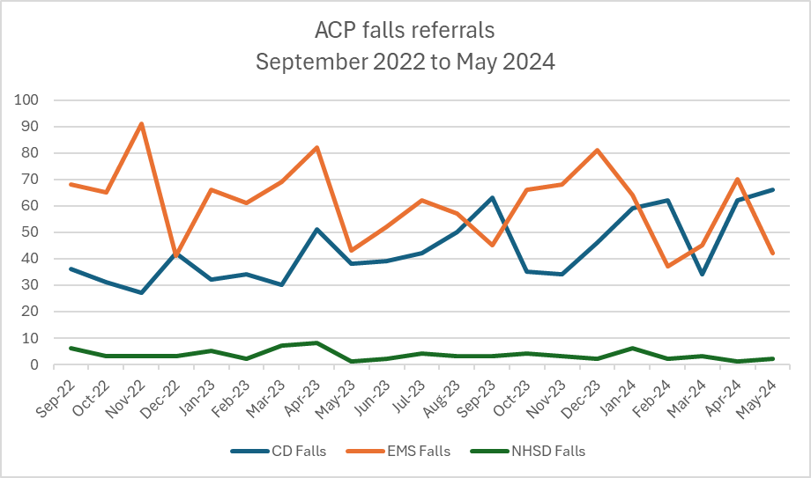
Figure 4.1: ACP fall referrals September 2022 to May 2024

Figure 4.2: All ACP falls referrals – September 2022 to May 2024

Table 4.1: ACP falls referral numbers – September 2022 to May 2024
 | Total | ‘EMS Falls’ | ‘CD Falls’ | ‘NHSD Falls’
ACP referrals | 2261 | 1275 | 913 | 73
% of total | 100 | 56.4% | 40.4% | 3.2%

Figure 4.3 shows the number of falls referrals made via the ePCR Pathways function from the first full month of operation, July 2024, to March 2026. This displays an increasing trend line over the period of operation. The higher numbers from July to November 2025 could be related to reduced handover delays at hospitals meaning that more falls received a response by an emergency ambulance (EA), which have access to the ePCR Pathways function (Welsh Ambulance Services University NHS Trust, 2026b).

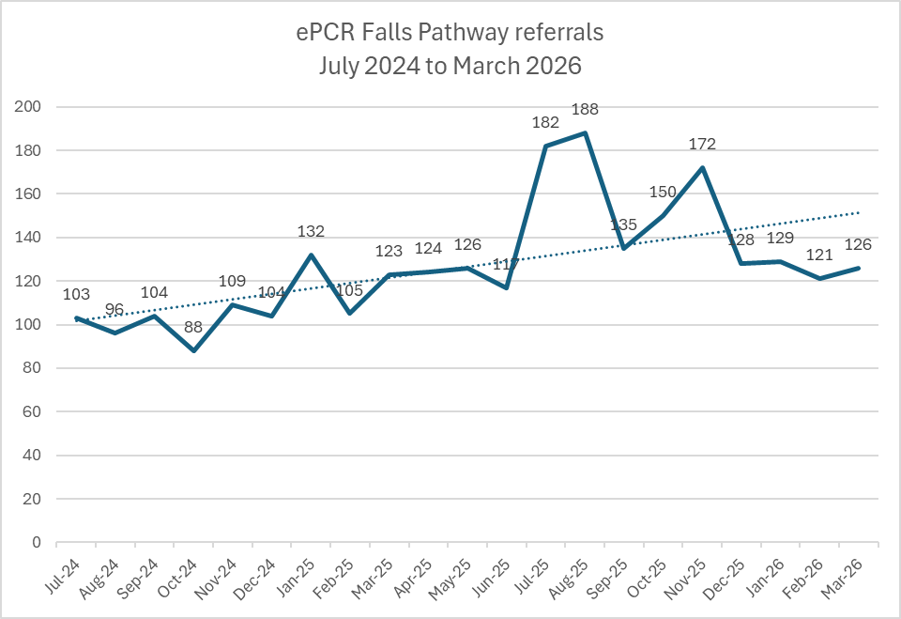
Figure 4.3: Falls referrals – ePCR Falls Pathway July 2024 to March 2026

Three types of falls pathways are available to be selected in the ePCR Pathways function, ‘EMS Falls Pathway’, ‘EMS CSD Falls Pathway’, and ‘EMS 111 Falls Pathway’. The same information is recorded in the falls pathway form whichever is selected. There is no description within ePCR as to which should be selected. The ePCR Pathway user manual within ePCR uses EMS Falls Pathway as the example, and this is by far the most often used. Table 4.2 shows the total number of each type of falls referral recorded in the ePCR Pathways system.

Table 4.2: ePCR falls referral numbers July 2024 to March 2026
 | Total | ‘EMS Falls’ | ‘CSD Falls’ | ‘111 Falls’
All referrals | 2662 | 2618 | 28 | 16
% of total | 100 | 98.3% | 1.1% | 0.6%

Table 4.3 shows the total number of referrals in the ACP database and ePCR Pathways data in the 21 full months prior to and after the ePCR Pathways implementation. June 2024 data is not included as the ePCR Pathways function was introduced partway through the month. Based on these figures, the number of falls referrals has increased by 17.7% since the implementation of the ePCR Pathways function, with an additional 19.1 referrals per month (229.2 per year).

Table 4.3: Falls referral numbers and monthly average pre and post ePCR Falls Pathway
Falls referral data source | Date range | Period | Number of referrals | Monthly average
ACP database | September 2022 to May 2024 | 21 months | 2,261 | 107.7
ePCR database | July 2024 to March 2026 | 21 months | 2,662 | 126.8
% increase |  |  | 17.7% | 17.7%

The referral rate per day has increased from 3.5439 per day in the pre-implementation period (638 days) to 4.1659 per day in the post-implementation period (639 days).
The post-implementation numbers (ePCR data) do not include referrals from ACP which do not originate with face-to-face patient contact, for example the ACP NHSD Falls referrals.
The increase in referral numbers may have been impacted by other factors, such as the launch and promotion of the updated WAST ‘Non-injury fallers pathway’ in November 2022 and wider work being undertaken by the WAST Falls Lead and the work in relation to the National Framework (NHS Wales Executive, 2024).
The referral numbers for June 2024 are shown in Table 4.4, for both systems. The ePCR Pathway function was introduced on 10th June 2024.
Table 4.4: ACP and ePCR falls referral numbers – June 2024
 | Total | ‘EMS Falls’ | ‘CD Falls’ or ‘CDS Falls’ | ‘NHSD Falls’ or  ‘111 Falls’
ACP | 122 | 62 | 60 | 0
ePCR | 37 | 35 | 2 | 0
Total | 159 | 97 | 62 | 0

  - ePCR referral auto-rejects
Before considering referral rate and appropriateness of referrals it is important to highlight an issue identified during this study of a high level of auto rejections of ePCR Pathway falls referrals. This issue has a key impact on the ability to evaluate the impact of the ePCR function on referral appropriateness.
Figure 4.4 displays the status of all falls referrals made via ePCR from June 2024 to March 2026. This shows that 69.3% of ePCR referrals have been auto rejected. As shown in Figure 4.5, auto-rejects account for 91% of all rejections. This means that although an automated email has been sent to the selected falls service, with system-generated PDF attached containing information entered on the ePCR pathways form, the referral has not been acted upon by the receiving falls service. Auto-rejection occurs when following the receipt of the email by the falls team it has not been ‘Accepted’ or ‘Rejected’ within 96 hours. In some cases, the time-out was after 72 hours, but since August 2024 the time-out for all services has been 96 hours.
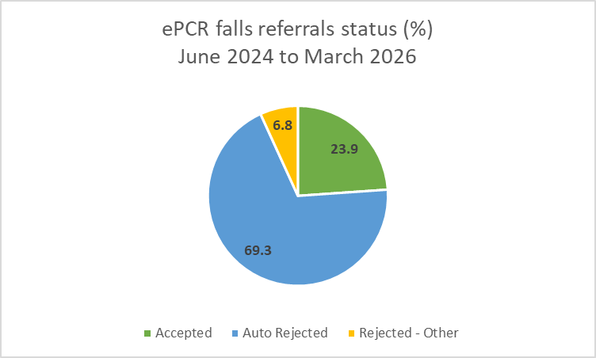
Figure 4.4: ePCR falls referrals status
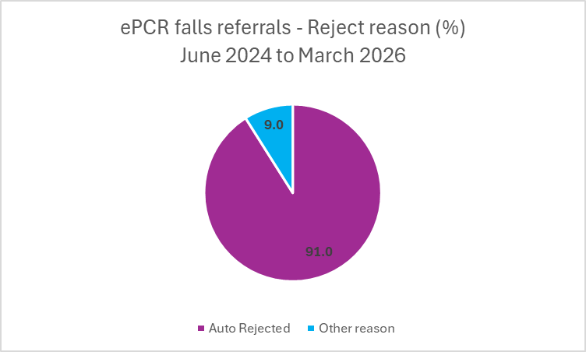
Figure 4.5: ePCR falls referrals – reject reason

The auto-rejected ePCR referrals are currently being manually notified to the WAST Co-ordination Agent to be logged into the ACP database and the referrals being re-sent by email to the relevant falls service. This is creating duplication of work in the falls referral process. The continued use of the ACP system in particular for EMS and CD falls referrals appears to be clearly related to the level of auto-rejects in the ePCR system, leading to referrals being sent again via the ACP process. Anecdotally, many of these ‘re-referrals’ have already been acted upon by the receiving falls service, although there is no formal method of recording this, and therefore no visibility in WAST data (Welsh Ambulance Services University NHS Trust, 2025b).
Figure 4.6 shows ePCR falls referrals from June 2024 to March 2026 by status (accepted, auto-rejected, rejected-other). This distinctly displays the significant proportion of auto-rejects in every month since the implementation of the ePCR Pathways function. The total figures for the period June 2024 to March 2026 are shown in Table 4.5.
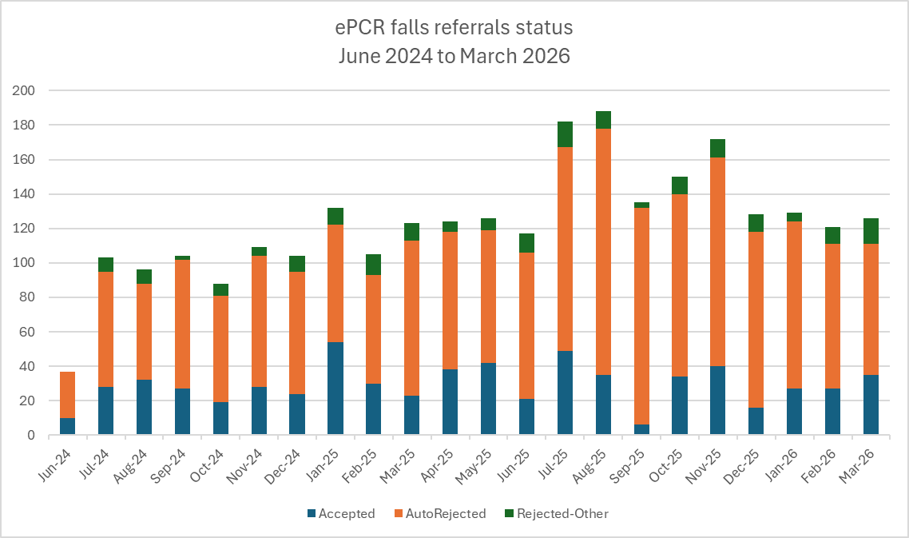
Due to the high level of auto-rejects it is not possible to clearly state what impact the introduction of the ePCR falls pathway function has had on the appropriateness of falls referrals. Also, the lack of measures of the acceptance rate of referrals via the ACP system limit the ability to evaluate the impact of the ePCR function on referral appropriateness.
Figure 4.6: ePCR falls referrals June 2024 to March 2026

Table 4.5: ePCR falls referral numbers by status June 2024 to March 2026
 | Total | Accepted | Auto rejected | Rejected – Other reason
EMS Falls | 2653 | 634 | 1838 | 181
CSD Falls | 30 | 7 | 20 | 3
111 Falls | 16 | 4 | 12 | 0
Total | 2699 | 645 | 1870 | 184
% of total | 100 | 23.9% | 69.3% | 6.8%

The auto-reject issue has affected the continued use of the ACP system. One of the anticipated benefits of the ePCR Pathways function was the reduced use of the previous process of on-scene clinicians phoning the WAST Co-ordination point, for the referral to be made via the ACP database as an EMS Falls referral and an e-mail referral sent to the falls team. Therefore, it would be expected that the numbers of referrals entered on the ACP database would significantly reduce following the ePCR Pathway implementation on 10th June 2024. This same would also apply to the other Pathway options, Resolved Epilepsy and Resolved Hypoglycaemia referrals, previously also made by phoning the WAST Co-ordination point, replaced by an automated email to patient’s GP from the ePCR. Figure 4.7 shows the monthly ACP numbers for May 2023 to August 2025, with a clear reduction in the Resolved Epilepsy and Resolved Hypoglycaemia referrals made via ACP following the introduction of the ePCR Pathways function. Figure 4.8 shows the numbers of falls referrals made via ACP over the same period, with no similar reduction in numbers following the introduction of the ePCR Pathways function.
The continued, unforeseen, use of the ACP system for referrals from on-scene clinicians is contributing to unnecessary system complexity (and inefficiency) in the falls referral process. This is preventing the decommissioning of the ‘old’ system, or at least part of it, which should occur with the implementation of a new system. The benefit of ‘forgetting’ obsolete practices in a learning health system has been explored in a commentary piece by Enrico Coiera (Coiera, 2017).

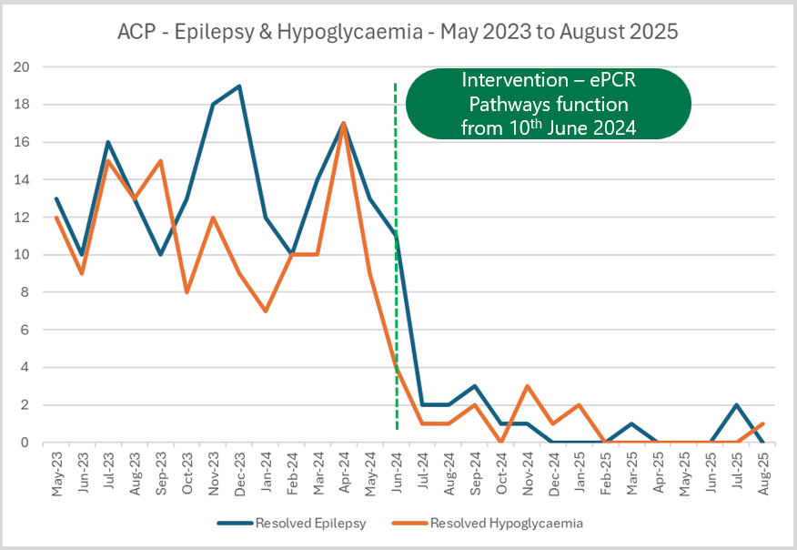
Figure 4.7: ACP – Epilepsy and Hypoglycaemia referrals
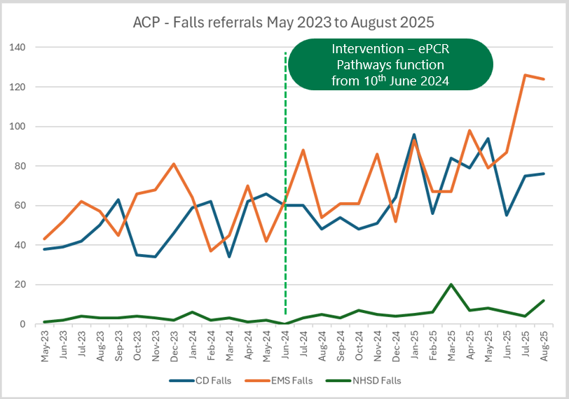
Figure 4.8: ACP falls referrals May 2023 to August 2025

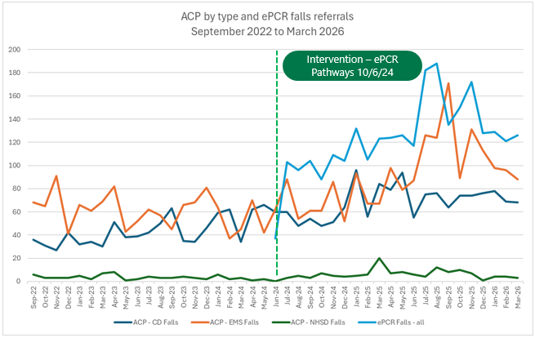
The effect of auto-rejects and re-referrals can be also seen in Figure 4.9 which shows the total number of ACP referrals by type and ePCR falls referrals in the period September 2022 to March 2026. A pattern can be seen in the ePCR referral numbers being replicated by the ACP referrals.
Figure 4.9: ACP and ePCR falls referral numbers September 2022 to March 2026
  - Referral rate
Organisational data was analysed to identify the referral rate since the introduction of the ePCR Pathways function. The denominator used is the number of 999 calls coded as a ‘Fall’, for patients aged 65 and over which have received a face-to-face response from WAST and where the patient was not conveyed to hospital. All 999 calls are allocated a Chief Complaint code based on the Medical Priority Dispatch System (MPDS). The code for falls is 17. There are caveats with the use of MPDS code 17 as the basis for a denominator for falls referrals. For example, the patient may have other medical conditions, or on arrival at scene the patient may not have actually had a fall. However, it provides a basis for comparing referral rates over time. Conversely, it is interesting but may have limited value in comparison with referral rates in other ambulance services or studies, as the precise denominator used may have been different. For example, referral rates of fallers aged 65 years or above, attended by paramedics to community-based falls services/ falls prevention services stated in Snooks et al (2017) and Scott (2020) were 8% and 7% respectively. It may be of value to WAST in tracking the referral rate over time, with a clearly defined denominator, although any comparison with other Trusts should be treated with caution due to differing types of falls response, and referral pathways available.
Figure 4.10 shows the denominator and WAST referral rates from May 2023 to March 2026. The referral numbers are from the ACP system, to ensure a single source of data, due to the known issue of auto-rejection of ePCR referrals. The chart shows an increasing trendline before and after the introduction of the ePCR Pathways function. The average rate in from May 2023 to May 2024 is 10.5%. The average rate from June 2024 to March 2026 is 15.7%.

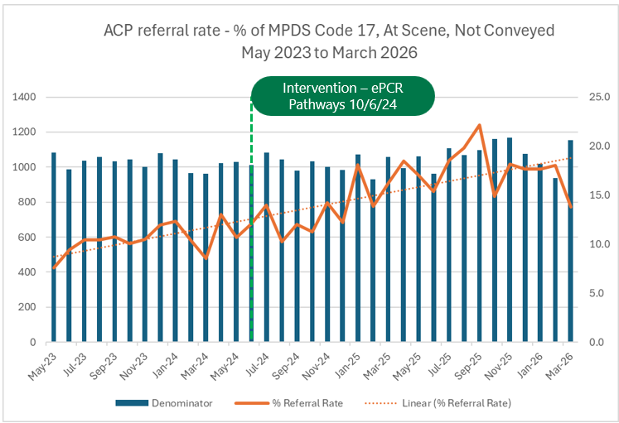
Figure 4.10: ACP Falls referral rate May 2023 to March 2026

  - Appropriateness of referrals
Some insights can be drawn from analysing other, genuine, reasons for rejection other that auto rejections. From the introduction of the ePCR Pathway function in June 2024 to the end of March 2026, 23.9% (n=645) of referrals were accepted by the receiving team. If auto-rejects are excluded, the acceptance rate is 77.8% (n=645/829) of referrals which were accepted or rejected.
6.8% (n=184/2699) of all referrals were rejected for specific reasons. Excluding auto-rejects, the figure is 22.2% (n=184/829). Comments can be entered by the receiving falls team in a ‘Reason’ free text field in the automated email sent from the ePCR, when clicking ‘Reject’. Entries are returned and stored in the ePCR portal in the referral record. The rejection comments fields were scrutinised and allocated a primary reason for rejection, which are shown in the Figure 4.11 pareto chart and Table 4.6. For example, if a patient was in hospital or living in the wrong area for the team they were referred to, these were recorded as the primary reason, even though other reason/s may also apply. The numbers and percentages for rejection reasons are shown in by category, number, and percentage.

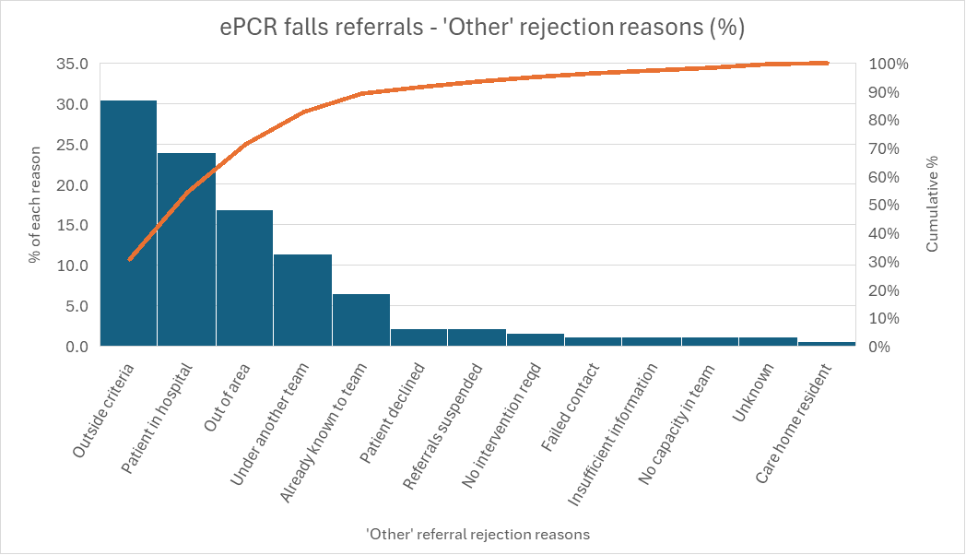
Figure 4.11: ePCR falls pathway – rejection reasons by % (excluding auto-rejects)

Table 4.6: ePCR Falls Pathway – rejection reasons by number and percentage
Reason for rejection | Number | % (rounded to 1 dec place)
Outside eligibility criteria | 56 | 30.4
Patient in hospital | 44 | 23.9
Out of area | 31 | 16.8
Patient under another team | 21 | 11.4
Patient already known to falls team | 12 | 6.5
Patient declined referral / assessment | 4 | 2.2
Referrals from WAST suspended | 4 | 2.2
No intervention required | 3 | 1.6
Failed contact | 2 | 1.1
Insufficient information | 2 | 1.1
No capacity in team to accept | 2 | 1.1
Unknown (unclear from comments) | 2 | 1.1
Care home resident | 1 | 0.5
Total | 184 | 100

The top three reasons account for 71.1% of the rejections. These could all reasonably be considered as ‘outside eligibility criteria’. Patient in hospital and wrong area have been identified separately as they are distinct issues resulting in a failed (inappropriate) referral. They and the next two highest reasons for rejection (patient under another team or already known to falls team) could be described as preventable waste in terms of the time spent by WAST and the receiving falls team in unproductive activity. They demonstrate a shortfall in harnessing information already in existence.
Most of the referrals rejected for being outside eligibility criteria were rejected by the services in one health board area (n=49/56). This health board area temporarily suspended its falls referral pathway from 12th September 2025. The suspension is still in place as at the end of March 2026. The rejections due to being outside the service criteria in this health board area included patient having a Clinical Frailty Scale (CFS) score of above 4. The CFS is designed as a baseline score, that is how the patient normally is, or two weeks prior to the acute event. Scores range from 1, Very Fit to 8, Living With Very Severe Frailty, or 9, Terminally ill (Dalhouse University, 2024). One service in this health board rejected some referrals as they stated their pathway was for patients with CFS 1-4, with stable health needs. This criterion is not used by all falls services, and indicates the ongoing challenge of maintaining consistent, uniform referral criteria for 20 community falls services across Wales.
Other examples of referrals being outside criteria were where patients have experienced a long-lie and require urgent referral to their GP for blood tests to rule out certain conditions. One such referral was reported by the receiving service as being outside the safe referral zone. Some referrals were rejected due to the patient being bed-bound, or already using mobility equipment, such as a hoist.
  - Qualitative data - user survey results
The responses from the 59 completed user surveys were saved to an Excel spreadsheet. This data set was then analysed to identify themes relating to the research question.
The survey itself was designed to include a high proportion of open questions with free-text answer fields to enable a range of responses to contribute to a broad evaluation of the system. Although asking a question about what improvements could be made to a system may imply that there are potential improvements, that is, it is not perfect right now!
The nature of survey respondents are summarised in Tables 4.7 and 4.8.

Table 4.7: Survey respondents by staff grade
Staff Grade | Number of respondents
Senior Paramedic | 23
Advanced Paramedic Practitioner | 7
Newly Qualified Paramedic | 6
Paramedic | 6
Senior Advanced Paramedic Practitioner | 6
Emergency Ambulance Practitioner | 4
Emergency Medical Technician | 4
Clinical Lead | 1
Health Board Clinical Lead | 1
Consultant Paramedic | 1
Total | 59

Table 4.7 shows the range of staff grades who completed the survey. The grade with the highest number of respondents (n=23) was Senior Paramedics. They may not be surprising as the email promoting the survey was primarily sent to Senior Paramedics with a request to forward to their teams, which comprise staff on other clinical grades.
Table 4.8: Survey respondents by Health Board area
Health Board | Number of respondents
Betsi Cadwaladr | 19
Hywel Dda | 11
Powys | 10
Cardiff & Vale | 8
Aneurin Bevan | 5
Swansea Bay | 4
Cwm Taf Morgannwg | 1
N/A (Clinical Directorate) | 1
Total | 59

Table 4.8 shows respondents by health board and confirm that there was at least one respondent from every health board across Wales. However, the higher numbers of respondents in certain health board areas may indicate differing levels of interest in the survey by different Senior Paramedics in those areas, and interest in the ePCR referral system in different health boards.
Table 4.9 shows the respondents experience in using the previous method of making referrals to community falls services (phoning the 0300 number) and using the ePCR Pathways function. This shows that a majority of respondents have experience of both processes, which provides a basis for comparison. 64.4% (n=38/59) of respondents stated that they had used both processes. The preferred system if used both is shown in Table 4.10.
Table 4.9: Use of previous and new system
Question | Yes | No | Unsure
Have you ever used the previous method (phoning the 0300 number) for making referrals to community falls services? | 45  (76.3%) | 12  (20.3%) | 2  (3.4%)
Have you used the ePCR Pathways – EMS Falls pathway function? (introduced in June 2024) | 46  (78%) | 11  (18.6%) | 2  (3.4%)

Table 4.10: System preference if used both
Question | ePCR Pathways function | Phoning the 0300 number | No preference | Not applicable
If yes to both, which would you prefer using? | 41  (69.5%) | 4  (6.8%) | 3  (5.1%) | 11  (18.6%)
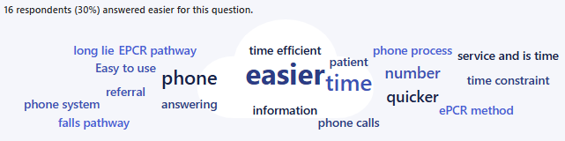
Figure 4.12: Word cloud relating to preferred system

Respondents were asked to enter the reason/s for their preference in a free text field. The word cloud generated by Microsoft Forms for the answers entered is shown in Figure 4.12. This reflects all entries, including preferences for either system, but gives a visual indication of reasons for the stated preference. A thematic analysis of the reason/s entered for preferring the ePCR function shows a clear theme. 80% (n=33/41) specifically mention ‘easier or quicker’ as a reason for preferring the ePCR function. This finding resonates with Barrett et al (2021). Examples of answers which demonstrate this theme are included below, and indicate a positive experience for users and patients compared to the previous system, and may partly explain the apparent increase in referral numbers:
Much quicker to do and sometimes you would ring the 0300 number and it would just ring and ring.
Faster, can write what you think is necessary. It works whatever time you are at the call.
Towards the latter end of the 0300 number being in place, there tended to be no answer at all when trying to refer a patient into the pathway. After using the ePCR pathway only a couple of shifts ago, there was so much more ease of use and assurance provided to the patient. Instead of having to sit on scene for an hour +, we were able to refer within 5 minutes and provide the patient peace of mind the referral had been sent off.

Table 4.11: ePCR function ease of use
Question | Very easy | Easy | Neither easy nor difficult | Difficult | Very difficult | Unsure/ prefer not to say | Not applicable/ not used
How easy do you find it to use the ePCR Pathways – EMS Falls Pathway function (select) | 19  (32.2%) | 21  (35.6%) | 6  (10.2%) | 1  (1.7%) | 0  (0%) | 1  (1.7%) | 11  (18.6%)

This analysis is supported by the answers to the question on ease of use of the ePCR function, as shown in Table 4.11. Among respondents who had used the new system, 83.3% (n=40/48) rated it as ‘easy’ or ‘very easy’. Respondents were asked to enter the reason/s if they selected ‘Difficult’ or ‘Very difficult’. The sole respondent who selected ‘Difficult’ stated,
The boxes are annoyingly discreet in what you can input into them. Also you are forced to enter every number including alternative contact numbers despite that may not available. You also cannot access the observations you have input on to previous pages so have to write down things like the various blood pressures etc on paper.
Although most respondents rated the new system as being easy or very easy to use, this response indicates that there may be areas for improvement in the system functionality. This is picked later in the thematic analysis of survey results.
To explore the correct operation of the ePCR system, there was a question asking,
“Have you ever phoned the Clinical Support Desk (CSD) to make a referral to a community falls service rather than using the ePCR pathways function?”
Only 10.2% (n=6/59) respondents answered Yes to this question. Two respondents, an Emergency Ambulance Practitioner (EAP) and a Newly Qualified Paramedic (NQP) have to ring the CSD to make a referral and safely discharge a patient on scene, as referral is outside their scope of practice. One respondent stated that phoning the CSD was due to a connectivity issue. Another stated that,
The EPCR wouldn’t submit so i contacted DCM [Duty Control Manager] to input the info over the phone in the old style.
Survey questions explored users’ confidence in making a referral within the pathway criteria, and to the correct team. The answers may contribute to an understanding of the ePCR function’s likelihood of ensuring that referrals made are appropriate. Table 4.12 shows the range of answers in terms of confidence scale, ranging from ‘Not at all’, to ‘Extremely’ confident.
Table 4.12: Confidence in making ePCR referrals within criteria and to correct team
Question | Not at all | Slightly | Moderately | Very | Extremely | Unsure/ prefer not to say | Not applicable/ not used
How confident do you feel when making a referral that it is within the criteria? | 1  (1.7%) | 3  (5.1%) | 17  (28.8%) | 25  (42.4%) | 11  (18.6%) | 1  (1.7%) | 1  (1.7%)
How confident do you feel in selecting the correct falls team? | 3  (5.1%) | 7  (11.9%) | 12  (20.3) | 25  (42.4%) | 8  (13.6%) | 2  (3.4) | 2  (3.4%)

Based on individual respondents’ previous answers, some responses were from those who have not used the referral function, which may cause some uncertainty to these answers.
61% (n=36/59) of respondents stated that they were ‘very’ or ‘extremely’ confident that referrals they make are within criteria. This seems like a positive indication of confidence but could be expected to be higher with a new system. Of those who stated they had used the ePCR falls pathway function the proportion was slightly higher with 69.6% (n=32/46) feeling ‘very’ or ‘extremely confident’ that their referrals are within criteria. A qualitative study by Halter et al identified the complexity of the decision-making process for ambulance staff when assessing older people who have fallen and whether they require conveyance to hospital or can safely remain at home with a suitable referral made (Halter et al., 2011).
Interestingly, the confidence level of selecting the correct falls team is lower, with just 55.9% (n=33/59) of all respondents being ‘very’ or ‘extremely’ confident. 16.9% (n=10/59) were ‘not at all’ or ‘slightly’ confident. However, among those who stated they had used the ePCR falls pathway function, the proportion was higher with 69.6% (n=32/46) feeling ‘very’ or ‘extremely confident’ of selecting the correct falls team.

Confidence levels may relate to the training or guidance received, or lack thereof, in using the new ePCR Pathways system. Respondents were asked, “Have you received any training or guidance in using the ePCR Pathways function?”. The results are shown in Figure 4.13.

Figure 4.13: ePCR Pathways function training or guidance received

Only 16.9% (n=10/59) of respondents stated that they had received training or guidance in the new system. 76.3% (n=45/59) of respondents said no training or guidance had been received, and 6.8% (n=4/59) were unsure. These findings reflect a previous study on the implementation in WAST of ePCR which identified a lack of meaningful training in using ePCR. Online training was available but was based on a slightly different version of ePCR (Muxworthy, 2025). If training or guidance had been provided respondents were asked to enter details. Examples of comments are,

Minimal brief over view, however it is pretty self explanatory.
As part of the EAP course, was shown the criteria etc but there was no specific training on the use of ePCR as the training team couldn’t access it.

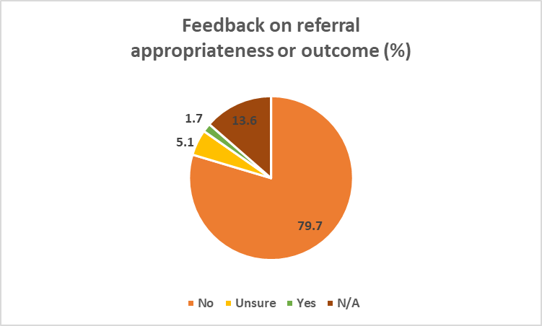
The question was also asked, “Do you receive any feedback on the appropriateness (i.e. within criteria, sent to correct team) of a referral you have made, or the outcome?”. 79.7% (n=47/59) stated no, 5.1% (n=3/59) were unsure, 13.6% (n=8/59) stated not applicable, and just 1.7% (n=1/59) said yes. Results in percentages are shown in Figure 4.14.
Figure 4.14: Feedback on referral appropriateness or outcome (%)

Feedback was one of the main themes identified in the suggestions for improvement invited from respondents to the ePCR Falls Pathway referral process, with a free text box to enter suggestions. 54.2% (n=32/59) of all respondents entered a response. This represents over two-thirds, 69.6% (n=32/46) of people who stated that they had used the new system.
The analysis of the suggested improvements identified three key themes: technology, training and feedback. Table 4.12 shows the prevalence of these identified themes. Examples of comments which demonstrate each theme and sub-themes, are shown in Table 4.13.

Table 4.12: Themes in improvement suggestions
Improvement theme | Number of mentions | % of 32 responses
Technology – user experience | 17 | 53.1%
Feedback on referrals made | 11 | 34.4%
Training – pathway criteria & ePCR | 4 | 12.5%
Total | 32 | 100%

Table 4.13: Survey extracts to illustrate improvement themes
Improvement theme | Sub-theme | Survey extract
Technology – user experience | Data entry | It is annoying not being able switch between the patient details [in main body of ePCR] and the referral form. This results in scribbled notes of demographics/meds etc which could lead to error
Technology – user experience | Data entry | A way of exiting back into the [ePCR] review screen to obtain details ie phone numbers and obs without all progress being lost!
Technology – user experience | Data entry | You also cannot access the observations you have input on to previous pages [in ePCR] so have to write down things like the various blood pressures etc on paper
Technology – user experience | Data entry | Stop us losing inputted data when we dip in and out to get information from the epcr. It is annoying that if you go out of the referral then back in again you lose all the information that’s inputted but we have to go in and out to get information from the epcr
Technology – user experience | Usability | It asks for blood sugars, and postural BPs, which aren’t always clinically relevant or possible and you have to input a value to submit the referral. It would be good if there was an exemption button.
Technology – user experience | Usability | It doesn't let you proceed if you don't put all the obs in that it is asking for, sometimes I don't or can't do a standing BP or BM and maybe there could be a box to tick to say considered but didn't or unable to bypass this, currently I put '0' in the boxes so that I can continue
Technology – user experience | Decision-support | When selecting the pt has had a fall, it should be prompt such as “is a fall pathway required?”
Technology – user experience | Decision-support | Check list that would automatically tell you if a patient was not suitable. e.g if you tick a box that says 'any recent infection' or similar, it would tell you the referral was inappropriate and not let you submit the form
Technology – user experience | Decision-support | a way of the correct falls team being auto selected
Feedback on referrals made | Referral intervention | An idea of the process after referral would be helpful to be able to inform the patient/manage their expectations
Feedback on referrals made | Referral intervention | Give crews more information on what will happen with referral. Often get questions on what actually happens with referrals.
Feedback on referrals made | Referral outcome | Better communication around appropriateness of the referral and if it has been accepted
Training – pathway criteria & ePCR |  | Criteria/exclusion made more clear on the falls pathway on ePCR. As no formal training has happened, I feel some people are unsure when/when not to do the referral
Training – pathway criteria & ePCR |  | Training on what happens next with our referrals and what’s appropriate or not.

The richness and variety of suggestions indicates that although there is a strong user preference for the ePCR Pathways function over the previous telephone route, there are clear areas for potential improvement of the system and integration of the referral process with training and feedback mechanisms. Previous research has found that EMS professionals have a strong desire for feedback. Feedback on clinical performance or patient outcomes can change professional behaviour, improve task ownership and clinical outcomes, and have a positive effect on staff mental health (Wilson et al., 2022).
A question was added to the survey on 16th December 2025 to explore any issues with connectivity, which has been previously identified as a barrier to effectively ePCR in Wales (Muxworthy, 2025).
Have you had any issues with completing the WDS Lookup prior to starting the pathway referral process?
The results from this question should be treated with caution in terms of wider applicability as the question was answered by just the last 11 respondents. Eight respondents answered yes, two answered no, and one not applicable. Of the respondents wo answered yes, six were based in Betsi Cadwaladr Health Board area, one in Hywel Dda, one based in Clinical Directorate rather than a geographical area. In a free-text box to give details, five respondents mentioned connectivity or signal issues. Specific comments included,
Signal issues in rural wales
Multiple similar demographics show but no name / details - makes it difficult knowing which to select
Haven’t been able to get signal on the iPad to WDS the patient so have had to wait to do it back in station or somewhere that has signal

The overall survey findings indicate that the perceived ease of use may have supported the increase in referral numbers since the implementation of the ePCR referral function. The desire for feedback on referral outcomes and appropriateness reveals an opportunity to improve the referral acceptance rate (subject to fixing the auto-reject issue, of which front line clinicians may be unaware). If such feedback were to be routinely provided to referring clinicians, it may provide an opportunity for learning and encourage greater confidence in completing referrals and providing reassurance to patients of what should happen next. One comment sums this up well,
It is a common theme within ambulance services about the lack of feedback, so that would be my only thing is not knowing what happens as a result. If staff did get constructive feedback from community services….it might encourage more referrals
However, the current level of auto-rejects in the ePCR referral system, means that there is a lack of data on the true level of rejections, and the reasons.

- Discussion
  - ePCR referral numbers and the auto-reject issue
This study has identified challenges in reporting on the numbers of falls referrals by on-scene clinicians before and after the implementation of the ePCR Pathways function. Referrals are recorded in both the existing ACP system and the new ePCR Pathways system.
To gain a complete picture of the numbers of falls referrals after implementation of the ePCR Pathways function it is not possible to simply add the figures in both systems as the ACP figures include some referrals that were initially sent from the ePCR but have been auto rejected (timed out due to no response from the receiving team). The above average number ACP referrals in June 2024 (shown in Table 4.4) may be an early indication of the issue caused by the high level of auto-rejection of ePCR referrals.
The falls referral numbers available in WAST data are being affected by the ePCR referral auto-reject issue. This is creating difficulty in measuring with confidence the total number of referrals from WAST to community falls services, due to the auto-rejects in effect being counted twice in two different systems. The initial ePCR referral is recorded in ePCR data as it has been successfully sent. However, in the 69.3% of referrals (1,870) auto-rejected between 10th June 2024 and 30th March 2026, they are being re-referred via the ACP system (~>4 days later) and therefore also included in the ACP figures for the same month or the subsequent month if the original ePCR referral occurred within 4 days (96 hours) of month-end.
The ePCR referral system is designed with the auto-reject feature as a fail-safe mechanism in case a referral email is not accepted or rejected by the receiving team within 96 hours of being sent. The rejection is visible to WAST within the ePCR portal. The auto-rejects are re-submitted via the ACP system. This is happening much more frequently than anticipated.
The ePCR Pathways automated emails were tested by WAST before the system went live, to confirm receipt of emails. The falls referral emails contain voting buttons to ‘Accept’ or ‘Reject’ the referral. If ‘Reject’ is selected the falls service can enter comments to provide the reason/s for the rejection. The acceptance decision and any comments are relayed back to the WAST ePCR portal. Prior to implementation in ePCR a falls team was used to test if emails were being received correctly and that Accept/ Reject voting buttons were working as intended (Welsh Ambulance Services University NHS Trust, 2026a). However, it appears that on launching the ePCR Pathways function, that many falls services were unable to view or use the Accept and Reject buttons possibly due to organisational IT security settings and firewalls. Therefore, the ePCR referral system is not currently functioning as intended or expected. A solution to this issue is being developed by WAST and the ePCR supplier.
The number of referrals in itself may not be a complete, appropriate measure of the quality of care for this group of patients. There could be reasons for non-referral such as alternative pathways available, GP referral (e.g. to review a patient’s medications), Out of Hours GP, arrangements already in in place (e.g. a recent falls referral, or adaptations already planned). Numbers only can be a blunt instrument. However, due to the perceived background of under-referral, and the aim of the national framework to increase the numbers of falls referrals, the apparent positive impact on numbers is an important part of this evaluation.
  - Referral appropriateness
The digital falls referral process needs to recognise that the success of the referral process depends on the alignment of expectations (what is an appropriate referral?) between the services making and receiving the referral. Previous studies have identified potential barriers and enablers to the success of a collaborative approach between two heath care providers (Comans et al., 2013). Liu et al (2021) and Delardes et al (2022) have highlighted the importance of involving stakeholders in designing digital referral pathways to improve their likelihood of success in ensuring continuity of care and improving patient outcome. The situation in Wales is made challenging by the fact that referrals from WAST are sent to 20 different community falls services, across seven local health board areas. There is a clear challenge in maintaining consistent and uniform referral criteria across a large number of receiving services, even after initial consultation and agreement. There was previous stakeholder engagement by WAST in agreeing the referral pathway for non-injury falls (Welsh Ambulance Services University NHS Trust, 2022a), however there was significant time lag from the concept to delivery of the ePCR Pathway function in June 2024.
The new system has the potential to record and track reasons for rejection to inform learning, and system improvement. Currently, the rejection reasons have had to be manually analysed in this study from the free text entries on the ‘Rejected – Comments’ box. There could be scope to improve the quality of data (and efficiency) by providing falls services with pre-defined choices to select e.g. ‘outside criteria’, ‘out of area’, ‘already known to team’, with the option to add further details in the free text box, rather than the free text box being the sole source of rejection data.
The beneficial role of education and training for ambulance staff was highlighted by Aïdoud et al (2025) who reviewed a paramedic-based fall prevention initiative in France, for example on fall risks and potential complications such as long lies. In the initiative under review, paramedics contributed to the screening protocols completed prior to referral. This approach could be applied in WAST to involve paramedics in any future update or re-design of the falls referral criteria and the ePCR Pathway fields.
Gunson et al (2025) found that training and decision-support have a role in supporting increased specialist fall service referrals, which can improve patient care by reducing unnecessary hospital attendance.

  - Data entry
While the user survey showed a clear user preference for the ePCR Pathways function over the previous telephone route there are clear areas for potential improvement of the system in terms of data entry, usability and the potential for decision-support.
Table 5.1 shows the patient observations and falls questionnaire data fields in the ePCR Falls Pathway, with a description of each field and whether the fields are pre-populated with data entered in the main ePCR sections or are manually entered in the pathways form. The use of the Pathways function is dependent on patient demographics being confirmed via a link to Welsh Demographics Service (WDS).
Table 5.1: ePCR Falls Pathway - selected data entry fields
ePCR Pathways step | Action/ data field | Action / data entry type
Observations | Pulse rate | Pre-populated from ePCR Obs
Observations | Blood sugar | Manual entry
Observations | Blood pressure sitting | Manual entry
Observations | Blood pressure standing | Manual entry
Falls Questionnaire | Have you had any falls in the last 12 months? | Select Yes or No
Falls Questionnaire | Four or more medicines? | Select Yes or No
Falls Questionnaire | Any previous stroke / TIA? | Select Yes or No
Falls Questionnaire | Any visual impairment? | Select Yes or No
Falls Questionnaire | Does the patient have a problem with balance or struggle to stand from a chair? | Select Yes or No
Falls Questionnaire | Does a fear of falling prevent the patient from taking part in daily activities? | Select Yes or No
Additional information | Brief reason for fall | text entry 250 characters max
Additional information | Any other relevant information (e.g. care package in place / lives alone / cognitive impairment) | text entry 250 characters max
Review pathway referral for accuracy | Click Go Back or Add Referral to complete and submit the referral
System-generated email sent to selected falls team with PDF attached

The requirement to manually enter blood sugar and blood pressures mean that there is a built-in inefficiency in the process, which is also apparent from some of the comments and suggestions in the user survey. This can lead to indirect data input such as writing on paper or a surgical glove first or entering data retrospectively. This issue was identified in relation to ambulance ePCRs by Porter et al (2018).
A lack of alignment with ePCR fields is indicated by the fact that the falls referral requires a sitting and standing blood pressure, whereas the main ePCR section for recording blood pressures does not provide for recording the patient’s position when a blood pressure is taken.
Clinicians entering ‘Brief reason for fall’ in the pathway form will be repeating information that they will no doubt have already entered in the free-text ‘clinical narrative’ section of the main ePCR.
The ePCR Pathway fields do not fully align with the WAST Patient Referral Pathway for Non-Injury Falls criteria (‘Field Guide v2) (Welsh Ambulance Services University NHS Trust, 2022b). There is semantic inconsistency within the ePCR Pathways falls questionnaire i.e., (my italics) “Have you had any falls in the last 12 months?”, compared with, “Has the patient had any falls in the last 12 months”. The current Field Guide still includes the telephone referral route, although the 0300 number was ceased in June 2024. Figure 5.1 shows a summary of differences. Certain clinical issues identified as reasons for referrals being rejected are not mentioned in the field guide or ePCR Pathways form e.g. Clinical Frailty Scale and long-lie.
Alignment of questions and wording between the criteria (field guide) and the ePCR Pathway fields is an aspect of human factors and would encourage clarity of understanding and consistency of completion. The field guide could be made visible in the ePCR.
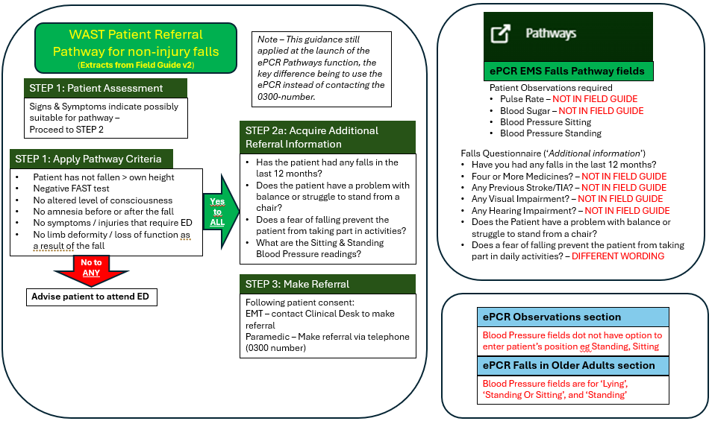
Figure 5.1: Comparison of ‘Field Guide’, ePCR Pathways and ePCR Observations

  - Digital environment
UK ambulance clinicians have been working in a dynamic digital environment since around the mid-2000s. The digitisation of health services in the UK is promoted by national policy (Welsh Government, 2015; Wachter, 2016; Topol, 2019). Referrals are a key part of the health care system which have the potential to benefit from digital transformation. The addition of falls-specific ambulance clinical guidelines and the development of care pathways for falls referrals has coincided with ambulance services moving away from paper records to ePCR systems, often accessed by on-scene clinicians on an iPad (Barrett et al, 2021). The Falls in Older Adults guideline was added to JRCALC in September 2017. A telephone survey of 13 UK ambulance trusts in 2018 found that 7 trusts were using ePCR, and 4 were considering or implementing an improved version of ePCR, having previously adopted ePCR and reverted to paper. WAST moved from a paper-based clinical records system and implemented ePCR in April 2022 (Porter et al., 2018; Muxworthy, 2025).
To gain a current picture of ePCR adoption and change in UK ambulance services, as part of this study Freedom of Information requests were sent to all UK ambulance services to ask,
- When did your Trust start using ePCR to record episodes of care by on-scene clinicians?
- When was the last (or next if planned) ePCR user interface change?
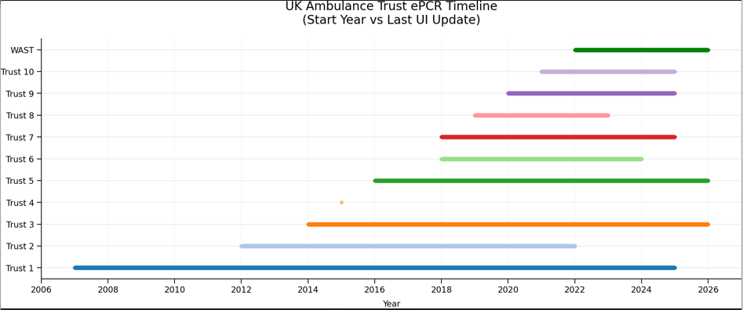
Responses were received from 10 trusts, not including WAST. The results are shown in Figure 5.2 with UK ambulance trusts anonymised except for WAST. The start of each line is when the trust started using ePCR and the end of the line indicates the last or next planned user interface change. Trust 4 stated that their ePCR user interface has not had a complete change since it was implemented in 2015. This timeline shows that WAST’s ePCR journey is relatively recent compared to other UK ambulance trusts and therefore is earlier in maturity in terms of fully realising the anticipated benefits of ePCR, including increased referrals to appropriate local services and improving continuity of patient care between providers.

Figure 5.2: UK ambulance trust ePCR timeline

  - Application of the FITT framework
The quantitative and qualitative findings in this study have been used to evaluate the ePCR Pathways referral function in terms of the ‘FITT’ framework (Ammenwerth, Iller and Mahler, 2006) The framework was developed to assist with the exploration of the socio-organisational-technical factors which impact on the adoption of IT systems in a health care environment. FITT stands for the Fit between Individuals, Task and Technology. It has been applied in this study as it is suited to the socio-technical nature of the ePCR Pathways system, to be used as a tool for post-implementation evaluation.
The framework helps to assess the success or failure of digital transformation in health care settings by examining how individuals, task and technology fit together, rather than evaluating the technology in isolation. In this study the ‘individuals’ are the ambulance clinicians making referrals; the ‘task’ is the falls assessment and referral; the ‘technology’ is the ePCR Pathways function and related systems.
The framework is expressed in three key relationships:
- Fit between individuals and task
- Fit between individuals and technology
- Fit between task and technology
These relationships can be illustrated as a model, as shown in Figure 5.3. Table 5.2 shows examples of the considerations and risks in relation to each of the ‘fit relationships in terms of the ePCR Falls Pathway referral process.

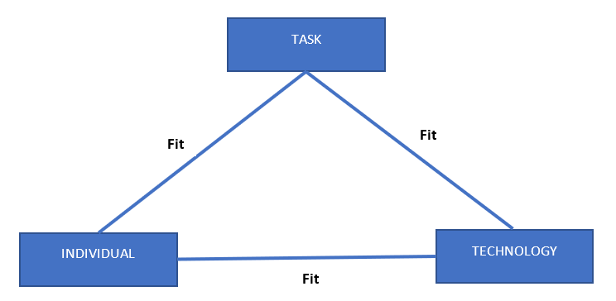
Figure 5.3: The FITT framework

Table 5.2: The FITT framework in relation to the ePCR Falls Pathway referrals process
FITT Relationship | Considerations - examples | Signs / risks of poor fit
Fit between Individuals and Task | Clarity and understanding of the eligibility criteria of falls services  Referral may be seen as outside ambulance clinicians primary responsibility to provide emergency care  Do clinicians see the benefits of referrals in preventing future emergencies and improving patient outcomes | Clinicians do not hear what happens after referral; unsure if referrals are acted on.  Over or under-referral  Variable referral rates between teams (not part of this study)
Fit between Individuals and Technology | ePCR ease of use in pre-hospital environment  Do referral fields auto-populate from patient assessment data  Do clinicians trust that referrals are sent successfully, and that falls services receive and act on them | Inability to switch between referral form and main ePCR  Clinicians have to enter data in referral fields that has already been entered elsewhere  Indirect data input (e.g. write data on paper first)
Fit between Task and Technology | Does the system support the work of making a referral  Balance between decision-support to indicate referral eligibility (or not) and to enable clinical judgement  Automatic electronic transfer to falls teams, and ease of acceptance or rejection | All fields mandatory where not all are possible e.g. blood glucose, standing blood pressure  Automated email voting buttons to accept/reject referral not affected by local firewalls

In this study the FITT framework has been applied by considering the data collected in relation to each of the three key relationships and identifying if the fit was uncomplicated or if there were any problems with the fit.
Fit between individuals and task – user survey identified some lack of clarity in terms of the criteria for referrals and a clear desire for feedback on referral process and outcomes.
Fit between individuals and technology – users found the ePCR Pathways function easy to use, but not all referral pathway fields auto-populate with patient assessment data.
Fit between task and technology – users expressed some frustration that all fields in the referral form are mandatory. Some users also stated that prompts within ePCR could be useful to highlight whether a referral is appropriate. Automated referral emails are sent from the ePCR, however only a minority (30.7%, from Figure 4.4) of these emails have been actively accepted or rejected by falls teams, due to the auto-reject issue.
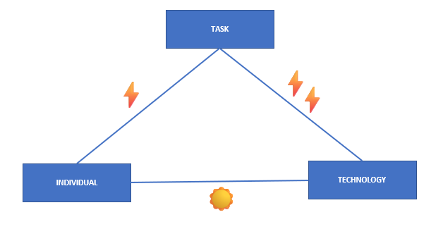
This study has considered where applicable the quality of the fit in terms of the key FITT relationships. The analysis is shown in Figure 5.4. This follows Ammenworth, Iller and Mahler (2006) who used lightning arrows to represent a problem with the fit (two arrows for larger problems), or a sun to represent an uncomplicated fit.
Figure 5.4: Analysis of the fit in the ePCR falls referral process. One arrow indicates smaller problems with the fit; two arrows indicate larger problems; a sun indicates a relatively uncomplicated fit.

The analysis of the fit as shown indicates that there are interventions that are required to be taken in future to improve the quality of fit, to enable the ePCR referrals process to be a successful and fully digital process. In this context, the process ends with the successful acceptance or rejection of the referral. The actual community intervention to benefit the patient is what comes next.
The application of the FITT framework underlines that the success of electronic falls referrals is not principally a technology issue. It is a socio-technical challenge where ambulance clinicians, their clinical tasks, and the ePCR system (including the link to receiving falls teams) must be in alignment. Addressing all of the key relationships is necessary to promote referral consistency, staff engagement and patient outcomes.

  - Application of the Donadebian model
The concept of describing healthcare as a system was discussed by Avedis Donabedian in his seminal 1966 article on evaluating the quality of medical care when he first described medical care in terms of structure, process, and outcome (Donabedian, 2005). Figure 5.5 shows a version of a modified Donabedian diagram, as proposed by Lilford et al, for the ePCR falls referral process, which can be defined as a targeted process intervention (Lilford et al., 2010).

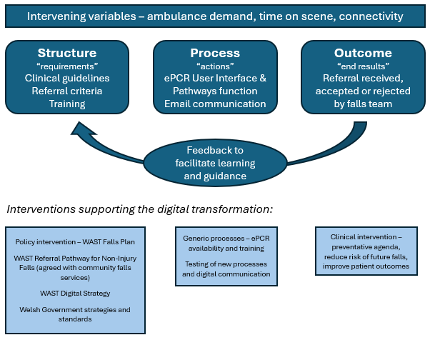
Figure 5.5: Modified Donabedian Diagram

This visualisation helps with seeing the digital falls process as system, dependent for success on the consistent and smooth alignment of structure, process, and outcome. The operation of the system is affected by intervening variables and supported by purposeful interventions. Feedback from the outcome part of the process can and should be used to inform individual and organisational learning. For example, reasons for referral rejection can inform guidance to referring clinicians and may alert the organisation to changing referral criteria which may need to be incorporated into the digital process, that is the ePCR user interface. Learning can reduce the risk of unsafe referrals, for example in the case of a long-lie patient who is in need of an urgent referral to their GP for blood tests.

- Conclusions
The number of WAST referrals to community falls services has increased since the implementation of the ePCR Pathway falls referral function. The ePCR function itself may have contributed to this increase although there may be other significant contributory factors. The user survey found that the new function was ‘quicker and easier’ to use than the previous process of telephoning a dedicated number within WAST to make referrals.
It has not been possible to evaluate the impact of the new function on the appropriateness of referrals. The previously existing ACP system does not record whether referrals are accepted or rejected. The new function has a high proportion of referrals that are auto rejected. This means it is not possible to fully measure an accurate acceptance rate for all referrals made, and to analyse entirely the reasons for rejection. However, if the auto rejection issue can be solved, the ePCR system will allow for referral appropriateness to be measured and analysed so that learning can be used to improve the efficiency and effectiveness of the referral process for patients, ambulance clinicians, and the receiving falls services. It may help with referral criteria adherence if the WAST field guide for referrals was visible in the ePCR application.
The ePCR falls referral system has been well received by WAST ambulance clinicians, but it is flawed in that since implementation it has produced and continues to produce a high level of auto-rejects. One respondent stated,
ePCR referrals are a great idea and more are required
This evaluation has identified that usability of the system is deemed good by users but could be improved by reducing the amount of double-entry of patient observations – the Pathways form requires certain patient observations to be entered, which in most cases will already have been entered in the ePCR Observations section.
A question arising is, is the ePCR falls pathways referral ‘form’ even needed? The relevant information could be entered into the ePCR ‘Falls in Older Adults’ section, and the Pathways function would be purely to send a referral notification to the falls team, and allow the falls team to see this is in the ePCR portal and to view the whole ePCR including full patient history, rather than just the PDF attachment to the automated email, which contains limited information on the patient’s condition and nature of the fall, even if all the fields in the falls pathways referral form have been fully completed.
This study has produced some key themes, which could be addressed to improve the WAST falls referral process
- Alignment of referral guidelines with system content
- Ability of the system to fully track acceptance and rejection of referrals (and solve the auto-reject issue)
- Current lack of a single reliable source of referral data and outcomes
The FITT analysis (Figure 5.4) provides a possible reference point for improvement, to continue the journey to a fully digital falls referral process, as intended.
This study cannot conclude that increased ambulance falls referrals have had a direct impact on alleviating pressure on the wider health care system and improving patient health outcomes but based on the literature surveyed referrals are a part of the broader efforts on prevention-based health and care (Public Health Wales, 2025). The challenge to health care systems presented by an ageing population with multiple comorbidities was made plain at a recent symposium organised by the Bevan Commission (Denaxas, 2026).
It seems that the ePCR falls pathway referral function implemented in June 2024 has replicated the previous process, and so far, at least, has just replaced the telephone call with an automated email, rather than taken the opportunity to fully share the ePCR record with falls teams to provide full informational continuity of care. This phrase is from Delardes et al (2022). One of the anticipated benefits of ePCR was to improve the continuity of individual’s care between providers (Welsh Ambulance Services University NHS Trust, 2021).
Digital transformation should start with the process, what it is the service wants to achieve to improve patient care and outcomes. Once this is clear, then ‘good’ user friendly, workable digital processes can be designed at the outset to support new pathways. Technology should be the enabler, not the driver of system change (Southam, 2026). Successful digital change should start with the behavioural (social) aspect – redesign the process first, the technology should come second (Foskett, 2026).
This study can only provide a snapshot of a complex reality. For WAST there is the challenge of attempting to agree, maintain, embed in digital processes, and communicate to clinicians uniform criteria, across all of Wales which comprises seven local health boards, and currently 20 community falls services. This is a complex environment with changing pathway criteria and availability.
Ambulance falls referrals can play a role in preventative health care by integrating with community falls services. To do so efficiently, effectively and safely requires completing the journey to fully harnessing digital capability by having a fully digital process.

Appendices

Appendix 1: ePCR Falls Pathway User Survey

Appendix 2: Project Brief

Appendix 3: Ethics Form

References
Aïdoud, A. et al. (2025) ‘A Comprehensive, Home‐Based, Fall Prevention Initiative: Preliminary Data From the Raise’Age Program’, Journal of the American Geriatrics Society, 73(6), pp. 1895–1905. Available at: https://doi.org/10.1111/jgs.19350.
Ammenwerth, E., Iller, C. and Mahler, C. (2006) ‘IT-adoption and the interaction of task, technology and individuals: a fit framework and a case study’, BMC Medical Informatics and Decision Making, 6(1), p. 3. Available at: https://doi.org/10.1186/1472-6947-6-3.
Association of Ambulance Chief Executives (2025) Falls Governance Framework V2.0.
Barrett, J.W. et al. (2021) ‘A survey of ambulance clinicians’ perceptions of recording and communicating patient information electronically’, British Paramedic Journal, 6(1). Available at: https://doi.org/10.29045/14784726.2021.6.6.1.1.
Bonner, M., Capsey, M. and Batey, J. (2021) ‘A paramedic’s role in reducing number of falls and fall-related emergency service use by over 65s: a systematic review’, British Paramedic Journal, 6(1). Available at: https://doi.org/10.29045/14784726.2021.6.6.1.46.
Braun, V. and Clarke, V. (2006) ‘Using thematic analysis in psychology’, Qualitative Research in Psychology, 3(2), pp. 77–101. Available at: https://doi.org/10.1191/1478088706qp063oa.
Coiera, E. (2017) ‘The forgetting health system’, Learning Health Systems, 1(4). Available at: https://doi.org/10.1002/lrh2.10023.
Comans, T.A. et al. (2013) ‘Problems with a great idea: referral by prehospital emergency services to a community-based falls-prevention service’, Injury Prevention, 19(2), pp. 134–138. Available at: https://doi.org/10.1136/injuryprev-2011-040076.
Dalhouse University (2024) Geriatric Medicine Research - Clinical Frailty Scale. Available at: https://www.dal.ca/sites/gmr/our-tools/clinical-frailty-scale.html (Accessed: 30 April 2026).
Delardes, B. et al. (2022) ‘Development of an electronic referral proforma from paramedics to general practitioners: A Delphi study’, Australasian Journal of Paramedicine, 19. Available at: https://doi.org/10.33151/ajp.19.918.
Denaxas, S. (2026) ‘Future Trends and the Implications for Future Service Design [Speech]’, Bevan Commission Health Matters Symposium, Great Hall, Swansea University, 12 March.
Donabedian, A. (2005) ‘Evaluating the Quality of Medical Care (1966)’, The Milbank Quarterly, 83(4), pp. 691–729. Available at: https://doi.org/10.1111/j.1468-0009.2005.00397.x.
Faul, P. et al. (2025) ‘Digital referral versus clinical reality: evaluating prehospital trauma allocation with IVENA eHealth®’, European Journal of Trauma and Emergency Surgery, 51(1), p. 278. Available at: https://doi.org/10.1007/s00068-025-02949-w.
Foskett, K. (2026) ‘Insights from Industry in Mobilising Change [Panel Discussion]’, Bevan Commission Health Matters Symposium, Great Hall, Swansea University, 12 March.
Friend, T.H. et al. (2024) ‘Community emergency medical services approaches to fall prevention: a systematic review’, Injury Prevention, 30(6), pp. 446–453. Available at: https://doi.org/10.1136/ip-2023-045110.
Gunson, I.M. et al. (2025) ‘Ambulance responses to older adults who have fallen: A systematic review’, Age and Ageing. Available at: https://doi.org/10.1093/ageing/afaf228.
Halter, M. et al. (2011) ‘Complexity of the decision-making process of ambulance staff for assessment and referral of older people who have fallen: a qualitative study’, Emergency Medicine Journal, 28(1), pp. 44–50. Available at: https://doi.org/10.1136/emj.2009.079566.
JRCALC / AACE (2020) ‘Joint Royal Colleges Ambulance Liaison Committee Clinical Guidelines’, JRCALC Clinical Guidelines - JRCALC Plus 2020 V2.4 (Mobile Application Software) [Preprint].
JRCALC Senior Editor (2026) ‘Email to Richard Teulon 26 March 2026’. Unpublished.
Lilford, R.J. et al. (2010) ‘Evaluating policy and service interventions: framework to guide selection and interpretation of study end points’, BMJ, 341(aug27 1), pp. c4413–c4413. Available at: https://doi.org/10.1136/bmj.c4413.
Liu, S.L. et al. (2021) ‘Patient and paramedic experiences with a direct electronic referral programme for focused hypoglycaemia education following paramedic service assist‐requiring hypoglycaemia in London and Middlesex County, Ontario, Canada’, Diabetic Medicine, 38(8). Available at: https://doi.org/10.1111/dme.14569.
Logan, P.A. et al. (2010) ‘Community falls prevention for people who call an emergency ambulance after a fall: randomised controlled trial’, BMJ, 340(may11 1), pp. c2102–c2102. Available at: https://doi.org/10.1136/bmj.c2102.
Mikolaizak, A.S. et al. (2016) ‘A multidisciplinary intervention to prevent subsequent falls and health service use following fall-related paramedic care: a randomised controlled trial’, Age and Ageing [Preprint]. Available at: https://doi.org/10.1093/ageing/afw190.
Muxworthy, C. (2025) An Evaluation of the Electronic Patient Clinical Record (ePCR) implemented by the Welsh Ambulance Services University NHS Trust (WAST) from a Clinical Perspective. MSc dissertation. University of Wales Trinity Saint David.
National Institute for Health and Care Excellence (2025) ‘Falls Quality Standard QS86 Updated April 2025’.
NHS England (2020) Making Every Contact Count (MECC), Making Every Contact Count (MECC) | NHS England | Workforce, training and education. Available at: https://www.hee.nhs.uk/our-work/population-health/our-resources-hub/making-every-contact-count-mecc (Accessed: 2 May 2025).
NHS Wales (2024) Six Goals For Urgent and Emergency Care National Programme. Available at: https://performanceandimprovement.nhs.wales/functions/six-goals-uec/ (Accessed: 30 March 2026).
NHS Wales Executive (2024) National Community-Based Falls Response Framework for Wales.
Paulin, J. et al. (2025) ‘Exploring care pathways of patients conveyed by emergency medical services (EMS) through electronic health records’, Scandinavian Journal of Trauma, Resuscitation and Emergency Medicine, 33(1), p. 60. Available at: https://doi.org/10.1186/s13049-025-01378-3.
Porter, A. et al. (2018) ‘70 The digital ambulance: electronic patient clinical records in prehospital emergency care’, Abstracts. British Medical Journal Publishing Group, p. A26.3-A27. Available at: https://doi.org/10.1136/bmjopen-2018-EMS.70.
Public Health Wales (2025) ‘Prevention-Based Health and Care (PBHC) in Action - Case Studies’.
Public Services Ombudsman for Wales (2025) The investigation of a complaint against Welsh Ambulance Services University NHS Trust and Swansea Bay University Health Board, Cases: 202302966 and 202307480.
Scott, J. (2020) ‘Re-contact rates with a UK ambulance service following paramedic referral to a falls prevention service for those aged ≥ 65 years: a retrospective cohort study’, British Paramedic Journal, 5(2), pp. 18–25. Available at: https://doi.org/10.29045/14784726.2020.09.5.2.18.
Scott P.J. (2016) ‘Mixed Methods: A Paradigm for Holistic Evaluation of Health IT’, in E. Ammenwerth and M. Rigby (eds.) Evidence-Based Health Informatics: Promoting Safety and Efficiency Through Scientific Methods and Ethical Policy. IOS Press. Available at: https://doi.org/10.3233/978-1-61499-635-4-102.
Snooks, Helen A. et al. (2017) ‘Paramedic Assessment of Older Adults After Falls, Including Community Care Referral Pathway: Cluster Randomized Trial’, Annals of Emergency Medicine, 70(4), pp. 495-505.e28. Available at: https://doi.org/10.1016/j.annemergmed.2017.01.006.
Snooks, Helen A et al. (2017) ‘Support and Assessment for Fall Emergency Referrals (SAFER) 2: a cluster randomised trial and systematic review of clinical effectiveness and cost-effectiveness of new protocols for emergency ambulance paramedics to assess older people following a fall with referral to community-based care when appropriate’, Health Technology Assessment, 21(13), pp. 1–218. Available at: https://doi.org/10.3310/hta21130.
Southam, V. (2026) ‘Digital Innovation - Future Horizons and Opportunities for Health and Care [Speech]’, Bevan Commission Health Matters Symposium, Great Hall, Swansea University, 12 March.
Taylor, R. (2026) ‘Rethinking 999’, The Sunday Times Magazine, 8 February, pp. 10–17.
The Health Foundation (2015) ‘Evaluation: What to Consider - Commonly asked questions about how to approach evaluation of quality improvement in health care’. Available at: https://www.health.org.uk/resources-and-toolkits/quick-guides/evaluation-what-to-consider (Accessed: 29 April 2026).
Topol, E. (2019) ‘The Topol Review - Preparing the healthcare workforce to deliver the digital future. An independent report on behalf of the Secretary of State for Health and Social Care’. Available at: https://topol.digitalacademy.nhs.uk/the-topol-review (Accessed: 5 May 2026).
Wachter, R. (2016) ‘Making IT Work: Harnessing the Power of Health Information Technology to Improve Care in England. Report of the National Advisory Group on Health Information Technology in England’. Available at: https://assets.publishing.service.gov.uk/government/uploads/system/uploads/attachment_data/file/550866/Wachter_Review_Accessible.pdf (Accessed: 5 May 2026).
WAST ePCR Provider (2023) ‘Referrals Service Functional Design Specification V3.0’, Unpublished [Preprint].
Welsh Ambulance Services NHS Trust (2016) ‘Patient Pathway for Fallers, resolved Hypoglycaemia and resolved Epileptic Seizure Version 4.3’, Unpublished [Preprint].
Welsh Ambulance Services University NHS Trust (2021) ‘ePCR Project - Project Initiation Document’, Unpublished [Preprint].
Welsh Ambulance Services University NHS Trust (2022a) ‘Clinical Notice 38/2022: Non-injury fallers pathway’, Unpublished [Preprint].
Welsh Ambulance Services University NHS Trust (2022b) ‘WAST Patient Referral Pathway for Non-Injury Falls (Field Guide v2)’, Unpublished [Preprint].
Welsh Ambulance Services University NHS Trust (2023) ‘Microsoft Teams discussion with Falls Improvement Lead, 24 October 2023’.
Welsh Ambulance Services University NHS Trust (2024a) ‘Clinical Notice 22/2024 – ePCR Patient Pathway Referrals’, Unpublished [Preprint].
Welsh Ambulance Services University NHS Trust (2024b) Welsh Ambulance Services NHS Trust Integrated Medium-Term Plan 2024 - 2027.
Welsh Ambulance Services University NHS Trust (2025a) ‘Falls Plan 2025 – 2029 Draft Version 0.6’, Unpublished [Preprint].
Welsh Ambulance Services University NHS Trust (2025b) ‘Microsoft Teams discussion with Health Information Co-ordinator, 9 December 2025’.
Welsh Ambulance Services University NHS Trust (2026a) ‘Email correspondence with WAST Digital Systems Product Specialist, 30 March’.
Welsh Ambulance Services University NHS Trust (2026b) ‘Microsoft Teams discussion with Falls Improvement Lead, 16 April 2026’.
Welsh Ambulance Services University NHS Trust (2026c) ‘WAST Trust Board January 2026 - Part 1’, You Tube [Preprint]. Available at: https://www.youtube.com/watch?v=5PhLiSlMfo4 (Accessed: 4 February 2026).
Welsh Government (2015) ‘Informed Health and Care - A Digital Health and Social Care Strategy for Wales’. Available at: https://www.gov.wales/sites/default/files/publications/2019-03/informed-health-and-care-a-digital-health-and-social-care-strategy-for-wales.pdf (Accessed: 5 May 2026).
Welsh Government (2022) Six Goals for Urgent and Emergency Care: A policy handbook 2021-2026.
Wilson, C. et al. (2022) ‘The role of feedback in emergency ambulance services: a qualitative interview study’, BMC Health Services Research, 22(1), p. 296. Available at: https://doi.org/10.1186/s12913-022-07676-1.
Wohlin, C. et al. (2022) ‘Successful combination of database search and snowballing for identification of primary studies in systematic literature studies’, Information and Software Technology, 147, p. 106908. Available at: https://doi.org/10.1016/j.infsof.2022.106908.

