A Strategic Formulation Plan for Audi Company in UK Automotive Sector
Component 2: Strategic Plan: – Academic Report

Andreea alina Tudorache
Student ID 2130698

LCBB6015 Strategic Management and Sustainability

Executive Summary
Through Audi’s philosophy of ‘Vorsprung durch Technik’, the company focuses on growing by using the latest technology to produce quality products. Audi is transforming the future of mobility by producing electric vehicles and digital services to improve its sustainability performance. Based on this philosophy, the company promises continuous development of quality and innovative automobile products that meets consumers’ needs and preferences. This strategic formulation plan focused on Audi’s strategic analysis, analysing its external and internal environments audits. PESTEL analysis was used to analyse the company’s external environment audit to understand consumer behaviors and market trends. Similarly, the report covered internal environment audit using VRIO, Value Chain analysis, and SWOT analysis to identify the company’s internal strengths/capabilities and weaknesses. The company’s strategic choice focused on leveraging Audi’s internal capabilities and resources to expand its EV portfolio and market presence in the booming UK’s EV market. This strategy will enable Audi to position itself as a leader in the EV market and in the eco-friendly mobility.

Contents
Executive Summary 2
1. Introduction 4
2. Company Overview- Audi AG 4
3. Audi’s Strategic Intent 5
3.1. Vision 5
3.2. Mission 5
3.3. Strategic Objectives 5
4. Audi AG’s Current Performance 6
5. Strategy Analysis of Audi UK 7
5.1. External Environmental Audit 7
5.1.1. PESTEL Analysis 7
5.2. Internal Environmental Audit 12
5.2.1. VRIO analysis 12
5.2.2. Value Chain analysis of Audi UK Company 13
5.2.3. SWOT Analysis 14
6. Strategy Formulation 14
7. Conclusion and Recommendation 15
Reference List 16

Introduction
Strategic management is a management process that is concerned with formation of strategic vision, objectives/goals, and formulation and implementation of strategies to achieve organisational goals. Therefore strategic management is a blueprint that guides companies to survive the changes in business environment (Dalirazar and Sabzi, 2020). Moreover, it plays an important role in enabling organisations to gain a competitive advantage in the industry by helping them to achieve their long-term objectives. Besides, strategic management sets the long-term vision and direction, which helps to keep companies on the right path to achieving their objectives despite the changes that may occur in the business environment (Dalirazar and Sabzi, 2020). Moreover, strategic management enables organisations to identify business opportunities and threats in the external environment, as well s internal strengths and weaknesses (Barney, William, and Sahay, 2019). Companies can use their internal strengths to leverage opportunities in external environment to improve their competitive advantage in the market (Ibrahim, 2024). Similarly, strategic management helps to modernise processes and reduce wastefulness within organisations, helping to improve their operational efficiency (Ibrahim, 2024). This report covers the strategy formulation plan for Audi Company in the UK automotive sector. The report covers Audi’s background, strategic intent, current performance, strategic analysis, and strategic formulation.

Company Overview- Audi AG
Audi Company is one of the leading premium brands in the world that has been operating as part of Volkswagen Group since 1965. It was formed in 1909 in Germany and formed the Auto Union in 1932 that comprised four brands (Volkswagen Group, 2026). However, the Auto Union collapsed during the Second World War after its production facilities were destroyed (Volkswagen Group, 2026). Audi uses its sustainable future vision to exemplify growth. It is guided by three pillars, including pushing the limits, revolutionising mobility, and unique soul to create unique car designs and exceptional driving experience (Audi Newsroom, 2023). Moreover, Audi uses latest technologies to prioritise innovation in its designs and products. The company entered into electric vehicle models, and has produced Audi Q4 e-tron and Audi e-tron GT models. These models offer exceptional driving experiences while minimising the company’s environmental impact (Audi Newsroom, 2023). Besides, the company offers various services for its electric car models, including financing, repairmen and maintenance. The company’s myA udi app helps to simplify the process of how customers can get its services, including connecting their cars with their phones, finding nearby charging stations, and managing their finances (Audi Newsroom, 2023).

Audi’s Strategic Intent
Audi AG’s strategic cornerstone lies in its vision, mission, and objectives. They provide an important direction in the competitive premium automobile sector. Through the ‘Vorsprung durch Technik’ philosophy, which emphasises the use of technology to grow, Audi wants to transform the future of transport by adopting digitalisation and electric vehicles (Audi Club, 2024).

Vision
The company’s vision is to become the leading sustainable luxury brand in the world through electric mobility and digitalisation (Audi Club, 2024) .The Company’s vision is powered by various strategic intents, including the desire for sustainability through electric vehicles and detailed digital transformation. To show its commitment to sustainability, Audi has invested in electric vehicle technologies to ensure it eliminates ICE models by 2033.

Mission
The company’s mission is to change the luxury mobility’s future through adoption of technologies that empower individuals and improve their lives.

Strategic Objectives
- To fully go electrification by eliminating ICE models by 2033 and focus on electric vehicles and charging infrastructures.
- To implement digitalisation by developing digital services and autonomous driving to improve customers’ driving experience.
- To attain carbon neutrality by promoting sustainability in order to comply with the UK’s net zero target.
- To produce quality and stylish vehicles in a bid to position itself as a leader in the premium market.

Audi AG’s Current Performance
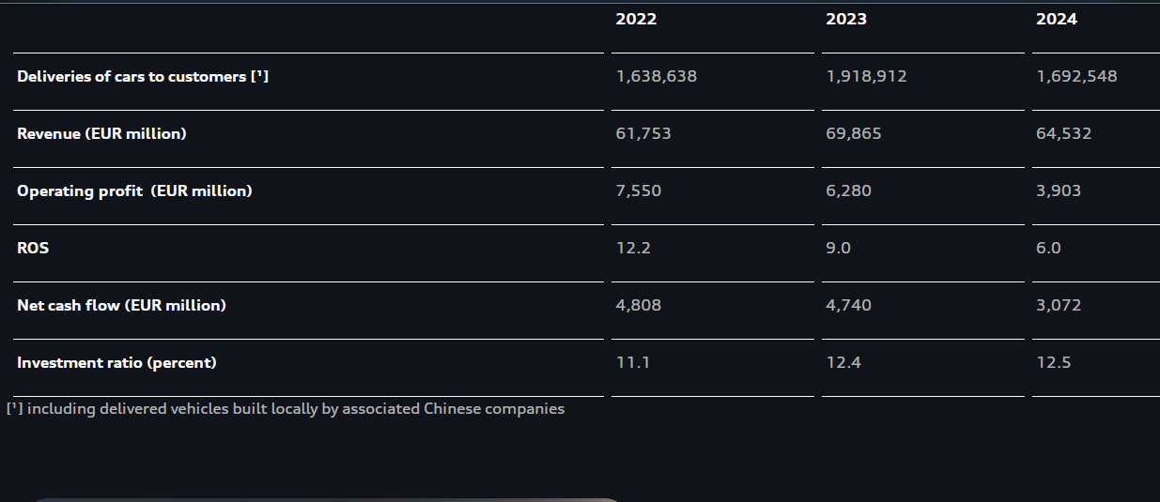
Table 1: Audi AG’s Performance 2022-2024
Source: Audi Report (2024)
The company experienced an increase of over 85% in the number of EVs delivered to customers UK market alone, as shown in table 2 below (Audi News, 2026). However, despite this increase, the company’s operating profit reduced from €7.5 billion in 2022 to €6.2 billion in 2023 (Audi News, 2026). The high cost of producing EVs could have caused this reduction in operating profit.
The company’s car sale declined in 2024, selling about 1.7 million cars. Similarly, the company’s revenue and income also declined in the same period, as shown in table 1 above. Investment in EVs technology could have increased the company’s expenses, thus reducing its operating profit (Audi News, 2026). Moreover, political instability in some parts of Europe and the Middle East and increased completion could have contributed to the reduction of the company sales (Barney, William, and Sahay, 2019). Global economic slump may have also weaned customers’ purchasing power, which affected Audi’s sales.

Fuel Type | Number of cars sold in UK | Percentage
Petrol | 84,471 | 13%
BEV | 24,773 | 85%
Diesel | 16,814 | 5%
PHEV | 11,432 | 98%

Table 2: Audi UK 2023 car sales breakdown by fuel type
Source: Audi Newsroom (2023)

Strategy Analysis of Audi UK

External Environmental Audit

PESTEL Analysis
Political Factors: Audi UK must comply with the UK’s regulations that guide the automobile industry, including the Zero Emission Vehicle Mandate. The ZEV mandate provides the roadmap for the elimination of diesel and petrol vehicles in the UK’s market by 2035, as shown in table 3 below. Audi has responded by increasing sale of EVs in the UK to comply with this regulation (Fitzgerald and Spencer, 2020). Besides, Audi is also affected Brexit-related trade tariffs and supply chain challenges in the UK.
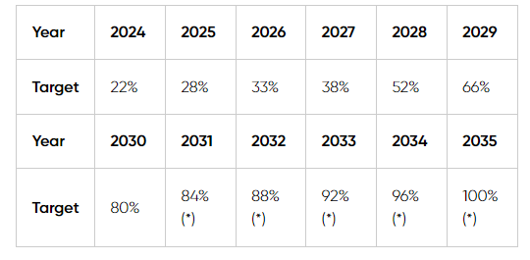
Table 3: UK’s ZEV Mandate
Source: EVA England (2026)
Economic Factors: The increasing inflationary pressures in the UK’s economic environment, as shown in figure 1 below, have weakened consumers’ purchasing power and increase companies’ operational costs (Fitzgerald and Spencer, 2020). The premium market, where Audi operates has been the most affected by these inflationary pressures. Besides, the Bank of England raised interest rates to combat the inflationary pressures, as shown in figure 2, which increased the cost financing, further reducing the demand for premium cars.
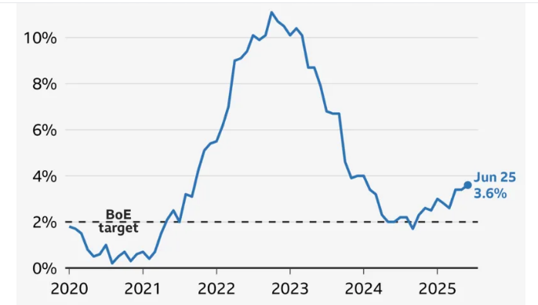
Figure 1: UK inflation rate
Source: Hooker and Bowker (2025)
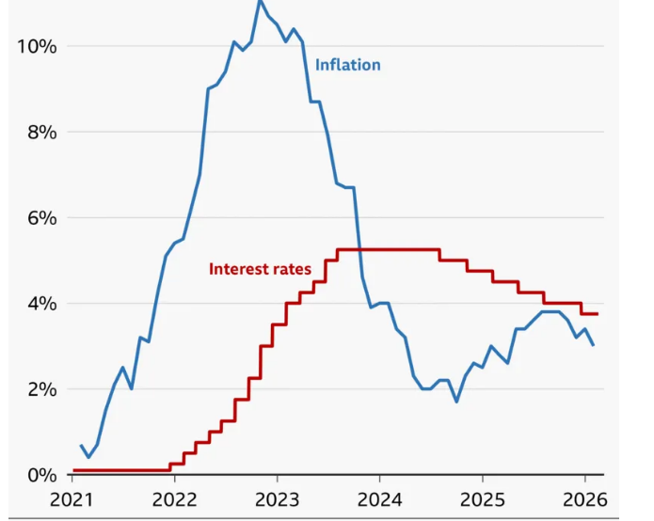
Figure 2: UK Inflation and Interest
Source: Peachey (2026)
Social Factors: One of the main social factors likely to affect Audi’s business operations in the UK automobile market is consumers’ preferences for sustainability. Figure 3 below shows that 80% of the UK’s consumers are willing to pay more for eco-friendly products, while is likely to benefit Audi’s EV products in the market. This increased interest in sustainability by the UK consumers has played an important role in increasing the demand for EVs in the country.
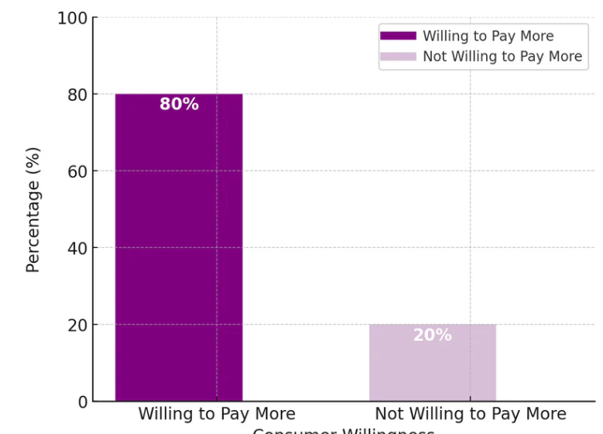
Figure 3: UK Consumers’ willingness to pay more for sustainability
Source: Asaolu (2025)
Technological Factors: the advancement in electric vehicle and charging infrastructure technologies, as shown in figure 4 below, have been the most important factors driving the adoption of EVs by automobile companies (Sun et al,. 2024). Besides, the autonomous driving technologies have also influenced the design of the automobile products. Audi has embraced these technologies producing EVs and including autonomous technology to help drivers prevent collusion and maintain safe distances from other vehicles.
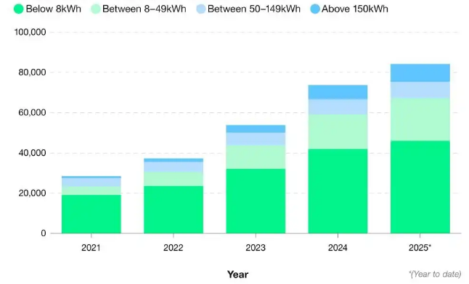
Figure 4: Number of Public EV charging devices with a power rating
Source: Moninska (2025)
Legal Factors: There are various regulations that Audi must comply with to avoid legal issues. For instance, the company must comply with the UK’s vehicle safety standards and product liability regulations (Fitzgerald and Spencer, 2020). These regulations require automobile companies to include advanced driver-assistance systems (ADAS) in their cars to improve safety of the drivers.
Environmental Factors: There are various environmental regulations which this company comply with to avoid fines. It has responded by adopting circular economy to reduce waste and cost of materials. Audi uses recyclable materials in its batteries to minimise waste (Fitzgerald and Spencer, 2020). Similarly, it has entered into the EV market to produce EVs and reduce its environmental impact.

Internal Environmental Audit

VRIO analysis
This strategic framework helps to evaluate the company’s competitiveness by assessing the value, rareness, inimitability, and organisation of its capabilities and resources (Ibrahim, 2024).

Capability/Resource | Valuable | Rare | Imitable | Organised | Competitive implication
Volkswagen Group financing | Yes | No | Costly | Yes | Sustained competitive advantage
Quattro technology | Yes | Yes | Costly | Yes | Sustained competitive advantage
Brand reputation | Yes | Yes | Costly | Yes | Sustained competitive advantage
Strong network of UK dealers and service centres | Yes | Yes | Costly | Yes | Sustained competitive advantage
EV Portfolio | Yes | No | Yes | Yes | Temporary competitive advantage
Pricing strategies | Yes | No | No | Yes | Temporary competitive advantage
Digital platforms/services | Yes | Yes | Yes | Yes | Sustained competitive advantage
Leadership Vision | Yes | No | Yes | Yes | Competitive parity

Value Chain analysis of Audi UK Company
AUDI COMPANY’S PRIMARY ACTIVITIES
Inbound logistics  -sources its components and materials from different suppliers worldwide | Operations  -Has modern manufacturing facilities where it assembles its cars using latest technologies | Outbound logistics  -Delivers completed vehicles to customers through its strong dealership network |  | Marketing & Sales  -It marketing and sales focus on offering customers personalised and premium experiences through digital platforms and dealers | Services  -Warranty services  -Car repair  -Maintenance.
SUPPORTING ACTIVITIES
Company infrastructure  -Manufacturing plants  -R&D centres  -Global dealership network  -Global service centers | HRM  -Maintains highly experience employees  -Provides opportunities for training and growth |  | Technology Development  -Develops new technology for electric vehicles and self-driving cars |  | Procurement  - Gets its components, parts, and materials from different vendors worldwide

SWOT Analysis
Strengths  -Technology and engineering in designing stylish vehicles  -Strong brand name for premium quality which has improved consumer trust (Audi Newsroom, 2023)  -Wide product portfolio of various car models  - Strong network of car dealership in the UK | Weaknesses  -High production costs of its vehicles  -Depends on the parent company Volkswagen Group for materials  -Supply chain disruptions  -Challenges in the EV market demand
Opportunities  -The increase number of EV charging stations will increase the demand for EVs  -Increased customer preference for e-co-friendly products and services  -Increase sales by entering emerging markets  -Technological advancements enables Audi to improve customer experience by including driver assistance technology and other digital services | Threats  -High competition in the EV sector from Tesla and low-cost Chinese companies  -Changing in emission standards and regulations, including high EU tariff  -Global economic slump  - Geopolitical tensions  - supply chain disruptions

Strategy Formulation
Audi’s strategic choices are aligned with its promise to expanding sustainability performances to improve its competitive advantage (Baur et al., 2012). One of the important strategic choices of Audi is to prioritise expansion of its EV portfolio and market presence in the booming EV market (Baur et al., 2012). Audi should leverage transformative opportunities in the automobile sector to expand its EV model to position itself as a market leader in the eco-friendly mobility (Dathe et al., 2022). The company’s affiliation to Volkswagen Group gives it a competitive edge, in terms of the required experience and resources to successfully implement this strategic choice.
Moreover, Audi should embrace circular economy principles to help improve its sustainability performances in line with its strategic intent (Toma and Tohanean, 2019). Audi uses recyclable materials in its batteries to reduce waste (Deberdt and Le Billon, 2022). Besides, Audi is using green energy to improve its sustainability performances. It is using renewable energy sources in some of its operations. This will help to reduce its Audi’s environmental impact and energy costs.
Similarly, Audi needs to improve employee engagement in order to successfully implement its sustainability programs (Ibrahim, 2024). It is important to ensure employees understand the benefits of implementing these programs in the company to motivate them to willingly accept to implement them (Ibrahim, 2024).

Conclusion and Recommendation
Audi’s strategic intent shows the company’s commitment to promoting sustainability in the automobile sector through production and sale of electric vehicles and related EV technologies and digital services. Besides, the environmental audit showed examined external and internal factors likely to affect Audi’s business activities in the UK. Eternal environment audit used PESTEL analysis to understand consumer behaviors and market trends. Internal environment audit used VRIO, Value Chain analysis, and SWOT analysis to understand the company’s strengths and weaknesses. Information from this strategic analysis informs the kind of strategic choices that this company can adopt to improve its market positioning. The increasing consumer preference for sustainability creates an opportunity for Audi to prioritise expansion of its EV product portfolio and market presence in this booming EV market. This strategy will enable Audi to position itself as a leader in the EV market and in the eco-friendly mobility.

Reference List
Asaolu, R. (2025). 80% of UK consumers prioritise sustainability: How Ethical shopping is changing Retail (2022-2024). Available at: https://rufinadesigns.com/blogs/posts/80-of-uk-consumers-prioritises-sustainability (Accessed: 16 March 2026)
Audi News (2026). Audi Group: Strong Financial Performance in a Challenging Environment Available at: https://press.audi.co.uk/releases/832 (Accessed: 16 March 2026)
Audi Newsroom (2023). Audi UK cements position as number one premium brand. Available at: https://press.audi.co.uk/releases/875 (Accessed: 15 March 2026)
Audi Report (2024). Annual and Sustainability Report. Available at: https://www.audi.com/en/company/investor-relations/key-figures/ (Accessed: 14 March 2026)
Barney, J. B, William, S and Sahay, A. (2019). Strategic management and competitive advantage: Concepts and cases. Pearson. ISBN 1-292-26696-1.
Baur, F., Koch, G., Prügl, R. and Malorny, C., 2012. Identifying future strategic options for the automotive industry. In Zukünftige Entwicklungen in der Mobilität (pp. 273-286). Gabler Verlag
Dalirazar, S. and Sabzi, Z. (2020). Strategic analysis of barriers and solutions to the development of sustainable buildings using the PESTLE technique. International Journal of Construction Management, pp.1-30
Dathe, T., Dathe, R., Dathe, I. and Helmold, M., (2022). Sustainability management and social responsibility in the value chain. In Corporate Social Responsibility (CSR), Sustainability and Environmental Social Governance (ESG) Approaches to Ethical Management (pp. 23-28). Cham: Springer International Publishing.
Deberdt, R. and Le Billon, P. (2022). The green transition in context—cobalt responsible sourcing for battery manufacturing. Society & Natural Resources, 35(7), pp.784-803.
EVA England (2026) ZEV Mandate: What is the ZEV Mandate? Available at: https://www.evaengland.org.uk/our-work/zev-mandate/#:~:text=The%20Zero%20Emission%20Vehicle%20(ZEV,it%20reaches%20100%25%20in%202035. (Accessed: 15 March 2026)
Fitzgerald, A.J. and Spencer, D. (2020). Governmentality and environmental rights: Regulatory failure and the Volkswagen emissions fraud case. Critical Criminology, 28, pp.43-63.\
Hooker, L. and Bowker, C. (2025). UK inflation at highest for almost a year and a half. BBC News. Available at: https://www.bbc.com/news/articles/c3en2enpy7po (Accessed: 16 March 2026)
Ibrahim, B. (2024). Strategic Management: A Comprehensive Review Paper. International Journal Professional Business Review. 9 (3), pp. 4373-4373. Available at: https://doi.org/10.26668/businessreview/2024.v9i3.4373 (Accessed: 15 March 2026)
Moninska (2025). EV Charging Statistics 2025. Available at: https://www.uswitch.com/electric-car/ev-charging/ev-charging-statistics/ (Accessed: 14 March 2026)
Peachey (2026). Are UK interest rates still expected to fall soon? Available at: https://www.bbc.com/news/articles/c3dky111m40o (Accessed: 16 March 2026)
Sun, J., Sun, S. Chen, B., and Hu, Y., (2024). "Charging change: Analysing the UK's electric vehicle infrastructure policies and market dynamics," Energy Policy, Elsevier, vol. 191(C). Available at: 10.1016/j.enpol.2024.114178. (Accessed: 15 March 2026)
Toma, S.G. and Tohanean, D. (2019). Green business models: The case of a German automaker. Quality-Access to Success, 20.
Volkswagen Group (2026). The History of Audi. Available at: https://www.volkswagen-group.com/en/the-history-of-the-brands-17668/the-history-of-audi-17672 (Accessed: 14 March 2026)

