Level 3 Understanding Domestic Abuse Unit Curriculum

Overview of the curriculum
This curriculum is to deliver a Level 3 Agored Cymru unit in Understanding Domestic Abuse (Agored Cymru, 2025). This module provides a basic framework for the delivery of content, however Agored Cymru does not prescribe specific assessment methods, and therefore the assessment can be decided by the relevant approved training centre. This curriculum will be delivered in community venues such as local domestic abuse services. The teacher will be employed by an approved Agored Cymru training centre. Thrive WA is an approved Agored Cymru training centre.
This curriculum will be delivered to post-16 adult learners, however, Agored Cymru specify that this curriculum should have a minimum age of 18 (Agored Cymru, 2025). This curriculum will be delivered to learners who have an interest in working in or are working in the violence against women, domestic abuse and sexual violence (VAWDASV) sector. This module is suitable for group 4 learners within the National Training Framework developed under the Violence Against Women, Domestic abuse and Sexual Violence (2015) legislation (Welsh Government, 2016, 2023).
This curriculum will provide an overview of domestic abuse, including relevant definitions of domestic abuse, key legislation, types of domestic abuse, good practice when supporting victims of domestic abuse and the role of specialist services and the benefit of a multi-agency approach.
This curriculum will be delivered over 12 hours. This will be split into six, two-hour lessons which will be delivered only on working days, and during term time only. These lessons will take place over three weeks, with two lessons being delivered per day. There will also be a lunchbreak between lessons and the end of the day will coincide with the end of a school day to ensure that learners will be able to care for their children.
Rationale
The reason for this curriculum is to provide education under the National Training Framework. In 2015, Wales issued groundbreaking legislation on Violence Against Women, Domestic Abuse and Sexual Violence (VAWDASV) (Wales 2015) and the purpose of the act has three main aims, firstly to prevent all forms of gender-based violence, secondly to protect victims of gender-based violence and support for victims of gender-based violence (Welsh Government 2015). Under section 15 of the Act, has provided requirements for local authorities to provide training on VAWDASV to all members of staff, and as a result a national training framework has been produced (Welsh Government 2016, 2023). This curriculum provides information to support all three aims of the VAWDASV act (2015).
The national training framework has two main aims, firstly to provide consistent training for all relevant authorities to improve the understanding of VAWDASV and secondly to improve learning and training for the specialist sector (Welsh Government 2016). However, the VAWDASV act (2015) only applies to devolved public sector services in Wales, for instance, education, local authorities, NHS trusts and fire and rescue services, however this can exclude some civil servants working in Wales, such as those working for the DVLA or HMRC and those who are working for public corporations (Welsh Government 2016).
The national training framework has created six groups of people in Wales, the first group is made up of all employees from public bodies and the third sector in Wales and this is designed as an awareness raising campaign. Group 2 is training for those who are likely to be meeting those experiencing violence and the knowledge is targeted towards care pathways. The third group is for those who provide a service to those experiencing domestic abuse and the learning is targeted towards immediate needs and risk assessment. Group 4 is the training designed for those who work in the VAWDASV sector and equips them with specialist knowledge needed to provide support to those who have experienced VAWDASV. Groups 5 and 6 are concerned with those in management and those with responsibility for policies and effecting change within their organisation. This curriculum supports those learners who identify with group 4 of the national training framework (Agored Cymru 2025). It is also recommended that learners within group 4 attend up to 35 hours of continuing professional development each year. This is in addition to the recommendation that professionals should complete 24 units at level 3 or above (Welsh Government 2016) This curriculum is designed for participants to gain 2 credits at level 3 (Agored Cymru 2025). This curriculum would provide 12 hours towards the learners recommended continuing professional development for the year.

Jung and Pinar (2016) discuss concepts of curriculum and suggests that curriculum design is very complicated as it can be conceived very differently by different teachers, with different demands, from different educational establishments. However, curriculum can be classed as all courses on offer at a specific educational establishment or simply one specific course. However, Connelly (2008) defines curriculum as “what students are expected to know and be able to do”. However Kelly (2009) notes that a curriculum should be much more than the knowledge or subjects, it should outline and justify the outcomes that the subject has or will have on the recipients

Tyler (1949 cited in Kelly 2009) suggests that educational establishments answer the following four questions when creating a curriculum, firstly what the educational purposes should the establishment attain? then, what educational experiences could be provided and how could they be organised? and lastly, what purposes are being attained? However, this theory was originally written with schools in mind, but Kelly (2009) notes that this theory can be simplified into a linear model which firstly requires the teacher “to specify our objectives, to plan the content and the methods… and finally to endeavour to measure the extent of our success.” (Kelly 2009).
Kelly (2009) suggests that the official curriculum is something that is showcased in the syllabus and what the students experience is the actual curriculum, and this might be a conscious or unconscious decision by the teacher.
Bobbit (1918 cited in Jung and Pinar 2016) says that “curriculum is the entire range of experiences, both directed and undirected, concerned in unfolding the abilities of the individual”. Kelly (2009) notes that the hidden curriculum is additional learning that students receive just by the way that schools are organised, and this could include social roles as well as more practical things such as time-keeping, however, Kelly (2009) does go on to note that educational establishments are aware of these concepts and therefore this part of the curriculum is only hidden from the students.
Kelly (2009) also discusses a formal curriculum which takes place during the official times that the education provider has set and will consist of formal learning activities. The informal curriculum is the learning that takes place outside of these formal learning activities, usually during breaks or after the school day, however the Newsome Report (CACE 1963, cited in Kelly 2009) suggests that the informal curriculum should be recognised as an important part of education.

Young and Muller (2013) seek to discuss the concept of ‘powerful knowledge’ as a curriculum principle. Sherrington (2018) cites that there are four components of a knowledge-based curriculum, firstly, knowledge provides a driving, underpinning philosophy, secondly, the knowledge content is specified in detail, thirdly, knowledge is taught to be remembered and not merely encountered, where information is not just to be encountered, it should be designed to be easily remembered and retrieved by the learner and finally knowledge is sequenced and mapped deliberately and coherently where thought is given to the optimum sequence to teach the learners the information to ensure that learning has taken place.
Kelly (2009) discusses the creation of a product curriculum, Bobbit (1918 cited in Kelly 2009) and Davies (1976 cited in Kelly 2009) noted that prior to the creation of a product curriculum, teachers were often vague and imprecise, however as technology improved there was a requirement for teachers to become more precise and outline clear objectives for learning, which were easily measurable. However, James (1968 cited in Kelly 2009) notes that a product curriculum restricts the freedom of the teachers and students as both groups tend to see the objectives as inflexible.
A process curriculum allows for teachers to break down an aim of the course into more manageable goals and objectives and switches from having one predetermined approach to teaching a particular subject and allows the teaching to be learner centred. This curriculum means that the outcomes of a product curriculum are still met with measurable outcomes, but the process to get the outcomes varies by teacher and student (Kelly 2009).
A praxis curriculum is one that is built on “a form of action and reflection; action is informed by reflection, and reflection is informed by action” (Ford and Profetto-McGrath, 1994). Grundy (1989 cited in Ford and Profetto-McGrath 1994) suggests that this curriculum challenges traditional beliefs and changes the students view of the world. Shor and Freire (1987) note that within a praxis curriculum, the teacher should work with the student rather that the teacher be seen as superior, and the student should use their own experiences to reflect and interpret the learning. Ford and Profetto-McGrath (1994) note that a Praxis curriculum should engage students in a dialogue which encourages thinking and to consider the possibilities of engaging in appropriate action. By using this definition, this curriculum guides students to that critical thinking and ways to engage in appropriate action and to challenge the status quo and therefore it could be considered a praxis curriculum.
Aims and learning outcomes
This curriculum uses Blooms Taxonomy (1956 cited in Shabatura 2022). Blooms Taxonomy is a way to classify the learning outcomes for students and has six different levels. The levels are hierarchical starting with remembering, which means that learners have to recall information from memory and the last level is the creating levels where students create a conclusion based on prior information learned. The learning outcomes of this course will come under three levels of the taxonomy, starting with remembering, then understanding and then application.
By the end of this curriculum learners will be able to:
- Define domestic abuse
- Identify the different types of domestic abuse, including sexual violence, female genital mutilation and so-called honour-based abuse
- Quote relevant domestic abuse legislation
- Quote statistics and data in relation to the prevalence of domestic abuse.
- Recognise the impact that gender has on domestic abuse.
- Categorise different examples of domestic abuse.
- Examine the dynamics of power and control within a domestic abuse relationship
- Recognise the six stages of leaving (Kelly 2014)
- Recognise the 8 stages of homicide (Monckton-Smith 2019)
- Explain perpetrator beliefs
- Discuss the myths and stereotypes of domestic abuse
- Recognise the short- and long-term effects of domestic abuse on victims and children
- Identify good practice in relation to supporting victims and survivors of domestic abuse
- Summarise the barriers that a victim faces when leaving an abusive relationship
- Determine the immediate needs of a victim of domestic abuse
- Explain the role of specialist and multi-agency responses to domestic abuse
- Identify appropriate support for a victim of domestic abuse
- Recognise the barriers to engagement with a specialist service that a victim of domestic abuse may face.

Skills and knowledge
Prior to attending this course, learners will either be working in the violence against women, domestic abuse and sexual violence sector or have an interest in working in the sector. In Wales, the VAWDASV sector is mostly made up of workers in specialist third sector charities such as Women’s Aid, however there are a number of specialist workers within the local health boards and local authorities. Learners will have also completed the group 1 Ask and Act e-learning from the NHS prior to attending the course. There is not a requirement for learners to have completed any prior accredited learning prior to signing up for this course, however prior knowledge of domestic abuse is advantageous.
Prior to attending the course, learners should also have a basic understanding of safeguarding children and vulnerable adults. While a level 2 qualification in safeguarding is preferred, learners will be required to complete the group A e-learning developed by Social Care Wales prior to attending.
Once learners have completed the course, they will have increased knowledge on how to support people who are or have experienced VAWDASV. This course will also offer increased knowledge of VAWDASV and therefore may increase opportunities to gain employment in the VAWDASV sector.
Transferrable skills that learners will gain while completing this course include engaging with people who have experienced VAWDASV, motivational interviewing, risk identification and risk management and multi-agency collaboration (Welsh Government 2016). This course will provide “expert practitioners [that] are able to offer efficient, informed intervention to every referral received”. (Welsh Government 2016).

Professional Standards
This curriculum follows the Welsh Government (2023) professional standards for further education teachers, work-based learning practitioners and adult learning practitioners in Wales.
The professional standards were developed by a range of partners working in the further education and work-based learning sector and have been designed in a way that practitioners can take ownership of the standards as they are written in first person language. These standards also note that many work based learning practitioners are not based in classrooms and therefore it is important for these standards to be inclusive to all training and education providers (Welsh Government, 2023). The Welsh Government (2023) also recommend that employers within Wales, use the professional standards to embed elements of professional learning within their current processes.
This curriculum meets the following key indicators:
In my practice and with others, I demonstrate commitment to learners, their learning, safety and well-being by providing safe and inclusive environments, as the main venue has full accessibility for people with disabilities. This curriculum is also designed to establish baseline learning and then supporting learners with further study. Each lesson will also be conducted by an experienced teacher who has previously worked in the VAWDASV sector who can provide support and information to anyone who may make a disclosure during the lesson. The learners will also be provided with contact information for other avenues of support that would help with their well-being.
In my practice and with others, I value and promote diversity, equality of opportunity and inclusion. This curriculum is designed to discuss domestic abuse in a gender-neutral way, however, it also challenges the discrimination that certain groups of people face when accessing help around domestic abuse. As this course will be delivered term-time only and the timings will be coincided with school hours, this would provide equality of opportunity for learners to attend.
In my practice and with others, I demonstrate dignity, courtesy and respect towards others, as a teacher I will ensure that the learners have an equal opportunity to be heard and will ensure that I always behave professionally.
In my practice and with others, I maintain and update knowledge of my subject and how best to teach and assess them. This curriculum uses a mixture of formative and summative assessment to support learner progress. As the teacher, I also value my own continuing professional development to ensure that my knowledge is up to date.
In my practice and with others, I know how to use evidence and research to improve my practice. This curriculum uses a wide range of statistical evidence from a wide range of sources to support the teaching. This curriculum will use up-to-date statistics from the Office for National Statistics in order to use relevant research to improve practice
In my practice and with others, I plan and deliver effective learning, teaching and assessment. This curriculum is planned around the Agored Cymru Level 3 framework with an appropriate assessment. The lessons within this curriculum also use a range of media including videos and learning platforms in order to support learners.
In my practice and with others, I enable learners to share responsibility for their own learning and assessment. This curriculum allows learners to set targets for their own learning so that they can evaluate their own progress, and that as the teacher, I will communicate with learners as appropriate to provide support and information when required. Most of the communication with learners will take place via email so that the learners can access support when required, however a response will only be sent during working hours.
This curriculum will also have the benefit of aligning the professional standards of the VAWDASV workforce between sectors including those working in the NHS, local authority and third sector. This curriculum will also align the professional standards of the VAWDASV workforce with that of similar professions such as social work (Welsh Government 2016). For example, Social Work England (2025) recommend that all social workers should “be accountable for the quality of my practice and the decisions I make”, which includes recognising risk factors of different types of abuse and taking appropriate action. This aligns with the curriculum outcomes.
Curriculum timetable
Lesson | Topics | Teaching or Learning Strategy | Lesson length | Resources required
Introduction to Domestic Abuse | - Definitions of domestic abuse, FGM and HBV  - Types of domestic abuse  - Key legislations | - Lecture  - Small group activities  - Videos | 2 Hours | Powerpoint  Workbook handouts
Prevalence of Domestic Abuse | - Impact of gender on domestic abuse  - Key statistics on domestic abuse  - The numbers of people affected by domestic abuse | - Lecture  - Small Group activities | 2 Hours | Powerpoint
How abusive relationships develop | - Duluth Power and Control Wheels  - Coercive Control  - Beliefs of a perpetrator | - Lecture  - Videos | 2 Hours | Powerpoint  Duluth Wheel handouts
Impact of Domestic Abuse | - Myths and stereotypes of domestic abuse  - Short term and long-term effects of domestic abuse  - ACES  - 8 Stages of homicide (Monckton-Smith 2019) | - Lecture | 2 Hours | Powerpoint
Supporting Survivors | - Barriers to leaving  - 6 Stages of leaving (Kelly 2014)  - Immediate needs of victims  - Good practice in relation to support. | - Lecture  - Small group activities | 2 Hours | Powerpoint
Specialist Services | - The role of specialist DA services  - The role of multi-agency responses  - Barriers to accessing support | - Lecture  - Small group activities | 2 Hours | Powerpoint  Literature in relation to local specialist services

Teaching Strategies
This curriculum will mainly be delivered through the teaching strategy of a lecture.
Lectures can be defined as a method to deliver formal content to a group of people, especially students (Cambridge Dictionary, 2025), Race & Pickford (2007) argue that lectures can be a “relatively ineffective and inefficient teaching method”. However Minton (2005) notes that while a PowerPoint can supplement a lecture, but it can have an impact on the student’s motivation to learn and that sometimes too much text on a slide can impair the students learning (Hertz, et al., 2016).
Race & Pickford (2007) discuss the VARK theory of learning. The first element is visual where the teacher uses images such as cartoons or photographs. Auditory is the next element which concerns with tone of voice or elements of sound. The third element is read-write where students are given the opportunity to read books, newspapers or even information on the powerpoint slides and finally kinaesthetic, which is movement, but can be involving practical skills. This theory of learning is more about how the students learn, however it is advisable as teachers to include multiple elements of VARK into their lessons as this would provide interesting and more varied content and by explaining a concept in more than one way will allow for more students to grasp the concept without being repetitive (VARK Learn 2025).
During the lectures there will be small group activities, such as splitting the learners into four small groups and giving them a different type of abuse (physical, emotional, financial, sexual) and asking them to discuss a few examples of that type of abuse and the key indicators. Race & Pickford, (2007) argue that small groups allow students to learn by doing the activity, allows students to take control of their learning, however, when the teacher supports small group activities, this would allow the students to ask additional questions that they might not have been able to ask during the lecture.
Assessment strategies
This curriculum uses both summative and formative assessment strategies.
The summative assessment for this assignment is a workbook that has been designed for the learners to answer questions. The questions have been written to ensure that they meet the learning outcomes set by Agored Cymru. Agored Cymru do not have any prescribed assessment methods, however the assessment must be fit for purpose and generate evidence that the learner has met the assessment criteria. There will be a requirement for the learners to complete their workbook with some additional self-study and to return it via email within 30 days after the last lesson has been conducted. Race (2005 cited in Race & Pickford, 2007) notes that assessment is the catalyst for student learning and that students “devote energy to those aspects which count towards their final qualifications, often at the expense of other element” (Race & Pickford, 2007). Once the workbook has been completed and submitted, the teacher will provide feedback and once the learner has evidenced that they have met all the required outcomes, the work will undergo internal quality assurance and verification. Once this process has been completed, the work will be submitted to Agored Cymru, and a level 3 certificate will be sent to the learner.
However, as this is an evidence-based qualification, learners will have the chance to make amendments to their workbook and can resubmit as many times as needed to ensure that they meet the evidence criteria. The learners will be provided with feedback and feedforward elements through ‘track-changes’ on Word. This allows for personalised feedback, that does not deface the learners work with handwritten comments and this allows for teachers to track the feedback provided to learners, however this can get lost by some learners who choose to file their emails and files in different places (Race, 2020).
Formative assessment strategies are used throughout the lesson. The first lesson will consist of introductions and will ask the learner what previous training they have undertaken and then during the lessons there will also be points where the learners can ask questions to ensure that learning has taken place. Another example of a formative assessment strategy used within this curriculum is the use of small group discussions to allow students to feedback and have an input into class discussions without talking in front of everyone. Myatt (2018) discusses that encouraging children to talk in pairs helps them to see if their classmates agree, and that they have understood the content.
However, there is no exact definition of formative assessment (Ecclestone, 2010). Formative assessment refers to any activity undertaken by a student or teacher which provides an element of feedback that can modify the learning or teaching activities (Ecclestone, 2010). Brookhart (2010) notes that formative assessment is used before teaching begins and then during teaching to see how they are getting on and further argues that when used correctly, both motivation and achievement increase in students.
Costings
The cost of this course is £85 per person. The cost includes the guided learning hours and administrative time for marking and providing feedback on the learner’s workbook. This fee also includes the administration cost of £3.50 levied by Agored Cymru to provide the learner with the certificate of achievement.
It is recommended that all workers within the VAWDASV sector, regardless of their employer, have access to the training. The Welsh Government (2023) notes that this training and education will normally be organised and paid for by the learner’s employer as this learning is classed as work-based learning.
Recommended reading
Essential Pre-course reading:
NHS Wales (n.d.) Ask and Act, group 1 E-Learning: https://learning.nhs.wales/course/view.php?id=1152
Social Care Wales (n.d.) Understanding Safeguarding, Group A E-Learning: https://socialcare.wales/learning-modules/group-a-safeguarding
Additional Resources:
Hagemann-White, C. (2019) Interventions against child abuse and violence against women : Ethics and culture in practice and policy. 1st ed. Edited by C. Hagemann-White, L. Kelly, and T. Meysen. Leverkusen: Verlag Barbara Budrich.
Home Office (2022) Domestic Abuse Statutory Guidance: https://assets.publishing.service.gov.uk/media/62c6df068fa8f54e855dfe31/Domestic_Abuse_Act_2021_Statutory_Guidance.pdf
Home Office (2022) Controlling or Coercive Behaviour Statutory Guidance Framework: https://assets.publishing.service.gov.uk/media/626cffcbd3bf7f0e7947f3a4/MASTER_ENGLISH_-Draft_Controlling_or_Coercive_Behaviour_Statutory_Guidance.pdf
Monckton-Smith J (n.d.) The Homicide Timeline: https://www.youtube.com/watch?v=sQ0W4ZT5ju4
Myhill, A., & Hohl, K. (2019). The “Golden Thread”: Coercive Control and Risk Assessment for Domestic Violence. Journal of Interpersonal Violence, 34(21-22), 4477-4497. https://doi-org.ezproxy.uwtsd.ac.uk/10.1177/0886260516675464
SafeLives (n.d.) MARAC Toolkit For Specialist Domestic Violence Services: https://safelives.org.uk/resources-library/marac-toolkit-for-specialist-domestic-violence-services/
Welsh Government (2022) Violence Against Women, Domestic Abuse and Sexual Violence: Strategy 2022-2026: https://www.gov.wales/violence-against-women-domestic-abuse-and-sexual-violence-strategy-2022-2026-html

References
Agored Cymru, 2025. Understanding Domestic Abuse. [Online]
Available at: https://www.agored.cymru/Units-and-Qualifications/Unit/CDL556
[Accessed 04 01 2025].
Brookhart, S. M., 2010. Formative Assessment Strategies for Every Classroom. 2nd ed. Alexandria: ASCD.
Cambridge Dictionary, 2025. Lecture. [Online]
Available at: https://dictionary.cambridge.org/dictionary/english/lecture
[Accessed 05 01 2025].
Connelly, F. M., 2008. The Sage Handbook of Curriculum and Instruction. London: Sage Publications.
Ford, J. S. & Profetto-McGrath, J., 1994. A Model for Critical Thinking Within the Context of Curriculum as Praxis. Journal of Nursing Education, 33(8), pp. 341-344.
Hertz, B., Kerkhof, P. & Van Woerkum, C., 2016. PowerPoint Slides as Speaking Notes: The Influence of Anxiety on the Use of Text on Slides. Business and Professional Communication Quarterly, 79(3), pp. 348-359.
Jung, J.-H. & Pinar, W. F., 2016. Concepts of Curriculum. In: D. Wyse, L. Hayward & J. Pandya, eds. The Sage Handbook of Curriculum, Pedagogy and Assessment. London: Sage Publications.
Kelly, A. V., 2009. The Curriculum. 6th ed. London: Sage Publications.
Minton, D., 2005. Teaching Skills in Further and Adult Education. 3rd ed. London: Thomson Learning.
Race, P., 2020. The Lecturer's Toolkit: a practical guide to assessment, learning and teaching. 5th ed. London: Routledge.
Race, P. & Pickford, R., 2007. Making Teaching Work: Teaching smarter in Post-Compulsory Education. London: Sage Publications.
Shabatura, J., 2022. Using Bloom’s Taxonomy to Write Effective Learning Outcomes. [Online]
Available at: https://tips.uark.edu/using-blooms-taxonomy/#gsc.tab=0
[Accessed 07 01 2025].
Sherrington, T., 2018. What is a knowledge-rich curriculum? Principle and Practice.. [Online]
Available at: https://teacherhead.com/2018/06/06/what-is-a-knowledge-rich-curriculum-principle-and-practice/
[Accessed 07 01 2025].
Social Work England, 2025. Professional Standards. [Online]
Available at: https://www.socialworkengland.org.uk/standards/professional-standards/
[Accessed 08 01 2025].
VARK Learn, 2025. How to use VARK® to improve learning: a Guide for Teachers. [Online]
Available at: https://vark-learn.com/using-vark/guide-for-teachers/
[Accessed 08 01 2025].
Welsh Government, 2015. Violence against Women, Domestic Abuse and Sexual Violence (Wales) Act 2015. [Online]
Available at: https://www.legislation.gov.uk/anaw/2015/3/section/3
[Accessed 05 01 2025].
Welsh Government, 2016. The National Training Framework on violence against women, domestic abuse and sexual violence: Statutory guidance under section 15 of the Violence against Women, Domestic Abuse and Sexual Violence (Wales) Act 2015 and section 60 of the Government of Wales. [Online]
Available at: https://www.gov.wales/sites/default/files/publications/2023-03/national-training-framework.pdf
[Accessed 04 01 2025].
Welsh Government, 2023. National Training Framework on violence against women, domestic abuse and sexual violence. [Online]
Available at: https://www.gov.wales/national-training-framework-violence-against-women-domestic-abuse-and-sexual-violence#22974
[Accessed 04 01 2025].
Welsh Government, 2023. Professional Standards for Further Education Teachers and Work-Based Learning Practitioners in Wales, Cardiff: Welsh Government.
Young, M. & Muller, J., 2013. On the Powers of Powerful Knowledge. Review of Education, 10(3), pp. 229-250.

Appendix 1- Lesson Plan for Lesson 1
Lesson Plan Template



Lesson Plan

Topic: Violence Against Women, Domestic Abuse and Sexual Violence (VAWDASV) Awareness |  | Class:Level 3 Understanding Domestic Abuse
Date:Day 1, lesson 1 | Length of lesson:2 Hours |  | Number of students:10
Resources required:
Powerpoint projector
WIFI Internet
Aim of Lesson
The aim of this lesson is to introduce domestic abuse to the learners
Learning Outcomes – The Learners Should Be Able To:
- Define Domestic Abuse
- Explore the different types of abuse including:
  - Sexual abuse
  - Coercive Control
  - FGM
  - HBV
- Examine key indicators of abuse
- Describe relevant VAWDASV Legislation
Previous student knowledge required for the session:
It is expected that students who attend this course will already be working in the VAWDASV sector or have an interest in working in the sector and therefore will have some basic knowledge.
It is also essential for learners to complete the group 1 Ask and Act e-learning and the group A safeguarding prior to attending the first lesson
Anticipated difficulties (if applicable):
It is estimated that one in four people will experience VAWDASV at some point in their lifetime and therefore it is likely that there will be a number of students in the room that may find this lesson difficult. Therefore they will be directed to avenues of support whether that is from the Wales national helpline or directed to avenues of support through their employer.
Professional Standards (where are these being met within the session)
In my practice and with others I demonstrate commitment to learners, their learning, safety, and well-being. This is done by providing a trigger warning to students prior to the lesson and providing contact details of a national helpline at the end of the session. Students will also be directed to additional avenues of support through their employer.
In my practice and with others I value and promote diversity, equality of opportunity and inclusion. This lesson challenges discrimination in all forms, as discussing domestic abuse challenges a form of gender-based discrimination.
In my practice and with others I know how to use evidence and research to improve my practice. This has been achieved by researching the most up to date research and quoting the ONS statistics for the year ending March 2023 and discussing the most recent and up to date domestic abuse legislation.
In my practice and with others I plan and deliver effective learning, teaching, and assessment. This has been achieved, by planning the lesson prior to delivery taking into account the different learning styles.

Lesson Detail:

Stage | Focus | Strategy | Time
Introduction  Development  Plenary/conclusion | Slide 1- Title Slide  Slide 2- Trigger Warning  Slide 3- Learning Outcomes  Slide 4- Introductions  Slide 5- Language used  Slide 6-What is Domestic Abuse?  Slide 7- Home Office Definition  Slide 8- DA Act 2021  Slide 9- DA Task  Slide 10- Physical Abuse  Slide 11- Sexual abuse  Slide 12- Violent or Threatening Behaviour  Slide 13- Economic/Financial abuse  Slide 14- Emotional/Psychological Abuse  BREAK  Slide 15- Coercive Control  Slide 16- Where is the Line?  Slide 17- Coercive Control  Slide 18- Stalking and Harassment  Slide 19- Let’s Talk Stalking  Slide 20- FGM  Slide 21- FGM Video  Slide 22- HBV  Slide 23- DV Context  Slide 24-Key DA Legislation  Slide 25- VAWDASV  Slide 26- DA Act 2021  Slide 27- Key Changes  Slide 28- Helpline | Welcome students to the lesson and discuss housekeeping arrangements such as toilets, confidentialty and fire safety.  Read out the trigger warning to all students and advise the students to give a thumbs up or a wave if they need to leave the room and support can be arranged if required.  Read the learning outcomes to the students.  Ask the students to introduce themselves one by one by one by answering the questions presented on the screen.  Define each of the key terms used one by one:  Service user: Usually a term given to someone using a VAWDASV service and advise the students to use this term if they want to share an example  Survivor/Victim- Victim tends to be associated with the police service as a category, many people who have experienced VAWDASV prefer the term survivor.  Perpetratior/Alleged Perpetrator- This term is used to describe the person who is carrying out VAWDASV and is preferred over the term abuser  Abuse- Encompasses all aspects of VAWDASV including coercive control  Violence- Only covers physical abuse, so abuse is the preferred term  Violence Against Women- This term encompasses all abuse that occurs to women and girls, just because they are women such as FGM and HBV.  Ask the learners to shout out what they already know about domestic abuse.  Read this definition out and explain that this was an old definition and something that learners may be familiar with.  Read the definition out to the learners and explain that this is a new definition and was created with the new DA Act. The age 16 is in line with the sexual age of consent. Personal connection can mean anything from people who were in an intimate relationship to those who are family members, to even parents of the same child.  Introduce this task, split the learners into 4 small groups or pairs, allocate each group a type of abuse and ask them to answer the two questions on the slide, allow time for discussion and visit each group at least once for additional support  Before showing this slide, ask the group to feedback examples and indicators and then read out a few examples.  Before showing this slide, ask the group to feedback examples and indicators and then read a few examples.  Before showing this slide, ask the group to feedback examples and indicators and then read a few examples.  Before showing this slide, ask the group to feedback examples and indicators and then read a few examples.  Before showing this slide, ask the group to feedback examples and indicators and then read a few examples.  Offer the students a 10 Minute Comfort Break  Read the slide out and explain that coercive control was coined by Evan Stark and since 2015, it has been an offence in England and Wales.  Play the video and ask the students if they have any questions at the end of the video.  Read out these examples of coercive control.  Read this slide out and explain that this can be carried out by various means including online, phone, text or in person.  Play the video and ask if anyone has any questions.  Talk through this slide and explain that this is sometimes known as female circumcision, however, should not be compared with male circumcision.  Play the first 7 Minutes of the video and advise the students that they can watch the rest in their own time.  Read this slide out and outline that this mainly happens to women but can affect some gay men too  Read out one or two statistics here and explain that there will be another lesson to highlight the context.  Explain to students that we will now be covering key legislations.  Read this slide out and explain that this only applies to devolved services which includes health, education, fire and rescue, partially the police.  Read this slide out for the student and explain this legislation brought key changes which we will explore next  Read out these key changes and explain that it is best practice to double check the availability of special measures anyway.  Inform the students that this is the end of the lesson, they can come to you if they need any additional support or they can contact the helpline | 3 Minutes  2 Minutes  2 Minutes  10 Minutes  5 Minutes  5 Minutes  3 Minutes  3 Minutes  5 Minutes  5 Minutes  5 Minutes  5 Minutes  5 Minutes  5 Minutes  10 Minutes  3 Minutes  5 Minutes  2 Minutes  2 Minutes  5 Minutes  3 Minutes  10 Minutes  2 Minutes  2 Minutes  1 Minute  2 Minutes  2 Minutes  2 Minutes  2 Minutes  Total time: 2 Hours

Assessment Strategies: when and how are they included within the lesson?
During this lesson, students will take part in two formative assessment strategies, by firstly asking the question “what previous VAWDASV training have you done?” as this establishes the baseline knowledge of the students prior to starting. The second formative strategy used is the small group activity where students discuss the types and indicators of abuse.

Informal reflection (to be completed after the session)

Appendix 2- Lesson 1 Resources
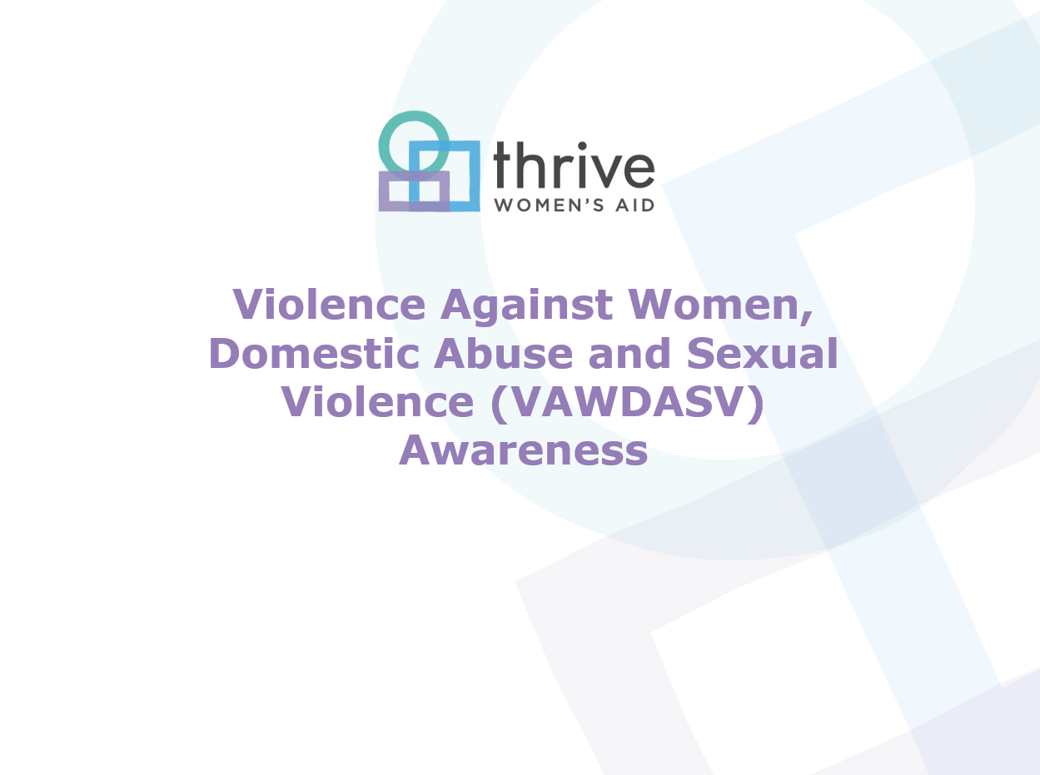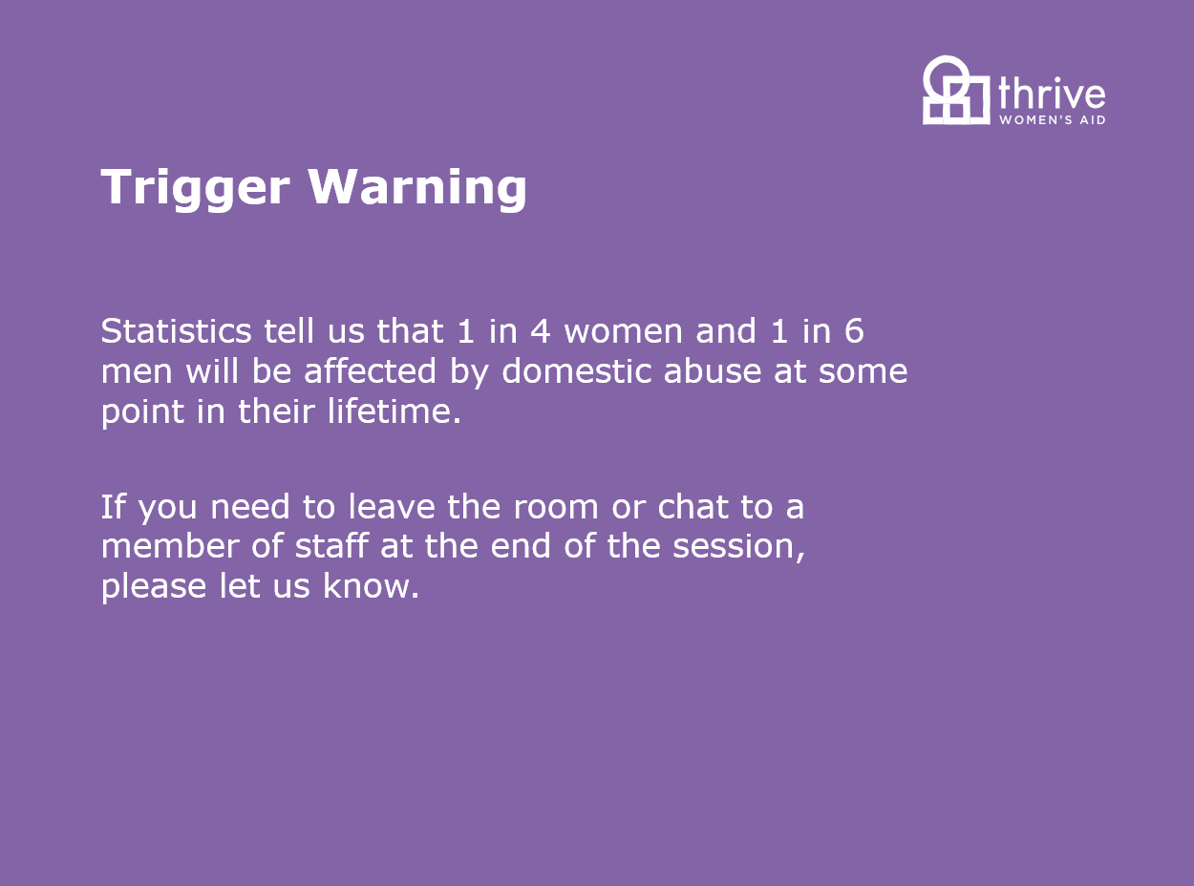
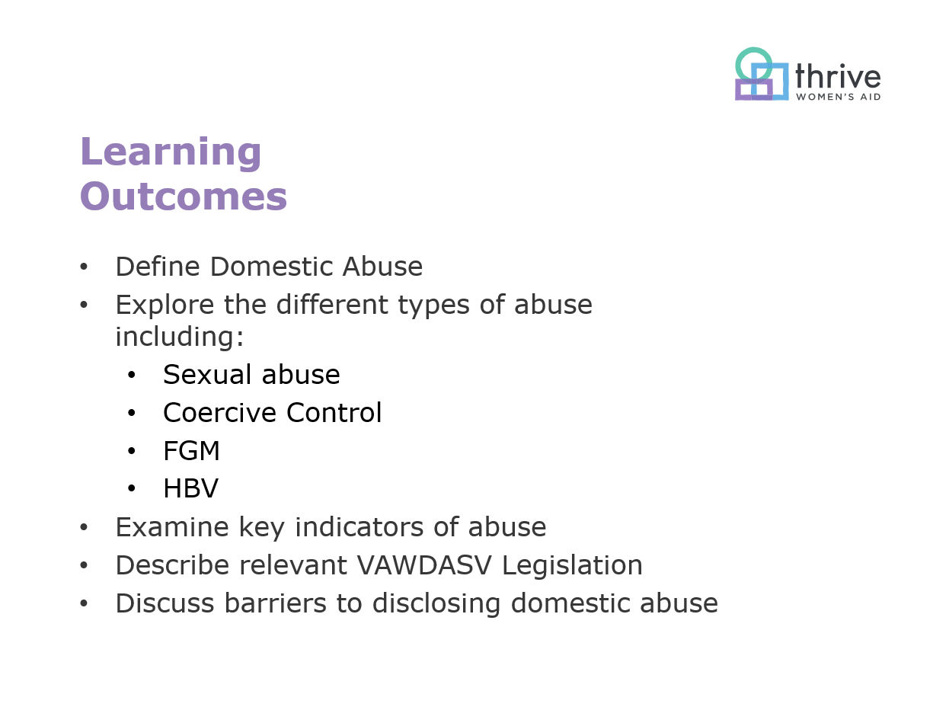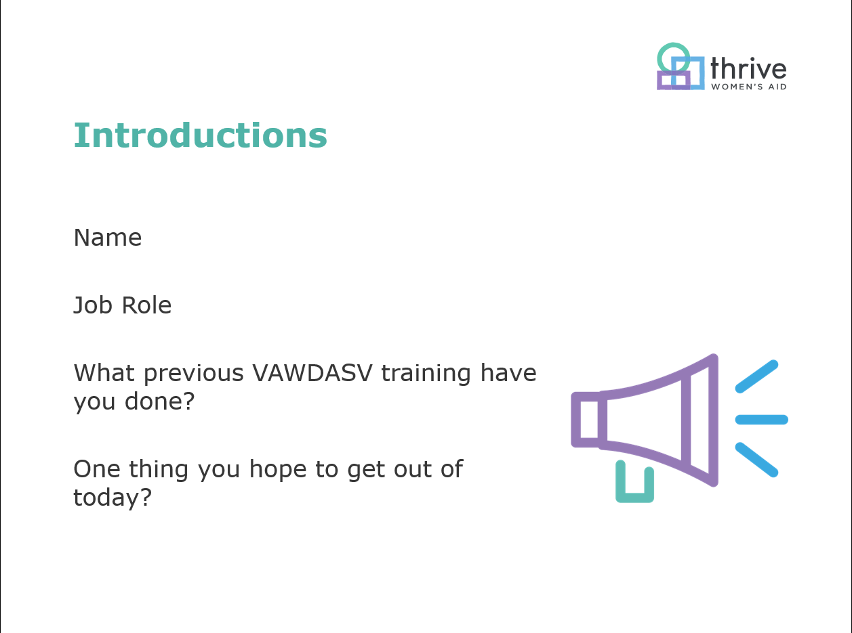
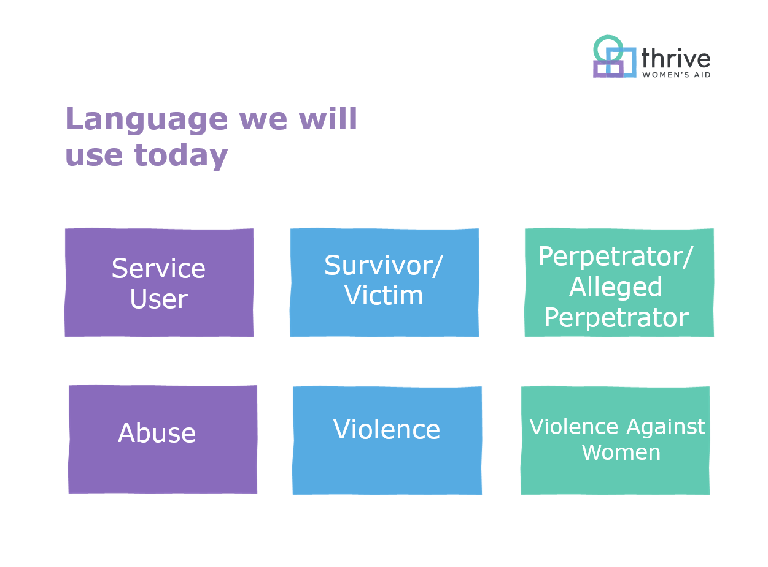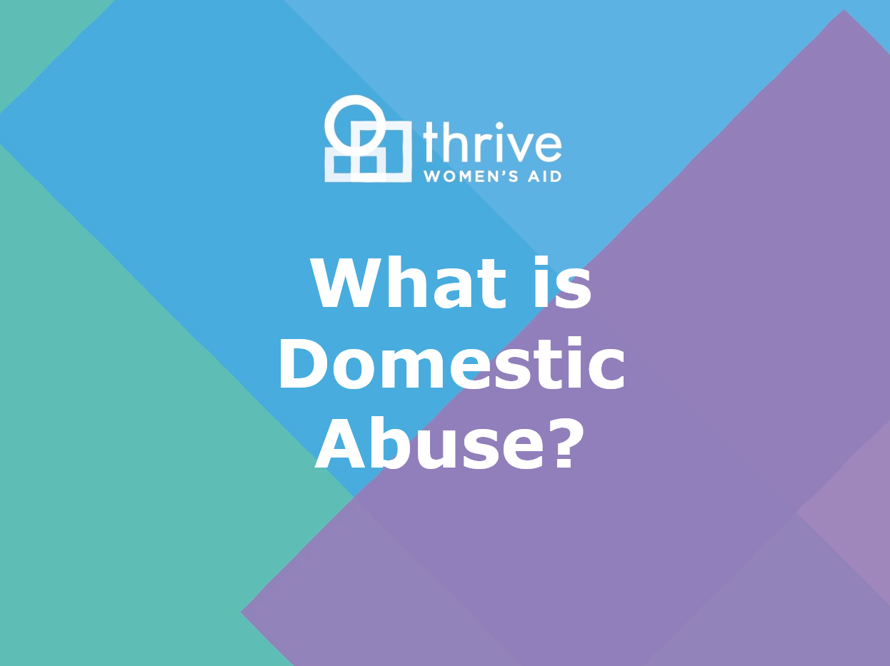
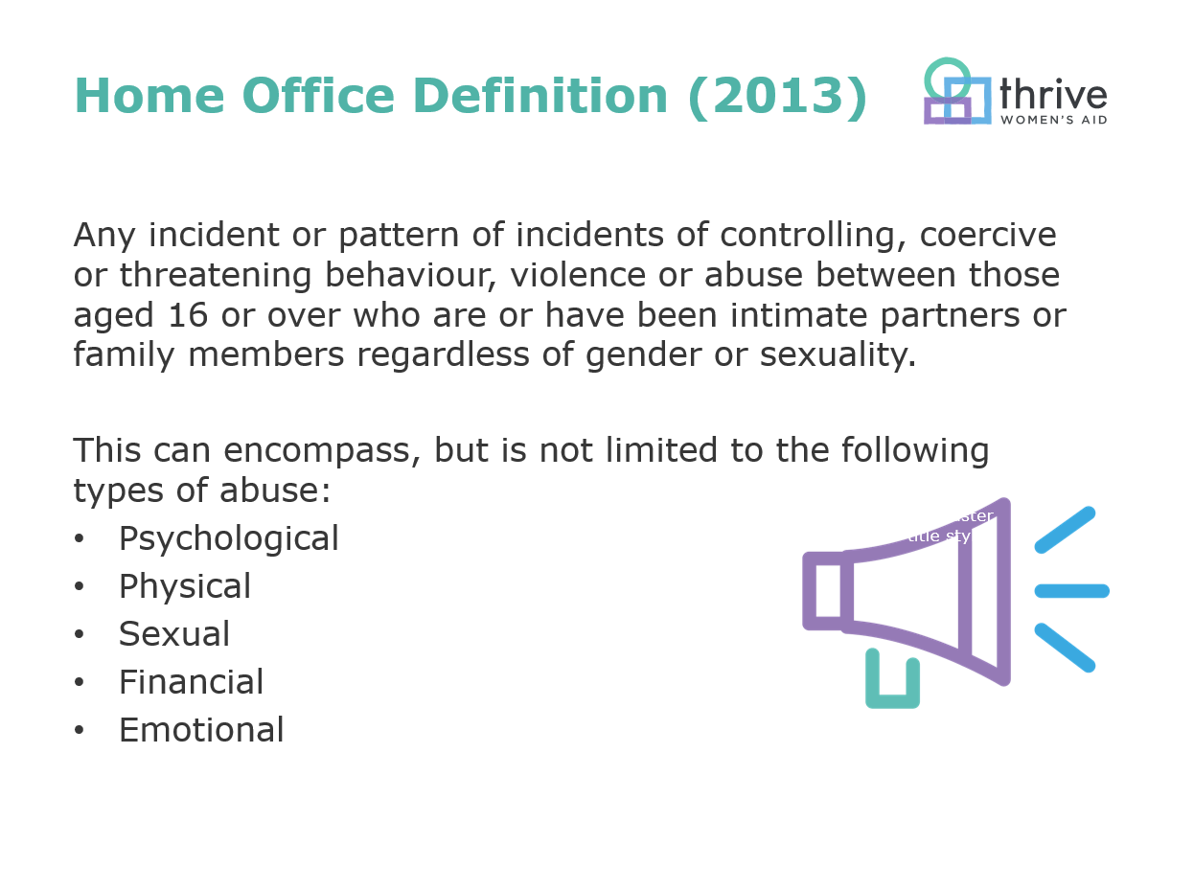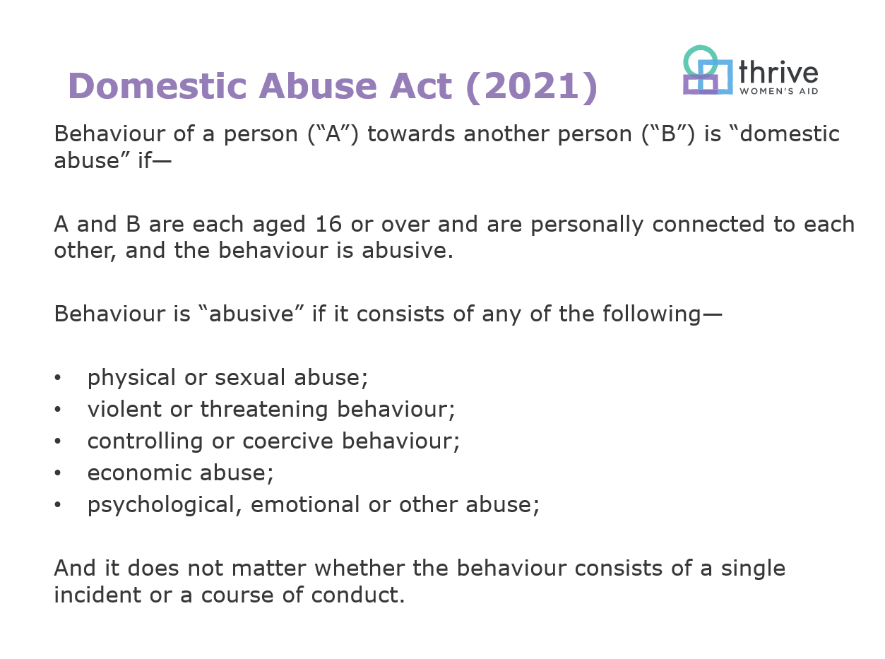
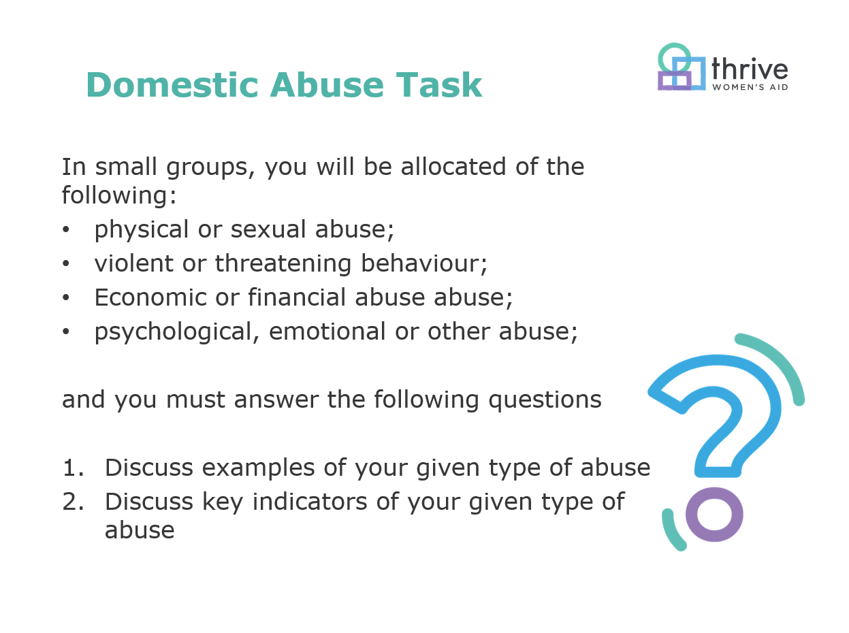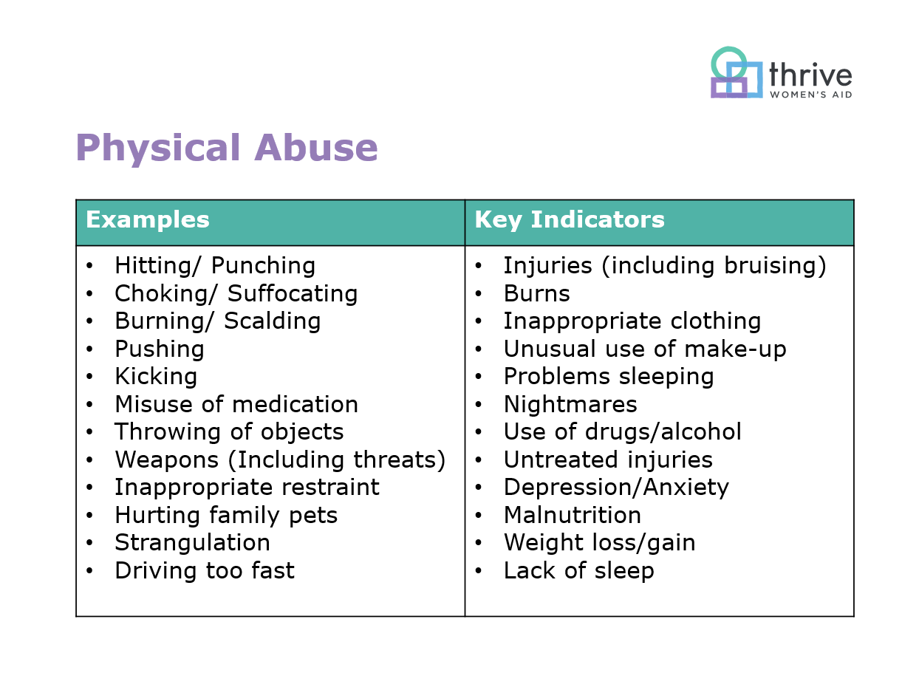
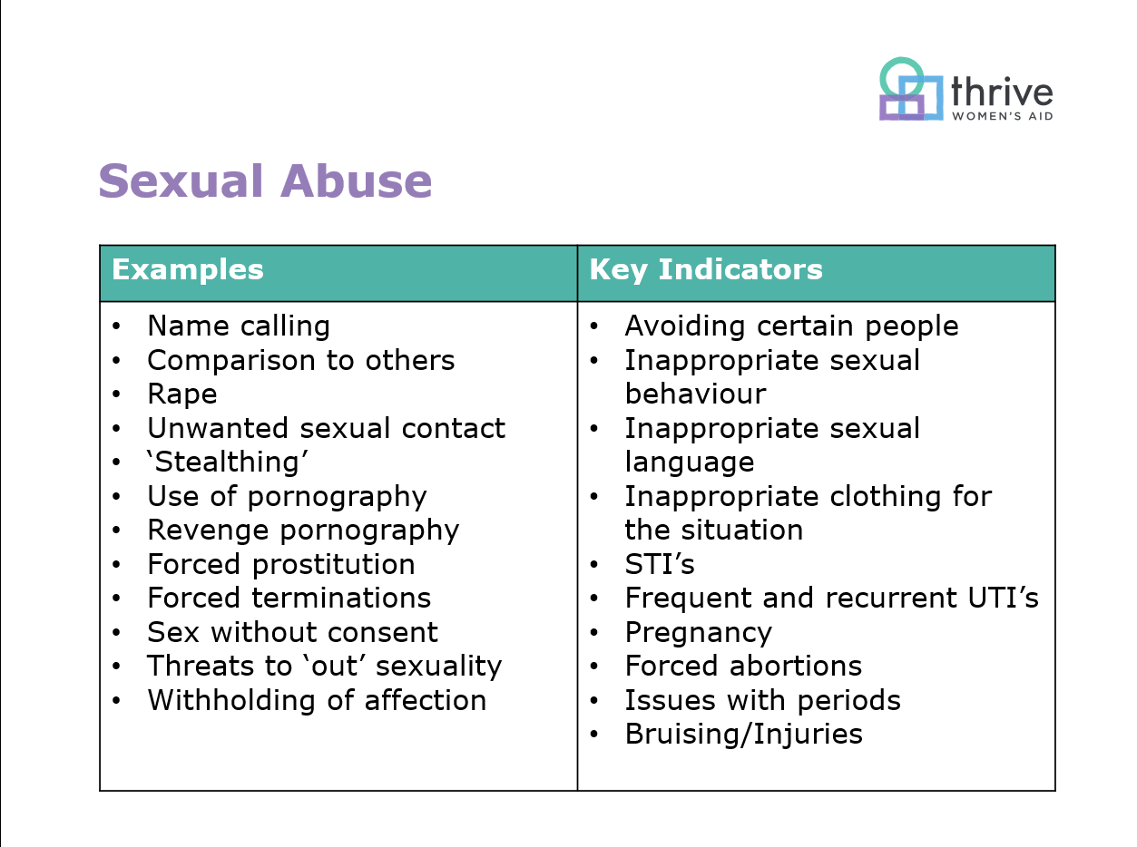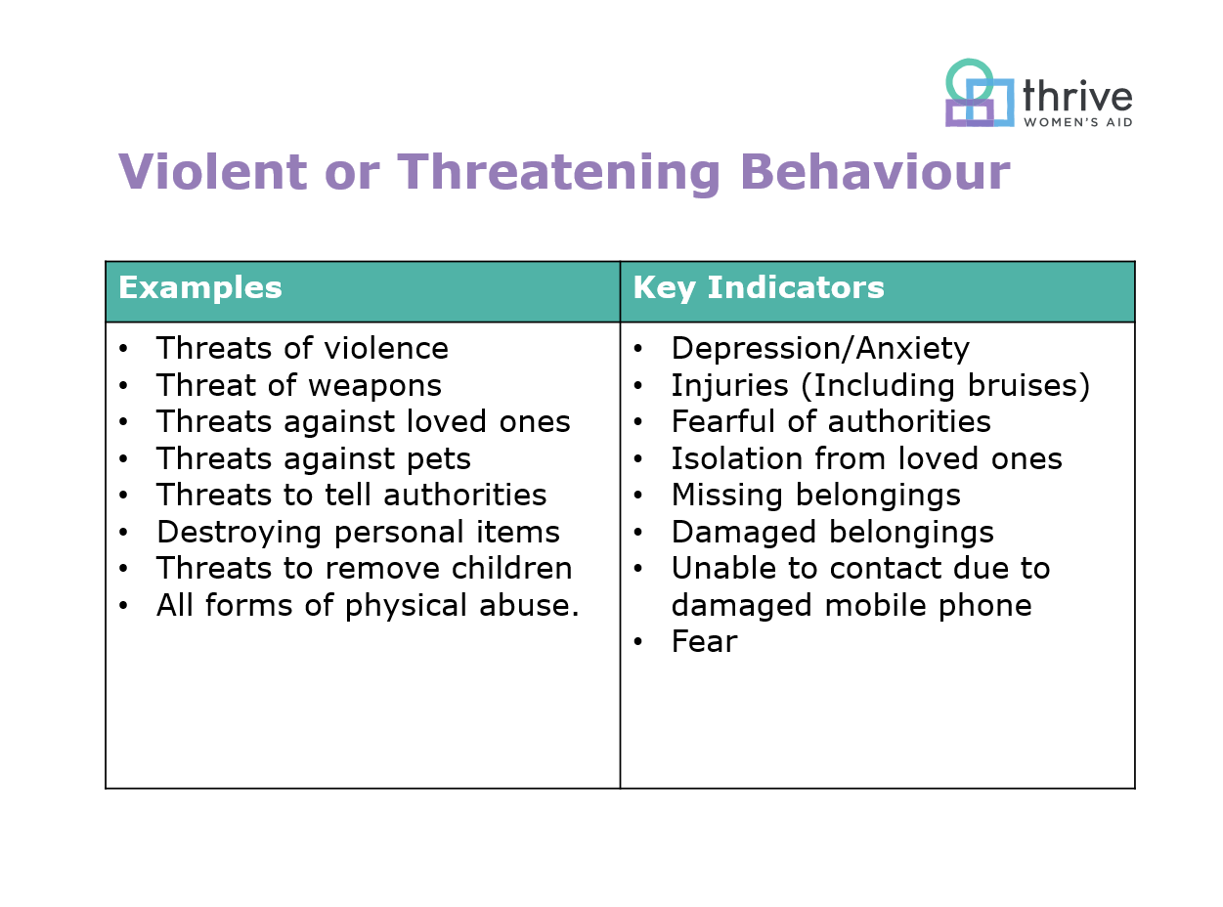
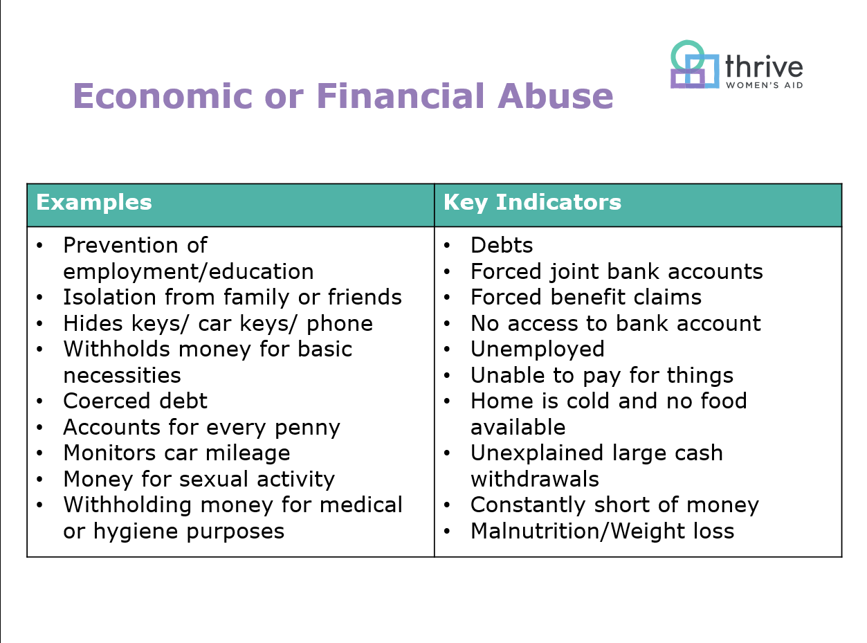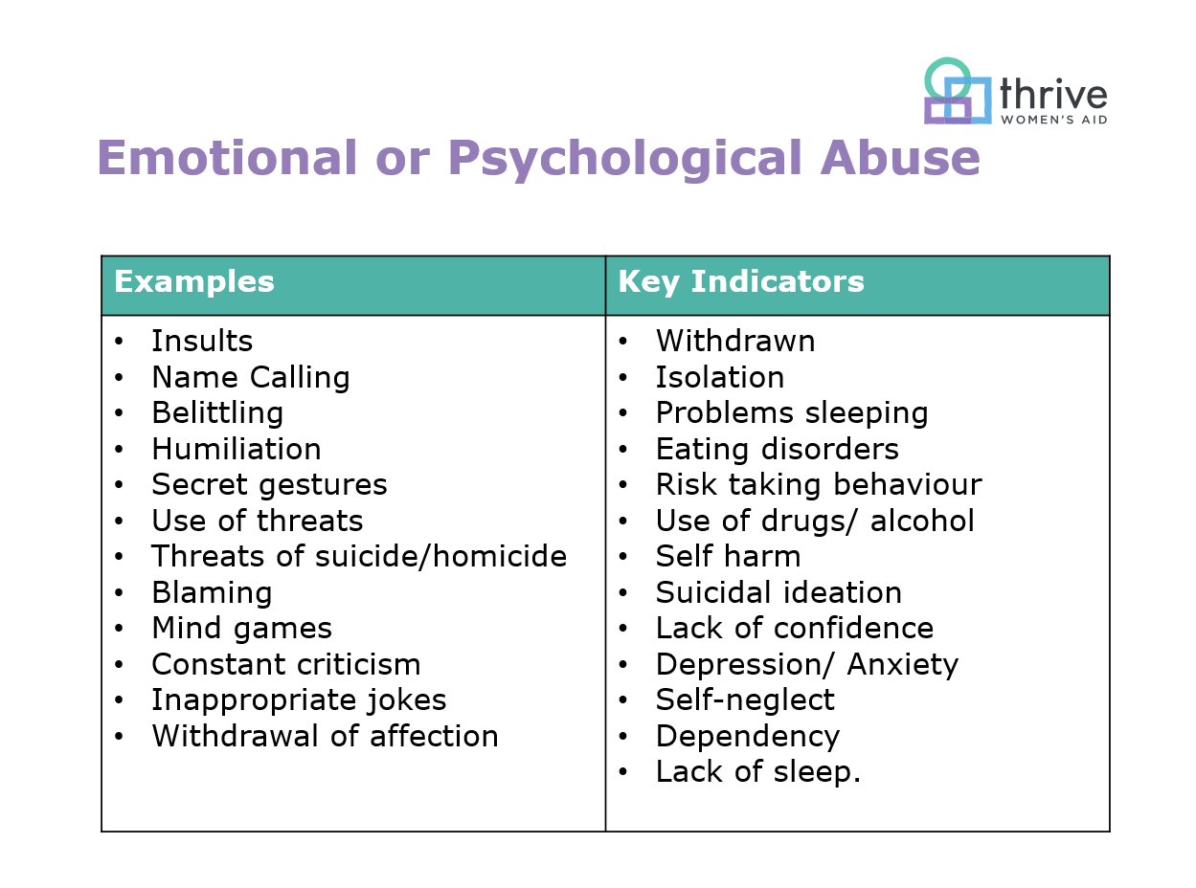
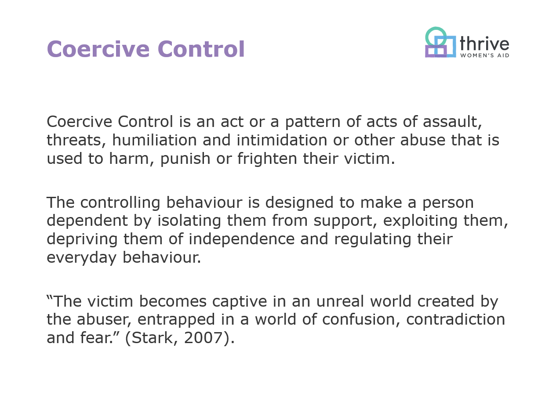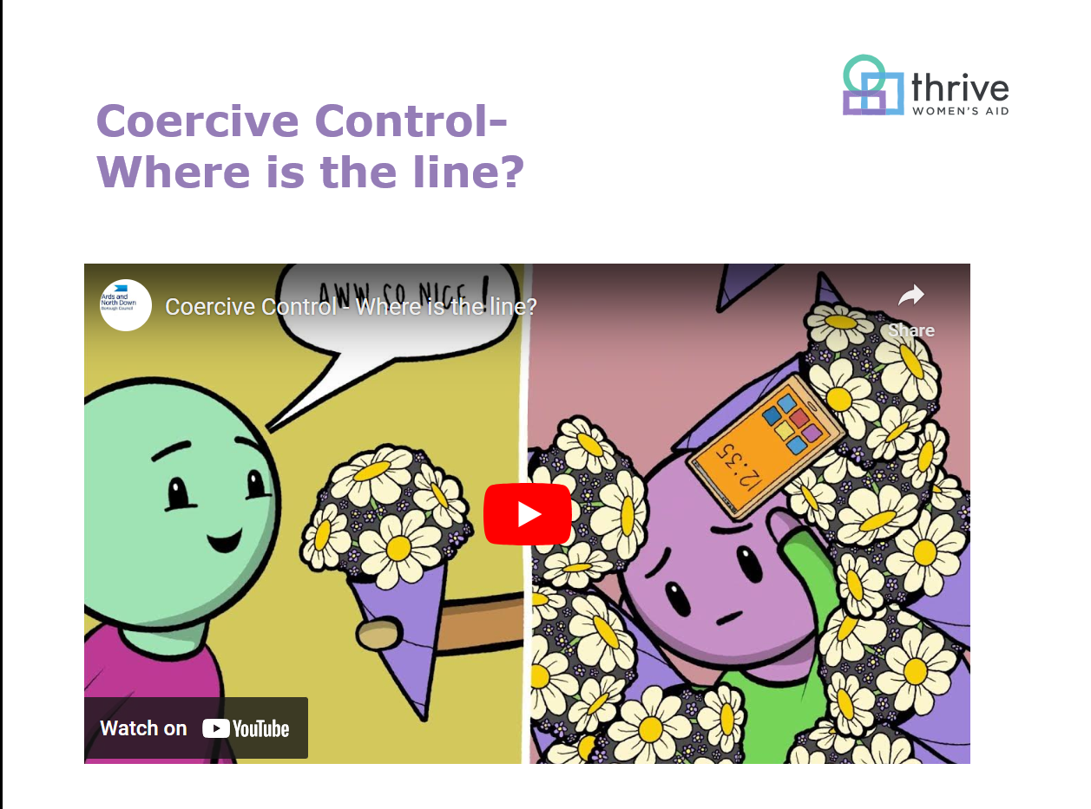
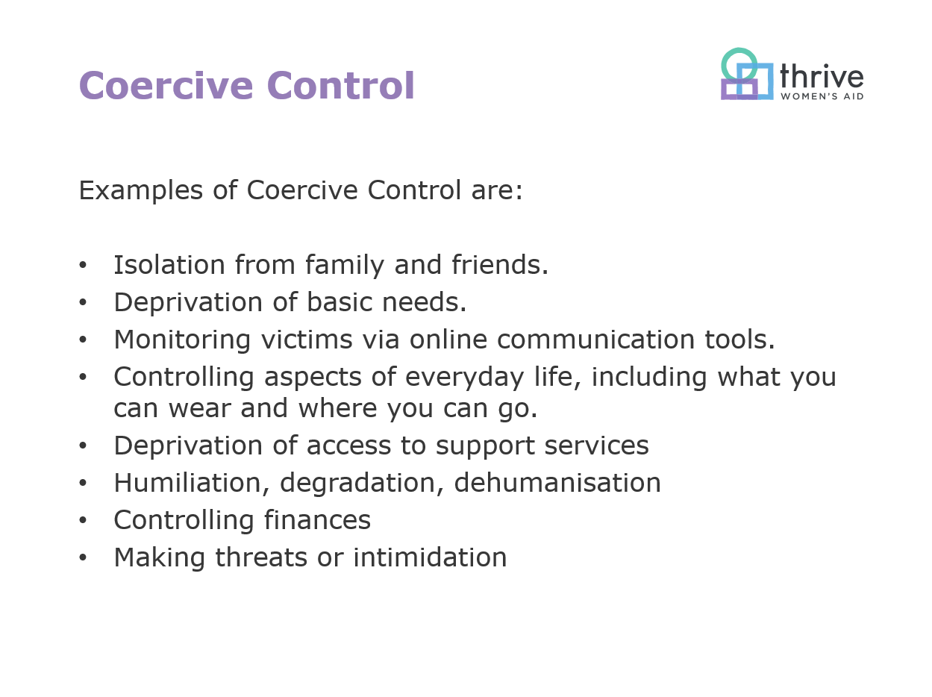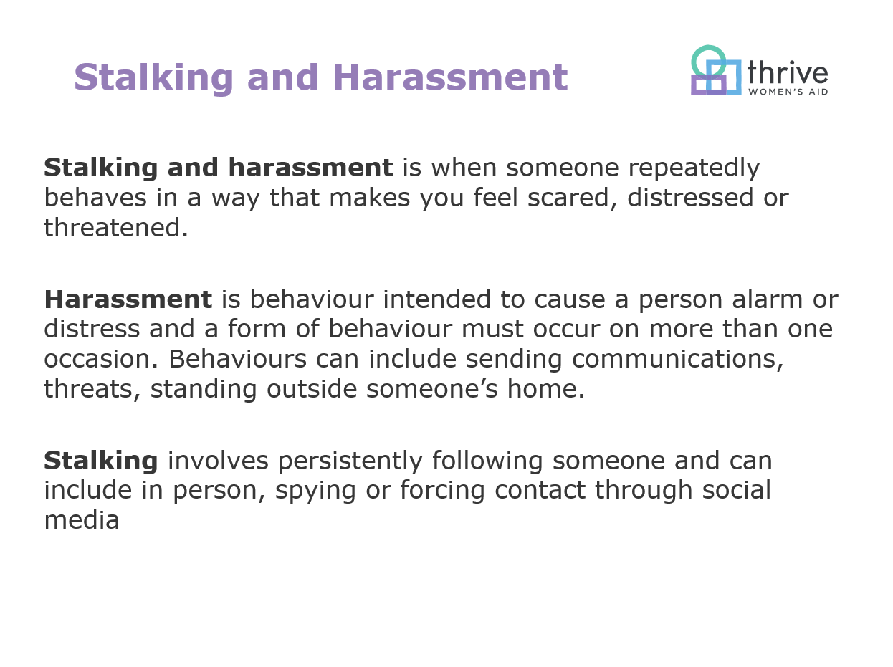
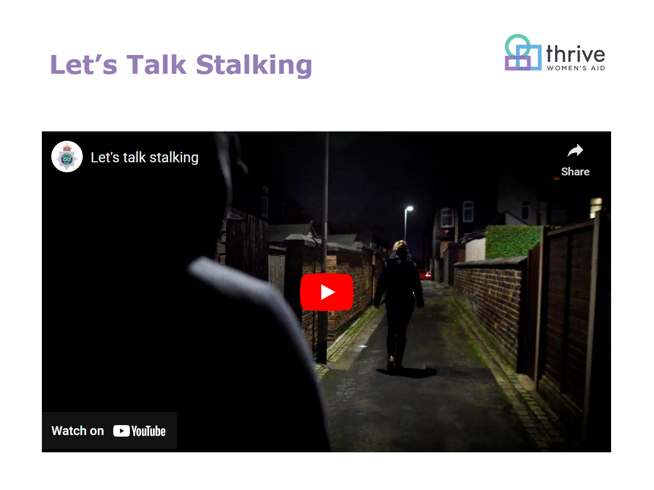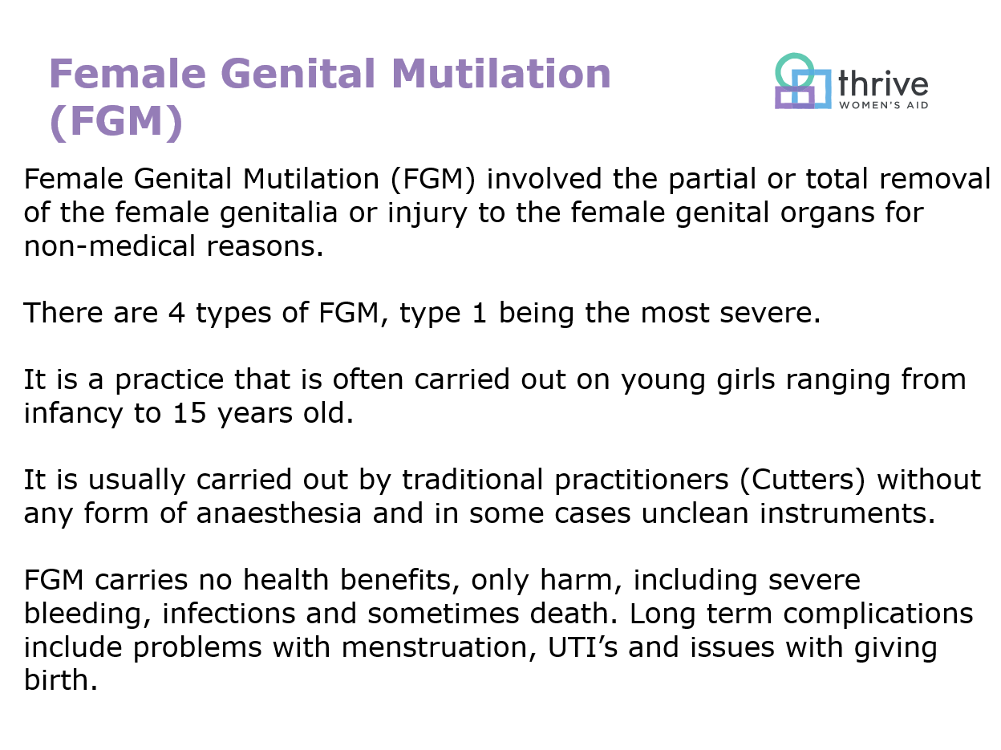
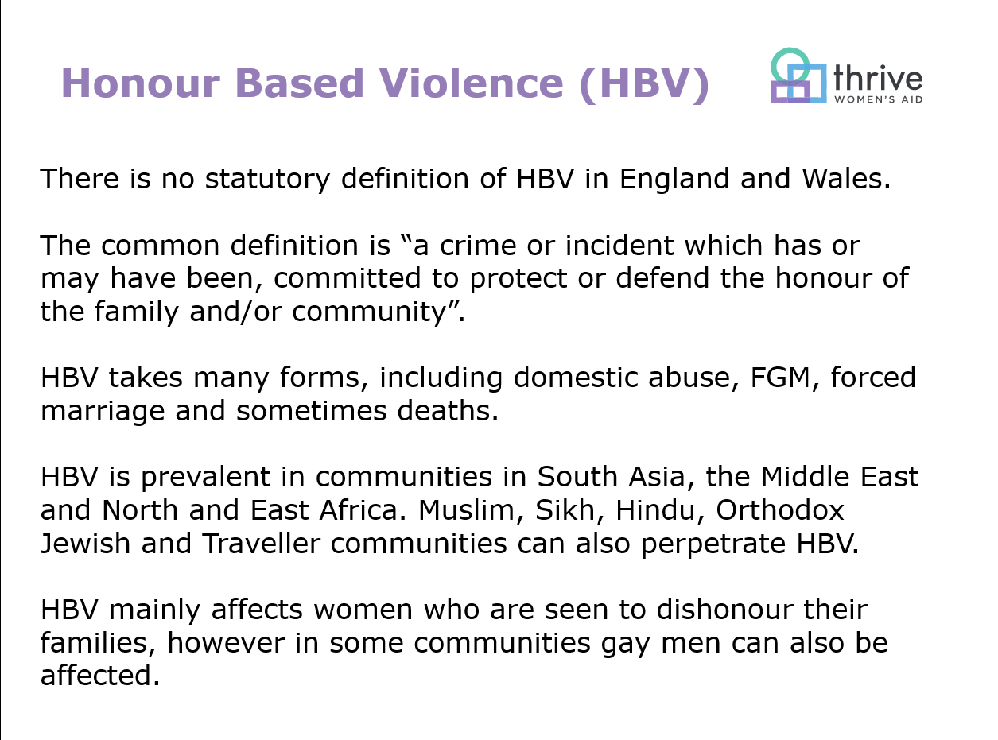
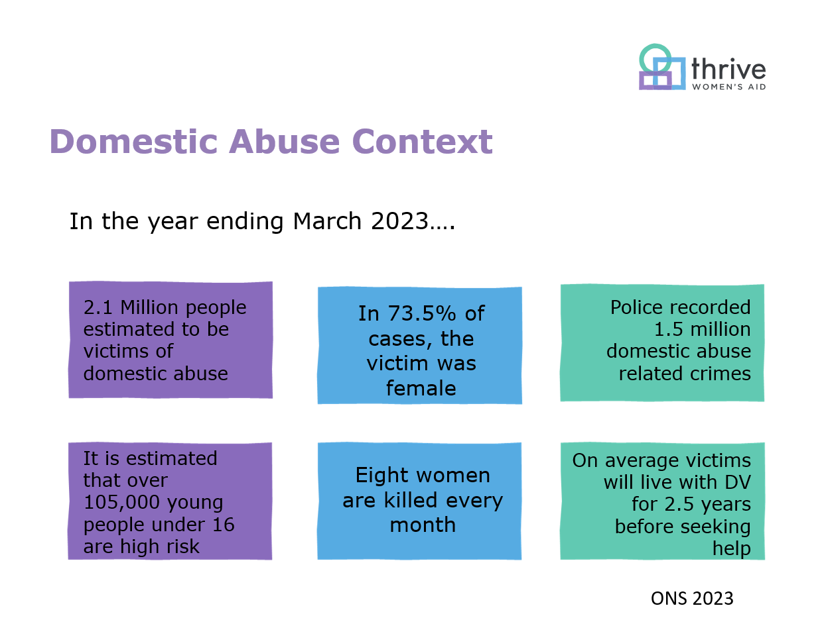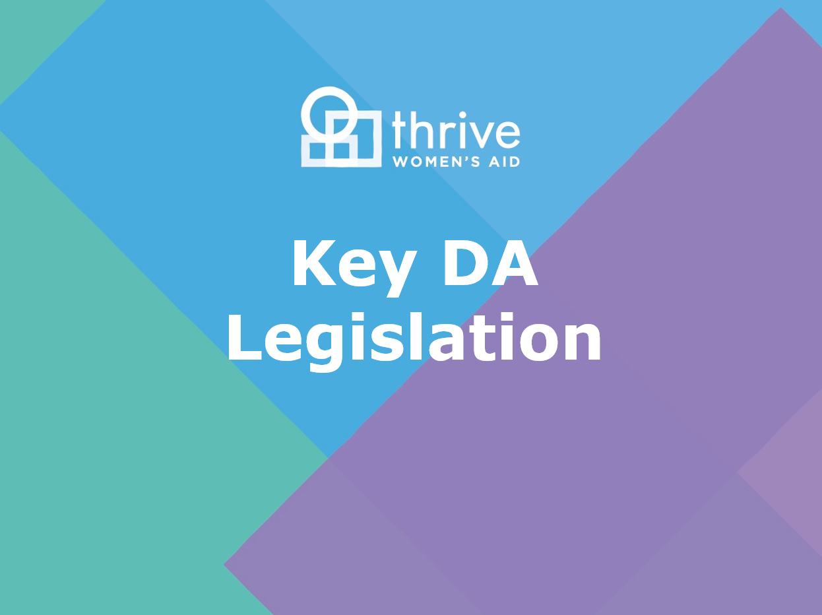
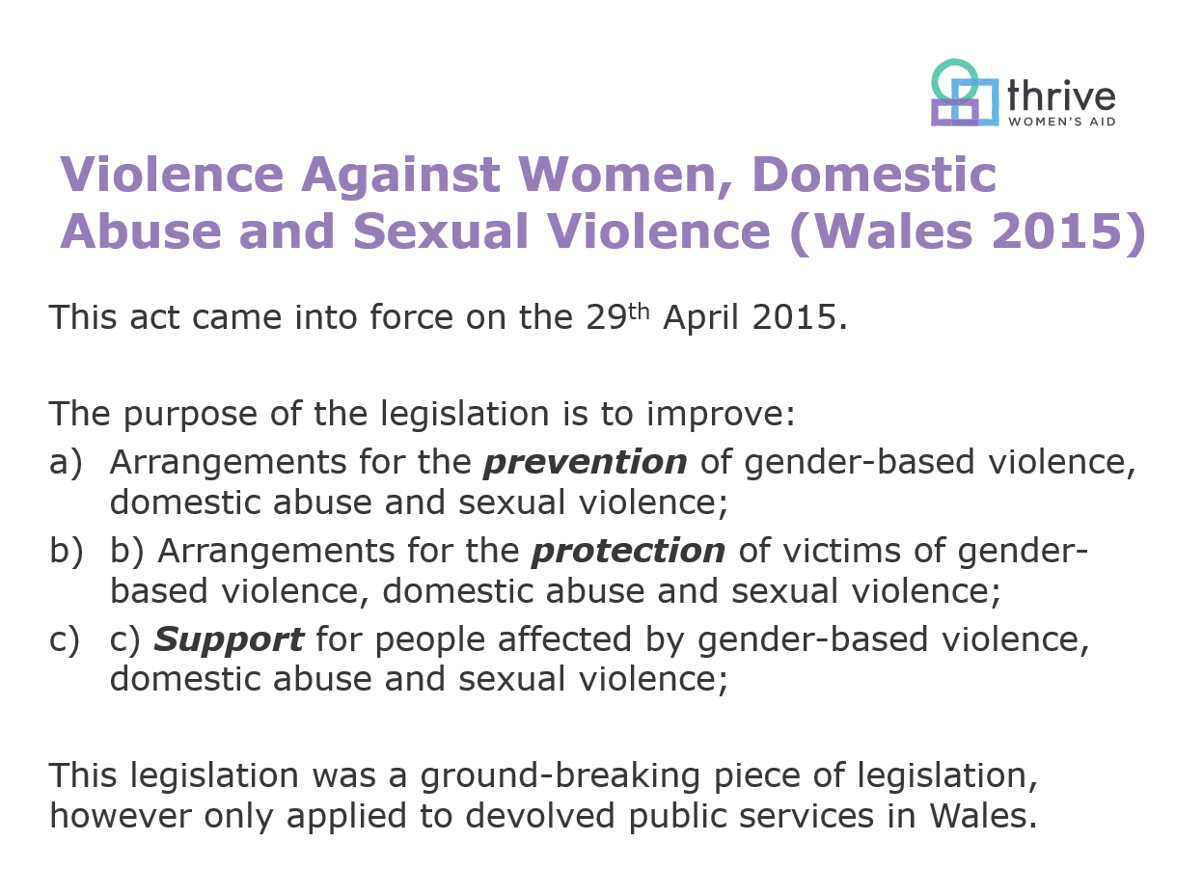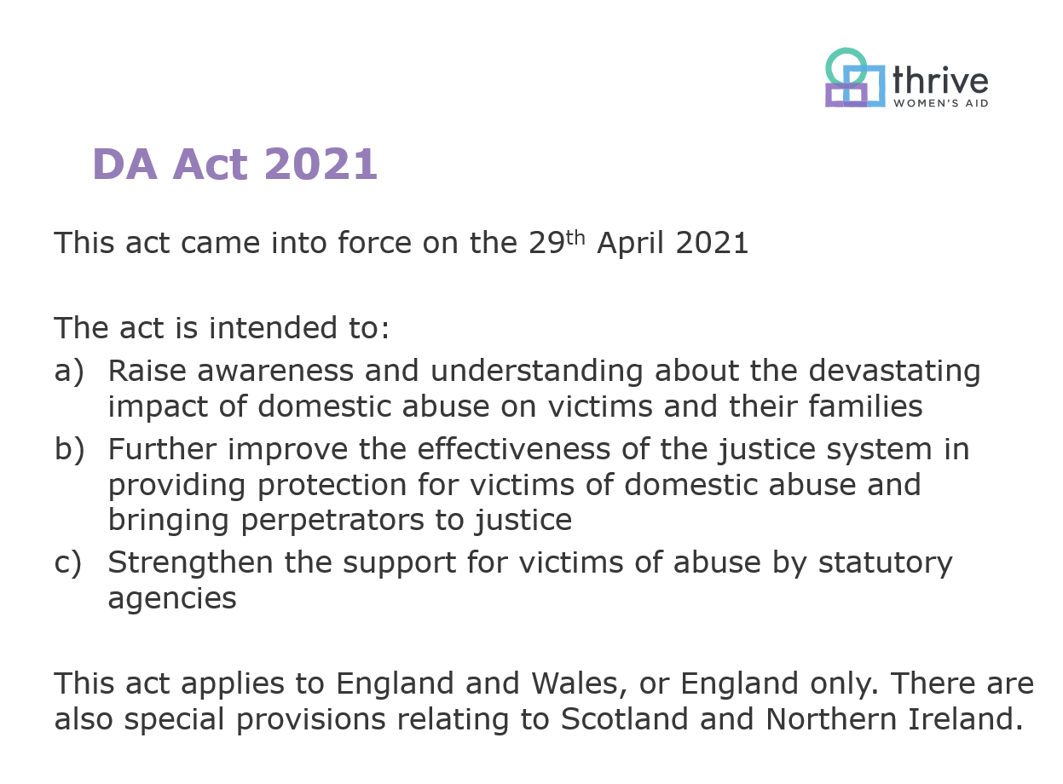
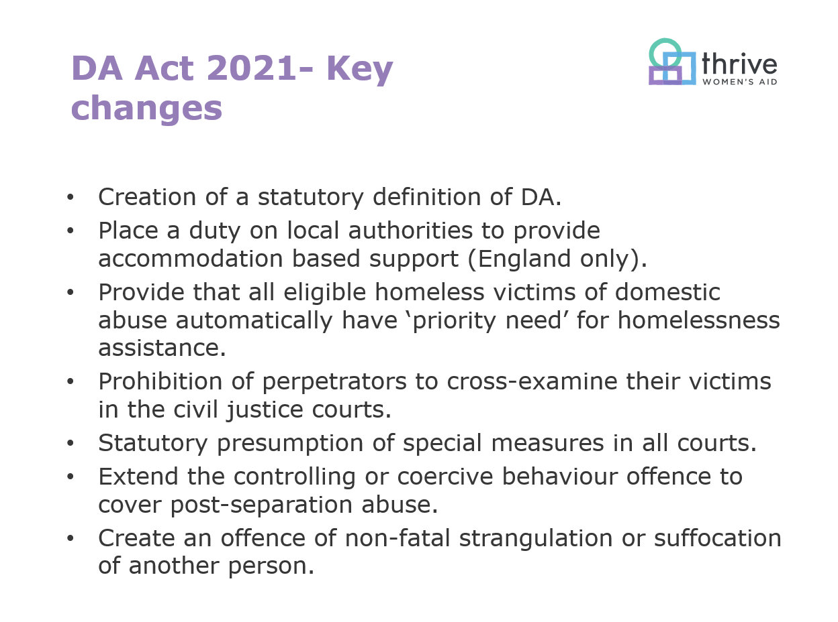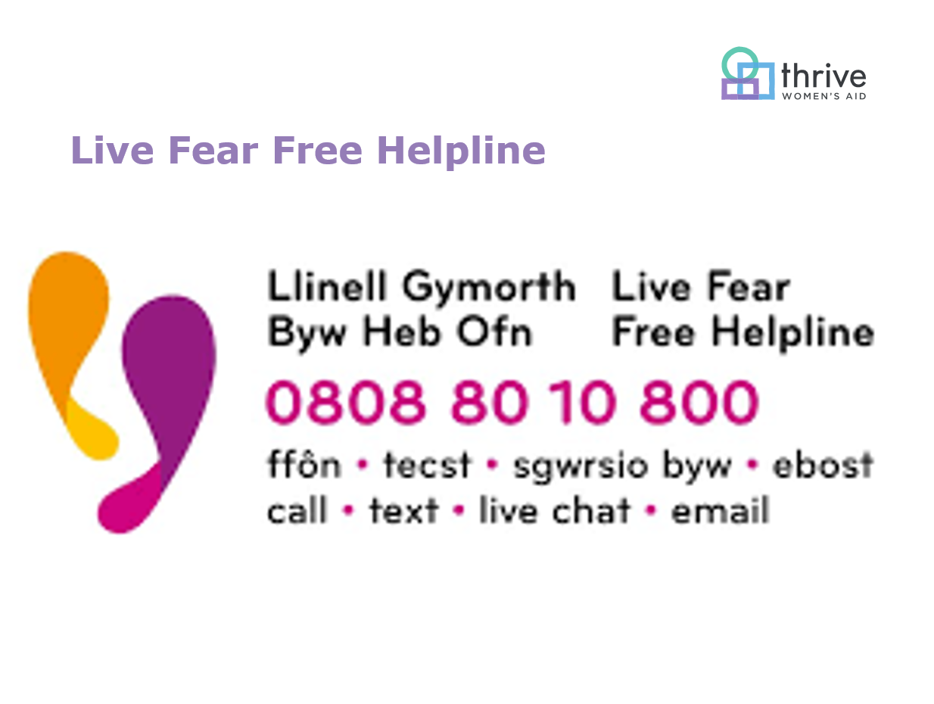

Appendix 3- Lesson 5 Lesson Plan
Lesson Plan Template

Lesson Plan

Topic: VAWDASV Awareness: Supporting Survivors |  | Class: Level 3 Understanding Domestic Abuse
Date: Day 3, Lesson 5 | Length of lesson: 2 Hours |  | Number of students: 10
Resources required:
Powerpoint projector
WIFI Internet
Aim of Lesson
The aim of this lesson is to discuss the barriers to leaving an abusive relationship and determine best practice for supporting survivors.
Learning Outcomes – The Learners Should Be Able To:
- Identify the barriers to leaving an abusive relationship
- Recognise the stages of leaving
- Determine what survivors lose and gain when leaving an abusive relationship.
- Identify the barriers to accessing specialist services
- Identify good and bad practice when dealing with victims of VAWDASV
Previous student knowledge required for the session:
This is lesson 5 out of a 6 lesson curriculum, and therefore it is expected that students will have already attended the previous lessons.
There is also a requirement that students completed two e-learning packages prior to attending this course.
Anticipated difficulties (if applicable):
It is estimated that one in four people will experience VAWDASV at some point in their lifetime and therefore it is likely that there will be a number of students in the room that may find this lesson difficult. Therefore they will be directed to avenues of support whether that is from the Wales national helpline or directed to avenues of support through their employer.
Professional Standards (where are these being met within the session)
In my practice and with others I demonstrate commitment to learners, their learning, safety, and well-being. This is done by providing a trigger warning to students prior to the lesson and providing contact details of a national helpline at the end of the session. Students will also be directed to additional avenues of support through their employer.
In my practice and with others I value and promote diversity, equality of opportunity and inclusion. This lesson challenges discrimination in all forms, as discussing domestic abuse challenges a form of gender-based discrimination.
In my practice and with others I know how to use evidence and research to improve my practice. This has been achieved by researching the most up to date research and quoting the ONS statistics for the year ending March 2023 and discussing the most recent and up to date domestic abuse legislation.
In my practice and with others I plan and deliver effective learning, teaching, and assessment. This has been achieved, by planning the lesson prior to delivery taking into account the different learning styles.

Lesson Detail:

Stage | Focus | Strategy | Time
Introduction  Development  Plenary/conclusion | Slide 1- Welcome  Slide 2- Trigger Warning  Slide 3- Learning Outcomes  Slide 4- Barrier’s task  Slide 5- 6 Stages of leaving  Slide 6- Managing the situation  Slide 7- Distortion of reality  Slide 8- Defining the abuse  Slide 9- Evaluation of the relationship  Slide 10- Ending the relationship  Slide 11- Ending the abuse  Slide 12- Gains and losses  Slide 13- Leaving  BREAK  Slide 14- Barriers Task  Slide 15- Immediate needs  Slide 16- Good Practice  Slide 17- Bad Practice  Slide 18- Safeguarding Responsibilities  Slide 19- Helpline | Welcome participants to another lesson and remind them of the housekeeping arrangements.  Remind participants of the content of the lesson and remind them that the need to signal they are ok if they leave the room.  Read the learning outcomes out loud  Split the room into pairs, allocate each pair one group and ask them to discuss the barriers that these groups face when leaving a relationship. Allow time for feedback also.  Introduce the 6 stages of leaving. Note that this was developed by Liz Kelly. These stages are not linear, but research has been conducted in that all victims will undergo these stages of leaving at some point, but a victim may visit a stage more than once.  Read the information out and discuss that it is likely that the victim has experienced coercive control long before they become aware of it. They use negative coping mechanisms, and the ways to manage the situation aren’t successful in stopping the behaviour.  Read the information aloud, and explain that at this stage the victim often loses their own sense of reality and makes excuses for the behaviour.  Read this information and explain that this is the stage where the victim becomes aware that they are experiencing abuse and this is not normal. At this stage they are not considering leaving so they are deploying the coping mechanisms.  Read the information, discuss at this stage, the victim is reconsidering the relationship, however isn’t taking any steps to leave at this point, however may reach out to services to evaluate their options.  This is the stage where the victim has decided to leave, This is the riskiest stage and involvement of the police or other services may be involved in assisting the victim. The abuse does not end at this stage.  This is the stage where the abuse finally ends, this is where the perpetrator ends the abuse and this may happen years after the relationship has finally ended.  Split the room into two groups, give each group one category, and a few minutes to discuss what either the victim would gain or lose, ask the gains group to feedback first and write a list on a flipchart. Then ask the losses group to go next, and note the list. Once this is done, make the room aware that the loses are usually immediate and the gains may never happen.  Before this film is played, present a trigger warning to the students and explain that this film is used to uncover the difficulties that someone has when leaving  Offer a 10 Minute Comfort Break  In the same groups as earlier, ask the groups to discuss the barriers that those groups face when seeking specialist support such as Women’s Aid. Allow each group to feedback.  Discuss each point in turn and ask participants to shout out what would be the immediate needs in that section and how they could be overcome:  Safety- Is the victim on their own or can they attend somewhere, where they can be or is police assistance needed?  Housing- What is the victims housing situation, do they need the locks changed urgently, do they need additional safety measures such as window locks or do they need to move out?  Injuries- Does the victim have any injuries that need immediate attention? Does the victim need to see a SARC centre for a forensic examination?  Children- Where are the children, are they safe and at this stage it is worth figuring out who has parental responsibility for the children.  Refuge- does the victim need emergency accommodation such as refuge, are there any spaces locally that are suitable for her and her children?  Legal- Does the victim need any emergency orders such as a restraining order or need support to make a statement so that an arrest can be made?  Before the information is revealed ask the students to split into small groups and discuss positive and negative ways that support can be offered to victims. Then read the information out.  Read this information out, explaining that confronting the abuser will put you and the victim at risk. Acting without their consent may have exceptions which includes safeguarding responsibilities as you may have to make a referral to social services without consent.  Read the information out and explain that this has come from the Social Services and Wellbeing act. And even though third sector charities do not have a mandatory duty to report, it is still expected that workers report any concerns to the relevant authorities should they have any concerns.  Thank learners for attending the session and should they need any additional support they can contact the helpline | 2 Minutes  2 Minutes  2 Minutes  10 Minutes  5 Minutes  2 Minutes  2 Minutes  2 Minutes  2 Minutes  2 Minutes  2 Minutes  10 Minutes  25 Minutes  10 Minutes  10 Minutes  10 Minutes  10 Minutes  5 Minutes  5 Minutes  2 Minutes  Total: 2 hours

Assessment Strategies: when and how are they included within the lesson?
This lesson will use formative assessment strategies throughout the lesson, firstly the lesson asks the groups to discuss the barriers that certain groups face when they are leaving an abusive relationship. There will also be a similar activity after the break where the learners are asked to discuss barriers to accessing specialist support services.
It is also expected that the students will discuss gains and losses as a formative assessment tool, along with best practice guidelines.

Informal reflection (to be completed after the session)

Appendix 4- Lesson 5 Resources


