Student name: Thomas Bennison
P number: 2101111
Programme of study: BA (Hons) Graphic Design
Module: ADAD4018 Ways of thinking

Tasks in the order I received them:
Task One: Semiotic Analysis = 500 Words
Task Two: Manifesto = 500 Words
Task Three: Practice based writing = 500 Words

SEMIOTIC ANALYSIS

Semiotics is a quintessential part of everyday life; we use it to understand our surroundings and infer information. We use it to understand symbols and it helps us to keep safe and benefit our society. Another use for semiotics is to raise awareness for charities and for benefiting those in need. The red ribbon is an example of this, and it is used to raise awareness for the AIDs virus, the ribbon goes towards helping those inflicted and the movement to provide a cure to stop the virus from moving forward any more than it has progressed.


The idea of the ribbon alone stands for the support and further awareness of those in need. An example of said ribbon would be the pink ribbon which goes toward the active charities that help those who have been diagnosed with breast cancer, the symbol raises awareness and helps to raise money towards the charities and pushes help and support for those who need it. Furthermore, as the signified part of the image it is a straight bridge to raising awareness and a better understanding of how to tackle the issue at hand in a much deeper manner. An example of the awareness being raised is through the book written by Elton John called Love is the cure where he goes over his life during the AIDS years and his take on losing many friends during the epidemic it goes toward the narrative as a whole

The fact that the ribbon is red can be inferred in different ways to the viewer, in many ways it symbolises blood or the human condition, both are ways that the ribbon above is understood by many of those who perceive it, it allows them to gain an understanding of the virus itself. The two conditions of the image create an understood symbol that pushes the narrative of the danger of said virus. The image has no concern able text to show the viewer so the information is purely inferred for the viewer which allows the symbol to be as important as it is for raising awareness of the issue. Another book that goes through the awareness of the condition is How to survive a plague, it shows the damage it caused and how people made it their lives work to find a cure. Finally, another book used is When we rise that goes through the damage caused to those who searched for a new beginning during the epidemic and how awareness can be spread using many means including literature and how it can express to the viewer what it was like to live during a life of constant fear of such a dangerous virus

My understanding of the image has changed through the information provided to me by semiotics and has further allowed me to infer the information, I have gained onto other sources that are like greatly benefit my knowledge of not just how to spread awareness but to expand my understanding of the virus.

MANIFESTO

My core beliefs allow me to be a better person through the way that I both compose myself and present myself to others and surroundings.

The first of my beliefs is that the only way to have a friend is to be one, I believe this because to have a friend is to at first prove yourself to them, this means that through this you can gain a level of mutual respect and trust. Through this you can gain a stronger level of mutual admiration. In practice I am there for my friends when they need me and through this it both benefits my own well-being along with theirs. Furthermore, through pushing my friends to be honest to themselves and those around them I believe that it allowed them to grow as people. Through this own belief I think that it has allowed me to become a better friend and overall.

The next core belief that I have is that the purpose of life is to be happy, as a person I try to put my own mental health before everything else in life, this is because I believe that it is quintessential to my own well-being, as for the statement I believe that a life without happiness is a life not worth living. One needs to be understanding and transparent to allow themselves to be happy, this is because if a person lies to themselves then they cannot understand how to improve their own mental health and therefore improve their surroundings and community as a result of this. Moving forward a person who understands that the meaning and purpose of life is to be happy will lead an honest and healthy life. To ‘Hope and help your nerves’ (Dr Claire Weekes) is a good way to understand how to deal with your own mental health and therefore improve upon your own life situation. Talking to another person can benefit your own life and therefore you can get a taste of how someone else feels in the situation (Lori Gottlieb).

Finally my last core belief is that happiness can be found even in the darkest of times, even a simple quote by a fictional character resonates with me because of the fact of how honest and relatable it, I have found that even at my lowest to look for happiness is to allow yourself to be free as a person, people need to understand that if they do not reach out and ask for help during dark times in their own lives then they cannot grow or develop themselves to better understanding people. To search for happiness even at your lowest is to branch out and help others who are in similar situations, without doing so our mental health suffers. Understanding that not everything is in your control is one step further to finding happiness (Mark Wolynn) In conclusion my core beliefs designate with mental health as it is what I am passionate about as someone who struggled with it.

PRACTICE BASED WRITING

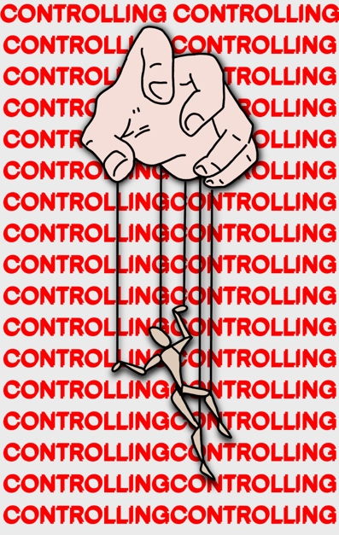
This is an art piece that I created during my A-level course in graphic design. The piece shows a man being suspended from a hand being controlled like a puppet, the image I created represents being controlled by society within the ways that we act daily, I initially created the piece to reflect how we are manipulated by those around us and how every act that we have has a consequence on someone else overall. I believe that the image does convey that narrative but there needs to be some groundwork to help the viewer understand the overall message that I am trying to push the through the image overall.

Through the image alone I understand that most things we do in our society we do to please another, and this can lead to us acting in ways that do not represent our own beliefs nor our understanding of the workings within our surroundings, we actively change and hide who we really are to appease others and that in turn changes everyone’s perspective on who we are. A better understanding of the message that I am showing is that we are subconsciously being led by others’ opinions and world views rather than moving on our own volition. Though I tried to convey this I do not believe that the message comes across clearly to the person who views this image.

I used information from the book ‘so you’ve been publicly shamed’ by Jon Ronson, the book goes over how society has control over people’s opinions and how them being publicly shamed for having their own opinions can change who they are as a person and causing them to retreat into themselves for being publicly outspoken, the quote from the book ‘A great renaissance of public shaming is sweeping our land’ goes toward this point.

Another book that shows this is the book The Undiscovered Self which is about how people act unconsciously as if they are being controlled by someone else’s narrative as a result of an overly oppressive society and how it can dictate the way that we act on our own thoughts and volitions, I wanted to convey a similar message through my own image, but I do not think that it is as clear as it could be overall.

One final book that I used as both reference and inspiration is the book Hidden Agenda which talks about mass opinion and how it buries facts and danger to push a bigger narrative, it talks about war in Iraq and poverty in Haiti and how the fact that it is hidden from the general public is an example of controlling the narrative by pushing other opinions towards the reader and how it can negatively affect the outlook of the situation as a whole, the book goes on to discuss the cover up of the gulf war which actively goes towards my point of society pushing a false narrative towards readers which causes damage overall to everyone.

BIBLIOGRAPHY
Jonson, R (2015) So You’ve Been Publicly Shamed. Riverhead Books Publishers
Jung, C, G (1961) The Undiscovered Self. Signet Publishers
Pilger, J (1998) Hidden Agendas. New Press Publishers
Weekes, C (1969) Hope and help your nerves. Berkley books
Gottlieb, L (2019) Maybe you should talk to someone. Mariner Books

Jonson, R (2015) So You’ve Been Publicly Shamed. Riverhead Books Publishers
Jung, C, G (1961) The Undiscovered Self. Signet Publishers
Pilger, J (1998) Hidden Agendas. New Press Publishers

