

Student name: Bouadoua Sylvie Kouao
Student ID: 2417904

Module name: Building your Personal Brand for Sustainable Employment

Module code: BMHP5015
Lecturer name: Brian Mashumba

Table of contents

1.Introduction
2. Job description of the selected job
3. Analyse the skills needed for the job and assess your skills and experience
4. Drawing on reflective learning from Units 1–4

5. Building My Personal Brand and Professional Identity

6. Building a Professional Network

7. My Health and Social Care Experience and Qualifications

8. Action Plan and Timeline (Five-Year Plan)

9. Resources Needed

10. Communicating My Skills to Employers
11. Conclusion
12. Reference

Report – Care Manager in Domiciliary Care (UK)
1. Introduction
The health and social care sector in the United Kingdom continues to evolve due to increasing demand for community-based services, an ageing population, and the growing emphasis on high-quality, person-centred care. Domiciliary care plays a crucial role in enabling individuals to maintain independence in their own homes, and the Care Manager position is central to ensuring safe, effective, and compassionate service delivery. As regulatory expectations increase and workforce challenges persist, the role requires a combination of leadership capability, cultural competence, professional communication, and a strong understanding of Care Quality Commission (CQC) standards.
This report critically analyses the employability skills required for the role of Care Manager in domiciliary care. It evaluates my current skills, strengths, and areas for development in relation to these expectations. It also presents a detailed five-year action plan outlining how I intend to progress towards this career goal. The report draws on learning from the BMHP5015 module, including theories of personal branding, cultural competence, opportunity recognition, wellbeing, and sustainable employability. These concepts provide a framework for understanding how I can strengthen my professional identity, enhance my visibility within the sector, and build a supportive professional network that will contribute to long-term career success.
In addition, the report reflects on the barriers that have previously affected my career progression, including challenges with professional English communication. By acknowledging these limitations and identifying strategies for improvement, the report demonstrates how reflective practice can support personal growth and readiness for leadership roles. Ultimately, this introduction sets the foundation for a comprehensive analysis of the skills, behaviours, and developmental steps required to achieve my ambition of becoming a Care Manager within the next five years.

2. Job description of the selected job
To ensure accuracy, a current vacancy was sourced from Indeed (2026) for a Registered Care Manager – Helping Hands, Bromley. The screenshot below shows the vacancy used for this assignment.
Screenshot of Vacancy Registered Care Manager – Helping Hands, Bromley (£47,250 per year) (Indeed, 2026) 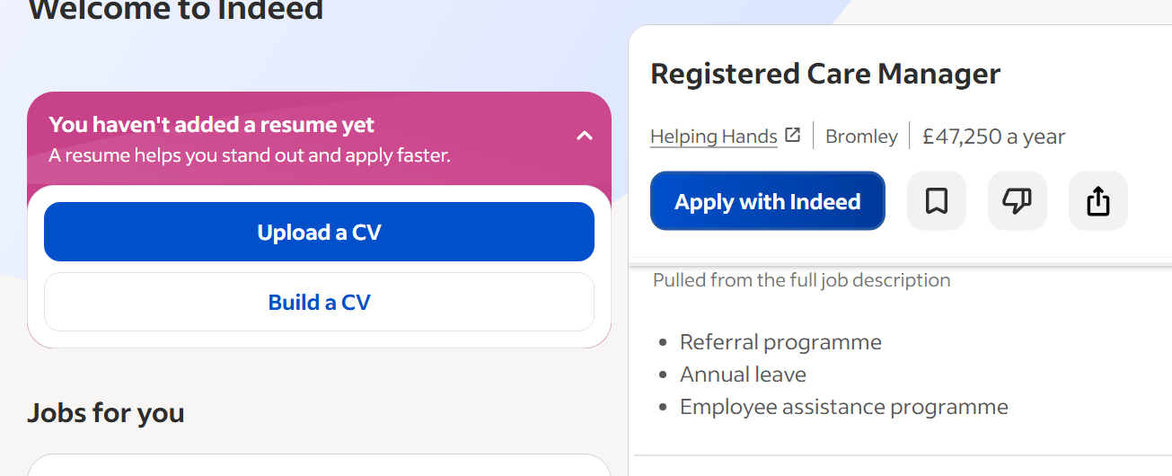

Key Responsibilities
According to the job advert (Indeed, 2026), the Care Manager role includes:
- Leading and managing the domiciliary care service
- Ensuring compliance with CQC regulations
- Conducting care assessments and reviews
- Managing staff rotas, supervision, and performance
- Maintaining accurate care plans and risk assessments
- Ensuring safeguarding procedures are followed
- Liaising with families, professionals, and local authorities
- Supporting recruitment, training, and development of care staff

Person Specification
The advert outlines the following requirements:
- Level 3 or Level 5 Diploma in Leadership for Health and Social Care
- Experience in domiciliary care
- Strong leadership and communication skills
- Knowledge of CQC standards
- Digital literacy
- Ability to work under pressure
- Commitment to person-centred care

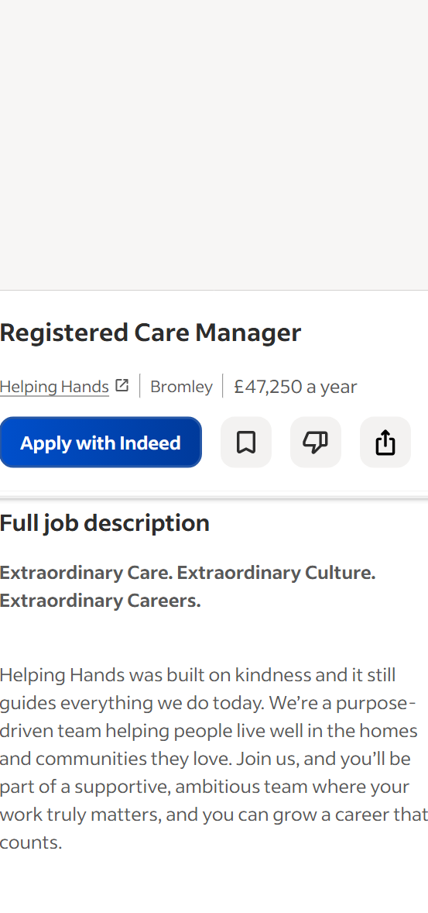
3. Analyse the skills needed for the job and assess your skills and experience
The role of Care Manager requires a combination of technical knowledge, leadership capability, and interpersonal skills. The following employability skills are essential:

3.1 Leadership and Management
Care Managers must lead teams effectively, motivate staff, and ensure high-quality care delivery. This includes delegation, supervision, conflict resolution, and performance management. Skills for Care (2023) emphasises that strong leadership is essential for safe and effective care.

3.2 Communication Skills
Clear communication is vital for liaising with service users, families, staff, and external agencies. This includes verbal communication, written documentation, and digital communication. Goleman (1998) highlights communication as a core component of emotional intelligence.

3.3 Organisational and Time-Management Skills
The role involves managing rotas, assessments, audits, and staff schedules. Strong organisational skills ensure smooth service delivery and compliance with regulations.

3.4 Knowledge of CQC Regulations
Understanding the Care Quality Commission’s standards is essential for maintaining compliance and ensuring safe, effective care (CQC, 2023).

3.5 Digital Skills
Care Managers must use digital systems for care planning, incident reporting, scheduling, and communication.

3.6 Problem-Solving and Decision-Making
Unexpected situations arise frequently in domiciliary care. Managers must make quick, safe, and effective decisions.

3.7 Emotional Intelligence and Cultural Competence
Supporting diverse service users requires empathy, cultural awareness, and the ability to adapt communication styles. Betancourt et al. (2003) emphasise cultural competence as essential for equitable care.

3.8 Resilience and Stress Management
The role is demanding, requiring resilience, self-care, and the ability to manage pressure effectively. Maslach and Leiter (2016) link burnout to excessive workload and emotional exhaustion.
4. Drawing on reflective learning from Units 1–4
I evaluated my current skills using Skills for Care reflection templates, emotional intelligence questionnaires, and feedback from supervisors.

4.1 My Strengths
- Empathy and compassion: I consistently demonstrate person-centred values, treating service users with dignity and respect.
- Communication: I communicate confidently with service users and colleagues and adapt my approach to different cultural backgrounds.
- Reliability and professionalism: I maintain high standards of care and follow organisational policies.
- Experience in domiciliary care: My current role has strengthened my understanding of community-based care and safeguarding.
- Cultural competence: I have experience supporting individuals from diverse backgrounds, aligning with modern domiciliary care needs.
- Calm under pressure: I remain composed during emergencies and unexpected situations.

4.2 Areas for Development
- Leadership experience: I have limited formal leadership responsibilities.
- Confidence in multidisciplinary meetings: I sometimes hesitate when sharing ideas.
- Digital skills: I need to strengthen my ability to use care management software.
- Knowledge of CQC compliance: I need deeper knowledge of audits, inspections, and regulatory frameworks.
- Formal qualifications: I need to complete the Level 5 Diploma in Leadership for Health and Social Care.

4.3 Tools Used to Assess My Skills
- Skills for Care self-assessment
- Emotional intelligence questionnaire (Goleman, 1998)
- Feedback from supervisors
- Reflective journals from BMHP5015

4.4 Support Available
- Mentoring from my current manager
- Training opportunities within my organisation
- Online CPD courses
- Peer support from colleagues

5. Building My Personal Brand and Professional Identity
Unit 1 emphasised that personal branding is more than a CV; it is how I present myself consistently through my values, behaviours, and communication.

5.1 Core Values
- Compassion
- Integrity
- Respect
- Accountability
- Cultural awareness

5.2 Unique Selling Point (USP)
My USP is my ability to build trusting relationships with service users from diverse backgrounds while remaining calm under pressure. Montoya and Vandehey (2009) argue that authenticity is essential for a strong personal brand.

5.3 Professional Identity
I will promote myself as a future leader committed to person-centred care, continuous learning, and high-quality service delivery.

5.4 Branding Tools
- Professional CV
- LinkedIn profile
- Skills for Care membership
- Professional online presence

6. Building a Professional Network
Networking is essential for career progression. As Unit 3 highlighted, opportunities often arise through relationships and proactive engagement.

6.1 Networking Strategies
- Join Skills for Care networks
- Connect with local authority commissioning teams
- Attend health and social care conferences
- Engage with LinkedIn groups
- Build relationships with CQC inspectors and local providers

6.2 Benefits of Networking
- Access to job opportunities
- Learning from experienced managers
- Understanding regulatory changes
- Gaining mentorship

7. My Health and Social Care Experience and Qualifications

Current Experience
I have developed a strong foundation of practical skills and sector knowledge through my work as a domiciliary care worker. In this role, I support adults with a wide range of needs, including physical disabilities, dementia, learning disabilities, and long-term health conditions. My responsibilities include providing personal care, administering medication in line with organisational policies, completing risk assessments, and ensuring that safeguarding procedures are always followed. These experiences have strengthened my ability to deliver safe, person-centred care and respond appropriately to changes in service users’ needs.
Working with individuals from diverse cultural backgrounds has also enhanced my cultural competence and communication skills. I have learned to adapt my approach to meet the cultural, linguistic, and personal preferences of service users, which is essential for delivering inclusive and respectful care. This experience aligns closely with the values required for leadership roles in health and social care, where cultural sensitivity and equality are central to high-quality service delivery.
In addition, my role involves regular collaboration with multidisciplinary teams, including nurses, occupational therapists, social workers, and family carers. Through this, I have gained experience in sharing information effectively, contributing to care plans, and supporting coordinated interventions. This teamwork has helped me understand the importance of professional communication, accountability, and partnership working—key competencies for a future Care Manager.
If you want, I can continue this section with:

• Qualifications and Training

• Skills Gained and How They Relate to Care Manager Requirements

• Gaps Identified and Areas for Development

8. Action Plan and Timeline (Five-Year Plan)

Year 1
- Complete Level 3 Diploma (if not completed)
- Attend training on CQC regulations
- Shadow current Care Manager
- Improve digital literacy
- Build LinkedIn profile

Year 2
- Take on informal leadership tasks
- Complete CPD courses on leadership
- Attend Skills for Care workshops
- Strengthen confidence in meetings

Year 3
- Enrol in Level 5 Diploma
- Lead small projects
- Continue networking

Year 4
- Apply for Senior Carer or Team Leader roles
- Participate in audits and compliance checks
- Gain experience in rota management and assessments

Year 5
- Complete Level 5 Diploma
- Apply for Care Manager positions
- Present strong personal brand
- Demonstrate leadership experience and regulatory knowledge

9. Resources Needed
- Funding for Level 5 Diploma
- CPD courses
- Mentorship
- Shadowing opportunities
- Digital training
- Networking platforms

10. Communicating My Skills to Employers

10.1 CV
A professional CV highlighting leadership aspirations, cultural competence, and CPD.

10.2 LinkedIn
A profile showcasing achievements, training, and networking.

10.3 Professional Portfolio
Certificates, reflective accounts, and training records.

10.4 Interviews
Demonstrating confidence, communication skills, and person-centred values.

11. Conclusion

This report has analysed the employability skills required for the role of Care Manager in domiciliary care, evaluated my current skills, and presented a detailed five-year action plan for achieving this position. By building a strong personal brand, promoting my professional identity, and developing a robust professional network, I will be well positioned to progress into a Care Manager role. With commitment to lifelong learning and person-centred care, I am confident in my ability to achieve this career goal and contribute positively to the domiciliary care sector.
Furthermore, the report has highlighted the importance of reflective practice in identifying both strengths and areas for development. Recognising the impact of professional communication—particularly the need to strengthen my English speaking and writing skills—has been a crucial part of understanding the barriers that previously limited my progression. Addressing this challenge will not only enhance my confidence but also ensure that I meet the communication standards expected of a Care Manager, especially in relation to safeguarding, documentation, and leadership responsibilities.
The integration of theories from the BMHP5015 module has provided a valuable framework for understanding how personal branding, cultural competence, wellbeing, and sustainable employability contribute to long-term career success. By applying these concepts, I can continue to develop a professional identity that reflects reliability, compassion, and cultural awareness—qualities that are essential within the health and social care sector.
Ultimately, achieving my goal of becoming a Care Manager will require dedication, resilience, and continuous professional development. However, with a clear action plan, a commitment to improving my communication skills, and a proactive approach to building professional relationships, I am confident that I can progress into this leadership role and make a meaningful contribution to high-quality domiciliary care.
12. Reference
Ardichvili, A., Cardozo, R. and Ray, S. (2003) ‘A theory of entrepreneurial opportunity identification and development’, Journal of Business Venturing, 18(1), pp. 105–123.
Betancourt, J.R., Green, A.R., Carrillo, J.E. and Ananeh-Firempong, O. (2003) ‘Defining cultural competence’, Public Health Reports, 118(4), pp. 293–302.
Busch, C. (2020) The Serendipity Mindset. London: Penguin.
Care Quality Commission (CQC) (2023) Guidance for Providers: Domiciliary Care Services. Available at: https://www.cqc.org.uk (Accessed: 22 July 2026).
Dweck, C. (2006) Mindset. New York: Random House.
Giddens, A. (1990) The Consequences of Modernity. Cambridge: Polity Press.
Goleman, D. (1998) Working with Emotional Intelligence. New York: Bantam Books.
Helping Hands (2026) Registered Care Manager – Bromley. Indeed, job advert. (Screenshot provided by student).
Maslach, C. and Leiter, M.P. (2016) Burnout. New York: Psychology Press.
Montoya, P. and Vandehey, T. (2009) The Brand Called You. New York: McGraw-Hill.
Peters, T. (1997) ‘The brand called you’, Fast Company, 10, pp. 83–90.
Seligman, M.E.P. (2011) Flourish. New York: Free Press.
Skills for Care (2022) Guide to Reflective Practice. Leeds: Skills for Care.
Skills for Care (2023) Leadership in Adult Social Care. Leeds: Skills for Care.

