University of Wales Trinity Saint David

Assessment technical report

James Charles Saccone

2200780

BEng Automotive, Motorcycle & Motorsport Foundation Engineering

Module code: mg

Contents:

Chapter 1:
Introduction……………………………………………………………………………………………………………………..Page 3

Chapter 2:
Impact of the topics…………………………………………………………………………………………………………Page 4

2.1 – Manufacturing processes…………………………………………………………………………………………Page 4

2.2 – Materials used in manufacturing …………………………………………………………………………….Page 4

2.3 – Powertrain……………………………………………………………………………………………………………….Page 5

2.4 – chassis design…………………………………………………………………………………………………………..page 5

2.5 – Aerodynamics..…………………………………………………………………………………………………………Page 6

Chapter 3:
Current state of the industry……………………………………………………………………………………………..Page 7

Chapter 4:
Conclusion…………………………………………………………………………………………………………………………Page 7

References……………………………………………………………………………………………………………………….Page 8
Chapter 1-Introduction:

In this report I will be writing about the 2002 Honda NSX-R. The NSX first went into production in 1990, the reason for having chosen the 2002 variant is due to its blistering lap time around the Nürburgring also known as “Nordschleife”. This track is known for its approximately 20.8-kilometre-long lap length. It has plenty of challenges which include and are not limited to; high speed corners, unforgiving kerbs and its tight and technical sections. The Nürburgring was famously nicknamed as “The Green Hell” by Sir Jackie Stewart after he won the 1968 German Grand Prix. Although the track has had many changes since, it is still widely known for its unforgiving nature.

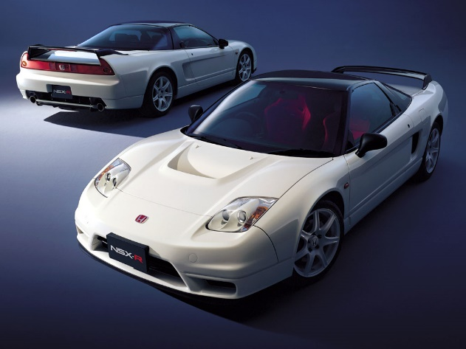
The 2002 NSX-R set a lap time of 7:56.73, the average lap time set by base model production cars is usually within the nine-to-ten-minute mark. This demonstrates how well engineered the NSX was for its time. Honda has a reputation within the motorsports world for being well refined with their powertrains. This is something I will be exploring later within the text. I plan to further examine the following topics: Manufacturing methods, Materials used in manufacturing, chassis design & the aerodynamics of the NSX-R
Figure 1: (Terence W, 2002 Honda NSX-R: History, specifications, &amp; performance 2020)

Chapter 2 -Impact of the topics:

2.1 – Manufacturing processes:

The Manufacturing process for the NSX as a whole was not like that of other mass-produced cars on the market. Firstly, there was no automated assembly line. The chassis of the NSX was mounted onto a Dolley with wheels and pushed by hand to the next station. Once the current station had completed its quality checks and ensured all the tight tolerances were within their corresponding limits the car would proceed to the next workstation.
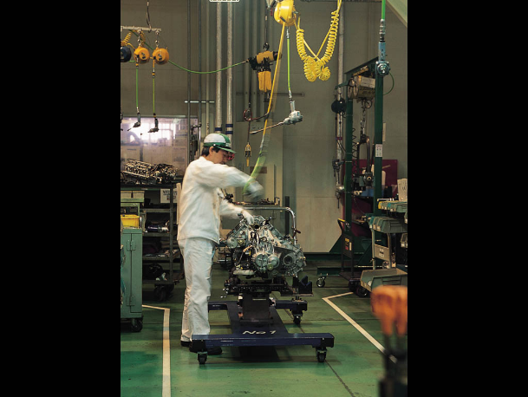
Parts for the chassis for the NSX were manufactured by using an aluminium process called extrusion meaning that aluminium was heated up to roughly 600 degrees Celsius (just below melting point). The metal is then forced through a “die” with specific cross-sectional profile. In the case of the NSX this was a honeycomb cross section. The rational for its use was to it add stiffness to the chassis as well as a weight saving ability.
Figure 2:(Terence W, 2002 Honda NSX-R: History, specifications, &amp; performance 2020)
Contrary to most mass-produced powertrains the engine in the NSX (C32B) was distinctively built by a highly qualified technician. Said technician would assemble the engine from start to finish. Having an individual assemble the entire powertrain meant that the tolerances observed would be much greater than that of a mass-produced counterpart. This ensured greater reliability and durability, which is what Honda is renowned for.

2.2 – Materials used in manufacturing:

As demonstrated in Figure 2.1 the chassis was mainly made up of aluminium. The alloy series which was used for the chassis is known as the 6000 series aluminium. This series of aluminium is known for its high strength, extrudability and high chemical resistance. The main ingredients of the 6000 series alloy include magnesium, silicone, and aluminium. The use of this alloy enabled Honda to achieve the same stiffness and strength levels as opposed to a chassis made of steel weighing 200Kg (including all other components).
Only non-structural components of the NSX type R were made from carbon fibre. This was not considered too important to its stiffness and strength, but rather reflected on its experience load from the downforce they produced. Components produced from carbon fibre included the rear spoiler, front and rear diffusers, and the bonnet. Seemingly, at the time it was said to be the largest carbon fibre bonnet produced. The choice of Carbon fibre used for these parts was due to its corrosion resistance, light weight and its ability to maintain its form when under downforce loads.

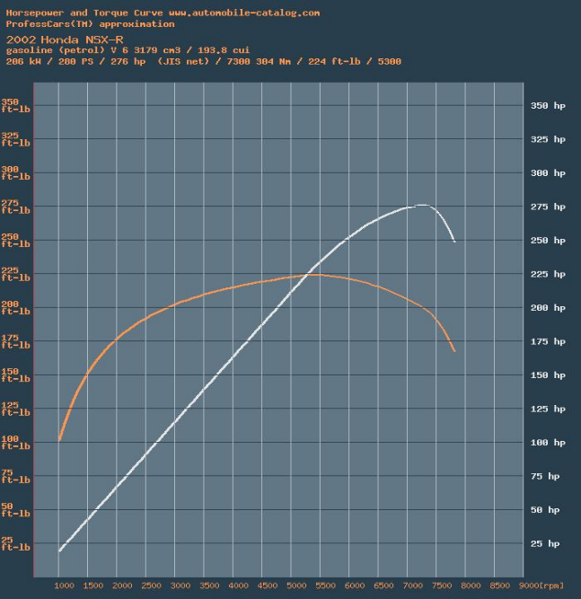
2.3 – Powertrain:
Figure 3: (2002 Honda NSX Series II Type R Full Range Specs - automobile-catalogue)
The 2002 NSX-R had the C32B engine that was engineered and tuned specifically by Honda for the NSX. The C32B is an aluminium V6 with DOHC (Dual Overhead Camshafts) which also featured V-TEC™(Hondas version of Variable valve timing), and a Variable Volume Induction system. This controls the amount of volume of air that is let into the engine. It’s purpose was in an effort to promote quicker and fuller filling of the cylinders. The C32B has a displacement of 3179 cm3, which equals to 529.83cm3 per cylinder. Each cylinder has 4 valves; 2 intake and 2 exhaust. At its peak RPM of 7100 the C32B made 290hp and 224 lb-ft at 5500 rpm. As shown in Figure 2. This was all delivered to the rear wheels via a 6-speed manual gearbox.

2.4 - Chassis Design:

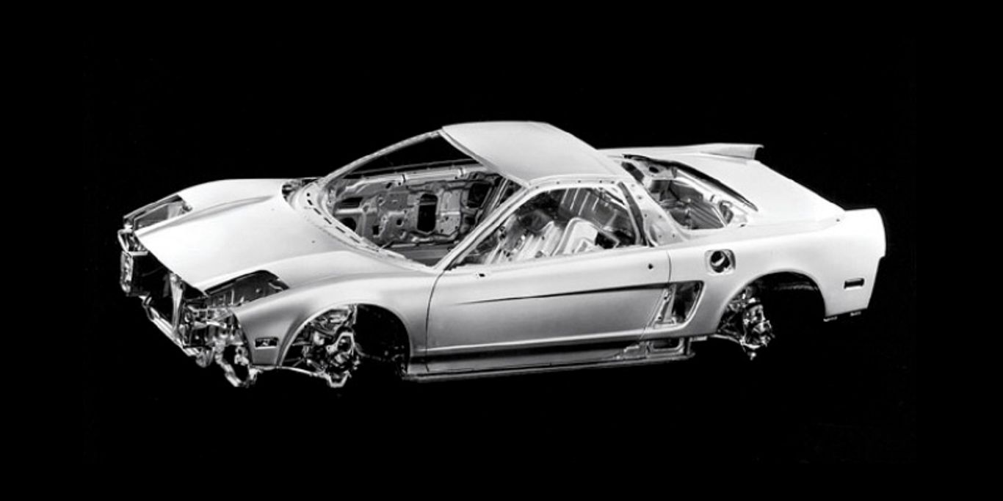
When creating a high-performance supercar such as the NSX-R having a rigid chassis is essential to create a stable platform to maintain a proper suspension geometry. The NSX-R had an all-aluminium monocoque chassis. Meaning that the entire chassis was one piece, rather than a Ladder frame chassis which needs the body to be mounted on top of the chassis. This in turn makes the car less rigid and gives the car worse performance attributes. The use of 6000 series aluminium allowed the engineers at Honda to remove metal where it wasn’t needed. Hence reducing the weight of the car. Otherwise, the NSX would have weighed over 200 kilograms more had they used steel. The engineers at Honda came up with the use of extruded aluminium in a honey-comb pattern when they began running into complications due to the deep shape of the chassis. By using this extruded honeycomb pattern, they were able to increase the rigidity of the chassis.
Figure 4: (Robinson,www.carthrottle.com, 2002 NSX-R chassis ,2015)

The suspension of the NSX-R resembles that of a modern Formula One car due to its double wish bone suspension which is made up of an upper and lower control arms. These were chosen due to their outstanding performance characteristics and ride quality. These control arms were also made out of the 6000 series aluminium. The shock absorbers on the NSX were filled with nitrogen and featured a unique progressive valve design. This valve was applied because of its favourable dampening profile and much more precise damping control in comparison to shock absorbers without the progressive release valve.

2.5 – Aerodynamics

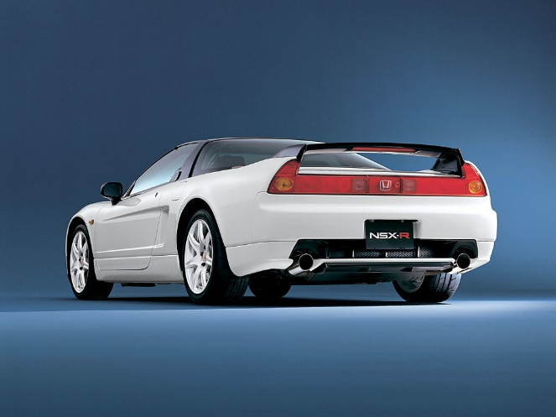
In an effort to produce a high speed and stable car Hondas engineers had to come up with a way of using aerodynamics to their advantage. It was with this in mind that they developed a front and rear diffuser to create downforce and smooth out the underbody of the car. By implementing the diffusers, Honda was able to create a ground effect which was seen in Formula One during the 80’s championship. Ground effect is created by using the venturi effect, which is the creation of a low pressure zone under the car by narrowing the centre part of the body to accelerate the air which in turn creates a vacuum sucking the car to the ground. The engineers at Honda also added a more aggressive rear wing which was used to stabilize the car at high speeds and in corners. The base model NSX in 2002 had a drag coefficient of 0.32. With all of the aerodynamic changes made for the NSX type R they were able to reduce drag to 0.3.
Figure 5: (Terence W, 2002 Honda NSX-R: History, specifications, &amp; performance 2020)

Chapter 3:

Current state of the industry:

The automotive industry is experiencing a significant shift towards alternative fuels and sustainable transportation solutions. Honda is one automaker that is leading in this initiative. As part of its dedication to lowering emissions and giving its customers environmentally friendly transport options, Honda has been investing in alternative fuel technologies, including electric and hydrogen fuel cell vehicles. Figure 6 shows Honda’s briefing on Electric and Hydrogen fuel systems.
Honda's first all-electric vehicle, the Honda Clarity Electric, made its debut in 2017 and is available in select markets in the United States. The Clarity Electric has a range of up to 89 miles on a single charge .
Honda has also been developing hydrogen fuel cell technology. The Honda Clarity Fuel Cell debuting in 2016. The Clarity Fuel Cell has a range of up to 360 miles on a single hydrogen tank and emits only water vapor. Honda has also collaborated with General Motors to develop a next-generation fuel cell system and hydrogen storage technology in order to bring low-cost fuel cell vehicles to market.
Honda has been researching the use of biofuels such as ethanol and biodiesel in addition to electric and hydrogen fuel cell vehicles. Honda has been researching the use of ethanol derived from non-food sources, such as grass and wood chips, in its vehicles. In addition, the company is working on developing a more efficient diesel motor that can run on biodiesel.
Honda is also dedicated to reducing the environmental impact of its manufacturing processes. The company has set a goal of reducing CO2 emissions from its global manufacturing operations by fifty percent by 2050 compared to 2000 levels. Honda is also working to reduce waste and increase the use of renewable energy sources in its production facilities.

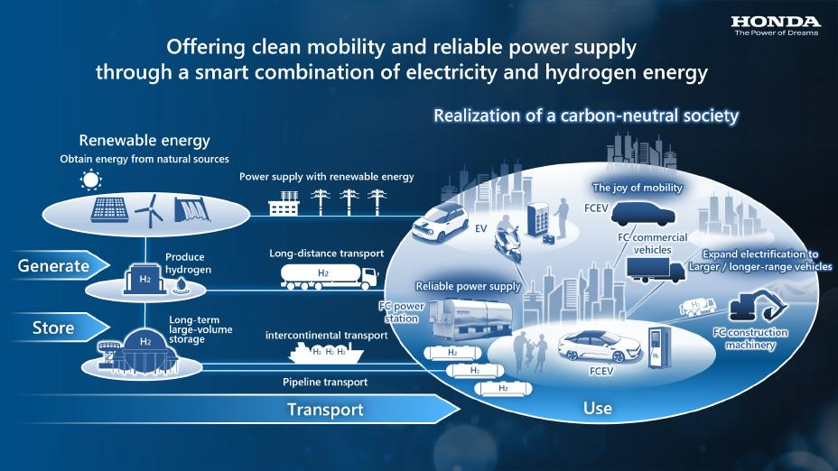
Figure 6: (Summary of briefing on Honda Hydrogen Business 2023)

Chapter 4:

Conclusion:

The 2002 Honda NSX-R achieved an impressive lap time of 7:56.73 at the Nürburgring, which was much faster than the average production car lap time. This report discusses various aspects of the NSX-R, including its manufacturing process, materials used, chassis design, and aerodynamics. The NSX-R was not mass-produced on an assembly line, and the chassis was moved by hand between stations. The chassis was made of 6000 series aluminium, which is strong and corrosion-resistant, and the non-structural components were made of carbon fibre. The car's powertrain had a 290hp C32B engine with a 6-speed manual gearbox. The NSX-R had an all-aluminium monocoque chassis, which made the car lighter and more rigid due to the use of honeycomb-patterned extruded aluminium.
In conclusion, the 2002 Honda NSX-R was a well-engineered car that showcased Honda's reputation within the motorsports world. The manufacturing process, materials used, and chassis design all contributed to the car's impressive lap time at the Nürburgring.

References:

Battula, D.D.S. and Kuruvilla, J. (2020) Carbon Fiber Properties, Carbon Fiber Properties - an overview | ScienceDirect Topics. Available at: https://www.sciencedirect.com/topics/materials-science/carbon-fiber-properties#:~:text=Carbon%20fibers%20are%20high%2Dstrength,expansion%2C%20and%20superior%20chemical%20resistance.
Calif, T. (2002) 2002 Acura NSX Press Kit, Acura Newsroom. Acura Newsroom. Available at: https://acuranews.com/en-US/releases/release-892a7927aecb51abfd11df004c34c77c-2002-acura-nsx-introduction.
Cara, unknown (2021) 6000 series aluminum alloys, Taber Extrusions. Available at: https://taberextrusions.com/6000-series-aluminum-alloys/.
Robinson, M. (2015) 8 fascinating technical facts about the Honda NSX, Car Throttle. Car Throttle. Available at: https://www.carthrottle.com/post/8-fascinating-technical-facts-about-the-honda-nsx/.
Summary of briefing on Honda Hydrogen Business (2023) Electrification. Available at: https://hondanews.com/en-US/electrification/releases/summary-of-briefing-on-honda-hydrogen-business.
unknown (no date) 2002 Honda NSX Series II Type R Full Range Specs - automobile-catalog, 2002 Honda NSX Series II Type R all versions specifications and performance data. Available at: https://www.automobile-catalog.com/make/honda/nsx/nsx-r_series_ii/2002.html.
W, T. (2020) 2002 Honda NSX-R: History, specifications, & performance, Supercars.net. Available at: https://www.supercars.net/blog/2002-honda-nsx-r-guide-history-specifications-performance/.

