Anti-Lock Braking Systems

University of Wales Trinity Saint David
School of Engineering
Leighton Coughlin (1802971)
Emissions Control & Diagnosis - M5X02202



Contents Page
Introduction – Page 3
Research – Page 4
History of ABS – Page 4 to 5
ABS system Components – Page 5
Wheel Speed Sensors – Page 6
Electronic Control System – Page 6
Hydraulic Modulator – Page 6 to 7
Brake Master Cylinder – Page 7
Bosch ABS 2EH and Teves Mk IV – Page 7
Methodology – Page 8
Results – Page 9
Multi Meter Readings – Page 9 to 10
Wheel Speed Sensors – Page 10 to 11
Hydraulic Modulator Solenoids – Page 12 to 13
Flow Chart – Page 14
Conclusion – Page 15
References – Page 16
Figures – Page 16 to 17
Appendices – Page 18 to 22

1. Introduction
As part of this assignment, it is assumed that the group is part of a trouble shooting team and have been tasked with diagnosing an ABS system fault. The system in question is a Teves Mk IV ABS system and a Bosch 2EH system. To achieve this, individually, the team will research the system looking at the history of the two systems, the operation of the system and what problems this system was created to solve.
Once this is done, as part of the working group, a full system test on the two systems will be carried out in the workshop. This will aim to investigate the voltage or resistance of the components to determine their typical values. Some signal waveforms will also be looked at. Once this is done we will individually produce a report that will outline the diagnostic procedures involved in diagnosing an ABS light on fault. The report will also include a fault diagnostic chart that will act like a layman’s guide to diagnosing and rectifying an ABS warning light fault. The main operational differences between the Bosch and the Ford Teves system will also be compared along with any strengths or weaknesses that each system may or may not have. The report will also pay particular attention to safe working practises when carrying out the test as well as the procedure adopted when carrying out the test.

2. Research

History of ABS
An ABS or anti-lock braking system is a safety feature that almost all modern vehicles now have. Sources suggest that (Hillier, 2001, p.373) an ABS allows the vehicle to be steerable during extreme braking situations as well as stop at a shorter distance. Traditionally wheels would tend to lock up during heavy braking. This is due to the brake force being applied to a wheel, causing the wheel to stop or rotate slower than the equivalent vehicle speed. In order to combat this manufactures developed a system in which the optimum amount of braking force required can be applied to each wheel which in turn limits wheel slip or lockup and allows the car to steer away from any obstacles it might encounter.
According to an online source, (Moore, no date) the first ever development of an ABS system was in the 1920s and was used in aircraft. At this time ABS systems were employed by the aviation industry primarily to shorten stopping distances of aircraft. Demonstrated in figure 1 below, as well as steer ability, the optimum braking force which can be applied to the tyre also decreases once the slip ratio goes over a certain ratio. This means that by having an ABS system, during extreme cases a vehicle will not only be able to steer when braking but also stop at a lesser distance.
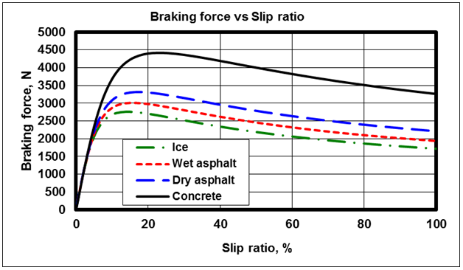
FIGURE 1 – Watany (2014)
Online sources also suggest that (Moore, no date) ABS systems were at first solely featured in aircraft all the way up to the 1950s. When the benefits of an ABS became apparent engineers then decided that reducing wheel slip on a motorcycle would greatly improve the safety and controllability. During the 1960s the technology was then experimented with to work on four wheeled vehicles with the ford zodiac prototype. Unfortunately, the technology was deemed too expensive to manufacture and wouldn’t see use in a production car until the 1970s
The vehicle which can be deemed as the first production car with ABS was a Mercedes Benz. According to an online source (Stuttgart, 2008) from 1978 the S-class sedans were the first ever production cars with this system as one of the optional extras. Mercedes saw the benefit of this system and it soon became standard on most vehicles. Since then many studies were done in order to look at the effectiveness of this system. According to the European union section on road safety
‘’A meta-analysis of research studies shows that ABS give a relatively small, but statistically significant reduction in the number of crashes.’’ (European Commission, no date)

ABS system components
sources suggest that all ABS systems are made up of 4 main components. The wheel speed sensors, the electronic control unit, the master cylinder and the hydraulic modulator.
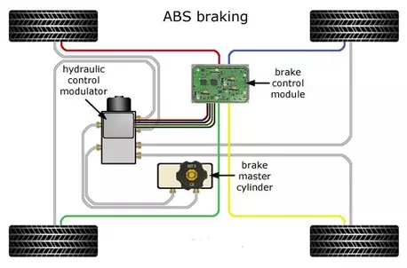
FIGURE 2 - Daftardar (2016)

Wheel Speed Sensors
The wheel speed sensors are used to measure the rotational speed of each wheel and can be one of two kinds. A passive or magnetic inductive type sensor, and an active, or magneto resistive type sensor. A passive sensor uses a tone ring and a permanent magnet. (APEC, no date) the tone ring is toothed and is connected to a rotating part within each wheel assembly such as the hub or driveshaft. The sensor comprises of a permanent magnet core surrounded by copper windings. As the tone ring rotates through the magnetic field created by the permanent magnet, an alternating amount of voltage is then induced within the windings producing an analogue signal which the ECU then converts to a digital signal so that the ECU can interpret the data. An active sensor, often referred to as a Hall Effect sensor, is an upgrade upon the previous passive sensors. This is due to an active sensor being much more accurate and able to measure from speeds much lower than passive sensors which are essential for most traction control systems. Both systems feature a passive sensor.
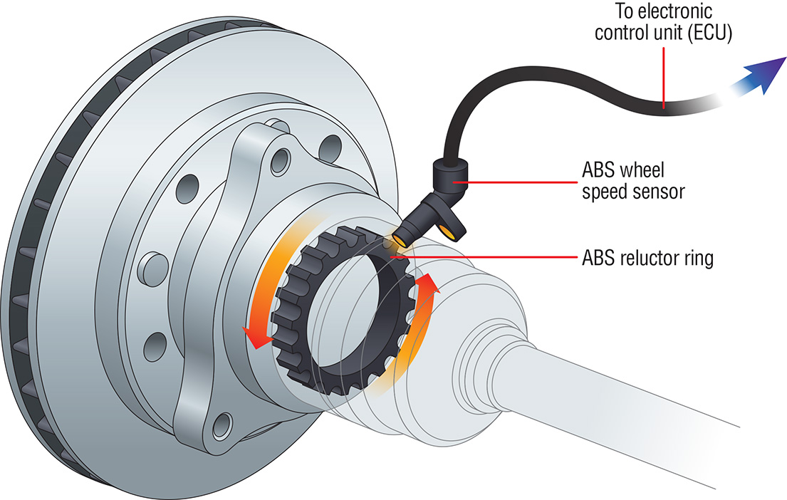
Figure 3 - APEC (no date)

Electronic Control Systems
sources say that (Denton, 2000, p.29) The main purpose of the electronic control unit is to take in data from the wheel speed sensors, decide the best course of action and tell the hydraulic modulator what to do. The ECU is also responsible for fault detection. If the ECU detects a fault within the system it will disconnect the ABS and switch on a warning light for the driver. in order to detect faults a test is done every time the ignition is switched on. Multiple tests are performed such as current supply and operation of relays etc.

Hydraulic modulator
The Hydraulic modulator varies in design but all are technically a set of solenoid operated valves which operate in one of three stages. Pressure build up, pressure hold and pressure release. During the pressure build phase, fluid from the master cylinder is allowed to flow to the brake calliper thus increasing pressure. This is what happens during normal braking. Pressure hold is when the pressure at the brake calliper stays the same by isolating the brake cylinder from the hydraulic modulator and pressure release is when fluid is allowed to return to the reservoir thus decreasing the pressure at the calliper. if the ECU decides that the wheel is about to lock up the modulator will alternate between these phases in order to give the driver the optimum amount of brake pressure for that situation.

Brake master cylinder
The purpose of the master cylinder is to convert the pressure from the brake pedal into hydraulic pressure which can be supplied to the braking system. to do this the brake pedal is connected to two pistons. The displacement of fluid caused by the piston increases the pressure within the system thus allowing the system to operate.

Bosch ABS 2EH and Teves Mk IV
According to online sources (Bosch, 2018) Bosch was the first supplier to develop an ABS system suitable for a production vehicle. Working closely with Mercedes in 1978 they released the system to the automotive world. The Bosch 2EH system was produced around the same time as the Teves Mk IV system and was found in many Vauxhall vehicles. Its main goal was safety but another concern was the comfort of the system. This included how the brake pedal behaved under normal braking but also when the ABS is in use.
The Teves Mk IV system is one version of an anti-lock braking system developed for use in General Motors Vehicles. One paper by the SAE suggests (SAE, 1990) that the Teves Mk IV system was the natural successor to the Teves mark II system and was developed with many goals in mind. A major goal when designing this system was to maintain performance of the Mk II system in terms of safety and comfort. However, the main task for the Mk IV system was to allow the system to be more adaptable and modular allowing for the system to be used in all models and vehicles. The system was also developed with traction control in mind so that it could easily be added to the vehicle with ease

3. Methodology
In order to be able to fully describe the system a test was carried out on both systems. The aim of the test was to look at the voltage and resistance readings of certain components as well as a few signal waveforms. this data will then be used to outline the diagnostic process as the data will be that of a functional system.
In order to test the systems two pieces of equipment were used, A multi-meter and an oscilloscope. Sources suggest (Denton, 2000, p.29) A multi meter is a Device which through ohm’s law can measure voltage, resistance and current. The device will then display these values in real time. This allows the user to quickly check components and if the value isn’t equivalent to the manufacturer’s specification this would indicate a possible problem within that component. The problem with this piece of equipment is when a voltage that changes constantly over time is analysed. Many voltages change extremely fast inside a vehicle and a multimeter cannot log the data it displays so trying to log each reading physically using a multimeter would be impossible at some of the timescales involved. Therefore, an oscilloscope is used. Sources say (Denton, 2000, p.30) that an oscilloscope is a piece of equipment which can graphically display signal voltages. The signal voltages are displayed as a function of time and are called waveforms. Waveforms allow the user to better interpret the data and look for any possible problems within the data which could indicate a fault within the system. It is also very important to check the accuracy of the test equipment. Sources suggest (Denton, 2000, p.28) that in order to ensure the accuracy of the test equipment they must be calibrated regularly. In order to calibrate the equipment, use other equipment which has been proven to be accurate or measure something of a known value such as a resistor. This ensures that the data produced by the apparatus is correct.
Sources suggest (HSE, no date) that there are many ways to injure or harm yourself and others within the workshop. In order to ensure safe working practises some general guidelines were followed. Before entering the room, the correct PPE was worn which involved protective steel toe cap boots to protect from any falling objects as well as overalls to protect clothing and skin from any dangerous chemicals or substances. It is also recommended to remove any loose items of clothing such as jewellery or ties as they may get caught in something or come into contact with a live wire. An inspection of the system is also performed checking that the battery is sufficiently charged as well as checking the brake fluid is at a sufficient level. A visual inspection is also done to ensure no leaks, broken/disconnected terminals or connections. It is also important to disconnect the battery when not in use.
As well as your own personal safety it is important for companies to improve the safety of their working conditions as much as possible. The HSE suggest (HSE, no date) that there are many substances within the work environment that can be both incredibly dangerous as well as extremely difficult to detect by yourself. For example, Carbon monoxide is a colourless odourless chemical which has extreme bad health effects and can even cause death in high enough doses. It is for this reason that the workshop used to carry out the test follows the rules set by the COSHH regulations. The COSHH regulations or control of substances hazardous to health regulations set in place how exposure to dangers such as chemicals, particulates and even harmful bacteria etc. must be reduced or removed completely.

4. Results

Multi Meter Readings
The data obtained by the tests for the Bosch ABS 2EH can be found below.
Pin Number | Description | Ignition Off (V) | Ignition On (V)
1 | ABS Warning Lamp Indicator | 0 | 12.43
2 | N/S/R Wheel Speed Sensor (Ground) | 0 | 0.22
4 | N/S/R Wheel Speed Sensor Signal | 0 | 0.33
5 | O/S/F Wheel Speed Sensor (Ground) | 0 | 0.22
6 | O/S/R Wheel Speed Sensor Signal | 0 | 0.33
7 | N/S/F Wheel Speed Sensor (Ground) | 0 | 0.22
9 | Brake Light Switch Feed | 0 | 12.4
10 | O/S/F Wheel Speed Sensor Signal | 0 | 0.33
13 | N/S/F Wheel Speed Sensor Signal | 0 | 0.33
14 | O/S/R Wheel Speed Sensor (Ground) | 0 | 0.22
 | Pulse generator resistance | 1090 ohms

The data obtained by the tests for the Teves Mk IV can be found below.
Pin Number | Description | Ignition off (V) | Ignition On (V)
1 | Pulse Generator Earth | 2.39 | 2.4
2 | Pulse Generator Earth | 2.39 | 2.4
7 | Permanent Live | 12.6 | 12.5
9 | Ignition Live | 0.2 | 12.6
10 | Pulse Generator Earth | 2.39 | 2.4
11 | Pulse Generator Earth | 2.39 | 2.4
12 | Live | 0.2 | 12.5
13 | OBD | 10.83 | 10.78
15 | Switched Live | 0.12 | 12.4
17 | Pulse Generator Supply | 2.35 | 2.35
18 | Pulse Generator Supply | 2.35 | 2.35
19 | Pulse Generator Supply | 2.35 | 2.35
20 | Pulse Generator Supply | 2.35 | 2.35
25 | Permanent Live | 12.61 | 12.6
30 | Permanent Live | 12.45 | 12.45
 | Pulse Generator Resistance | 1090

In the case of this report it is assumed that the ABS warning light is stuck on. Even after the ABS system completes its self-diagnostic test. Sources suggest (Denton, 2000, p.207) that the following actions should be taken in order to correctly identify the cause of the problem. Firstly, do any preliminary checks required such as the battery condition, fluid levels and the condition of the wiring and connections before working on anything else. Once this is done move onto checking the fuses. To do this find the manufacturers data and do a visual inspection to ensure the correct resistance value is in use as well as looking for a break in the circuit. Use a multimeter and do a continuity test to be sure. Once this is done check for the correct voltages being supplied into the ECU. If one of the supply’s are out of manufacturers specification or to dissimilar from the values achieved above, consider tracing the supply back to its component or it could indicate a problem with the sensor which leads to the next step of checking the wheel speed sensors.

Wheel speed sensors
Once this the ECU supply voltages have been checked, the signal waveform produced by the wheel speed sensor must be examined. The wheel speed sensors, also referred to as WSS, for both systems are passive and therefore each sensor will have two wires connected to it a signal and an earth. Both sensors will also output an analogue signal as shown by the signal waveforms produced below. Sources suggest (Denton, 2000, p.207) A properly working passive sensor should produce a ‘’clean regular sine wave output proportional to wheel speed.’’ (Denton, 2000, p.207)
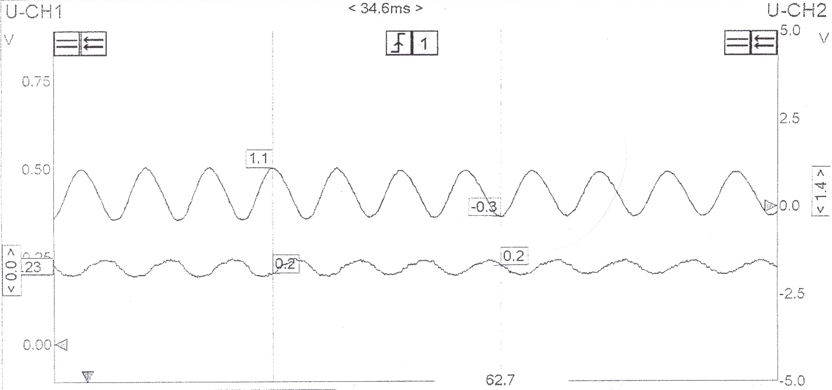
BOSCHE

The Bosche system shows a very clear and precise sine waveform for both the signal and earth and is exactly how the signal waveform should look. If a clean wave such as the one shown above is achieved on all four wheels then the next step would be to check the continuity of the signal from the sensor to the ECU. If the signal wire is fine move onto checking the continuity of the wires connecting to the modulator assembly. Making sure to inspect the resistance of the solenoid valves within the modulator, each solenoid should have the same value. The Bosch system has three solenoids since it is a three-channel system where as the Teves system has four since it is four channels. Both systems have four-wheel speed sensors.

TEVES
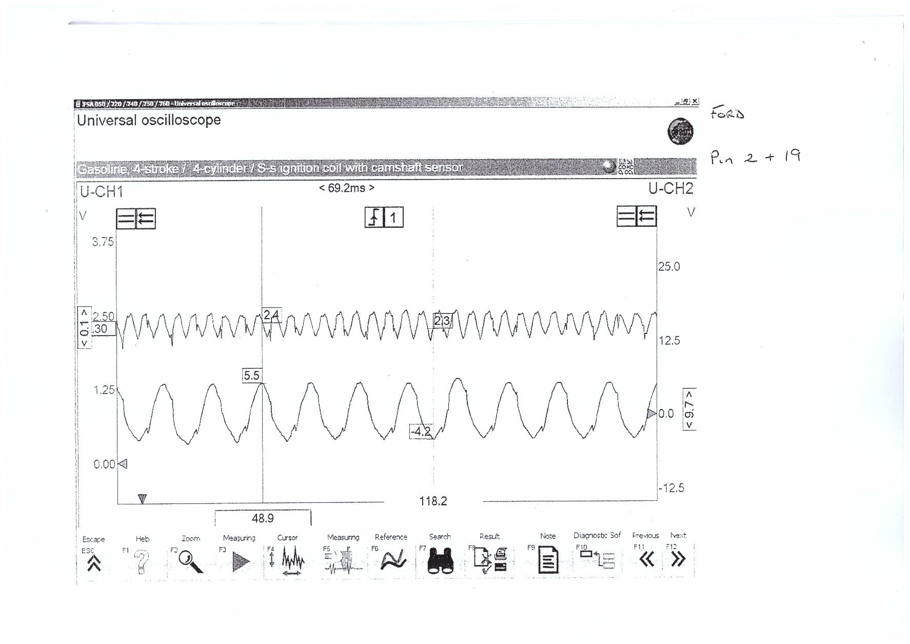
The signal produced by the Teves system is not as clean and precise as the Bosche system. This could possibly indicate that the sensor is either faulty or installed in correctly. It would be important to do a further visual inspection of the sensor and tone ring to check for anything that would cause the interference seen above. This may include checking the tone ring and sensor for any damage or contaminants such as dirt, stones or any other loose material. Also If all wheels are spun to the same speed but read different voltages then this would cause the ECU to report a fault.

Hydraulic Modulator solenoids
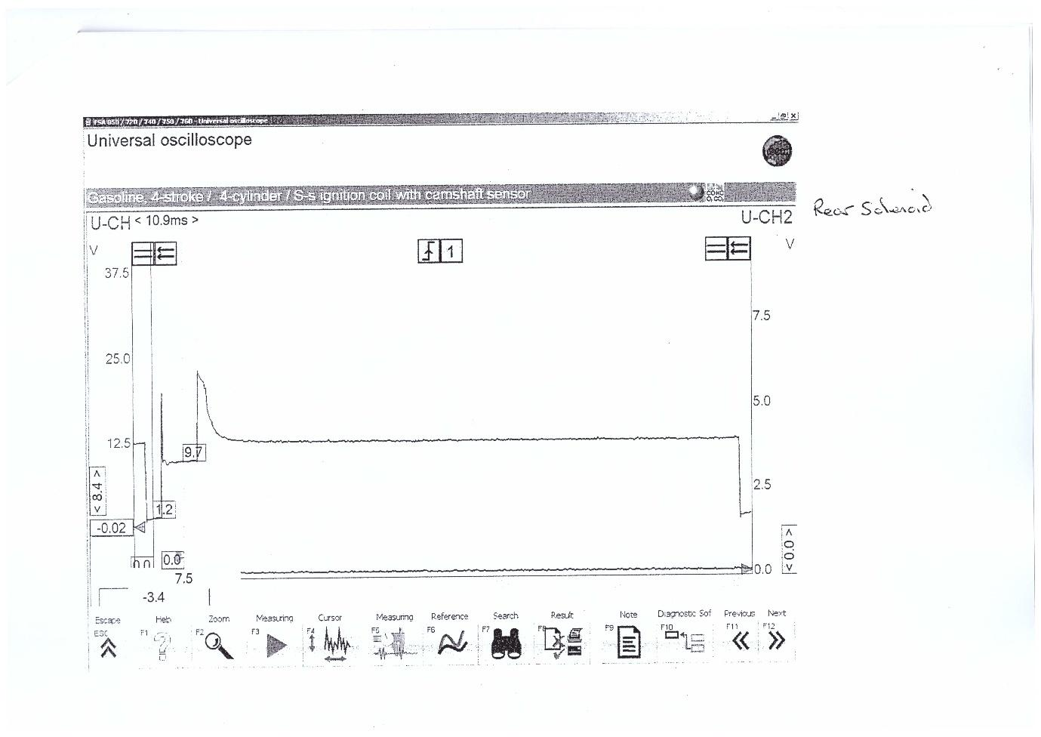
If there is the correct voltage coming from the sensors and the correct voltage is entering the hydraulic modulator then the next step would be to check the operation of the modulator using an oscilloscope.
A key difference between the two systems is that the Teves system features two separate valves to control pressure hold and pressure release whilst the Bosch uses one to do both. The wave form above shows the Bosch system solenoid valve during the pressure hold phase which draws 2v.
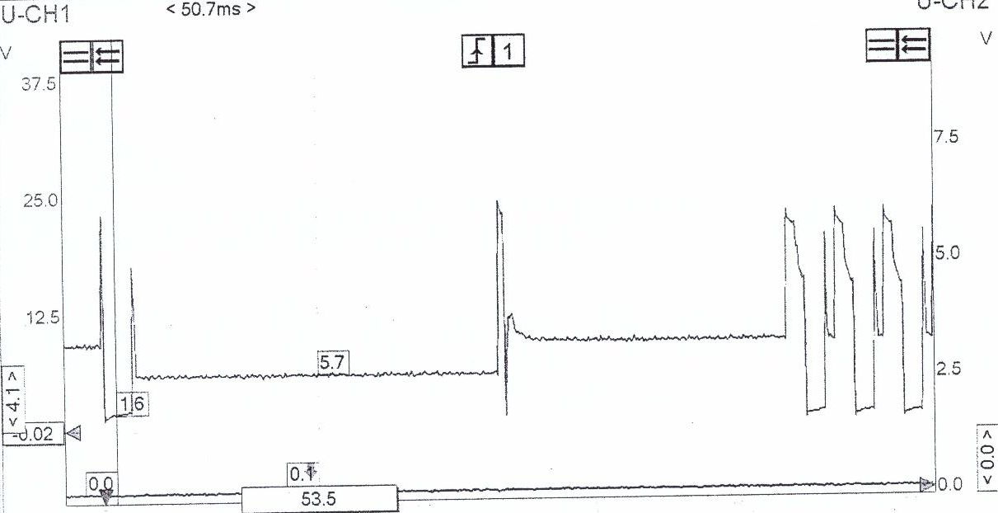

When the ECU decides to then release pressure, the solenoid valve will then draw 5v to raise the solenoid pin higher to allow the brake fluid to return to the reservoir. The Teves system does this differently by having two separate solenoids which draw voltage independent of each other.

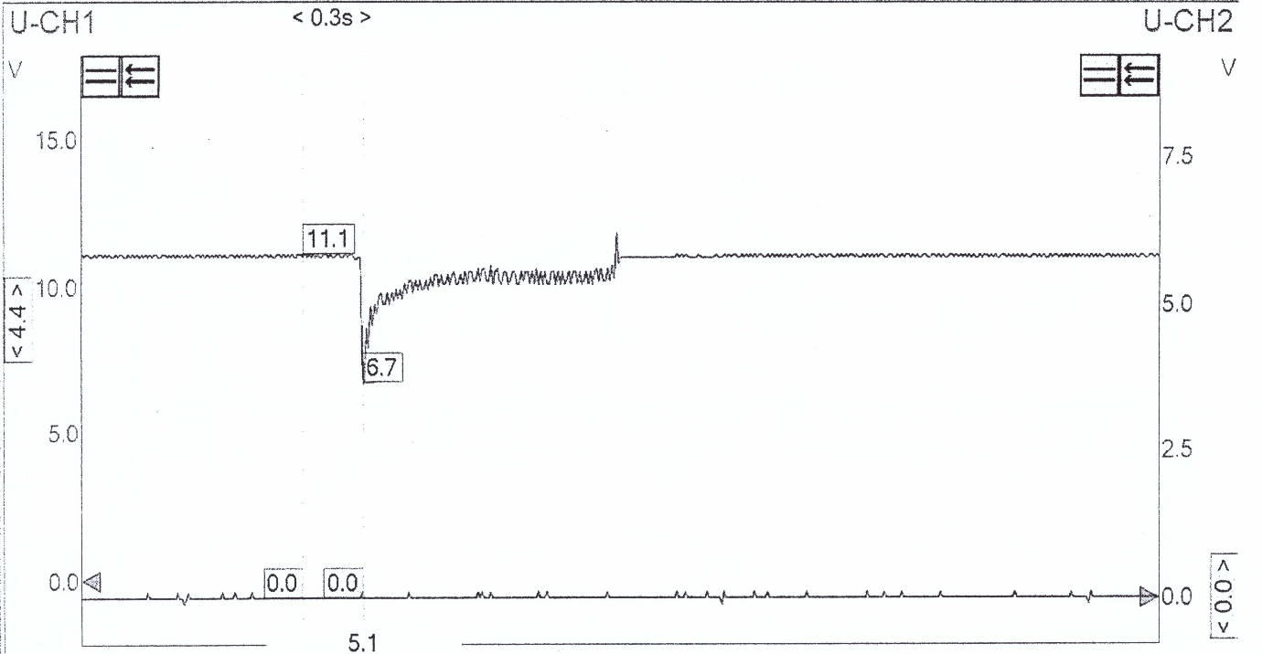

Another component to check would be the pump motor. Shown above is the voltage draw from the pump motor on a brake light switch circuit. This shows the pump motor in operation as it draws voltage from the rest of the vehicle’s systems and could have been done on many other components. It is also important to check the resistance of the pump motor. Sources suggest (Denton, 2000, p.207) 0.3 to 0.5 ohms. The diagnostic techniques mentioned above can be shortened into the following flow chart.

Flow chart


5.Conclusion
When reflecting on both systems it is clear to see both systems have their strengths and weaknesses. The Bosch system is a more basic system than the Teves system. It has three channels instead of four and features a solenoid valve which is used for all three phases that the hydraulic modulator operates within. This simplicity allows for lower weight, manufacturing costs and improved reliability as there are less components to go wrong. The Bosch system also operates on OBD I which makes it harder to access the fault codes as each manufacturer uses a different scanner. The Teves system however is more advanced using a 4-channel system and using two solenoids to control pressure build, release and hold. The Teves system also features OBD II which allows any scanner to read the fault codes as well as additional diagnostic techniques that the system allows.

6. References
V. A. W. Hiller (2001). Fundamentals of Automotive Electronics, 2nd edition, Cheltenham: Nelson Thornes Ltd
Moore C. (no date). Who invented ABS brakes?, Available at: https://itstillruns.com/invented-abs-brakes-5017704.html (accessed: 20/12/2019)

Stuttgart, (2008). Mercedes-Benz and the invention of the anti-lock braking system: ABS, ready for production in 1978, Available at: https://media.daimler.com/marsMediaSite/en/instance/ko/Mercedes-Benz-and-the-invention-of-the-anti-lock-braking-system-ABS-ready-for-production-in-1978.xhtml?oid=9913502 (accessed: 20/12/2019)

European commission, (no date). Anti-lock braking systems in cars (ABS), Available at: https://moodle.uwtsd.ac.uk/pluginfile.php/84970/mod_resource/content/2/Harvard%202018.pdf (accessed: 20/12/2019)
APEC, (no date). ABS sensors, Available at: https://www.apecbraking.co.uk/Resources/TechniciansGuides/ABS-Sensors.aspx (accessed: 20/12/2019)
Denton, T (2000). Advanced Automotive Fault Diagnosis, London: Arnold Publishers
Bosch, (no date). History – Safe Braking, Available at: https://www.bosch.com/stories/beginnings-of-abs/ (accessed: 20/12/2019)
SAE, (1990) SAE Technical Paper 900208, Available at: https://saemobilus.sae.org/content/900208/viewannotation (accessed: 20/12/2019)
HSE, (no date). Health and safety in motor vehicle repair and associated industries, Available at: https://www.hse.gov.uk/pubns/priced/hsg261.pdf (accessed: 20/12/2019)
HSE, (no date). Working with substances hazardous to health. Available at: https://moodle.uwtsd.ac.uk/pluginfile.php/84970/mod_resource/content/2/Harvard%202018.pdf (accessed: 20/12/2019)

Figures
Figure 1
Watany, M. (2014). Performance of a Road Vehicle with Hydraulic Brake Systems Using Slip Control Strategy. American Journal of Vehicle Design, figure 15
Figure 2
Daftardar, I. (2016). How Does Anti-lock Braking System (ABS) Technology In Cars Work?, Available at: https://www.scienceabc.com/innovation/abs-sensors-anti-lock-breaking-system-technology-cars-work.html (accessed: 20/12/2019)
Figure 3
APEC, (no date). ABS sensors, Available at: https://www.apecbraking.co.uk/Resources/TechniciansGuides/ABS-Sensors.aspx (accessed: 20/12/2019)

7. Appendices
Bosch ABS 2EH Waveforms
Wheel speed sensor

ABS brake light switch

`

Rear solenoid

Rear solenoid

Teves Mk IV waveforms
Wheel speed sensor

Flow Chart
Bosch Data Used
Pin Number | Description | Ignition Off (V) | Ignition On (V)
1 | ABS Warning Lamp Indicator | 0 | 12.43
2 | N/S/R Wheel Speed Sensor (Ground) | 0 | 0.22
4 | N/S/R Wheel Speed Sensor Signal | 0 | 0.33
5 | O/S/F Wheel Speed Sensor (Ground) | 0 | 0.22
6 | O/S/R Wheel Speed Sensor Signal | 0 | 0.33
7 | N/S/F Wheel Speed Sensor (Ground) | 0 | 0.22
9 | Brake Light Switch Feed | 0 | 12.4
10 | O/S/F Wheel Speed Sensor Signal | 0 | 0.33
13 | N/S/F Wheel Speed Sensor Signal | 0 | 0.33
14 | O/S/R Wheel Speed Sensor (Ground) | 0 | 0.22
 | Pulse generator resistance | 1090 ohms

Teves Data Used
Pin Number | Description | Ignition off (V) | Ignition On (V)
1 | Pulse Generator Earth | 2.39 | 2.4
2 | Pulse Generator Earth | 2.39 | 2.4
7 | Permanent Live | 12.6 | 12.5
9 | Ignition Live | 0.2 | 12.6
10 | Pulse Generator Earth | 2.39 | 2.4
11 | Pulse Generator Earth | 2.39 | 2.4
12 | Live | 0.2 | 12.5
13 | OBD | 10.83 | 10.78
15 | Switched Live | 0.12 | 12.4
17 | Pulse Generator Supply | 2.35 | 2.35
18 | Pulse Generator Supply | 2.35 | 2.35
19 | Pulse Generator Supply | 2.35 | 2.35
20 | Pulse Generator Supply | 2.35 | 2.35
25 | Permanent Live | 12.61 | 12.6
30 | Permanent Live | 12.45 | 12.45
 | Pulse Generator Resistance | 1090

