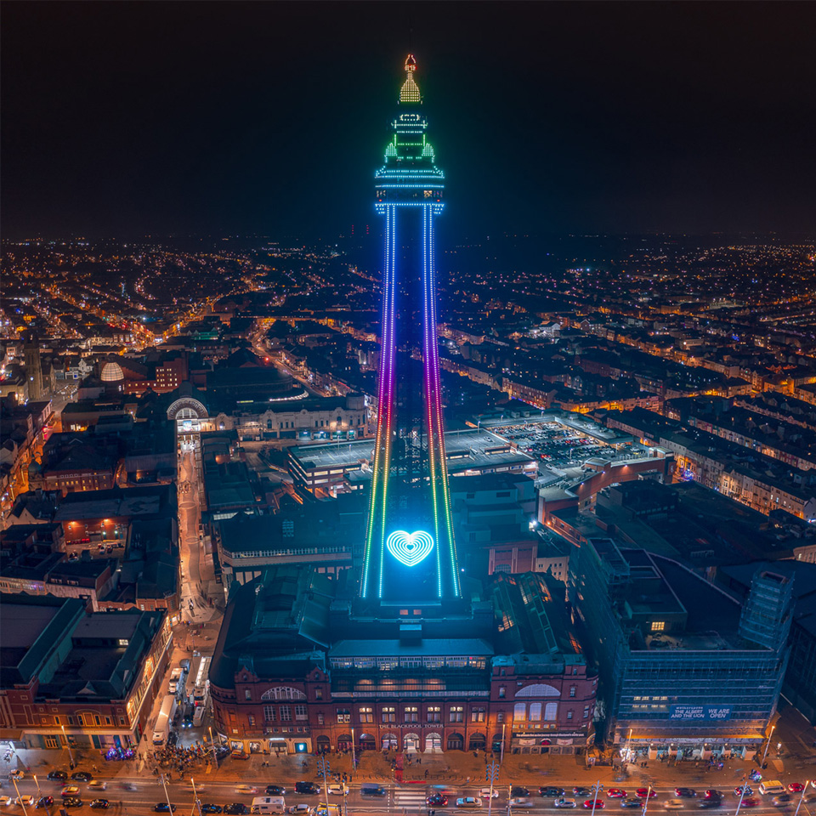
(Blackpool Tower, n.d.)

The Blackpool Tower
  - Construction REPORT
Callum Griffiths (2417576) | Skills for Professional Practice (ACBA4027) | 07/12/2024

Table of Contents

1.Introduction 2
2.Background information and stakeholders. 2
3.Design and Engineering 3
4.Construction Process 4
5.Conclusion 5
Reference list 6

1.Introduction
This report is on the history and construction of the Blackpool Tower. This construction is of interest to the author due to frequent trips to Blackpool over many childhood years. This report will be on the initial construction of the building and any issues that occurred throughout the building’s history, in particular issues that were down to the materials used and the building methods of the time.
The Blackpool Tower is of huge importance to the city and the significance of the building cannot be overstated. It is Blackpool’s only Grade 1 Listed Building and has stood at the forefront of tourism for the area since it’s opening in 1894 with roughly a million people visiting every year (Humphries, 2024).This report will show how relevant the Blackpool Tower still is for people working in the construction industry, but also showcasing how mistakes that happened in the 19th century, are still happening in 2024.
The purpose of this report is for the reader to understand the history, design and construction methods of one of the UK’s most important and impressive buildings. The report will detail background information on the structure as well as discuss key members of the project. The report will investigate design principles and challenges that came up during the construction and will demonstrate highly innovative design elements that are still influencing the industry today.

2.Background information and stakeholders.
Blackpool Tower is a 518ft tourist attraction set in the heart of Blackpool along the front of the promenade. The tower cost approximately £290,000 to construct, which is in the region of £35m today. At the time of writing, it is the 120th tallest free-standing tower in the world (Institution of Civil Engineers, n.d.).
Construction started on the tower in 1891 and ended in 1894 (Institution of Civil Engineers, n.d.). The purpose of building the tower was to increase revenue and tourism in the area. Over 3,000 people visited the tower on the opening day (BBC, 2023)

Taking inspiration from the recently erected Eiffel Tower in Paris, a London based company bought an aquarium on the central promenade with the intention of building a Tower. John Bickerstaffe who was a former mayor of Blackpool was appointed chairman of the project (The National Archives, 2019).
Designs were drawn by architects James Maxwell and Charles Took who owned the architectural practice Maxwell & Tuke which was based in Manchester. Unfortunately, both James and Charles passed away before the project was completed. Another Manchester based company, Heenan & Froude were appointed structural engineers (Institution of Civil Engineers, n.d.).

3.Design and Engineering
Due to the inspiration from the Eiffel Tower, the structures are similar but not a direct copy, the plan was never to replicate the Eiffel Tower. One difference the architects made was to have the legs incorporated within the ground, whereas the Eiffel Tower is a standalone structure with metal base feet visible from the ground (Blackpool Tower Company, n.d.).
Heenan and Froude were the engineers in charge of the construction of the Tower. 2,533 tonnes of steel and 94 tonnes of cast iron were used to build the structure. The Tower has four legs, each of which is made up of an additional four legs. The additional four legs were braced with lattice girders (Blackpool Tower Company, n.d.).
Within the tower, there are many attractions. One of these attractions is the ballroom. The dance floor is considered to be the first purpose-built public ballroom in England. The aim of this was to try and increase the number of working-class holidaymakers and to give extra room to the outdoor dances that were common at the time. The dance floor is a sprung floor which means it will absorb shock and give a softer feel for the users. These floors can reduce the risk of injury (French, 2015). This was a highly innovative design for the time and the ballroom is still in use today

4.Construction Process
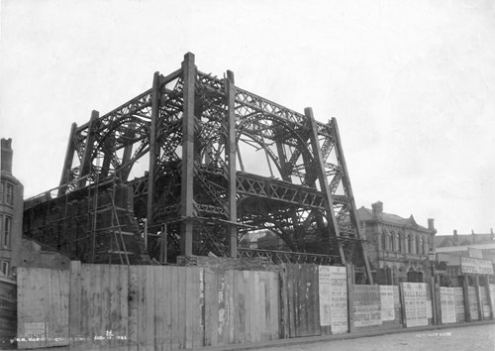
(Blackpool Tower, n.d.)
The construction of the Tower took two years and seven months from the first foundation stone being laid to the Tower opening to the public. Like all projects, there were issues that had to be resolved. As mentioned by Hodson (1999, p. 69) before work was able to commence, some properties within the vicinity of the Tower had to be demolished to make room for the foundations. In the article referenced above, Hodson stated the erection of the tower then began in 1892, a year after the foundations were laid.
Throughout the construction, various methods and techniques were employed to aid the workers in erecting the tower. According to Hodson, the lift that would eventually carry passengers was built to always be higher than the construction by a couple of feet, this allowed for a working platform to be placed within the shaft. This working platform would be mounted with cranes and various equipment.
Construction projects of this scale will always come with challenges, even more so when you consider the period the project was undertaken and the location of the tower. The strong winds and heavy rain of the area would have been a challenge as well as the erection of the tower considering the size and weight of the materials.

5.Conclusion
The Blackpool Tower still stands today as a testament to the skills and knowledge of the construction industry from a bygone era. The techniques and methods that were used then are still being used today. This report should also hopefully demonstrate an improvement in certain aspects of an ever-evolving industry. The transportation methods we use today are still similar but are more environmentally friendly, but we must also look at the challenges facing the workers at the time and accept that there were not many alternative options.
The tower is still looked upon today as one of the greatest UK construction achievements of the Victoria era and has become a symbol of Blackpool.

Reference list
BBC (2023). Blackpool Tower creator’s great-grandson visits for first time. BBC News. [online] 6 Apr. Available at: https://www.bbc.co.uk/news/uk-england-lancashire-65202453 [Accessed 26 Nov. 2024].
Blackpool Tower (n.d.). Blackpool Tower at Night. [Online Image] Blackpool Tower. Available at: https://www.theblackpooltower.com/ [Accessed 22 Nov. 2024].
Blackpool Tower (n.d.). Foundation of Blackpool Tower. [Online Image] Blackpool Tower. Available at: https://www.theblackpooltower.com/history/the-tower/ [Accessed 26 Nov. 2024].
Blackpool Tower Company (n.d.). Blackpool Tower Vs Eiffel Tower | The Blackpool Tower. [online] The Blackpool Tower. Available at: https://www.theblackpooltower.com/news/blackpool-tower-vs-eiffel-tower/ [Accessed 1 Dec. 2024].
French, H. (2015). Glamorous Spaces: Public Ballrooms and Dance Halls, 1890-1950. Interiors : Design, Architecture, Culture, 6(1), 41–57. https://doi.org/10.2752/204191115X14218559960196
Hodson, H. (1999). ‘Iron and steel at the seaside: Blackpool Tower’, Steel Times, 227(2), p. 69. (Accessed: 09 November 2024)
Humphries, J. (2024). Blackpool Tower memories sought as icon turns 130. BBC News. [online] 30 May. Available at: https://www.bbc.co.uk/news/articles/cd11247dmd2o. (Accessed: 02 December 2024)
Institution of Civil Engineers (n.d.). Blackpool Tower: An Icon of British Engineering. [online] Institution of Civil Engineers (ICE). Available at: https://www.ice.org.uk/what-is-civil-engineering/infrastructure-projects/blackpool-tower [Accessed 9 Dec. 2024].
The National Archives (2019). 1833 Factory Act. Nationalarchives.gov.uk, [online] 1(1). doi: https://www.nationalarchives.gov.uk/default.htm.

