Marketing plan
written for

________________________________Premier Inn ______________________________

________________________Jessica Tatiana Santos Gomes_______________________

___________2210702__________

Marketing Essentials BMIH4005
Lecturer

________________Christopher Wilkin ________________

Introduction

This paper will be discussed a marketing strategy for Premier Inn using an overview of the company. The main areas that require improvement will be highlighted in this marketing plan. Firstly, “Premier Inn has over 800 hotels in the UK containing over 80,0000 rooms all located near airports and touristic locations. It serves over five million customers every month” (Whitbread, 2022).
Most of these areas will be addressed by the SOSTAC framework, this one will create a marketing plan. As a result, Premier Inn's SWOT and PESTLE will be presented.
A new plan for Premier Inn will finally be revealed.

See appendix 1: SOSTAC Framework

This discussion's main focus will be the SOSTAC framework in detail, this one will analyse the value of SWOT and PESTLE analyses, as well as the objectives, strategies, tactics, actions and control of Premier Inn.
This SWOT analysis's goal is to define the business situation and evaluate Premier Inn's strengths and weaknesses and highlight the possibilities and threats the company will likely face in the future. “Situation analysis helps inform a company’s decision-making process by looking at the external and internal factors impacting its overall success” (Masterclass, 2022). Additionally, it seeks to examine some of the chances for the hotel's future growth as well as the dangers to which it should pay attention in order to develop effective responses.
This SWOT analysis example is shown below.
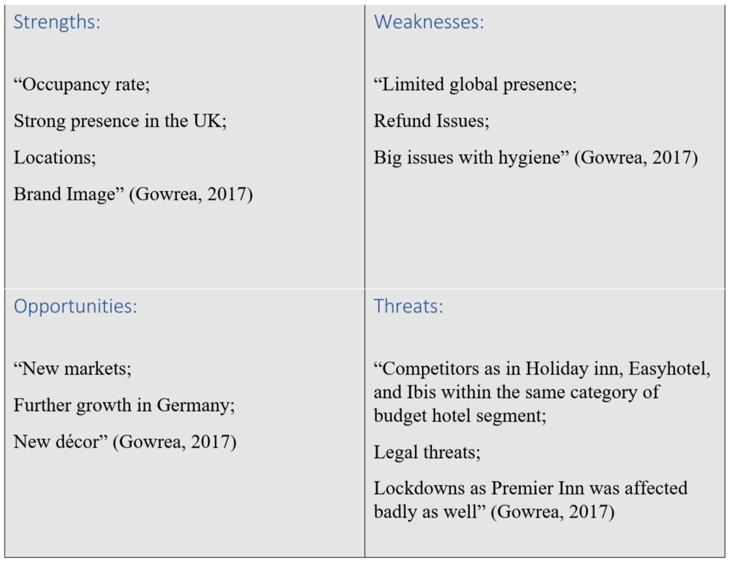

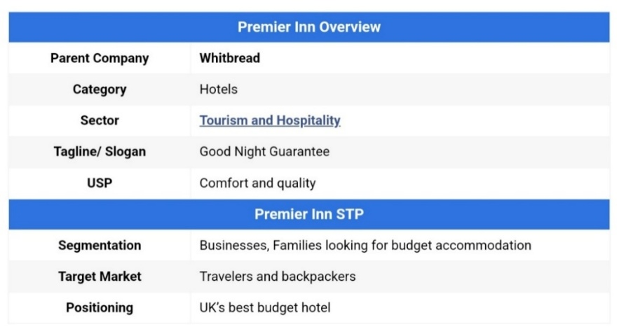
Families, travellers, backpackers and tourists looking for decent lodging on a budget are the primary target markets for Premier Inn, as these establishments offer comfort and quality during their stay.

(Whitbread, 2022)
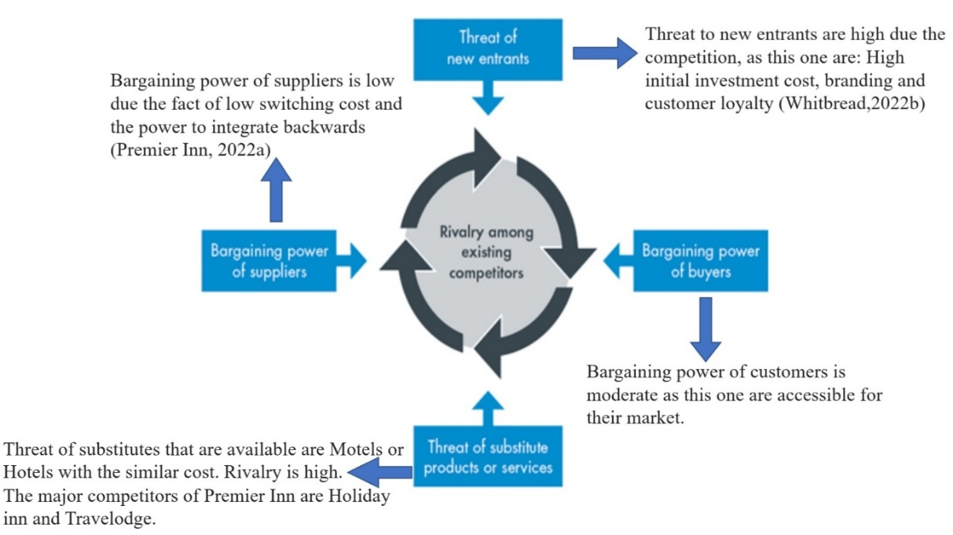
The low-cost hotels and Motels that offer comparable services are Premier Inn's major rivals. As the “main competitors of Premier Inn are Holiday inn, Easyhotel, and Ibis within the same category of budget hotel segment” (Gowrea, 2022).

Premier Inn, “one of the largest hotel chains in the UK, is owned by Whitbread PLC” (Whitbread, 2022).
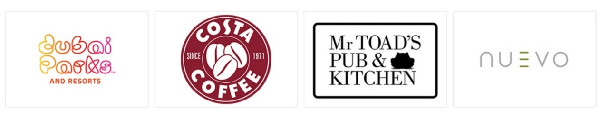
They enhance the brand's value and deliver special advantages. Their principal collaborators are:

(Premier Inn, 2022b)


Premier Inn “works with many different Travel Management Companies and Hotel Booking agents, offering connectivity via online booking tools and expense management platforms” (Premier Inn, 2022d)
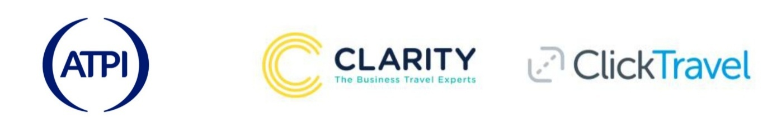
(Premier Inn, 2022d)

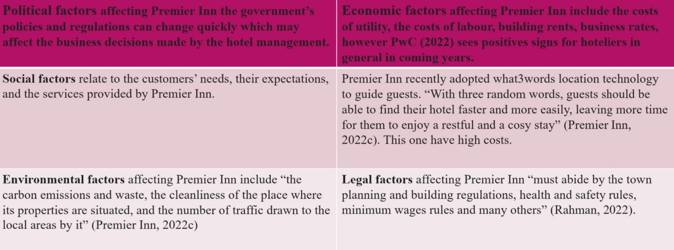
PESTLE Analysis of Premier Inn “identifies different types of threats that an organisation faces. It also helps strategic planners devise strategies to address those threats and take advantages of the opportunities” (Rahman, 2022a).

The importance of SWOT and PESTLE analysis for Premier Inn has been established, how is demonstrated the increased competition and the fear of customer dissatisfaction. For this purpose “Porter's five forces analysis is beneficial to assess the profit potential, while PESTLE analysis offers a valuable framework for understanding the overall environment” (Hall, 2022). Making environment friendly energy sources and new technology approached became more attractive for costumers.

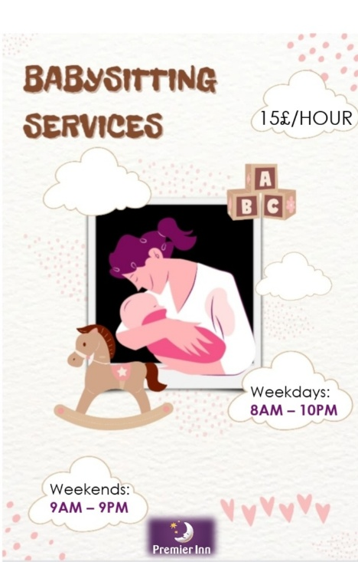
Families are Premier Inn's primary target market, yet the motels lack child-friendly amenities.
The new strategy includes a section where a qualified child care provider will be on hand with requirement of booking, as this one will have a cost per hour. Without taking away from the enjoyment of the holidays, the kids will be introduced to new fun opportunities.
This will be a specific children's space inside the hotel with a play area, a learning area and a place to relax. “Not all hotels offer a babysitting service, or an outside babysitting provider affiliated with the hotel” (Sitters, 2022)

For this reason the new marketing plan for Premier Inn will increase their target market for families, as them will prefer this one based on their pricing.
The main goal is for them to be able to relax and enjoy their holidays while having someone trustworthy watch over their kids.
The Premier Inn will only make a request through that kind of booking.
During specific hours, 15£ will be charged each hour. These hours are:
Weekdays from 8AM to 10PM
Weekends from 9AM to 9PM
Furthermore, if the family would like a special service during night time, that will be charged 25£/hour.
To achieve this goal will be set a target dates and ways how to publicised this new marketing plan to be able to reach the costumers.
Premier Inn is between Hybrid and Differentiation as this one created a great loyalty with their costumers base on their reachable pricing.
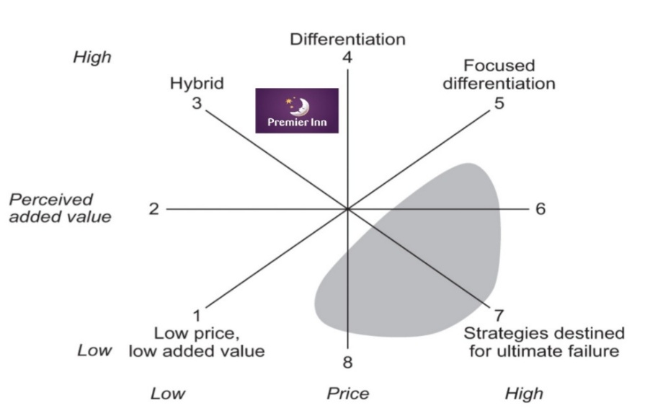

Babysitting service is not provided by Premier Inn Hotels. With this new service will be available on all hotels of Premier Inn throughout United Kingdom. For this reason was created for helping increase their bookings. Babysitting service will meet the costumers needs, as they have various attributes on this service to help their growth.
This will be a successful service as the main costumers are families and they will be able to relay on the hotel to keep their children safe and be able to enjoy adult activities and events on their holidays. As hiring a professional children care the main advantage is the safety and security that this ones brings with their specials skills, their flexibility for the requested hours that they will booked in.
Premier Inn is one of the most known budget hotels in United Kingdom, for this reason the families will chose this hotel due to the fact that they always kept their word of a good accommodation on a budget price, as this ones provide comfort and quality. The babysitting service will range between 15£ to 25£ rely on the service ordered by the costumer, and the amount of hours for this one. 15£ service is between weekdays and weekends and 25£ service is special night hours.
Babysitting Services by Premier Inn will be advertised by differences ways. First of all will rely on their website promoting the new service, secondly will create Social Media Ads, especial promotional codes used by TV, radio provided by the Premier Inn. The use of Flyers will be dispersed around the hotel and hang on effective places as local shops and dining venues. Chat online and click rate will be analysed on website and social media posts.
With this in mind, will be able to see the engagement made by the audience. One of the goals is to be able to create a special promotional code for this service. The engagement of the team to promote this service will develop a relationship with the costumers using the chat of website, social presence, email and on presence on the hotel.
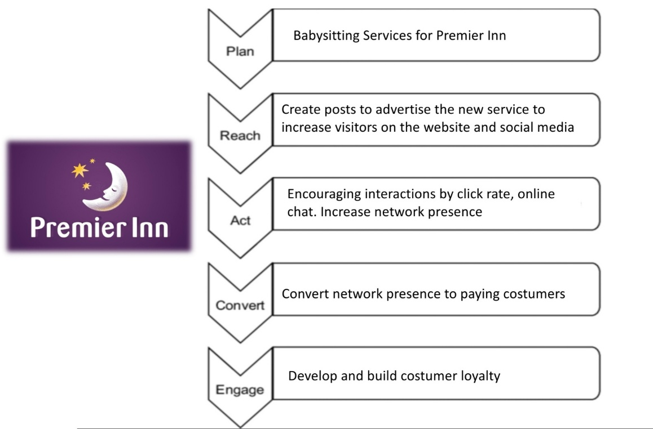

On the communications plans we can observe the marketing channels schedules. TV and Radio will be reviewed by special promotional codes and views, will be advertised on the highest months of the year specifically summer season due this ones have a high cost of advertising.
Sales promotion such as Premier Inn website, social media and public release will be analysed by click rate, posts and videos shares. Finally, the direct marking as emails and flyers will be created a special promotional code and a direct link. As this ones have low cost of advertising will be running all year around.
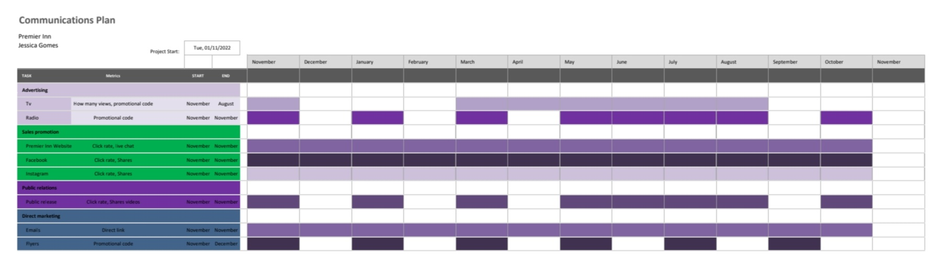

(Social Media Posts) (Flyers)
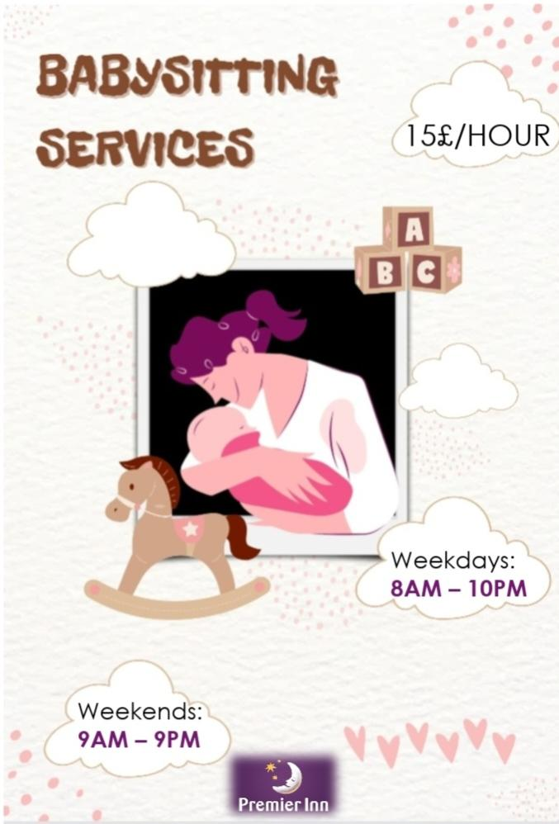
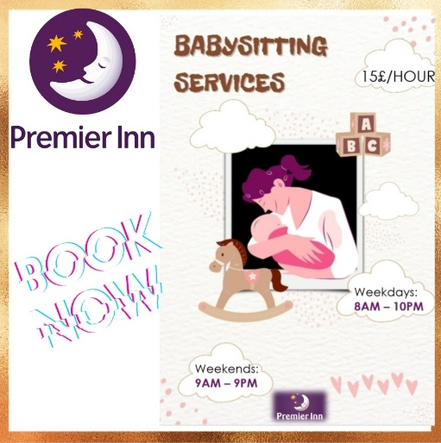

The unique selling proposition is to maintain the quality and comfort of Premier Inn and maintain the same budget towards the costumer. Babysitting service will attract new costumers and existing ones.
With this new approaches we can break down by sales to the new costumers, sales to existing costumers and the profit by them. As a result, is possible to analyse which advertising will be more efficient to reach our target market.
To expand this new service to all hotels of Premier Inn will be able to develop this service for the purpose of attract new costumers and grown worldwide.

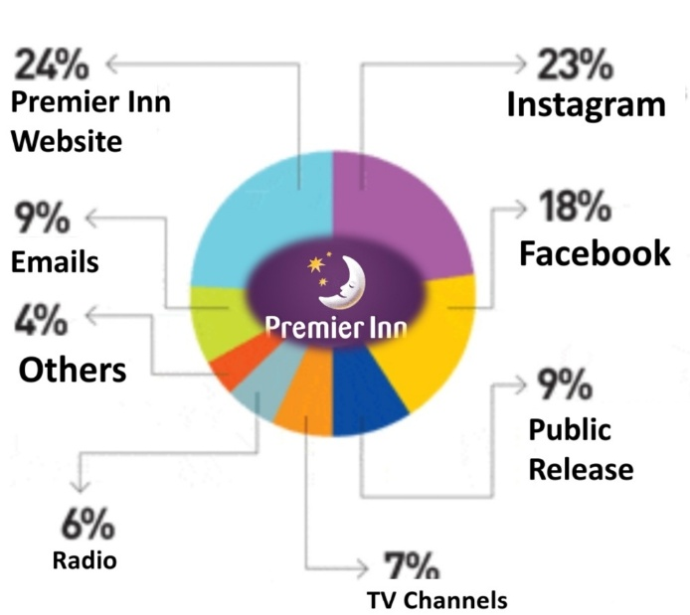

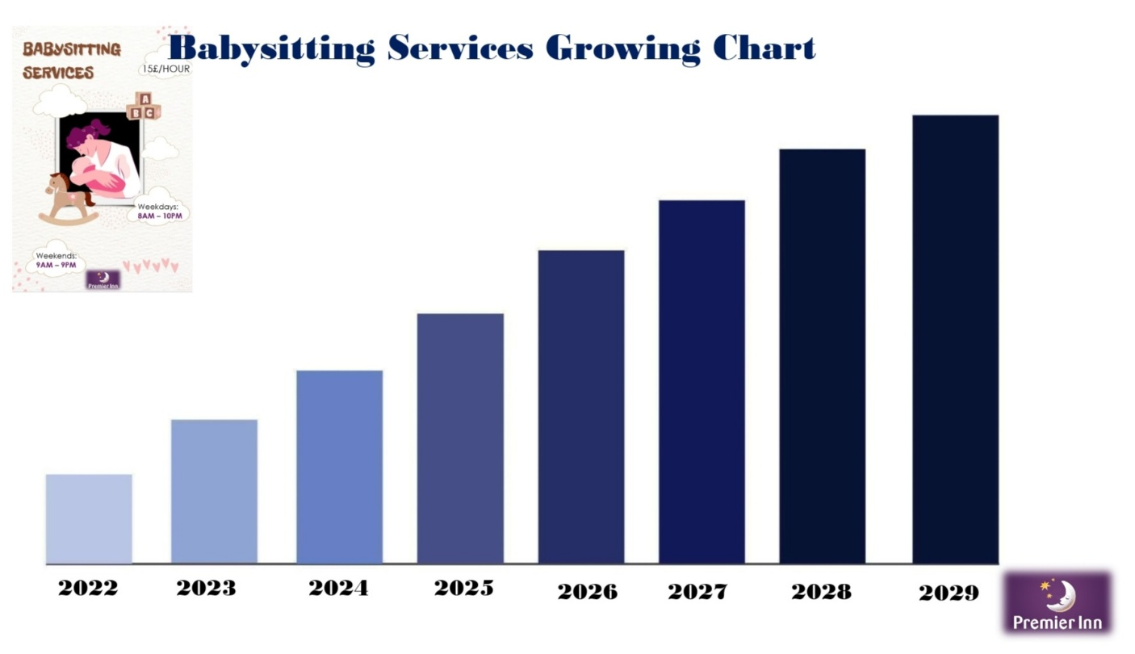

Conclusion

Summarising the above topic about Premier Inn and the new strategy, we can conclude it will bring new areas to explore. There is some evidence on above PESTLE, porters model and swot analysis, Premier Inn is considering to expanding their businesses and becoming the brand leader in hospital industry. For this reason the Babysitting Services not only going to reach new costumers, increase profit and the Premier Inn brand will grow worldwide.
In conclusion, the main aim was achieved in being able to state what strategies and ways to advertise the new service that will be provided by Premier Inn.

References

Gowrea, V. (2017) SWOT Analysis of Premier Inn. Retrieved from https://howandwhat.net/swot-analysis-premier-inn-premier-inn-swot-analysis/
Gilliland, N. (2017) What makes Premier Inn the world’s strongest hotel chain? Retrieved from https://econsultancy.com/what-makes-premier-inn-the-world-s-strongest-hotel-chain/
Hall, M. (2022) Porter's 5 Forces vs. PESTLE Analysis: What's the Difference? Retrieved from https://www.investopedia.com/ask/answers/041015/whats-difference-between-porters-5-forces-and-pestle-analysis.asp
MasterClass (2022) What Is Situation Analysis? 5 Situation Analysis Tools. Retrieved from
https://www.masterclass.com/articles/situation-analysis
Premier Inn (2022a) About us. Retrieved from
https://www.premierinn.com/gb/en/why.html
Premier Inn (2022b) Partners. Retrieved from
https://mena.premierinn.com/en/attractions-partners
Premier Inn, (2022c) Premier Inn adopts addressing technology what3words. Retrieved from https://www.premierinn.com/gb/en/news/2019/what3words.html
Premier Inn, (2022d) Travel Partners. Retrieved from https://www.premierinn.com/gb/en/business/travel-partners.html
PwC (2022) Headwinds create uncertain outlook for hoteliers. Retrieved from https://www.pwc.co.uk/industries/hospitality-leisure/insights/uk-hotels-forecast.html
Rahman, M. (2022a) PESTEL analysis of Premier Inn. Retrieved from
https://howandwhat.net/pestel-analysis-premier-inn/
Rahman, M. (2022b) Marketing Mix of Premier Inn. Retrieved from https://howandwhat.net/marketing-mix-premier-inn/
Sitters (2022) Hotel Babysitting Options When You’re on Holiday. Retrieved from https://www.sitters.co.uk/blog/hotel-babysitting-options-when-you-re-on-holiday.aspx
Think Insights (2021) Bowman’s Strategic Clock – How to position your product? Retrieved from https://thinkinsights.net/strategy/bowmans-strategic-clock/
Whitbread PLC (2022a). About us. Retrieved from
https://www.whitbread.co.uk/about-us/
Whitbread PLC (2022b). Our business model and strategy. Retrieved from
https://www.whitbread.co.uk/about-us/our-business-model/

Appendices



