
Managing aN IT PROJECT FOR HOME USERS
Project Management

April 27, 2018
UWTSD
Thomas Evans p145653

Table of Contents

Risk

Sustainability

Ethical and Legal Issues

Quality Assurances

References

Risk
Poor risk management can lead to a project failing in any field. Risk management can be separated into several categories when being used correctly in the context of a project. Risk identification. Finding a projects specific risks. Risk Analysis. Identifying which Risks are the most serious. Risk Planning. Creating a plan to deal with the serious Risks. Risk Monitoring. Continuously checking the risks throughout the life cycle of the project to make sure that the planning is working.
Risk Identification
Before beginning the project, it is essential that the risks for the project are identified to ensure something can be done about them before they become an issue during the projects lifecycle.
The first risk that can face a project in any field is personal shortfall. This risk can include any member of a team not meeting their requirements of not having the capabilities to meet a deadline. This risk can be avoided in this project by maintaining a high standard of job-matching and ensuring that all project participants are assigned to jobs that they are able to complete. Also, it is essential to make sure that a project schedule is allows reasonable and realistic goals for each task to be completed to avoid constantly over-running on sections of the project.
Unrealistic cost and time estimates are another risk that will plague projects in all fields. This can be avoided by analysing previous projects and using multiple form of estimation techniques to ensure a realistic schedule and costing scheme is arrived at.
Risk Exposure Calculations
The risk exposure calculation is a calculation used to estimate the cost of a risk. The equation is:
Risk Exposure = Potential Damage (£) x Probability of Occurrence
For the purpose of this assessment this equation is not ideal as there are no finances involved in the project from the people conducting the project. But for large scale projects this equation can be used to calculate the amount of money the risk would cost to insure. Companies can then use this to estimate whether the Risk is a crucial one and if it interferes with the project going ahead.

Probability Impact Matrix
Although the risk equation isn’t suitable for this project a probability impact matrix can be used to evaluate whether or not the project is viable and whether the risks taken are too much for the project. Firstly in this section of the report it will be essential to pinpoint the major project risks and then assign them to a spot on the Impact matrix to see the true impact the risk could have if something were to occur.
Risk 1 (R1) - The first risk as touched upon earlier in the report could be personal shortfall. This could include failure to complete work before a deadline. This could result in having a significant effect on the project although it is believed that the likelihood of this issue is low.
Risk 2 (R2) - Due to the project being done on apple hardware and software the group members will have to use hardware available from the university as not all have their own Apple software. There is a small risk however that they might not be available when needed. This would highly impact the project although the probability is incredible low.
Risk 3 (R3) - During the cycle of the project some group members may experience illness. This could lead to a grouo member having to miss a day of working on the project. Although this could lead to a few days missed it is likely the group could cope without one member for a day or two. Thr probability of this happening is moderate but the impact is low.
Risk 4 (R4) - As the project is being conducted for the purposes of a university module it is possible that not all students will attend sessions of infact still be in university come the end of the project. Although to the probablility of this is low it would leave the group without needed staff and therefore could end up with a major impact and could delay the project.


Sustainability
For the purpose of this report it is essential to provide a first, second and third orders of impact. The first being the projects direct impact on the environment. The second being a result of the projects efforts to reduce others impact and third being a long term thing that could affect the project.
Firstly, a first order sustainability impact for this project could be GHG emission and E-waste as a result of the energy used to run the hardware that the group need to complete the project.
The second order of sustainability for this project would be the reduction of travel for all group members. All group members will travel by foot to any group meetings of working sessions. Also work is sometimes completed at home and shared between group members to avoid having to travel to university on days not needed.
The third order of sustainability impact for this project could be energy intensity.

Ethical and legal issues
When conducting a project for the purpose of this module it is essential to study the ethics that must be considered when creating the app.
An important issue to consider when developing the app is data protection. Any data submitted by a user should have a certain level of privacy and any details submitted to the application by the user should be protected and should only be seen by those that the user wishes to see it. All admins should refrain from looking at data that they do not need to see.
It is essential to protect the charities data from external interference. The project should consider taking steps to secure data and prevent unauthorised access without restricting legitimate users from accessing the application.
When working on the application it will be important to meet the IEEE code of ethics. The IEEE code of ethics includes 5 sections. The first of which is to be friendly to others this rule states that everyone should be respectful of others and should always take care in the protection of their personal data and information. The second rule states that no one’s should harass or bully anyone whether it be in person or via any form of technological communication. The rule also states that no one should be discriminated against for characteristics that are protected by law. IEEE also states that no one should come to harm and their data, belongings, reputation or employment should be effected. The fourth rule states there will be no retaliation. Finally the IEEE code of conduct states that they must comply with all rules and regulation in counties in which the IEEE conducts business. [1]
Another code of conduct it is important to consider when creating any ICT resource is the British computer society’s code of conduct. The British computer society code of conduct contains 4 main points. Public interest. Conduct activities without discrimination. Always promote equality. This point greatly supports the app created for the purpose of this report. The second point is professional competence and integrity. This point states that someone should only undertake work they have the competency to complete. Thirdly Duty to relevant authority. This states that a person should carry out their duties within the requirements and standards of the relevant authorities. Lastly the fourth point states Duty to the profession. A person should accept their personal duty top uphold the reputation of the profession and not bring the profession into disrepute.

Quality Assurances
When looking for quality in an ICT product the SMART objectives are regularly looked at Specific, Measurable, Achievable, Realistic, and timely.
Another way of measuring quality in use is by analysing effectiveness productivity and safety. Firstly effectiveness states that the application should achieve user goals with accuracy and completeness. If this is compared to the finishes application it can be considered a success as the application does everything that was outlined in the specification that the user may need within the application. The application allows access to the user’s device as well if permitted so that the user can be reminded of any events that the user has confirmed they wish to attend.
The application is productive. It does not contain ant wasted space on pages and does not provide and needless services that a user would not require and does not demand excessive use of resources in order to run to the specifications. Most devices would be able to run the application without any issue what so ever.
The application does not allow for user safety to be compromised in anyway at all. And would not allow the business software property or enviroment to be harmed either.

Screenshots
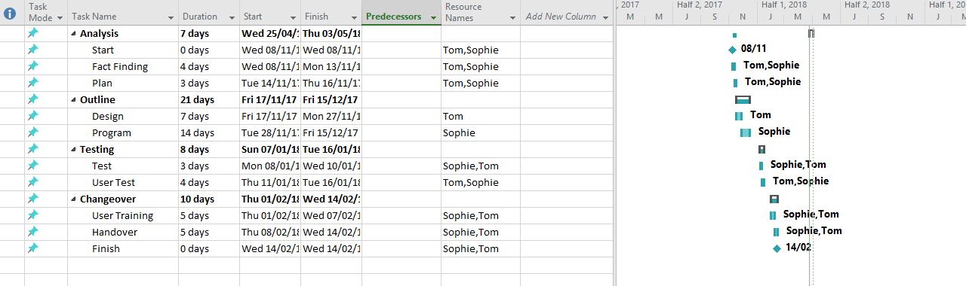
Above is the amended Gantt chart for the life cycle of the application. As can be seen when compared to the original Gantt chart included in the PID. A main difference between both diagrams is that the recourses have been changed so that ‘Iestyn’ is no longer included as he never took part in any development of the project and never made contact with the group. Also once compared to the original diagram It can be studied to see the changes to see the amount of time that tasks realistically took for example the outline section in the diagram took a week longer in reality than originally expected to. Below is the network diagram created for the planning stage this unfortunately cannot be compared to the original from the PID as one was not originally included in that document. Also below are screenshots demonstrating the functionality of application.
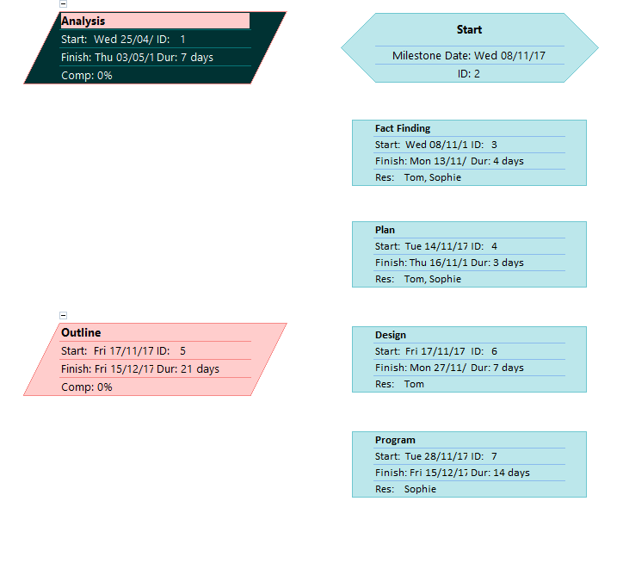
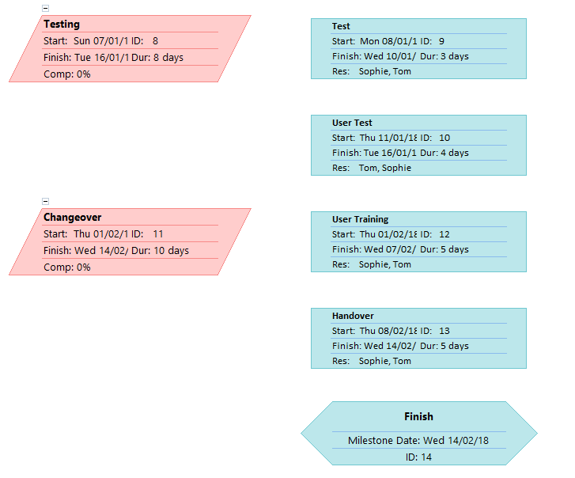

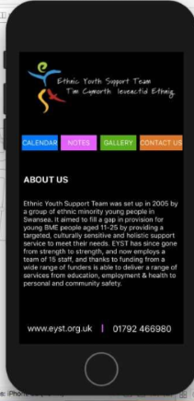
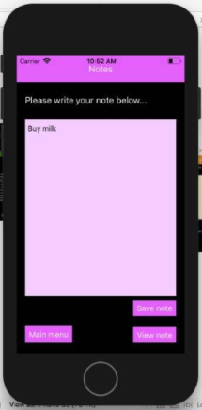
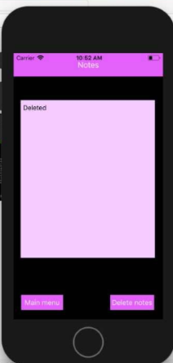
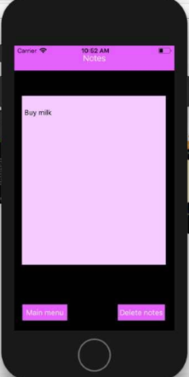
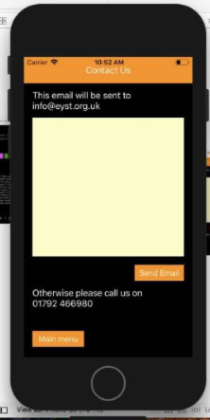
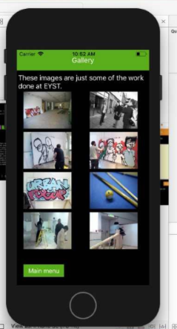
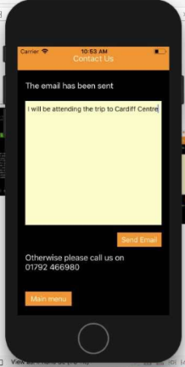
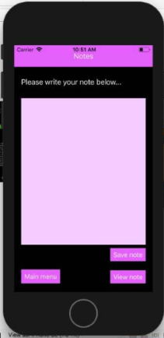
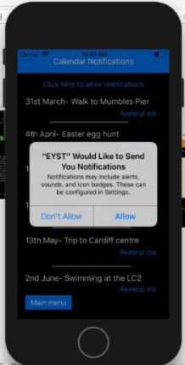
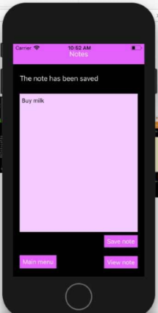
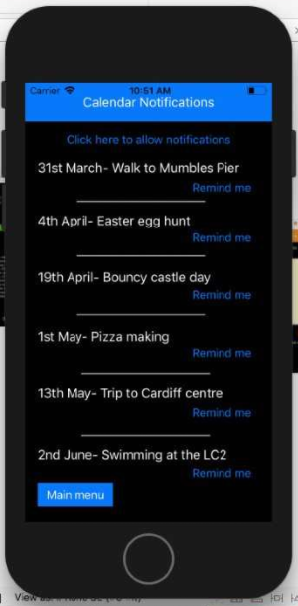

Functionality
As can be seen in the above screenshots the application works to the original specification. The app is able to save and delete and notes that are needed. The app is able to set reminders for any of the events on the application and input a reminder on to the user’s phone. The user is able to browse the applications gallery which includes pictures from the charities website. The applications design also mimics that of the website.

References

[1] IEEE Code of conduct URL: https://www.ieee.org/content/dam/ieee-org/ieee/web/org/about/ieee_code_of_conduct.pdf [Accessed 25/04/18]
[2] BCS Code of Conduct URL: https://www.bcs.org/upload/pdf/conduct.pdf [accessed 25/04/18]

