
APPENDIX GA36d

LEVEL 7 ASSESSMENT SPECIFICATION
Student name: | BALA JAYA CHANDRA PICHIKALA | Student ID number: | 2219819
Programme: | Computer Networks and Cyber Security
Module: | Network Security
Module code: | ACCA7019 | Contribution to Overall Module Assessment (%): | 100%
Lecturer: | Dr Carlene Campbell | Internal Verifier: | Nitheesh Kaliyamurthy
Assignment Title: | Construct and mitigating security vulnerabilities and weaknesses. | Word count (or equivalent): | 6,000
Submission deadline: | May 5th 2023 | Return date of provisional marks & written feedback:
Submission method: | All written assessments, where practical and possible, must be submitted via Turnitin unless otherwise instructed by the Lecturer. (Please DO NOT put this assessment specification into Turnitin or it will match many similarities with other students’ submissions.)  Alternative submission method (if applicable):  Late submission of the assessment will result in a late penalty mark. Penalties for late submission: Up to one week late, maximum mark of 50%. Over one week late, 0%. Only the Extenuating Circumstances Panel may approve a change to submission dates.

NETWORKS SECURITY

Table of Contents
PART 1 1
1. Security Threats Facing Modern Network Infrastructures 1
1.1 Network Security 1
1.2 Types of Threats and Attacks 1
1.3 Tools and Procedures for Mitigation of Attacks 2
1.4 Fundamental Principles of Securing a Network 2
1.4.1 Defense in Depth 2
1.4.2 Least Privilege 3
1.4.3 Segmentation 3
1.4.4 Patch Management 3
1.4.5 Strong Authentication and Authorization 3
1.4.6 Monitoring and Logging 3
1.4.7 Encryption 3
1.4.8 Security Awareness and Training 3
1.4.9 Incident Response Planning 3
1.4.10 Regular Security Assessments 3
1.5 Mitigation of Common Network Attack Methods Effects in SMEs 4
1.5.1 Endpoint Security 4
1.5.2 Network Security 4
1.5.3 Access Control 4
1.5.4 Data Encryption 4
1.5.5 Backup and Recovery 4
1.5.6 Monitoring and Incident Response 4
1.6 Cisco Network Foundation Protection (NFP) Framework 4
1.6.1 Management Plane Protection (MPP) 4
1.6.2 Control Plane Protection (CPP) 5
1.6.3 Data Plane Protection (DPP) 5
1.7 Mitigating the effects of Viruses, Worms, and Trojan Horses in SMEs 6
1.7.1 Endpoint Protection 6
1.7.2 Firewall 6
1.7.3 Patch Management 6
1.7.4 Email Security 6
1.7.5 Web Security 6
1.7.6 Application Control 6
1.8 Endpoint Vulnerabilities and Protection Methods 7
2. Configuration of Secure Network 7
2.1 Securing Routers and Implementing AAA 7
2.2 Mitigate common Layer 2 Attacks 8
2.3 Configuration of ZPF on Routers 10
2.4 Configuration of Firewall 11
2.5 Implementation of IPS 12
2.6 Configuration of VPN 14
2.6.1 Purpose of VPN 14
2.6.2 Operation of IPSec VPN 14
PART 2 16
1. Secure Network Infrastructure Proposal 16
1.1 Proposed Choices and Security Measures 16
1.1.1 Network Segmentation 16
1.1.2 Virtual Private Network (VPN) 16
1.1.3 Network Access Control (NAC) 17
1.1.4 Firewall and Intrusion Prevention System (IPS) 17
1.1.5 Endpoint Security 17
1.1.6 Cloud Security 17
1.2 Cost Analysis 18
1.2.1 Network Segmentation 18
1.2.2 VPN Solution 19
1.2.3 NAC Implementation 19
1.2.4 Firewall and IPS 19
1.2.5 Endpoint Security 19
1.2.6 Cloud Security 19
1.3 Attacks that Plagues A2Z Technologies Network Infrastructure 20
1.3.1 Distributed Denial of Service (DDoS) Attacks 20
1.3.2 Advanced Persistent Threats (APTs): 20
1.3.3 Ransomware Attacks 20
1.4 Recommendation of Security Tests 21
1.4.1 Vulnerability Scanning 21
1.4.2 Penetration Testing 21
1.4.3 Social Engineering Testing 22
1.5 Invoice for the Professional Services 22
References 23

List of Tables
Table 1: Various Types of Threats and Attacks to Network Security 1
Table 2: Tools and Procedures to Mitigate the Different Types of Threats and Attacks 2
Table 3: Endpoint Vulnerabilities and Their Mitigation Methods 7

List of Figures
Figure 1: A Secure Network Design for A2Z Technologies 18

PART 1

Security Threats Facing Modern Network Infrastructures

Network Security
Network security is a set of measures and strategies employed to protect the integrity, confidentiality, and accessibility of computer networks and data from unauthorized access, misuse, or damage (Srinivas, 2019). It encompasses a wide range of practices, including the implementation of strong authentication and authorization mechanisms, encryption, intrusion detection and prevention systems, firewalls, and secure network architecture design (Srinivas, 2019). The primary goal of network security is to ensure that sensitive information remains protected and that network services are available to authorized users, while defending against threats such as cyberattacks, malware, and data breaches.

Types of Threats and Attacks
Table 1 summarizes the various types of threats and attacks to network security.
Attack Type | Description
Malware | Malicious software, including viruses, worms, and Trojans, designed to infiltrate, damage, or compromise systems.
DDoS | Distributed Denial of Service attacks overwhelm a network or system with traffic, causing a service outage.
Man-in-the-Middle | Attackers intercept and manipulate communication between two parties without their knowledge.
SQL Injection | Injecting malicious SQL code into a database query to manipulate or exfiltration of sensitive data.
Cross-Site Scripting | Injecting malicious scripts into web pages, targeting users who visit the affected site.
Zero-Day | Exploiting previously unknown vulnerabilities in software or hardware before a patch is available.
Brute Force | Repeatedly attempting different credentials to gain unauthorized access to a system.
Table 1: Various Types of Threats and Attacks to Network Security

Tools and Procedures for Mitigation of Attacks
Table 2 summarizes the various tools and procedures to mitigate the different types of threats and attacks to network security.
Tools and Procedures | Description
Antivirus Software | Detects, quarantines, and removes malware from systems.
Firewalls | Filters incoming and outgoing traffic, blocking unauthorized connections.
IDPS | Monitors network traffic for suspicious activity, alerts administrators, and blocks potential threats.
Patch Management | Regularly updates software and hardware to fix known vulnerabilities.
Secure Network Design | Segments networks, implements access controls, and uses VPNs for secure communication.
Multifactor Authentication | Enhances account security by requiring an additional verification step.
Regular Backups | Stores copies of critical data, enabling recovery after an attack.
Robust Security Policies | Establishes guidelines and procedures for handling and protecting sensitive information.
Incidence Response Planning | Outlines steps to follow in case of a security breach, minimizing the impact and ensuring a swift recovery.
Employee Training | Educates staff on security best practices, such as recognizing phishing attempts and using strong passwords.
Table 2: Tools and Procedures to Mitigate the Different Types of Threats and Attacks

Fundamental Principles of Securing a Network
Securing a network involves adhering to several fundamental principles that serve as the foundation for a robust security posture. These principles include:

Defense in Depth
Implement multiple layers of security controls to create a comprehensive defense system, ensuring that if one layer is compromised, others can still protect the network (Fink et al., 2017).

Least Privilege
Limit user access rights to the minimum necessary for their job function, reducing the potential damage caused by unauthorized access or insider threats (Catescu, 2018).

Segmentation
Divide the network into smaller segments to contain potential breaches, limit lateral movement, and reduce the attack surface (Fink et al., 2017).

Patch Management
Regularly update software and hardware with security patches to fix known vulnerabilities and prevent exploitation.

Strong Authentication and Authorization
Implement strong authentication mechanisms, such as two-factor authentication (2FA), and enforce granular access control policies to ensure only authorized users have access to network resources.

Monitoring and Logging
Continuously monitor network traffic, system activities, and user behavior to detect and respond to anomalies and potential threats in real-time. Maintain logs for audit and forensic purposes.

Encryption
Use encryption to protect sensitive data in transit and at rest, making it unreadable to unauthorized users.

Security Awareness and Training
Educate employees about security best practices, such as detecting phishing attempts, using strong passwords, and reporting suspicious activities.

Incident Response Planning
Develop a comprehensive incident response plan outlining how to detect, respond to, and recover from security breaches, minimizing their impact.

Regular Security Assessments
Conduct periodic assessments, such as penetration tests and vulnerability scans, to identify and remediate security weaknesses and ensure the effectiveness of security controls.

Mitigation of Common Network Attack Methods Effects in SMEs
To mitigate the effects of common network attack methodologies in a small to medium-sized business, consider implementing the following strategies:

Endpoint Security
Install antivirus software and firewalls on all devices to prevent malware infections and unauthorized access. Enable automatic updates to keep software up-to-date.

Network Security
Set up a network firewall to filter traffic and segment the network to limit lateral movement in case of a breach. Use Virtual Private Networks (VPNs) for secure remote access.

Access Control
Implement the principle of least privilege, restricting user access to the minimum necessary for their job function. Regularly review and update access rights.

Data Encryption
Encrypt sensitive data both in transit and at rest, using strong encryption algorithms and secure key management practices.

Backup and Recovery
Regularly back up critical data and systems, storing backup’s offsite or in the cloud. Test backup and recovery procedures to ensure they work effectively in case of an attack or system failure.

Monitoring and Incident Response
Implement a monitoring system to detect and alert on suspicious activities. Develop an incident response plan outlining how to detect, respond to, and recover from security incidents.

Cisco Network Foundation Protection (NFP) Framework
The Cisco Network Foundation Protection (NFP) Framework is a comprehensive approach to securing a network infrastructure (Paquet, 2012). It consists of three functional areas that focus on different aspects of network security, aiming to provide a robust and resilient foundation for the overall network (Paquet, 2012). The author (Paquet, 2012) described these three layers as:

Management Plane Protection (MPP)
MPP focuses on securing the management interfaces and protocols used to access, configure, and monitor network devices. MPP involves implementing the following measures:
- Restricting access to management interfaces by using access control lists (ACLs) and authentication mechanisms.
- Employing secure management protocols, such as SSH for remote access and SNMPv3 for network management.
- Implementing role-based access control (RBAC) to limit user privileges based on their job functions.
- Logging and monitoring user activities for auditing and detecting suspicious behavior.

Control Plane Protection (CPP)
CPP aims to secure the control plane, which is responsible for maintaining communication between network devices and determining the best path for data traffic. Key components of CPP include:
- Rate limiting control plane traffic to prevent malicious traffic from overwhelming the control plane.
- Implementing routing protocol authentication to secure communication between routers and prevent unauthorized devices from participating in routing updates.
- Protecting the routing infrastructure by filtering incoming and outgoing route advertisements to ensure only trusted routes are used.
- Deploying security mechanisms like Control Plane Policing (CoPP) to limit the impact of Denial of Service (DoS) attacks on control plane resources.

Data Plane Protection (DPP)
DPP focuses on securing the data plane, which carries user data traffic between network devices. Some measures to protect the data plane include:
- Implementing ingress and egress filtering using ACLs to block unwanted traffic and prevent spoofing attacks.
- Enabling security features like Dynamic ARP Inspection (DAI) and DHCP Snooping to prevent ARP and DHCP-based attacks.
- Using Virtual LANs (VLANs) and Private VLANs (PVLANs) to segment the network and isolate sensitive traffic from other traffic.
- Deploying traffic monitoring and intrusion detection/prevention systems (IDS/IPS) to identify and block malicious traffic.
By implementing the NFP framework, organisations can secure their network infrastructure across the management, control, and data planes, thereby providing a solid foundation for the overall network security posture.

Mitigating the effects of Viruses, Worms, and Trojan Horses in SMEs
Mitigating the effects of viruses, worms, and Trojan horses in a small to medium-sized business involves a multi-layered approach to security. The following measures can help protect the organisation from these types of malware:

Endpoint Protection
Install reputable antivirus software on all devices, including computers, servers, and mobile devices. Ensure the software is updated regularly with the latest malware definitions.

Firewall
Deploy firewalls at the network perimeter and on individual devices to block malicious traffic and prevent unauthorized access.

Patch Management
Regularly update operating systems, applications, and firmware with the latest security patches to address known vulnerabilities that malware may exploit.

Email Security
Implement email filtering and scanning to detect and block phishing attempts and malicious attachments. Educate employees on how to recognize and report suspicious emails.

Web Security
Utilize web filtering and reputation-based systems to block access to malicious websites and prevent drive-by downloads.

Application Control
Restrict the execution of unauthorized applications on devices, minimizing the risk of running malicious software.
By implementing above-mentioned measures, SMEs can significantly reduce their risk of falling victim to viruses, worms, and Trojan horses, and minimize the potential impact of such malware on their operations.

Endpoint Vulnerabilities and Protection Methods
Table 3 summarizes the endpoint vulnerabilities and their mitigation methods.
Endpoint Vulnerabilities | Protection Methods
Outdated software | Regularly update software and apply patches
Malware infections | Install antivirus software and update regularly
Unauthorized access | Use strong passwords and enable 2FA
Phishing attacks | Implement email filtering and employee training
Drive-by downloads | Utilize web filtering and reputation systems
Unauthorized applications | Implement application control policies
Insider threats | Apply the principle of least privilege
Data leakage | Encrypt sensitive data and control access
Physical theft | Implement device tracking and remote wipe
Network-based attacks | Use personal firewalls and network segmentation
Table 3: Endpoint Vulnerabilities and Their Mitigation Methods

Configuration of Secure Network

Securing Routers and Implementing AAA
Authentication, Authorization, and Accounting (AAA) is a framework used to secure a network by providing a comprehensive set of measures for controlling access to network resources. Together, these three components of AAA provide a comprehensive framework for securing a network by controlling access to resources and tracking network activity. By implementing AAA, organisations can enforce access policies, monitor activity, and respond quickly to security incidents, reducing the risk of unauthorized access, data breaches, and other security incidents.
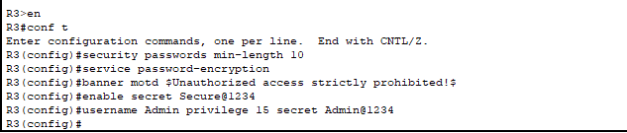
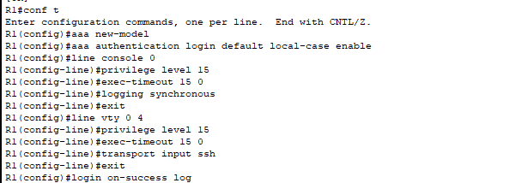
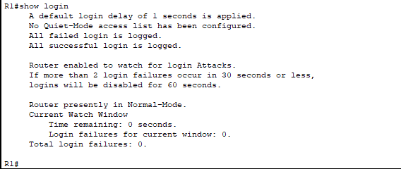

Mitigate common Layer 2 Attacks
The Layer 2 infrastructure of a network can be vulnerable to various security threats, such as MAC flooding, ARP spoofing, STP manipulation, VLAN hopping, and DHCP snooping (Alabady, 2008). These vulnerabilities can lead to network downtime, data theft, or unauthorized access to sensitive resources. To secure the Layer 2 infrastructure, organisations should implement various mitigation techniques. These may include enabling port security, limiting the number of MAC addresses allowed on each port, configuring trusted DHCP servers, and enabling DHCP snooping (Alabady, 2008). Other techniques may involve using static ARP entries, enabling ARP inspection, and configuring root guard and BPDU guard to prevent STP manipulation (Mustafa, 2015). Additionally, organisations may also use layer 2 encryption technologies such as MACsec to secure traffic between devices at the data link layer. Overall, implementing a combination of network design, configuration, and monitoring best practices can help mitigate Layer 2 vulnerabilities and reduce the risk of security threats.
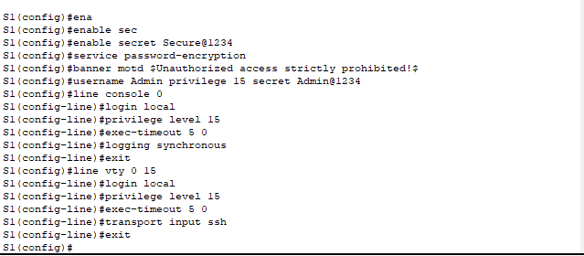
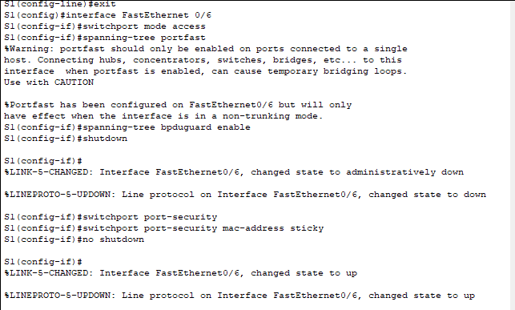
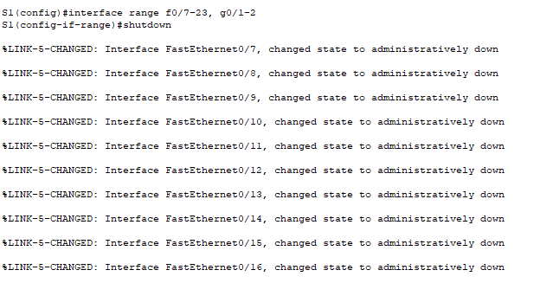

Configuration of ZPF on Routers
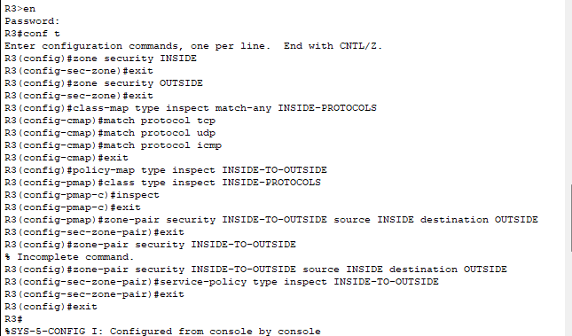
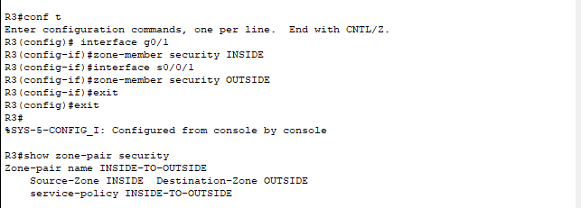

Configuration of Firewall
The ASA operates as an advanced stateful firewall by inspecting and tracking network traffic in real-time, enforcing access control policies based on the context of the connections, and providing advanced threat prevention features to protect against various types of cyber threats.
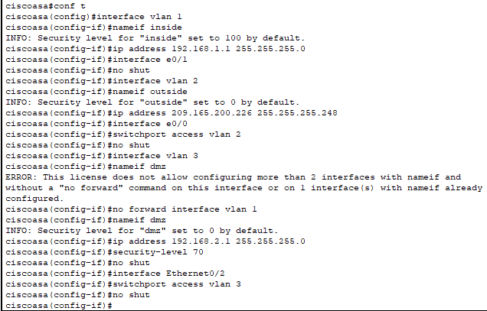
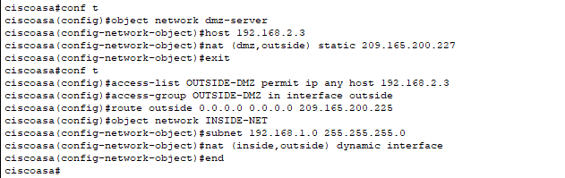
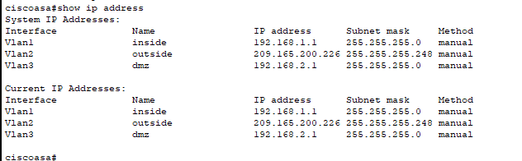

Implementation of IPS
Network-based Intrusion Prevention Systems (IPS) are security devices that are used to monitor and protect networks from malicious activity. Network-based IPS are an essential tool for securing networks from cyber threats. By monitoring network traffic in real-time, detecting known and unknown threats, alerting and blocking suspicious traffic, and integrating with other security technologies, network-based IPS can help organisations stay one step ahead of cyber attackers and keep their networks secure.
Signatures are used to detect malicious network traffic by comparing network traffic against a database of known signatures that are associated with specific types of attacks, viruses, malware, or other malicious activity. Signatures can be used in different types of security technologies, such as intrusion detection systems (IDS), intrusion prevention systems (IPS), and antivirus software. Signatures are regularly updated to keep pace with emerging threats, and are an important component of an effective security strategy.
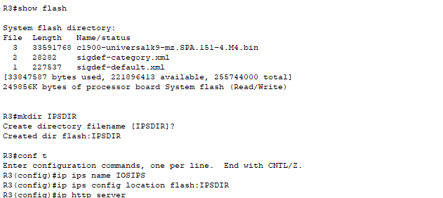
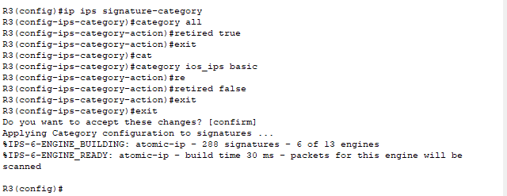
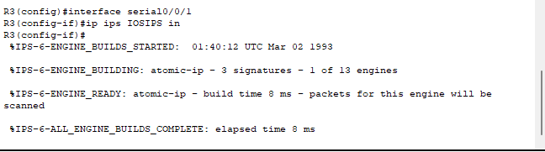
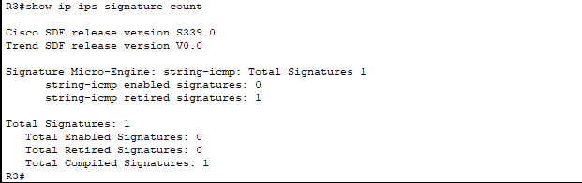

Configuration of VPN

Purpose of VPN
A VPN (Virtual Private Network) is a technology that allows users to securely access a private network over the internet (Jyothi, 2018). The main purpose of a VPN is to provide secure remote access to a private network, allowing users to work from anywhere in the world without compromising security. VPNs are commonly used to connect remote employees, branch offices, and business partners to a central network, such as a company's intranet or a cloud-based infrastructure (Jyothi, 2018).

Operation of IPSec VPN
IPsec (Internet Protocol Security) is a widely used protocol for creating secure VPN connections over the internet. IPsec VPNs operate by using a combination of encryption, authentication, and key exchange mechanisms to ensure the confidentiality, integrity, and authenticity of data transmitted between two networks.
According to Gunleifsen (2019), the following are the steps involved in the operation of IPSec VPN:

Authentication and Key Exchange
The IPsec client and gateway establish a secure channel by exchanging authentication credentials and negotiating encryption keys. This process typically uses one of two protocols: IKEv1 (Internet Key Exchange version 1) or IKEv2 (Internet Key Exchange version 2).

Encryption and Tunneling
Once the authentication and key exchange are complete, the IPsec client and gateway use encryption algorithms to encrypt all traffic transmitted between the two networks. The encrypted traffic is then encapsulated within IP packets and sent over the internet in a secure "tunnel".

Traffic Filtering and Access Control
The IPsec gateway can filter and control the flow of traffic between the two networks, based on policies and rules configured by the network administrator. This allows the IPsec gateway to enforce access control and security policies, such as restricting access to specific applications, services, or devices.

Decryption and Processing
Upon receiving the encrypted traffic, the IPsec gateway decrypts it using the shared encryption key and passes it to the destination network. The traffic is then processed and handled as if it originated from within the destination network.
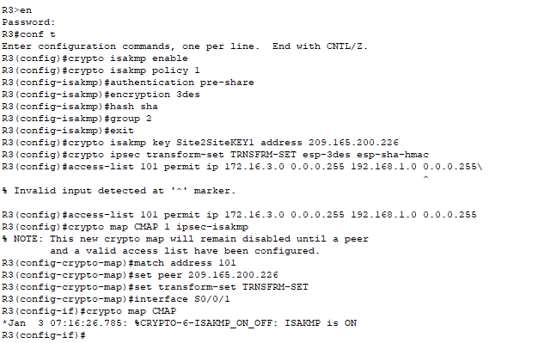
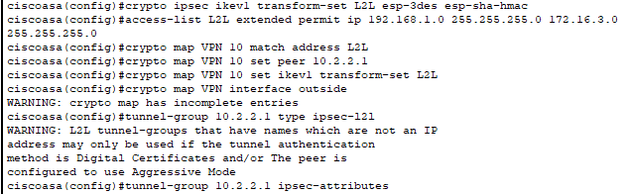
By using encryption, hashing, and digital signatures together, a message can be protected against unauthorized access, tampering, and impersonation. For example, an encrypted message can only be decrypted with the correct key, ensuring confidentiality. Hashing can be used to detect any changes to the original message, ensuring integrity. Finally, digital signatures can be used to confirm the authenticity of the sender and the integrity of the message, ensuring authentication. By combining these techniques, cryptographic systems can provide secure and trustworthy communications.

PART 2

Secure Network Infrastructure Proposal
As cybersecurity experts, we understand the importance of securing the organisation's network infrastructure, especially given the increase in remote work, cloud services adoption, and the use of personal devices. With this in mind, we have designed a comprehensive blueprint for a secure network infrastructure tailored to organisation's unique requirements.
Our proposal includes detailed explanations of the proposed choices and security measures, a cost analysis for implementing the solutions, and a three-month project plan timeline for implementation.

Proposed Choices and Security Measures

Network Segmentation
We propose creating separate VLANs for each department and the manufacturing plant, isolating them to prevent unauthorized access and limit the spread of potential attacks. By implementing network segmentation, we will create separate Virtual Local Area Networks (VLANs) for each department and the manufacturing plant. This approach will minimize the attack surface and prevent unauthorized access to sensitive information. In case of a security breach, it will limit the spread of the attack by containing it within the affected VLAN. Additionally, we will deploy Access Control Lists (ACLs) to manage inter-VLAN traffic and ensure that only authorized personnel can access specific resources.

Virtual Private Network (VPN)
To ensure secure remote access, we recommend implementing a robust VPN solution that uses strong encryption and multi-factor authentication (MFA). Implementing a robust VPN solution will provide secure remote access to A2Z Technologies organisation's network resources. By using strong encryption protocols, such as OpenVPN or IKEv2/IPSec, we will ensure that all data transmitted between remote workers and A2Z Technologies network is encrypted and secure from eavesdropping. Furthermore, multi-factor authentication (MFA) will be integrated to provide an extra layer of security, requiring users to present two or more pieces of evidence (e.g., password, security token) to verify their identity.

Network Access Control (NAC)
Implementing NAC will help regulate access to network resources based on user roles, device types, and security policies. NAC will help regulate access to A2Z Technologies network resources based on predefined user roles, device types, and security policies. This will enable A2Z to monitor and control who can access A2Z Technologies network and what resources they can access. NAC implementation will involve profiling devices, enforcing access policies, and providing remediation actions for non-compliant devices. This will ensure that only authorized devices can connect to A2Z network and help prevent unauthorized access.

Firewall and Intrusion Prevention System (IPS)
A next-generation firewall with an integrated IPS will help protect organisation’s network from external threats and unauthorized access. We will deploy a next-generation firewall with an integrated IPS to protect A2Z Technologies network from external threats and unauthorized access. The firewall will be configured to allow only necessary traffic while blocking potentially harmful traffic. The IPS will monitor network traffic, detect and prevent intrusion attempts, and alert security personnel about potential threats in real-time. Regular updates to firewall and IPS signatures will ensure up-to-date protection against emerging threats.

Endpoint Security
We recommend deploying endpoint security software on all devices, including personal ones, to prevent malware infections and data breaches. To safeguard organisation from malware infections and data breaches, we will deploy comprehensive endpoint security software on all devices, including those owned by employees. The endpoint security solution will offer anti-malware, anti-phishing, and exploit prevention capabilities. It will also include a host-based intrusion prevention system (HIPS), which will monitor system behavior and block suspicious activities. We will enforce a security policy that mandates regular updates and scans on all devices connected to A2Z Technologies network.

Cloud Security
For A2Z Technologies cloud services, we suggest implementing robust access controls, encryption, and monitoring solutions to safeguard sensitive data and applications. As A2Z Technologies adopts cloud services, it is crucial to ensure the security of sensitive data and applications. We will implement robust access controls using Identity and Access Management (IAM) to define and manage user roles and permissions within A2Z Technologies cloud environment. Data-at-rest and data-in-transit encryption will be employed to protect sensitive data from unauthorized access. We will also deploy cloud-native security tools to monitor activity and detect potential threats in real-time. Regular audits and reviews of cloud security configurations will be conducted to maintain a strong security posture.
By adopting these in-depth security measures, A2Z Technologies will greatly enhance its cybersecurity resilience and minimize the risk of cyber-attacks.
Figure 1 illustrates the secure network design for A2Z Technologies
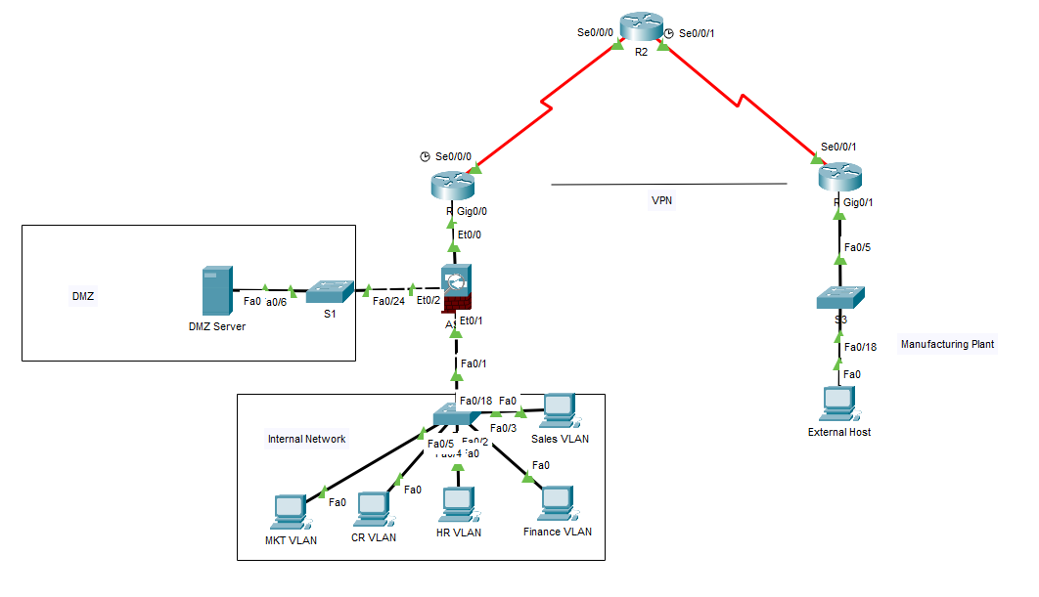
Figure 1: A Secure Network Design for A2Z Technologies

Cost Analysis
In this section, we provide a detailed technical cost analysis for the proposed security measures, including hardware, software, and subscription services. The costs are broken down into initial setup, ongoing maintenance, and support costs.

Network Segmentation
VLAN-capable Switches: $4,000 (4 x $1,000 per switch)
Installation and Configuration: $3,000
Annual Maintenance and Support: $3,000
Initial Cost = Switches + Installation
Total Initial Cost: $7,000

VPN Solution
VPN Server Hardware: $5,000
VPN Software Licenses: $10,000 (100 x $100 per user)
Installation and Configuration: $5,000
Annual Maintenance and Support: $5,000
Initial Cost = Server + Licenses + Installation
Total Initial Cost: $20,000

NAC Implementation
NAC Server Hardware: $5,000
NAC Software Licenses: $10,000 (100 x $100 per user)
Installation and Configuration: $3,000
Annual Maintenance and Support: $2,000
Initial Cost = Server + Licenses + Installation
Total Initial Cost: $18,000

Firewall and IPS
Next-Generation Firewall Hardware: $20,000
Firewall and IPS Subscription Services: $7,000 (annual)
Installation and Configuration: $3,000
Initial Cost = Firewall Hardware + Installation
Total Initial Cost: $23,000

Endpoint Security
Endpoint Security Software Licenses: $10,000 (100 x $100 per user, annual subscription)
Installation and Configuration: $5,000
Initial Cost = Licenses + Installation
Total Initial Cost: $15,000

Cloud Security
Cloud Security Services Subscription: $10,000 (annual)
Implementation and Configuration: $2,000
Initial Cost = Subscription + Implementation
Total Initial Cost: $12,000
Total Initial Cost = $7,000 + $20,000 + $18,000 + $23,000 + $15,000 + $12,000 = $95,000
Total Annual Maintenance and Support = $3,000 + $5,000 + $2,000 + $7,000 + $10,000 + $10,000 = $37,000
The total initial cost of implementing the proposed security measures is $95,000, while the ongoing annual maintenance and support cost is estimated to be $37,000.

Attacks that Plagues A2Z Technologies Network Infrastructure
In order to provide a comprehensive understanding of the potential threats to A2Z Technologies network infrastructure, we have outlined three common attacks that frequently plague organisations. By being aware of these threats, A2Z Technologies can better protect A2Z Technologies organisation and maintain a secure network infrastructure.

Distributed Denial of Service (DDoS) Attacks
DDoS attacks occur when multiple systems are used to flood a target, such as a server, website, or network, with an overwhelming amount of traffic (Durcekoca, 2012). This can lead to a denial of service, rendering the target inaccessible to legitimate users. DDoS attacks may be motivated by financial gain, activism, or simply the desire to disrupt an organisation's operations. Implementing robust security measures such as Intrusion Prevention Systems (IPS), Web Application Firewalls (WAF), and traffic monitoring solutions can help detect and mitigate DDoS attacks.

Advanced Persistent Threats (APTs):
APTs are stealthy, long-term attacks carried out by skilled adversaries, often targeting organisations with high-value information or resources (Siddiqi, 2016). The attackers typically gain access to the network through targeted phishing, exploiting vulnerabilities, or leveraging compromised credentials. Once inside, they move laterally, maintain a low profile, and gradually exfiltration of sensitive data. To defend against APTs, it is essential to adopt a multi-layered security approach, including network segmentation, continuous monitoring, endpoint protection, and employee security training.

Ransomware Attacks
Ransomware is a type of malicious software that encrypts an organisation's data, rendering it inaccessible until a ransom is paid to the attacker (Mos, 2020). Ransomware attacks can have severe financial and operational consequences, often causing downtime and reputational damage. These attacks are usually initiated through phishing emails, drive-by downloads, or exploiting known vulnerabilities in software. To protect against ransomware, it is critical to maintain regular backups of important data, keep software and systems up-to-date, deploy endpoint security, and educate employees about the risks of phishing and other social engineering tactics.
By understanding these common attacks and implementing the appropriate security measures, A2Z Technologies Ltd can significantly reduce the risk of falling victim to cyber threats and maintain a secure network infrastructure.

Recommendation of Security Tests
After implementing the secure network infrastructure, it is crucial to verify its effectiveness and identify any potential vulnerabilities. We recommend conducting the following three types of security tests periodically to ensure that A2Z Technologies network infrastructure remains secure over time. These tests will help A2Z Technologies stay proactive in addressing potential security issues and maintaining a strong security posture.

Vulnerability Scanning
Vulnerability scanning is an automated process that identifies potential security weaknesses in A2Z Technologies network infrastructure, systems, and applications. It involves using specialized tools to scan A2Z Technologies network for known vulnerabilities, misconfigurations, and other security issues. Regular vulnerability scanning helps A2Z Technologies stay informed about potential risks and prioritize remediation efforts. We recommend conducting vulnerability scans at least quarterly, or more frequently if significant changes are made to A2Z Technologies network infrastructure.

Penetration Testing
Penetration testing, or "pen testing," is a simulated cyberattack on A2Z Technologies network infrastructure designed to identify exploitable vulnerabilities and assess A2Z Technologies organisation's security posture. There are different types of penetration tests, including black-box (no prior knowledge), grey-box (limited knowledge), and white-box (full knowledge) tests, depending on the level of information provided to the tester (Blackwell, 2014). Penetration tests should be conducted periodically, at least once a year, or after significant changes to A2Z Technologies network infrastructure, to ensure that A2Z Technologies security measures are effectively protecting A2Z Technologies organisation.

Social Engineering Testing
Social engineering attacks, such as phishing, are a common method used by cybercriminals to gain unauthorized access to A2Z Technologies network. To assess A2Z Technologies organisation's resilience against social engineering attacks, it is essential to conduct regular social engineering tests. These tests simulate real-life scenarios, such as phishing emails or phone calls, to evaluate employee awareness and adherence to security policies. Based on the test results, A2Z Technologies can provide targeted training to employees, reinforcing best practices and improving overall security awareness. We recommend conducting social engineering tests at least twice a year.
By performing these security tests on a regular basis, A2Z Technologies Ltd will be able to identify and address potential vulnerabilities proactively, ensuring that A2Z Technologies network infrastructure remains secure and resilient against cyber threats.

Invoice for the Professional Services
Date: 5 April 2023
Invoice No: 1011
Bill To:
A2Z Technologies Ltd
Item Description | Rate | Amount
Network Security Consultation
Security Assessment & Gap Analysis | $2,500.00 | $2,500.00
Secure Network Infrastructure Design | $3,500.00 | $3,500.00
Vendor & Solution Selection | $2,000.00 | $2,000.00
Technical Cost Analysis | $2,000.00 | $2,000.00
Security Measures & Attack Overview | $2,000.00 | $2,000.00
Post-Implementation Security Testing Recommendations | $3,000.00 | $3,000.00
Sub Total | $15,000
Network Security Implementation
Project Management & Implementation Support | $5,000.00 | $5,000.00
Assistance with Vendor Coordination | $2,000.00 | $2,000.00
On-site Support & Remote Assistance (as required) | $5,000.00 | $5,000.00
- Post-Implementation Security Testing & Validation | $8,000.00 | $8,000.00
Sub Total | $20,000
Grand Total | $35,000.00

References
Alabady, S.A.J., 2008, April. Design and implementation of a network security model using static VLAN and AAA server. In 2008 3rd International Conference on Information and Communication Technologies: From Theory to Applications (pp. 1-6). IEEE.
Blackwell, C., 2014. Towards a penetration testing framework using attack patterns. Cyberpatterns: Unifying Design Patterns with Security and Attack Patterns, pp.135-148.
Catescu, G., 2018. Detecting insider threats using Security Information and Event Management (SIEM). University of Applied Sciences Technikum Wien. Available at: shorturl. at/dtzOT.
Durcekova, V., Schwartz, L. and Shahmehri, N., 2012, May. Sophisticated denial of service attacks aimed at application layer. In 2012 ELEKTRO (pp. 55-60). IEEE.
Fink, G.A., Edgar, T.W., Rice, T.R., MacDonald, D.G. and Crawford, C.E., 2017. Overview of Security and Privacy in Cyber‐Physical Systems. Security and Privacy in Cyber‐Physical Systems: Foundations, Principles and Applications, pp.1-23.
Gunleifsen, H., Kemmerich, T. and Gkioulos, V., 2019. Dynamic setup of IPsec VPNs in service function chaining. Computer Networks, 160, pp.77-91.
Jyothi, K.K. and Reddy, B.I., 2018. Study on virtual private network (VPN), VPN’s protocols and security. International Journal of Scientific Research in Computer Science, Engineering and Information Technology, 3(5), pp.919-932.
Mos, M.A. and Chowdhury, M.M., 2020, July. The growing influence of ransomware. In 2020 IEEE International Conference on Electro Information Technology (EIT) (pp. 643-647). IEEE.
Mustafa, A., Siddique, N. and Zubair, M., 2015. Data link layer security problems and solutions.
Paquet, C., 2012. Implementing Cisco IOS Network Security (IINS 640-554) Foundation Learning Guide: Imp Cisco IOS Netw Sec F _c2. Cisco Press.
Siddiqi, M.A. and Ghani, N., 2016. Critical analysis on advanced persistent threats. Int. J. Comput. Appl, 141(13), pp.46-50.
Srinivas, J., Das, A.K. and Kumar, N., 2019. Government regulations in cyber security: Framework, standards and recommendations. Future generation computer systems, 92, pp.178-188.

