University of Wales Trinity Saint David
School of Engineering
Flow Bench
James Smith
1801879
Bsc Motorsport Engineering
Powertrain Design & Efficiency M5X02200
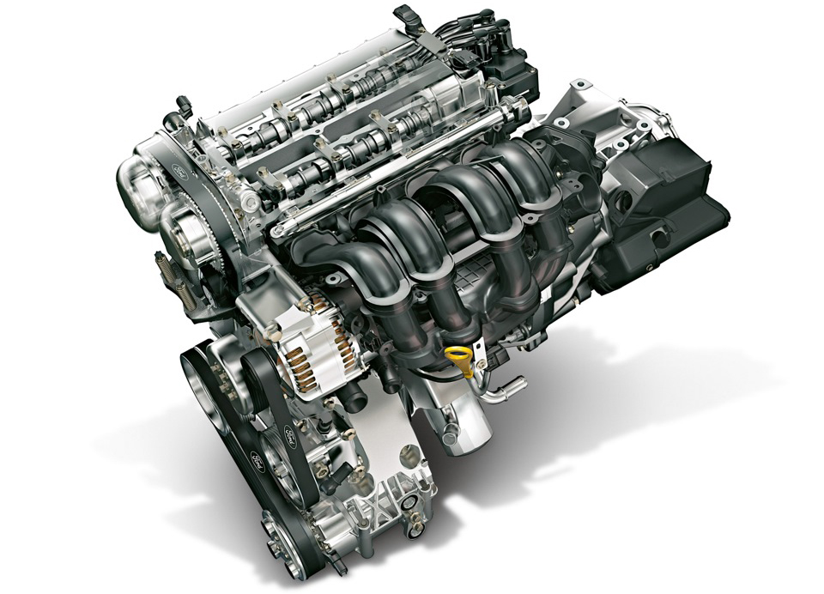
-Figure 1: Ford 1.6L Sigma Engine

Contents
Title Page……………………………………………………………………………………………………………………..Page 1
Contents Page…………………………………………………………………………………………………….………..Page 2
List of Figures…………………………………………………………………………………………………….…………Page 3
1. Introduction…………………………..…………………………………………………………………………..…….Page 4
2. Research…………………………………..……………………………………………………………………….……..Page 5
2.1. Flow Bench Background Research…………………………………..…………………..……..Page 5
2.2. Engine Background Research…………………………………………..……………….………..Page 6
3. Methodology……………..………………………………………………………………………………………….…Page 7
4. Results / Analysis….……………..………………….………………………………….…………….……………..Page 7
4.1. Obtaining Measurements and Data…………………………………..………….…….……..Page 8
4.1.1. Measurements and Data Tables………………………..………………….……..Page 9
4.2. Super Flow Testing…………………………………..…………………….....……..….…….……..Page 9
4.2.1. CFM Excel Calculations……………………………….…..………………….……..Page 10
4.2.2. Valve Lift Against Crank Angle……………………………….…..……………...Page 10
4.2.3. CFM Against Valve Lift……………………………….…..…………….…………...Page 11
4.3. Determine how much Larger Inlet and Exhaust Valves can be fitted………….Page 11
4.4. Theoretical Modifications to Improve Flow Coefficient………………..……………Page 12
4.5. CFM Per Sq. Inch Against Inlet Valve Lift……………………………………………………Page 13
4.6. Flow Coefficient Against Valve Lift for All Tests………………….….………………….Page 13
4.6.1. Inlet Flow Coefficient Against Crank Angle………………..………….…….Page 14
4.6.2. Determine the Mean Inlet Flow Coefficient…………………….………….Page 15
4.7. Determine Engine Speed for Maximum Power……………………………..……….….Page 16
4.8. Valve Lift Against Crank Angle……………………………………………………….………….Page 17
5. Conclusion……………..……………………………………………………………………….………………………Page 18
References……………..……………………………………………………………………….…………………………Page 19
Appendix……………..……………………………………………………………………….…………………………...Page 20

List of Figures
Figure 1………….………………………………………….……………………Ford 1.6L Sigma Engine………. Page 1
Figure 2…………………………………………….…………………....Smaller Super Flow Machine……….Page 5
Figure 3……………………………………………………..………………Larger Super Flow Machine……….Page 5
Figure 4……………………………………………………………………………Ford 1.6L Sigma Engine……….Page 6
Figure 5, 6, 7……………………………………..…….Obtaining Measurements and Weights……….Page 8
Figure 8, 9………………………………...………….………Obtaining Camshaft Measurements……….Page 8
Figure 10………………………………………………….….………………….………………Intake Mases……….Page 9
Figure 11…………………………………………….….………..……….Component Measurements……….Page 9
Figure 12……………………………………………………………....……..………Flow Bench Diagram………Page 9
Figure 13………………………………………………………………………...………Super Flow Set-up……….Page 9
Figure 14……………………………………………….………………….…………Conversion Factors……….Page 10
Figure 15…………………………………………………….Valve Lift Against Crank Angle Graph………Page 10
Figure 16…………………………………………………………….…CFM Against Valve Lift Graph……….Page 11
Figure 17…………………………………………..…………Theoretical Modifications Sketches……….Page 12
Figure 18……………………………………………………….CFM Per Sq. Inch Against Valve Lift……….Page 13
Figure 19……………………………………………………….Flow Coefficient Against Valve Lift……….Page 14
Figure 20…………………………………..………………Flow Coefficient Against Crank Angle……….Page 15
Figure 21……………………………………………………………….Manufactures Specifications……….Page 16
Figure 22…………………………………….………………………. Bare Cylinder Head Flow Data……….Page 20
Figure 23………………………………………..…Bare Head Plus Standard Intake Flow Data……….Page 20
Figure 24…………………………………..Bare Cylinder Head with Flared Entry Flow Data……….Page 21
Figure 25…………………………………………………………Masses and Measurements Data……….Page 21
Figure 26………………………………………………………………………………….Cam Angles Data……….Page 25
1. Introduction

This report is going to involve the investigation into the flow characteristics, including the positive and negative factors that influence the design and operation of the induction and exhaust manifolds for a cylinder head provided by the University. Measurements and testing will be carried out on the 1.6 Ford Sigma Zetec S cylinder head in the University of Wales Trinity Saint David, vehicle lab in the engineering workshop.

Firstly, background research into the super flow machine will be stated alongside relevant research into the cylinder head taken from the 1.6 Sigma engine. A methodology, including the correct equipment and procedures that will be adopted for testing will be stated, also showing an insight into the flow bench operations and how the data produced can be used to evaluate and analyse the flow characteristic of the cylinder head.

During testing, the super flow bench will be used to flow air through the cylinder head under three different physical conditions. The data recorded during testing will then be used to graphically and mathematically analyse the flow characteristics of the cylinder head.

The results will then include all pre-testing and final testing results obtained, organised in excel tables and charts, to then produce final statements for the flow characteristics of the Sigma cylinder head. To assist any discussions stated in this section, graphs, diagrams, illustrations and appropriate literature reviews will be included where appropriate to finally conclude the report by summarising the outcomes discovered.

2. Research

The research section of this flow bench assignment is going to include the relevant background information needed for the super flow machine and the Ford 1.6 Sigma Zetec s cylinder head, to gain an informed understanding of the equipment and engine to be tested. The aims of this section are to acquire an in-depth knowledge into the flow bench’s operations and to understand the key features present in the cylinder head of the engine, before the testing is fulfilled.

2.1. Flow Bench Background Research

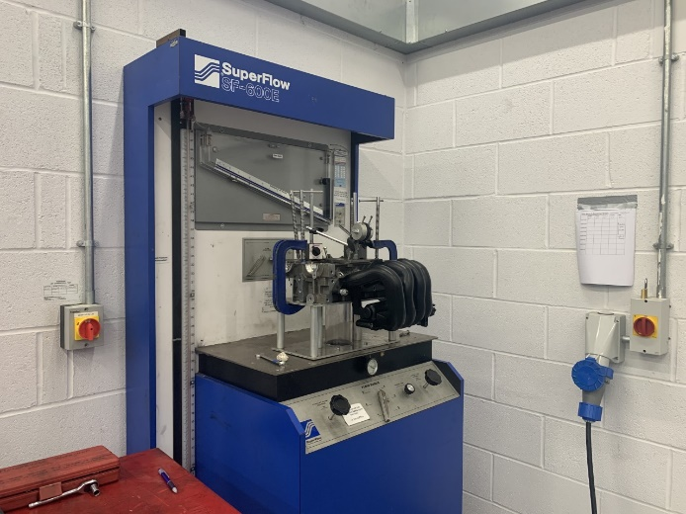
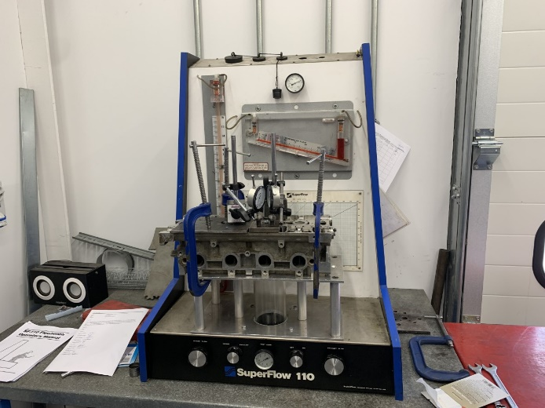
The machine that will be used to flow the provided cylinder is a super flow machine set up in the vehicle lab. Pre-testing was performed in the vehicle lab to check the super flow machine was working efficiently. It was found that the larger flow bench was broken, so pre-testing on the smaller flow bench was performed to gain an understanding and knowledge into the machines functions to flow air through a cylinder head.
-Figure 2: Small Super Flow Machine -Figure 3: Larger Super Flow Machine

This pre-testing exercise was valuable to ensure the larger flow bench is working on the day of testing, due to this machine being able to perform all needed operations for testing much more efficiently and accurately.

A super flow machine performs testing the flow characteristic of a given cylinder head, firstly by blowing or sucking air through the inlet or exhaust ports at a constant pressure rate. Each flow rate is then measured at a different valve lift, which can be increased or decreased as the testing is carried out. The benefits of this machine are that any results taken from a cylinder head can be compared to any other cylinder head tested under the same conditions. The results taken from the flow bench during the testing phase of this report, will be used to perform further calculations to determine for example the mean inlet flow coefficient and port lengths (SuperFlow Corporation).

2.2. Engine Background Research

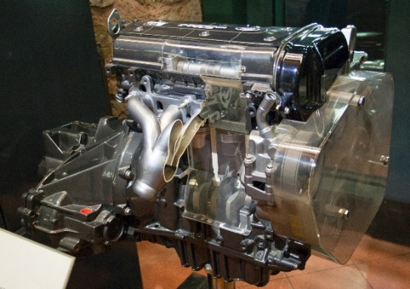
The cylinder head to be used during the testing phase of this report is from a 2010 1.6 litre Ford Sigma Zetec s engine, with the engine code Q4NRA. This supplied power unit has a 16 valve, inline configuration, with four cylinders and dual-overhead cam, set up in a transverse engine orientation. The Sigma’s cylinder head and block are both produced from aluminium and was first introduced after its predecessor the Ford Kent engine. -Figure 4: Ford 1.6L Sigma Engine

The Kent engine was first developed in 1959, in the Ford factory for the new Ford Anglia at the time. The unit was supplied with an inline four-cylinder overhead valve type pushrod engine, with the cylinder head and block produced from cast iron, unlike the more modern and lighter aluminium Sigma engine. The benefits of this engine were a comparatively large bore, which resulted in a generous valve size and a very good brake mean effective pressure also known as BMEP. This factor and many more, resulted in the Kent engine to be one of the most widely used four-cylinder engines for motorsport of all time (Anderson, 2013).

The successor to the Sigma engine used in testing is the new 1.0 litre Ford Eco boost engine. The engine is fitted with a turbo charger, using wasted exhaust gases to push more air into the engine to boost the power output. The new Eco Boost can impressively produce similar power readings to that of the older Sigma engine (Ford Motor company Ltd, 2020).

3. Methodology

To be able to further investigate and report on the factors influencing the design and operation of the induction manifold of the provided Sigma cylinder head, testing must firstly be conducted in the Vehicle lab, to make a clear, concise and critical evaluation of the flow characteristic of the Sigma cylinder head.

The correct equipment, including rules, Vernier callipers and weighing scales will then be used to determine weights and diameters of all moving components, including the camshaft, valves, springs and collets. The compression ratio, bore/stroke and camshaft profile for the inlet cam will be measured, to allow for graphs to be plotted.

Once all measurements and weights are obtained, the super flow machine will be used to measure the flow properties of the provided cylinder head. Testing will be carried out, by recording the flow properties after increasing the valve lift by 0.5 mm increments, collecting data whilst performing three tests under different conditions. The conditions the super flow machine will be used to flow, are the bare cylinder head, the bare head plus the standard intake and the bare head through a flared entry port.

Subsequently after all testing is complete, the measurements, weights and flow data obtained will be used in a range of graphs and equations to successfully present and analyse the maximum flow coefficients, the loss in flow coefficient and suggestions for theoretical modifications to improve the flow coefficient. All calculations will be shown with complete equations and all data sets provided in the appendix.

4. Results / Analysis

During the results section of this report, the equipment and processes adopted to obtain the needed measurements for the intake masses, component measurements and the camshaft profile will be stated with images and diagrams where appropriate. The process taken to record the flow data using the super flow machine will be provided alongside the necessary graphs and calculations to determine flow rates and flow coefficients.
4.1. Obtaining Measurements and Data

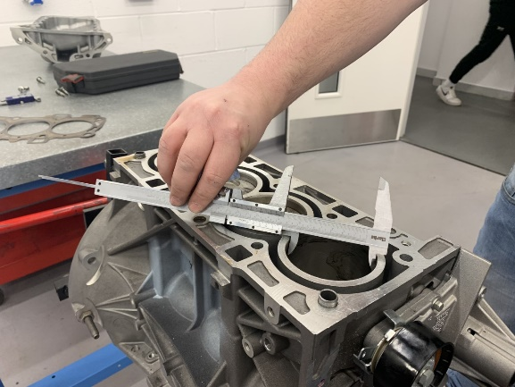
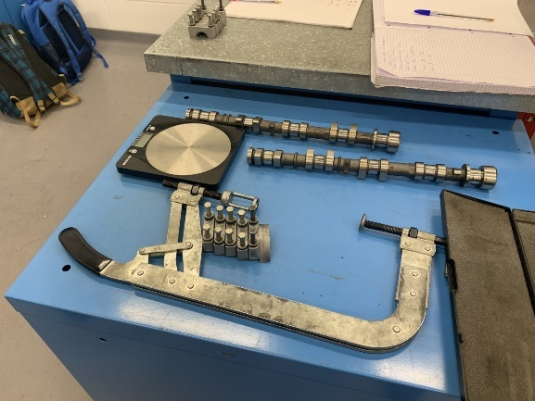
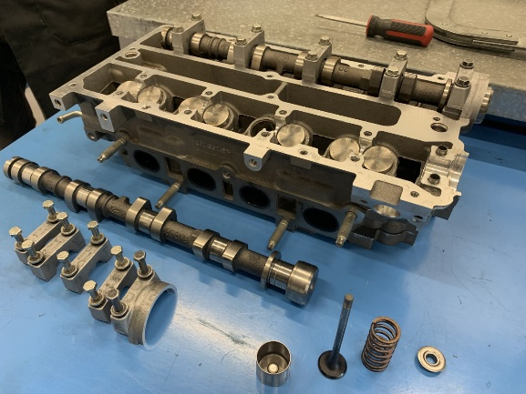
The component masses for the intake system of the Sigma cylinder head have been obtained by disassembling the top of the head using a socket, screw driver and valve spring compressor. Using a set of small weighing scales, the masses of all moving components were recorded through an excel spreadsheet. Vernier callipers were then used to determine the component measurements.
-Figures 5, 6, 7: Obtaining Measurements and Weights

Once the measurements and weights were obtained, the 360-degree camshaft profile for the inlet cam was recorded using a manual lathe. A DTI gauge was attached to the lathe and set up on the cam lobe to allow for manual readings to be recorded for every 2 degrees of angular displacement.

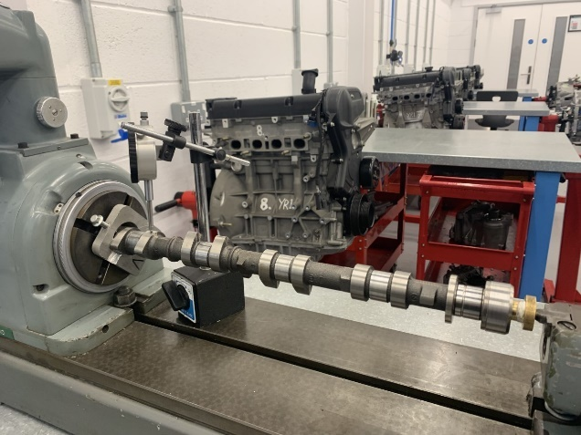
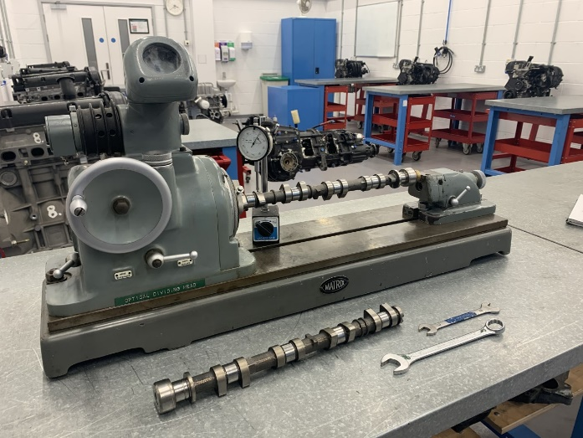
The camshaft was set up in the lathe with one end secured to the chuck through an adaptor plate and the other end attached to the second chuck. Figures 8 and 9 below show the process used to accurately determine the cam profile at each degree.
-Figures 8 and 9: Obtaining Camshaft Measurements
4.1.1. Measurements and Data Tables
Masses
Intake | Mass (g) | Quantity | Total (g)
Valve | 38.0 | 1 | 38.0
Collet | 0.5 | 2 | 1.0
Lifter | 23.8 | 1 | 23.8
Spring | 20.4 | 1 | 20.4
Retainer | 7.7 | 1 | 7.7
Component | Measurement (mm)
Valve Diameter | 24.0
Inlet Port Diameter | 30.0
Exhaust Port Diameter | 24.0
Bore | 78.4
Stroke | 81.8
Head Gasket Depth | 0.38

-Figure 10: Intake Mases -Figure 11: Component Measurements

The processes as stated in section ‘4.1’ of the results section have been used to produce figures 10 and 11 above. These tables show the masses and measurements for the Sigma engine, needed to be able to perform future calculations.

4.2. Super Flow Testing

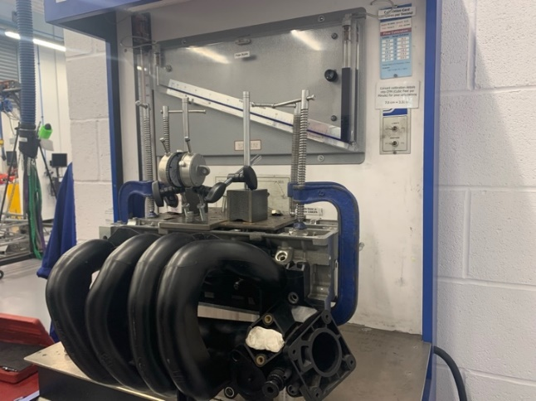
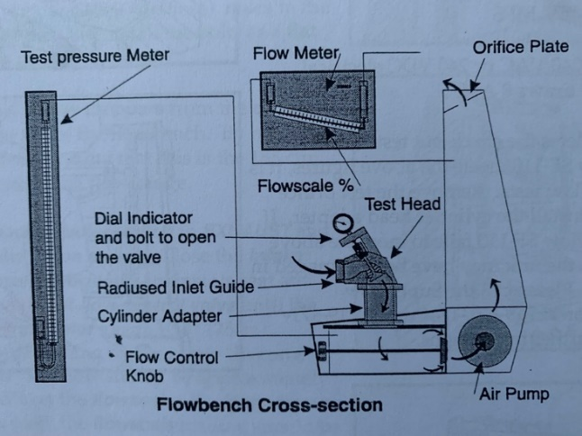
The super flow diagram in figure 12, shows all the components used to measure the air flow resistance of the Sigma cylinder head. The pressure meter measures the pressure at the base of the cylinder and is a standard value, set at 25.00 inches of water for these tests. DTI gauges were set up on the inlet valves as shown in figure 13, to allow for adjustments by 0.5mm increments to be made throughout the testing.
-Figure 12: Flow Bench Diagram (SuperFlow Corporation) -Figure 13: Super Flow Set-up

Flow through the cylinder head was measured and shown on the flow meter, which produces readings from zero to one hundred percent. Once these flow readings are above 80%, the range of the flow meter can be changed between six ranges to be able to open the valves more and achieve a higher accuracy of results. The readings are obtained by measuring the pressure difference present between the five flow orifices (SuperFlow Corporation).
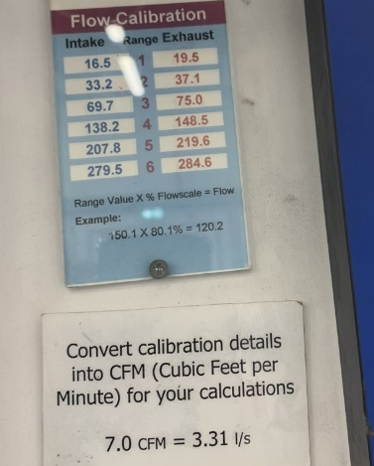
4.2.1. CFM Excel Calculations

To convert the data calculated on the flow bench in percent to litres to second (l/s), the range inlet conversion was used in excel as shown in figure 14. To then convert the l/s to cubic feet per minute (CFM), the conversion factor 7.0 CFM=3.31 l/s was used to calculate the CFM for future graphs.

-Figure 14: Conversion Factors
4.2.2. Valve Lift Against Crank Angle
-Figure 15: Valve Lift Against Crank Angle Graph

Figure 15 shows a graph created for valve lift against crank angle. The crank angle of the camshaft was determined in section ‘4.1’ of the results and the intake valve lift is measured between 0 and 8 mm. The graph shown in figure 15 shows that the intake valve starts to open at 84 degrees and is closed at 229 degrees of crank angle. The intake valves will start to open just before the piston can reach top dead centre (TDC), to be able to fully lift the valve seat within time. These intake valves usually open just before the exhaust valves have closed, to overlap the exhaust and intake valve to force a new mixture into the combustion chamber and increase volumetric efficiency (McClintock et al. 2008).

4.2.3. CFM Against Valve Lift

To create a graph for flow in cubic feet per minute (CFM) against valve lift, the CFM values calculated in section ‘4.2.1’ for each flow test will be used. After creating the graph, the valve lift, that is equal to a quarter of the inlet valve diameter was calculated using the equation; L= D / 4. Where D, is the valve curtain diameter and L is the length of valve lift. The valve diameter was measured as 24 mm, so 24 / 4 = 6 mm of valve lift is equal to a quarter of the valve diameter.
-Figure 16: CFM Against Valve Lift Graph

From analysing figure 16 and performing the previous calculation, it is clear that after 6 mm of valve lift the flow begins to saturate. This is due to the port area now being larger than the curtain area, so the port area is restricted as the valve is now open enough. This means that after 8 mm of valve flow, the flow starts to saturate at 6 mm of valve lift. Many lift strategies are used including swirl, by keeping one inlet valve open and one inlet valve nearly closed to keep a rich fuel cloud near the cylinder head (Lumley, 1999). By restricting the inlet after 6 mm of lift reduces the chances of damage or contact with the piston.

4.3. Determine how much Larger Inlet and Exhaust Valves can be fitted

To firstly determine the inlet to exhaust valve diameter ratio, the inlet valve diameter measured as 24 mm and the exhaust valve diameter given as 30 mm is used to determine the ratio as 24:30 and using six as a common divisor, the ratio of 4:5 is determined. It is believed that by increasing your inlet and exhaust valve areas relative to you bore, you will keep the velocity through the valve low.

The most effective way of increasing the inlet and exhaust valves is to change the shape of the combustion chamber or by removing valves. By having a single intake valve and double exhaust valves, you are able to increase the size of the intake and keep the exhaust valves smaller for shorter heat paths, to increase the cooling of the valve (Lumley, 1999, p.45).

4.4. Theoretical Modifications to Improve Flow Coefficient

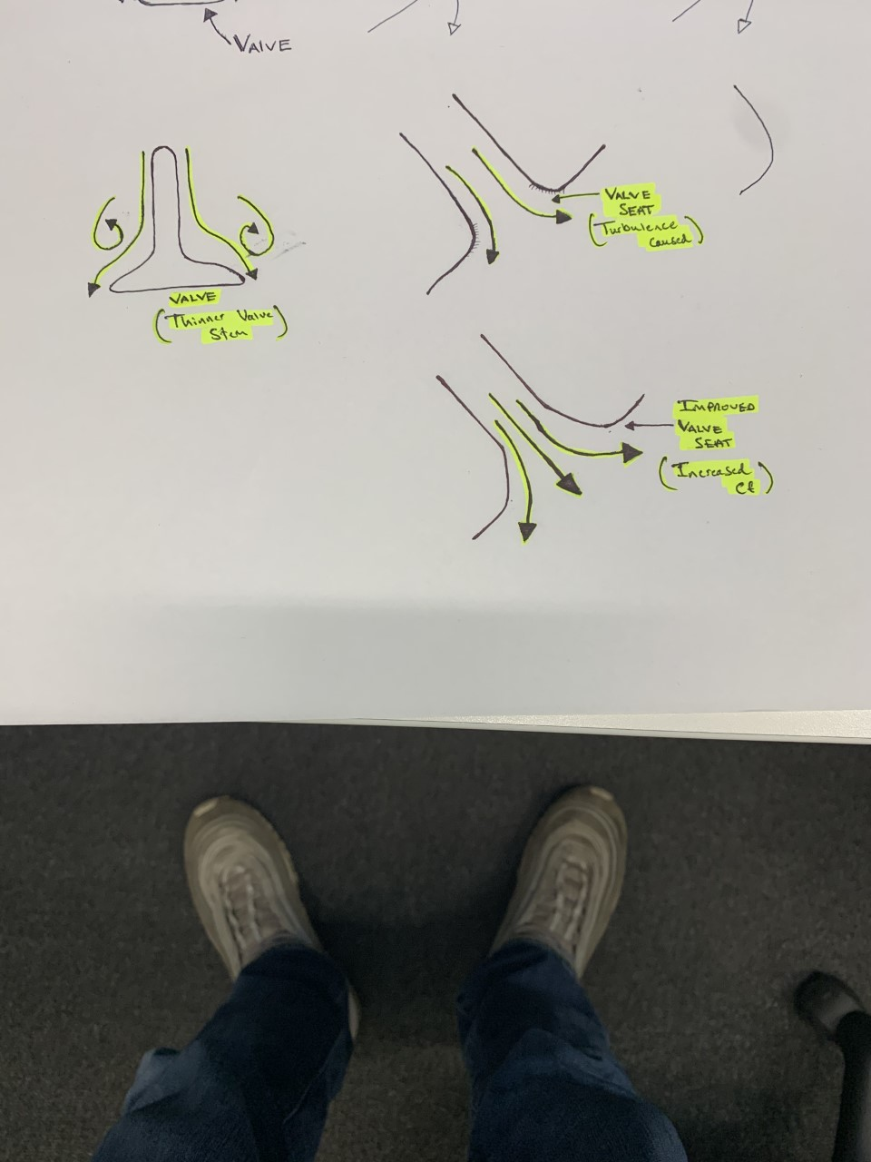
After carefully inspecting the cylinder head and intake ports, it is clear that some theoretical scope for possible modifications can be made to increase flow coefficient. During the phases of flow, valves create turbulence flow, where the inlet jet induces turbulence by forming turbulent boundary layers, as it flutters back and forth irregularly striking the piston crown and walls, turning mean flow in the jet into turbulent energy (Lumley, 1999, p.146).
-Figure 17: Theoretical Modifications Sketches

By firstly looking into the scope for modifications to be made to the valve, it is clear that a thinner valve stem and by removing extruding valve guides will increase the flow coefficient. The shape of the valve head, port and seat are developed to produce minimum pressure drop and provide a uniform flow across the inlet system (Stone, 1999, p.285), so possible modifications would need to be tested to see benefits created. Other scope for modifications would be changing the port shape and surface finish to increase flow and reduce turbulence energy created. Finally, as shown in the sketches in figure 17, the valve seat causes a lot of turbulence, so by smoothing the valve seat the ideal design can be created. Disadvantages to these modifications are the decrease in the heat transfer taken away from the valves.
4.5. CFM Per Sq. Inch Against Inlet Valve Lift

Before plotting the graph, the valve diameter had to be converted from millimetres to sq. inches. Firstly, converting mm to inches and then using the equation; $π x r^{2}$ to calculate sq. inches. The equation $\frac{CFM}{valve area in sq. Inches}$, was then used to calculate the CFM per sq. inch for all sets of flow data taken from the flow bench.
-Figure 18: CFM Per Sq. Inch Against Valve Lift

The graph as shown in figure 18, shows the CFM per sq. inch calculated for the inlet with and without the inlet manifold attached to the cylinder head. These graphs show a similar flow correlation to the CFM against valve lift graph shown previously, which both show after 6 mm of valve lift, the flow starts to saturate and flattens out. The graphs show that the flow with the bare head is much more effective at flowing air through the cylinder. This is shown at around 3.5 mm of valve lift, where the flow reaches perfect flow for the engine. Dissimilar to the flow results for the head plus the standard intake, where the flow does not reach perfect flow until around 4.5 mm of valve lift.

4.6. Flow Coefficient Against Valve Lift for All Tests

To create graphs for the flow coefficient against valve lifts for all three tests, the equation; $CF=\frac{Measured CFM Per Sq. Inch}{Perfect CFM Per Sq. Inch}$ was used to calculate the CF for each valve lift increment. The perfect CFM per sq. inch was taken from the Super Flow Corporation Manual as 138 CFM per sq. inch.
-Figure 19: Flow Coefficient Against Valve Lift
1.309
1.145
6 mm Practical Lift

Figure 19 shows the flow coefficient against the valve lift for each set of data collected. Stated on the graph is the practical lift and the maximum practical flow for each test. The maximum practical flow coefficient has been determined by calculating the max CF at 6 mm of lift. This valve lift has been chosen, because it is the max safe practical lift available before contact with the piston crown is made.

After calculating the max practical flow coefficient for each test, the overall tuning potential can be assumed. The loss in flow coefficient by adding the standard intake to the bare head, reduces flow coefficient by 0.164. This shows that there is around 0.15 to 0.17 of determined tuning potential. As shown in figure 19, by adding the standard intake with a flared entry port, the flow coefficient losses are reduced to zero CF. This improvement in flow coefficient by using a flared entry proves that the tuning potential determined is very possible.

4.6.1. Inlet Flow Coefficient Against Crank Angle

To create the graph for flow coefficient (CF) for all data sets, an x and y trendline was created for each CF graph created in excel. By using the correct x lift values, the equations created for each graph were used to calculate the inlet flow coefficient for each data set for the 360 degrees of the camshaft. The data sets created for this graph in excel are included in the appendix of this report.
-Figure 20: Flow Coefficient Against Crank Angle

Using the previous results from section ‘4.2.2.’ for inlet valve against crank angle, figure 20 has been plotted to show the flow coefficient against crank angle for all three tests. All tests, the CF starts to increase around 45 degrees of crank angle and decreases after around 115 degrees of crank angle. From observing the graph, it is clear the bare head and the flared entry are the most effective way to increase the flow coefficient calculated, as it reaches a peak of 1.0 CF.

4.6.2. Determine the Mean Inlet Flow Coefficient

Using the data calculated for flow coefficient in section ‘4.6’ of the results, the mean flow coefficient for the bare head and for the bare head plus the standard intake can be calculated by dividing the sum of all the flow coefficients for each test by the amount of results.

Bare Cylinder Head Mean Flow Coefficient:
15.21069383 ÷ 16 = 0.95066836
Bare Head Plus Standard Intake Mean Flow Coefficient:
13.41737586 ÷ 16 = 0.83858599

The calculations show that the bare head has more effective flow characteristics than the cylinder head with the standard intake attached.

4.7. Determine Engine Speed for Maximum Power

After calculating the mean flow coefficient for the bare cylinder head and the bare head plus standard intake, the data for the bare head testing will be used because the mean is much greater. This mean value can now be used to calculate the engine speed for the maximum power of the Sigma engine.

Mean effective area over duration of valve opening for two valves with 24 mm diameter:
0.95066836 $×$ 2 $×$ $\frac{π x {24}^{2} }{4}$ = 860.14 $m^{2}$
Assuming for these calculations that at max power, max gas velocity is 330 m/s.
Mean Gas Velocity = $\frac{2}{π}$ $×$ 330 = 210 m/s @ max power
Engine Displacement = $\frac{π}{4}$ x ${Bore}^{2}$ x Stroke x no. Cylinders
Engine Displacement = $\frac{π}{4}$ $×$ ${78.4 }^{2}$ $×$ 81.4 $×$ 4 = 1.5796 ${x10}^{6}$ $m^{3}$(394.9 ${x10}^{6}$ per cyclinder)
Calculating the engine speed @ max power:
Time of valve open =$\frac{Duration °}{360}$ $×$ $\frac{60}{RPM}$
Engine Displacement = Effective Area x Gas Velocity Mean x Valve Time Opening
1.5796 ${x10}^{6}$ = 860.14 $×$ 210 $×$ $\frac{Duration °}{360}×\frac{60}{RPM}$
(Using duration as 250$°$ and re-arranged to equal RPM)
RPM @ Max Power = 860.14 $×$ 210 $×$ $\frac{250}{360}×\frac{60}{1.5796 {x10}^{6}}$ = 4,764 RPM
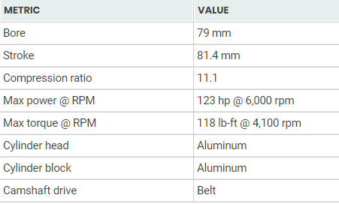
Comparing to the manufacturer specifications, the max power is 123 HP at 6,000 rpm and max torque at 4100 rpm. Reasoning for the rpm at max power to be a lot lower is due to accuracy of measurements and flow testing whilst using the flow bench.

-Figure 21: Manufactures Specifications

4.8. Valve Lift Against Crank Angle

To determine the max flow coefficient and max inlet valve diameter needed to raise the RPM by 50% at max power, the equations as followed will be used.

4,764 RPM @ Max Power raised by 50% = 9,528 RPM
Mean effective area over duration of valve opening with increased 29 mm diameter:
1.309 $×$ 2 $×$ $\frac{π x {29}^{2} }{4}$ = 1729.24 $m^{2}$
Assuming for these calculations that at max power, max gas velocity is 330 m/s.
Mean Gas Velocity = $\frac{2}{π}$ $×$ 330 = 210 m/s @ max power
Engine Displacement = $\frac{π}{4}$ $×$ ${Bore}^{2}$ $×$ Stroke $×$ no. Cylinders
Engine Displacement = $\frac{π}{4}$ $×$ ${78.4 }^{2}$ $×$ 81.4 x 4 = 1.5796 ${x10}^{6}$ $m^{3}$(394.9 ${x10}^{6}$ per cyclinder)
Calculating the engine speed @ max power:
Time of valve open =$\frac{Duration °}{360}$ $×$ $\frac{60}{RPM}$
Engine Displacement = Effective Area $×$ Gas Velocity Mean $×$ Valve Time Opening
1.5796 ${x10}^{6}$ = 1729.24 $×$ 210 $×$ $\frac{Duration °}{360}×\frac{60}{RPM}$
(Using duration as 250$°$ and re-arranged to equal RPM)
RPM @ Max Power = 1729.24 $×$ 210 $×$ $\frac{250}{360}×\frac{60}{1.5796 {x10}^{6}}$ = 9,578 RPM

By performing these calculations, it is determined that the required max flow coefficient and max valve diameter available to increase the RPM at max power by 50% is 1.309 CF and 29 mm.

5. Conclusion

After performing testing and appropriate calculations to create graphs to determine max and mean practical flow coefficients for all three tests. Recommendations for possible modifications to be made to improve flow coefficient were stated. Observed from testing and through the results and analysis section, it is believed that the bare head plus a flared entry port is the best way to increase the flow coefficient of the engine.

Once analysing the results, it was clear that the rate of flow is much greater with the flared entry because it helps to accelerate the flow as it is sucked through the ports. “In all experiments measuring pressure drops through orifices, slightly rounding any sharp corners can have a profound effect on the flow characteristics” (Stone, 1999, p.285). As stated by Stone in ‘Introduction to Internal Combustion Engines’, by using the slightly flared entry port can massively increase the flow characteristics and flow coefficient.

Finally, to conclude this report, it is believed that throughout the task an in-depth knowledge into the engine tested and equipment used during testing was shown with an understanding of how to perform testing to analyse the flow characteristics of the provided cylinder head. An understanding into the impacts that a design can have on the flow was stated, with a strong demonstration of practical skills throughout testing to support statements made.

References

Figures 1, 4 and 20. Motrolix (2020). Ford 1.6L Sigma Engine [Online]
Available: https://fordauthority.com/fmc/ford-motor-company-engines/ford-sigma-engine-family/ford-1-6l-sigma-engine/
(Accessed: 12th February 2020)

Figure 12. SuperFlow Corporation (No Date). SF-110 Flowbench Operator’s Manual
(Accessed: 10th February 2020)

Anderson, K (2013). The Ford “Kent” Engine: Four Cylinder Domination since 1959 [Online] Available: https://thegaragista.com/2013/06/23/the-ford-kent-engine-four-cylinder-domination-since-1959/
(Accessed: 7th February 2020)

Ford Motor company Ltd (2020). Ford Eco Boost Engine Technology [Online]
Available: https://www.ford.co.uk/shop/research/technology/performance-and-efficiency/ford-ecoboost
(Accessed: 5th February 2020)

SuperFlow Corporation (No Date). SF-110 Flowbench Operator’s Manual
(Accessed: 12th February 2020)

McClintock, Walkingshaw, McCartan, McCullough, Cunningham (2008). Camshaft Design for an Inlet-Restricted FSAE Engine [Online] Available: https://www.researchgate.net/publication/272824198_Camshaft_Design_for_an_Inlet-Restricted_FSAE_Engine
(Accessed: 18th February 2020)

Appendix

Bare Cylinder Head Flow
Lift (mm) | Flow Scale (%) | Range | Intake | Flow (l/s) | Flow (CFM) | CFM/IN^2 | CF
0.5 | 0.46 | 1 | 16.5 | 7.59 | 16.0822992 | 22.54253958 | 0.16335174
1 | 0.76 | 1 | 16.5 | 12.54 | 26.5707552 | 37.24419583 | 0.26988548
1.5 | 0.6 | 2 | 33.2 | 19.92 | 42.2080897 | 59.16302878 | 0.4287176
2 | 0.78 | 2 | 33.2 | 25.896 | 54.8705166 | 76.91193741 | 0.55733288
2.5 | 0.455 | 3 | 69.7 | 31.7135 | 67.197101 | 94.19009604 | 0.68253693
3 | 0.56 | 3 | 69.7 | 39.032 | 82.7041243 | 115.9262721 | 0.84004545
3.5 | 0.62 | 3 | 69.7 | 43.214 | 91.5652805 | 128.3469441 | 0.93005032
4 | 0.695 | 3 | 69.7 | 48.4415 | 102.641726 | 143.8727841 | 1.04255641
4.5 | 0.75 | 3 | 69.7 | 52.275 | 110.764452 | 155.2584001 | 1.12506087
5 | 0.79 | 3 | 69.7 | 55.063 | 116.67189 | 163.5388481 | 1.18506412
5.5 | 0.415 | 4 | 138.2 | 57.353 | 121.524125 | 170.3402204 | 1.23434942
6 | 0.44 | 4 | 138.2 | 60.808 | 128.844855 | 180.6016794 | 1.30870782
6.5 | 0.445 | 4 | 138.2 | 61.499 | 130.309001 | 182.6539712 | 1.3235795
7 | 0.455 | 4 | 138.2 | 62.881 | 133.237293 | 186.7585548 | 1.35332286
7.5 | 0.46 | 4 | 138.2 | 63.572 | 134.70144 | 188.8108467 | 1.36819454
8 | 0.47 | 4 | 138.2 | 64.954 | 137.629732 | 192.9154303 | 1.3979379
-Figure 22: Bare Cylinder Head Flow Data

Bare Head Plus Standard Intake Flow
Lift (mm) | Flow Scale (%) | Range | Intake | Flow (l/s) | Flow (CFM) | CFM/IN^2 | CF
0.5 | 0.41 | 1 | 16.5 | 6.765 | 14.3342232 | 20.0922635 | 0.14559611
1 | 0.695 | 1 | 16.5 | 11.4675 | 24.2982564 | 34.058837 | 0.24680317
1.5 | 0.505 | 2 | 33.2 | 16.766 | 35.5251421 | 49.7955492 | 0.36083731
2 | 0.71 | 2 | 33.2 | 23.572 | 49.9462394 | 70.0095841 | 0.50731583
2.5 | 0.41 | 3 | 69.7 | 28.577 | 60.5512339 | 84.874592 | 0.61503328
3 | 0.465 | 3 | 69.7 | 32.4105 | 68.6739603 | 96.260208 | 0.69753774
3.5 | 0.54 | 3 | 69.7 | 37.638 | 79.7504056 | 111.786048 | 0.81004383
4 | 0.595 | 3 | 69.7 | 41.4715 | 87.8731321 | 123.171664 | 0.89254829
4.5 | 0.675 | 3 | 69.7 | 47.0475 | 99.688007 | 139.73256 | 1.01255478
5 | 0.71 | 3 | 69.7 | 49.487 | 104.857015 | 146.977952 | 1.06505762
5.5 | 0.37 | 4 | 138.2 | 51.134 | 108.34681 | 151.869594 | 1.1005043
6 | 0.385 | 4 | 138.2 | 53.207 | 112.739248 | 158.026469 | 1.14511934
6.5 | 0.39 | 4 | 138.2 | 53.898 | 114.203394 | 160.078761 | 1.15999102
7 | 0.405 | 4 | 138.2 | 55.971 | 118.595833 | 166.235637 | 1.20460606
7.5 | 0.41 | 4 | 138.2 | 56.662 | 120.059979 | 168.287929 | 1.21947774
8 | 0.415 | 4 | 138.2 | 57.353 | 121.524125 | 170.34022 | 1.23434942
-Figure 23: Bare Head Plus Standard Intake Flow Data

Bare Cylinder Head with Flared Entry Flow
Lift (mm) | Flow Scale (%) | Range | Intake | Flow (l/s) | Flow (CFM) | CFM/IN^2 | CF
0.5 | 0.45 | 1 | 16.5 | 7.425 | 15.732684 | 22.0524844 | 0.15980061
1 | 0.79 | 1 | 16.5 | 13.035 | 27.6196008 | 38.7143615 | 0.28053885
1.5 | 0.595 | 2 | 33.2 | 19.754 | 41.8563556 | 58.6700035 | 0.42514495
2 | 0.38 | 3 | 67.9 | 25.802 | 54.6713418 | 76.6327544 | 0.55530981
2.5 | 0.42 | 3 | 69.7 | 29.274 | 62.0280932 | 86.944704 | 0.63003409
3 | 0.57 | 3 | 69.7 | 39.729 | 84.1809837 | 117.996384 | 0.85504626
3.5 | 0.64 | 3 | 69.7 | 44.608 | 94.5189992 | 132.487168 | 0.96005194
4 | 0.715 | 3 | 69.7 | 49.8355 | 105.595444 | 148.013008 | 1.07255803
4.5 | 0.38 | 4 | 138.2 | 52.516 | 111.275102 | 155.974178 | 1.13024766
5 | 0.39 | 4 | 138.2 | 53.898 | 114.203394 | 160.078761 | 1.15999102
5.5 | 0.42 | 4 | 138.2 | 58.044 | 122.988271 | 172.392512 | 1.2492211
6 | 0.44 | 4 | 138.2 | 60.808 | 128.844855 | 180.601679 | 1.30870782
6.5 | 0.45 | 4 | 138.2 | 62.19 | 131.773147 | 184.706263 | 1.33845118
7 | 0.455 | 4 | 138.2 | 62.881 | 133.237293 | 186.758555 | 1.35332286
7.5 | 0.46 | 4 | 138.2 | 63.572 | 134.70144 | 188.810847 | 1.36819454
8 | 0.46 | 4 | 138.2 | 63.572 | 134.70144 | 188.810847 | 1.36819454
-Figure 24: Bare Cylinder Head with Flared Entry Flow Data
Mases |  |  |  | Component | Measurements (mm) | Inches
Intake | Mass (g) | Quantity | Total | Valve Diameter | 24 | 0.94488189
Valve | 38 | 2 | 76 | Inlet Port Diameter | 30 | 1.18110236
Collet | 0.5 | 2 | 1 | Exhaust Port Diameter | 24 | 0.94488189
Lifter | 23.8 | 1 | 23.8 | Bore | 78.4 | 3.08661417
Spring | 20.4 | 1 | 20.4 | Stroke | 81.8 | 3.22047244
Retainer | 7.7 | 1 | 7.7 | Head Gasket Depth | 0.38 | 0.01496063
-Figure 25: Masses and Measurements Data
Cam Shaft |  | X | BH | BH + Intake | BH + Intake + Flared
Angle (Degrees) | Lift (mm) | Degrees | CF | CF | CF
0 | 0 | 0 | 0 | 0 | 0
2 | 0 | 1 | 0 | 0 | 0
4 | 0 | 2 | 0 | 0 | 0
6 | 0 | 3 | 0 | 0 | 0
8 | 0 | 4 | 0 | 0 | 0
10 | 0 | 5 | 0 | 0 | 0
12 | 0 | 6 | 0 | 0 | 0
14 | 0 | 7 | 0 | 0 | 0
16 | 0 | 8 | 0 | 0 | 0
18 | 0 | 9 | 0 | 0 | 0
20 | 0 | 10 | 0 | 0 | 0
22 | 0 | 11 | 0 | 0 | 0
24 | 0 | 12 | 0 | 0 | 0
26 | 0 | 13 | 0 | 0 | 0
28 | 0 | 14 | 0 | 0 | 0
30 | 0 | 15 | 0 | 0 | 0
32 | 0 | 16 | 0 | 0 | 0
34 | 0.01 | 17 | 0.00177745 | 0.00154753 | 0.00182842
36 | 0.01 | 18 | 0.00177745 | 0.00154753 | 0.00182842
38 | 0.01 | 19 | 0.00177745 | 0.00154753 | 0.00182842
40 | 0.01 | 20 | 0.00177745 | 0.00154753 | 0.00182842
42 | 0.01 | 21 | 0.00177745 | 0.00154753 | 0.00182842
44 | 0.01 | 22 | 0.00177745 | 0.00154753 | 0.00182842
46 | 0.01 | 23 | 0.00177745 | 0.00154753 | 0.00182842
48 | 0.02 | 24 | 0.0035538 | 0.00309412 | 0.00365568
50 | 0.02 | 25 | 0.0035538 | 0.00309412 | 0.00365568
52 | 0.02 | 26 | 0.0035538 | 0.00309412 | 0.00365568
54 | 0.02 | 27 | 0.0035538 | 0.00309412 | 0.00365568
56 | 0.02 | 28 | 0.0035538 | 0.00309412 | 0.00365568
58 | 0.02 | 29 | 0.0035538 | 0.00309412 | 0.00365568
60 | 0.02 | 30 | 0.0035538 | 0.00309412 | 0.00365568
62 | 0.02 | 31 | 0.0035538 | 0.00309412 | 0.00365568
64 | 0.03 | 32 | 0.00532905 | 0.00463977 | 0.00548178
66 | 0.03 | 33 | 0.00532905 | 0.00463977 | 0.00548178
68 | 0.03 | 34 | 0.00532905 | 0.00463977 | 0.00548178
70 | 0.03 | 35 | 0.00532905 | 0.00463977 | 0.00548178
72 | 0.03 | 36 | 0.00532905 | 0.00463977 | 0.00548178
74 | 0.03 | 37 | 0.00532905 | 0.00463977 | 0.00548178
76 | 0.04 | 38 | 0.0071032 | 0.00618448 | 0.00730672
78 | 0.04 | 39 | 0.0071032 | 0.00618448 | 0.00730672
80 | 0.04 | 40 | 0.0071032 | 0.00618448 | 0.00730672
82 | 0.04 | 41 | 0.0071032 | 0.00618448 | 0.00730672
84 | 0.05 | 42 | 0.00887625 | 0.00772825 | 0.0091305
86 | 0.05 | 43 | 0.00887625 | 0.00772825 | 0.0091305
88 | 0.08 | 44 | 0.0141888 | 0.01235392 | 0.01459488
90 | 0.15 | 45 | 0.02654625 | 0.02311425 | 0.0273045
92 | 0.22 | 46 | 0.0388498 | 0.03382852 | 0.03995728
94 | 0.26 | 47 | 0.0458562 | 0.03993028 | 0.04716192
96 | 0.29 | 48 | 0.05109945 | 0.04449673 | 0.05255322
98 | 0.33 | 49 | 0.05807505 | 0.05057217 | 0.05972538
100 | 0.36 | 50 | 0.0632952 | 0.05511888 | 0.06509232
102 | 0.4 | 51 | 0.07024 | 0.061168 | 0.072232
104 | 0.49 | 52 | 0.08580145 | 0.07472353 | 0.08822842
106 | 0.55 | 53 | 0.09612625 | 0.08371825 | 0.0988405
108 | 0.63 | 54 | 0.10983105 | 0.09565857 | 0.11292498
110 | 0.74 | 55 | 0.1285602 | 0.11197828 | 0.13216992
112 | 0.85 | 56 | 0.14715625 | 0.12818425 | 0.1512745
114 | 0.98 | 57 | 0.1689618 | 0.14719012 | 0.17367168
116 | 1.14 | 58 | 0.1955442 | 0.17036388 | 0.20096832
118 | 1.31 | 59 | 0.22347945 | 0.19472233 | 0.22964562
120 | 1.5 | 60 | 0.254325 | 0.221625 | 0.2613
122 | 1.73 | 61 | 0.29113305 | 0.25373737 | 0.29905818
124 | 1.95 | 62 | 0.32579625 | 0.28398825 | 0.3346005
126 | 2.15 | 63 | 0.35684625 | 0.31109425 | 0.3664245
128 | 2.49 | 64 | 0.40862145 | 0.35631153 | 0.41946042
130 | 2.78 | 65 | 0.4517778 | 0.39402052 | 0.46363728
132 | 2.82 | 66 | 0.4576578 | 0.39915972 | 0.46965408
134 | 3.11 | 67 | 0.49976145 | 0.43596913 | 0.51272082
136 | 3.46 | 68 | 0.5493442 | 0.47934148 | 0.56339872
138 | 3.84 | 69 | 0.6016512 | 0.52512768 | 0.61681152
140 | 4.21 | 70 | 0.65105545 | 0.56840473 | 0.66720922
142 | 4.62 | 71 | 0.7040418 | 0.61485732 | 0.72120048
144 | 5.12 | 72 | 0.7661568 | 0.66936832 | 0.78440448
146 | 5.52 | 73 | 0.8138688 | 0.71128512 | 0.83287968
148 | 5.95 | 74 | 0.86319625 | 0.75466825 | 0.8829205
150 | 6.36 | 75 | 0.9083352 | 0.79441488 | 0.92863632
152 | 6.69 | 76 | 0.94332345 | 0.82525833 | 0.96401562
154 | 6.89 | 77 | 0.96394545 | 0.84345313 | 0.98484282
156 | 7.04 | 78 | 0.9791232 | 0.85685248 | 1.00015872
158 | 7.09 | 79 | 0.98412745 | 0.86127193 | 1.00520602
160 | 6.9 | 80 | 0.964965 | 0.844353 | 0.985872
162 | 6.7 | 81 | 0.944365 | 0.826177 | 0.965068
164 | 6.38 | 82 | 0.9104898 | 0.79631332 | 0.93081648
166 | 6.08 | 83 | 0.8777088 | 0.76744192 | 0.89762688
168 | 5.55 | 84 | 0.81737625 | 0.71436825 | 0.8364405
170 | 5.08 | 85 | 0.7612888 | 0.66509392 | 0.77945488
172 | 4.58 | 86 | 0.6989538 | 0.61039492 | 0.71601888
174 | 4.19 | 87 | 0.64842345 | 0.56609833 | 0.66452562
176 | 3.81 | 88 | 0.59757945 | 0.52156233 | 0.61265562
178 | 3.42 | 89 | 0.5437458 | 0.47444292 | 0.55767888
180 | 3.05 | 90 | 0.49112625 | 0.42841825 | 0.5038905
182 | 2.73 | 91 | 0.44440305 | 0.38757537 | 0.45609018
184 | 2.43 | 92 | 0.39957705 | 0.34841097 | 0.41019858
186 | 2.14 | 93 | 0.3553042 | 0.30974788 | 0.36484432
188 | 1.9 | 94 | 0.317965 | 0.277153 | 0.326572
190 | 1.71 | 95 | 0.28795545 | 0.25096473 | 0.29579922
192 | 1.46 | 96 | 0.2478642 | 0.21598948 | 0.25467072
194 | 1.28 | 97 | 0.2185728 | 0.19044352 | 0.22460928
196 | 1.12 | 98 | 0.1922368 | 0.16748032 | 0.19757248
198 | 0.98 | 99 | 0.1689618 | 0.14719012 | 0.17367168
200 | 0.86 | 100 | 0.1488402 | 0.12965188 | 0.15300432
202 | 0.75 | 101 | 0.13025625 | 0.11345625 | 0.1339125
204 | 0.67 | 102 | 0.11665705 | 0.10160617 | 0.11993938
206 | 0.61 | 103 | 0.10641145 | 0.09267913 | 0.10941082
208 | 0.56 | 104 | 0.0978432 | 0.08521408 | 0.10060512
210 | 0.52 | 105 | 0.0909688 | 0.07922512 | 0.09353968
212 | 0.49 | 106 | 0.08580145 | 0.07472353 | 0.08822842
214 | 0.45 | 107 | 0.07889625 | 0.06870825 | 0.0811305
216 | 0.42 | 108 | 0.0737058 | 0.06418692 | 0.07579488
218 | 0.39 | 109 | 0.06850545 | 0.05965713 | 0.07044882
220 | 0.35 | 110 | 0.06155625 | 0.05360425 | 0.0633045
222 | 0.31 | 111 | 0.05458945 | 0.04753633 | 0.05614162
224 | 0.28 | 112 | 0.0493528 | 0.04297552 | 0.05075728
226 | 0.22 | 113 | 0.0388498 | 0.03382852 | 0.03995728
228 | 0.19 | 114 | 0.03358345 | 0.02924233 | 0.03454162
230 | 0.15 | 115 | 0.02654625 | 0.02311425 | 0.0273045
232 | 0.12 | 116 | 0.0212568 | 0.01850832 | 0.02186448
234 | 0.09 | 117 | 0.01595745 | 0.01389393 | 0.01641402
236 | 0.07 | 118 | 0.01241905 | 0.01081297 | 0.01277458
238 | 0.06 | 119 | 0.0106482 | 0.00927108 | 0.01095312
240 | 0.06 | 120 | 0.0106482 | 0.00927108 | 0.01095312
242 | 0.06 | 121 | 0.0106482 | 0.00927108 | 0.01095312
244 | 0.05 | 122 | 0.00887625 | 0.00772825 | 0.0091305
246 | 0.05 | 123 | 0.00887625 | 0.00772825 | 0.0091305
248 | 0.05 | 124 | 0.00887625 | 0.00772825 | 0.0091305
250 | 0.05 | 125 | 0.00887625 | 0.00772825 | 0.0091305
252 | 0.05 | 126 | 0.00887625 | 0.00772825 | 0.0091305
254 | 0.04 | 127 | 0.0071032 | 0.00618448 | 0.00730672
256 | 0.04 | 128 | 0.0071032 | 0.00618448 | 0.00730672
258 | 0.04 | 129 | 0.0071032 | 0.00618448 | 0.00730672
260 | 0.04 | 130 | 0.0071032 | 0.00618448 | 0.00730672
262 | 0.04 | 131 | 0.0071032 | 0.00618448 | 0.00730672
264 | 0.04 | 132 | 0.0071032 | 0.00618448 | 0.00730672
266 | 0.04 | 133 | 0.0071032 | 0.00618448 | 0.00730672
268 | 0.04 | 134 | 0.0071032 | 0.00618448 | 0.00730672
270 | 0.03 | 135 | 0.00532905 | 0.00463977 | 0.00548178
272 | 0.03 | 136 | 0.00532905 | 0.00463977 | 0.00548178
274 | 0.03 | 137 | 0.00532905 | 0.00463977 | 0.00548178
276 | 0.03 | 138 | 0.00532905 | 0.00463977 | 0.00548178
278 | 0.03 | 139 | 0.00532905 | 0.00463977 | 0.00548178
280 | 0.03 | 140 | 0.00532905 | 0.00463977 | 0.00548178
282 | 0.03 | 141 | 0.00532905 | 0.00463977 | 0.00548178
284 | 0.03 | 142 | 0.00532905 | 0.00463977 | 0.00548178
286 | 0.03 | 143 | 0.00532905 | 0.00463977 | 0.00548178
288 | 0.03 | 144 | 0.00532905 | 0.00463977 | 0.00548178
290 | 0.02 | 145 | 0.0035538 | 0.00309412 | 0.00365568
292 | 0.02 | 146 | 0.0035538 | 0.00309412 | 0.00365568
294 | 0.02 | 147 | 0.0035538 | 0.00309412 | 0.00365568
296 | 0.02 | 148 | 0.0035538 | 0.00309412 | 0.00365568
298 | 0.02 | 149 | 0.0035538 | 0.00309412 | 0.00365568
300 | 0.02 | 150 | 0.0035538 | 0.00309412 | 0.00365568
302 | 0.02 | 151 | 0.0035538 | 0.00309412 | 0.00365568
304 | 0.02 | 152 | 0.0035538 | 0.00309412 | 0.00365568
306 | 0.02 | 153 | 0.0035538 | 0.00309412 | 0.00365568
308 | 0.02 | 154 | 0.0035538 | 0.00309412 | 0.00365568
310 | 0.01 | 155 | 0.00177745 | 0.00154753 | 0.00182842
312 | 0.01 | 156 | 0.00177745 | 0.00154753 | 0.00182842
314 | 0.01 | 157 | 0.00177745 | 0.00154753 | 0.00182842
316 | 0.01 | 158 | 0.00177745 | 0.00154753 | 0.00182842
318 | 0.01 | 159 | 0.00177745 | 0.00154753 | 0.00182842
320 | 0.01 | 160 | 0.00177745 | 0.00154753 | 0.00182842
322 | 0.01 | 161 | 0.00177745 | 0.00154753 | 0.00182842
324 | 0.01 | 162 | 0.00177745 | 0.00154753 | 0.00182842
326 | 0.01 | 163 | 0.00177745 | 0.00154753 | 0.00182842
328 | 0.01 | 164 | 0.00177745 | 0.00154753 | 0.00182842
330 | 0.01 | 165 | 0.00177745 | 0.00154753 | 0.00182842
332 | 0.01 | 166 | 0.00177745 | 0.00154753 | 0.00182842
334 | 0 | 167 | 0 | 0 | 0
336 | 0 | 168 | 0 | 0 | 0
338 | 0 | 169 | 0 | 0 | 0
340 | 0 | 170 | 0 | 0 | 0
342 | 0 | 171 | 0 | 0 | 0
344 | 0 | 172 | 0 | 0 | 0
346 | 0 | 173 | 0 | 0 | 0
348 | 0 | 174 | 0 | 0 | 0
350 | 0 | 175 | 0 | 0 | 0
352 | 0 | 176 | 0 | 0 | 0
354 | 0 | 177 | 0 | 0 | 0
356 | 0 | 178 | 0 | 0 | 0
358 | 0 | 179 | 0 | 0 | 0
360 | 0 | 180 | 0 | 0 | 0
-Figure 26: Cam Angles Data

