Programme: BA Leadership and Management
Module: Design Thinking and Innovation
Module code: LCLM 6002

Borys Sekulski
2321808

Table of Contents
1. Introduction to the Chosen Organisation 4
1.1 Overview of the Organisation 4
1.2 Strategic Context 4
1.3 Purpose and Structure of the Report 4
2. Key Consumer and Industry Trends 5
2.1 UK Retail Industry Trends 5
2.2 Consumer Behaviour Trends 5
2.3 Implications for the Organisation 6
3. Part 1: Analysis of Innovation and Current Customer Journey 6
3.1 Theoretical Foundation 6
3.2 Application of the Innovation Ambition Matrix 8
3.2.1 Core Innovation (Horizon 1) 8
3.2.2 Adjacent Innovation (Horizon 2) 9
3.2.3 Transformational Innovation (Horizon 3) 10
3.2.4 Evaluation of Overall Innovation Portfolio 11
3.3 Current Customer Journey Mapping 11
3.3.1 Identification of Core Customer Persona 12
3.3.2 Mapping of Current Customer Journey Stages 12
3.3.3 Identification of Pain Points 13
3.3.4 Identification of Gain Points 13
3.3.5 Identification of Digital Innovation Opportunities 13
4. Part 2: Proposed Digital Transformation Initiative 13
4.1 Identification of Key Strategic Problem 14
4.2 Proposed Initiative: AI-Integrated Unified Retail Experience Platform 14
4.3 Enhanced Customer Journey 15
4.4 Value Creation Analysis 15
4.4.1 Desirability 15
4.4.2 Feasibility 16
4.4.3 Viability 16
4.5 Measurement and Evaluation 17
4.6 Risks and Limitations 17
4.7 Concluding Position 17
5. Conclusion 18
6. References 20
7. Appendix A: Customer Journey 25

1. Introduction to the Chosen Organisation

1.1 Overview of the Organisation
Marks & Spencer is a retailing business that has a long history in the United Kingdom and has been operating since the year 1884 since it began as a market stall before developing into a multinational retail chain (Marks & Spencer, 2026c). The organisation has created a quality, reliability and good brand trust reputation in over more than a hundred years. Its main business segments are modified based on Clothing & Home and Food and the two divisions are the core segments of the revenue generation and brand positioning at the company. The Food division, and especially the premium and convenience divisions have grown to be a key competitive advantage, and Clothing Houses remain in the process of repositioning to appeal to a wider range of demographics.
Recent performance documented in the Annual Report 2025 indicates that the organisation has continued to undertake strategic restructuring, which is under the Reshaping M&S programme, and investment in digital capability and store transformations are continuing (Marks & Spencer, 2025). The customer has also advanced with regards to digital adoption as more than fifty percent of online orders are done through the mobile application.

1.2 Strategic Context
The UK retail market is very competitive with digital-native entrants, price-sensitive consumer behaviour and speeding up AI integration in the industry. Established retailers are experiencing structural tension between the store estates created during their history and the demand of the omnichannel capability. Innovation in this setting does not act as growth improvement, but as a survival mechanism.
Marks & Spencer have followed the path of digital transformation by optimising its chain of supply, creating applications and leading in ESG. However, the threat of online competitors that are more agile requires the capability to fully integrate predictive analytics and personalisation.

1.3 Purpose and Structure of the Report
In this report, the Innovation Ambition Matrix is used in assessing the innovation portfolio of the organisation and mapping the existing customer journey to find out structural strengths and areas of friction. This analysis is further carried over to propose and critically evaluate a proposed digital transformation initiative in terms of desirability, feasibility and viability in order to ascertain its long-term strategic value.

2. Key Consumer and Industry Trends

2.1 UK Retail Industry Trends
The Omni channel integration in the UK retail sector is shifting towards a decisive move as the industry adopts structural changes of consumer interaction with brands. It is also evidence that shopping is no longer conducted in a solitary medium: it is always followed by consumers to alternate among their online and offline spaces until they come up with a shopping choice. Studies show that With 81% also shop online frequently and 83% also go in-store frequently because it is proving its competitive advantage is building more on channel integration than channel dominance (RSM UK, 2025). Those retailers that do not consolidate visibility of inventory, consistency of prices and customer information across channels run the risk of being strategically disjointed.
The competitive pressure has also been increased by digital acceleration. Artificial intelligence is being used more in merchandising, demand forecasting and customer engagement functions. Industry analysis can reveal that over 70% of retail companies already started to use AI-based systems to increase the operational efficiency and personalisation of customers (Hale, 2025). This is the indicator that the use of AI is not a novel phenomenon but it is actively turning into a standard in the industry. The implication is obvious: digital inertia at this point is a weakness of strategy.
Resilience and cost control has also taken the centre stage with supply chain digitalisation. About 66%of UK supply network are restructuring to increase their transparency and responsiveness (McArdle, 2026). The recent world unrests have changed digital visibility in supply chains to both efficiency and necessity of operations.

2.2 Consumer Behaviour Trends
Similar change is shown in consumer behaviour. Online retailing connexions have been enhanced to mobile-first uses, where more than 72% of the e-commerce traffic in the UK began with smartphones (Adpage, 2025). It implies that mobile optimisation should be the key point of digital strategy, instead of the assumptions of desktop interactions. The need of personalisation has become heightened. Customers demand more and more algorithmic recommendations, personalised offers and personal communication. Scholarly evidence suggests that bespoke online interaction helps to convert many more people and makes them loyal to the brand (Rowi et al., 2024). To the extent that retailers cannot utilise customer data to their benefit, they face commoditisation.
Expectations of convenience have also gone up. Same-day delivery, frictionless checkout and real-time inventory availability are no longer high-value certificates, but some minimum provisions. Retailers using old systems might fail to maintain these standards on a regular basis (Dasari, 2025). The field on ethical consumption has also grown stronger. Younger age segments are more sensitive to sustainability credentials and labour practises, which confirms the effect of the ESG transparency on purchasing decisions.

2.3 Implications for the Organisation
These converging trends are causing a lot of strategic tension to Marks & Spencer. Being a retailer that has a large physical footprint and a pre-existing brand history, there is structural complexity to balancing the digital transformation with the operational legacy complexity. Omni channel integration involves the cost of both technology and cultural shift, which are financial risks. The competition pressure is increasing (Saghiri and Mirzabeiki, 2021). The competitors that possess digital-native models have the ability to scale in their iterations, personalise and work with less infrastructure restrictions. Unless supply chain analytics and mobile-first experience design are invested in over time, competitive positioning could be lost.
Opportunity is created by these trends, though. Good brand trust and developed customer loyalty creates an opportunity of utilising data-driven personalisation and leadership on sustainability. In case the concept of digital transformation is in unison with convenience as expected by the consumer in terms of ethics and seamless experience, differentiation can still be attained. It is no longer a case of incremental switching in terms of how the UK retail environment is characterised but is instead experiencing transformative change (Orr et al., 2022). Retailers that embed the idea of omnichannel capability, AI integration, sustainability as a core or strategic initiative, but not marginalised ones will have higher chances of remaining competitive.

3. Part 1: Analysis of Innovation and Current Customer Journey

3.1 Theoretical Foundation
Design Thinking is one of the human-centric innovation strategies that focus on empathy, experimentation and iterative prototyping (Romero and Donaldson, 2024). Design Thinking is not externally based on internal abilities or budget forecasts, but instead on examining the needs of users and putting issues into fresh perspective after observation and experimenting. This method is contrary to the linear, top-down, strategic models in that it lays more weight on the desirability of an idea than on its feasibility and viability.
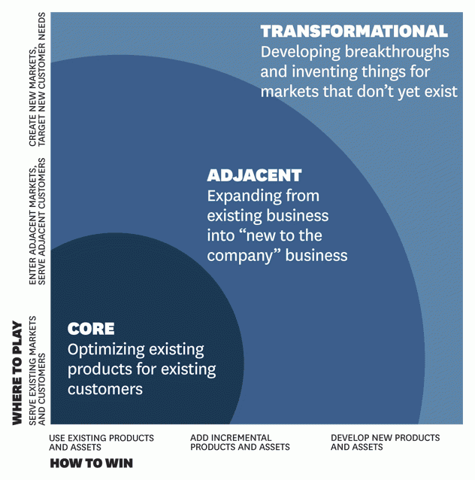
Figure 1: The Innovation Ambition Matrix
Source: (Skillicorn, 2021)
Innovation views innovation in three horizons with core innovation (Horizon 1), adjacent innovation (Horizon 2), and transformational innovation (Horizon 3); both of which were created by Baghai, Coley and White (2000) Innovation Ambition Matrix (Mathews, 2025). Core innovation is concerned with making minor changes to products and markets. Adjacent innovation increases existing capabilities to new markets or segments. Transformational innovation develops new offerings or new business paradigms. The advantages of the matrix are that it allows the balance of portfolios and distribution of risk to be evaluated. Excessive attention to Horizon 1 enhancements in retailing would generate immediate profits but leave the company vulnerable to long-term risks.
Customer Journey Mapping is an addition to these frameworks as it allows visualisation of the end-to-end experience of awareness to post-purchase engagement (Dzreke, 2025). This model recognises touchpoints, emotional states, pain points and opportunities of value creation. It has been shown that companies that do well in customer experience achieve a higher profit 4-8 percent above average in the market (Morgan, 2019). Journey mapping, therefore, does not act as a descriptive analysis tool, but as a diagnostic innovation tool.
In comparison to the classical strategic planning that focuses on financial prognostication, market share goals and competitive placement these systems devote precedence to adaptive experimentation and customer-centric change (Akbar, 2024). This might create operational stability out of traditional planning but in changing digital markets; strategic agility is more important than steady optimisation.

3.2 Application of the Innovation Ambition Matrix

3.2.1 Core Innovation (Horizon 1)
Core innovation in Marks & Spencer is mostly an embodiment of improvement of current operations. Marks & Spencer introduce Annual Report 2025, which emphasises the continuous store renewal programmes and investment in digital infrastructure as the means of modernising the estate (Marks & Spencer, 2025). The objectives of such initiatives are to enhance the productivity of stores and customer navigation without changing the underlying business model.
Another Horizon 1 activity is with respect to loyalty improvements. The Sparks loyalty programme is based on digital interaction as well as targeted offers that strengthens the repeat purchasing behaviour. Moreover, the report indicates that, 54% of online orders are taken through the application, which show incremental optimisation of digital volumes, indicating a lack of radical innovation (Marks & Spencer, 2025).
The supply chain digitisation and better forecasting systems will be part of the improvement of its operational efficiency. The Basis of Reporting 2025 has improved the reporting accuracy by ensuring that the value of emissions tracking and operational control systems have been enhanced (Marks & Spencer, 2026b). These measures although enhance efficiency and governance are majorly used to protect current competitive positions.
Most importantly, dominance of Horizon 1 can be an indication of risk aversion. Incremental innovations can produce foreseeable returns but might fail in the response to disruptive threats posed by digital native rivals. This horizon could be limiting long term adaptability in case excessive concentration is applied.

3.2.2 Adjacent Innovation (Horizon 2)
Adjacent innovation takes the competencies of Marks & Spencer to its adjacent markets. The partnership with Ocado Retail is an excellent example of expanding the channels and, therefore, offering online grocery development opportunities when not being tied to the traditional store-based grocery configurations (Marks & Spencer, 2025). This project plays on brand power as new distribution skills are accessed. Market extension can also be the repositioning of clothing collections to younger audiences in the form of selected collections and online marketing efforts. These efforts indicate efforts to go beyond the regular core customers.
But the problem with the innovation being put next to each other is strategic coherence. Although a channel expansion boosts the presence of the online grocery, the level of rivalry in the online grocery sector is significant, and consumers, who are price-sensitive, often change the provider. As per the data provided by ONS, online sales were 26% of total UK retail sales in peak pandemic periods and have levelled at 26% in early 2024 (Statista, 2025). Being in saturated online markets does not mean being differentiated, it takes persistence.
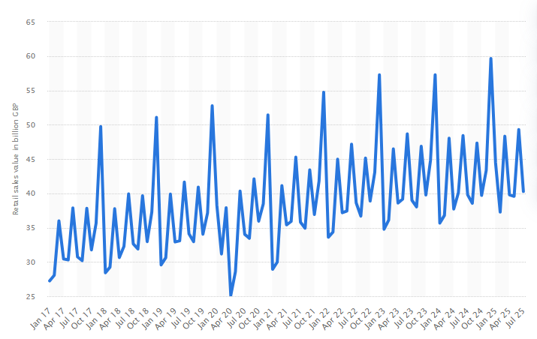
Figure 2: Retail sales value monthly in Great Britain 2017-2025
Source: (Statista, 2025)
Thus, even though the Horizon 2 projects are ambitious, strategic intent should not be expansion-focused, but should instead shift toward unique value creation.

3.2.3 Transformational Innovation (Horizon 3)
Transformational innovation entails long term investments that redefine the mode of operations. Plan A ESG strategy reported by Marks & Spencer has shown systemic ambition which requires like a reduction of Scope 1 and 2 emissions by 33% compared with the 2016/17 baseline (Marks & Spencer, 2026). Sustainability transformation is not merely a process of increased compliance but a process of differentiating environmental performance as a strategic differentiating variable.
Horizon 3 potential is also evident in the data-driven forecasting and data-driven supply chain optimisation that are digital transformation initiatives. Nonetheless, mandatory reporting focuses more on the governance and performance indicators rather than a business model reinvention on a disruptive basis (Khan, 2025). The transformational ambition can be said to be moderate in comparison with the digital-native retailers who have made aggressive investments in AI-based personalisation and automation. As a result, there are Horizon 3 investment, just that it might not indicate high intensity of innovation in the industry.

3.2.4 Evaluation of Overall Innovation Portfolio
In total, the distribution of innovation seems to be biased towards Horizon 1 having moderate expansion in Horizon 2 and risky exploration in Horizon 3. Risk diversification is still around but is arguably conservative. Brand trust, quality positioning, and ESG leadership have a very high level of strategic coherence. The limitations are however slower radical experimentation as well as underutilization of data analytics capabilities. Competitive differentiation may only be restricted by incrementalism in highly dynamic retailing settings where 70% of the retailers are adopting AI systems (Hale, 2025). Refocusing of the portfolio towards greater transformational experimentation holds the potential of increasing long-term resilience.

3.3 Current Customer Journey Mapping
In this section, customer journey mapping is used to analyse the existing experience provided by Marks & Spencer on major touchpoints. Through customer thought analysis, activity and behaviour of customer awareness to post-purchase response are assessed, which stipulates the structural strengths and stress areas on which future digital transformation and innovation recommendations are based.
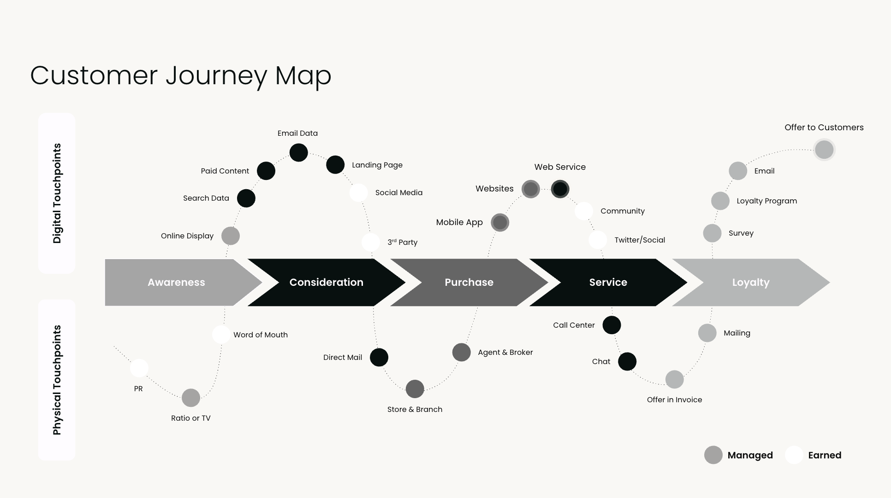
Figure 3: Customer Journey Mapping
Source: (Show, 2026)

3.3.1 Identification of Core Customer Persona
The primary customer ideal can be defined as a middle-income professional who is aged between 35 and 60, and appreciates quality, trust and reliability. The buying reasons put the accents on perceived longevity, ethical sourcing and superior food provision. Loyalty is supported by brand familiarity and heritage.

3.3.2 Mapping of Current Customer Journey Stages
The creation of awareness comes about by means of television advertising, online campaigns as well as word-of-mouth reputation. Consideration is the item that includes using online platforms or attending stores in order to compare the quality of products. Browsing online is more done through mobile phones, and it is in line with national statistics that indicate that out of the 70-percent of e-commerce interactions, over 70- percent are made through smartphones (Adpage, 2025).
The type of in-store interaction is oriented to its tactile assessment; in the case of clothing and high-end food categories. The completion of the purchases can be made either online or in the real world with the help of loyalty programmes. After-sales activities include Sparks loyalty points, email requests and notifications (Dobre et al., 2023). Exchange and returns are made easy using stores, which enhances integration of the Omni channel.

3.3.3 Identification of Pain Points
The existence of the digital friction is still observed especially with the complexity of navigation, and transparency of stock availability. Physical stores drawbacks involve the lack of uniform combination between application and physical experience (Chandrasekhar et al., 2024). The perception of pricing sometimes goes against a value-for-money message when living costs run high. Gaps in stock visibility lower the expectations of convenience in the Omni channel environments.

3.3.4 Identification of Gain Points
Trust in the brand also continues to be an important factor of gain, which is supported by ESG transparency and ethical commitment (Marks & Spencer, 2026a). Perceived value is increased by product quality and high-end differentiation of food. Repeat purchase behaviour is reinforced by the display of loyalty.

3.3.5 Identification of Digital Innovation Opportunities
There is immediate opportunity due to personalisation gaps. The usage of AI-based individualisation is still low in comparison with its digital-native competition, despite the level of its adoption. The use of data would improve predictive recommendation and inventory management. The main areas of weakness that are still faced include Omni channel integration in the real-time stock synchronisation as well as a flow of mobile to stores. The enhanced journey integration would yield positive financial results considering the fact that the customer experience leaders gain 4-8% of revenue power (Morgan, 2019).
To sum up, the present level of innovation activity can be characterised by operational competence and ESG credibility. More powerful transformational experiment and more data-driven personalisation might be necessary to achieve competitive advantage in an ever more digital retail environment, though.

4. Part 2: Proposed Digital Transformation Initiative

4.1 Identification of Key Strategic Problem
Part 1 analysis shows that Marks & Spencer has a high brand equity, ESG credibility and operational Omni channel. Nevertheless, the deficiencies in the structure still lie in the profundity of digital integration toward data processing and the complexity of the use of data. Though 54% of online purchases are received through the mobile application (Marks & Spencer, 2025), there does not seem to be much engagement made to predict or cater to specific people. Digital infrastructure is in place, but it has not completely planned customer needs and removed friction between touchpoints.
Also, ESG output is so far showing visible improvement, with a reported 33 percent decrease in Scope 1 and 2 emissions since the baseline (Markes and Spencer, 2026), but sustainability data are still mostly present in reporting and not directly integrated into the customer digitally escapades. This lack of connection cracks down on differentiation. As more than three-quarters of retailers in an industry have started adopting AI-based technologies (Hale, 2025) and incremental digital optimisation is a risk to competitive stagnation. The strategic issue is hence inadequate intensity of transformation in addition to lack of digital capability.

4.2 Proposed Initiative: AI-Integrated Unified Retail Experience Platform
The proposed change includes the creation of an integrated AI-powered retail platform that would incorporate customer data, real-time inventory tracking, predictive analytics and sustainability involvedness in a smooth Omni channel experience (Patil, 2024). The project does not concentrate on the functionality of the app only; instead, it rearranges the connection between the digital infrastructure and physical locations and supply chains.
Such change would include AI-based personalisation engines that can create dynamic product recommendations based on behavioural patterns. Purchase uncertainty would be minimised by synchronising stock real-time both in the store and online setting (Mukkath, 2025). In-store would reduce paper usage by providing mobile-enabled features in digital form through digital receipts, scan-and-go payment and product transparency which is links to QR code. Dashboard on sustainability would be included on the product pages and the customers would come across the environmental impact details in the process of making a purchase.
This initiative, being a strategic one, is aligned with the corporate goal of Reshaping M&S by speeding up digitally and developing the customer-centric growth (Marks & Spencer, 2025). The initiative is also on track to strengthen the firm commitments since it entails ESG transparency embedded into the digital interaction, and thereby there is no parallel agenda.

4.3 Enhanced Customer Journey
The new customer journey will be altered to be not mainly reactive but proactive navigation. At the awareness level, AI would be used to customise digital advertising with regard to purchasing history and behavioural predictors of purchasing instead of using general demographic advertising (Hye, 2023). Comparing dynamic pricing and customised suggestions would minimise perceived risk and promote messaging of value during consideration.
Online browsing would involve predictive search, instant stock confirmation through location and carbon impact indicating by ESG datasets. Online receipts and mobile check out would be involved in purchase phases so that no friction would occur in queuing and the adoption of the app could be reinforced (Gu and Kannan, 2021). The predictive analytics would be used to establish post-purchase engagement by sending personalised offers and communication at the lifecycle in place of generic promotional messages. The emotional finding of such changes would be less feeling of uncertainty and more perceived control. Customers would also enjoy a process of informed decision instead of a disjointed search which would build trust and satisfaction.

4.4 Value Creation Analysis

4.4.1 Desirability
The issue of desirability must be evaluated based on the changing consumer expectations as opposed to the internal strategic ambition. Consumers within the UK are putting more demands on their desire to have smooth, customised and assisted-retailing services, especially in mobile platforms. It has been demonstrated in the industry that more than 50% of online retail purchases in the UK are now completed through mobile devices (Statista, 2025a), which supports the argument that the quality of digital experience directly influences the ability to make a purchase.
Moreover, customer-focused organisations are always ahead of the competitors in terms of customer loyalty and retention. PwC research (2023) shows that 73% of consumers use experience as a factor when buying products. Fulfiling this behavioural fact is an embedded predictive Assistant, real time stock confirmation as well as built in loyalty recognition. The suggested initiative hence builds up desirability by matching consumer need of relevance, transparent and control, as opposed to wearing heritage brand prowess.

4.4.2 Feasibility
The aspect of feasibility lies in the technological maturity and the organisational capacity. Robots that enable recommendations, demand prediction systems and integrated checkout platforms are a commonplace fact among major world retailers. According to Gartner (2026), artificial intelligence is now an existing operational tool of retail supply chain, especially in prediction and inventory optimisation. This indicates that, the technologies that are required are not experimental.
Previous infrastructure and governance are additional environmental supporters of organisational preparedness. The Basis of Reporting 2025 provides design data management practises and a delimited reporting boundary (Marks & Spencer, 2026b) meaning that it is established to deal with intricate datasets. Therefore, implementation is scaling and integration of current competencies relying on many already in place and not new technological architecture.

4.4.3 Viability
The viability is established using financial sustainability and operational efficiency in the long run. The digital personalisation has been seen to boost the conversion rates and value of order on average in the retail industries. According to reports by Deloitte (2022), retailers who successfully applied advanced analytics achieve customer lifetime value improvement and a decrease in churn that can be measured.
In operational terms, predictive replenishment and better inventory visibility minimises excess and markdown dependency which directly enhances the gross margins. Also, an improvement in the level of customer acquisition through better digital interaction will reduce the cost of customer acquisition through improved retention. As the online retail currently constitutes a structurally relevant slice of aggregate UK retail activity (ONS, 2025), a digital conversion and retention optimisation has been demonstrated to have scalable financial effect. Consequently, the viability is a product of revenue boost, expense management, and a better use of assets that make the initiative appear to be lucrative and not a fantasy.

4.5 Measurement and Evaluation
Customer, financial and operational indicators should be incorporated in performance review. Measurement alignment can be as shown in the following table:
Table 2: Performance Management and Its Evaluation
Category | Key Indicators
Customer Metrics | Increase in repeat purchase frequency; improvement in Net Promoter Score; personalised offer redemption rate
Financial Metrics | Growth in digital revenue contribution; increase in average order value; gross margin improvement (Evmenchik et al., 2021)
Operational Metrics | Reduction in stockout frequency; forecasting accuracy improvement; decrease in return rate
Experience Metrics | Reduction in checkout time; app engagement growth; conversion rate increase
Measurement should occur quarterly, enabling iterative optimisation consistent with innovation best practice.

4.6 Risks and Limitations
The complexity of implementation is also a serious risk factor especially when it comes to integration with older systems. Digital transformation among large organisations tends to be met with gradual disruption, which can have a short-term impact on the level of service. The issues of data privacy are increased as the requirements of GDPR compliance (Oluoha et al., 2023). The increased use of data should also be supported by the transparent consent process and governance protection to prevent the loss of reputation.
Financial risk is as a result of initial capital investment prior to realisation of measurable returns. Also, organisational resistance to change can be a cause of slow adoption, where store-level settings are digitally integrated, and workflows have to be adjusted to changes (Bonetti et al., 2025). These dangers notwithstanding, lack of intensifying transformation can be of more strategic threat. Cautious incrementalism is likely to destroy differentiation and undermine long-term competitiveness in increasingly AI-driven retail markets.

4.7 Concluding Position
The suggested AI-based integrated retail experience platform is a strategically consistent and suitable economically feasible change. The initiative will reinforce the competitive positioning by balancing technology capability alongside the customer-focused design and ESG transparency, and maintaining the brand trust (Moshood and Adejumobi, 2024). It is claimed that the argument is in favour of accelerated digital integration as a non-frivolous evolution but as fundamental to the modern UK retail dynamic.

5. Conclusion
The analysis shows that Marks & Spencer has a stable and plausible portfolio of innovations, but that is heavily focused on the incremental improvement (Horizon 1). Disciplined execution is reflected with core initiatives like store optimisation, growth of app engagement, and improved operational efficiency, but transformational intensity is relatively moderate. Combination of ESG performance and digital adoption rates indicate quantifiable improvement, but it doesn’t seem that innovation activity is disruptive, but evolutionary. Such incrementalism can limit differentiation in the long term in a retail space with growing integration of AI and, ultimately, competition on an Omni channel.
The present customer experience exposes organisational strengths on brand trust, product quality and customer loyalty involvement. However, there are still the weak areas in digital-personalisation depth, real-time stock synchronisation and mobile to store seamless integration. Despite the fact that more than a half of all orders online are carried out through the mobile app (Marks & Spencer, 2025), the experience is somewhat transactional instead of predictive. Friction points in navigation, value communication and Omni channel consistency lessen the experiential coherence and restrict the potential of revenue optimisation.
The suggested platform of AI-based unified retail experience makes up these flaws that the company currently has and places the predictive analytics, real-time inventory and sustainability transparency concepts directly in the customer experience. The project has been made to meet the needs of customers who want personalisation and mobility-based interactions in addition to the firm corporate values of transparency and operational excellence. The transformation makes customer value and operation efficiency better by increasing the element of anticipatory engagement over reactive interaction.
In the future, competitive advantage in the UK retail should become less about the heritage brand awareness and more about the adaptive digital potential. Rapid transformation is thus strategic need and not discretionary improvement. To maintain long-term competitiveness, there will be the need to redirection of innovation portfolio in more profound transformational experimentation in the context of data-driven decision-making.

6. References
Adpage, (2025). 7 Key Trends in Online Consumer Behaviour for Marketers. https://www.adpage.io/en-uk/post/7-key-trends-in-online-consumer-behaviour-for-marketers-en
Akbar, M. A. (2024). Customer-centric strategies: Navigating the dynamics of marketing management for competitive advantage. Advances in Business & Industrial Marketing Research, 2(2), 96-109. http://advancesinresearch.id/index.php/ABIM/article/view/288
Bonetti, F., Perry, P., and Warnaby, G. (2025). Managerial approaches and sociotechnical implications of the adoption of consumer-facing in-store technology in organizational processes: the case of fashion retail. Information Technology & People, 38(1), 116-136. https://www.emerald.com/itp/article/38/1/116/1241246
Chandrasekhar, K., Das, S., Gupta, N., and Jena, S. K. (2024). Comparative analysis of impulse buying behaviour across retail channels: a study of physical stores, e-commerce websites and mobile shopping apps. Economic Affairs, 69(2), 1109-1120. https://www.researchgate.net/profile/Neha-Gupta-238/publication/382641482_Comparative_Analysis_of_Impulse_Buying_Behaviour_Across_Retail_Channels_A_Study_of_Physical_Stores_E-commerce_Websites_and_Mobile_Shopping_Apps/links/66a773e2c6e41359a84769a6/Comparative-Analysis-of-Impulse-Buying-Behaviour-Across-Retail-Channels-A-Study-of-Physical-Stores-E-commerce-Websites-and-Mobile-Shopping-Apps.pdf
Dasari, H. (2025). Implementing Site Reliability Engineering (SRE) in legacy retail infrastructure. Emerging Frontiers Library for The American Journal of Engineering and Technology, 7(07), 167-179. http://emergingsociety.org/index.php/efltajet/article/view/238
Deloitte, (2022). Global Powers of Retailing 2022. https://www.deloitte.com/global/en/Industries/consumer/analysis/global-powers-of-retailing-2021.html
Dobre, C., Milovan, A. M., Preda, G., and Naghi, R. (2023). Post-purchase behaviour triggers in branded mobile shopping apps. Marketing Intelligence & Planning, 41(3), 344-359. https://www.emerald.com/mip/article/41/3/344/294088
Dzreke, S. S. (2025). Developing holistic customer experience frameworks: Integrating journey management for enhanced service quality, satisfaction, and loyalty. Frontiers in Research, 2(1), 90-115. https://firjournal.com/index.php/pub/article/view/110
Evmenchik, O. S., Niyazbekova, S. U., Seidakhmetova, F. S., and Mezentceva, T. M. (2021). The role of gross profit and margin contribution in decision making. In Socio-economic systems: Paradigms for the future (pp. 1393-1404). Cham: Springer International Publishing. https://link.springer.com/chapter/10.1007/978-3-030-56433-9_145
Gartner, (2026). How AI Is Transforming Supply Chain Management. Gartner Inc. https://www.gartner.com/en/supply-chain/topics/supply-chain-ai
Gu, X., and Kannan, P. K. (2021). The dark side of mobile app adoption: Examining the impact on customers’ multichannel purchase. Journal of Marketing Research, 58(2), 246-264. https://journals.sagepub.com/doi/abs/10.1177/0022243720988257
Hale, C., (2025). Over two-thirds of retailers have already partially deployed AI agents for efficiency. Tech Radar. https://www.techradar.com/pro/over-two-thirds-of-retailers-have-already-partially-deployed-ai-agents-for-efficiency
Hye, A. (2023). Artificial Intelligence in Product Marketing: Transforming Customer Experience And Market Segmentation. ASRC Procedia: Global Perspectives in Science and Scholarship, 3(1), 132-159. https://global.asrcconference.com/index.php/asrc/article/view/63
Khan, M. N. M. (2025). Artificial intelligence driven big data and business analytics: A comprehensive review of multi-sectoral applications in healthcare, finance, supply chain, and organizational innovation. Pacific Journal of Business Innovation and Strategy, 2(4), 122-137. https://scienceget.org/index.php/pjbis/article/view/130
Marks & Spencer, (2025). Annual Report 2025. https://corporate.marksandspencer.com/sites/marksandspencer/files/2025-05/Marks-and-Spencer-Group-plc-Annual-Report-and-Financial-Statements-2025_INTERACTIVE_FINAL.pdf
Marks & Spencer, (2026). 2025 ESG REPORT. https://corporate.marksandspencer.com/sites/marksandspencer/files/2025-05/Marks-and-Spencer-Group-plc-ESG-Report-2025.pdf
Marks & Spencer, (2026a). Modern Slavery Statement. https://corporate.marksandspencer.com/sites/marksandspencer/files/2025-05/Modern%20Slavery%20Statement%202025.pdf
Marks & Spencer, (2026b). Basis of Reporting. https://corporate.marksandspencer.com/sites/marksandspencer/files/2025-05/Basis%20of%20Reporting%202025.pdf
Marks & Spencer, (2026c). Our History. https://corporate.marksandspencer.com/about-us/our-history
Mathews, B. (2025). What Should We Do Next? Designing an Innovation Portfolio for Academic Libraries. Practical Academic Librarianship: The International Journal of the SLA Academic Division, 15(1). https://pal-ojs-tamu.tdl.org/pal/article/view/7213
McArdle, S., (2026). Trends reshaping consumer & retail in 2026. Shoosmiths. https://www.shoosmiths.com/perspectives/stories/articles/trends-reshaping-consumer-retail-in-2026
Morgan, B., (2019). 50 Stats That Prove The Value Of Customer Experience. Forbes. https://www.forbes.com/sites/blakemorgan/2019/09/24/50-stats-that-prove-the-value-of-customer-experience/
Moshood, M., and Adejumobi, A. M. (2024). Evaluating integrated branding and supply chain digitization strategies in driving customer-centric innovation and scalable business growth models. Int J Eng Technol Res Manag, 8(4), 434. https://ijetrm.com/issues/files/Aug-2024-10-1754797479-APR202468.pdf
Mukkath, S. P. (2025). Real-Time Inventory Optimization in Retail Using Streaming Data. Journal of Computer Science and Technology Studies, 7(3), 757-765. https://al-kindipublishers.org/index.php/jcsts/article/view/9428
Oluoha, O. M., Odeshina, A. B. I. S. O. L. A., Reis, O. L. U. W. A. T. O. S. I. N., Okpeke, F. R. I. D. A. Y., Attipoe, V. E. R. L. I. N. D. A., and Orieno, O. (2023). A privacy-first framework for data protection and compliance assurance in digital ecosystems. Iconic Research and Engineering Journals, 7(4), 620-646. https://www.researchgate.net/profile/Oluchukwu-Oluoha-2/publication/395415430_A_Privacy-First_Framework_for_Data_Protection_and_Compliance_Assurance_in_Digital_Ecosystems/links/68c346657e1397188302eb45/A-Privacy-First-Framework-for-Data-Protection-and-Compliance-Assurance-in-Digital-Ecosystems.pdf
ONS, (2025). Retail industry. https://www.ons.gov.uk/businessindustryandtrade/retailindustry
Orr, A.M., Jackson, C., White, J.T., Lawson, V., Gardner, A., Hickie, J., Richardson, R. and Stewart, J.L., (2022). Retail Change and Transition in UK City Centres. Real Estate, Place Adaptation and Innovation within an integrated Retailing system (REPAIR) End of Project Report. https://eprints.gla.ac.uk/277602/
Patil, D. (2024). Artificial intelligence in retail and e-commerce: Enhancing customer experience through personalization, predictive analytics, and real-time engagement. Predictive Analytics, And Real-Time Engagement (November 26, 2024). https://papers.ssrn.com/sol3/papers.cfm?abstract_id=5057420
PwC, (2023). Customer experience is everything. https://www.pwc.com/us/en/services/consulting/library/consumer-intelligence-series/future-of-customer-experience.html
Romero, V., and Donaldson, H. (2024). Human‐centred design thinking and public health education: A scoping review. Health Promotion Journal of Australia, 35(3), 688-700. https://onlinelibrary.wiley.com/doi/abs/10.1002/hpja.802
Rowi, A. S., Wahyudi, M. A., Oswari, T., and Purwoko, B. (2024). The role of digital marketing strategies in enhancing customer engagement and brand loyalty: a study of e-commerce platforms. International Journal of Business, Law, and Education, 5(2), 2778-2788. http://ijble.com/index.php/journal/article/view/936
RSM UK, (2025). Retail industry outlook 2025. https://www.rsmuk.com/insights/consumer-outlook/retail-industry-outlook
Saghiri, S., and Mirzabeiki, V. (2021). Omni-channel integration: the matter of information and digital technology. International journal of operations & production management, 41(11), 1660-1710. https://www.emerald.com/ijopm/article-abstract/41/11/1660/147397
Show, J., (2026). Customer journey map framework. Product Marketing Alliance. https://www.productmarketingalliance.com/customer-journey-map-template-framework/
Skillicorn, N., (2021). What is the ambition matrix and how does it work as part of an innovation portfolio? Value to Value. https://www.ideatovalue.com/inno/nickskillicorn/2021/01/what-is-the-ambition-matrix-and-how-does-it-work-as-part-of-an-innovation-portfolio/
Statista, (2025). Total monthly sales value of all retailing including automotive fuel in Great Britain from January 2017 to July 2025 (in billion GBP). https://www.statista.com/statistics/287867/retail-sales-total-value-monthly-great-britain-gb/?srsltid=AfmBOopFU3UQe6EsA7sn5DADk1dmC0_2HMYQ613_914wGdZOk7KepOvw
Statista, (2025a). Leading channels for consumers to research their Ramadan shopping in Malaysia as of June 2021. https://www.statista.com/statistics/1229095/malaysia-leading-information-channels-for-ramadan-offers/

7. Appendix A: Customer Journey
Table 1: Customer Journey Map
Customer Journey: Current State | Step 1: Awareness | Step 2: Consideration | Step 3: Online Browsing | Step 4: Purchase (Store/Online) | Step 5: Post-Purchase & Loyalty
What is the customer  thinking or feeling? | Trust in brand quality but concern over pricing. | Comparing value with competitors. | Expecting smooth navigation and stock clarity. | Seeking efficiency and reassurance on value. | Evaluating satisfaction and reward recognition.
What is the customer’s action? | Engages with advertising or passes store. | Searches website/app and reviews products. | Filters products, checks availability, adds to basket. | Completes purchase via app or store. | Engages with Sparks or considers return.
What is the customer’s touchpoint with  the business? | Social media, adverts, storefront. | Website homepage, mobile app, email. | App (noting over half of online orders placed via app per Annual Report 2025), stock checker. | Physical store, checkout, digital payment system. | Email confirmation, app notification, returns desk.
What do we want  to change about  this step? | Strengthen value perception. | Improve clarity and comparison tools. | Reduce friction and enhance personalisation. | Improve omnichannel integration and checkout speed. | Increase repeat engagement and simplify returns.
How and/or why  will we make this change? | Use targeted digital messaging and sustainability credentials. | Deploy data-driven personalised offers. | Introduce AI-led recommendations and real-time stock visibility. | Integrate app-based checkout and digital receipts. | Use analytics to personalise follow-up and loyalty rewards.

