

University of Wales Trinity Saint David
School of Engineering

Leadership, Innovation and Product Development
M7X01372
Innovative Approaches

Jake Mowbray
1603023
November 2019

Abstract
The attainment of knowledge is a key component of innovation; successful innovation relies on having the right knowledge available at the right time (Leonard-Barton, 1995). This report provides a comprehensive view on the impact of innovation alongside working examples, and continues by discussing the methods available for supporting change within the organisation.
Figure 1 offers the concept of innovative struggle and triumph; the notions portrayed resemble the goings on within industry, however abstract.


Figure 1 – Artist Impression of Organisational Innovation (Brigante, 2015)

Contents

Abstract i
Contents ii
List of Figures iii
1. Innovation in the Organisation 1
1.1 Introduction 1
1.2 Incremental Innovation 2
1.2.1 Definition 2
1.2.2 Case Study 2
1.2.3 Benefits and Limitations 2
1.2.4 Impact on the Organisation 3
1.3 Architectural and Modular Innovation 4
1.3.1 Definition 4
1.3.2 Case Study 4
1.3.3 Benefits and Limitations 4
1.3.4 Impact on the Organisation 5
1.4 Radical and Disruptive Innovation 5
1.4.1 Definition 5
1.4.2 Case Study 6
1.4.3 Benefits and Limitations 6
1.4.4 Impact on the Organisation 7
2. Change Initiatives 8
2.1 Introduction 8
2.2 The 70% Failure Issue 8
2.3 Change Management Models 9
2.3.1 Lewin’s Change Management Model 9
2.3.2 The McKinsey 7-S Model 9
2.3.3 Kotter’s Theory 10
2.3.4 Nudge Theory 10
2.3.5 ADKAR 11
2.3.6 Bridges’ Transition Model 12
2.3.7 Kübler-Ross’ Change Curve 12
2.3.8 The Satir Change Management Model 13
3. Conclusion 14
References 15

List of Figures
Figure 1 – Artist Impression of Organisational Innovation (Brigante, 2015) i
Figure 2 - Henderson-Clark Innovation Model (World of Work, 2019) 1
Figure 3 - Lewin’s Change Model (process.st, 2017) 9
Figure 4 - McKinsey’s 7-S Model (process.st, 2017) 10
Figure 5 - Kotter’s Theory (process.st, 2017) 10
Figure 6 - Nudge Theory (process.st, 2017) 11
Figure 7 - ADKAR (process.st, 2017) 11
Figure 8 - Bridges’ Transition Model (process.st, 2017) 12
Figure 9 - Kübler-Ross’ Change Curve (Mulholland, 2017) 13
Figure 10 - Satir Change Management Model (process.st, 2017) 13

1. Innovation in the Organisation

1.1 Introduction
QinetiQ are a company that embrace innovation in all its forms and recognise its unparalleled importance in delivering success. Innovation is at the heart of the company’s approach to research, development, testing and evaluation. The company’s values provide its people with this empowerment to push the limits, and steer towards innovative approaches when developing solutions. This level of investment in innovation is reflected in the company’s vision: “The chosen partner around the world for mission-critical solutions, innovating for our customers’ advantage” (QinetiQ, 2019a, p. 24). This assertion is endorsed by the innovation arm of the company’s strategy: “Invest in and apply our inherent strengths for customer advantage in defence, security and critical infrastructure markets” (QinetiQ, 2019a, p. 24). The Chief Financial Officer’s review boasts an organic growth of 3% on the previous year’s revenue; successful returns from innovative services are showcased throughout the review (QinetiQ, 2018a). The Financial Times (2018) acknowledged positive growth after a review of the company’s respective annual financial report and projected sustainability for the future through consideration of the market heading, directed by the vision and strategy. Being that the organisation is often presented with unique problems, the corresponding solutions are often unique in the form of products, services and processes; and comprise innovation of the following types: incremental, modular, architectural and radical.
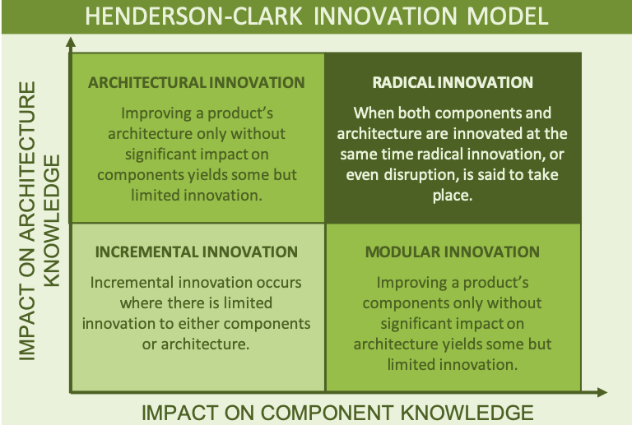
Figure 2 - Henderson-Clark Innovation Model (World of Work, 2019)

1.2 Incremental Innovation

1.2.1 Definition
Incremental innovation occurs when developments are made to either the architecture or the components of a product; often, small in-service improvements to a product will constitute an incremental innovation categorisation (World of Work, 2019). The ICC define incremental innovation as: “changes to existing products or production processes that enhance their commercial value” (ICC, 2018, p. 7), their explanation continues by stating delivery of such changes should only constitute refinements in existing technologies. Any observed improvements beyond this description are unlikely to be the result of singular changes to architecture or components and warrant further investigation.

1.2.2 Case Study
QinetiQ Aberporth have recently supported project Centurion- the Eurofighter Typhoon aircraft enhancement programme. QinetiQ’s involvement in the project contributed towards the safe integration of the Brimstone precision strike missile system to the aircraft (QinetiQ, 2018b). MBDA’s longstanding Brimstone system had originally been integrated and serviced by the Tornado GR4 aircraft, which has now been fully decommissioned by the Royal Air Force (MBDA, 2019). There have been no notable changes to the weapon system itself, however the architecture which supports the system was smartly reconfigured to accommodate the new requirement with minimal impact. This innovative, incremental change enabled the swift handover of an essential defence system from one aircraft to another, ensuring the Typhoon remains a paramount combat capability for the United Kingdom’s Ministry of Defence (QinetiQ, 2018b).
To summarise, the system reconfiguration did not significantly impact the overall architectural knowledge thus the innovation is incremental (Thuhang, 2008). Additionally, separate from project Centurion; it is documented that numerous incremental changes have been made by MBDA to the Brimstone system over its service period. During the British involvement in Afghanistan the system suffered corrosion issues which prompted an innovative, incremental change in procedure to sustain serviceability (Hoyle, 2010).

1.2.3 Benefits and Limitations
The benefits of successful incremental innovations are recognised as cost efficiency and better performance which contributes towards increased customer satisfaction (ICC, 2018). Geiger and Finch (2016) discuss how the potential for refinement as a product matures, through being subject to continual incremental innovation. Through this continual commitment it is possible to adapt the product, service or process to the changing environment, as the change occurs.
Ford (2018) informs how statutory regulation amendments are complied with through utilising incremental change; otherwise, un-unified compliance will eventually prompt the need for costly, major impact on the current knowledge. Appel (2016) and Gagnon et al. (2003) discuss the possible unintentional changes that may occur over time as the product develops through incremental innovation; the work highlights the potential for redundant, surplus resource. The overall limiting factor of incremental innovation is that unexpected sudden expansions in knowledge are not accommodated for (Carr, 2015). Realistically, a combination of innovation types will be required throughout a products lifecycle (Gomes, 2014).

1.2.4 Impact on the Organisation
Burggren (2019) discusses how the implementation of continuous incremental change may better a product’s cost effectiveness; small changes provide the opportunity to try and test diverse ideas where some will result in increased quality, cost and reduced time. Quite simply, “many enterprises use incremental innovation to help maintain or improve a product's market position” (Rouse, 2019). It is discussed, with the example of reducing greenhouse gas emissions in the automobile manufacturing sector; that the EU parliament's targets run the risk of placing the industry at a disadvantage. It is proposed by Burggren that the incremental fine-tuning of existing technologies will be adequate in providing a low-cost solution for meeting the 2030 targets. Griffiths et al. (2006) state that a firm’s acceptance of incremental innovation and its rewards in terms of competitiveness may indeed provide the incentive for further innovation in order to retain the advancing product with corresponding market position.
Brandl et al. (2018) state that “a greater adaptiveness to changing requirements” is enabled through incremental change by concentrating innovation on solving small, problematic elements in order to progress; this method inculcates the lean and agile approach in further company developments. On the other hand, Strong (2018) challenges the status quo of organisational conformity with blanket terminology. It is explained that simply working towards becoming lean and agile can hamper contextual development; innovating towards an end product is presented as improvement. However, this argument does not consider a company’s alignment with lean and agile principles to enable specific innovation types. Chen and Taylor (2009) realise that lean principles may affect the suitability of internal company innovation and states that outsourcing may be required in particular situations to operate effectively; hence, removing the uncertainty of failure and additional cost. A similar situation is ongoing with a QinetiQ maritime target requirement where the outsourcing of innovation is the only viable option. Internal department incremental innovation has been the appropriate method of maintaining competitiveness since initial design. However, recent external factors have dramatically reduced cost effectiveness of the target system thus placing the required innovation outside what is realistically deliverable by the department.

1.3 Architectural and Modular Innovation

1.3.1 Definition
The changing of components within a system without affecting the overall configuration is categorised as modular innovation. Likewise, the change in configuration of a system which alters the way in which components interact is categorised as architectural innovation. The defined innovation types can be seen as the inverse of one another. It is important to note that in both cases; the product, service or procedure outcome is unchanged, but the way in which that outcome is reached is variable (Rijsdijk, 2018).

1.3.2 Case Study
QinetiQ Pendine have recently delivered a trial to investigate a concept associated with the firing of large calibre rounds, previously thought to be unfeasible due to safety implications. The customer requirement was to understand the terminal ballistic performance of 12.7mm ammunition by conducting a series of tests similar to those carried out on small calibre ammunition. In general, a trial is sold to the customer as a package, or product (LTPA, 2019). Therefore, changes were made for the customer’s advantage, positively impacting the product component knowledge. The standard weapon system was changed for a high calibre system capable of meeting the requirements. The standard components for gauging bullet effectiveness at the target end were also updated to account for the increased hazards presented by firing high explosive charge carrying ammunition. Allowing the change of components, enabled the firing without the need to change the procedure, or trial architecture (QinetiQ, 2019b).

1.3.3 Benefits and Limitations
These types of innovation have the potential to enable useful advantages when applied in the appropriate setting. The benefits of modularity and architecture are discussed as the ability to remain or enhance customer satisfaction whilst effectively preserving the original product (Brax, et al., 2017). With regards to the case study, the trial’s success was recognised by the promotion of innovation taking place within the company. That said, further work is required to identify and educate on the specific types of innovative practise taking place and its overall impact on associated projects (QinetiQ, 2019b). Acosta et al. (2016) outline the common misconceptions surrounding innovation, reaffirming the need for accurate innovation identification in industry.
Saha and Sharma (2014) argue the limiting conditions often associated with architectural or modular change alone render them detrimental to the overall system, reliant on environmental circumstance. Greve and Krause (2019) take a similar view, their work discuss’ the probability of rising implications that result from modularising systems and reconfiguring systems; certain difficulties will only become apparent after an unknown period of time. Gie (2011) expands on this by proposing theory for the incompatibilities; a lack of informed design and failure to apply existing knowledge during system or component reconfiguration. It is essential to target the amount of knowledge required by this innovation type to prevent needless changes, leading to excessive issues further down the line.

1.3.4 Impact on the Organisation
Bessant & Tidd (2013) provide a holistic view on the impact of innovation as a whole for developing products in the marketplace; the work considers the need for agility in the sense of being able to change manufacturing materials to suit demands through the utilisation of component innovation. Belkadi et al. (2018) compare traditional manufacturing methods which make use of incremental development against modular system design; they propose that gearing manufacture towards interchangeable modules, based on extensively researched customer requirements can substantially reduce demands on resources resulting in an efficiency advantage over the competition.
Distanont & Khongmalai’s (2018) study on creating competitive advantage states the need for preparation within organisations in order to successfully face the challenges bought on by economic change. With regards to architectural or modular innovation at an organisation level, QinetiQ are generally dominant in providing solutions that are one step ahead of the competition, as discussed in the case study. However, the company struggle to apply those lessons to the next solution or indeed collaborate those lessons to another department who face the same, already worked solution. The explanation of limited delivered results from agile initiatives discussed by Rigby et al. (2016a) are appropriate: without appreciation for the prospective benefits of agility such as gaining bespoke experience in the specific customer solution and recycling those skills to better innovate the product, unrealistic deadlines are set by certain leaders in an attempt to hurry through those innovations which have not fully benefitted from the incorporation of an experience influenced, leaner design (Vester, 2017). A lengthy period of trial and error is often required in relation to materials, assembly methods and tolerances to hone the most economical system configuration; note, the balance between fine tuning and potential gain is crucial (Luthardt & Mörchel, 2010).

1.4 Radical and Disruptive Innovation

1.4.1 Definition
The current rate of technological advancement has prompted widespread digital disruption; these changes have placed evermore emphasis on the need to develop radically innovative products, services and processes for the purpose of protecting sovereign interests (QinetiQ, 2018c). According to the Henderson-Clark (1990) innovation model, radical innovation is the result of synchronous architectural and component knowledge development. Radical innovation is often associated with the emergent of new to market products that feature a dominant design; furthermore, disruptive or revolutionary innovation is observed in the marketplace when current products are made obsolete by the technologically advanced product (Saha & Sharma, 2014). It is accepted that a change in customer requirements may provide a trigger for the transformation of an existing product, given the correct level of investment (Big Think, 2018).

1.4.2 Case Study
The UK Dragonfire consortium is currently working to achieve a major advancement in the UK’s defensive capability through the development of a laser directed energy weapon (UK Defence Journal, 2017). QinetiQ are working alongside several UK defence technology companies in order to deliver this innovative system. The company’s role within the consortium is to develop a world leading laser technology and provide a testing and evaluation programme upon completion of the overall product. A prototype of the turret and weapon housing was unveiled in 2017 at the Defence and Security Equipment International exhibition for the purpose of showcasing the collaborative innovation efforts of the consortium (QinetiQ, 2017a). The nature and magnitude of this project is a true reflection of the commitment made by the government to develop high-tech yet sustainable equipment through the Defence Equipment Plan (MOD, 2018); the delegation of tasks to appropriate expert companies has secured access to areas containing the ability to extensively reform both architectural and component knowledge from the current, to a position of radical innovation (Müller & Blanquart, 2018). It is proposed that UK Dragonfire has developed the potential to disrupt the current weapon systems market; this is facilitated by the acquisition of and application of profound advancement in technological knowledge, providing an incomparable end product (QinetiQ, 2018c).

1.4.3 Benefits and Limitations
Radical and disruptive innovation both offer the provider of products, services or process’ with the unique opportunity to transform entire markets, replacing the current with completely new technology. The company becomes the innovation driver, steering the market towards its advantage (Innolytics, 2019).
The benefits accompanying UK Dragonfire are vast; providing a market dominating defence product will fortify British capability in this sector. This is delivered through a number of channels; government publicity, press and media, increase in supply chain utilisation which benefits third party manufacturers and further research in around the newly recognised knowledge (Leonardo, 2019). The government have been active in promoting the rewards of their investment for the purpose of confirming and justifying the defence budget. The Minister for Defence Procurement- Harriet Baldwin, stated: “The UK has long enjoyed a reputation as a world leader in innovation and it is truly ground-breaking projects like the laser directed energy weapon which will keep this country ahead of the curve” (MOD, DSTL, Baldwin MP, 2017). The continued success of UK Dragonfire has permitted QinetiQ to establish a centre of excellence for the development and testing of advanced laser technology; named Dragonworks, the facility aims to drive laser innovation alongside the product roll-out (QinetiQ, 2017b). The downside to disruptive innovation for the marketplace is if newer technologies are accepted by the customer; the existing technology becomes obsolete and companies must adapt in accordance with the innovation, evidence shows how companies are slow to adapt when placed in this situation (Lopez, 2015).

1.4.4 Impact on the Organisation
Lennerts et al. (2019) explore the impact of exploitation-exploration interactions with regards to competitive advantage, alongside the impact on incremental and radical innovation performance. It is widely recognised that exploitation and exploration are required to innovate; Raisch & Birkinshaw (2008) and Schnellbächer (2019) agree positive impact on operational performance. Furthering the case studies, QinetiQ’s collaboration between independent defence contractors with the goal of radical innovation is an example of explorative efforts; similarly, the establishment of a very recent collaborative project to deliver training support to the Royal Navy is, in itself exploitation of the network already set out by the preceding exploration (QinetiQ, 2019c). The issue with relying on exploitation in this way is that new networking opportunities stand the chance of being overlooked and essential, project bespoke innovation may be missed; a combination is often better on the whole, although requiring more investment (Sáez, 2014). Fundamentally, a company’s use of such techniques must be justified against potential gain; the correct formula for interaction is the difference between reaping the benefits of delivering pioneering solutions and the substantially fewer benefits of mediocre innovation (Lennerts, et al., 2019). This divide will profoundly affect the final products, services or processes’ competitive edge, which guides customer satisfaction, which drives success and market position (Fellnhofer, 2017).
Cooper (2018) provides a sceptical view on the impact radical and disruptive innovation can have on lean operation; it is discussed that such resource intensive concepts are difficult to control and justify before the end product’s market reception. On the other hand, Cooper provides a solution which ties lean to a developing product in place of applying lean to the departments associated with the product; this way, wasteful work duplication and non-applicable concepts are removed from the equation (Cooper, 2018). Controversially, being behind the curve with innovative emerging technologies provides ample opportunity to test the organisation’s agile response; to counter the emergent through quick, customer requirement aligned innovation (Rigby, et al., 2016b).

2. Change Initiatives

2.1 Introduction
Tasler (2017) offers an essential piece on human factors, for consideration before divulging into the dynamics of change initiatives. The concept of negative bias among people, especially people working within an organisation structure is said to have an impeding effect on the reception of change. It is proposed that an unsubstantiated connection between difficulty and failure is deep-rooted: the challenges associated with change are perceived as too difficult to overcome, due to being uninformed of the potential benefits. The employee resistance concept is also acknowledged by Ewenstein et al. (2015); their article presents the notion of improving the acceptance of change through gaining workforce investment.
The second point to consider is the actual relevance of success and failure in regards to organisational change. The NineFeetTall (2019) blog summarises and presents the work of Hughes (2011); it is impractical to use the terms, success and failure as definitive designations as “neither add clarity to the outcomes achieved and problems encountered” (NineFeetTall, 2019). Many challenges may have been overcome throughout the course of a project, providing significant positive impact for certain areas; however, when the overarching goal is not reached, the project is branded a failure (Hughes, 2011). The fact that a change initiative was delivered on time and to budget does not necessarily constitute success; factors such as adopting new behaviours and applying new technologies should reflect the success of an initiative (Frahm, 2013).

2.2 The 70% Failure Issue
It has been widely accepted that 70% of change initiatives may fail (Maurer, 2010); however, there are many arguments to discredit this statistic as not being the result of empirical work (Hughes, 2011) ; (Frahm, 2013) ; (Leeman, 2015) ; (Gilbert & Lorthois, 2013). The original statement has provided reference for countless reports; and yet, the source information itself does not confirm any study in regards to the figures stated:
Sadly, we must report that despite the success stories described in previous chapters, many companies that begin reengineering don’t succeed at it…Our unscientific estimate is that as many as 50 per cent to 70 per cent of the organizations that undertake a reengineering effort do not achieve the dramatic results they intended (Hammer & Champy, 1993, p. 200).
Buckley (2016) takes a slightly different approach; whilst recognising the much repeated 70% of all change initiatives may fail, as a myth. An extensive global survey is presented which considers the level of successfulness; the results yield 6% of initiatives where outright unsuccessful (McKinsey & Company, 2010). Leeman (2015) further expands on the so-called failure rate by stressing its lack of substance; they proclaim the abundance of change monitoring tools for the purpose of establishing a new focus towards bespoke, qualitative results. Hughes (2011) and Chowthi-Williams (2018) consider the importance of capturing the value of qualitative elements when assessing success to allow a truly reflective success criteria. If the 70% figure has no real-worlds standing, this provides an explanation as to why the number has not, generally changed over the years even though change management has been vastly adopted by organisations. It would seem that the figure has provided more of an influential tolerance rather than a universal constant of change initiative failure (Stagl, 2014).

2.3 Change Management Models
APM define change management as “a structured approach to moving an organisation from the current state to the desired future state” (APM, 2019). Change management is required when the organisation embraces a new idea that could disrupt normal operation (Perkins, 2018).

2.3.1 Lewin’s Change Management Model
Method- Unfreeze the organisation, make the required changes, refreeze as the organisation embraces the new way of working.
Pros- Suited towards widespread change requirements as the entire organisation can be dismantled and rebuilt for the better.
Cons- Unfreezing the organisation can be a costly process which may unearth greater issues than originally expected (Mind Tools, 2019) (Mulholland, 2017).

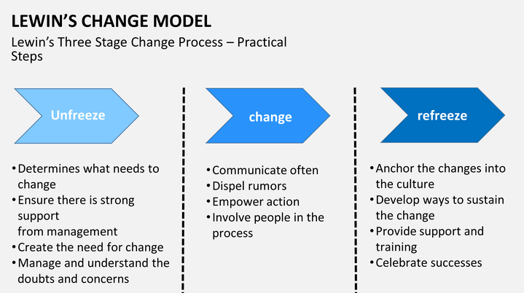
Figure 3 - Lewin’s Change Model (process.st, 2017)

2.3.2 The McKinsey 7-S Model
Method- Analyse and make improvements on the interactions between; Strategy, Structure, Systems, Shared Values, Style, Staff and Skills. Alignment between the seven elements is attained to enable in improved, effective operation.
Pros- Opportunity to upgrade each element one at a time as the model exposes the system weakness.
Cons- Resource requirements are high when attempting to evaluate entire sections of a large organisation (McKinsey & Company, 2008) (Mulholland, 2017).
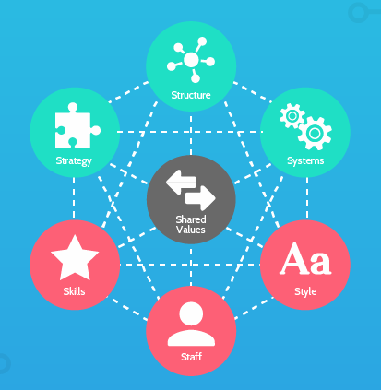
Figure 4 - McKinsey’s 7-S Model (process.st, 2017)

2.3.3 Kotter’s Theory
Method- The sequence as set out in Figure 4 provides the plan for organisation improvement.
Pros- Instilling a sense of urgency from the onset enables perseverance to complete the series of events.
Cons- Employee alienation due to the top-down approach (Kotter, 2019) (Mulholland, 2017).
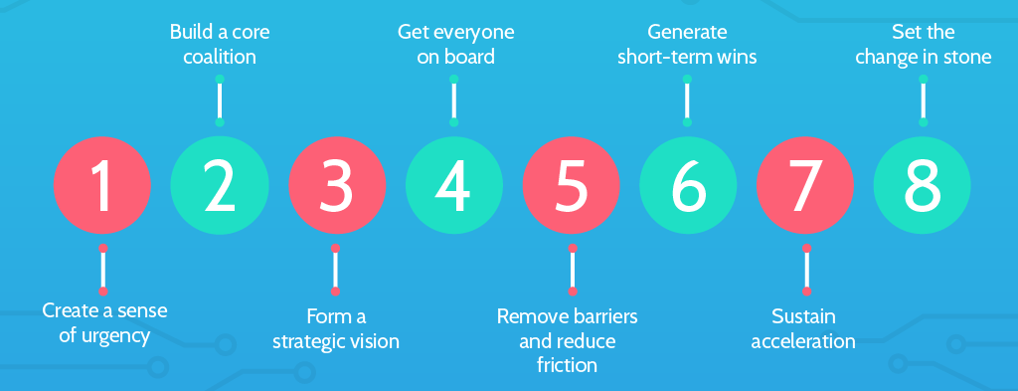
Figure 5 - Kotter’s Theory (process.st, 2017)

2.3.4 Nudge Theory
Method- A slightly subtler approach, where changes are decided upon with the assistance of local input.
Pros- Facilitates good engagement between the initiative and the employees due to influencing the change.
Cons- Results can become predictable, meaning restructuring drifts from the original purpose. (Mulholland, 2017) (PA, 2019).
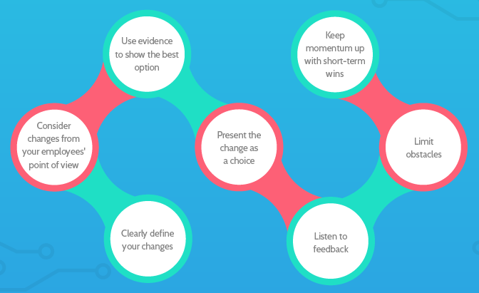
Figure 6 - Nudge Theory (process.st, 2017)

2.3.5 ADKAR
Method- A staged framework where each section applied, requires deliberation between all involved parties to deliver change.
Pros- Bottom-up approach which provides good engagement and an ideal setting to develop incremental innovation.
Cons- Not geared towards larger innovation types. Desired organisational direction must be fed into the process (Prosci, 2019) (Mulholland, 2017).

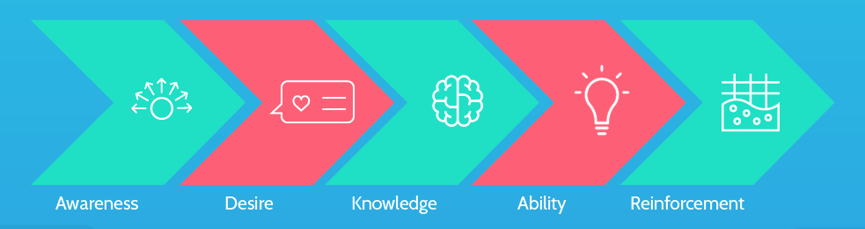
Figure 7 - ADKAR (process.st, 2017)

2.3.6 Bridges’ Transition Model
Method- Letting go of the old, supporting employees through the transition and innovating for the future in the desire of improved operational performance.
Pros- Provides a personal approach which will prepare employee skills-sets for the new challenges.
Cons- No defined steps to follow, transition period can take longer than required at the risk of making employees feel uncertain about the future (Mulholland, 2017) (William Bridges Associates, 2019).

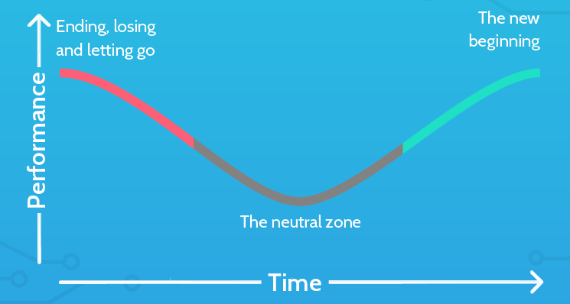
Figure 8 - Bridges’ Transition Model (process.st, 2017)

2.3.7 Kübler-Ross’ Change Curve
Method- By recognising the stages prior to acceptance, the company can utilise the framework to guide when and how certain elements of change can progress.
Pros- Designed around human response hence, elevated emotion and its effect on productivity can be expected and managed accordingly.
Cons- The model provides little guidance through each stage which causes uncertainty as to whether the correct course of action is being taken. The model will not fit every individual due to the unpredictability of human nature (Mulholland, 2017) (Connelly, 2018).

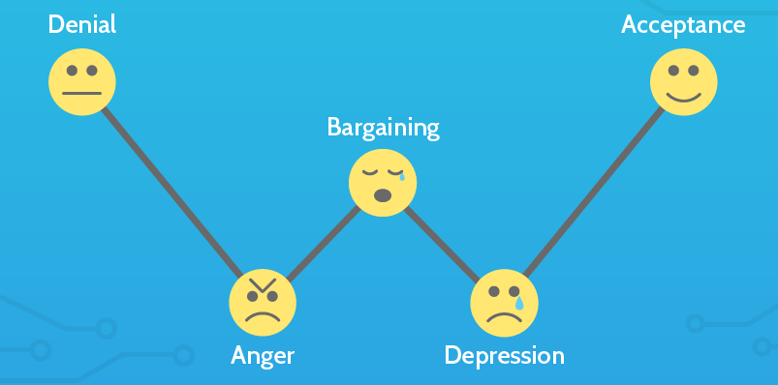
Figure 9 - Kübler-Ross’ Change Curve (Mulholland, 2017)

2.3.8 The Satir Change Management Model
Method- Similar to the previous model, applying the five stages of grief as a method of predicting the impact of change.
Pros- Good at anticipating the impact of change before implementation, effects of change can easily be compared against company progression.
Cons- Failing to allow enough fall in productivity to allow change will not yield substantial benefits (Mulholland, 2017) (Kaplan-Moss, 2019).

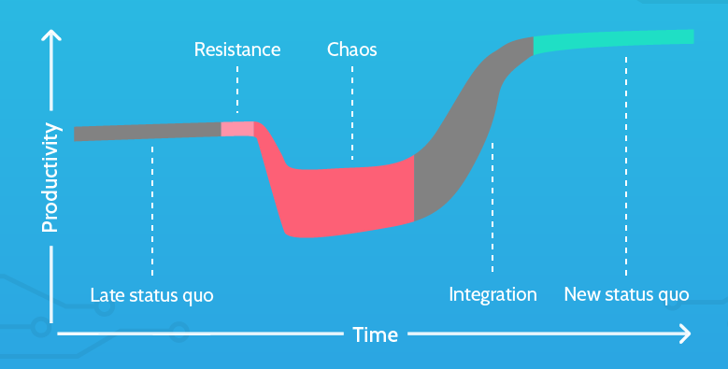
Figure 10 - Satir Change Management Model (process.st, 2017)

3. Conclusion
It is realised that any quoted number of change initiative may fail, depending on the subjective criteria for measuring success. The value of change initiatives has developed significantly in recent times; the scope of tools and techniques which are available to the organisation are a testament to the level of knowledge surrounding the concept. Each organisational change requirement differs from the next, creating the need for innovative, qualitative approaches to enable an efficient balance between investment and potential gain. A lack of innovative strategy is said to be the problem with improvement efforts (Pisano, 2015). Exploiting a tailored change management framework which comprises a combination of models is the current standard for realigning the organisation to suit the marketplace and deliver competitiveness through a leaner operation. The types of innovation available to the organisation are shown to enable and recognise achievements of solution development for the customer. I holistic approach is available to every organisation, one which encompasses innovation types and management models among a multitude of other concepts. It is proposed that the exact combination of tools should be based on the desired outcome, and failure to achieve the desired outcome does not mean the initiative has been wholly unsuccessful.

References
Acosta, B., Acosta, M. & Espinoza, B., 2016. Understanding innovation based on company optics: interpretation mistakes on the types of innovation developed. RAI Revista de Administração e Inovação, 13(4), pp. 295-304.
APM, 2019. Change management. [Online]
Available at: https://www.apm.org.uk/body-of-knowledge/delivery/scope-management/change-management/
[Accessed 3 November 2019].
Appel, A., 2016. Incremental vs radical change. [Online]
Available at: https://prezi.com/d25jcq2aoh2-/incremental-vs-radical-change/
[Accessed 29 October 2019].
Basu, S., 2014. Product market strategies and innovation types: finding the fit!. Strategic Direction, 30(3), pp. 28-31.
Belkadi, F. et al., 2018. Modular design of production systems tailored to regional market requirements: A Frugal Innovation perspective. International Federation of Automatic Control, 51(11), pp. 96-101.
Berggren, C., 2019. The cumulative power of incremental innovation and the role of project sequence management. International Journal of Project Management, 37(3), pp. 461-472.
Bessant, J. & Tidd, J., 2013. Managing Innovation. 5th ed. NJ: John Wiley.
Big Think, 2018. Radical vs. Disruptive Innovation: What They Mean for Organizations. [Online]
Available at: https://www.bigthinkedge.com/radical-vs-disruptive-innovation-what-they-mean-for-organizations/
[Accessed 30 October 2019].
Brandl, F. J., Kagerer, M. & Reinhart, G., 2018. A Hybrid Innovation Management Framework for Manufacturing – Enablers for more Agility in Plants. 51st CIRP Conference on Manufacturing Systems, Volume 72, pp. 1154-1159.
Brax, S., Bask, A., Hsuan, J. & Voss, C., 2017. Service modularity and architecture – an overview and research agenda. International Journal of Operations & Production Management, 37(6), pp. 686-702.
Brigante, G., 2015. Innovation. [Art] (HBR).
Buckley, L., 2016. Do 70% of change projects really fail?. [Online]
Available at: http://acumen.sg/do-70-of-change-projects-really-fail/
[Accessed 3 November 2019].
Carr, G., 2015. THE BENEFITS OF RADICAL INNOVATION. [Online]
Available at: http://www.thethinkteam.com/blog/posts/the-benefits-of-radical-innovation
[Accessed 31 October 2019].
Chen, H. & Taylor, R. D., 2009. Exploring the impact of lean management on innovation capability. Portland International Center for Management of Engineering and Technology, Volume 10, pp. 826-834.
Chowthi-Williams, A., 2018. Evaluation of how a real time pre-registration health care curricula was managed through the application of a newly designed Change Management Model: A qualitative case study. Nurse Education Today, Volume 61, pp. 242-248.
Connelly, M., 2018. Kubler-Ross Five Stage Model. [Online]
Available at: https://www.change-management-coach.com/kubler-ross.html
[Accessed 4 November 2019].
Cooper, B., 2018. WHAT IS LEAN INNOVATION? COMPONENTS AND EXAMPLES. [Online]
Available at: https://www.movestheneedle.com/all-blog/2018/8/14/what-is-lean-innovation-components-and-examples
[Accessed 2 November 2019].
Distanont, A. & Khongmalai, O., 2018. The role of innovation in creating a competitive advantage. Kasetsart Journal of Social Sciences, Volume 39.
Ewenstein, B., Smith, W. & Sologar, A., 2015. Research tells us that most change efforts fail. Yet change methodologies are stuck in a predigital era. It’s high time to start catching up.. [Online]
Available at: https://www.mckinsey.com/featured-insights/leadership/changing-change-management
[Accessed 2 November 2019].
Fellnhofer, K., 2017. Drivers of innovation success in sustainable businesses. Journal of Cleaner Production, 167(20 November 2017), pp. 1534-1545.
Ford, C., 2018. Innovation as a Challenge to Regulation. [Online]
Available at: https://www.theregreview.org/2018/03/12/ford-innovation-regulation/
[Accessed 29 October 2019].
Frahm, J., 2013. 70% OF CHANGE PROJECTS FAIL: BOLLOCKS!. [Online]
Available at: https://conversationsofchange.com.au/70-of-change-projects-fail-bollocks1/
[Accessed 2 November 2019].
Gagnon, M. A. & Michael, J. H., 2003. Employee strategic alignment at a wood manufacturer. Forest Products Journal, 53(10), pp. 24-29.
Geiger, S. & Finch, J., 2016. Making incremental innovation tradable in industrial service settings. Journal of Business Research, 69(7), pp. 2463-2470.
Gie, R. L., 2011. Architectural innovation and design, London: Imperial College Business School.
Gilbert, F. & Lorthois, L., 2013. https://www2.deloitte.com/content/dam/Deloitte/lu/Documents/public-sector/lu-demystifying-change-management.pdf, London: Delitte.
Gomes, P., 2014. The role of TQM in strategic product innovation: an empirical assessment. International Journal of Operations & Production Management, 34(10), pp. 1307-1337.
Greve, E. & Krause, D., 2019. Long-term effects of modular product architectures: An empirical follow-up study. Procedia CIRP, 84(1), pp. 731-736.
Griffiths, R., Harrison, R. & Simpson, H., 2006. The link between product market reform, innovation and EU macroeconomic performance, European Commission: Directorate General Economic and Financial Affairs.
Hammer, M. & Champy, J., 1993. Reengineering the Corporation: A Manifesto for Business Revolution. New York: Harper Collins.
Henderson, R. M. & Clark, K. B., 1990. Architectural Innovation: The Reconfiguration Of Existing Product Technologies and the Failure of Established Firms. Administrative Science Quarterly, 35(1), p. 9.
Hoyle, C., 2010. FlightGlobal - MBDA details problems with dual-mode Brimstone. [Online]
Available at: https://www.flightglobal.com/news/articles/mbda-details-problems-with-dual-mode-brimstone-339739/
[Accessed 28 October 2019].
Hughes, M., 2011. Do 70 per cent of all organizational change initiatives really fail?. Journal of Change Management, 11(4), pp. 451-464.
ICC, 2018. The Importance of Fostering Incremental Innovation. [Online]
Available at: https://pdfs.semanticscholar.org/4294/23500d51085f703ddd1e8641946bae91fc7a.pdf
[Accessed 28 October 2019].
Innolytics, 2019. What is radical innovation?. [Online]
Available at: https://innolytics-innovation.com/radical-innovation/
[Accessed 31 October 2019].
Kabir, M. N., 2019. Innovation. In: Knowledge-Based Social Entrepreneurship. New York: Palgrave Macmillan, pp. 163-204.
Kaplan-Moss, J., 2019. Using the Satir Change Management Model On A Rapidly-Growing Software Team. [Online]
Available at: https://www.woventeams.com/blog/satir-change-management-model-software
[Accessed 4 November 2019].
Kotter, 2019. 8-STEP PROCESS. [Online]
Available at: https://www.kotterinc.com/8-steps-process-for-leading-change/
[Accessed 3 November 2019].
Leeman, R., 2015. 70% of Change Management Initiatives Fail–REALLY?. [Online]
Available at: http://flevy.com/blog/70-of-change-management-initiatives-fail-really/
[Accessed 2 November 2019].
Lennerts, S., Schulze, A. & Tomczak, T., 2019. The asymmetric effects of exploitation and exploration on radical and incremental innovation performance: An uneven affair. European Management Journal, Issue In Press, Proof Version.
Leonard-Barton, D., 1995. Wellsprings of Knowledge. NY: Harvard Business School Press.
Leonardo, 2019. Dragonfire: Laser fire power. [Online]
Available at: https://www.uk.leonardocompany.com/en/innovation/dragonfire
[Accessed 31 October 2019].
Lopez, J., 2015. Types of Innovation. [Online]
Available at: https://techblog.constantcontact.com/software-development/types-of-innovation/
[Accessed 30 October 2019].
LTPA, 2019. MOD Pendine. [Online]
Available at: https://www.ltpa.co.uk/SitesAndRanges/Pendine
[Accessed 29 October 2019].
Luthardt, S. & Mörchel, J., 2010. The Impact of Different Types of Innovations on Industrial, Berlin: Humboldt-Universität.
Maurer, R., 2010. Why 70% of Changes Fail. [Online]
Available at: http://www.reply-mc.com/2010/09/19/why-70-of-changes-fail-by-rick-maurer/
[Accessed 2 November 2019].
MBDA, 2019. Brimstone. [Online]
Available at: https://www.mbda-systems.com/product/brimstone/
[Accessed 29 October 2019].
McKinsey & Company, 2008. Enduring Ideas: The 7-S Framework. McKinsey Quarterly.
McKinsey & Company, 2010. McKinsey Global Survey results: What successful transformations share, Chicago: McKinsey & Company.
Mind Tools, 2019. Lewin's Change Management Model. [Online]
Available at: https://www.mindtools.com/pages/article/newPPM_94.htm
[Accessed 3 November 2019].
MOD, DSTL, Baldwin MP, 2017. UK Innovation: Laser Weapon Contract Awarded. [Online]
Available at: https://www.gov.uk/government/news/uk-innovation-laser-weapon-contract-awarded
[Accessed 31 October 2019].
MOD, 2018. The Defence Equipment, London: Defence Equipment & Support.
Mulholland, B., 2017. 8 Critical Change Management Models to Evolve and Survive. [Online]
Available at: https://www.process.st/change-management-models/
[Accessed 3 November 2019].
Müller, S. & Blanquart, C., 2018. The Inventor’s Perspective on Conditions for Radical Innovations in Freight Transportation: Case Studies from France and Germany. Journal of Innovation Economics & Management, 25(1), pp. 211-238.
NineFeetTall, 2019. Good news: 70% of change initiatives don’t fail. [Online]
Available at: http://www.ninefeettall.com/blog/good-news-70-change-initiatives-dont-fail/
[Accessed 2 November 2019].
PA, 2019. Change management: a nudge in the right direction. [Online]
Available at: https://www.paconsulting.com/insights/change-management-a-nudge-in-the-right-direction/
[Accessed 5 November 2019].
Perkins, B., 2018. What is change management? A guide to organizational transformation. [Online]
Available at: https://www.cio.com/article/2439314/change-management-change-management-definition-and-solutions.html
[Accessed 3 November 2019].
Pisano, G. P., 2015. You Need an Innovation Strategy. [Online]
Available at: https://hbr.org/2015/06/you-need-an-innovation-strategy
[Accessed 5 November 2019].
process.st, 2017. 8 Critical Change Management Models to Evolve and Survive. [Online]
Available at: https://www.process.st/change-management-models/
[Accessed 3 November 2019].
Prosci, 2019. The Prosci ADKAR Model. [Online]
Available at: https://www.prosci.com/adkar
[Accessed 3 November 2019].
QinetiQ, 2017a. Transforming future weapons technology for UK MOD. [Online]
Available at: https://www.qinetiq.com/Blogs/2017/11/Dragonfire-Case-Study
[Accessed 30 October 2019].
QinetiQ, 2017b. QinetiQ launches UK ‘centre of excellence’ for laser technology. [Online]
Available at: https://www.qinetiq.com/news/2017/11/dragonworks
[Accessed 31 October 2019].
QinetiQ, 2018a. Annual Report and Accounts, Hampshire: QinetiQ plc.
QinetiQ, 2018b. Eurofighter Typhoon enhancement programme: our crucial role. [Online]
Available at: https://www.qinetiq.com/blogs/2018/01/eurofighter-typhoon-enhancement-programme
[Accessed 28 October 2019].
QinetiQ, 2018c. Research and Experimentation: Disruptive Technology at FIA. [Online]
Available at: https://www.qinetiq.com/blogs/2018/06/research-and-experimentation-at-fia
[Accessed 30 October 2019].
QinetiQ, 2019a. Annual Report and Accounts 2019, Hampshire: QinetiQ Group plc.
QinetiQ, 2019b. Team continues to innovate for our customers' advantage, Internal: Unpublished.
QinetiQ, 2019c. eam iMAST sets out to provide a step-change for UK Royal Navy and Royal Marines Training. [Online]
Available at: https://www.qinetiq.com/news/2019/09/team-imast-sets-out-to-provide-a-step-change-for-uk-royal-navy-and-royal-marines-training
[Accessed 1 November 2019].
Raisch, S. & Birkinshaw, J., 2008. Organizational ambidexterity: Antecedents, outcomes, and moderators. Journal of Management, 34(3), pp. 375-409.
Rigby, D. K., Berez, S., Caimi, G. & Noble, A., 2016b. Agile methods are poised to improve innovation in nearly every function of every business.. [Online]
Available at: https://www.bain.com/insights/agile-innovation/
[Accessed 1 November 2019].
Rigby, D. K., Sutherland, J. & Takeuchi, H., 2016a. Embracing Agile. Harvard Business Review, Issue May 2016, pp. 40-48, 50.
Rijsdijk, S., 2018. Architectural and modular innovations, Rotterdam: Erasmus University.
Rouse, M., 2019. Incremental innovation. [Online]
Available at: https://searchcio.techtarget.com/definition/incremental-innovation
[Accessed 31 October 2019].
Sáez, F., 2014. Productivity Strategies: Exploration vs Exploitation. [Online]
Available at: https://facilethings.com/blog/en/exploration-vs-exploitation
[Accessed 1 November 2019].
Saha, S. & Sharma, R., 2014. Relating Architectural and Modular innovation to Organization structure of the R&D function. European Journal of Business Research, 14(1), pp. 29-38.
Schnellbächer, B., Heidenreich, S. & Wald, A., 2019. Antecedents and effects of individual ambidexterity – A cross-level investigation of exploration and exploitation activities at the employee level. European Management Journal, 37(4), pp. 442-454.
Stagl, H., 2014. It’s Time to Abolish the 70% Change Failure Rate Statistic. [Online]
Available at: http://www.enclaria.com/2014/06/03/its-time-to-abolish-the-70-change-failure-rate-statistic/
[Accessed 3 November 2019].
Strong, C., 2018. Scaled Agile Frameworks — Agility or Efficiency. [Online]
Available at: https://medium.com/the-lean-product-lifecycle/agile-frameworks-scaled-incremental-delivery-for-enterprises-3a17b7e4fe10
[Accessed 2 October 2019].
Tasler, N., 2017. Stop Using the Excuse “Organizational Change Is Hard”. [Online]
Available at: https://hbr.org/2017/07/stop-using-the-excuse-organizational-change-is-hard
[Accessed 2 November 2019].
The Financial Times, 2018. Significant orders put defence group Qinetiq on track for growth. [Online]
Available at: https://www.ft.com/content/ff914db6-e8ab-11e8-8a85-04b8afea6ea3
[Accessed 25 October 2019].
Thuhang, T., 2008. A conceptual model of learning culture and innovation schema. Competitiveness Review, 18(3), pp. 287-299.
UK Defence Journal, 2017. Dragonfire, the new British laser weapon. [Online]
Available at: https://ukdefencejournal.org.uk/dragonfire-new-british-laser-weapon/
[Accessed 30 October 2019].
Vester, J., 2017. Agile - For the Sake of Being Agile. [Online]
Available at: https://dzone.com/articles/agile-for-the-sake-of-being-agile
[Accessed 1 November 2019].
William Bridges Associates, 2019. What is William Bridges’ Transition Model?. [Online]
Available at: https://wmbridges.com/what-is-transition/
[Accessed 3 November 2019].
World of Work, 2019. The Henderson-Clark Innovation Model. [Online]
Available at: https://worldofwork.io/2019/07/the-henderson-clark-innovation-model/
[Accessed 27 October 2019].

Bibliography

Anthony, S. D., Duncan, D. S., & Siren, P. M. (2014). Build an Innovation Engine in 90 Days. NY: Harvard Business Review.
The Royal Academy of Engineering. (2012). Educating engineers to drive the innovation economy. London: RAENG.

The Henderson-Clark framework (Henderson & Clark, 1990) is widely accepted in industry for the categorisation of innovation into four well defined types, as listed (Basu, 2014).

