Reflection on Interview Role Play Report

Judy Lee (2028008)

BMSW4005 Professional Career Development

3rd May 2022

Lecturer : Akinseye Aluko

Introduction
The purpose of this report is to write a personal reflection on the role play regarding interview techniques and our career development planning. Career development is essential to any individual who wants progression, to grow and expand, according to (Hoekstra, 2011), this is your internal identity and external career growth. I will use a reflection cycle such as Gibbs or Kolb and demonstrate an understanding of skills and knowledge which makes successful working in employment. I must demonstrate how competent I am through the process of searching for work, establishing employment goals, because (Nord, et al 2018) states that people who set employment goals have significantly higher chances of gaining employment, finally applying for the position, and progressing to the interview process. In additional I would need to identify my strength and weaknesses, my career goals and develop a personal action plan or development plan.
Part of this reflection also incorporates our role play in class where we paired up with a partner and the set up would be an interview process for a particular job which involved filling in a job application form and devising 5 questions for the prospective employee during the interview.
During the Professional career and development module, we learnt how to prepare for job interviews and given tools on how to identify our own skills and applying them to the potential job role and if we feel we have a skill gap, what further training we could use to further our careers.
Method
I will be using Gibbs reflection cycle under the heading ‘Recruitment and Selection’ to analysis my role play and the SWOT Analysis to identify my strengths and weaknesses because it is essential to recognise skills and knowledge, this is essential because I need to identify the internal and external implications that impacts my career development.
Finally, I will set goals and plan how to implement these strategies using the SMART criteria, these tools will help me to target specific areas I want to improve, and how to achieve them with a timeline, so it is measurable and achievable. (CFI, 2015) states that majority of goals are vague therefore have no direction but with this SMART tool it pinpoints specific actions and time frames, so it is more successful.
Below is an example of the SWOTS Analysis which I will use within the report, and the diagram is divided into four categories, Strengths, which is what qualities or positives you have. Weaknesses, these are any constructive criticism you feel you need to improve on such as lack of training in a certain area and you feel you need to gain training to improve your skills to perform your job role, both factors are internal therefore it is the personal factors that impact or are a positive to yourself.
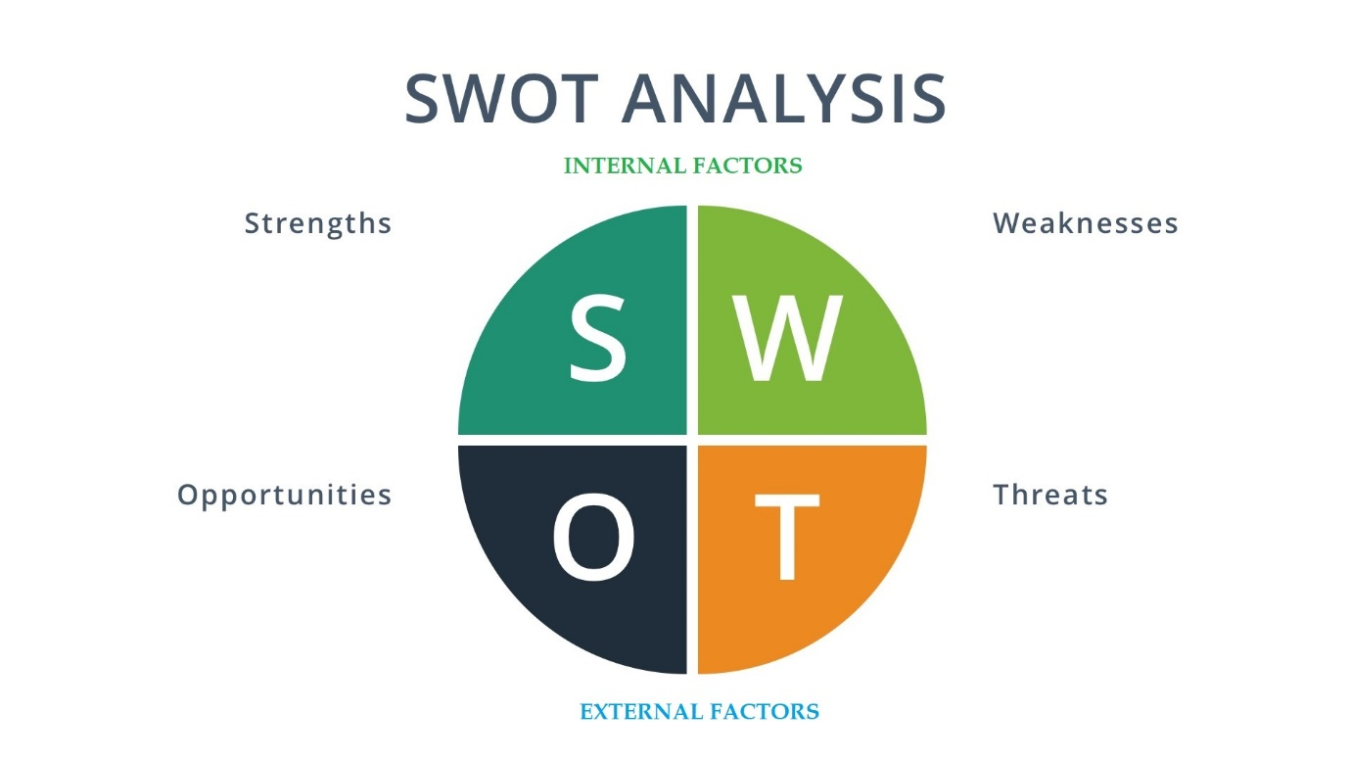(Dingani 2020)
The external factors are the opportunities which you can foresee in your career or environment, to ensure you grow, such as does the job offer you job promotion in the next few years?, according to (Atkinson, 2013) the analysis enables professionals to identify desired qualities, and lastly, the threats, these are factors that can negatively affect your job role, for example if a job is temporary you may not be able to fore fill your expectations, or maybe due to the pandemic economic growth has declined you may have to take a pay cut. All these factors enable you to identify and plan areas of employment goals.

Recruitment and Selection
Below is an example of the Gibbs reflective cycle model which I will use to analyse my role play in class
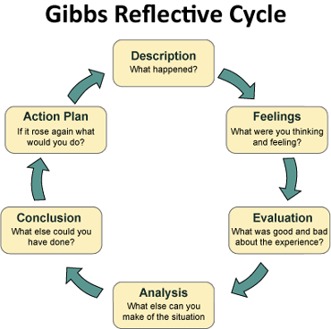
(Crowe Associates n.d)
Description
To participate in this role play I had to partner with a fellow student to improvise an interview scenario about a specific job application, the job role is Supervisor of a luxury fashion retail brand. I had to fill in a job application form (see Appendix A) prior to the role play and devise 5 questions (see Appendix B) to be asked during the interview. The questions are related to the interviewee’s job experiences, qualifications or what they can bring into the new role.
Feelings
Prior to the role play I researched types of questions I may be potentially asked and fully practised my role with my partner. I was confident but still nervous due to unpredictable circumstances that may occur such as, the role play of the interviewer, they may have forgotten what to say, so the interview may not be flowing, maintaining good body language and look interested in the role, and if my partner may not be present on that day. Overall, I felt I prepared for the day and consistently practised with my partner, so the conversation was more fluent.
On the actual day it went better than expected, both myself and my partner rehearsed our roles thoroughly, because the role play was over teams I tried to memorise all my answers and kept eye contact with the camera. I answered the questions with ease and covered the key points and felt my partner was great with his role too as I felt at ease.
Evaluation
It was a positive experience it enabled me to experience interview techniques and my body language which is important in real life interview scenarios. I received good feedback and constructive ones too, it was a learning curb and to identify on what I can improve.
Analysis
I felt the experience can be challenging and unpredictable as well, technical issues with microphone therefore being prepared for this situation is important as in real life, interviews can be conducted online as well. When you are not fully prepared you can panic therefore to alleviate this, ensure sound and camera is working at least fifteen minutes before the interview.
Conclusion
I felt our rehearsals could have been done online, we only practised over the phone, instead of being taken by surprise on the day. Paced my speech slower, as I spoke too quickly and remain with good calm composure. I did not get any feedback on that but that was my intuition.
Action Plan
In hindsight if I were to complete this task again I would rehearse face to face and pace my speech in a timely manner. Ensure I control my breathing in-between sentences and be ready with my technical equipment fifteen minutes beforehand. In addition, dressing in a more appropriate formal attire, I was wearing a blouse but my partner was casual so we should have synchronised our attire prior to the role play.

Findings
During the entire process of preparing my role play I have identified my personal strengths and weaknesses and external factors that impact my career development using the SWOT Analysis
Strengths
Reliable, good interpersonal skills, artist, intelligent, passionate about my job role, self-motivator, great mentor, work well in teams, leadership skills, organised, articulate, helpful, willing to learn and better myself, proactive, responsible, attention to details, problem solver, confident, warm personality, work well under pressure and professional.
For ten years working in retail, I have gained a lot of self-reflection on how I interact with people, and in this industry you need to be confident and approachable with clients and your connections. Teamwork is vital because of the nature in competitive work you need to remain professional and courteous with your colleagues. Most importantly retail is a busy and pressurised environment therefore you must be able to work under pressure and remain calm and especially dealing with challenging clients.
Weaknesses
Perfectionist, self-critical, can not say no, need more training in management, demanding. I am my own harsh critic, I tend to procrastinate on situations because I want to be certain the quality of service I give is the same standard as I received, would I be happy if I receive this standard of service.
Opportunities
Study further in BA Business Administration or Business Management, apply for Management position in two years. I want to further my qualifications and feel it will progress my career in management positions, therefore studying further and working is achievable.
Threats
Finance into further education, time, and commitment, being too complacent. Finance is the main issue, I will have to apply for student finance again which means I will accumulate a greater debt, in addition the time and commitment towards a degree course. Considering I had a big gap from my last qualification, I am impressed with how I become accustomed to writing essays, digital skills and planning my time whilst working.
Action Plan I will now use the SMART criteria to set and plan my career goals
(fitsmallbusiness 2021) SMART Template
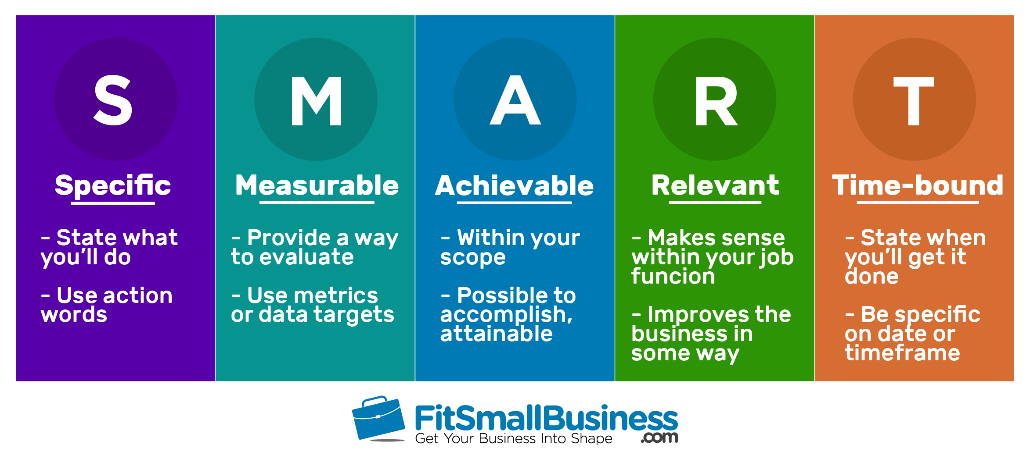
Specific – Apply for Degree in Business and Management and look for leadership roles such as supervisor positions
Measurable – UWTSD BA in Business and Management three-year course apply now, needs to submit application form within 2 weeks
Achievable – To pass CertHE skills in the workplace this June, have already passed two modules and confident that I will pass this last module
Relevant – My focus is to progress into management within the retail fashion industry, I have experience in retail for more than ten years, five years in a senior role, I understand the retail business and is a passion of mine.
Time Bound – applying for degree this year, applying for supervisor roles within 6 months, management roles within 3 years
With this information I can confidently ascertain the following :
- Update CV to include all my strengths, implement now
- Applying for BA courses in Business and Management, now to one year
- Search for job roles which to improve my leadership skills, within 6 months
- Finish my degree course and research and apply for management roles, within 2 years

Setting goals with a simple tool like SMART is proven successful, according to (Carlson, 2018), it is proven with collective data that people who set goals have a high chance of achieving them than people who do not set any plans. Like new year resolutions but the benefit of using SMART is that it is measurable therefore realistic, otherwise with new year resolutions when a person cannot achieve it they lose interest and give up.

Reference List

Atkinson K, (27th September 2013), British Journal of Therapy and Rehabilitation, Vol 5, No. 8, SWOT analysis: a tool for continuing professional development

CFI Education Inc, (2015), SMART Goals, What are SMART Goals? https://corporatefinanceinstitute.com/resources/knowledge/other/smart-goal/
Crowes Associates Limited (n.d), based on a mindtools article, https://www.crowe-associates.co.uk/coaching-tools/gibbs-reflective-cycle/

Dingani S, (8th July 2020), How to Do a SWOT Analysis for Individual Betterment, https://www.thehumancapitalhub.com/articles/How-To-Do-A-SWOT-Analysis-For-Individual-Betterment

Fitsmallbusiness, (2021), https://fitsmallbusiness.com/smart-goals-examples/

Hoekstra Hans A, (April 2011), Journal of Vocational Behaviour, Vol 78, issue 2, pg 159-173, A career roles model of career development

Nord D, Hamre K, Pettingell S, Magiera L (12th July 2018), Employment Goals and Settings: Effects of Individual and Systemic Factors, Sage Journals

Appendix A
Job application form Date 3rd May 2022
Application for [Supervisor] -

Your details
Name: Judy Lee

Education and training
Please give details:
St Martin’s Art College, UWTSD,

Qualifications
Please give details:
BA (Hons) Fine Arts, CertHE skills in the workplace, GCSE Maths, English Language, literature, Art, Physics, chemistry, biology, Music. A level Maths, English Language, Art

Employment history

Your current or most recent employer
Name of employer: Dolce Gabbana
Job title: Senior Sales Executive
Length of time with employer: 5 years
Reason for leaving: no room for growth, no openings for supervisor position

Duties:
CRM data update, support and delegate daily chores for sales associate, stock control, checking emails responding to enquires, repair log, organising break schedules, opening closing tills, security checks before leaving, clientele networking. Training staff on product knowledge, dealing with general client enquiries and approving returns.

Previous employers
Please tell us about other jobs you have done and about the skills you used or learned in those jobs.
Jimmy Choo 3 years sales associate
Roberto Cavalli 5 years sales associate
Assisting clients in store, daily shop floor cleaning, stock taking, sales and returns. Arranging repairs and alterations, measuring clients for fitting.

Supporting statement
Please tell us why you applied for this job and why you think you are the best person for the job.
I have extensive sales experience in luxury brands, I am confident and trustworthy member of my team, I always research and gain product knowledge to understand and cater for each client’s needs. I have leadership skills managing a team of 10 sales associate and have the reliability and trust of my line manager. I am capable of this step up to supervisor because I am exceeding my job role and expectations. I understand and am passionate about my industry and feel I will go further within your company. I want to challenge myself and this is a great opportunity for me.

Right to work in the UK
Do you need a work permit to work in the UK? Yes / No*

References
Please give the names and contact details of 2 people who we can ask to give you a reference. We may ask them before an employment offer is made. We will not ask your current employer until we get your permission.

Declaration
I confirm that to the best of my knowledge the information I have provided on this form is correct and I accept that providing deliberately false information could result in my dismissal.
Name: Judy Lee
Signature:
Appendix B
Role Play Job Interview
Retail Supervisor
Assessment Interview questions
1. Why should we hire you?
I have the skills and experience which fits your job specifications, such as leaderships skills as a senior member of staff managing a team of 10. Highly organised and prioritise workload, able to work under pressure in a highly busy department and many challenges arising stay calm and focussed. Work effectively in a team with a great command in interpersonal skills and always reliable and dependable.
2. What is your greatest weakness?
I tend to solve everyone’s challenges as I can resolves issues and problems arising, this can be a weakness because most of my colleagues will come to me and I find it difficult to let issues pass if it’s not my job description, but now I am able to be assertive and prioritise my workload first before attempting to solve other people’s problems and delegate tasks.
3. How do you deal with conflict?
I am very assertive and professional, if there is a conflict I will address it immediately in a professional way. Firstly, I reflect on myself to see if I had handled or said things in an appropriate way, then secondly, approach the person in question asking to speak privately, but ensuring it is not accusatory or judgemental way. Usually this resolves the issue. I have not experienced a conflict I could not resolve, but if it still not resolve and it affects the work then I would speak to my next line manager. It is essential to understand that any conflicts that is professional is resolved straight away as this hinders team morale and team objective, if the issue was personal then this needs to be put aside and dealt with outside of work.
4. Why did you leave your last job?
It was not anything negative as I have been with the company 5 years and all my colleagues and managers even the company were fantastic. I enjoyed my time there; it was time to leave I needed a new challenge and felt I could not further my career. I am ready for a fresh and new challenge which is why I applied for your company as it will be growth and exciting and I believe it will help me grow my skills.
5. Where do you see yourself in the next 5 years?
I am ready to develop my career and feel your company will challenge and progress this, I have researched your company and feel I will be an integral part of your team. Therefore, I see myself staying long-term moving along the corporate ladder, gaining valuable skills, knowledge, and experience.

Do you have any questions for us?
What is the one thing you are hoping a new person can bring into this role?
What is the biggest challenge of this job?

